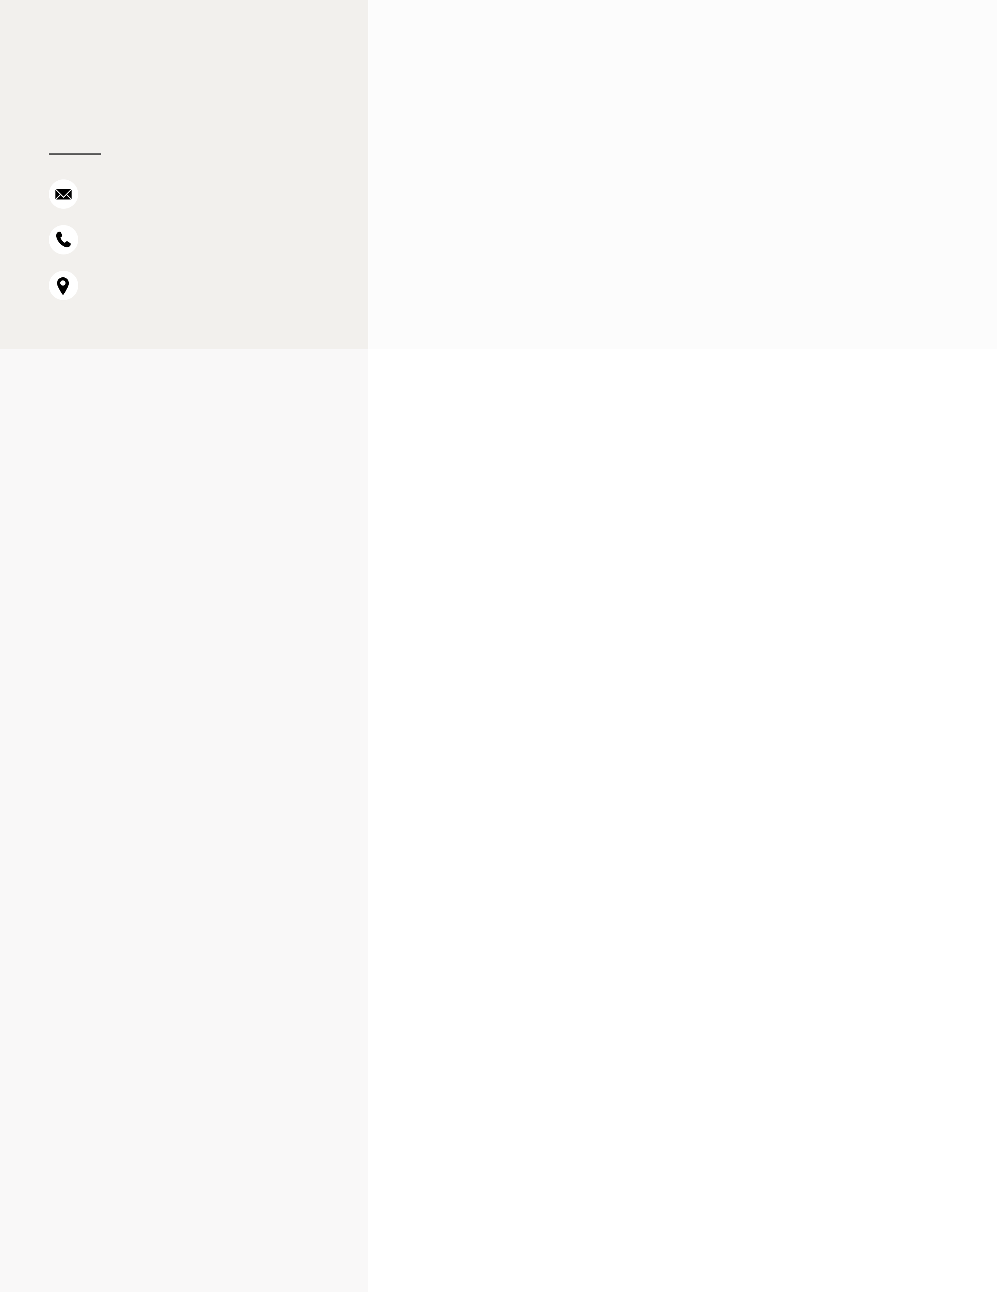

|  |  |
| --- | --- |
| **DANEEN MAYS** | **PROFESSIONAL SUMMARY**  Experienced Senior Quality Assurance Engineer with 9+ years of  expertise in leading automation and testing strategies for web, mobile, |

frontend, and backend systems. Demonstrated ability to improve

|  |  |
| --- | --- |
| Mays.d87@gmail.com (732) 306 - 2058  Philadelphia, PA 19144  **SKILLS** | software quality, identify critical issues, and mentor cross-functional teams in Agile environments. Collaborative approach with developers to integrate CI/CD pipelines and implement state-of-the-art tools such as Selenium, Appium, and Postman for seamless functionality and  exceptional user experience.  **WEBSITES, PORTFOLIOS, PROFILES** |

|  |  |  |  |
| --- | --- | --- | --- |
| • | Java | • | linkedin.com/in/daneen-mays |
| • | JavaScript | • | https://github.com/DaneenM |
| • | SQL | **WORK HISTORY** | |
| • | HTML |
| • | CSS | **Outlier** - **Freelance Prompt Engineer** | |
| • | Selenium WebDriver | *Remote* • *08/2024* - *Current* | |
| • | • | Designed complex mathematical equations and logic challenges to |
| Appium |
| • | WebdriverIO | enhance AI model performance and reasoning capabilities | |
| • | Promoted to Reviewer, where responsibilities included evaluating, |
| • | TestNG |
| correcting, and improving peer contributions with a focus on quality | |
| • | Testbed | and detail | |
| • | • | Leveraged 9+ years of QA expertise to identify gaps in AI outputs and |
| Postman |
| ensure consistent quality improvements | |
| • | CURL | **Razor (Booz Allen/Veterans Affairs)** - **Senior SDET Engineer /** | |
| • | REST APIs |
| **Associate Technical Writer** | |
| • | Oracle Database | *Remote* • *07/2023* - *Current* | |
| • | SQL Server | • | Led backend API testing using Postman, cURL, and SQL, ensuring |
| • | Kafka |
| seamless CRUD operations for Oracle Database and verifying Kafka | |
| • | topics | |
| Zookeeper |
| • | Collaborated closely with a cross-functional team of 3 developers, a |
| • | HashiCorp Vault | Scrum Master, and a Technical Architect in an Agile environment, | |
| • | Jenkins | driving quality across sprints | |
| • | Created and maintained comprehensive test cases and test plans to |
| • | CircleCI | validate application functionality and performance | |
| • | Maven | • | Automated backend testing workflows using Java, Maven, and |
| • | TestNG, improving test efficiency and reliability by 20% | |
| Docker |
| • | Integrated CI/CD pipelines using Jenkins, ensuring smooth builds and |
| • | Liquibase | deployments for microservices tested with Spring Boot and Liquibase | |
| • | React | • | Utilized Docker for containerized testing environments, enhancing |
| consistency and scalability across multiple platforms | |
| • | Redux |
| • | Provided mentorship and coaching on QA strategies to team |
| • | Flutter | members and other QA teams, improving bug-reporting accuracy and | |
| • | collaboration | |
| Spring Boot |
| • | Authored comprehensive technical documentation to support QA |

|  |  |  |  |
| --- | --- | --- | --- |
| • | Express | workflows, test cases, and automation processes, enhancing team | |
| • | Node.js | productivity | |
| • | Ensured continuous improvement in testing practices, applying |
| • | RestAssured | expertise in HashiCorp Vault and Agile methodologies to align with | |
| • | IntelliJ IDEA | project goals | |
| • | VS Code | **Ellevest** - **Quality Assurance Engineer II** | |
| • | VirtualBox | *Remote* • *07/2019* - *10/2022* | |
| • | Xcode | • | Conducted front-end automation testing using Selenium, Appium, |
| • | and WebdriverIO, ensuring high-quality web and mobile application | |
| Android Studio |
| releases | |
| • | Alpha and Beta Builds (Desktop & | • | Created and maintained comprehensive test plans and test cases for |
| • | Mobile) | Alpha and Beta builds, aligning with Agile methodologies in a | |
| Version Control (Git) | fast-paced environment | |
| • | • | Collaborated with 11 developers as the sole QA engineer, ensuring |
| VPN (OpenVPN, Cisco) |
| efficient communication and thorough testing coverage across | |
| • | Microsoft 365 (Excel, Outlook, | sprints | |
| • | OneDrive) | • | Integrated automated tests into CI/CD pipelines using CircleCI, |
| enhancing release efficiency and reducing manual testing efforts | |
| JIRA |
| • | Managed releases, including final test execution and reporting, |
| • | Confluence | ensuring smooth and timely deployments | |
| • | Trello | • | Authored detailed bug reports and performed root cause analysis, |
| • | Slack | improving resolution time and reducing recurring defects by 15% | |
| • | Performed automation testing on both web and mobile platforms, |
| • | Microsoft Teams | validating functionality and user experience across various devices | |
| • | Zoom | • | Leveraged testbeds to simulate real-world conditions, enhancing the |
| accuracy of test results and product reliability | |
| • | AI Prompting |
| • | Test Case & Test Plan Creation | **Oracle, Inc** - **Lead Quality Assurance Engineer** | |
| *New York* • *10/2016* - *06/2019* | |
| • | Release Management |
| • | • | Promoted to Team Lead, overseeing an outsourced QA team in India, |
| Technical Writing |
| providing guidance, project goals, and testing methodologies to | |
| • | Bug Reporting | ensure high-quality results | |
| • | Communication | • | Conducted rigorous manual testing across multiple platforms, |
| including consoles, mobile devices, web, and iPads, focusing on ad | |
| • | Mentorship |
| metrics for social media platforms like Facebook, Instagram, | |

Snapchat, and YouTube

|  |  |  |
| --- | --- | --- |
| **EDUCATION** | • | Created detailed test case scenarios, executed comprehensive test |
| plans, and reported defects using tools such as JIRA, Confluence, |
| **DigitalCrafts Coding Bootcamp** | • |
| and Excel, improving team efficiency and bug resolution accuracy |
| Discovered a critical bug where ads were incorrectly measured as |
| Remote • 04/2023 |
| in-viewport, leading to Facebook reimbursing clients for |
| ***Full-Stack Software Development*** | • | overcharging—recognized as one of the most impactful findings in |
| ***Certificate*** | tech, resulting in a promotion |
| Validated and measured ad metrics, ensuring compliance with |
| **The College of New Rochelle** |
| industry standards and providing accurate data for social media |
| New York • 05/2017 |
| advertising platforms |
| ***Bachelor of Science*:** Mathematics | • | Led cross-functional collaboration between development and QA |
| GPA: 3.6 | teams, ensuring timely defect resolution and improved product |
| quality |