COS 214 Practical 5
CampusGuard: Emergency Response Coordination
FINAL SUBMISSION REPORT

Team member | Student number
Danel Steyn | u24943802
Jayden Smith | u24583741
Rei Piater-Boswell | u25678592

1. System Description
CampusGuard is a emergency-response coordination application for a university campus.
The system manages incidents from reporting through resolution and coordinates campus security, medical responders, access control and emergency alerts. The implementation integrates six GOF design patterns in two scenarios.
- Scenario 1 models a fire/evacuation at the Engineering building. The incident moves through its lifecycle, observers are notified, operator commands dispatch security and secure the area, and the security response causes the CampusMediator to coordinate medical standby, access restriction and an evacuation notice. The notice is translated through AlertAdapter to the incompatible LegacyAlertSystem.
- Scenario 2 models a medical emergency at the Library. EmergencyFacade provides one high-level operation that activates the incident and coordinates the MedicalTeam, SecurityTeam, AccessControl and AlertDesk. The program also demonstrates invalid operations, including attempting to reactivate or reprocess a resolved incident.

2. GoF Pattern Participant Mapping
Pattern | Participants | Role in CampusGuard
Command | - Command: Command  - ConcreteCommand: DispatchSecurityCommand; SecureAreaCommand; SendAlertCommand;  - Invoker: OperatorConsole;  - Receiver:SecurityResponse/AccessResponse/AlertService  - Client: main.cpp | Operator requests are represented as objects. OperatorConsole invokes the commands, which call real receiver behaviour.
Mediator | - Mediator: ResponseMediator;  - ConcreteMediator: CampusMediator;  - Colleague: ResponseComponent;  - ConcreteColleauges: SecurityTeam; MedicalTeam; AccessControl; AlertDesk | Response components report events through CampusMediator instead of directly coordinating with every other component.
Adapter | - Target: AlertService;  - Adapter: AlertAdapter;  - Adaptee: LegacyAlertSystem | CampusGuard uses sendAlert/sendNotice, while the legacy system expects broadcast(priority, text). AlertAdapter translates between them.
Facade | - Facade: EmergencyFacade;  - Subsystem Classes: SecurityResponse; MedicalResponse; AccessResponse; AlertService  - Client: main.cpp | handleMedicalEmergency() provides one high-level workflow that coordinates four subsystem operations.
State | - Context:Incident  - State: IncidentState;  - ConcreteState: ReportedState; ActiveState; ResolvedState; | Incident behaviour and valid lifecycle transitions depend on the current state object.
Observer | - Subject: Incident  - Observer: IncidentObserver;  - ConcreteObservers: StatusDisplay; CampusMediator | Incident notifies subscribed observers after successful state changes, allowing status display and coordination without hard-coding those dependants into Incident.

3. Team-Selected Pattern Justification

3.1 State
Problem solved: an incident has a lifecycle and not every transition is valid. A Reported incident may become Active, and an Active incident may become Resolved. Behaviour therefore depends on the incident's current state.
Why State is appropriate: placing transition behaviour in ReportedState, ActiveState and ResolvedState avoids huge if else structure inside Incident. Invalid transitions return no next state and are rejected rather than silently changing the incident.
Integration: State participates directly in both scenarios. Successful transitions cause Incident to notify its observers. In Scenario 2, EmergencyFacade first attempts to activate the incident and rejects the workflow if the lifecycle entry is invalid.

3.2 Observer
Problem solved: several parts of the system need to react when an incident changes, but Incident should not need direct knowledge of every concrete component that is interested in those changes.
Why Observer is appropriate: Incident publishes state changes to objects implementing IncidentObserver. This keeps Incident focused on its own lifecycle and allows observers to be added or removed without changing the Incident class.
Integration: StatusDisplay records and displays status changes, while CampusMediator also observes incidents. When an incident becomes Resolved, the mediator coordinates the all-clear workflow across access control, medical, security and alerts.

4. Pattern Interaction
The six patterns form one integrated application. In Scenario 1, Incident uses State to move from Reported to Active and Observer to notify StatusDisplay and CampusMediator. OperatorConsole then executes DispatchSecurityCommand. The SecurityTeam receiver performs real dispatch behaviour and, because the incident description requires evacuation, reports an EvacuationRequired event through the Mediator. CampusMediator coordinates MedicalTeam, AccessControl and AlertDesk. AlertDesk delegates the notice to AlertAdapter, which converts the CampusGuard alert interface into the LegacyAlertSystem broadcast interface.
In Scenario 2, EmergencyFacade hides a multi-step medical-emergency workflow. It activates the Incident and then invokes MedicalTeam, SecurityTeam, AccessControl and AlertDesk. State, Observer, Facade and Adapter therefore participate in the same normal application behaviour.

5. UML Diagram Portfolio

5.1 Final UML Class Diagram
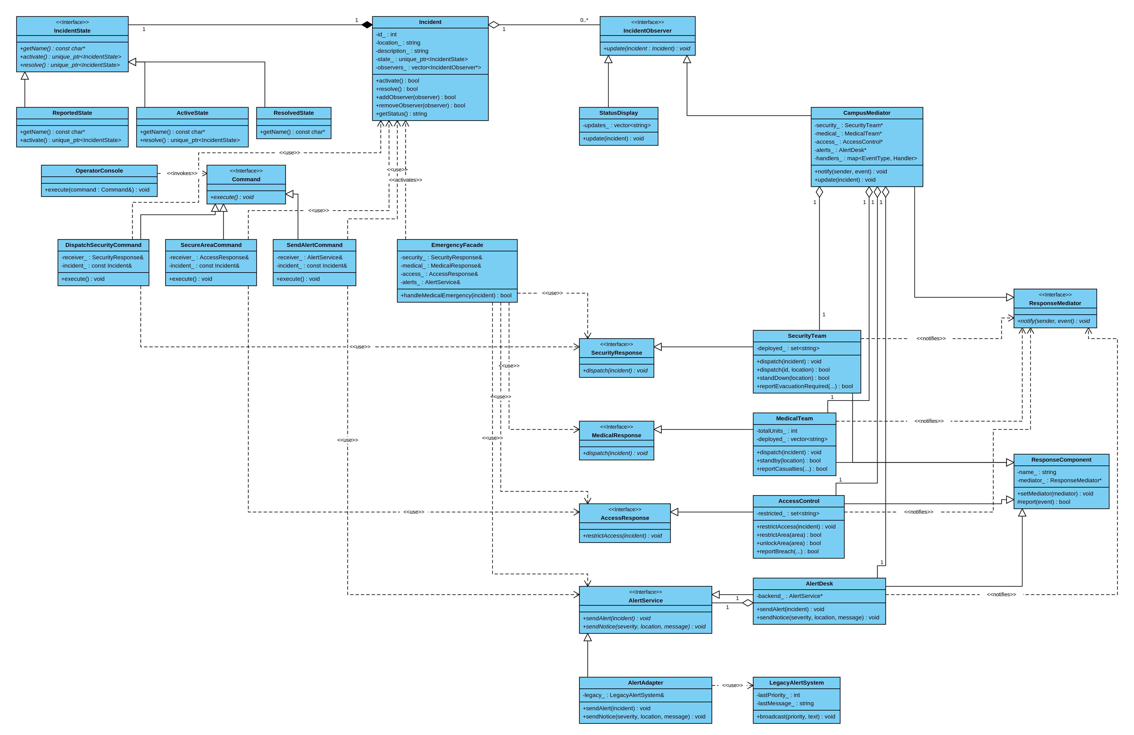
The class diagram shows the final CampusGuard structure and the participants in the six design patterns.

5.2 Sequence Diagram 1 - Command, Mediator and Adapter
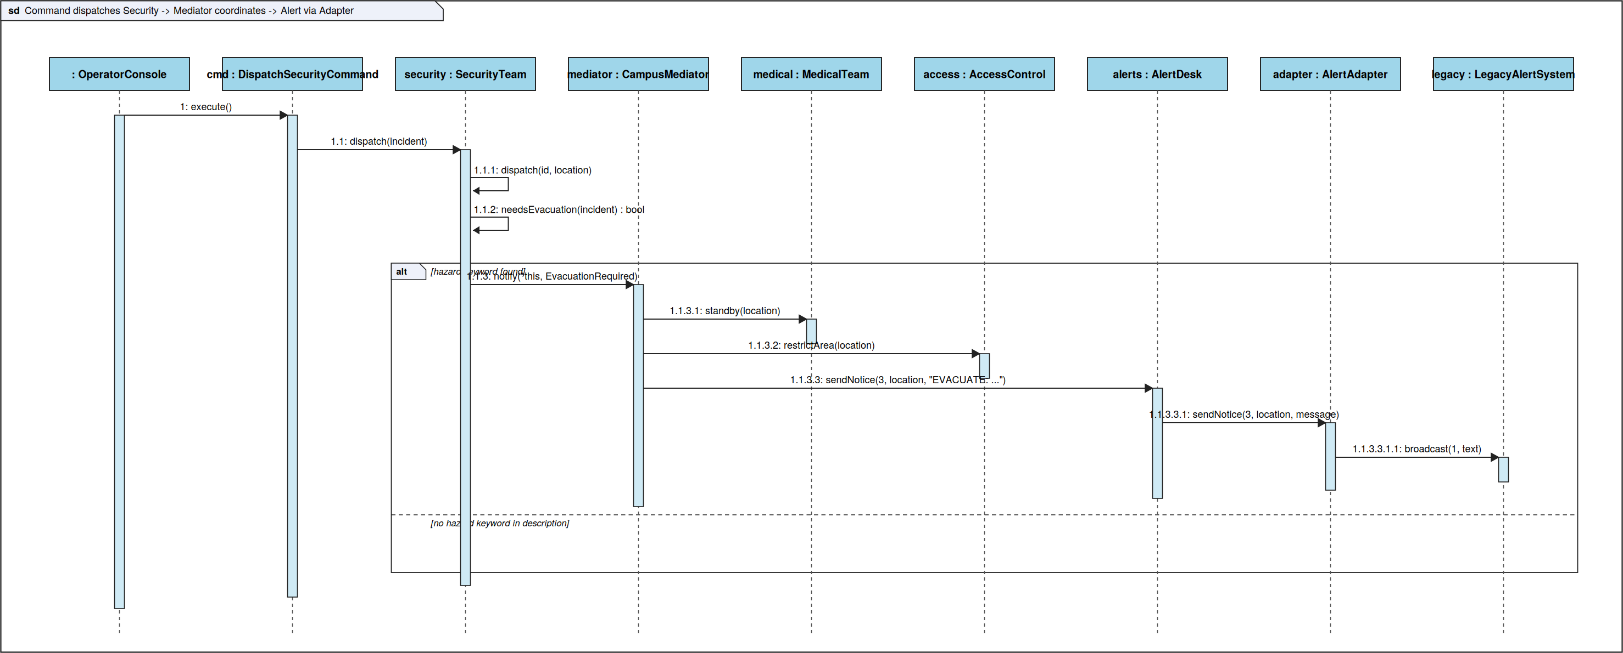
This sequence follows the fire/evacuation workflow from an operator command through SecurityTeam and CampusMediator to coordinated response services and the legacy alert integration.

5.3 Sequence Diagram 2 - Facade and Adapter
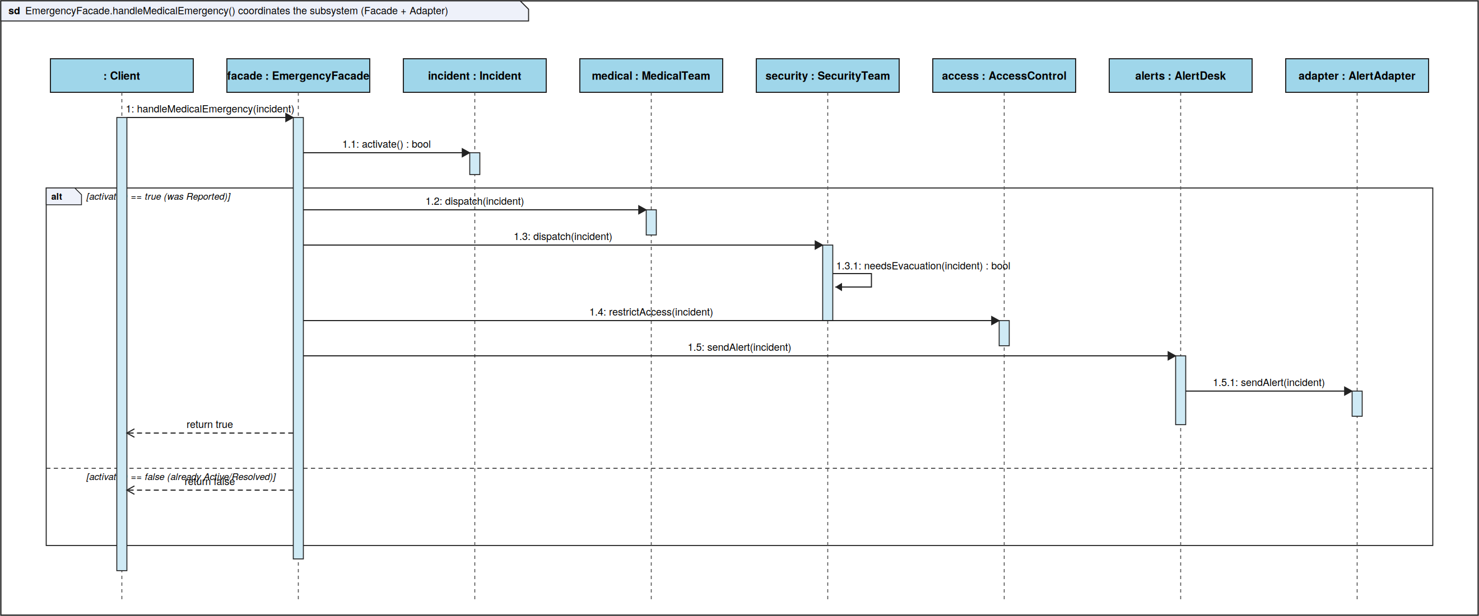
This sequence shows the high-level medical-emergency workflow performed by EmergencyFacade and the alert path through the adapter.

5.4 Incident State Diagram
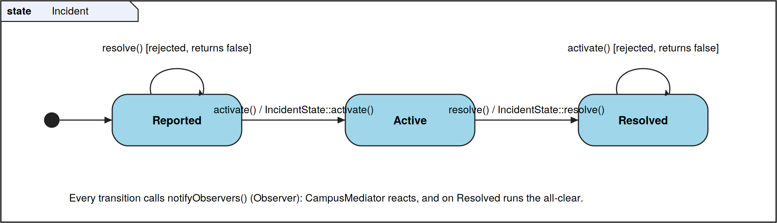
The behavioural diagram explains the State pattern used for the Incident lifecycle.

6. Design and Ownership Rationale
Incident owns its current IncidentState through std::unique_ptr<IncidentState>. Replacing a state therefore transfers ownership safely, and the old state is destroyed automatically. Incident is non-copyable to avoid accidental duplication of owned state.
Incident stores IncidentObserver pointers as non-owning subscriptions. Observers are created outside Incident and must remain alive until they are removed. main.cpp removes StatusDisplay and CampusMediator from each incident before the incident leaves scope.
ResponseComponent stores a non-owning ResponseMediator pointer. CampusMediator similarly stores non-owning pointers to the registered SecurityTeam, MedicalTeam, AccessControl and AlertDesk. These service objects are created in main() and outlive the mediator interactions. AlertDesk holds a non-owning AlertService backend pointer, and AlertAdapter holds a reference to the LegacyAlertSystem created in main().
Polymorphic base classes provide virtual destructors, including Command, IncidentObserver, IncidentState, ResponseMediator, ResponseComponent, AlertService and the response service interfaces. This supports safe polymorphic use and a clear destruction policy.

7. Invalid and Failure Handling
- A resolved Incident cannot be activated again; the invalid transition is rejected.
- EmergencyFacade rejects a medical-emergency workflow when the incident is not in the Reported state.
- AccessControl warns when asked to unlock an area that is not restricted.
- AccessControl can reject/report invalid breach operations, and response components report warnings for unavailable or duplicate actions where appropriate.

8. Engineering Evidence

8.1 Build and Makefile
The Makefile compiles all .cpp files using g++ with -std=c++11 -Wall -Wextra -g -MMD -MP and produces the campusguard executable. It also provides run, valgrind and clean targets.
make
make run

8.2 Docker
The Dockerfile uses Ubuntu 24.04 and installs g++, make, gdb and valgrind. It copies the project into /campusguard, builds it using make, and runs ./campusguard. docker-compose.yml defines the normal CampusGuard service plus Valgrind and GDB tool services.
docker compose up –build
This is the command used to build and launch the assessed application.

8.3 Valgrind Evidence
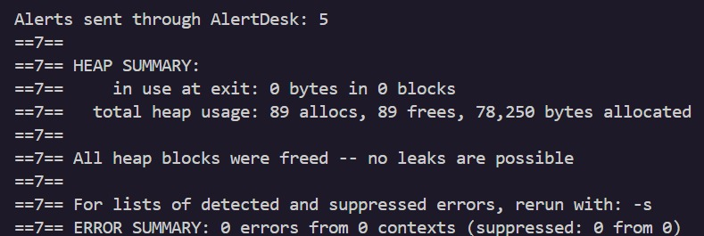

8.4 GDB Investigation
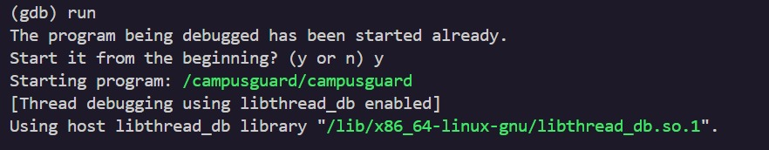

9. GitHub and Collaboration
Repository: https://github.com/DanelSteyn/COS214Prac5
The team used Git/GitHub throughout development, with work committed on separate branches and integrated into main. The repository history records contributions from all three team members and includes implementation, integration, Docker and documentation work.

9.1 Collaboration Reflection
The practical was divided by subsystem/pattern responsibility and then integrated into one CampusGuard application. Integration required the shared interfaces and runtime scenarios to connect the separate pattern implementations. The final main program demonstrates the patterns as collaborating parts of the same emergency-response workflows.

9.2 Contribution Statements
Team member | Contribution
Danel Steyn | Incident model, State and Observer implementation; pdf
Jayden Smith | Response components and CampusMediator; Docker/integration/diagrams
Piater-Boswell | Command/Facade/initial build setup;

