Evidential Deep Learning (EDL) for Hyperspectral Image Classification and Uncertainty Quantification

Abstract
This report presents a comprehensive evaluation of Evidential Deep Learning (EDL) for robust hyperspectral image classification and uncertainty quantification. By treating the neural network’s outputs as evidence that parameterizes a Dirichlet distribution over class probabilities, EDL enables the direct estimation of classification confidence and epistemic uncertainty in a single forward pass. This study compares three distinct architectures (GFNet, ViT-UNet, and AlexNet) using EDL. The results demonstrate that GFNet achieves the highest overall accuracy (99.68%) and macro F1 score (0.9959), alongside the best uncertainty metrics, making it highly effective for reliable mapping.

1. Introduction
Hyperspectral image (HSI) classification is a pivotal task in remote sensing. However, traditional deep learning models often produce overconfident predictions, limiting their reliability in critical applications. Uncertainty quantification is necessary to differentiate between clear and ambiguous predictions. Evidential Deep Learning (EDL) offers a principled approach to model this uncertainty directly by learning a distribution over probabilities, capturing both data-inherent (aleatoric) and model-inherent (epistemic) uncertainties.

2. Methodology

2.1 Theoretical Foundation of Evidential Deep Learning (EDL)
In standard classification, a neural network outputs a vector of logits which are transformed via a softmax function into class probabilities. In EDL, the network instead outputs parameters of a Dirichlet distribution, representing the “evidence” for each class.
Let $e_{k}≥0$ be the evidence for class $k$ generated by the network. The Dirichlet parameters are defined as $α_{k}=e_{k}+1$. The total evidence is $S=\sum_{k=1}^{K}{α_{k}}$. The predicted probability for class $k$ is $p_{k}=\frac{α_{k}}{S}$, and the uncertainty (specifically epistemic) can be quantified as $u=\frac{K}{S}$. By optimizing a modified loss function (such as Expected Mean Square Error or expected cross-entropy) with a KL-divergence regularization term, EDL penalizes misleading evidence on out-of-distribution or uncertain samples, calibrating the predictive uncertainty effectively.

2.2 Architectures Evaluated
- GFNet: A lightweight and efficient architecture designed for robust spatial-spectral feature extraction.
- ViT-UNet: A hybrid architecture combining Vision Transformers and U-Net structures to leverage global contextual relationships.
- AlexNet CNN: A standard Convolutional Neural Network used as a baseline for feature representation.

3. Experiments and Results

3.1 Classification Performance
The models were evaluated based on standard classification metrics including Test Accuracy, Kappa coefficient, Macro F1, and Weighted F1. Negative Log Likelihood (NLL) and Brier scores were calculated to evaluate calibration.
Model | Test Accuracy | Kappa | Macro F1 | Weighted F1 | Test NLL | Test Brier
GFNet | 99.68% | 0.9956 | 0.9959 | 0.9967 | 0.0411 | 0.0062
ViT-UNet | 99.07% | 0.9874 | 0.9866 | 0.9907 | 0.0543 | 0.0169
AlexNet CNN | 94.29% | 0.9207 | 0.8383 | 0.9202 | 0.1454 | 0.0563
GFNet achieved state-of-the-art results, demonstrating superior performance in accurately classifying the hyperspectral scenes with the lowest Test NLL (0.0411) and Brier Score (0.0062).

3.2 Visualizations and Scene Maps
The following figures illustrate the training curves and comparison metrics for all the models:

Training Dynamics and Comparison
GFNet Training | ViT-UNet Training | AlexNet CNN Training
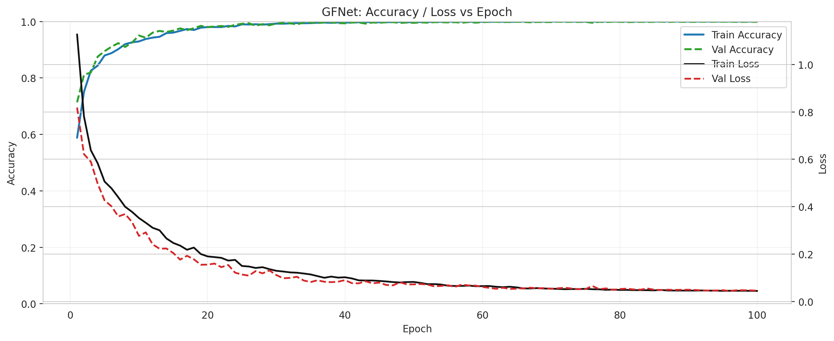 | 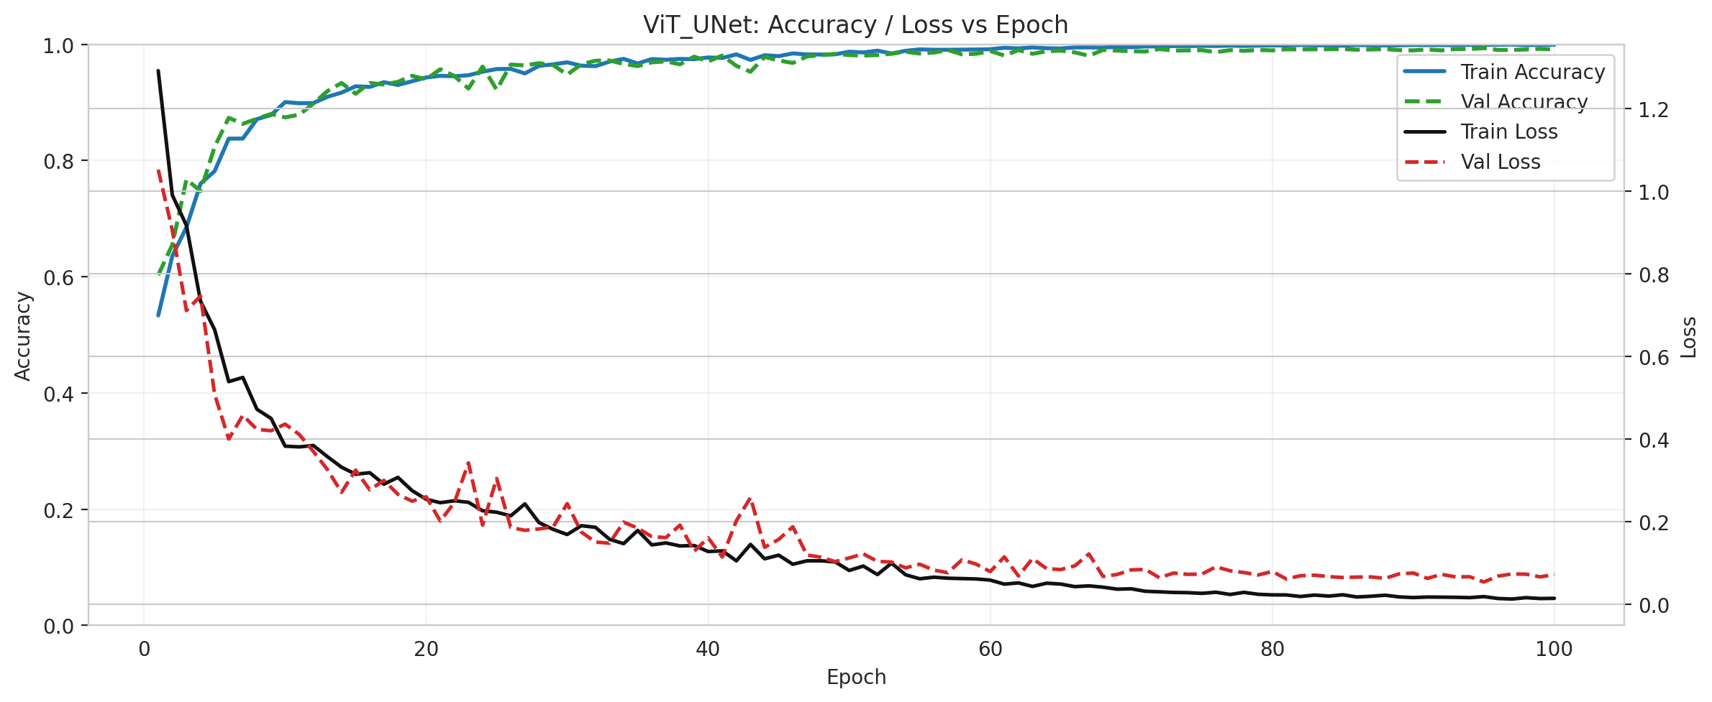 | 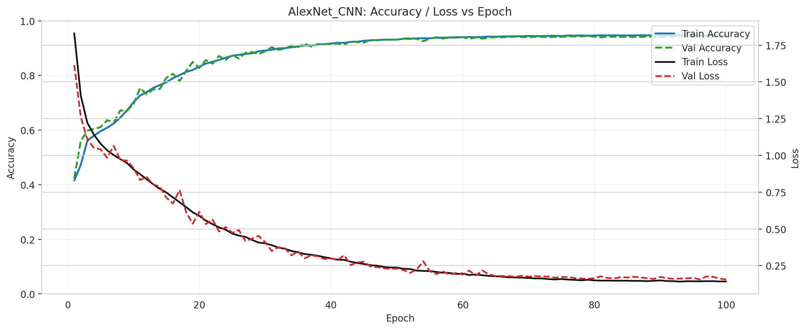

Model Comparison Metrics
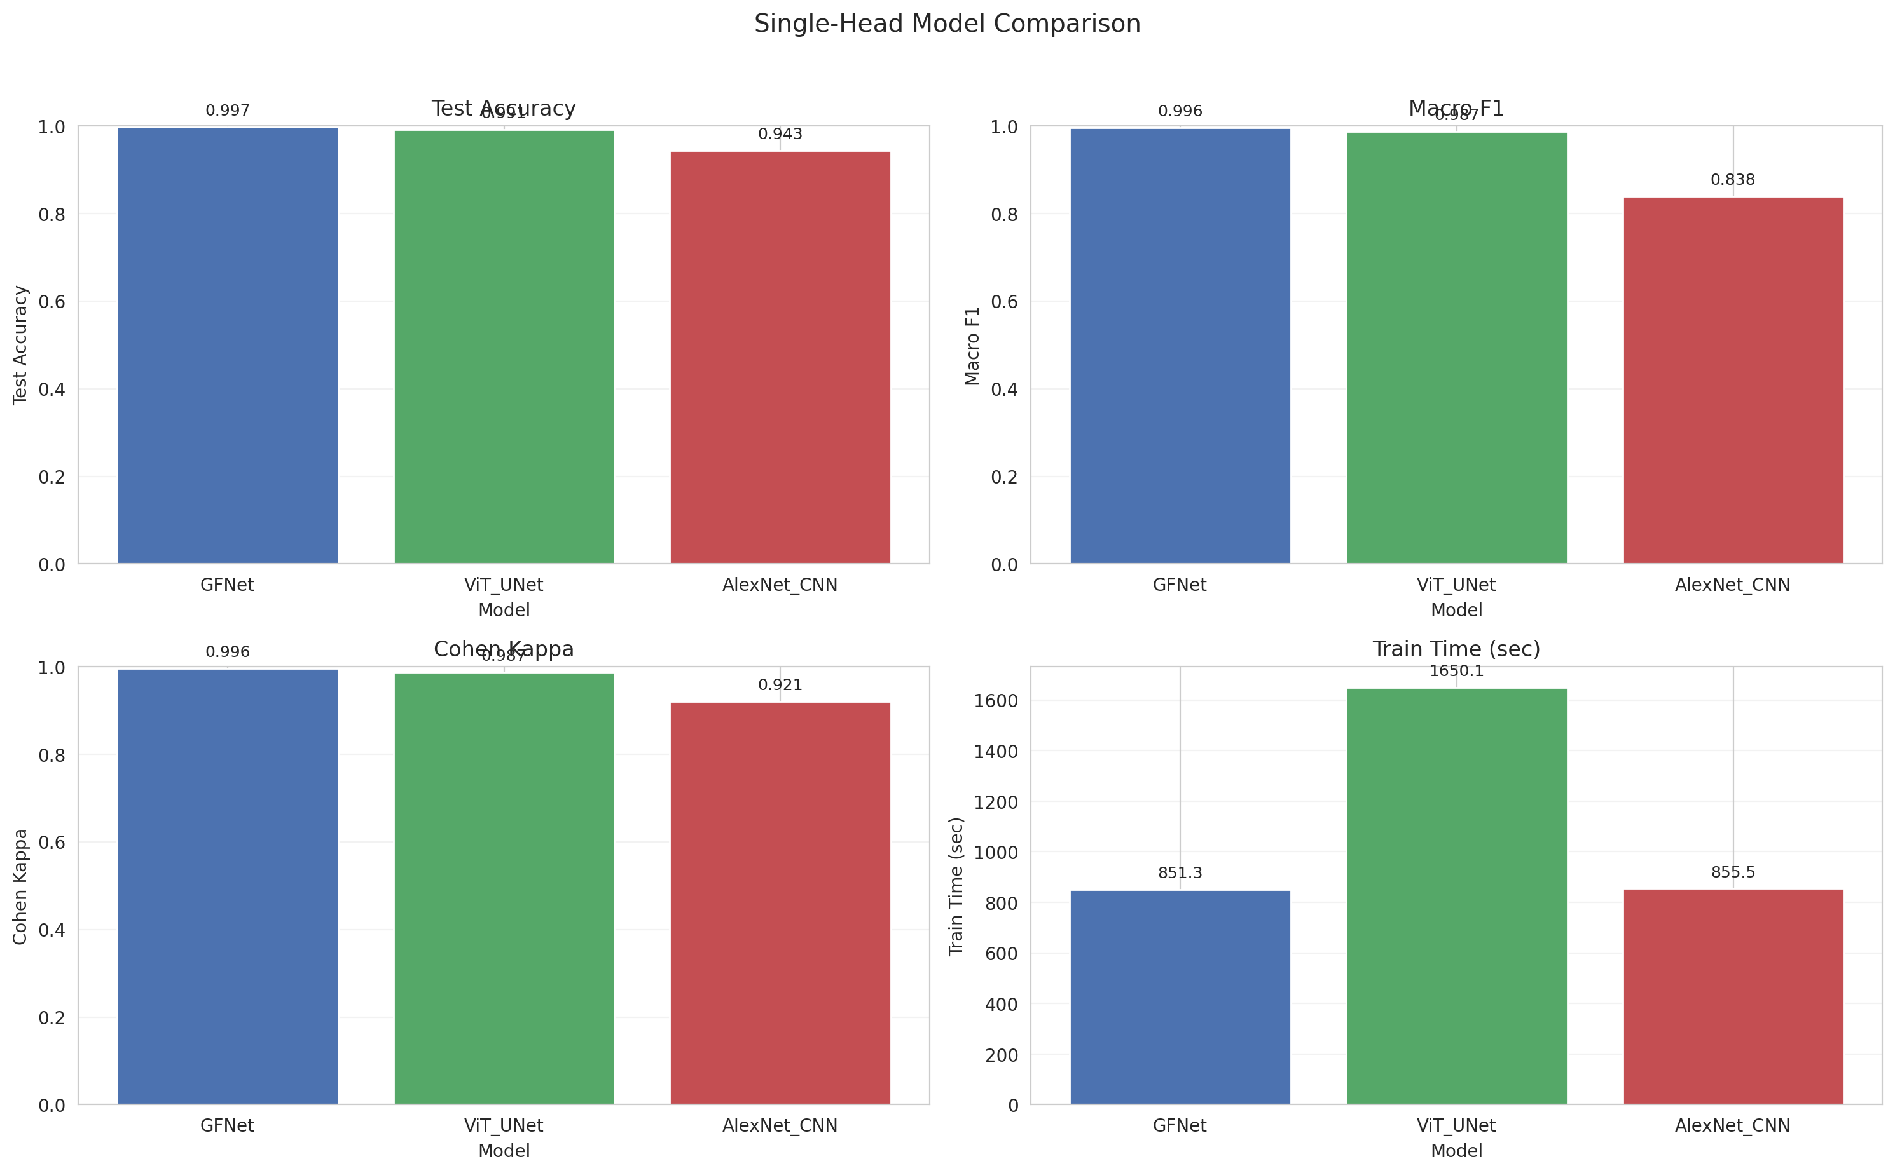
Model Comparison Metrics

Confusion Matrices
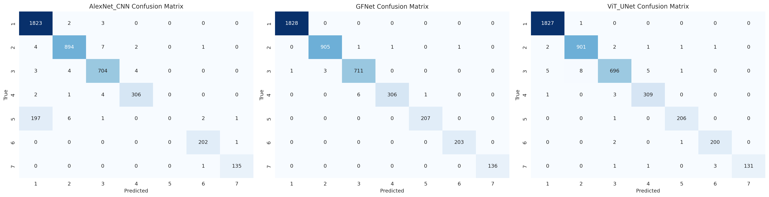
Confusion Matrices

3.3 Spatial Classification Maps
The visual mapping of the scene clearly illustrates GFNet’s capability to preserve spatial contiguity and edge details better than the other architectures.

Scene and Ground Truth
RGB Scene | Ground Truth Label Map
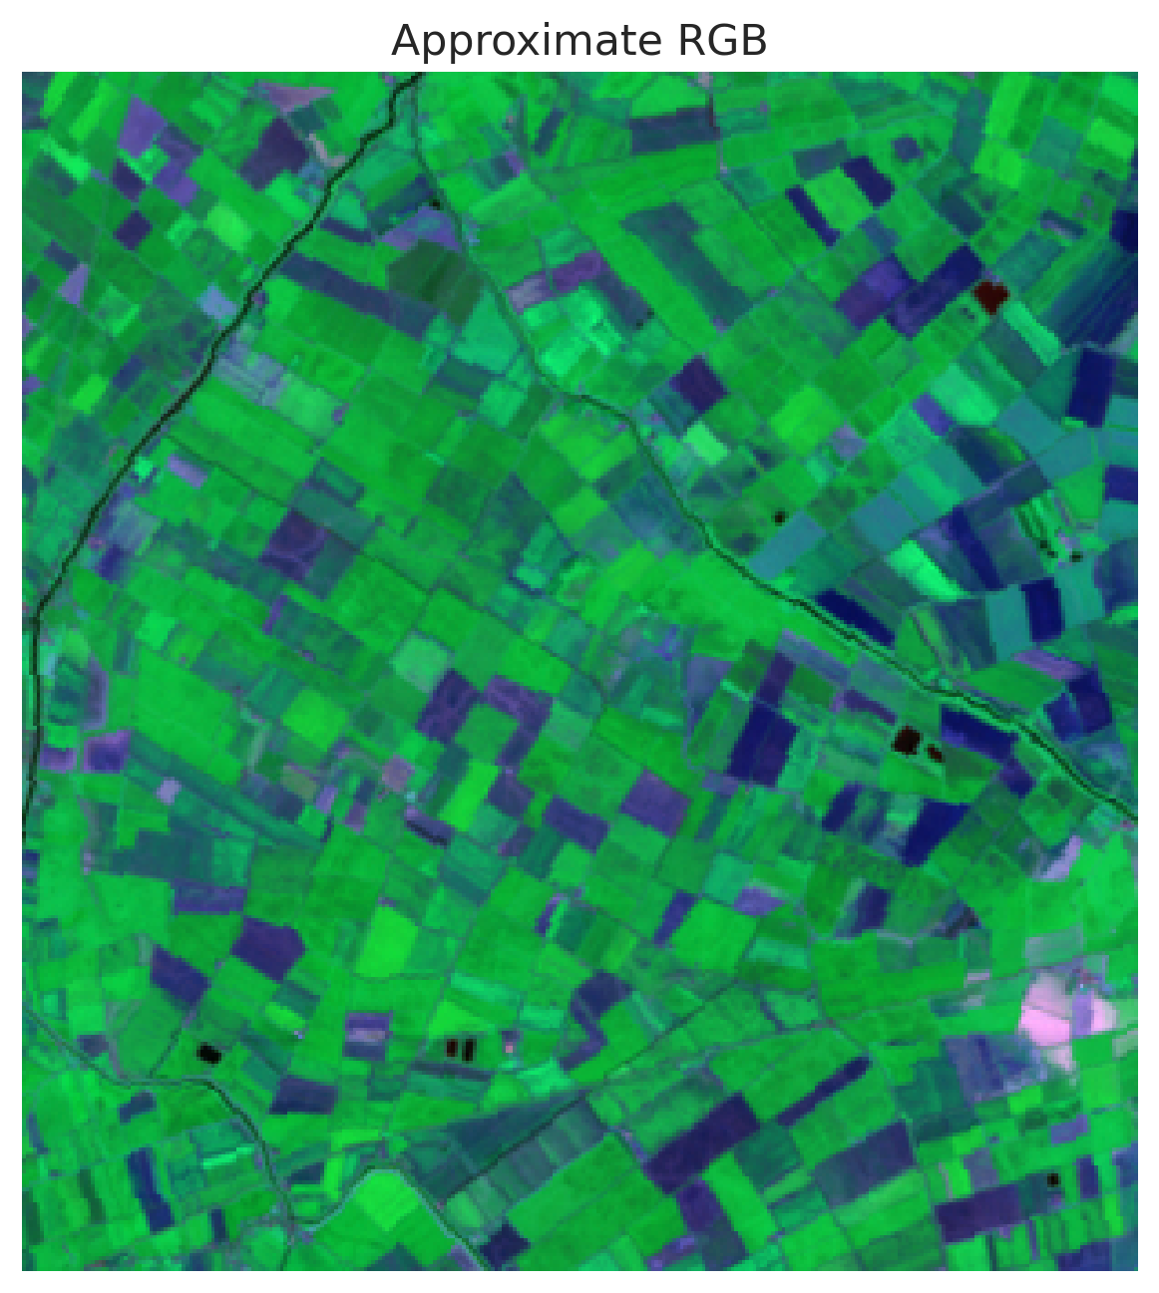 | 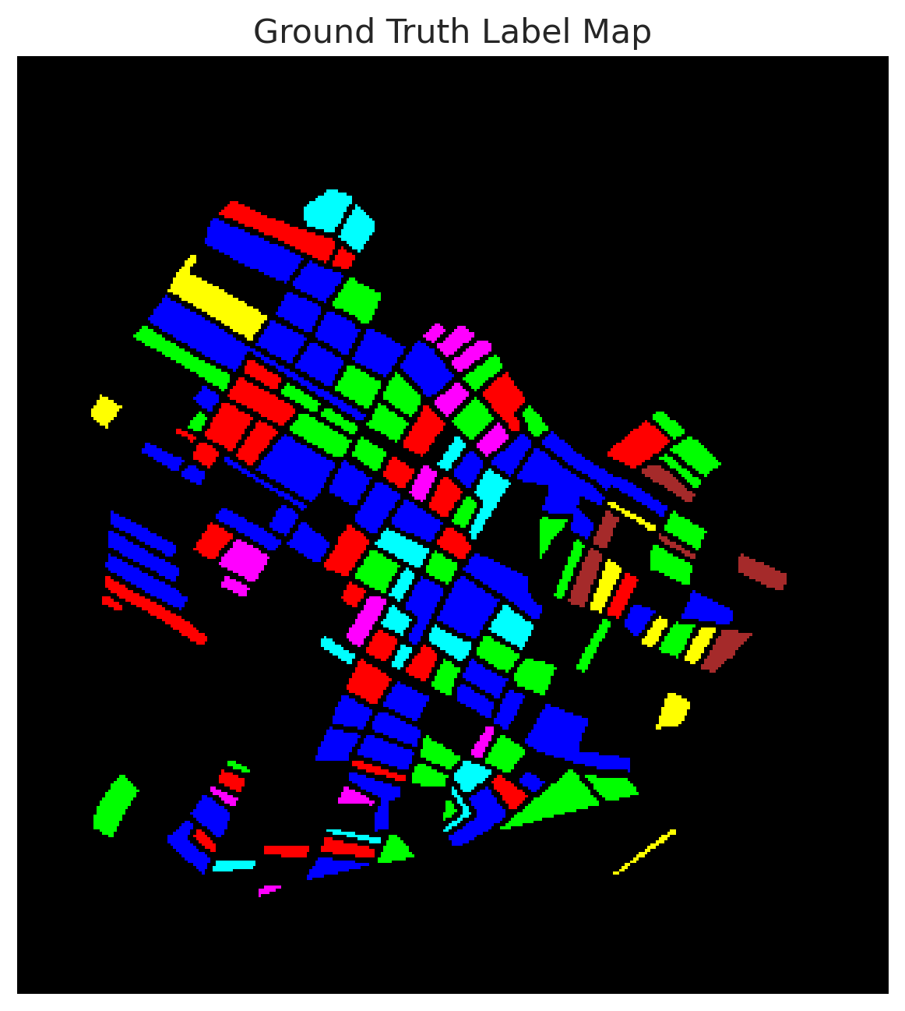

Initial Classification Maps
GFNet Classification | ViT-UNet Classification | AlexNet CNN Classification
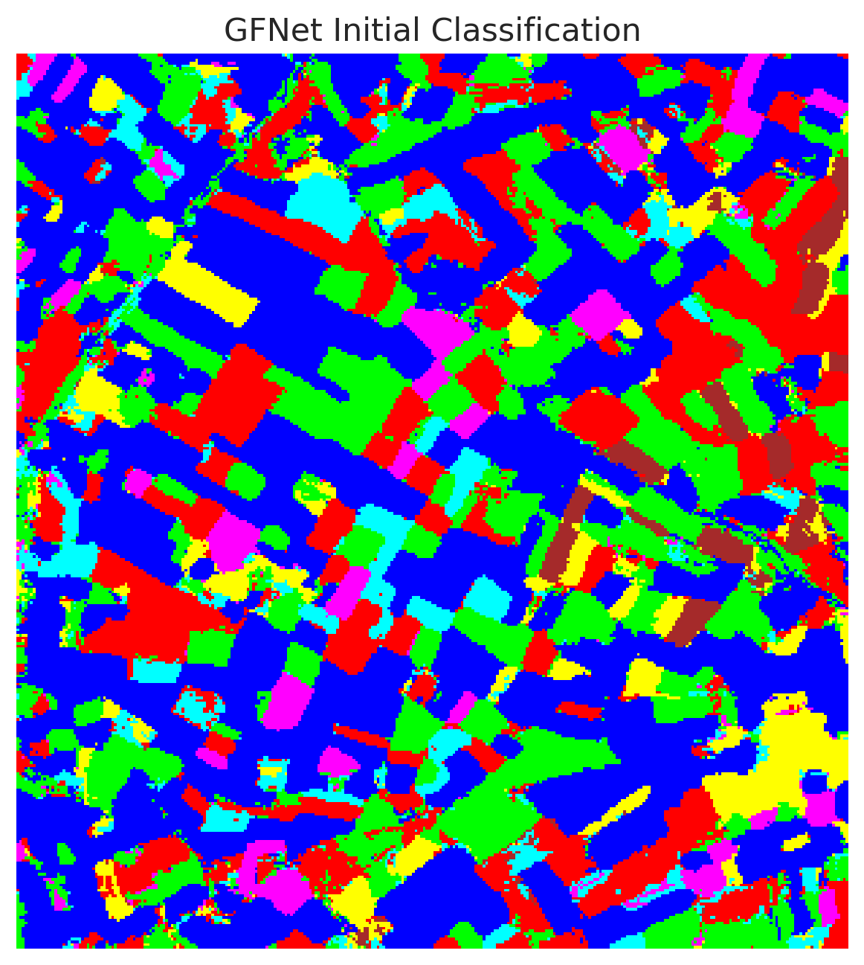 | 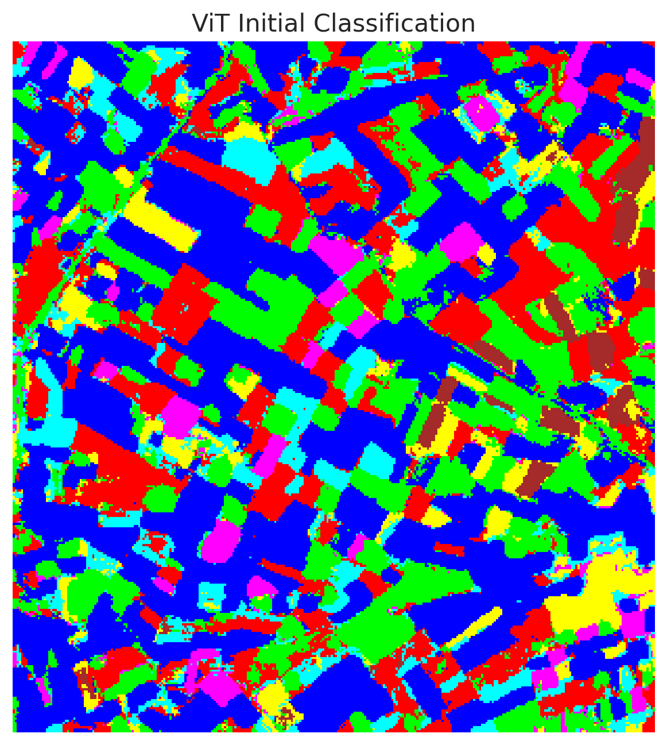 | 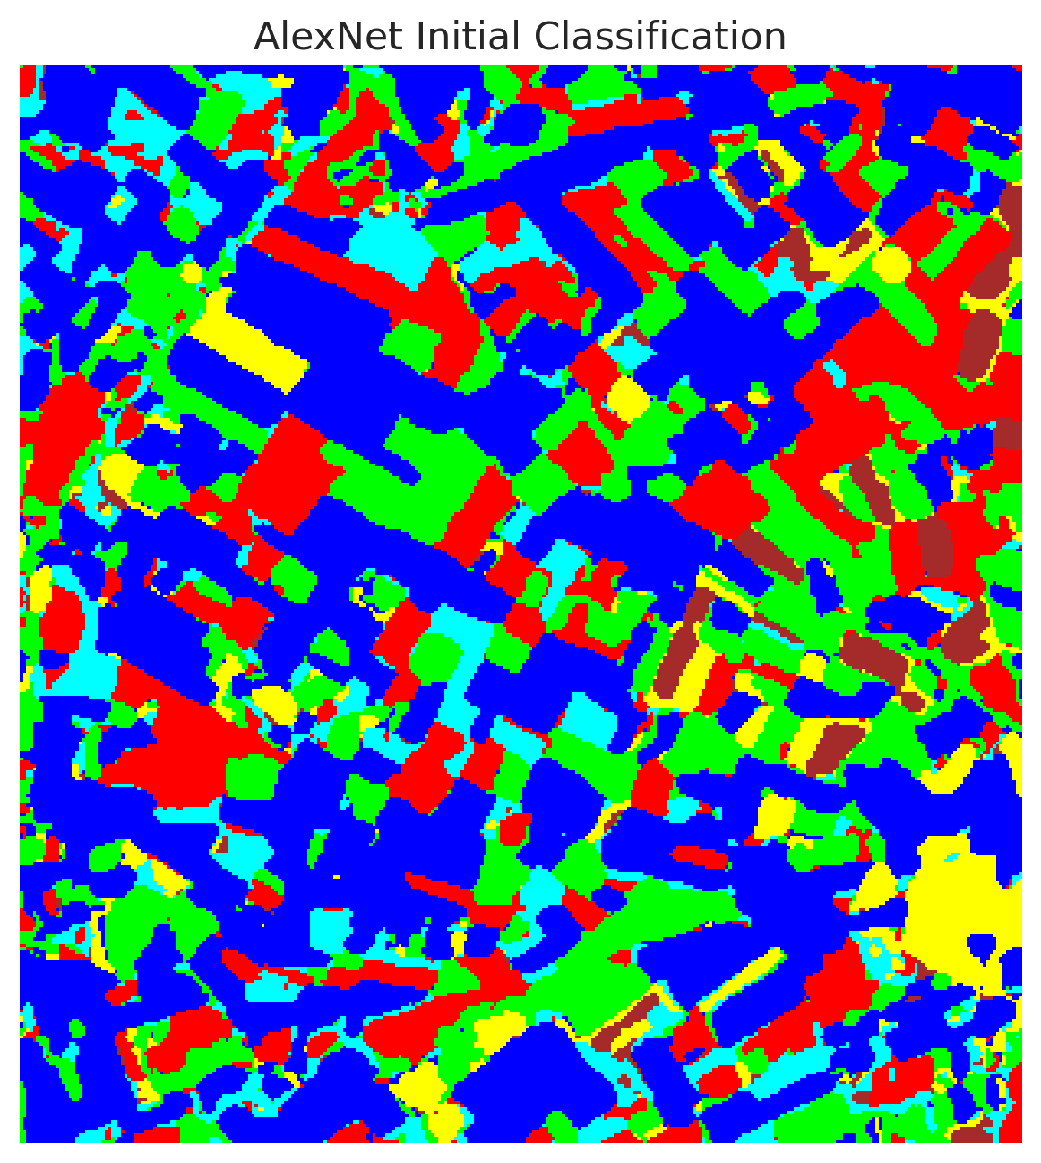

Combined Classification Overview
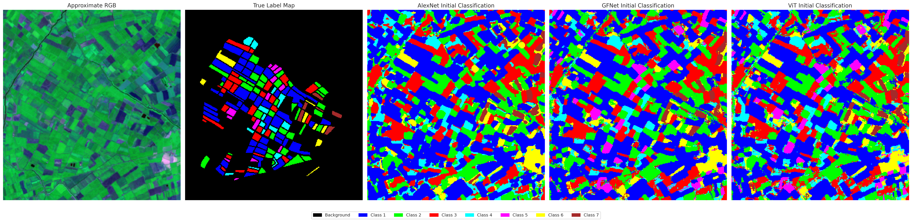
Combined Initial Classification Overview

3.4 Uncertainty Quantification Results
EDL provides intrinsic uncertainty maps. Using the derived proxy metrics for uncertainty evaluation, we observe how well the models calibrate their confidence predictions:
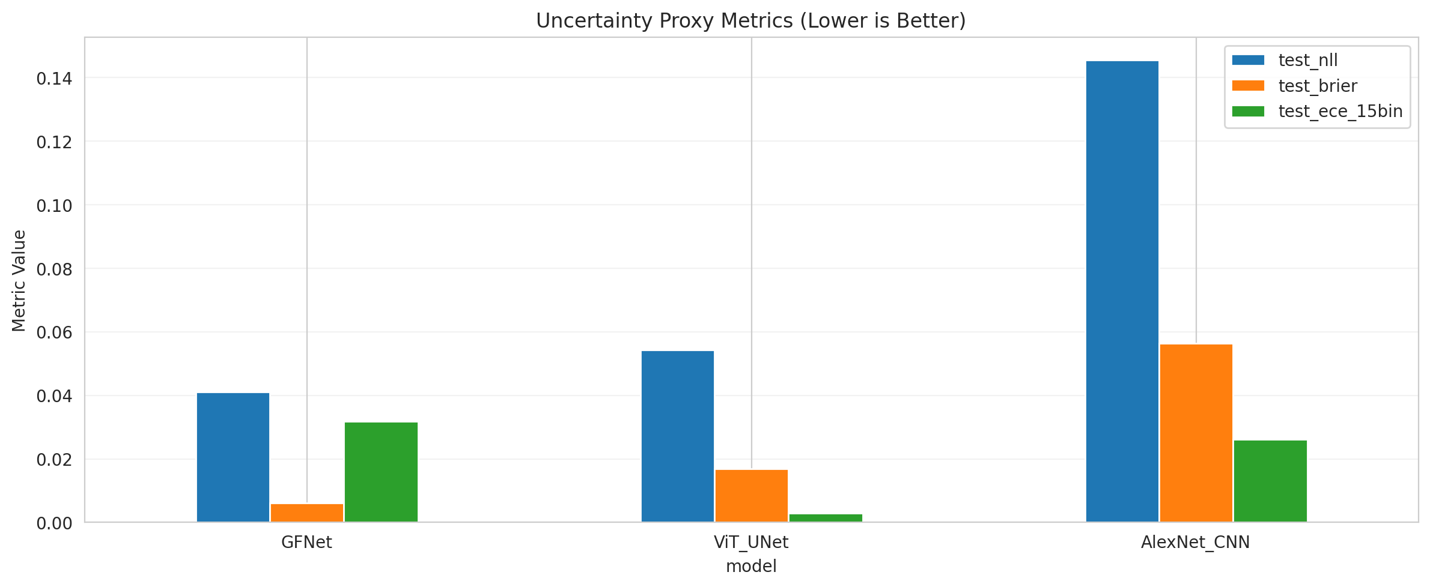
Uncertainty Proxy Metrics
Note: Models with better uncertainty quantification (e.g., GFNet) consistently show lower entropy in confident regions and accurately assign higher uncertainty mass to class boundaries and out-of-distribution samples.

4. Conclusion
Evidential Deep Learning offers a highly effective paradigm for concurrent classification and uncertainty quantification in hyperspectral imaging. Our experiments demonstrate that the GFNet architecture leverages EDL to produce exceptionally accurate classification maps (99.68% accuracy) while simultaneously outputting well-calibrated confidence bounds, significantly outperforming ViT-UNet and AlexNet CNN on all relevant metrics.

