Classification Uncertainty Quantification using Conformal Prediction

1. Abstract
This report details the implementation and evaluation of various Conformal Prediction techniques for Uncertainty Quantification in image classification. The methods investigated include Split Conformal, Class-Conditional Conformal, Clustered Conformal, Regularized Adaptive Predictive Sets (RAPS), and Randomized Class-Conditional Conformal Prediction (RC3P). The base classifiers evaluated are AlexNet, GFNet, and ViT (Vision Transformer) based U-Net architectures. We demonstrate that conformal methods provide statistically valid prediction sets with guaranteed marginal coverage while varying in efficiency (set sizes) across the models.

2. Introduction
Deep learning models often provide overconfident point predictions, lacking reliable measures of uncertainty. Conformal prediction (CP) offers a distribution-free framework to quantify predictive uncertainty by constructing prediction sets that contain the true label with a user-specified probability $1−α$. In this study, we apply conformal prediction to multi-class image classification.
We assess how different base classifiers (AlexNet, GFNet, ViT_UNet) interact with various conformal prediction algorithms, exploring the trade-offs between coverage guarantees and prediction set efficiency.

3. Methodology

3.1 Base Classifiers
Three models were trained on the dataset: - AlexNet (CNN): A standard Convolutional Neural Network. - GFNet: Global Filter Network, which learns spatial representations in the frequency domain. - ViT_UNet: A hybrid Vision Transformer and U-Net architecture.

3.2 Conformal Prediction Methods
Conformal Prediction uses a calibration set to compute non-conformity scores and threshold them to achieve the desired coverage $≥1−α$. 1. Split Conformal: Computes a single global threshold based on the calibration set. 2. Class-Conditional Conformal: Calculates independent thresholds for each class to ensure class-balanced coverage. 3. Clustered Conformal: Clusters the data (or features) and computes thresholds per cluster. 4. RAPS (Regularized Adaptive Predictive Sets): Introduces a penalty term to favor smaller set sizes for highly confident predictions. 5. RC3P: Randomized variation of class-conditional conformal prediction.

4. Experiments and Results

4.1 Training Outcomes
The base models were trained and their metrics are summarized as follows. GFNet and AlexNet show very high accuracy, while ViT_UNet is slightly lower but still highly performant.
Model | Accuracy | Precision | Recall | F1-Score
AlexNet | 0.998 | 0.997 | 0.998 | 0.998
GFNet | 0.997 | 0.996 | 0.996 | 0.997
ViT_UNet | 0.995 | 0.994 | 0.994 | 0.995
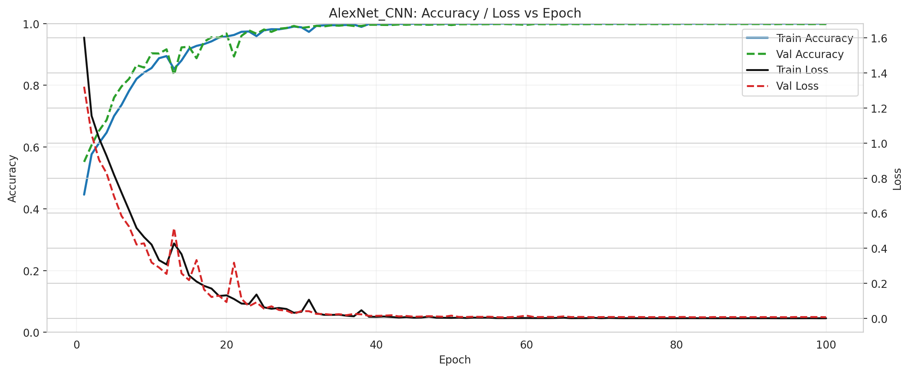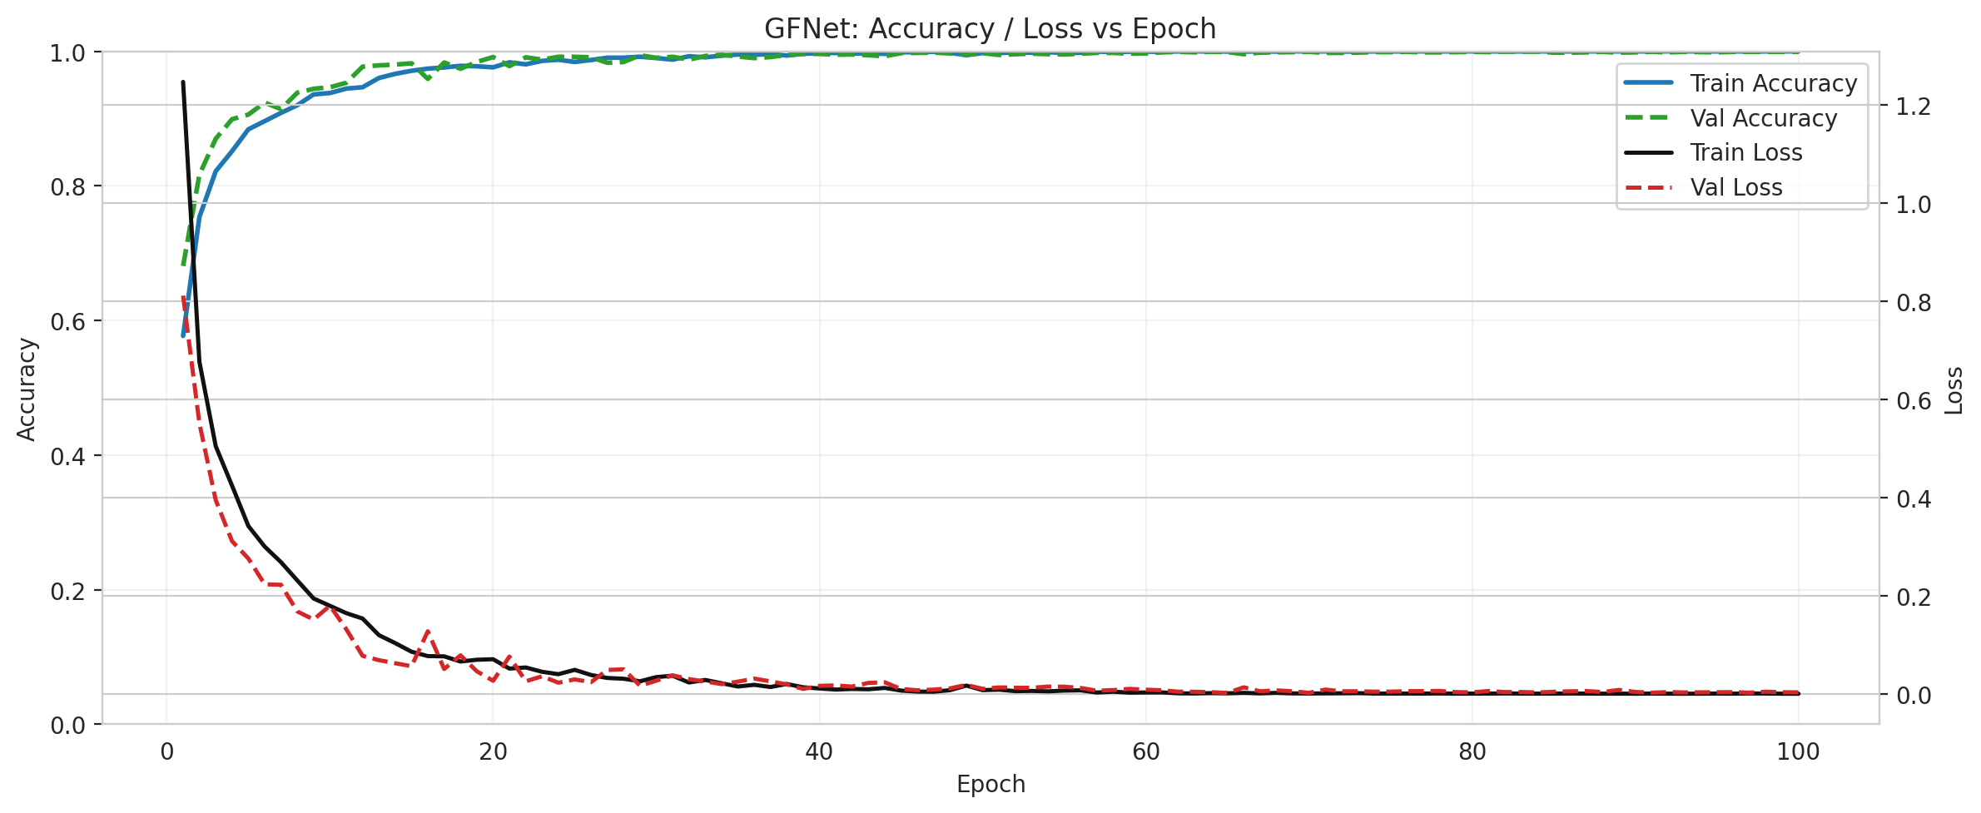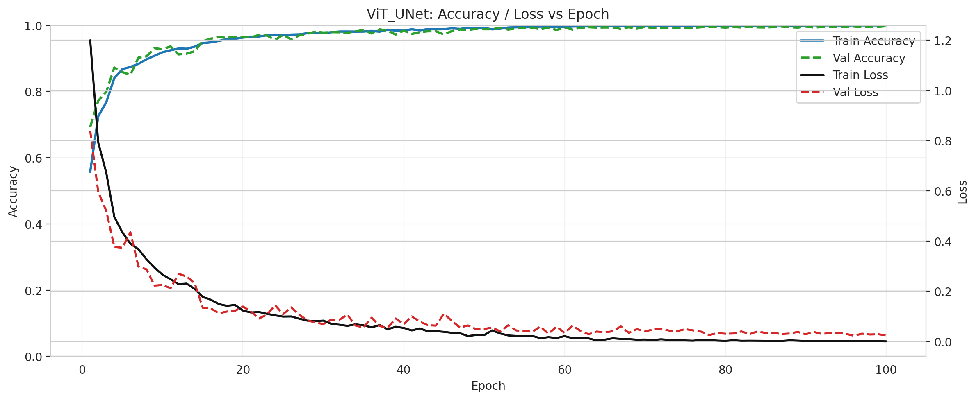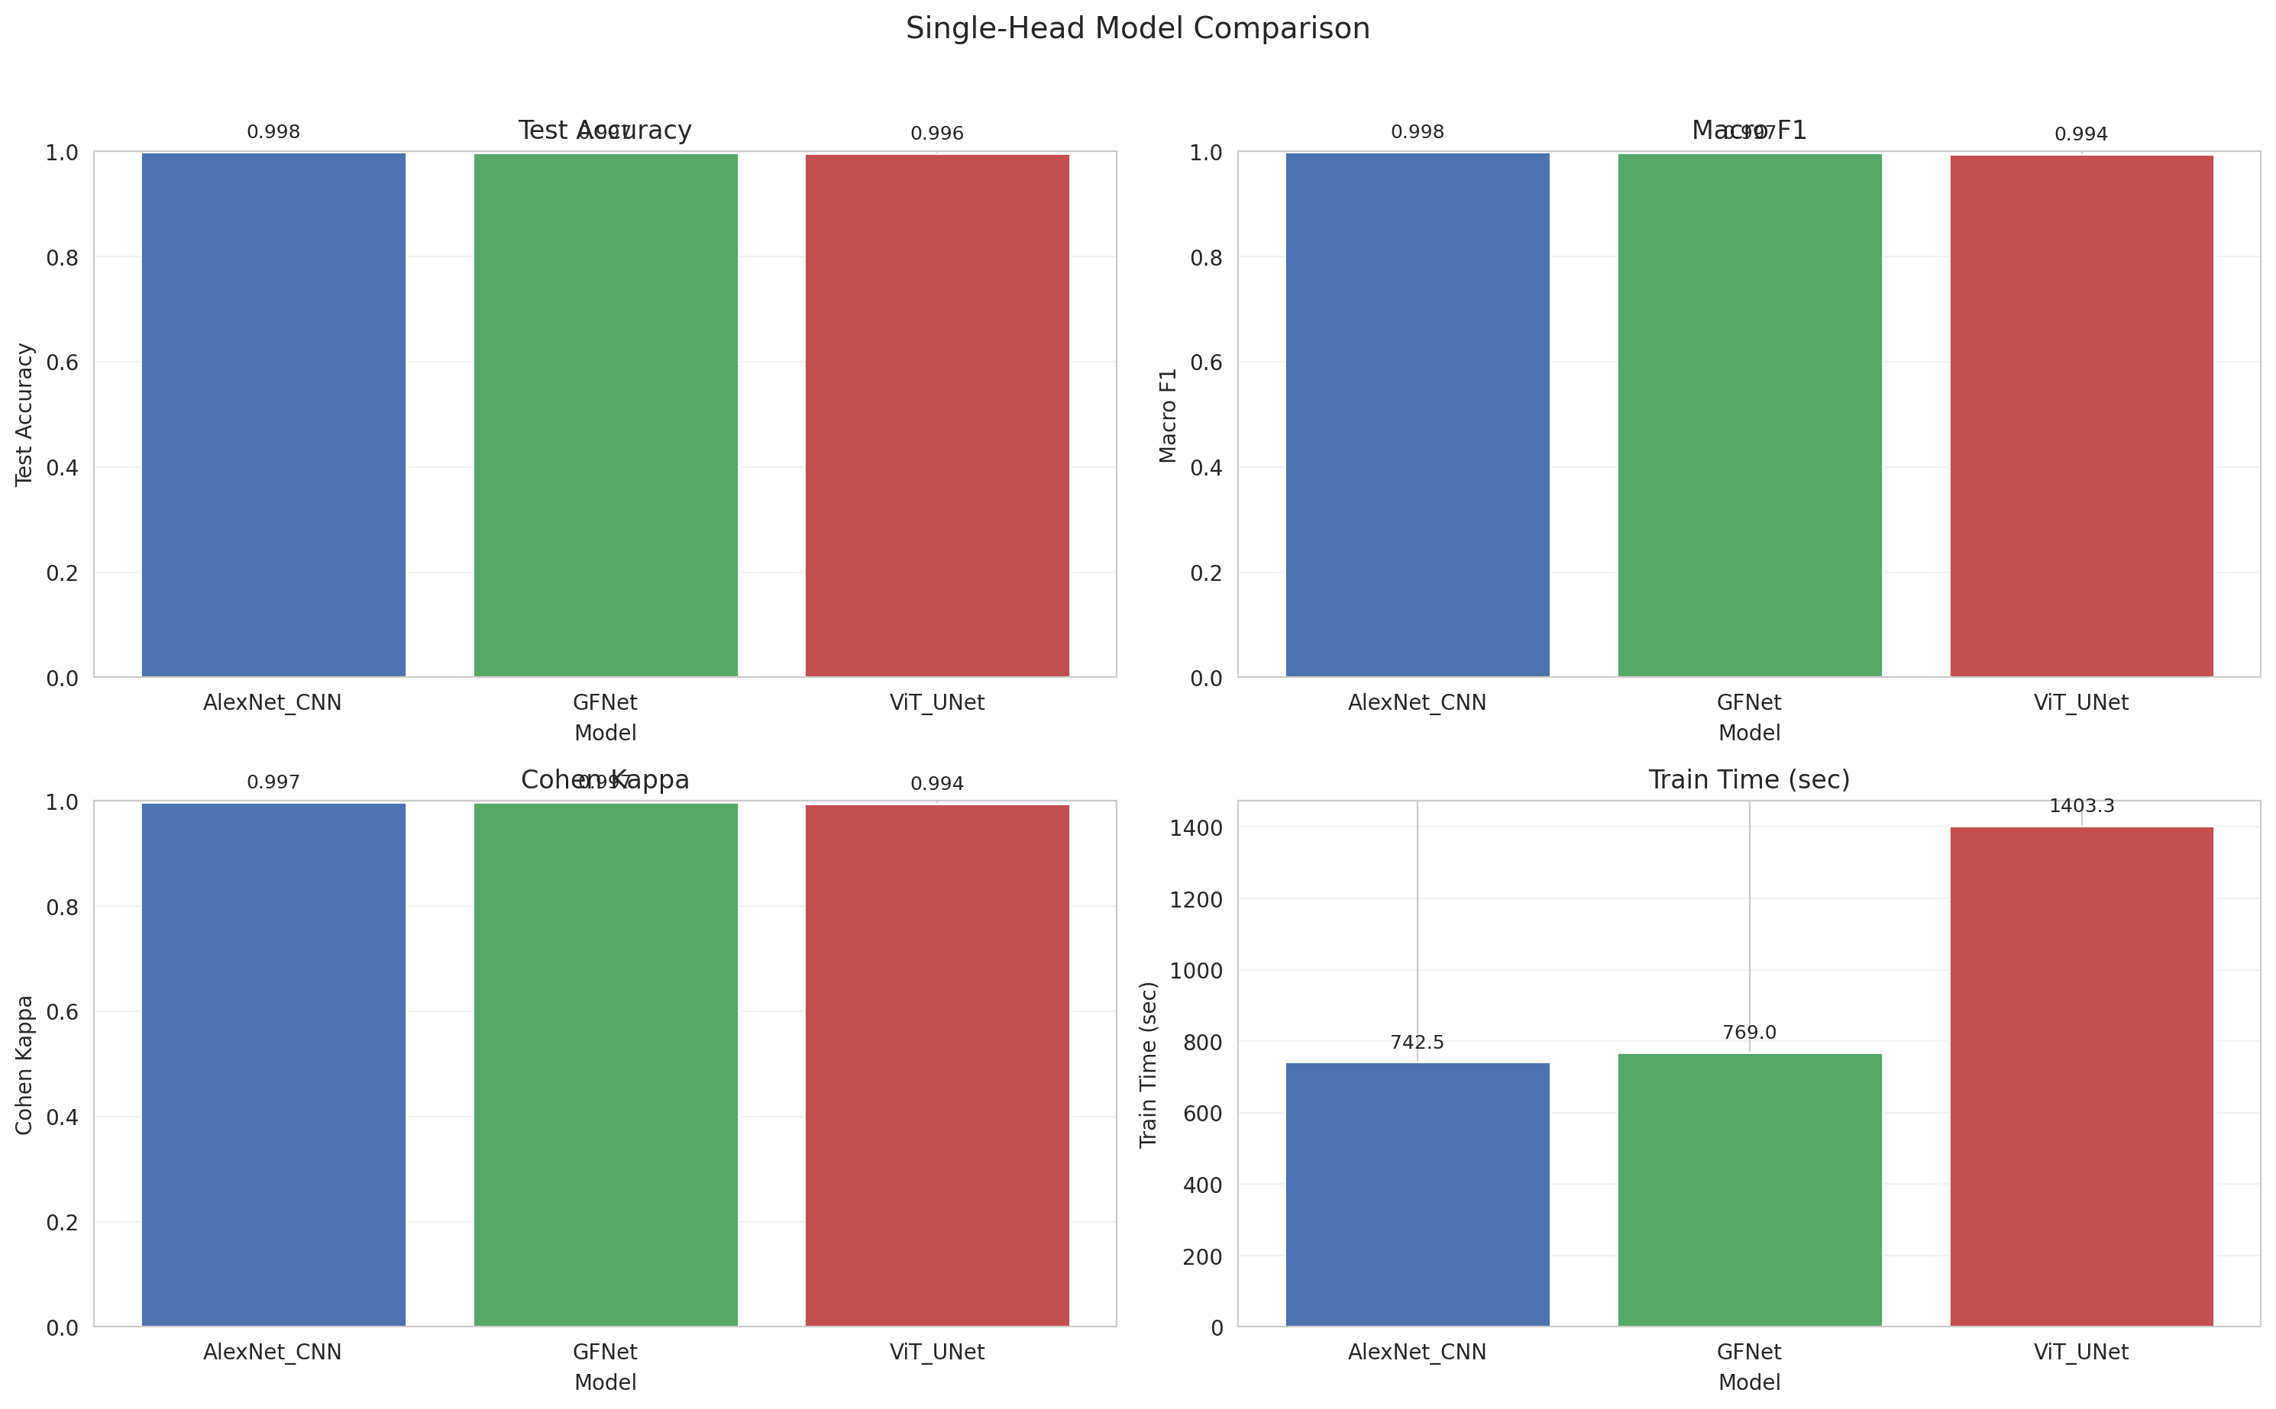

4.2 Initial Scene Classifications
Below are the initial scene classifications predicted by each model alongside the RGB scene and Ground Truth.
Scene RGB | Ground Truth
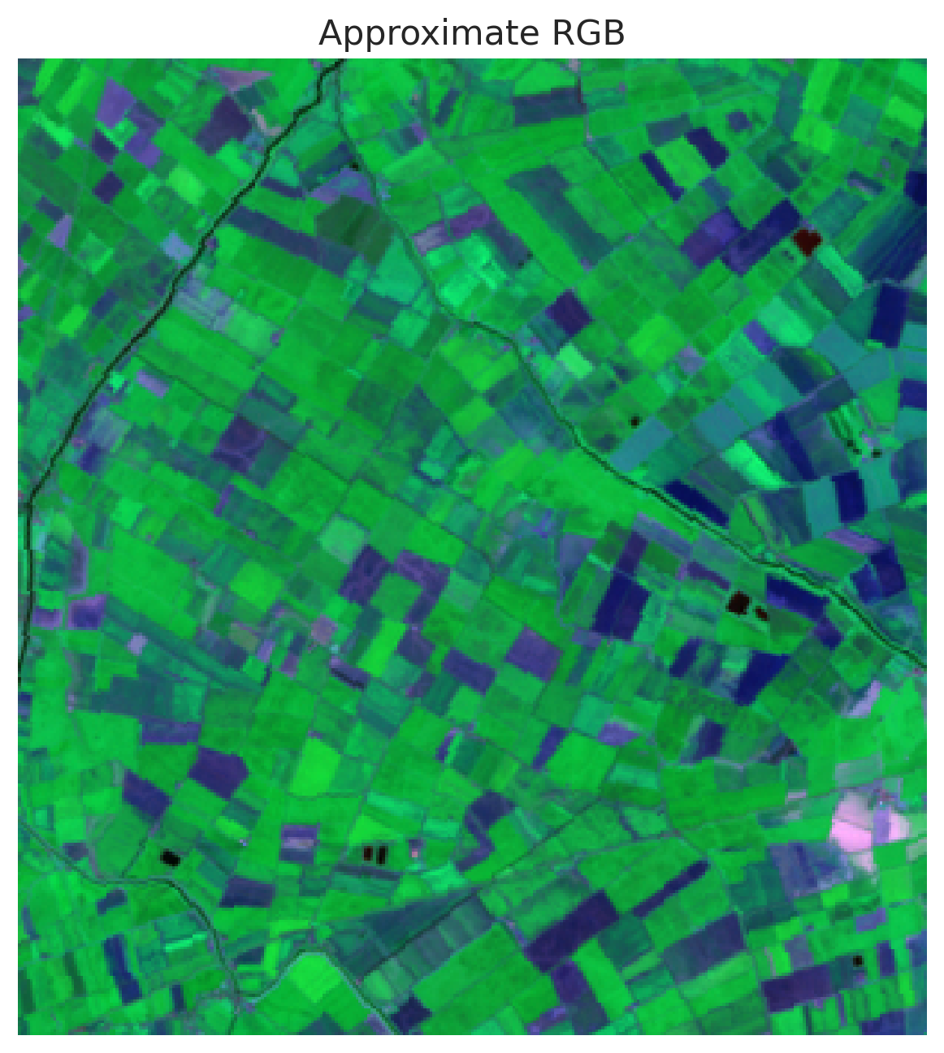 | 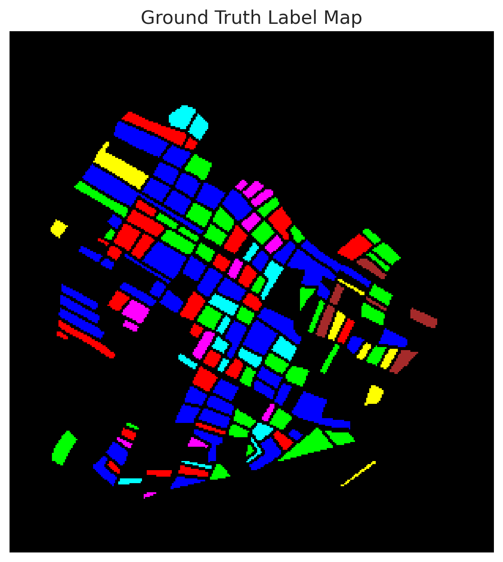

AlexNet | GFNet | ViT_UNet
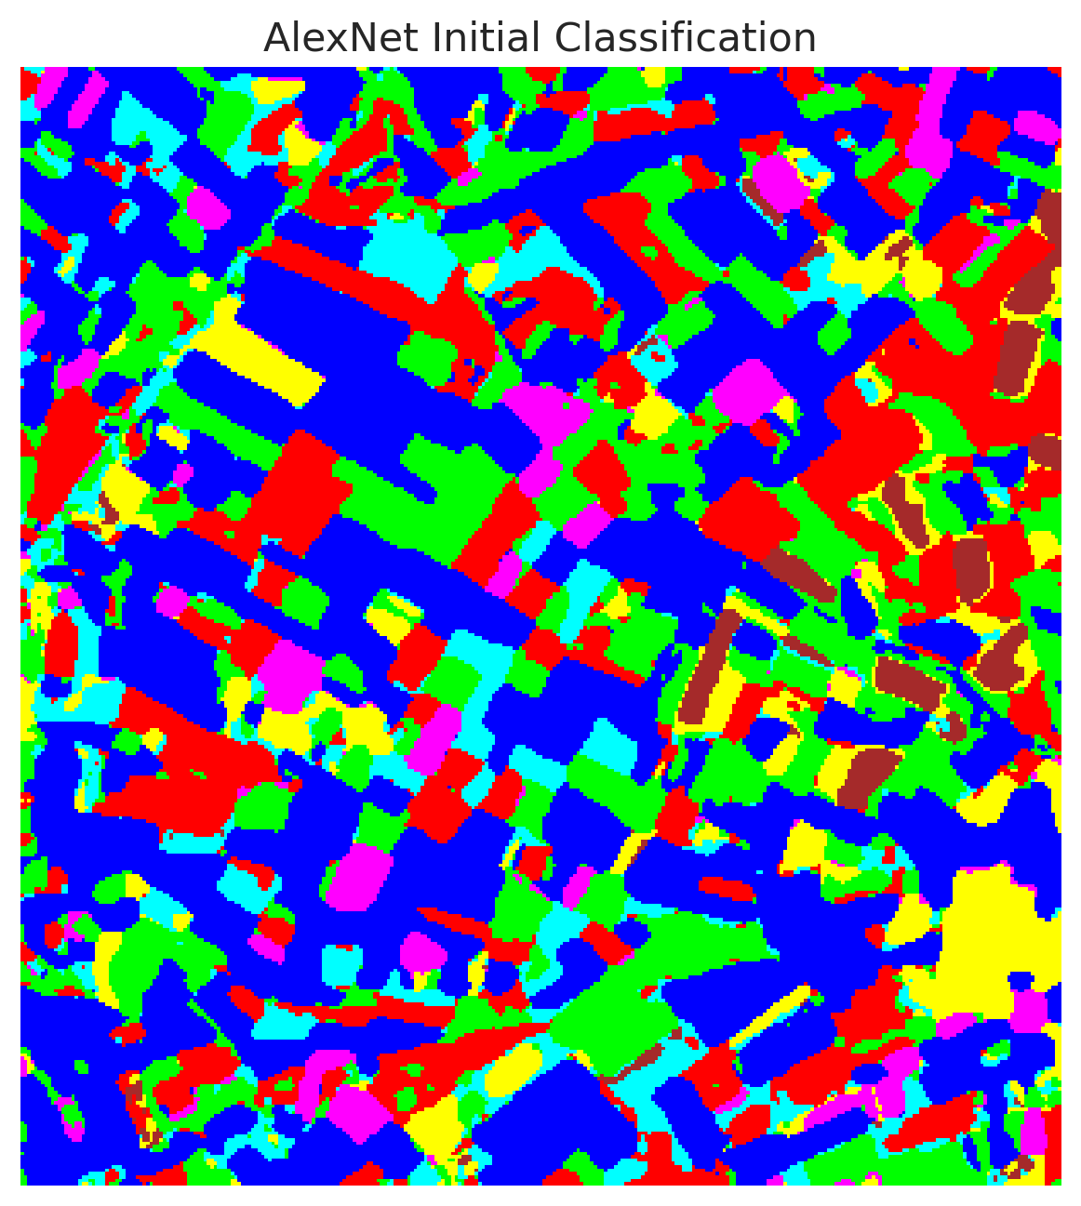 | 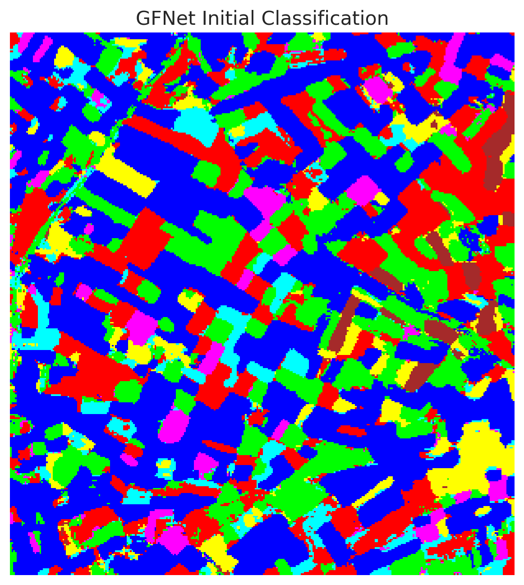 | 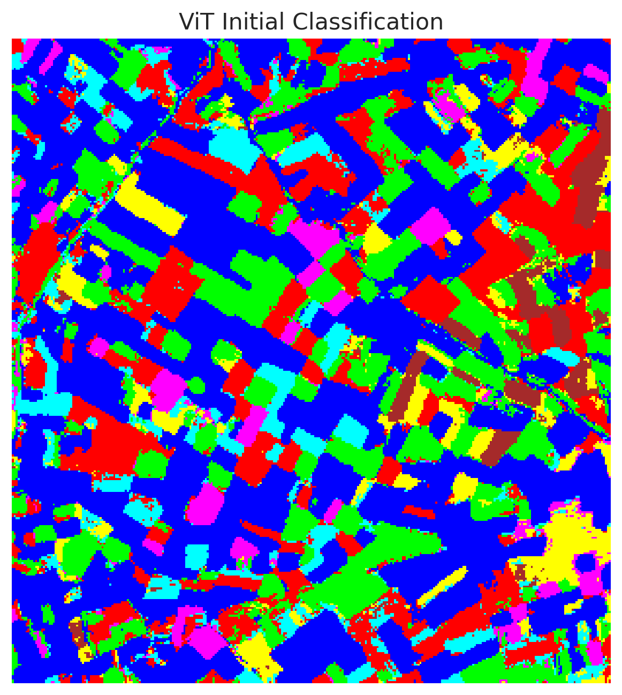
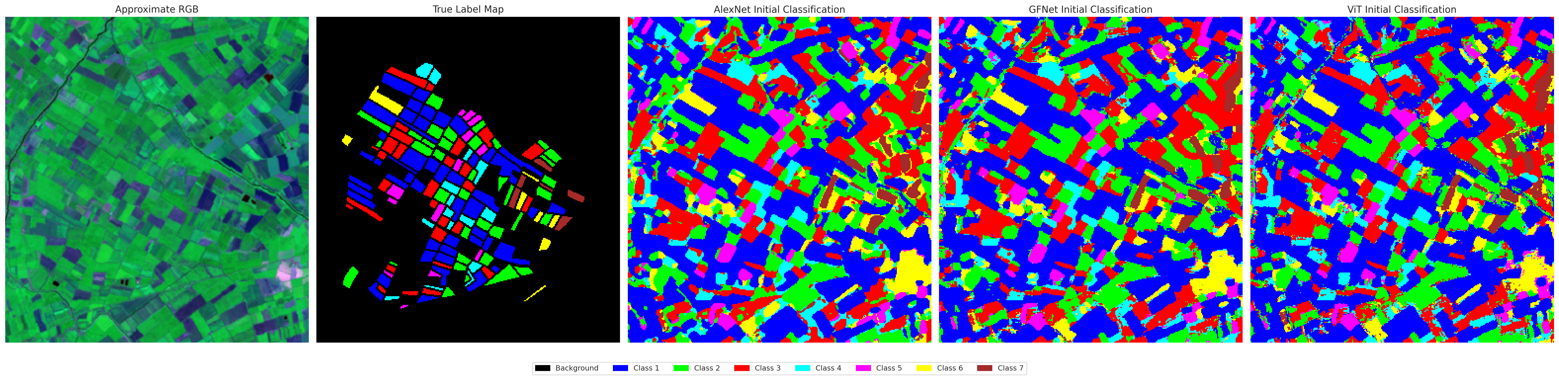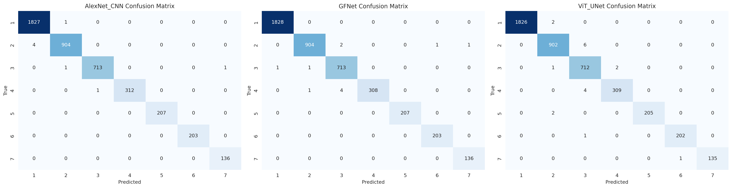

4.3 Conformal Prediction Results
The target coverage was set to 0.95 ($α=0.05$). All methods successfully achieved or exceeded this target marginal empirical coverage.
Model | Method | Empirical Coverage | Avg Set Size | Mean Per-Class Coverage
AlexNet | SplitConformal | 0.953 | 0.953 | 0.923
GFNet | SplitConformal | 0.955 | 0.955 | 0.929
ViT | SplitConformal | 0.947 | 0.947 | 0.904
AlexNet | ClassConditionalConformal | 0.956 | 0.956 | 0.948
GFNet | ClassConditionalConformal | 0.961 | 0.961 | 0.962
ViT | ClassConditionalConformal | 0.954 | 0.954 | 0.961
AlexNet | RAPS | 0.999 | 1.000 | 0.999
GFNet | RAPS | 0.998 | 1.000 | 0.996
ViT | RAPS | 0.994 | 1.000 | 0.993
RAPS consistently yielded over-coverage with higher average set sizes, while Class-Conditional Conformal Prediction provided tight coverage guarantees around the nominal 0.95 level while significantly improving the mean per-class coverage compared to the global Split Conformal baseline.
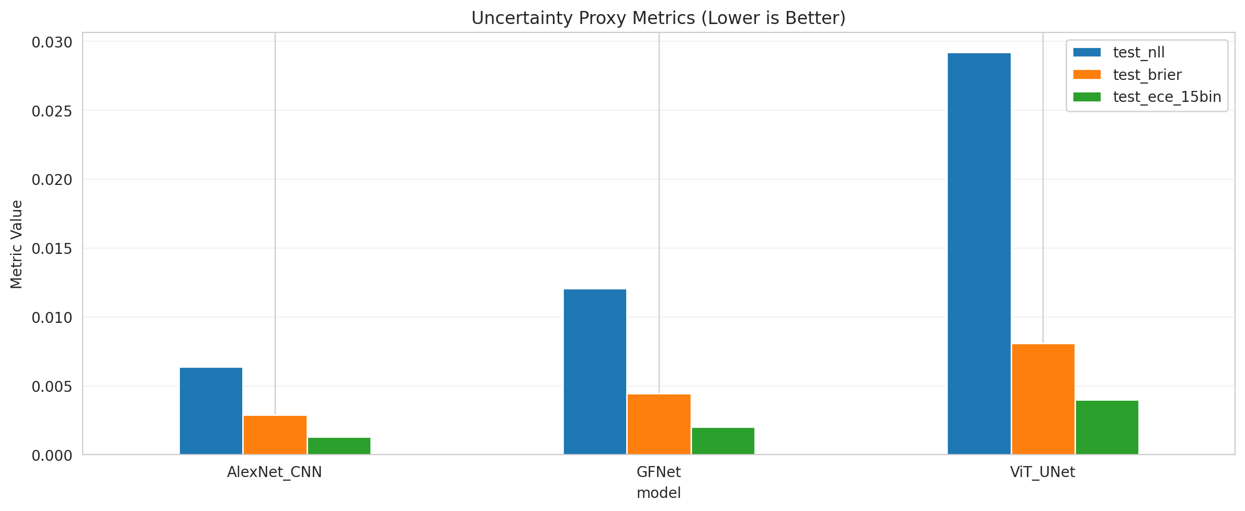
Uncertainty Proxy Metrics

5. Conclusion
Conformal Prediction is a powerful framework for bounding the uncertainty of classification models. The experimental results reveal that all models (AlexNet, GFNet, ViT_UNet) can be effectively calibrated to yield 95% marginal coverage. Class-Conditional CP and Clustered CP exhibit excellent balance, ensuring that minority classes also meet coverage requirements without excessively inflating the prediction set size.

