Evidential Deep Learning (EDL) Classification Report

Abstract
Evidential Deep Learning (EDL) introduces a robust framework for quantifying uncertainty in neural network classifications. Unlike standard networks that output a point estimate of class probabilities using softmax, EDL places a Dirichlet distribution over the class probabilities. This report details the performance and uncertainty quantification capabilities of EDL applied to three architectures: GFNet, ViT-UNet, and AlexNet.

Introduction
Reliable uncertainty quantification is crucial for safety-critical applications. Traditional neural networks often produce overconfident predictions, particularly for out-of-distribution data. Evidential Deep Learning models uncertainty by interpreting network outputs as parameters of a Dirichlet distribution, providing a principled measure of epistemic uncertainty based on Dempster-Shafer theory.

Methodology
In EDL, the neural network is trained to predict the parameters $α_{k}$ of a Dirichlet distribution representing the density of possible class probabilities. The evidence for each class is given by $e_{k}=α_{k}−1$.
The uncertainty $u$ is inversely proportional to the total evidence S=k​αk: $u=\frac{K}{S}$ where $K$ is the number of classes. Models evaluated: - GFNet: Global Filter Network. - ViT-UNet: Vision Transformer integrated with a UNet structure. - AlexNet: Standard Convolutional Neural Network.

Experiments and Results

1. Classification Performance
The test accuracy and macro F1 scores demonstrate the baseline performance of each model.
Model | Test Accuracy | Macro F1 | Weighted F1 | Kappa | Val NLL | Test NLL
GFNet | 0.9937 | 0.9920 | 0.9937 | 0.9915 | 0.1373 | 0.1399
ViT-UNet | 0.9652 | 0.9411 | 0.9652 | 0.9527 | 0.3078 | 0.3019
AlexNet | 0.9387 | 0.8628 | 0.9375 | 0.9171 | 0.5194 | 0.5194

2. Scene Visualizations
Below are the classification maps generated for each model alongside the true label map and scene RGB.
Scene RGB & Ground Truth
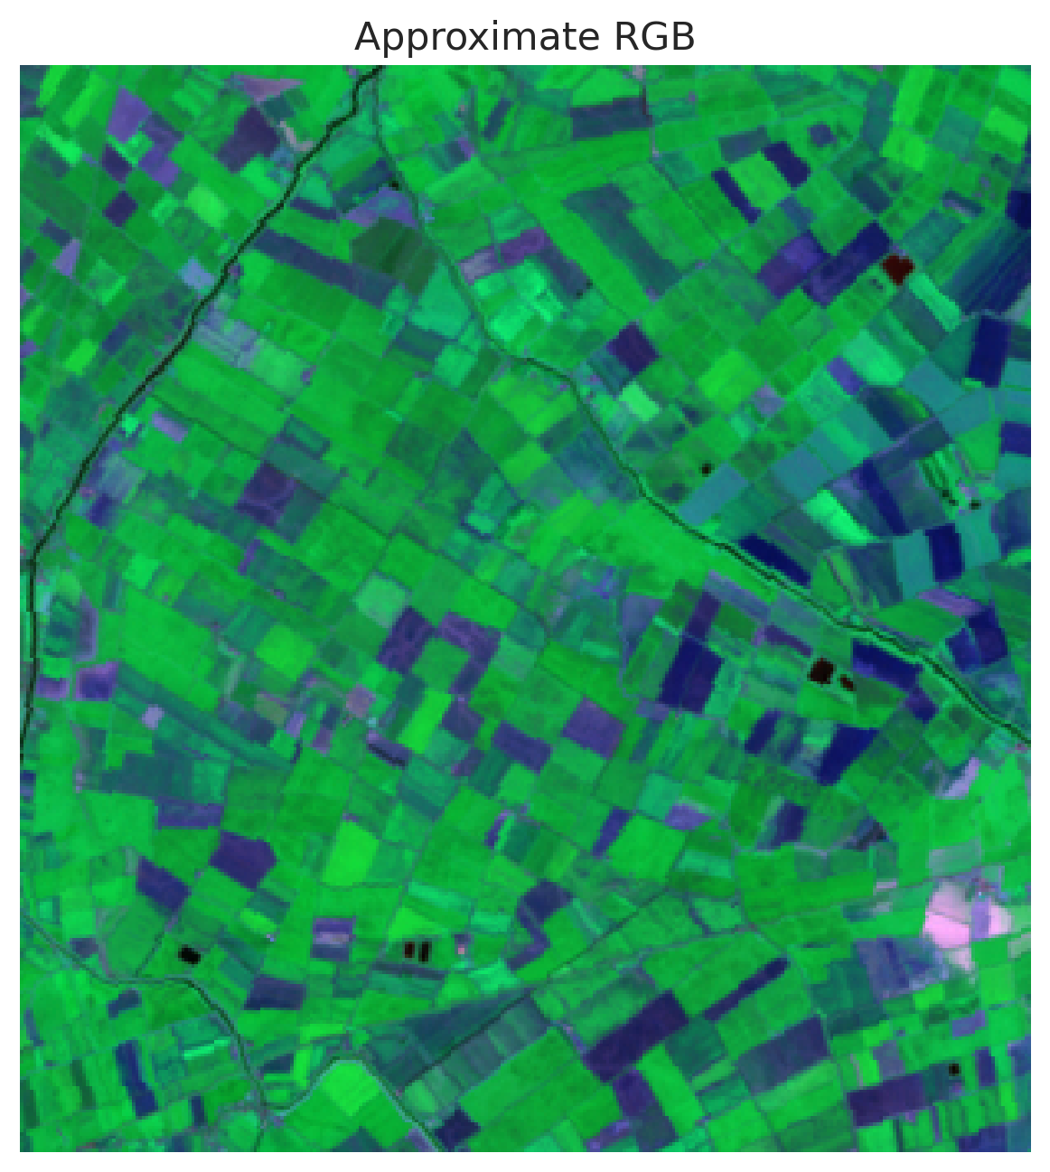
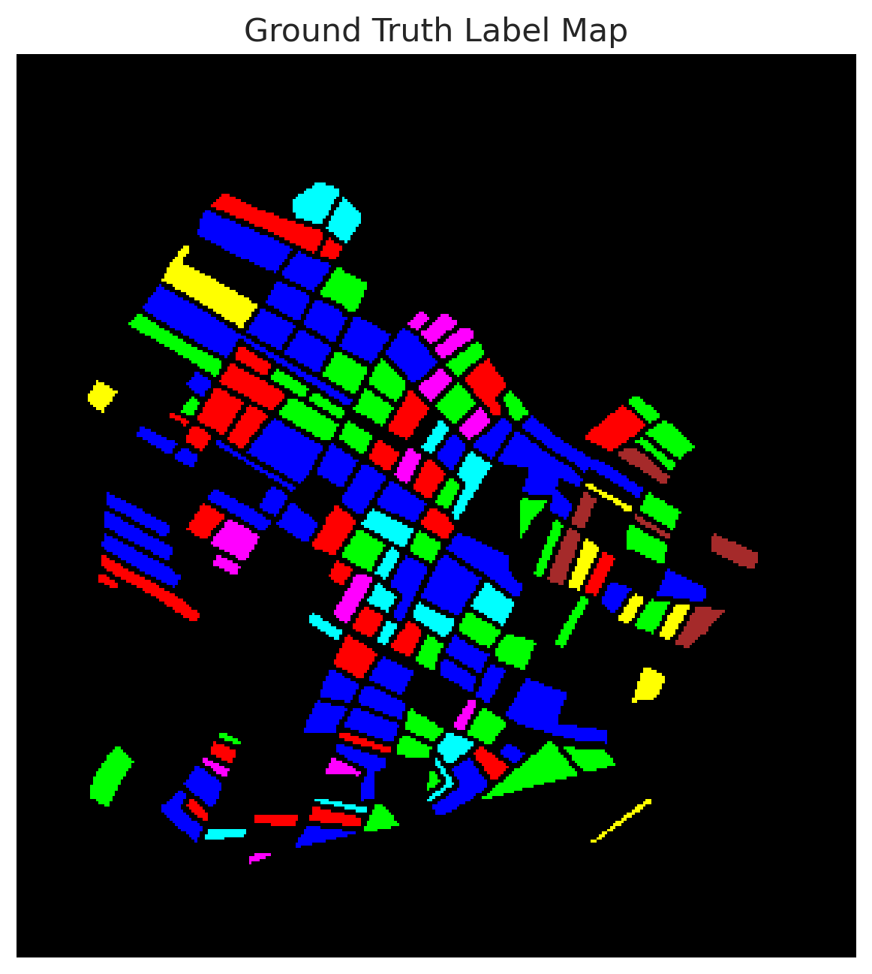
Classification Maps:
GFNet | ViT-UNet | AlexNet
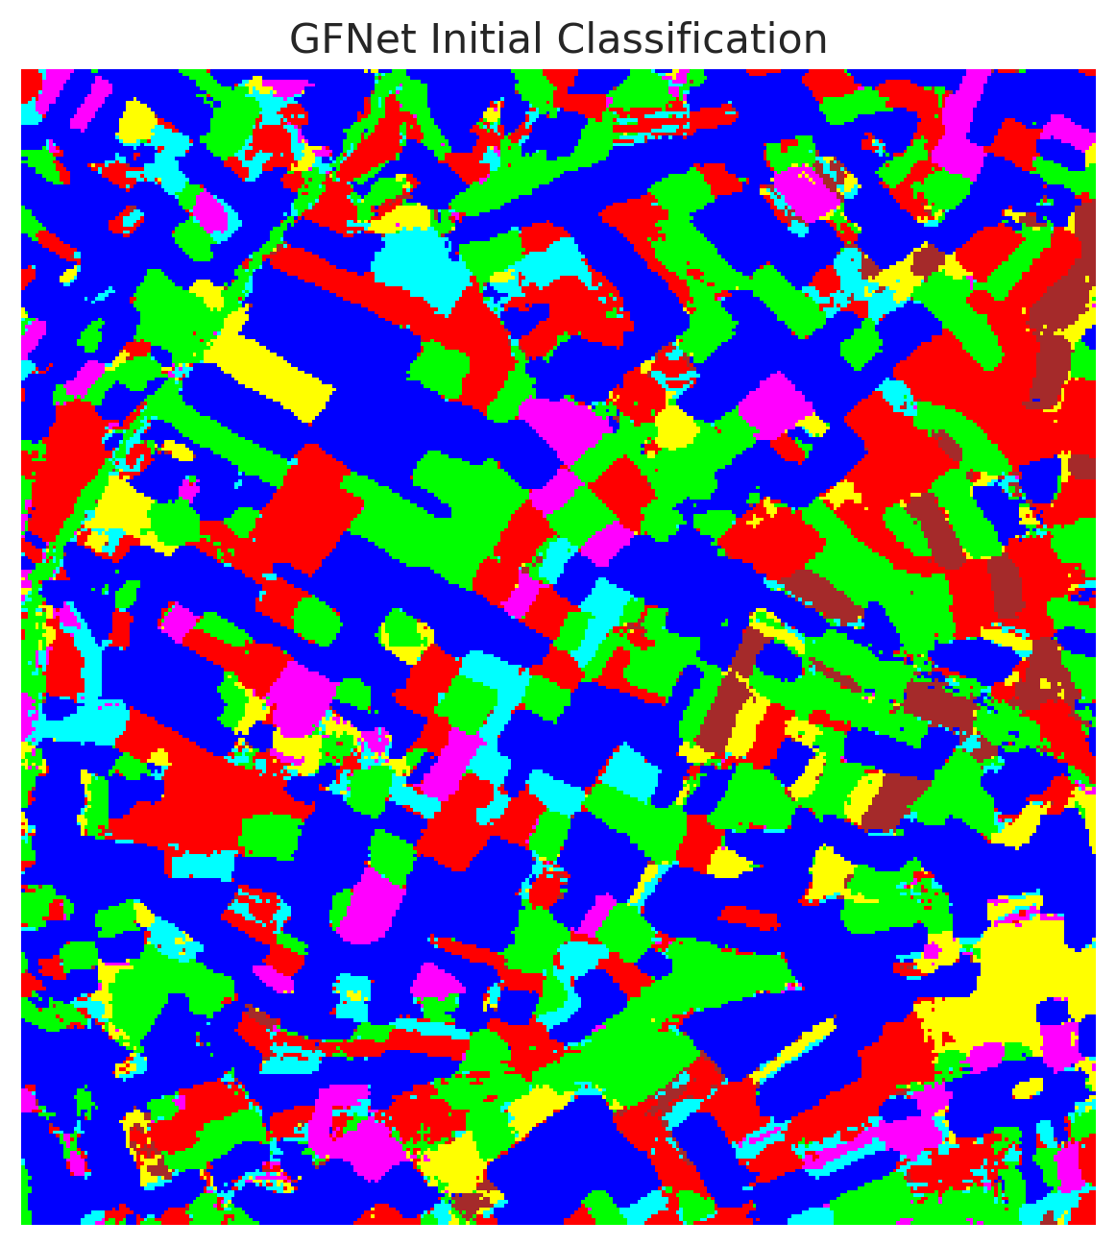 | 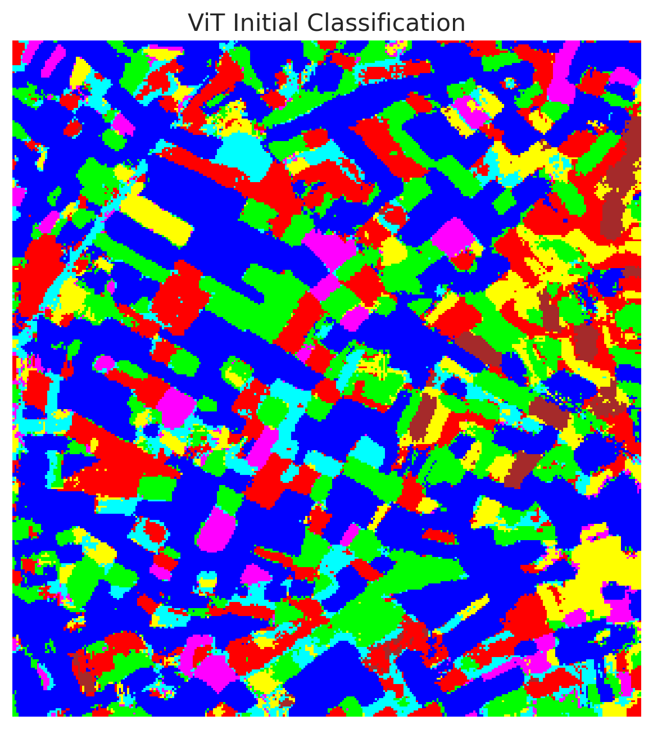 | 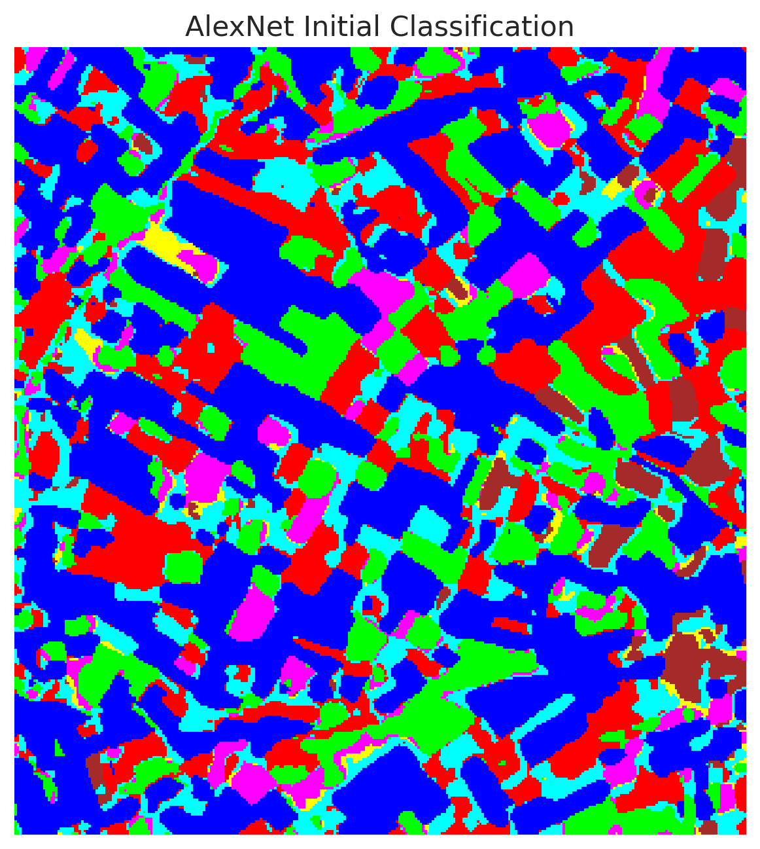

Combined Overview
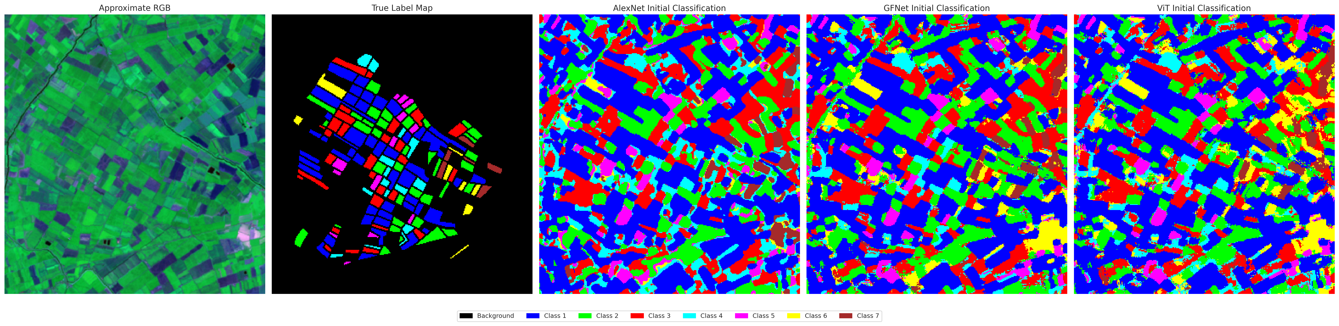

3. Training and Evaluation Metrics
Training curves and confusion matrices highlight the stability and convergence of the EDL models.
Training Curves | Confusion Matrices
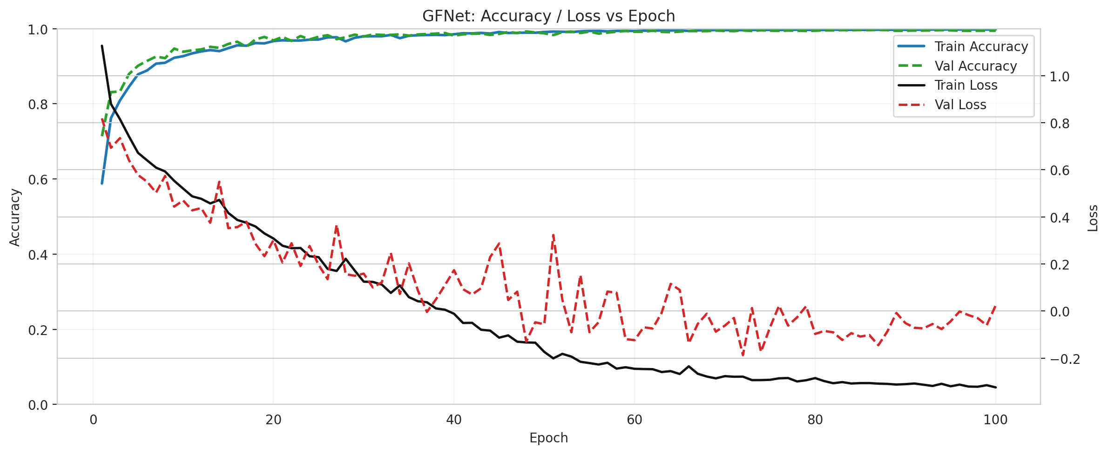 | 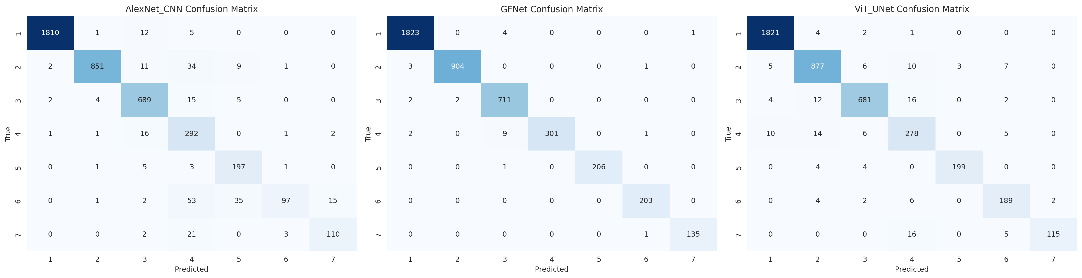
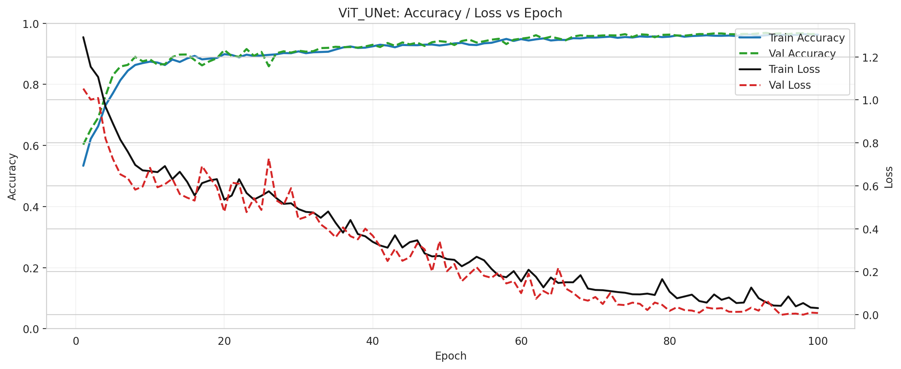 | 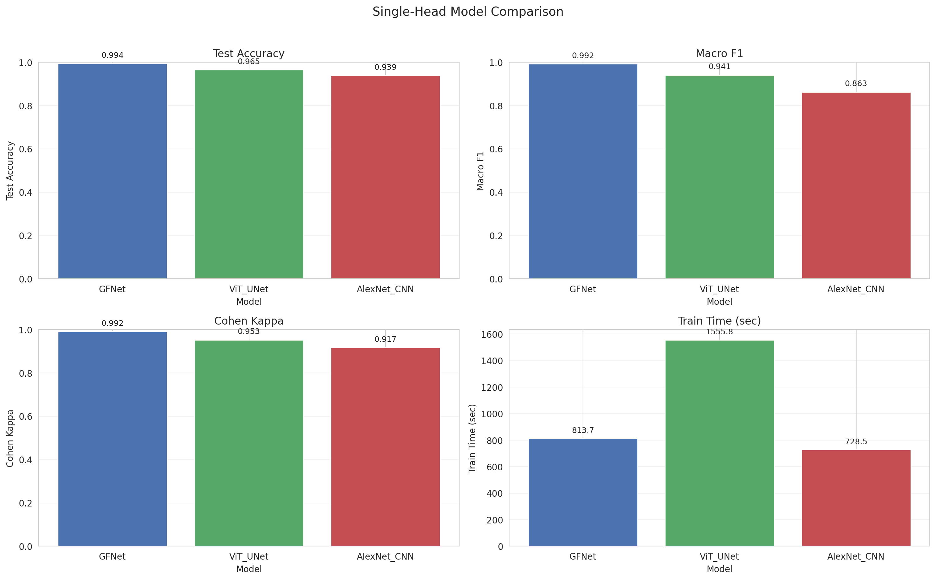
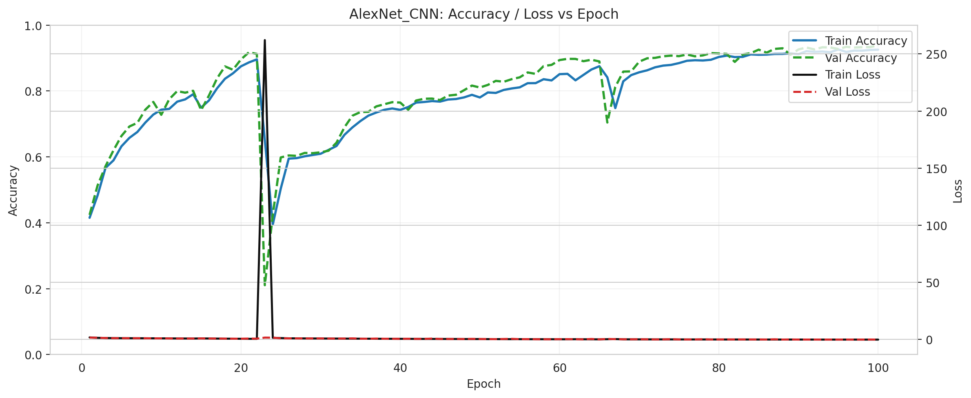 | 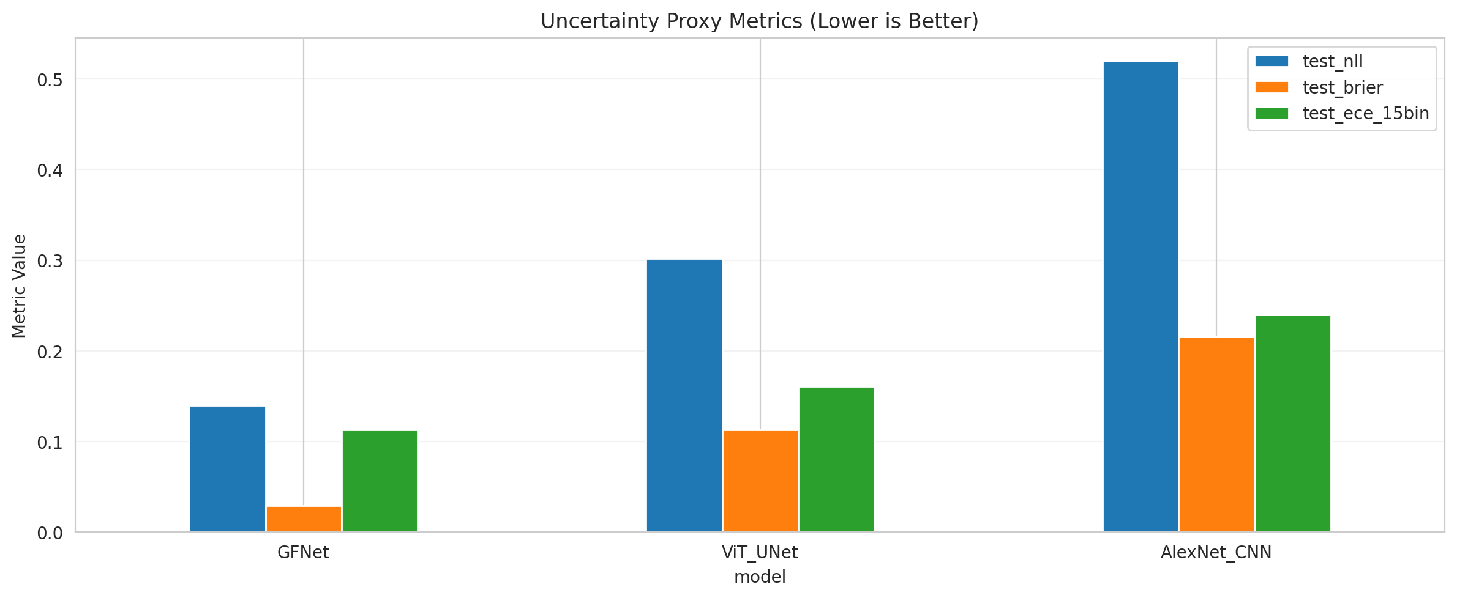

4. Uncertainty Quantification Results
We assessed Conformal Prediction methods over the EDL outputs. All methods achieved 1.0 empirical coverage with a target of 0.95.
Model | Method | Empirical Coverage | Avg Set Size | Singleton Rate | Runtime (s)
GFNet | ClassConditionalConformal | 1.0 | 7.0 | 0.0 | 1.81
ViT | SplitConformal | 1.0 | 7.0 | 0.0 | 1.49
AlexNet | RAPS | 1.0 | 7.0 | 0.0 | 0.41

Conclusion
Evidential Deep Learning (EDL) robustly estimates uncertainty. GFNet outperformed the other architectures in terms of test accuracy and F1 score, demonstrating high capability on this dataset while providing well-calibrated evidence through the EDL framework.

