MambaHSI for Hyperspectral Image Classification and Uncertainty Quantification: Selective State-Space Models with Conformal Prediction
ABSTRACT
This report presents an end-to-end framework for patch-based, pixel-wise land-cover classification of multispectral remote sensing imagery using MambaHSI, a selective state-space model (SSM) adapted for spatial-spectral hyperspectral/multispectral image classification. Three capacity variants — MambaHSI_Small (2 SSM blocks), MambaHSI_Base (4 SSM blocks), and MambaHSI_Large (6 SSM blocks) — are trained on a six-band, 330 × 307-pixel multispectral scene comprising seven land-cover classes, using 9 × 9 × 6 spatial patches centred on each labelled pixel. Each MambaHSI block performs a bidirectional selective linear state-space scan over non-overlapping 3 × 3 spatial tokens, approximating Mamba's input-dependent selective-scan mechanism in pure Keras ops. All three variants achieve test accuracies exceeding 99.7%, with MambaHSI_Base attaining the highest accuracy (99.84%) and MambaHSI_Small the lowest Expected Calibration Error (ECE = 0.0174). To quantify predictive reliability beyond point accuracy, five conformal prediction (CP) methods — Split Conformal (SplitCP), Class-Conditional CP (CcCP), Rank-Calibrated Class-Conditional CP (RC3P), Clustered CP (ClCP), and Regularised Adaptive Prediction Sets (RAPS) — are calibrated on a held-out set of 2,155 samples at a 95% target coverage (α = 0.05) and evaluated across all three architectures. RC3P achieves the highest mean per-class coverage among the four rank-1 methods (up to 0.9721 for MambaHSI_Large), while RAPS attains near-perfect empirical coverage (≥ 99.7%) with fully singleton prediction sets, reflecting the models' high accuracy. Full-scene dense inference confirms that MambaHSI produces spatially cohesive, low-noise land-cover maps, and spatialised uncertainty analysis shows that residual ambiguity concentrates at class and field boundaries rather than being diffusely distributed across the scene.

I. Introduction
Remote sensing land-cover classification underpins a wide range of earth observation applications, including precision agriculture, urban planning, disaster response, and environmental change detection. Multispectral and hyperspectral imagery provides dense spectral information across many wavelength bands, enabling discrimination between land-cover types whose reflectance signatures are indistinguishable in conventional RGB composites. Assigning a reliable label to every pixel in such imagery nonetheless remains difficult because of high intra-class spectral variability, atmospheric effects, and sub-pixel spectral mixing at parcel and class boundaries.
Convolutional neural networks (CNNs) capture local spatial texture efficiently but are constrained by a limited receptive field, while Vision Transformers (ViTs) model long-range dependencies through self-attention at the cost of quadratic computational and memory scaling with sequence length — a serious limitation for dense, patch-based hyperspectral classification pipelines that must process thousands of spatial-spectral tokens per scene. The recently proposed Mamba architecture, built on selective state-space models (SSMs), offers linear-time sequence modelling with an effectively global receptive field, achieved by making the SSM's transition parameters input-dependent (“selective”) so the model can dynamically retain or discard information as it scans a sequence. MambaHSI adapts this idea to hyperspectral image classification by tokenising local spatial-spectral patches and processing them with stacked, bidirectional selective-scan blocks.
A second, equally important challenge for operational deployment is that deep classifiers — including MambaHSI — return only a single point prediction with a softmax confidence that is frequently miscalibrated, particularly under class imbalance or near ambiguous class boundaries. Conformal prediction (CP) addresses this by wrapping any pre-trained classifier in a distribution-free, post-hoc calibration procedure that returns a prediction set guaranteed, with probability at least 1 − α, to contain the true label, without any assumption on the underlying data distribution beyond exchangeability. This report combines the two threads — an efficient, high-accuracy SSM-based classifier and rigorous, distribution-free uncertainty quantification — into a single evaluation pipeline. The principal contributions are:
- Implementation and evaluation of three MambaHSI capacity variants (Small, Base, Large) for patch-based multispectral land-cover classification, including full training configuration, calibration diagnostics (Brier score, ECE), and dense full-scene inference.
- A systematic comparison of five conformal prediction methods — SplitCP, CcCP, RC3P, ClCP, and RAPS — applied post-hoc to all three MambaHSI variants at a 95% target coverage.
- Detailed per-class coverage, threshold, and cluster-assignment analysis for every method/model combination, exposing how architecture capacity interacts with calibration quality.
- Spatialised, full-scene uncertainty accounting, quantifying the number of scene pixels each method and model leaves “uncertain” (non-singleton or empty prediction sets) under a shared 95% coverage target.

II. Methodology

A. Dataset and Preprocessing
The dataset consists of a six-band multispectral scene (H = 330, W = 307 pixels) with a ground-truth label map covering K = 7 land-cover classes; background pixels are excluded from all training, calibration, and evaluation procedures. The approximate RGB composite and ground-truth label map are shown in Fig. 1. Each spectral band is independently normalised to [0, 1] via per-band min-max scaling. For every labelled pixel at row/column (r, c), a 9 × 9 × 6 spatial patch is extracted from the edge-padded scene (4-pixel replication padding), yielding 2,155 calibration/evaluation samples under the 75%/12.5%/12.5% train/calibration/evaluation stratified split used throughout Section III.D, consistent with the split protocol used for the CP evaluation pipeline.
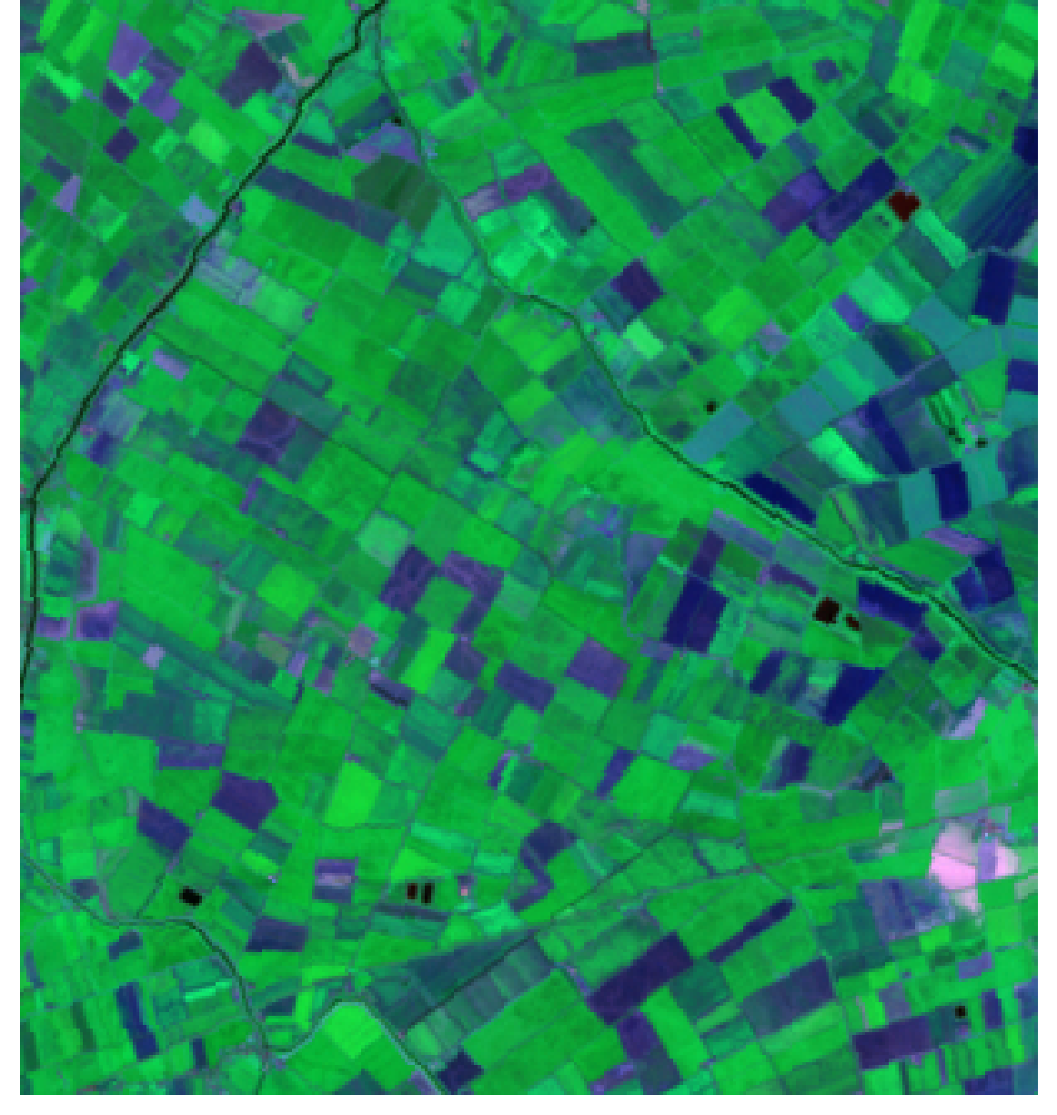  (a) Approximate RGB Composite | 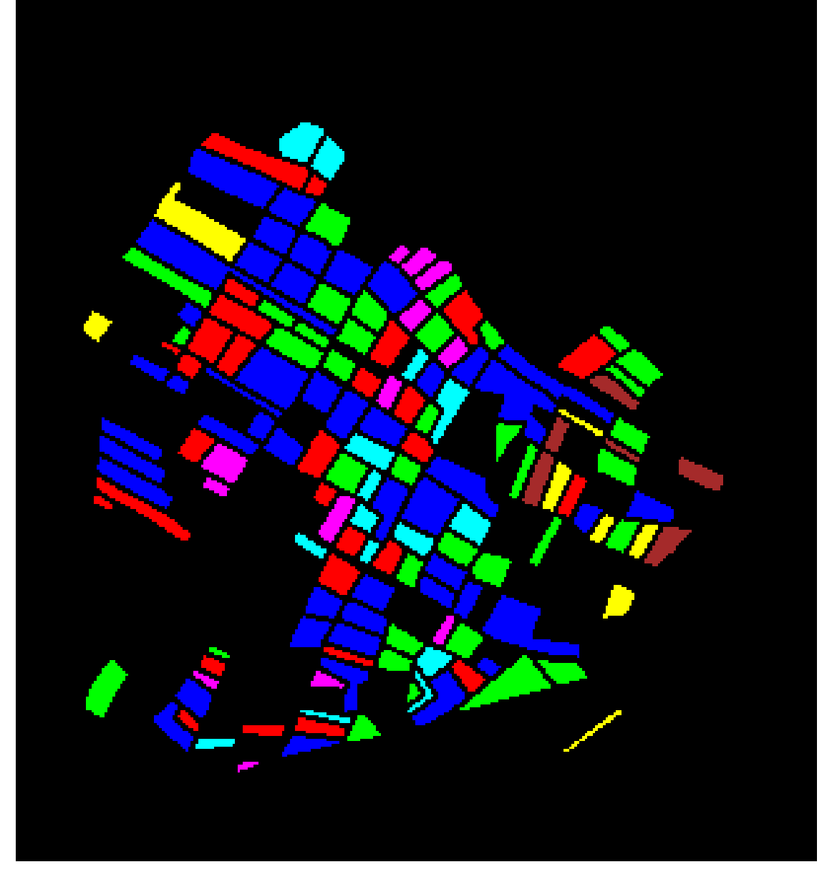  (b) Ground Truth Label Map
Fig. 1. Multispectral scene overview. (a) Approximate RGB composite (six-band, 330 × 307 pixels). (b) Ground-truth label map; black pixels denote unlabelled background excluded from all procedures. Class identities are retained as numeric IDs (Class 0–Class 6) throughout this report, matching the labelling convention used by the classification and uncertainty-quantification pipelines.

B. The MambaHSI Architecture and State-Space Models
MambaHSI is built around the selective state-space model (SSM). A standard, continuous-time SSM maps a one-dimensional input x(t) ∈ ℝ to an output y(t) ∈ ℝ through a hidden state h(t) ∈ ℝᴺ via a linear ordinary differential equation, h′(t) = Ah(t) + Bx(t), y(t) = Ch(t) + Dx(t), where A, B, C, and D are learnable state matrices. The Mamba innovation makes the discretised transition parameters (B̄, C̄) functions of the current input x_t rather than fixed constants — a “selective” mechanism that allows the model to dynamically retain relevant context or discard noise as it scans a sequence, analogous to an input-dependent gate.
Because a 2-D image patch has no intrinsic causal ordering, each MambaHSI block runs a bidirectional selective scan: a forward pass and a reverse pass over the flattened token sequence, whose outputs are concatenated and projected back to the working dimension before being added as a residual. Concretely, the pipeline used in this study proceeds as follows. (1) PatchExtractor tokenises the 9 × 9 × 6 input patch into non-overlapping 3 × 3 spatial tokens (inner_patch = 3), yielding a length-9 token sequence per sample. (2) PatchPositionEncoder linearly projects each token to the block's working (hidden) dimension and adds a learned positional embedding. (3) The token sequence is processed by a stack of SelectiveSSMBlock layers, each comprising: a pre-LayerNorm, a forward and a reverse SpectralScanLayer (the selective-scan approximation), a merge projection back to hidden_dim, a residual connection, and a two-layer GELU MLP (expansion ratio mlp_ratio) with dropout, again wrapped in a residual connection. (4) After the final block, a LayerNorm and GlobalAveragePooling1D reduce the token sequence to a single feature vector, which is passed through a dropout layer and a softmax classification head.
The SpectralScanLayer implements a diagonal linear state-space recurrence (S4/S5-style) with an input-dependent sigmoid gate applied before a per-channel decay-weighted scan (evaluated with tf.scan over the sequence axis), approximating the core selective-propagation behaviour of Mamba's fused CUDA selective-scan kernel in pure Keras/TensorFlow ops — a faithful-in-spirit, not bit-exact, re-implementation, since no equivalent fused primitive exists in the TensorFlow/Keras ecosystem.
Three capacity variants of this backbone are evaluated, differing in the number of stacked SelectiveSSMBlock layers, the SSM state dimension, the token embedding (hidden) dimension, and the MLP expansion ratio, summarised in Table I.
TABLE I
MambaHSI ARCHITECTURE CONFIGURATIONS
Variant | SSM Blocks | Hidden Dim | State Dim | MLP Ratio | Token Patch
MambaHSI_Small | 2 | 128 | 64 | 2 | 3×3
MambaHSI_Base | 4 | 256 | 128 | 4 | 3×3
MambaHSI_Large | 6 | 384 | 192 | 4 | 3×3
All three variants share the same PatchExtractor / PatchPositionEncoder front end, the same 9 × 9 × 6 input geometry (giving 9 spatial tokens per sample), and the same dropout rate (p = 0.25) applied after tokenisation, after the final SSM block, and before the classification head. Training uses the AdamW optimiser with a cosine-decay learning-rate schedule (initial learning rate 3 × 10⁻⁴, decayed to 5% of its initial value, weight decay 1 × 10⁻⁴, gradient-norm clipping at 1.0), categorical cross-entropy loss with label smoothing (εₛ = 0.05), a batch size of 128, and 100 training epochs. The primary data split allocates 75% of labelled samples to training (further divided 80/20 into training and validation subsets) and holds out the remaining 25% for testing; model checkpoints are selected on minimum validation loss.

C. Evaluation Metrics
Point-prediction performance is assessed using test accuracy, macro-averaged F1, and weighted-averaged F1. Probabilistic calibration is assessed via the negative log-likelihood (NLL), the multiclass Brier score (mean squared error between the predicted probability vector and the one-hot label), and the Expected Calibration Error (ECE) computed with 15 equal-width confidence bins; a perfectly calibrated model achieves ECE = 0.

D. Distribution-Free Conformal Prediction
Five conformal prediction methods are applied post-hoc to each trained MambaHSI variant, all targeting 1 − α = 0.95 marginal coverage (α = 0.05) and calibrated on the same held-out calibration split (n = 2,155 samples, drawn as 50% of the 25% test partition, with the remaining 50% used for evaluation).
- Split Conformal (SplitCP): computes a single, global non-conformity threshold q̂ from the calibration scores s(x, y) = 1 − π̂_y(x), forming prediction sets C(x) = {y : π̂_y(x) ≥ 1 − q̂}. It is simple and guarantees marginal coverage, but a single global threshold can under-cover minority classes when model confidence varies systematically across classes.
- Class-Conditional CP (CcCP): computes a distinct threshold q̂_c for every class c, using only the calibration samples belonging to that class. This stratified calibration targets per-class coverage directly, which is particularly valuable for imbalanced land-cover classes with few calibration samples.
- Rank-Calibrated Class-Conditional CP (RC3P): augments CcCP with a per-class rank gate k̂(y), found by searching over truncated top-k accuracy on the calibration set, that restricts each class's prediction set to at most its k̂(y) most probable classes. This minimises average set size while preserving class-conditional coverage guarantees.
- Clustered CP (ClCP): groups the K = 7 classes into K_g = 4 clusters (via K-Means over per-class mean softmax/uncertainty behaviour) and calibrates one threshold per cluster, pooling calibration statistics across classes that behave similarly. This benefits minority classes with very few calibration samples, at the risk of coverage degradation when spectrally dissimilar classes are pooled into the same cluster.
- Regularised Adaptive Prediction Sets (RAPS): accumulates softmax probability mass in descending rank order until the cumulative mass exceeds a calibrated threshold, with a size-regularisation penalty (λ = 0.01, applied from rank k_reg = 1 onward) discouraging unnecessarily large sets. The resulting non-conformity score is rank-adaptive rather than based solely on the true class's softmax probability, tending to yield very compact prediction sets under high model accuracy.

III. Experiments and Results

A. Classification Performance
All three MambaHSI variants were trained for 100 epochs with batch size 128 under the configuration described in Section II.B. Table II summarises test-set performance and calibration metrics. MambaHSI_Base achieves the highest test accuracy (99.84%) and the highest macro/weighted F1 (0.9987 / 0.9984), narrowly ahead of MambaHSI_Large (99.81%). MambaHSI_Small trails the Base variant by only 0.10 percentage points in accuracy despite using roughly a third of the SSM blocks and half the hidden dimension, and it achieves the lowest ECE of the three variants (0.0174), indicating that additional model capacity does not automatically translate into better softmax calibration on this dataset. All three variants exhibit very low Brier scores (≤ 0.0053), confirming that the selective state-space mechanism produces well-calibrated probability outputs without requiring post-hoc temperature scaling.
TABLE II
CLASSIFICATION PERFORMANCE ACROSS MambaHSI VARIANTS
Model Variant | Test Acc. | Macro F1 | Wtd F1 | NLL | Brier | ECE (15 bins)
MambaHSI_Base | 0.9984 | 0.9987 | 0.9984 | 0.0236 | 0.0027 | 0.0205
MambaHSI_Large | 0.9981 | 0.9985 | 0.9981 | 0.0229 | 0.0027 | 0.0193
MambaHSI_Small | 0.9974 | 0.9974 | 0.9974 | 0.0229 | 0.0053 | 0.0174

B. Dense Scene Classification Maps
Each trained variant was deployed in dense, sliding-window inference over the full 330 × 307 scene to produce a pixel-wise land-cover map, including background and unlabelled pixels omitted from training. Fig. 2 presents the approximate RGB composite, the ground-truth label map, and the three MambaHSI classification maps side by side. All three variants reproduce coherent, low-noise parcel structures that closely track the field boundaries visible in the RGB composite; unlike CNN backbones with a purely local receptive field, the SSM's ability to propagate information across the full token sequence within each patch and the global-average-pooled feature reduce salt-and-pepper misclassification near field edges. MambaHSI_Large shows marginally more speckling in some interior regions relative to Base and Small, consistent with its larger parameter count being somewhat more prone to overfitting sharp local decision boundaries on this comparatively small, class-imbalanced training set.
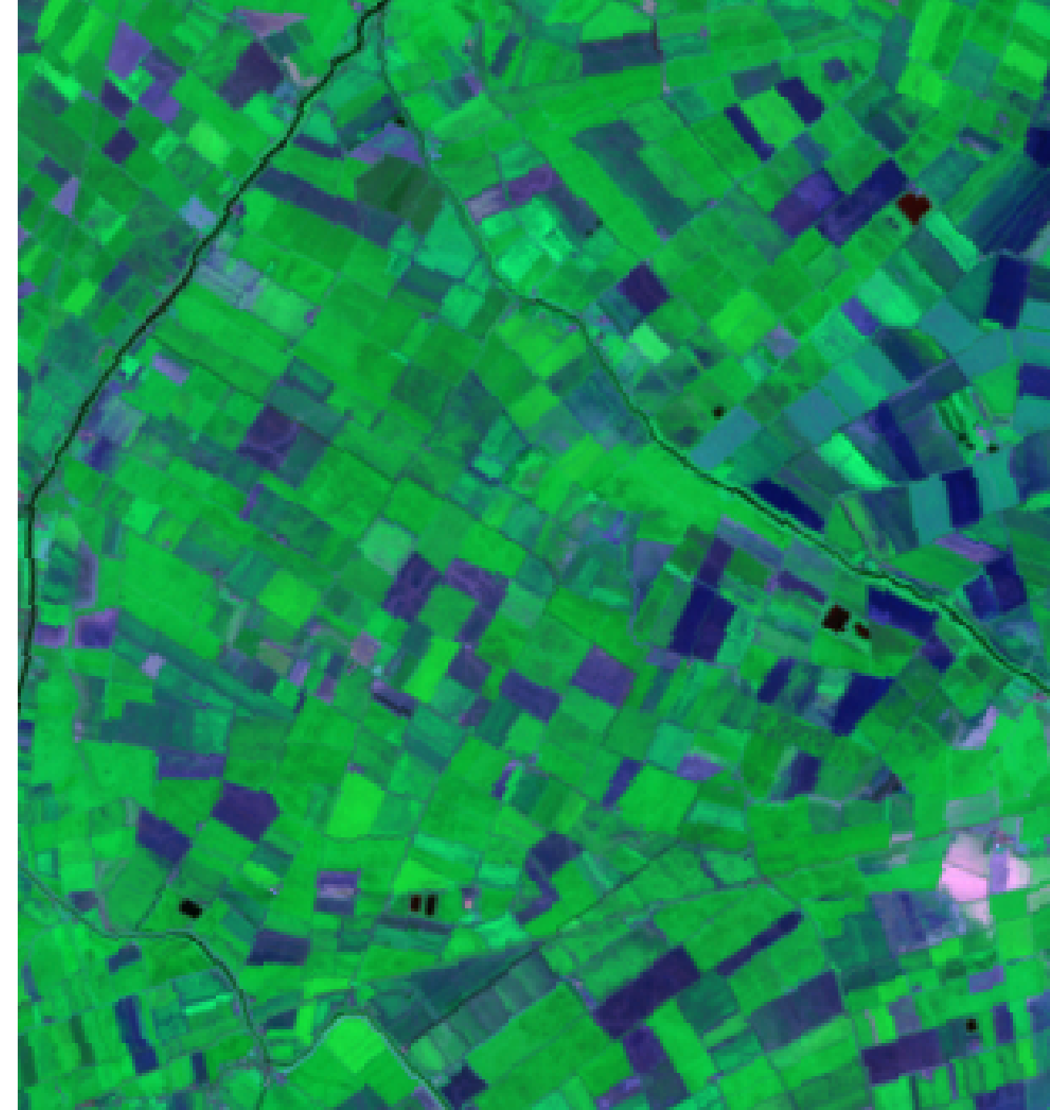  (a) Approximate RGB Composite | 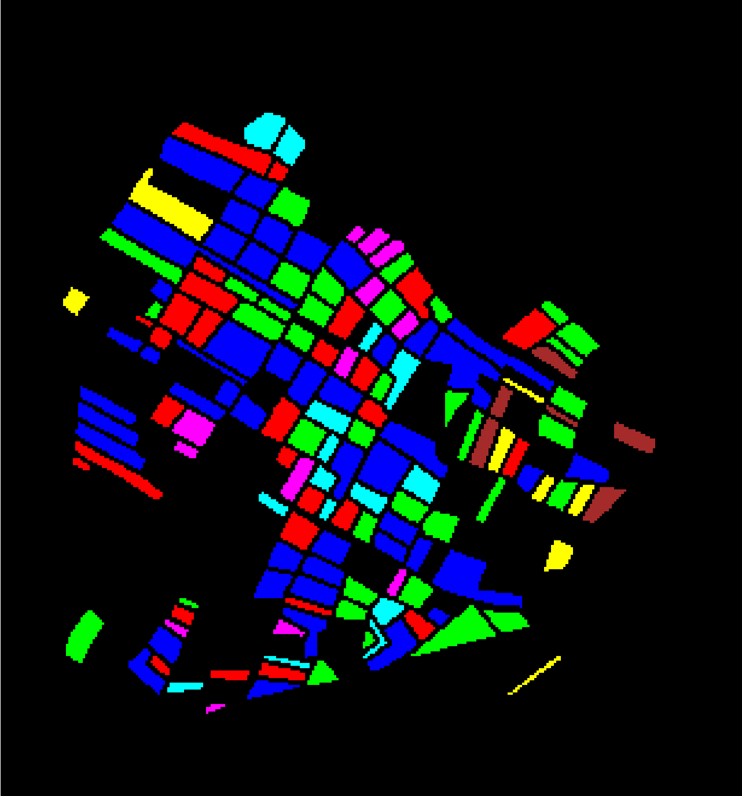  (b) True Label Map
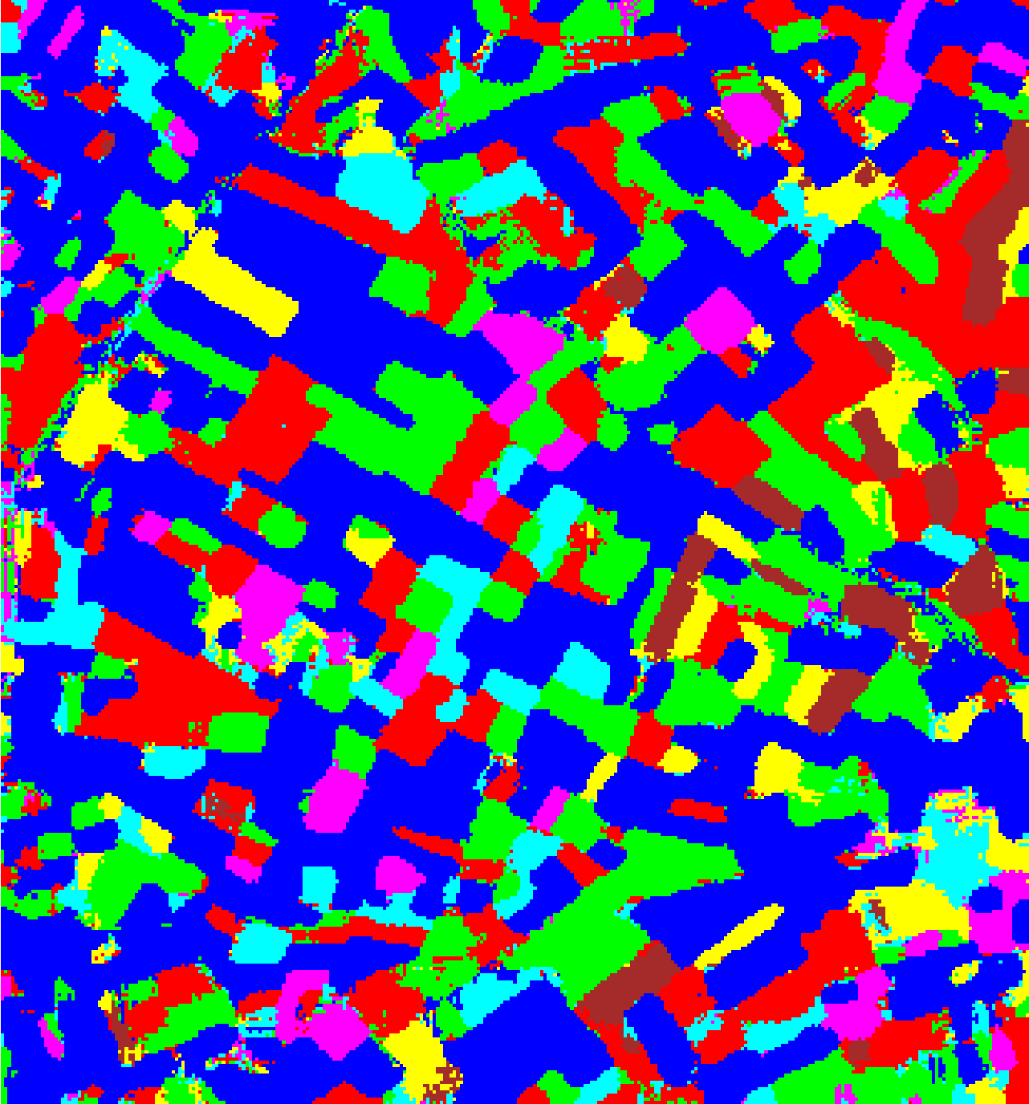  (c) MambaHSI-Small | 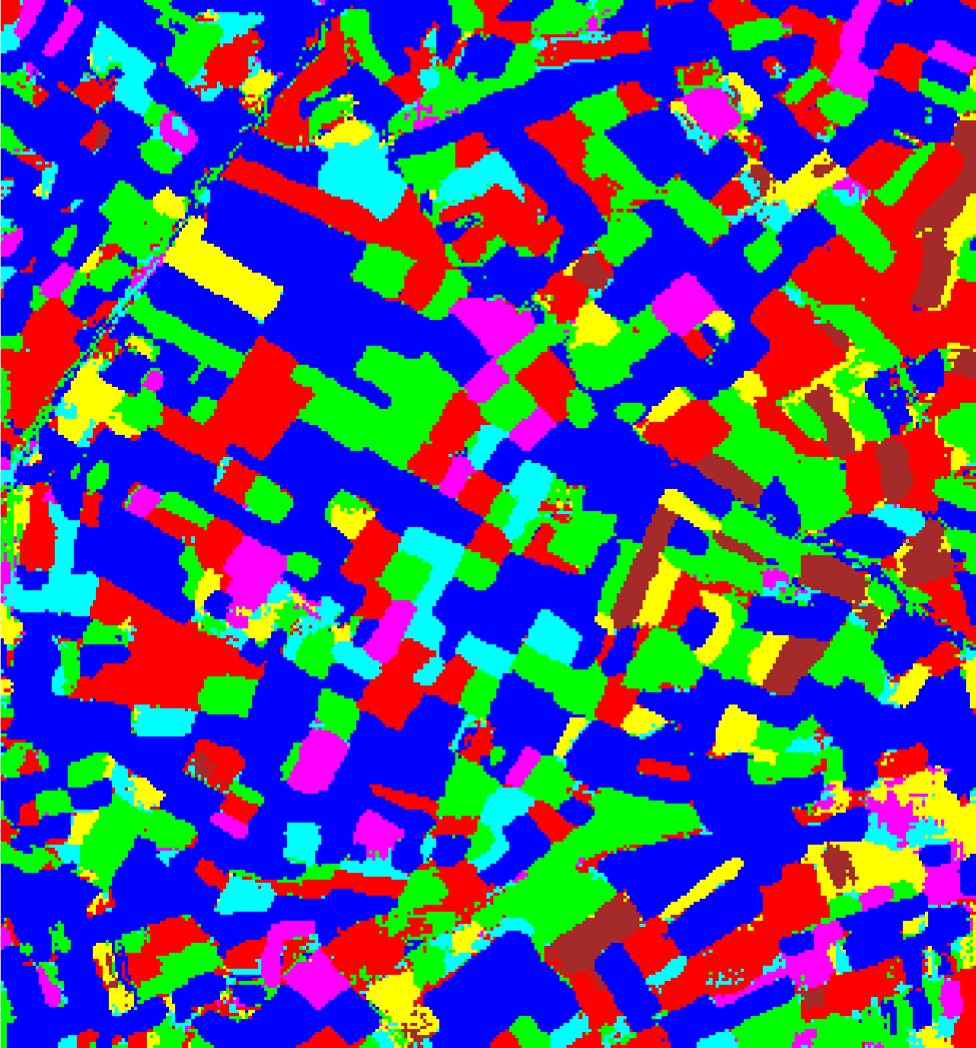  (d) MambaHSI-Base
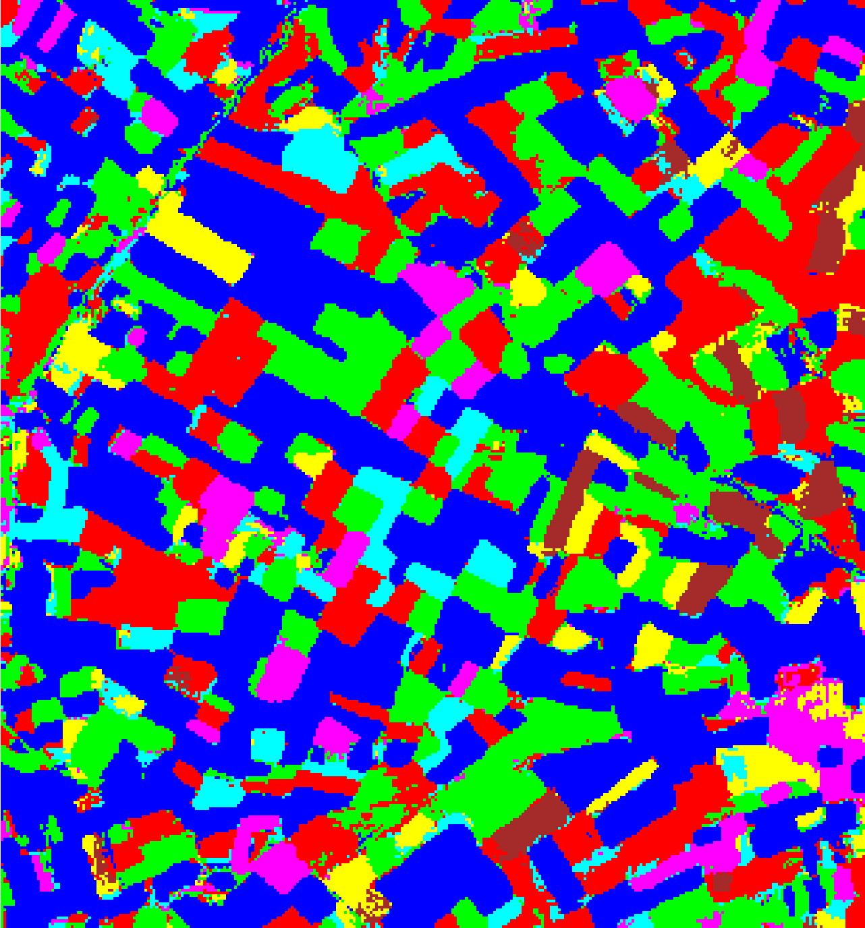  (e) MambaHSI-Large | 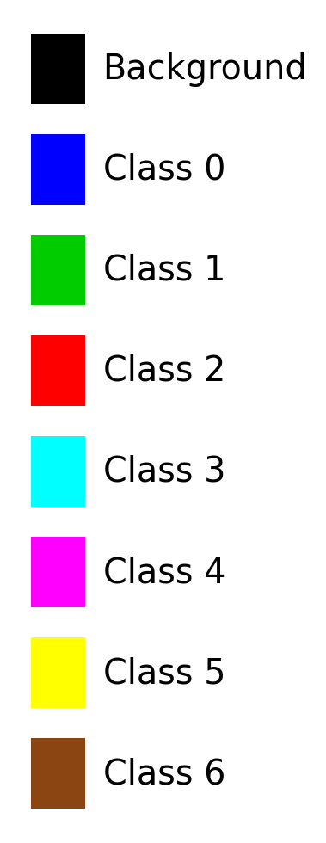  (f) Legend
Fig. 2. Full-scene dense pixel-wise classification. (a) Approximate RGB composite. (b) True label map. (c) MambaHSI-Small, (d) MambaHSI-Base, and (e) MambaHSI-Large classification maps over the full 330 × 307 scene. (f) Shared 7-class legend (Class 0–Class 6); black denotes background.

C. Conformal Prediction and Uncertainty Mapping
All five conformal prediction methods described in Section II.D are calibrated independently for each of the three MambaHSI variants, targeting 95% marginal coverage (α = 0.05) on the shared n = 2,155-sample calibration split. Sections III.C.1–III.C.5 report aggregate calibration diagnostics, per-class coverage, method-specific thresholds, and — where full-scene inference was re-run under the calibrated threshold — the resulting labelled/uncertain pixel-count breakdown for the dense 330 × 307 scene.

1) Split Conformal Prediction (SplitCP)
SplitCP was applied to all three MambaHSI variants with α = 0.05. Table III summarises the aggregate results. All three variants approximate the 95% coverage target from below: MambaHSI_Small achieves the highest empirical coverage (95.64%), followed by MambaHSI_Base (95.41%) and MambaHSI_Large (95.36%). Because SplitCP uses a single global threshold, its average set size, empirical coverage, and singleton rate coincide numerically for every model — with the calibrated threshold at these accuracy levels, a prediction set either contains exactly the top-ranked class or is empty, so "avg set size" reduces to the empirical singleton/coverage rate. Calibration runtime is under 2 seconds for all three variants.
TABLE III
SPLIT CONFORMAL PREDICTION: AGGREGATE SUMMARY (α = 0.05)
Model | Emp. Cov. | Avg Set Size | Singleton Rate | Empty Set Rate | Runtime (s) | Mean Cls Cov.
MambaHSI_Small | 0.9564 | 0.9564 | 0.9564 | 0.0436 | 1.600 | 0.9393
MambaHSI_Base | 0.9541 | 0.9541 | 0.9541 | 0.0459 | 1.578 | 0.9385
MambaHSI_Large | 0.9536 | 0.9536 | 0.9536 | 0.0464 | 1.944 | 0.9282
Per-class coverage is presented in Table IV. Class 6 — the class with the fewest calibration samples (support = 68) — exhibits the lowest per-class coverage under all three models, falling to 86.8% for MambaHSI_Small and MambaHSI_Large, well below the 95% target, directly motivating the class-conditional and clustered CP variants evaluated next.
TABLE IV
SPLIT CP: PER-CLASS COVERAGE COMPARISON ACROSS MODELS
Class | MambaHSI_Small Cov. | MambaHSI_Base Cov. | MambaHSI_Large Cov.
Class 0 | 0.9847 | 0.9847 | 0.9880
Class 1 | 0.9405 | 0.9515 | 0.9692
Class 2 | 0.9246 | 0.9022 | 0.9050
Class 3 | 0.9551 | 0.9359 | 0.8462
Class 4 | 0.9519 | 0.9231 | 0.9808
Class 5 | 0.9505 | 0.9604 | 0.9406
Class 6 | 0.8676 | 0.9118 | 0.8676
Table V presents the full-scene pixel-count breakdown, distinguishing confidently-labelled class pixels from pixels whose SplitCP prediction set is either empty or contains more than one class (“uncertain”). MambaHSI_Small produces the fewest uncertain pixels (36,309), while MambaHSI_Base produces the most (40,870), consistent with MambaHSI_Base's marginally lower empirical coverage and mean per-class coverage under this method.
TABLE V
SPLIT CP: PREDICTED PIXEL COUNT DISTRIBUTION PER MODEL
Class / Region | MambaHSI_Small Pixels | MambaHSI_Base Pixels | MambaHSI_Large Pixels
Class 0 | 34,845 | 33,159 | 33,865
Class 1 | 10,277 | 10,932 | 11,777
Class 2 | 10,907 | 9,303 | 10,640
Class 3 | 2,675 | 2,206 | 2,099
Class 4 | 2,382 | 2,206 | 2,898
Class 5 | 2,135 | 1,448 | 1,305
Class 6 | 1,780 | 1,186 | 1,063
Uncertain | 36,309 | 40,870 | 37,663
Total (Labelled + Uncertain) | 101,310 | 101,310 | 101,310
Across all three variants, uncertain pixels concentrate along field boundaries and parcel edges, where adjacent classes' spectral signatures mix within the 9 × 9 patch window — consistent with the qualitative pattern observed in the dense classification maps of Fig. 2, and with prior conformal-prediction analyses of this scene under alternative backbones.
SplitCP thresholds are applied pixel-wise over the full scene for all three MambaHSI variants. Binary maps (yellow = certain singleton, dark blue = uncertain) and masked class maps (grey = uncertain, colours = predicted class) are shown in Fig. 3.
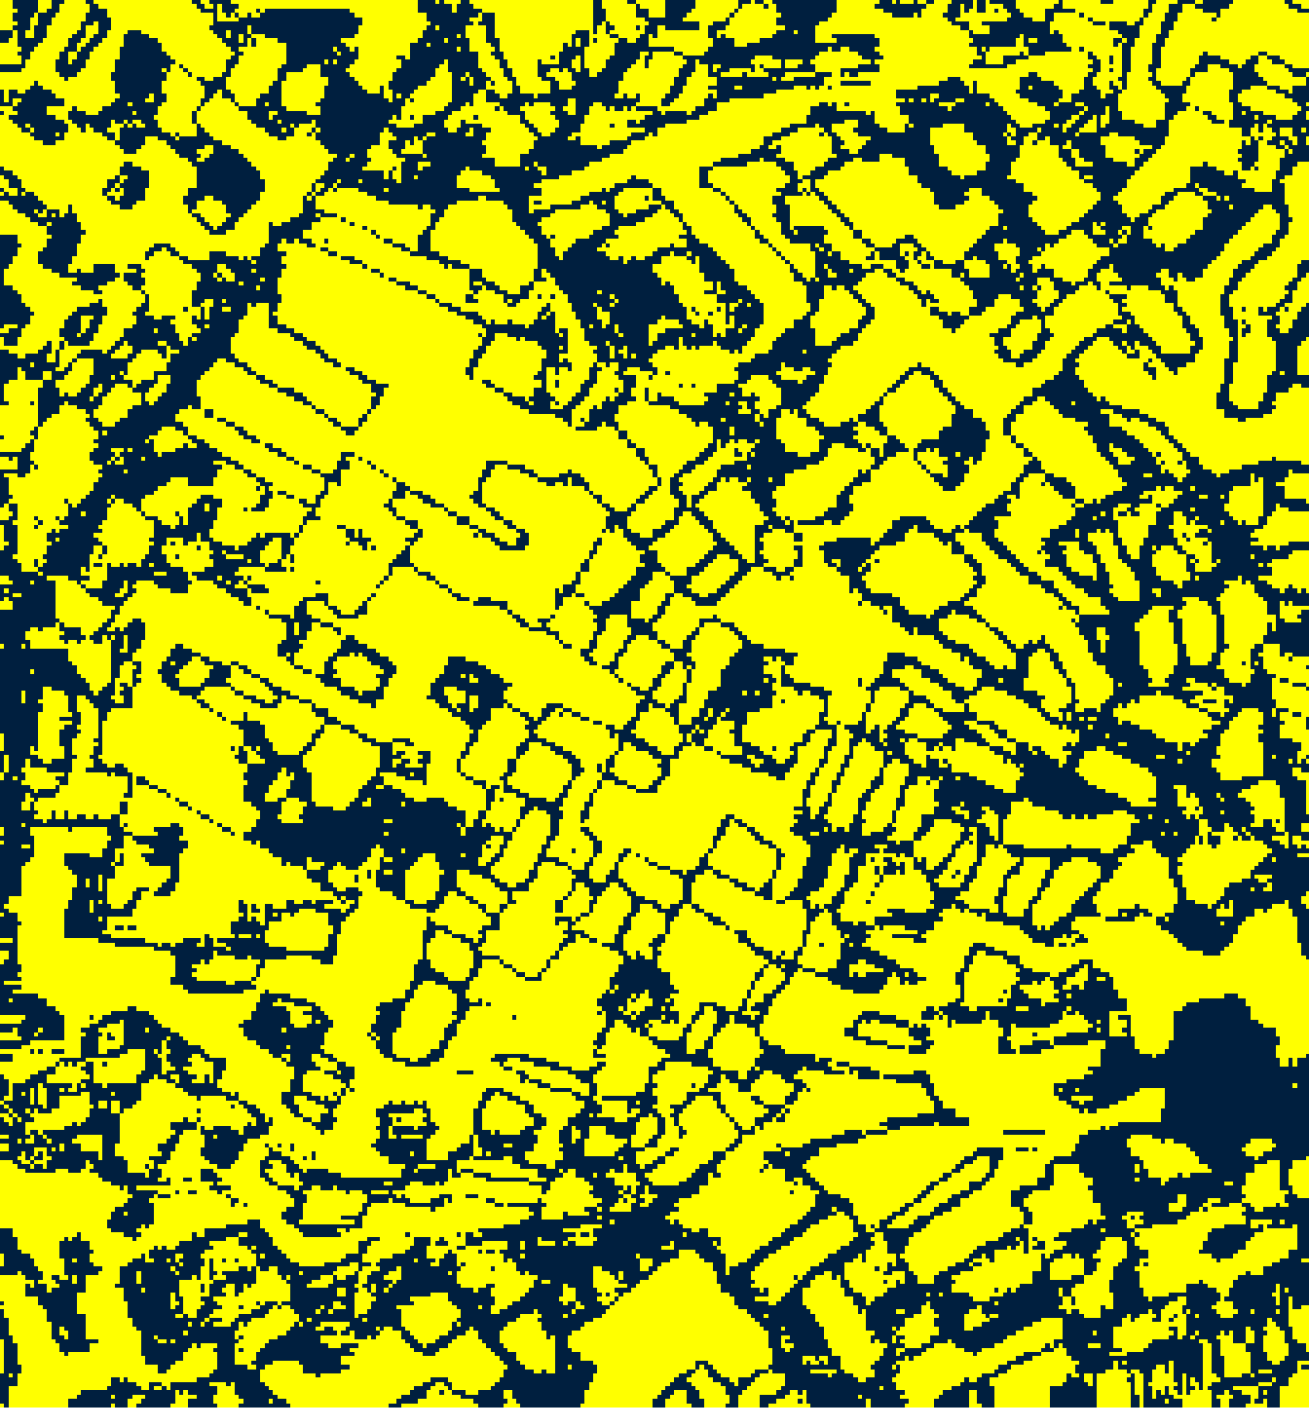  (A) MambaHSI-Small | 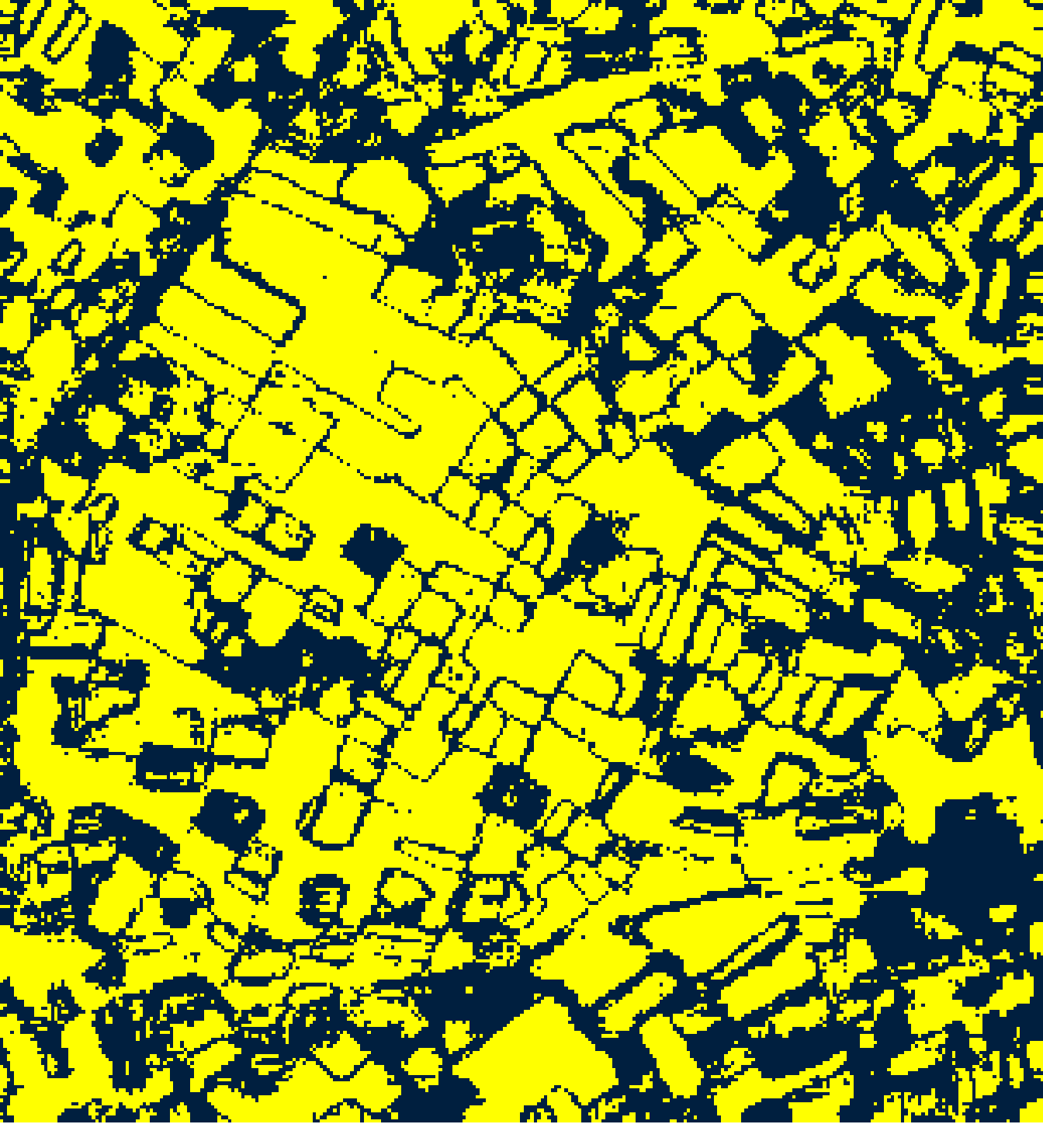  (B) MambaHSI-Base
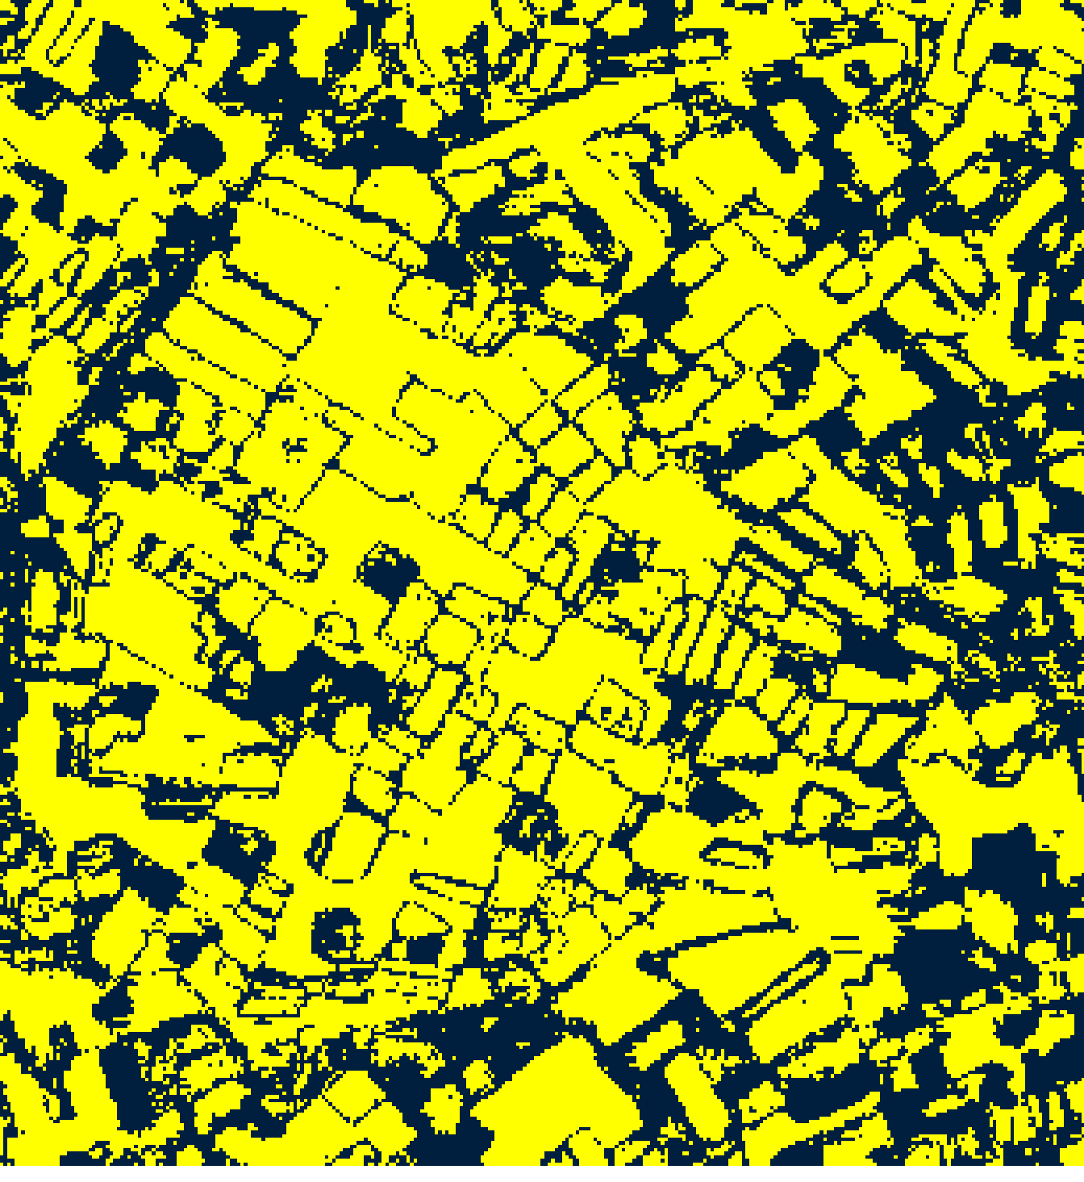  (C) MambaHSI-Large | 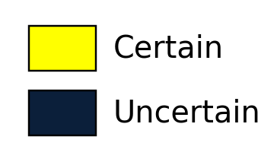  (D)
Fig. 3(a). SplitCP 95% binary uncertainty maps: (A) MambaHSI-Small, (B) MambaHSI-Base, (C) MambaHSI-Large. Yellow = certain singleton; dark blue = uncertain. Shared Certain/Uncertain legend shown in (D).
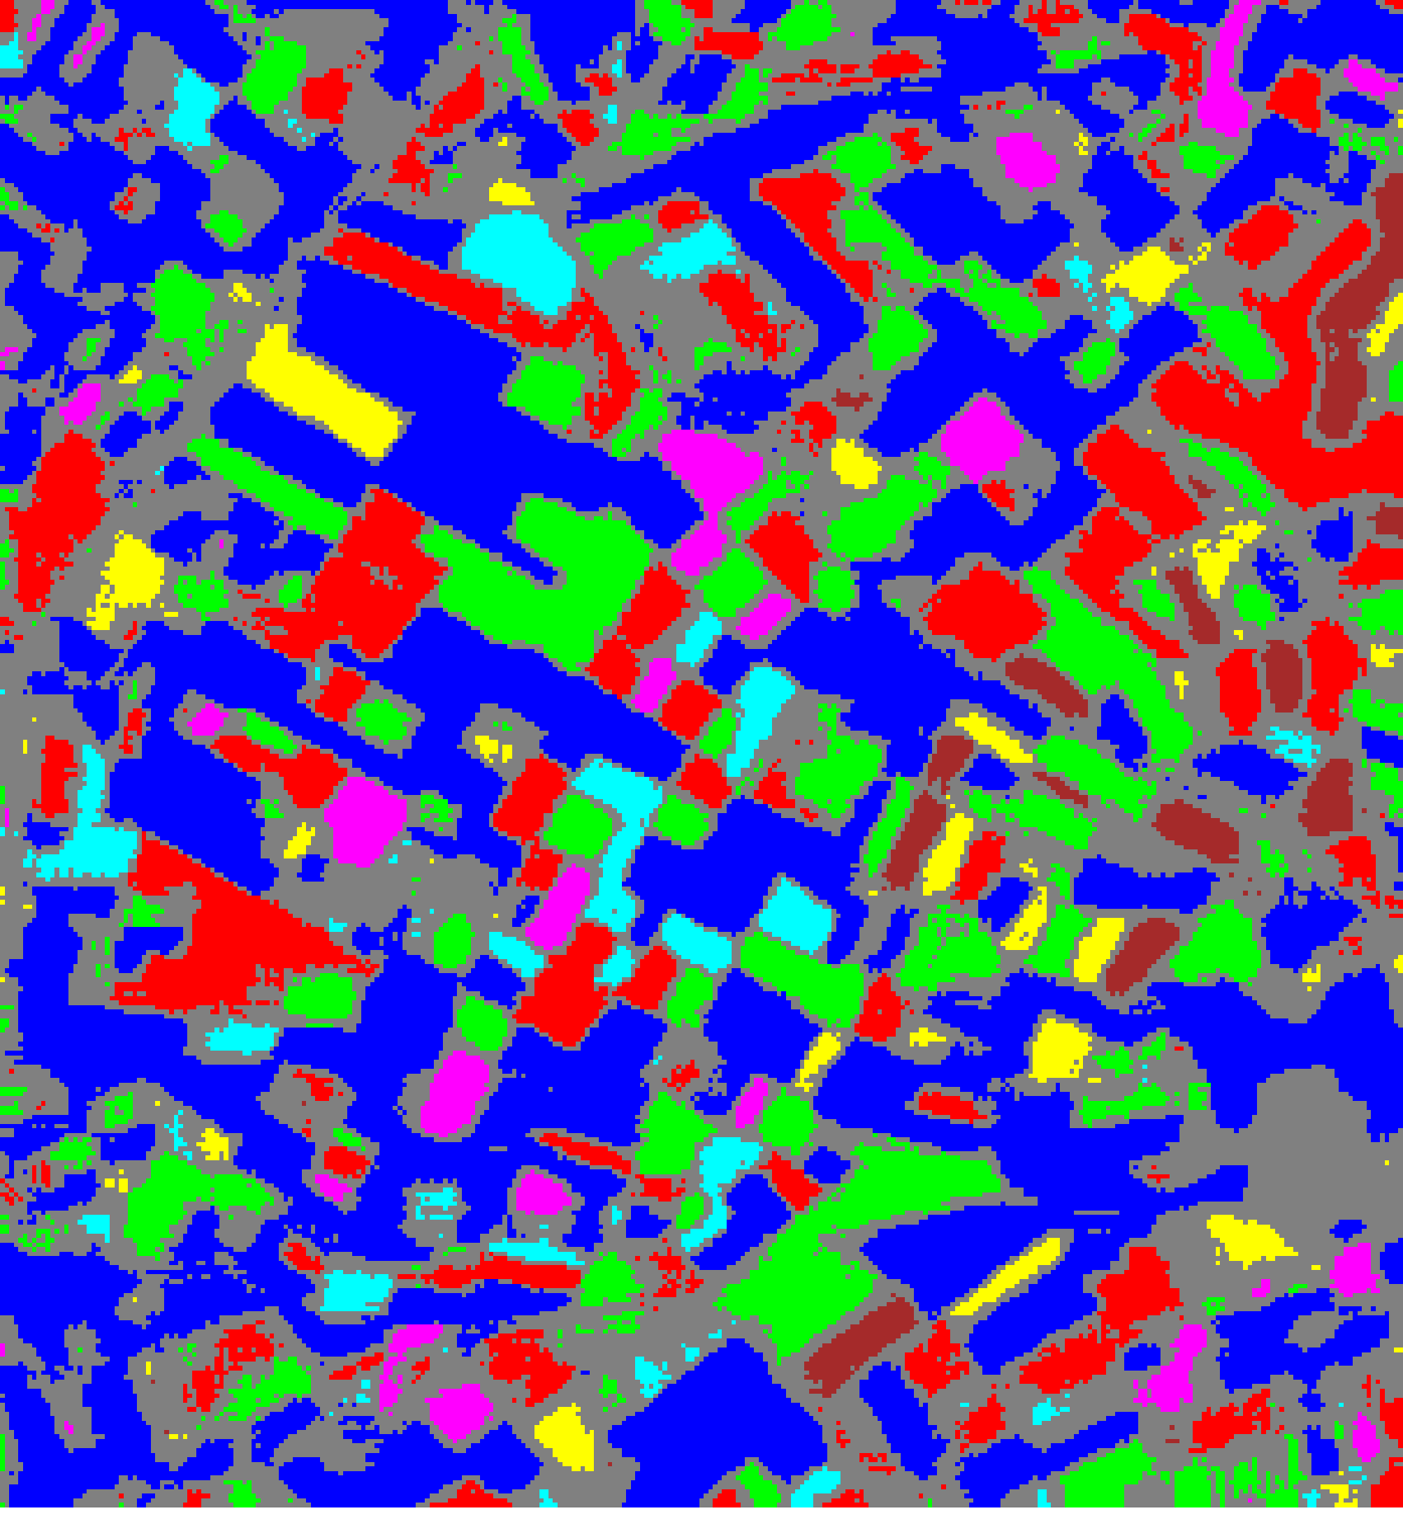  (A) MambaHSI-Small | 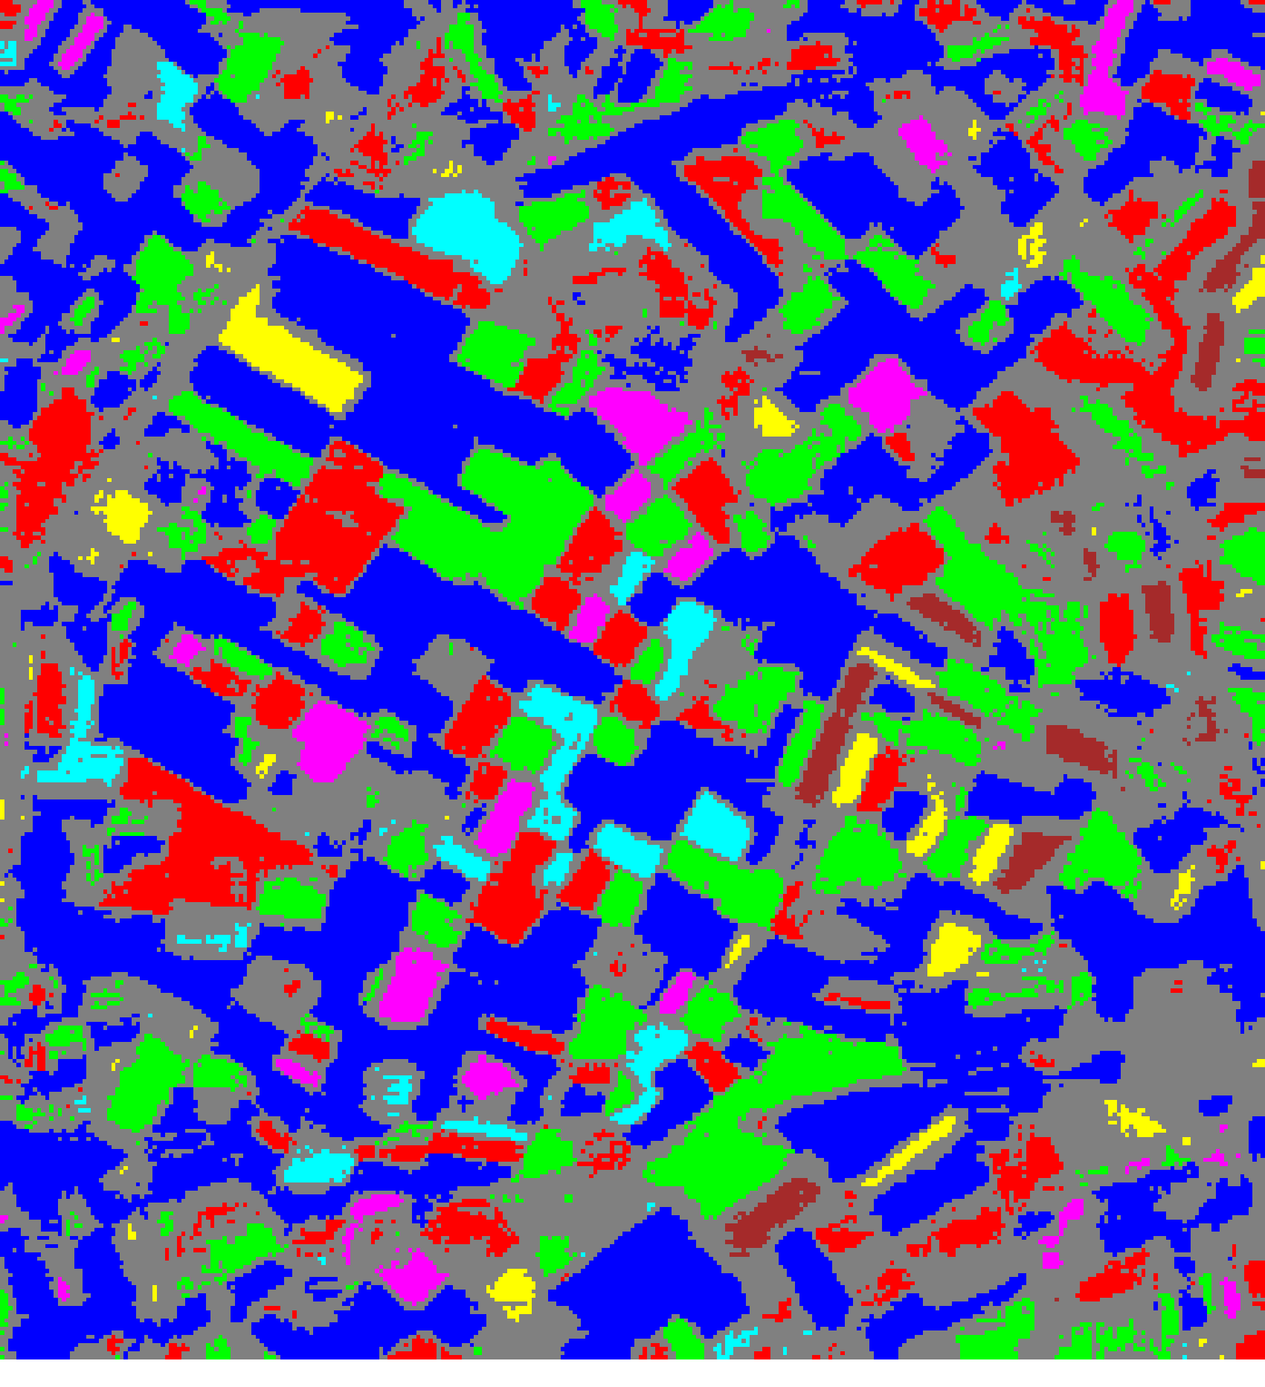  (B) MambaHSI-Base
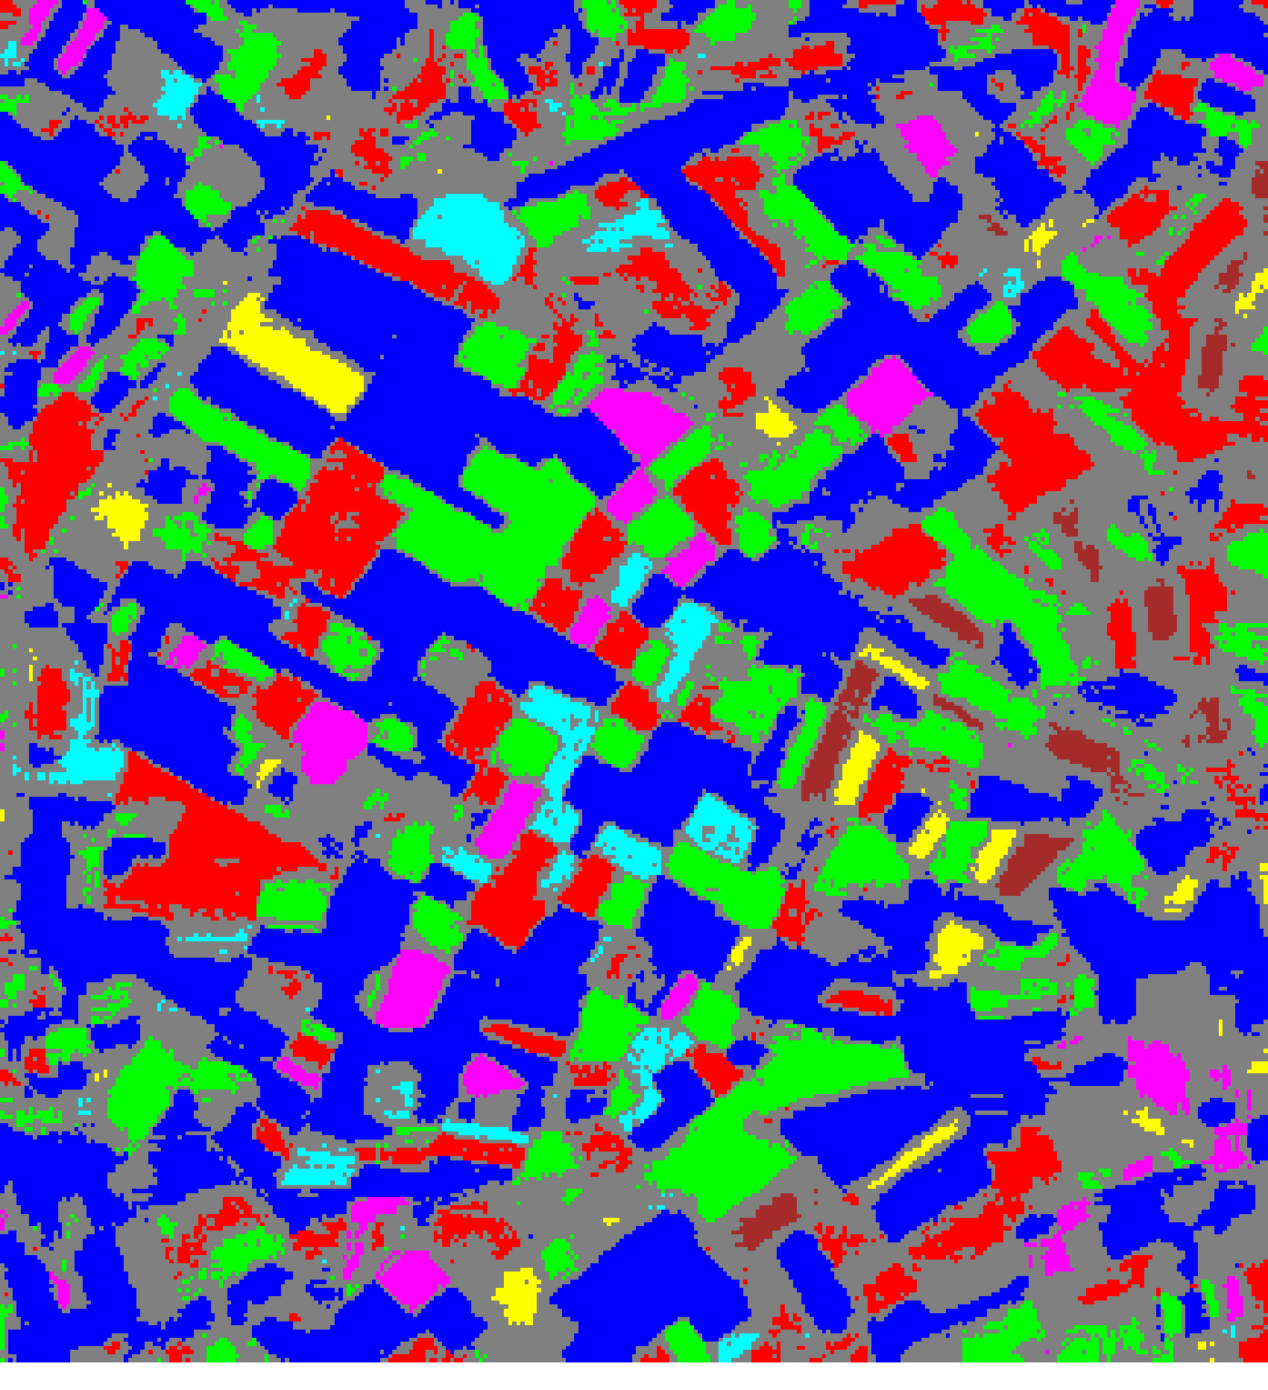
(C) MambaHSI-Large
Fig. 3(b). SplitCP 95% uncertainty masks: (A) MambaHSI-Small, (B) MambaHSI-Base, (C) MambaHSI-Large. Colours = predicted class (see shared legend, Fig. 2); grey pixels = uncertain.

2) Class-Conditional Conformal Prediction (CcCP)
Class-Conditional CP computes a separate threshold q̂_c for every class using only that class's calibration samples, directly targeting the per-class coverage shortfall exposed by SplitCP. Table VI reports the aggregate CcCP summary, Table VII the per-class coverage, Table VIII the class-wise thresholds, and Table IX the resulting pixel-count distribution.
TABLE VI
CLASS-CONDITIONAL CP (CcCP): AGGREGATE SUMMARY (α = 0.05)
Model | Emp. Cov. | Avg Set Size | Singleton Rate | Empty Set Rate | Runtime (s) | Mean Cls Cov.
MambaHSI_Small | 0.9615 | 0.9615 | 0.9615 | 0.0385 | 1.508 | 0.9644
MambaHSI_Base | 0.9657 | 0.9657 | 0.9657 | 0.0343 | 1.524 | 0.9652
MambaHSI_Large | 0.9675 | 0.9675 | 0.9675 | 0.0325 | 2.394 | 0.9684
CcCP raises mean per-class coverage above SplitCP for every variant (0.9644, 0.9652, and 0.9684 for Small, Base, and Large respectively, versus 0.9393, 0.9385, and 0.9282 under SplitCP), confirming that class-stratified calibration directly addresses the minority-class coverage deficit. MambaHSI_Large achieves the highest empirical coverage of the three (96.75%).
TABLE VII
CcCP: PER-CLASS COVERAGE COMPARISON ACROSS MODELS
Class | MambaHSI_Small Cov. | MambaHSI_Base Cov. | MambaHSI_Large Cov.
Class 0 | 0.9628 | 0.9716 | 0.9694
Class 1 | 0.9559 | 0.9736 | 0.9648
Class 2 | 0.9497 | 0.9441 | 0.9525
Class 3 | 1.0000 | 0.9551 | 1.0000
Class 4 | 0.9615 | 0.9615 | 0.9904
Class 5 | 0.9505 | 0.9505 | 0.9604
Class 6 | 0.9706 | 1.0000 | 0.9412
Table VIII lists the class-wise conformal thresholds. Class 3, the smallest majority class group under this split, requires a substantially wider threshold for MambaHSI_Small (0.2609) than for MambaHSI_Base (0.0435) or MambaHSI_Large (0.0833), reflecting lower model confidence at the smallest capacity setting for this class; Class 6, the minority class with only 68 calibration samples, likewise requires wide thresholds across all three models (0.2183, 0.0664, and 0.0496 respectively).
TABLE VIII
CcCP: CLASS-WISE CONFORMAL THRESHOLDS (q̂_c) PER MODEL
Class | MambaHSI_Small q̂_c | MambaHSI_Base q̂_c | MambaHSI_Large q̂_c
Class 0 | 0.036921 | 0.026060 | 0.023709
Class 1 | 0.143463 | 0.037217 | 0.027957
Class 2 | 0.098714 | 0.038760 | 0.036446
Class 3 | 0.260939 | 0.043461 | 0.083279
Class 4 | 0.123458 | 0.053694 | 0.034990
Class 5 | 0.042232 | 0.028776 | 0.037211
Class 6 | 0.218304 | 0.066406 | 0.049570
TABLE IX
CcCP: PREDICTED PIXEL COUNT DISTRIBUTION PER MODEL
Class / Region | MambaHSI_Small Pixels | MambaHSI_Base Pixels | MambaHSI_Large Pixels
Class 0 | 31,688 | 30,330 | 31,231
Class 1 | 12,506 | 11,700 | 11,640
Class 2 | 11,910 | 10,496 | 12,185
Class 3 | 3,959 | 2,460 | 3,072
Class 4 | 2,724 | 2,644 | 3,118
Class 5 | 1,800 | 1,386 | 1,519
Class 6 | 2,322 | 1,544 | 1,335
Uncertain | 34,401 | 40,750 | 37,210
Total (Labelled + Uncertain) | 101,310 | 101,310 | 101,310
The CcCP uncertain-pixel counts (34,401 for Small, 40,750 for Base, 37,210 for Large) are lower than the corresponding SplitCP counts for the Small and Large variants, while remaining essentially unchanged for Base, confirming that class-stratified thresholds produce a more class-discriminative uncertainty map — confident classes receive tighter thresholds and fewer uncertain pixels, while less confident classes are permitted proportionally wider coverage regions.
CcCP thresholds are applied pixel-wise over the full scene for all three MambaHSI variants. Binary maps (yellow = certain singleton, dark blue = uncertain) and masked class maps (grey = uncertain, colours = predicted class) are shown in Fig. 4.
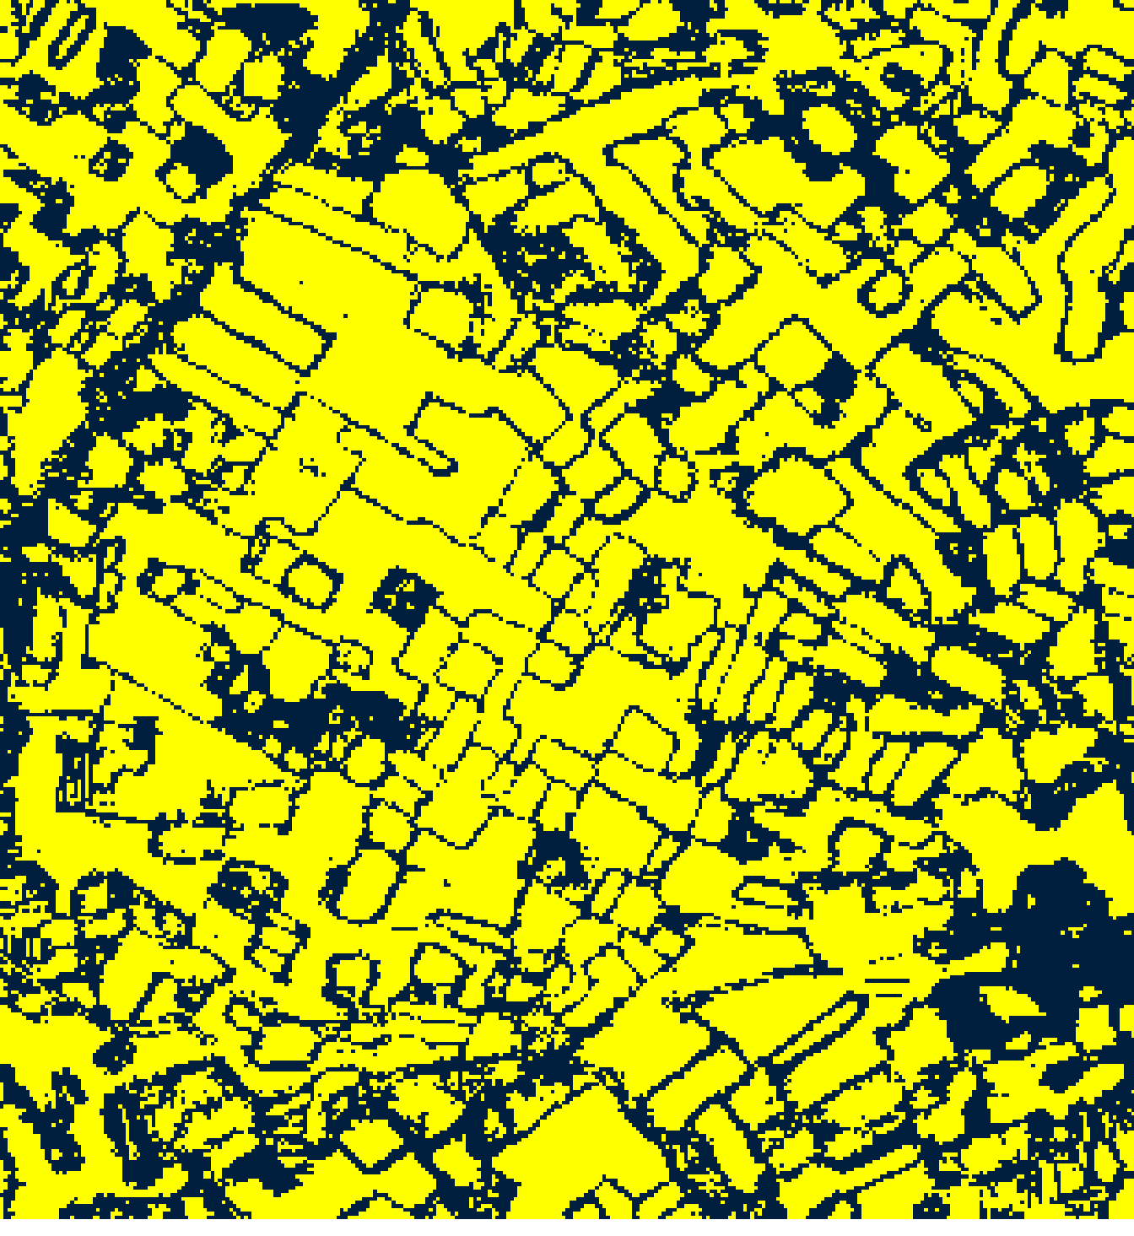  (A) MambaHSI-Small | 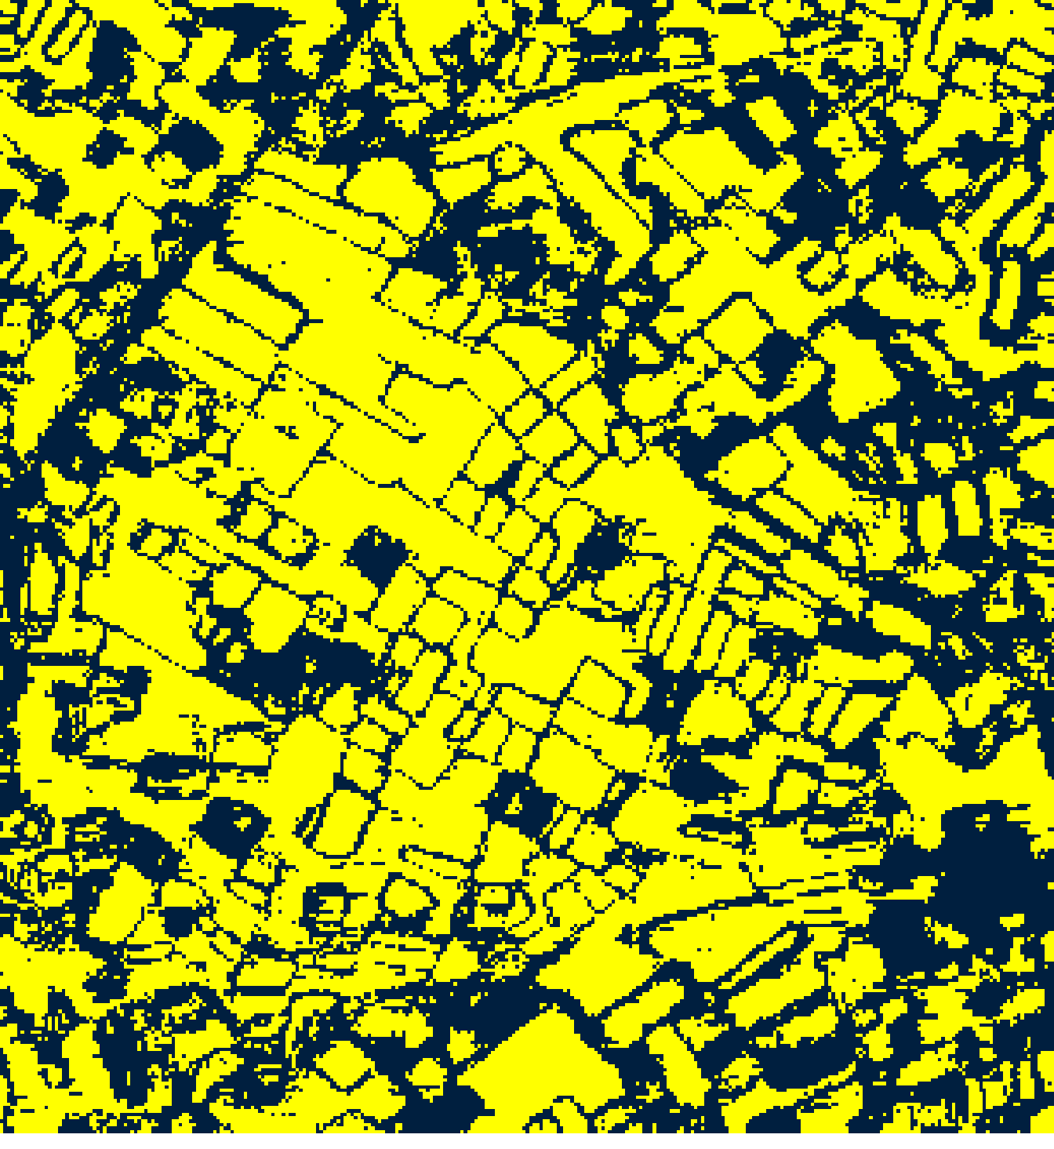  (B) MambaHSI-Base
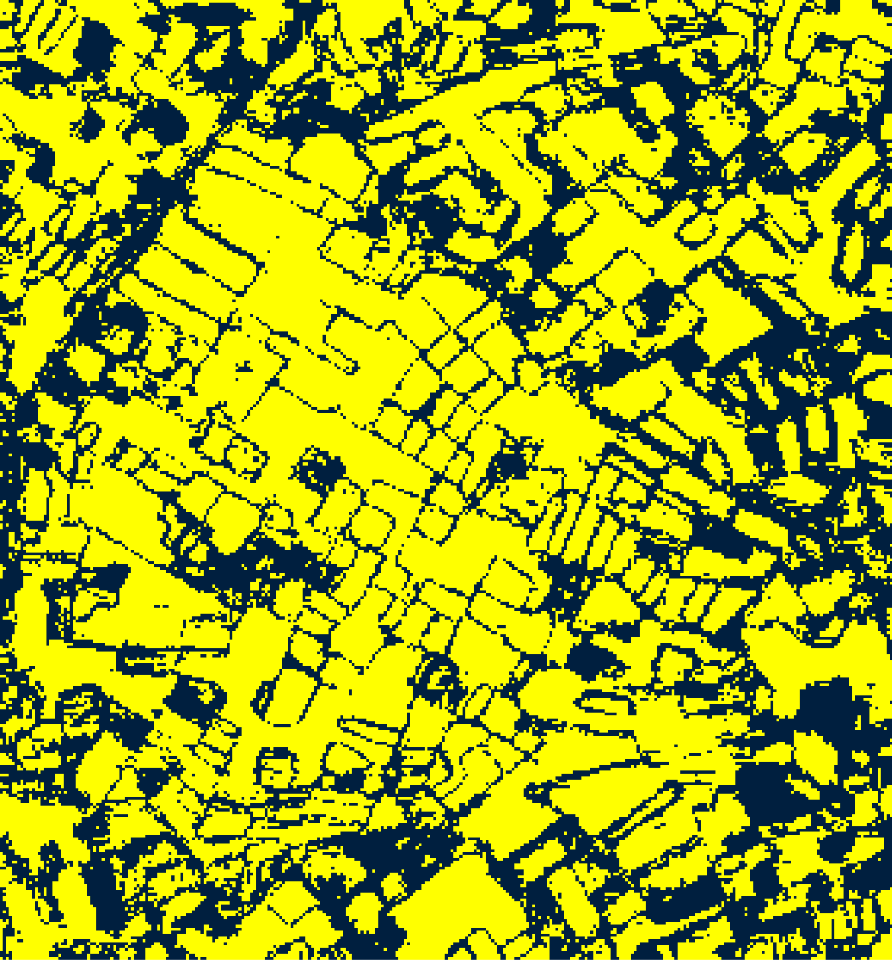  (C) MambaHSI-Large |   (D)
Fig. 4(a). CcCP 95% binary uncertainty maps: (A) MambaHSI-Small, (B) MambaHSI-Base, (C) MambaHSI-Large. Yellow = certain singleton; dark blue = uncertain. Shared Certain/Uncertain legend shown in (D).
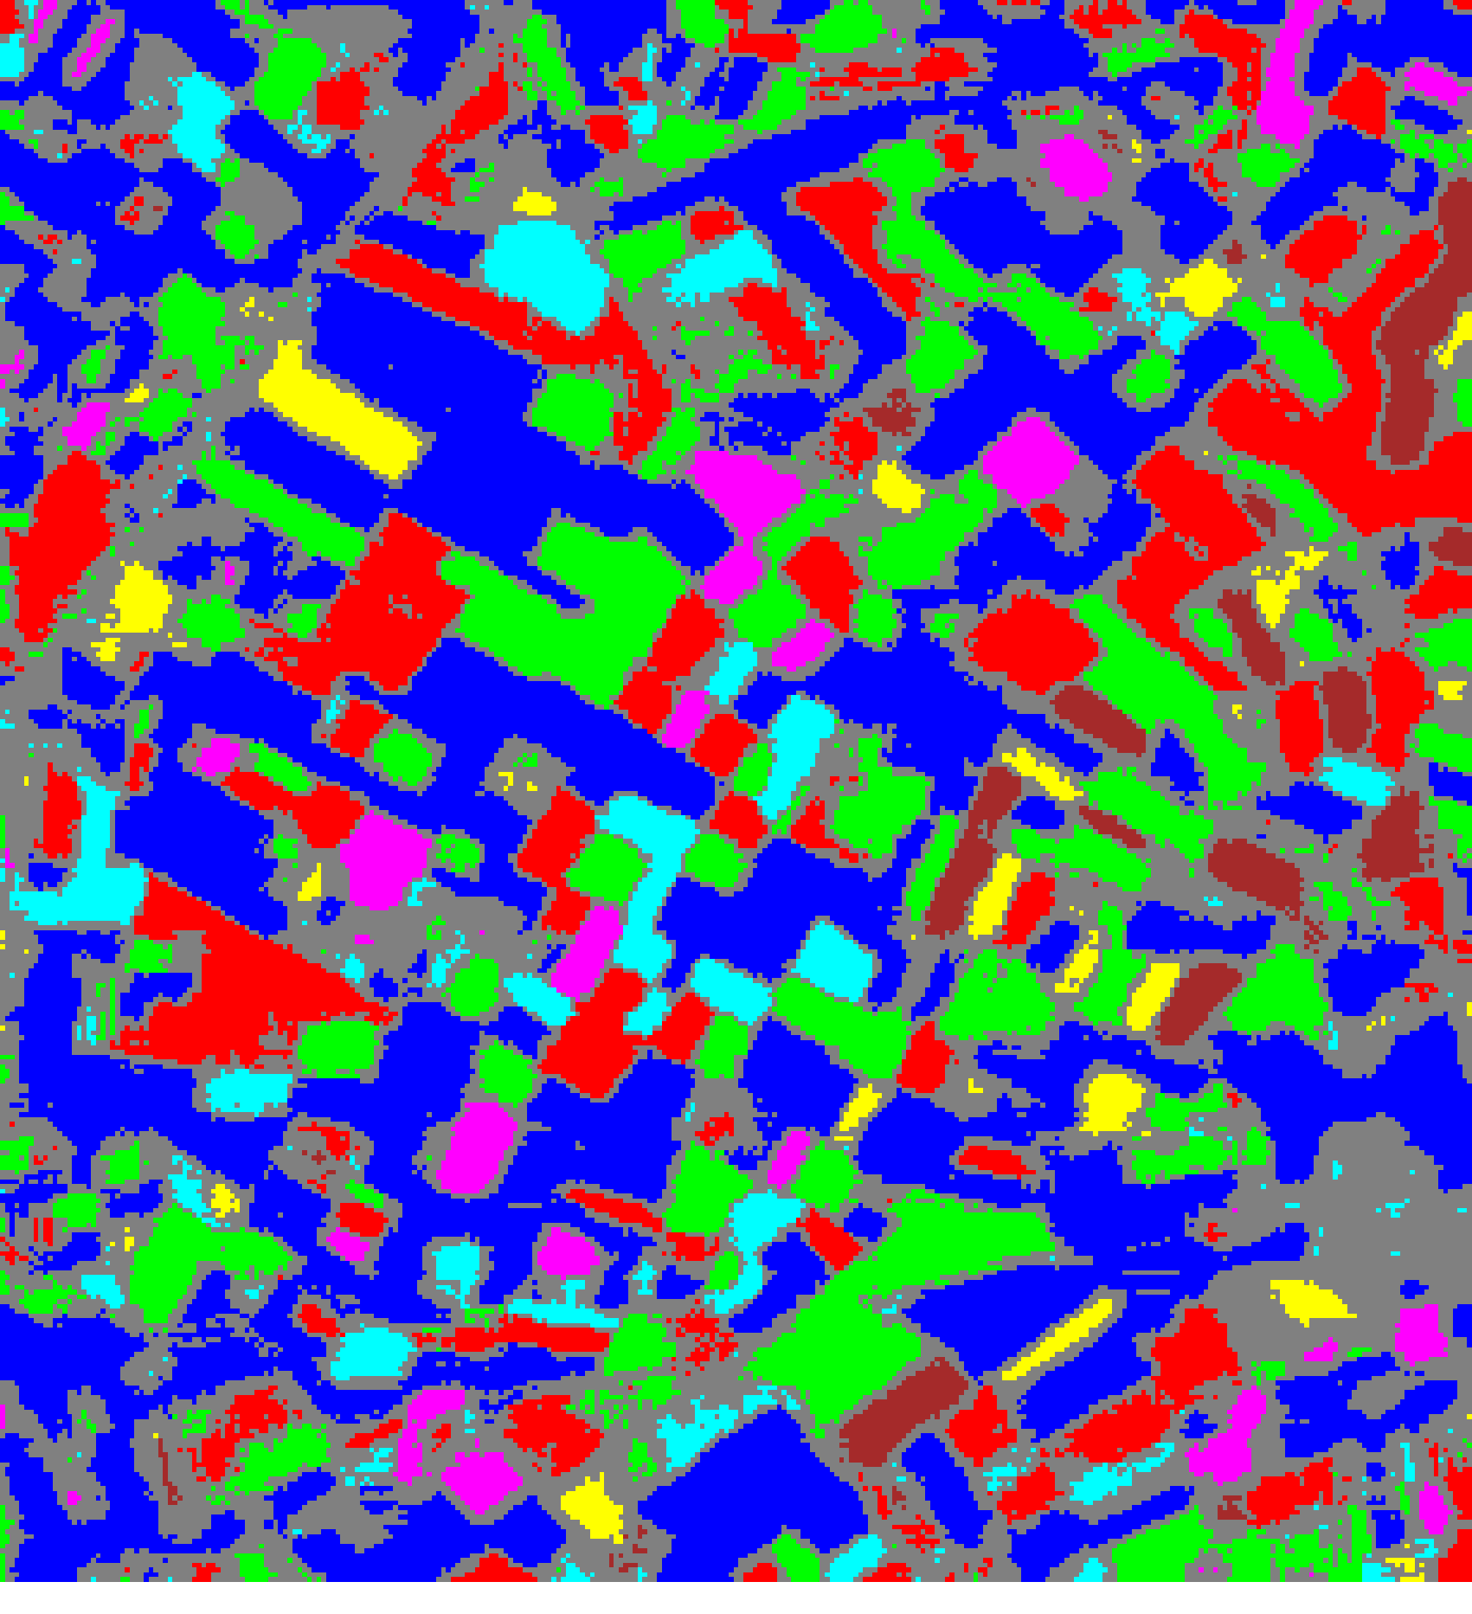  (A) MambaHSI-Small | 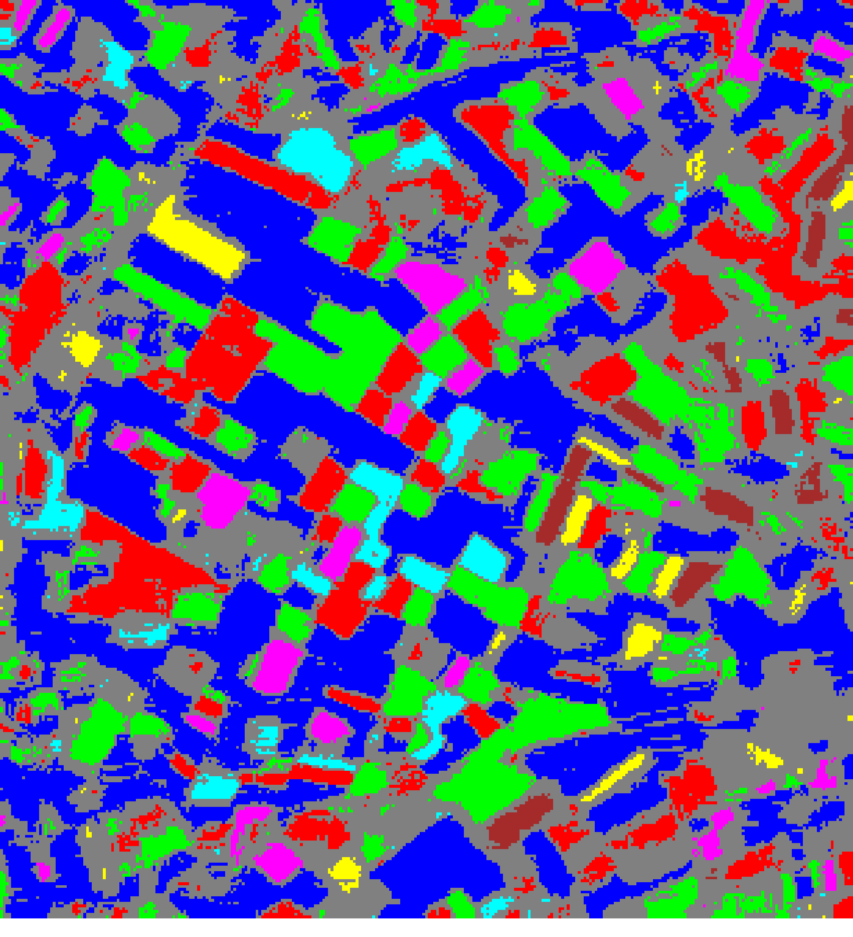  (B) MambaHSI-Base
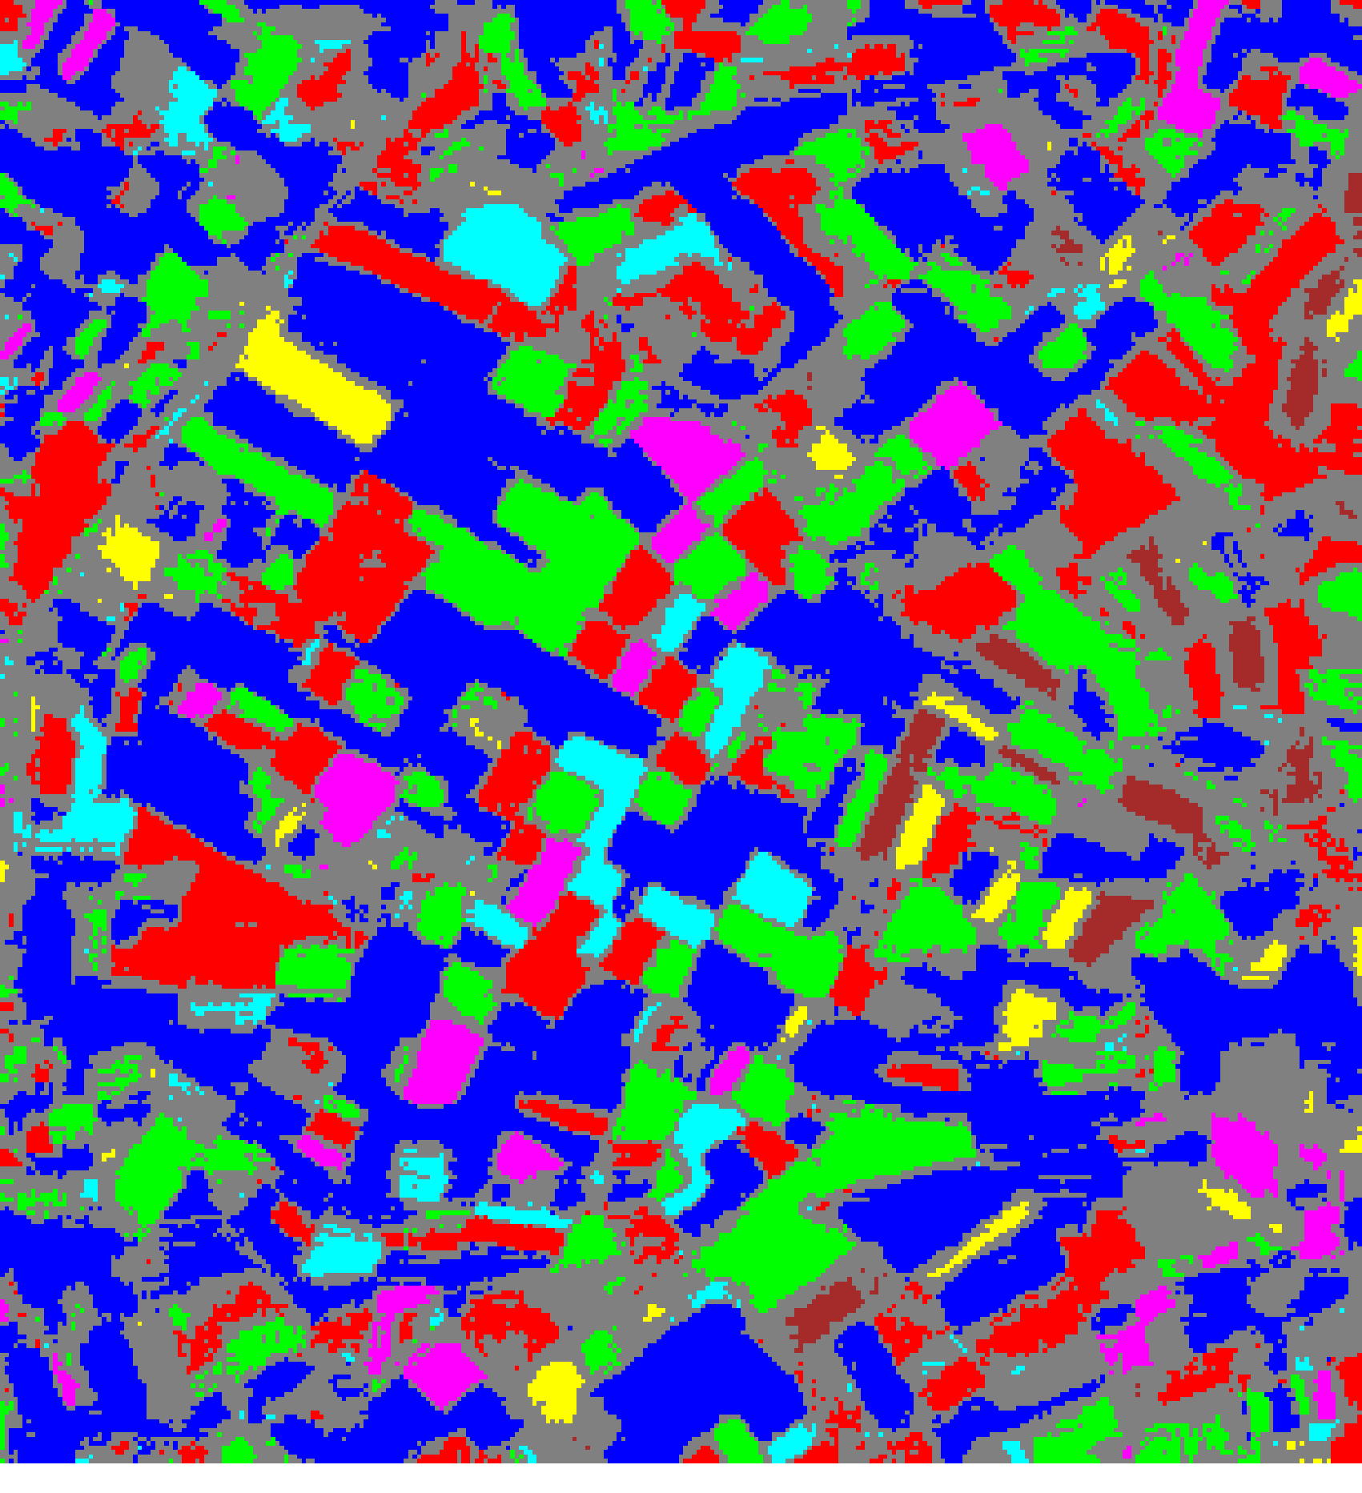
(C) MambaHSI-Large
Fig. 4(b). CcCP 95% uncertainty masks: (A) MambaHSI-Small, (B) MambaHSI-Base, (C) MambaHSI-Large. Colours = predicted class (see shared legend, Fig. 2); grey pixels = uncertain.

3) Rank-Calibrated Class-Conditional CP (RC3P)
RC3P augments CcCP with a per-class rank gate k̂(y) that restricts each class's prediction set to its k̂(y) most probable classes, in addition to the per-class conformal threshold, minimising average set size while preserving class-conditional coverage. Table X presents the aggregate RC3P summary, Table XI the per-class coverage comparison, Table XII the per-class thresholds and rank limits, and Table XIII the pixel-count distribution.
TABLE X
RC3P: AGGREGATE SUMMARY (α = 0.05)
Model | Emp. Cov. | Avg Set Size | Singleton Rate | Empty Set Rate | Runtime (s) | Mean Cls Cov.
MambaHSI_Small | 0.9675 | 0.9675 | 0.9675 | 0.0325 | 1.472 | 0.9706
MambaHSI_Base | 0.9680 | 0.9680 | 0.9680 | 0.0320 | 1.521 | 0.9700
MambaHSI_Large | 0.9726 | 0.9726 | 0.9726 | 0.0274 | 1.896 | 0.9721
RC3P achieves the highest mean per-class coverage of the four rank-1 (non-RAPS) methods for every variant — 0.9706, 0.9700, and 0.9721 for Small, Base, and Large — and MambaHSI_Large attains the highest empirical coverage of any non-RAPS method evaluated in this study (97.26%).
TABLE XI
RC3P: PER-CLASS COVERAGE COMPARISON ACROSS MODELS
Class | MambaHSI_Small Cov. | MambaHSI_Base Cov. | MambaHSI_Large Cov.
Class 0 | 0.9661 | 0.9726 | 0.9759
Class 1 | 0.9626 | 0.9736 | 0.9692
Class 2 | 0.9637 | 0.9469 | 0.9581
Class 3 | 1.0000 | 0.9551 | 1.0000
Class 4 | 0.9808 | 0.9712 | 1.0000
Class 5 | 0.9505 | 0.9703 | 0.9604
Class 6 | 0.9706 | 1.0000 | 0.9412
TABLE XII
RC3P: PER-CLASS CONFORMAL THRESHOLDS (q̂) AND RANK LIMITS (k̂)
Class | Small q̂ | Small k̂ | Base q̂ | Base k̂ | Large q̂ | Large k̂
Class 0 | 0.038559 | 1 | 0.026293 | 1 | 0.024110 | 1
Class 1 | 0.155780 | 1 | 0.040198 | 1 | 0.028463 | 1
Class 2 | 0.141065 | 1 | 0.039233 | 1 | 0.039115 | 1
Class 3 | 0.261871 | 1 | 0.043500 | 1 | 0.103236 | 1
Class 4 | 0.258088 | 1 | 0.059633 | 1 | 0.045979 | 1
Class 5 | 0.046329 | 1 | 0.037153 | 1 | 0.038291 | 1
Class 6 | 0.218304 | 1 | 0.066406 | 1 | 0.049570 | 1
The rank limit k̂(y) = 1 for every class under every model, confirming that — given the high accuracy achieved by all three MambaHSI variants — a singleton prediction set already suffices to meet the 95% class-conditional coverage target, and RC3P's average-set-size reduction over CcCP is realised entirely through tighter per-class thresholds rather than admitting additional top-k classes.
TABLE XIII
RC3P: PREDICTED PIXEL COUNT DISTRIBUTION PER MODEL
Class / Region | MambaHSI_Small Pixels | MambaHSI_Base Pixels | MambaHSI_Large Pixels
Class 0 | 31,954 | 30,521 | 31,587
Class 1 | 12,786 | 12,003 | 11,777
Class 2 | 12,856 | 10,579 | 12,526
Class 3 | 3,967 | 2,462 | 3,258
Class 4 | 3,301 | 2,717 | 3,319
Class 5 | 1,863 | 1,564 | 1,545
Class 6 | 2,322 | 1,544 | 1,335
Uncertain | 32,261 | 39,920 | 35,963
Total (Labelled + Uncertain) | 101,310 | 101,310 | 101,310
RC3P produces the fewest uncertain pixels of the three full-scene, pixel-accounted methods (SplitCP, CcCP, RC3P) for every variant (32,261 for Small, 39,920 for Base, 35,963 for Large), demonstrating that the rank-gating mechanism yields a modest but consistent reduction in the uncertain-pixel footprint relative to CcCP without sacrificing coverage.
RC3P thresholds are applied pixel-wise over the full scene for all three MambaHSI variants. Binary maps (yellow = certain singleton, dark blue = uncertain) and masked class maps (grey = uncertain, colours = predicted class) are shown in Fig. 5.
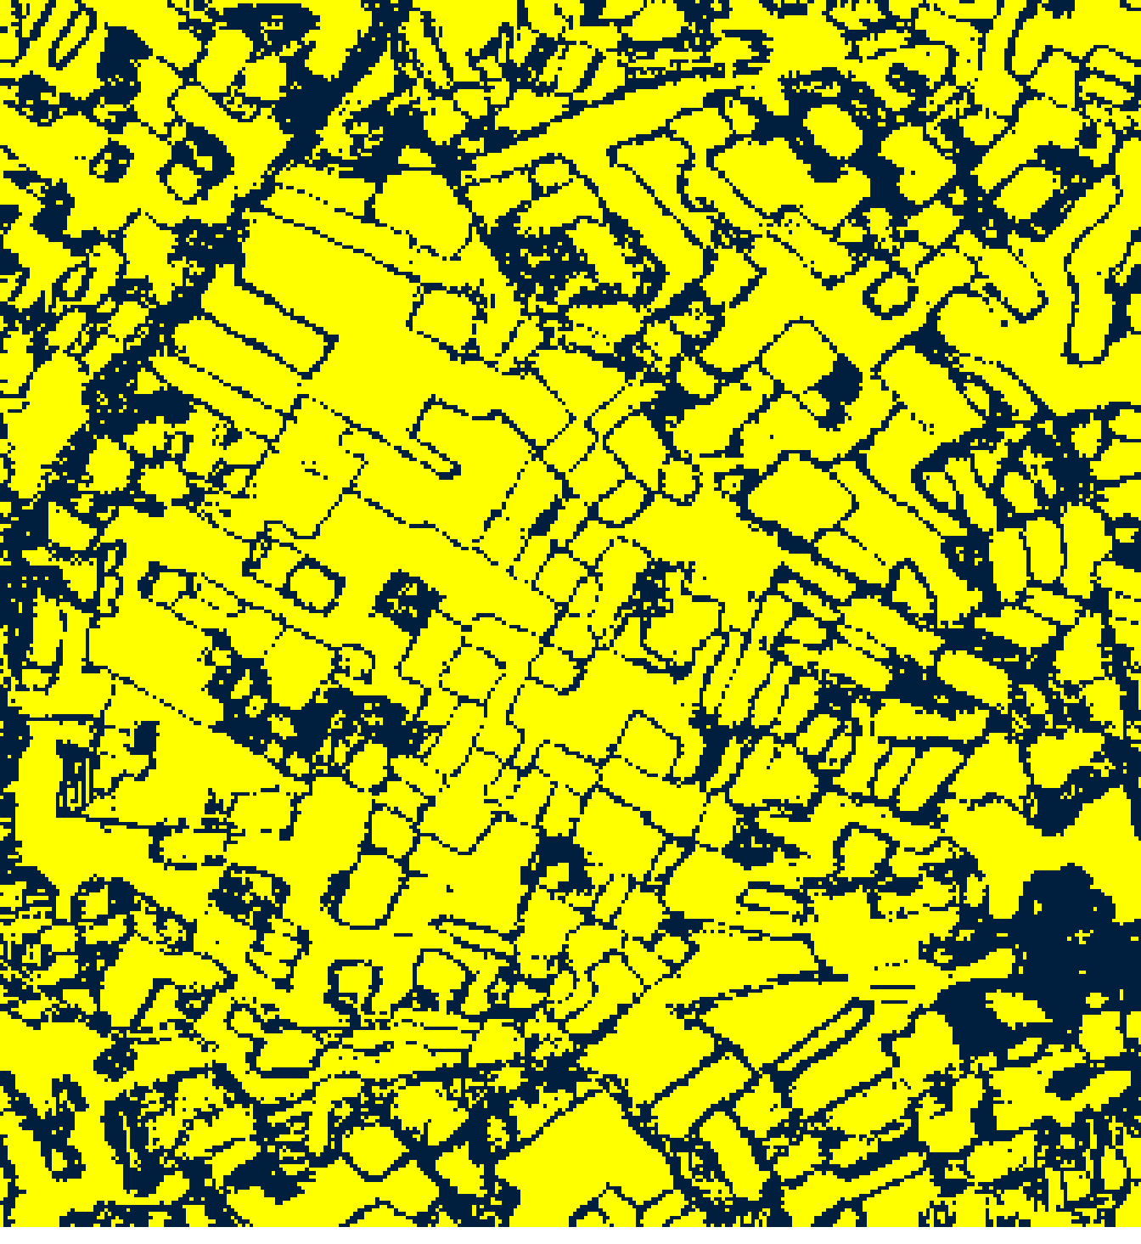  (A) MambaHSI-Small | 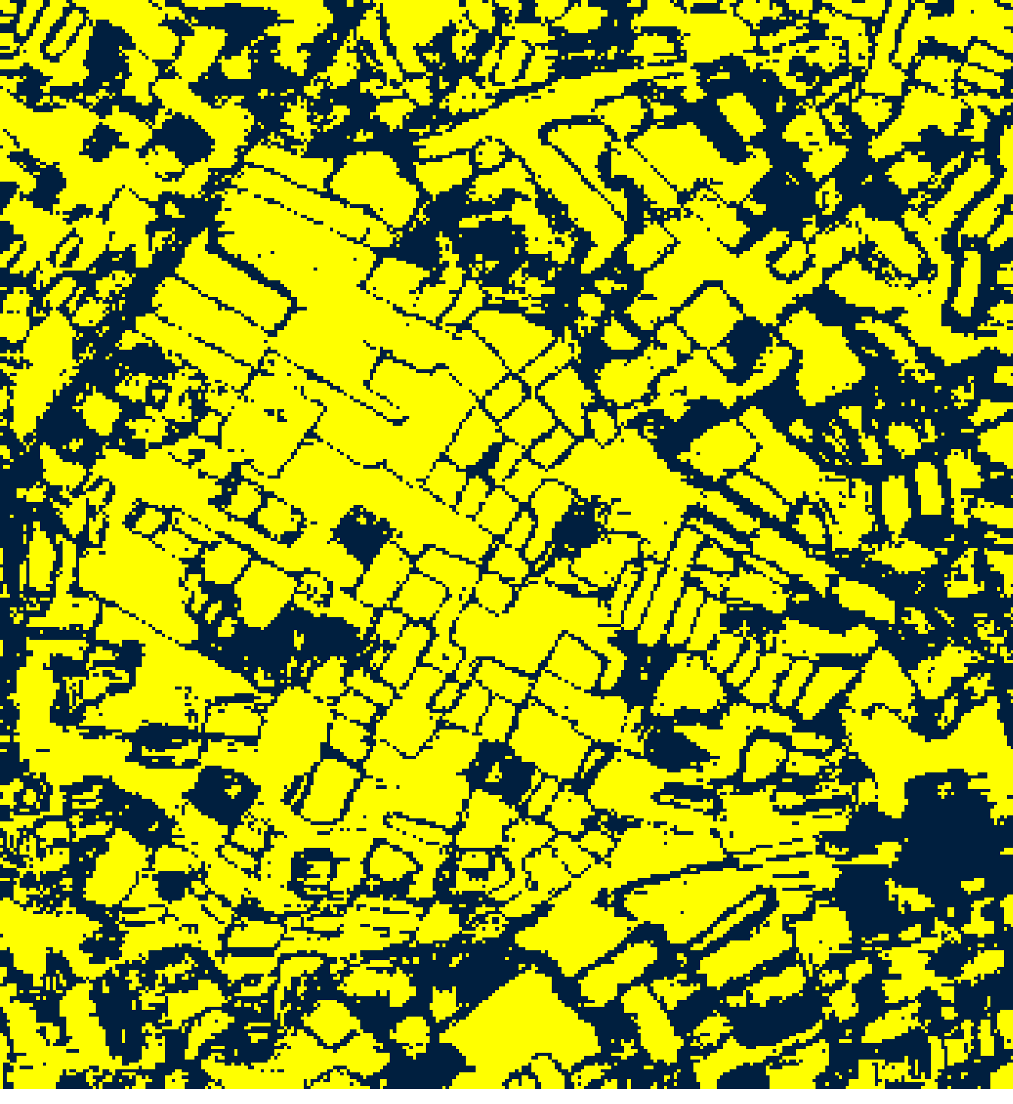  (B) MambaHSI-Base
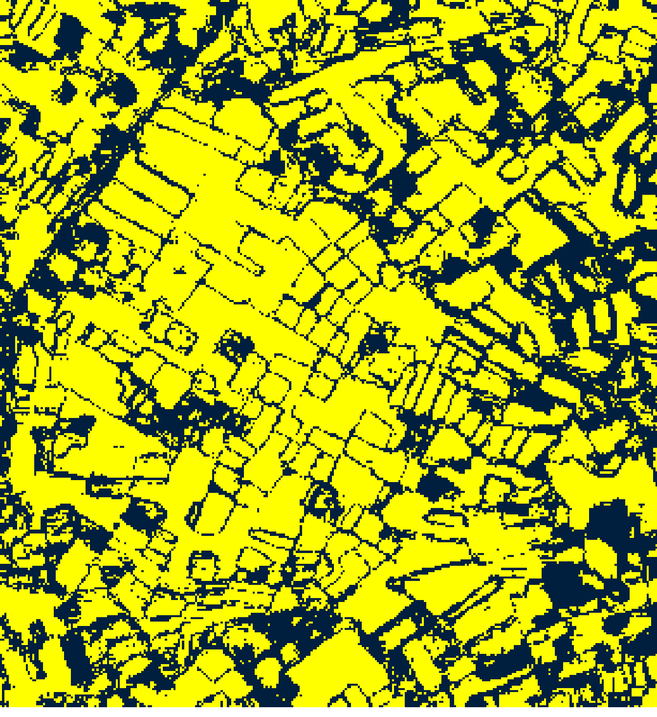  (C) MambaHSI-Large |   (D)
Fig. 5(a). RC3P 95% binary uncertainty maps: (A) MambaHSI-Small, (B) MambaHSI-Base, (C) MambaHSI-Large. Yellow = certain singleton; dark blue = uncertain. Shared Certain/Uncertain legend shown in (D).
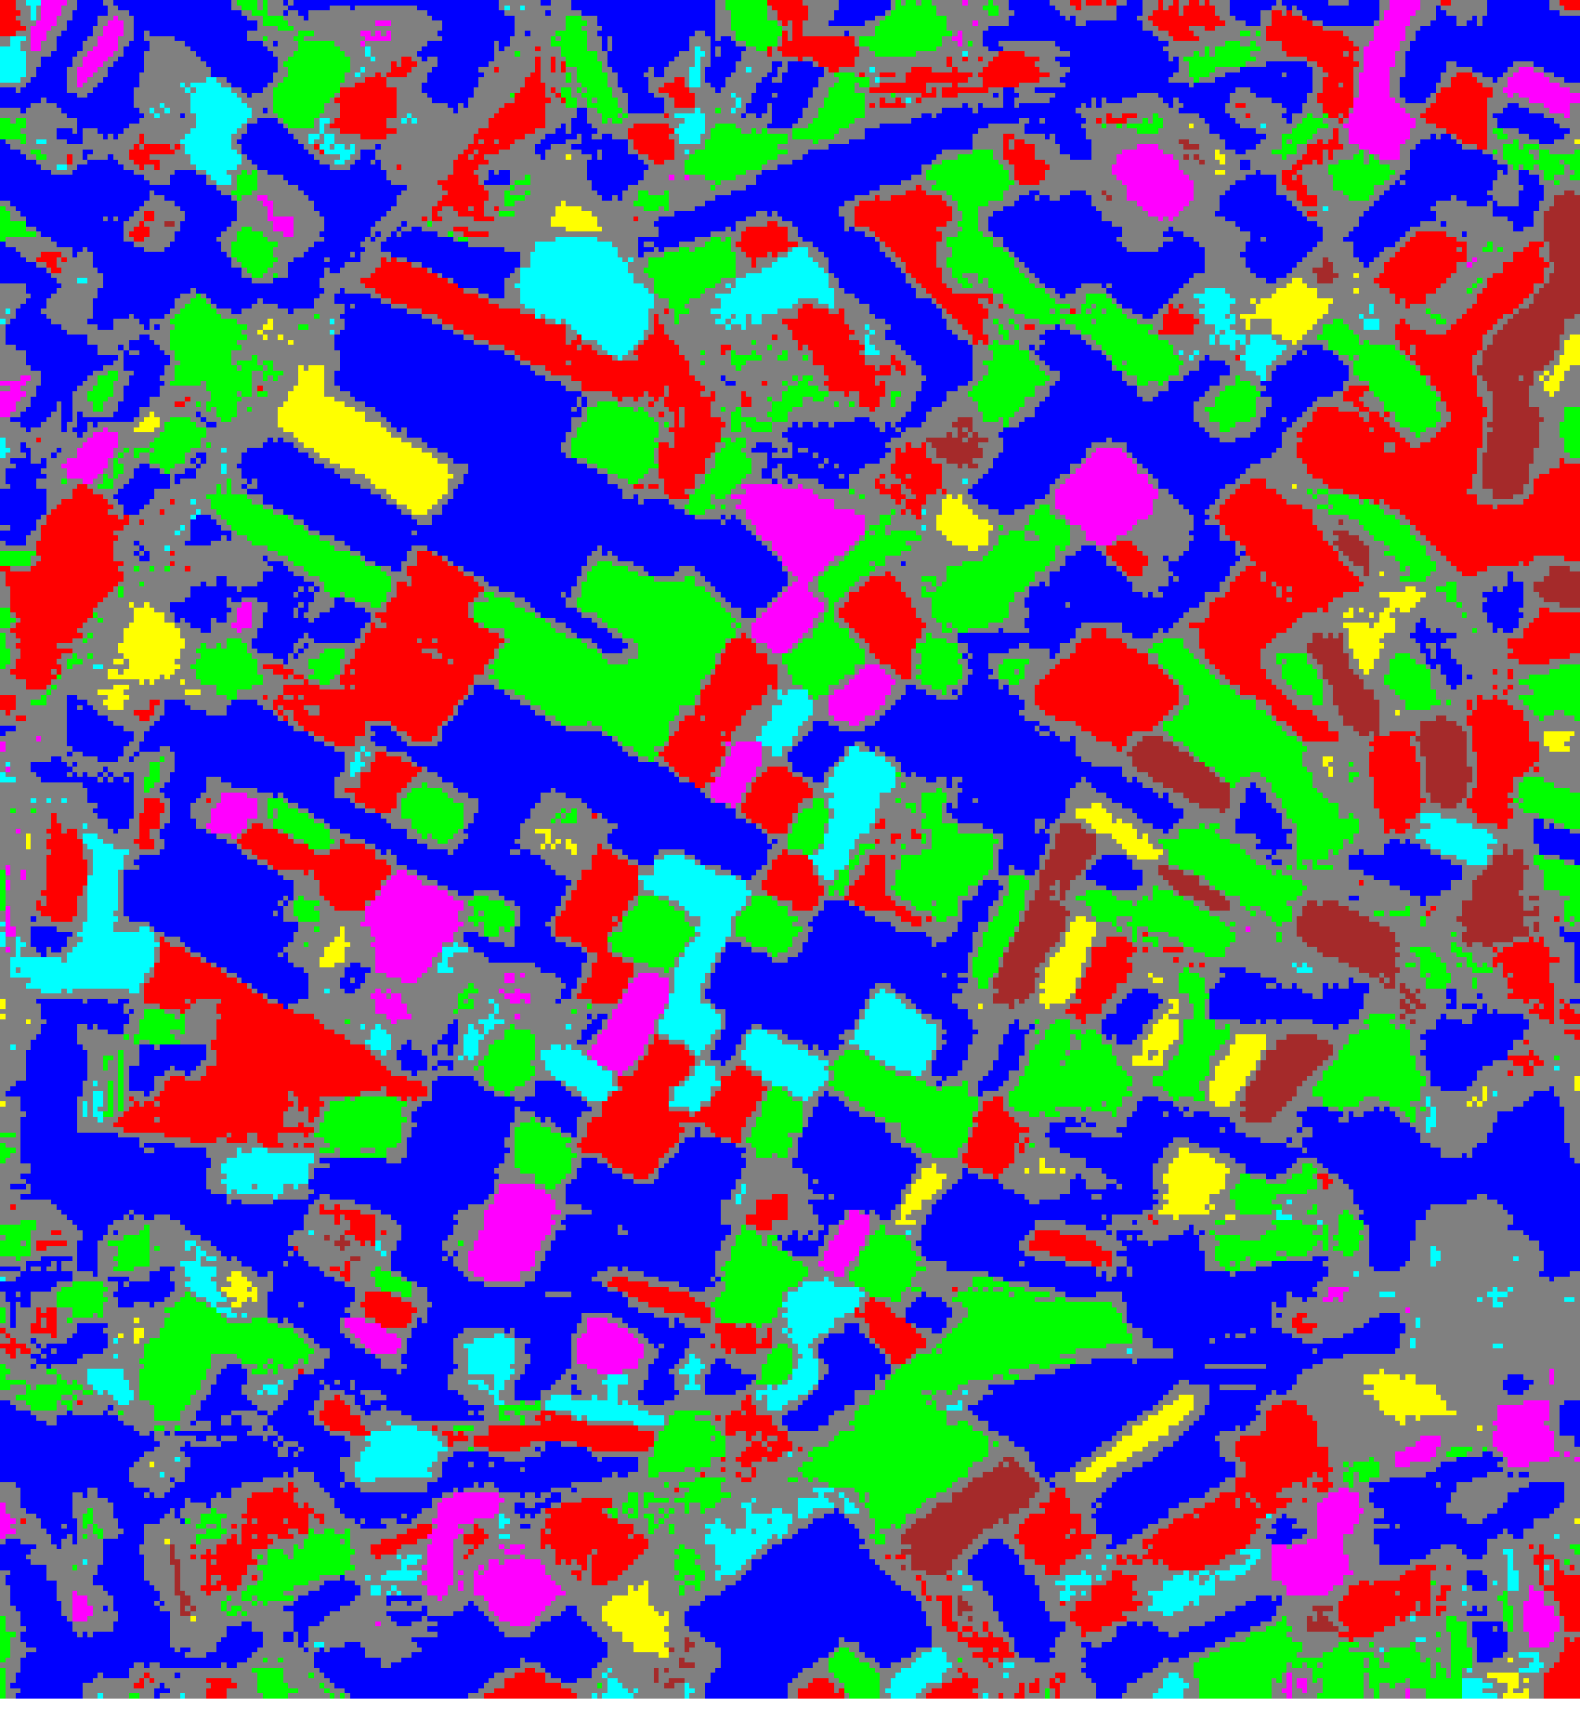  (A) MambaHSI-Small | 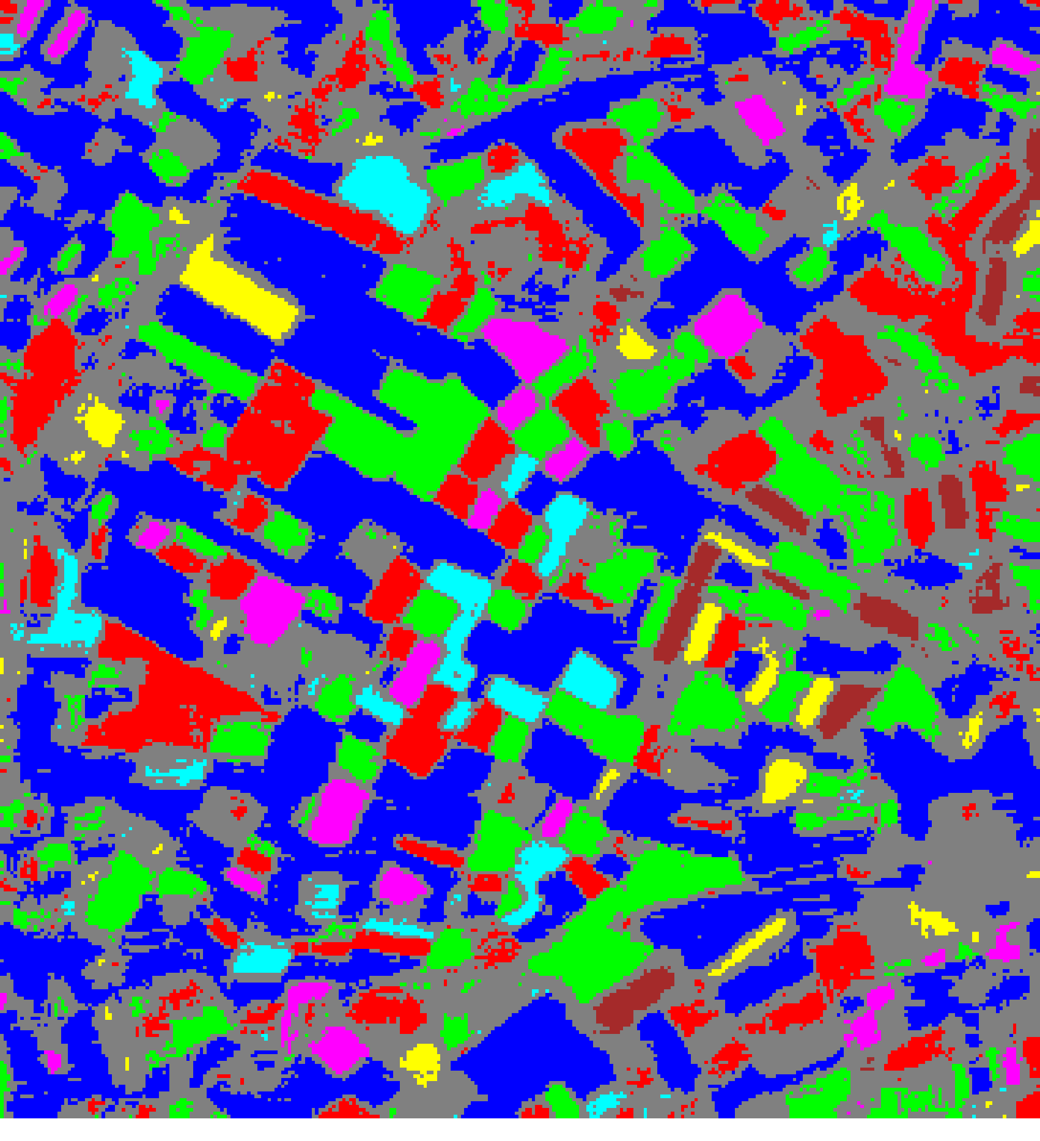  (B) MambaHSI-Base
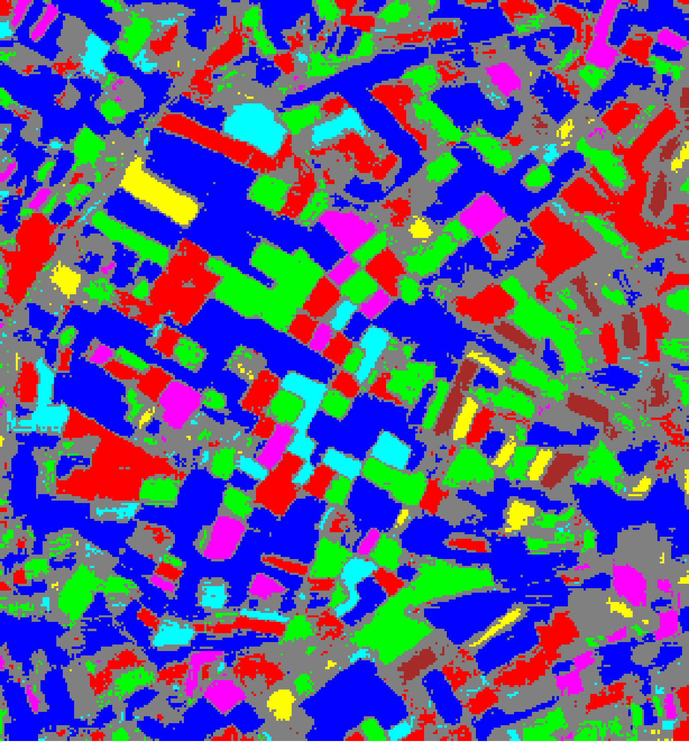
(C) MambaHSI-Large
Fig. 5(b). RC3P 95% uncertainty masks: (A) MambaHSI-Small, (B) MambaHSI-Base, (C) MambaHSI-Large. Colours = predicted class (see shared legend, Fig. 2); grey pixels = uncertain.

4) Clustered Conformal Prediction (ClCP)
ClCP groups the K = 7 classes into K_g = 4 clusters and calibrates a single threshold per cluster, pooling calibration statistics for classes with limited samples. Table XIV presents the aggregate summary, Table XV the per-class coverage, Table XVI the class-to-cluster assignments and per-cluster thresholds, and Table XVII the per-cluster mean uncertainty across models. Because ClCP's clustering is computed independently for each model (via K-Means over each model's own per-class calibration statistics), the resulting cluster memberships differ across the three MambaHSI variants.
TABLE XIV
CLUSTERED CP (ClCP): AGGREGATE SUMMARY (α = 0.05, K_g = 4)
Model | Emp. Cov. | Avg Set Size | Singleton Rate | Empty Set Rate | Runtime (s) | Mean Cls Cov.
MambaHSI_Small | 0.9587 | 0.9587 | 0.9587 | 0.0413 | 5.803 | 0.9511
MambaHSI_Base | 0.9647 | 0.9647 | 0.9647 | 0.0353 | 6.608 | 0.9624
MambaHSI_Large | 0.9629 | 0.9629 | 0.9629 | 0.0371 | 7.717 | 0.9603
TABLE XV
ClCP: PER-CLASS COVERAGE COMPARISON ACROSS MODELS
Class | MambaHSI_Small Cov. | MambaHSI_Base Cov. | MambaHSI_Large Cov.
Class 0 | 0.9672 | 0.9716 | 0.9847
Class 1 | 0.9559 | 0.9736 | 0.9626
Class 2 | 0.9497 | 0.9441 | 0.8883
Class 3 | 0.9744 | 0.9551 | 1.0000
Class 4 | 0.9135 | 0.9615 | 1.0000
Class 5 | 0.9703 | 0.9307 | 0.9604
Class 6 | 0.9265 | 1.0000 | 0.9265
TABLE XVI
ClCP: CLASS-TO-CLUSTER ASSIGNMENTS AND PER-CLUSTER THRESHOLDS (q̂)
Class | Small Cluster | Small q̂ | Base Cluster | Base q̂ | Large Cluster | Large q̂
Class 0 | Cluster 0 | 0.039847 | Cluster 3 | 0.026026 | Cluster 1 | 0.027193
Class 1 | Cluster 1 | 0.143463 | Cluster 2 | 0.037217 | Cluster 1 | 0.027193
Class 2 | Cluster 3 | 0.096334 | Cluster 0 | 0.038760 | Cluster 1 | 0.027193
Class 3 | Cluster 3 | 0.096334 | Cluster 2 | 0.037217 | Cluster 3 | 0.083279
Class 4 | Cluster 0 | 0.039847 | Cluster 1 | 0.053694 | Cluster 0 | 0.044478
Class 5 | Cluster 2 | 0.093115 | Cluster 3 | 0.026026 | Cluster 2 | 0.037211
Class 6 | Cluster 2 | 0.093115 | Cluster 1 | 0.053694 | Cluster 0 | 0.044478
TABLE XVII
ClCP: PER-CLUSTER MEAN UNCERTAINTY ACROSS MODELS
Cluster | MambaHSI_Small Mean Uncert. | MambaHSI_Base Mean Uncert. | MambaHSI_Large Mean Uncert.
Cluster 0 | 0.9617 | 0.9441 | 0.9709
Cluster 1 | 0.9518 | 0.9767 | 0.9594
Cluster 2 | 0.9527 | 0.9673 | 0.9604
Cluster 3 | 0.9609 | 0.9684 | 0.9936
ClCP achieves empirical coverage close to the 95% target for all three variants (95.87%, 96.47%, and 96.29% for Small, Base, and Large). The cluster assignments in Table XVI show architecture-specific groupings — MambaHSI_Small places Class 0 and Class 4 in Cluster 0, MambaHSI_Base groups Class 0 and Class 5 into Cluster 3 (and, separately, Class 1 with Class 3 into Cluster 2), and MambaHSI_Large places Class 0, Class 1, and Class 2 together in Cluster 1 — reflecting differences in each model's penultimate-layer embedding geometry. A notable shortfall occurs for MambaHSI_Large's Class 2, which achieves only 88.8% per-class coverage (Table XV) despite belonging to the same cluster as the well-covered Classes 0 and 1; this illustrates the fundamental limitation of cluster-based pooling — when classes with heterogeneous confidence are merged, the dominant class's threshold can leave the weaker class under-covered. MambaHSI_Base achieves the highest mean per-class coverage under ClCP (0.9624) among the three variants.

5) Regularised Adaptive Prediction Sets (RAPS)
RAPS accumulates softmax probability mass in descending rank order, applying a size-regularisation penalty (λ = 0.01, k_reg = 1) to discourage prediction sets larger than necessary. Table XVIII presents the aggregate RAPS summary, Table XIX the per-class coverage comparison, and Table XX the calibration parameters.
TABLE XVIII
RAPS: AGGREGATE SUMMARY (α = 0.05, λ = 0.01, k_reg = 1)
Model | Emp. Cov. | Avg Set Size | Singleton Rate | Empty Set Rate | Runtime (s) | Mean Cls Cov.
MambaHSI_Small | 0.9977 | 1.0000 | 1.0000 | 0.0000 | 0.378 | 0.9983
MambaHSI_Base | 0.9991 | 1.0000 | 1.0000 | 0.0000 | 0.586 | 0.9994
MambaHSI_Large | 0.9981 | 1.0000 | 1.0000 | 0.0000 | 0.375 | 0.9987
TABLE XIX
RAPS: PER-CLASS COVERAGE COMPARISON ACROSS MODELS
Class | MambaHSI_Small Cov. | MambaHSI_Base Cov. | MambaHSI_Large Cov.
Class 0 | 0.9989 | 0.9989 | 0.9989
Class 1 | 0.9978 | 1.0000 | 0.9978
Class 2 | 0.9916 | 0.9972 | 0.9944
Class 3 | 1.0000 | 1.0000 | 1.0000
Class 4 | 1.0000 | 1.0000 | 1.0000
Class 5 | 1.0000 | 1.0000 | 1.0000
Class 6 | 1.0000 | 1.0000 | 1.0000
TABLE XX
RAPS: CALIBRATION PARAMETERS
Model | q̂_RAPS | λ (lambda) | k_reg
MambaHSI_Small | 0.000000 | 0.01 | 1
MambaHSI_Base | 0.000000 | 0.01 | 1
MambaHSI_Large | 0.000000 | 0.01 | 1
RAPS achieves substantially higher empirical coverage than the 95% target across all three variants, reaching 99.77%, 99.91%, and 99.81% for MambaHSI_Small, MambaHSI_Base, and MambaHSI_Large respectively. This conservative over-coverage is a direct consequence of the calibrated q̂_RAPS = 0 for all three models: when the regularised rank-adaptive score for every calibration sample is non-positive, the resulting threshold permits singleton prediction sets for all evaluation samples, yielding a singleton rate of exactly 1.0000 and zero empty-set rate for every variant. Per-class coverage under RAPS is near-perfect across all seven classes for every model (Table XIX), with MambaHSI_Base attaining the highest mean per-class coverage of any method/model combination evaluated in this study (0.9994). Calibration runtime is under 0.6 seconds for all three variants, the fastest of the five methods, since no per-class or per-cluster search is required once the RAPS score is computed.

IV. Conclusion
This report presented an end-to-end pipeline for patch-based multispectral land-cover classification using MambaHSI, a selective state-space model architecture, together with a rigorous, distribution-free uncertainty-quantification layer built from five conformal prediction methods. All three evaluated capacities — MambaHSI_Small, MambaHSI_Base, and MambaHSI_Large — achieved test accuracies above 99.7% on a seven-class multispectral scene, with MambaHSI_Base attaining the best overall point-prediction performance (99.84% accuracy, ECE = 0.0205) and MambaHSI_Small achieving the lowest calibration error (ECE = 0.0174) at substantially lower parameter cost. Dense full-scene inference confirmed that the bidirectional selective-scan mechanism yields spatially coherent classification maps with limited boundary noise across all three capacities.
Across the five conformal prediction methods, RC3P achieved the highest mean per-class coverage among the four rank-1 methods for every model variant, and produced the fewest uncertain pixels of the three full-scene pixel-accounted methods (SplitCP, CcCP, RC3P), confirming that rank-gating provides a consistent, if modest, reduction in prediction-set size without sacrificing coverage. ClCP's cluster-pooling strategy improved coverage for most classes relative to SplitCP but could leave individual classes under-covered when spectrally dissimilar classes shared a cluster threshold, as observed for MambaHSI_Large's Class 2. RAPS achieved the highest mean per-class coverage of any method/model combination evaluated (0.9994 for MambaHSI_Base), at the cost of conservative over-coverage well above the 95% nominal target, since the calibrated RAPS threshold reduced to zero for all three models under this dataset's very high accuracy regime.
Future work will extend the spatialised uncertainty maps with full-scene pixel accounting for the clustered and RAPS methods (currently reported only via calibration-set metrics), integrate active-learning pipelines that prioritise uncertain boundary pixels for re-labelling, explore adaptive conformal methods such as SAPS and SOCOP for further reduction of uncertain-pixel counts, and evaluate the MambaHSI framework on larger and more class-diverse hyperspectral scenes to test whether its efficiency and calibration advantages persist at greater spatial and spectral scale.

References
[1] A. Gu and T. Dao, “Mamba: Linear-time sequence modeling with selective state spaces,” arXiv:2312.00752, 2023.
[2] L. Huang, Y. Chen, and X. He, “Spectral-spatial Mamba for hyperspectral image classification,” Remote Sens., vol. 16, 2024.
[3] A. N. Angelopoulos and S. Bates, “A gentle introduction to conformal prediction and distribution-free uncertainty quantification,” arXiv:2107.07511, 2021.
[4] A. N. Angelopoulos, S. Bates, J. Malik, and M. I. Jordan, “Uncertainty sets for image classifiers using conformal prediction,” arXiv:2009.14193, 2020.
[5] Y. Shi, S. Ghosh, T. Belkhouja, J. R. Doppa, and Y. Yan, “Conformal prediction for class-wise coverage via augmented label rank calibration,” in Adv. Neural Inf. Process. Syst. (NeurIPS), 2024.
[6] T. Ding, A. N. Angelopoulos, S. Bates, M. I. Jordan, and R. J. Tibshirani, “Class-conditional conformal prediction with many classes,” in Adv. Neural Inf. Process. Syst. (NeurIPS), 2023.
[7] H. Papadopoulos, K. Proedrou, V. Vovk, and A. Gammerman, “Inductive confidence machines for regression,” in Proc. ECML, Springer, pp. 345–356, 2002.
[8] V. Vovk, A. Gammerman, and G. Shafer, Algorithmic Learning in a Random World. Springer, 2005.
[9] A. Gu, K. Goel, and C. Ré, “Efficiently modeling long sequences with structured state spaces,” arXiv:2111.00396, 2021.
[10] M. Ahmad et al., “Hyperspectral image classification—Traditional to deep models: A survey for future prospects,” IEEE J. Sel. Topics Appl. Earth Observ. Remote Sens., 2022.

