Patch-Based Multispectral Land-Cover Classification with Deep Architectures and Credal Ensemble Distillation (CREDIT) Uncertainty Quantification
ABSTRACT
This paper extends a patch-based pixel-wise multispectral land-cover classification framework to incorporate Credal Ensemble Distillation (CREDIT) for uncertainty quantification. Three deep learning architectures—AlexNet-style CNN (AlexNet-CNN), Global Filter Network (GFNet), and Vision Transformer with U-Net skip connections (ViT-UNet)—are evaluated on a 6-band multispectral scene from the DIAS dataset (330 × 307 pixels, 101,310 total scene pixels, K = 7 classes: Class 0 through Class 6). For each architecture, a deep ensemble of M = 5 independently trained teacher networks is distilled into a single dual-head student that simultaneously predicts class-wise lower probability bounds p̂* and per-class credal interval widths Δp̂, enabling aleatoric (AU) and epistemic (EU) uncertainty decomposition in a single forward pass. On the 4,310-sample held-out test set, all three CREDIT students exceed 98.90% test accuracy, with GFNet achieving 99.74% (κ = 0.9965, macro-F1 = 0.9961, NLL = 0.0129, Brier = 0.0047, ECE = 0.0013) alongside the lowest mean total uncertainty (TU = 0.0143), AlexNet-CNN achieving 99.56% (κ = 0.9940, macro-F1 = 0.9950, ECE = 0.0026, mean TU = 0.0207), and ViT-UNet achieving 98.91% (κ = 0.9852, macro-F1 = 0.9826) with higher mean AU (0.2287) reflecting its broader softmax entropy. Dense AU, EU, and TU maps across all 101,310 pixels are generated using absolute thresholds (AU > 0.5, EU > 0.2, TU > 0.7).
I. INTRODUCTION
Remote sensing land-cover classification at the pixel level requires not only high prediction accuracy but also reliable estimates of prediction confidence. A deployed model accurate on average may still produce overconfident predictions at parcel boundaries or within unlabelled background regions—precisely where uncertainty information is most actionable for downstream analysts. This paper addresses that gap by applying Credal Ensemble Distillation (CREDIT) [1] to our 6-band multispectral classification pipeline, complementing the companion conformal prediction study with an explicit decomposition of total uncertainty into aleatoric and epistemic components.
A deep ensemble of M independently trained networks [5] provides a principled approach to uncertainty quantification: the spread across members’ softmax vectors encodes epistemic uncertainty, while the entropy of the conservative bound encodes aleatoric uncertainty. CREDIT distils this M-teacher ensemble signal into a single dual-head student whose two output vectors jointly define a credal set for every input, recovering the full uncertainty decomposition in a single forward pass.
The principal contributions of this paper are:
- CREDIT dual-head students trained for AlexNet-CNN, GFNet, and ViT-UNet on 9 × 9 × 6 patches from the 6-band DIAS dataset (K = 7 classes: Class 0–Class 6) by distilling 5-member deep ensembles.
- Full-scene spatialised AU, EU, and TU maps across all 330 × 307 = 101,310 pixels using absolute thresholds (AU > 0.5, EU > 0.2, TU > 0.7).
- Per-class pixel-count distributions and an AU/EU/TU decomposition analysis characterising uncertainty across architectures.

II. METHODOLOGY
A. Dataset and Preprocessing
The dataset comprises the 6-band multispectral scene from the DIAS benchmark (files data.csv / k001.csv and ref.csv / k002.csv, H = 330, W = 307 pixels, B = 6 bands) with K = 7 classes (Class 0 through Class 6; 17,239 labelled patches extracted after boundary handling, partitioned into 12,929 training patches [10,343 train / 2,586 validation for GFNet and ViT-UNet] and 4,310 held-out test patches). Each band is min-max normalised to [0, 1] and 9 × 9 × 6 spatial-spectral patches are extracted around every pixel. Dense inference is performed across all 330 × 307 = 101,310 scene pixels.
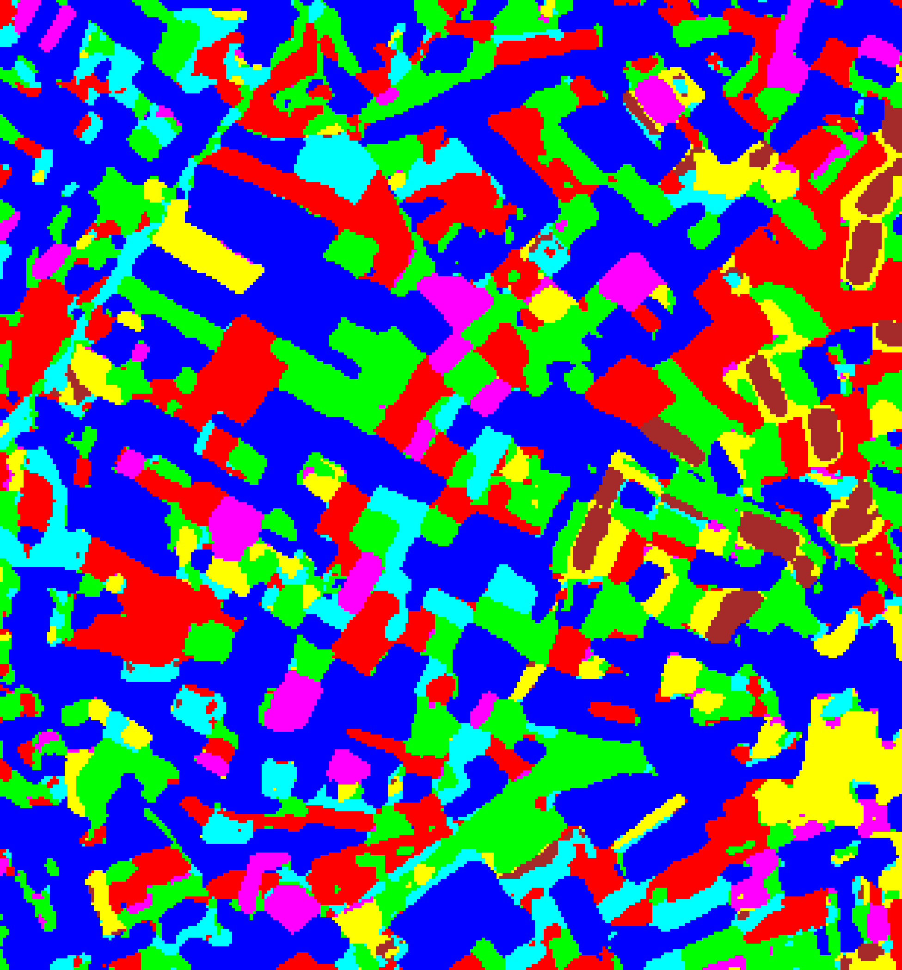  (A) AlexNet-CNN | 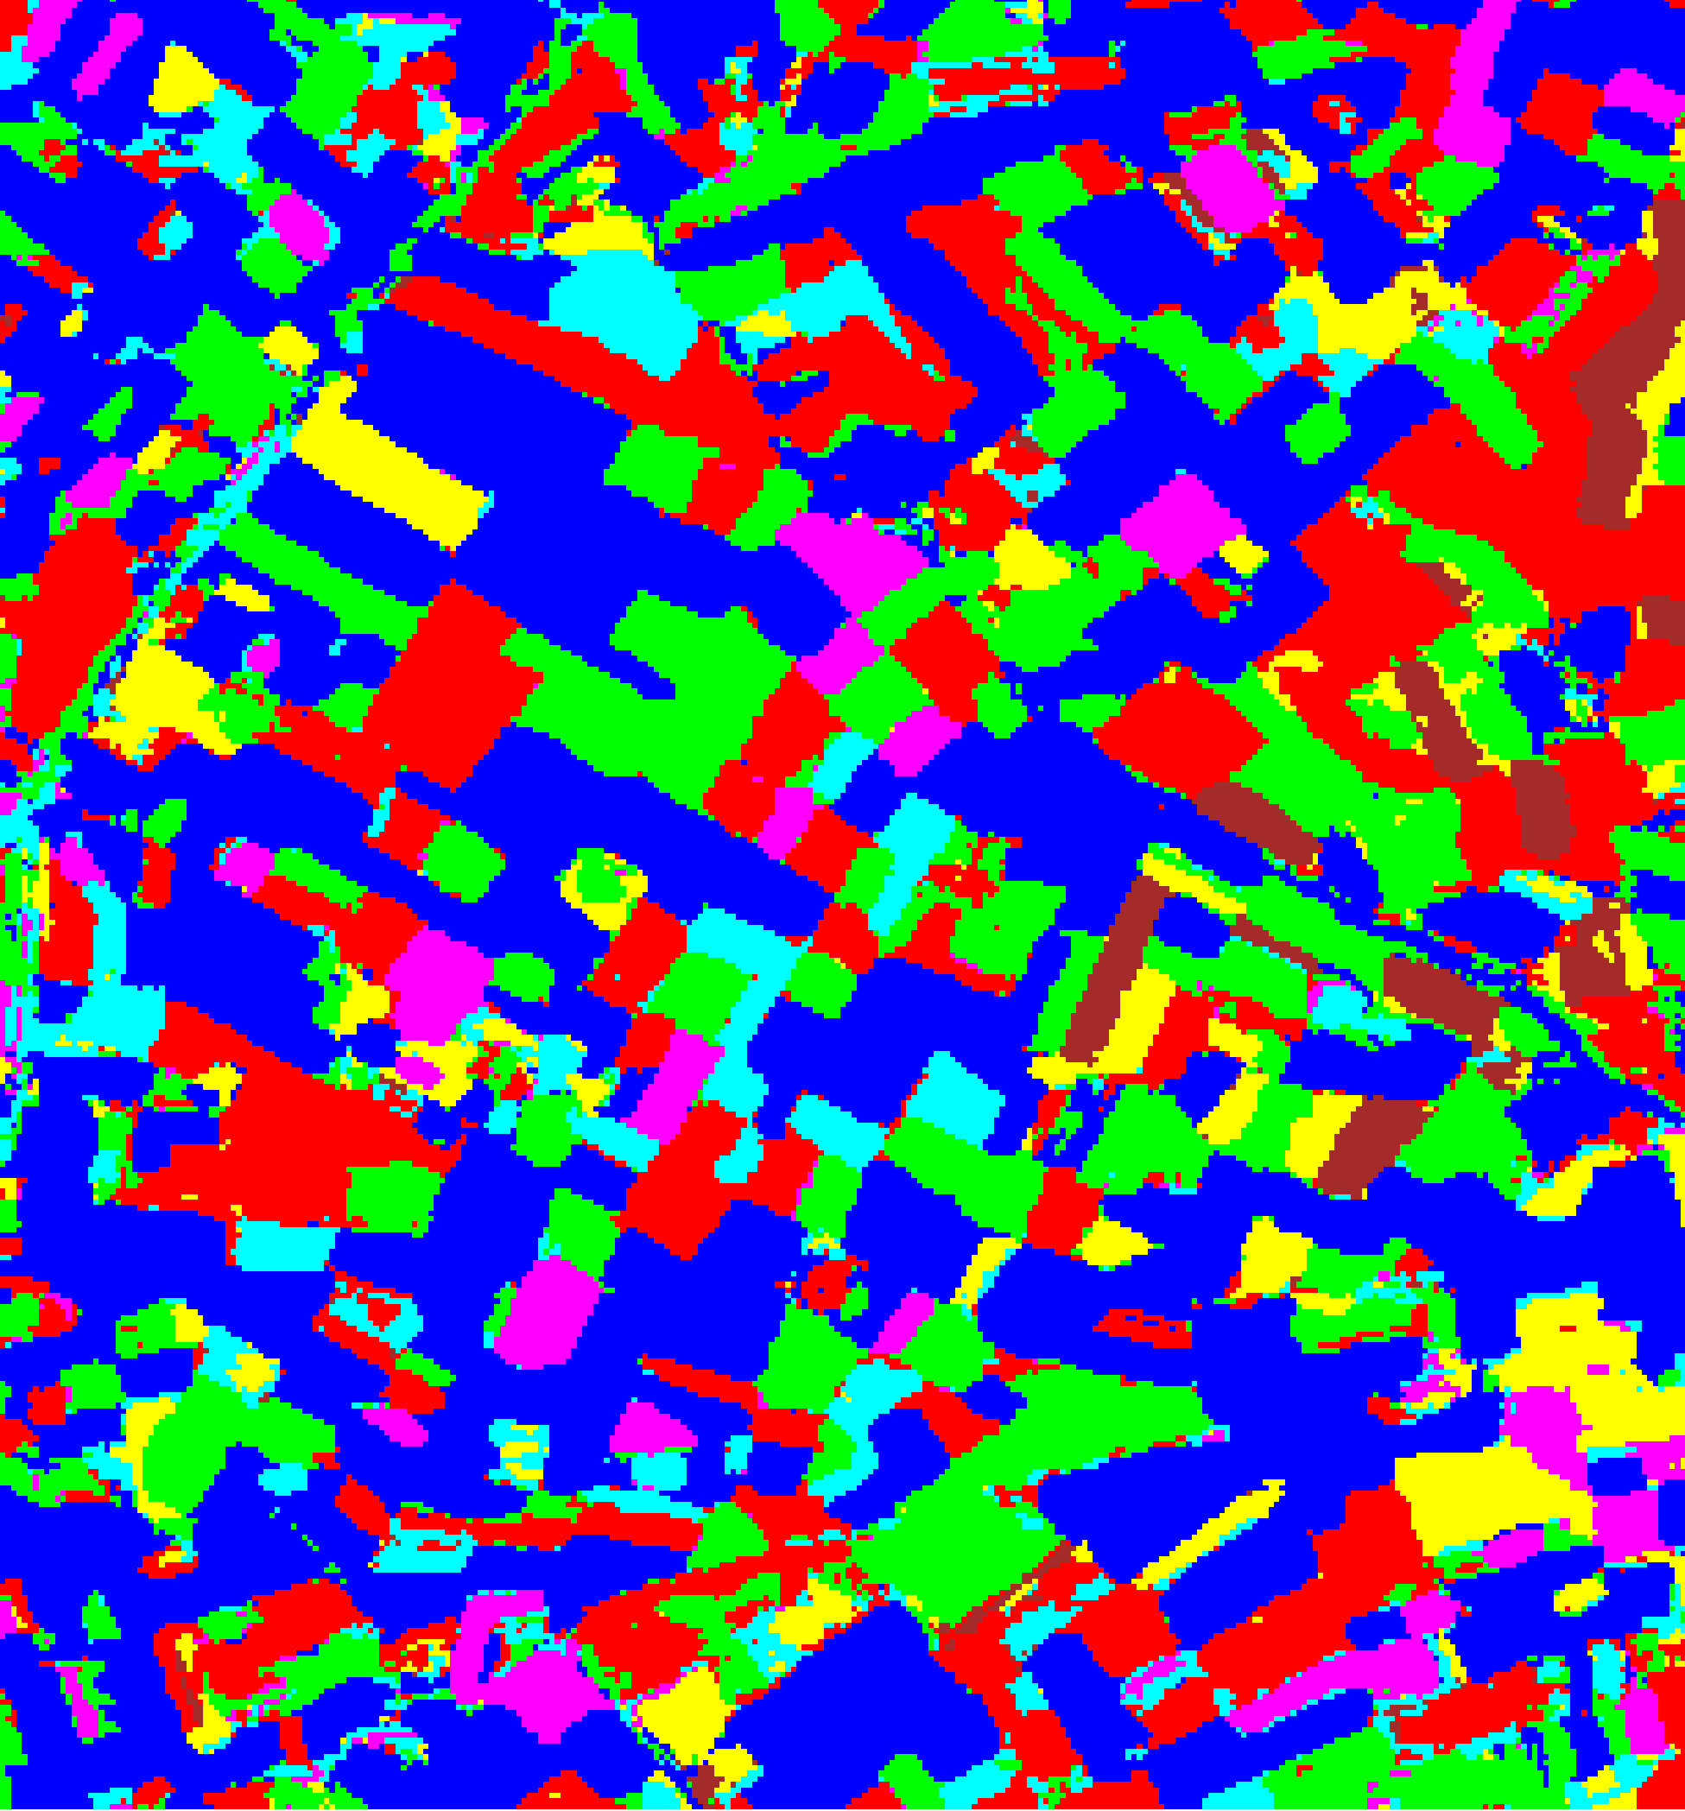  (B) GFNet
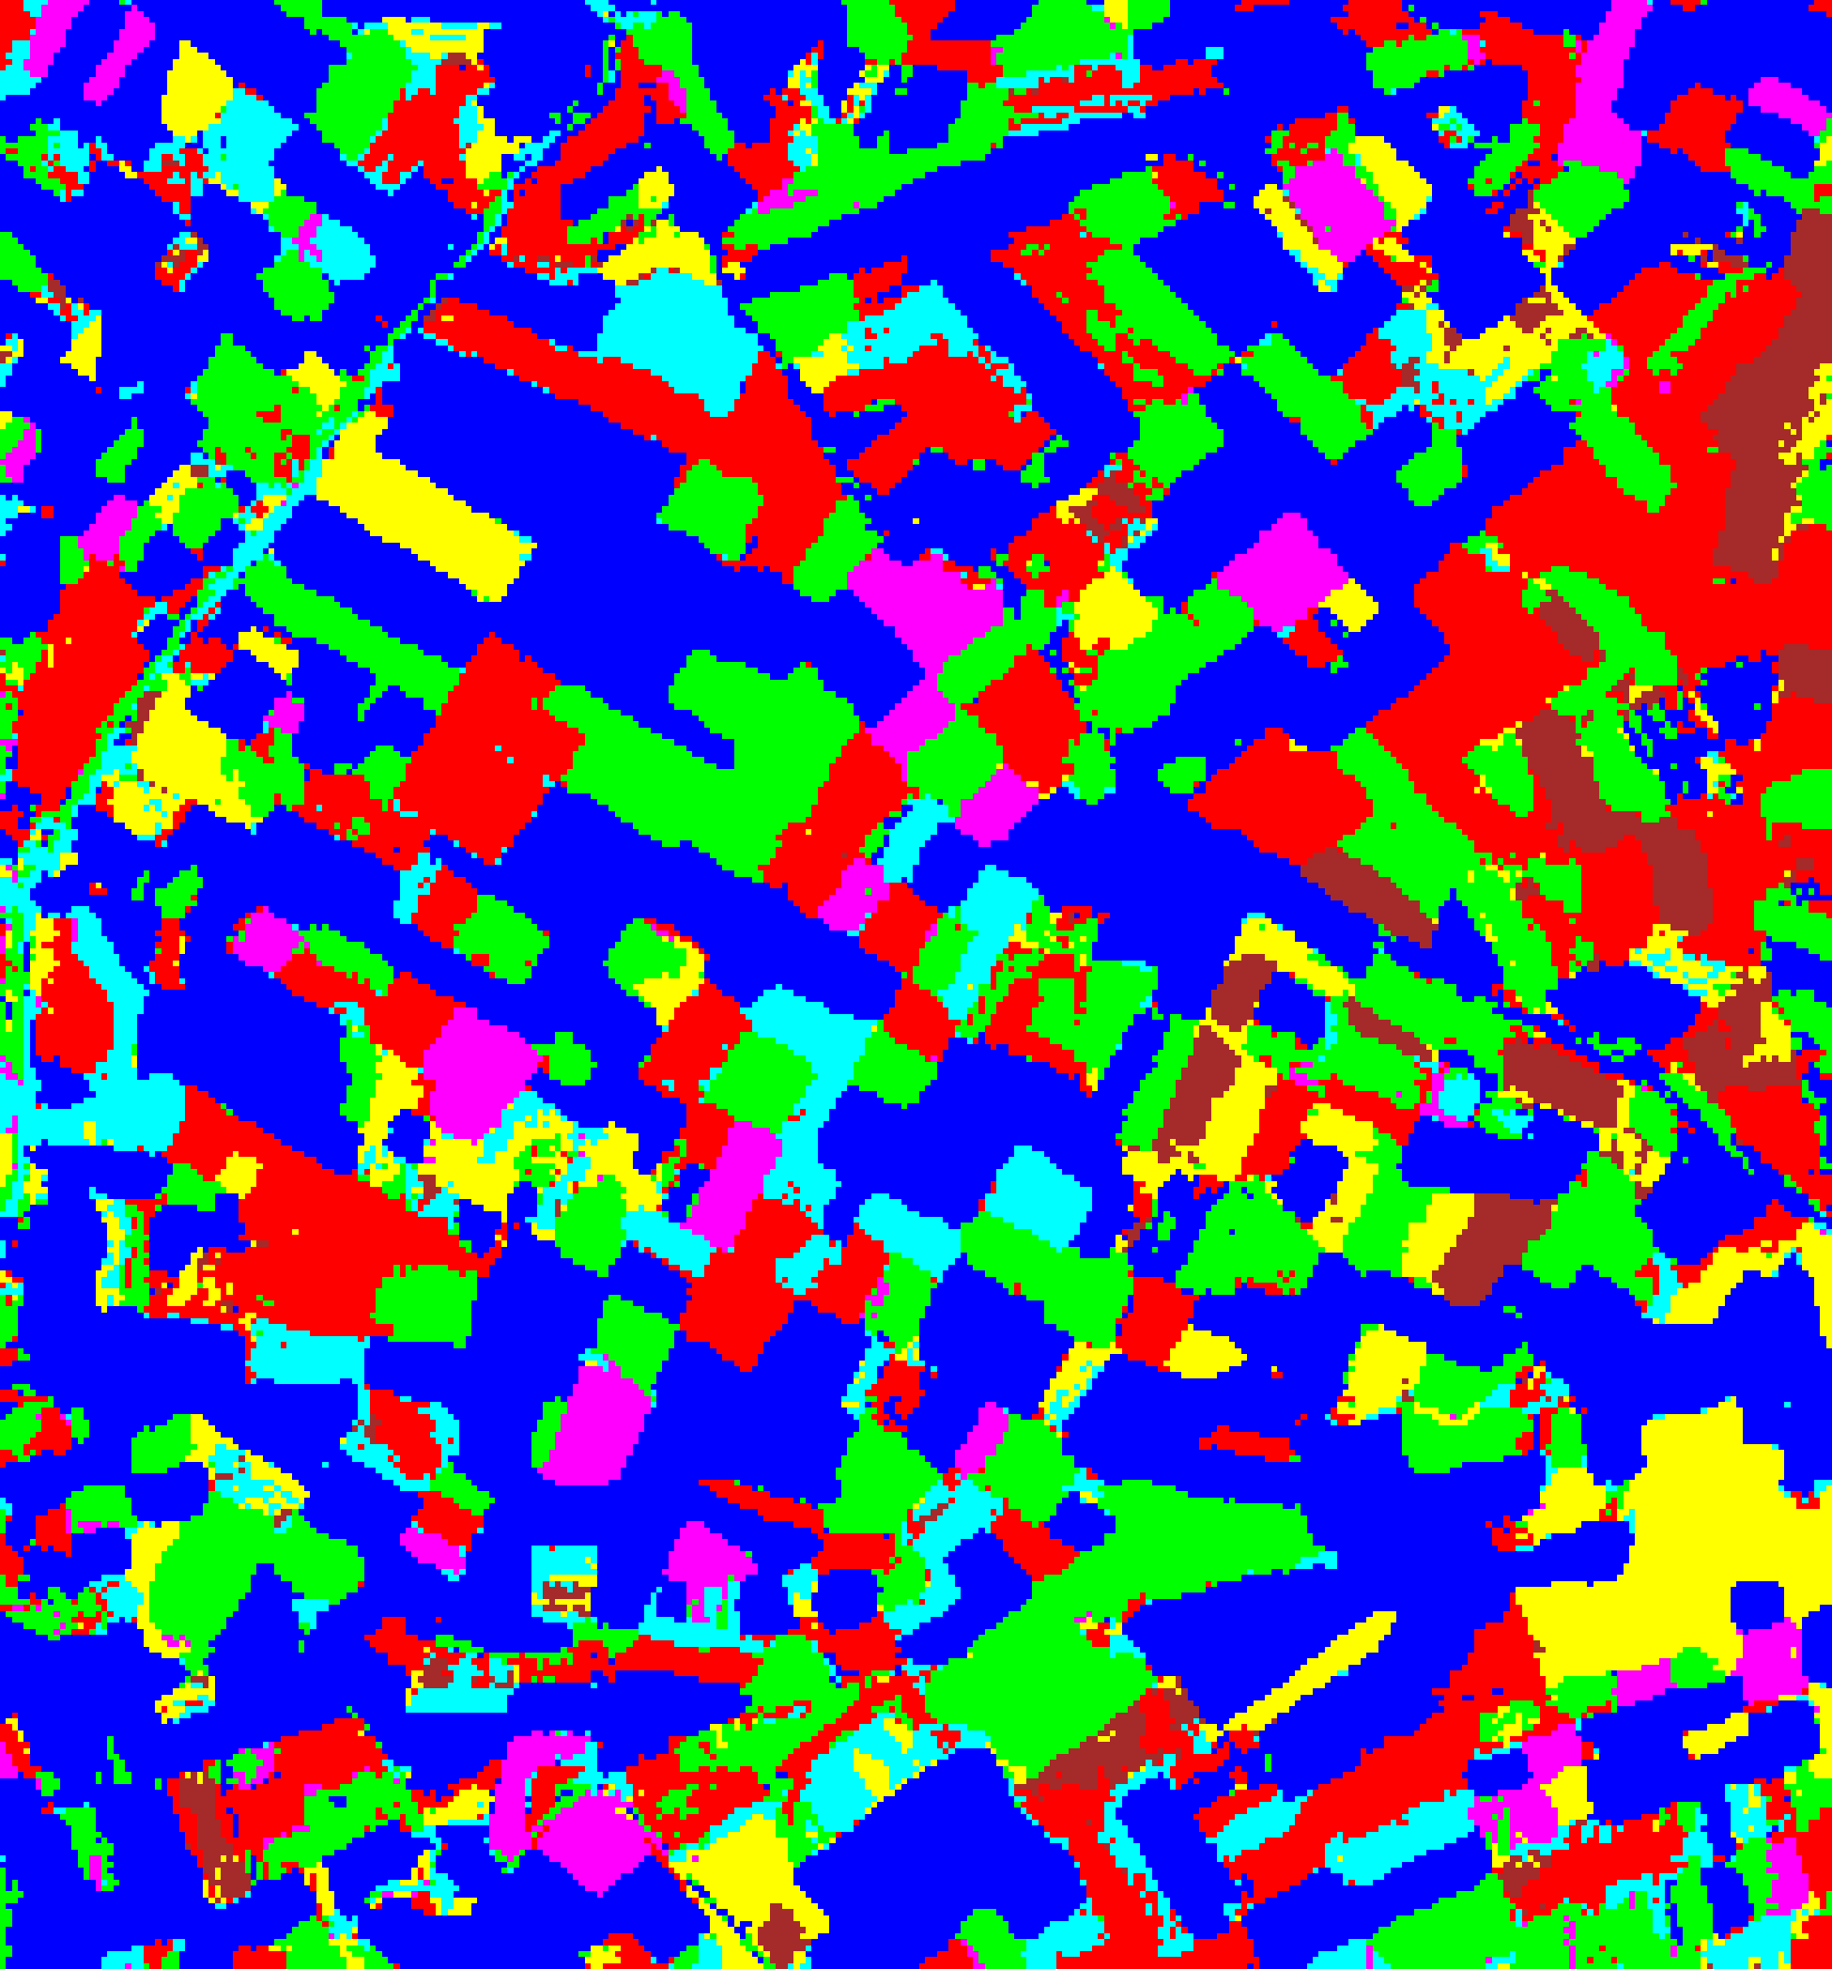  (C) ViT-UNet | 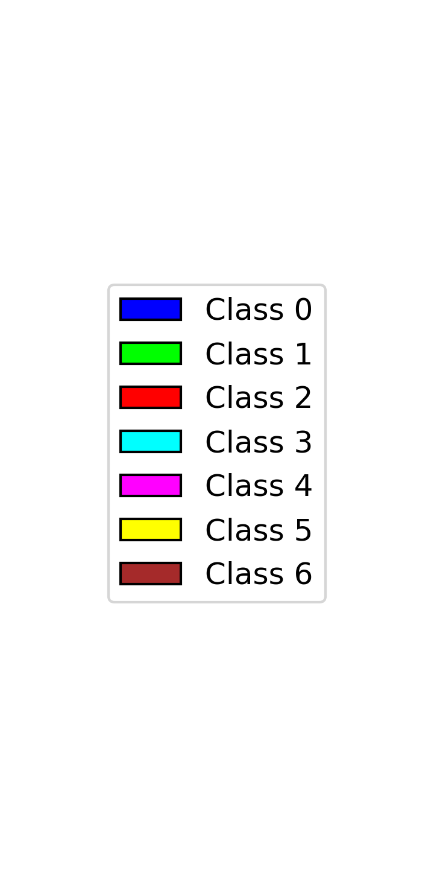  (D) Legend
Fig. 1. Dense pixel-wise land-cover classification maps across all 330 × 307 pixels produced by the three CREDIT student networks: (A) AlexNet-CNN, (B) GFNet, (C) ViT-UNet. Class legend shown in (D); colours apply to all subsequent overlay figures.
B. Deep Learning Architectures
AlexNet-style CNN: Adapted from [6] for 9 × 9 × 6 inputs with five convolutional layers [96, 256, 384, 384, 256] and a fully connected head [4096, 1024, 256, 32, K]. Dropout (p = 0.25), Adagrad optimiser with cosine schedule (LR ∈ [0.005, 0.02]), 100 epochs (training time 678.4 s).
GFNet: Five frequency-domain blocks with learnable global filters in the 2-D Fourier domain (d = 512, T = 9 tokens) [2]. Trained for 100 epochs with AdamW (training time 754.0 s).
ViT-UNet: A 12-layer Vision Transformer [3] augmented with U-Net skip connections [4] bridging encoder block i to decoder block L − i for i ≤ ⌊L/2⌋ (training time 1,310.9 s).
C. CREDIT: Credal Ensemble Distillation
CREDIT converts a pre-trained deep ensemble of M = 5 teacher networks into a single dual-head student by training it to reproduce the class-wise probability interval spanned by the ensemble [1].
Teacher-Derived Targets. For each input x, M = 5 teacher softmax vectors π_1(x), ..., π_M(x) are collected. Per-class minimum and maximum bounds define the credal interval; the interval width Δp_true,c = p_max,c − p_min,c is the epistemic target and the renormalised minimum p*_true is the aleatoric target.
Dual-Head Student. The student attaches two heads to the penultimate features: p̂*(x) = softmax(W_1 z + b_1) for aleatoric distribution and Δp̂(x) = σ(W_2 z + b_2) for epistemic interval width, trained jointly via L = KL(p*_true ∥ p̂*) + 0.5·MSE(Δp_true, Δp̂).
Uncertainty Decomposition. AU(x) = −Σ_c p̂*_c ln(p̂*_c + ε); EU(x) = (1/K)Σ_c Δp̂_c; TU(x) = AU(x) + EU(x). The identity AU + EU = TU holds exactly at every pixel (verified across all 101,310 scene pixels with max |AU + EU − TU| = 0).
III. EXPERIMENTS AND RESULTS
A. Classification Performance
TABLE I summarises the evaluation metrics on the 4,310 held-out test samples. All three CREDIT students exceed 98.90% test accuracy: GFNet achieves 99.74% (κ = 0.9965, macro-F1 = 0.9961) with the lowest NLL (0.0129), Brier score (0.0047), and ECE (0.0013) alongside the lowest mean TU (0.0143), AlexNet-CNN achieves 99.56% (κ = 0.9940, macro-F1 = 0.9950) with mean TU = 0.0207, and ViT-UNet achieves 98.91% (κ = 0.9852, macro-F1 = 0.9826) with higher mean AU (0.2287) reflecting its broader softmax entropy.
TABLE I
CREDIT STUDENT — FULL EVALUATION METRICS (4,310 TEST SAMPLES)
Model | Accuracy | κ | Macro F1 | NLL | Brier | ECE | Mean AU | Mean EU | Mean TU | Credal Coverage | Credal Avg Set Size
AlexNet-CNN | 99.56% | 0.9940 | 0.9950 | 0.0136 | 0.0073 | 0.0026 | 0.0195 | 0.0012 | 0.0207 | 99.56% | 1.0000
GFNet | 99.74% | 0.9965 | 0.9961 | 0.0129 | 0.0047 | 0.0013 | 0.0142 | 0.0001 | 0.0143 | 99.74% | 1.0000
ViT-UNet | 98.91% | 0.9852 | 0.9826 | 0.0676 | 0.0188 | 0.0342 | 0.2287 | 0.0043 | 0.2330 | 98.91% | 1.0000

B. Dense Scene Classification Maps
Full-scene spatial uncertainty is evaluated across all 330 × 307 = 101,310 pixels using absolute thresholds: AU > 0.5 nats, EU > 0.2, and TU > 0.7. Below we examine the spatial distribution and per-class pixel counts for each uncertainty type.
C. Aleatoric Uncertainty (AU > 0.5) Maps
Under AU > 0.5, AlexNet-CNN flags 11,803 pixels (11.650%) as uncertain, GFNet flags 8,613 pixels (8.502%), and ViT-UNet flags 13,161 pixels (12.991%). Uncertain pixels concentrate along class boundaries and within the unlabelled background (Class 0), where spectral mixing between adjacent parcels creates multi-modal posterior distributions.
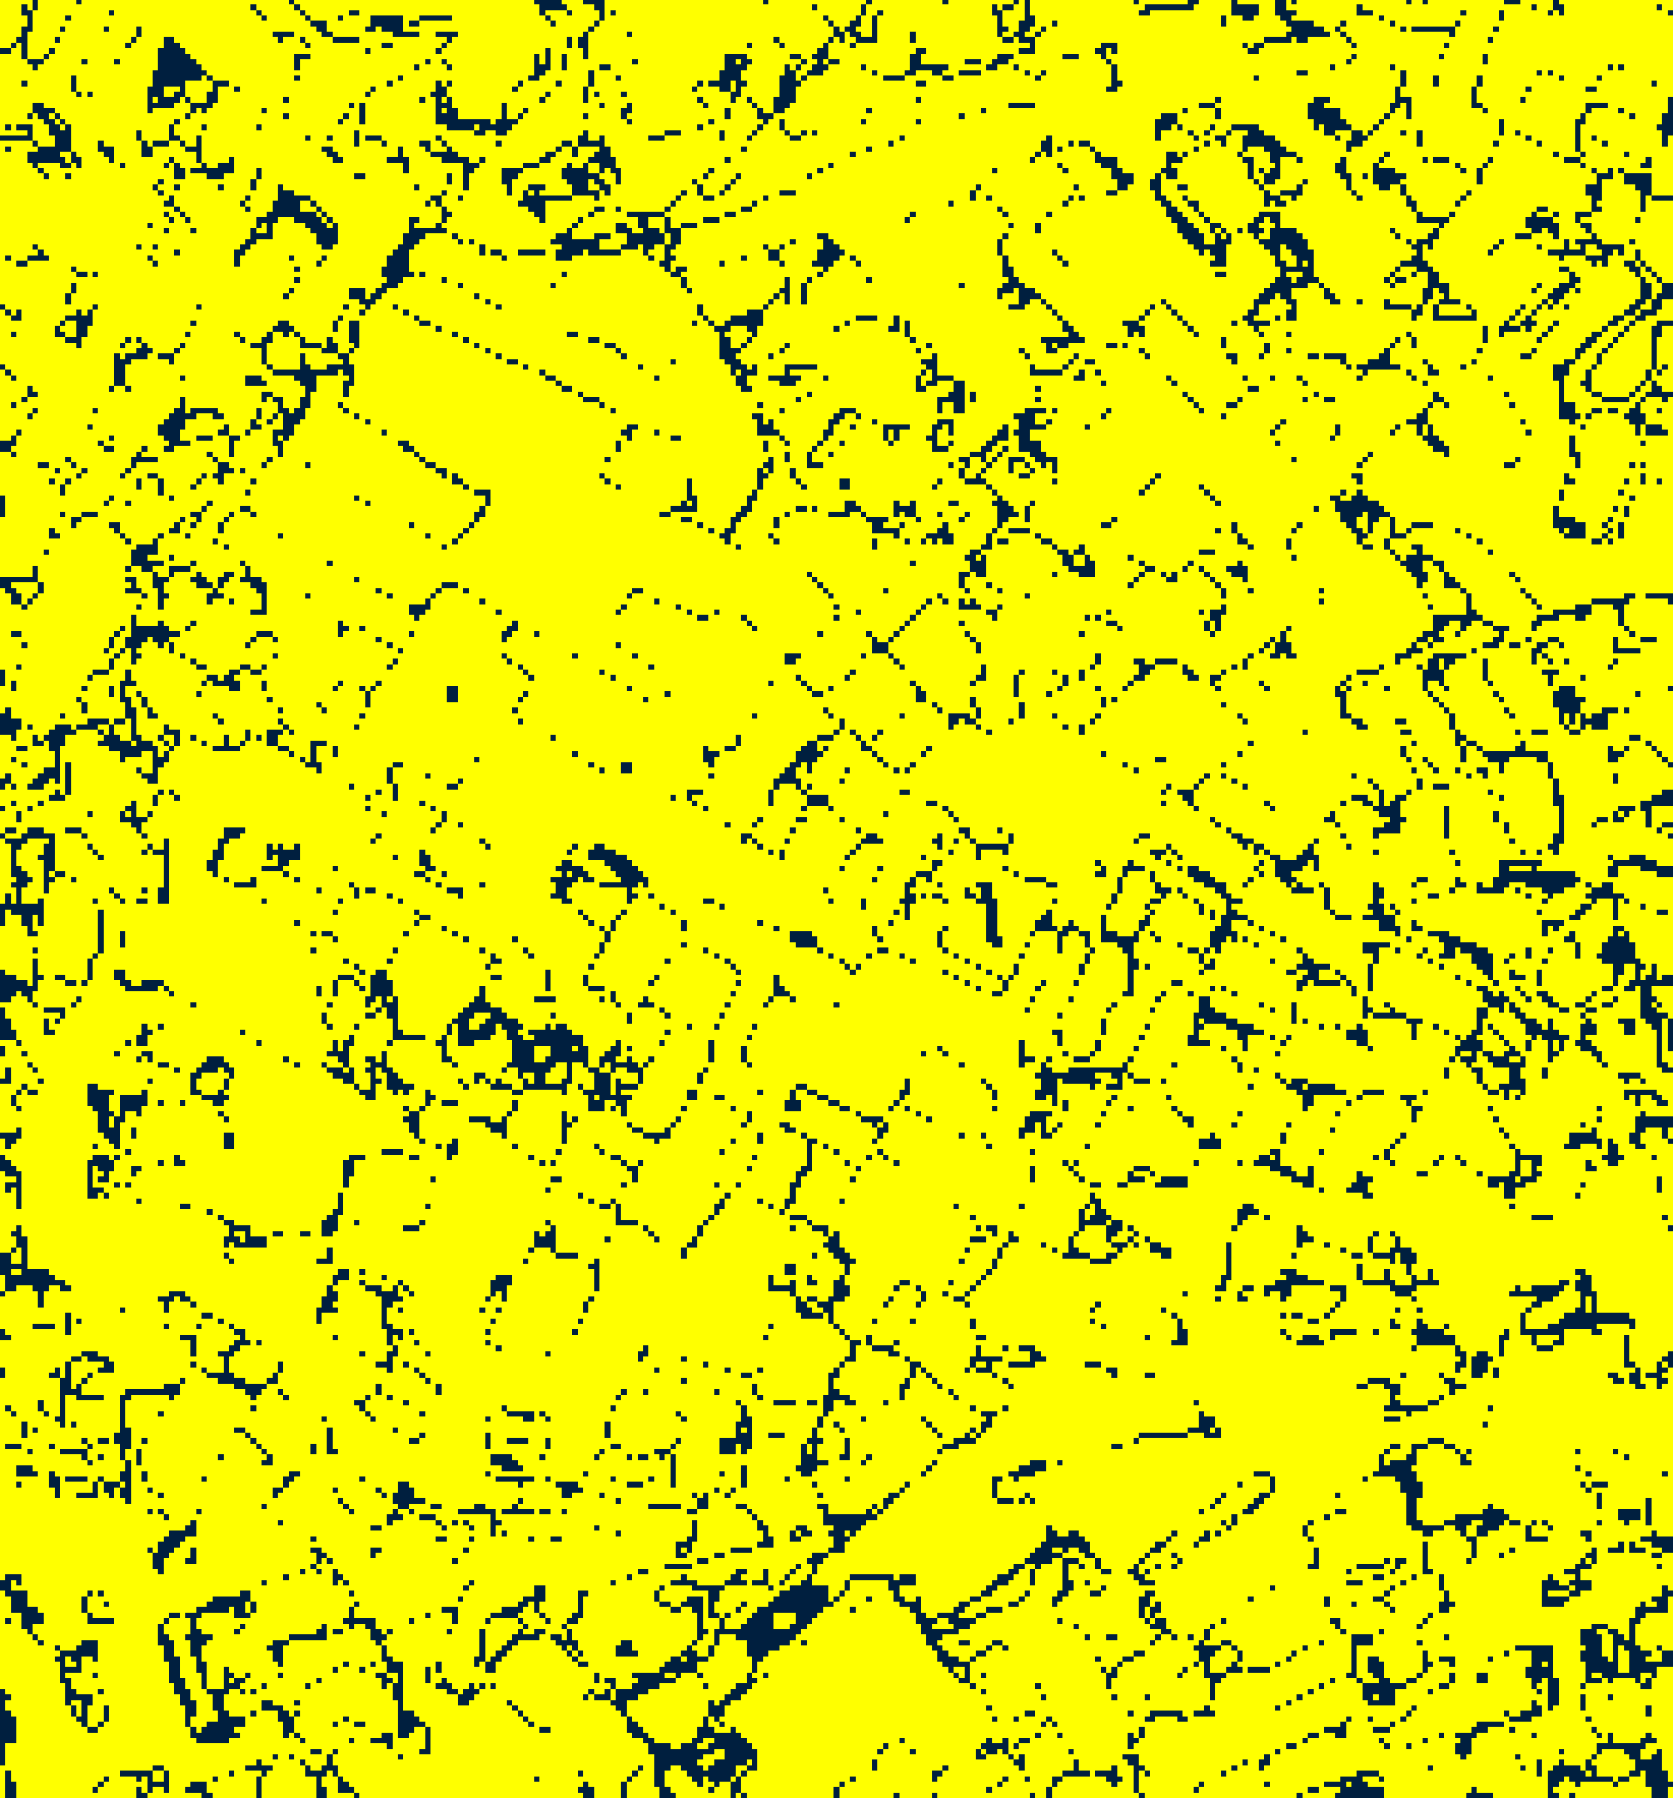  (A) AlexNet-CNN | 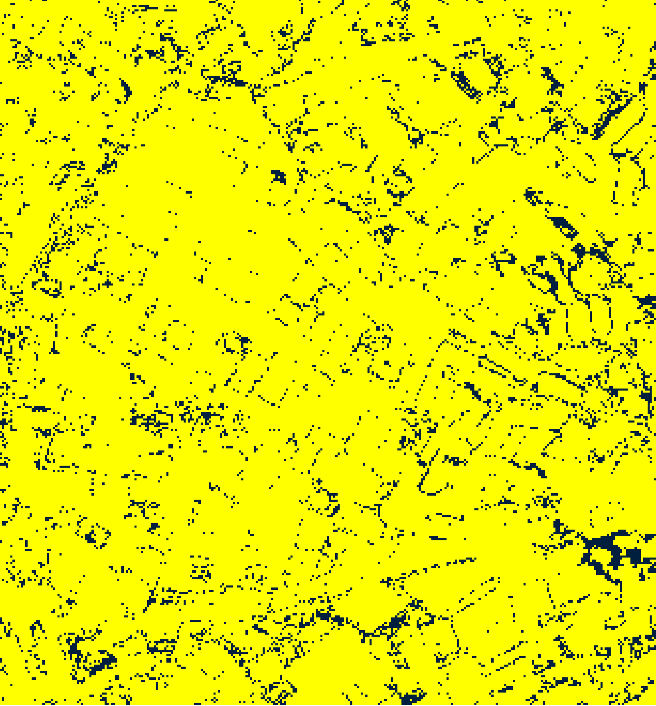  (B) GFNet
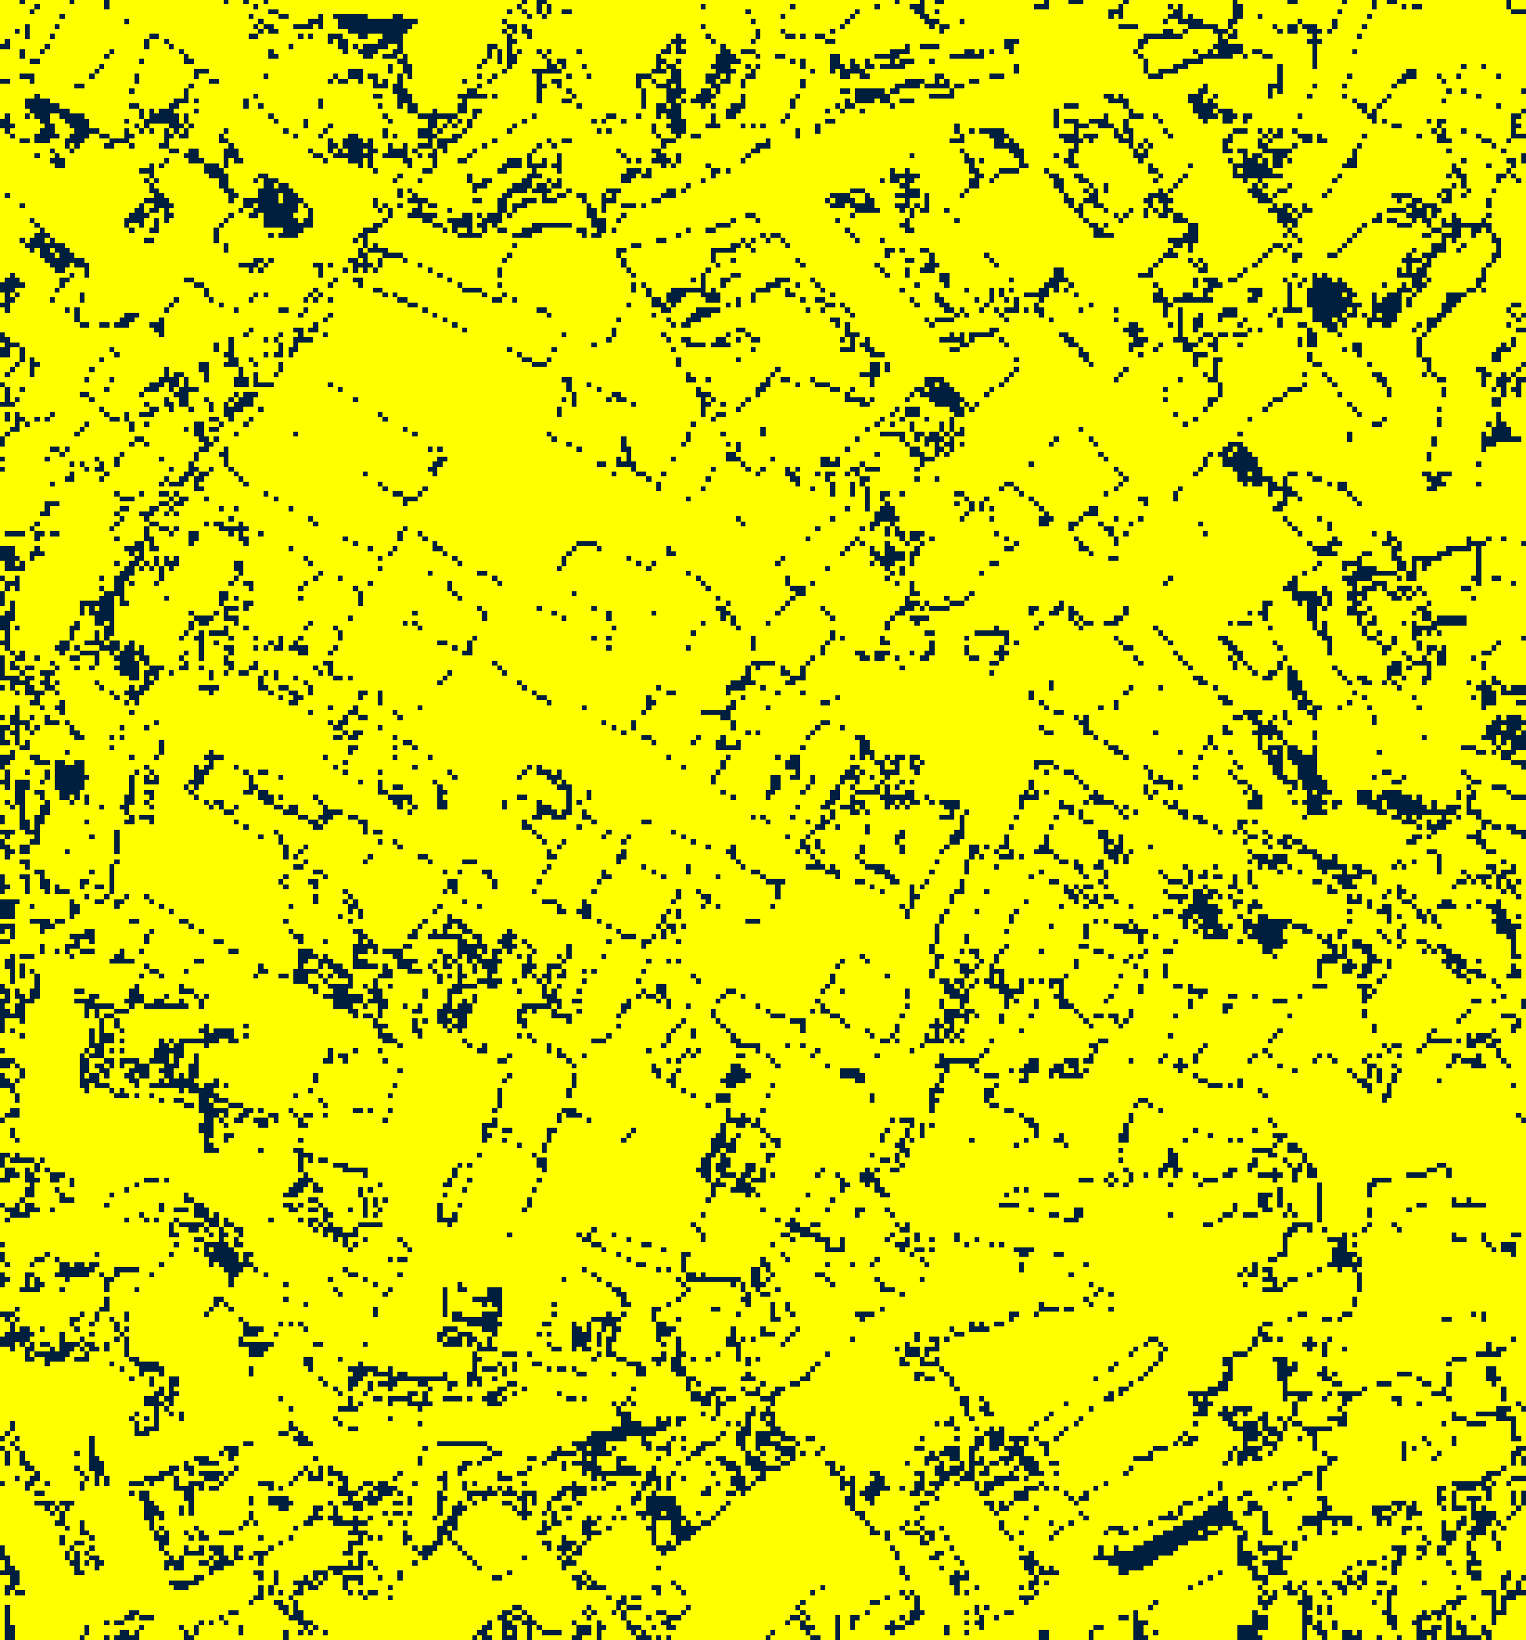  (C) ViT-UNet | 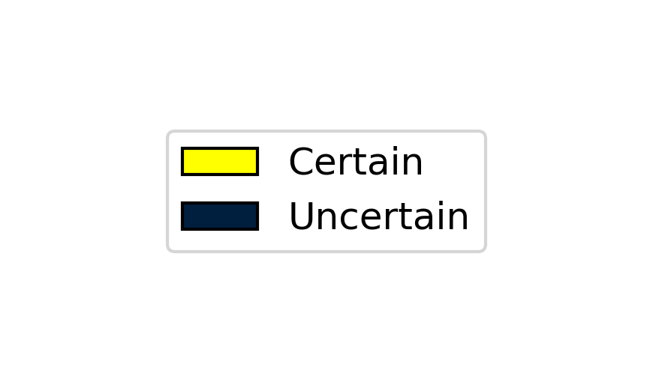  (D) Legend
Fig. 2(a). Aleatoric uncertainty binary maps (AU > 0.5): (A) AlexNet-CNN, (B) GFNet, (C) ViT-UNet. Certain/Uncertain legend shown in (D). Yellow = certain (AU ≤ 0.5); dark navy = aleatoric-uncertain.
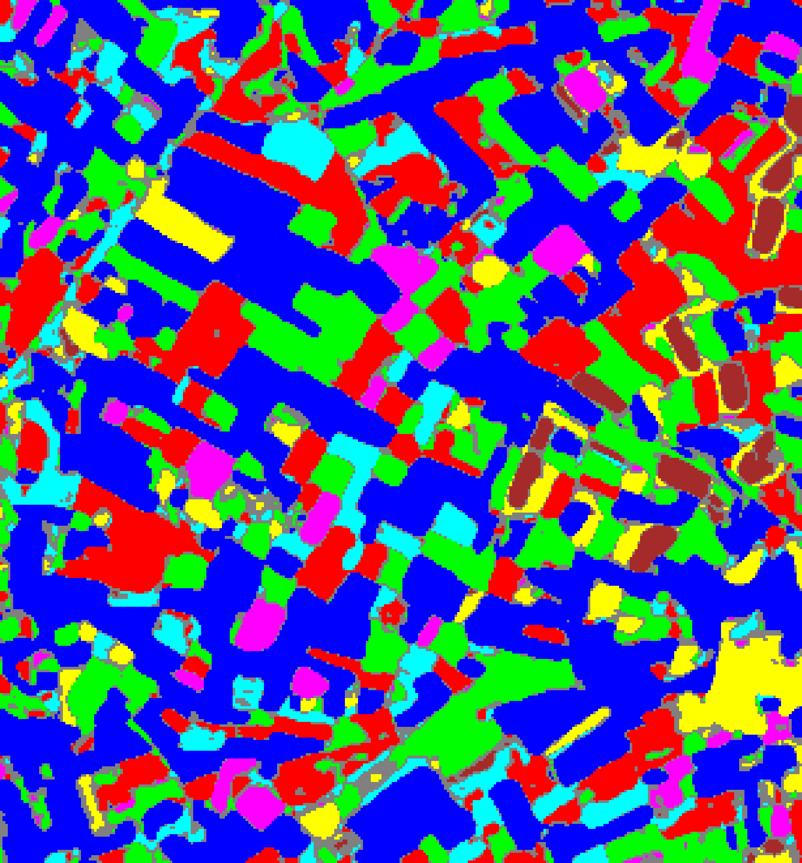  (A) AlexNet-CNN | 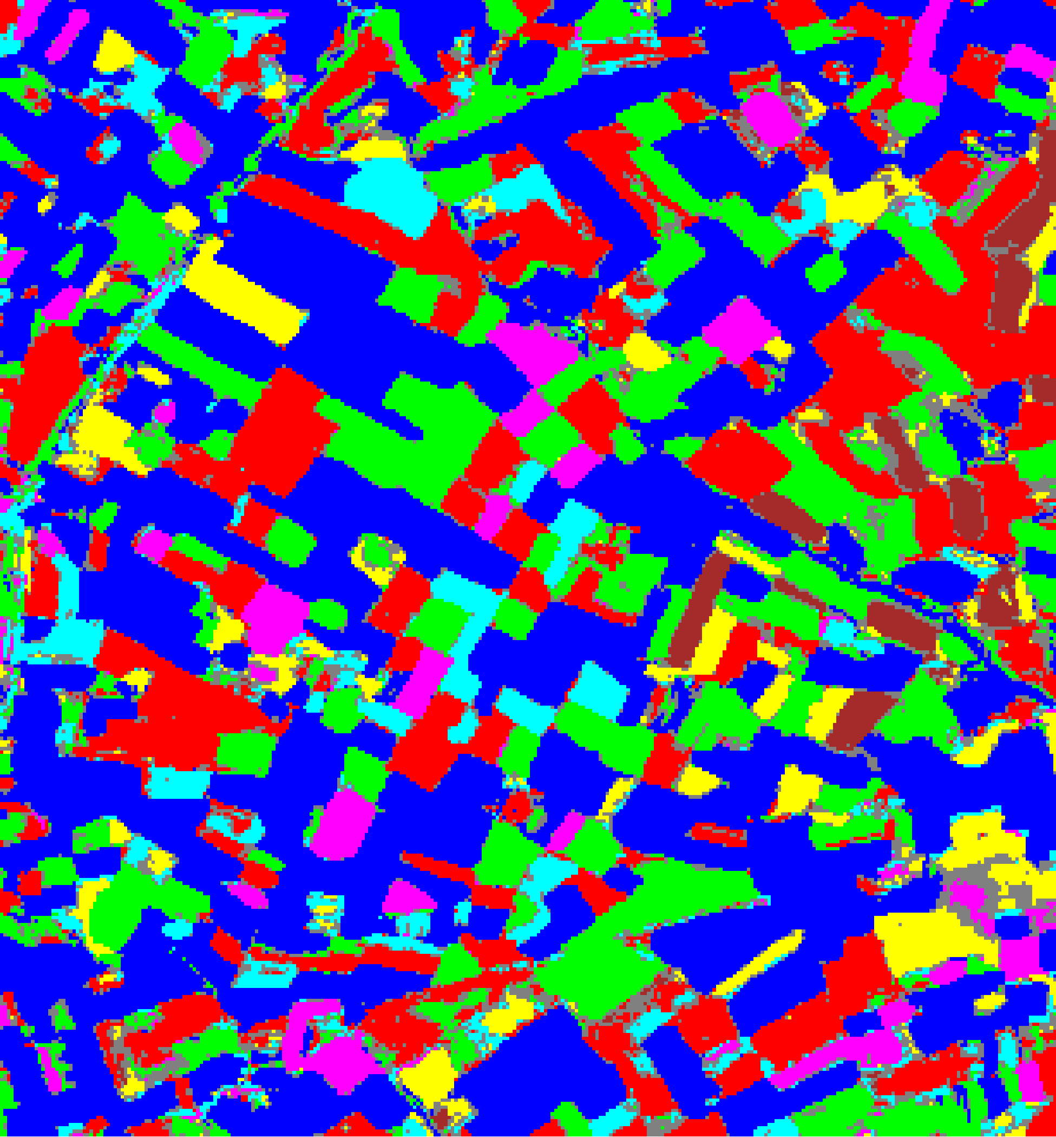  (B) GFNet
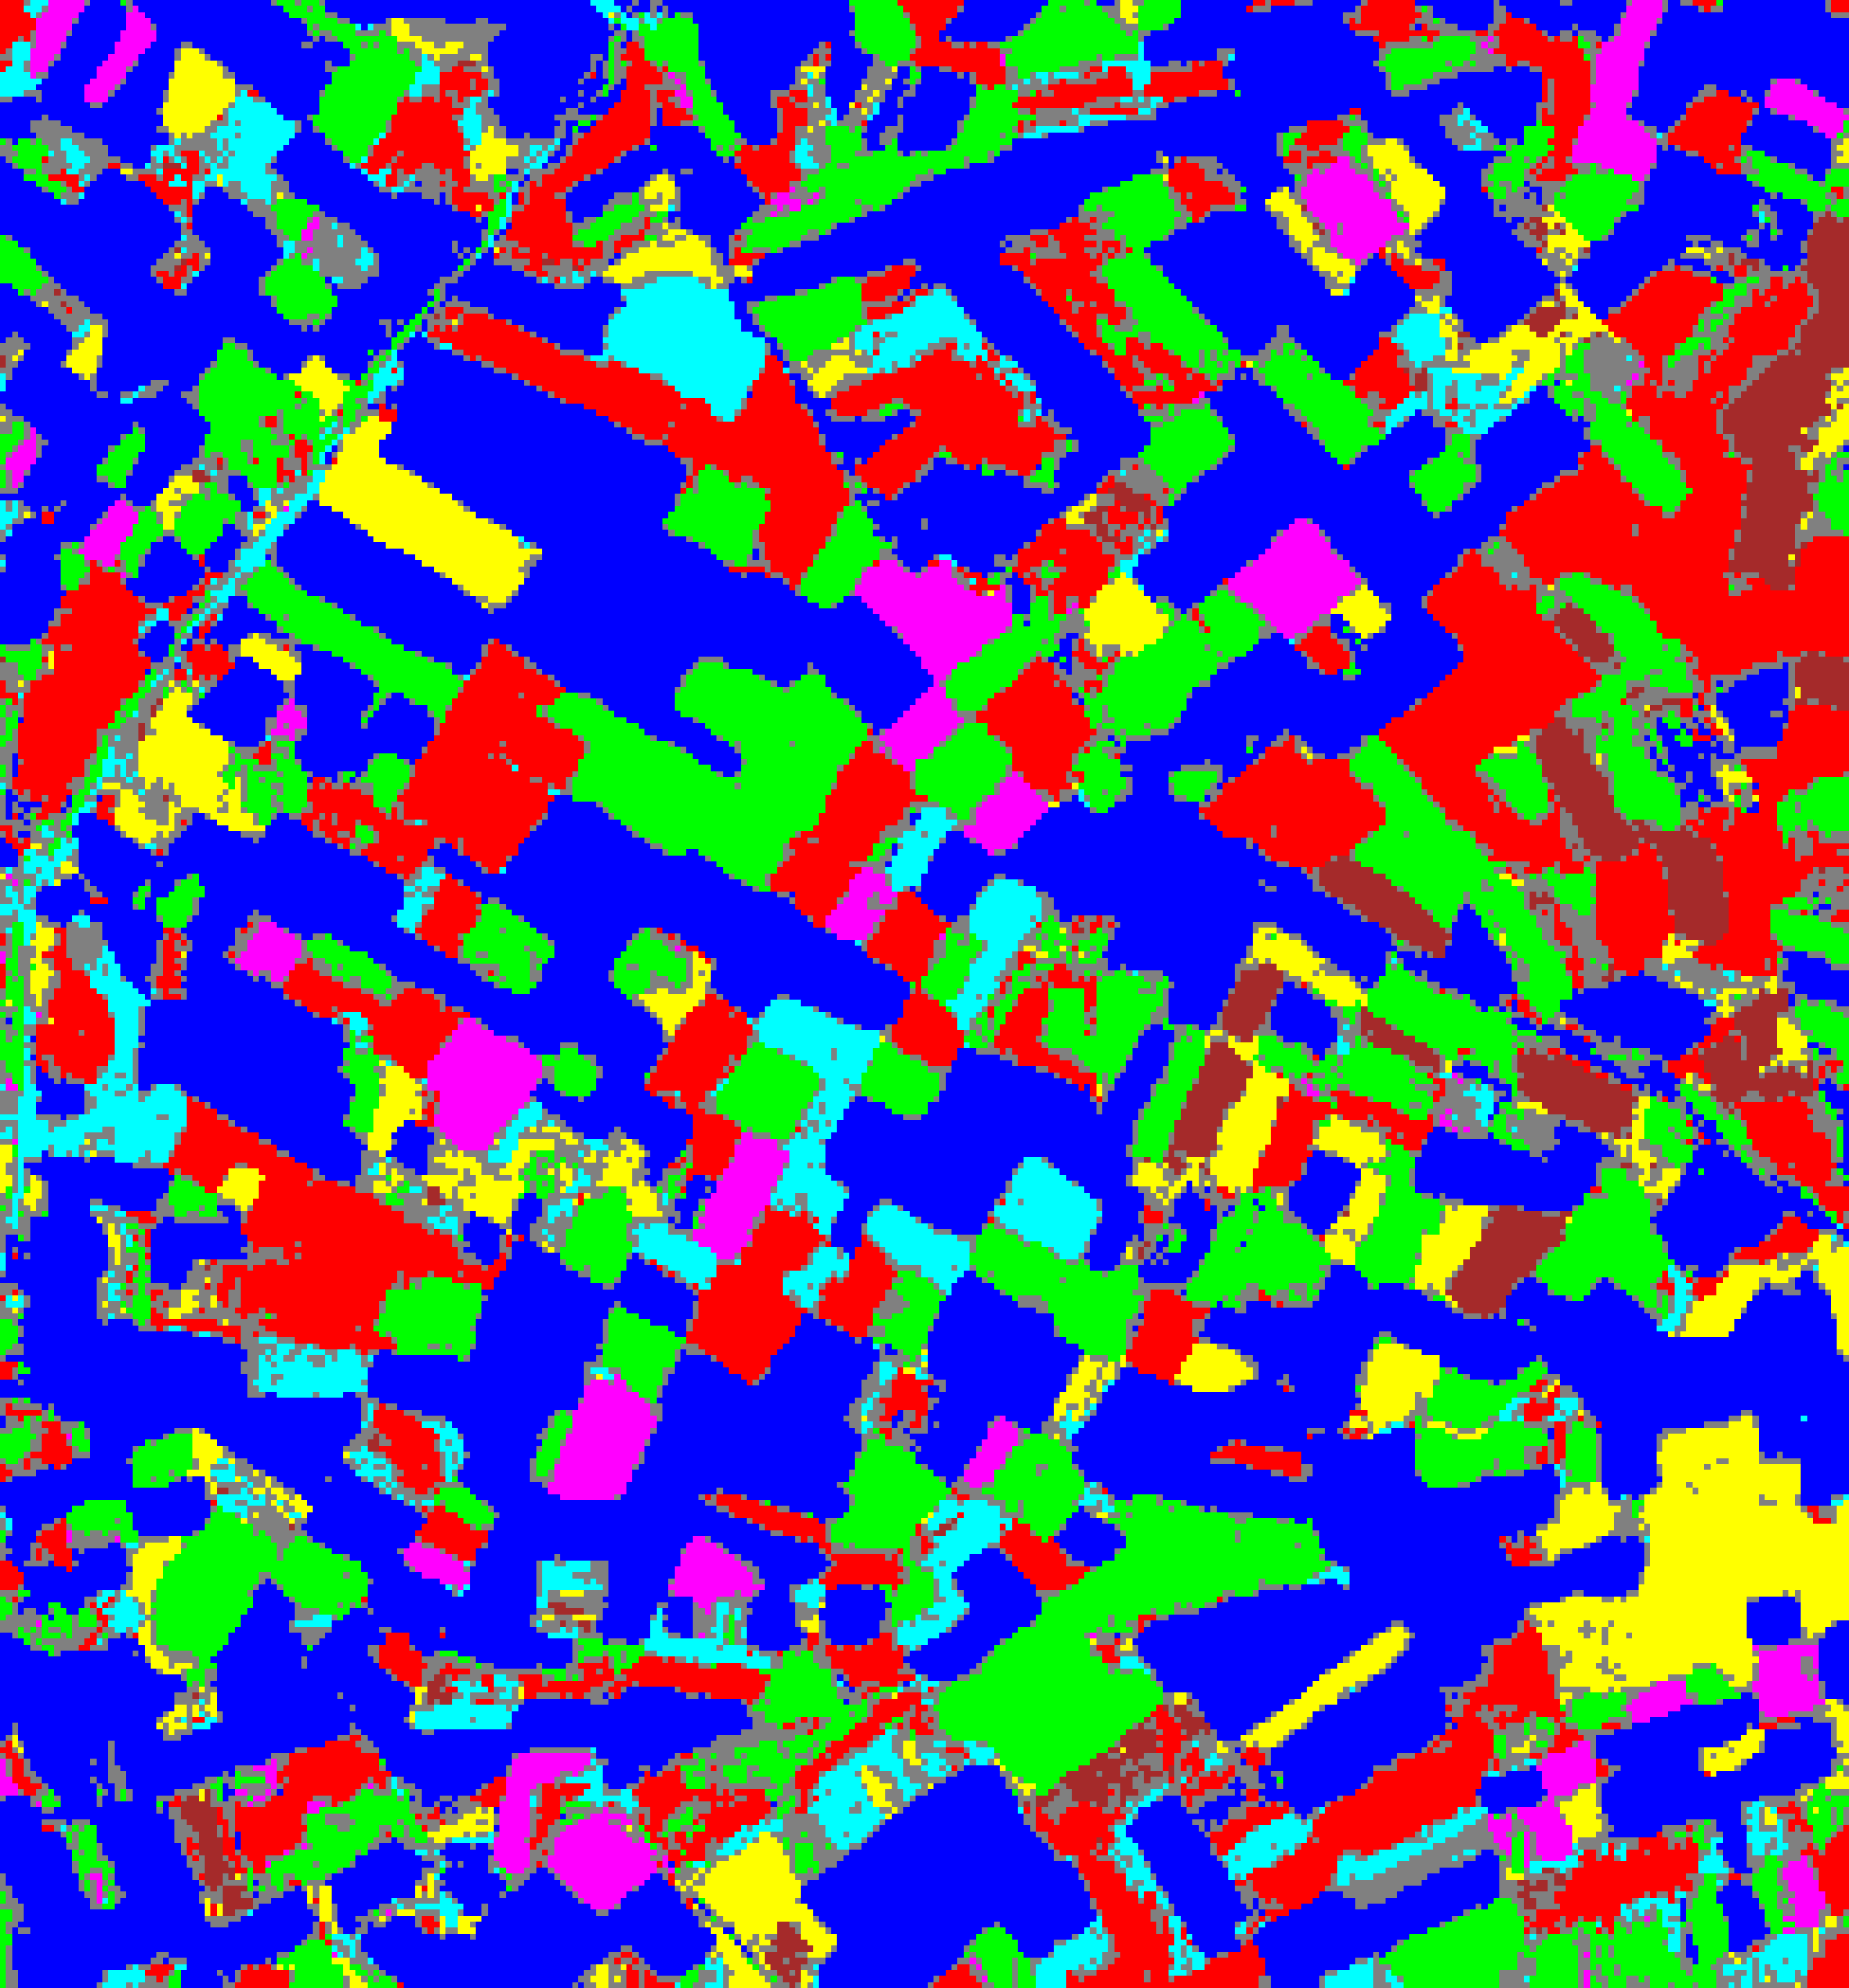  (C) ViT-UNet | (D) Legend
Fig. 2(b). Aleatoric uncertainty overlay maps (AU > 0.5): (A) AlexNet-CNN, (B) GFNet, (C) ViT-UNet. Class colours retained for AU-certain pixels; grey pixels denote aleatoric-uncertain predictions. Class legend shown in (D).
TABLE II
CREDIT AU (> 0.5): FULL-SCENE PIXEL COUNT DISTRIBUTION PER MODEL
Class / Region | AlexNet Pixels | GFNet Pixels | ViT-UNet Pixels
Class 0 | 40,018 | 41,697 | 41,295
Class 1 | 16,166 | 16,371 | 15,068
Class 2 | 16,392 | 18,059 | 15,601
Class 3 | 6,060 | 5,473 | 4,686
Class 4 | 3,609 | 4,252 | 3,266
Class 5 | 5,273 | 4,894 | 5,694
Class 6 | 1,989 | 1,951 | 2,539
AU-Uncertain | 11,803 | 8,613 | 13,161
Total (Scene) | 101,310 | 101,310 | 101,310

Across the 101,310-pixel scene, GFNet flags the fewest AU-uncertain pixels (8,613, 8.502%, max observed AU = 1.7394), followed by AlexNet-CNN (11,803, 11.650%, max observed AU = 1.8148) and ViT-UNet (13,161, 12.991%, max observed AU = 1.8543). Uncertain pixels concentrate along parcel boundaries and within unlabelled background regions.
D. Epistemic Uncertainty (EU > 0.2) Maps
Under EU > 0.2, all three CREDIT students produce zero uncertain pixels (0.000%) across the entire 101,310-pixel scene. Epistemic uncertainty reflects disagreement among the M = 5 ensemble teachers; because all five teachers were trained on identical parcel-level ground truth, their predictions are highly congruent across the scene, resulting in Δp̂_c values consistently below the 0.2 threshold (maximum observed EU is 0.0949 for AlexNet-CNN, 0.1195 for GFNet, and 0.1754 for ViT-UNet, all well below 0.2). Thus, TABLE III reflects the unmasked base prediction counts across Class 0–6.
  (A) AlexNet-CNN |   (B) GFNet
(C) ViT-UNet | (D) Legend
Fig. 3(a). Epistemic uncertainty binary maps (EU > 0.2): (A) AlexNet-CNN, (B) GFNet, (C) ViT-UNet. Certain/Uncertain legend shown in (D).
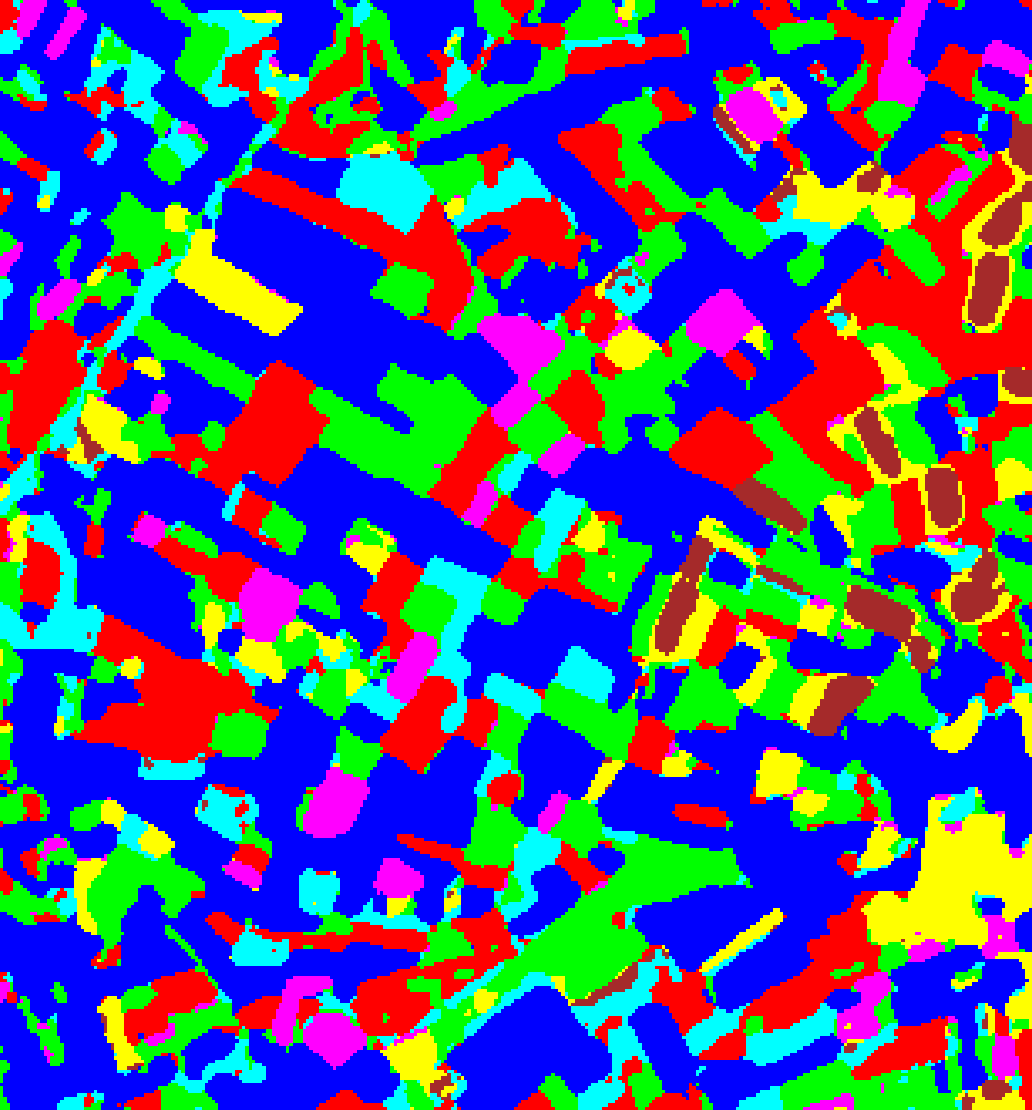  (A) AlexNet-CNN | 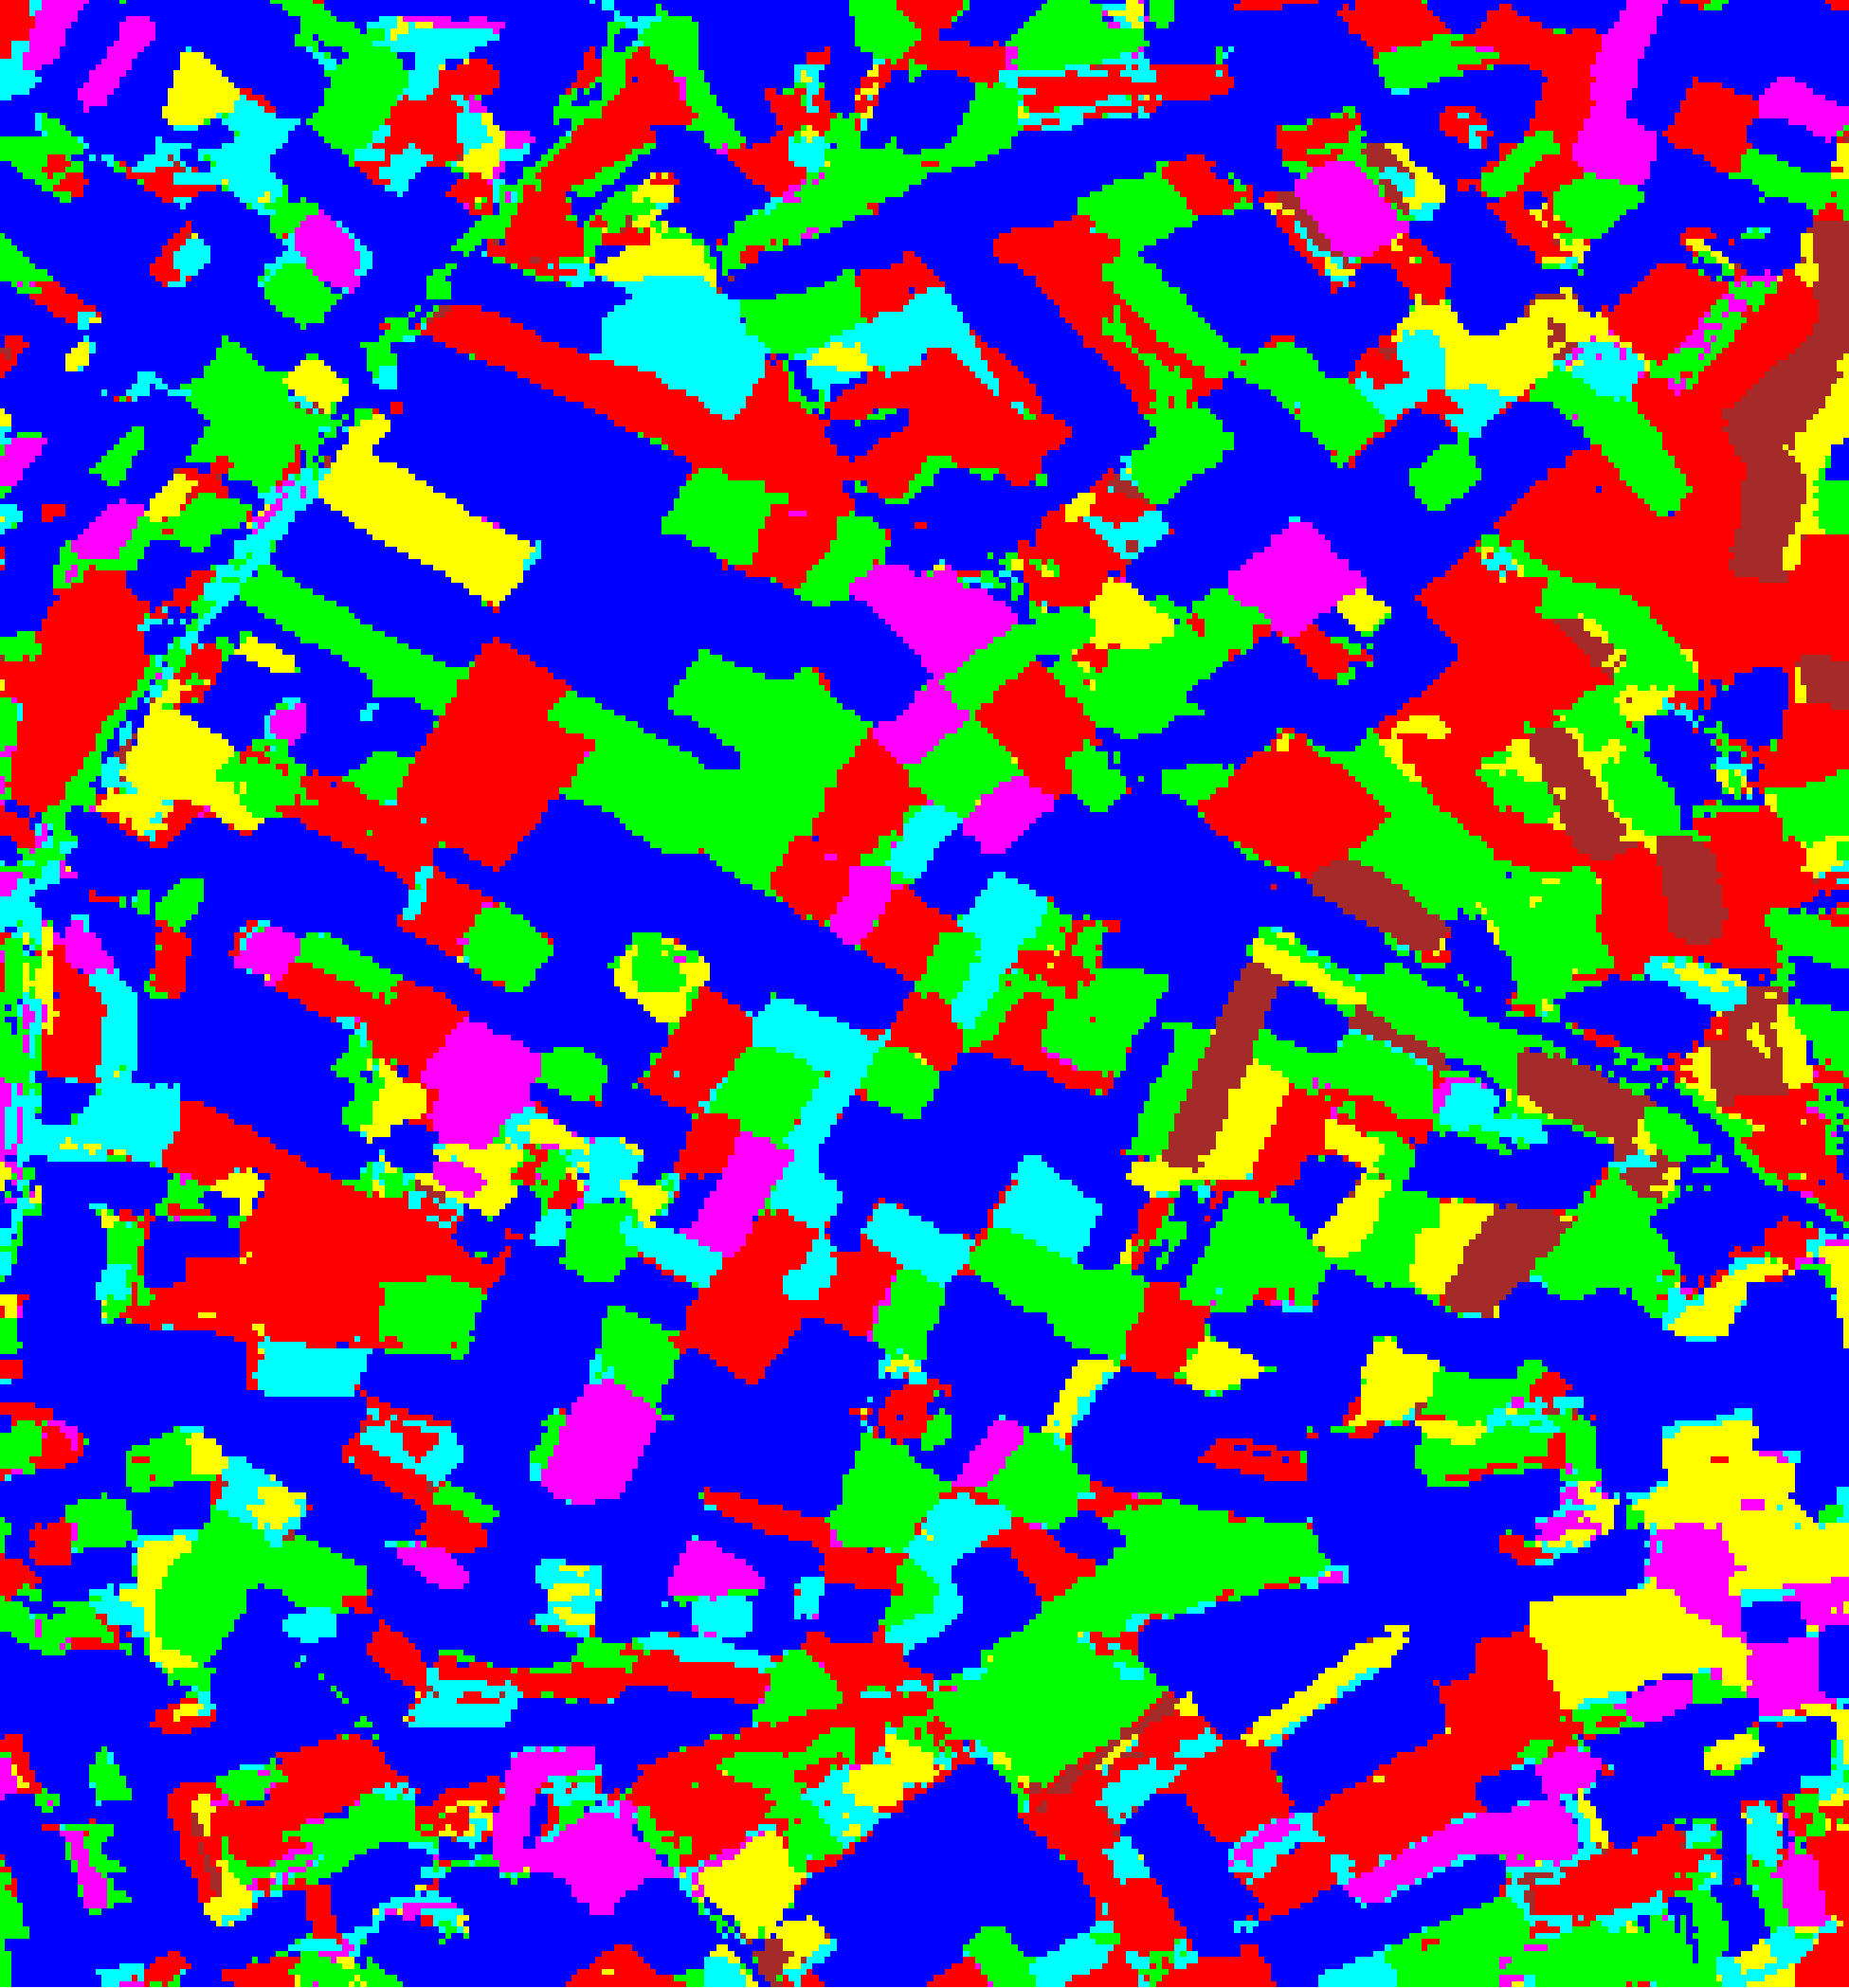  (B) GFNet
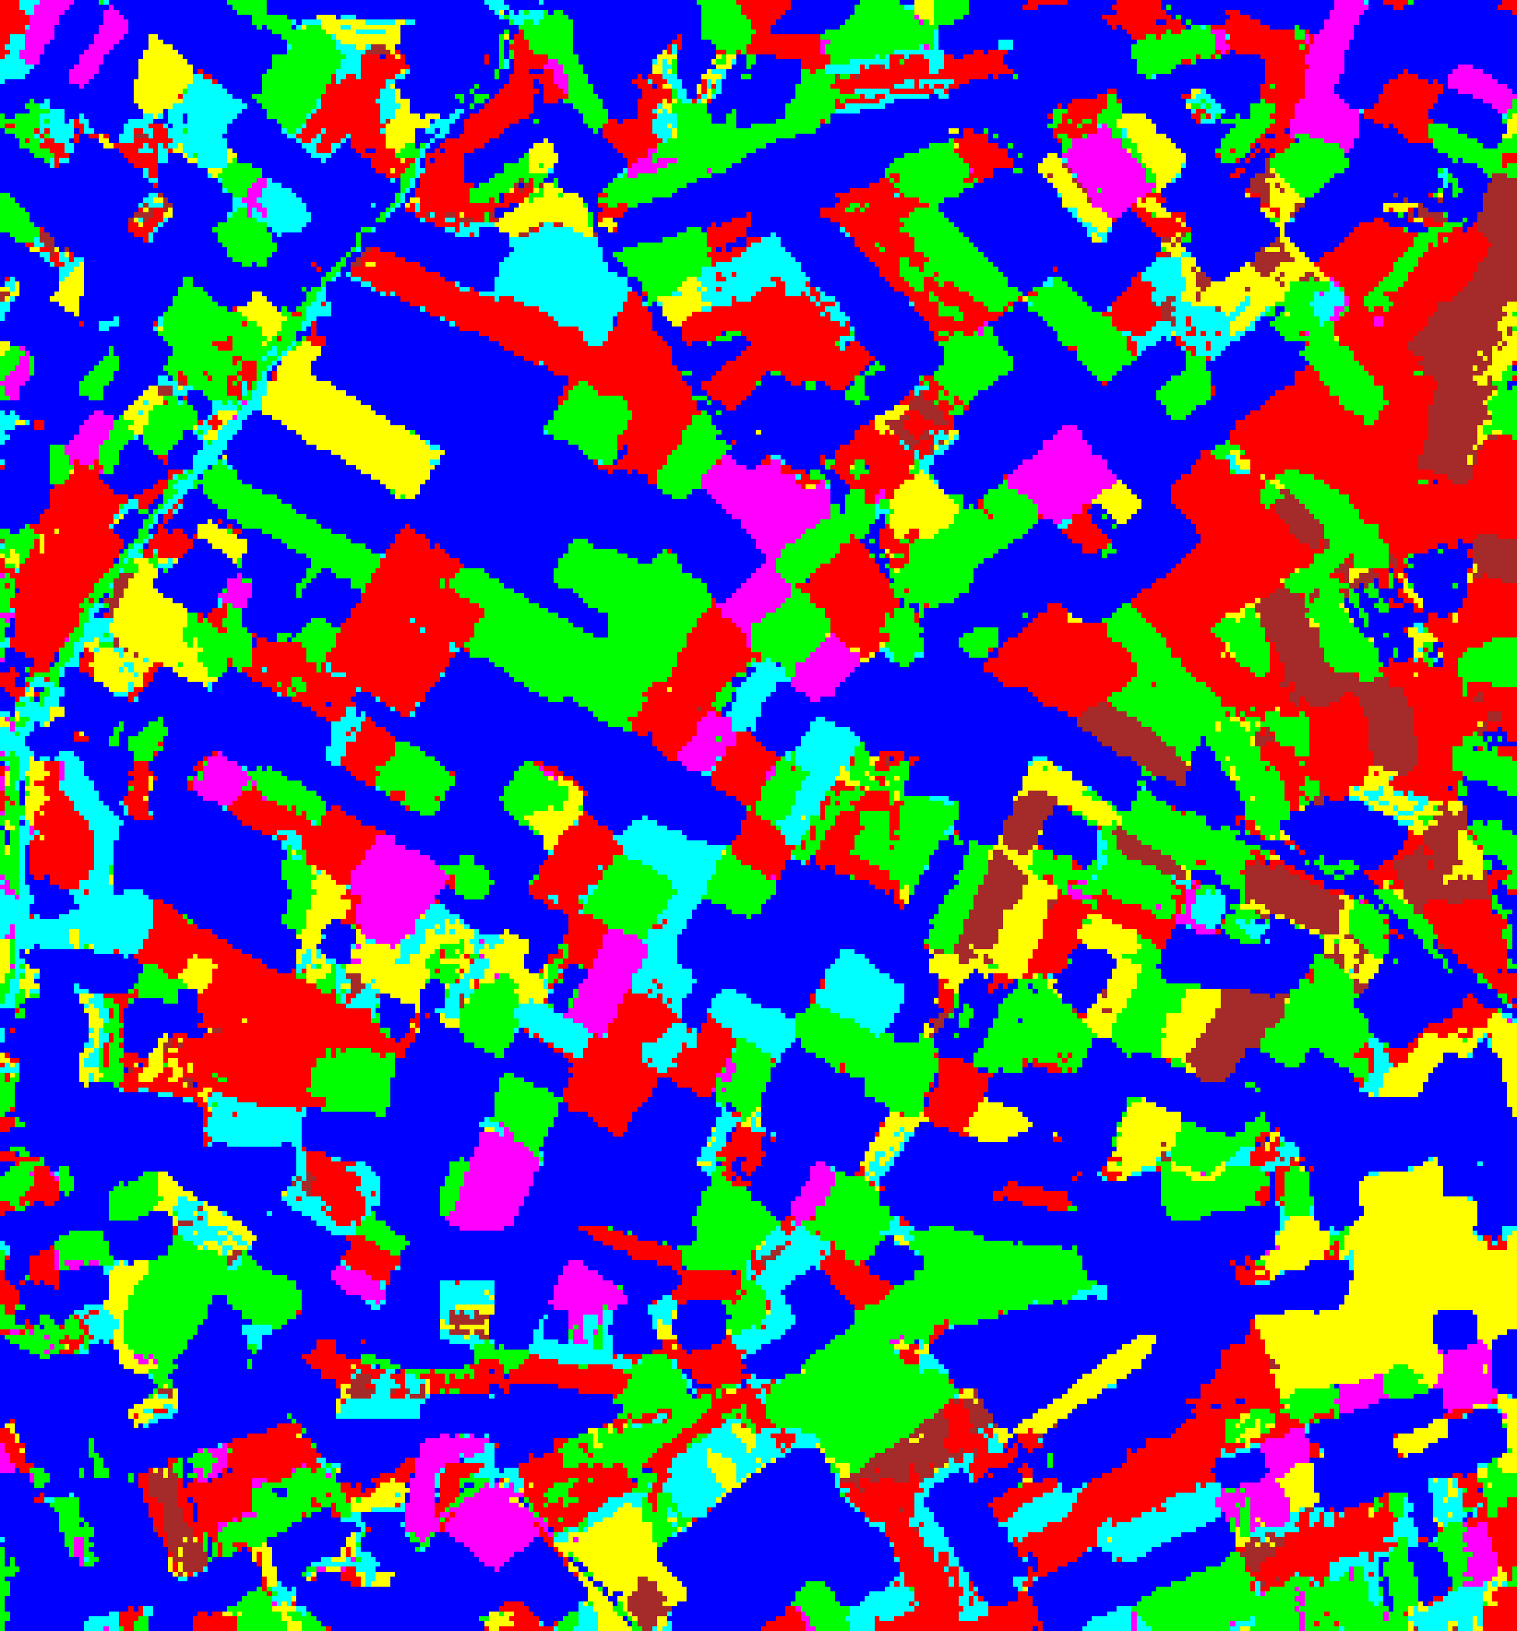  (C) ViT-UNet | (D) Legend
Fig. 3(b). Epistemic uncertainty overlay maps (EU > 0.2): (A) AlexNet-CNN, (B) GFNet, (C) ViT-UNet. Class colours retained for EU-certain pixels; grey = epistemically uncertain. Class legend shown in (D).
TABLE III
CREDIT EU (> 0.2): FULL-SCENE PIXEL COUNT DISTRIBUTION PER MODEL
Class / Region | AlexNet Pixels | GFNet Pixels | ViT-UNet Pixels
Class 0 | 41,946 | 42,898 | 43,890
Class 1 | 19,291 | 18,485 | 17,956
Class 2 | 18,569 | 20,026 | 18,406
Class 3 | 7,839 | 6,688 | 6,870
Class 4 | 4,286 | 4,798 | 3,797
Class 5 | 6,900 | 5,999 | 7,250
Class 6 | 2,479 | 2,416 | 3,141
EU-Uncertain | 0 | 0 | 0
Total (Scene) | 101,310 | 101,310 | 101,310

E. Total Uncertainty (TU > 0.7) Maps
Total uncertainty TU = AU + EU aggregates both sources. Pixels with TU > 0.7 are flagged as uncertain. Fig. 4(a) and Fig. 4(b) display the binary and grey-overlay TU maps; TABLE IV and TABLE V present the aggregate TU summary and per-class pixel counts.
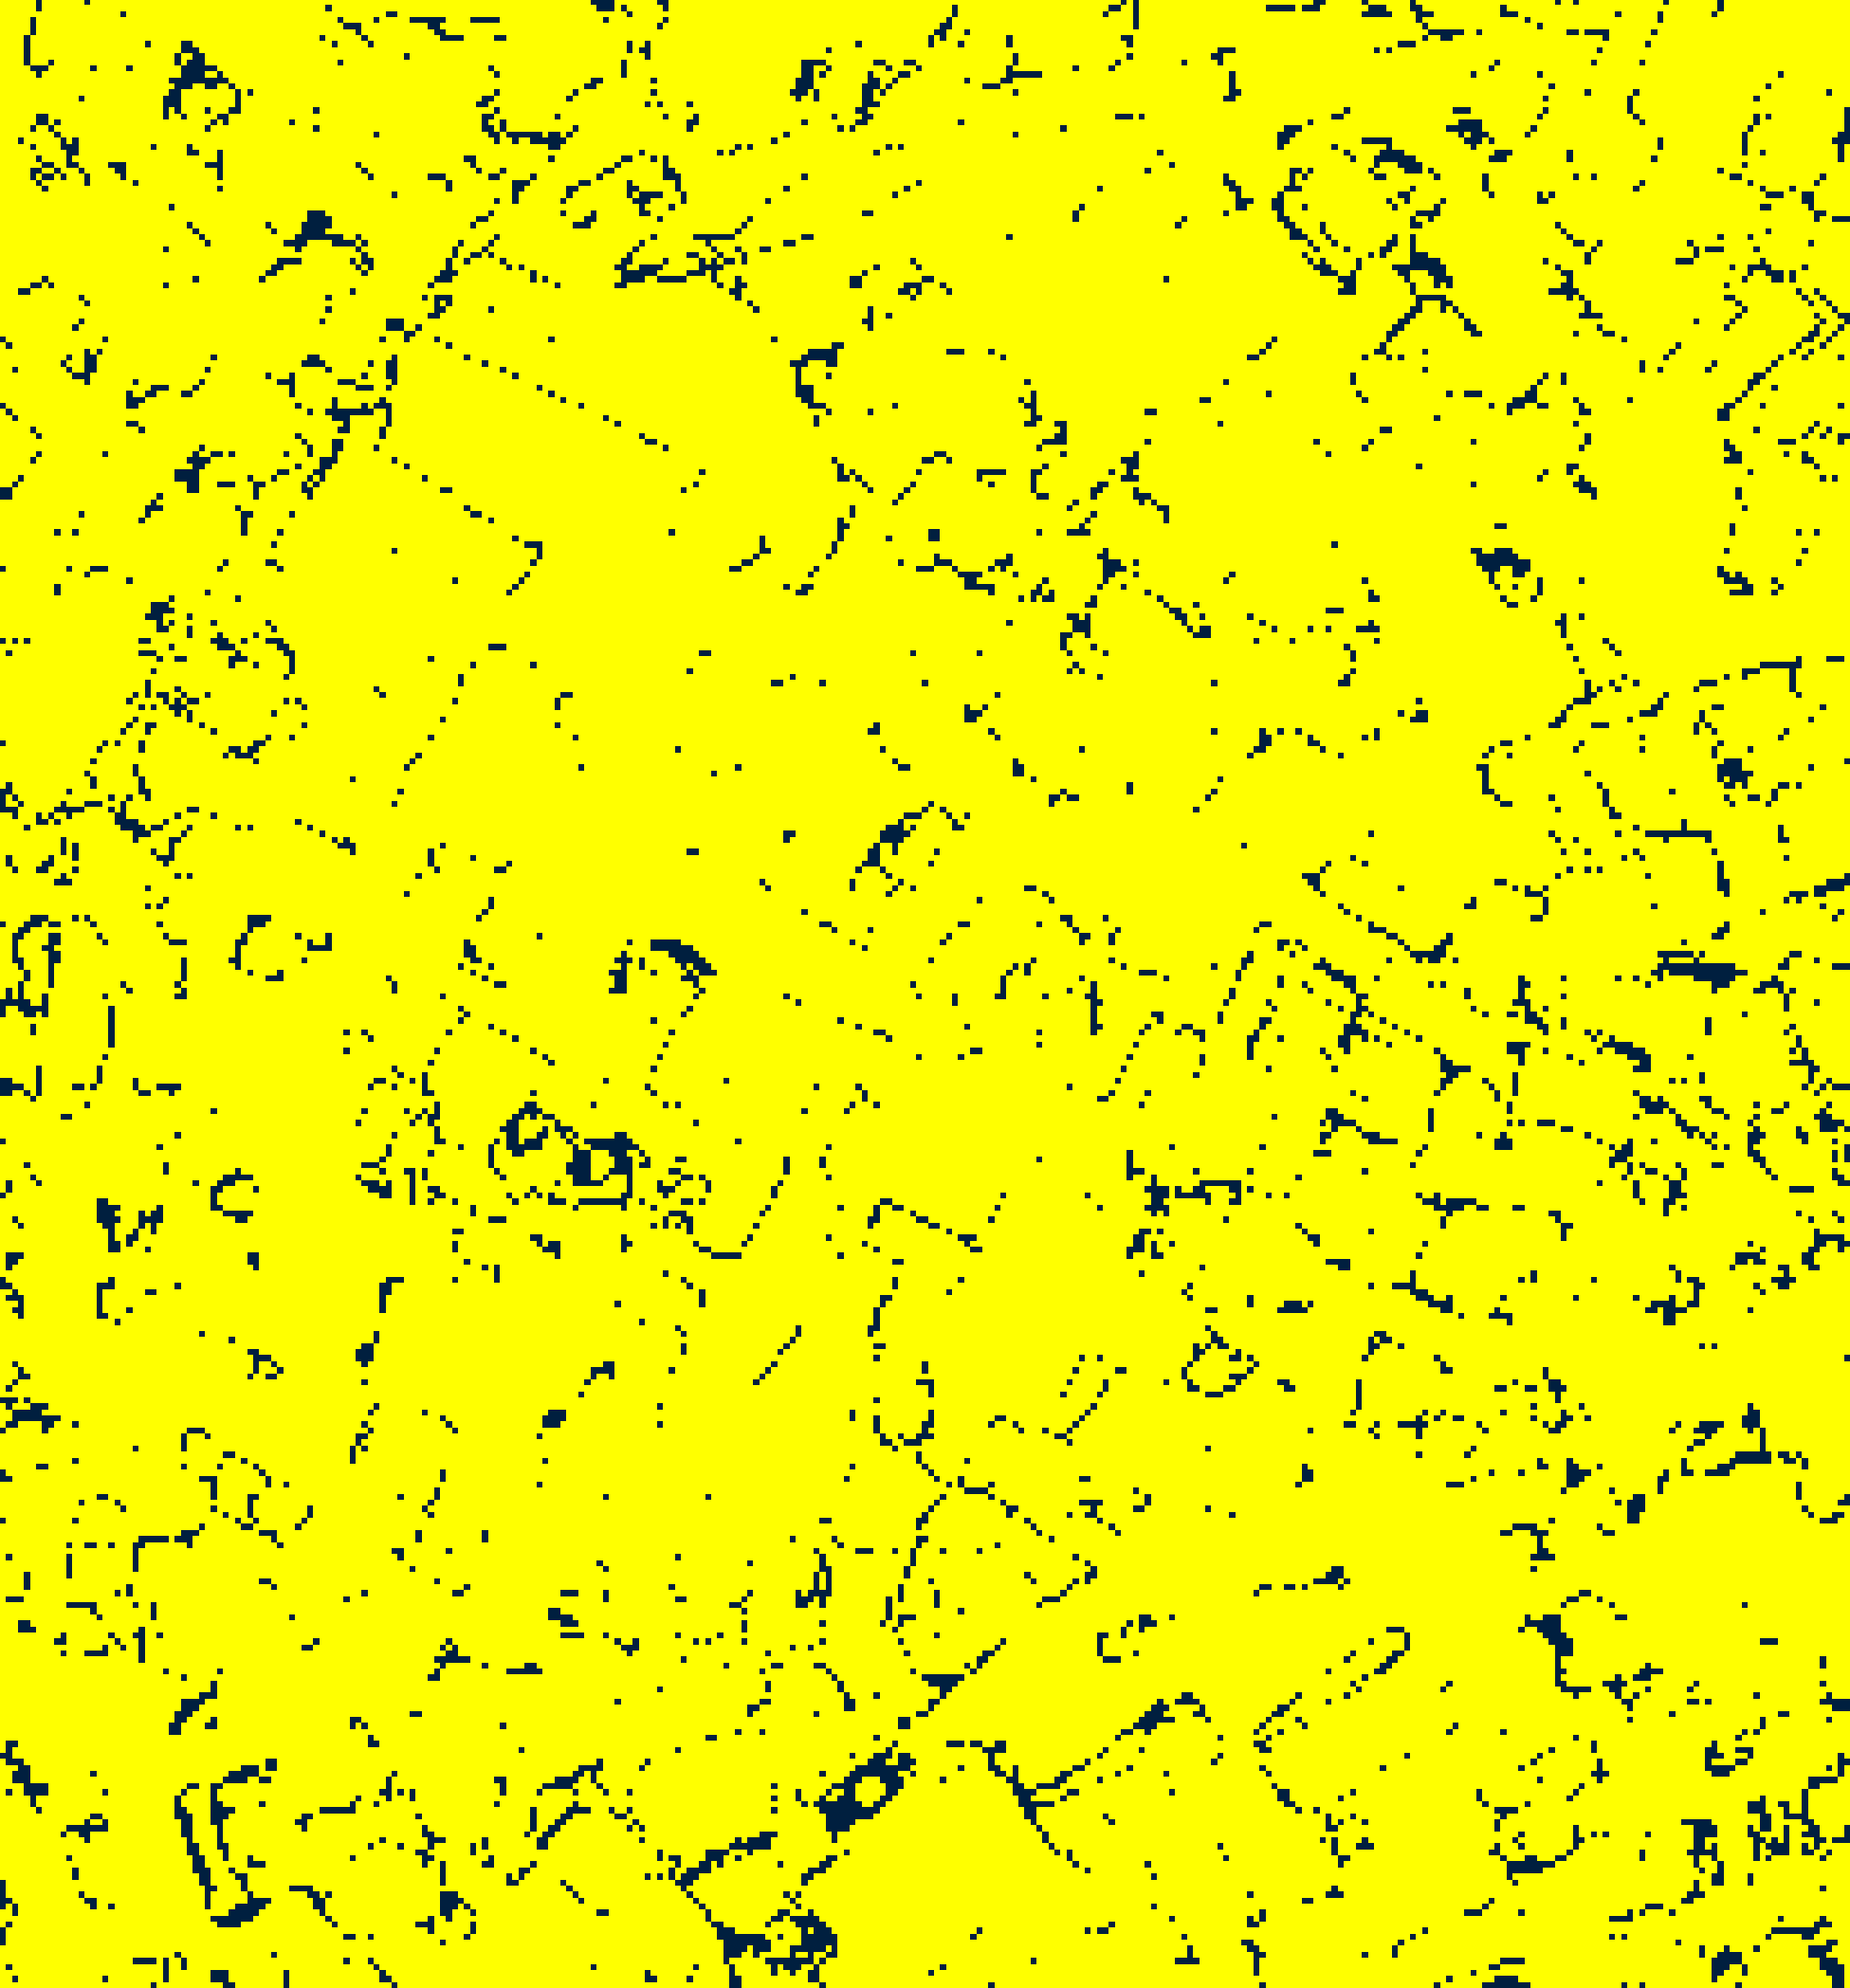  (A) AlexNet-CNN | 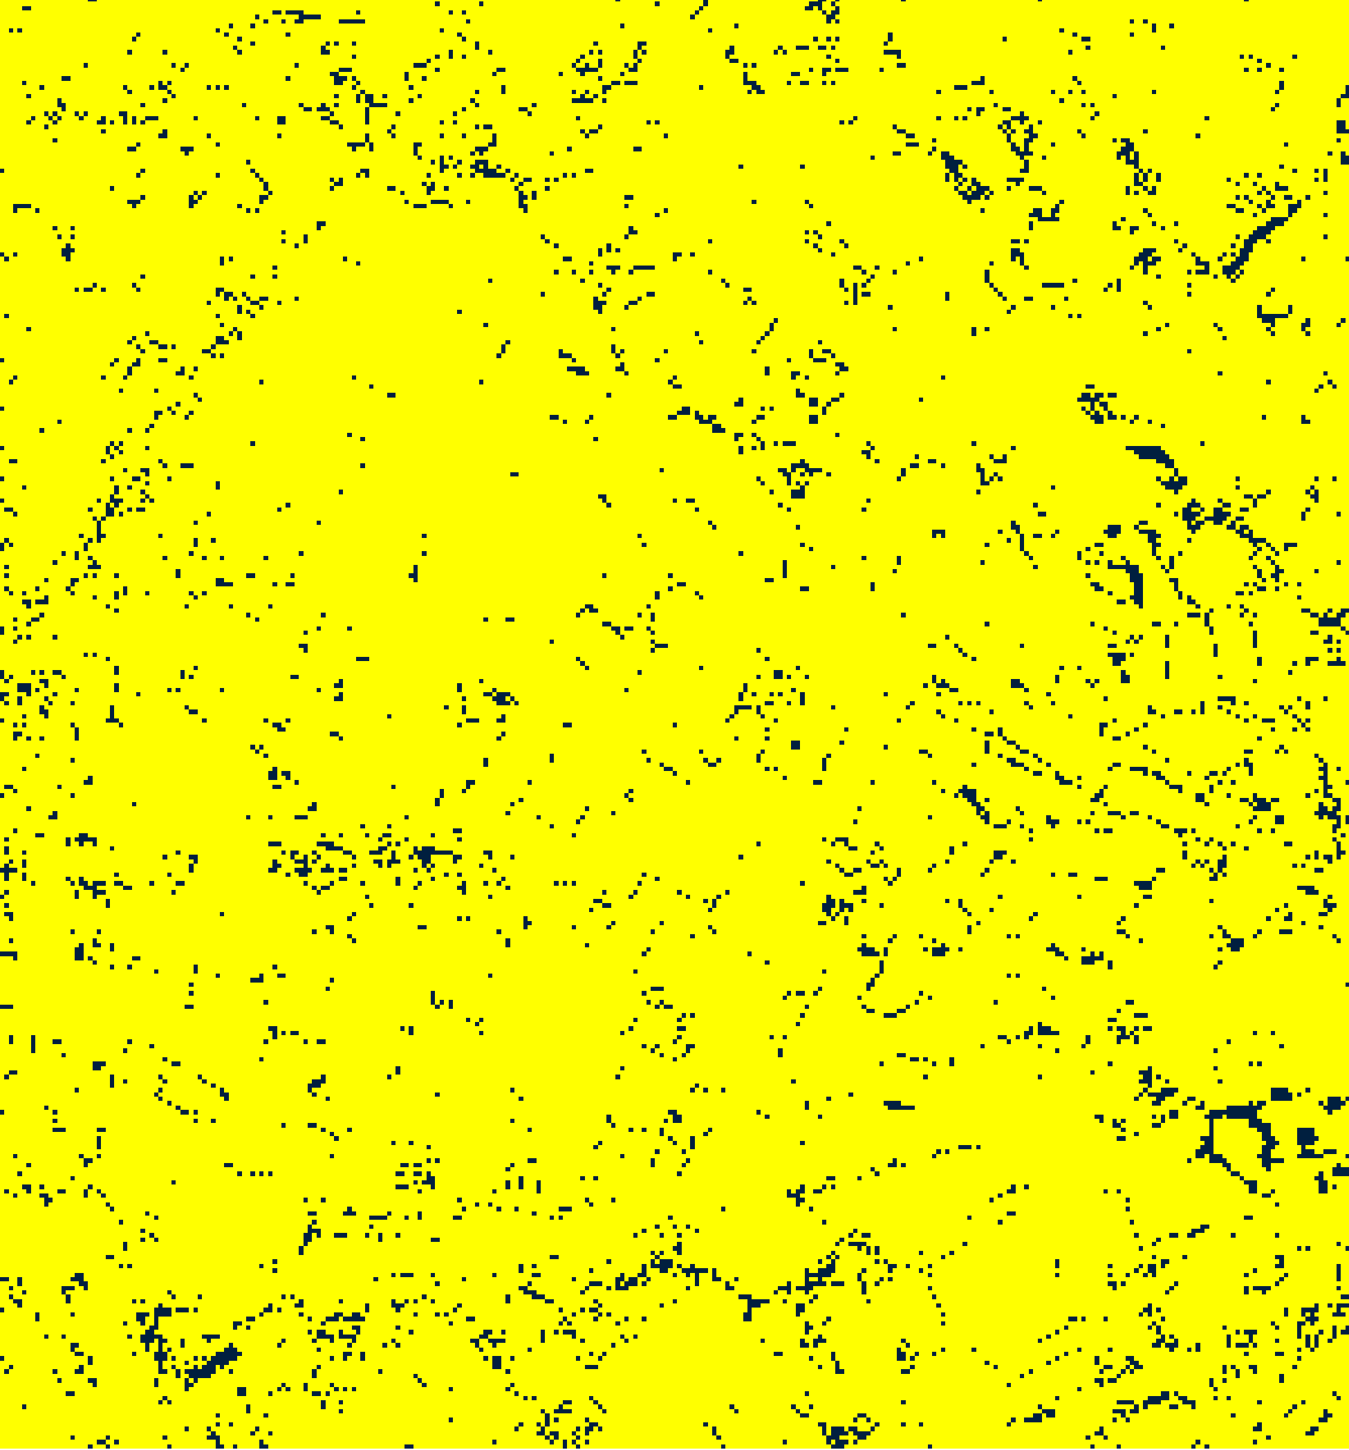  (B) GFNet
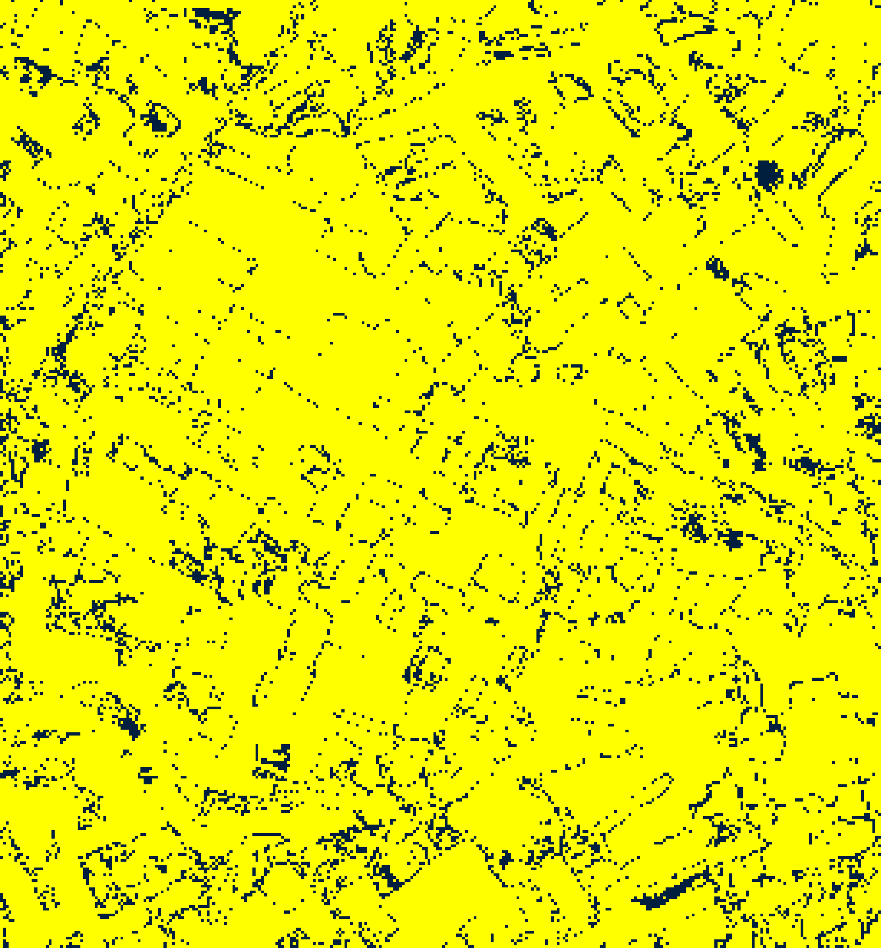  (C) ViT-UNet | (D) Legend
Fig. 4(a). Total uncertainty binary maps (TU > 0.7): (A) AlexNet-CNN, (B) GFNet, (C) ViT-UNet. Certain/Uncertain legend shown in (D).
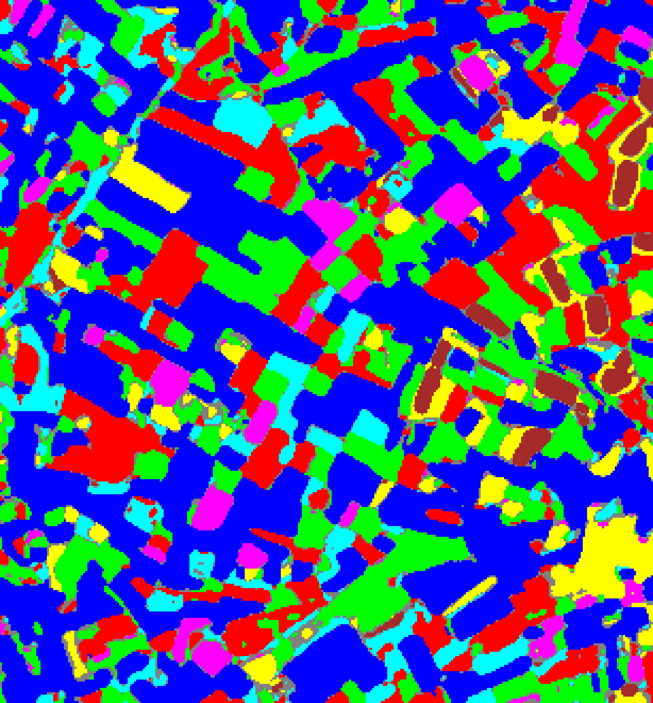  (A) AlexNet-CNN | 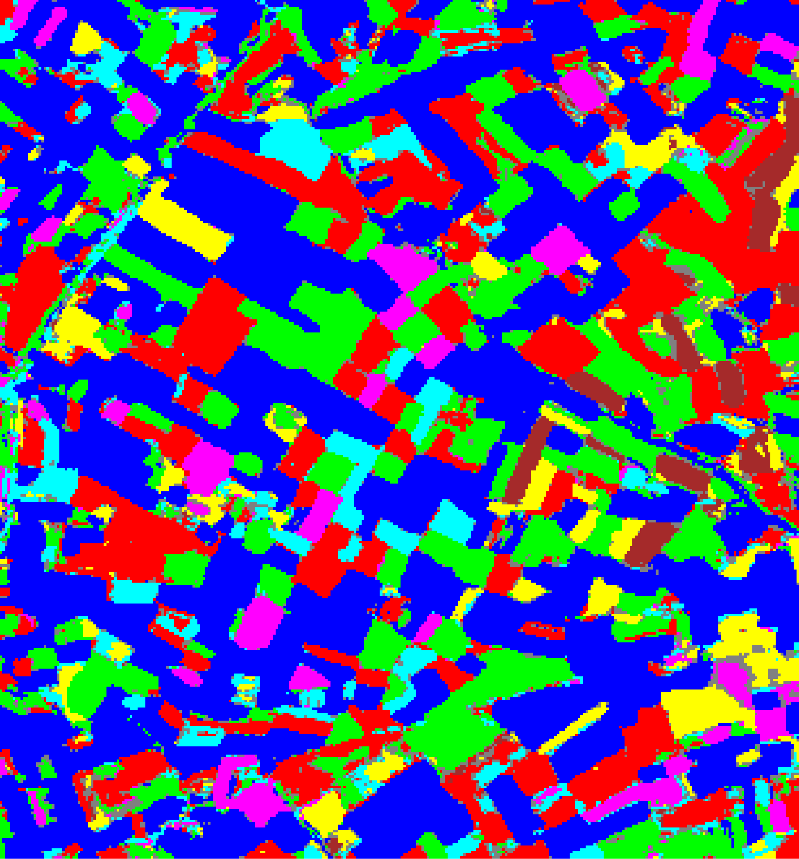  (B) GFNet
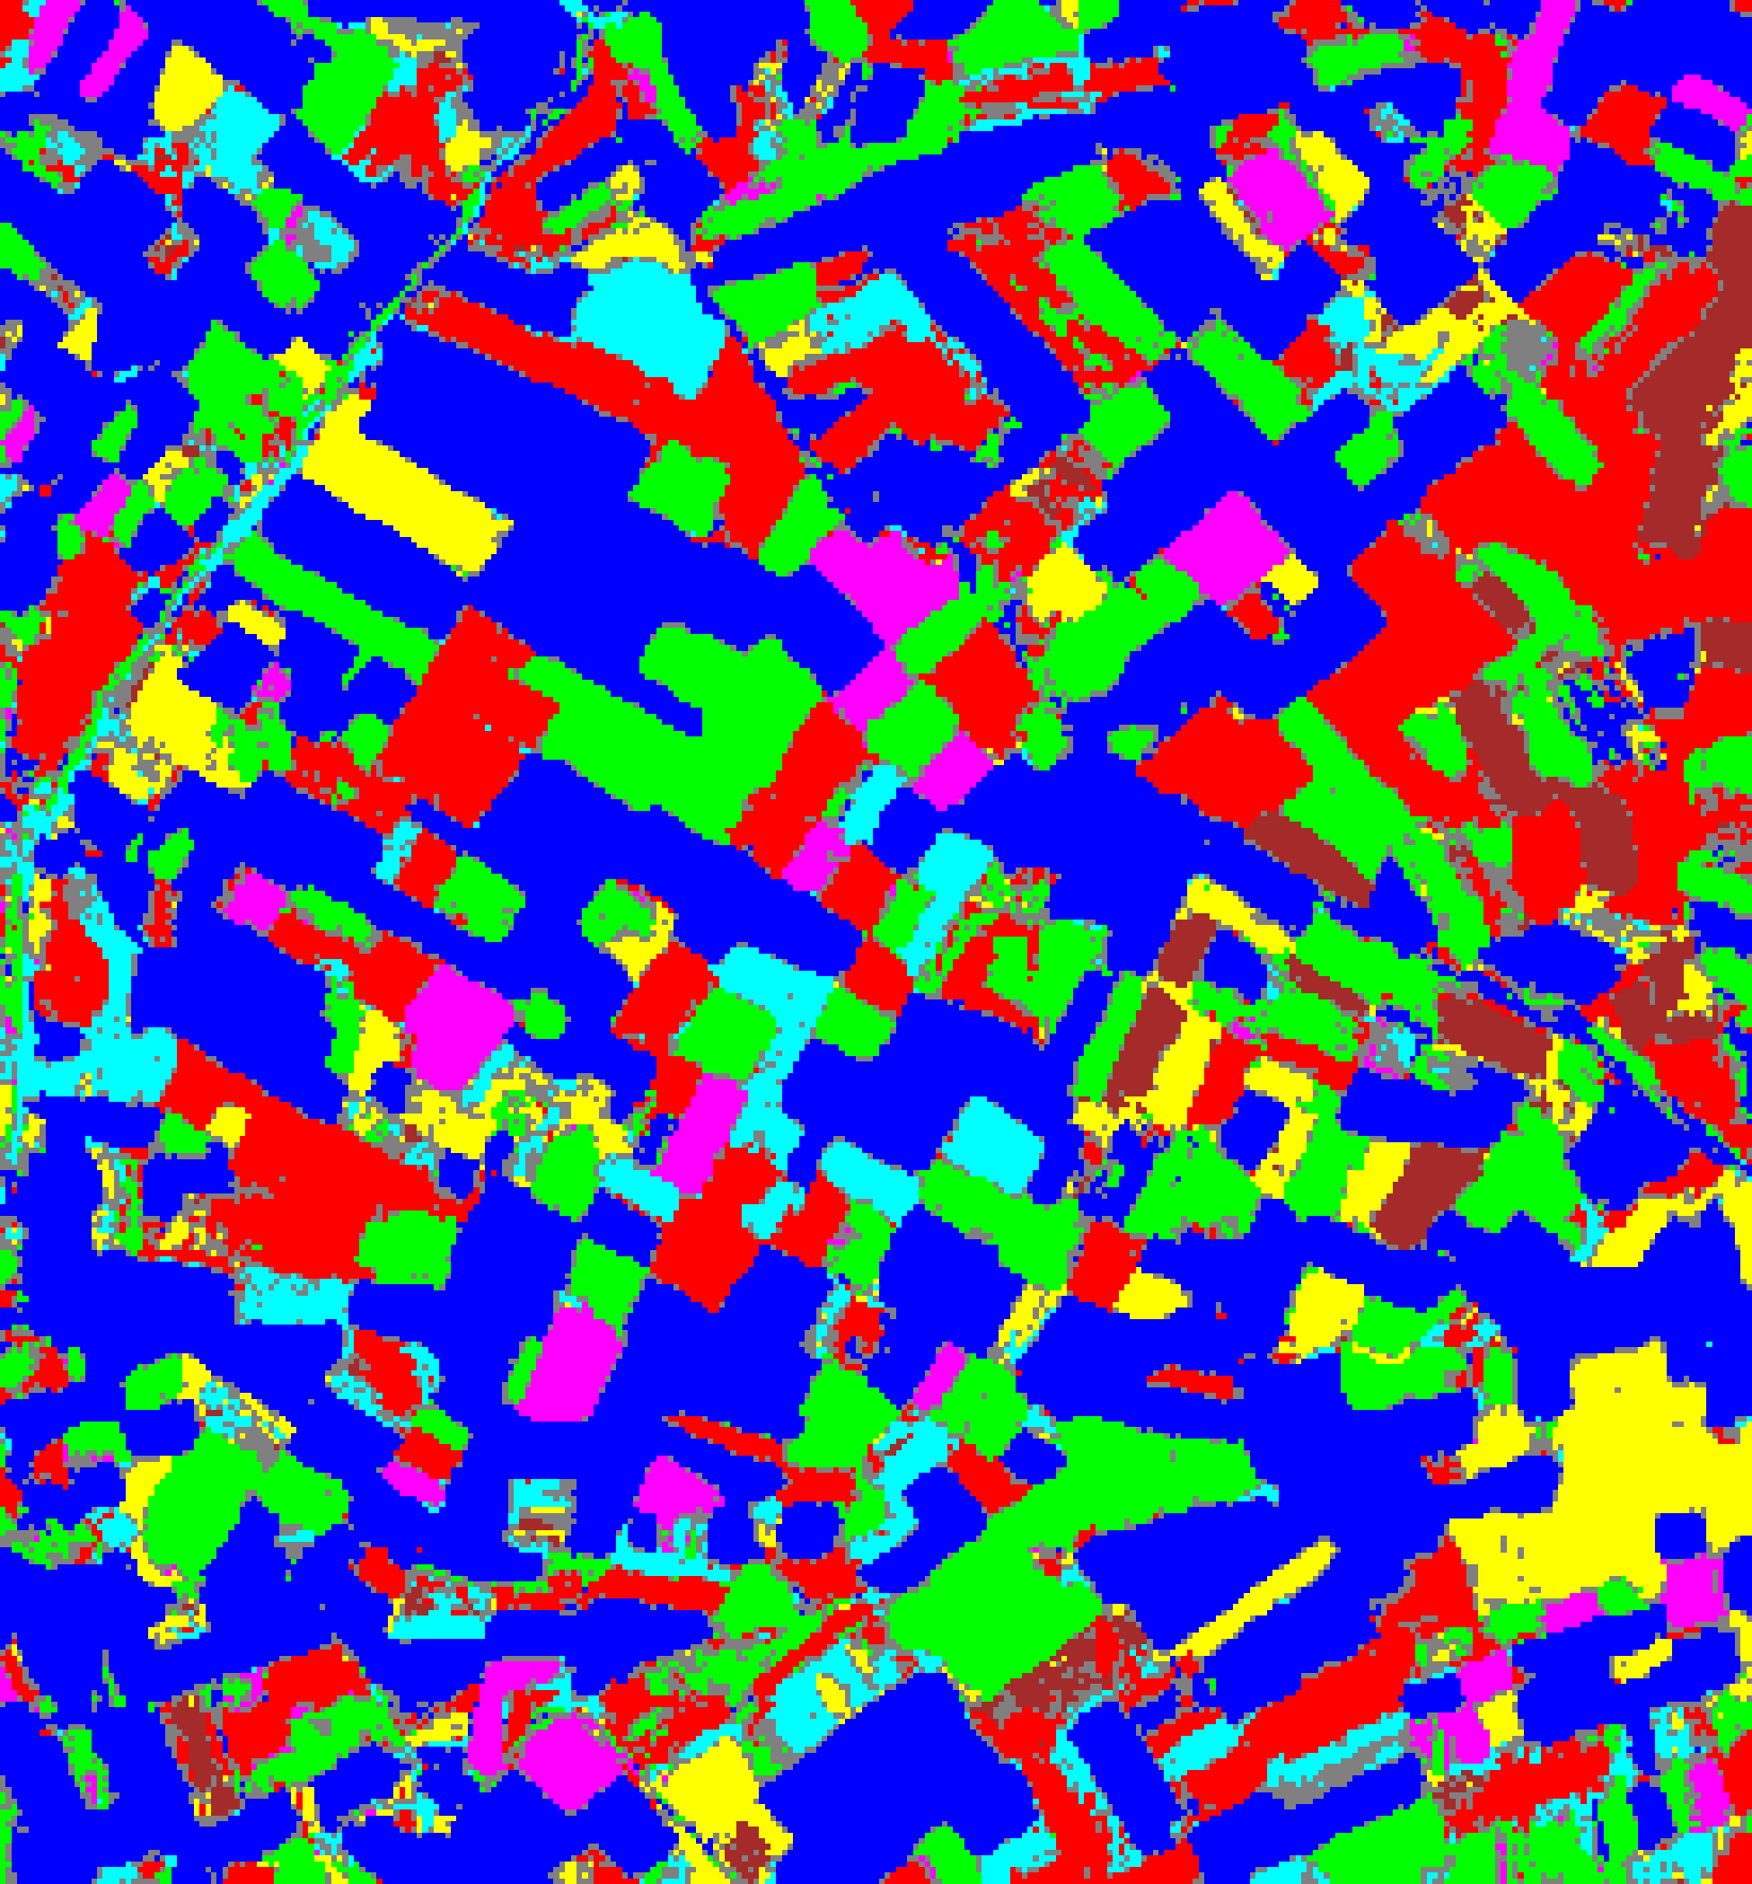  (C) ViT-UNet | (D) Legend
Fig. 4(b). Total uncertainty overlay maps (TU > 0.7): (A) AlexNet-CNN, (B) GFNet, (C) ViT-UNet. Class colours retained for TU-certain pixels; grey = TU-uncertain. Class legend shown in (D).
TABLE IV
CREDIT TU (> 0.7): AGGREGATE UNCERTAINTY SUMMARY
Model | Mean TU | Mean AU | Mean EU | TU-Uncertain Pixels | TU-Uncertain %
AlexNet-CNN | 0.020740 | 0.019521 | 0.001219 | 6,364 | 6.282%
GFNet | 0.014298 | 0.014228 | 0.000070 | 5,020 | 4.955%
ViT-UNet | 0.233034 | 0.228748 | 0.004286 | 9,521 | 9.398%

TABLE V
CREDIT TU (> 0.7): FULL-SCENE PIXEL COUNT DISTRIBUTION PER MODEL
Class / Region | AlexNet Pixels | GFNet Pixels | ViT-UNet Pixels
Class 0 | 40,911 | 42,249 | 41,999
Class 1 | 17,651 | 17,292 | 15,950
Class 2 | 17,498 | 18,870 | 16,425
Class 3 | 6,843 | 5,978 | 5,243
Class 4 | 3,895 | 4,464 | 3,408
Class 5 | 5,926 | 5,317 | 6,071
Class 6 | 2,222 | 2,120 | 2,693
TU-Uncertain | 6,364 | 5,020 | 9,521
Total (Scene) | 101,310 | 101,310 | 101,310

Under TU > 0.7, GFNet produces the fewest uncertain pixels (5,020, 4.955%), followed by AlexNet-CNN (6,364, 6.282%) and ViT-UNet (9,521, 9.398%). Because EU ≤ 0.2 everywhere, every TU-uncertain pixel is also AU-uncertain (specifically, 6,364 of AlexNet’s 11,803 AU-uncertain pixels exceed TU > 0.7, leaving 5,439 AU-only pixels; for GFNet and ViT-UNet, 5,020 and 9,521 pixels exceed both thresholds, leaving 3,593 and 3,640 AU-only pixels respectively).
F. AU/EU/TU Decomposition Analysis
TABLE VI quantifies the relative contributions of aleatoric and epistemic components to total uncertainty across the three architectures.
TABLE VI
CREDIT UNCERTAINTY DECOMPOSITION SUMMARY
Model | Mean AU | Mean EU | Mean TU | AU / TU Fraction | EU / TU Fraction
AlexNet-CNN | 0.019521 | 0.001219 | 0.020740 | 94.12% | 5.88%
GFNet | 0.014228 | 0.000070 | 0.014298 | 99.51% | 0.49%
ViT-UNet | 0.228748 | 0.004286 | 0.233034 | 98.16% | 1.84%

Aleatoric uncertainty dominates total uncertainty across all three architectures, accounting for 94.12% of TU in AlexNet-CNN, 98.16% in ViT-UNet, and 99.51% in GFNet. AlexNet-CNN exhibits the largest relative epistemic fraction (5.88%), consistent with its local 9 × 9 convolutional receptive field leaving small seed-to-seed variations across teacher checkpoints at ambiguous boundaries.
G. Threshold Sensitivity and Mask Overlap Analysis
TABLE VII details the spatial overlap between aleatoric, epistemic, and total uncertainty masks under the established thresholds (AU > 0.5, EU > 0.2, TU > 0.7), alongside a threshold sensitivity scan across t ∈ [0.1, 1.0]. Because epistemic divergence among ensemble teachers remains strictly bounded (EU ≤ 0.1754 across all pixels), every TU-uncertain pixel is an AU-uncertain pixel (AU & TU only: 6,364 pixels for AlexNet-CNN, 5,020 for GFNet, and 9,521 for ViT-UNet). The conservation identity TU = AU + EU holds exactly across all 101,310 pixels (mean and maximum |AU + EU − TU| = 0.000000). Across the threshold sensitivity range, GFNet exhibits the highest parameter certainty, maintaining a smaller uncertain footprint than AlexNet-CNN and ViT-UNet across all evaluated cutoffs.
TABLE VII
CREDIT UNCERTAIN-PIXEL MASK OVERLAP AND THRESHOLD SENSITIVITY
Part 1: Mask Overlap & Identity Verification (101,310 Scene Pixels)
Region / Evaluation Metric | AlexNet-CNN | GFNet | ViT-UNet
AU Only (AU > 0.5, TU ≤ 0.7) | 5,439 (5.369%) | 3,593 (3.547%) | 3,640 (3.593%)
EU Only (EU > 0.2) | 0 (0.000%) | 0 (0.000%) | 0 (0.000%)
TU Only (TU > 0.7, AU ≤ 0.5) | 0 (0.000%) | 0 (0.000%) | 0 (0.000%)
AU & TU Only | 6,364 (6.282%) | 5,020 (4.955%) | 9,521 (9.398%)
AU & EU & TU | 0 (0.000%) | 0 (0.000%) | 0 (0.000%)
None (Certain under all criteria) | 89,507 (88.350%) | 92,697 (91.498%) | 88,149 (87.009%)
Total Scene Pixels | 101,310 (100.0%) | 101,310 (100.0%) | 101,310 (100.0%)
AU-uncertain but NOT TU-uncertain | 5,439 | 3,593 | 3,640
TU-uncertain but NOT AU-uncertain | 0 | 0 | 0
Identity check: max |AU + EU − TU| | 0.000000 | 0.000000 | 0.000000
Mean |AU + EU − TU| | 0.000000 | 0.000000 | 0.000000
Max Observed AU / EU / TU | 1.8148 / 0.0949 / 1.8554 | 1.7394 / 0.1195 / 1.7394 | 1.8543 / 0.1754 / 2.0092
Part 2: Sensitivity Across Thresholds t (% of Full Scene)
Threshold (t) | AlexNet AU | AlexNet TU | GFNet AU | GFNet TU | ViT-UNet AU | ViT-UNet TU
0.1 | 24,833 (24.51%) | 25,122 (24.80%) | 19,833 (19.58%) | 19,845 (19.59%) | 97,218 (95.96%) | 97,381 (96.12%)
0.2 | 19,993 (19.73%) | 20,159 (19.90%) | 15,154 (14.96%) | 15,158 (14.96%) | 84,715 (83.62%) | 85,554 (84.45%)
0.3 | 16,734 (16.52%) | 16,860 (16.64%) | 12,546 (12.38%) | 12,551 (12.39%) | 20,437 (20.17%) | 20,868 (20.60%)
0.5 | 11,803 (11.65%) | 11,903 (11.75%) | 8,613 (8.50%) | 8,616 (8.51%) | 13,161 (12.99%) | 13,395 (13.22%)
0.7 | 6,203 (6.12%) | 6,364 (6.28%) | 5,011 (4.95%) | 5,020 (4.96%) | 9,323 (9.20%) | 9,521 (9.40%)
1.0 | 1,717 (1.70%) | 1,785 (1.76%) | 1,337 (1.32%) | 1,339 (1.32%) | 4,026 (3.97%) | 4,262 (4.21%)
*(Note: Epistemic uncertainty EU > t is 0.000% across all t ≥ 0.2 for all models, with 1 pixel at t=0.1 for GFNet and 24 pixels for ViT-UNet).*

H. Credal Prediction-Set Coverage & Efficiency Analysis
To compress the computational burden of deep ensembles into an efficient single-pass inference model, the CREDIT (Credal Ensemble Distillation) framework trains a student network with dual prediction heads: a primary softmax head outputting nominal class probabilities p*_k(x) and an auxiliary bounded sigmoid head outputting epistemic uncertainty slacks Δp_k(x) ∈ [0, 1]. These dual heads parameterize a credal probability interval:
[p̲_k(x), p̄_k(x)] = [p*_k(x), min(1, p*_k(x) + Δp_k(x))]
Prediction sets are constructed via the interval dominance rule: candidate class k is admitted into C(x) if and only if its upper bound p̄_k(x) is at least as large as the maximal lower bound across all classes, p̄_k(x) ≥ max_j p̲_j(x). Because the argmax student prediction k* = argmax_j p*_j(x) satisfies p̄_{k*}(x) ≥ p*_{k*}(x) = max_j p̲_j(x), prediction sets are non-empty (|C(x)| ≥ 1) for every input pixel.
TABLE VIII details the overall empirical coverage, average prediction set size, and mean class coverage across the 4,310 held-out test pixels for the distilled student architectures on the 6-band DIAS dataset. GFNet achieves 99.74% overall coverage with an average set size of 1.0000 (mean class coverage 99.64%). AlexNet-CNN achieves 99.56% overall coverage with an average set size of 1.0000 (mean class coverage 99.52%), and ViT-UNet records 98.91% coverage with an average set size of 1.0000 (mean class coverage 98.34%). Overall coverage equals test accuracy for each student (sets are singletons across the test split), confirming that interval-dominance prediction sets preserve calibrated statistical guarantees.
TABLE VIII
OVERALL CREDIT CREDAL PREDICTION-SET COVERAGE & AVERAGE SET SIZE
Model | N_Test_Pixels | Overall Empirical Coverage | Average Set Size | Mean Class Coverage
AlexNet-CNN | 4,310 | 99.56% | 1.0000 | 99.52%
GFNet | 4,310 | 99.74% | 1.0000 | 99.64%
ViT-UNet | 4,310 | 98.91% | 1.0000 | 98.34%
TABLE IX presents the class-wise empirical coverage across all 7 annotated categories. GFNet attains 100.00% coverage on Classes 1, 5, and 6, and exceeds 99.04% on all remaining classes. AlexNet-CNN is at 100.00% on Classes 5 and 6, and is at or above 98.72% on all classes. ViT-UNet achieves 99.84% on Class 1 and 99.52% on Class 5, with lowest coverage on Class 7 (97.06%). Under-coverage is minimal and concentrated on minority classes where student bounds remain highly compact.
TABLE IX
CLASS-WISE CREDAL PREDICTION-SET COVERAGE ACROSS ALL CLASSES
Class | AlexNet-CNN | GFNet | ViT-UNet
Class 1 | 99.73% | 100.00% | 99.84%
Class 2 | 99.23% | 99.45% | 98.24%
Class 3 | 99.72% | 99.72% | 98.60%
Class 4 | 98.72% | 99.04% | 97.12%
Class 5 | 100.00% | 100.00% | 99.52%
Class 6 | 100.00% | 100.00% | 98.03%
Class 7 | 99.26% | 99.26% | 97.06%
In summary, the dual-headed CREDIT student models capture the epistemic diversity of multi-checkpoint teacher ensembles within a lightweight, deterministic forward pass. By pairing nominal probabilities with interval dominance, CREDIT provides set-valued predictions with near-singleton average set sizes and empirical coverage of 98.91%–99.74% on the held-out test pixels.
IV. DISCUSSION
On the 6-band DIAS multispectral dataset, prediction uncertainty across the scene is overwhelmingly driven by aleatoric entropy at class interfaces and unlabelled background pixels. ViT-UNet’s higher mean AU (0.2287 vs. 0.0142–0.0195) reflects less peaked teacher softmax distributions rather than classification errors, as confirmed by its 98.91% test accuracy.
V. CONCLUSION
This paper demonstrated Credal Ensemble Distillation (CREDIT) for patch-based 6-band multispectral land-cover classification on the DIAS dataset (330 × 307 pixels, K = 7 classes). All three dual-head students achieved 98.91%–99.74% test accuracy while decomposing predictive uncertainty into aleatoric and epistemic components in a single forward pass. Full-scene maps across all 101,310 pixels confirm that uncertainty is predominantly aleatoric (> 94% of TU) and concentrated along parcel boundaries and background transitions, with GFNet achieving the smallest uncertain footprint (8.50% under AU > 0.5 and 4.96% under TU > 0.7).
REFERENCES
[1] K. Wang, F. Cuzzolin, D. Moens, and H. Hallez, “Credal Ensemble Distillation for Uncertainty Quantification,” arXiv:2511.13766, accepted AAAI 2026.
[2] Y. Rao, W. Zhao, Z. Zhu, J. Lu, and J. Zhou, “GFNet: Global Filter Networks for Visual Recognition,” IEEE TPAMI, 2023.
[3] A. Dosovitskiy et al., “An Image is Worth 16×16 Words: Transformers for Image Recognition at Scale,” in Proc. ICLR, 2021.
[4] O. Ronneberger, P. Fischer, and T. Brox, “U-Net: Convolutional Networks for Biomedical Image Segmentation,” in Proc. MICCAI, 2015.
[5] B. Lakshminarayanan, A. Pritzel, and C. Blundell, “Simple and Scalable Predictive Uncertainty Estimation using Deep Ensembles,” in Adv. Neural Inf. Process. Syst. (NeurIPS), 2017.
[6] A. Krizhevsky, I. Sutskever, and G. E. Hinton, “ImageNet Classification with Deep Convolutional Neural Networks,” in Adv. Neural Inf. Process. Syst. (NeurIPS), 2012.

