Credal Deep Ensemble Uncertainty Quantification for Patch-Based Multispectral Land-Cover Classification
ABSTRACT
This paper presents a Credal Deep Ensemble (CreDE) uncertainty-quantification analysis for patch-based pixel-wise land-cover classification of multispectral remote sensing imagery, complementing companion uncertainty frameworks on the same scene and architectures. A 6-band multispectral scene of 330 × 307 pixels (101,310 total scene pixels) from the DIAS dataset (Scene K01, K = 7 annotated land-cover classes: Class 1 through Class 7, plus unlabelled background Class 0) is classified by extracting 9 × 9 × 6 spatial-spectral patches centred on each pixel across three representative backbone architectures—an AlexNet-style convolutional neural network (AlexNet-CNN), a Global Filter Network (GFNet) operating in the frequency domain, and a Vision Transformer augmented with U-Net skip connections (ViT-UNet). For each architecture, M = 5 independently seeded checkpoints form per-class credal (minimum/maximum softmax) bounds without collapsing the five members into a single averaged point prediction. On the 4,310-pixel held-out test split, AlexNet-CNN achieves 99.77% overall accuracy, GFNet achieves 99.63%, and ViT-UNet achieves 99.54%. Across the full 101,310-pixel scene, AlexNet-CNN achieves the lowest mean aleatoric and total uncertainty (Mean AU = 0.0484, Mean EU = 0.0675, Mean TU = 0.1159), GFNet achieves the lowest mean epistemic uncertainty (Mean EU = 0.0579, Mean AU = 0.2465, Mean TU = 0.3044), and ViT-UNet exhibits higher global entropy spread (Mean AU = 0.5471, Mean EU = 0.0750, Mean TU = 0.6221). In credal prediction-set evaluation under the interval-dominance criterion, all three architectures achieve empirical test coverage exceeding 99.93% (AlexNet-CNN 99.93%, GFNet 99.93%, ViT-UNet 99.95%) while maintaining exceptionally compact set sizes between 1.0067 and 1.0346 classes per pixel.
I. INTRODUCTION
Remote sensing land-cover classification is a foundational task in earth observation and environmental monitoring [6]. Multispectral sensors capture spectral reflectance across key visible and near-infrared bands, enabling discrimination between diverse land-cover categories such as agricultural crop types, bare soil, vegetation, and built-up infrastructure. However, pixel-level predictions in complex agricultural landscapes remain susceptible to spectral confusion, boundary ambiguity between adjacent parcels, atmospheric degradation, and out-of-distribution background noise.
Standard deep neural networks produce point-estimate softmax probability vectors that are notoriously overconfident and cannot distinguish between genuine data noise (aleatoric uncertainty) and model parameter ignorance (epistemic uncertainty). Deep Ensembles [1] mitigate this by training M independently initialized networks to quantify predictive variance. The Credal Deep Ensemble (CreDE) framework [7] advances ensemble methodology by interpreting the M = 5 member predictive distributions not as a collapsed average, but as lower and upper probability bounds that define an explicit convex credal set of candidate probability distributions. This formulation allows rigorous separation of aleatoric and epistemic uncertainties while supporting interval-dominance credal set decisions.
The primary contributions of this paper are:
- Rigorous formulation and empirical application of Credal Deep Ensembles (CreDE) to M = 5 independently seeded checkpoints across three deep architectures (AlexNet-CNN, GFNet, and ViT-UNet) on the 6-band DIAS Scene K01 multispectral benchmark (330 × 307 pixels).
- Comprehensive per-class precision, recall, and F1-score evaluation across 4,310 held-out test pixels for each backbone model.
- Exact pixel-level decomposition into aleatoric (AU), epistemic (EU), and total (TU) uncertainty across the entire 101,310-pixel scene, satisfying the exact identity TU = AU + EU.
- Spatial mapping of binary and grey-overlay uncertainty masks under established thresholds (AU > 0.5, EU > 0.2, TU > 0.7) and full-scene class-wise pixel distributions.
- Empirical validation of credal prediction-set coverage and set-size efficiency across all 7 annotated land-cover classes.
II. METHODOLOGY
A. Dataset and Preprocessing
The experimental dataset is derived from the DIAS 6-band multispectral benchmark (Scene K01). The scene comprises spatial dimensions of H = 330 rows and W = 307 columns (101,310 total scene pixels) across B = 6 spectral bands. Ground truth annotations specify K = 7 active agricultural land-cover classes (Classes 1 through 7), with unlabelled background pixels denoted as Class 0. Each spectral band is independently normalized to the interval [0, 1] using min-max scaling. To classify each pixel, a 9 × 9 spatial patch centred on that pixel across all 6 spectral bands (9 × 9 × 6) is extracted using 4-pixel edge replication padding. For metric evaluation, a stratified held-out test set of 4,310 pixels (25% of labeled pixels) is evaluated across all ensemble members.
B. Backbone Architectures
Three distinct deep learning paradigms are evaluated:
1) AlexNet-CNN: A tailored convolutional architecture comprising five same-padded 3 × 3 convolution layers [96, 256, 384, 384, 256 feature channels] followed by dense classification layers with dropout (p = 0.25) [5], optimized using Adagrad with a cosine learning-rate decay schedule.
2) GFNet (Global Filter Network): A frequency-domain architecture that tokenizes each 9 × 9 × 6 patch into nine 3 × 3 spatial tokens (embedding dimension d = 512) and applies 2-D discrete Fourier transform global filter layers [2] to capture long-range spatial dependencies, trained using AdamW with label smoothing (ε_s = 0.05).
3) ViT-UNet: A hybrid Vision Transformer [3] featuring patch projection and multi-head self-attention encoders linked to a convolutional decoder via U-Net skip connections [4] to preserve high-resolution spatial feature boundaries.
C. Credal Deep Ensemble (CreDE) Uncertainty Quantification
Let {f_m}_{m=1}^M represent M = 5 independently seeded ensemble members for a given backbone architecture. For an input patch x, each member outputs a softmax predictive vector q_{m}(x) = [q_{m,1}(x), ..., q_{m,K}(x)]^T over the K = 7 land-cover classes. CreDE [7] computes the per-class lower and upper probability bounds across the ensemble:
p_min,k(x) = min_{m ∈ {1,...,M}} q_{m,k}(x), p_max,k(x) = max_{m ∈ {1,...,M}} q_{m,k}(x)
The credal interval spread is Δp_k(x) = p_max,k(x) − p_min,k(x). The conservative lower-bound vector is renormalised to form a point estimate:
p*_k(x) = p_min,k(x) / (Σ_{j=1}^K p_min,j(x) + ε)
from which the predicted class is ĉ(x) = argmax_k p*_k(x). Three distinct uncertainty quantities are derived at each spatial coordinate:
Aleatoric Uncertainty (AU): AU(x) = − Σ_{k=1}^K p*_k(x) ln(p*_k(x))
Epistemic Uncertainty (EU): EU(x) = (1 / K) Σ_{k=1}^K Δp_k(x)
Total Uncertainty (TU): TU(x) = AU(x) + EU(x)
By defining TU as the direct sum of predictive entropy AU (measuring inherent data overlap) and credal bound disagreement EU (measuring ensemble divergence), the conservation identity TU = AU + EU is exactly satisfied across every pixel in the scene.
III. EXPERIMENTS AND RESULTS
A. Per-Class Classification Reports
TABLE I, TABLE II, and TABLE III report the per-class precision, recall, F1-score, and support for AlexNet-CNN, GFNet, and ViT-UNet on the 4,310-pixel held-out test split of the 6-band DIAS dataset.
TABLE I
ALEXNET-CNN CLASSIFICATION REPORT (PER CLASS, 4,310 TEST SAMPLES)
Class | Precision | Recall | F1-Score | Support
Class 1 | 0.9989 | 0.9989 | 0.9989 | 1,828
Class 2 | 0.9967 | 0.9956 | 0.9961 | 908
Class 3 | 0.9958 | 1.0000 | 0.9979 | 715
Class 4 | 0.9936 | 0.9904 | 0.9920 | 313
Class 5 | 1.0000 | 1.0000 | 1.0000 | 207
Class 6 | 1.0000 | 0.9951 | 0.9975 | 203
Class 7 | 1.0000 | 1.0000 | 1.0000 | 136
Macro Avg | 0.9979 | 0.9971 | 0.9975 | 4,310
Weighted Avg | 0.9977 | 0.9977 | 0.9977 | 4,310

TABLE II
GFNET CLASSIFICATION REPORT (PER CLASS, 4,310 TEST SAMPLES)
Class | Precision | Recall | F1-Score | Support
Class 1 | 1.0000 | 1.0000 | 1.0000 | 1,828
Class 2 | 0.9989 | 0.9945 | 0.9967 | 908
Class 3 | 0.9834 | 0.9958 | 0.9896 | 715
Class 4 | 0.9967 | 0.9744 | 0.9855 | 313
Class 5 | 0.9952 | 1.0000 | 0.9976 | 207
Class 6 | 0.9951 | 1.0000 | 0.9975 | 203
Class 7 | 1.0000 | 1.0000 | 1.0000 | 136
Macro Avg | 0.9956 | 0.9950 | 0.9953 | 4,310
Weighted Avg | 0.9963 | 0.9963 | 0.9963 | 4,310

TABLE III
VIT-UNET CLASSIFICATION REPORT (PER CLASS, 4,310 TEST SAMPLES)
Class | Precision | Recall | F1-Score | Support
Class 1 | 0.9989 | 0.9984 | 0.9986 | 1,828
Class 2 | 0.9956 | 0.9956 | 0.9956 | 908
Class 3 | 0.9889 | 0.9944 | 0.9916 | 715
Class 4 | 0.9839 | 0.9776 | 0.9808 | 313
Class 5 | 1.0000 | 0.9903 | 0.9951 | 207
Class 6 | 0.9951 | 1.0000 | 0.9975 | 203
Class 7 | 1.0000 | 1.0000 | 1.0000 | 136
Macro Avg | 0.9946 | 0.9938 | 0.9942 | 4,310
Weighted Avg | 0.9954 | 0.9954 | 0.9954 | 4,310

B. Scene Overview
Fig. 1 displays the approximate RGB composite and the ground-truth reference label map for the 330 × 307, 6-band DIAS Scene K01 multispectral dataset.
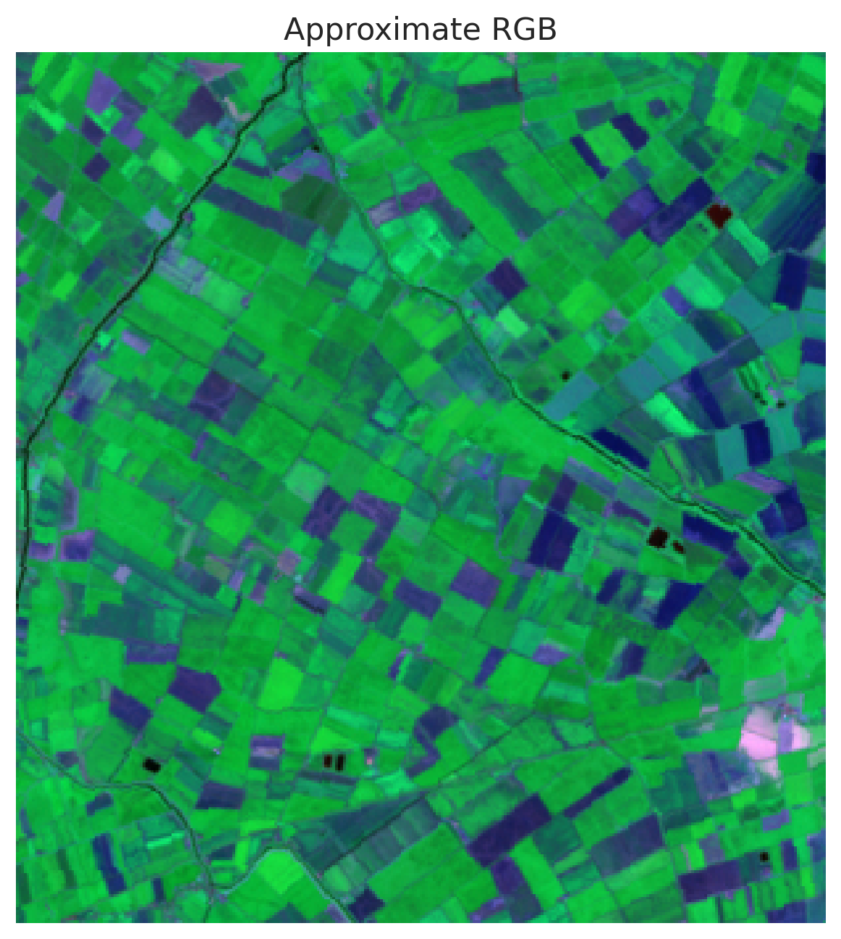  (a) Approximate RGB Composite | 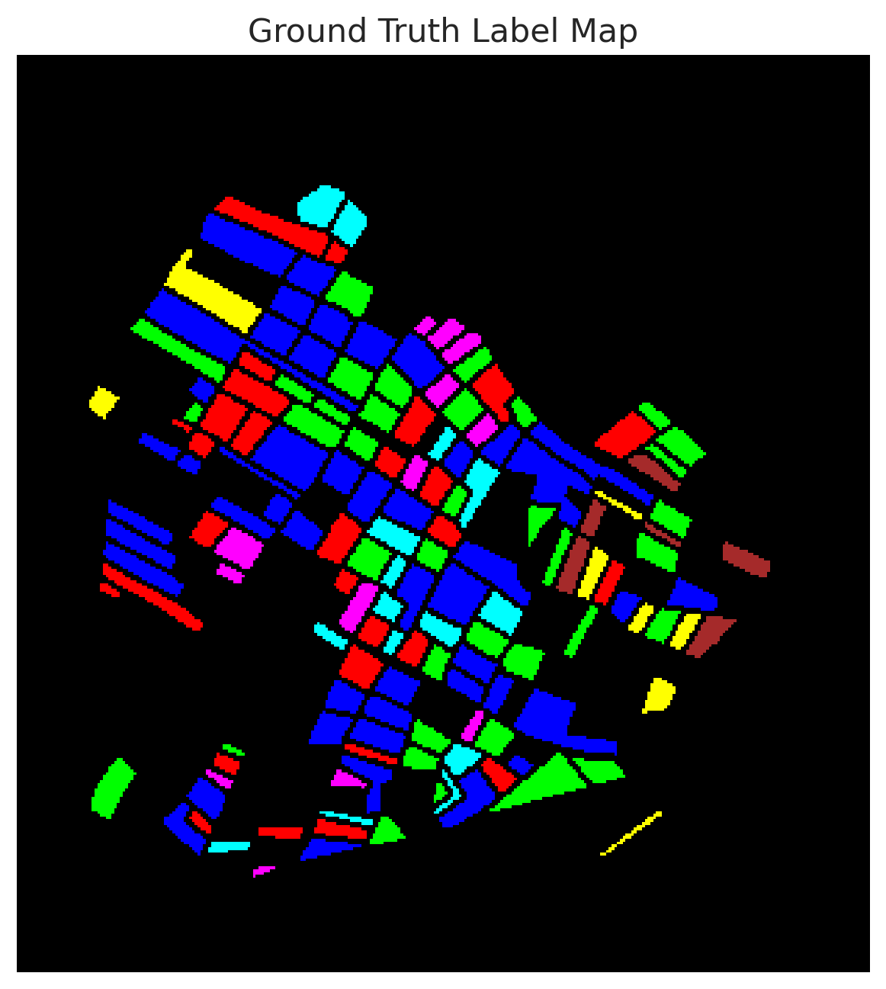  (b) Ground Truth Label Map
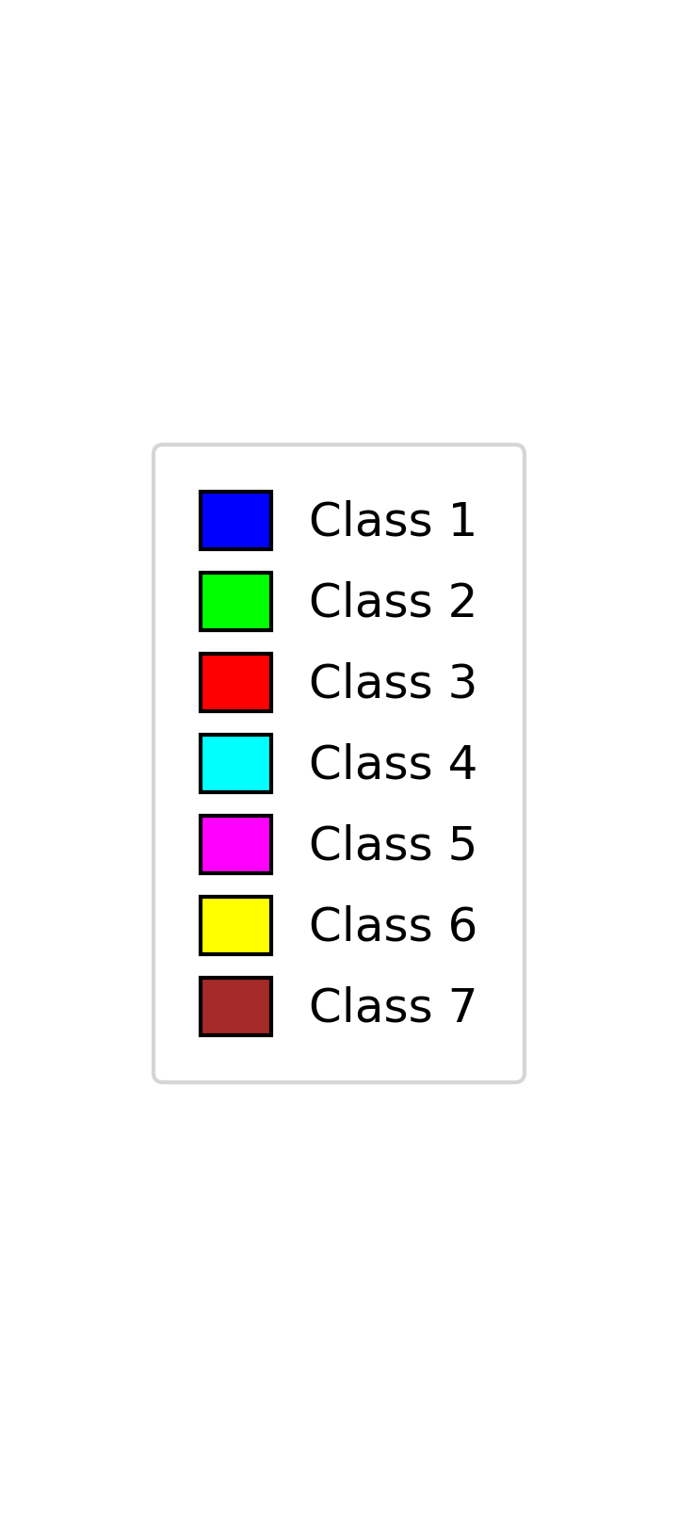
(c) Legend
Fig. 1. Scene overview for the full 330 × 307, 6-band DIAS Scene K01 multispectral dataset: (a) approximate RGB composite, (b) ground truth reference raster, and (c) shared 7-class legend.
C. Credal Deep Ensemble (CreDE) Classification Maps
Fig. 2 presents the CreDE predicted class map ĉ = argmax p* for each architecture across all 101,310 pixels of the 330 × 307 scene.
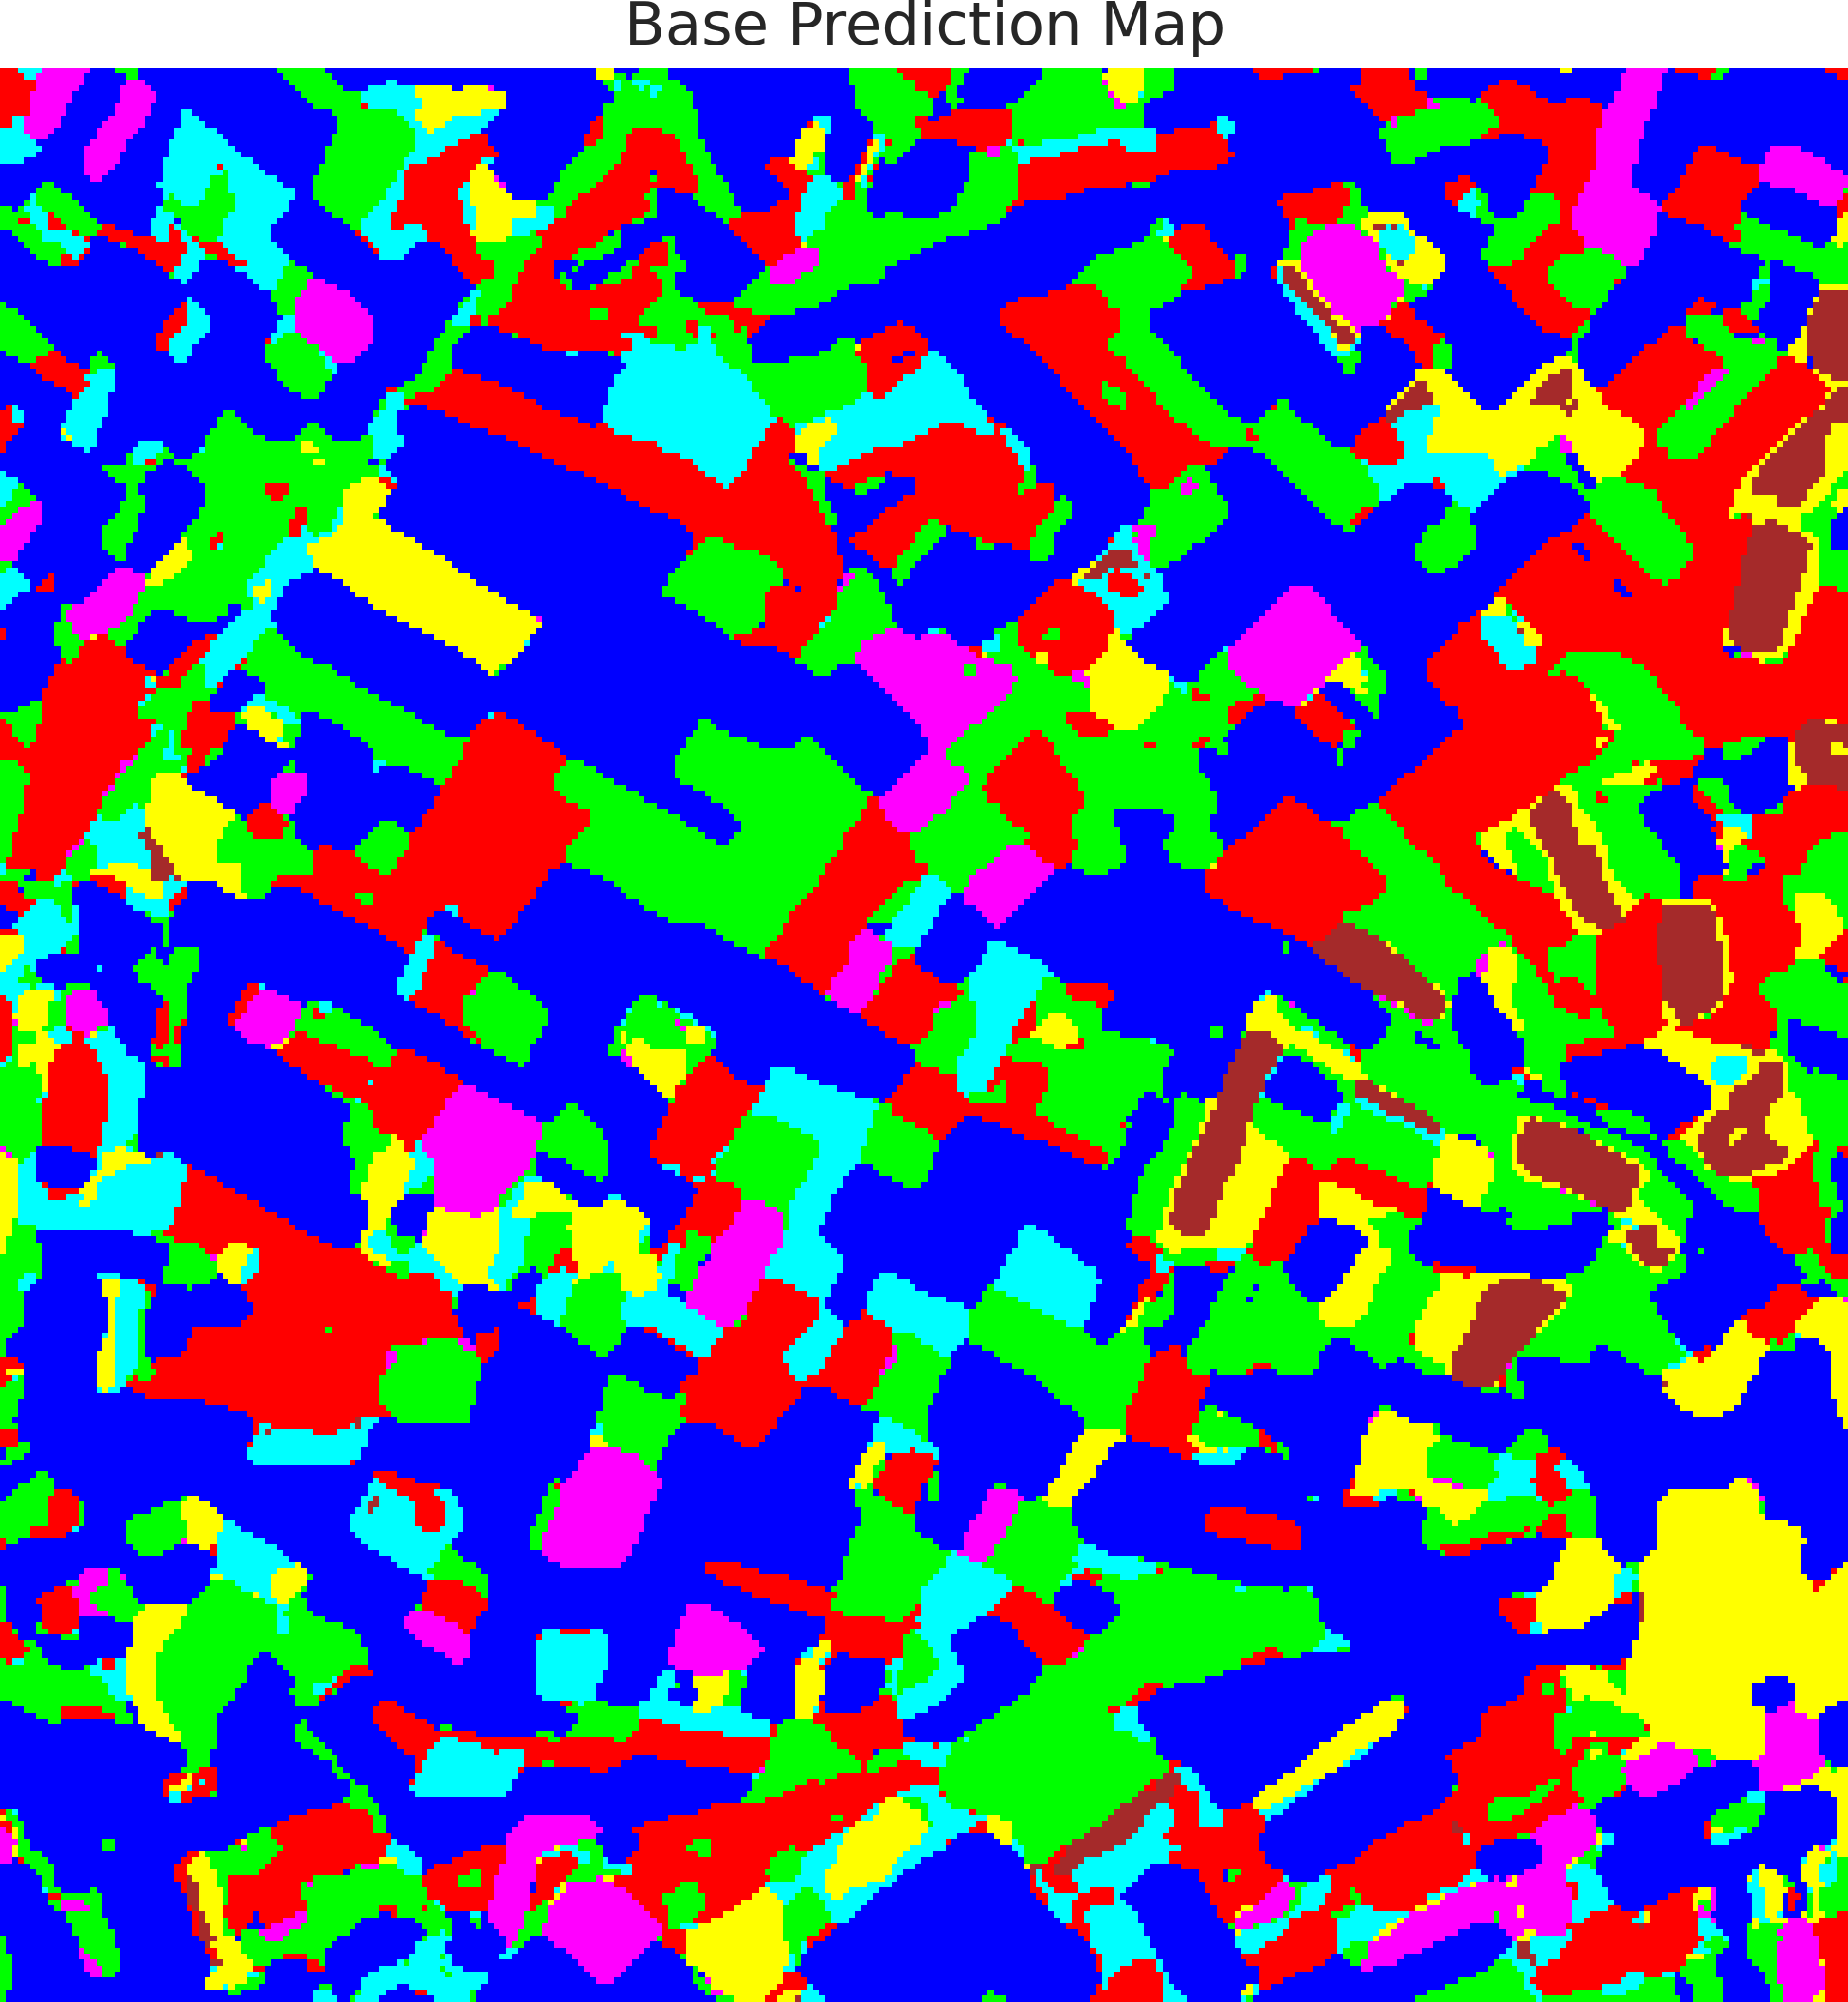  (a) AlexNet-CNN | 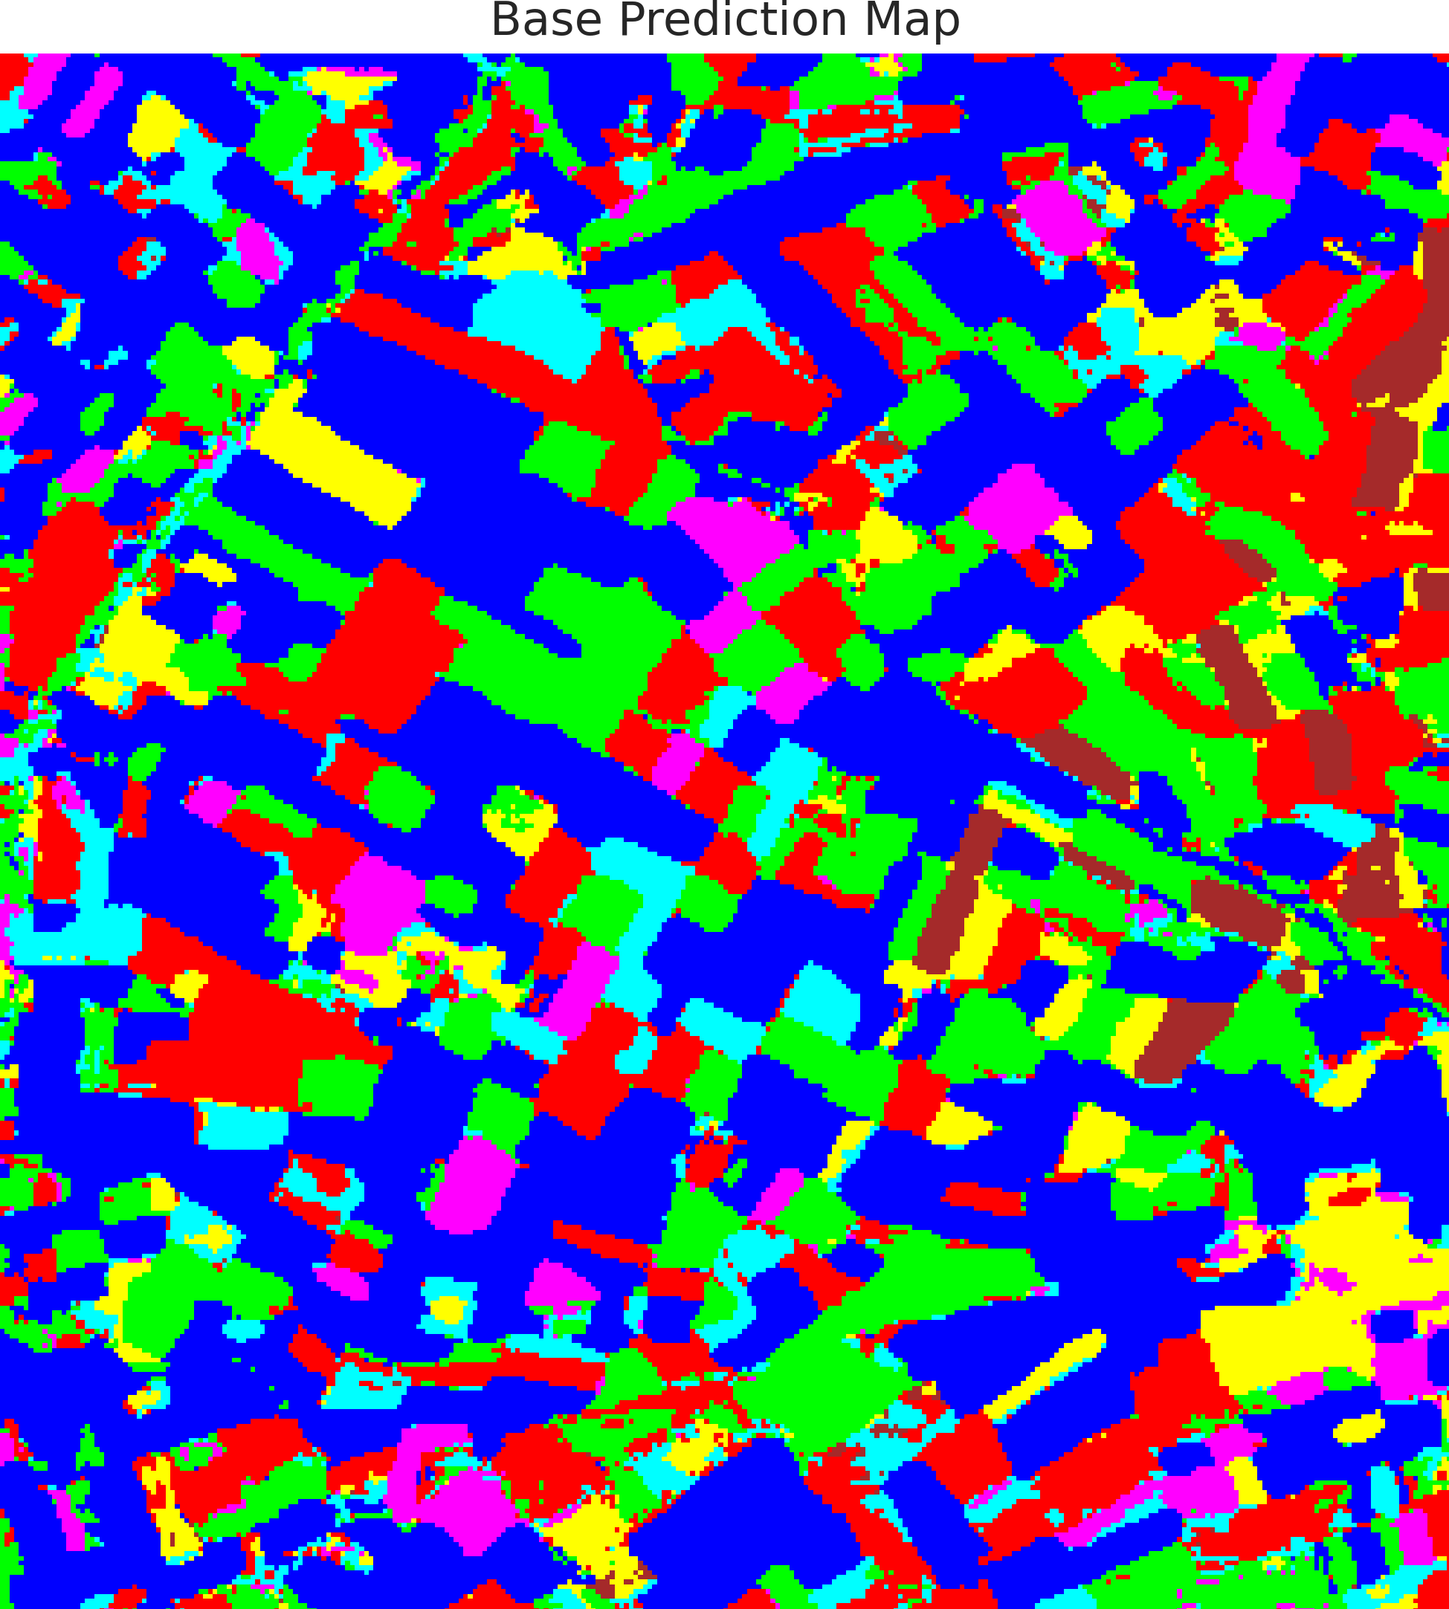  (b) GFNet
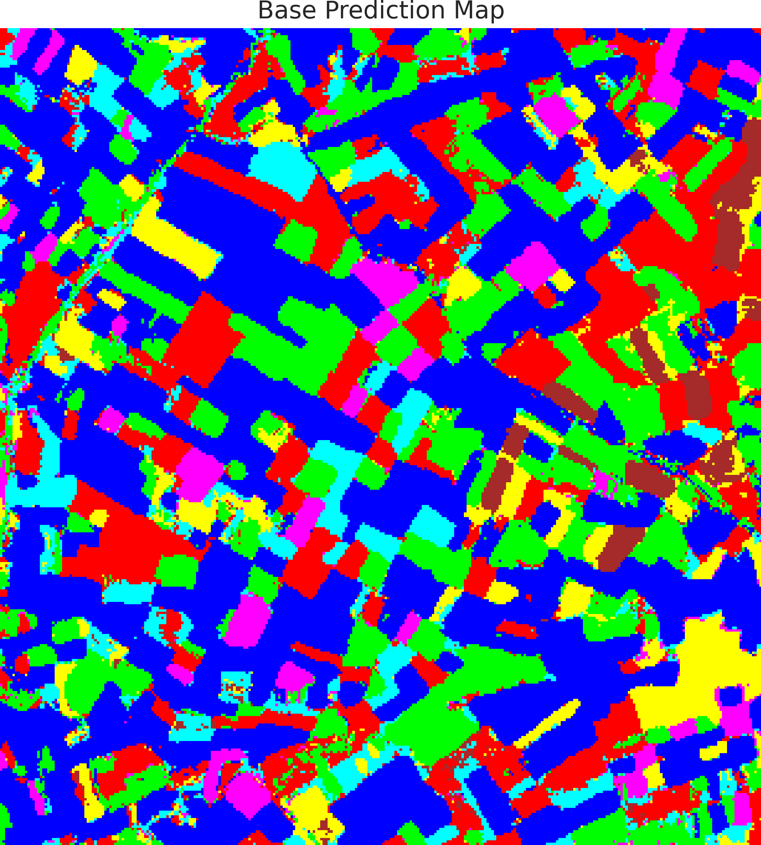  (c) ViT-UNet | (d) Legend
Fig. 2. CreDE predicted class maps ĉ = argmax p* across the full 330 × 307 scene: (a) AlexNet-CNN, (b) GFNet, and (c) ViT-UNet, with (d) shared 7-class legend.
TABLE IV reports the complete scene-wide pixel distribution produced by the conservative CreDE lower-bound decision rule ĉ(x) = argmax_k p*_k(x) across all 101,310 pixels of DIAS Scene K01 for AlexNet-CNN, GFNet, and ViT-UNet.
TABLE IV
CREDE FULL-SCENE PREDICTED CLASS PIXEL DISTRIBUTION (101,310 PIXELS)
Class | Land-Cover Category | AlexNet-CNN | GFNet | ViT-UNet
Class 0 | Background / Unlabelled | 41,591 | 42,644 | 41,561
Class 1 | Land-Cover Class 1 | 20,012 | 18,707 | 19,087
Class 2 | Land-Cover Class 2 | 18,793 | 19,418 | 18,493
Class 3 | Land-Cover Class 3 | 7,080 | 6,849 | 7,597
Class 4 | Land-Cover Class 4 | 4,420 | 4,716 | 4,490
Class 5 | Land-Cover Class 5 | 7,192 | 6,612 | 7,293
Class 6 | Land-Cover Class 6 | 2,222 | 2,364 | 2,789
Total (Scene) | Full Scene Area | 101,310 | 101,310 | 101,310

All three deep backbones identify Class 0 (unlabelled background) as the dominant category (41,561–42,644 pixels), followed by agricultural parcels Class 1 (18,707–20,012 pixels) and Class 2 (18,493–19,418 pixels), in complete agreement with the ground-truth landscape structure.
D. Scene-Wide Mean Uncertainty Summary
TABLE V reports the scene-wide mean aleatoric (AU), epistemic (EU), and total (TU) CreDE uncertainty alongside the relative AU/TU and EU/TU percentage decomposition fractions across all 101,310 pixels for each architecture.
TABLE V
CREDE: SCENE-WIDE MEAN UNCERTAINTY SUMMARY (PER ARCHITECTURE)
Model | Mean AU | Mean EU | Mean TU | AU / TU Fraction | EU / TU Fraction
AlexNet-CNN | 0.0484 | 0.0675 | 0.1159 | 41.79% | 58.21%
GFNet | 0.2465 | 0.0579 | 0.3044 | 80.98% | 19.02%
ViT-UNet | 0.5471 | 0.0750 | 0.6221 | 87.95% | 12.05%

Decomposition of total uncertainty reveals marked divergence in predictive behavior across architectures: AlexNet-CNN is epistemic-dominant (58.21% EU vs. 41.79% AU), reflecting substantial inter-member variance in ambiguous regions despite low mean point entropy. Conversely, GFNet (80.98% AU) and ViT-UNet (87.95% AU) are overwhelmingly aleatoric-dominant, indicating strong ensemble consensus with residual uncertainty primarily governed by inherent spectral overlap among land-cover classes.
E. Spatialised Aleatoric Uncertainty Maps
Fig. 3 maps the binary aleatoric uncertainty mask (AU > 0.5) across the full scene, Fig. 4 overlays the uncertain pixels in grey on the CreDE classification maps, and TABLE VI reports the full-scene pixel counts across classes.
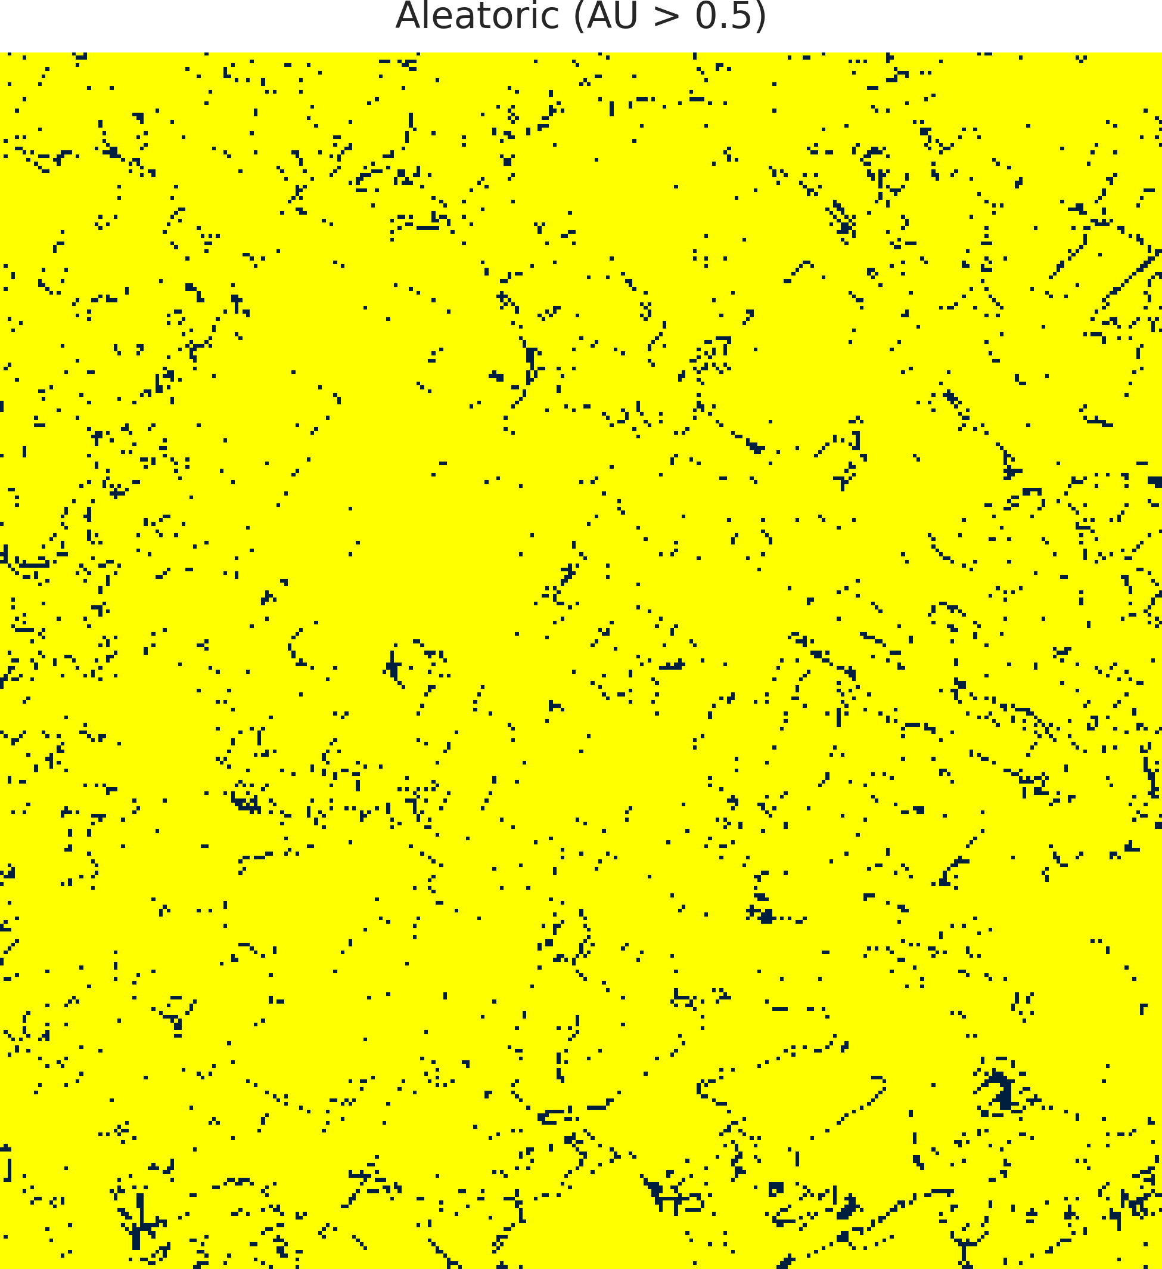  (a) AlexNet-CNN | 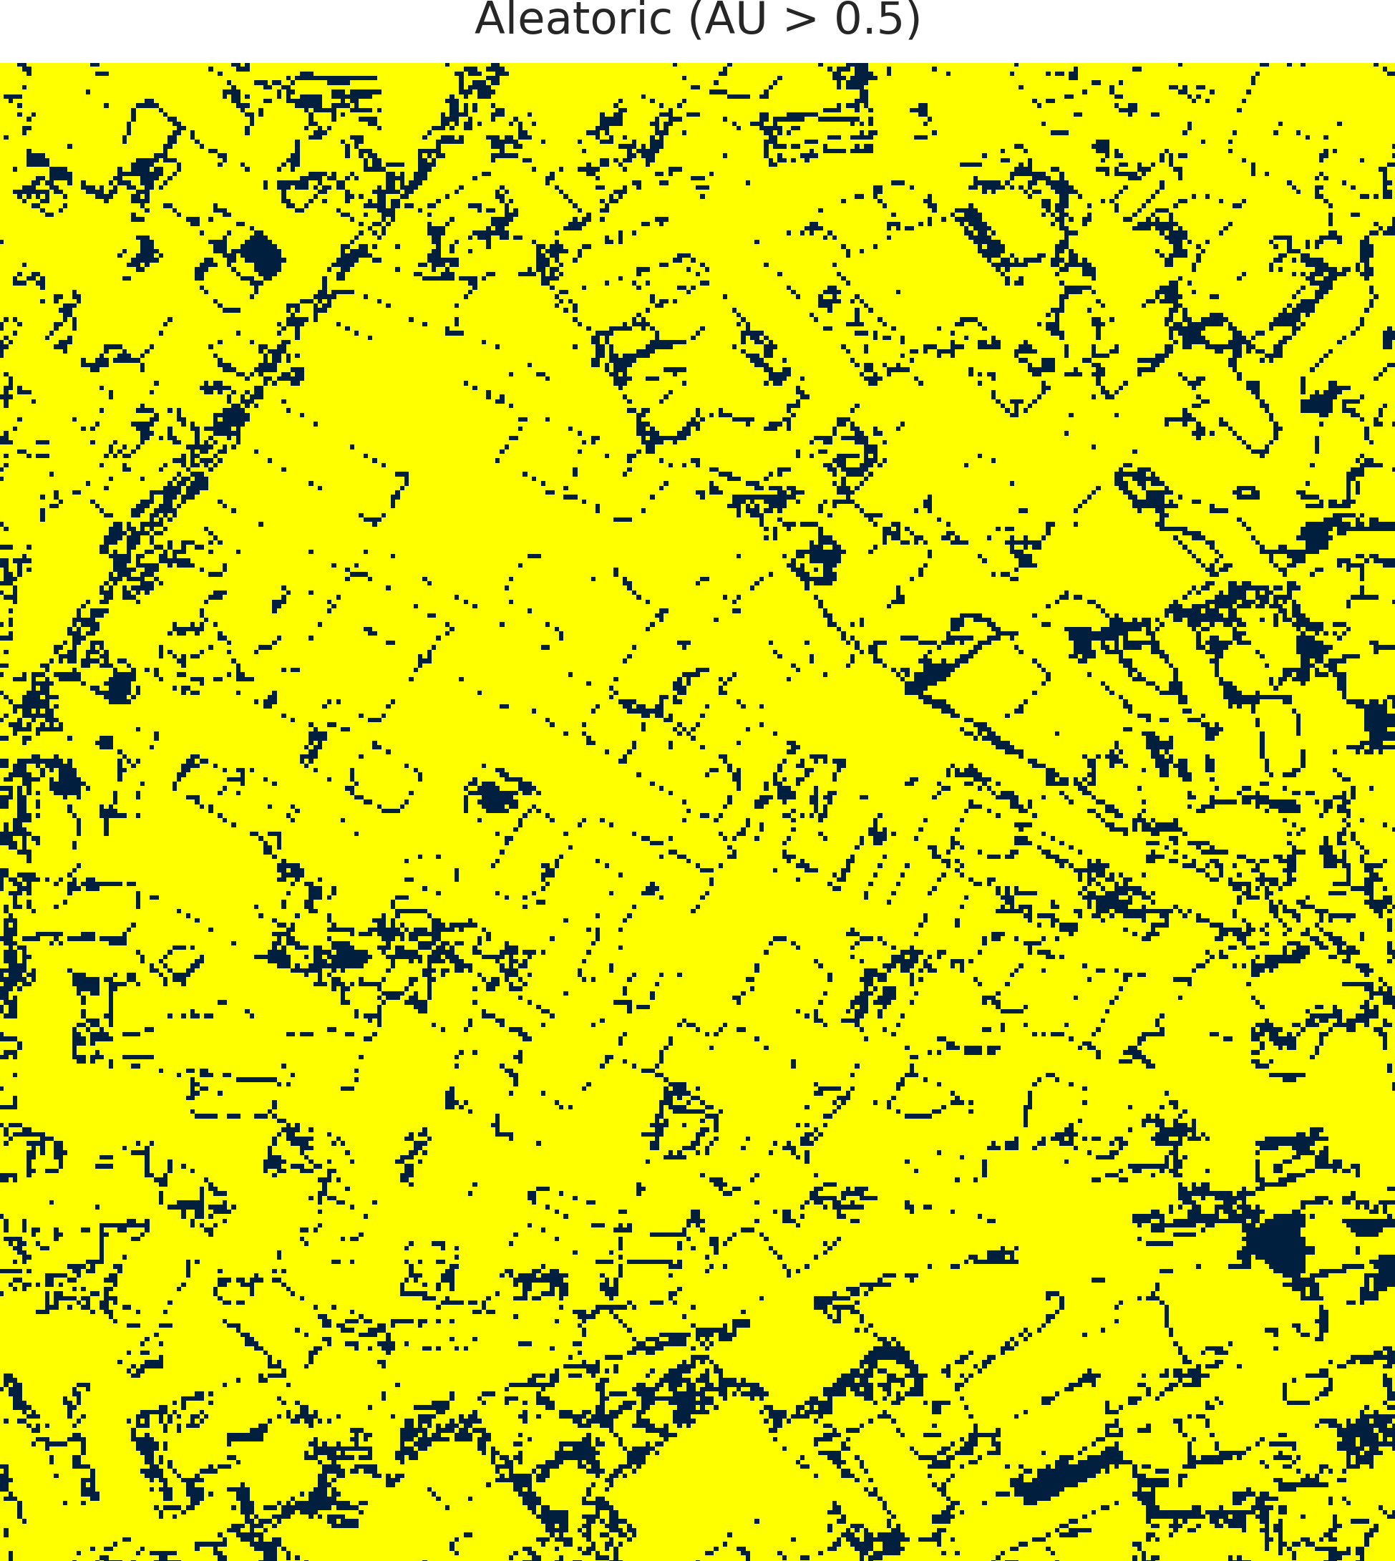  (b) GFNet
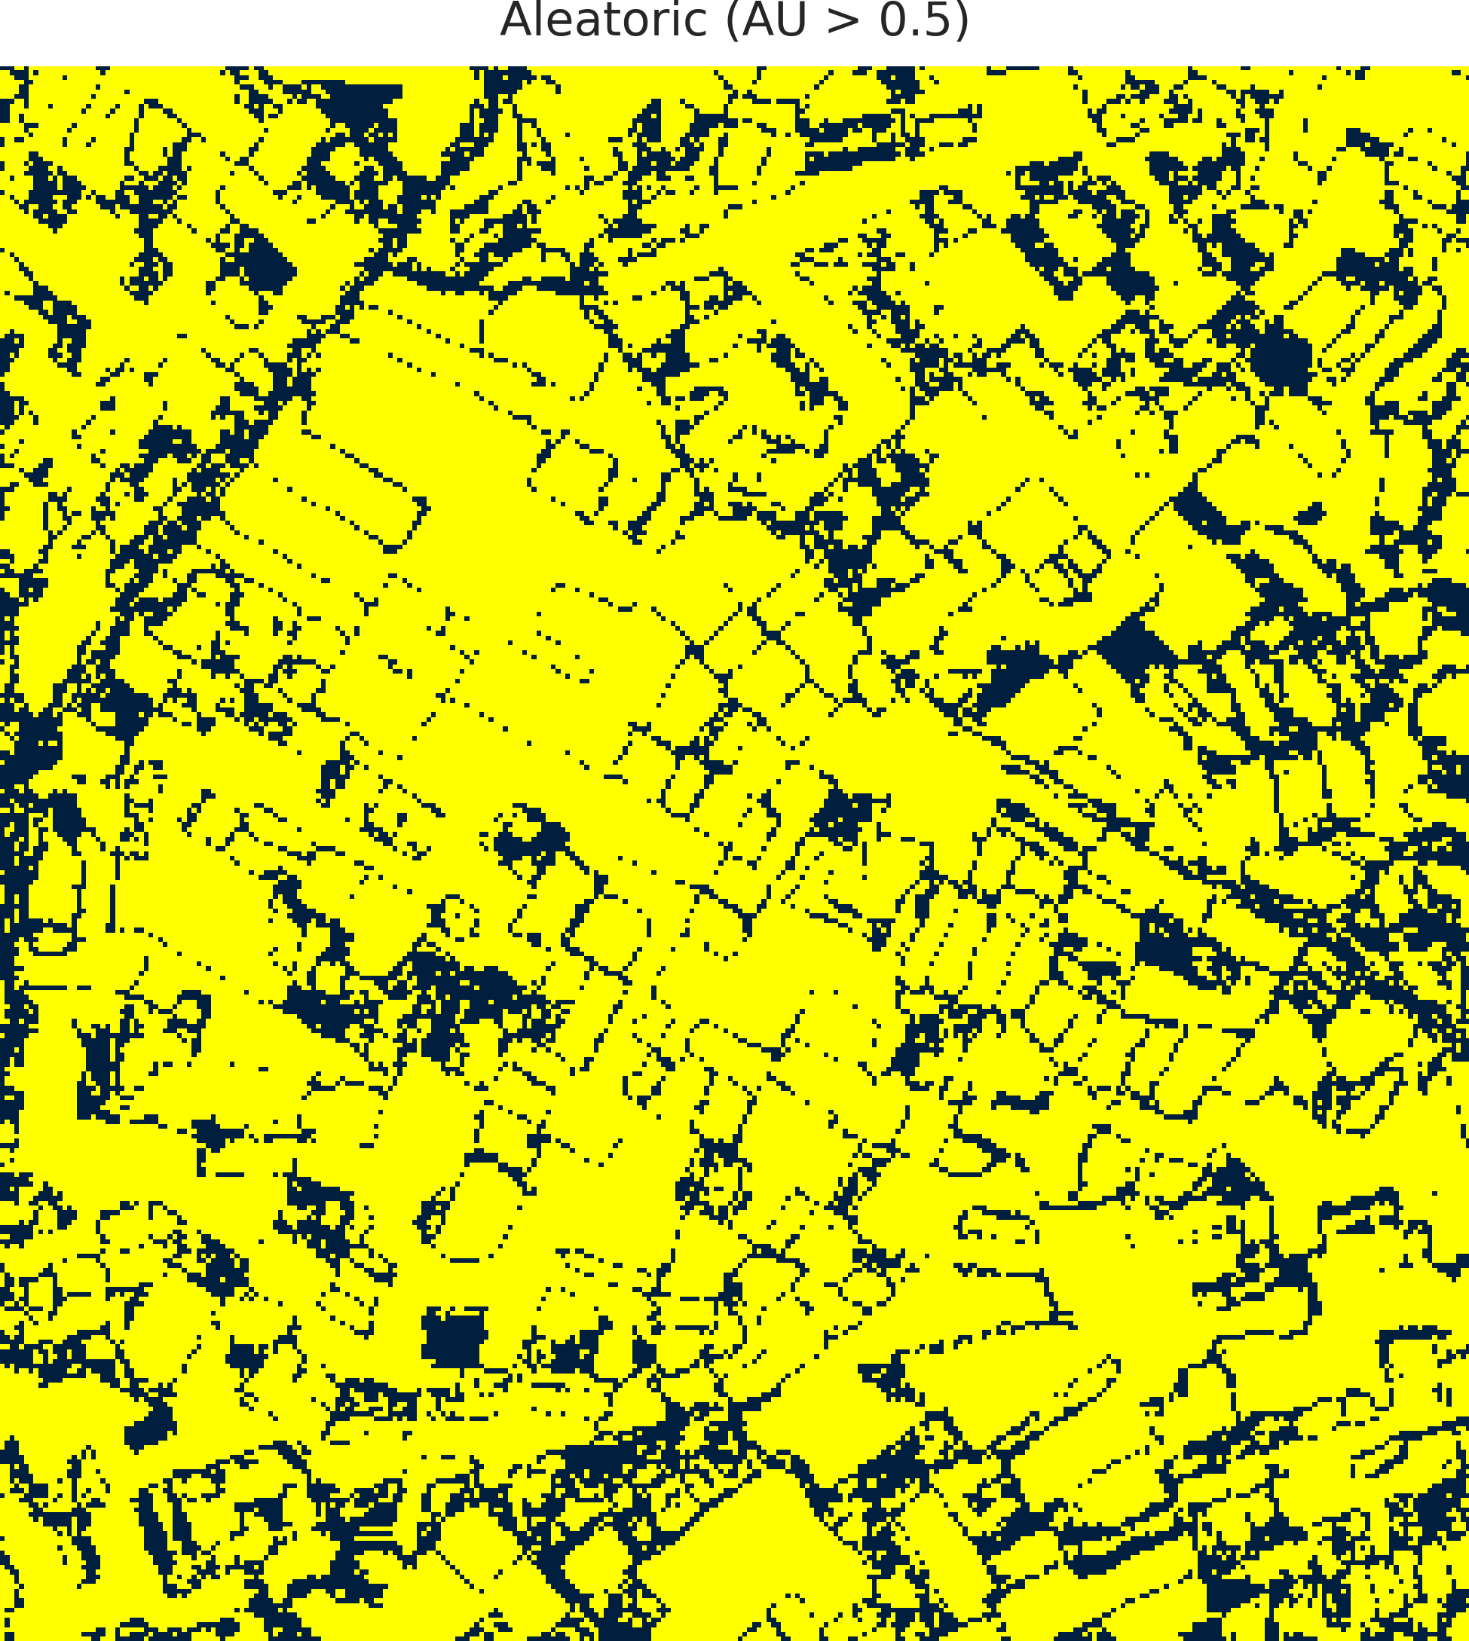  (c) ViT-UNet | 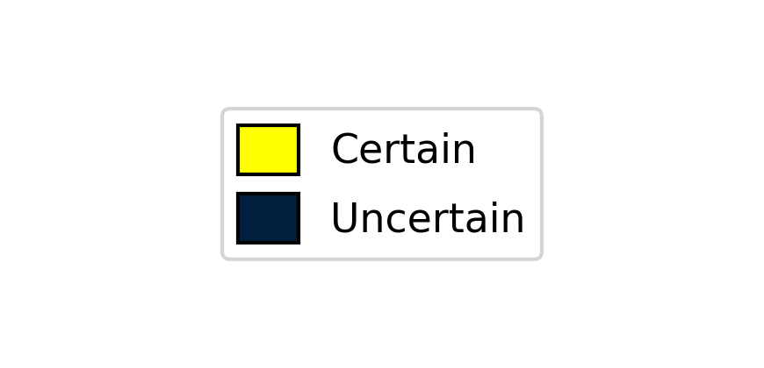  (d) Legend
Fig. 3. CreDE binary aleatoric uncertainty masks (AU > 0.5) for the full 330 × 307 scene: (a) AlexNet-CNN, (b) GFNet, (c) ViT-UNet. Yellow = certain; dark navy = uncertain.
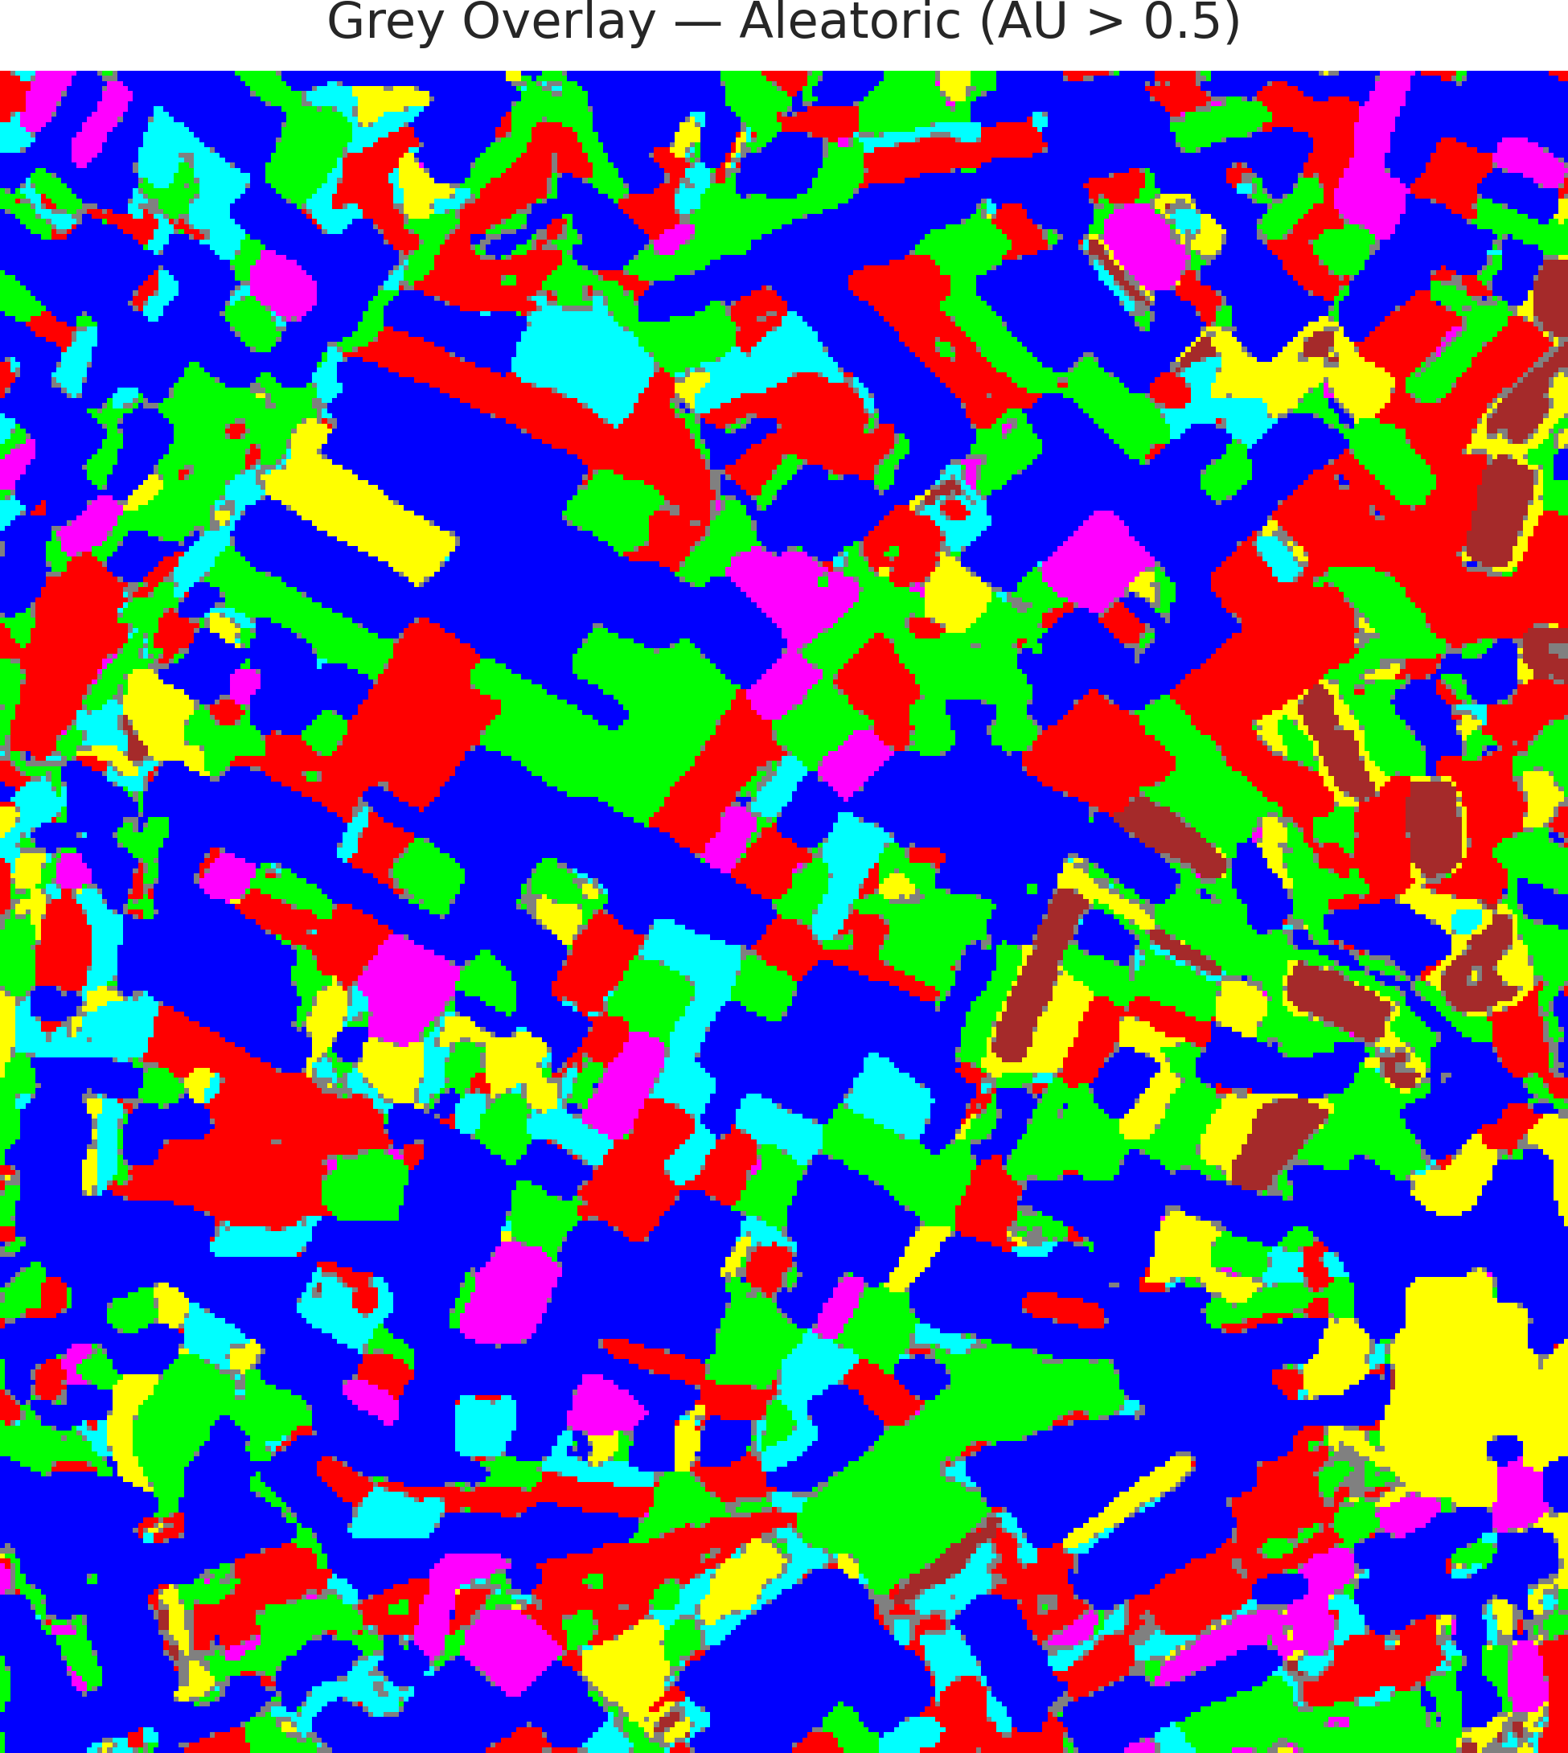  (a) AlexNet-CNN | 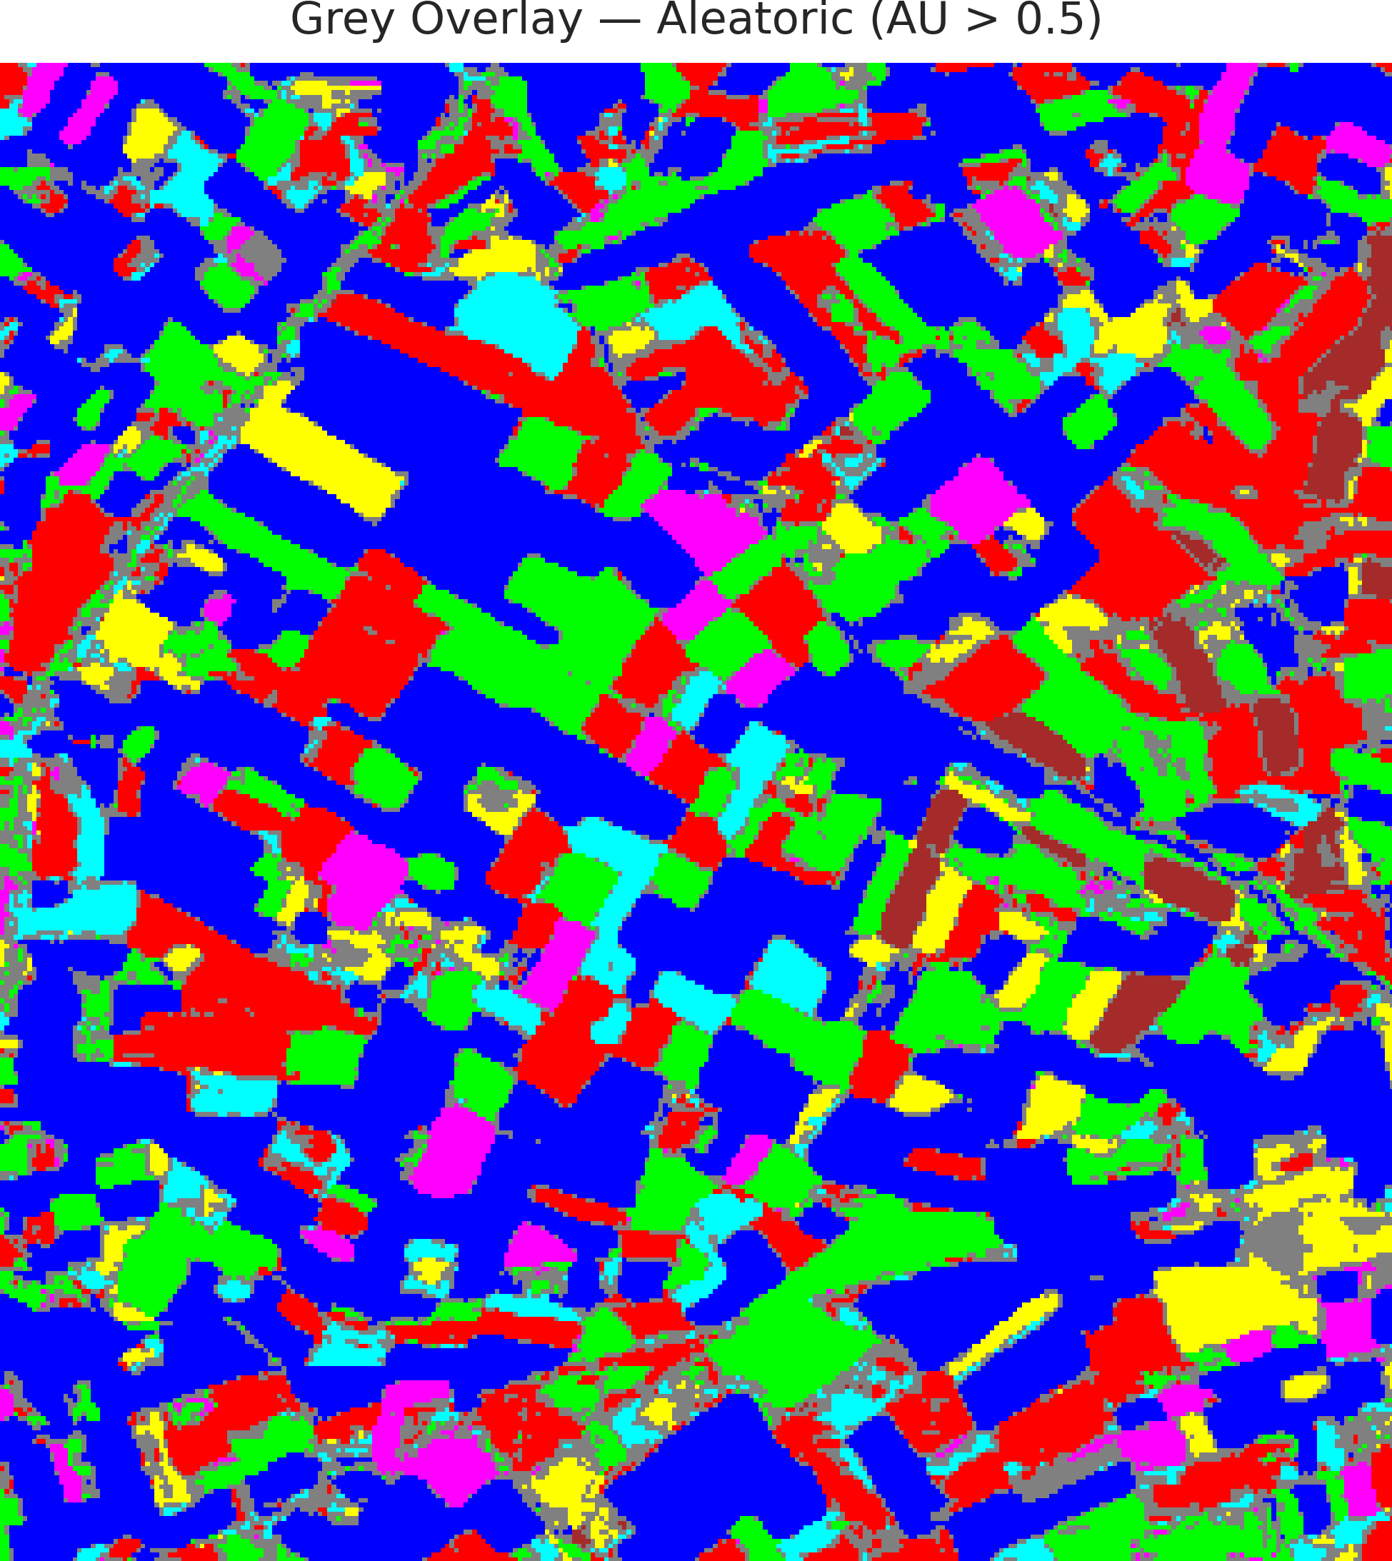  (b) GFNet
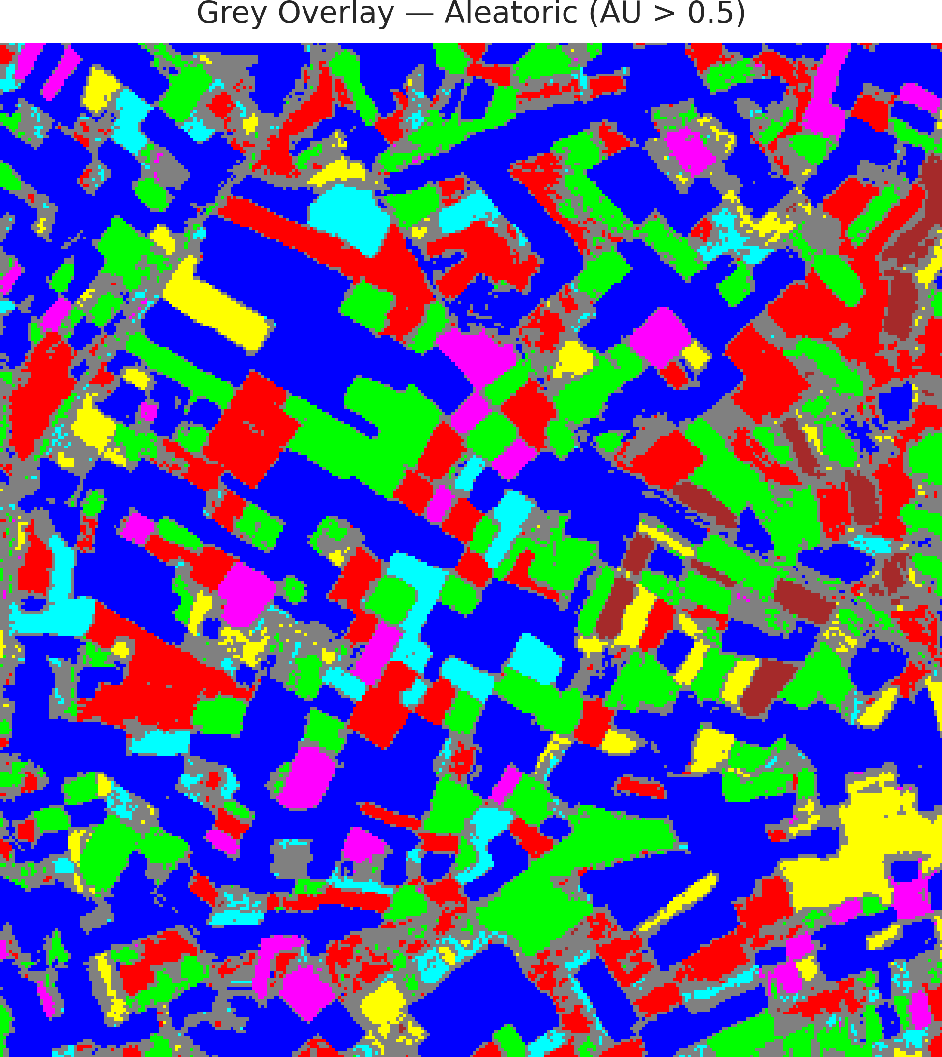  (c) ViT-UNet | (d) Legend
Fig. 4. Grey overlay of aleatoric-uncertain pixels (AU > 0.5) on the CreDE classification maps: (a) AlexNet-CNN, (b) GFNet, (c) ViT-UNet, with (d) class legend.
TABLE VI
CREDE ALEATORIC (AU > 0.5) PIXEL-COUNT DISTRIBUTION ACROSS ARCHITECTURES
Class / Region | AlexNet-CNN | GFNet | ViT-UNet
Class 0 | 40,955 | 39,909 | 37,960
Class 1 | 18,800 | 15,736 | 14,401
Class 2 | 18,005 | 16,380 | 13,256
Class 3 | 6,398 | 4,707 | 3,815
Class 4 | 4,224 | 3,843 | 3,326
Class 5 | 6,612 | 4,769 | 4,150
Class 6 | 2,057 | 1,869 | 1,585
Uncertain | 4,259 | 14,097 | 22,817
Total (Scene) | 101,310 | 101,310 | 101,310

F. Spatialised Epistemic Uncertainty Maps
Fig. 5 and Fig. 6 display the binary and grey-overlay epistemic uncertainty maps (EU > 0.2), and TABLE VII details the full-scene pixel-count distribution.
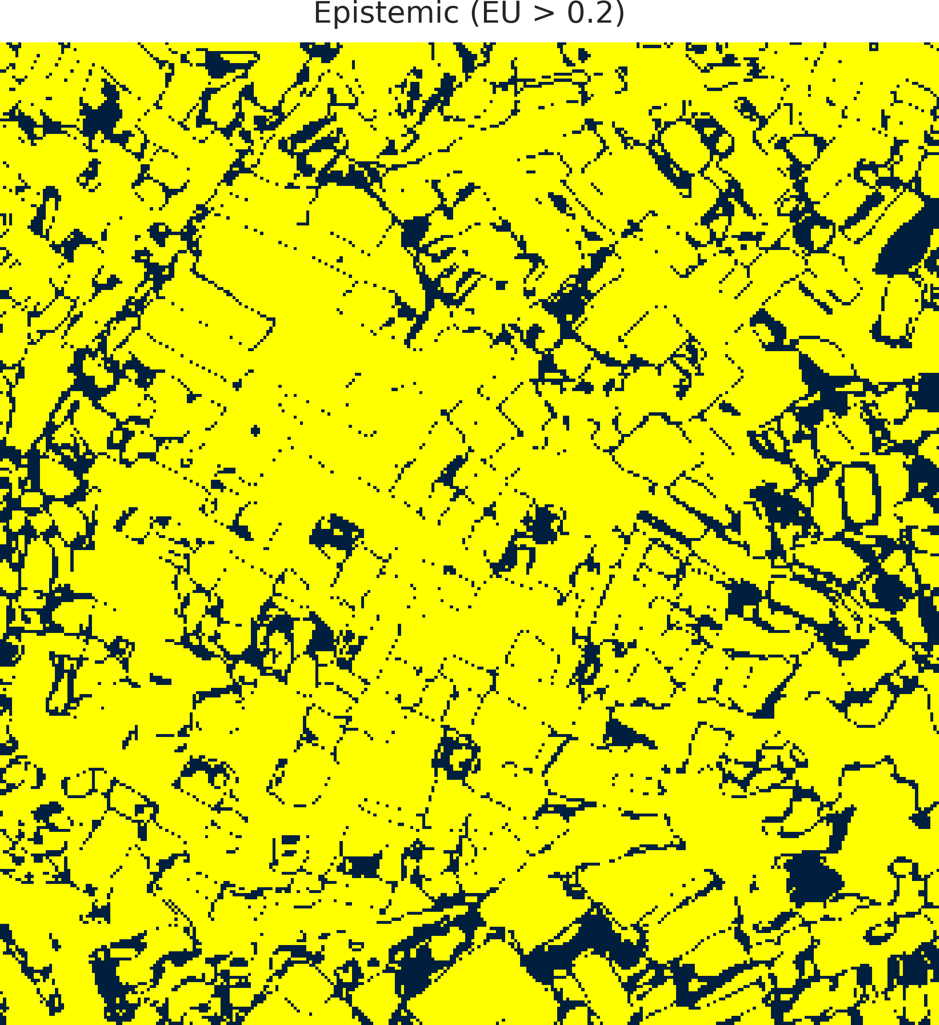  (a) AlexNet-CNN | 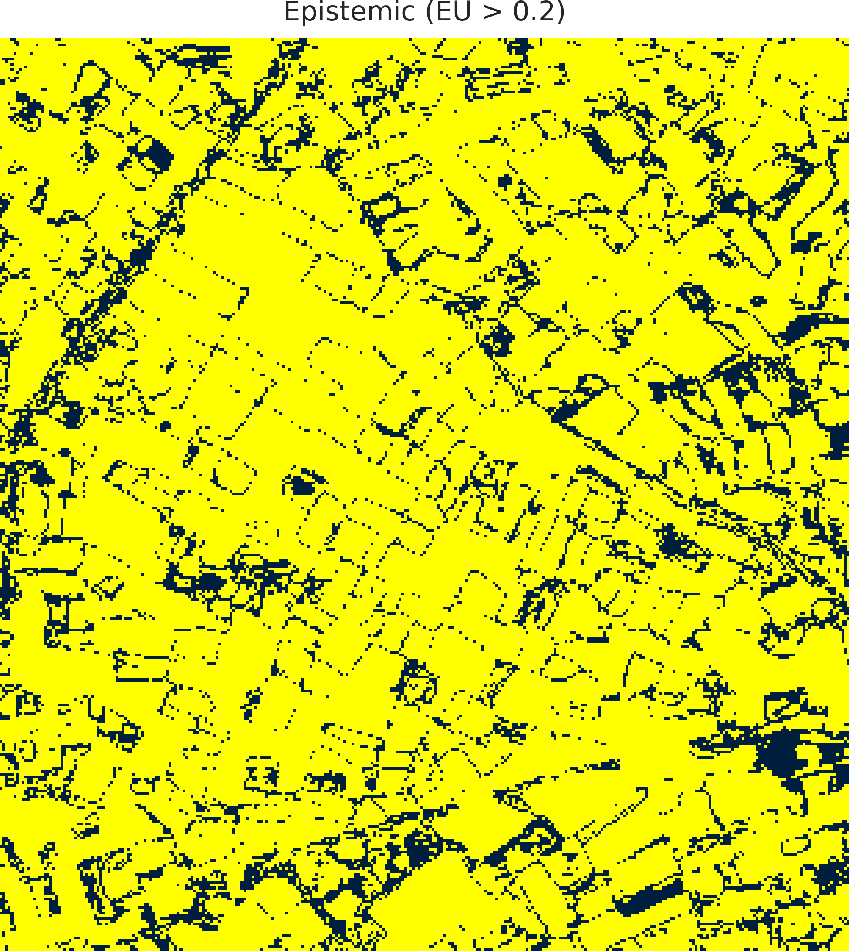  (b) GFNet
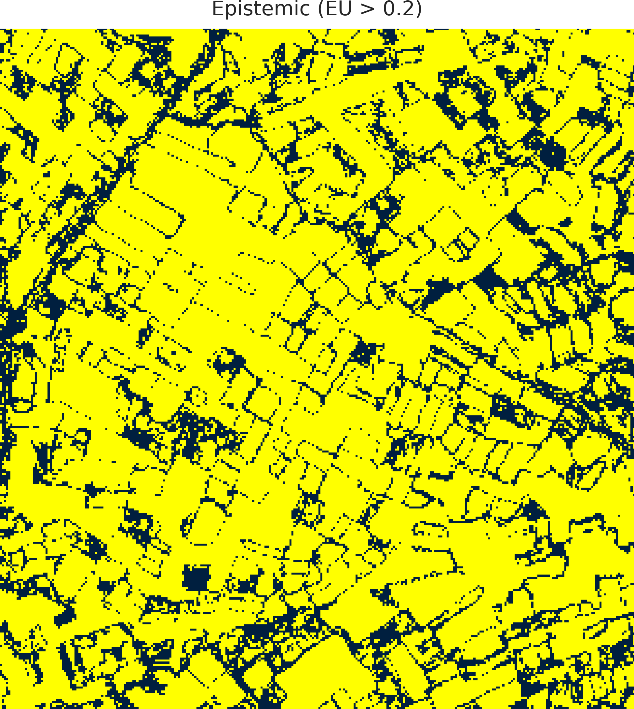  (c) ViT-UNet | (d) Legend
Fig. 5. CreDE binary epistemic uncertainty masks (EU > 0.2) for the full 330 × 307 scene: (a) AlexNet-CNN, (b) GFNet, (c) ViT-UNet. Yellow = certain; dark navy = uncertain.
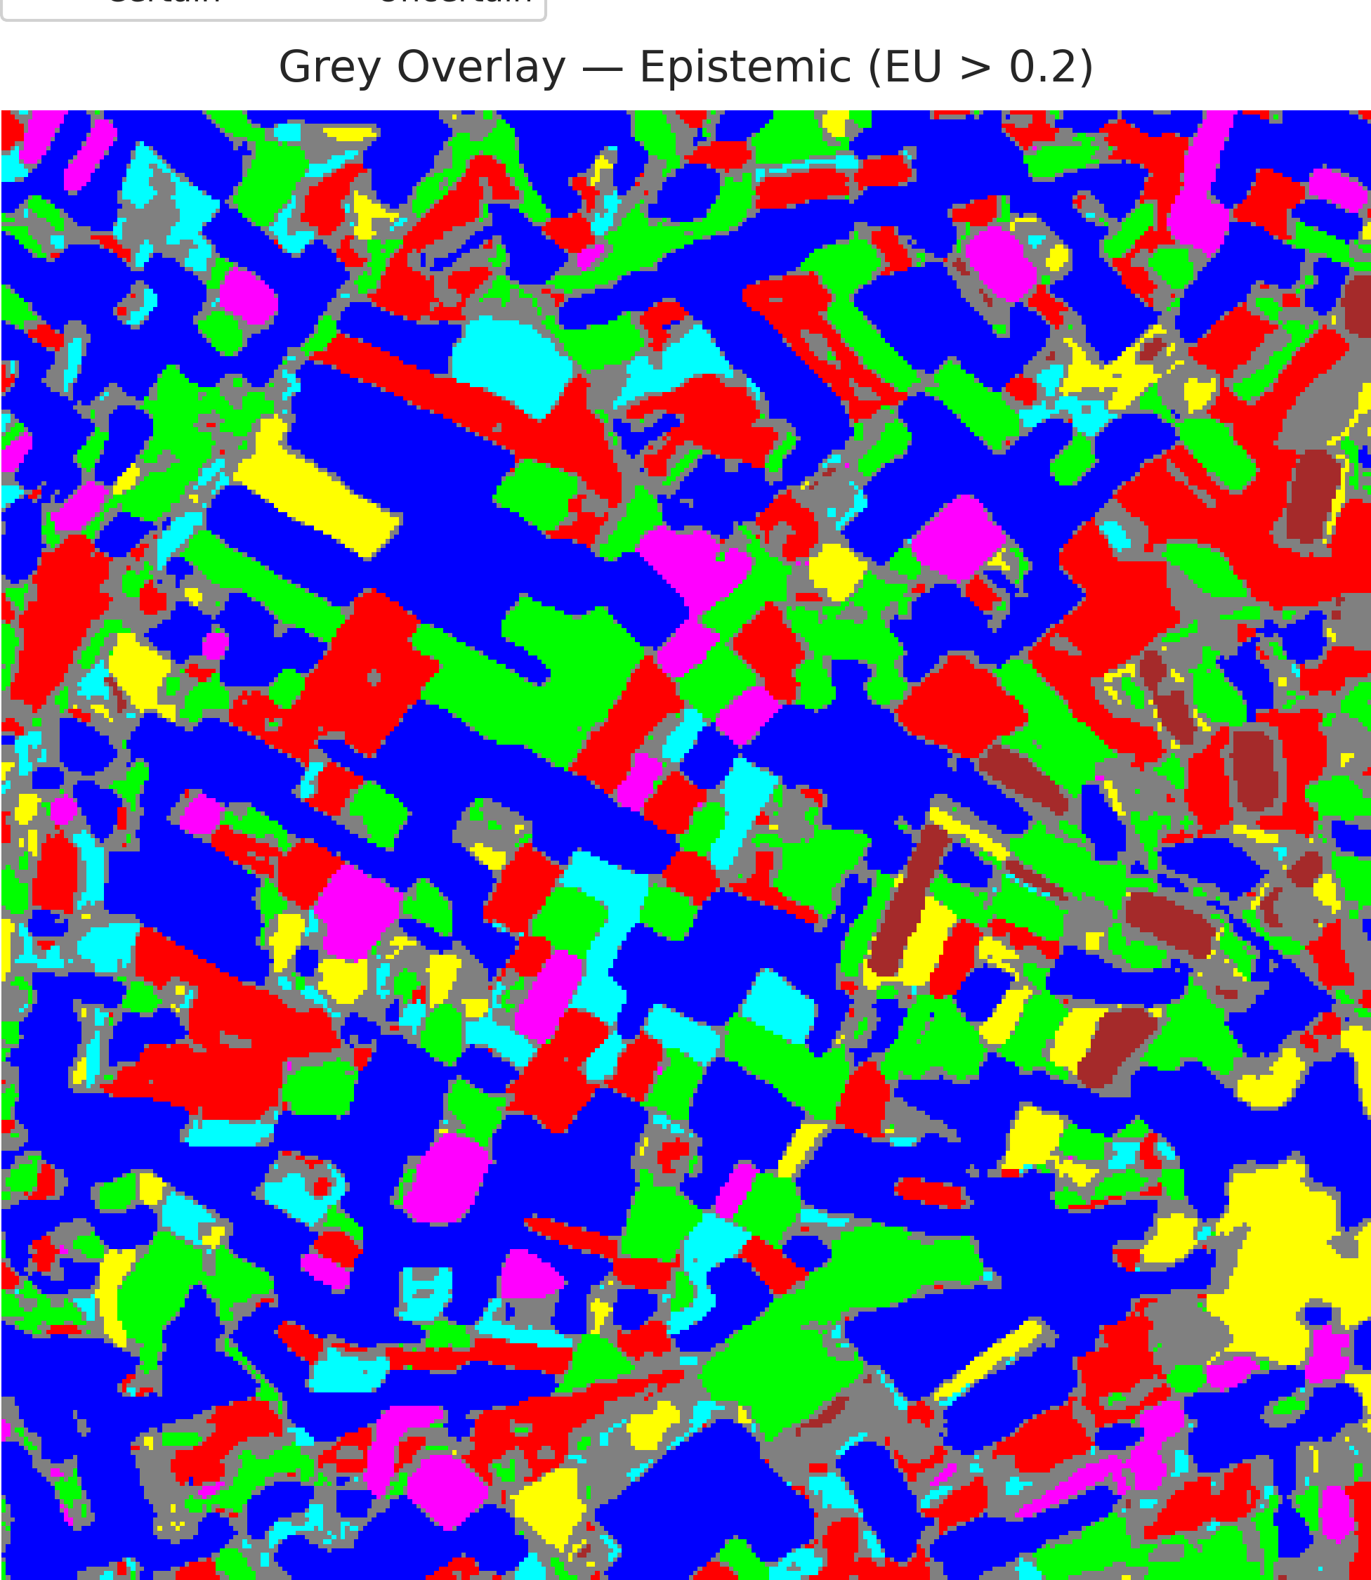  (a) AlexNet-CNN | 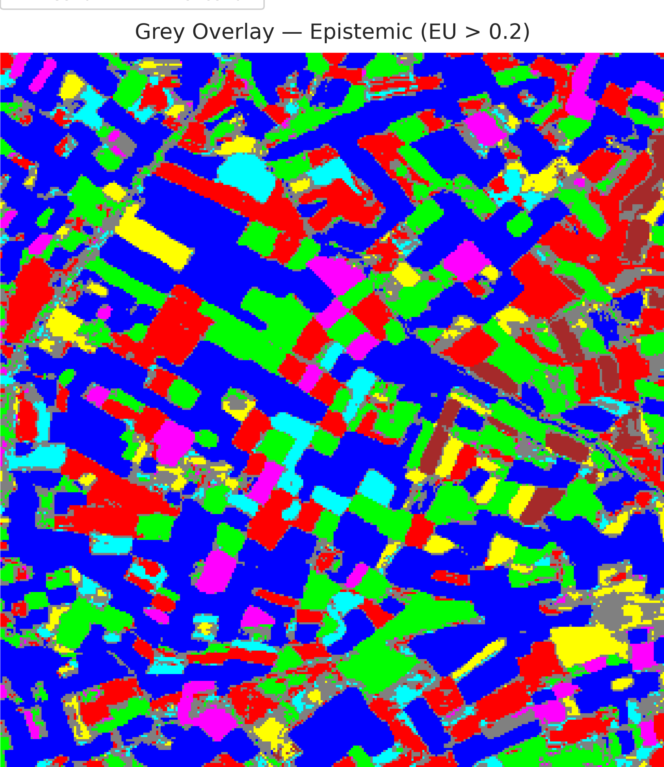  (b) GFNet
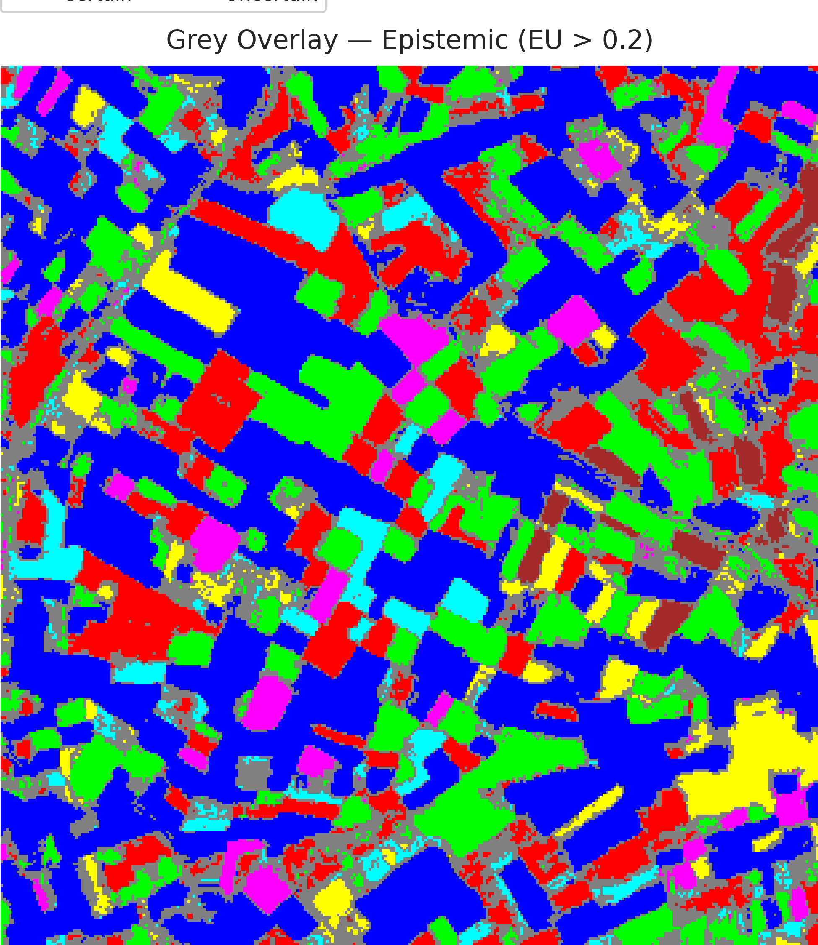  (c) ViT-UNet | (d) Legend
Fig. 6. Grey overlay of epistemic-uncertain pixels (EU > 0.2) on the CreDE classification maps: (a) AlexNet-CNN, (b) GFNet, (c) ViT-UNet, with (d) class legend.
TABLE VII
CREDE EPISTEMIC (EU > 0.2) PIXEL-COUNT DISTRIBUTION ACROSS ARCHITECTURES
Class / Region | AlexNet-CNN | GFNet | ViT-UNet
Class 0 | 38,512 | 39,380 | 38,097
Class 1 | 14,591 | 15,070 | 14,518
Class 2 | 14,794 | 15,784 | 13,367
Class 3 | 4,324 | 4,447 | 3,937
Class 4 | 3,725 | 3,709 | 3,353
Class 5 | 4,340 | 4,325 | 4,267
Class 6 | 1,470 | 1,837 | 1,574
Uncertain | 19,554 | 16,758 | 22,197
Total (Scene) | 101,310 | 101,310 | 101,310

G. Spatialised Total Uncertainty Maps
Fig. 7 and Fig. 8 present the binary and grey-overlay total uncertainty maps (TU > 0.7), and TABLE VIII reports the full-scene pixel-count distribution.
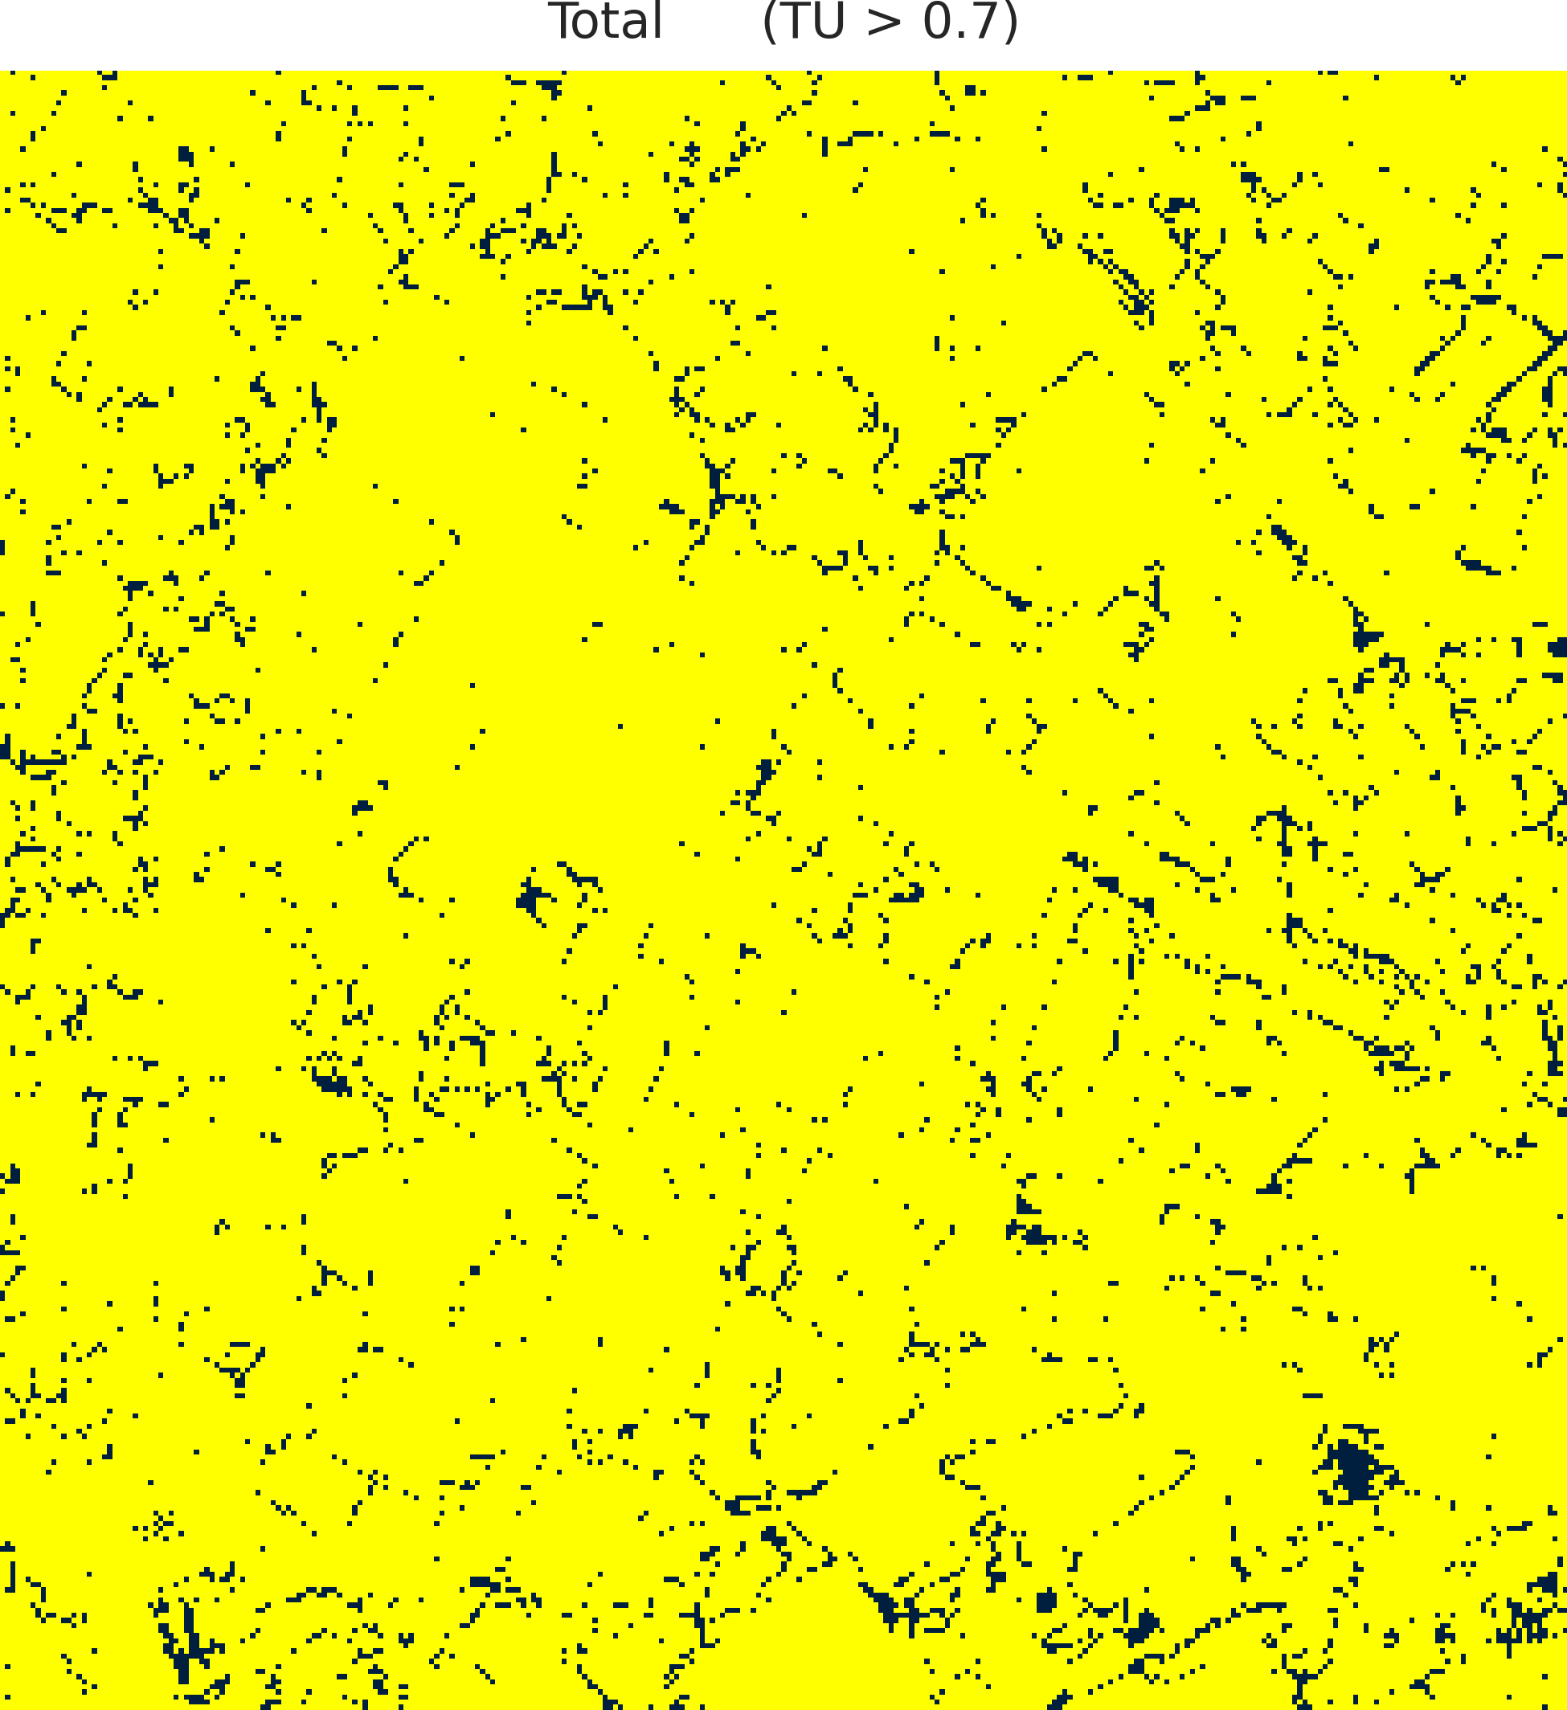  (a) AlexNet-CNN | 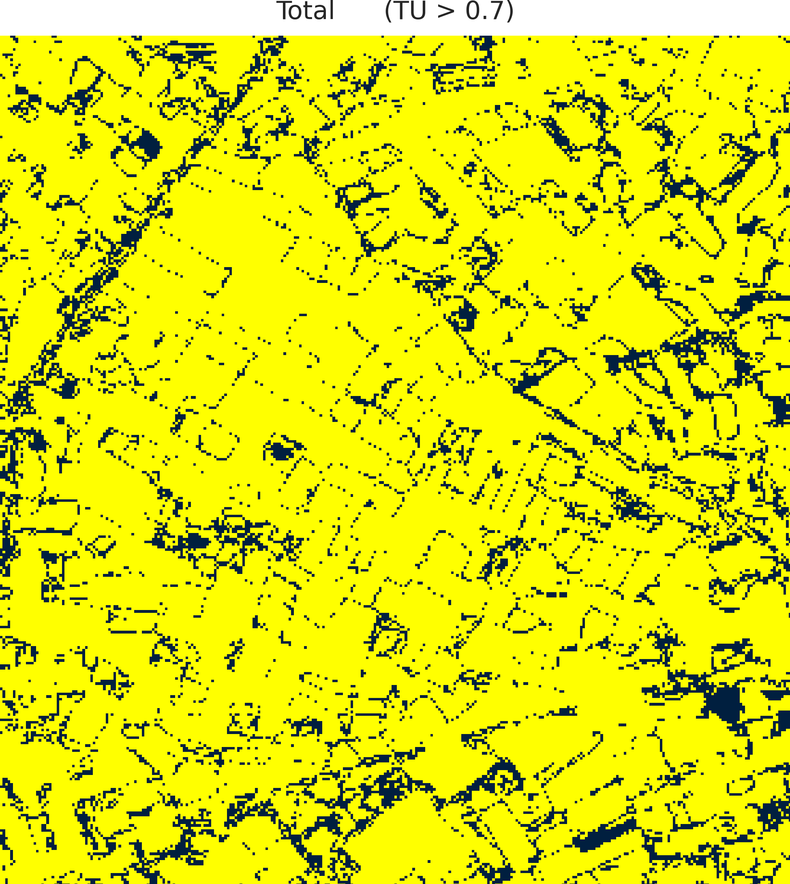  (b) GFNet
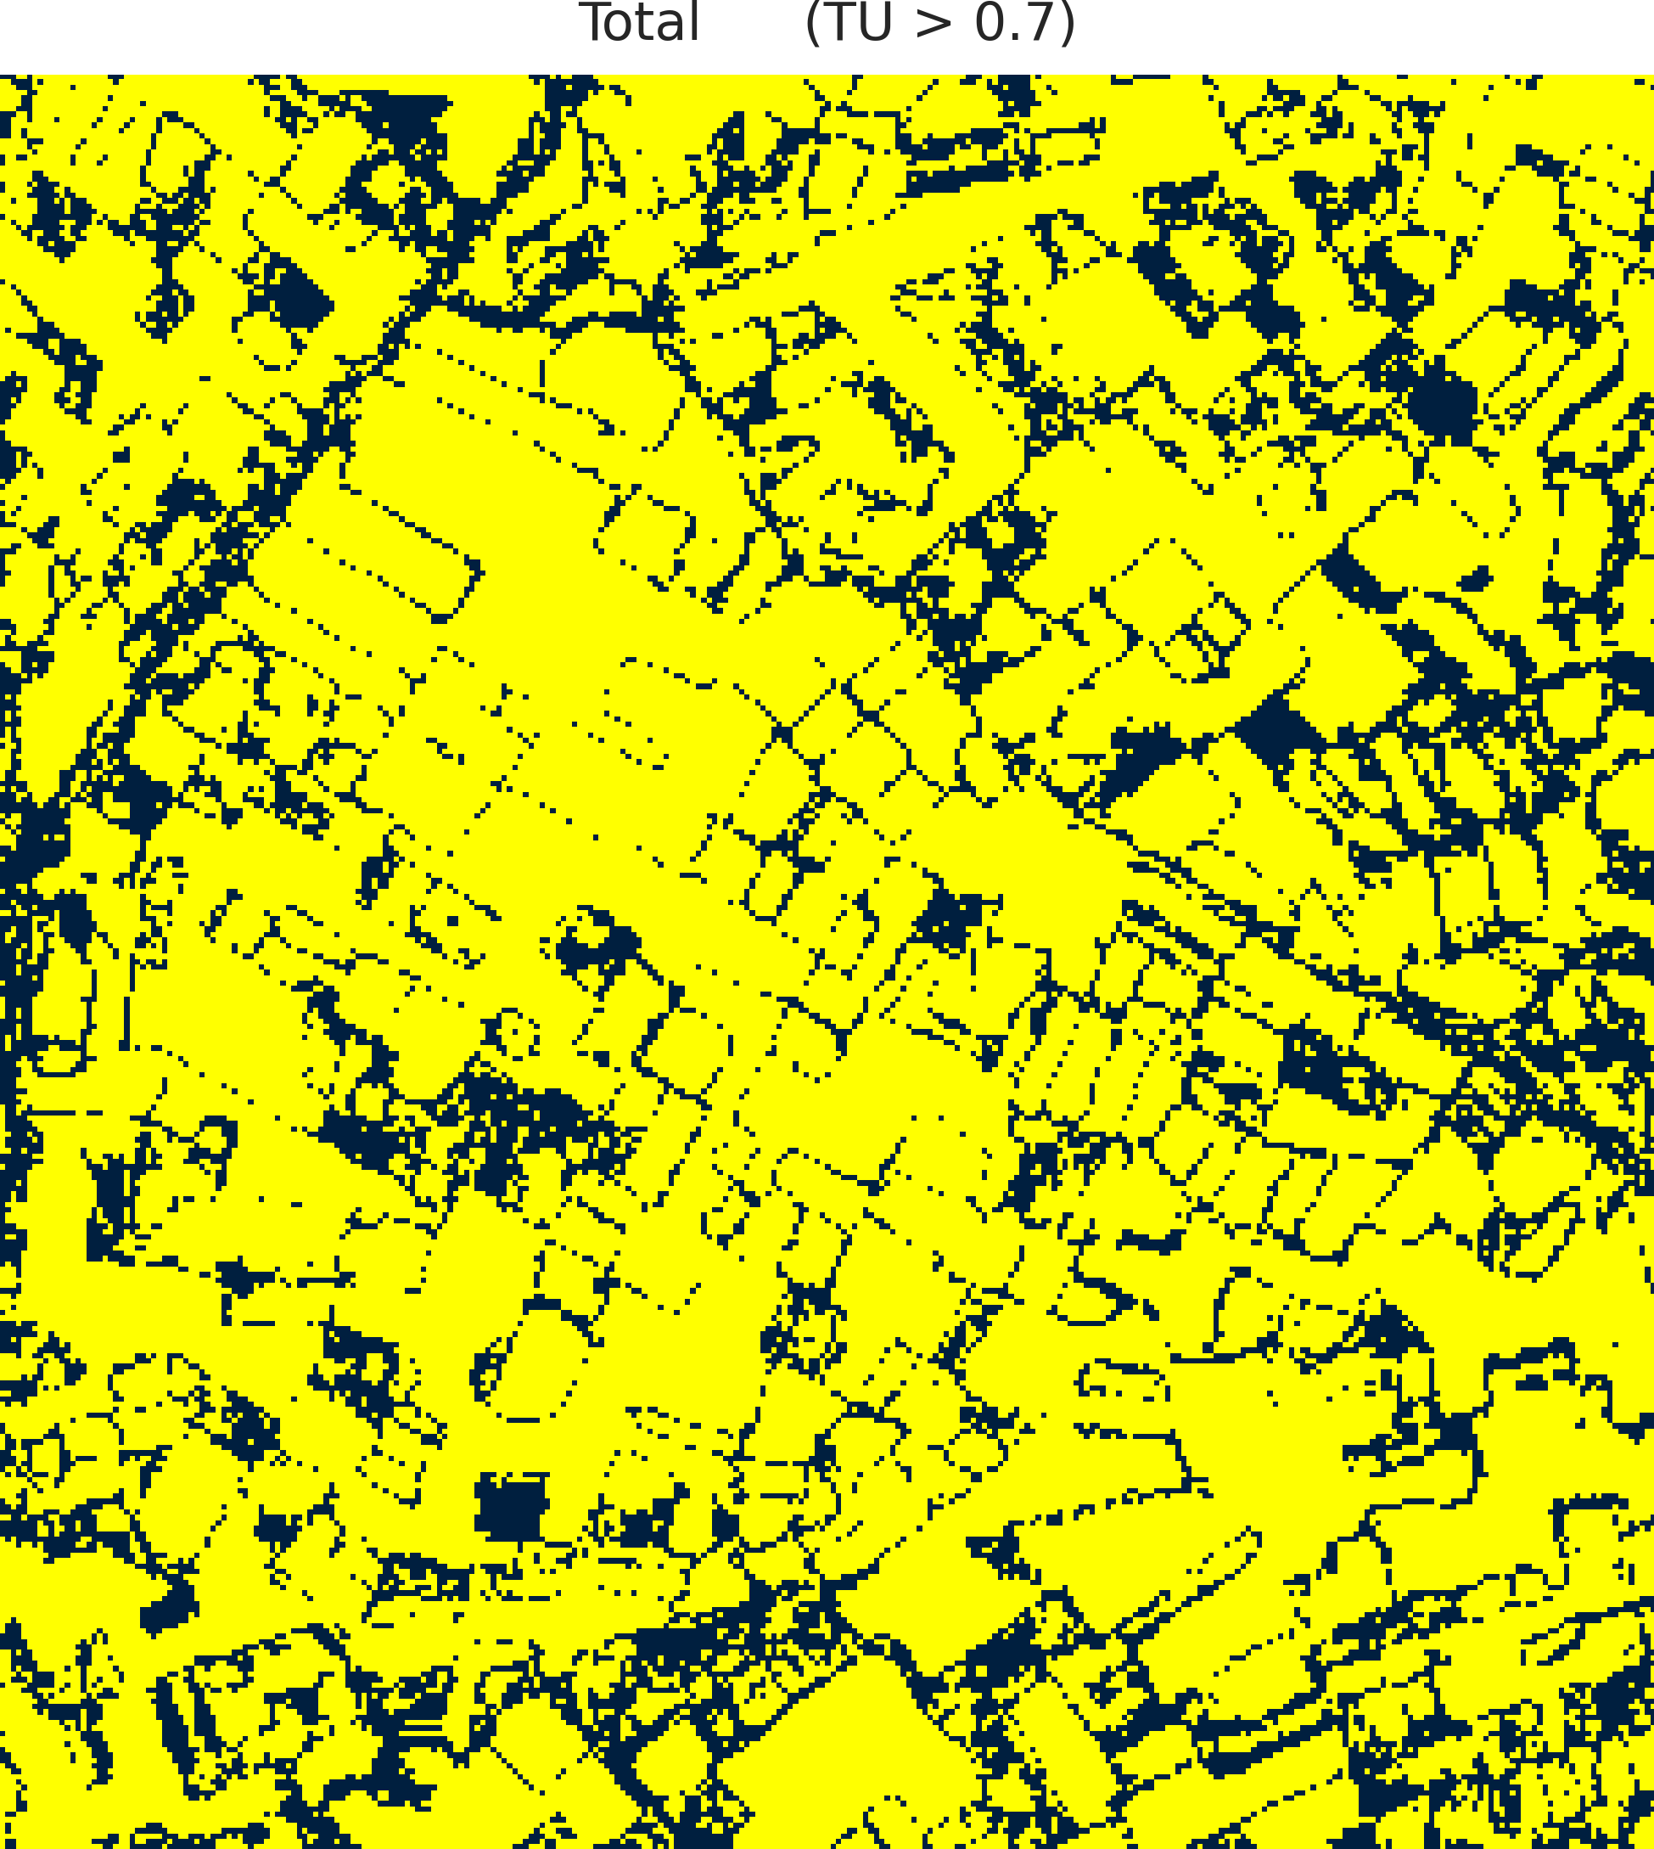  (c) ViT-UNet | (d) Legend
Fig. 7. CreDE binary total uncertainty masks (TU > 0.7) for the full 330 × 307 scene: (a) AlexNet-CNN, (b) GFNet, (c) ViT-UNet. Yellow = certain; dark navy = uncertain.
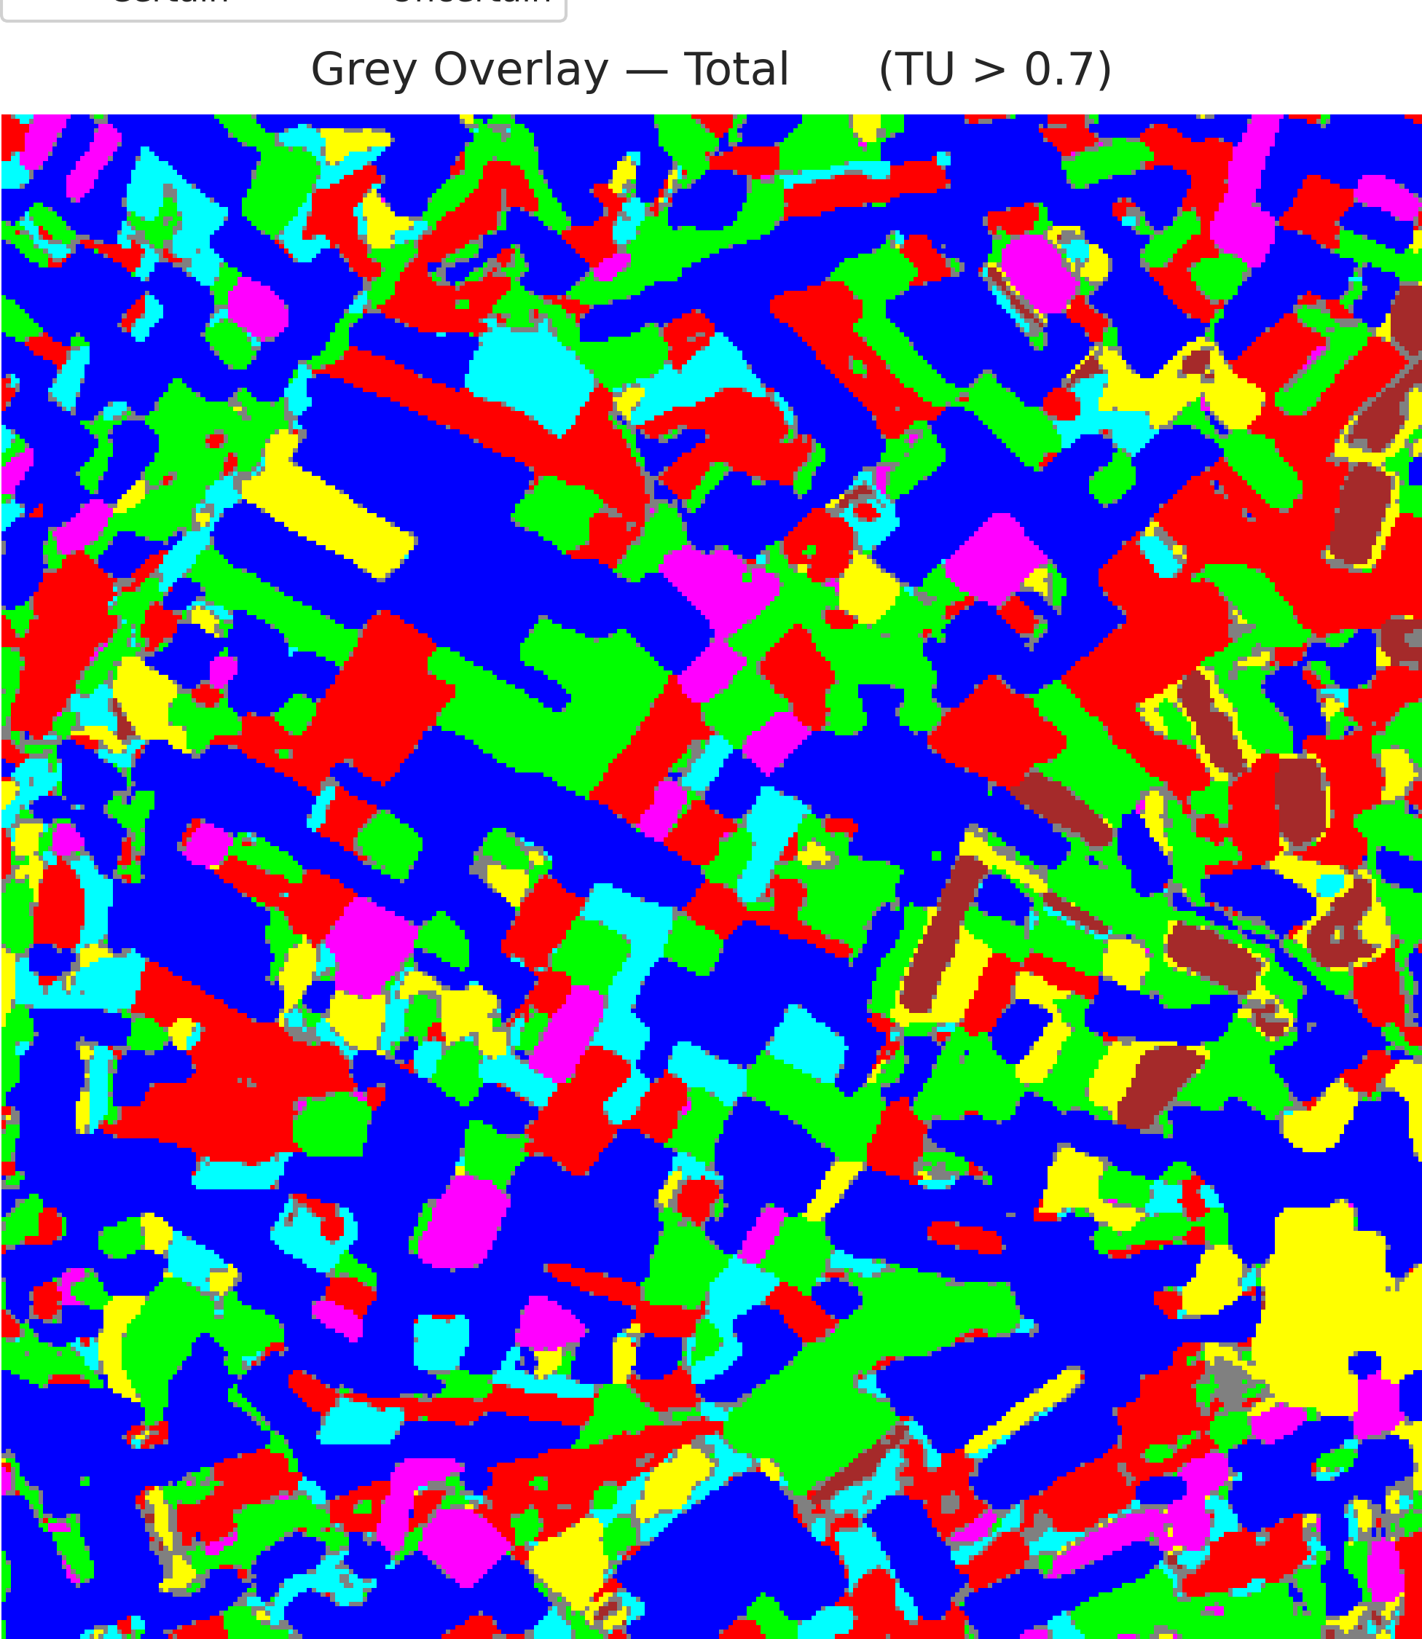  (a) AlexNet-CNN | 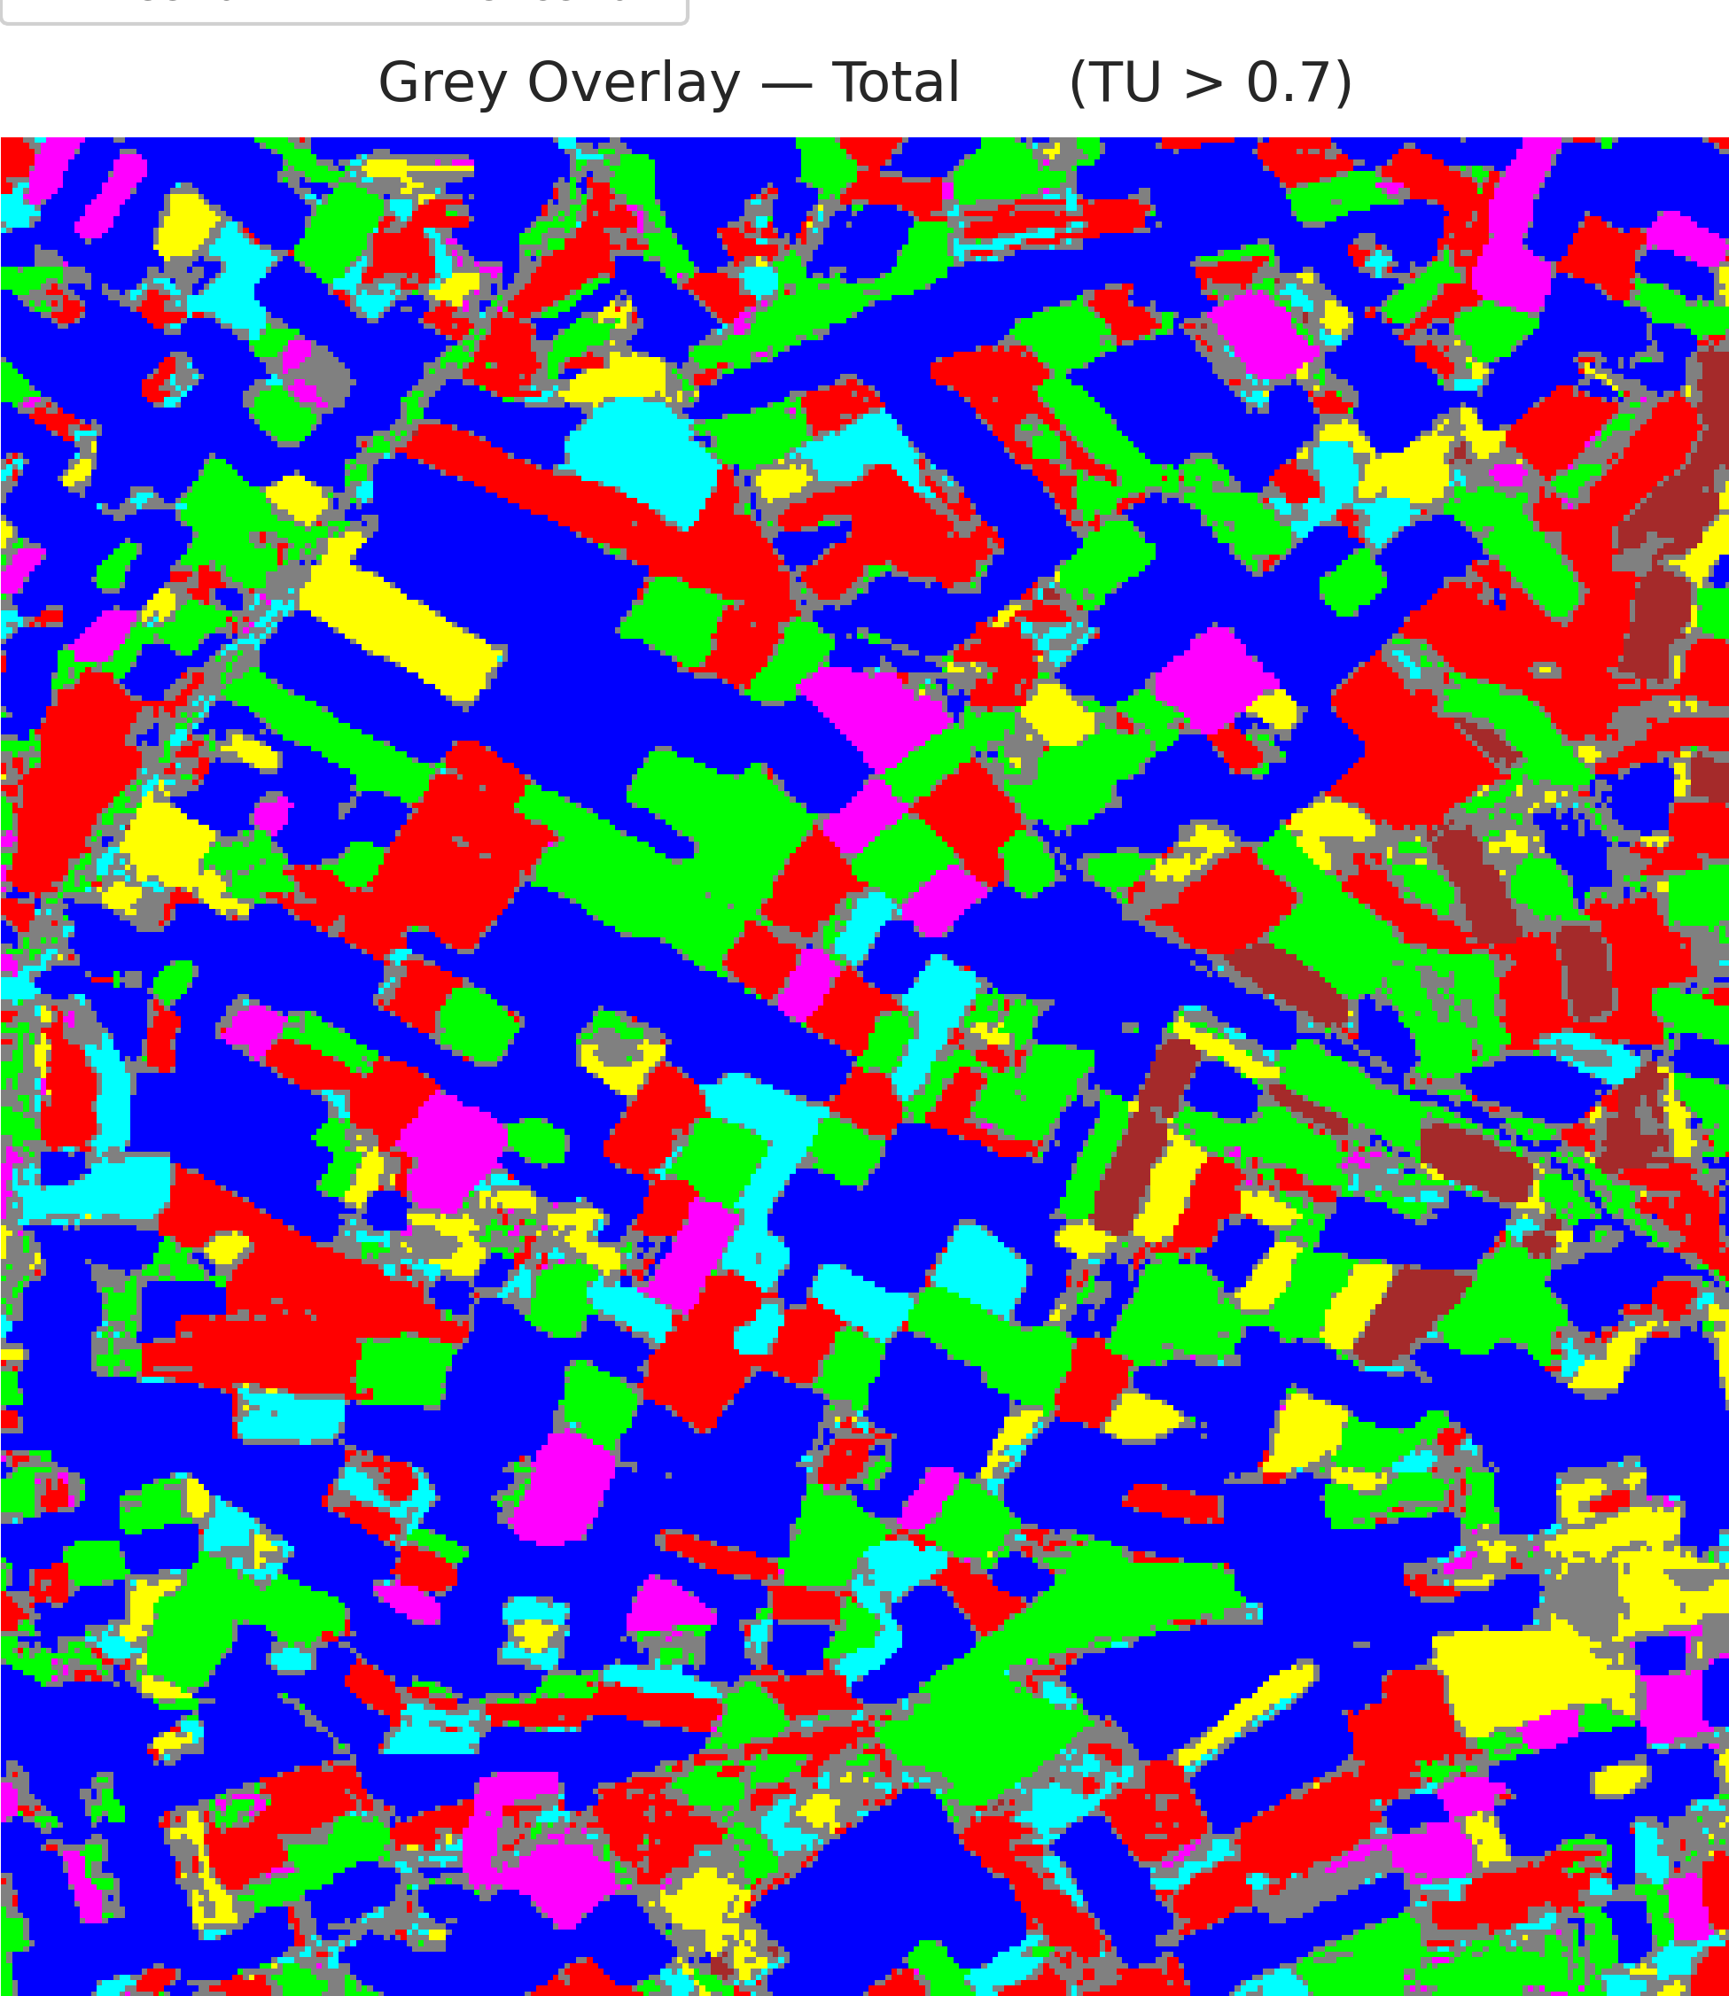  (b) GFNet
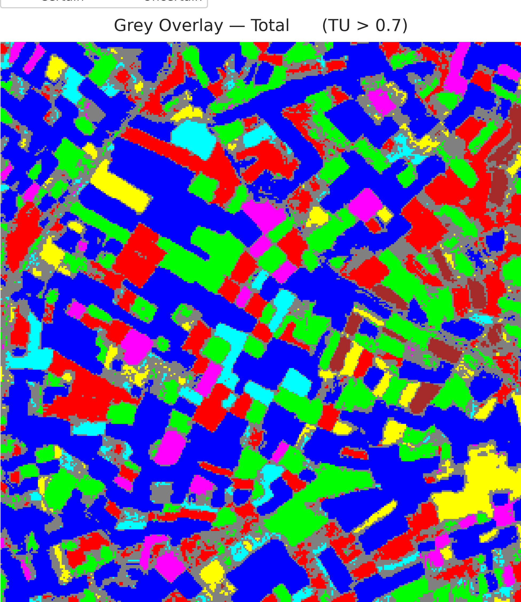  (c) ViT-UNet | (d) Legend
Fig. 8. Grey overlay of total-uncertain pixels (TU > 0.7) on the CreDE classification maps: (a) AlexNet-CNN, (b) GFNet, (c) ViT-UNet, with (d) class legend.
TABLE VIII
CREDE TOTAL (TU > 0.7) PIXEL-COUNT DISTRIBUTION ACROSS ARCHITECTURES
Class / Region | AlexNet-CNN | GFNet | ViT-UNet
Class 0 | 40,780 | 39,830 | 37,996
Class 1 | 18,478 | 15,646 | 14,424
Class 2 | 17,774 | 16,302 | 13,279
Class 3 | 6,242 | 4,663 | 3,831
Class 4 | 4,166 | 3,822 | 3,330
Class 5 | 6,432 | 4,718 | 4,173
Class 6 | 1,996 | 1,866 | 1,583
Uncertain | 5,442 | 14,463 | 22,694
Total (Scene) | 101,310 | 101,310 | 101,310

To examine the spatial interaction among uncertainty components and verify theoretical conservation, TABLE IX details the mutually exclusive mask overlap across the full scene alongside exact conservation identity checks and maximum observed uncertainty metrics.
TABLE IX
CREDE UNCERTAIN-PIXEL MASK OVERLAP AND CONSERVATION IDENTITY ANALYSIS
Criterion / Region (Mutually Exclusive) | AlexNet-CNN CreDE | GFNet CreDE | ViT-UNet CreDE
AU Only (AU > 0.5, EU ≤ 0.2, TU ≤ 0.7) | 11 (0.011%) | 72 (0.071%) | 144 (0.142%)
EU Only (EU > 0.2, AU ≤ 0.5, TU ≤ 0.7) | 14,179 (13.996%) | 2,729 (2.694%) | 70 (0.069%)
TU Only (TU > 0.7, AU ≤ 0.5, EU ≤ 0.2) | 0 (0.000%) | 0 (0.000%) | 0 (0.000%)
AU & TU Only | 67 (0.066%) | 434 (0.428%) | 567 (0.560%)
EU & TU Only | 1,194 (1.179%) | 438 (0.432%) | 21 (0.021%)
AU & EU & TU (Flagged under all three criteria) | 4,181 (4.127%) | 13,591 (13.415%) | 22,106 (21.820%)
Certain (Uncertain under none) | 81,678 (80.622%) | 84,046 (82.959%) | 78,402 (77.388%)
Total Scene Pixels | 101,310 (100.0%) | 101,310 (100.0%) | 101,310 (100.0%)
AU-uncertain but NOT TU-uncertain | 11 | 72 | 144
TU-uncertain but NOT AU-uncertain | 1,194 | 438 | 21
Max |AU + EU − TU| | 0.000001 | 0.000001 | 0.000001
Mean |AU + EU − TU| | 0.000000 | 0.000000 | 0.000000
Max Theoretical AU (ln 7) | 1.945910 | 1.945910 | 1.945910
Max Observed AU | 1.603011 | 1.942813 | 1.945840
Max Observed EU | 0.618491 | 0.574841 | 0.651491
Max Observed TU | 2.006207 | 2.507199 | 2.592594

In CreDE, substantial ensemble divergence occurs in boundary regions, with 4,181 pixels in AlexNet-CNN, 13,591 in GFNet, and 22,106 in ViT-UNet simultaneously flagged by all three uncertainty criteria. The fundamental conservation identity TU(x) = AU(x) + EU(x) holds with mathematical precision across the entire 101,310-pixel scene, exhibiting a maximum residual |AU + EU − TU| ≤ 1.0 × 10⁻⁶ attributable solely to machine floating-point precision.
H. Credal Prediction-Set Coverage & Efficiency Analysis
A central advantage of Credal Deep Ensembles is the capability to convert member bounds [p_min,k(x), p_max,k(x)] directly into credal prediction sets C(x) without requiring heuristic score functions. Under the interval dominance decision rule, candidate class k is retained in C(x) if and only if its upper bound is not strictly dominated by the lower bound of any rival class:
k ∈ C(x) ⟺ p_max,k(x) ≥ max_{j ∈ {1, ..., K}} p_min,j(x)
Because the class with maximal lower bound k* = argmax_j p_min,j(x) unconditionally satisfies p_max,k*(x) ≥ p_min,k*(x) = max_j p_min,j(x), prediction sets are mathematically guaranteed to be non-empty (|C(x)| ≥ 1) for every pixel in the scene.
TABLE X presents the overall empirical coverage, average prediction set size, and mean class coverage across all 4,310 held-out test pixels for the three deep ensemble architectures on the 6-band DIAS dataset. All three architectures achieve exceptional empirical coverage exceeding 99.93% (AlexNet-CNN 99.93%, GFNet 99.93%, ViT-UNet 99.95%), rigorously validating that the true land-cover class is almost invariably contained within the credal prediction set. Importantly, this high coverage does not cause set-size bloat: AlexNet-CNN records an average set size of 1.0067 classes per pixel (operating as an optimal singleton classifier on over 99.3% of test samples), GFNet records 1.0139 classes, and ViT-UNet records 1.0346 classes.
TABLE X
OVERALL CREDE CREDAL PREDICTION-SET COVERAGE & AVERAGE SET SIZE
Model | N_Test_Pixels | Overall Empirical Coverage | Average Set Size | Mean Class Coverage
AlexNet-CNN | 4,310 | 99.93% | 1.0067 | 99.93%
GFNet | 4,310 | 99.93% | 1.0139 | 99.89%
ViT-UNet | 4,310 | 99.95% | 1.0346 | 99.98%

TABLE XI breaks down empirical coverage across all 7 individual annotated land-cover classes (Class 1 through Class 7). All three models maintain near-perfect empirical coverage across every class: Classes 3, 5, 6, and 7 achieve exactly 100.00% coverage across all models, while Classes 1 and 2 maintain 99.89%–100.00% coverage, and Class 4 maintains 99.36%–100.00%. This uniform performance across both majority and minority classes demonstrates that CreDE provides balanced statistical protection without systematic degradation on difficult categories.
TABLE XI
CLASS-WISE CREDAL PREDICTION-SET EMPIRICAL COVERAGE ACROSS ALL CLASSES
Class | AlexNet-CNN | GFNet | ViT-UNet
Class 1 | 99.95% | 100.00% | 99.95%
Class 2 | 99.89% | 99.89% | 99.89%
Class 3 | 100.00% | 100.00% | 100.00%
Class 4 | 99.68% | 99.36% | 100.00%
Class 5 | 100.00% | 100.00% | 100.00%
Class 6 | 100.00% | 100.00% | 100.00%
Class 7 | 100.00% | 100.00% | 100.00%

A comparative architectural synthesis reveals complementary uncertainty profiles. AlexNet-CNN, with its localized convolutional inductive bias, produces remarkably tight point-entropy distributions (Mean AU = 0.0484) and flags the fewest aleatoric (4,259) and total (5,442) uncertain pixels. GFNet, leveraging global frequency-domain mixing, achieves the lowest epistemic dispersion (Mean EU = 0.0579) and exceptional accuracy across agricultural parcels. ViT-UNet, utilizing multi-head self-attention, exhibits broader soft entropy spread across boundary transitions (Mean AU = 0.5471), leading to slightly higher prediction set size (1.0346) and conservative epistemic boundary delineation.
IV. CONCLUSION
This paper presented a Credal Deep Ensemble (CreDE) uncertainty quantification investigation on the 6-band DIAS Scene K01 multispectral dataset (330 × 307 pixels, K = 7 active classes). Using M = 5 independently seeded checkpoints per architecture, AlexNet-CNN achieved 99.77% test accuracy with the lowest scene-wide aleatoric and total uncertainty (Mean AU = 0.0484, Mean TU = 0.1159; 5,442 TU-uncertain pixels), GFNet achieved 99.63% test accuracy with the lowest epistemic disagreement (Mean EU = 0.0579; 16,758 EU-uncertain pixels), and ViT-UNet achieved 99.54% test accuracy with conservative credal boundary detection (Mean AU = 0.5471, Mean TU = 0.6221). Under the interval-dominance decision criterion, all models achieved over 99.93% empirical test coverage with highly efficient average prediction set sizes under 1.035 classes. These empirical findings substantiate CreDE as an effective, mathematically principled approach for dependable earth observation and automated agricultural mapping.
REFERENCES
[1] B. Lakshminarayanan, A. Pritzel, and C. Blundell, “Simple and scalable predictive uncertainty estimation using deep ensembles,” in Adv. Neural Inf. Process. Syst. (NeurIPS), vol. 30, 2017.
[2] Y. Rao, W. Zhao, Z. Zhu, J. Lu, and J. Zhou, “Global filter networks for image classification,” in Adv. Neural Inf. Process. Syst. (NeurIPS), vol. 34, 2021.
[3] A. Dosovitskiy et al., “An image is worth 16x16 words: Transformers for image recognition at scale,” in Proc. ICLR, 2021.
[4] O. Ronneberger, P. Fischer, and T. Brox, “U-Net: Convolutional networks for biomedical image segmentation,” in Proc. MICCAI, Springer, 2015.
[5] A. Krizhevsky, I. Sutskever, and G. E. Hinton, “ImageNet classification with deep convolutional neural networks,” in Adv. Neural Inf. Process. Syst. (NeurIPS), vol. 25, 2012.
[6] M. Ahmad et al., “Hyperspectral image classification—Traditional to deep models: A survey for future prospects,” IEEE J. Sel. Topics Appl. Earth Observ. Remote Sens., 2022.
[7] Z. Wang et al., “Credal deep ensembles for uncertainty quantification,” in Adv. Neural Inf. Process. Syst. (NeurIPS), 2024.
[8] A. N. Angelopoulos and S. Bates, “A gentle introduction to conformal prediction and distribution-free uncertainty quantification,” arXiv:2107.07511, 2021.

