Patch-Based Hyperspectral Land-Cover Classification with Deep Architectures and Conformal Prediction Uncertainty Quantification
ABSTRACT
This paper presents a comprehensive framework for patch-based pixel-wise classification of hyperspectral remote sensing imagery, integrating three deep learning architectures with distribution-free uncertainty quantification via conformal prediction. A 65-band hyperspectral scene of 512 × 512 pixels (262,144 total scene pixels) from the DIAS dataset (Scene K01, K = 8 classes: Class 0 through Class 7) is classified by extracting 9 × 9 × 65 spatial-spectral patches centred on each pixel and training three architectures: an AlexNet-style convolutional neural network (AlexNet), a Global Filter Network (GFNet) operating in the two-dimensional Fourier domain, and a Vision Transformer augmented with U-Net skip connections (ViT-UNet). All three models achieve test accuracies exceeding 99.92%, with GFNet attaining 99.993% accuracy and Cohen’s κ of 0.9999. Post-hoc uncertainty quantification is applied via five conformal prediction methods—SplitCP, CcCP, RC3P, ClCP, and RAPS—targeting 95% marginal coverage (α = 0.05). SplitCP achieves 95.09%, 95.06%, and 94.78% empirical coverage for AlexNet, GFNet, and ViT-UNet respectively, while RC3P lifts empirical coverage above the 95% target across all three architectures (96.07%, 95.53%, and 95.35%) with a universal rank limit of k̂ = 1. Full-scene spatialised uncertainty maps over all 262,144 pixels demonstrate that while in-distribution labelled parcels exhibit low uncertainty (∼3.9%–5.5%) concentrated at parcel boundaries, out-of-distribution unlabelled background regions account for the majority of uncertain pixels across the scene.
I. INTRODUCTION
Remote sensing land-cover classification is a cornerstone task in earth observation, with applications spanning agricultural monitoring, urban planning, and environmental change detection [12]. Hyperspectral imagery provides rich spectral information across dozens of contiguous narrow bands, enabling fine-grained discrimination between surface classes that are indistinguishable in standard RGB or broadband multispectral imagery. Classification at the pixel level remains challenging due to within-class spectral variability, boundary ambiguity, and the presence of extensive unlabelled background regions.
Deep learning has substantially advanced the state of the art in remote sensing classification. Convolutional neural networks, frequency-domain architectures, and transformer-based models have each demonstrated strong performance on hyperspectral and multispectral datasets [1, 2, 10, 12]. Patch-based classification—wherein a spatial neighbourhood window centred on each pixel is provided to a classifier—allows the network to exploit local texture and structural cues beyond raw spectral vectors, and has become a standard paradigm for pixel-wise tasks.
Despite high classification accuracy, deep models typically return only a single predicted class without formal reliability guarantees [13]. Conformal prediction (CP) is a post-hoc statistical framework that wraps any pre-trained classifier and returns a prediction set guaranteed, with probability at least 1 − α, to contain the true class—without assumptions on the data distribution beyond exchangeability [6, 7, 8, 9]. The principal contributions of this work are:
- A rigorous comparative evaluation of AlexNet, GFNet, and ViT-UNet on an eight-class 65-band hyperspectral classification task (DIAS Scene K01) using 9 × 9 × 65 patch-based feature extraction.
- A systematic analysis of model calibration and computational efficiency via Negative Log-Likelihood (NLL), Brier Score, Expected Calibration Error (ECE), and training runtime [13].
- Application and comparison of five conformal prediction methods (SplitCP, CcCP, RC3P, ClCP, and RAPS) providing distribution-free 95% coverage guarantees [3, 4, 5, 6, 8].
- Generation of full-scene spatialised pixel-wise uncertainty maps across all 512 × 512 = 262,144 pixels identifying ambiguous boundary and background regions for downstream analysts.

II. METHODOLOGY
A. Dataset and Preprocessing
The dataset consists of a 65-band hyperspectral scene from the DIAS dataset, Scene K01 (files k001.mat and k002.mat, H = 512, W = 512 pixels, B = 65 spectral bands), with a ground truth label map of K = 8 classes indexed by IDs 0–7 (Class 0, Class 1, Class 2, Class 3, Class 4, Class 5, Class 6, Class 7). The approximate RGB composite and ground truth label map are shown in Fig. 1.
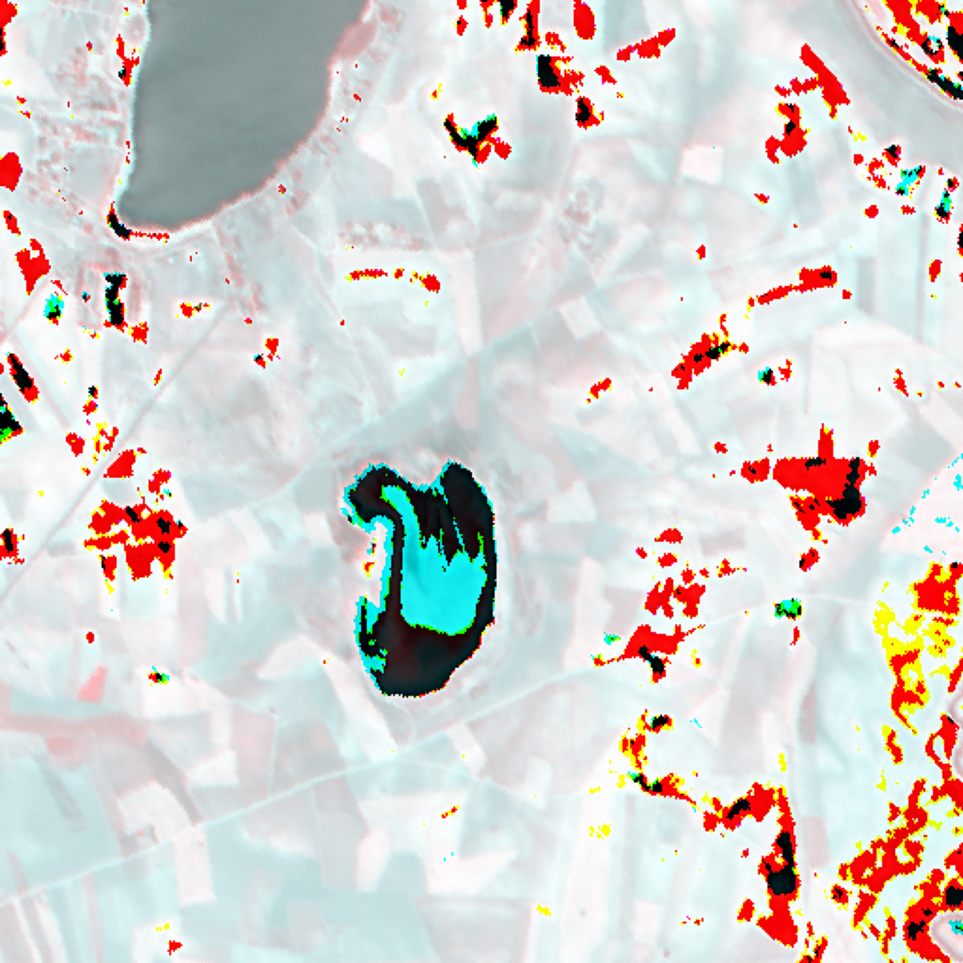  (a) Approximate RGB Composite | 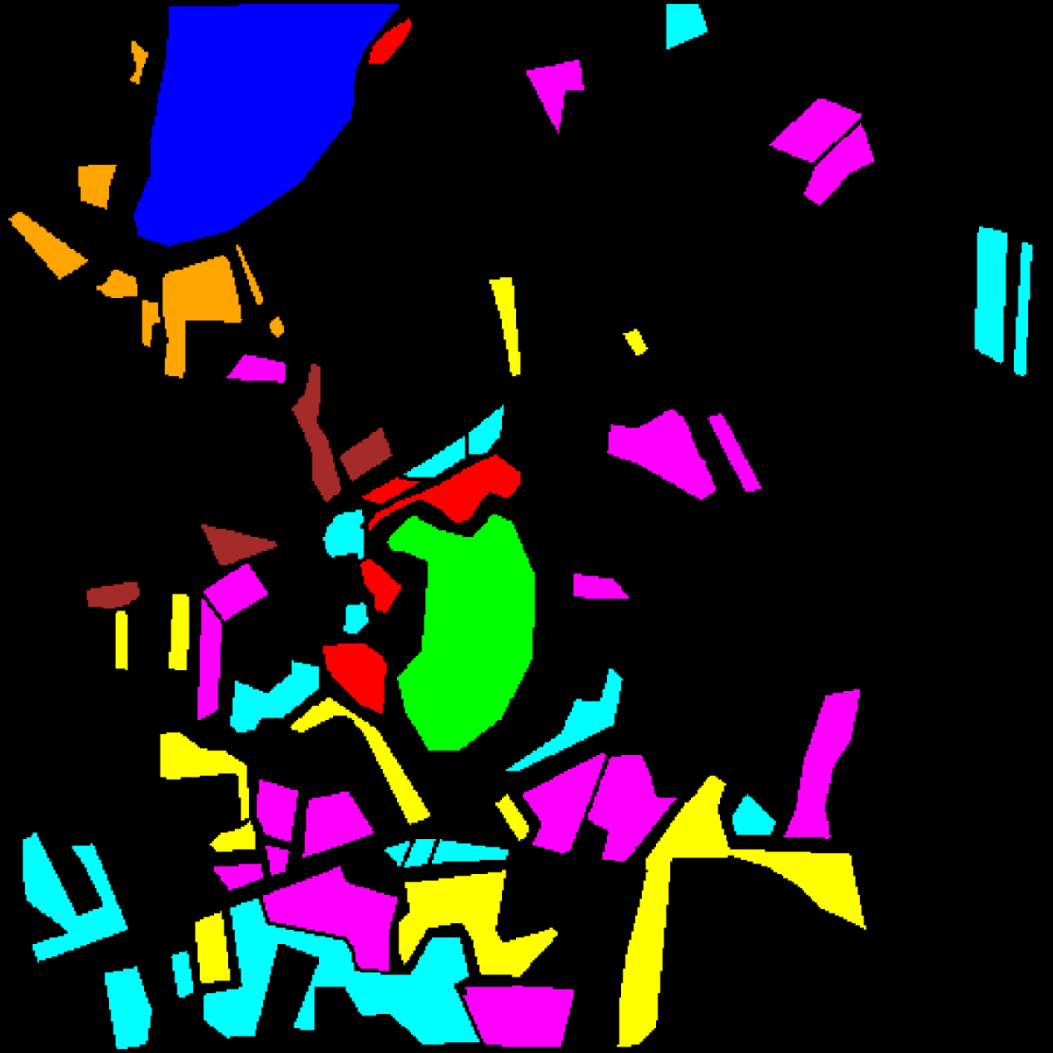  (b) Ground Truth Label Map
Fig. 1. Hyperspectral scene overview (DIAS Scene K01, 65 bands, 512 × 512 pixels). (a) Approximate RGB composite. (b) Ground truth label map for Class 0 through Class 7; black pixels denote unlabelled background.
Each spectral band is independently normalised to [0, 1] via per-band min-max scaling:
x̃(h, w, b) = [x(h, w, b) − min_{b}] / [max_{b} − min_{b} + ε], ε = 10⁻⁸
For each pixel at (h, w), a 9 × 9 × 65 patch is extracted from the edge-padded scene (4-pixel replication). Using random seed 42, the labelled dataset is split into training (75%), calibration (12.5%, i.e. 50% of the remaining 25% test part), and evaluation (12.5%) subsets across all three models. Summing the per-class support counts across Class 0–7 in the conformal evaluation sheets (1,216, 704, 283, 1,365, 1,590, 1,059, 200, and 320) yields n_eval = 6,737 evaluation samples, which implies n_cal = 6,737 calibration samples, 13,474 held-out test samples (2 × 6,737), and 53,896 total labelled pixels across the scene (40,422 training samples). During dense scene evaluation, conformal pixel counts are tallied across the entire 512 × 512 scene (262,144 total pixels).
B. Deep Learning Architectures
AlexNet-style CNN: Adapted from [1] for 9 × 9 × 65 inputs with five convolutional layers [96, 256, 384, 384, 256] and a fully connected head [4096, 1024, 256, 32, K] with K = 8 classes. Dropout (p = 0.25) is applied. An Adagrad optimiser with cosine schedule (LR ∈ [0.005, 0.02]) minimises sparse categorical cross-entropy over 100 epochs with batch size 128.
GFNet: Replaces spatial self-attention with learnable global filters in the 2-D Fourier domain [2]. Each 9 × 9 × 65 patch is tokenised into nine 3 × 3 sub-patches (d = 512). In each of L = 5 blocks, the DFT of the token grid is element-wise multiplied by W ∈ ℂ^{T×T×d} and inverse-transformed, achieving O(N log N) complexity with global receptive field. Label-smoothed cross-entropy (ε_s = 0.05) and AdamW (wd = 10⁻⁴) are used over 100 epochs with batch size 128.
ViT-UNet: A 12-layer Vision Transformer [10] with U-Net skip connections [11] accepting 9 × 9 × 65 patches. A [CLS] token and learned positional embeddings are prepended. Skip connections bridge encoder block i to decoder block L − i for i ≤ ⌊L/2⌋, enabling simultaneous access to low-level structural and high-level semantic representations over 100 epochs with batch size 128.
C. Evaluation Metrics
Performance is assessed using test accuracy, Cohen’s κ, macro-F1, weighted-F1, NLL, and training time (s). Calibration is measured by the Brier Score and ECE (M = 15 bins), where lower values indicate better calibration [13]. A perfectly calibrated model achieves ECE = 0.
D. Conformal Prediction Methods
Five CP methods are applied post-hoc using n = 6,737 calibration samples targeting 1 − α = 0.95 coverage (α = 0.05) [7, 9]. The threshold-based methods share the nonconformity score s(x, y) = 1 − π̂_y(x), forming prediction sets C(x) = {y : π̂_y(x) ≥ 1 − q̂}.
- SplitCP: Single global quantile q̂ from all calibration scores, guaranteeing marginal coverage ≥ 1 − α [8].
- CcCP: Per-class thresholds q̂_c from class-stratified calibration subsets for class-conditional coverage [6].
- RC3P: Augments CcCP with per-class rank gate k̂(y) to minimise set sizes while maintaining class-conditional coverage [4].
- ClCP: Groups classes into K_g = 4 clusters via K-Means on calibration nonconformity distributions, pooling calibration data across clustered classes [5].
- RAPS: Rank-adaptive score accumulating softmax mass above the true class rank; regularisation λ = 0.01, k_reg = 1 [3].

III. EXPERIMENTS AND RESULTS
A. Classification Performance
All three models were trained for 100 epochs with batch size 128. TABLE I summarises test-set metrics across the 13,474 held-out test samples. GFNet achieves the highest accuracy (99.993%, κ = 0.9999, macro-F1 = 0.9998, weighted-F1 = 0.9999) and the lowest Brier score (0.00023), followed by ViT-UNet (99.933%, κ = 0.9992, macro-F1 = 0.9990, weighted-F1 = 0.9993) and AlexNet (99.926%, κ = 0.9991, macro-F1 = 0.9983, weighted-F1 = 0.9993); reporting accuracy to three decimal places resolves the 1-pixel difference between ViT-UNet and AlexNet, which would otherwise tie at 99.93%. Calibration rankings differ across metrics: AlexNet achieves the lowest NLL (0.00256) and lowest 15-bin ECE (0.00049) but ranks second in Brier score (0.00133), whereas GFNet achieves the lowest Brier score (0.00023) and ranks second in NLL (0.00811) and ECE (0.00795), and ViT-UNet records the highest NLL (0.04173), Brier score (0.00270), and ECE (0.03891). Training time is nearly identical for GFNet (1130.3 s) and AlexNet (1132.1 s), while ViT-UNet requires 2168.5 s (roughly 1.92× longer).
TABLE I
CLASSIFICATION PERFORMANCE ACROSS ARCHITECTURES
Model | Accuracy (%) | κ | Macro F1 | Wtd F1 | NLL | Brier | ECE | Train Time (s)
GFNet | 99.993% | 0.9999 | 0.9998 | 0.9999 | 0.00811 | 0.00023 | 0.00795 | 1130.3
ViT-UNet | 99.933% | 0.9992 | 0.9990 | 0.9993 | 0.04173 | 0.00270 | 0.03891 | 2168.5
AlexNet | 99.926% | 0.9991 | 0.9983 | 0.9993 | 0.00256 | 0.00133 | 0.00049 | 1132.1

B. Dense Scene Classification Maps
Each model is deployed in dense sliding-window inference over the full 512 × 512 scene (262,144 pixels) to produce pixel-wise land-cover maps, shown in Fig. 2. Within the annotated ground-truth parcels, all three architectures yield clean, homogeneous parcel interiors matching the ground truth in Fig. 1(b), while across the surrounding unlabelled background GFNet and ViT-UNet produce broader contiguous class assignments and AlexNet exhibits more fragmented local transitions.
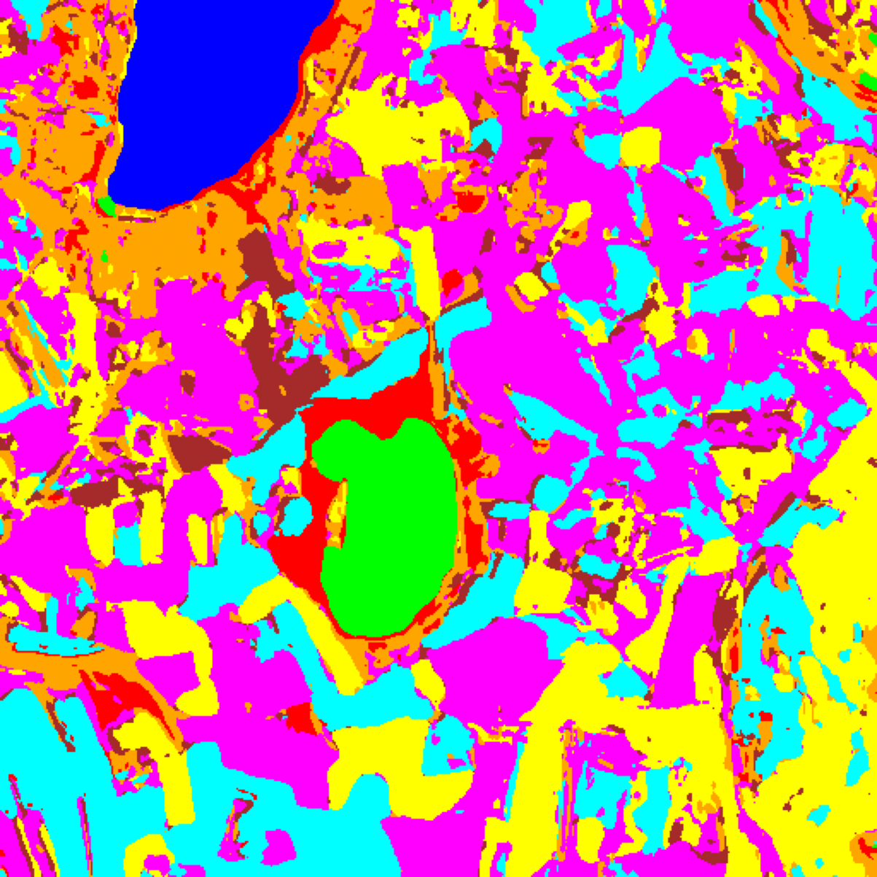  (a) AlexNet | 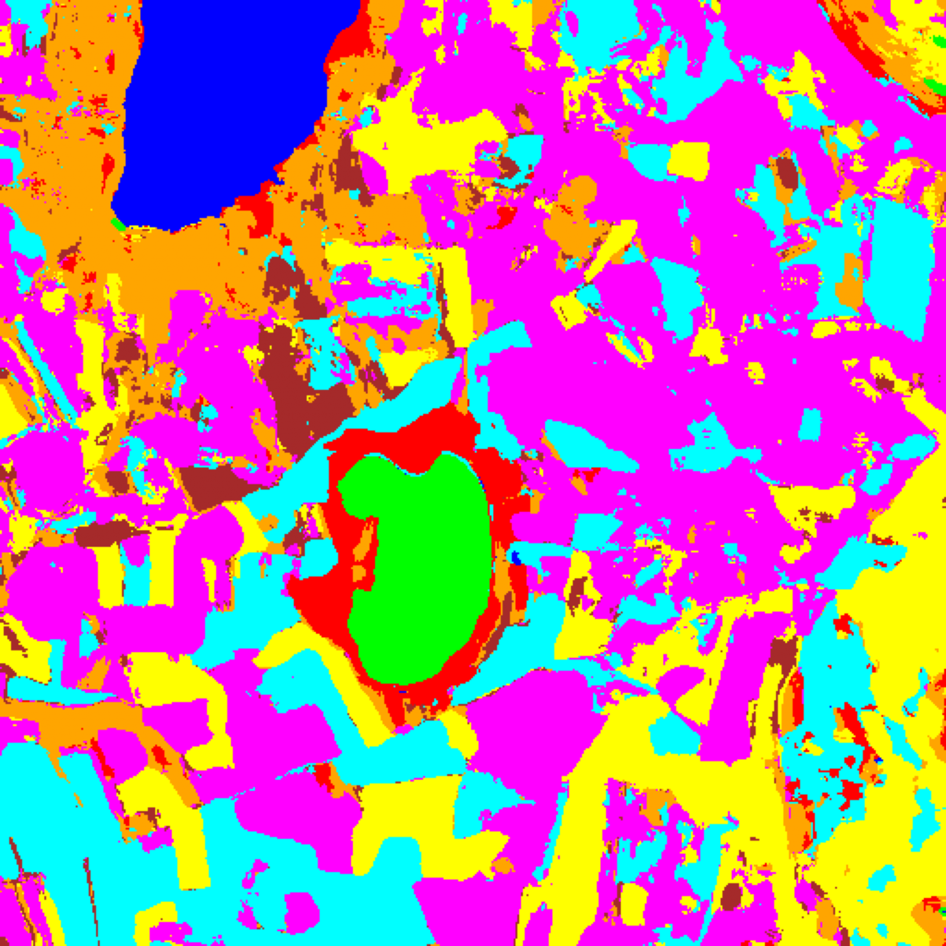  (b) GFNet
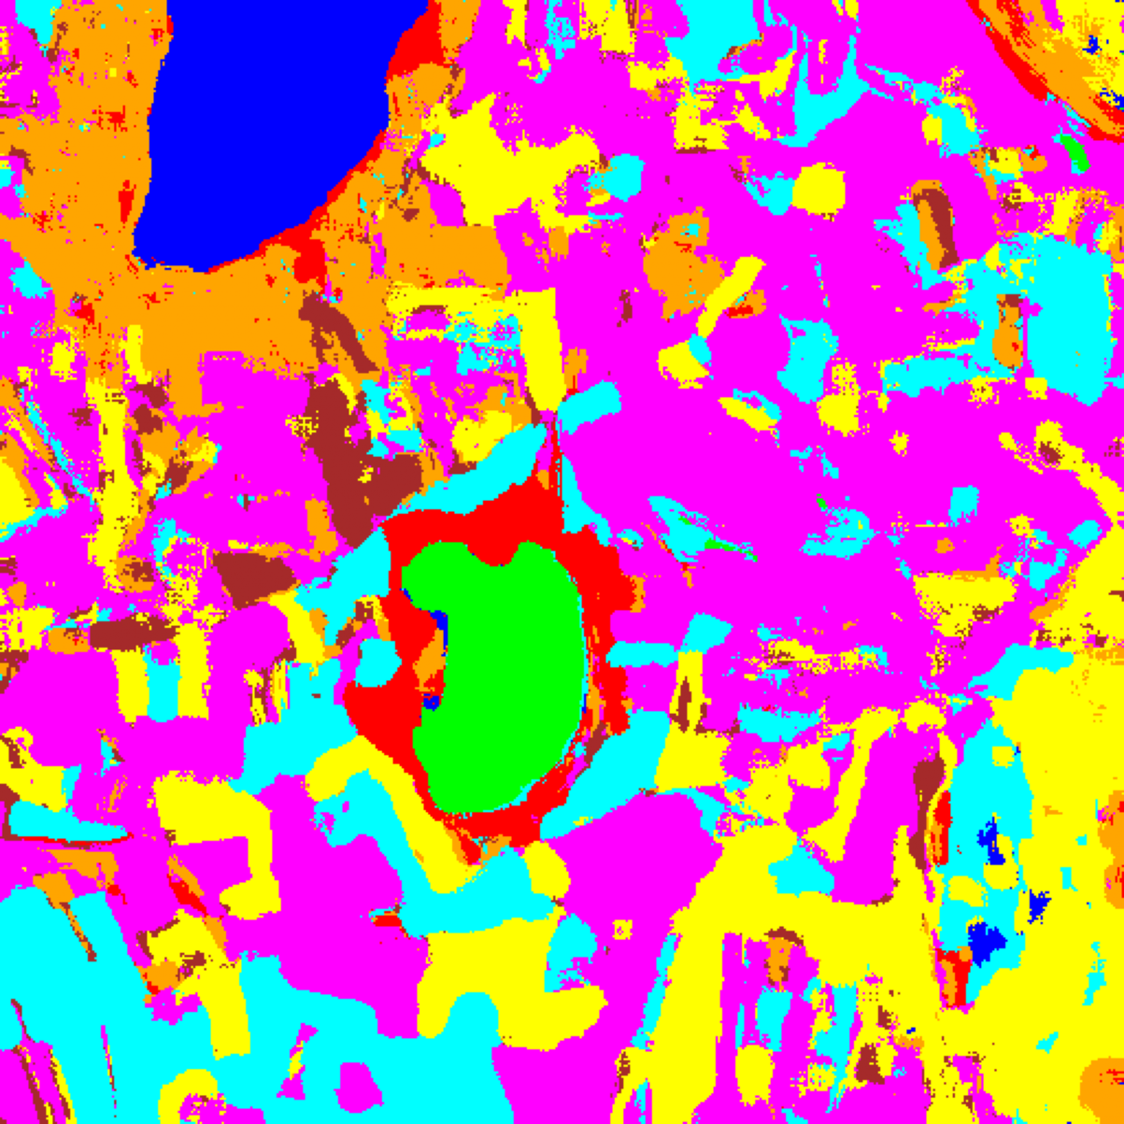  (c) ViT-UNet | 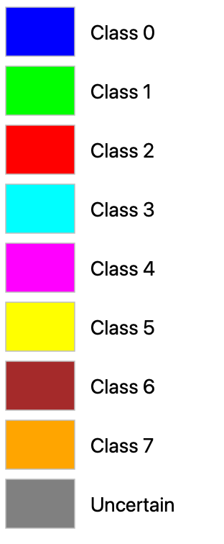  (d) Legend
Fig. 2. Dense pixel-wise classification maps for the full 512 × 512 scene: (a) AlexNet, (b) GFNet, (c) ViT-UNet, and (d) shared class legend (Class 0 through Class 7 and Uncertain) applicable to Figs. 2–5.
C. Split Conformal Prediction Results
SplitCP was applied to all three models with α = 0.05. TABLE II summarises aggregate results across the 6,737 evaluation samples. AlexNet (0.9509) and GFNet (0.9506) exceed the 95% coverage target, whereas ViT-UNet falls slightly below at 0.9478 (empty set rate 0.0522), consistent with its higher ECE (0.03891). Across SplitCP, CcCP, RC3P, and ClCP, every evaluation prediction set is either empty or a singleton (|C(x)| ≤ 1), so average set size equals singleton rate (1 − empty rate) identically and conditional set size on non-empty sets is singleton rate / (1 − empty rate) = 1. Calibration runtime is under 2.41 seconds for all models (2.252 s for ViT-UNet, 2.292 s for GFNet, and 2.403 s for AlexNet).
TABLE II
SPLIT CONFORMAL PREDICTION: AGGREGATE SUMMARY (Α = 0.05)
Model | q̂ | Emp. Cov. | Avg Set Size | Singleton Rate | Empty Set Rate | Runtime (s) | Mean Cls Cov.
AlexNet | 0.000159 | 0.9509 | 0.9509 | 0.9509 | 0.0491 | 2.403 | 0.9207
GFNet | 0.009658 | 0.9506 | 0.9506 | 0.9506 | 0.0494 | 2.292 | 0.9297
ViT-UNet | 0.041099 | 0.9478 | 0.9478 | 0.9478 | 0.0522 | 2.252 | 0.9245

Per-class coverage analysis is presented in TABLE III. Minority classes with fewer calibration samples—most notably Class 6 (support 200: coverage 0.7700 on AlexNet and 0.7650 on ViT-UNet) and Class 2 (support 283: coverage 0.7527 on GFNet and 0.8869 on AlexNet)—exhibit substantial under-coverage under SplitCP’s single global threshold, directly motivating class-conditional and clustered CP variants. GFNet achieves the highest mean per-class coverage under SplitCP (0.9297), followed by ViT-UNet (0.9245) and AlexNet (0.9207).
TABLE III
SPLIT CP: PER-CLASS COVERAGE COMPARISON ACROSS MODELS
Class | AlexNet Coverage | GFNet Coverage | ViT-UNet Coverage
Class 0 | 1.0000 | 0.9161 | 0.9984
Class 1 | 1.0000 | 0.9986 | 1.0000
Class 2 | 0.8869 | 0.7527 | 0.9293
Class 3 | 0.9641 | 0.9729 | 0.9194
Class 4 | 0.9679 | 0.9774 | 0.9535
Class 5 | 0.8895 | 0.9490 | 0.9396
Class 6 | 0.7700 | 0.9300 | 0.7650
Class 7 | 0.8875 | 0.9406 | 0.8906

TABLE IV presents the full-scene pixel-count breakdown per model across all 512 × 512 = 262,144 scene pixels, distinguishing confident singleton class predictions from uncertain pixels (empty prediction sets). ViT-UNet produces the fewest uncertain pixels across the scene (78,763, or 30.05% of the 262,144 scene pixels), compared to AlexNet (93,624, or 35.71%) and GFNet (132,923, or 50.71%).
TABLE IV
SPLIT CP: FULL-SCENE PREDICTED PIXEL COUNT DISTRIBUTION PER MODEL
Class / Region | AlexNet Pixels | GFNet Pixels | ViT-UNet Pixels
Class 0 | 10,756 | 9,515 | 11,019
Class 1 | 8,069 | 6,634 | 7,345
Class 2 | 5,302 | 3,353 | 7,055
Class 3 | 32,000 | 26,999 | 30,295
Class 4 | 58,601 | 48,346 | 67,417
Class 5 | 35,044 | 23,561 | 39,453
Class 6 | 3,923 | 2,230 | 4,149
Class 7 | 14,825 | 8,583 | 16,648
Uncertain | 93,624 | 132,923 | 78,763
Total (Scene) | 262,144 | 262,144 | 262,144

D. Spatialised Uncertainty Maps
SplitCP thresholds are applied pixel-wise over the full 512 × 512 scene. Binary maps (yellow = certain singleton, dark navy = uncertain) and masked class maps (grey = uncertain, colours = predicted class) are produced for all three models and presented in the 2 × 2 grids of Fig. 3(a) and Fig. 3(b), enabling direct visual comparison of prediction confidence across architectures.
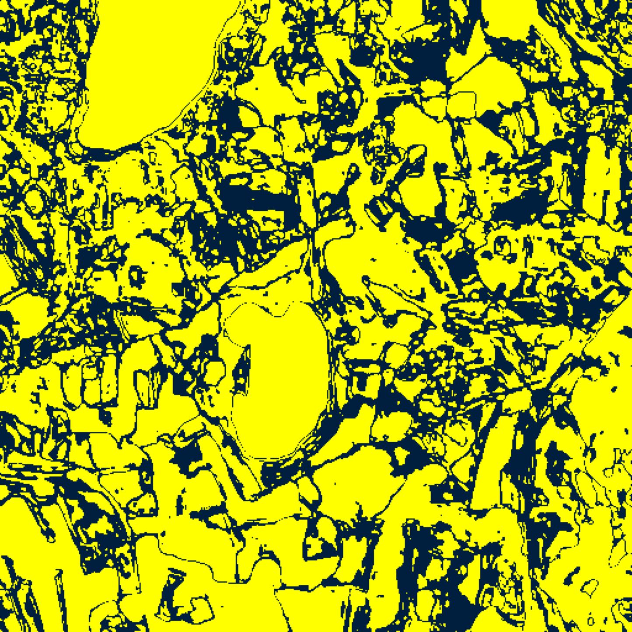  (A) AlexNet | 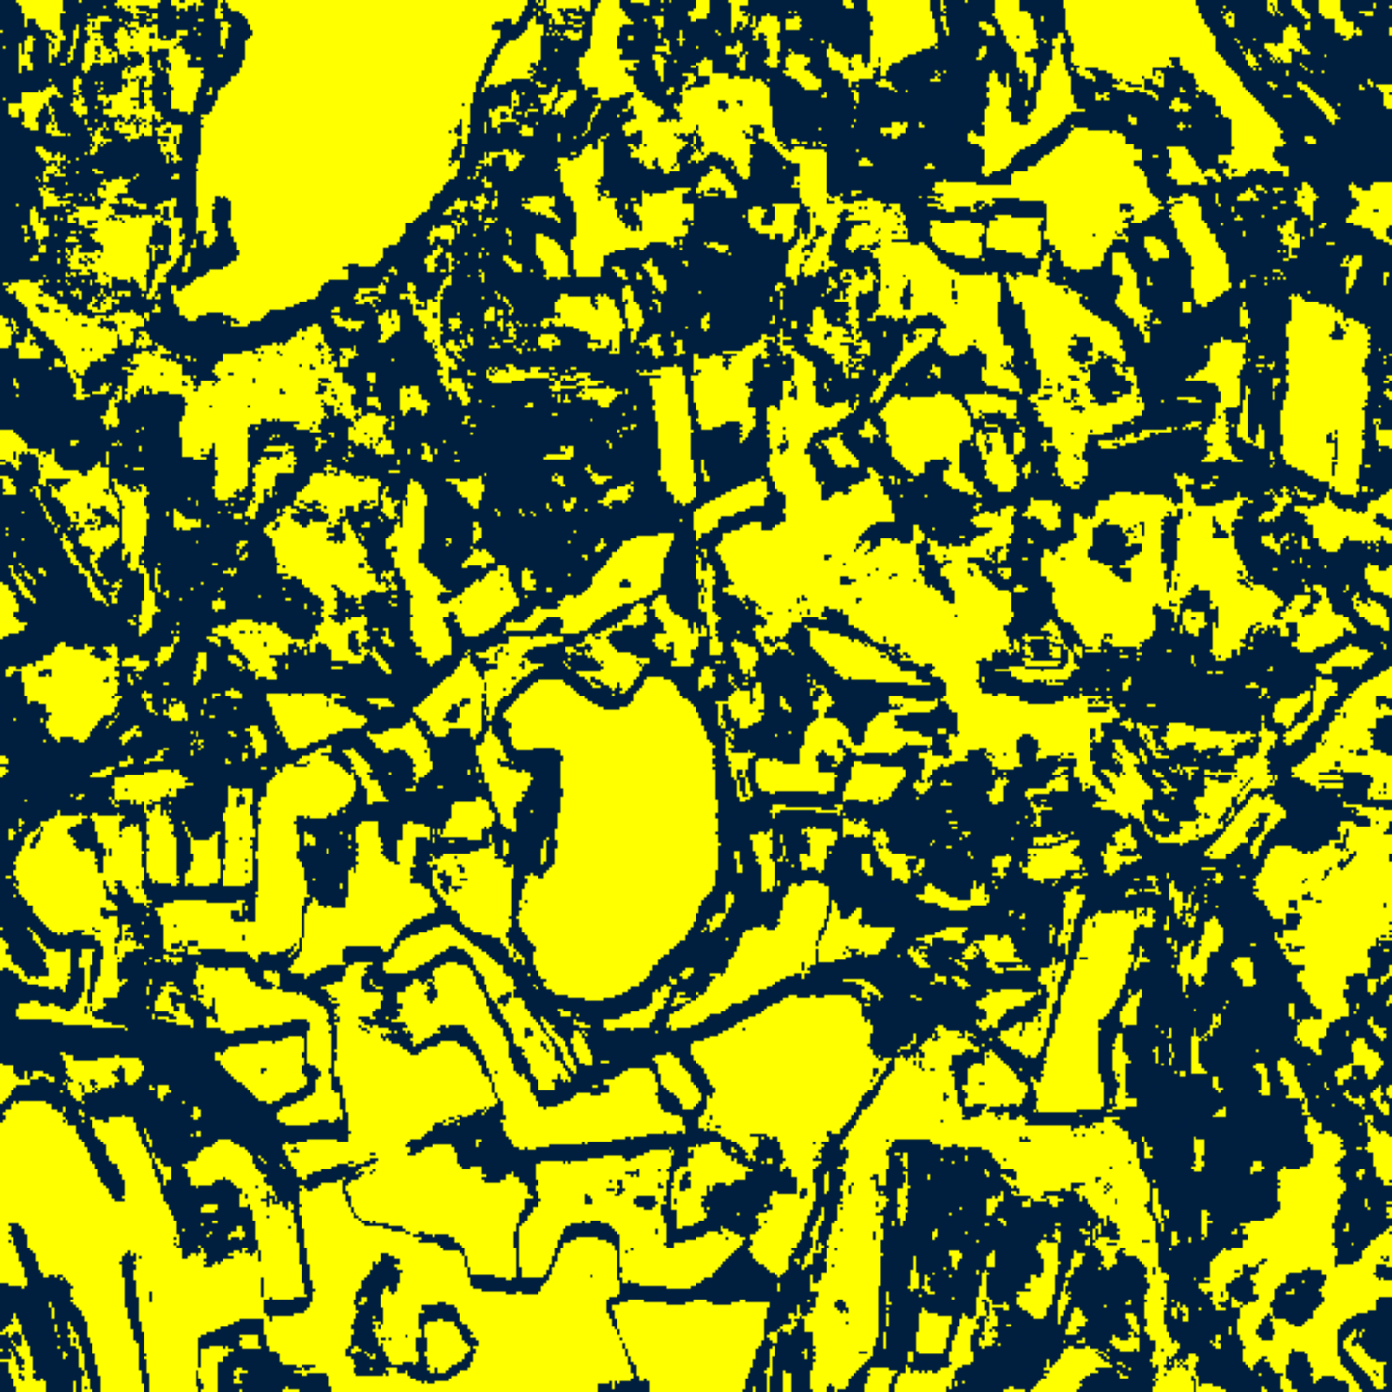  (B) GFNet
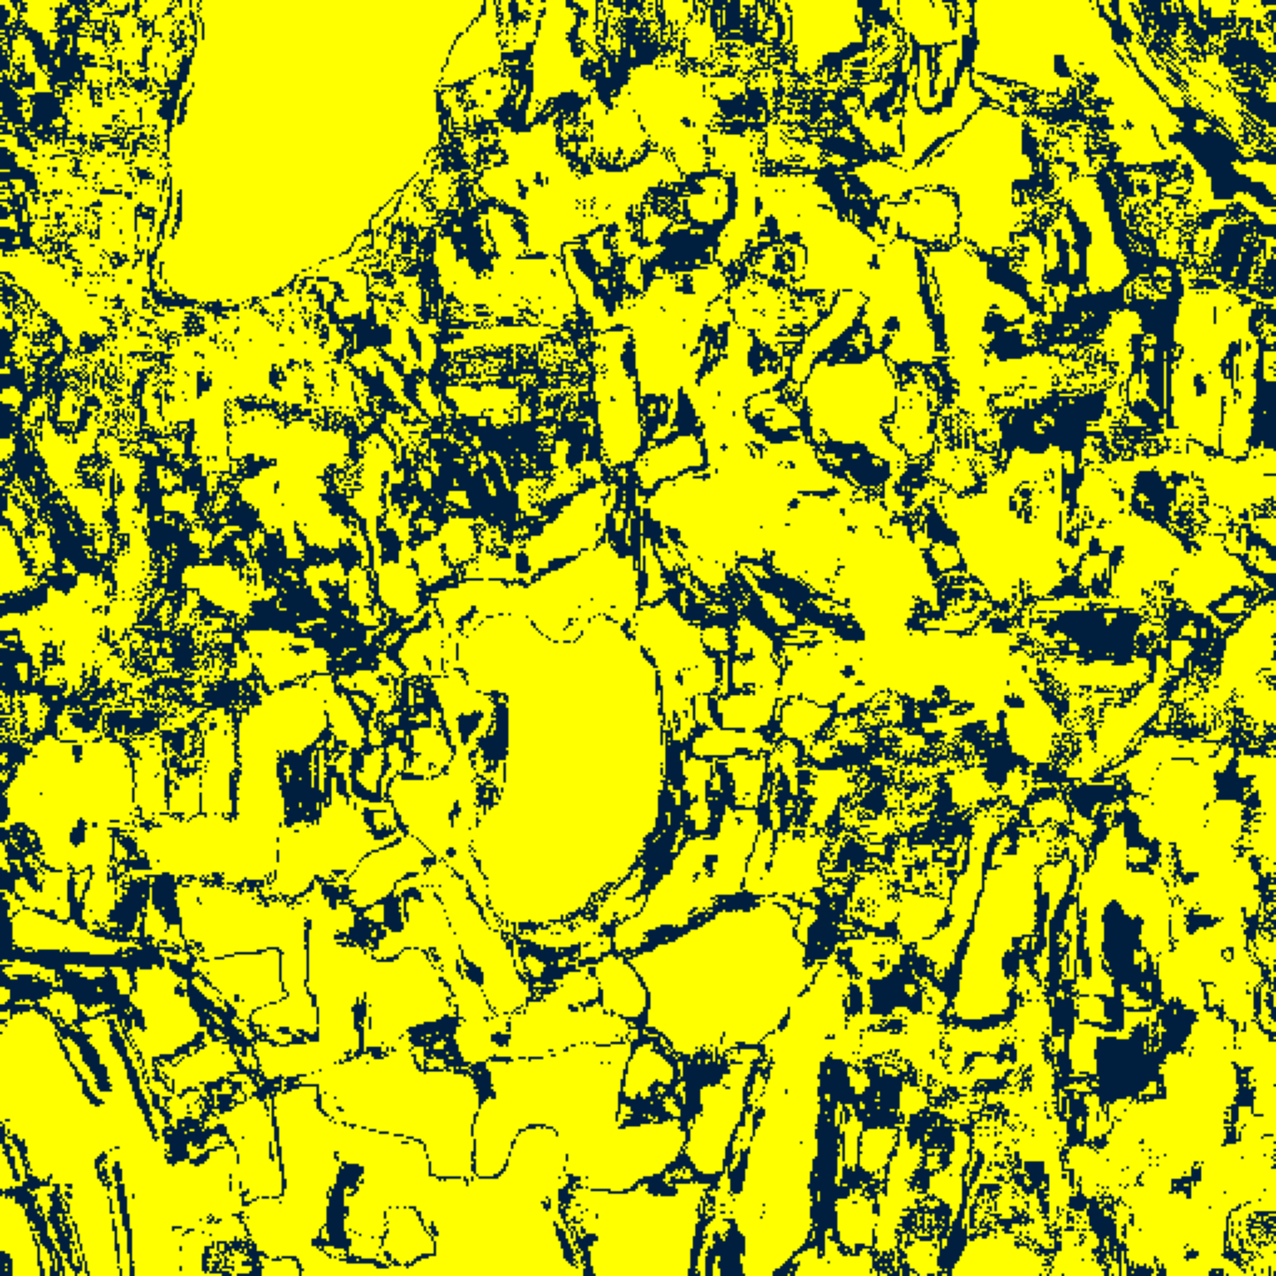  (C) ViT-UNet | 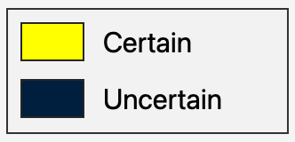  (D) Legend
Fig. 3(a). SplitCP 95% binary uncertainty maps: (A) AlexNet, (B) GFNet, (C) ViT-UNet. Yellow = certain singleton; dark navy = uncertain. Shared Certain/Uncertain legend shown in (D).
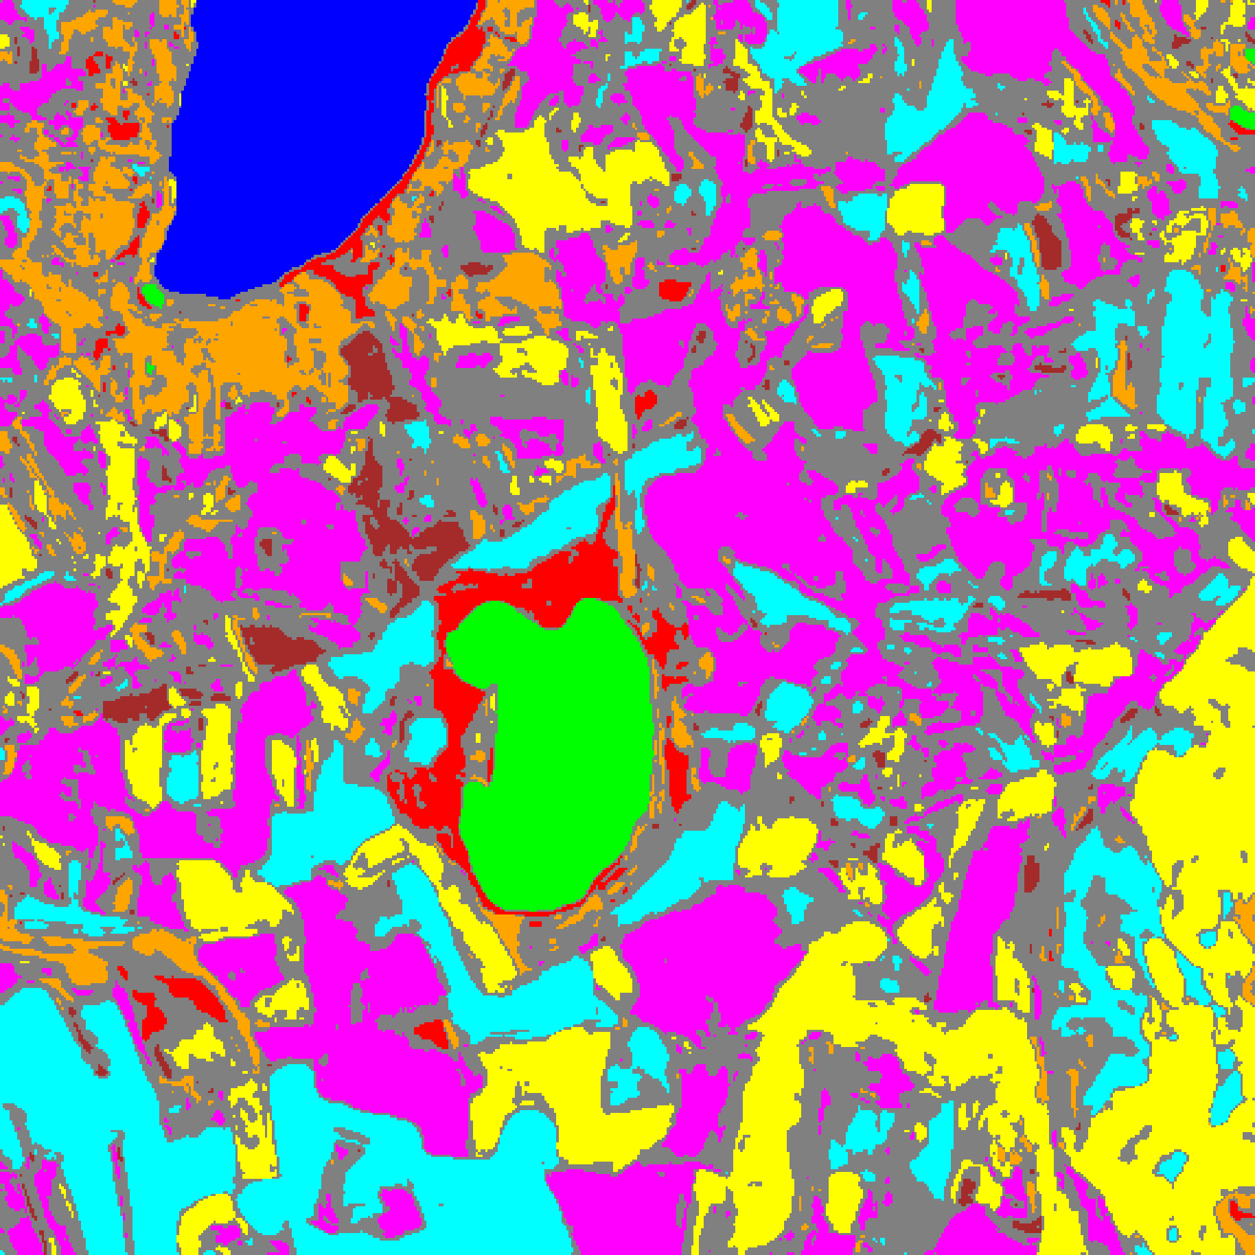  (A) AlexNet | 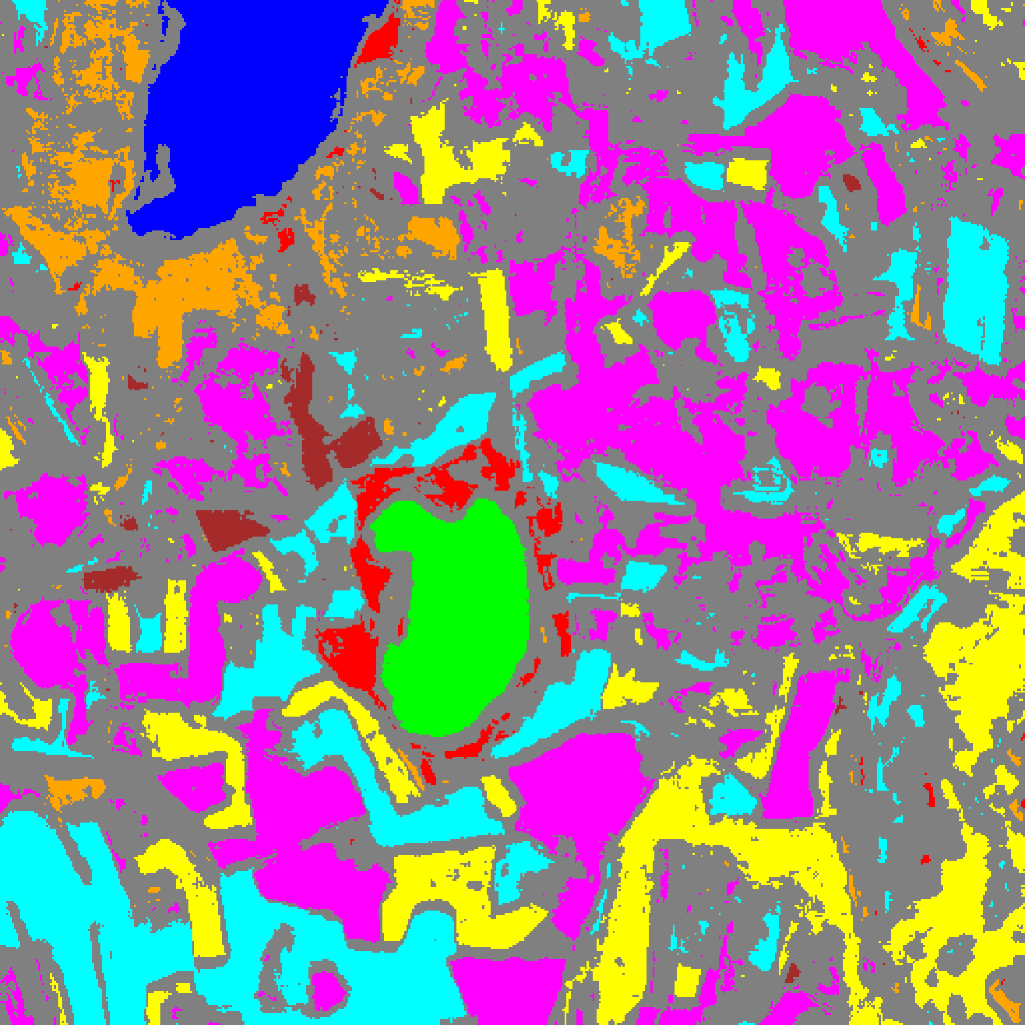  (B) GFNet
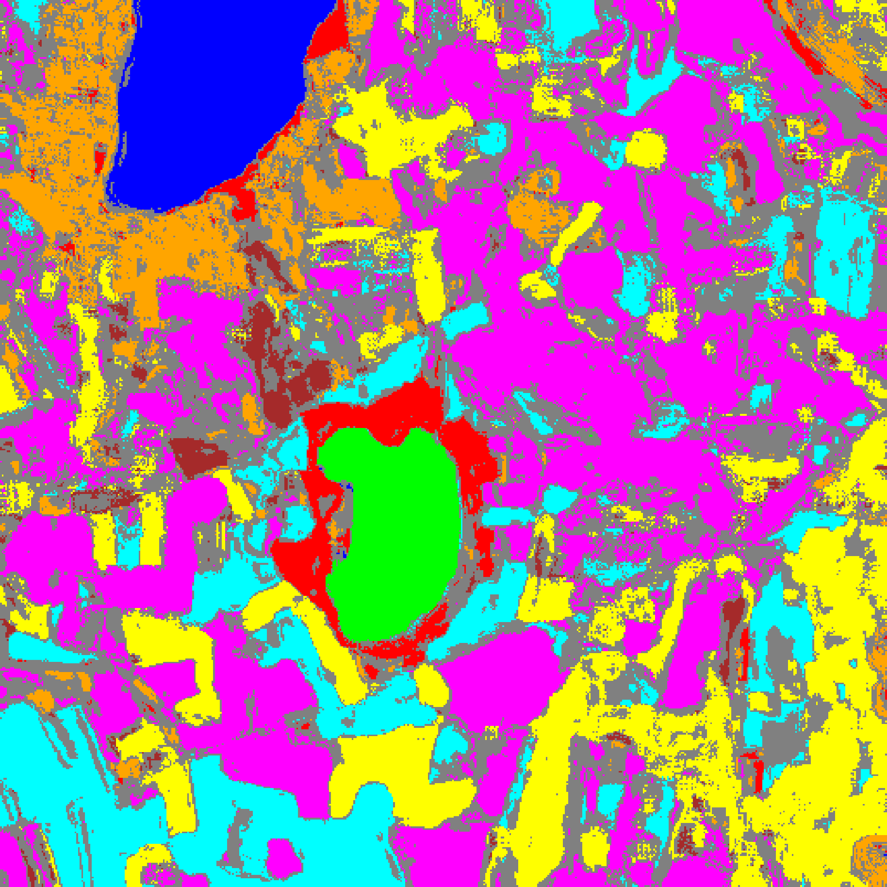
(C) ViT-UNet
Fig. 3(b). SplitCP 95% uncertainty masks: (A) AlexNet, (B) GFNet, (C) ViT-UNet. Colours = predicted class (see shared class legend, Fig. 2(d)); grey pixels = uncertain (prediction set empty).
Comparing Fig. 3(a) and Fig. 3(b) with the ground truth label map in Fig. 1(b) reveals a clear spatial dichotomy between annotated parcels and unlabelled background. Within the labelled ground-truth parcels (20.56% of the scene), interiors are predominantly certain (yellow) with only 5.0%–5.5% of pixels flagged as uncertain along parcel boundaries where adjacent spectral signatures mix within the 9 × 9 window. Across the unlabelled background (79.44% of the scene), out-of-distribution spectral mixtures trigger widespread empty prediction sets (34.4% of background pixels for ViT-UNet, 42.1% for AlexNet, and 62.1% for GFNet), accounting for the large contiguous uncertain zones spanning 30.05%–50.71% of the full scene.
E. Class-Conditional Conformal Prediction (CcCP) Results
Class-Conditional Conformal Prediction (CcCP) computes a separate conformal threshold q̂_c for each class c, using only calibration samples belonging to that class. This stratified calibration approach addresses the per-class coverage shortfall observed under SplitCP’s global threshold, particularly for minority classes. TABLE V presents the aggregate CcCP summary across all three models, TABLE VI the per-class coverage comparison, TABLE VII the class-wise q̂_c thresholds, and TABLE VIII the full-scene pixel-count distribution. Fig. 4(a) and Fig. 4(b) present the spatialised uncertainty maps.
TABLE V
CLASS-CONDITIONAL CP (CCCP): AGGREGATE SUMMARY (Α = 0.05)
Model | Emp. Cov. | Avg Set Size | Singleton Rate | Empty Set Rate | Runtime (s) | Mean Cls Cov.
AlexNet | 0.9547 | 0.9547 | 0.9547 | 0.0453 | 2.292 | 0.9630
GFNet | 0.9518 | 0.9518 | 0.9518 | 0.0482 | 2.339 | 0.9482
ViT-UNet | 0.9497 | 0.9497 | 0.9497 | 0.0503 | 2.224 | 0.9490

TABLE VI
CCCP: PER-CLASS COVERAGE COMPARISON ACROSS MODELS
Class | AlexNet Coverage | GFNet Coverage | ViT-UNet Coverage
Class 0 | 0.9482 | 0.9449 | 0.9605
Class 1 | 0.9986 | 0.9588 | 0.9801
Class 2 | 0.9753 | 0.9647 | 0.9329
Class 3 | 0.9443 | 0.9443 | 0.9341
Class 4 | 0.9453 | 0.9535 | 0.9421
Class 5 | 0.9481 | 0.9717 | 0.9556
Class 6 | 0.9850 | 0.9200 | 0.9400
Class 7 | 0.9594 | 0.9281 | 0.9469

TABLE VII
CCCP: CLASS-WISE CONFORMAL THRESHOLDS (Q̂_C) PER MODEL
Class | AlexNet q̂_c | GFNet q̂_c | ViT-UNet q̂_c
Class 0 | 0.000000 | 0.009739 | 0.039829
Class 1 | 0.000000 | 0.006875 | 0.039300
Class 2 | 0.001147 | 0.012835 | 0.041407
Class 3 | 0.000049 | 0.008872 | 0.041369
Class 4 | 0.000051 | 0.008571 | 0.040797
Class 5 | 0.000580 | 0.010103 | 0.041373
Class 6 | 0.030193 | 0.008793 | 0.044951
Class 7 | 0.000973 | 0.009263 | 0.045597

TABLE VIII
CCCP: FULL-SCENE PREDICTED PIXEL COUNT DISTRIBUTION PER MODEL
Class / Region | AlexNet Pixels | GFNet Pixels | ViT-UNet Pixels
Class 0 | 10,521 | 9,802 | 10,315
Class 1 | 7,861 | 5,700 | 6,959
Class 2 | 6,113 | 4,460 | 7,095
Class 3 | 29,508 | 25,258 | 30,872
Class 4 | 54,817 | 43,418 | 65,571
Class 5 | 37,918 | 24,456 | 39,915
Class 6 | 9,026 | 2,153 | 4,754
Class 7 | 17,948 | 8,404 | 18,462
Uncertain | 88,432 | 138,493 | 78,201
Total (Scene) | 262,144 | 262,144 | 262,144

CcCP substantially improves mean per-class coverage over SplitCP across all three models, reaching 0.9630 for AlexNet, 0.9482 for GFNet, and 0.9490 for ViT-UNet, while empirical marginal coverage reaches 0.9547 (AlexNet), 0.9518 (GFNet), and 0.9497 (ViT-UNet, 0.0003 below the 0.9500 target) with runtimes of 2.224–2.339 s (TABLE V). In TABLE VI, minority classes that suffered under SplitCP recover strongly: Class 6 rises from 0.7700 to 0.9850 on AlexNet and from 0.7650 to 0.9400 on ViT-UNet, while Class 2 on GFNet increases from 0.7527 to 0.9647. The class-wise thresholds in TABLE VII show that AlexNet assigns near-zero thresholds to high-confidence classes (0.000000 for Class 0 and Class 1) but relaxes Class 6 to q̂_6 = 0.030193, whereas GFNet (0.006875–0.012835) and ViT-UNet (0.039300–0.045597) exhibit more uniform threshold ranges. Across the full 262,144-pixel scene (TABLE VIII), ViT-UNet again yields the fewest uncertain pixels (78,201, or 29.83%), followed by AlexNet (88,432, or 33.73%) and GFNet (138,493, or 52.83%).
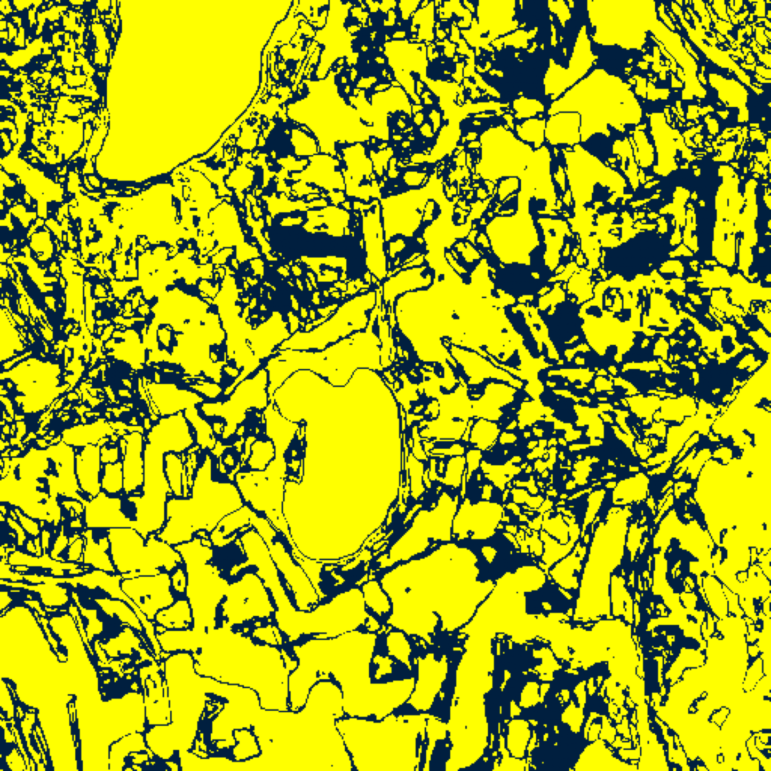  (A) AlexNet | 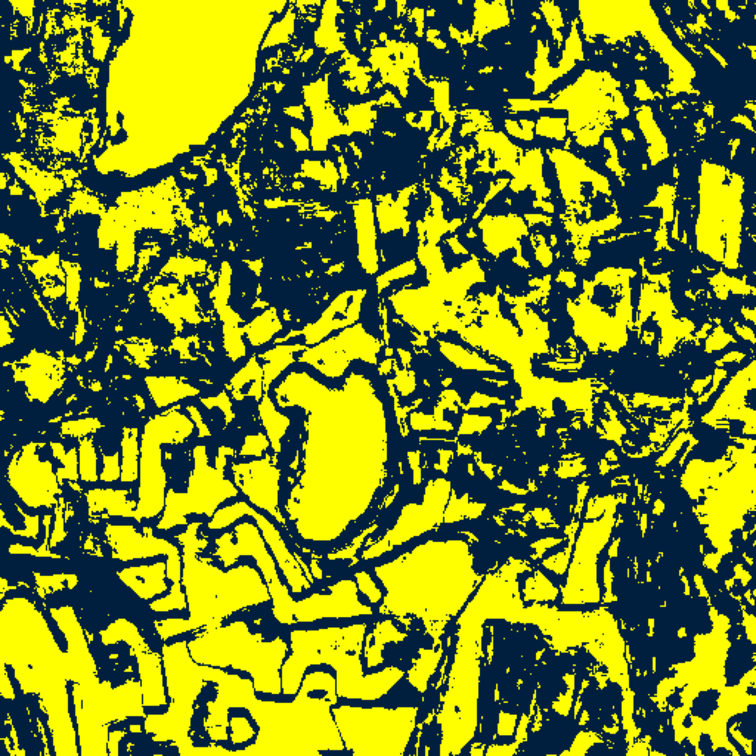  (B) GFNet
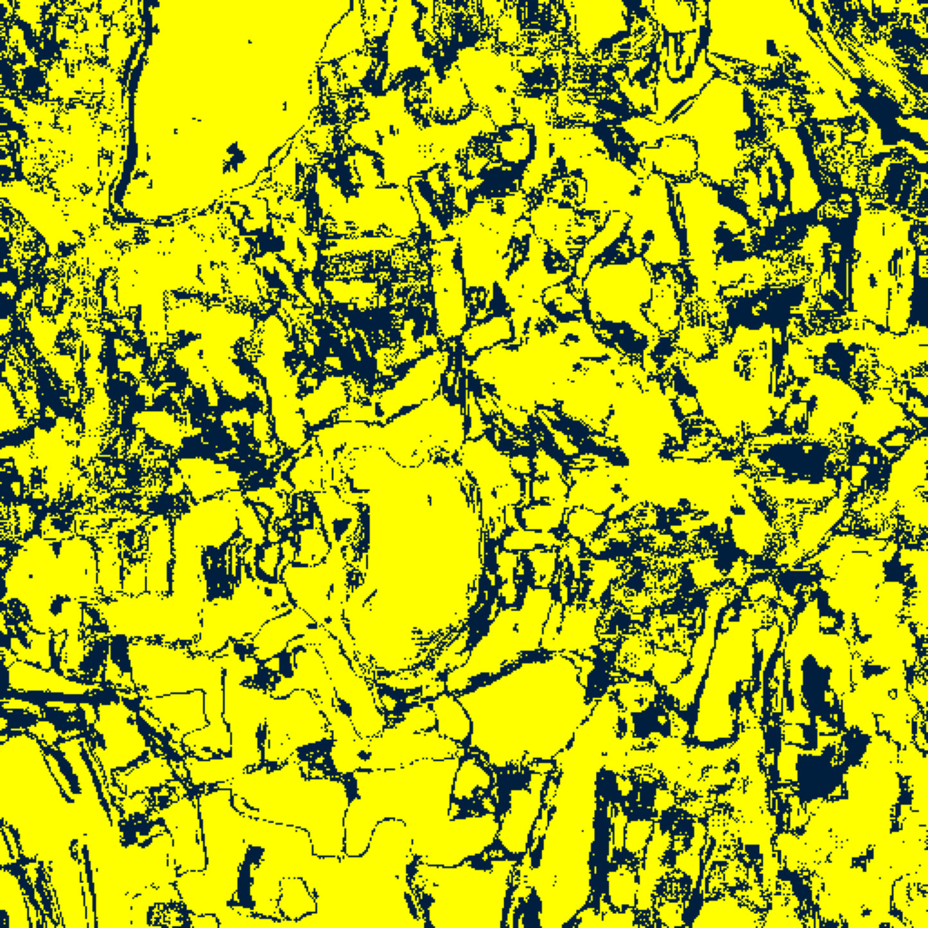
(C) ViT-UNet
Fig. 4(a). CcCP 95% binary uncertainty maps: (A) AlexNet, (B) GFNet, (C) ViT-UNet. Yellow = certain singleton; dark navy = uncertain. See shared legend, Fig. 3(a).
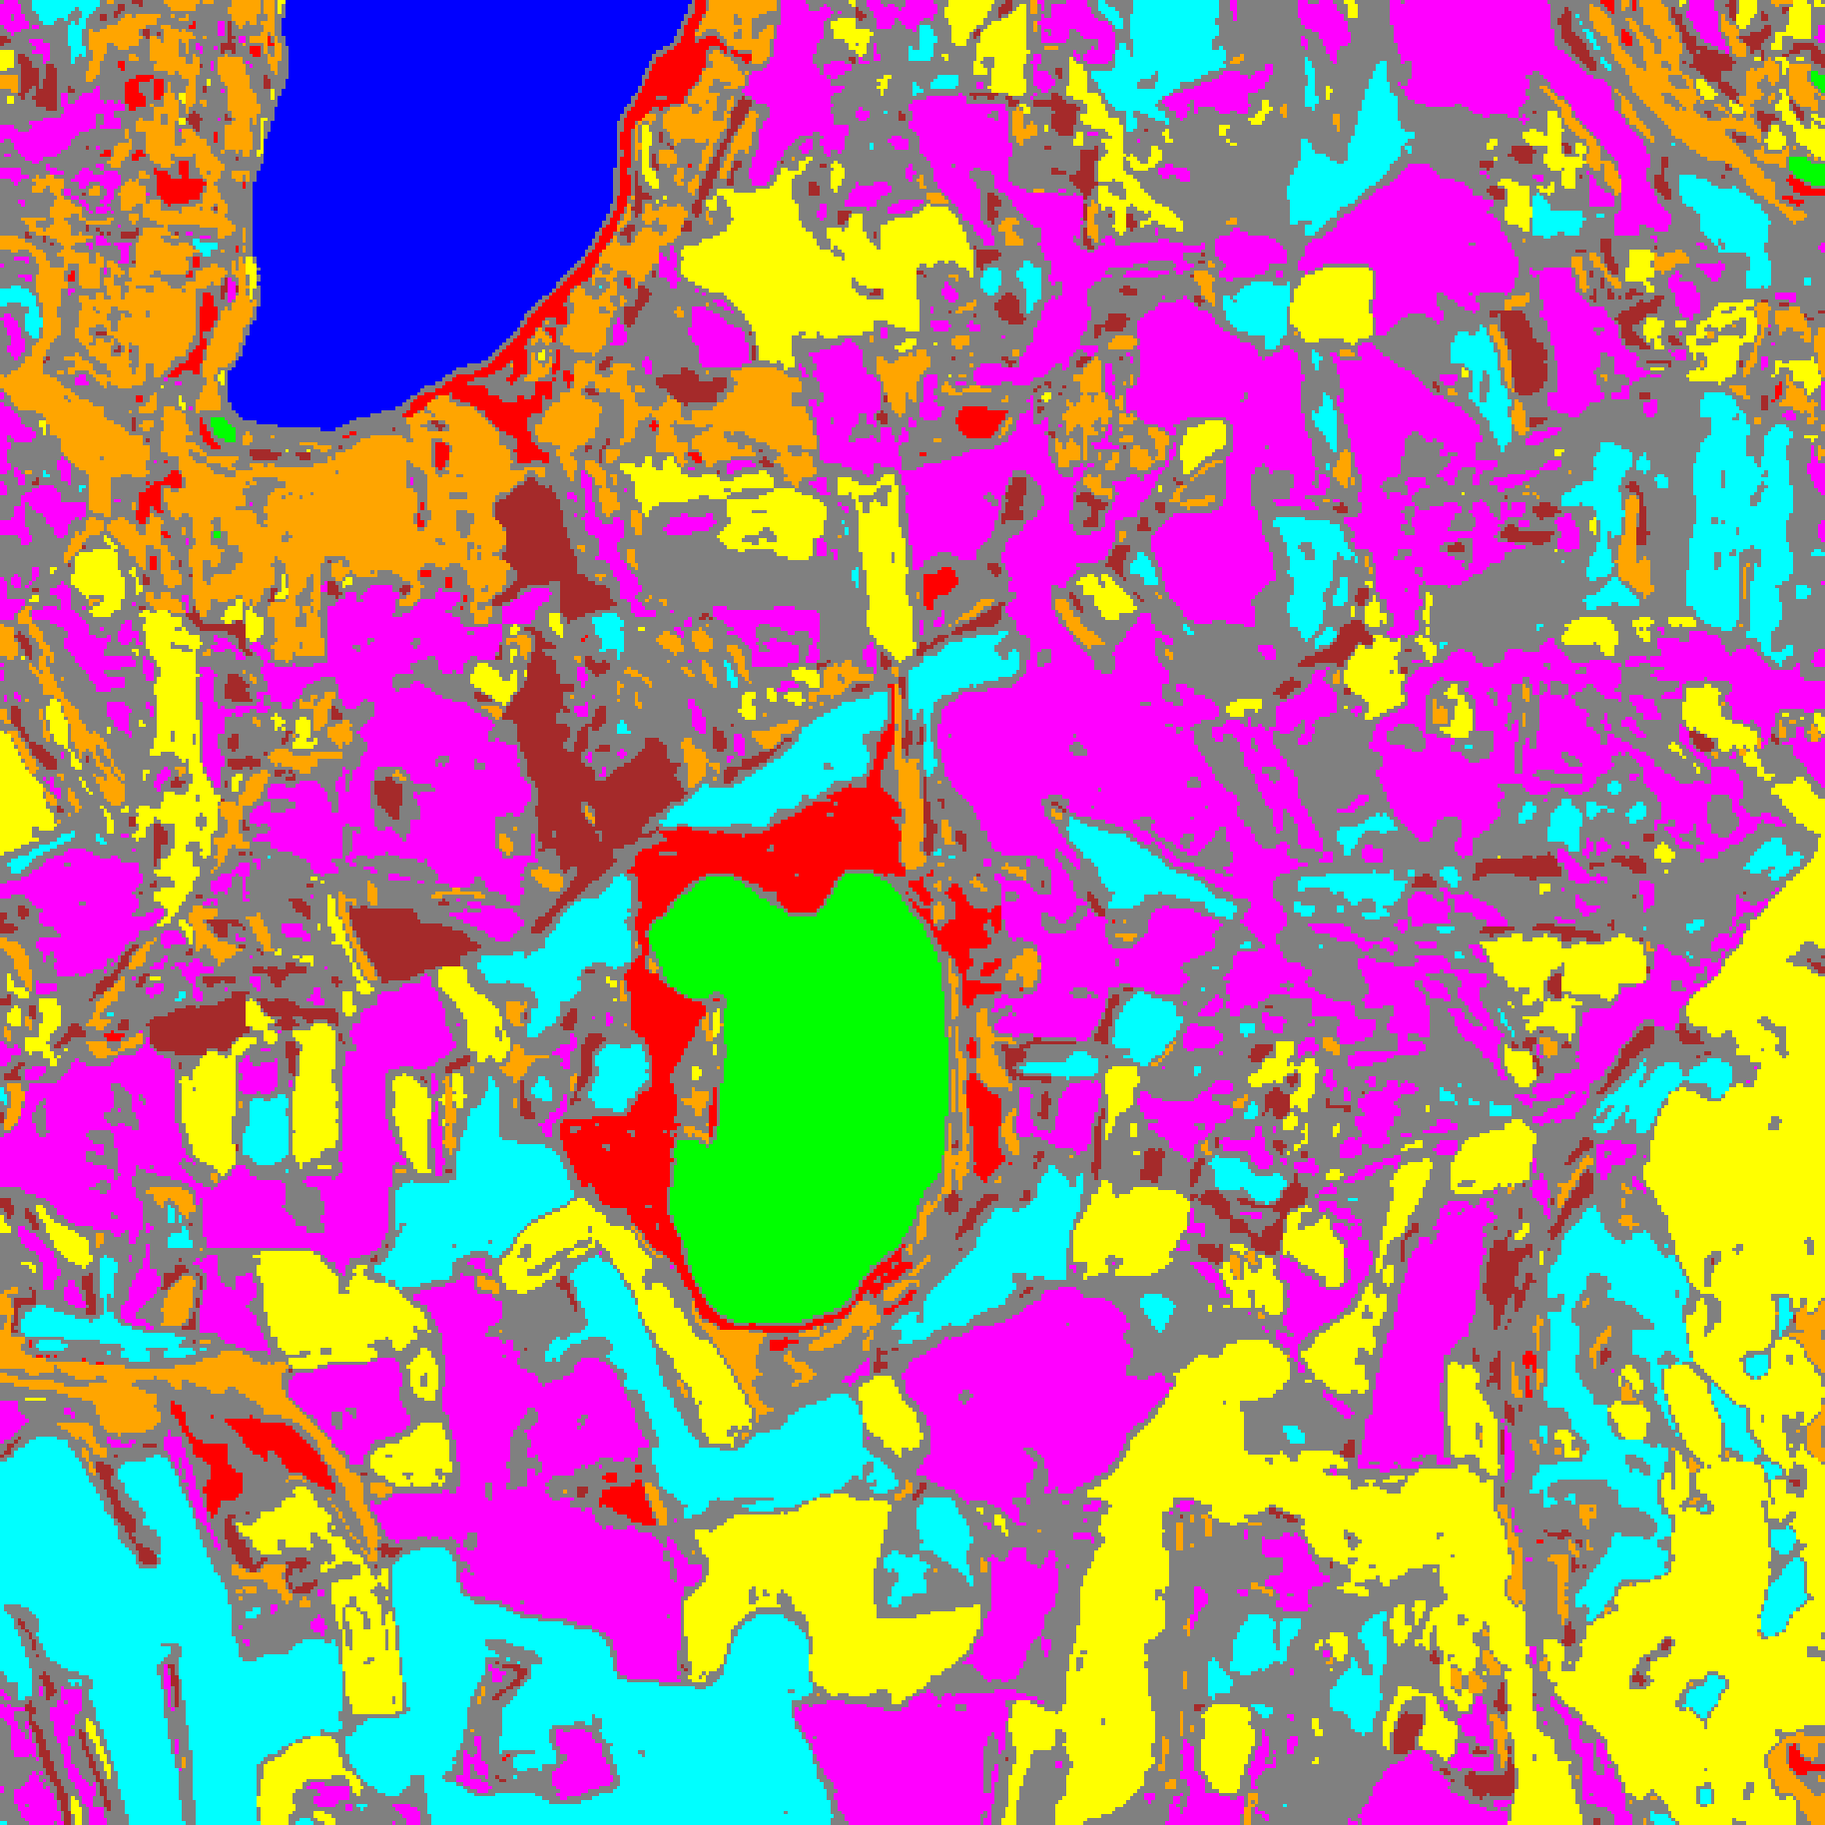  (A) AlexNet | 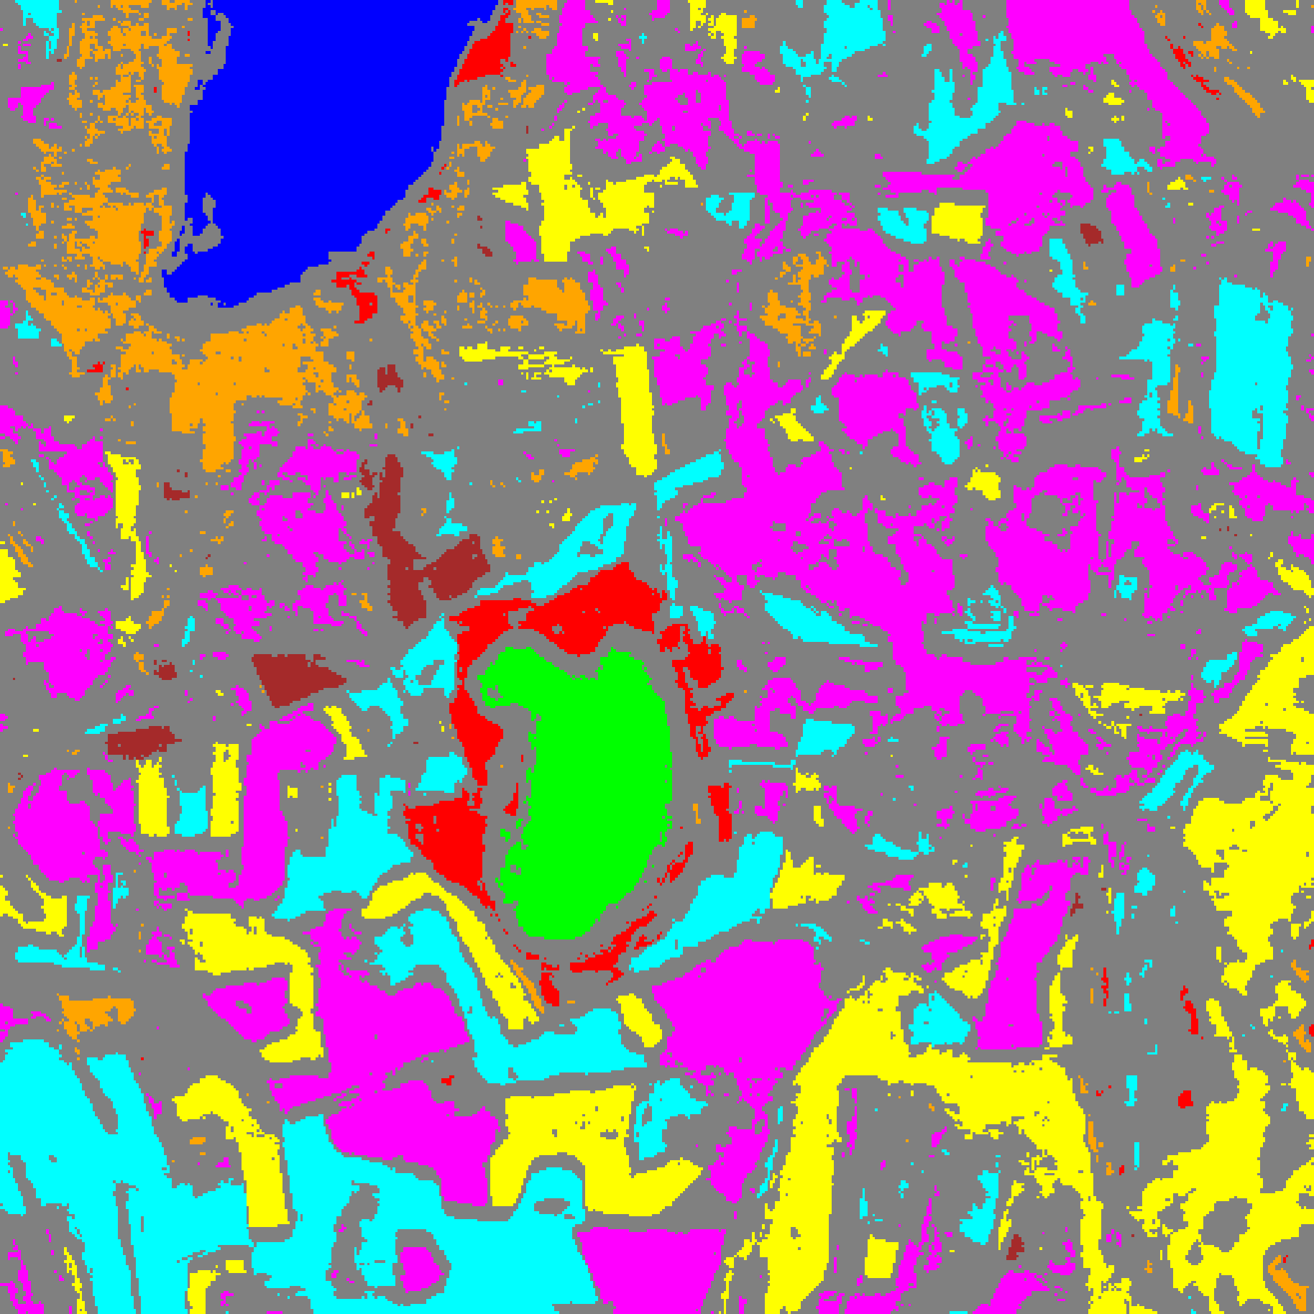  (B) GFNet
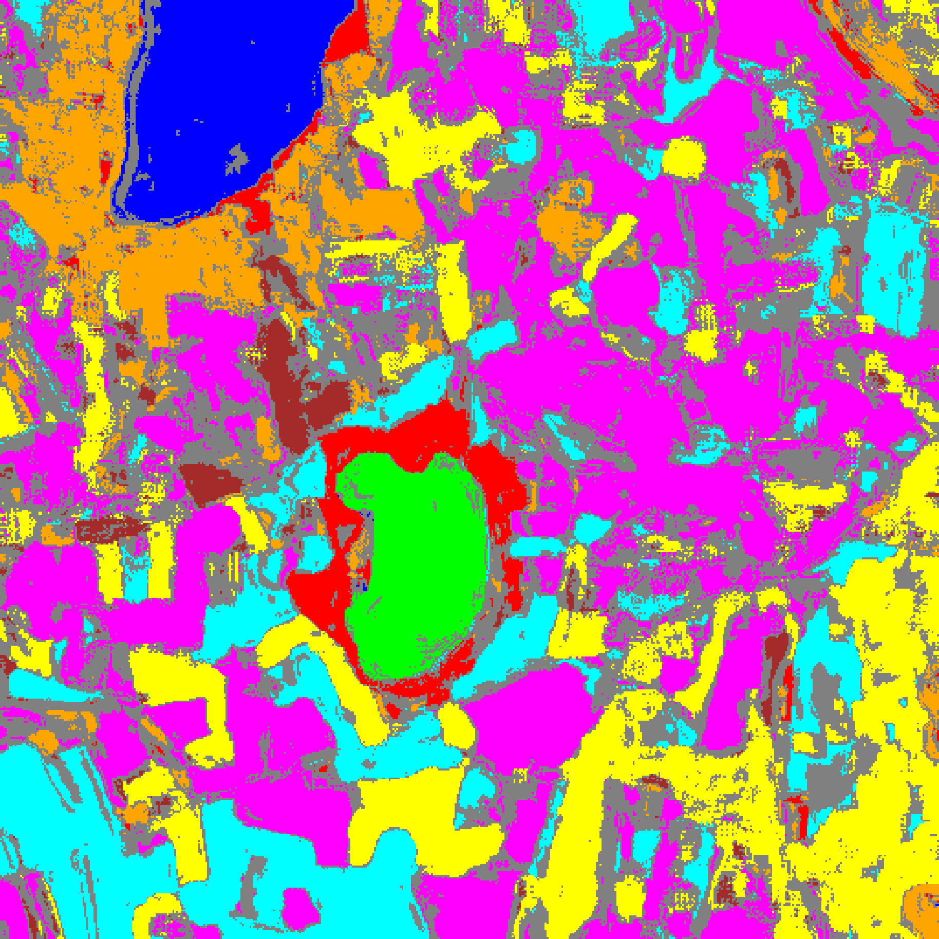
(C) ViT-UNet
Fig. 4(b). CcCP 95% uncertainty masks: (A) AlexNet, (B) GFNet, (C) ViT-UNet. Colours = predicted class (see shared class legend, Fig. 2(d)); grey pixels = uncertain.
The CcCP maps in Fig. 4(a) and Fig. 4(b) reflect the class-stratified recalibration: AlexNet retains substantially more confident Class 6 (brown, 9,026 vs 3,923 pixels) and Class 7 (orange, 17,948 vs 14,825 pixels) regions than under SplitCP, reducing labelled-parcel uncertainty to 4.3% while continuing to flag 39.9% of unlabelled background pixels as uncertain (compared to 34.2% on ViT-UNet and 64.7% on GFNet).
F. Rank Calibrated Class-Conditional Conformal Prediction (RC3P) Results
RC3P extends CcCP by introducing a per-class rank gate k̂(y) that restricts the prediction set to only the top-k̂(y) most probable classes, in addition to the per-class conformal threshold. TABLE IX presents the aggregate RC3P summary, TABLE X the per-class coverage comparison, TABLE XI the per-class RC3P thresholds and rank limits, and TABLE XII the full-scene pixel-count distribution. The spatialised uncertainty maps are shown in Fig. 5(a) and Fig. 5(b).
TABLE IX
RC3P: AGGREGATE SUMMARY (Α = 0.05)
Model | Emp. Cov. | Avg Set Size | Singleton Rate | Empty Set Rate | Runtime (s) | Mean Cls Cov.
AlexNet | 0.9607 | 0.9607 | 0.9607 | 0.0393 | 2.348 | 0.9673
GFNet | 0.9553 | 0.9553 | 0.9553 | 0.0447 | 2.365 | 0.9540
ViT-UNet | 0.9535 | 0.9535 | 0.9535 | 0.0465 | 2.288 | 0.9538

TABLE X
RC3P: PER-CLASS COVERAGE COMPARISON ACROSS MODELS
Class | AlexNet Coverage | GFNet Coverage | ViT-UNet Coverage
Class 0 | 0.9539 | 0.9465 | 0.9622
Class 1 | 0.9986 | 0.9631 | 0.9801
Class 2 | 0.9753 | 0.9717 | 0.9470
Class 3 | 0.9509 | 0.9458 | 0.9355
Class 4 | 0.9553 | 0.9572 | 0.9478
Class 5 | 0.9547 | 0.9717 | 0.9613
Class 6 | 0.9900 | 0.9200 | 0.9400
Class 7 | 0.9594 | 0.9563 | 0.9563

TABLE XI
RC3P: PER-CLASS CONFORMAL THRESHOLDS (Q̂_C) AND RANK LIMITS (K̂)
Class | AlexNet q̂ | AlexNet k̂ | GFNet q̂ | GFNet k̂ | ViT-UNet q̂ | ViT-UNet k̂
Class 0 | 0.000000 | 1 | 0.009742 | 1 | 0.039833 | 1
Class 1 | 0.000000 | 1 | 0.006908 | 1 | 0.039305 | 1
Class 2 | 0.001161 | 1 | 0.013649 | 1 | 0.041549 | 1
Class 3 | 0.000064 | 1 | 0.008920 | 1 | 0.041406 | 1
Class 4 | 0.000072 | 1 | 0.008637 | 1 | 0.040907 | 1
Class 5 | 0.000645 | 1 | 0.010165 | 1 | 0.041447 | 1
Class 6 | 0.050550 | 1 | 0.009207 | 1 | 0.044983 | 1
Class 7 | 0.001031 | 1 | 0.011244 | 1 | 0.048430 | 1

TABLE XII
RC3P: FULL-SCENE PREDICTED PIXEL COUNT DISTRIBUTION PER MODEL
Class / Region | AlexNet Pixels | GFNet Pixels | ViT-UNet Pixels
Class 0 | 10,521 | 9,812 | 10,338
Class 1 | 7,861 | 5,734 | 6,967
Class 2 | 6,118 | 4,608 | 7,118
Class 3 | 30,124 | 25,424 | 30,942
Class 4 | 55,988 | 43,838 | 66,312
Class 5 | 38,136 | 24,554 | 40,009
Class 6 | 9,694 | 2,194 | 4,759
Class 7 | 18,049 | 9,264 | 18,976
Uncertain | 85,653 | 136,716 | 76,723
Total (Scene) | 262,144 | 262,144 | 262,144

RC3P is the only threshold-based method under which all three architectures exceed both the 0.9500 marginal coverage target and 0.9500 mean per-class coverage (TABLE IX), achieving empirical coverage of 0.9607 (AlexNet), 0.9553 (GFNet), and 0.9535 (ViT-UNet) and mean per-class coverage of 0.9673 (AlexNet), 0.9540 (GFNet), and 0.9538 (ViT-UNet) with runtimes of 2.288–2.365 s. In TABLE X, every class on AlexNet achieves at least 0.9509 coverage (reaching 0.9900 on Class 6 and 0.9986 on Class 1). As shown in TABLE XI, the calibrated rank limit is k̂ = 1 for every class and every model, confirming that top-1 singleton sets suffice across all eight classes. In TABLE XII, RC3P yields the lowest full-scene uncertain pixel counts among the spatialised methods for both ViT-UNet (76,723, or 29.27% of the 262,144 scene pixels) and AlexNet (85,653, or 32.67%), while GFNet flags 136,716 uncertain pixels (52.15%).
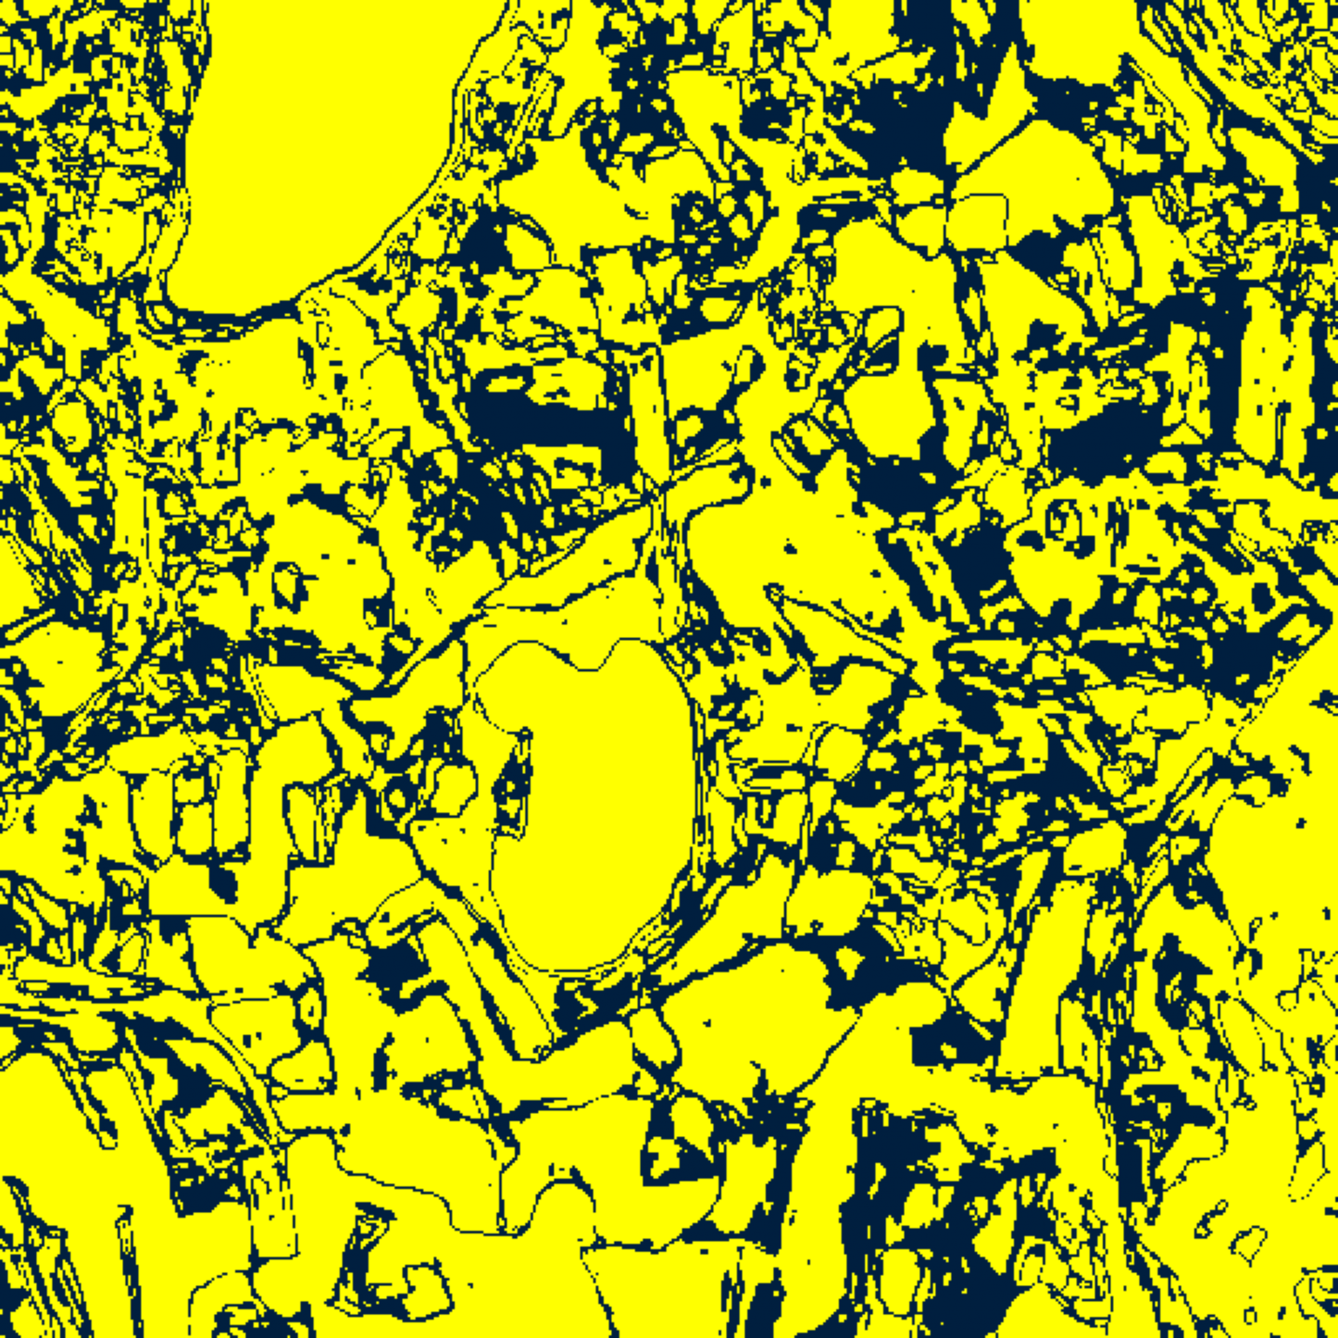  (A) AlexNet | 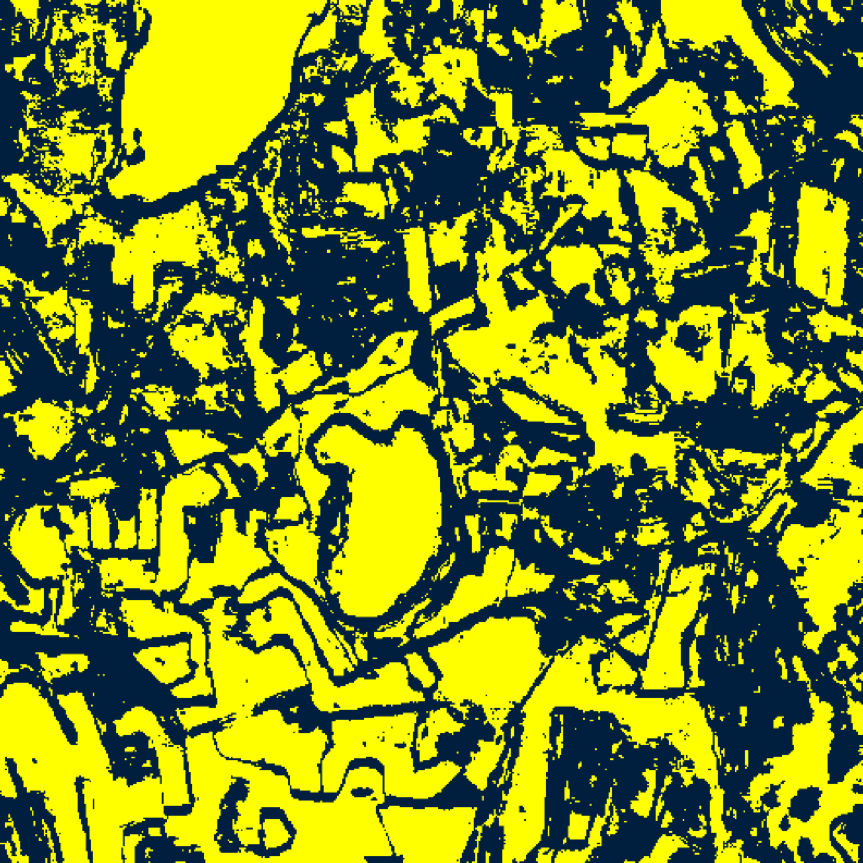  (B) GFNet
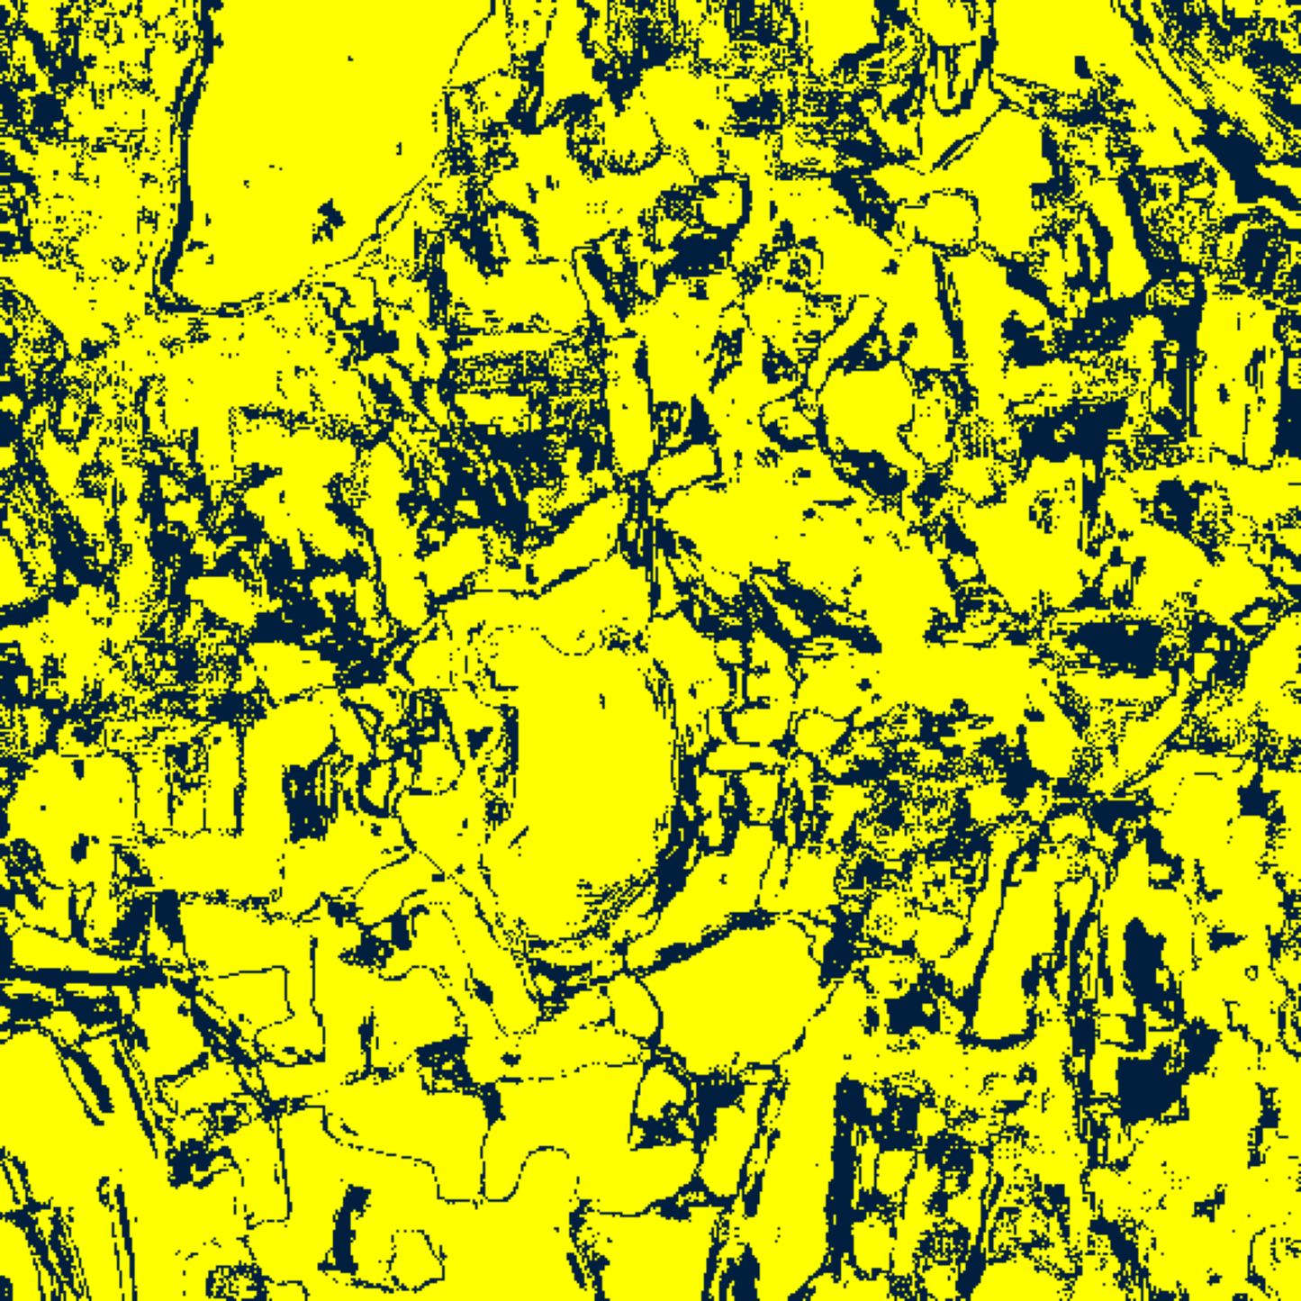
(C) ViT-UNet
Fig. 5(a). RC3P 95% binary uncertainty maps: (A) AlexNet, (B) GFNet, (C) ViT-UNet. Yellow = certain singleton; dark navy = uncertain. See shared legend, Fig. 3(a).
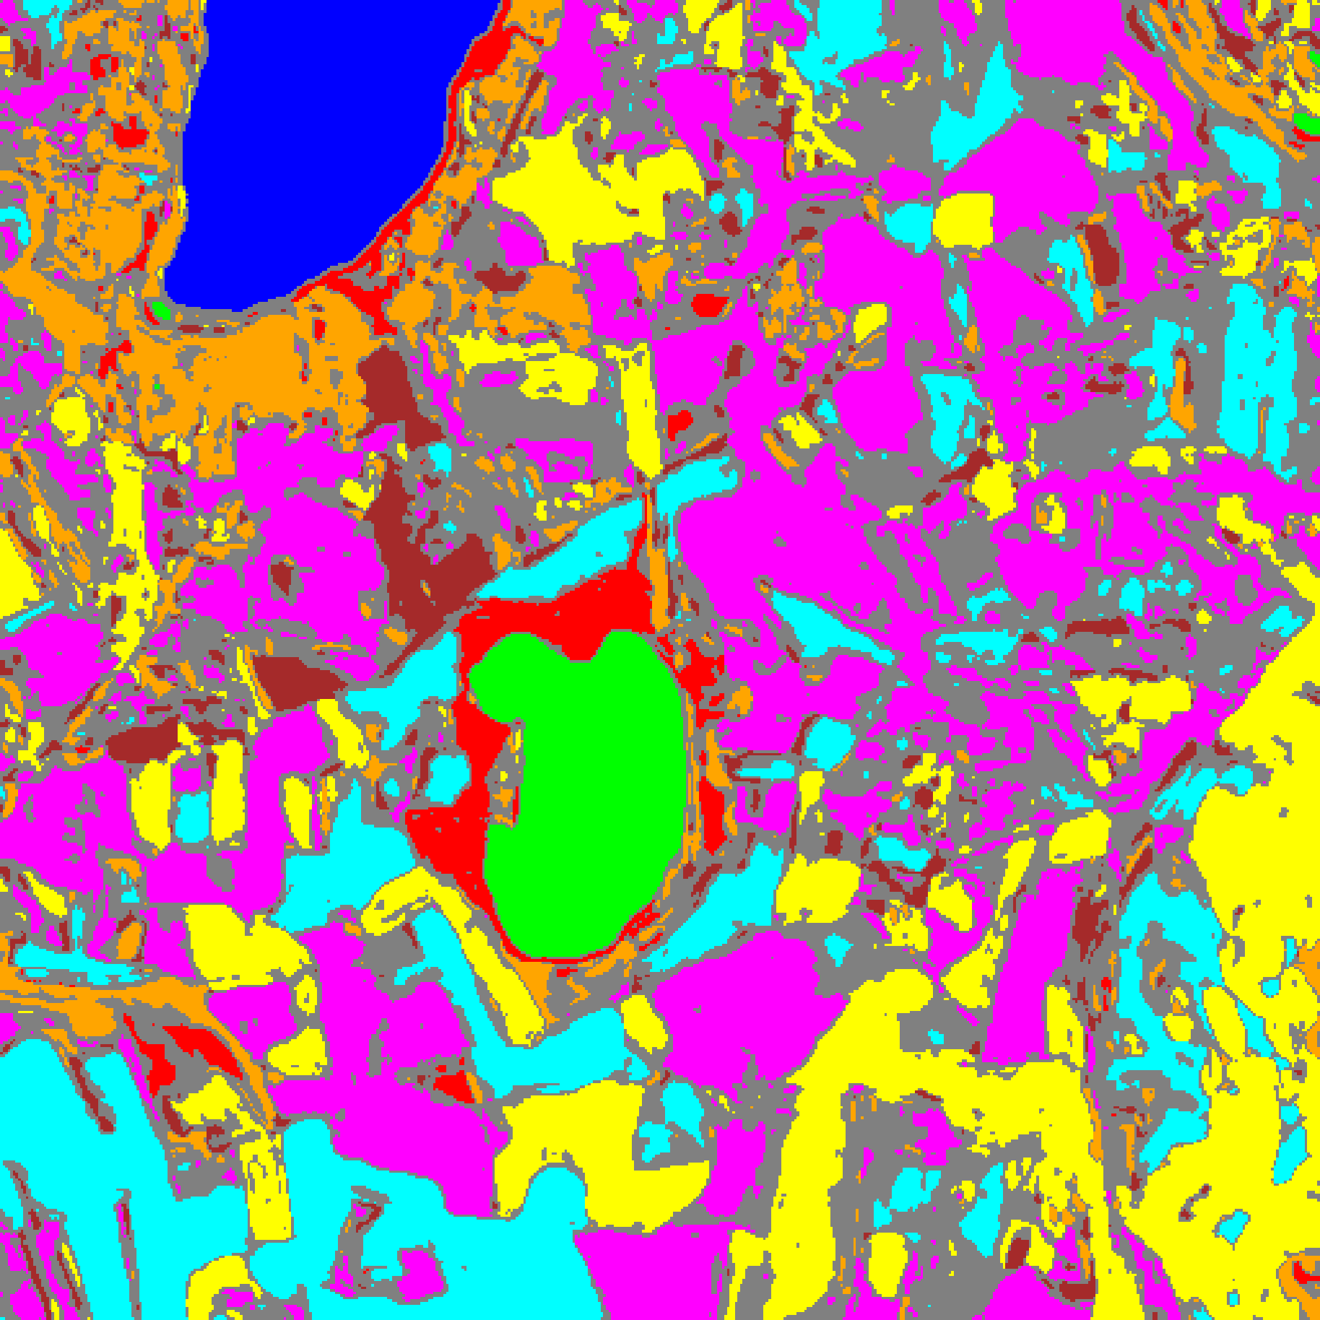  (A) AlexNet | 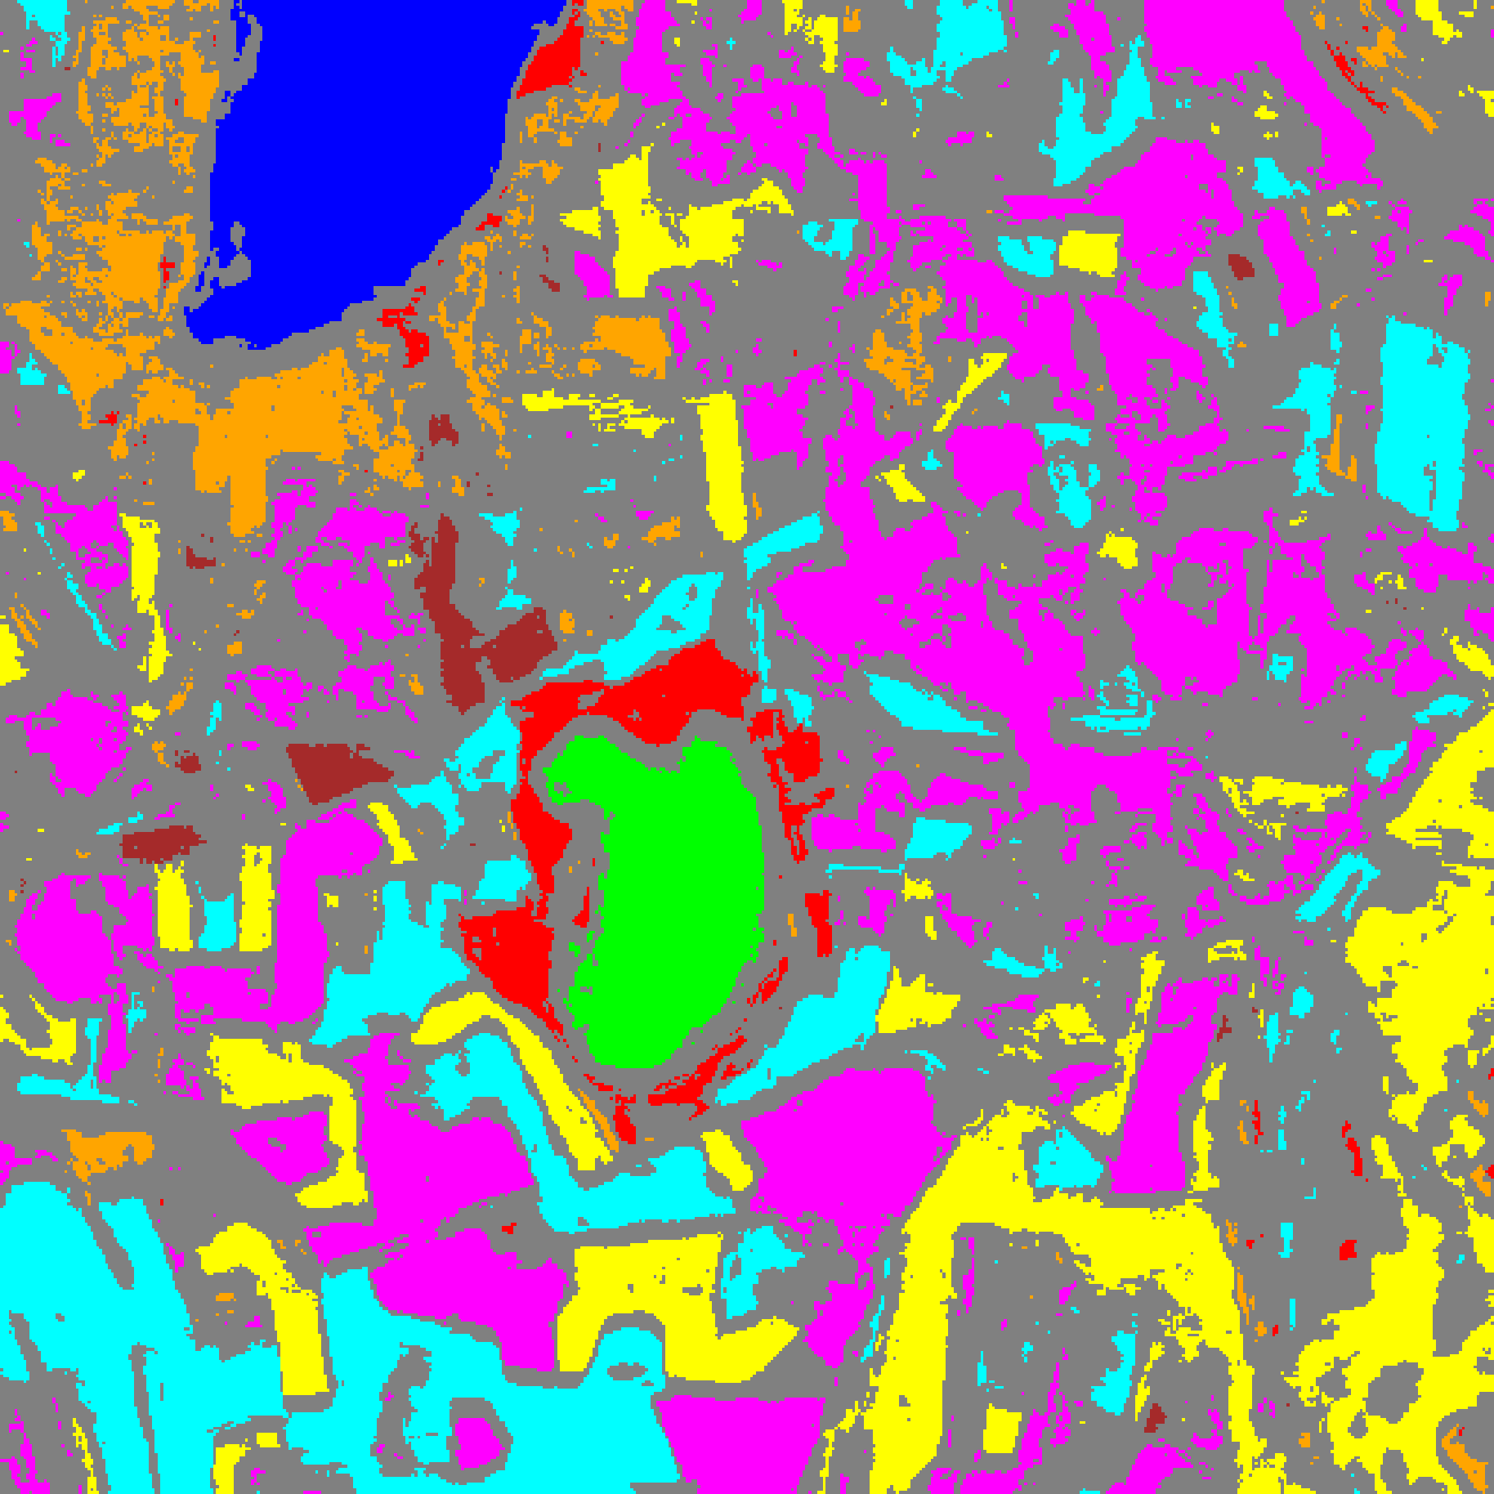  (B) GFNet
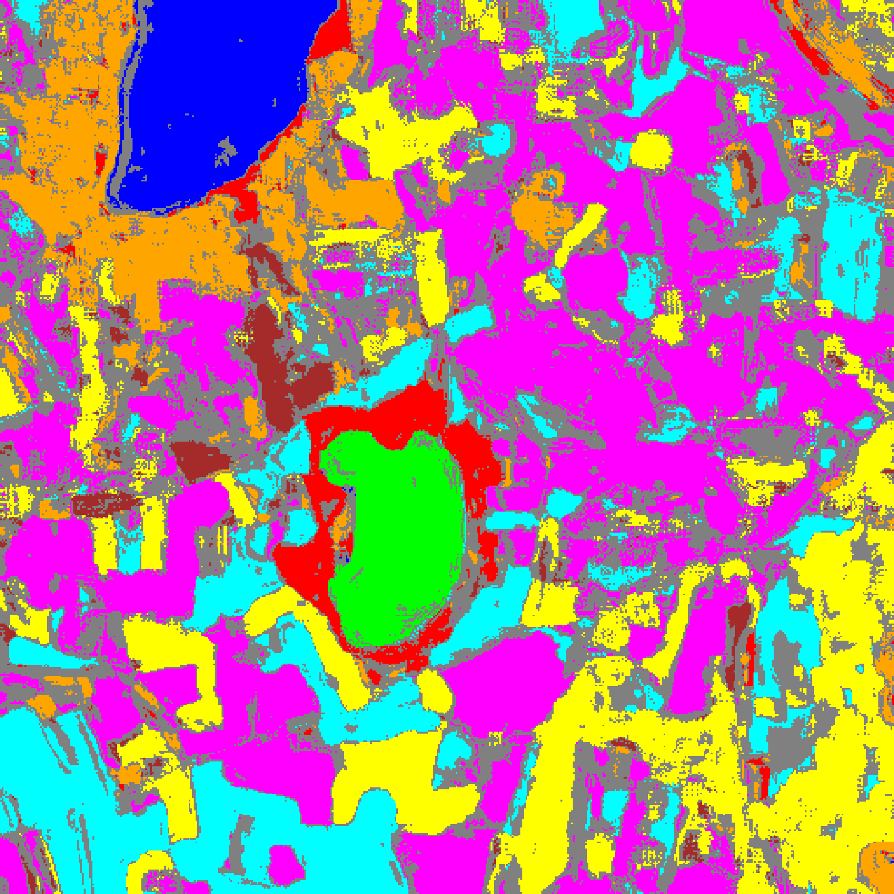
(C) ViT-UNet
Fig. 5(b). RC3P 95% uncertainty masks: (A) AlexNet, (B) GFNet, (C) ViT-UNet. Colours = predicted class (see shared class legend, Fig. 2(d)); grey pixels = uncertain.
The RC3P maps in Fig. 5(a) and Fig. 5(b) preserve the spatial structure of CcCP while further reducing uncertain pixels across labelled parcel interiors (to 3.9%–4.7% of labelled pixels), with unlabelled background regions continuing to account for the vast majority of uncertain pixels across the 512 × 512 scene (33.6% of background pixels for ViT-UNet, 38.6% for AlexNet, and 63.9% for GFNet).
G. Clustered Conformal Prediction (ClCP) Results
Clustered Conformal Prediction (ClCP) groups the K = 8 classes into K_g = 4 clusters based on calibration score similarity via K-Means, then calibrates one conformal threshold per cluster. TABLE XIII presents the aggregate summary, TABLE XIV the per-class coverage, TABLE XV the cluster assignments and per-cluster thresholds, and TABLE XVI the per-cluster empirical coverage (exported in the workbook as “Cluster Mean Uncertainty”).
TABLE XIII
CLUSTERED CP (CLCP): AGGREGATE SUMMARY (Α = 0.05, K_G = 4)
Model | Emp. Cov. | Avg Set Size | Singleton Rate | Empty Set Rate | Runtime (s) | Mean Cls Cov.
AlexNet | 0.9573 | 0.9573 | 0.9573 | 0.0427 | 3.059 | 0.9383
GFNet | 0.9525 | 0.9525 | 0.9525 | 0.0475 | 5.475 | 0.9385
ViT-UNet | 0.9455 | 0.9455 | 0.9455 | 0.0545 | 10.674 | 0.9471

TABLE XIV
CLCP: PER-CLASS COVERAGE COMPARISON ACROSS MODELS
Class | AlexNet Coverage | GFNet Coverage | ViT-UNet Coverage
Class 0 | 0.9482 | 0.9827 | 0.9975
Class 1 | 0.9986 | 0.9972 | 1.0000
Class 2 | 0.9364 | 0.8127 | 0.9329
Class 3 | 0.9692 | 0.9194 | 0.8974
Class 4 | 0.9717 | 0.9572 | 0.9440
Class 5 | 0.9481 | 0.9707 | 0.9178
Class 6 | 0.8250 | 0.9400 | 0.9400
Class 7 | 0.9094 | 0.9281 | 0.9469

TABLE XV
CLCP: CLASS-TO-CLUSTER ASSIGNMENTS AND PER-CLUSTER THRESHOLDS (Q̂)
Class | AlexNet Cluster | AlexNet q̂ | GFNet Cluster | GFNet q̂ | ViT-UNet Cluster | ViT-UNet q̂
Class 0 | Cluster 3 | 0.000000 | Cluster 0 | 0.009955 | Cluster 0 | 0.040824
Class 1 | Cluster 1 | 0.000000 | Cluster 2 | 0.008641 | Cluster 0 | 0.040824
Class 2 | Cluster 0 | 0.000219 | Cluster 0 | 0.009955 | Cluster 3 | 0.041407
Class 3 | Cluster 0 | 0.000219 | Cluster 2 | 0.008641 | Cluster 0 | 0.040824
Class 4 | Cluster 0 | 0.000219 | Cluster 2 | 0.008641 | Cluster 0 | 0.040824
Class 5 | Cluster 2 | 0.000580 | Cluster 1 | 0.010030 | Cluster 0 | 0.040824
Class 6 | Cluster 0 | 0.000219 | Cluster 1 | 0.010030 | Cluster 2 | 0.044951
Class 7 | Cluster 0 | 0.000219 | Cluster 3 | 0.009263 | Cluster 1 | 0.045597

TABLE XVI
CLCP: PER-CLUSTER EMPIRICAL COVERAGE (EXPORTED AS "MEAN UNCERTAINTY") ACROSS MODELS
Cluster | AlexNet Coverage | GFNet Coverage | ViT-UNet Coverage
Cluster 0 | 0.9550 | 0.9506 | 0.9467
Cluster 1 | 0.9986 | 0.9658 | 0.9469
Cluster 2 | 0.9481 | 0.9508 | 0.9400
Cluster 3 | 0.9482 | 0.9281 | 0.9231

ClCP achieves empirical coverage above the 95% target for AlexNet (0.9573) and GFNet (0.9525), whereas ViT-UNet falls below the target at 0.9455 (empty set rate 0.0545) while attaining the highest mean per-class coverage under ClCP (0.9471 vs 0.9385 for GFNet and 0.9383 for AlexNet; TABLE XIII). Because K-Means clustering is executed during calibration, runtime increases to 3.059 s for AlexNet, 5.475 s for GFNet, and 10.674 s for ViT-UNet.
The cluster assignments in TABLE XV and per-class coverages in TABLE XIV highlight the risk of pooling classes with heterogeneous support and confidence: AlexNet pools Classes 2, 3, 4, 6, and 7 into Cluster 0 (q̂ = 0.000219), leaving minority Class 6 at 0.8250 coverage; GFNet merges Class 0 (support 1,216) and Class 2 (support 283) into Cluster 0 (q̂ = 0.009955), reducing Class 2 coverage to 0.8127; and ViT-UNet groups Classes 0, 1, 3, 4, and 5 into Cluster 0 (q̂ = 0.040824), resulting in 0.8974 coverage for Class 3. Verification of the workbook’s “Cluster Mean Uncertainty” block in TABLE XVI confirms that the exported numbers (0.9231–0.9986) represent per-cluster empirical coverage / singleton certainty rates (1 − uncertainty rate), matching the exact per-class coverages on singleton clusters.
H. Regularised Adaptive Prediction Sets (RAPS) Results
Regularised Adaptive Prediction Sets (RAPS) constructs prediction sets by accumulating softmax probability mass in descending rank order, with a regularisation penalty λ = 0.01 applied from rank k_reg = 1 onward to discourage sets larger than singletons. For all three architectures, RAPS produced q̂_RAPS = 0.000000, indicating that top-1 singleton prediction sets on the calibration split already exceed the 95% coverage quantile. TABLE XVII presents the aggregate RAPS summary, TABLE XVIII the per-class coverage comparison, and TABLE XIX the RAPS calibration parameters.
TABLE XVII
RAPS: AGGREGATE SUMMARY (Α = 0.05, Λ = 0.01, K_REG = 1)
Model | Emp. Cov. | Avg Set Size | Singleton Rate | Empty Set Rate | Runtime (s) | Mean Cls Cov.
AlexNet | 1.0000 | 1.0000 | 1.0000 | 0.0000 | 0.498 | 1.0000
GFNet | 0.9999 | 1.0000 | 1.0000 | 0.0000 | 0.483 | 0.9994
ViT-UNet | 0.9993 | 1.0000 | 1.0000 | 0.0000 | 0.470 | 0.9995

TABLE XVIII
RAPS: PER-CLASS COVERAGE COMPARISON ACROSS MODELS
Class | AlexNet Coverage | GFNet Coverage | ViT-UNet Coverage
Class 0 | 1.0000 | 1.0000 | 0.9992
Class 1 | 1.0000 | 1.0000 | 1.0000
Class 2 | 1.0000 | 1.0000 | 1.0000
Class 3 | 1.0000 | 1.0000 | 0.9971
Class 4 | 1.0000 | 1.0000 | 1.0000
Class 5 | 1.0000 | 1.0000 | 1.0000
Class 6 | 1.0000 | 0.9950 | 1.0000
Class 7 | 1.0000 | 1.0000 | 1.0000

TABLE XIX
RAPS: CALIBRATION PARAMETERS
Model | q̂_RAPS | λ (lambda) | k_reg
AlexNet | 0.000000 | 0.01 | 1
GFNet | 0.000000 | 0.01 | 1
ViT-UNet | 0.000000 | 0.01 | 1

RAPS achieves conservative over-coverage near 100% across all three architectures, reaching 1.0000, 0.9999, and 0.9993 empirical coverage for AlexNet, GFNet, and ViT-UNet respectively (TABLE XVII). Because q̂_RAPS = 0.000000 (TABLE XIX), every evaluation sample receives a non-empty singleton prediction set (singleton rate = 1.0000, empty set rate = 0.0000, average set size = 1.0000). Calibration runtime is under 0.50 seconds for all models (0.498 s for AlexNet, 0.483 s for GFNet, and 0.470 s for ViT-UNet), making RAPS the fastest method evaluated.
Per-class coverage under RAPS (TABLE XVIII) equals 1.0000 across all eight classes for AlexNet (mean per-class coverage 1.0000), 1.0000 on seven classes and 0.9950 on Class 6 (199 / 200) for GFNet, and 1.0000 on six classes alongside 0.9992 on Class 0 (1,215 / 1,216) and 0.9971 on Class 3 (1,361 / 1,365) for ViT-UNet. Because GFNet’s single error falls in the smallest class (Class 6, support 200) whereas ViT-UNet’s five errors fall in larger classes (Classes 0 and 3), ViT-UNet attains a slightly higher unweighted mean per-class coverage (0.9995) than GFNet (0.9994) despite GFNet’s higher overall empirical coverage (0.9999 vs 0.9993).
IV. CONCLUSION
This paper presented an end-to-end pipeline for patch-based 65-band hyperspectral land-cover classification on DIAS Scene K01 (512 × 512 pixels, K = 8 classes: Class 0 through Class 7) with distribution-free conformal uncertainty quantification. All three deep architectures—AlexNet, GFNet, and ViT-UNet—achieved test accuracies above 99.92%, with GFNet attaining the highest classification accuracy (99.993%, κ = 0.9999) and lowest Brier score (0.00023), AlexNet achieving the lowest NLL (0.00256) and lowest 15-bin ECE (0.00049) at comparable training time (1132.1 s vs 1130.3 s), and ViT-UNet reaching 99.933% accuracy at roughly twice the training duration (2168.5 s).
Across the five conformal methods at α = 0.05, ViT-UNet’s higher calibration error caused slight marginal under-coverage under SplitCP (0.9478), CcCP (0.9497), and ClCP (0.9455), whereas AlexNet and GFNet met the 0.9500 target across all methods. CcCP corrected the minority-class coverage deficits of SplitCP, and RC3P achieved >0.9500 marginal and mean per-class coverage across all three architectures (0.9607 / 0.9673 for AlexNet, 0.9553 / 0.9540 for GFNet, and 0.9535 / 0.9538 for ViT-UNet) with k̂ = 1 universally. RAPS (λ = 0.01, k_reg = 1) calibrated at q̂_RAPS = 0.000000 for all models, producing 100% singleton predictions with 0.9993–1.0000 empirical coverage and sub-0.50 s runtime.
Full-scene uncertainty mapping across all 262,144 pixels demonstrated that while uncertainty within labelled parcels remained low (3.9%–5.5%) and concentrated along parcel boundaries, out-of-distribution unlabelled background pixels drove full-scene uncertain pixel counts to 29.27%–30.05% for ViT-UNet (minimum 76,723 pixels under RC3P), 32.67%–35.71% for AlexNet, and 50.71%–52.83% for GFNet. Future work will integrate out-of-distribution background detection with active learning pipelines and extend rank-calibrated conformal prediction to larger multi-scene hyperspectral benchmarks.
REFERENCES
[1] A. Krizhevsky, I. Sutskever, and G. E. Hinton, “ImageNet classification with deep convolutional neural networks,” in Adv. Neural Inf. Process. Syst. (NeurIPS), vol. 25, 2012.
[2] Y. Rao, W. Zhao, Z. Zhu, J. Lu, and J. Zhou, “Global filter networks for image classification,” in Adv. Neural Inf. Process. Syst. (NeurIPS), vol. 34, 2021.
[3] A. N. Angelopoulos, S. Bates, J. Malik, and M. I. Jordan, “Uncertainty sets for image classifiers using conformal prediction,” arXiv:2009.14193, 2020.
[4] Y. Shi, S. Ghosh, T. Belkhouja, J. R. Doppa, and Y. Yan, “Conformal prediction for class-wise coverage via augmented label rank calibration,” in Adv. Neural Inf. Process. Syst. (NeurIPS), 2024.
[5] T. Ding, A. N. Angelopoulos, S. Bates, M. I. Jordan, and R. J. Tibshirani, “Class-conditional conformal prediction with many classes,” in Adv. Neural Inf. Process. Syst. (NeurIPS), 2023.
[6] Y. Romano, M. Sesia, and E. Candès, “Classification with valid and adaptive coverage,” in Adv. Neural Inf. Process. Syst. (NeurIPS), 2020.
[7] A. N. Angelopoulos and S. Bates, “A gentle introduction to conformal prediction and distribution-free uncertainty quantification,” arXiv:2107.07511, 2021.
[8] H. Papadopoulos, K. Proedrou, V. Vovk, and A. Gammerman, “Inductive confidence machines for regression,” in Proc. ECML, Springer, pp. 345–356, 2002.
[9] V. Vovk, A. Gammerman, and G. Shafer, Algorithmic Learning in a Random World. Springer, 2005.
[10] A. Dosovitskiy et al., “An image is worth 16x16 words: Transformers for image recognition at scale,” in Proc. ICLR, 2021.
[11] O. Ronneberger, P. Fischer, and T. Brox, “U-Net: Convolutional networks for biomedical image segmentation,” in Proc. MICCAI, Springer, 2015.
[12] M. Ahmad et al., “Hyperspectral image classification—Traditional to deep models: A survey for future prospects,” IEEE J. Sel. Topics Appl. Earth Observ. Remote Sens., 2022.
[13] A. Niculescu-Mizil and R. Caruana, “Predicting good probabilities with supervised learning,” in Proc. ICML, 2005.

