Patch-Based Hyperspectral Land-Cover Classification with Deep Architectures and Credal Ensemble Distillation (CREDIT) Uncertainty Quantification
ABSTRACT
This paper extends a patch-based pixel-wise hyperspectral land-cover classification framework to incorporate Credal Ensemble Distillation (CREDIT) for uncertainty quantification. Three deep learning architectures—AlexNet-style CNN (AlexNet-CNN), Global Filter Network (GFNet), and Vision Transformer with U-Net skip connections (ViT-UNet)—are evaluated on a 65-band hyperspectral scene from the DIAS dataset (Scene K01, 512 × 512 pixels, 262,144 total scene pixels, K = 8 classes: Class 0 through Class 7). For each architecture, a deep ensemble of M = 5 independently trained teacher networks is distilled into a single dual-head student that simultaneously predicts class-wise lower probability bounds p̂* and per-class credal interval widths Δp̂, enabling aleatoric (AU) and epistemic (EU) uncertainty decomposition in a single forward pass. On the 13,474-sample held-out test set, all three CREDIT students exceed 99.86% test accuracy, with GFNet achieving 100.00% (κ = 1.0000, NLL = 0.0011, Brier = 0.0001) and AlexNet-CNN achieving 99.94% (κ = 0.9993) alongside the lowest mean total uncertainty (TU = 0.0028). Dense AU, EU, and TU maps across all 262,144 pixels are generated using absolute thresholds (AU > 0.5, EU > 0.2, TU > 0.7).
I. INTRODUCTION
Remote sensing land-cover classification at the pixel level requires not only high prediction accuracy but also reliable estimates of prediction confidence. A deployed model accurate on average may still produce overconfident predictions at parcel boundaries or within unlabelled background regions—precisely where uncertainty information is most actionable for downstream analysts. This paper addresses that gap by applying Credal Ensemble Distillation (CREDIT) [1] to our 65-band hyperspectral classification pipeline, complementing the companion conformal prediction study with an explicit decomposition of total uncertainty into aleatoric and epistemic components.
A deep ensemble of M independently trained networks [5] provides a principled approach to uncertainty quantification: the spread across members’ softmax vectors encodes epistemic uncertainty, while the entropy of the conservative bound encodes aleatoric uncertainty. CREDIT distils this M-teacher ensemble signal into a single dual-head student whose two output vectors jointly define a credal set for every input, recovering the full uncertainty decomposition in a single forward pass.
The principal contributions of this paper are:
- CREDIT dual-head students trained for AlexNet-CNN, GFNet, and ViT-UNet on 9 × 9 × 65 patches from the 65-band DIAS Scene K01 dataset (K = 8 classes: Class 0–Class 7) by distilling 5-member deep ensembles.
- Full-scene spatialised AU, EU, and TU maps across all 512 × 512 = 262,144 pixels using absolute thresholds (AU > 0.5, EU > 0.2, TU > 0.7).
- Per-class pixel-count distributions and an AU/EU/TU decomposition analysis characterising uncertainty across architectures.

II. METHODOLOGY
A. Dataset and Preprocessing
The dataset comprises the 65-band hyperspectral scene K01 from the DIAS benchmark (files k001.mat and k002.mat, H = 512, W = 512 pixels, B = 65 bands) with K = 8 classes (Class 0 through Class 7; 53,893 labelled patches extracted after boundary handling, partitioned into 40,419 training patches [32,335 train / 8,084 validation for GFNet and ViT-UNet] and 13,474 held-out test patches). Each band is min-max normalised to [0, 1] and 9 × 9 × 65 spatial-spectral patches are extracted around every pixel. Dense inference is performed across all 512 × 512 = 262,144 scene pixels.
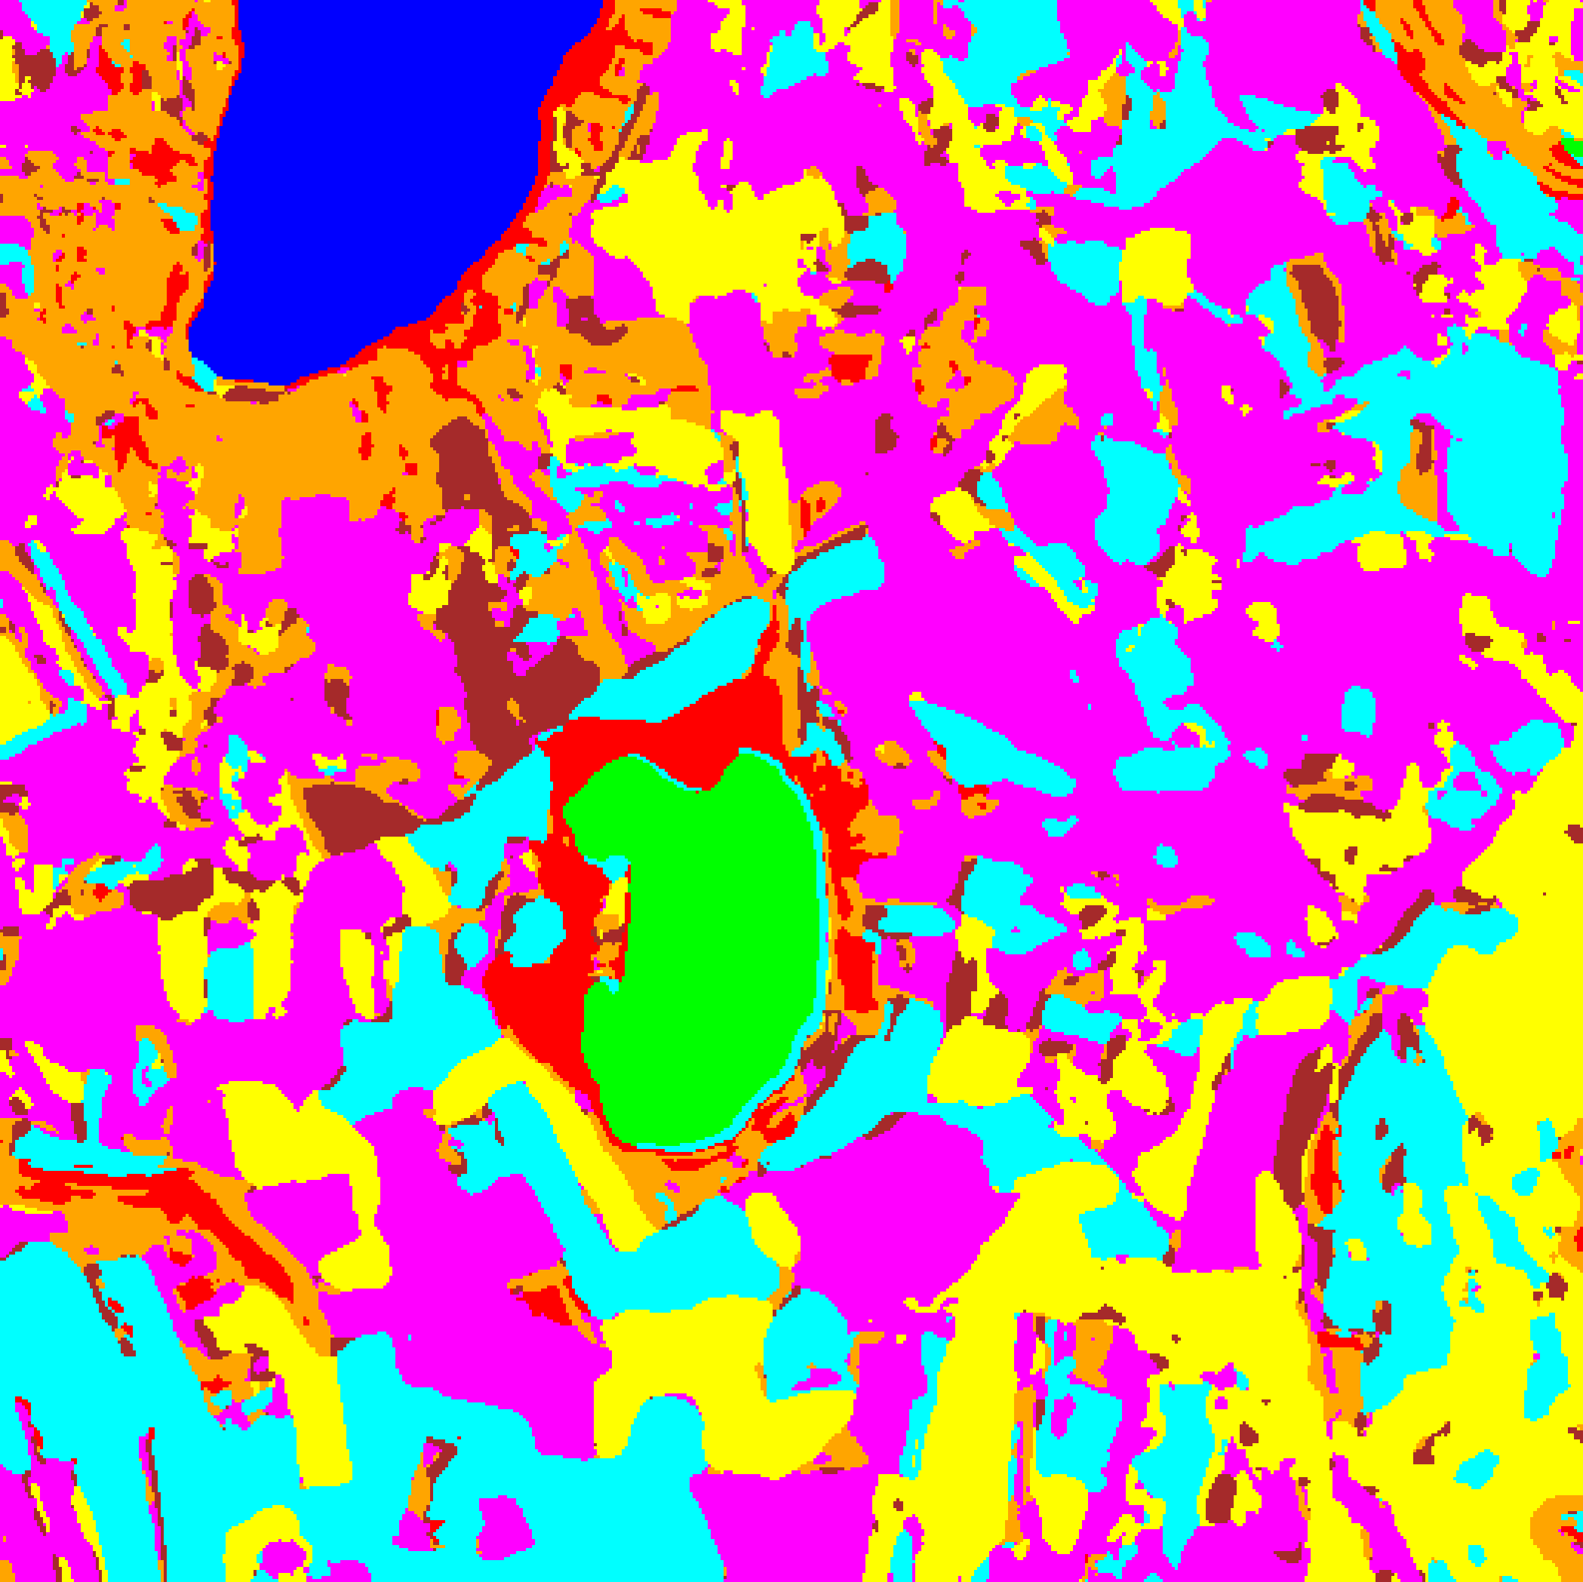  (A) AlexNet-CNN | 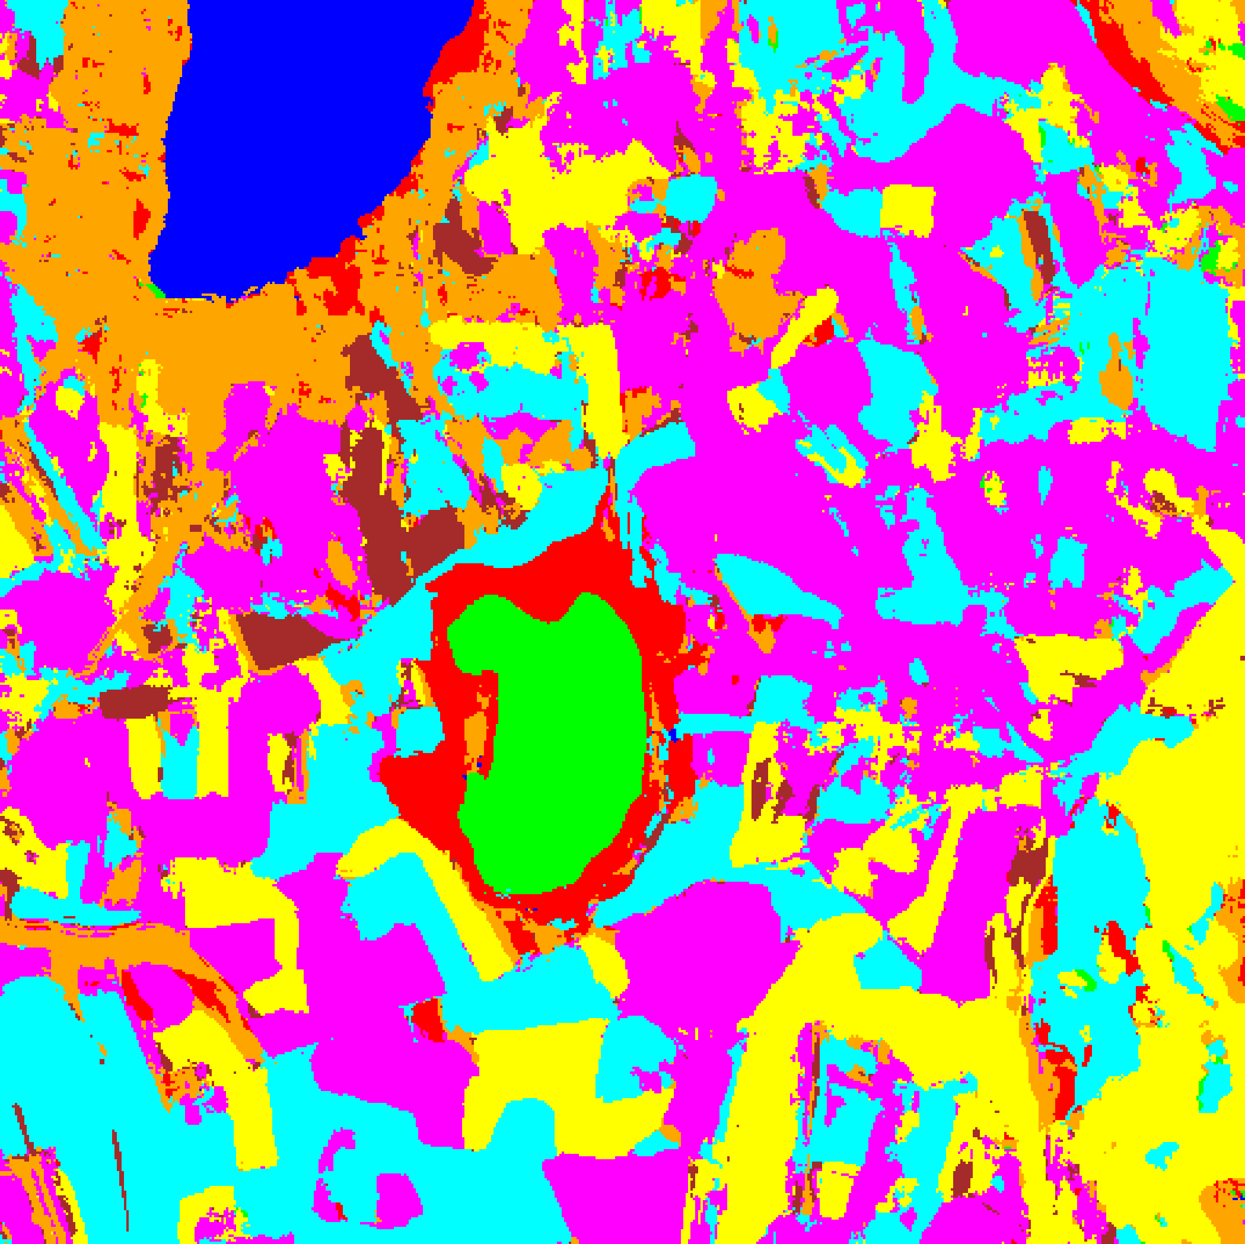  (B) GFNet
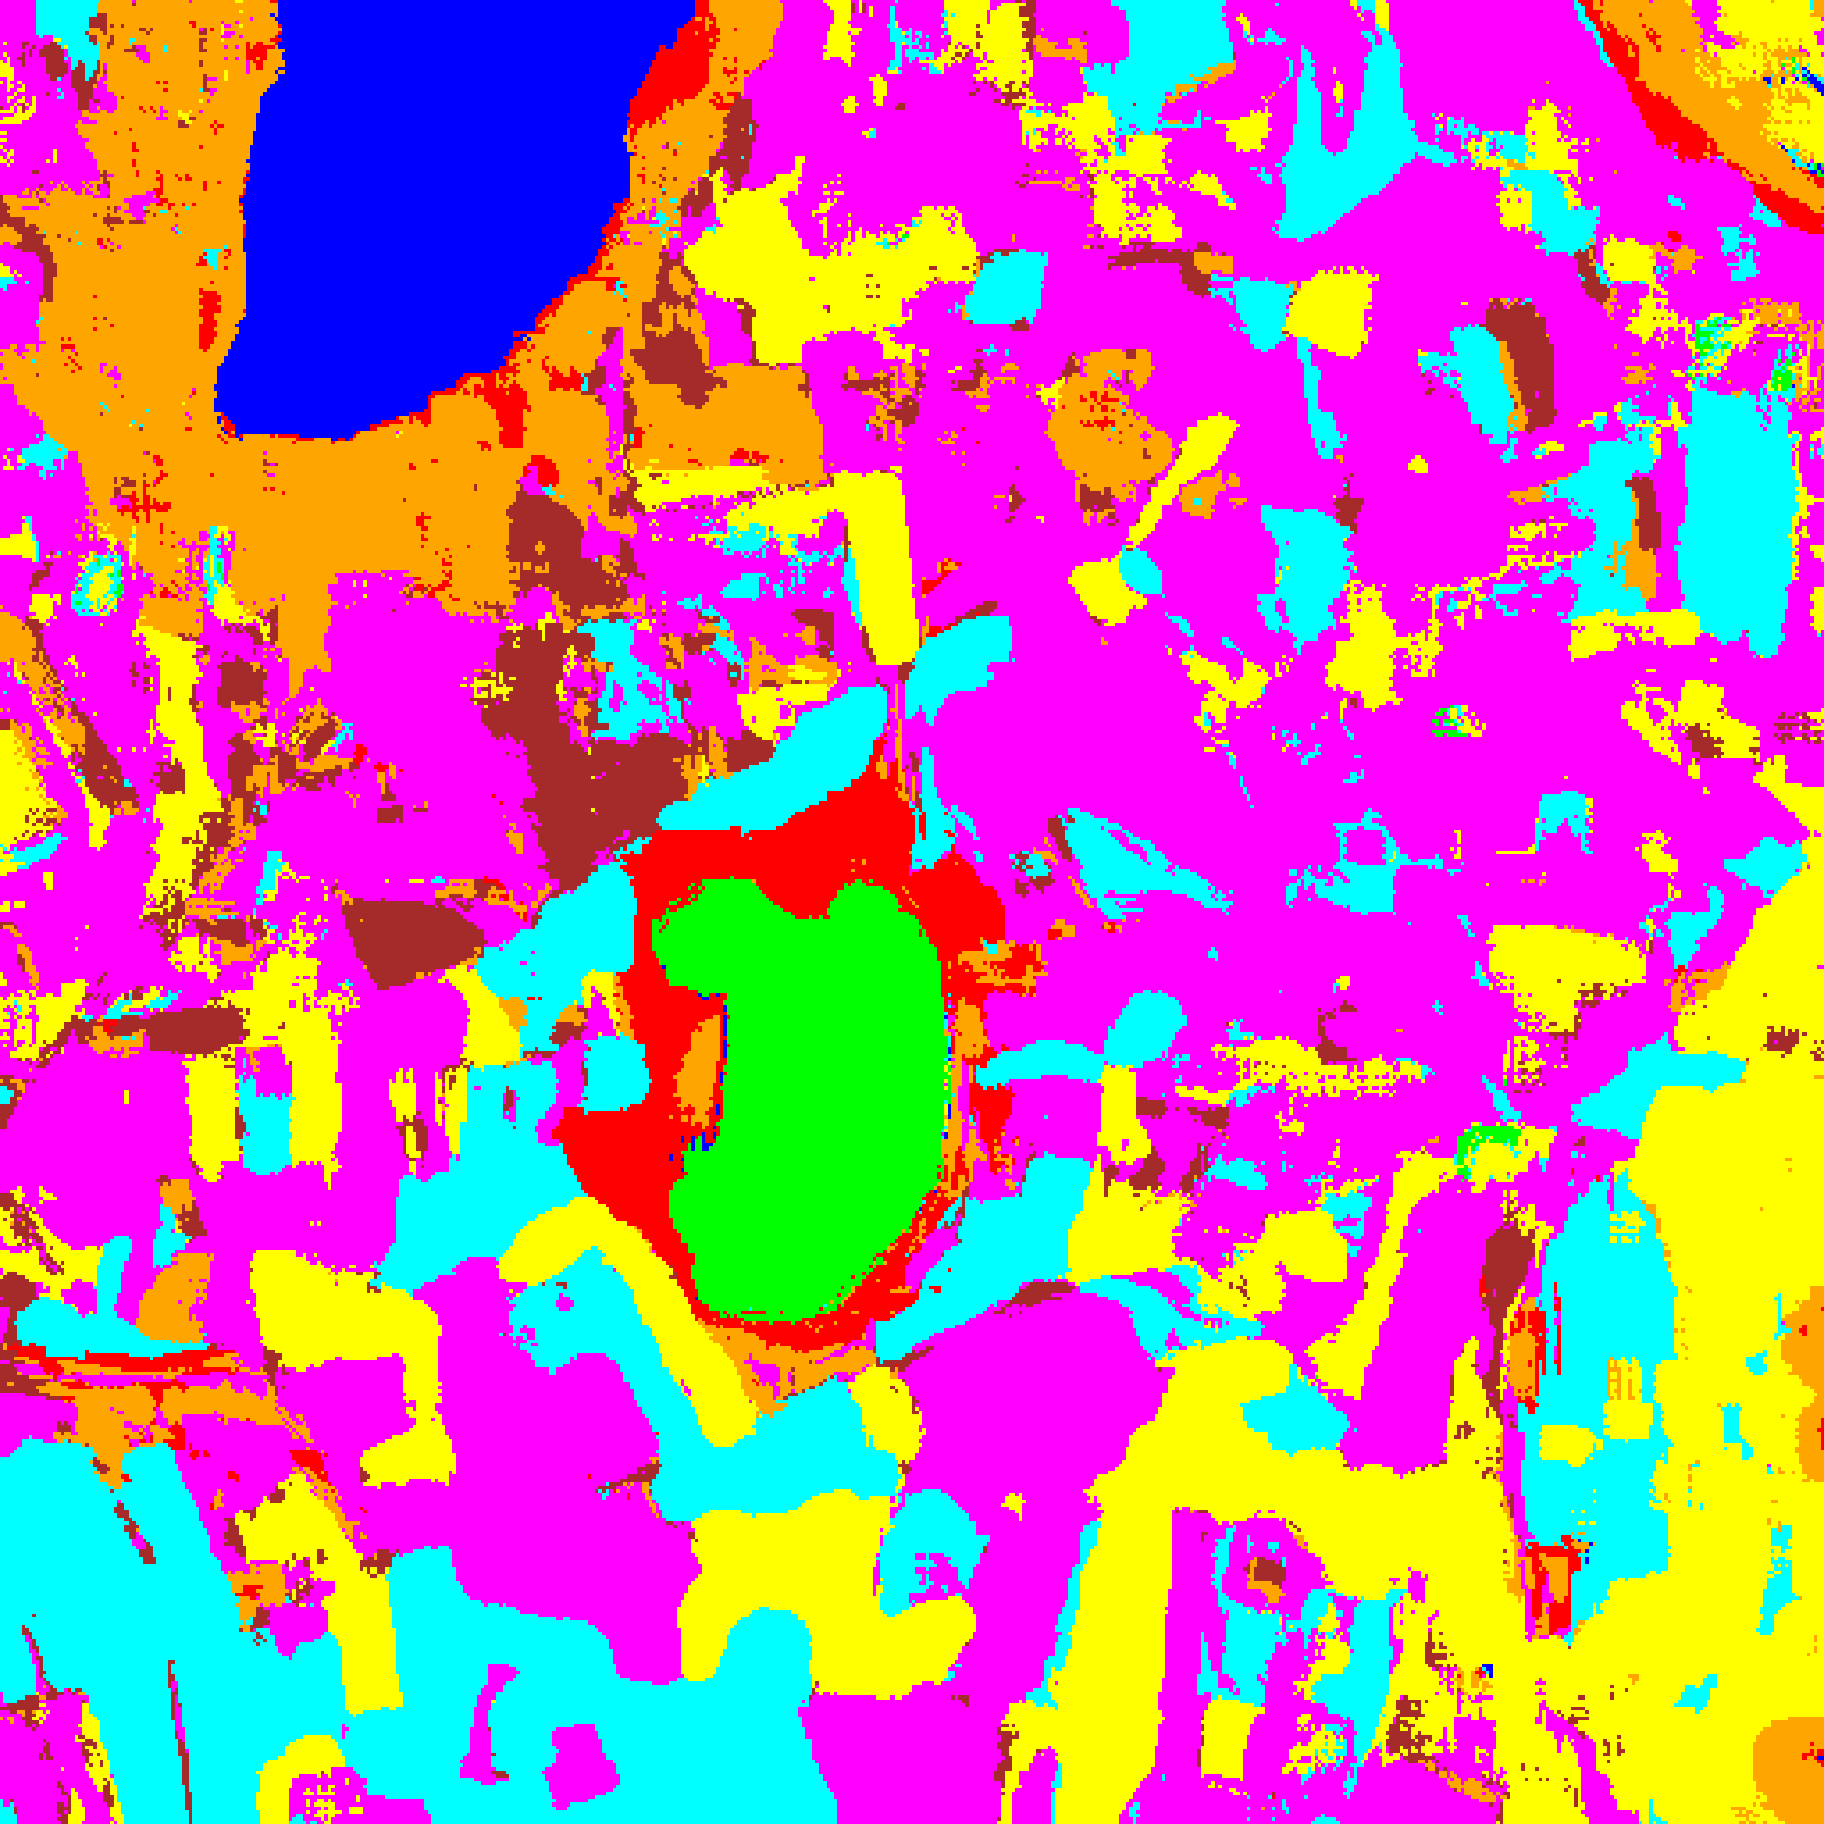  (C) ViT-UNet | 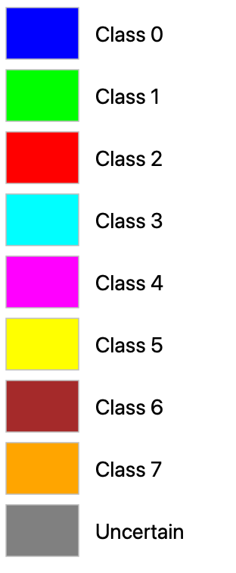  (D) Legend
Fig. 1. Dense pixel-wise land-cover classification maps across all 512 × 512 pixels produced by the three CREDIT student networks: (A) AlexNet-CNN, (B) GFNet, (C) ViT-UNet. Class legend shown in (D); colours apply to all subsequent overlay figures.
B. Deep Learning Architectures
AlexNet-style CNN: Adapted from [6] for 9 × 9 × 65 inputs with five convolutional layers [96, 256, 384, 384, 256] and a fully connected head [4096, 1024, 256, 32, K]. Dropout (p = 0.25), Adagrad optimiser with cosine schedule (LR ∈ [0.005, 0.02]), 100 epochs (training time 2,016.4 s).
GFNet: Five frequency-domain blocks with learnable global filters in the 2-D Fourier domain (d = 512, T = 9 tokens) [2]. Trained for 100 epochs with AdamW (training time 2,242.3 s).
ViT-UNet: A 12-layer Vision Transformer [3] augmented with U-Net skip connections [4] bridging encoder block i to decoder block L − i for i ≤ ⌊L/2⌋ (training time 3,720.6 s).
C. CREDIT: Credal Ensemble Distillation
CREDIT converts a pre-trained deep ensemble of M = 5 teacher networks (k016–k020.keras for AlexNet-CNN, k021–k025.keras for GFNet, k026–k030.keras for ViT-UNet) into a single dual-head student by training it to reproduce the class-wise probability interval spanned by the ensemble [1].
Teacher-Derived Targets. For each input x, M = 5 teacher softmax vectors π_1(x), ..., π_M(x) are collected. Per-class minimum and maximum bounds define the credal interval; the interval width Δp_true,c = p_max,c − p_min,c is the epistemic target and the renormalised minimum p*_true is the aleatoric target.
Dual-Head Student. The student attaches two heads to the penultimate features: p̂*(x) = softmax(W_1 z + b_1) for aleatoric distribution and Δp̂(x) = σ(W_2 z + b_2) for epistemic interval width, trained jointly via L = KL(p*_true ∥ p̂*) + 0.5·MSE(Δp_true, Δp̂).
Uncertainty Decomposition. AU(x) = −Σ_c p̂*_c ln(p̂*_c + ε); EU(x) = (1/K)Σ_c Δp̂_c; TU(x) = AU(x) + EU(x). The identity AU + EU = TU holds exactly at every pixel (verified across all 262,144 scene pixels with max |AU + EU − TU| = 0).
III. EXPERIMENTS AND RESULTS
A. Classification Performance
TABLE I summarises the evaluation metrics on the 13,474 held-out test samples. All three CREDIT students exceed 99.86% test accuracy: GFNet achieves a perfect 100.00% (κ = 1.0000, macro-F1 = 1.0000) with the lowest NLL (0.0011) and Brier score (0.0001), AlexNet-CNN achieves 99.94% (κ = 0.9993, macro-F1 = 0.9987) with the lowest ECE (0.0003) and lowest test-set mean TU (0.0028), and ViT-UNet achieves 99.87% (κ = 0.9984, macro-F1 = 0.9976) with higher mean AU (0.2134) reflecting its broader softmax entropy.
TABLE I
CREDIT STUDENT — FULL EVALUATION METRICS (13,474 TEST SAMPLES)
Model | Accuracy | κ | Macro F1 | NLL | Brier | ECE | Mean AU | Mean EU | Mean TU
AlexNet-CNN | 99.94% | 0.9993 | 0.9987 | 0.0027 | 0.0012 | 0.0003 | 0.0025 | 0.0003 | 0.0028
GFNet | 100.00% | 1.0000 | 1.0000 | 0.0011 | 0.0001 | 0.0010 | 0.0072 | 0.0000 | 0.0072
ViT-UNet | 99.87% | 0.9984 | 0.9976 | 0.0387 | 0.0034 | 0.0333 | 0.2134 | 0.0002 | 0.2136

B. Dense Scene Classification Maps
Each CREDIT student is deployed in dense inference over the full 512 × 512 scene (262,144 pixels) to produce the land-cover maps shown in Fig. 1. All three students accurately delineate the labelled parcels across Class 0 through Class 7 while assigning background pixels to their nearest spectral class prior to uncertainty masking.
C. Aleatoric Uncertainty (AU > 0.5) Maps
Pixels with Shannon entropy AU > 0.5 nats (where max possible AU = ln 8 = 2.0794 nats) are flagged as aleatoric-uncertain. Fig. 2(a) shows the binary certain/uncertain maps; Fig. 2(b) shows the grey-overlay masked maps; TABLE II reports the full-scene pixel counts.
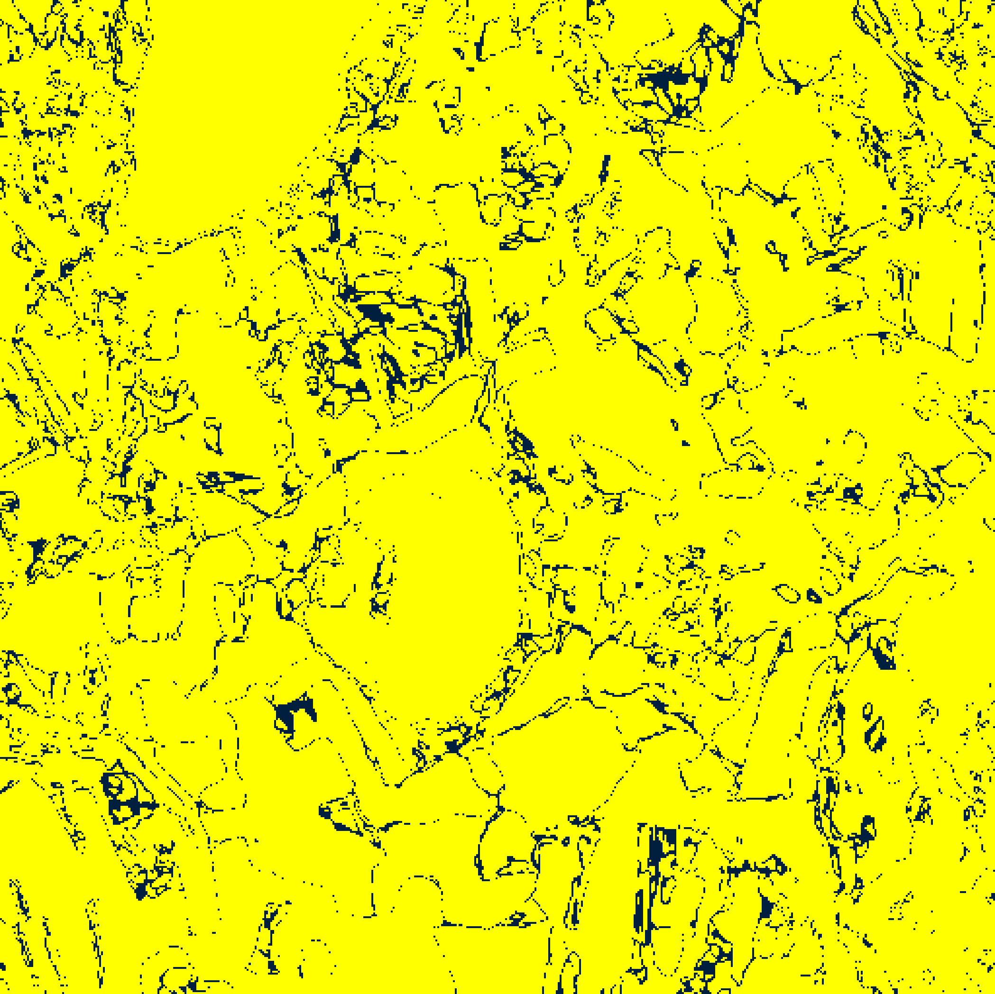  (A) AlexNet-CNN | 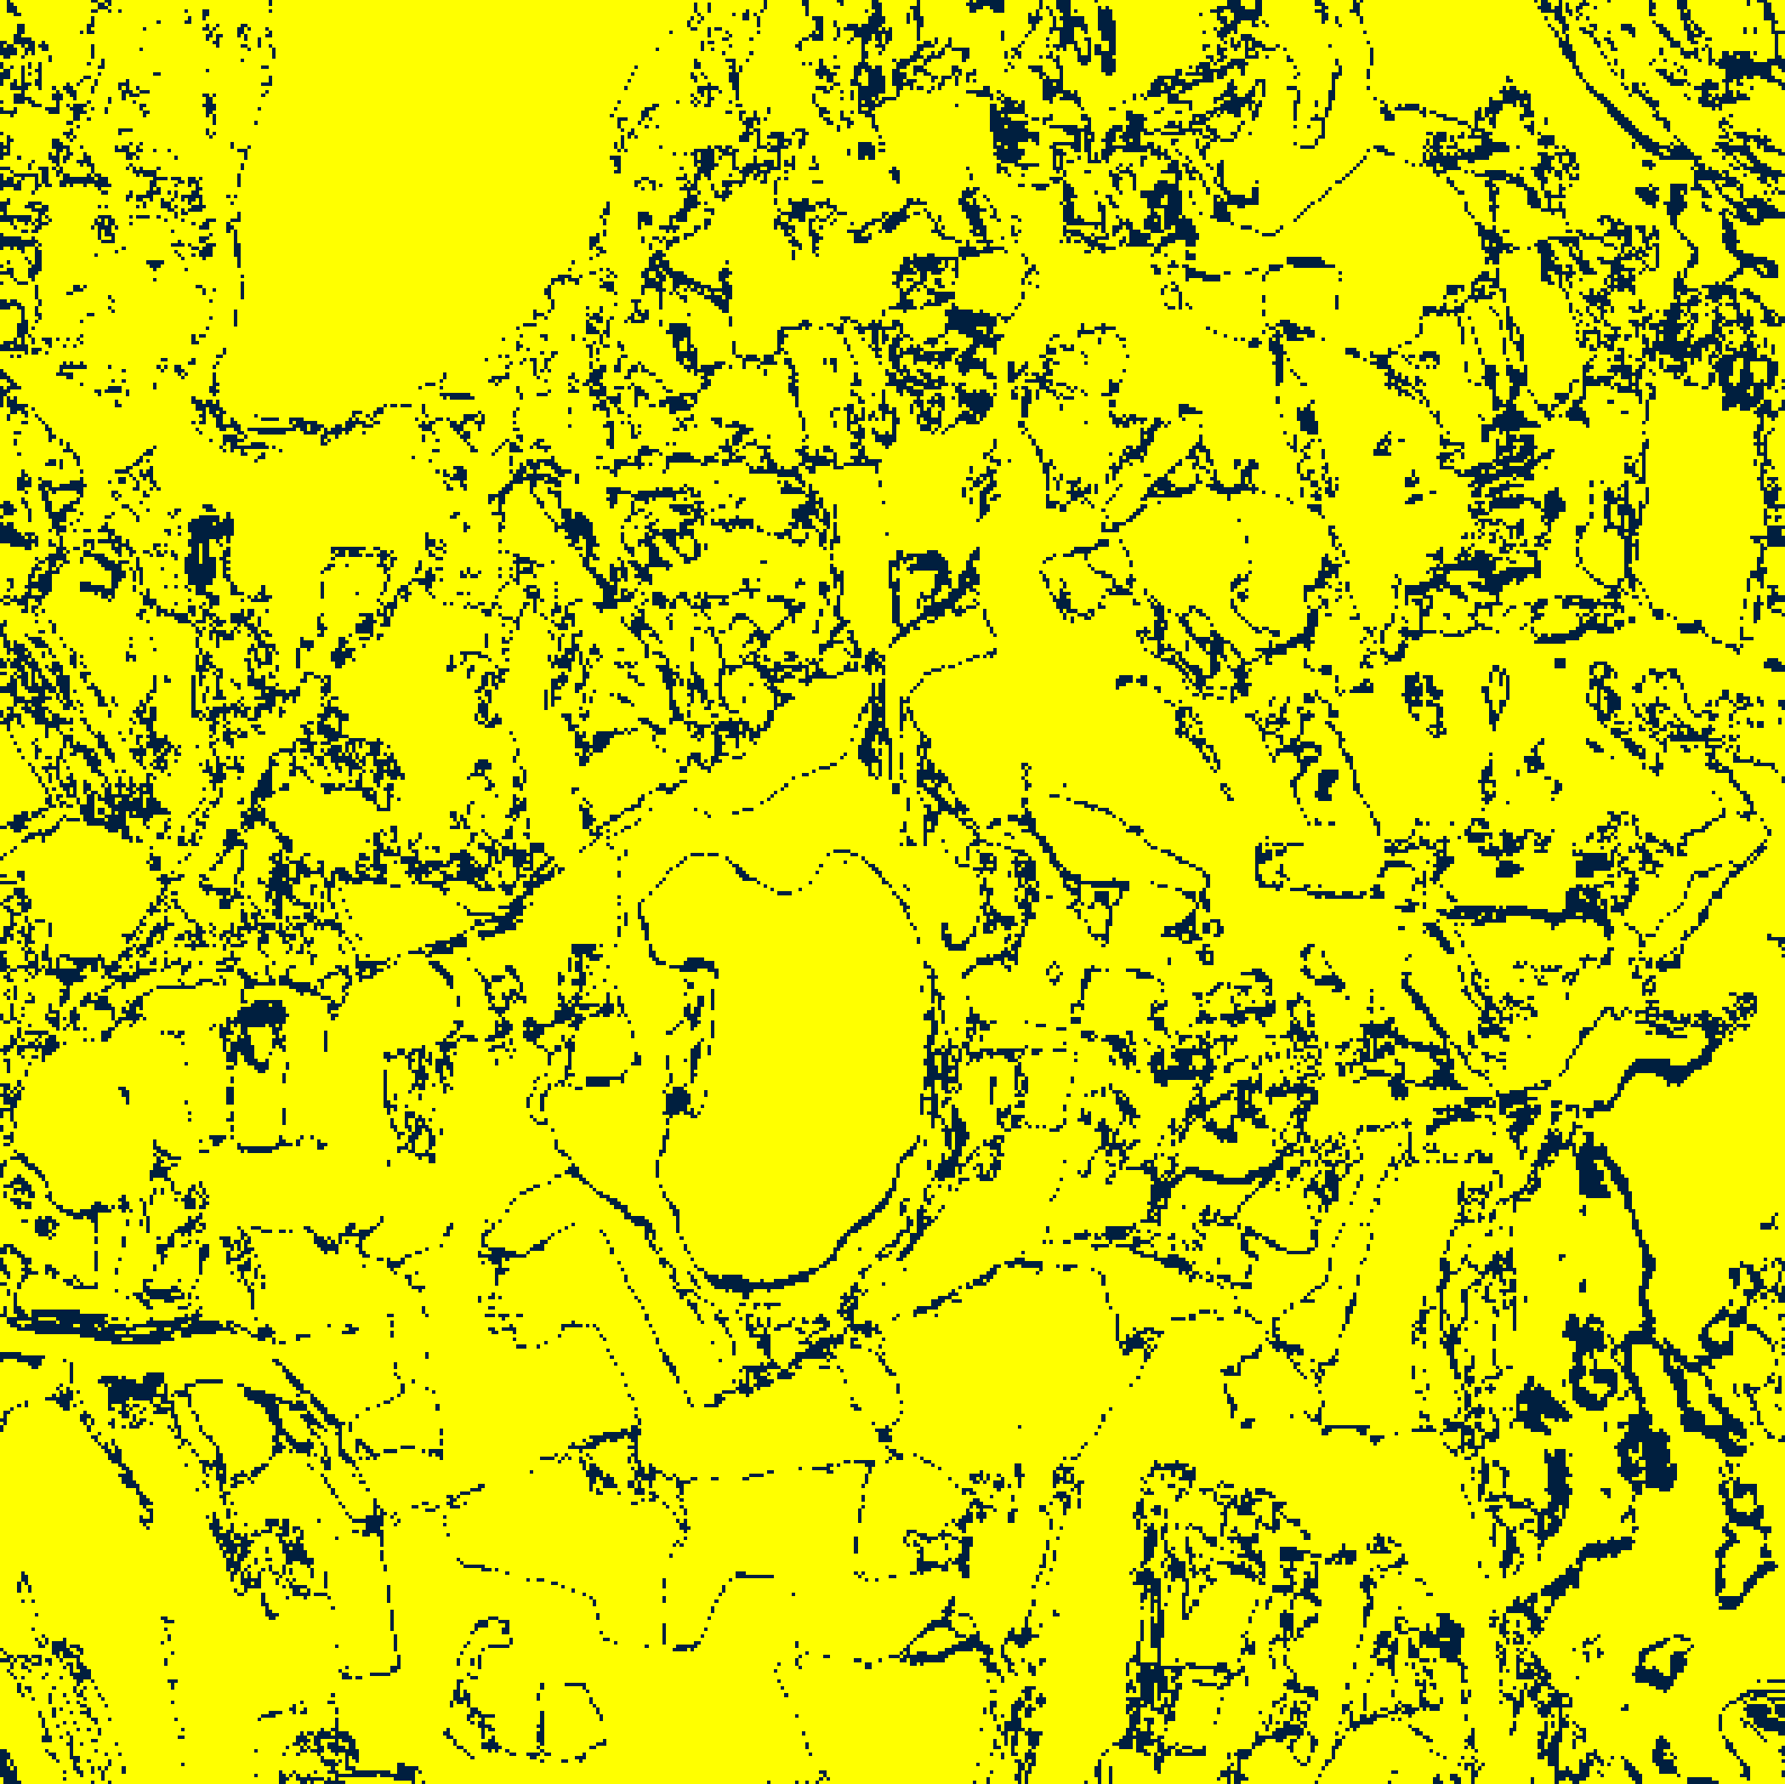  (B) GFNet
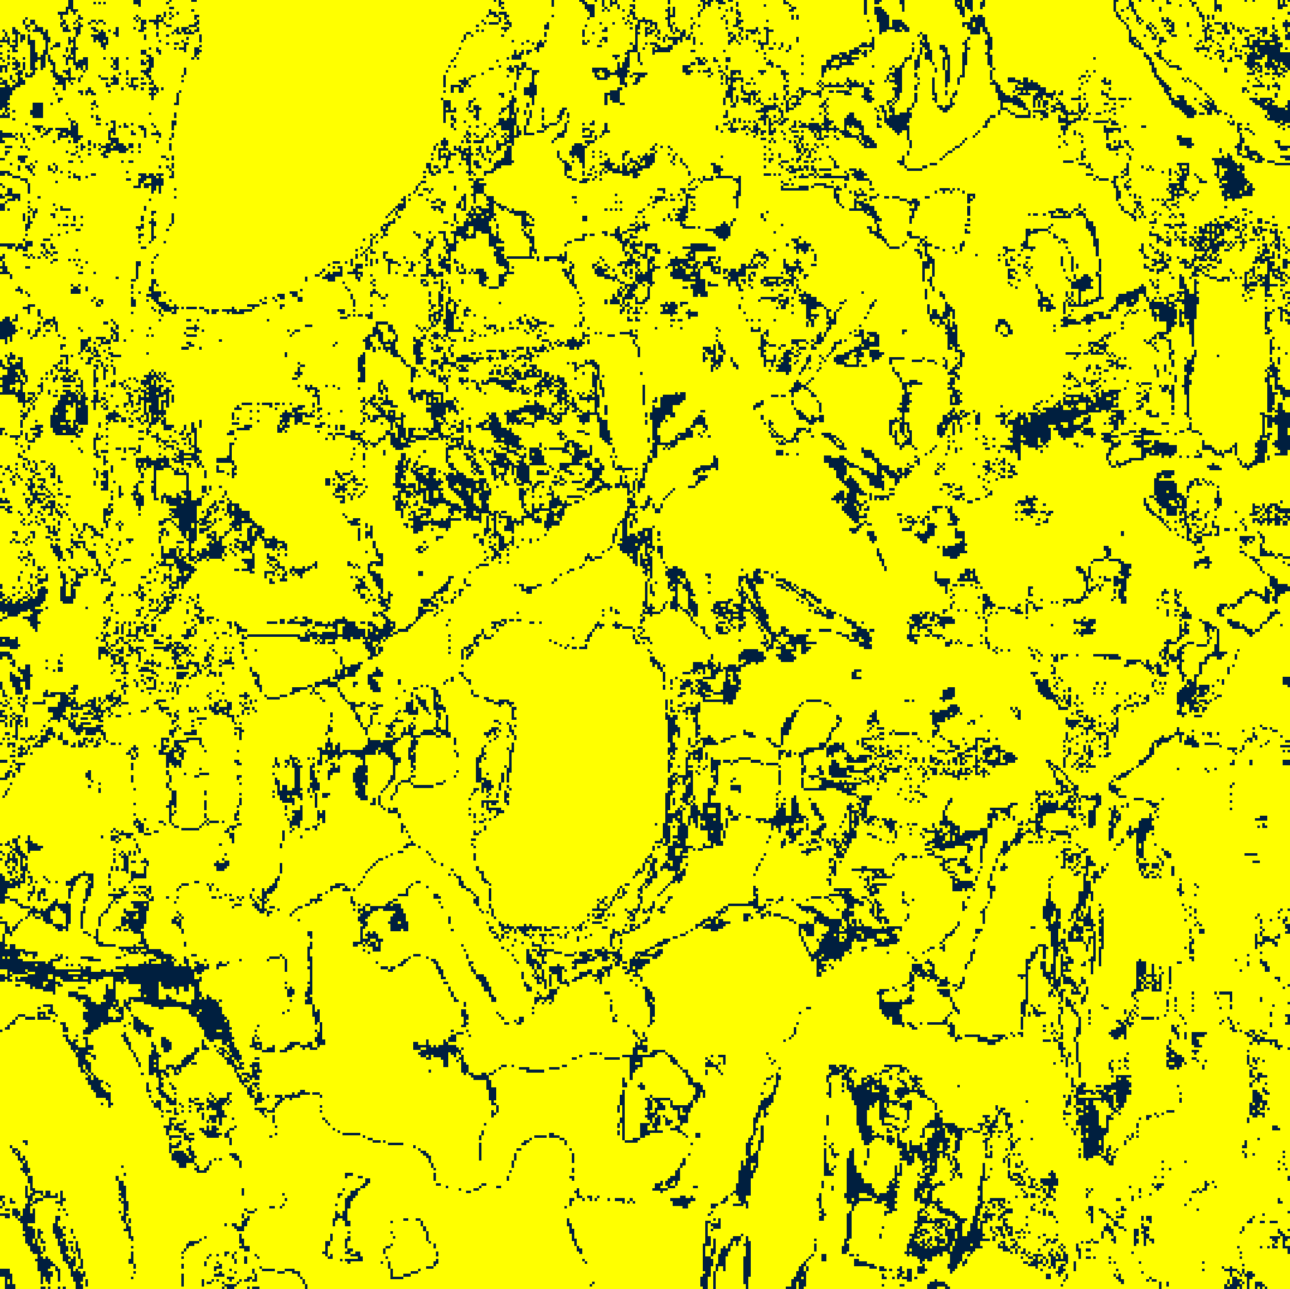  (C) ViT-UNet | 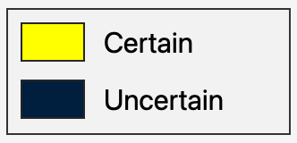  (D) Legend
Fig. 2(a). Aleatoric uncertainty binary maps (AU > 0.5): (A) AlexNet-CNN, (B) GFNet, (C) ViT-UNet. Certain/Uncertain legend shown in (D). Yellow = certain (AU ≤ 0.5); dark navy = aleatoric-uncertain.
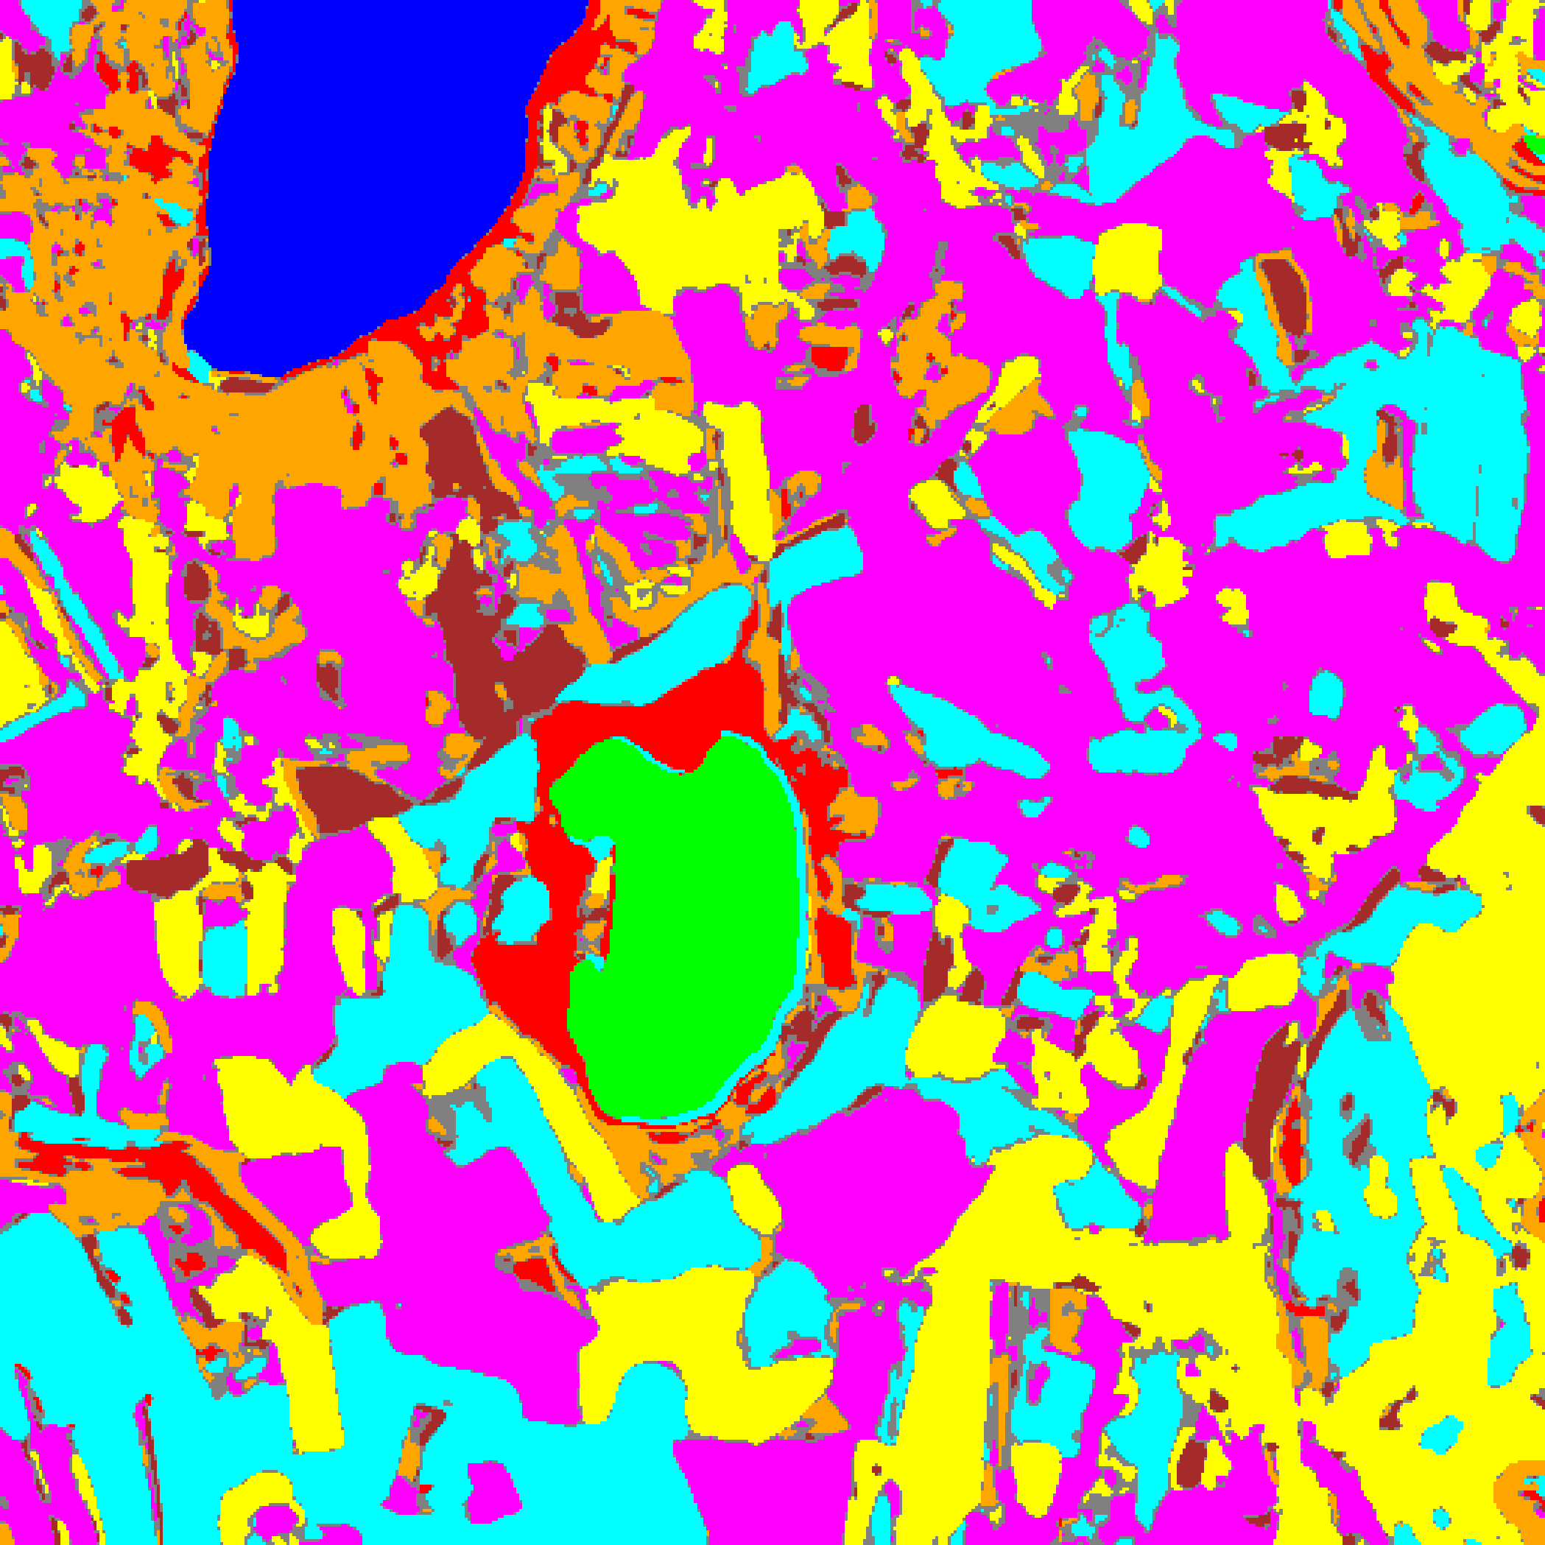  (A) AlexNet-CNN | 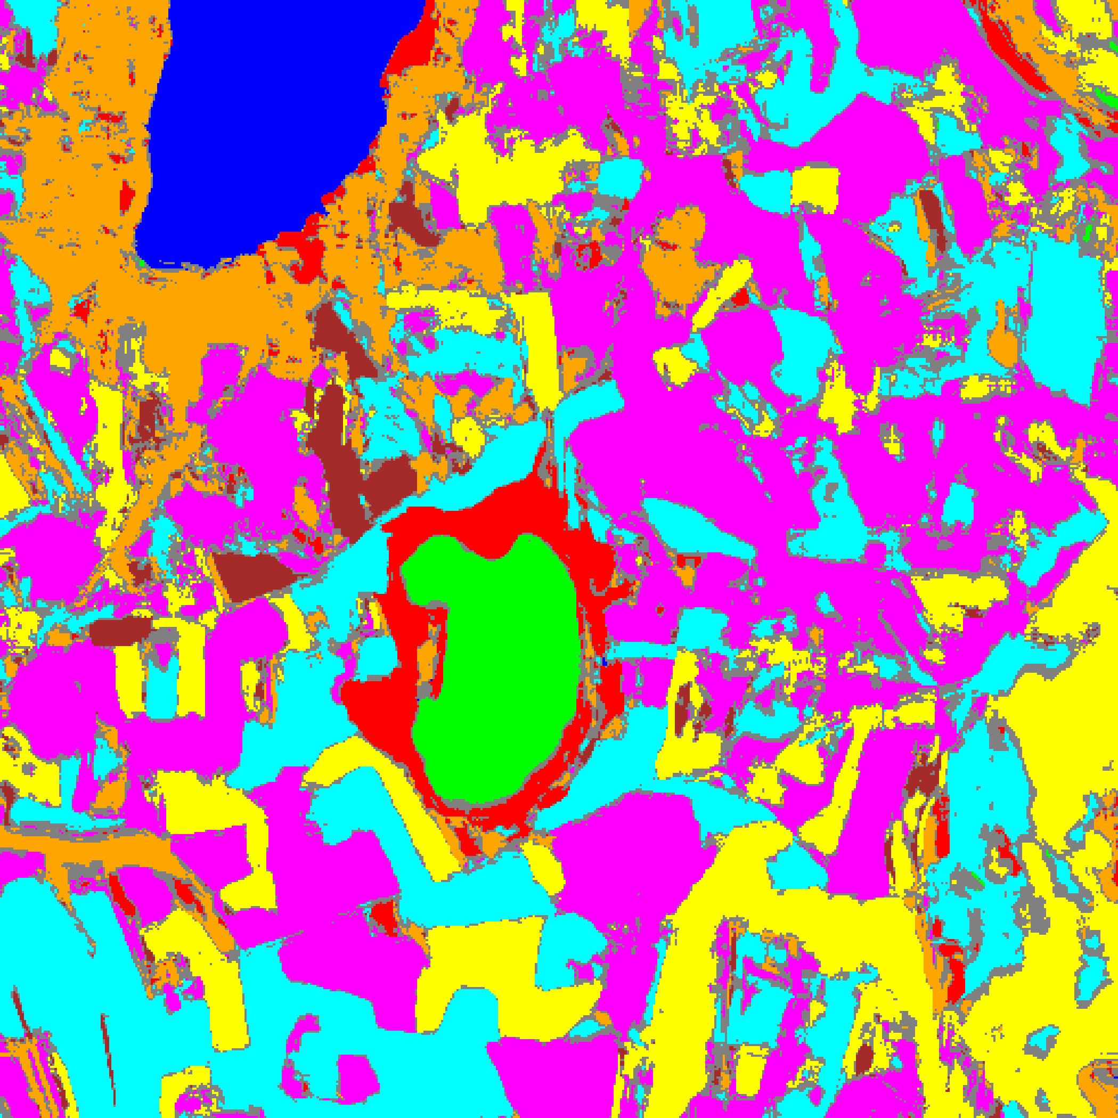  (B) GFNet
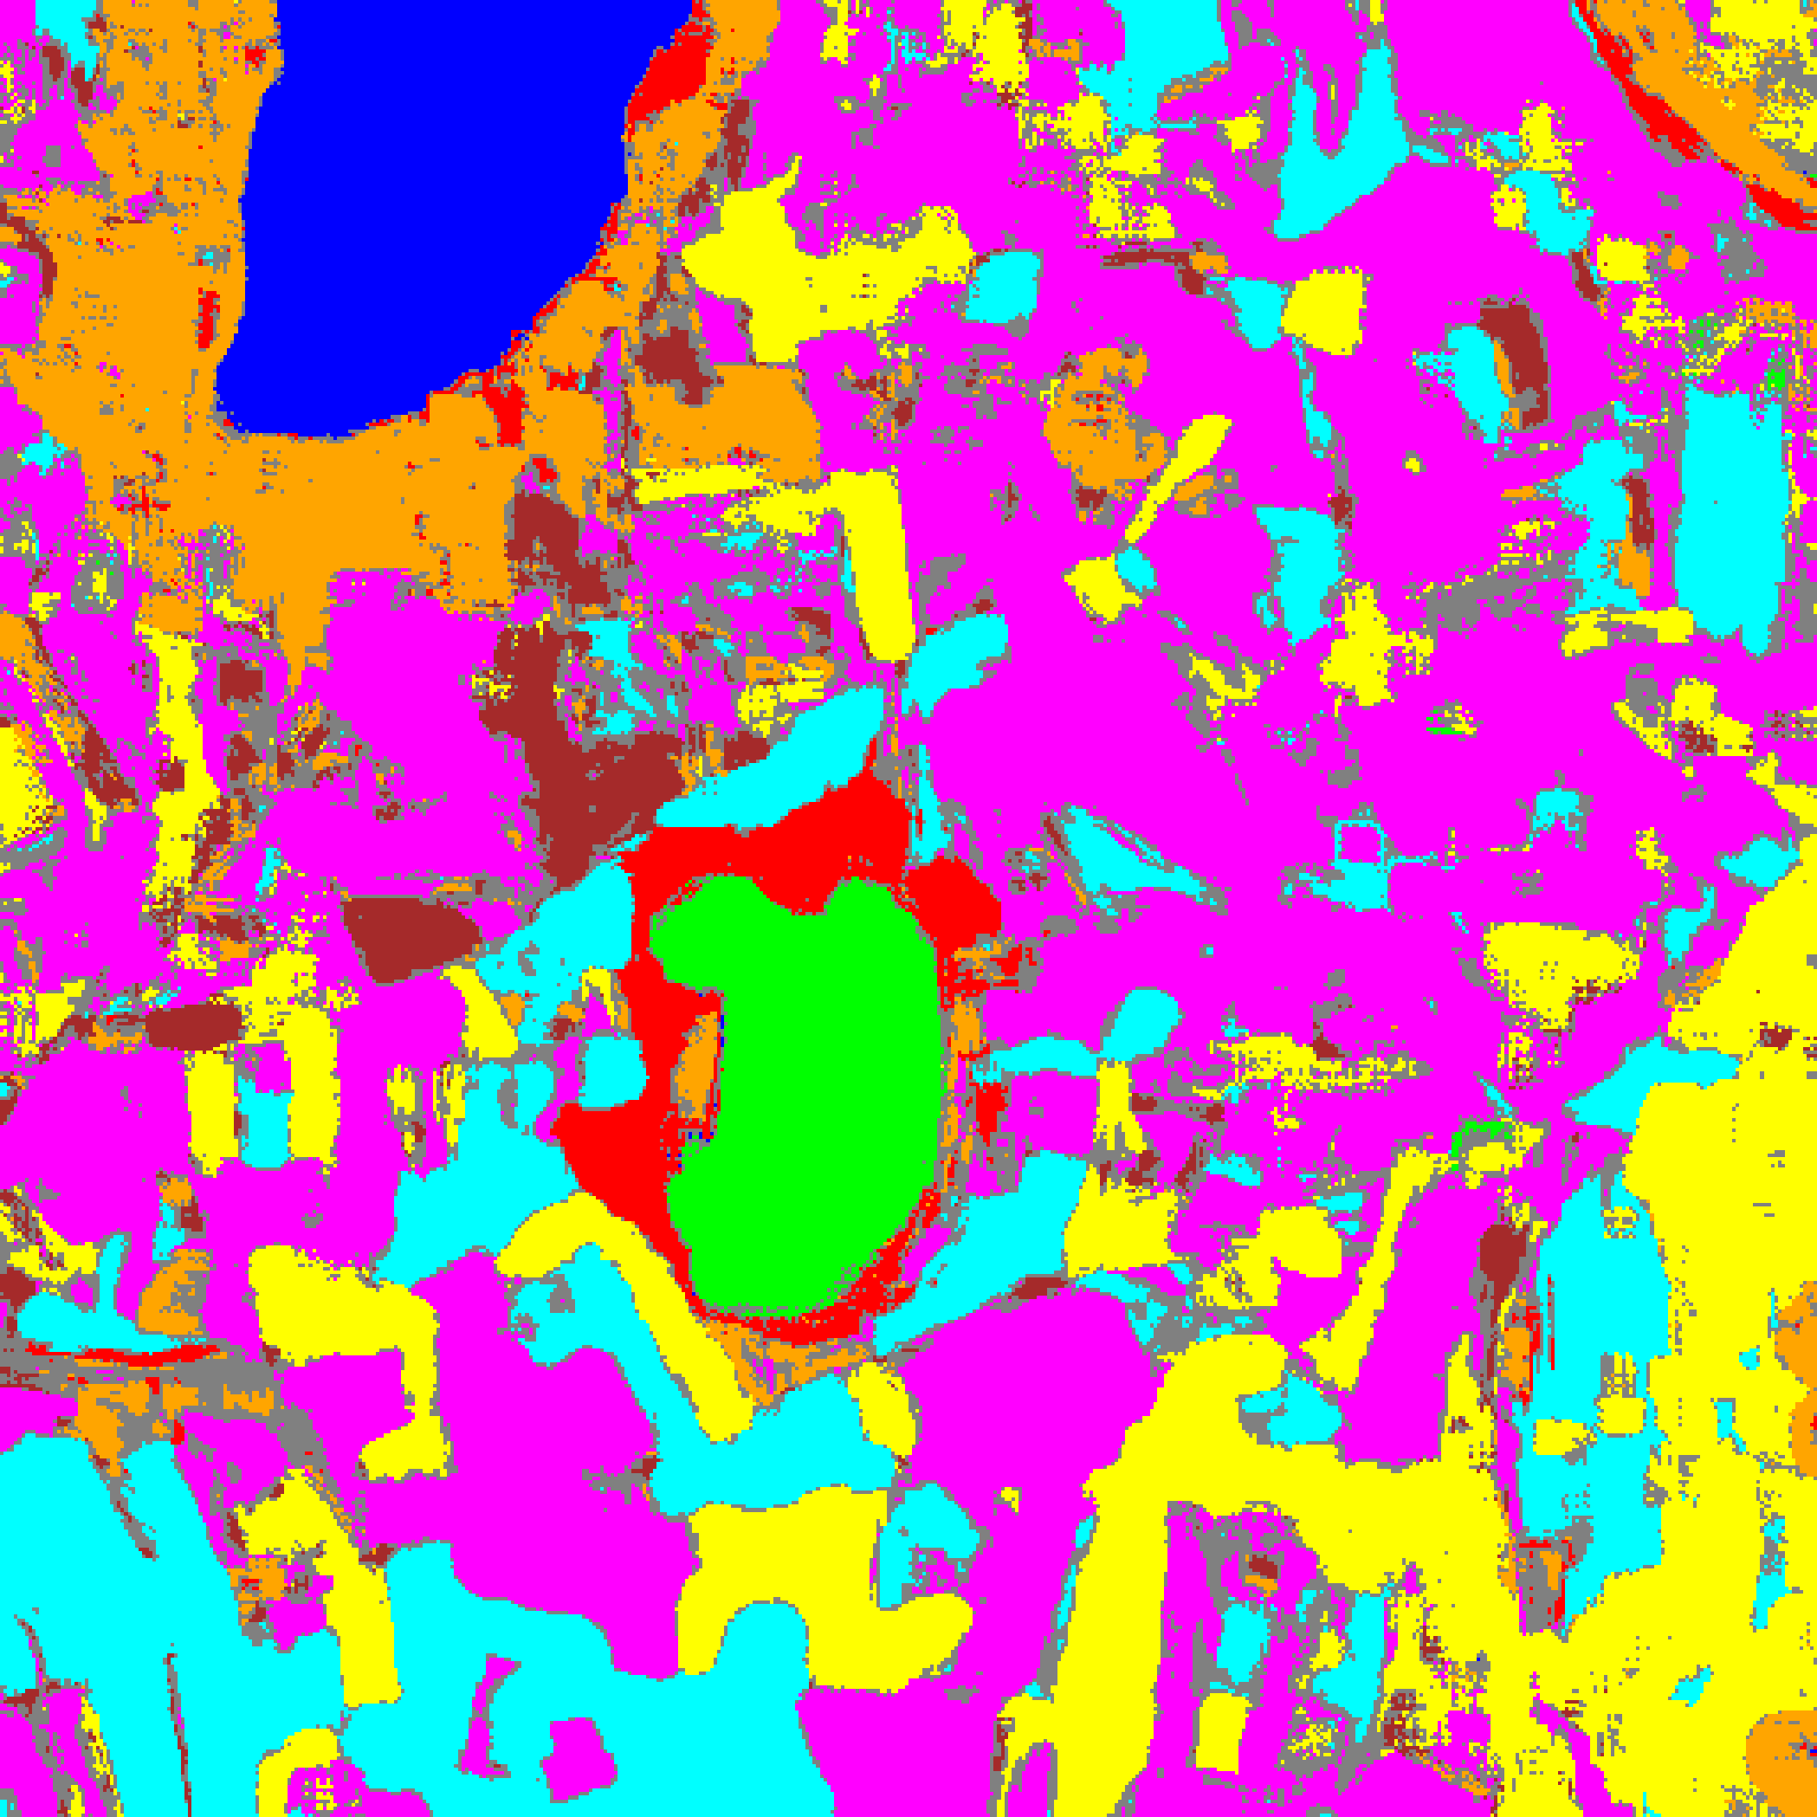  (C) ViT-UNet | (D) Legend
Fig. 2(b). Aleatoric uncertainty overlay maps (AU > 0.5): (A) AlexNet-CNN, (B) GFNet, (C) ViT-UNet. Class colours retained for AU-certain pixels; grey pixels denote aleatoric-uncertain predictions. Class legend shown in (D).
TABLE II
CREDIT AU (> 0.5): FULL-SCENE PIXEL COUNT DISTRIBUTION PER MODEL
Class / Region | AlexNet Pixels | GFNet Pixels | ViT-UNet Pixels
Class 0 | 11,271 | 11,359 | 11,377
Class 1 | 7,639 | 7,358 | 7,502
Class 2 | 8,332 | 8,867 | 6,694
Class 3 | 46,463 | 49,875 | 37,080
Class 4 | 86,666 | 73,652 | 90,553
Class 5 | 44,959 | 40,888 | 43,231
Class 6 | 9,425 | 5,683 | 8,142
Class 7 | 25,177 | 25,646 | 20,593
AU-Uncertain | 22,212 | 38,816 | 36,972
Total (Scene) | 262,144 | 262,144 | 262,144

Across the 262,144-pixel scene, AlexNet-CNN flags the fewest AU-uncertain pixels (22,212, 8.473%, max observed AU = 1.6032), followed by ViT-UNet (36,972, 14.104%, max observed AU = 2.0506) and GFNet (38,816, 14.807%, max observed AU = 2.0091). Uncertain pixels concentrate along parcel boundaries and within unlabelled background regions.
D. Epistemic Uncertainty (EU > 0.2) Maps
Epistemic uncertainty is the mean predicted credal interval width Δp̂ per pixel. Fig. 3(a) shows the binary EU maps (EU > 0.2), Fig. 3(b) the grey-overlay maps, and TABLE III the pixel counts.
  (A) AlexNet-CNN |   (B) GFNet
(C) ViT-UNet | (D) Legend
Fig. 3(a). Epistemic uncertainty binary maps (EU > 0.2): (A) AlexNet-CNN, (B) GFNet, (C) ViT-UNet. Certain/Uncertain legend shown in (D).
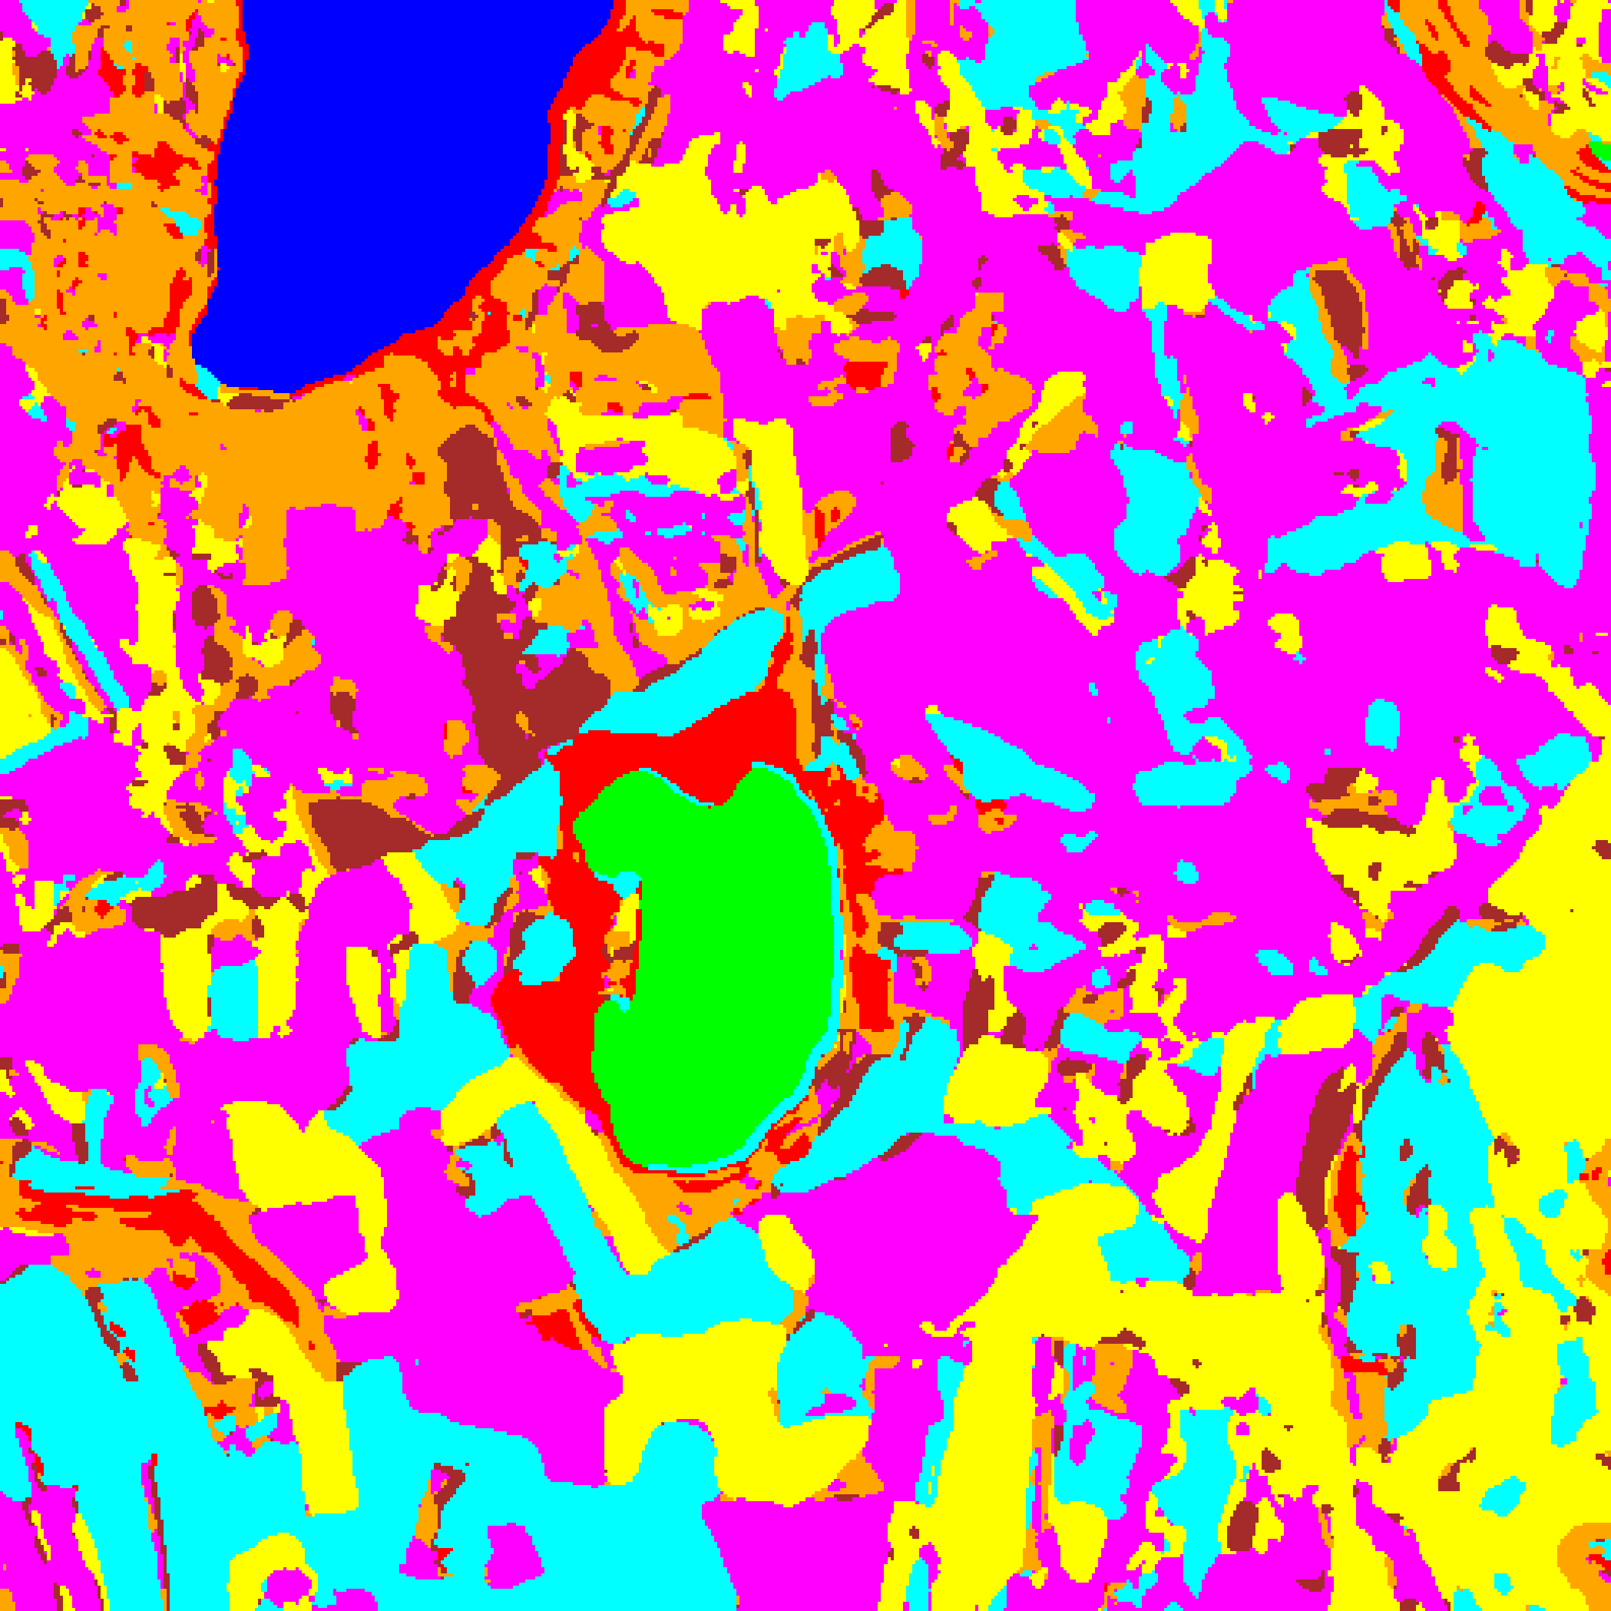  (A) AlexNet-CNN | 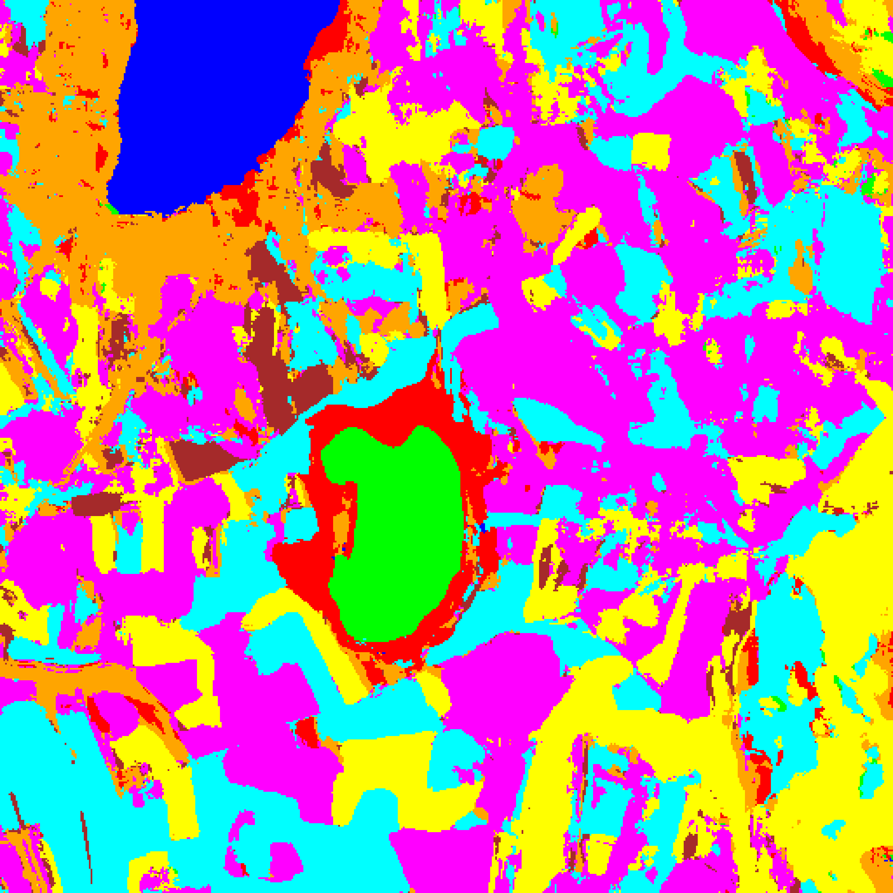  (B) GFNet
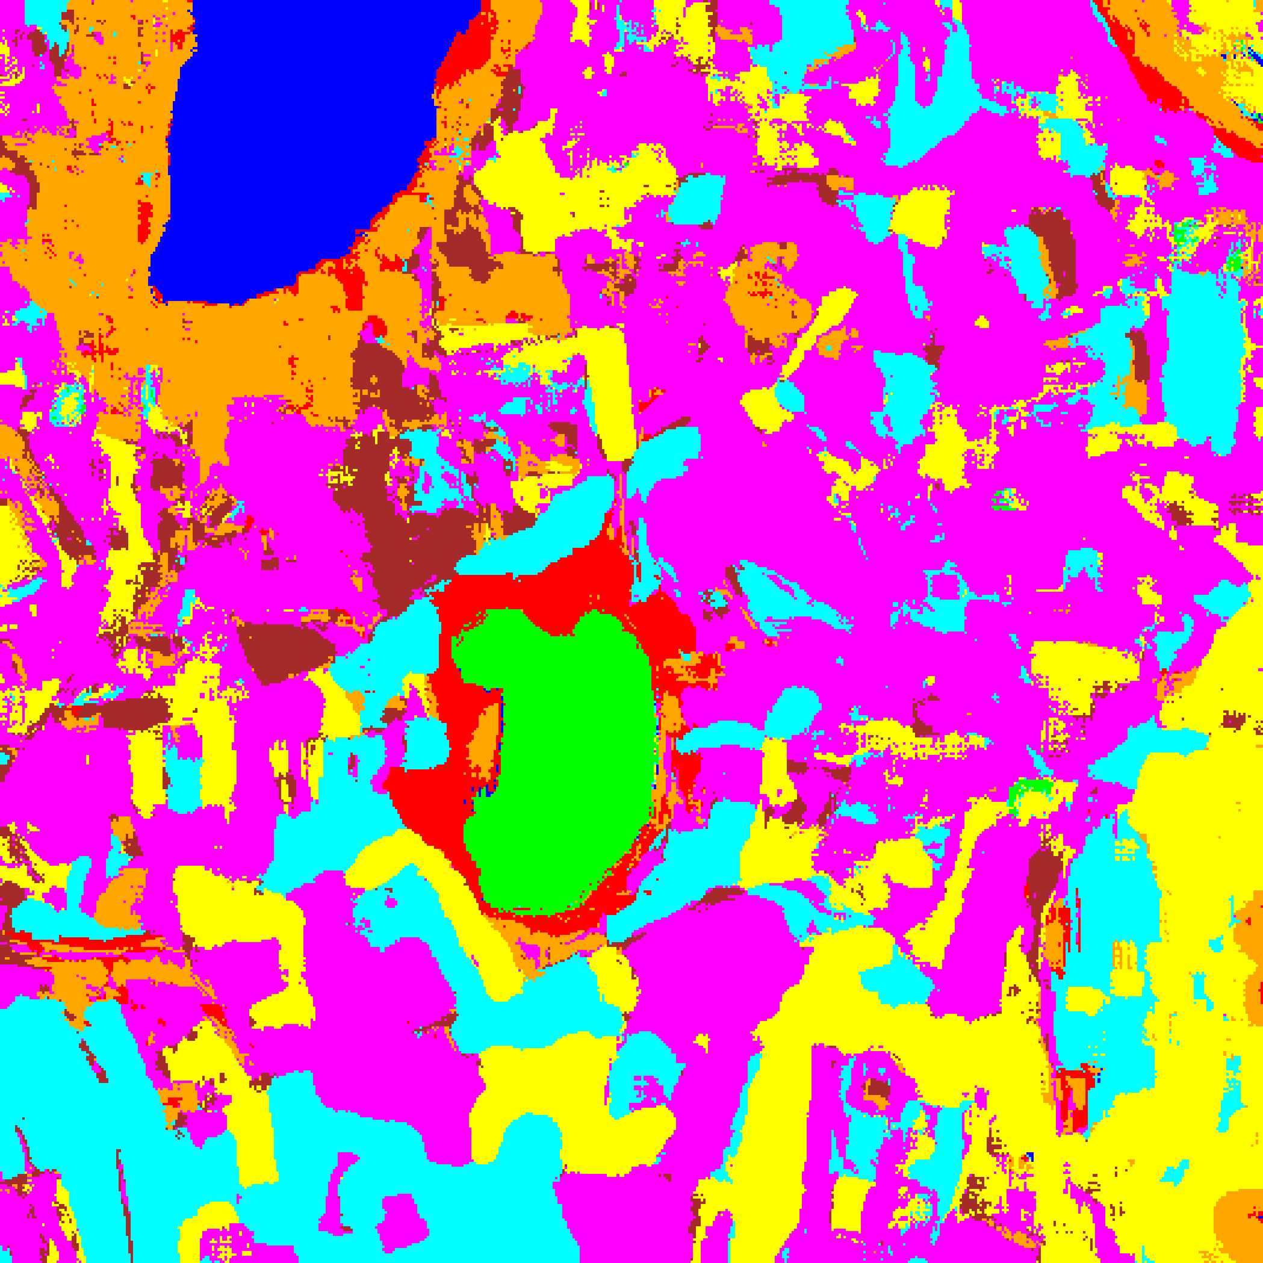  (C) ViT-UNet | (D) Legend
Fig. 3(b). Epistemic uncertainty overlay maps (EU > 0.2): (A) AlexNet-CNN, (B) GFNet, (C) ViT-UNet. Class colours retained for EU-certain pixels; grey = epistemically uncertain. Class legend shown in (D).
TABLE III
CREDIT EU (> 0.2): FULL-SCENE PIXEL COUNT DISTRIBUTION PER MODEL
Class / Region | AlexNet Pixels | GFNet Pixels | ViT-UNet Pixels
Class 0 | 11,302 | 11,490 | 11,544
Class 1 | 7,653 | 7,865 | 7,801
Class 2 | 9,485 | 11,259 | 8,620
Class 3 | 50,254 | 58,172 | 43,522
Class 4 | 93,214 | 84,759 | 103,709
Class 5 | 48,490 | 48,367 | 49,571
Class 6 | 12,027 | 7,915 | 11,777
Class 7 | 29,719 | 32,317 | 25,600
EU-Uncertain | 0 | 0 | 0
Total (Scene) | 262,144 | 262,144 | 262,144

Under EU > 0.2, all three models register zero epistemically uncertain pixels across the entire 262,144-pixel scene (maximum observed EU across the scene is 0.0856 for AlexNet-CNN, 0.0019 for GFNet, and 0.1866 for ViT-UNet—all below 0.2). Even at a stricter threshold of t = 0.1, only ViT-UNet flags 17 pixels (0.006%), while AlexNet-CNN and GFNet flag 0 pixels. Thus, TABLE III reflects the unmasked base prediction counts across Class 0–7.
E. Total Uncertainty (TU > 0.7) Maps
Total uncertainty TU = AU + EU aggregates both sources. Pixels with TU > 0.7 are flagged as uncertain. Fig. 4(a) and Fig. 4(b) display the binary and grey-overlay TU maps; TABLE IV and TABLE V present the aggregate TU summary and per-class pixel counts.
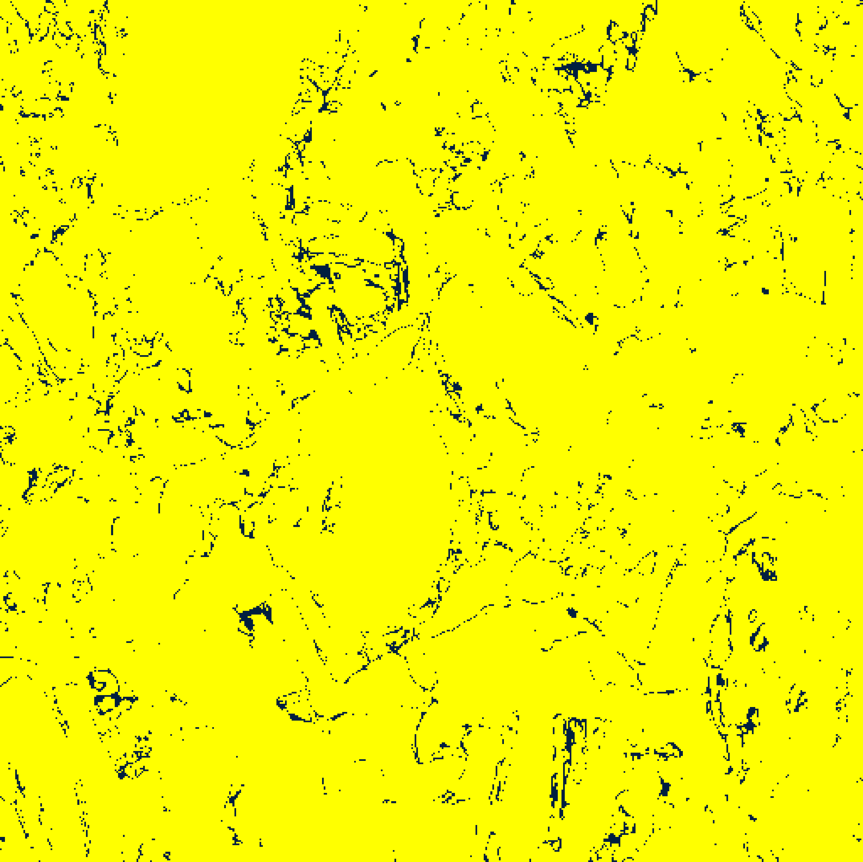  (A) AlexNet-CNN | 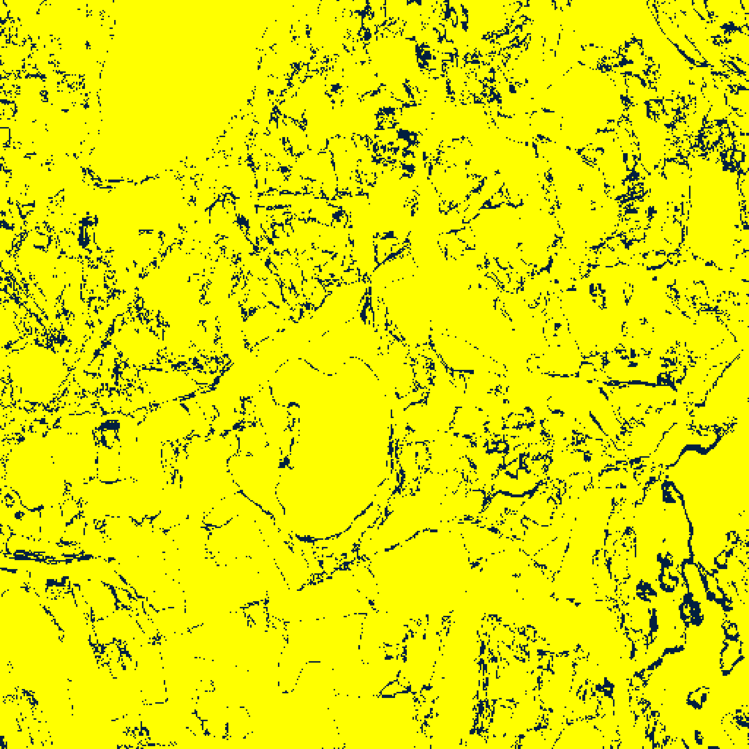  (B) GFNet
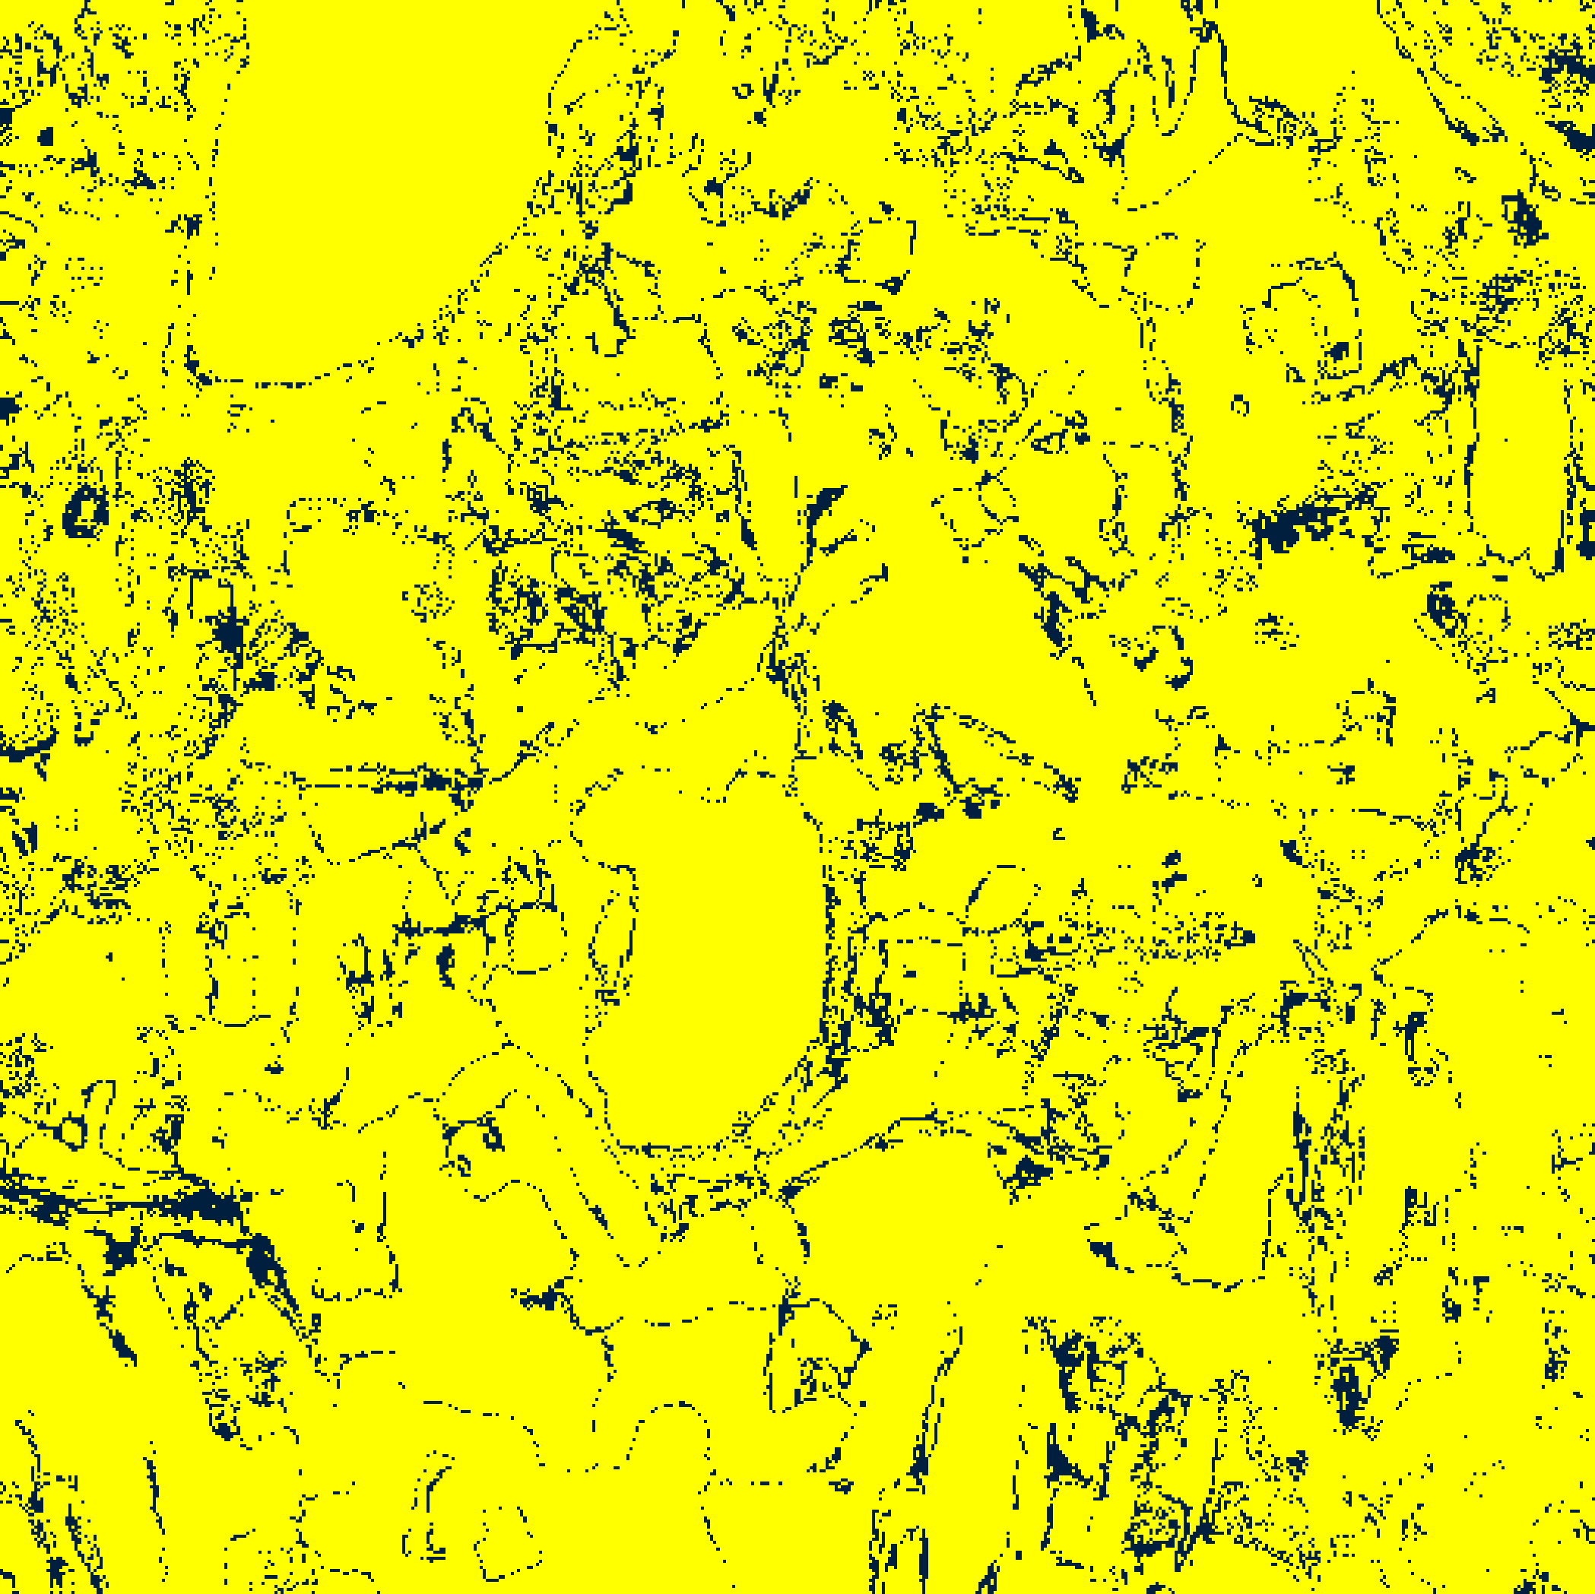  (C) ViT-UNet | (D) Legend
Fig. 4(a). Total uncertainty binary maps (TU > 0.7): (A) AlexNet-CNN, (B) GFNet, (C) ViT-UNet. Certain/Uncertain legend shown in (D).
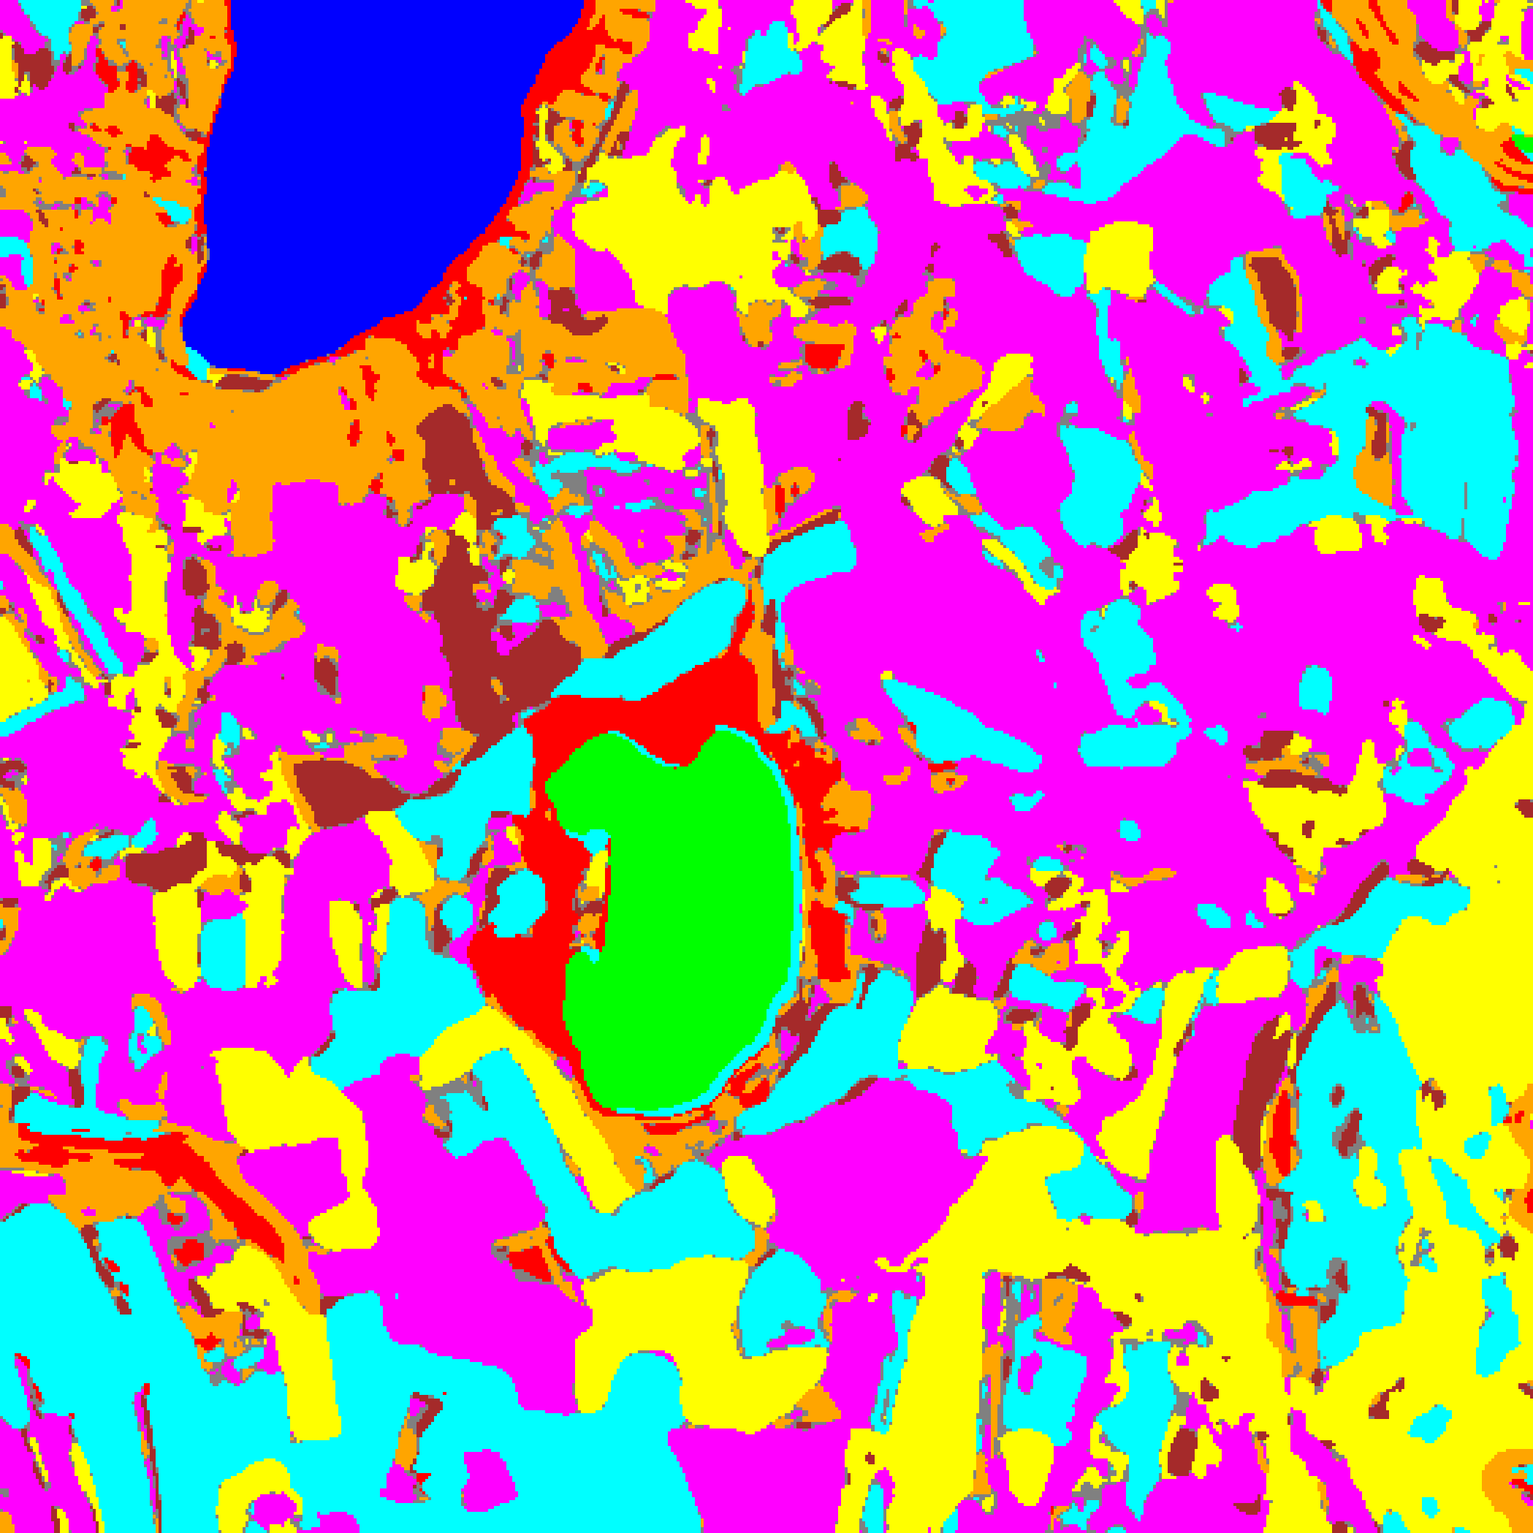  (A) AlexNet-CNN | 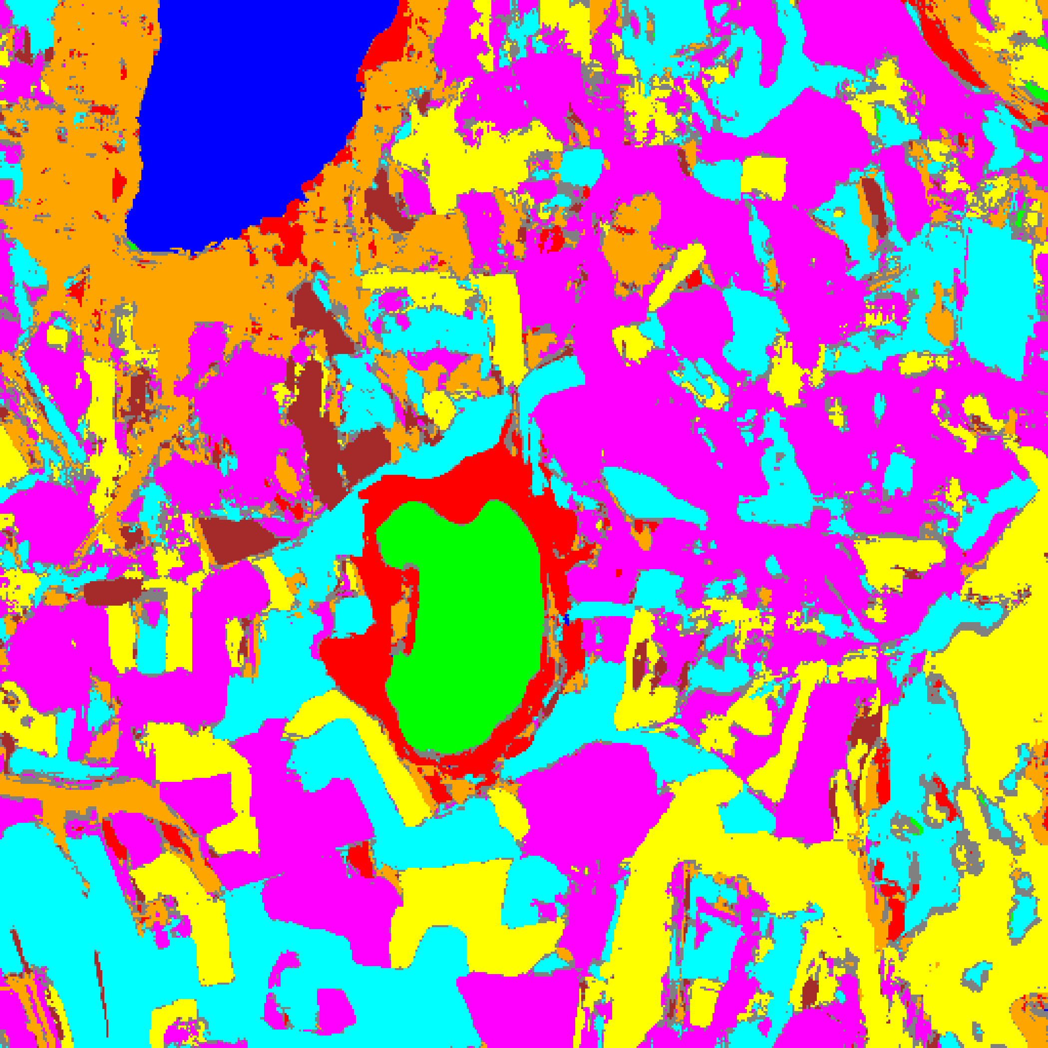  (B) GFNet
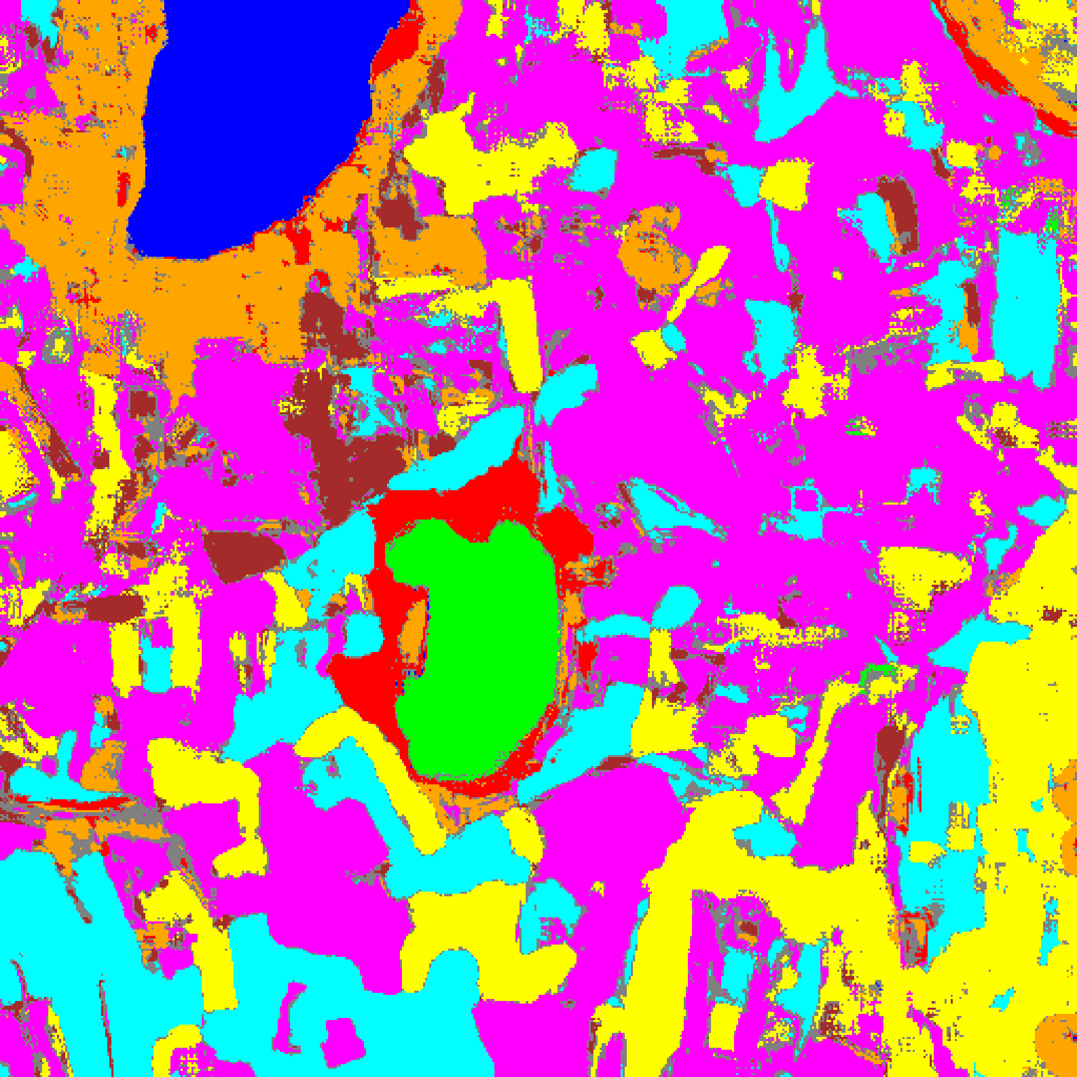  (C) ViT-UNet | (D) Legend
Fig. 4(b). Total uncertainty overlay maps (TU > 0.7): (A) AlexNet-CNN, (B) GFNet, (C) ViT-UNet. Class colours retained for TU-certain pixels; grey = TU-uncertain. Class legend shown in (D).
TABLE IV
CREDIT TU (> 0.7): AGGREGATE UNCERTAINTY SUMMARY
Model | Mean TU | Mean AU | Mean EU | TU-Uncertain Pixels | TU-Uncertain %
AlexNet-CNN | 0.002807 | 0.002527 | 0.000280 | 9,940 | 3.792%
GFNet | 0.007163 | 0.007162 | 0.000001 | 23,649 | 9.021%
ViT-UNet | 0.213608 | 0.213388 | 0.000220 | 25,767 | 9.829%

TABLE V
CREDIT TU (> 0.7): FULL-SCENE PIXEL COUNT DISTRIBUTION PER MODEL
Class / Region | AlexNet Pixels | GFNet Pixels | ViT-UNet Pixels
Class 0 | 11,296 | 11,428 | 11,409
Class 1 | 7,653 | 7,475 | 7,563
Class 2 | 9,060 | 9,782 | 7,240
Class 3 | 48,438 | 53,228 | 39,051
Class 4 | 90,452 | 78,344 | 94,715
Class 5 | 47,023 | 43,719 | 45,216
Class 6 | 10,696 | 6,407 | 9,142
Class 7 | 27,586 | 28,112 | 22,041
TU-Uncertain | 9,940 | 23,649 | 25,767
Total (Scene) | 262,144 | 262,144 | 262,144

Under TU > 0.7, AlexNet-CNN produces the fewest uncertain pixels (9,940, 3.792%), followed by GFNet (23,649, 9.021%) and ViT-UNet (25,767, 9.829%). Because EU ≤ 0.2 everywhere, every TU-uncertain pixel is also AU-uncertain (specifically, 9,940 of AlexNet’s 22,212 AU-uncertain pixels exceed TU > 0.7, leaving 12,272 AU-only pixels; for GFNet and ViT-UNet, 23,649 and 25,767 pixels exceed both thresholds, leaving 15,167 and 11,205 AU-only pixels respectively).
F. AU/EU/TU Decomposition Analysis
TABLE VI quantifies the relative contributions of aleatoric and epistemic components to total uncertainty across the three architectures.
TABLE VI
CREDIT UNCERTAINTY DECOMPOSITION SUMMARY
Model | Mean AU | Mean EU | Mean TU | AU / TU Fraction | EU / TU Fraction
AlexNet-CNN | 0.002527 | 0.000280 | 0.002807 | 90.02% | 9.98%
GFNet | 0.007162 | 0.000001 | 0.007163 | 99.99% | 0.01%
ViT-UNet | 0.213388 | 0.000220 | 0.213608 | 99.90% | 0.10%

Aleatoric uncertainty dominates total uncertainty across all three architectures, accounting for 90.02% of TU in AlexNet-CNN, 99.90% in ViT-UNet, and 99.99% in GFNet. AlexNet-CNN exhibits the largest relative epistemic fraction (9.98%), consistent with its local 9 × 9 convolutional receptive field leaving small seed-to-seed variations across teacher checkpoints at ambiguous boundaries.
IV. DISCUSSION
On the 65-band DIAS Scene K01 dataset, the rich spectral resolution allows all five ensemble teachers per architecture to converge to highly consistent predictions on labelled parcels, reducing test-set epistemic uncertainty to ≤ 0.00028. Consequently, prediction uncertainty across the scene is overwhelmingly driven by aleatoric entropy at class interfaces and unlabelled background pixels. ViT-UNet’s higher mean AU (0.2134 vs. 0.0025–0.0072) reflects less peaked teacher softmax distributions rather than classification errors, as confirmed by its 99.87% test accuracy.
V. CONCLUSION
This paper demonstrated Credal Ensemble Distillation (CREDIT) for patch-based 65-band hyperspectral land-cover classification on DIAS Scene K01 (512 × 512 pixels, K = 8 classes). All three dual-head students achieved 99.87%–100.00% test accuracy while decomposing predictive uncertainty into aleatoric and epistemic components in a single forward pass. Full-scene maps across all 262,144 pixels confirm that uncertainty is predominantly aleatoric (> 90% of TU) and concentrated along parcel boundaries and background transitions, with AlexNet-CNN achieving the smallest uncertain footprint (8.47% under AU > 0.5 and 3.79% under TU > 0.7).
REFERENCES
[1] K. Wang, F. Cuzzolin, D. Moens, and H. Hallez, “Credal Ensemble Distillation for Uncertainty Quantification,” arXiv:2511.13766, accepted AAAI 2026.
[2] Y. Rao, W. Zhao, Z. Zhu, J. Lu, and J. Zhou, “GFNet: Global Filter Networks for Visual Recognition,” IEEE TPAMI, 2023.
[3] A. Dosovitskiy et al., “An Image is Worth 16×16 Words: Transformers for Image Recognition at Scale,” in Proc. ICLR, 2021.
[4] O. Ronneberger, P. Fischer, and T. Brox, “U-Net: Convolutional Networks for Biomedical Image Segmentation,” in Proc. MICCAI, 2015.
[5] B. Lakshminarayanan, A. Pritzel, and C. Blundell, “Simple and Scalable Predictive Uncertainty Estimation using Deep Ensembles,” in Adv. Neural Inf. Process. Syst. (NeurIPS), 2017.
[6] A. Krizhevsky, I. Sutskever, and G. E. Hinton, “ImageNet Classification with Deep Convolutional Neural Networks,” in Adv. Neural Inf. Process. Syst. (NeurIPS), 2012.

