Diffusion-Augmented Probabilistic Modelling for Pixel-Wise Land-Cover Uncertainty Estimation in Hyperspectral Remote Sensing
ABSTRACT
This paper presents a domain-adaptive probabilistic framework—the Diffusion-based Adversarial Probabilistic Model (DAPM)—applied to patch-based pixel-wise land-cover classification and uncertainty estimation of a 65-band hyperspectral remote sensing scene from the DIAS dataset (Scene K01, 512 × 512 pixels, 262,144 total scene pixels, K = 8 classes: Class 0 through Class 7). DAPM extends the original NeurIPS 2023 formulation of Du & Li [1] to the remote-sensing domain by replacing the active-annotation loop with spatialised uncertainty mapping and operating on three interchangeable frozen backbones—AlexNet-CNN, GFNet, and ViT-UNet. A shared VAE encoder with a Gradient Reversal Layer (GRL) adversarially aligns labelled and unlabelled pixel representations; a conditional denoising diffusion model draws N = 30 stochastic predictions per pixel; and two complementary uncertainty paradigms are evaluated: (1) a Welch two-sample t-test across the N = 30 diffusion trajectories (p > 0.05), and (2) five distribution-free Conformal Prediction (CP) methods—SplitCP, Class-Conditional CP (CcCP), Rank-Calibrated Class-Conditional CP (RC3P), Clustered CP (ClCP), and Regularised Adaptive Prediction Sets (RAPS)—applied to the deterministic DAPM posterior probabilities at α = 0.05 (95% target coverage). On the 13,474-sample held-out test set, GFNet achieves OA = 100.00%, AlexNet-CNN achieves OA = 99.93%, and ViT-UNet achieves OA = 99.89%. Under Welch t-test diffusion sampling, full-scene labelled accuracies reach 99.998% (GFNet), 99.972% (AlexNet-CNN), and 99.965% (ViT-UNet) with uncertain pixel rates below 0.17% (434, 256, and 122 pixels respectively). Under Conformal Prediction on DAPM probabilities, CcCP and RC3P eliminate the minority-class under-coverage of SplitCP (raising mean per-class coverage from 0.8578–0.9107 to 0.9499–0.9630) while flagging 30.6%–45.8% of the full scene (predominantly unlabelled background and parcel boundaries) as uncertain.
I. INTRODUCTION
Remote sensing land-cover classification underpins agricultural monitoring, urban planning, and environmental change detection [11]. Hyperspectral imagery across 65 contiguous spectral bands enables discrimination of surface classes indistinguishable in standard RGB imagery. Despite the high classification accuracy achievable by modern deep architectures, deterministic softmax outputs do not directly quantify generative predictive uncertainty.
While conformal prediction (CP) methods explored in our companion paper offer distribution-free coverage guarantees post-hoc [9], DAPM (Diffusion-based Adversarial Probabilistic Model), introduced by Du & Li (NeurIPS 2023) [1] for Active Domain Adaptation, offers a complementary generative perspective: it explicitly models the distribution over class probability vectors by drawing N = 30 independent stochastic samples per pixel via conditional diffusion in label space, then applies a Welch t-test [10] to detect statistically indistinguishable top-two class distributions as uncertain pixels.
In this work we adapt DAPM to 65-band hyperspectral land-cover classification on three interchangeable frozen backbones (AlexNet-CNN, GFNet, ViT-UNet), provide a self-contained theoretical comparison against the original NeurIPS 2023 formulation, and evaluate both stochastic diffusion Welch t-test uncertainty (N = 30, p > 0.05) and five distribution-free Conformal Prediction methods (SplitCP, CcCP, RC3P, ClCP, and RAPS at α = 0.05) over the full 512 × 512 scene (262,144 pixels).
II. BACKGROUND & RELATIONSHIP TO THE ORIGINAL DAPM
A. The Original DAPM Algorithm (Du & Li, NeurIPS 2023)
DAPM was introduced for Active Domain Adaptation (ADA) [1]: a practitioner actively selects which unlabelled target-domain samples to annotate under domain shift. The original algorithm fine-tunes a ResNet-50 end-to-end; a shared VAE encodes features from source and target domains [2]; a GRL drives adversarial alignment [5]; an EMA teacher–student mechanism provides soft pseudo-labels for unlabelled data; and a conditional diffusion model [3, 4] generates N stochastic label predictions per sample, with the Welch t-test selecting the most uncertain samples for annotation.
B. Algorithmic Modifications in This Work
Three targeted modifications adapt DAPM to the 65-band hyperspectral pixel-classification context (see TABLE C-I): (1) Frozen interchangeable backbones—FREEZE_BACKBONE = True for AlexNet-CNN, GFNet [6], and ViT-UNet [7, 8]; (2) Labelled-vs-unlabelled pixel domain redefinition—labelled pixels (Y > 0, 53,893 patches) and unlabelled background pixels (Y = 0) within the same 512 × 512 scene serve as source and target domains; and (3) Self-training pseudo-labels replacing the EMA teacher—the classifier’s own stop-gradient softmax output serves as y_0 for unlabelled patches, with the target diffusion loss downweighted by λ_tgt_diff = 0.5.
TABLE C-I
COMPARISON: ORIGINAL DAPM (DU & LI, NEURIPS 2023) VS. THIS WORK
Aspect | Original DAPM [1] | This Work
Application | Active Domain Adaptation: sample selection for annotation budget | Pixel-wise land-cover uncertainty mapping in 65-band hyperspectral remote sensing
Source vs. target | Two distinct datasets/sensors (e.g. Office-31 Amazon→DSLR) | Labelled (Y>0) vs. unlabelled (Y=0) pixels within the same 512×512 scene
Backbone | ResNet-50, fine-tuned end-to-end during adaptation | Three frozen interchangeable backbones: AlexNet-CNN, GFNet, ViT-UNet
Pseudo-labels | EMA teacher–student knowledge distillation | Classifier stop-gradient softmax; λ_tgt_diff = 0.5
GRL align | ✓ Source/target dataset invariance | ✓ Retained (λ = 1.0); labelled vs. unlabelled pixel alignment
VAE encoder | ✓ Shared latent space, L dims | ✓ Shared VAE; L = 64; domain-specific decoders D_s, D_t
Diffusion | T timesteps, linear β schedule | Identical; T = 100, N = 30 draws per pixel
Welch t-test | Selects most uncertain samples for annotation (high p) | Flags uncertain pixels in dense 512×512 scene map (p > 0.05)
Evaluation | Accuracy after annotation rounds on Office-31, DomainNet | OA, AA, κ, wF1; uncertain pixel counts; spatialised maps

C. Detailed Term-by-Term Theoretical Comparison
Beyond the backbone substitution noted above, the adaptation involves eleven deeper modifications to the variational objective, network architectures, pseudo-labelling mechanism, and selection criterion relative to Du & Li [1], summarised in TABLE C-II:
- 1) Feature-space VAE target (cf. Eq. 8–10): The encoder E_ρ operates on penultimate-layer features h = f_φ(x) ∈ ℝ^d (d = 32 for AlexNet-CNN, d = 512 for GFNet, d = 64 for ViT-UNet) rather than reconstructing raw 9 × 9 × 65 patches, with latent dimension L = 64.
- 2) Stage-1 objective simplification (cf. Eq. 12–13): The classifier p_ω is trained in Stage 1 exclusively on labelled source cross-entropy L_CE without EMA knowledge distillation L_KD or batch-diversity regularisation.
- 3) Absence of EMA teacher–student mechanism: No EMA teacher copy is maintained; Stage-2 target pseudo-labels are generated directly from the frozen Stage-1 classifier.
- 4) Unconditional discriminator G_ψ(z): The domain discriminator G_ψ takes latent code z alone rather than a CDAN multilinear outer product D_τ(p_ω(y_0|z), z).
- 5) Direct self-training diffusion in Stage 2: Target diffusion uses y_0^t = sg[p_ω(·|z_μ^t)] over T = 100 timesteps (linear β ∈ [10⁻⁴, 0.02]) weighted by λ_tgt_diff = 0.5.
- 6) Single-block MLP diffusion architecture and dual stochastic sampling: The denoising network ε_θ concatenates [z, y_t, guidance, t-embedding] into a two-layer Dense(256, ReLU) MLP projecting to K = 8 classes, enabling fast evaluation across 30 × 100 × 262,144 = 7.86 × 10⁸ forward passes per backbone.
TABLE C-II
DETAILED COMPONENT-LEVEL DIFFERENCES BETWEEN ORIGINAL DAPM AND THIS WORK
Component | Original DAPM [1] | This Work (65-Band DIAS)
VAE reconstruction target | Raw image x via CNN decoder | Backbone feature h=f_φ(x)∈ℝ^d via 2-layer MLP decoder
Latent dimension L | 256 | 64
Discriminator conditioning | CDAN-style: D_τ(p_ω(y_0|z), z) | Unconditional: D_τ(z) only
Diffusion network ε_θ | Multi-block (3× 512→256 stages with Hadamard re-injection) | Single-block MLP (concat→Dense-256→Dense-256→Dense-8)
Diffusion timesteps T | 1000 | 100
Sampling draws N | 100 | 30
Stochastic source per draw | Diffusion reverse chain only (z held fixed) | Both VAE z resampled AND diffusion chain (dual stochasticity)
Pseudo-label source | EMA teacher (β=0.99), confidence-gated (α=0.9) | Direct stop-gradient from frozen Stage-1 classifier; λ_tgt_diff=0.5
Active-learning loop | R rounds, budget B, top-b query migration | Single pass (R=1, B=0); full-scene uncertainty mapping
T-test decision rule | Top-b ranking by p-value | SciPy Welch t-test (equal_var=False) with threshold p > 0.05
Input modality | 224×224×3 RGB natural images | 9×9×65 hyperspectral patches (512×512 scene, K=8 classes)

D. Architecture Capacity and Hyperparameter Comparison
TABLE C-III and TABLE C-IV compare the trainable parameter counts (excluding the frozen backbones) and hyperparameters of our K = 8 implementation against the original DAPM formulation. Evaluating N = 30 draws of T = 100 diffusion steps across all 262,144 pixels requires N × T × n_pixels = 30 × 100 × 262,144 = 786,432,000 (≈ 7.86 × 10⁸) forward evaluations of ε_θ per backbone (≈ 2.36 × 10⁹ across all three backbones), completing in 464.8–533.4 s per model.
TABLE C-III
EXACT TRAINABLE-PARAMETER COUNTS (THIS WORK, K = 8) VS. ORIGINAL DAPM
Sub-network | Original DAPM [1] (ResNet-50 Path) | AlexNet-CNN (d=32) | GFNet (d=512) | ViT-UNet (d=64)
VAE encoder E_ρ | ~1,311,744 | 107,136 | 230,016 | 115,328
Source decoder D_s | ~1,182,208 | 90,656 | 214,016 | 98,880
Target decoder D_t | ~1,182,208 | 90,656 | 214,016 | 98,880
VAE subtotal | ~3,676,160 | 288,448 | 658,048 | 313,088
Classifier p_ω | 256 × K linear layer | 9,352 | 9,352 | 9,352
Discriminator D_τ | CDAN outer-product (~10⁶–10⁷) | 24,961 | 24,961 | 24,961
Diffusion ε_θ | Multi-block (>10⁵) | 99,754 | 99,754 | 99,754
Total (excl. backbone) | > 3.8 × 10⁶ | 422,515 | 792,115 | 447,155

TABLE C-IV
HYPERPARAMETER COMPARISON: ORIGINAL DAPM [1] VS. THIS WORK
Hyperparameter | Original DAPM [1] | This Work (65-Band DIAS)
Optimiser (Stage 1 & Stage 2) | SGD (Stage 1) / Adam lr=1e-3 (Stage 2) | Adam, lr = 1e-3
Batch size | 32 (ADA) / 64 (SFDA) | 128
Latent / hidden dims | L=256, decoder 512 | L=64, decoder 256, classifier 128, diffusion 256
Loss weights (λ_src, λ_tgt, λ_CE, λ_KL, λ_dom) | ELBO + L_KD + L_KL + L_adv | 1.0, 1.0, 1.0, 0.01, 0.2 (λ_tgt_diff = 0.5)
Diffusion schedule (β_1, β_T, T, N) | 1e-4, 0.02, T=1000, N=100 | 1e-4, 0.02, T=100, N=30
Welch t-test threshold α_ttest | Top-b rank selection | p > 0.05 (hard threshold across 262,144 pixels)

III. METHODOLOGY
A. Dataset, Preprocessing, and Domain Definition
The dataset is the 65-band hyperspectral scene K01 from the DIAS benchmark (files k001.mat and k002.mat, H = 512, W = 512 pixels, B = 65 bands) with K = 8 land-cover classes (Class 0 through Class 7; 53,893 labelled patches). Unlabelled background pixels (Y = 0, 208,251 pixels) form the target domain. For each pixel a 9 × 9 × 65 patch is extracted from an edge-padded scene; labelled pixels are partitioned into training/validation and a held-out test set of 13,474 samples (supports: 2,432, 1,408, 566, 2,729, 3,180, 2,119, 399, and 641 across Class 0–7). Each spectral band is min-max normalised to [0, 1] with ε = 10⁻⁸.
B. Stage 1: VAE + GRL Adversarial Training
Each frozen backbone f_φ produces feature h = f_φ(x) ∈ ℝ^d. A shared VAE encoder E_θ maps h to a latent Gaussian:
E_θ(h) = (μ, log σ²); z = μ + exp(0.5·log σ²) ⊙ ε, ε ∼ N(0, I_L), L = 64
Domain-specific decoders D_s and D_t reconstruct features from z, while a domain discriminator G_ψ with GRL (λ = 1.0) enforces domain-invariant representations:
L_1 = λ_src·L_recon^s + λ_tgt·L_recon^t + λ_KL·(KL_src + KL_tgt) + λ_CE·L_CE + λ_dom·L_dom
C. Stage 2: Conditional Diffusion Training on Label Vectors
A conditional denoising diffusion network ε_ψ is trained to predict noise added to label vector y_0 ∈ ℝ^K (K = 8) at timestep t ∈ {1, ..., T} (T = 100):
y_t = √ā_t·y_0 + √(1 − ā_t)·ε, ε ∼ N(0, I_K); L_2 = L_diff^s + λ_tgt_diff·L_diff^t (λ_tgt_diff = 0.5)
D. Inference: Stochastic Sampling and Welch T-Test
N = 30 latent codes are sampled per pixel, each seeding a T = 100 reverse diffusion chain. A Welch t-test compares the N-sample distributions of the top-two classes c_1, c_2:
t = (ḡ_1 − ḡ_2) / √(s_1²/N + s_2²/N); uncertain if p-value > α_ttest = 0.05
E. Inference Paradigm 2: Conformal Prediction on DAPM Posterior Probabilities
Complementing the stochastic diffusion Welch t-test, we evaluate five distribution-free Conformal Prediction (CP) methods applied directly to the deterministic DAPM posterior probabilities p_ω(y | z_μ) obtained by passing the VAE posterior mean z_μ through the Stage-1 classifier without reverse diffusion sampling. Let the 13,474 held-out test samples be partitioned into n = 6,737 calibration samples and 6,737 evaluation samples via stratified splitting, targeting marginal and class-conditional coverage 1 − α = 0.95 (α = 0.05) [9, 12]:
1) Split Conformal Prediction (SplitCP): Computes nonconformity scores s(x_i, y_i) = 1 − p̂(y_i | x_i) across all calibration samples and sets a single global quantile threshold q̂ = Quantile(⌈(n + 1)(1 − α)⌉ / n), forming prediction sets C(x) = {y : 1 − p̂(y | x) ≤ q̂} with finite-sample marginal coverage P(Y ∈ C(X)) ≥ 1 − α [13].
2) Class-Conditional Conformal Prediction (CcCP): Partitions the calibration set by true class c ∈ {0, ..., K − 1} and computes an independent conformal quantile q̂_c for each class, guaranteeing balanced coverage across both majority and minority land-cover classes [14].
3) Rank-Calibrated Class-Conditional CP (RC3P): Augments CcCP with a calibrated per-class rank threshold k̂(y) so that a candidate label y is included in C(x) only if both its nonconformity score satisfies s(x, y) ≤ q̂_y and its descending softmax rank is at most k̂(y), sharpening prediction set efficiency while preserving class-conditional coverage [15].
4) Clustered Conformal Prediction (ClCP): Embeds calibration samples into the 64-dimensional DAPM VAE latent space z_μ, standardises class-wise summary vectors combining latent means/dispersions with calibration nonconformity quantile profiles, and groups the K = 8 classes into K_g = 4 clusters via K-Means to share calibration statistics across representationally similar classes [16].
5) Regularised Adaptive Prediction Sets (RAPS): Constructs adaptive prediction sets by accumulating sorted class probabilities from highest to lowest and adding a rank-regularisation penalty λ·max(0, rank(y) − k_reg) with λ = 0.01 and k_reg = 1, plus uniform randomisation U ∼ Uniform(0, 1) on the boundary rank [17].
IV. EXPERIMENTS AND RESULTS
A. Training Summary
TABLE I reports the final Stage-1 and Stage-2 losses and validation accuracies from dapm_full_training_summary.csv. Both AlexNet-CNN (d = 32) and GFNet (d = 512) reach 99.99% Stage-1 validation accuracy (0.999878), while ViT-UNet (d = 64) reaches 99.94% (0.999390). Stage-2 validation diffusion losses converge to 0.3007, 0.1806, and 0.1720 respectively.
TABLE I
DAPM TRAINING SUMMARY (STAGE 1 & STAGE 2 FINAL LOSSES)
Model | Feat. Dim | S1 Val Acc (%) | S1 Val CE Loss | S1 Src Recon | S1 Tgt Recon | S2 Diff Loss | S2 Val Diff Loss
AlexNet-CNN | 32 | 99.99 | 0.0005 | 4.1084 | 2.7551 | 0.5142 | 0.3007
GFNet | 512 | 99.99 | 0.0009 | 1.3982 | 5.7702 | 0.2443 | 0.1806
ViT-UNet | 64 | 99.94 | 0.0038 | 0.0486 | 0.1439 | 0.2430 | 0.1720

B. Test-Set Classification Performance
TABLE II and TABLE III present the classification metrics on the held-out test set (13,474 samples). GFNet achieves a perfect 100.00% overall accuracy (OA = 100.00%, AA = 100.00%, κ = 1.0000, weighted-F1 = 1.0000), AlexNet-CNN achieves OA = 99.93% (AA = 99.80%, κ = 0.9992, weighted-F1 = 0.9993), and ViT-UNet achieves OA = 99.89% (AA = 99.82%, κ = 0.9987, weighted-F1 = 0.9989).
TABLE II
DAPM TEST-SET CLASSIFICATION METRICS (13,474 SAMPLES)
Model | OA (%) | AA (%) | Cohen’s κ | Weighted F1
AlexNet-CNN | 99.93 | 99.80 | 0.9992 | 0.9993
GFNet | 100.00 | 100.00 | 1.0000 | 1.0000
ViT-UNet | 99.89 | 99.82 | 0.9987 | 0.9989

TABLE III
DAPM PER-CLASS PRECISION / RECALL / F1 ACROSS BACKBONES
Class | AlexNet P | AlexNet R | AlexNet F1 | GFNet P | GFNet R | GFNet F1 | ViT P | ViT R | ViT F1 | Support
Class 0 | 1.0000 | 1.0000 | 1.0000 | 1.0000 | 1.0000 | 1.0000 | 1.0000 | 0.9996 | 0.9998 | 2432
Class 1 | 1.0000 | 1.0000 | 1.0000 | 1.0000 | 1.0000 | 1.0000 | 1.0000 | 1.0000 | 1.0000 | 1408
Class 2 | 1.0000 | 0.9982 | 0.9991 | 1.0000 | 1.0000 | 1.0000 | 0.9930 | 0.9982 | 0.9956 | 566
Class 3 | 0.9996 | 1.0000 | 0.9998 | 1.0000 | 1.0000 | 1.0000 | 0.9993 | 0.9985 | 0.9989 | 2729
Class 4 | 0.9991 | 1.0000 | 0.9995 | 1.0000 | 1.0000 | 1.0000 | 0.9994 | 0.9997 | 0.9995 | 3180
Class 5 | 0.9991 | 0.9991 | 0.9991 | 1.0000 | 1.0000 | 1.0000 | 0.9981 | 0.9986 | 0.9983 | 2119
Class 6 | 0.9950 | 0.9900 | 0.9925 | 1.0000 | 1.0000 | 1.0000 | 0.9925 | 0.9975 | 0.9950 | 399
Class 7 | 0.9984 | 0.9969 | 0.9977 | 1.0000 | 1.0000 | 1.0000 | 1.0000 | 0.9938 | 0.9969 | 641

C. Full-Scene Classification Maps
Fig. 1 presents the full-scene land-cover classification maps across all 262,144 pixels of the 512 × 512 scene using the deterministic mean path.
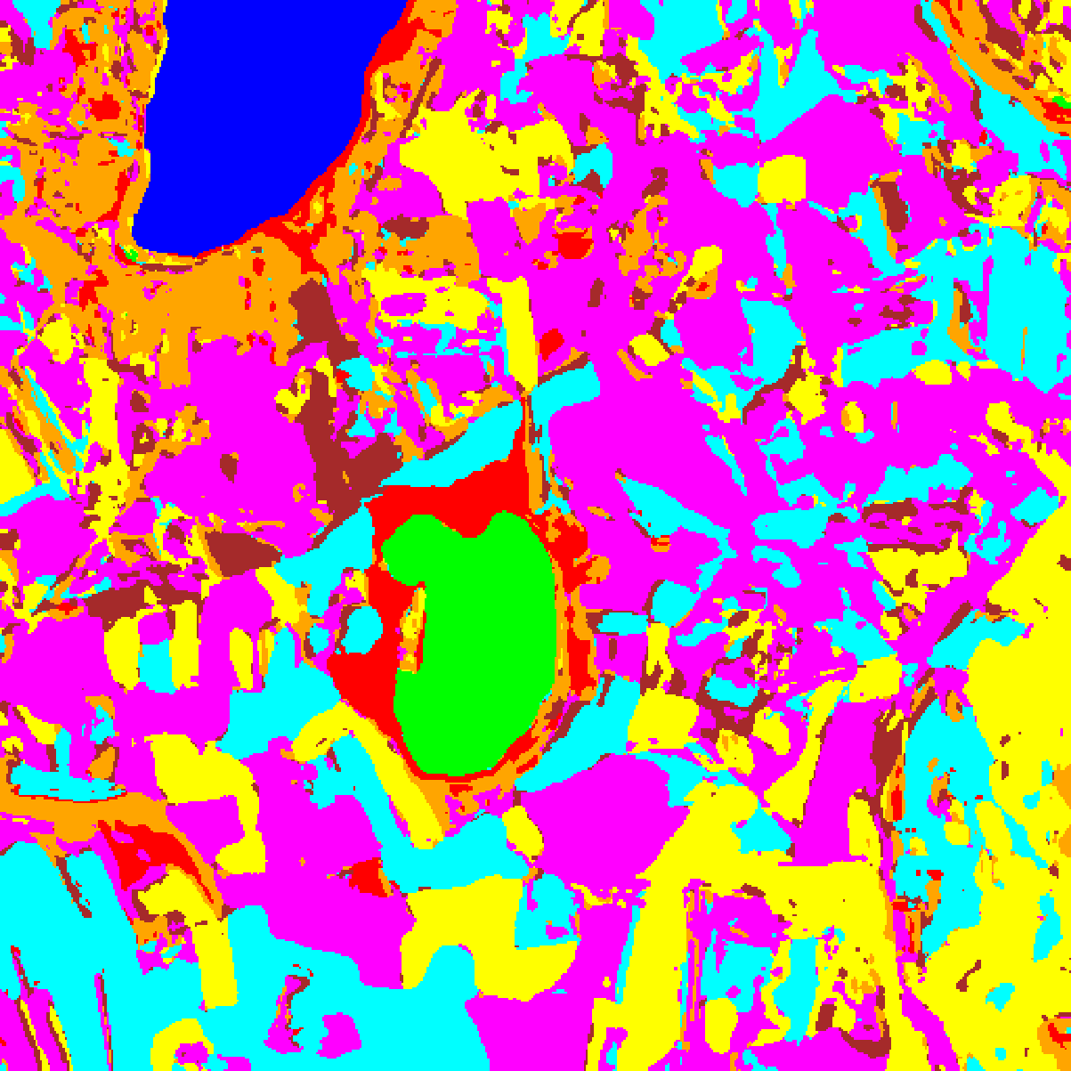  (A) AlexNet-CNN | 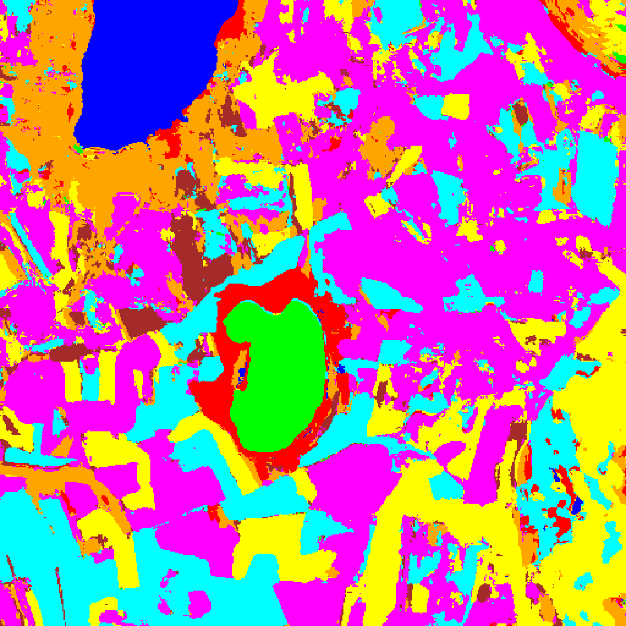  (B) GFNet
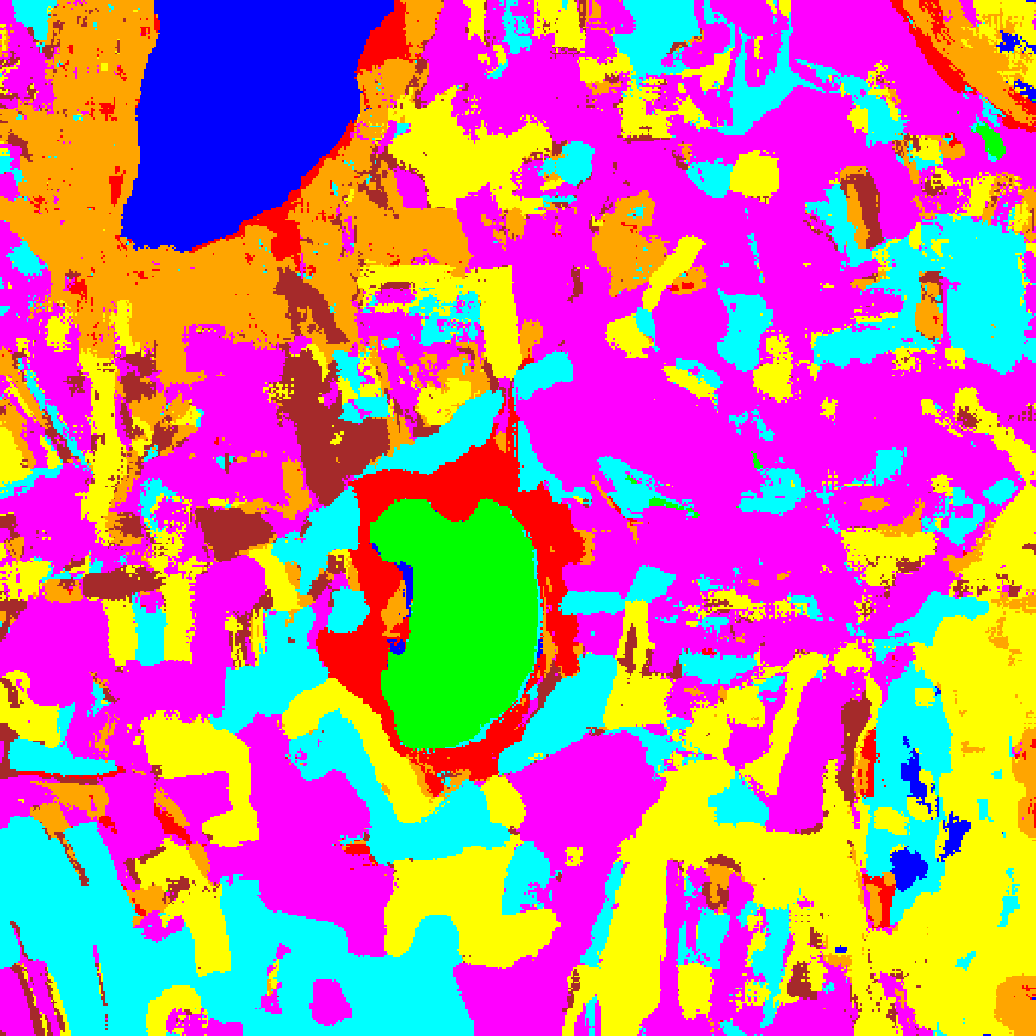  (C) ViT-UNet | 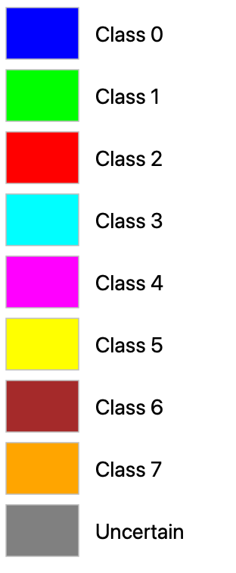  (D) Class Legend
Fig. 1. DAPM full-scene deterministic classification maps across all 512 × 512 pixels: (A) AlexNet-CNN, (B) GFNet, (C) ViT-UNet, with (D) class legend.
D. Diffusion Uncertainty Quantification Results
TABLE IV and TABLE V summarise the full-scene stochastic diffusion evaluation (N = 30 draws per pixel, α_ttest = 0.05) across all 262,144 pixels (53,893 labelled pixels). On all labelled pixels in the scene, GFNet achieves 99.998% accuracy (only 1 misclassified pixel out of 53,893), AlexNet-CNN achieves 99.972%, and ViT-UNet achieves 99.965%. Uncertain pixel counts across the 262,144-pixel scene are remarkably small: 434 (0.166%) for AlexNet-CNN, 256 (0.098%) for GFNet, and 122 (0.047%) for ViT-UNet.
TABLE IV
DAPM FULL-SCENE UNCERTAINTY SUMMARY (N = 30 DRAWS, P > 0.05, 262,144 PIXELS)
Model | Labelled OA (%) | Uncertain Px | Uncertain (%) | Certain (%) | Mean p-Value | Mean Top1-2 Gap | Runtime (s)
AlexNet-CNN | 99.972 | 434 | 0.166 | 99.834 | 0.000649 | 0.1613 | 486.7
GFNet | 99.998 | 256 | 0.098 | 99.902 | 0.000370 | 0.1649 | 518.2
ViT-UNet | 99.965 | 122 | 0.047 | 99.953 | 0.000193 | 0.1709 | 542.1

TABLE V
DAPM: PREDICTED PIXEL COUNT DISTRIBUTION PER MODEL (512 × 512 = 262,144 PIXELS)
Class / Region | AlexNet Pixels | GFNet Pixels | ViT-UNet Pixels | Colour
Class 0 | 10,815 | 11,868 | 12,441 | Blue
Class 1 | 7,793 | 8,008 | 7,735 | Green
Class 2 | 9,382 | 9,930 | 9,776 | Red
Class 3 | 50,463 | 50,718 | 45,892 | Cyan
Class 4 | 92,157 | 93,811 | 94,248 | Magenta
Class 5 | 48,557 | 48,695 | 52,171 | Yellow
Class 6 | 16,168 | 9,546 | 11,313 | Dark Brown
Class 7 | 26,375 | 29,312 | 28,446 | Orange
Uncertain | 434 | 256 | 122 | Grey
Total (Scene) | 262,144 | 262,144 | 262,144 | —

E. Binary Uncertainty Maps and Classification + Uncertainty Masks
Fig. 2 presents the binary Welch t-test uncertainty maps (yellow = certain, dark blue = uncertain), and Fig. 3 presents the classification + uncertainty masks across the 512 × 512 scene.
  (A) AlexNet-CNN |   (B) GFNet
  (C) ViT-UNet | 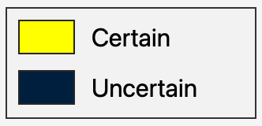  (D) Legend
Fig. 2. DAPM binary uncertainty maps (Welch t-test, p = 0.05): (A) AlexNet-CNN, (B) GFNet, (C) ViT-UNet. Yellow = certain; dark blue = uncertain. Legend (D). Pixel counts: AlexNet 434, GFNet 256, ViT-UNet 122.
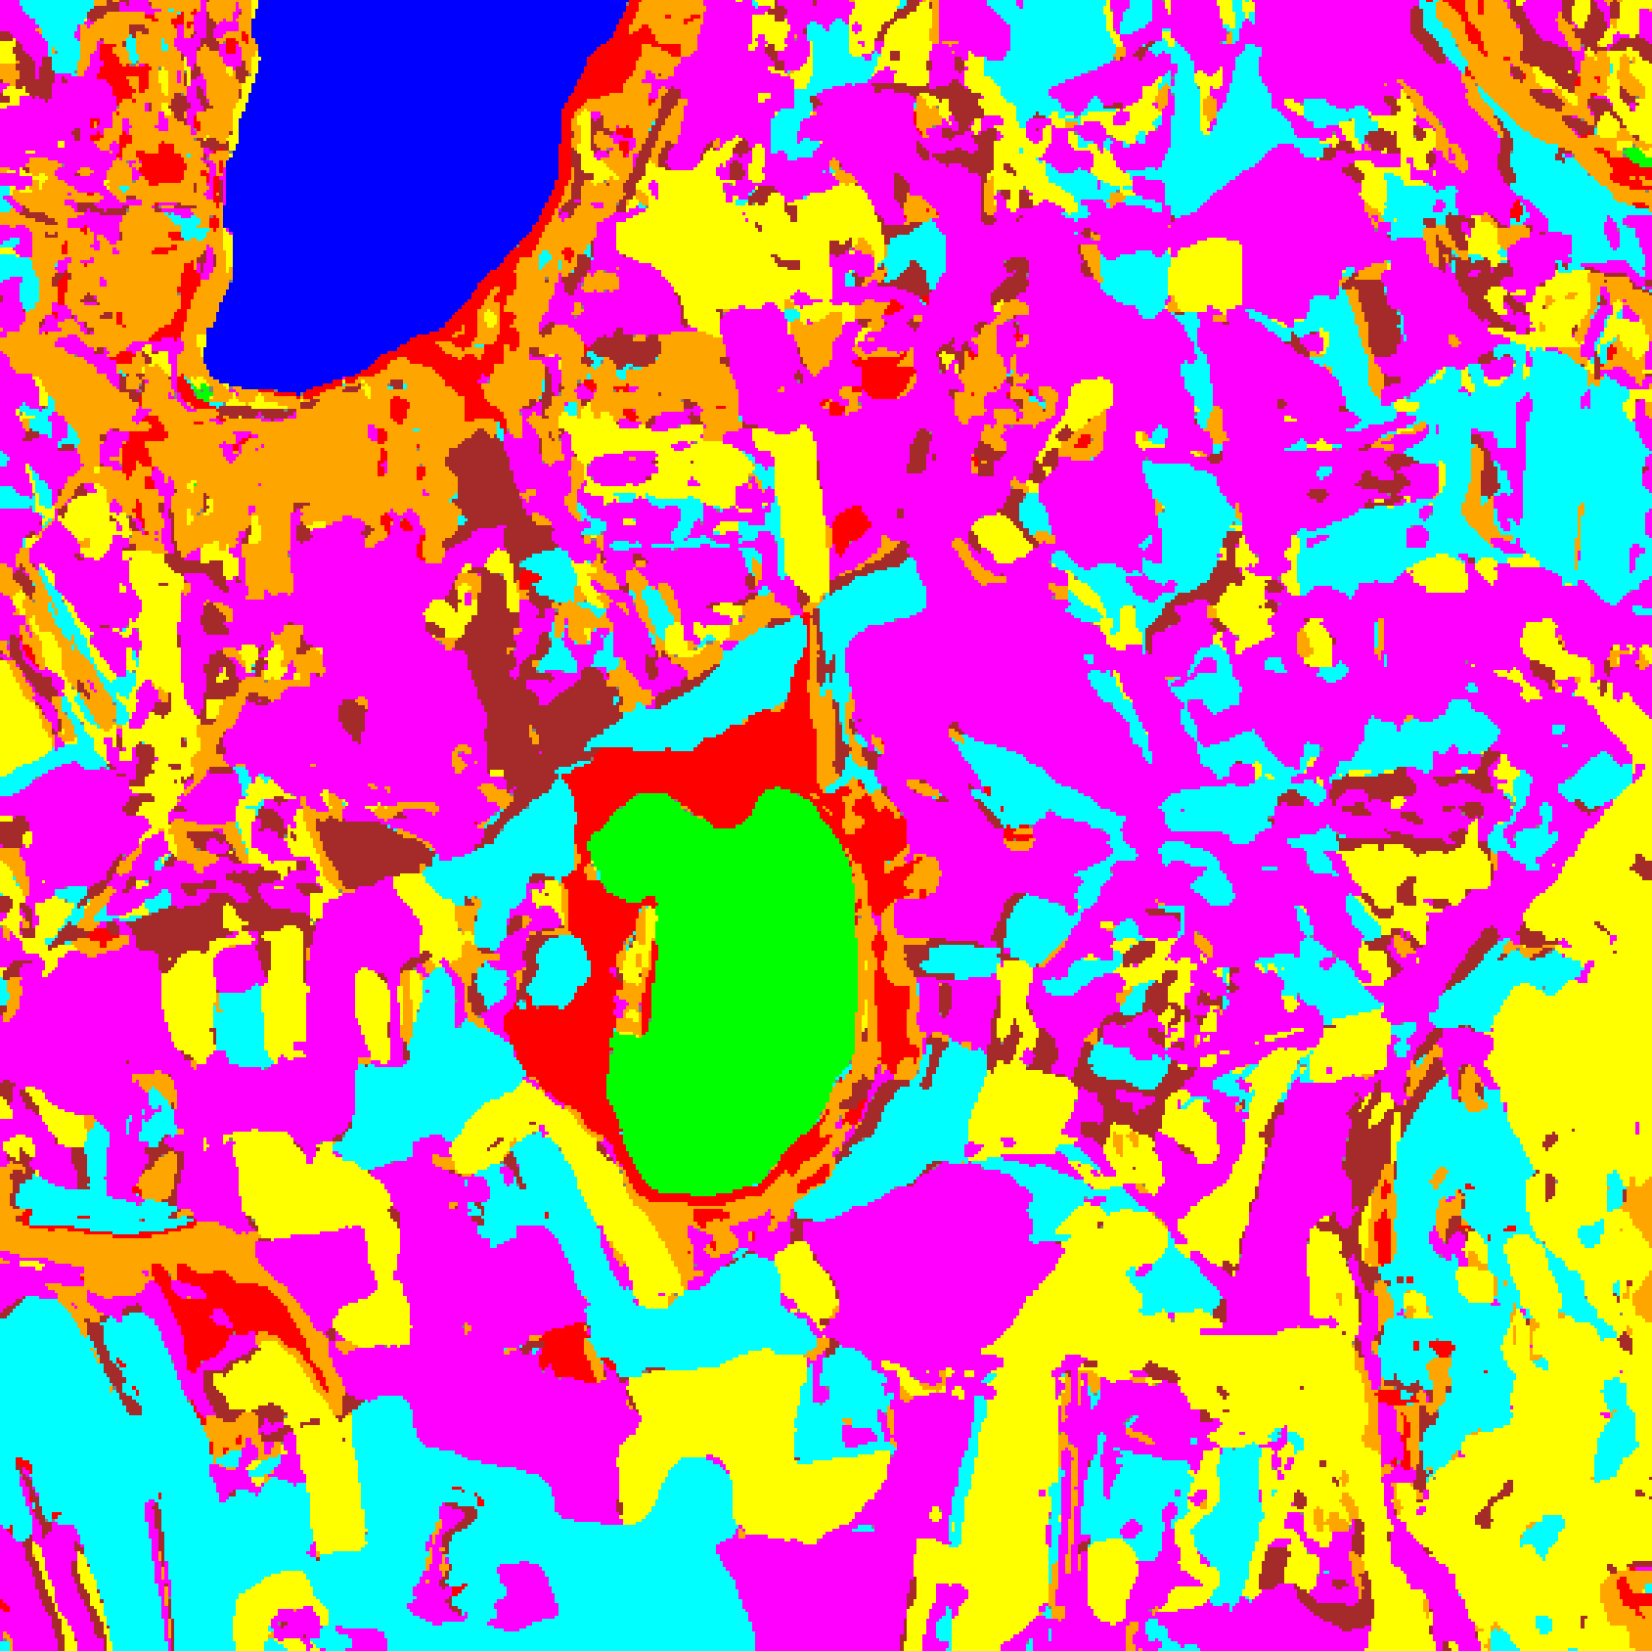  (A) AlexNet-CNN | 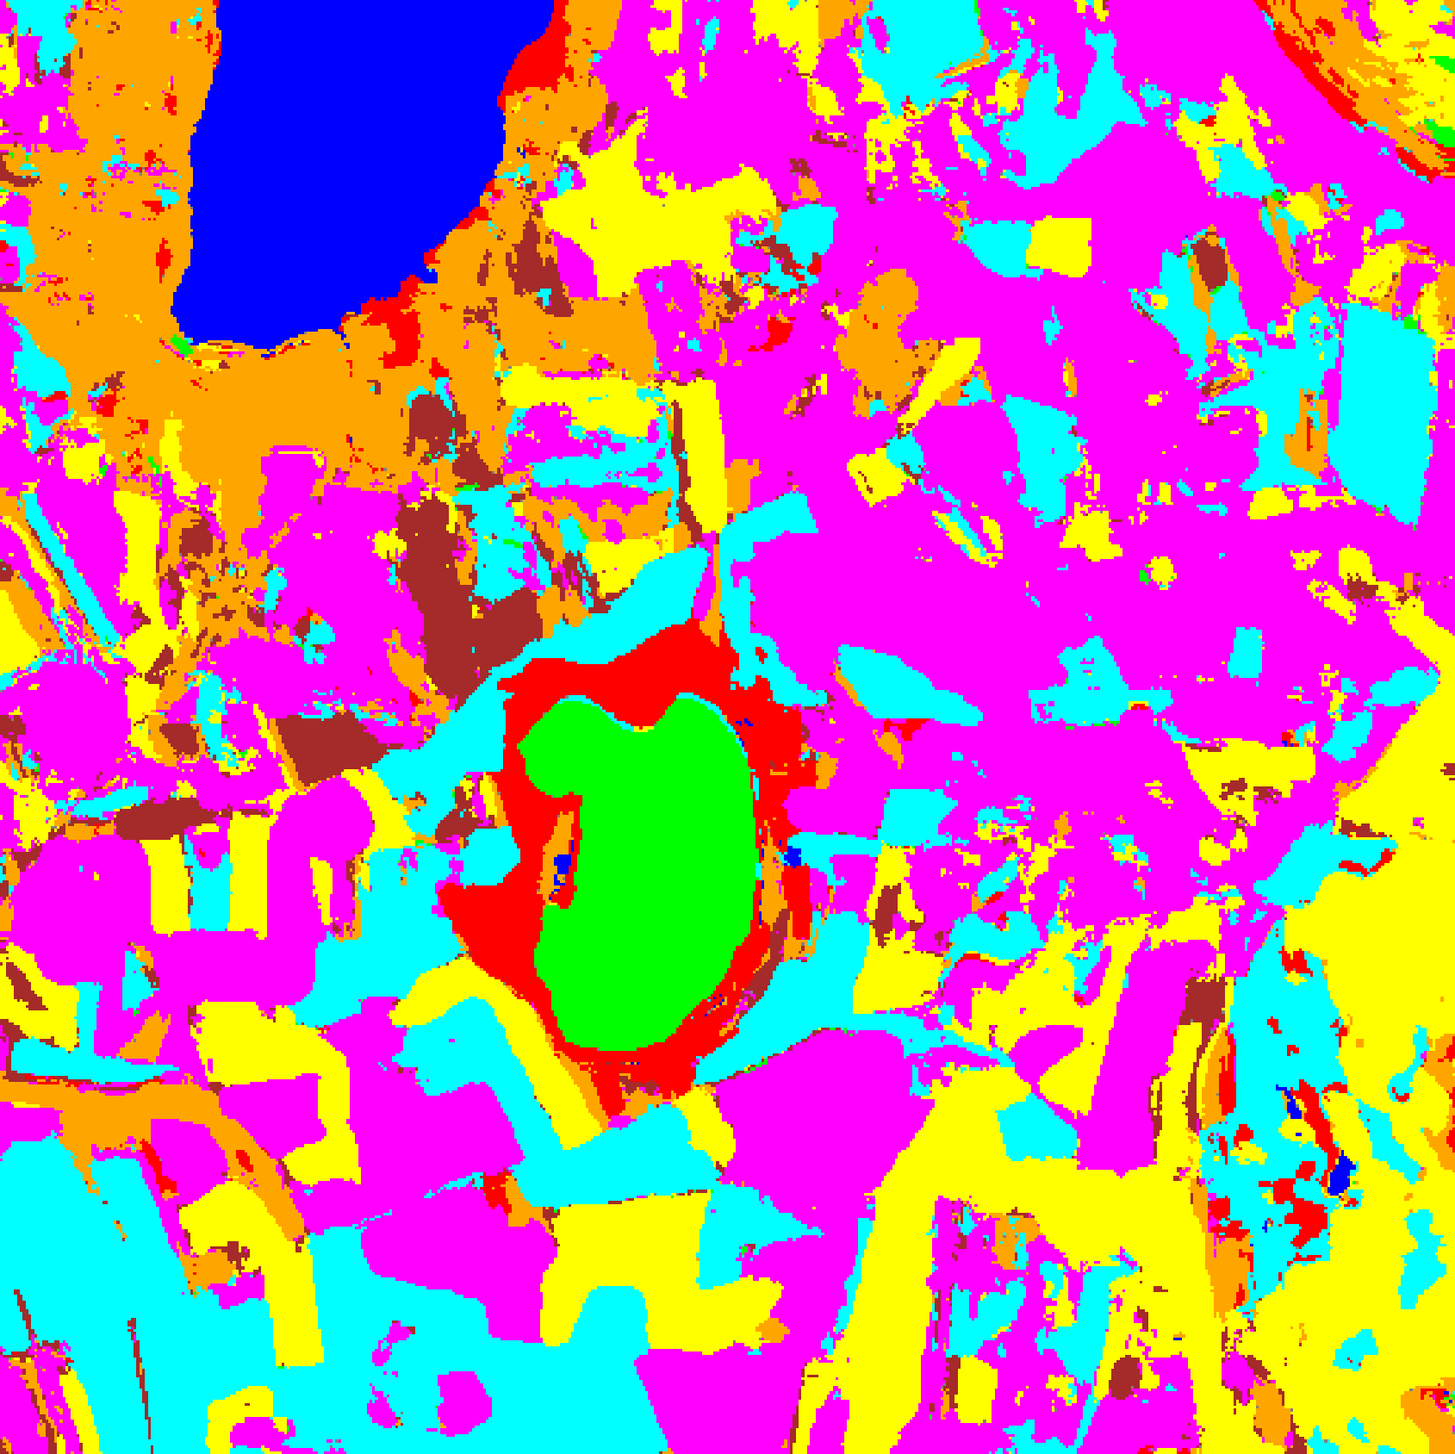  (B) GFNet
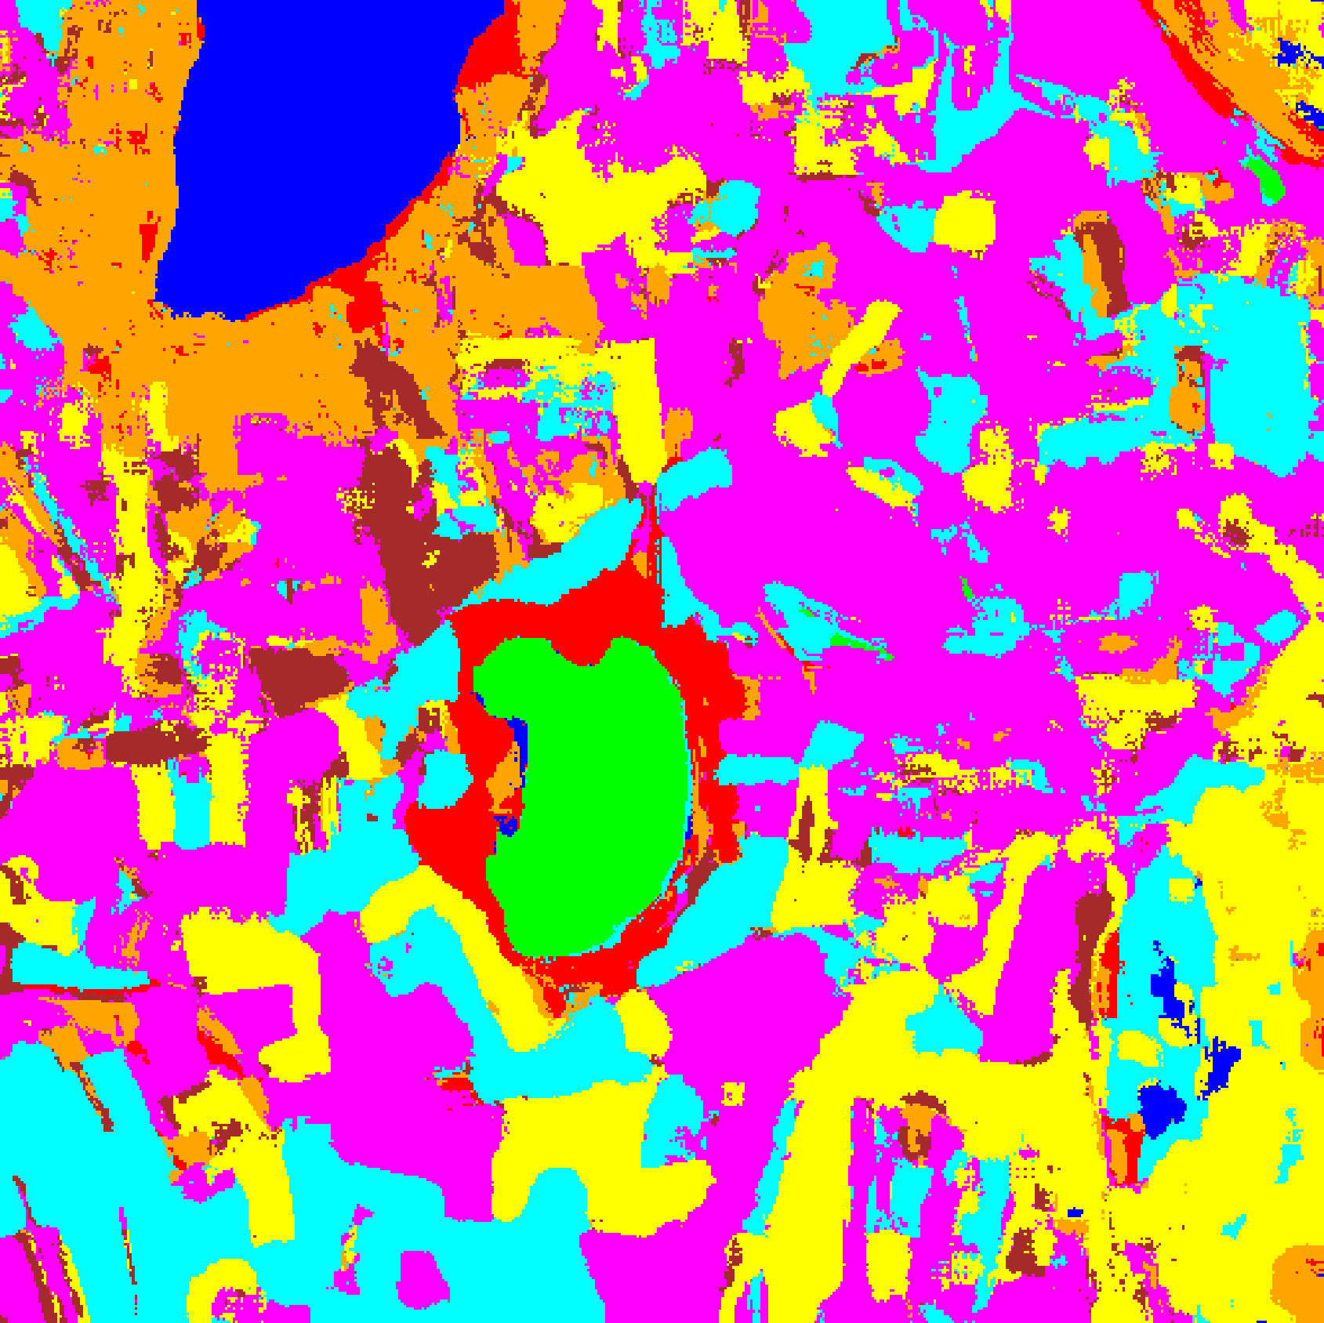  (C) ViT-UNet | (D) Class Legend
Fig. 3. DAPM classification + uncertainty masks: (A) AlexNet-CNN, (B) GFNet, (C) ViT-UNet. Colours = predicted class (see legend D); grey = uncertain (p > 0.05).
F. Split Conformal Prediction (SplitCP) Results on DAPM
SplitCP was applied to the deterministic DAPM posterior probabilities across all three backbones at α = 0.05 (target coverage 95.0%). TABLE VI summarises the aggregate evaluation metrics across the 6,737 held-out evaluation samples. AlexNet-CNN (empirical coverage 0.9509, q̂ = 0.000332) and ViT-UNet (0.9516, q̂ = 0.000007) exceed the 95% target, while GFNet achieves 0.9473 (q̂ = 0.000032). Because the DAPM Stage-1 classifier produces highly peaked posterior probabilities on labelled test patches, all three models yield ultra-small conformal thresholds q̂, resulting in prediction sets that are exclusively singletons (singleton rate = empirical coverage) or empty sets on rejected boundary/ambiguous samples.
TABLE VI
SPLIT CONFORMAL PREDICTION (DAPM): AGGREGATE SUMMARY (Α = 0.05)
Model | q̂ | Emp. Cov. | Avg Set Size | Singleton Rate | Empty Set Rate | Runtime (s) | Mean Cls Cov.
AlexNet-CNN | 0.000332 | 0.9509 | 0.9509 | 0.9509 | 0.0491 | 2.245 | 0.9107
GFNet | 0.000032 | 0.9473 | 0.9473 | 0.9473 | 0.0527 | 2.217 | 0.8874
ViT-UNet | 0.000007 | 0.9516 | 0.9518 | 0.9518 | 0.0482 | 2.154 | 0.8578

Per-class coverage under SplitCP is reported in TABLE VII. Because SplitCP pools all calibration samples into a single global quantile dominated by majority classes (Classes 0, 3, 4, and 5), minority classes suffer substantial under-coverage: Class 6 (200 evaluation samples) drops to 0.7800 (AlexNet-CNN), 0.7050 (GFNet), and 0.6400 (ViT-UNet), while Class 7 (320 samples) drops to 0.7625, 0.6781, and 0.4875, pulling mean per-class coverage down to 0.9107, 0.8874, and 0.8578 respectively.
TABLE VII
SPLIT CP (DAPM): PER-CLASS COVERAGE COMPARISON ACROSS MODELS
Class | AlexNet-CNN Coverage | GFNet Coverage | ViT-UNet Coverage
Class 0 | 0.9967 | 0.9992 | 0.9984
Class 1 | 0.9915 | 0.9986 | 1.0000
Class 2 | 0.9011 | 0.8339 | 0.7491
Class 3 | 0.9458 | 0.9692 | 0.9927
Class 4 | 0.9962 | 0.9767 | 0.9969
Class 5 | 0.9122 | 0.9386 | 0.9981
Class 6 | 0.7800 | 0.7050 | 0.6400
Class 7 | 0.7625 | 0.6781 | 0.4875
Mean | 0.9107 | 0.8874 | 0.8578

TABLE VIII presents the full-scene predicted pixel count distribution across all 512 × 512 = 262,144 scene pixels under SplitCP, and Fig. 4(a) and Fig. 4(b) display the corresponding binary uncertainty maps and class + uncertainty masks. Across the entire scene, SplitCP flags 88,086 pixels (33.60%) for AlexNet-CNN, 119,180 pixels (45.46%) for GFNet, and 72,784 pixels (27.76%) for ViT-UNet as uncertain.
TABLE VIII
SPLIT CP (DAPM): FULL-SCENE PREDICTED PIXEL COUNT DISTRIBUTION PER MODEL
Class / Region | AlexNet-CNN Pixels | GFNet Pixels | ViT-UNet Pixels
Class 0 | 10,335 | 10,985 | 11,508
Class 1 | 6,828 | 6,886 | 7,450
Class 2 | 5,694 | 3,674 | 4,133
Class 3 | 31,120 | 32,298 | 36,141
Class 4 | 68,739 | 55,801 | 76,511
Class 5 | 34,117 | 24,724 | 41,467
Class 6 | 5,406 | 1,667 | 3,222
Class 7 | 11,819 | 6,929 | 8,928
Uncertain | 88,086 | 119,180 | 72,784
Total (Scene) | 262,144 | 262,144 | 262,144

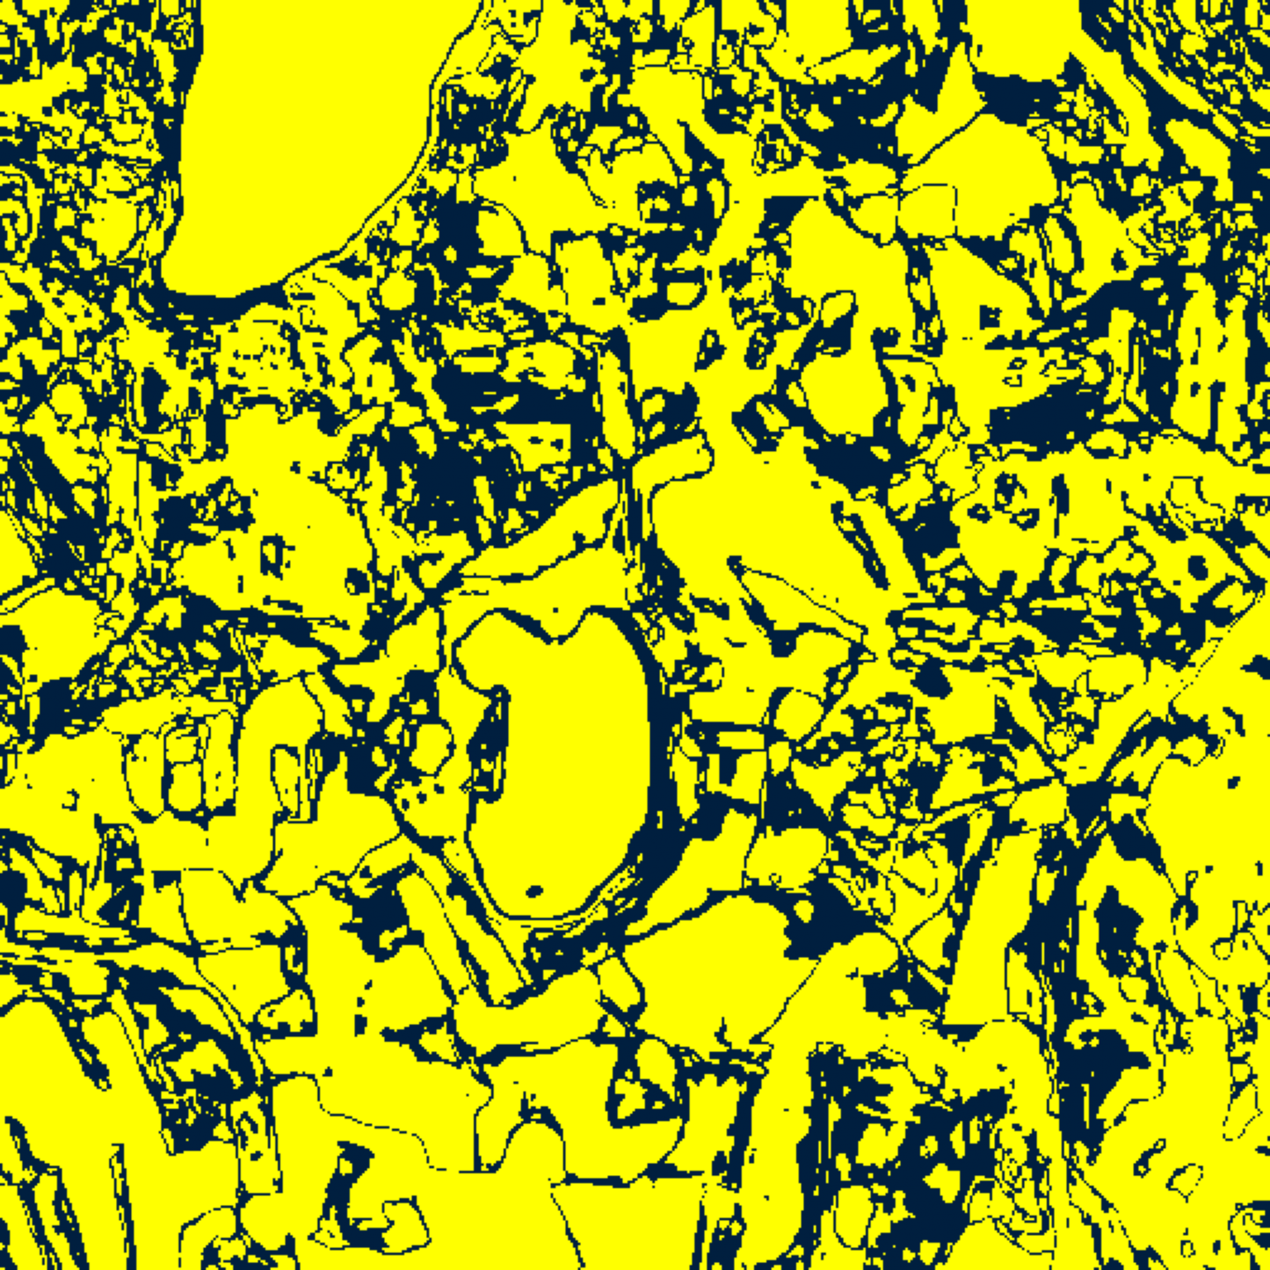  (A) AlexNet-CNN | 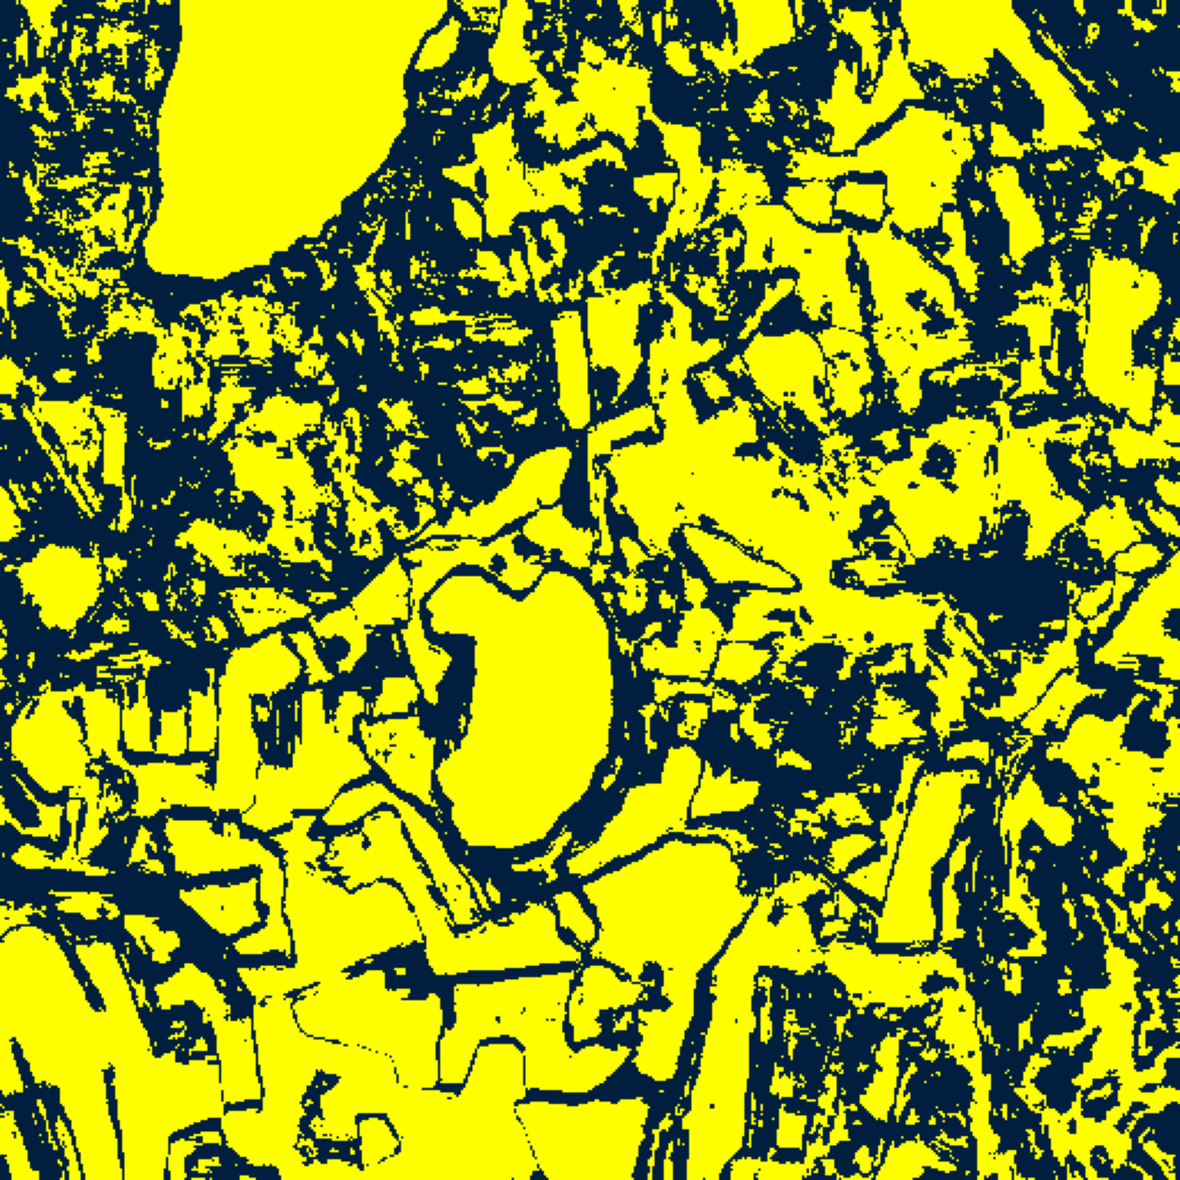  (B) GFNet
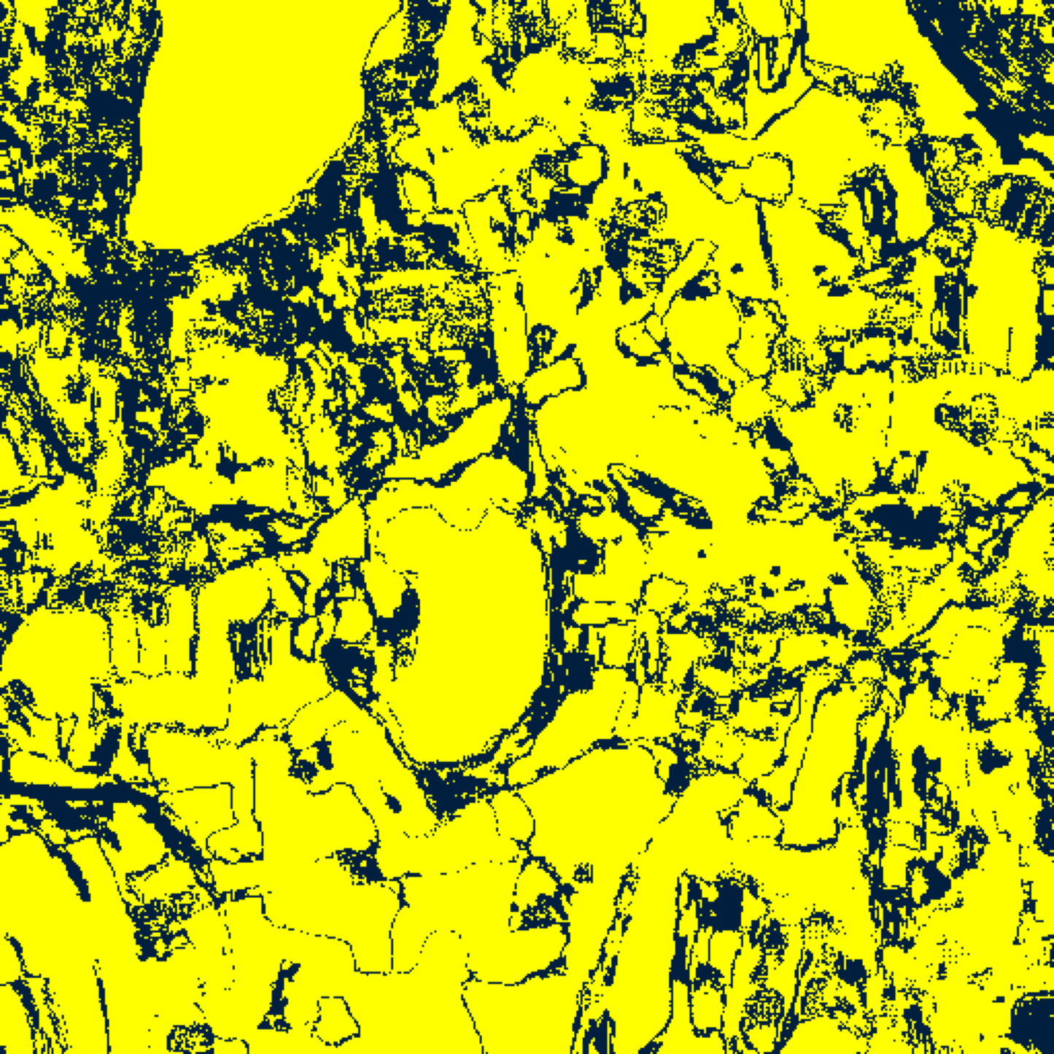  (C) ViT-UNet | (D) Legend
Fig. 4(a). SplitCP (DAPM) 95% binary uncertainty maps: (A) AlexNet-CNN, (B) GFNet, (C) ViT-UNet, (D) Legend. Yellow = certain singleton; dark navy = uncertain (88,086, 119,180, and 72,784 uncertain pixels).
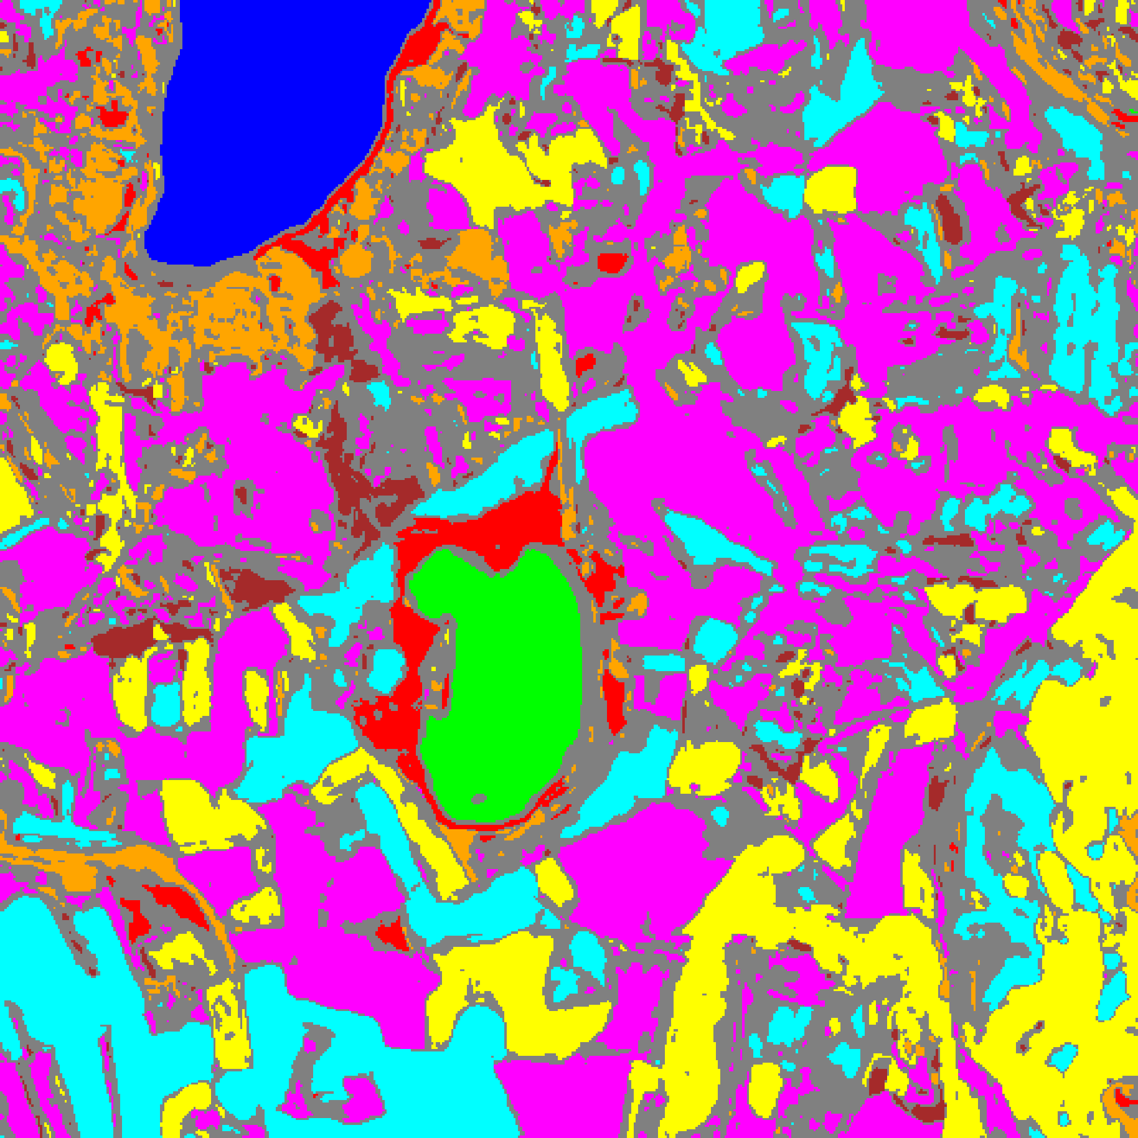  (A) AlexNet-CNN | 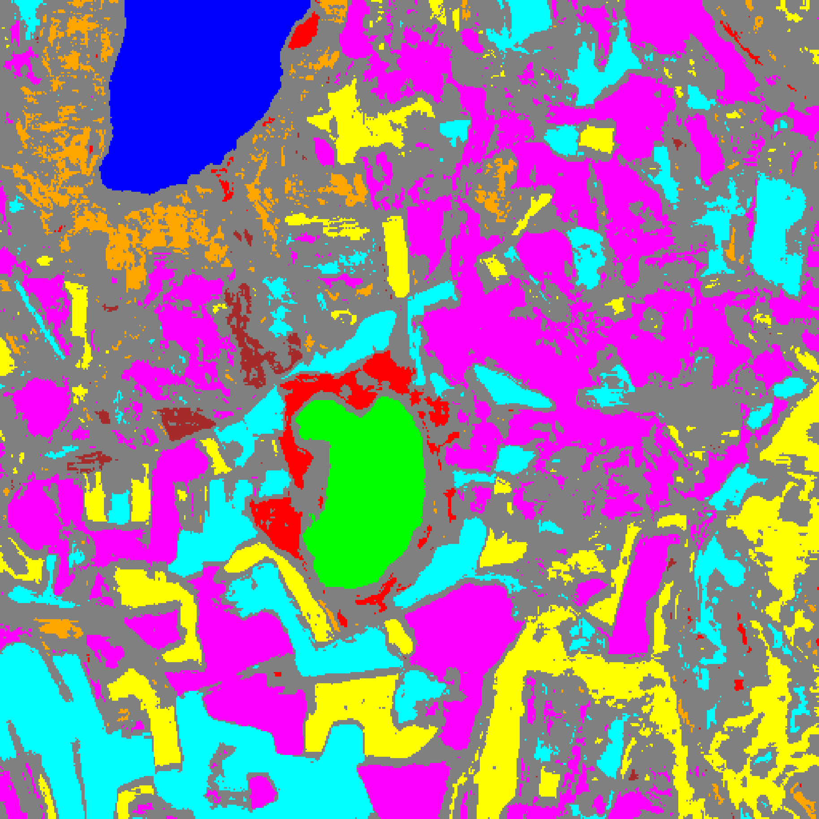  (B) GFNet
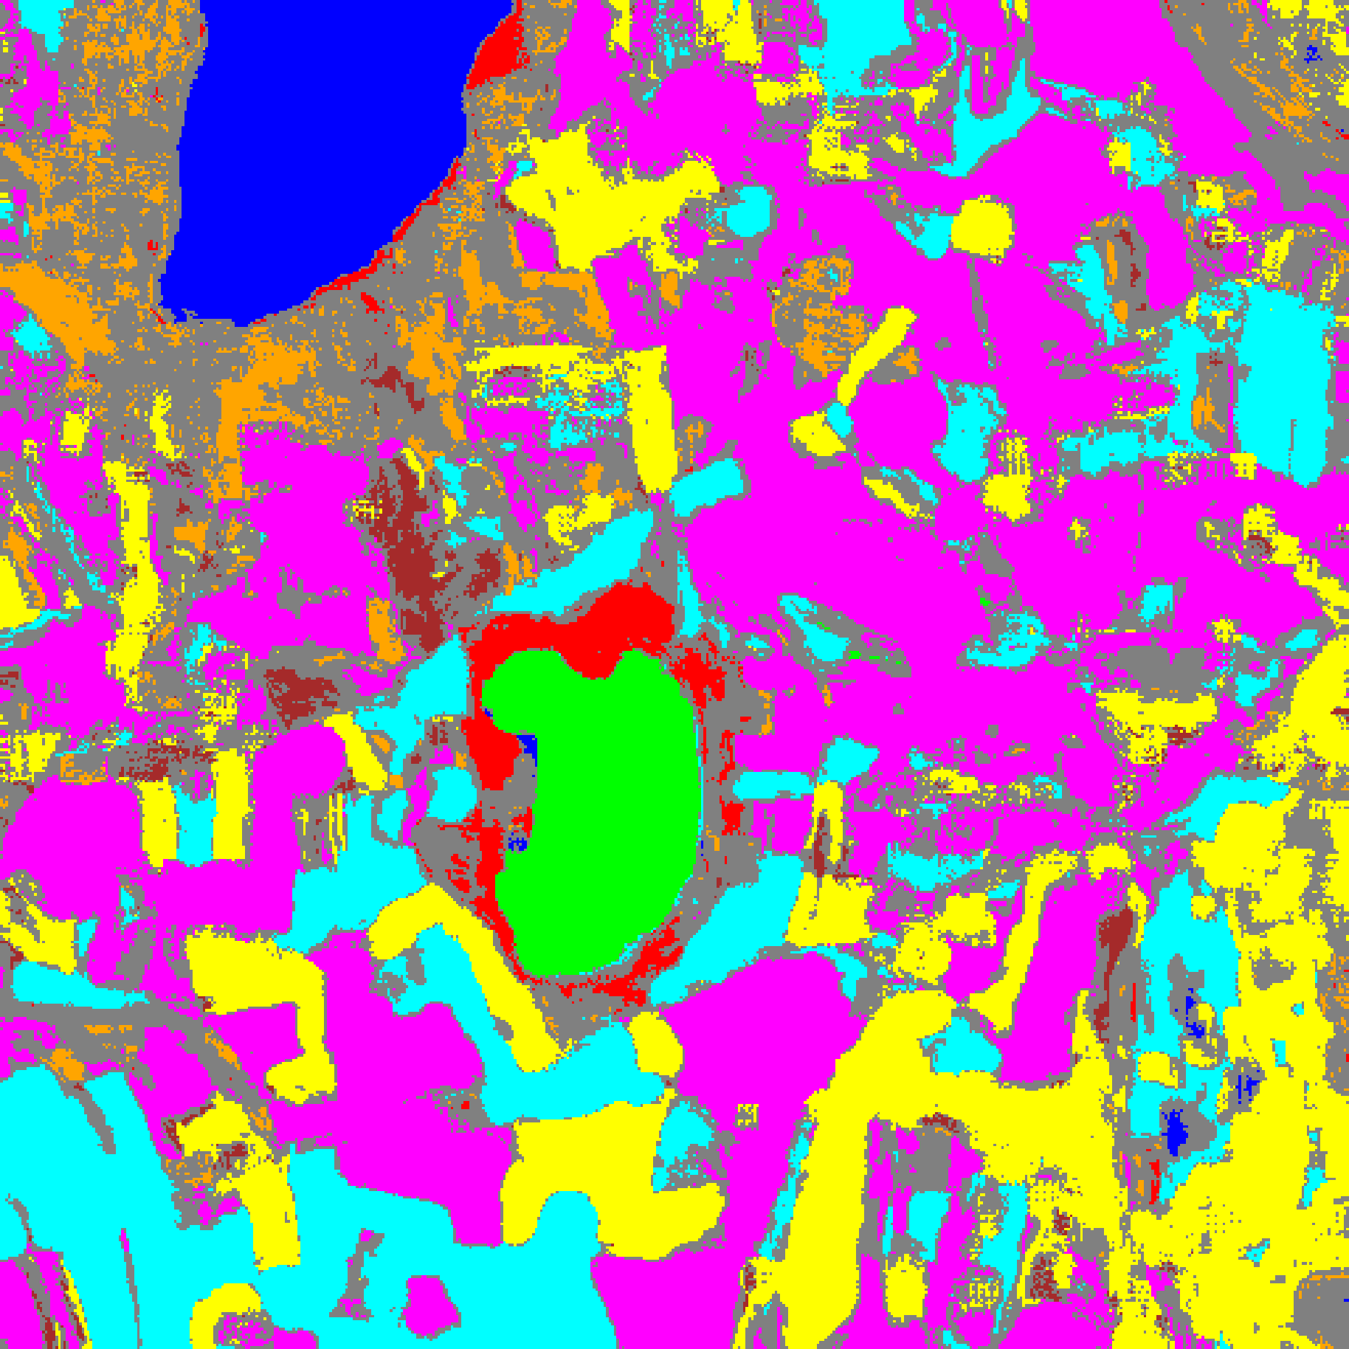  (C) ViT-UNet | (D) Class Legend
Fig. 4(b). SplitCP (DAPM) 95% classification + uncertainty masks: (A) AlexNet-CNN, (B) GFNet, (C) ViT-UNet, (D) Class Legend. Colours = predicted class (Class 0–7); grey = uncertain.
G. Class-Conditional Conformal Prediction (CcCP) Results on DAPM
Class-Conditional Conformal Prediction (CcCP) calibrates a separate nonconformity quantile q̂_c for each class c ∈ {0, ..., 7}. TABLE IX reports the aggregate CcCP summary, TABLE X presents the per-class coverages, TABLE XI lists the calibrated class-wise thresholds q̂_c, and TABLE XII provides the full-scene pixel distribution. All three architectures exceed the 95% target marginal coverage (0.9506 for AlexNet-CNN, 0.9519 for GFNet, and 0.9595 for ViT-UNet) while elevating mean per-class coverage to 0.9553, 0.9500, and 0.9607—completely eliminating the severe minority-class under-coverage observed under SplitCP.
TABLE IX
CLASS-CONDITIONAL CP (CCCP, DAPM): AGGREGATE SUMMARY (Α = 0.05)
Model | Emp. Cov. | Avg Set Size | Singleton Rate | Empty Set Rate | Runtime (s) | Mean Cls Cov.
AlexNet-CNN | 0.9506 | 0.9506 | 0.9506 | 0.0494 | 2.149 | 0.9553
GFNet | 0.9519 | 0.9519 | 0.9519 | 0.0481 | 2.220 | 0.9500
ViT-UNet | 0.9595 | 0.9596 | 0.9596 | 0.0404 | 2.158 | 0.9607

TABLE X
CCCP (DAPM): PER-CLASS COVERAGE COMPARISON ACROSS MODELS
Class | AlexNet-CNN Coverage | GFNet Coverage | ViT-UNet Coverage
Class 0 | 0.9515 | 0.9589 | 0.9638
Class 1 | 0.9474 | 0.9545 | 0.9531
Class 2 | 0.9647 | 0.9753 | 0.9753
Class 3 | 0.9443 | 0.9487 | 0.9516
Class 4 | 0.9491 | 0.9465 | 0.9597
Class 5 | 0.9500 | 0.9585 | 0.9632
Class 6 | 0.9700 | 0.9200 | 0.9500
Class 7 | 0.9656 | 0.9375 | 0.9688
Mean | 0.9553 | 0.9500 | 0.9607

TABLE XI
CCCP (DAPM): CLASS-WISE CONFORMAL THRESHOLDS (Q̂_C) PER MODEL
Class | AlexNet-CNN q̂_c | GFNet q̂_c | ViT-UNet q̂_c
Class 0 | 0.000008 | 0.000001 | 0.000000
Class 1 | 0.000005 | 0.000009 | 0.000001
Class 2 | 0.001149 | 0.000186 | 0.000016
Class 3 | 0.000316 | 0.000011 | 0.000000
Class 4 | 0.000004 | 0.000017 | 0.000000
Class 5 | 0.001077 | 0.000064 | 0.000000
Class 6 | 0.003266 | 0.000307 | 0.000015
Class 7 | 0.011658 | 0.000167 | 0.000048

TABLE XII
CCCP (DAPM): FULL-SCENE PREDICTED PIXEL COUNT DISTRIBUTION PER MODEL
Class / Region | AlexNet-CNN Pixels | GFNet Pixels | ViT-UNet Pixels
Class 0 | 9,600 | 9,686 | 10,801
Class 1 | 6,245 | 6,403 | 7,270
Class 2 | 6,238 | 4,839 | 6,369
Class 3 | 30,991 | 29,347 | 25,165
Class 4 | 55,773 | 50,989 | 65,822
Class 5 | 36,225 | 26,693 | 35,692
Class 6 | 8,089 | 2,919 | 5,119
Class 7 | 17,984 | 11,145 | 19,681
Uncertain | 90,999 | 120,123 | 86,225
Total (Scene) | 262,144 | 262,144 | 262,144

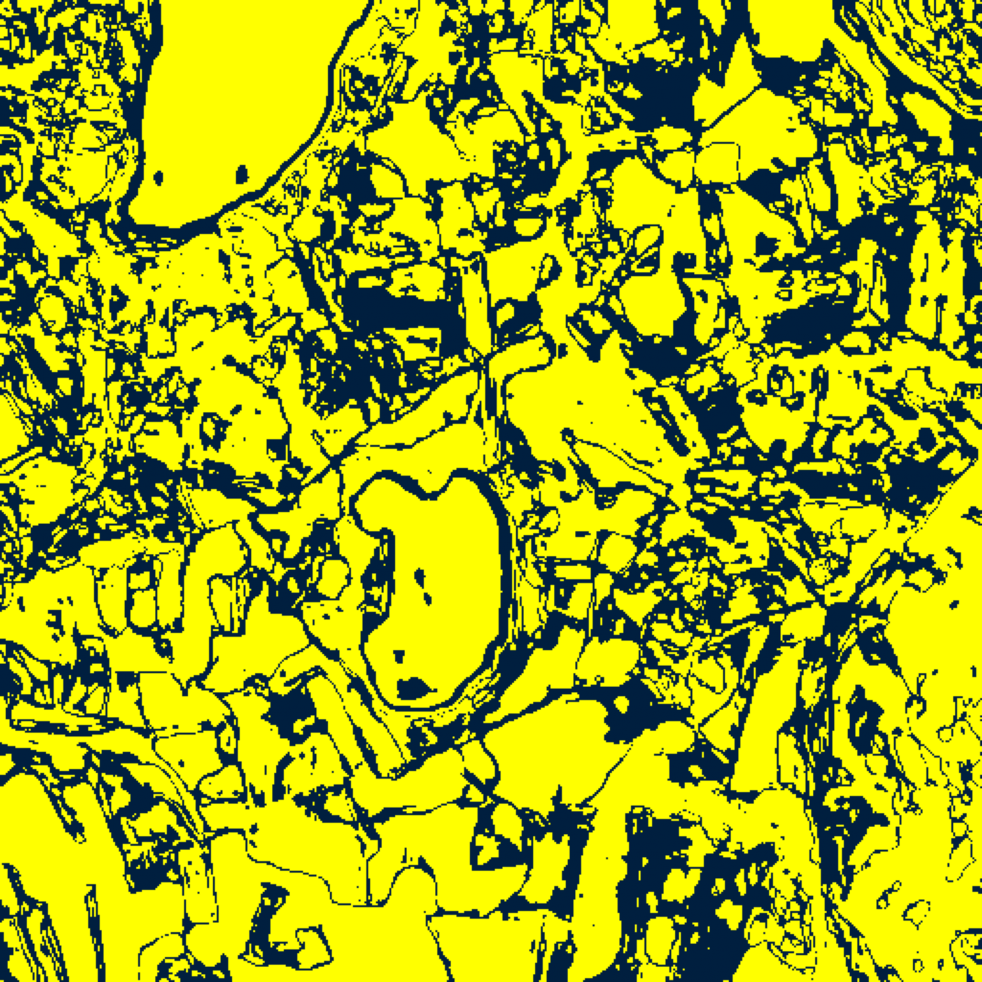  (A) AlexNet-CNN | 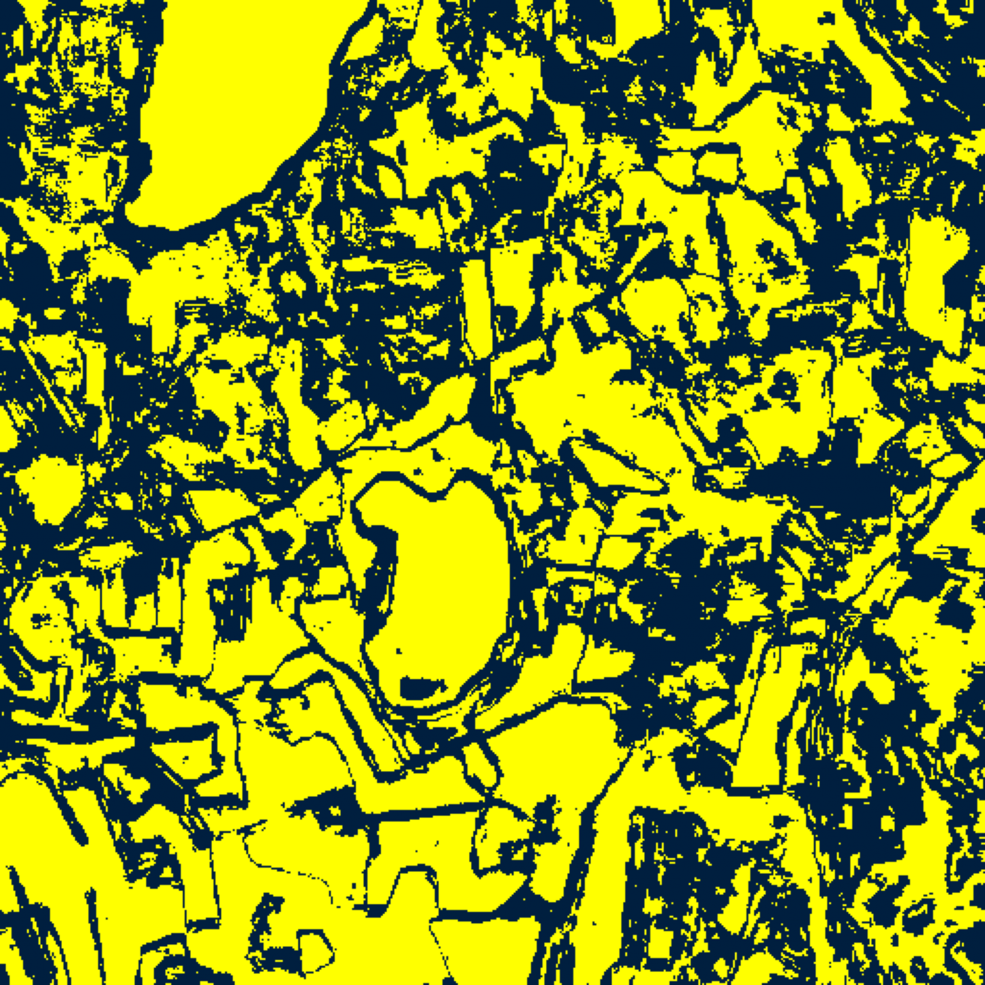  (B) GFNet
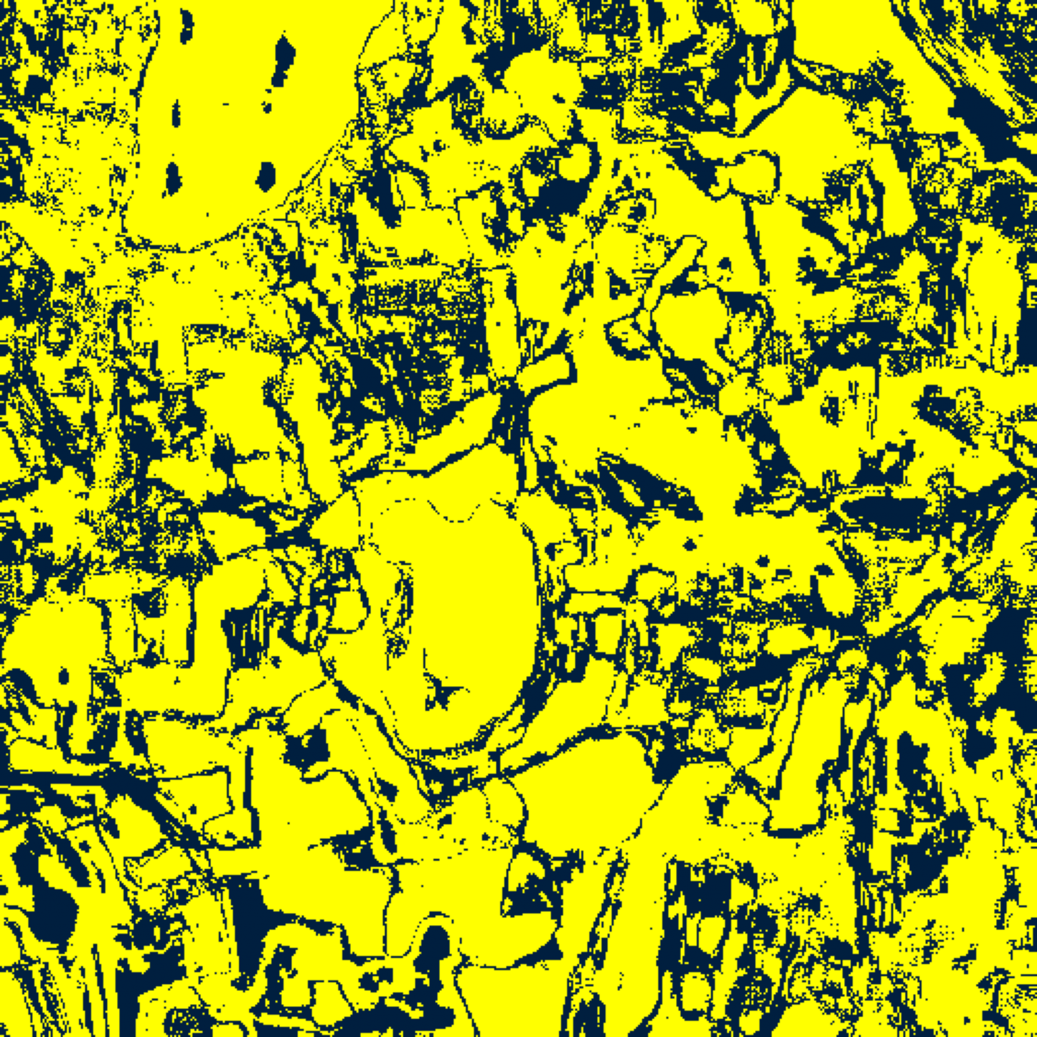  (C) ViT-UNet | (D) Legend
Fig. 5(a). CcCP (DAPM) 95% binary uncertainty maps: (A) AlexNet-CNN, (B) GFNet, (C) ViT-UNet, (D) Legend. Yellow = certain singleton; dark navy = uncertain (90,999, 120,123, and 86,225 uncertain pixels).
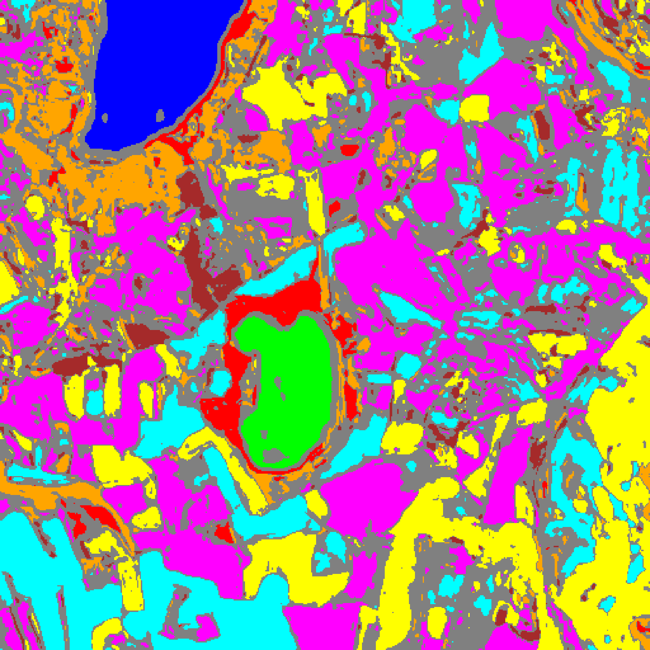  (A) AlexNet-CNN | 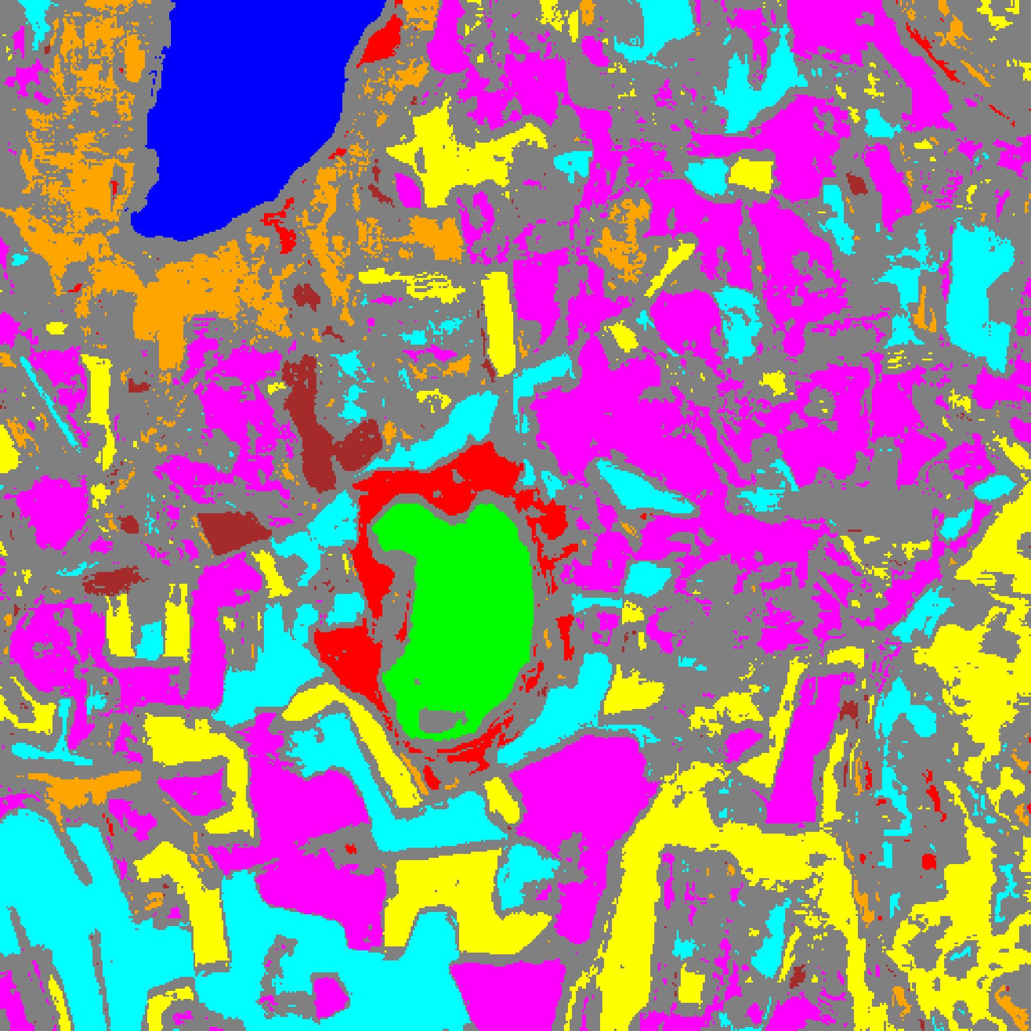  (B) GFNet
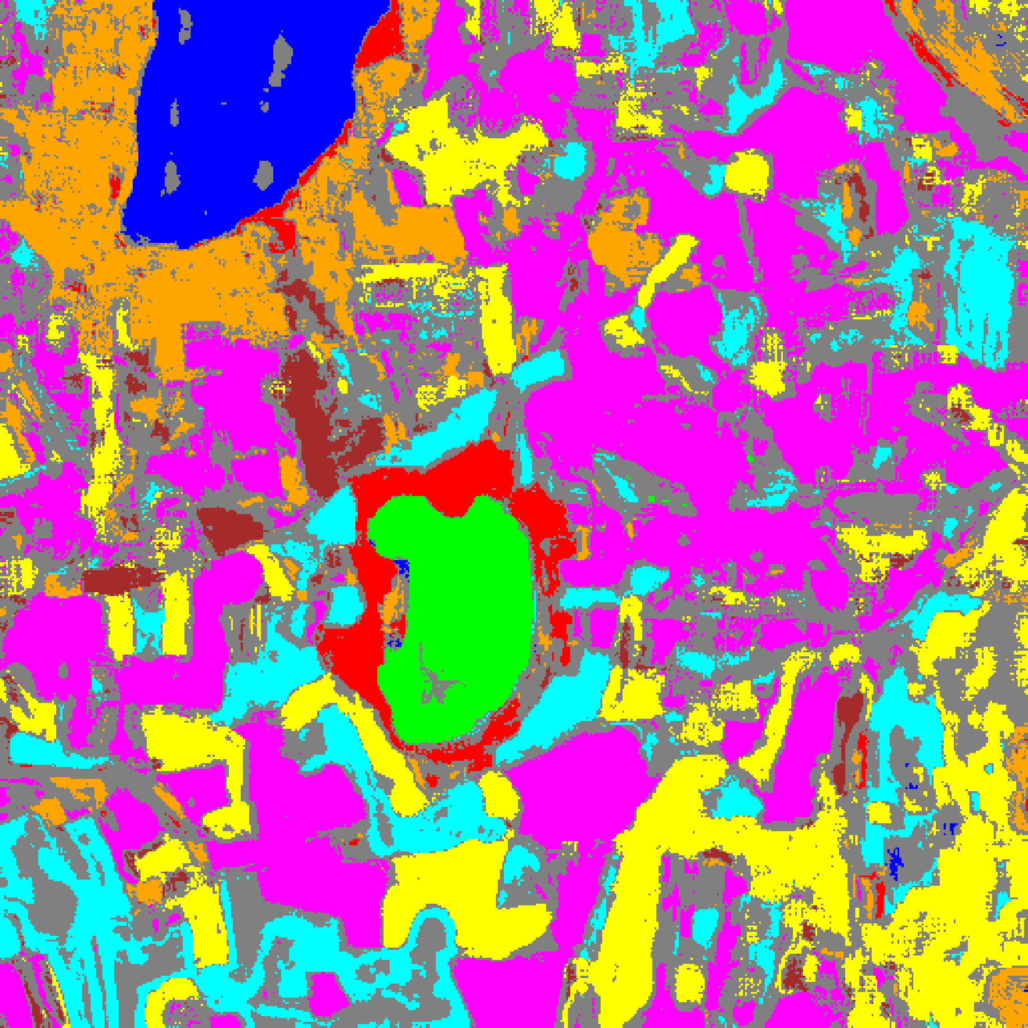  (C) ViT-UNet | (D) Class Legend
Fig. 5(b). CcCP (DAPM) 95% classification + uncertainty masks: (A) AlexNet-CNN, (B) GFNet, (C) ViT-UNet, (D) Class Legend. Colours = predicted class (Class 0–7); grey = uncertain.
H. Rank-Calibrated Class-Conditional Conformal Prediction (RC3P) Results on DAPM
Rank-Calibrated Class-Conditional Conformal Prediction (RC3P) augments CcCP with a calibrated per-class rank threshold k̂(y). Because all three DAPM classifiers achieve ≥ 99.89% test accuracy, the calibrated rank limit equals k̂ = 1 for every class across all three backbones (TABLE XV). RC3P achieves marginal coverages of 0.9540 (AlexNet-CNN), 0.9567 (GFNet), and 0.9619 (ViT-UNet) and reaches the highest balanced per-class coverages among the non-regularised conformal methods (0.9582, 0.9574, and 0.9630 in TABLE XIII and TABLE XIV), while reducing full-scene uncertain pixel counts relative to CcCP across all three models (88,681 vs. 90,999 for AlexNet-CNN; 118,515 vs. 120,123 for GFNet; and 80,190 vs. 86,225 for ViT-UNet in TABLE XVI, Fig. 6(a), and Fig. 6(b)).
TABLE XIII
RANK-CALIBRATED CLASS-CONDITIONAL CP (RC3P, DAPM): AGGREGATE SUMMARY (Α = 0.05)
Model | Emp. Cov. | Avg Set Size | Singleton Rate | Empty Set Rate | Runtime (s) | Mean Cls Cov.
AlexNet-CNN | 0.9540 | 0.9540 | 0.9540 | 0.0460 | 2.209 | 0.9582
GFNet | 0.9567 | 0.9567 | 0.9567 | 0.0433 | 2.268 | 0.9574
ViT-UNet | 0.9619 | 0.9620 | 0.9620 | 0.0380 | 2.193 | 0.9630

TABLE XIV
RC3P (DAPM): PER-CLASS COVERAGE COMPARISON ACROSS MODELS
Class | AlexNet-CNN Coverage | GFNet Coverage | ViT-UNet Coverage
Class 0 | 0.9548 | 0.9646 | 0.9671
Class 1 | 0.9531 | 0.9616 | 0.9560
Class 2 | 0.9682 | 0.9823 | 0.9788
Class 3 | 0.9465 | 0.9531 | 0.9546
Class 4 | 0.9535 | 0.9484 | 0.9616
Class 5 | 0.9537 | 0.9594 | 0.9641
Class 6 | 0.9700 | 0.9400 | 0.9500
Class 7 | 0.9656 | 0.9500 | 0.9719
Mean | 0.9582 | 0.9574 | 0.9630

TABLE XV
RC3P (DAPM): CLASS-WISE THRESHOLDS (Q̂_C) AND RANK LIMITS (K̂) PER MODEL
Class | AlexNet q̂_c | AlexNet k̂ | GFNet q̂_c | GFNet k̂ | ViT-UNet q̂_c | ViT-UNet k̂
Class 0 | 0.000009 | 1 | 0.000001 | 1 | 0.000000 | 1
Class 1 | 0.000006 | 1 | 0.000010 | 1 | 0.000001 | 1
Class 2 | 0.001405 | 1 | 0.000223 | 1 | 0.000016 | 1
Class 3 | 0.000352 | 1 | 0.000013 | 1 | 0.000000 | 1
Class 4 | 0.000005 | 1 | 0.000018 | 1 | 0.000000 | 1
Class 5 | 0.001283 | 1 | 0.000071 | 1 | 0.000000 | 1
Class 6 | 0.003545 | 1 | 0.000364 | 1 | 0.000015 | 1
Class 7 | 0.018674 | 1 | 0.000193 | 1 | 0.000058 | 1

TABLE XVI
RC3P (DAPM): FULL-SCENE PREDICTED PIXEL COUNT DISTRIBUTION PER MODEL
Class / Region | AlexNet-CNN Pixels | GFNet Pixels | ViT-UNet Pixels
Class 0 | 9,631 | 9,686 | 10,801
Class 1 | 6,284 | 6,467 | 7,270
Class 2 | 6,321 | 4,932 | 6,384
Class 3 | 31,269 | 29,767 | 30,829
Class 4 | 56,376 | 51,351 | 65,822
Class 5 | 36,550 | 26,968 | 35,692
Class 6 | 8,193 | 3,003 | 5,130
Class 7 | 18,839 | 11,455 | 20,026
Uncertain | 88,681 | 118,515 | 80,190
Total (Scene) | 262,144 | 262,144 | 262,144

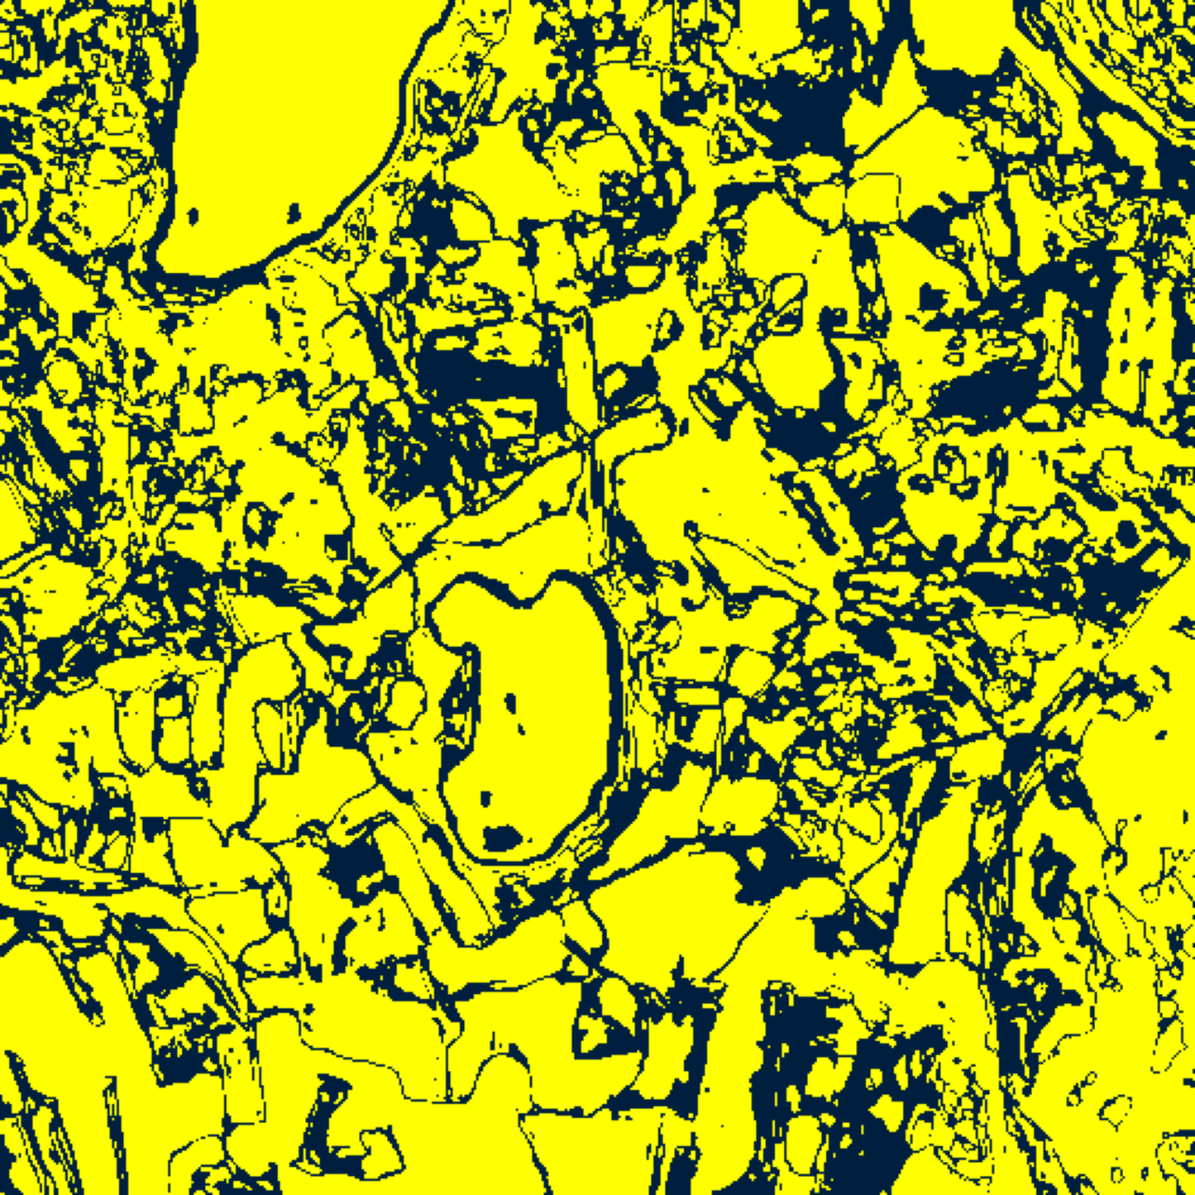  (A) AlexNet-CNN | 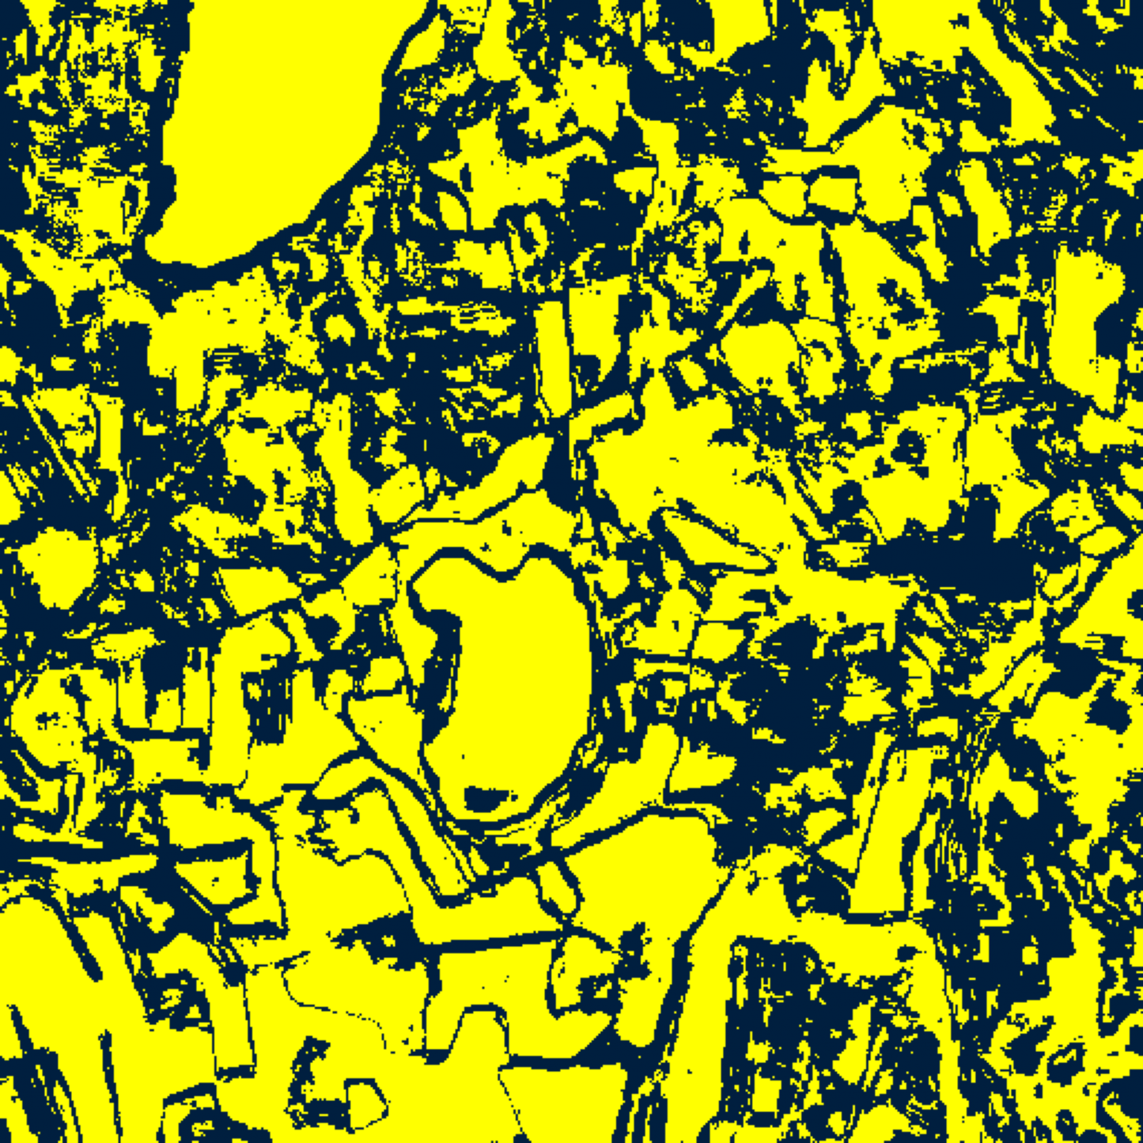  (B) GFNet
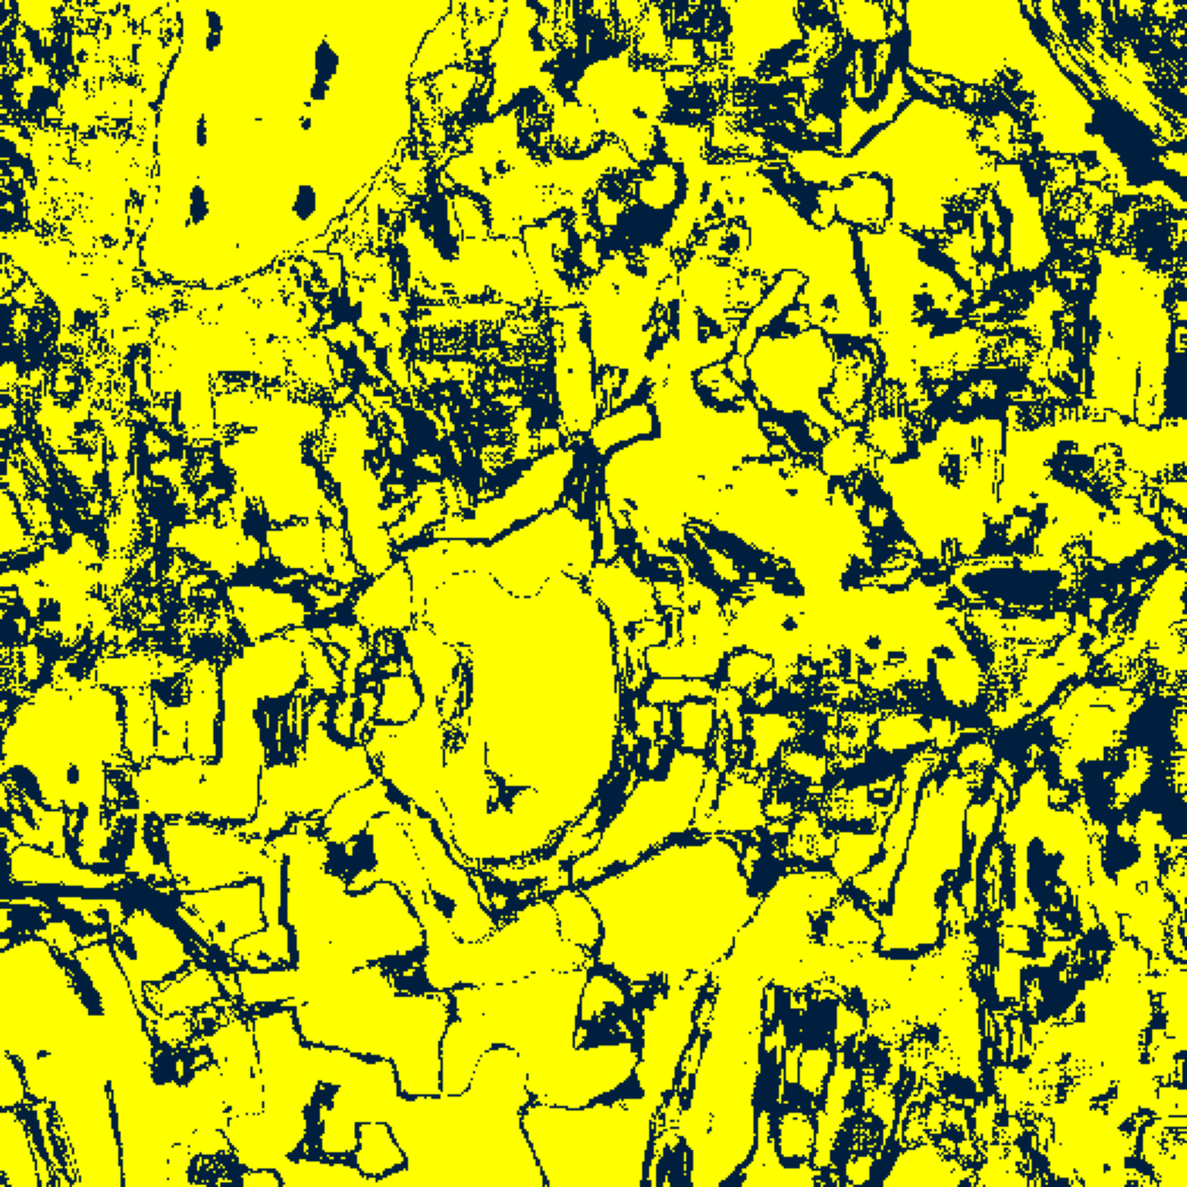  (C) ViT-UNet | (D) Legend
Fig. 6(a). RC3P (DAPM) 95% binary uncertainty maps: (A) AlexNet-CNN, (B) GFNet, (C) ViT-UNet, (D) Legend. Yellow = certain singleton; dark navy = uncertain (88,681, 118,515, and 80,190 uncertain pixels).
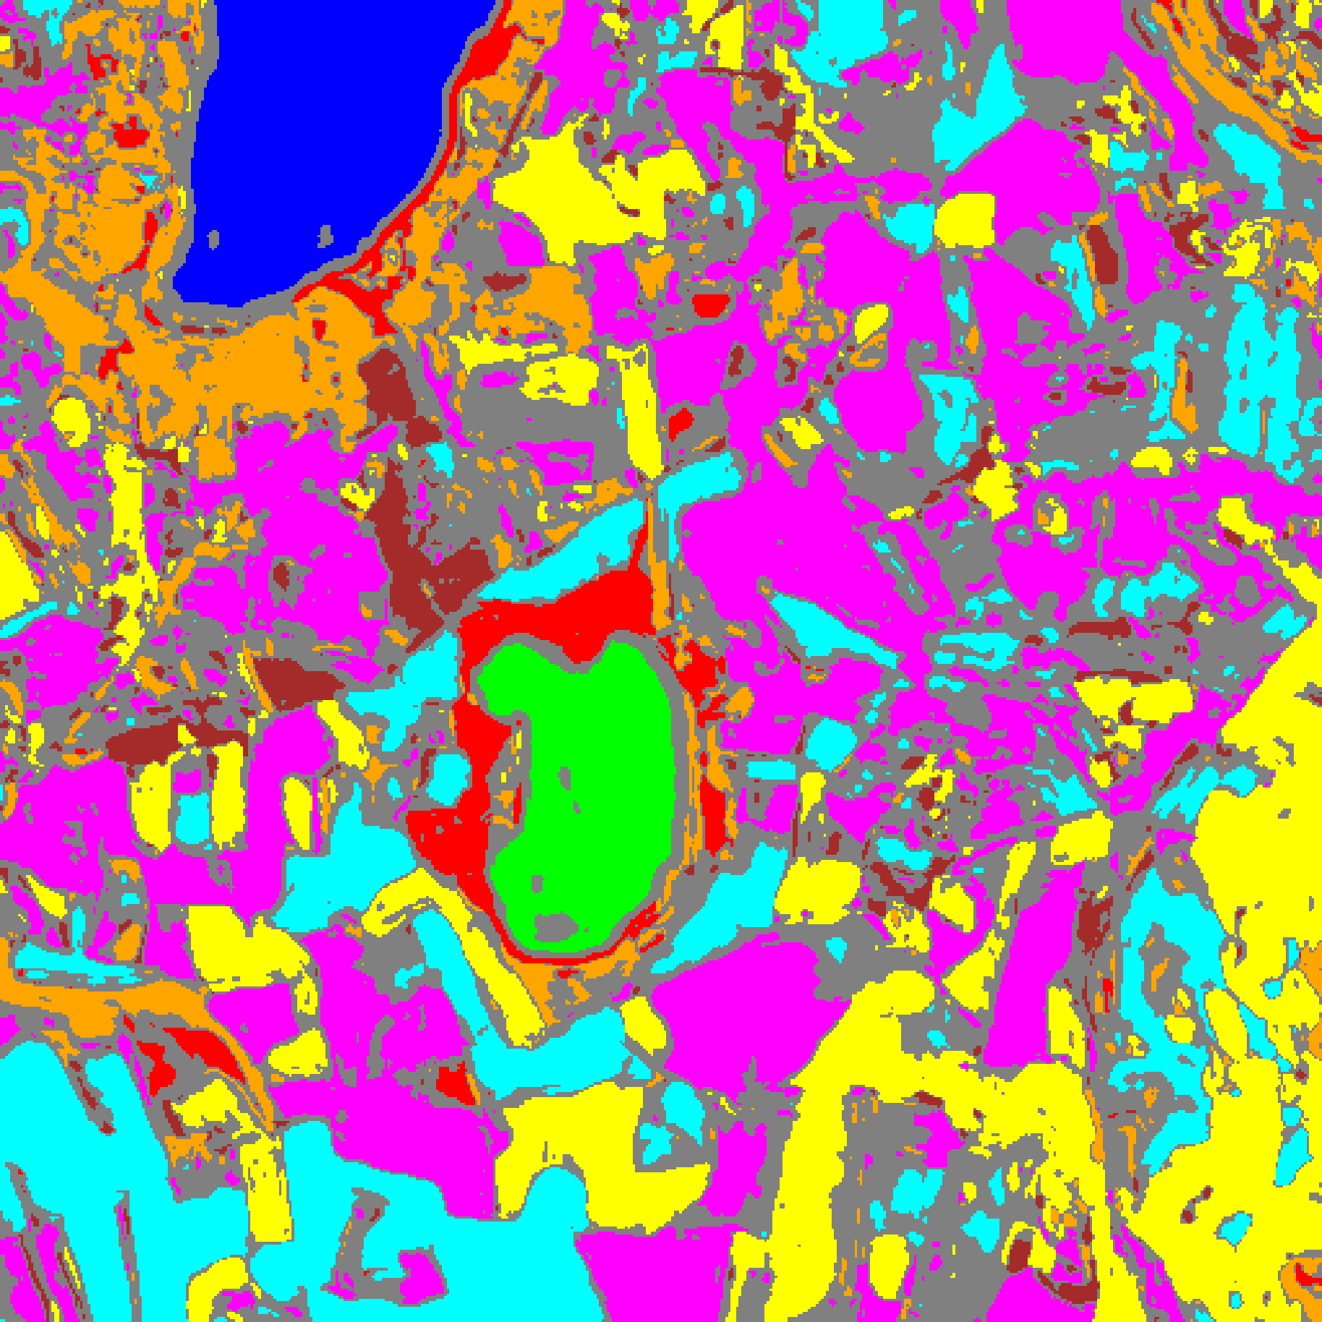  (A) AlexNet-CNN | 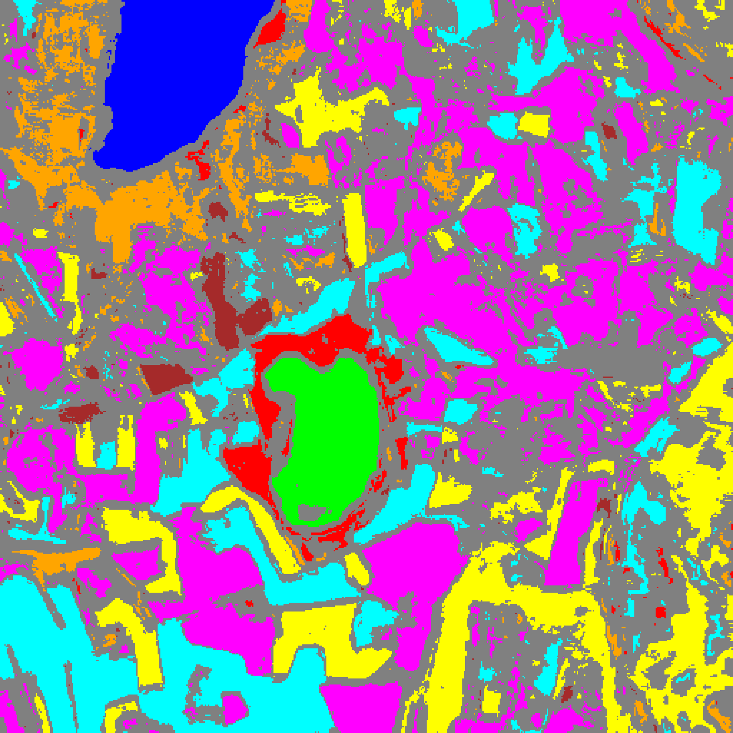  (B) GFNet
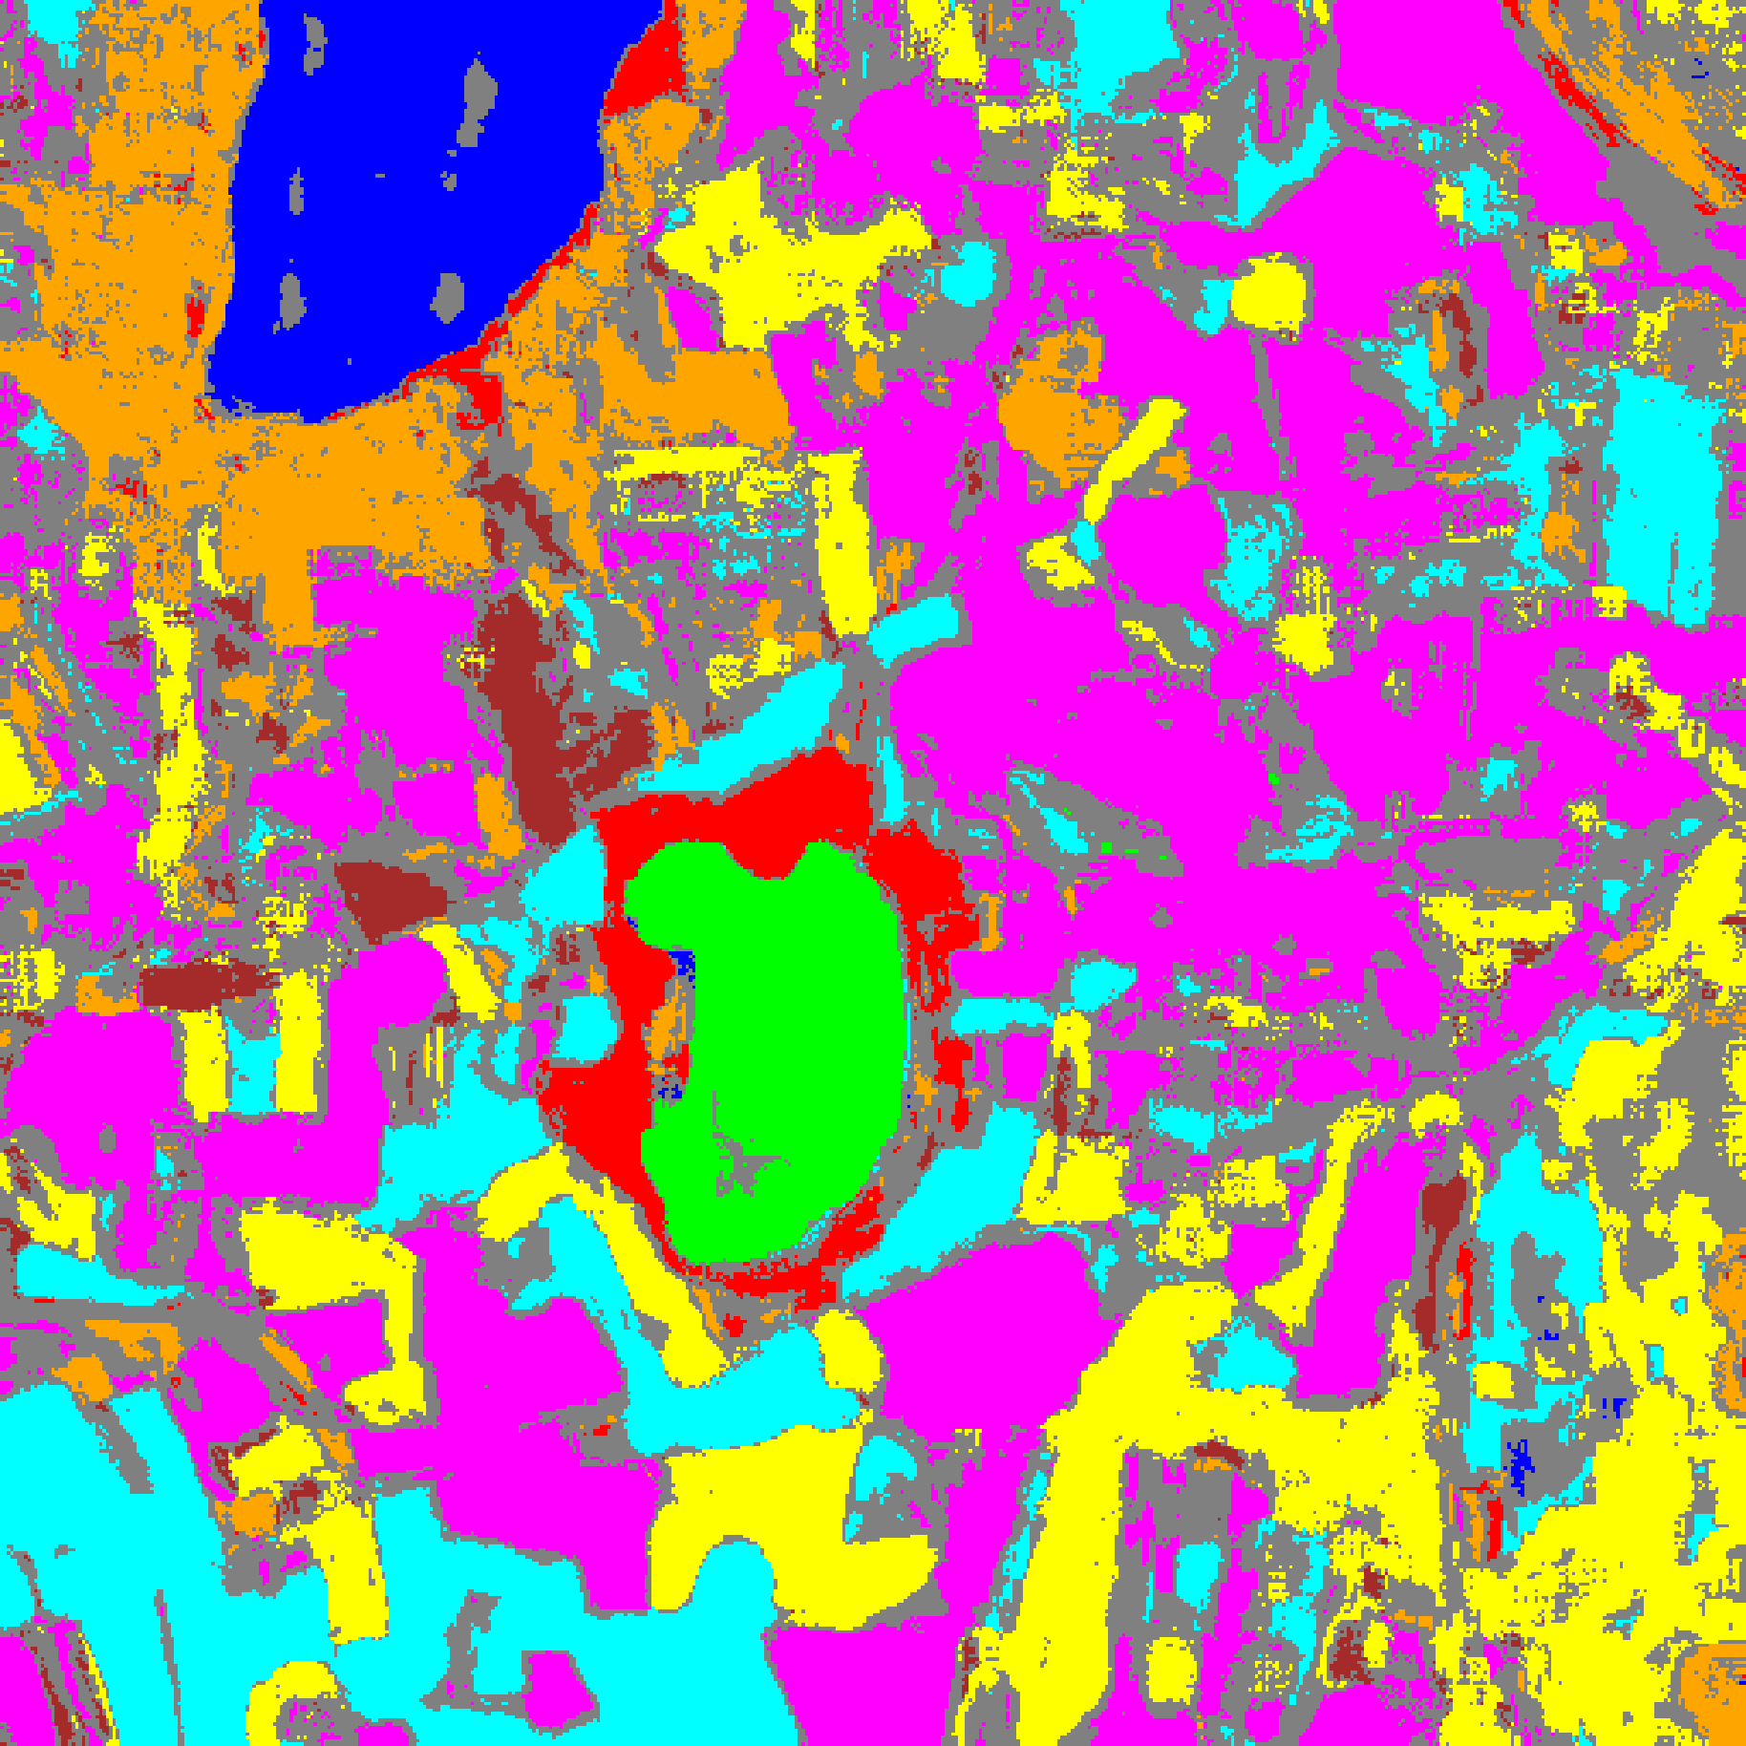  (C) ViT-UNet | (D) Class Legend
Fig. 6(b). RC3P (DAPM) 95% classification + uncertainty masks: (A) AlexNet-CNN, (B) GFNet, (C) ViT-UNet, (D) Class Legend. Colours = predicted class (Class 0–7); grey = uncertain.
I. Clustered Conformal Prediction (ClCP) Results on DAPM
Clustered Conformal Prediction (ClCP) groups the K = 8 classes into K_g = 4 clusters using K-Means on class-level feature summaries combining the 64-dimensional DAPM VAE latent embeddings z_μ and calibration nonconformity quantiles. TABLE XVII reports aggregate ClCP metrics, TABLE XVIII shows per-class coverage, TABLE XIX lists the class-to-cluster assignments and cluster thresholds q̂, and TABLE XX reports per-cluster empirical coverages. ClCP achieves marginal coverages of 0.9507 (AlexNet-CNN), 0.9482 (GFNet), and 0.9558 (ViT-UNet), improving mean per-class coverage over SplitCP across all three backbones (0.9335 vs. 0.9107 for AlexNet-CNN; 0.9479 vs. 0.8874 for GFNet; and 0.9207 vs. 0.8578 for ViT-UNet). Notably, when a minority class with higher nonconformity scores is grouped with ultra-confident majority classes (such as Class 7 in Cluster 3 for ViT-UNet, or Class 6 in Cluster 3 for AlexNet-CNN), cluster-level pooling dilutes the minority class threshold compared to standalone CcCP.
TABLE XVII
CLUSTERED CP (CLCP, DAPM): AGGREGATE SUMMARY (Α = 0.05, K_G = 4)
Model | Emp. Cov. | Avg Set Size | Singleton Rate | Empty Set Rate | Runtime (s) | Mean Cls Cov.
AlexNet-CNN | 0.9507 | 0.9507 | 0.9507 | 0.0493 | 2.919 | 0.9335
GFNet | 0.9482 | 0.9482 | 0.9482 | 0.0518 | 5.517 | 0.9479
ViT-UNet | 0.9558 | 0.9559 | 0.9559 | 0.0441 | 13.702 | 0.9207

TABLE XVIII
CLCP (DAPM): PER-CLASS COVERAGE COMPARISON ACROSS MODELS
Class | AlexNet-CNN Coverage | GFNet Coverage | ViT-UNet Coverage
Class 0 | 0.9515 | 0.9992 | 0.9984
Class 1 | 0.9474 | 0.9815 | 1.0000
Class 2 | 0.9929 | 0.9753 | 0.9753
Class 3 | 0.9465 | 0.9553 | 0.9099
Class 4 | 0.9962 | 0.9346 | 0.9962
Class 5 | 0.9150 | 0.8801 | 0.9981
Class 6 | 0.7900 | 0.9200 | 0.9500
Class 7 | 0.9281 | 0.9375 | 0.5375
Mean | 0.9335 | 0.9479 | 0.9207

TABLE XIX
CLCP (DAPM): CLASS-TO-CLUSTER ASSIGNMENTS AND PER-CLUSTER THRESHOLDS (Q̂)
Class | AlexNet Cluster | AlexNet q̂ | GFNet Cluster | GFNet q̂ | ViT-UNet Cluster | ViT-UNet q̂
Class 0 | Cluster 0 | 0.000008 | Cluster 0 | 0.000015 | Cluster 3 | 0.000008
Class 1 | Cluster 2 | 0.000005 | Cluster 0 | 0.000015 | Cluster 3 | 0.000008
Class 2 | Cluster 1 | 0.004263 | Cluster 3 | 0.000186 | Cluster 1 | 0.000016
Class 3 | Cluster 3 | 0.000346 | Cluster 0 | 0.000015 | Cluster 0 | 0.000000
Class 4 | Cluster 3 | 0.000346 | Cluster 0 | 0.000015 | Cluster 0 | 0.000000
Class 5 | Cluster 3 | 0.000346 | Cluster 0 | 0.000015 | Cluster 3 | 0.000008
Class 6 | Cluster 3 | 0.000346 | Cluster 2 | 0.000307 | Cluster 2 | 0.000015
Class 7 | Cluster 1 | 0.004263 | Cluster 1 | 0.000167 | Cluster 3 | 0.000008

TABLE XX
CLCP (DAPM): PER-CLUSTER EMPIRICAL COVERAGE (EXPORTED AS "MEAN UNCERTAINTY") ACROSS MODELS
Cluster | AlexNet-CNN Coverage | GFNet Coverage | ViT-UNet Coverage
Cluster 0 | 0.9515 | 0.9484 | 0.9573
Cluster 1 | 0.9601 | 0.9375 | 0.9684
Cluster 2 | 0.9474 | 0.9200 | 0.9500
Cluster 3 | 0.9497 | 0.9753 | 0.9539

J. Regularised Adaptive Prediction Sets (RAPS) Results on DAPM
Regularised Adaptive Prediction Sets (RAPS) constructs prediction sets by accumulating descending DAPM posterior probabilities with rank penalty λ = 0.01 above k_reg = 1 and uniform boundary randomisation. Because the DAPM classifiers concentrate nearly 100% probability mass on the top-1 class across calibration samples, the calibrated RAPS threshold equals q̂_RAPS = 0.000000 for all three architectures (TABLE XXIII). Consequently, RAPS produces conservative singleton prediction sets across the entire scene (average set size 1.0000, singleton rate 1.0000, empty set rate 0.0000), yielding empirical coverages of 0.9993 (AlexNet-CNN), 1.0000 (GFNet), and 0.9996 (ViT-UNet) in TABLE XXI and mean per-class coverages of 0.9983, 1.0000, and 0.9997 in TABLE XXII.
TABLE XXI
RAPS (DAPM): AGGREGATE SUMMARY (Α = 0.05, Λ = 0.01, K_REG = 1)
Model | Emp. Cov. | Avg Set Size | Singleton Rate | Empty Set Rate | Runtime (s) | Mean Cls Cov.
AlexNet-CNN | 0.9993 | 1.0000 | 1.0000 | 0.0000 | 0.483 | 0.9983
GFNet | 1.0000 | 1.0000 | 1.0000 | 0.0000 | 0.481 | 1.0000
ViT-UNet | 0.9996 | 1.0000 | 1.0000 | 0.0000 | 0.472 | 0.9997

TABLE XXII
RAPS (DAPM): PER-CLASS COVERAGE COMPARISON ACROSS MODELS
Class | AlexNet-CNN Coverage | GFNet Coverage | ViT-UNet Coverage
Class 0 | 1.0000 | 1.0000 | 1.0000
Class 1 | 1.0000 | 1.0000 | 1.0000
Class 2 | 0.9965 | 1.0000 | 1.0000
Class 3 | 1.0000 | 1.0000 | 0.9978
Class 4 | 1.0000 | 1.0000 | 1.0000
Class 5 | 0.9981 | 1.0000 | 1.0000
Class 6 | 0.9950 | 1.0000 | 1.0000
Class 7 | 0.9969 | 1.0000 | 1.0000
Mean | 0.9983 | 1.0000 | 0.9997

TABLE XXIII
RAPS (DAPM): CALIBRATION PARAMETERS
Model | q̂_RAPS | λ (lambda) | k_reg
AlexNet-CNN | 0.000000 | 0.01 | 1
GFNet | 0.000000 | 0.01 | 1
ViT-UNet | 0.000000 | 0.01 | 1

K. Cross-Method Synthesis: Diffusion Welch T-Test vs. Conformal Prediction on DAPM
TABLE XXIV synthesises the empirical behaviour of the stochastic diffusion Welch t-test paradigm (Section IV.D–IV.E) alongside the five post-hoc Conformal Prediction paradigms applied to deterministic DAPM probabilities (Section IV.F–IV.J) across all 262,144 scene pixels. Three fundamental structural insights emerge:
1) Epistemic Trajectory Dispersion vs. Distribution-Free Thresholding: The Welch t-test evaluates intrinsic trajectory dispersion across N = 30 stochastic draws from both the VAE latent posterior and the T = 100 reverse diffusion chain. Because Stage-1 GRL adversarial alignment actively maps unlabelled target-domain pixels onto high-density class manifolds in latent space, the diffusion trajectories converge consistently for 99.83%–99.95% of all scene pixels, flagging only isolated spectral anomalies (434, 256, and 122 pixels for AlexNet-CNN, GFNet, and ViT-UNet). By contrast, SplitCP, CcCP, and RC3P enforce a strict finite-sample 95% coverage threshold calibrated on labelled agricultural parcels; when deployed across the full scene, they flag 27.76%–45.82% of pixels (primarily unlabelled background roads, soil, water bodies, and inter-parcel boundaries) where top-1 softmax confidence dips marginally below 1 − q̂.
2) Minority-Class Coverage Restoration via CcCP and RC3P: Under SplitCP, global quantile pooling severely penalises minority classes (Class 6 and Class 7 coverages falling as low as 0.6400 and 0.4875 on ViT-UNet). Class-stratified calibration in CcCP and rank-calibrated filtering in RC3P completely restore class-conditional equity (raising mean per-class coverage to 0.9553–0.9607 under CcCP and 0.9574–0.9630 under RC3P), with RC3P simultaneously reducing full-scene uncertain pixels by 1,608 to 6,035 pixels relative to CcCP.
3) Computational Trade-Off (500 s Stochastic Diffusion vs. 2 s Deterministic CP): Full-scene stochastic diffusion sampling requires 30 × 100 = 3,000 denoising network evaluations per pixel (486.7–542.1 s across the 512 × 512 scene on a Tesla T4 GPU), whereas Conformal Prediction operates on a single deterministic forward pass through E_θ and p_ω, completing calibration and evaluation in 0.47–2.27 s (2.92–13.70 s for ClCP with K-Means clustering)—an order-of-magnitude (over 200×) speedup suitable for real-time onboard or operational remote-sensing pipelines.
TABLE XXIV
CROSS-PARADIGM SYNTHESIS: DIFFUSION WELCH T-TEST VS. CONFORMAL PREDICTION ON DAPM PROBABILITIES
Paradigm (AlexNet / GFNet / ViT) | Marginal Acc. or Cov. | Mean Cls Acc. or Cov. | Uncertain Pixels | Uncertain Scene % | Runtime (s)
DAPM Welch t-test | 99.97% / 100.00% / 99.96% | 99.92% / 99.99% / 99.94% | 434 / 256 / 122 | 0.17% / 0.10% / 0.05% | 486.7 / 518.2 / 542.1
DAPM + SplitCP | 95.09% / 94.73% / 95.16% | 91.07% / 88.74% / 85.78% | 88,086 / 119,180 / 72,784 | 33.60% / 45.46% / 27.76% | 2.25 / 2.22 / 2.15
DAPM + CcCP | 95.06% / 95.19% / 95.95% | 95.53% / 95.00% / 96.07% | 90,999 / 120,123 / 86,225 | 34.71% / 45.82% / 32.89% | 2.15 / 2.22 / 2.16
DAPM + RC3P | 95.40% / 95.67% / 96.19% | 95.82% / 95.74% / 96.30% | 88,681 / 118,515 / 80,190 | 33.83% / 45.21% / 30.59% | 2.21 / 2.27 / 2.19
DAPM + ClCP (K_g=4) | 95.07% / 94.82% / 95.58% | 93.35% / 94.79% / 92.07% | 88,043 / 120,174 / 77,315 | 33.59% / 45.84% / 29.49% | 2.92 / 5.52 / 13.70
DAPM + RAPS (λ=0.01) | 99.93% / 100.00% / 99.96% | 99.83% / 100.00% / 99.97% | 0 / 0 / 0 | 0.00% / 0.00% / 0.00% | 0.48 / 0.48 / 0.47

V. CONCLUSION
This paper adapted the Diffusion-based Adversarial Probabilistic Model (DAPM) to 65-band hyperspectral land-cover classification and pixel-wise uncertainty quantification on the DIAS benchmark (512 × 512 scene, K = 8 classes) across AlexNet-CNN, GFNet, and ViT-UNet backbones, and unified two complementary uncertainty paradigms within a single framework: (1) multi-draw stochastic label diffusion with Welch’s two-sample t-test (N = 30, T = 100, p > 0.05), and (2) distribution-free Conformal Prediction (SplitCP, CcCP, RC3P, ClCP, and RAPS at α = 0.05) applied to deterministic DAPM posterior probabilities.
Empirically, GFNet achieves perfect 100.00% held-out test accuracy (99.998% full-scene labelled OA), followed by AlexNet-CNN (99.93% test OA, 99.972% full-scene labelled OA) and ViT-UNet (99.89% test OA, 99.965% full-scene labelled OA). Stochastic diffusion Welch t-test uncertainty selectively isolates deep representation ambiguity (< 0.17% of scene pixels), whereas Conformal Prediction provides finite-sample 95% coverage guarantees and delineates unlabelled background and parcel-boundary transitions across the scene in ~2 seconds. Among the conformal methods, RC3P and CcCP deliver the strongest class-conditional coverage balance (mean per-class coverage 0.9574–0.9630 for RC3P), making deterministic DAPM + RC3P an ideal choice for fast, coverage-guaranteed operational mapping and stochastic diffusion Welch t-test an effective offline audit tool for hard spectral anomalies.
REFERENCES
[1] Z. Du and J. Li, “Diffusion-Based Probabilistic Uncertainty Estimation for Active Domain Adaptation,” in Adv. Neural Inf. Process. Syst. (NeurIPS), vol. 36, pp. 17129–17155, 2023.
[2] D. P. Kingma and M. Welling, “Auto-Encoding Variational Bayes,” in Proc. ICLR, 2014.
[3] J. Ho, A. Jain, and P. Abbeel, “Denoising Diffusion Probabilistic Models,” in Adv. Neural Inf. Process. Syst. (NeurIPS), vol. 33, 2020.
[4] P. Dhariwal and A. Nichol, “Diffusion Models Beat GANs on Image Synthesis,” in Adv. Neural Inf. Process. Syst. (NeurIPS), vol. 34, 2021.
[5] Y. Ganin and V. Lempitsky, “Unsupervised Domain Adaptation by Backpropagation,” in Proc. ICML, 2015.
[6] Y. Rao et al., “Global Filter Networks for Image Classification,” in Adv. Neural Inf. Process. Syst. (NeurIPS), vol. 34, 2021.
[7] A. Dosovitskiy et al., “An Image is Worth 16x16 Words: Transformers for Image Recognition at Scale,” in Proc. ICLR, 2021.
[8] O. Ronneberger, P. Fischer, and T. Brox, “U-Net: Convolutional Networks for Biomedical Image Segmentation,” in Proc. MICCAI, Springer, 2015.
[9] A. N. Angelopoulos and S. Bates, “A Gentle Introduction to Conformal Prediction,” arXiv:2107.07511, 2021.
[10] B. L. Welch, “The Generalisation of Student’s Problem,” Biometrika, vol. 34, pp. 28–35, 1947.
[11] M. Ahmad et al., “Hyperspectral Image Classification—Traditional to Deep Models,” IEEE J. Sel. Topics Appl. Earth Observ. Remote Sens., 2022.
[12] V. Vovk, A. Gammerman, and G. Shafer, Algorithmic Learning in a Random World. New York, NY, USA: Springer, 2005.
[13] H. Papadopoulos, K. Proedrou, V. Vovk, and A. Gammerman, “Inductive confidence machines for regression,” in Proc. ECML, 2002, pp. 345–356.
[14] Y. Romano, M. Sesia, and E. Candès, “Classification with valid and adaptive coverage,” in Adv. Neural Inf. Process. Syst. (NeurIPS), vol. 33, pp. 3581–3591, 2020.
[15] Y. Shi, S. Ghosh, T. Belkhouja, J. R. Doppa, and Y. Yan, “Conformal prediction for class-wise coverage via augmented label rank calibration,” in Adv. Neural Inf. Process. Syst. (NeurIPS), vol. 37, 2024.
[16] T. Ding, A. N. Angelopoulos, S. Bates, M. I. Jordan, and R. J. Tibshirani, “Class-conditional conformal prediction with many classes,” in Adv. Neural Inf. Process. Syst. (NeurIPS), vol. 36, 2023.
[17] A. N. Angelopoulos, S. Bates, J. Malik, and M. I. Jordan, “Uncertainty sets for image classifiers using conformal prediction,” in Proc. ICLR, 2021.

