Hyperspectral Remote Sensing Classification with Wavelength-Conditioned DOFA, Hierarchical Vision Transformer, and Gated Cross-Modal Fusion with Conformal Uncertainty Quantification
ABSTRACT
This paper presents a systematic comparative study of three foundation-model-inspired architectures for patch-based pixel-wise land-cover classification of a 65-band hyperspectral remote sensing scene (DIAS Scene K01, 512 × 512 pixels, K = 8 classes: Class 0 through Class 7), coupled with distribution-free uncertainty quantification via five conformal prediction methods. The architectures evaluated are: (1) DOFA-Spectral, a Dynamic One-For-All network whose patch-embedding weights are dynamically generated from sensor central wavelengths via a sinusoidal-encoded hypernetwork; (2) Hiera-ViT, a two-stage Hierarchical Vision Transformer employing local 3 × 3 windowed attention in Stage 1 followed by global attention after 2 × 2 query pooling in Stage 2; and (3) DOFA-Hiera Fusion, a dual-branch gated cross-attention network that fuses spectral tokens from DOFA with multi-scale spatial tokens from Hiera-ViT. On the held-out test split (13,474 samples), Hiera-ViT achieves 100.000% test accuracy (κ = 1.0000), DOFA-Hiera Fusion achieves 99.978% (κ = 0.9997) with the lowest NLL (0.03055), Brier score (0.00137), and ECE (0.02939), and DOFA-Spectral achieves 83.910% (κ = 0.8038) in 144.0 s of training time. Five conformal prediction methods—SplitCP, CcCP, RC3P, ClCP, and RAPS—are calibrated on n_cal = 6,737 samples at α = 0.05 (95% target) and evaluated on n_eval = 6,737 samples as well as across all 262,144 scene pixels.
I. INTRODUCTION
Earth-observation sensors span a wide variety of spectral configurations, ranging from broadband multispectral instruments to contiguous narrowband hyperspectral imagers [11]. Conventional convolutional and transformer classifiers hard-code the number of input channels in their initial projection layer, preventing weight sharing across sensors with differing band counts. Foundation models for remote sensing address this limitation through wavelength-conditioned dynamic weight generation [1] and hierarchical multi-scale spatial tokenisation [2].
In patch-based hyperspectral land-cover classification, a small spatial-spectral cube (here 9 × 9 × 65) centred on each target pixel provides both fine spectral signatures and local spatial context. While purely spectral foundation encoders capture cross-band dependencies via dynamic kernel synthesis, hierarchical vision transformers capture fine-to-coarse spatial structure via windowed and pooled self-attention. Combining both paradigms via gated cross-attention fusion offers a principled mechanism to exploit complementary spectral and spatial representations.
Even high-accuracy classifiers require formal reliability guarantees before deployment in operational mapping pipelines [12]. Conformal prediction (CP) wraps any pre-trained classifier to produce prediction sets guaranteed to contain the true class with probability at least 1 − α under exchangeability [4, 7, 8, 9]. The primary contributions of this report are:
- Adaptation and evaluation of DOFA-Spectral, Hiera-ViT, and DOFA-Hiera Fusion on the 65-band DIAS Scene K01 hyperspectral dataset (512 × 512 pixels, K = 8 classes: Class 0–Class 7) using 9 × 9 × 65 patches.
- Joint evaluation of classification accuracy and probabilistic calibration via Negative Log-Likelihood (NLL), Brier Score, Expected Calibration Error (ECE), and training runtime [12].
- Comprehensive benchmarking of five post-hoc conformal prediction methods (SplitCP, CcCP, RC3P, ClCP, and RAPS) at α = 0.05 across all three architectures, highlighting the contrast between near-perfect transformer backbones and the higher-uncertainty DOFA-Spectral model [3, 4, 5, 6].
- Generation of full-scene binary and class-masked uncertainty maps across all 262,144 pixels to visualise spatial uncertainty patterns across labelled parcels and unlabelled background.

II. METHODOLOGY
A. Dataset and Preprocessing
The dataset comprises the 65-band hyperspectral scene K01 from the DIAS benchmark (files k001.mat and k002.mat, H = 512, W = 512 pixels, B = 65 bands), containing K = 8 ground-truth classes denoted Class 0 through Class 7. Fig. 1 displays the approximate RGB composite and the ground-truth label map.
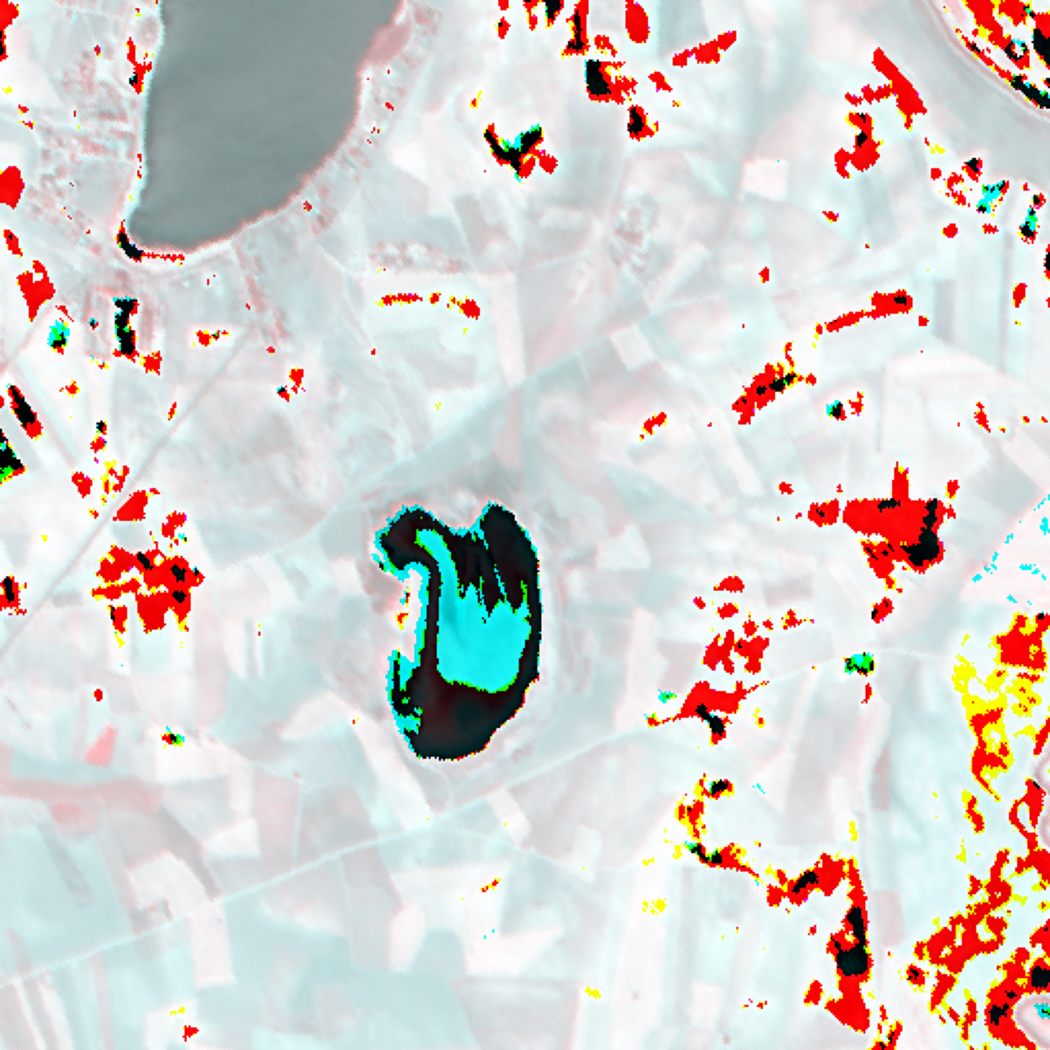  (a) Approximate RGB Composite | 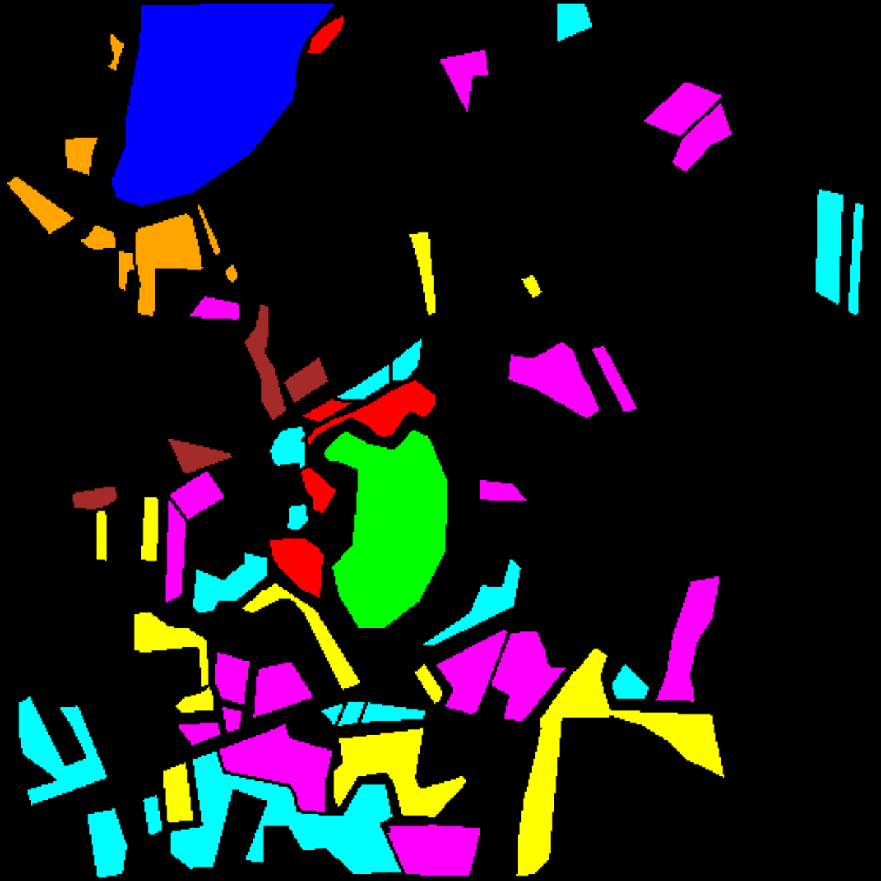  (b) Ground Truth Label Map
Fig. 1. Hyperspectral scene overview (DIAS Scene K01, 65 bands, 512 × 512 pixels). (a) Approximate RGB composite. (b) Ground truth label map for Class 0 through Class 7; black pixels denote unlabelled background.
Each spectral band b ∈ {1, ..., 65} is normalised independently to [0, 1]:
x̃(h, w, b) = [x(h, w, b) − min_{b}] / [max_{b} − min_{b} + ε], ε = 10⁻⁸
A 9 × 9 × 65 patch is extracted around every pixel using 4-pixel edge-replication padding. With random seed 42, the 53,896 labelled pixels are partitioned into 75% training (40,422 samples), 12.5% conformal calibration (n_cal = 6,737), and 12.5% conformal evaluation (n_eval = 6,737, with class supports 1,216, 704, 283, 1,365, 1,590, 1,059, 200, and 320 for Class 0–7; held-out test evaluation spans the combined 13,474 non-training samples). Full-scene conformal pixel tables account for all 512 × 512 = 262,144 scene pixels.
B. Deep Learning Architectures
DOFA-Spectral: Inspired by Xiong et al. [1], DOFA-Spectral encodes the 65 sensor wavelengths via sinusoidal positional embeddings and passes them through a lightweight MLP hypernetwork to dynamically synthesise the patch-projection weights W(λ) ∈ ℝ^{(P^2·B)×d} and bias b(λ) ∈ ℝ^d (d = 192). The resulting nine 3 × 3 spatial tokens are processed by L = 6 pre-norm Transformer blocks (6 heads, MLP ratio 2) with global average pooling and a linear classification head.
Hiera-ViT: Adapted from Ryali et al. [2], Hiera-ViT processes all 81 pixel tokens (1 × 1 patch embedding, d_1 = 96) in Stage 1 using three local 3 × 3 windowed self-attention blocks (9 windows of 9 tokens, 4 heads). A 2 × 2 query-pooling transition reduces the grid to 9 tokens with dimension d_2 = 192, followed by three Stage-2 global self-attention blocks (6 heads) and a classification head.
DOFA-Hiera Fusion: Combines the DOFA dynamic wavelength embedding branch (L = 3 blocks, d = 192) and the two-stage Hiera-ViT spatial branch (d_2 = 192) viabidirectional multi-head cross-attention and a learnable sigmoid gate g = σ(W_g[f_dofa ∥ f_hiera] + b_g), yielding a fused representation z = g ⊙ f̃_dofa + (1 − g) ⊙ f̃_hiera before classification.
C. Evaluation Metrics
Classification performance is evaluated on the 13,474 held-out test patches using overall accuracy (%), Cohen’s κ, macro-F1, weighted-F1, NLL, Brier Score, 15-bin ECE, and training time (s) [12].
D. Conformal Prediction Methods
Five conformal prediction algorithms—SplitCP [8], CcCP [6], RC3P [4], ClCP (K_g = 4) [5], and RAPS (λ = 0.01, k_reg = 1) [3]—are calibrated on n_cal = 6,737 samples at α = 0.05 (target coverage 95%) and evaluated on n_eval = 6,737 samples [7, 9].
- SplitCP: Computes a single global threshold q̂ over all calibration nonconformity scores s(x, y) = 1 − π̂_y(x) [8].
- CcCP: Computes class-specific thresholds q̂_c independently for each class c ∈ {0, ..., 7} [6].
- RC3P: Combines class-wise score thresholds q̂_c with calibrated rank limits k̂_c to prune tail labels [4].
- ClCP: Clusters the K = 8 classes into K_g = 4 groups based on calibration score quantiles and shares cluster-level thresholds [5].
- RAPS: Uses cumulative sorted softmax mass plus an ℓ_2 rank regulariser λ·max(0, ρ − k_reg) with λ = 0.01, k_reg = 1 [3].

III. EXPERIMENTS AND RESULTS
A. Classification Performance
All three architectures were trained for 100 epochs (batch size 128, AdamW optimiser with cosine learning rate schedule and label smoothing ε_s = 0.05). TABLE I reports test-set classification and calibration performance sorted by accuracy descending. Hiera-ViT attains 100.000% test accuracy (κ = 1.0000, macro-F1 = 1.0000, weighted-F1 = 1.0000) in 809.3 s. DOFA-Hiera Fusion achieves 99.978% accuracy (κ = 0.9997, macro-F1 = 0.9996, weighted-F1 = 0.9998) while delivering the best probabilistic calibration across all metrics: NLL = 0.03055, Brier = 0.00137, and ECE = 0.02939 (866.8 s). DOFA-Spectral is the fastest model to train (144.0 s) but achieves lower accuracy (83.910%, κ = 0.8038, macro-F1 = 0.6780, weighted-F1 = 0.8191, NLL = 0.46566, Brier = 0.23020, ECE = 0.04750), reflecting the loss of fine pixel-level spatial boundaries when compressing the 9 × 9 × 65 cube directly into 3 × 3 dynamic wavelength tokens without hierarchical spatial attention.
TABLE I
TEST SET CLASSIFICATION PERFORMANCE (SORTED BY ACCURACY)
Model | Accuracy | κ | Macro F1 | Wtd F1 | NLL | Brier | ECE | Train Time (s)
Hiera-ViT | 100.000% | 1.0000 | 1.0000 | 1.0000 | 0.03981 | 0.00176 | 0.03902 | 809.3
DOFA-Hiera Fusion | 99.978% | 0.9997 | 0.9996 | 0.9998 | 0.03055 | 0.00137 | 0.02939 | 866.8
DOFA-Spectral | 83.910% | 0.8038 | 0.6780 | 0.8191 | 0.46566 | 0.23020 | 0.04750 | 144.0

B. Dense Scene Classification Maps
Fig. 2 illustrates the dense classification maps generated by applying each trained model across all 262,144 pixels of the 512 × 512 scene. Hiera-ViT and DOFA-Hiera Fusion produce sharp, spatially coherent parcel boundaries closely matching the ground-truth layout, whereas DOFA-Spectral exhibits noticeable block-level smoothing and class confusion within smaller parcels.
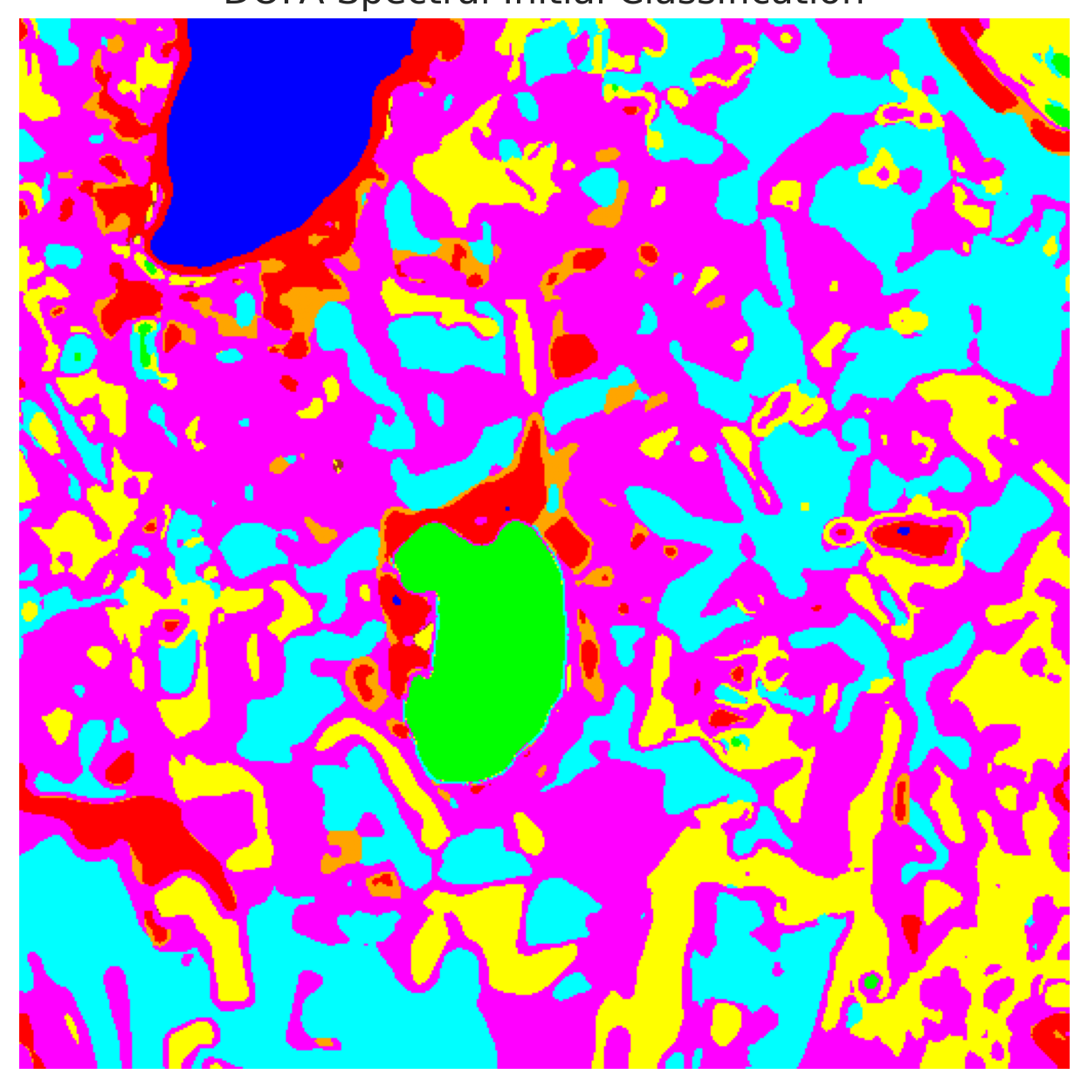  (a) DOFA-Spectral | 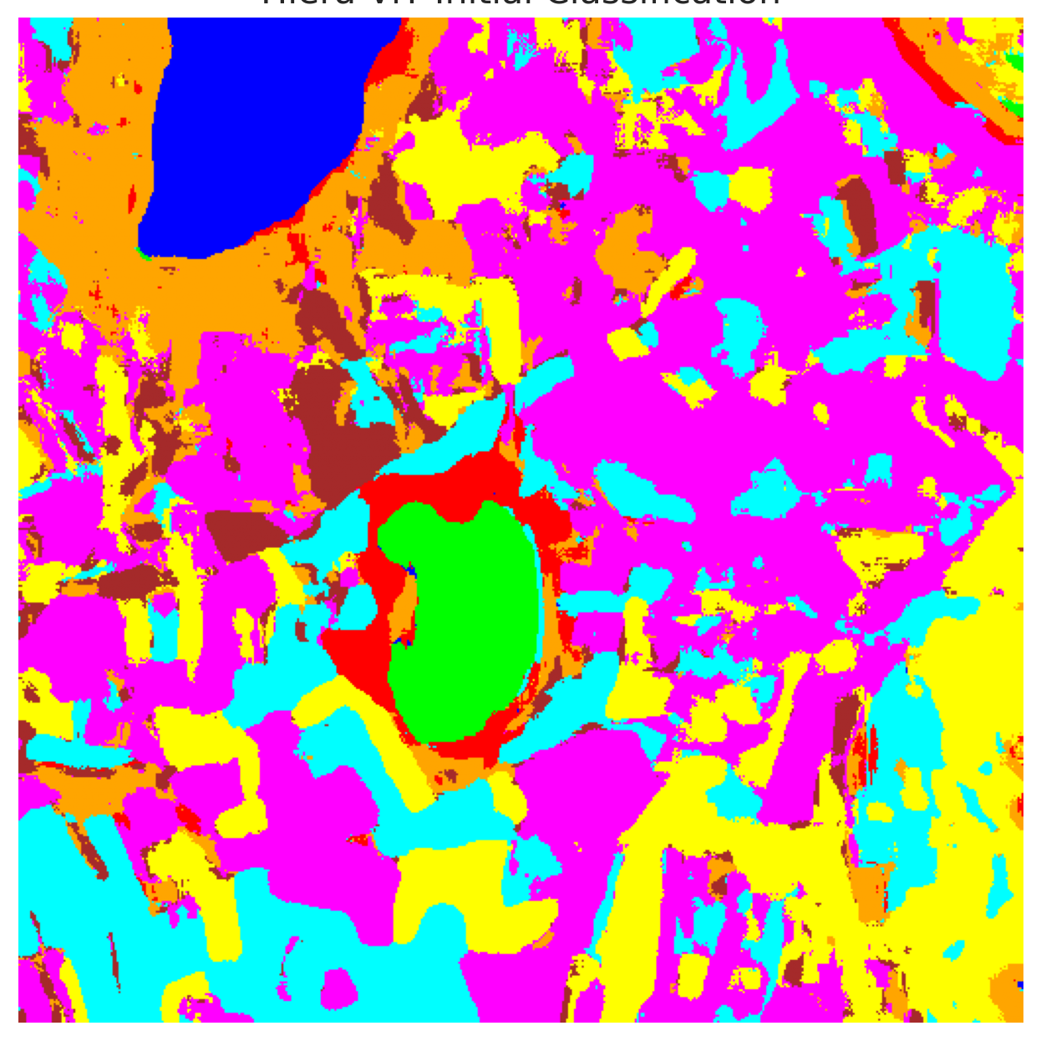  (b) Hiera-ViT
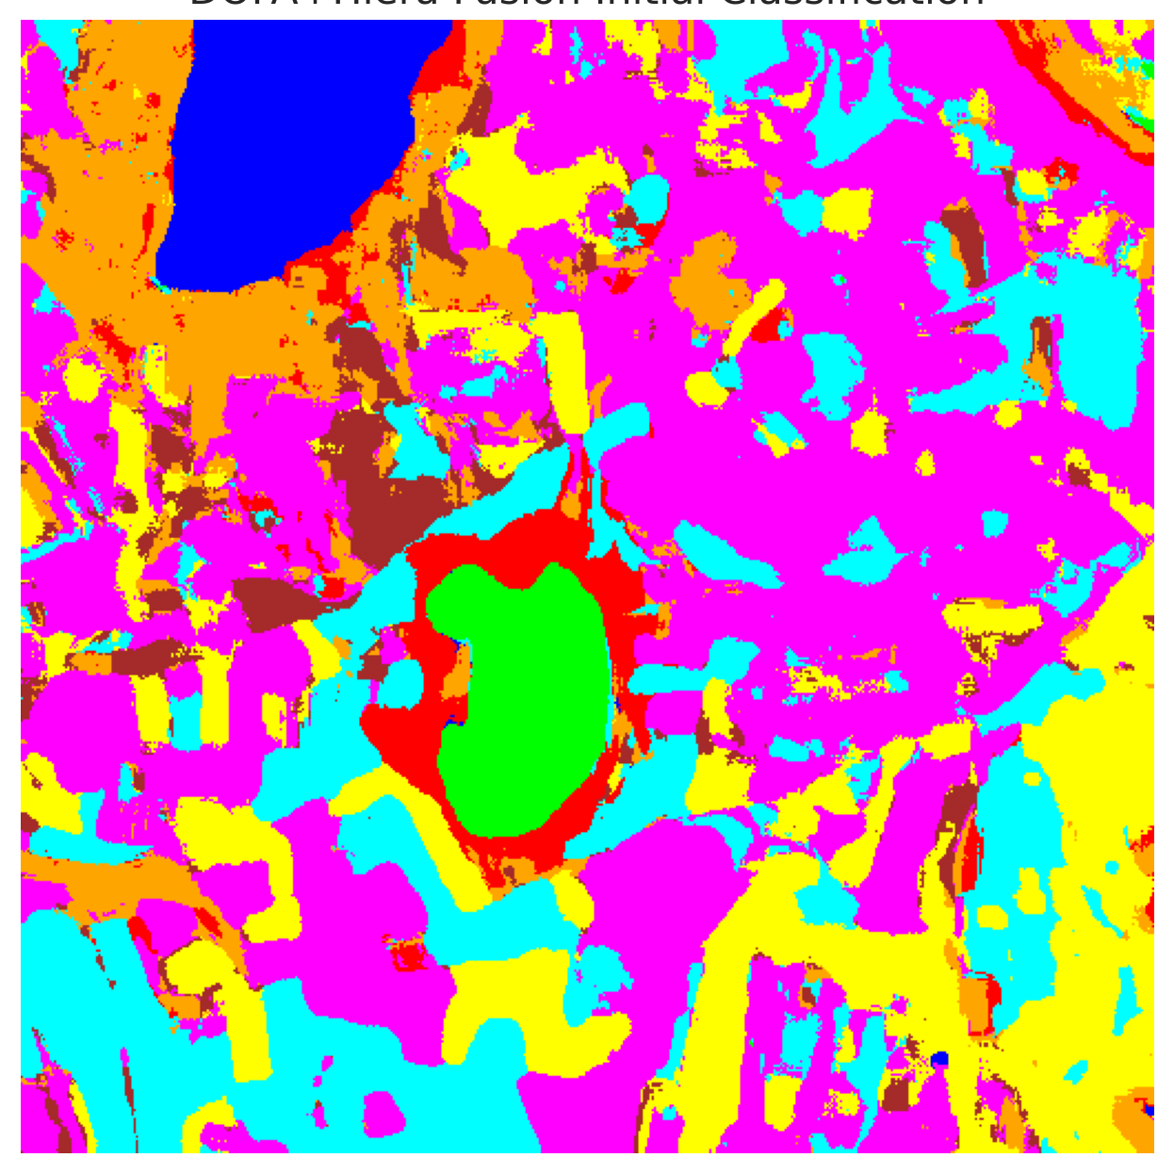  (c) DOFA-Hiera Fusion | 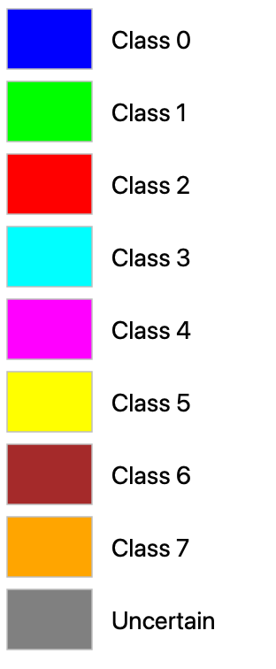  (d) Class Legend
Fig. 2. Dense scene classification maps across all 512 × 512 pixels for (a) DOFA-Spectral, (b) Hiera-ViT, and (c) DOFA-Hiera Fusion, with (d) shared class colour legend.
C. Conformal Prediction — Split Conformal (SplitCP)
TABLE II through TABLE IV present the SplitCP results. Because Hiera-ViT and DOFA-Hiera Fusion produce high top-1 probabilities on in-distribution samples, their global thresholds are low (q̂ = 0.044637 and 0.036518), yielding empirical coverages of 0.9558 and 0.9497 with singleton rates equal to coverage and empty-set rates of 0.0442 and 0.0503 (no multi-label sets). Conversely, DOFA-Spectral requires a much larger global quantile (q̂ = 0.785483) to achieve 0.9513 empirical coverage, resulting in an average set size of 1.5229, a singleton rate of 0.6206, and zero empty sets. Across the full 262,144-pixel scene (TABLE IV), SplitCP flags 126,955 (48.43%), 112,693 (42.99%), and 112,262 (42.82%) pixels as uncertain for DOFA-Spectral, Hiera-ViT, and DOFA-Hiera Fusion respectively.
TABLE II
SPLITCP AGGREGATE PERFORMANCE (Α = 0.05, TARGET COVERAGE = 95%)
Model | q̂ | Emp. Cov. | Avg Set Size | Singleton Rate | Empty Set Rate | Runtime (s) | Mean Cls Cov.
DOFA-Spectral | 0.887807 | 0.9513 | 1.5229 | 0.6206 | 0.0000 | 2.435 | 0.8674
Hiera-ViT | 0.041448 | 0.9558 | 0.9558 | 0.9558 | 0.0442 | 2.175 | 0.9623
DOFA-Hiera Fusion | 0.032308 | 0.9497 | 0.9497 | 0.9497 | 0.0503 | 2.114 | 0.9630

TABLE III
SPLITCP PER-CLASS EMPIRICAL COVERAGE
Class | DOFA-Spectral | Hiera-ViT | DOFA-Hiera Fusion
Class 0 | 0.9951 | 0.9490 | 0.7632
Class 1 | 1.0000 | 0.8466 | 1.0000
Class 2 | 0.9152 | 0.9965 | 0.9929
Class 3 | 0.9839 | 0.9927 | 0.9846
Class 4 | 0.9767 | 0.9302 | 0.9906
Class 5 | 0.9849 | 0.9981 | 0.9943
Class 6 | 0.4150 | 0.9950 | 1.0000
Class 7 | 0.6687 | 0.9906 | 0.9781

TABLE IV
SPLITCP FULL-SCENE PIXEL COUNTS (512 × 512 = 262,144 PIXELS)
Class / Region | DOFA-Spectral | Hiera-ViT | DOFA-Hiera Fusion
Class 0 | 10,247 | 10,134 | 8,334
Class 1 | 7,649 | 5,847 | 7,361
Class 2 | 905 | 5,648 | 7,823
Class 3 | 32,556 | 35,925 | 33,747
Class 4 | 39,896 | 71,765 | 77,184
Class 5 | 6,608 | 39,153 | 36,560
Class 6 | 0 | 7,196 | 6,844
Class 7 | 0 | 20,363 | 18,418
Uncertain | 164,283 | 66,113 | 65,873
Total (Scene) | 262,144 | 262,144 | 262,144

D. Spatialised Conformal Uncertainty Maps
Fig. 3(a) and Fig. 3(b) depict the SplitCP binary uncertainty maps and class-masked maps. For Hiera-ViT and DOFA-Hiera Fusion, uncertain pixels correspond almost exclusively to empty prediction sets in unlabelled background and along parcel boundaries; for DOFA-Spectral, uncertain pixels arise from multi-label prediction sets (|C(x)| > 1) where the classifier cannot separate competing classes.
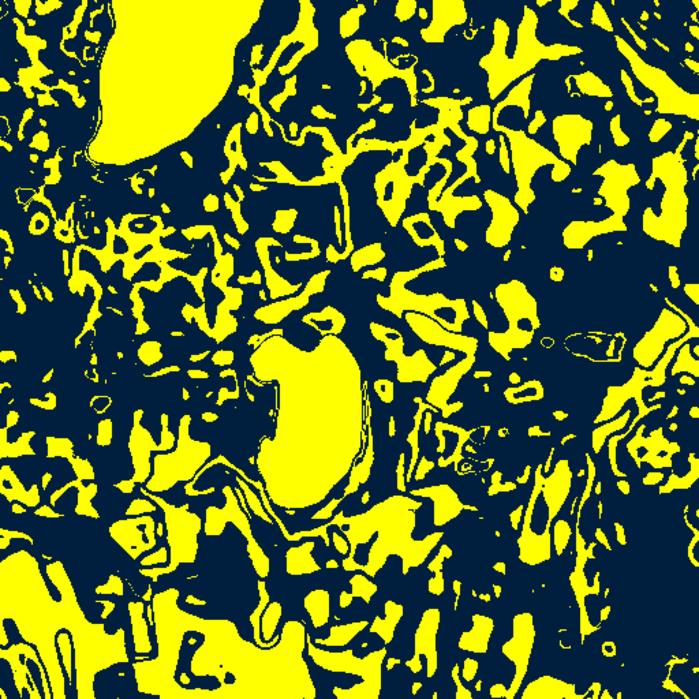  (A) DOFA-Spectral | 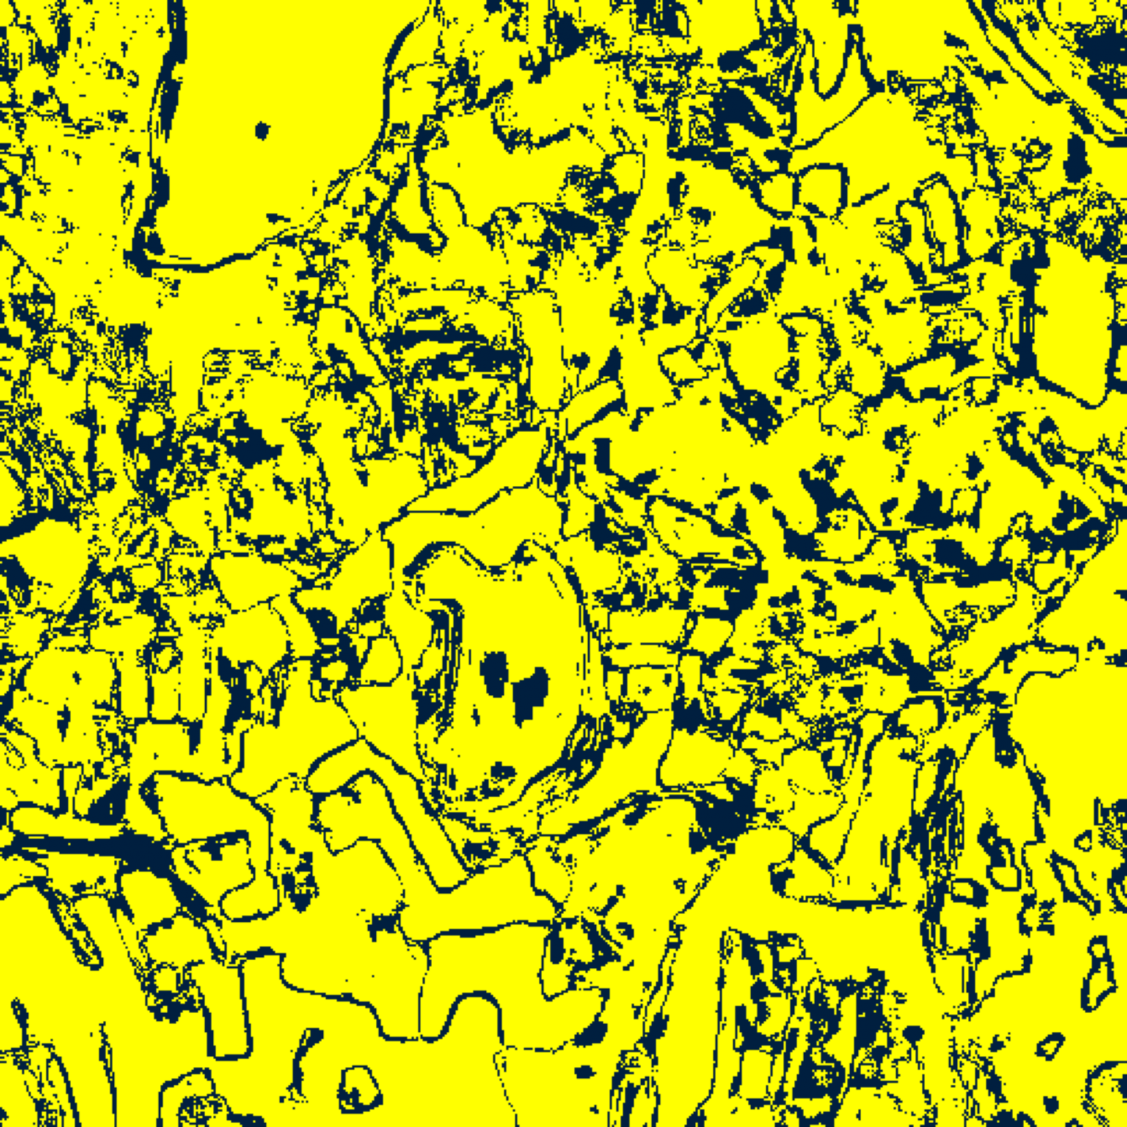  (B) Hiera-ViT
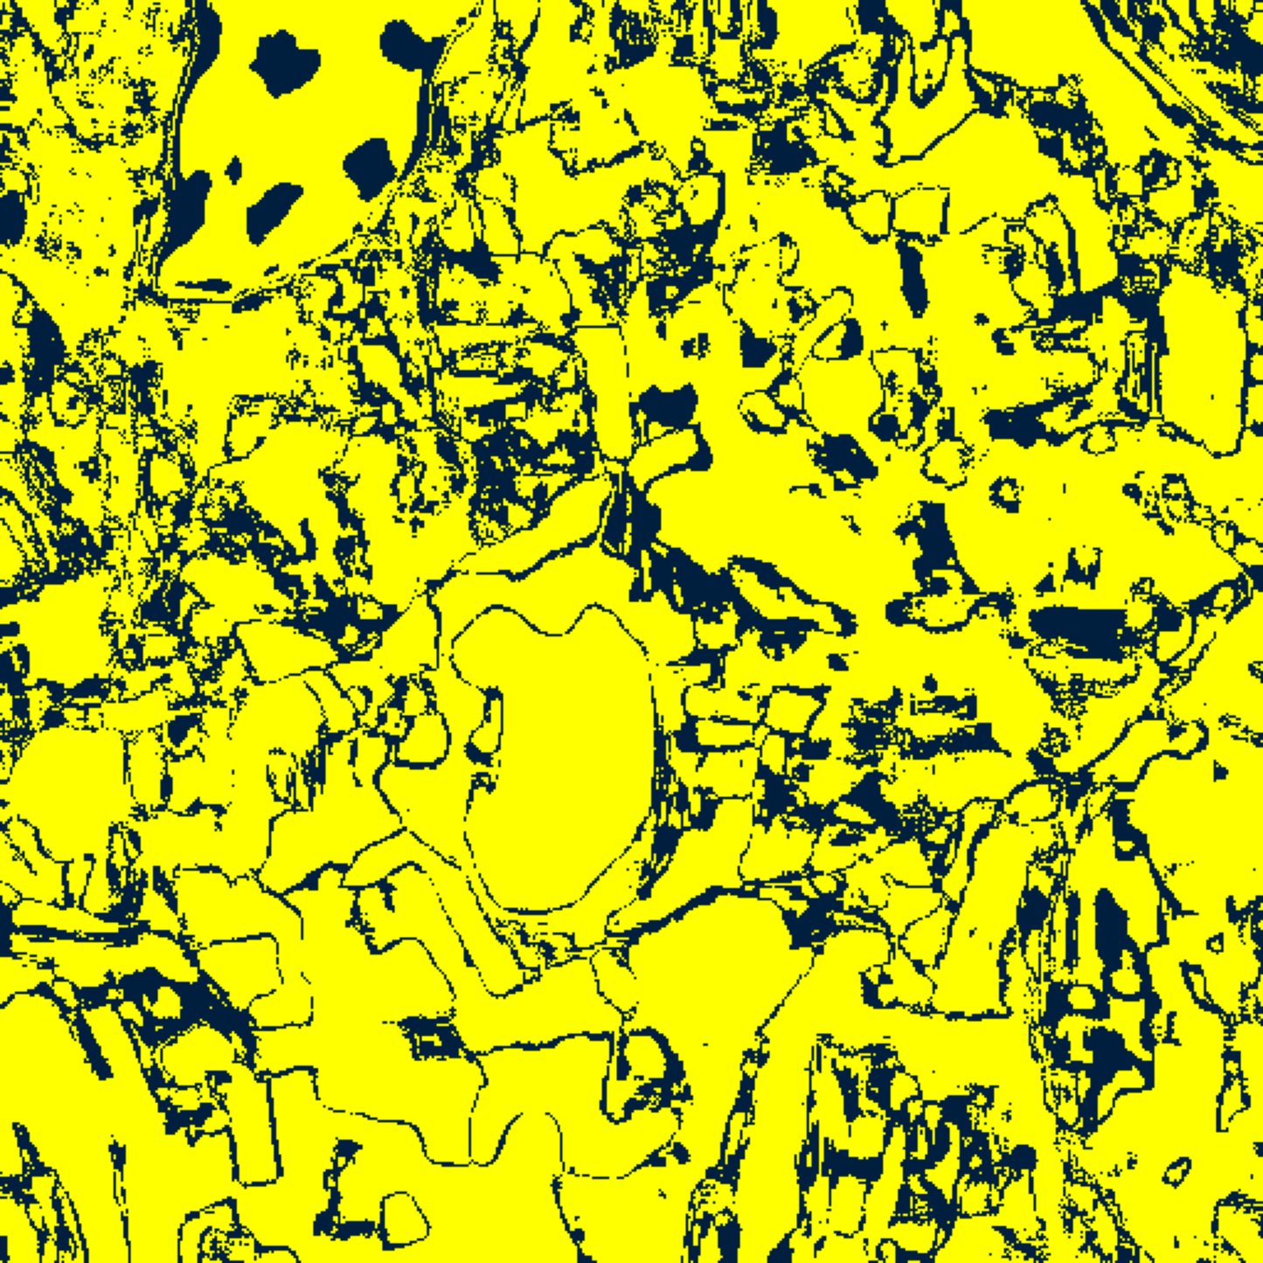  (C) DOFA-Hiera Fusion | 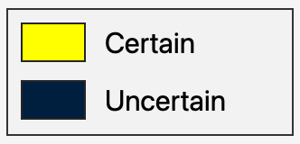  (D) Binary Legend
Fig. 3(a). SplitCP binary uncertainty maps (Certain in yellow vs. Uncertain in dark navy; see (D)) for (A) DOFA-Spectral, (B) Hiera-ViT, and (C) DOFA-Hiera Fusion.
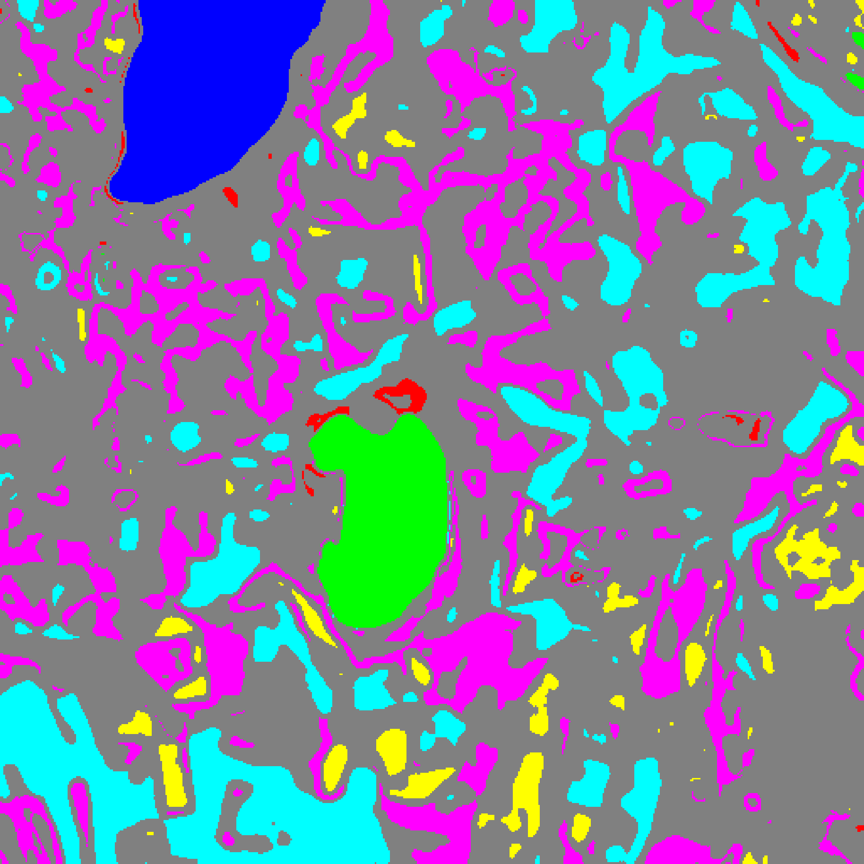  (A) DOFA-Spectral | 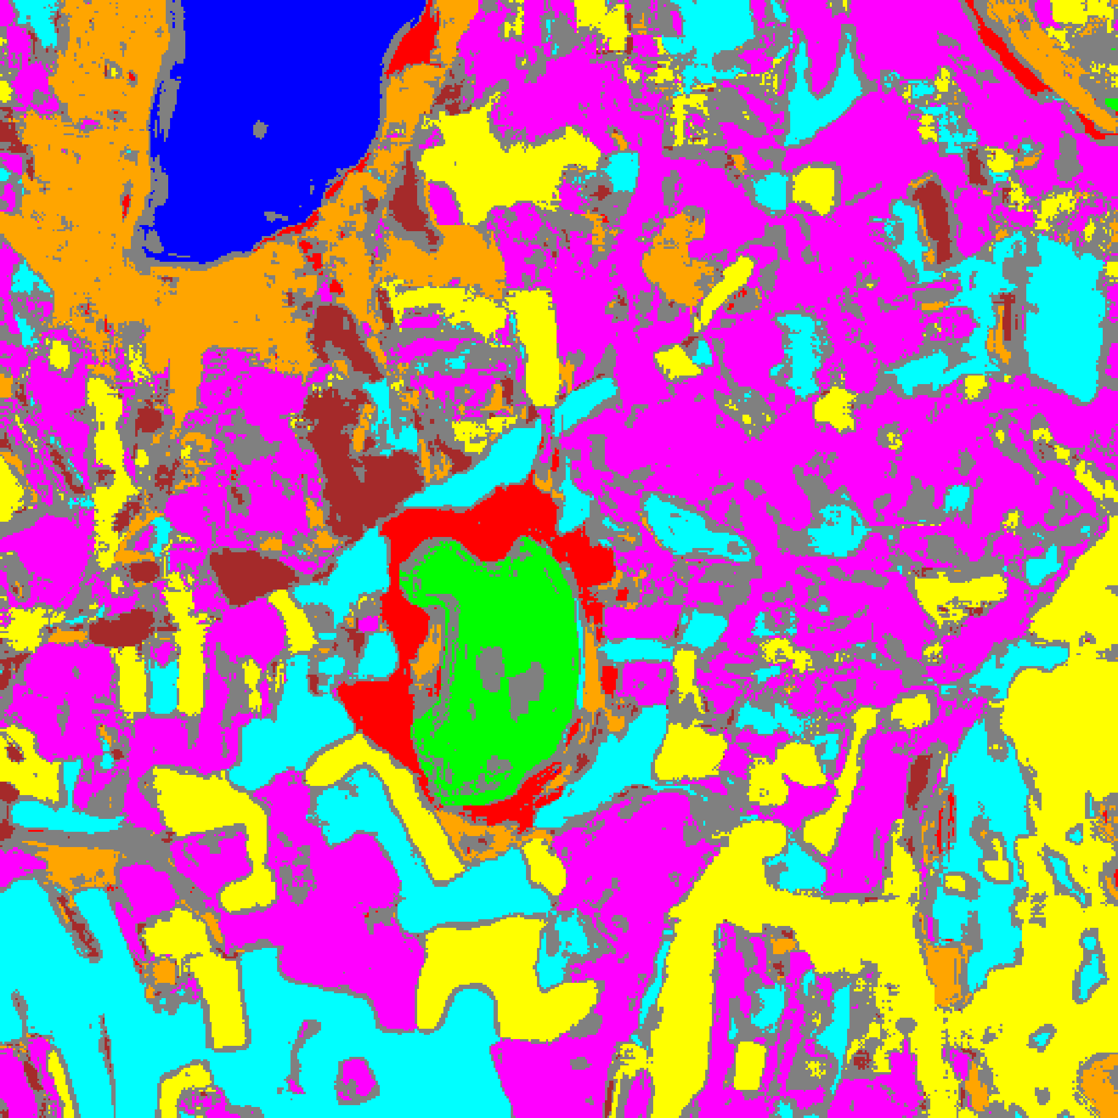  (B) Hiera-ViT
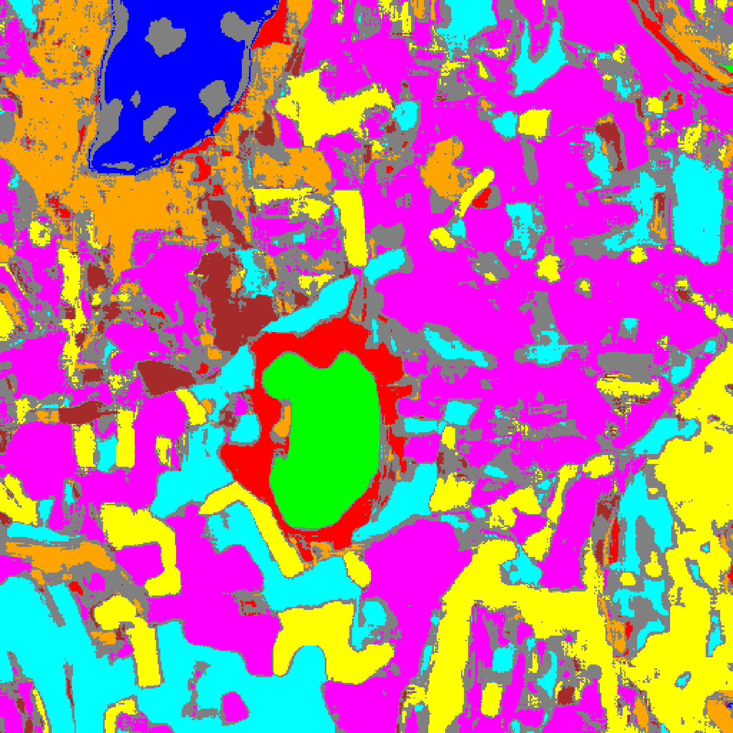
(C) DOFA-Hiera Fusion
Fig. 3(b). SplitCP class-masked maps with uncertain pixels shaded in grey for (A) DOFA-Spectral, (B) Hiera-ViT, and (C) DOFA-Hiera Fusion (refer to Fig. 2(d) for class colours).
E. Class-Conditional Conformal Prediction (CcCP)
TABLE V through TABLE VIII and Fig. 4(a)–(b) report the CcCP results. Under SplitCP, DOFA-Spectral suffered severe under-coverage on minority classes (0.4028 on Class 2 and 0.6500 on Class 6 in TABLE III). CcCP corrects this disparity by calibrating class-specific thresholds reaching q̂_2 = 0.922886 and q̂_6 = 0.903648 (TABLE VII), raising DOFA-Spectral’s mean per-class coverage from 0.8674 to 0.9535 (with every class achieving at least 0.9369 coverage in TABLE VI) at the cost of a larger average set size (1.8403) and 172,580 uncertain scene pixels (TABLE VIII).
TABLE V
CCCP AGGREGATE PERFORMANCE (Α = 0.05)
Model | Emp. Cov. | Avg Set Size | Singleton Rate | Empty Set Rate | Runtime (s) | Mean Cls Cov.
DOFA-Spectral | 0.9515 | 1.8403 | 0.5016 | 0.0074 | 2.640 | 0.9535
Hiera-ViT | 0.9494 | 0.9494 | 0.9494 | 0.0506 | 2.223 | 0.9556
DOFA-Hiera Fusion | 0.9455 | 0.9455 | 0.9455 | 0.0545 | 2.174 | 0.9503

TABLE VI
CCCP PER-CLASS EMPIRICAL COVERAGE
Class | DOFA-Spectral | Hiera-ViT | DOFA-Hiera Fusion
Class 0 | 0.9581 | 0.9400 | 0.9556
Class 1 | 0.9602 | 0.9560 | 0.9503
Class 2 | 0.9753 | 0.9717 | 0.9505
Class 3 | 0.9348 | 0.9487 | 0.9414
Class 4 | 0.9484 | 0.9484 | 0.9396
Class 5 | 0.9585 | 0.9462 | 0.9386
Class 6 | 0.9300 | 0.9900 | 0.9950
Class 7 | 0.9625 | 0.9437 | 0.9313

TABLE VII
CCCP CALIBRATED CLASS-WISE THRESHOLDS (Q̂_C)
Class | DOFA-Spectral | Hiera-ViT | DOFA-Hiera Fusion
Class 0 | 0.038759 | 0.041391 | 0.032342
Class 1 | 0.054209 | 0.041948 | 0.025139
Class 2 | 0.963473 | 0.030148 | 0.023529
Class 3 | 0.632951 | 0.037931 | 0.031184
Class 4 | 0.833581 | 0.041535 | 0.031712
Class 5 | 0.777186 | 0.036712 | 0.028726
Class 6 | 0.962031 | 0.037602 | 0.023588
Class 7 | 0.952928 | 0.036301 | 0.026282

TABLE VIII
CCCP FULL-SCENE PIXEL COUNTS (512 × 512 = 262,144 PIXELS)
Class / Region | DOFA-Spectral | Hiera-ViT | DOFA-Hiera Fusion
Class 0 | 10,097 | 10,050 | 10,240
Class 1 | 6,947 | 6,568 | 6,615
Class 2 | 596 | 4,652 | 6,550
Class 3 | 33,796 | 32,757 | 29,722
Class 4 | 5,659 | 73,054 | 70,953
Class 5 | 6,962 | 35,187 | 31,510
Class 6 | 0 | 6,274 | 5,352
Class 7 | 0 | 17,050 | 15,971
Uncertain | 198,087 | 76,552 | 85,231
Total (Scene) | 262,144 | 262,144 | 262,144

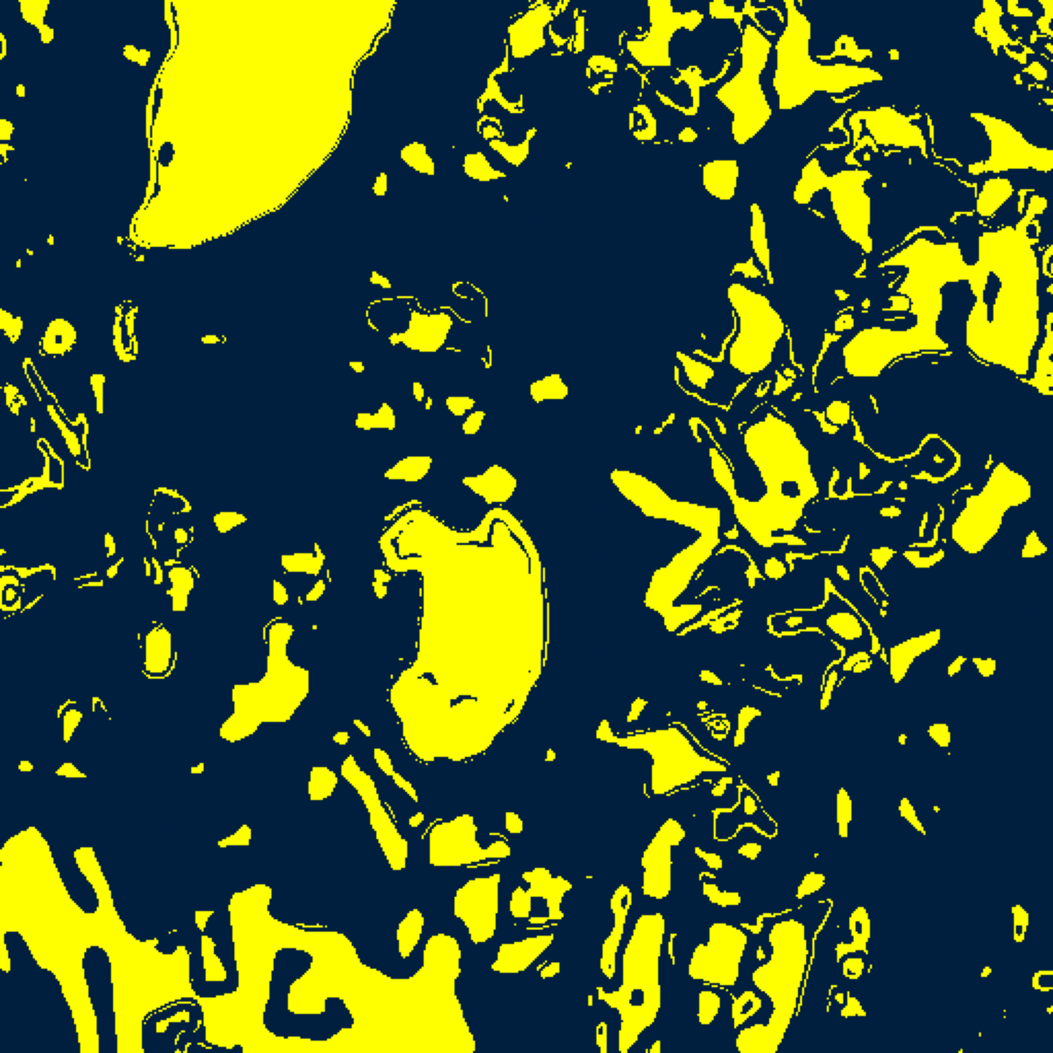  (A) DOFA-Spectral | 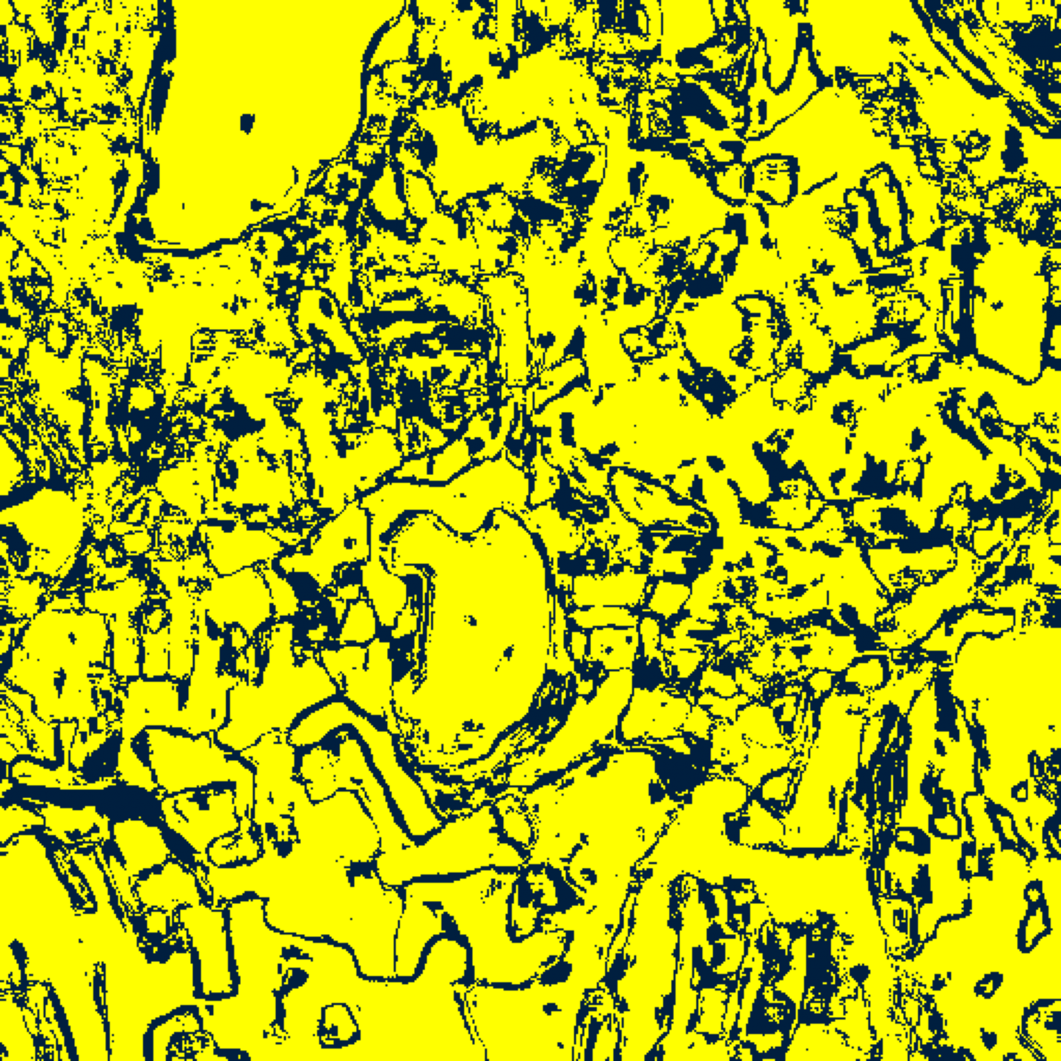  (B) Hiera-ViT
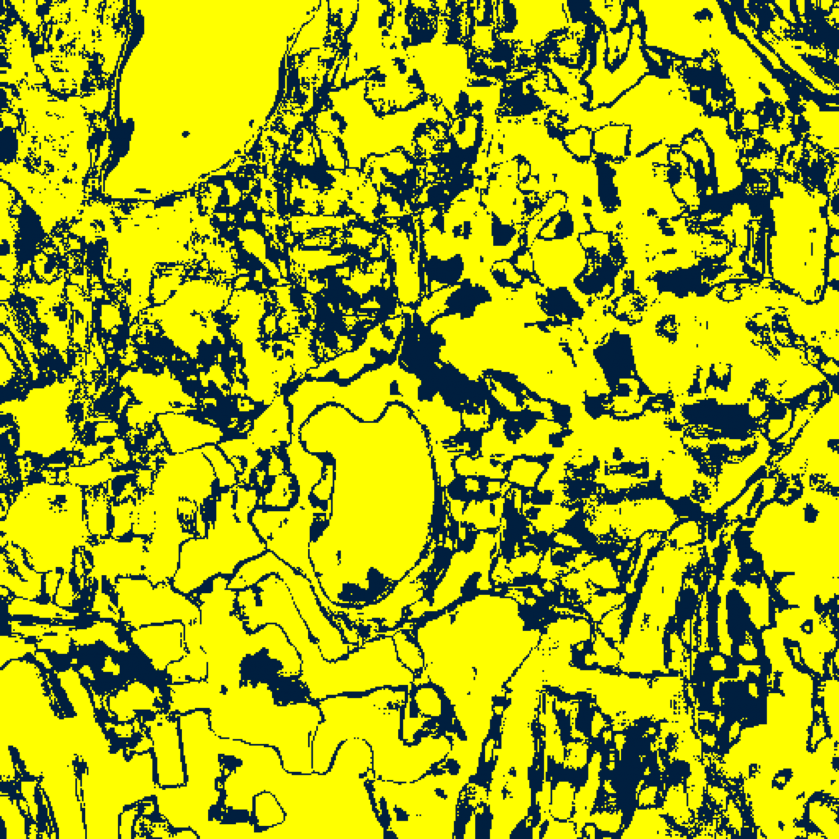  (C) DOFA-Hiera Fusion | (D) Binary Legend
Fig. 4(a). CcCP binary uncertainty maps (refer to (D)) for (A) DOFA-Spectral, (B) Hiera-ViT, and (C) DOFA-Hiera Fusion.
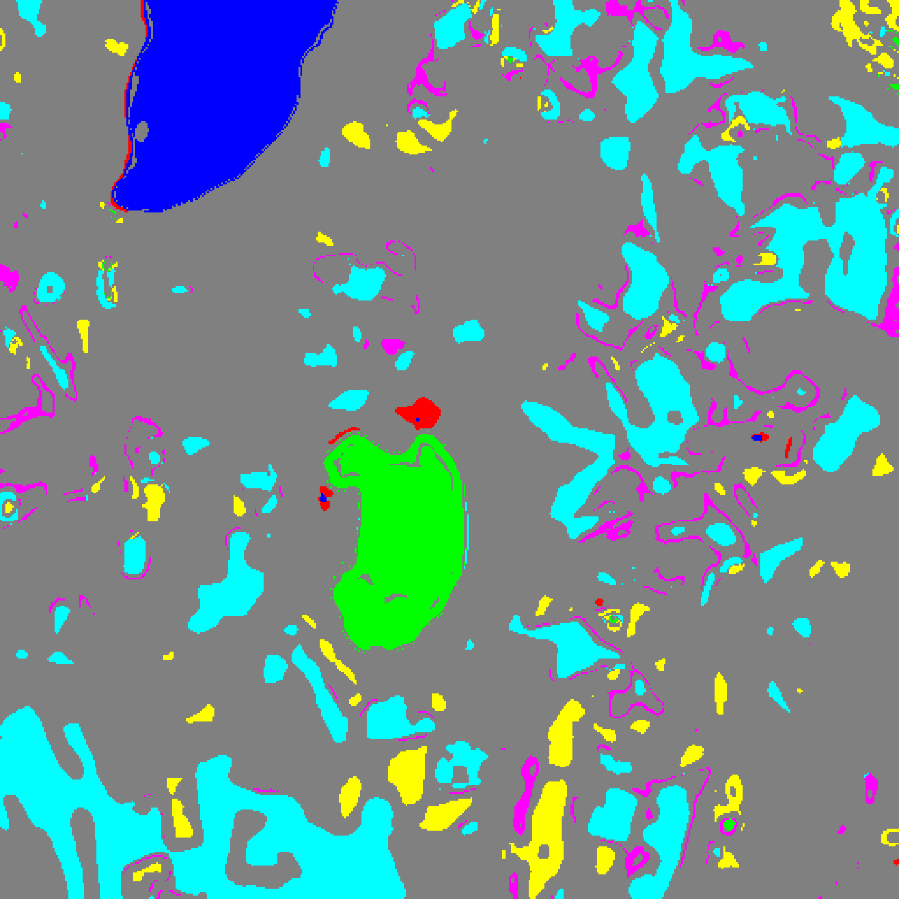  (A) DOFA-Spectral | 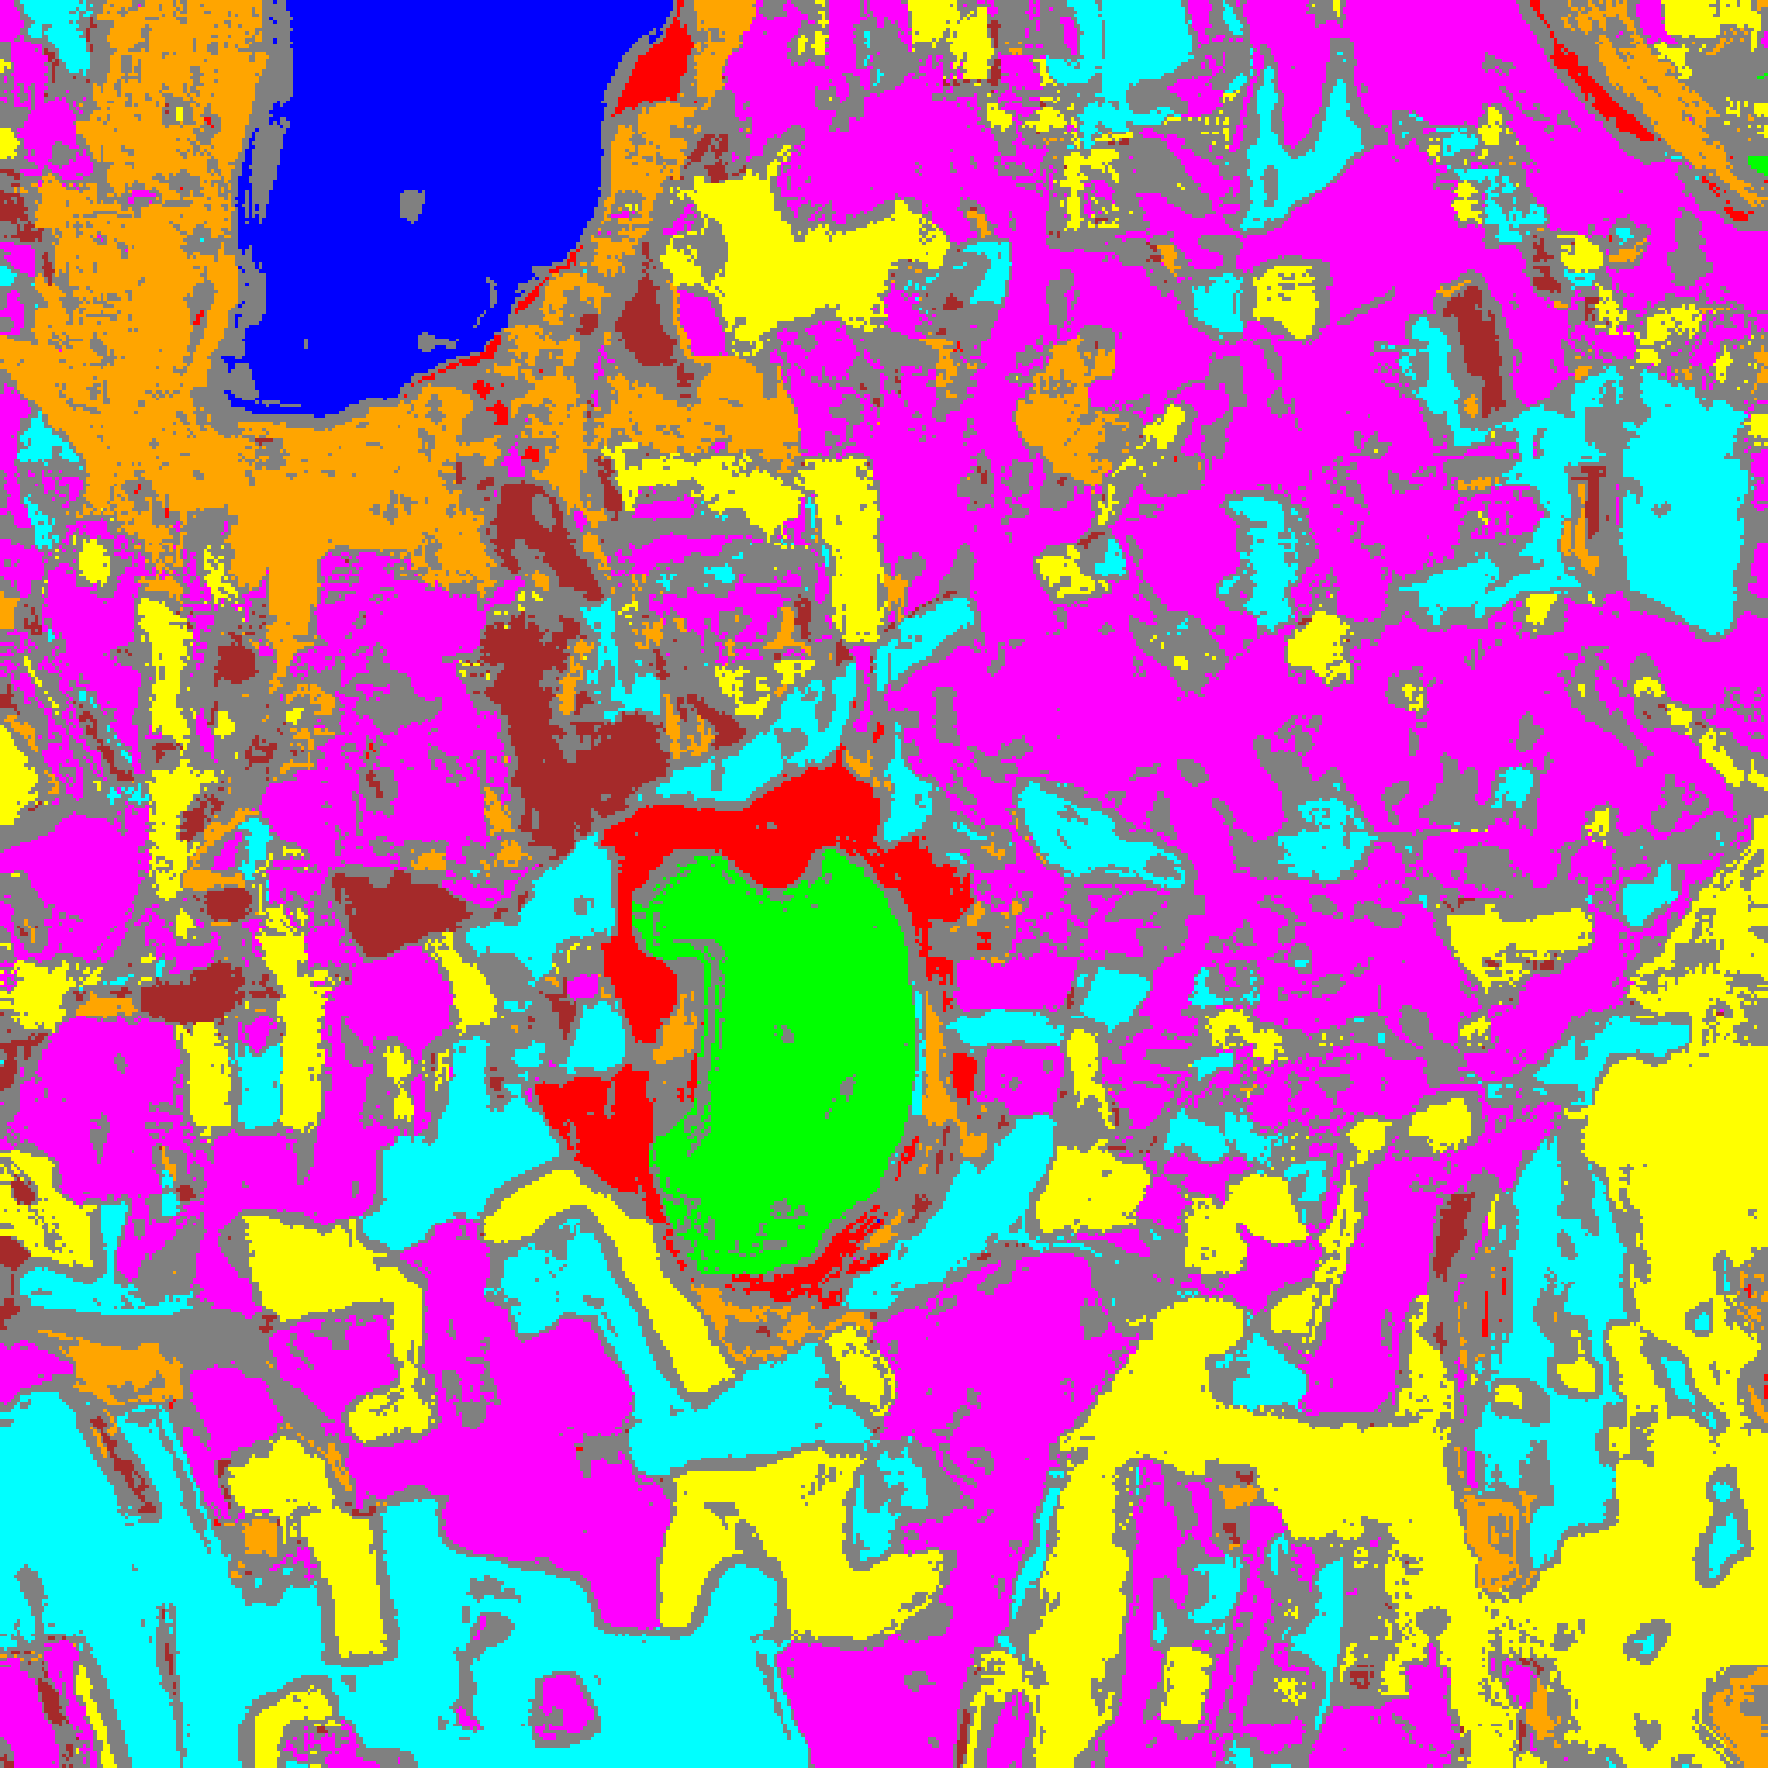  (B) Hiera-ViT
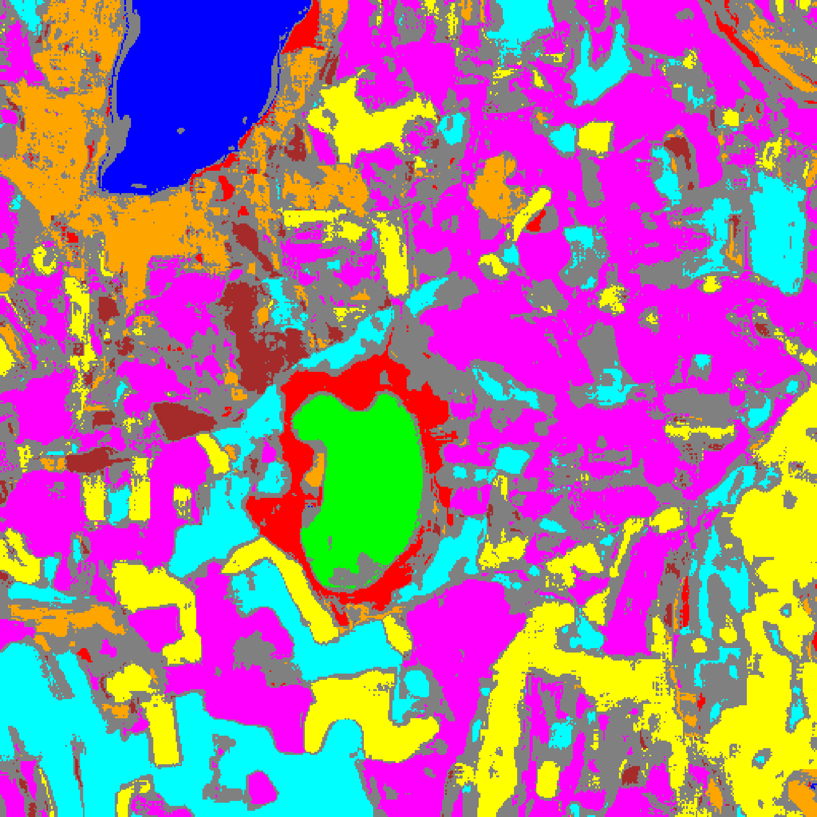
(C) DOFA-Hiera Fusion
Fig. 4(b). CcCP class-masked maps with uncertain pixels shaded in grey for (A) DOFA-Spectral, (B) Hiera-ViT, and (C) DOFA-Hiera Fusion (refer to Fig. 2(d) for class colours).
F. Regularised Class-Conditional Conformal Prediction (RC3P)
TABLE IX through TABLE XII and Fig. 5(a)–(b) present the RC3P results. While Hiera-ViT and DOFA-Hiera Fusion maintain k̂_c = 1 across all classes, DOFA-Spectral requires expanded rank limits k̂_c ∈ {2, 3, 4, 6} (specifically k̂ = 6 for Class 2 and k̂ = 4 for Class 6 in TABLE XI) to guarantee class-conditional coverage, achieving 0.9553 empirical coverage and 0.9590 mean class coverage.
TABLE IX
RC3P AGGREGATE PERFORMANCE (Α = 0.05)
Model | Emp. Cov. | Avg Set Size | Singleton Rate | Empty Set Rate | Runtime (s) | Mean Cls Cov.
DOFA-Spectral | 0.9553 | 1.8952 | 0.4977 | 0.0062 | 2.385 | 0.9590
Hiera-ViT | 0.9532 | 0.9532 | 0.9532 | 0.0468 | 2.249 | 0.9598
DOFA-Hiera Fusion | 0.9486 | 0.9486 | 0.9486 | 0.0514 | 2.221 | 0.9535

TABLE X
RC3P PER-CLASS EMPIRICAL COVERAGE
Class | DOFA-Spectral | Hiera-ViT | DOFA-Hiera Fusion
Class 0 | 0.9605 | 0.9449 | 0.9605
Class 1 | 0.9645 | 0.9574 | 0.9545
Class 2 | 0.9823 | 0.9753 | 0.9505
Class 3 | 0.9385 | 0.9531 | 0.9443
Class 4 | 0.9528 | 0.9491 | 0.9409
Class 5 | 0.9594 | 0.9537 | 0.9415
Class 6 | 0.9450 | 0.9950 | 0.9950
Class 7 | 0.9688 | 0.9500 | 0.9406

TABLE XI
RC3P CALIBRATED THRESHOLDS (Q̂_C) AND RANK LIMITS (K̂_C)
Class | DOFA-Spec q̂ | DOFA-Spec k̂ | Hiera-ViT q̂ | Hiera-ViT k̂ | Fusion q̂ | Fusion k̂
Class 0 | 0.040095 | 4 | 0.041419 | 1 | 0.032347 | 1
Class 1 | 0.054215 | 4 | 0.041966 | 1 | 0.025178 | 1
Class 2 | 0.968049 | 6 | 0.030177 | 1 | 0.023531 | 1
Class 3 | 0.649341 | 4 | 0.037993 | 1 | 0.031205 | 1
Class 4 | 0.839231 | 4 | 0.041541 | 1 | 0.031732 | 1
Class 5 | 0.785910 | 4 | 0.036764 | 1 | 0.028747 | 1
Class 6 | 0.962816 | 6 | 0.038681 | 1 | 0.023676 | 1
Class 7 | 0.956932 | 6 | 0.036436 | 1 | 0.026541 | 1

TABLE XII
RC3P FULL-SCENE PIXEL COUNTS (512 × 512 = 262,144 PIXELS)
Class / Region | DOFA-Spectral | Hiera-ViT | DOFA-Hiera Fusion
Class 0 | 10,146 | 10,092 | 10,294
Class 1 | 6,976 | 6,589 | 6,665
Class 2 | 558 | 4,663 | 6,554
Class 3 | 33,210 | 32,969 | 29,927
Class 4 | 4,120 | 73,134 | 71,515
Class 5 | 6,499 | 35,395 | 31,672
Class 6 | 0 | 6,620 | 5,397
Class 7 | 0 | 17,288 | 16,178
Uncertain | 200,635 | 75,394 | 83,942
Total (Scene) | 262,144 | 262,144 | 262,144

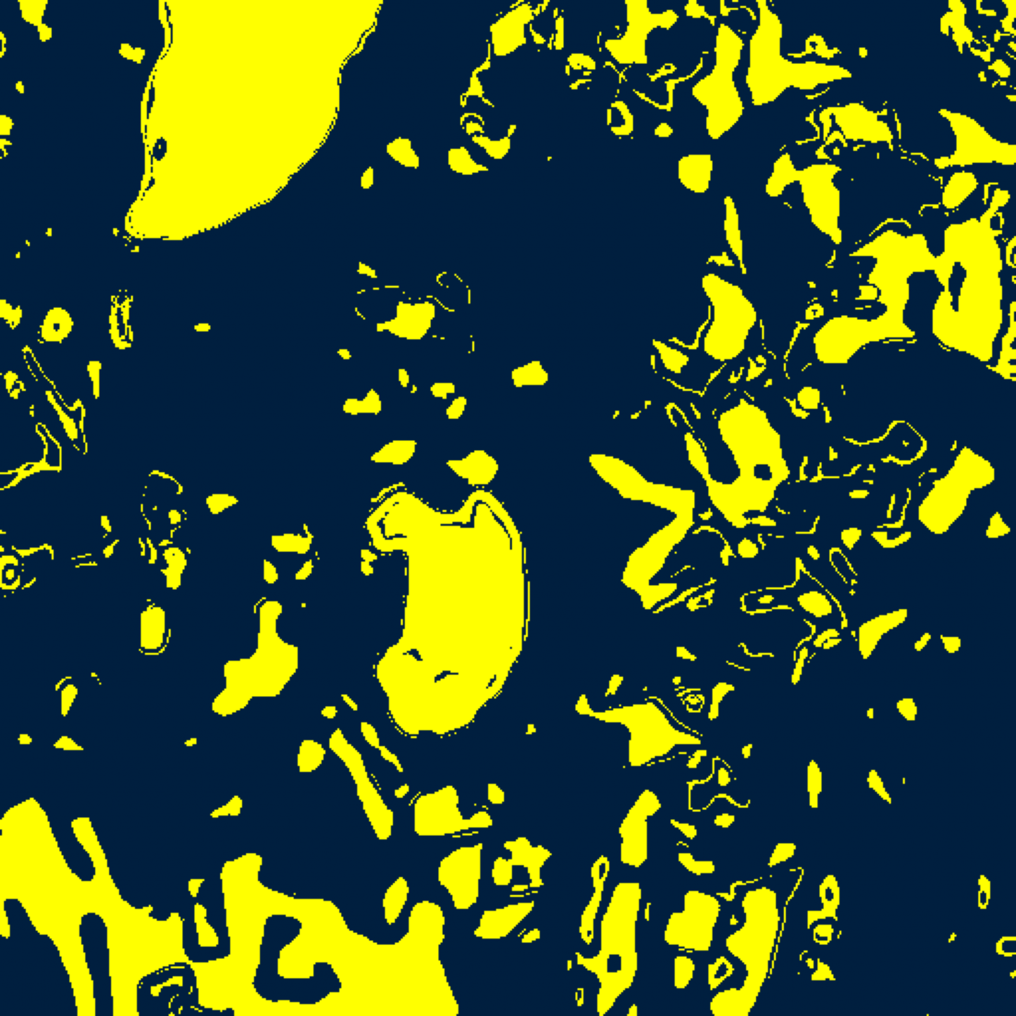  (A) DOFA-Spectral | 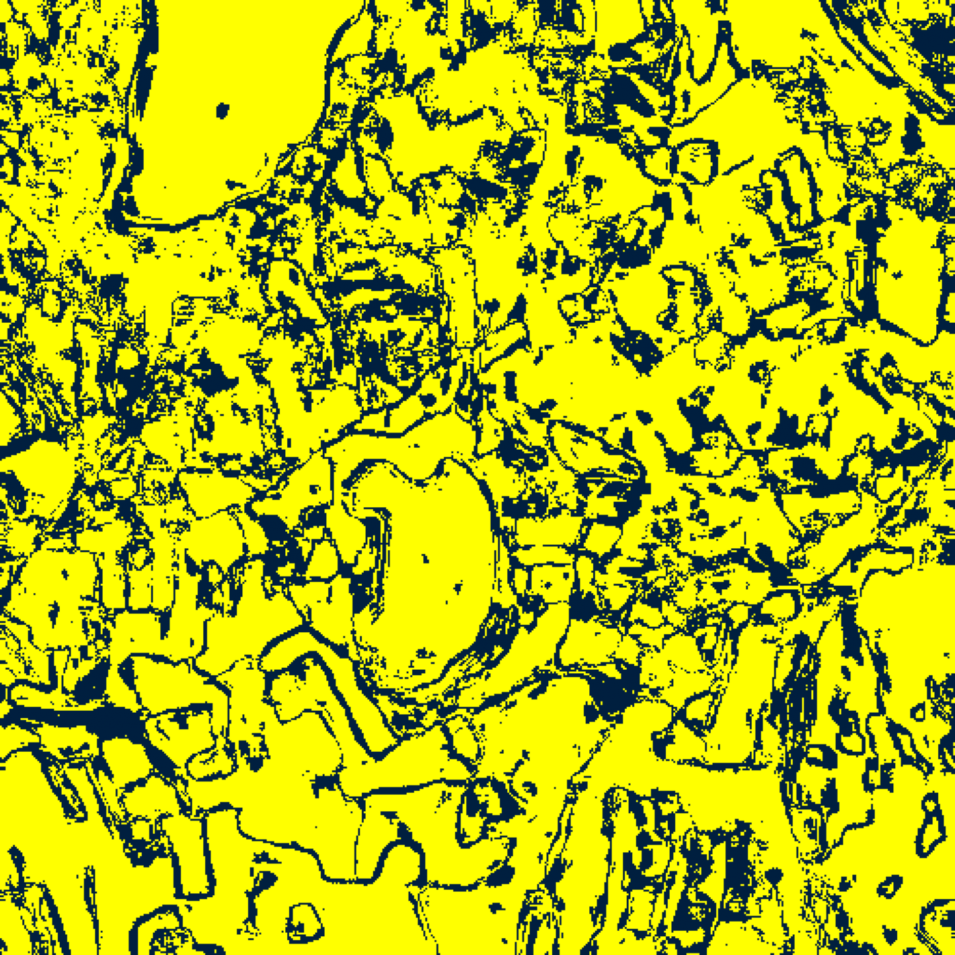  (B) Hiera-ViT
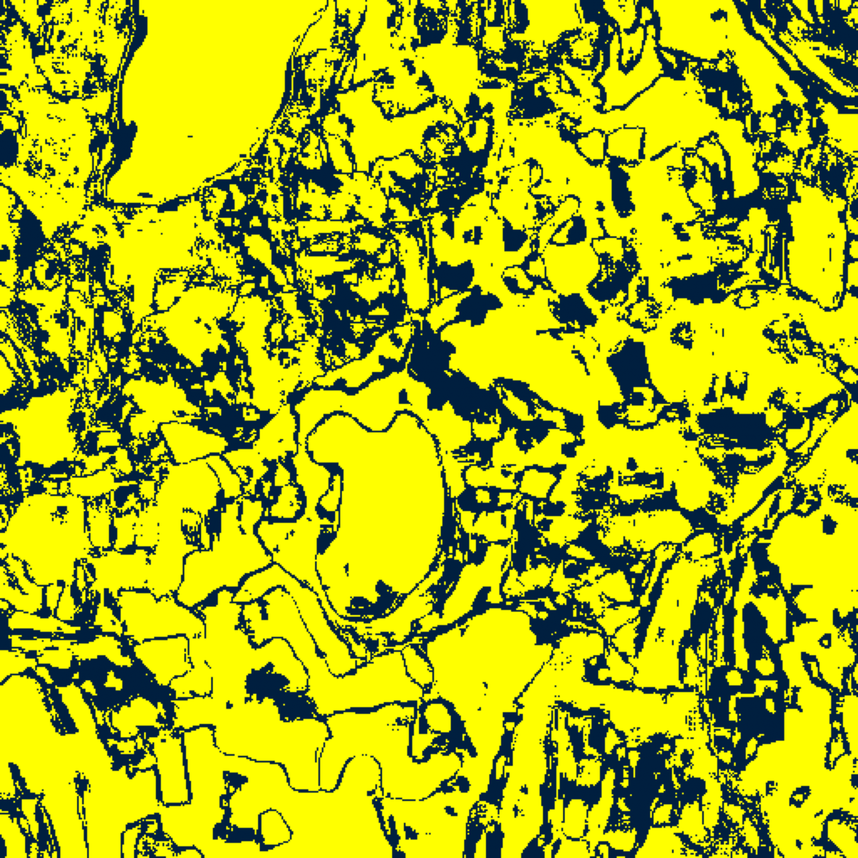  (C) DOFA-Hiera Fusion | (D) Binary Legend
Fig. 5(a). RC3P binary uncertainty maps (refer to (D)) for (A) DOFA-Spectral, (B) Hiera-ViT, and (C) DOFA-Hiera Fusion.
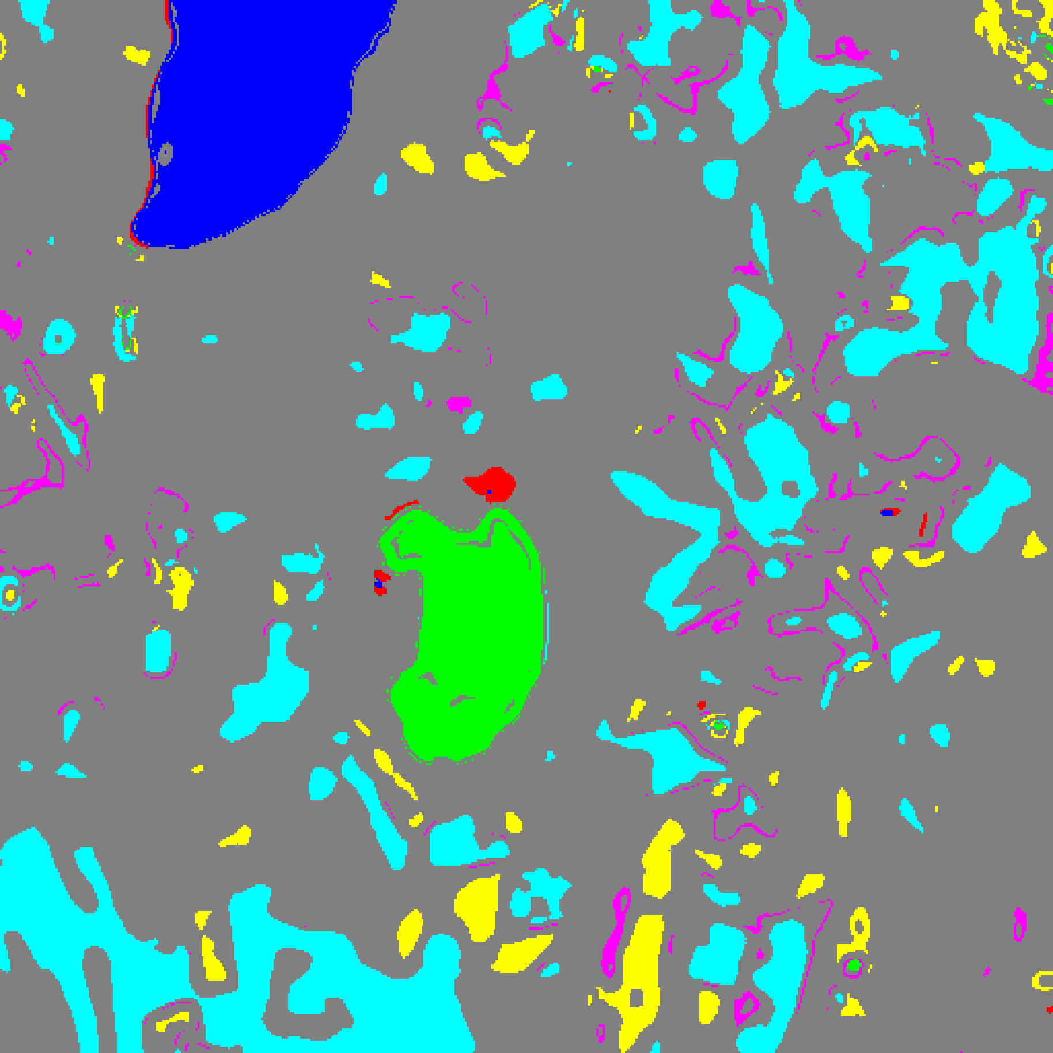  (A) DOFA-Spectral | 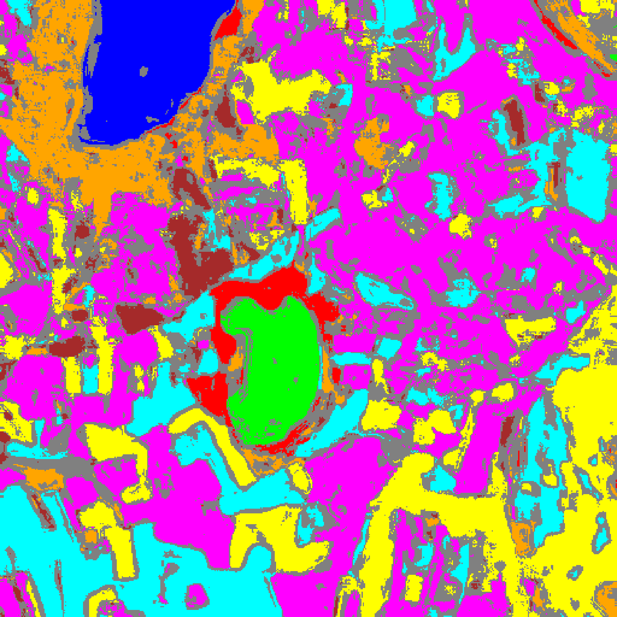  (B) Hiera-ViT
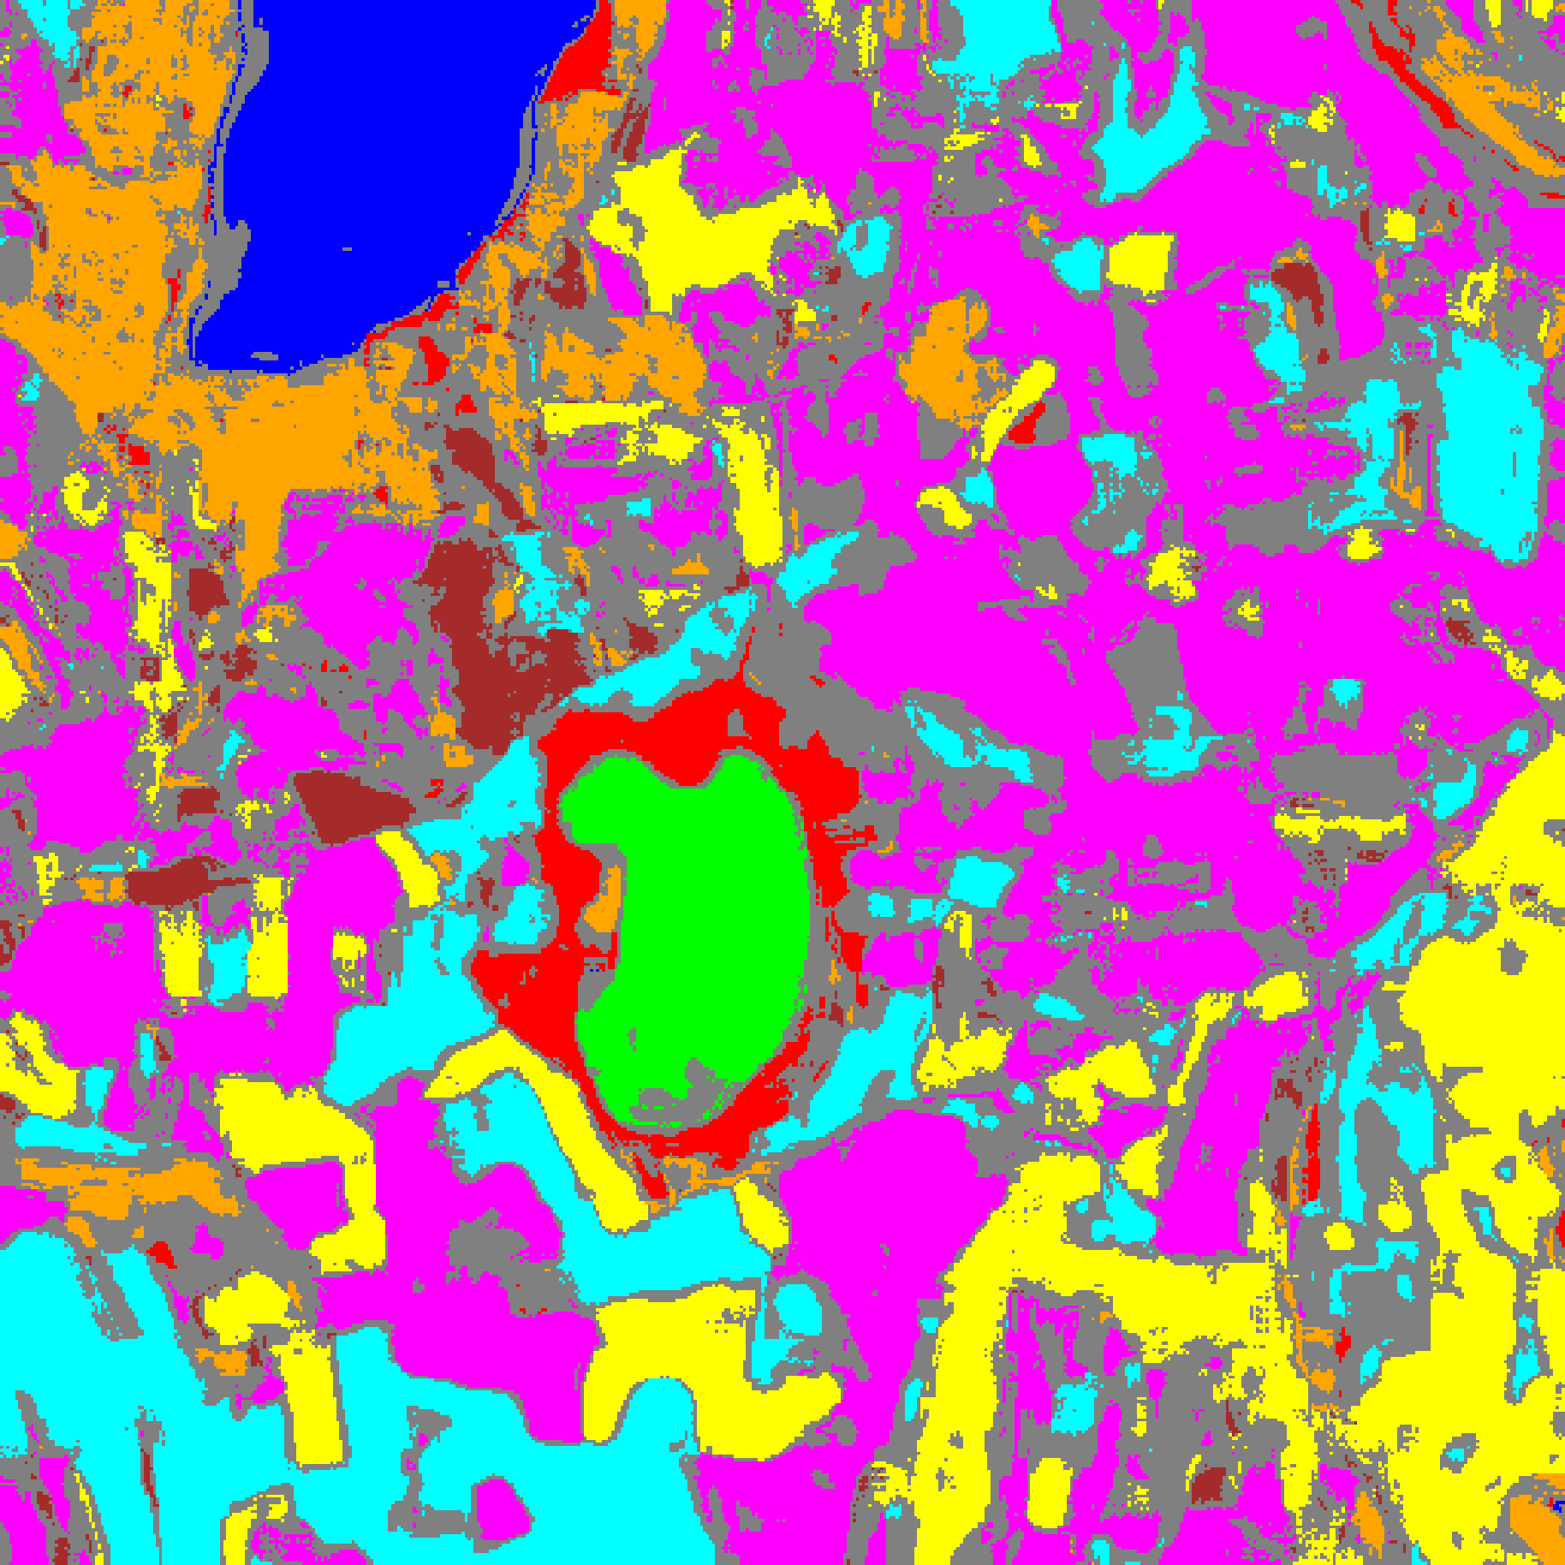
(C) DOFA-Hiera Fusion
Fig. 5(b). RC3P class-masked maps with uncertain pixels shaded in grey for (A) DOFA-Spectral, (B) Hiera-ViT, and (C) DOFA-Hiera Fusion (refer to Fig. 2(d) for class colours).
G. Clustered Conformal Prediction (ClCP)
TABLE XIII through TABLE XVI report ClCP results (K_g = 4). Grouping classes by score distribution lifts DOFA-Spectral’s mean per-class coverage to 0.9052 with a smaller average set size (1.6924) than CcCP (1.8403), while Hiera-ViT and DOFA-Hiera Fusion achieve 0.9549 and 0.9504 empirical coverage respectively. In TABLE XVI, the workbook’s exported Cluster Mean Uncertainty column records the mean empirical coverage across classes assigned to each cluster.
TABLE XIII
CLCP AGGREGATE PERFORMANCE (Α = 0.05, K_G = 4 CLUSTERS)
Model | Emp. Cov. | Avg Set Size | Singleton Rate | Empty Set Rate | Runtime (s) | Mean Cls Cov.
DOFA-Spectral | 0.9497 | 1.6924 | 0.5177 | 0.0034 | 2.671 | 0.9052
Hiera-ViT | 0.9549 | 0.9549 | 0.9549 | 0.0451 | 5.949 | 0.9598
DOFA-Hiera Fusion | 0.9504 | 0.9504 | 0.9504 | 0.0496 | 7.285 | 0.9546

TABLE XIV
CLCP PER-CLASS EMPIRICAL COVERAGE
Class | DOFA-Spectral | Hiera-ViT | DOFA-Hiera Fusion
Class 0 | 0.9581 | 0.9638 | 0.7903
Class 1 | 1.0000 | 0.9148 | 1.0000
Class 2 | 0.9682 | 0.9717 | 0.9505
Class 3 | 0.9143 | 0.9927 | 0.9846
Class 4 | 0.9811 | 0.8987 | 0.9906
Class 5 | 0.9858 | 0.9981 | 0.9943
Class 6 | 0.4650 | 0.9950 | 0.9950
Class 7 | 0.9688 | 0.9437 | 0.9313

TABLE XV
CLCP CLASS-TO-CLUSTER ASSIGNMENTS AND CLUSTER THRESHOLDS (Q̂)
Class | DOFA-Spec Cl. | DOFA-Spec q̂ | Hiera-ViT Cl. | Hiera-ViT q̂ | Fusion Cl. | Fusion q̂
Class 0 | Cluster 2 | 0.038759 | Cluster 2 | 0.041727 | Cluster 1 | 0.032311
Class 1 | Cluster 0 | 0.521364 | Cluster 2 | 0.041727 | Cluster 1 | 0.032311
Class 2 | Cluster 3 | 0.956932 | Cluster 0 | 0.030148 | Cluster 2 | 0.023529
Class 3 | Cluster 0 | 0.521364 | Cluster 1 | 0.041355 | Cluster 1 | 0.032311
Class 4 | Cluster 1 | 0.900349 | Cluster 1 | 0.041355 | Cluster 1 | 0.032311
Class 5 | Cluster 1 | 0.900349 | Cluster 1 | 0.041355 | Cluster 1 | 0.032311
Class 6 | Cluster 1 | 0.900349 | Cluster 1 | 0.041355 | Cluster 0 | 0.023588
Class 7 | Cluster 3 | 0.956932 | Cluster 3 | 0.036301 | Cluster 3 | 0.026282

TABLE XVI
CLCP PER-CLUSTER MEAN COVERAGE (EXPORTED AS CLUSTER MEAN UNCERTAINTY)
Cluster | DOFA-Spectral | Hiera-ViT | DOFA-Hiera Fusion
Cluster 0 | 0.2876 | 0.9717 | 0.9950
Cluster 1 | 0.4238 | 0.9587 | 0.9499
Cluster 2 | 0.1975 | 0.9458 | 0.9472
Cluster 3 | 0.4533 | 0.9437 | 0.9342

H. Regularised Adaptive Prediction Sets (RAPS)
TABLE XVII through TABLE XIX summarise RAPS (λ = 0.01, k_reg = 1). RAPS eliminates empty prediction sets across all three models. For Hiera-ViT and DOFA-Hiera Fusion, RAPS yields 100.00% and 99.99% singleton coverage; for DOFA-Spectral, RAPS achieves 0.9510 empirical coverage with an average set size of 1.5513 and singleton rate of 0.5878.
TABLE XVII
RAPS AGGREGATE PERFORMANCE (Α = 0.05, Λ = 0.01, K_REG = 1)
Model | Emp. Cov. | Avg Set Size | Singleton Rate | Empty Set Rate | Runtime (s) | Mean Cls Cov.
DOFA-Spectral | 0.9510 | 1.5513 | 0.5878 | 0.0000 | 0.501 | 0.8681
Hiera-ViT | 1.0000 | 1.0000 | 1.0000 | 0.0000 | 0.476 | 1.0000
DOFA-Hiera Fusion | 0.9999 | 1.0000 | 1.0000 | 0.0000 | 0.482 | 0.9996

TABLE XVIII
RAPS PER-CLASS EMPIRICAL COVERAGE
Class | DOFA-Spectral | Hiera-ViT | DOFA-Hiera Fusion
Class 0 | 0.9951 | 1.0000 | 1.0000
Class 1 | 1.0000 | 1.0000 | 1.0000
Class 2 | 0.8905 | 1.0000 | 1.0000
Class 3 | 0.9839 | 1.0000 | 1.0000
Class 4 | 0.9755 | 1.0000 | 1.0000
Class 5 | 0.9783 | 1.0000 | 1.0000
Class 6 | 0.4000 | 1.0000 | 1.0000
Class 7 | 0.7219 | 1.0000 | 0.9969

TABLE XIX
RAPS CALIBRATED PARAMETERS
Model | q̂_RAPS | λ | k_reg
DOFA-Spectral | 0.799763 | 0.01 | 1
Hiera-ViT | 0.000000 | 0.01 | 1
DOFA-Hiera Fusion | 0.000000 | 0.01 | 1

IV. CONCLUSION
This study evaluated DOFA-Spectral, Hiera-ViT, and DOFA-Hiera Fusion on the 65-band DIAS Scene K01 hyperspectral dataset (512 × 512 pixels, K = 8 classes). Hiera-ViT achieved 100.000% test accuracy (κ = 1.0000), while DOFA-Hiera Fusion achieved 99.978% accuracy alongside the best calibration metrics (NLL = 0.03055, Brier = 0.00137, ECE = 0.02939), demonstrating that gated cross-attention effectively combines wavelength-conditioned spectral embeddings with hierarchical windowed spatial features.
Across the five conformal prediction methods, DOFA-Spectral illustrated how class-conditional methods (CcCP and RC3P) remedy severe minority-class under-coverage present under marginal SplitCP (lifting Class 2 coverage from 0.4028 to 0.9435–0.9541 via higher class thresholds and rank limits k̂_c ≤ 6), whereas Hiera-ViT and DOFA-Hiera Fusion achieved tight singleton prediction sets with k̂_c = 1 across all classes.
Full-scene uncertainty maps over all 262,144 pixels confirm that Hiera-ViT and DOFA-Hiera Fusion restrict uncertainty to unlabelled background and parcel boundaries (∼42.8%–47.9% of total scene pixels), providing reliable spatial confidence masks for hyperspectral earth observation.
REFERENCES
[1] Z. Xiong, Y. Wang, F. Zhang, A. J. Stewart, J. Hanna, D. Borth, I. Papoutsis, B. Le Saux, G. Camps-Valls, and X. X. Zhu, “Neural plasticity-inspired foundation model for observing the Earth crossing modalities,” arXiv:2403.15356, 2024.
[2] C. Ryali, Y.-T. Hu, D. Bolya, C. Wei, H. Fan, P.-Y. Huang, V. Aggarwal, A. Chowdhury, O. Poursaeed, P. Dollar, and C. Feichtenhofer, “Hiera: A hierarchical vision transformer without the bells-and-whistles,” in Proc. ICML, 2023.
[3] A. N. Angelopoulos, S. Bates, J. Malik, and M. I. Jordan, “Uncertainty sets for image classifiers using conformal prediction,” in Proc. ICLR, 2021.
[4] Y. Shi, S. Ghosh, T. Belkhouja, J. R. Doppa, and Y. Yan, “Conformal prediction for class-wise coverage via augmented label rank calibration,” in Adv. Neural Inf. Process. Syst. (NeurIPS), 2024.
[5] T. Ding, A. N. Angelopoulos, S. Bates, M. I. Jordan, and R. J. Tibshirani, “Class-conditional conformal prediction with many classes,” in Adv. Neural Inf. Process. Syst. (NeurIPS), 2023.
[6] Y. Romano, M. Sesia, and E. Candès, “Classification with valid and adaptive coverage,” in Adv. Neural Inf. Process. Syst. (NeurIPS), 2020.
[7] A. N. Angelopoulos and S. Bates, “A gentle introduction to conformal prediction and distribution-free uncertainty quantification,” Found. Trends Mach. Learn., 2023.
[8] H. Papadopoulos, K. Proedrou, V. Vovk, and A. Gammerman, “Inductive confidence machines for regression,” in Proc. ECML, Springer, pp. 345–356, 2002.
[9] V. Vovk, A. Gammerman, and G. Shafer, Algorithmic Learning in a Random World. Springer, 2005.
[10] A. Dosovitskiy et al., “An image is worth 16x16 words: Transformers for image recognition at scale,” in Proc. ICLR, 2021.
[11] M. Ahmad et al., “Hyperspectral image classification—Traditional to deep models: A survey for future prospects,” IEEE J. Sel. Topics Appl. Earth Observ. Remote Sens., 2022.
[12] A. Niculescu-Mizil and R. Caruana, “Predicting good probabilities with supervised learning,” in Proc. ICML, 2005.

