Credal Deep Ensemble Uncertainty Quantification for Patch-Based Hyperspectral Land-Cover Classification
ABSTRACT
This paper presents a Credal Deep Ensemble (CreDE) uncertainty-quantification analysis for patch-based pixel-wise land-cover classification of hyperspectral remote sensing imagery, complementing the companion conformal-prediction study on the same scene and architectures. A 65-band hyperspectral scene of 512 × 512 pixels (262,144 total scene pixels) from the DIAS dataset (Scene K01, K = 8 classes: Class 0 through Class 7) is classified by extracting 9 × 9 × 65 spatial-spectral patches centred on each pixel across three backbone architectures—an AlexNet-style convolutional neural network (AlexNet-CNN), a Global Filter Network (GFNet) operating in the frequency domain, and a Vision Transformer augmented with U-Net skip connections (ViT-UNet). For each architecture, M = 5 independently seeded checkpoints form per-class credal (minimum/maximum softmax) bounds without collapsing the five members into a single averaged distribution. On the 13,474-pixel held-out test set, GFNet achieves 100.00% overall accuracy, ViT-UNet achieves 99.96%, and AlexNet-CNN achieves 99.93%. Across the full 262,144-pixel scene, AlexNet-CNN achieves the lowest mean aleatoric and total uncertainty (Mean AU = 0.0664, Mean TU = 0.1700), GFNet achieves the lowest mean epistemic uncertainty (Mean EU = 0.0502, Mean AU = 0.2556, Mean TU = 0.3058), and ViT-UNet exhibits the highest scene-wide uncertainty (Mean AU = 0.6706, Mean EU = 0.0811, Mean TU = 0.7517).
I. INTRODUCTION
Remote sensing land-cover classification is a cornerstone task in earth observation [6]. Hyperspectral imagery across 65 contiguous bands provides rich spectral detail enabling fine-grained discrimination between surface classes, yet pixel-level predictions remain subject to boundary ambiguity and out-of-distribution background variation.
A single neural network’s softmax vector cannot distinguish genuine spectral ambiguity from seed-to-seed model disagreement. Deep Ensembles [1] train M independently initialised networks to capture model spread, and Credal Deep Ensembles (CreDE) [7] preserve the per-class minimum and maximum softmax probabilities across the M = 5 members as explicit lower and upper probability bounds defining a convex credal set. The principal contributions of this work are:
- Application of Credal Deep Ensembles (CreDE) to M = 5-seed checkpoints of AlexNet-CNN, GFNet, and ViT-UNet on the eight-class 65-band DIAS Scene K01 hyperspectral dataset (512 × 512 pixels).
- Per-class precision, recall, and F1-score classification reports across all 13,474 held-out test samples for each architecture.
- Formation of per-class credal bounds and conservative point estimates p*, yielding scene-wide aleatoric (AU), epistemic (EU), and total (TU) uncertainty scores across all 262,144 pixels.
- Generation of binary and grey-overlay spatial uncertainty maps and per-class pixel-count distributions under absolute thresholds (AU > 0.5, EU > 0.2, TU > 0.7).

II. METHODOLOGY
A. Dataset and Preprocessing
The dataset consists of the 65-band hyperspectral scene K01 from the DIAS benchmark (files k001.mat and k002.mat, H = 512, W = 512 pixels, B = 65 spectral bands) with K = 8 classes denoted Class 0 through Class 7. Each spectral band is independently normalised to [0, 1] via per-band min-max scaling, and 9 × 9 × 65 patches are extracted around each pixel (4-pixel edge replication). For each backbone architecture, M = 5 independently seeded weight checkpoints are trained and evaluated on the 13,474-pixel held-out test split as well as across the entire 262,144-pixel scene.
B. Backbone Architectures
AlexNet-style CNN: Five same-padded 3 × 3 convolutional layers [96, 256, 384, 384, 256] and a dense classification head with dropout (p = 0.25) [5], trained with Adagrad and a cosine learning-rate schedule.
GFNet: Tokenises each 9 × 9 × 65 patch into nine 3 × 3 sub-patches (d = 512) and applies five 2-D Fourier global-filter blocks [2], trained with AdamW and label smoothing (ε_s = 0.05).
ViT-UNet: A 12-layer Vision Transformer [3] augmented with U-Net skip connections [4] linking encoder block i to decoder block L − i for i ≤ ⌊L/2⌋.
C. Credal Deep Ensemble (CreDE) Uncertainty Quantification
Given M = 5 member softmax predictions q_{m,i}(x) for class i ∈ {0, ..., 7}, the lower and upper probability bounds are p_min,i(x) = min_m q_{m,i}(x) and p_max,i(x) = max_m q_{m,i}(x), with interval width Δp_i(x) = p_max,i(x) − p_min,i(x) [7]. The lower bound is renormalised to p*(x) = p_min(x) / (Σ_j p_min,j(x) + ε), from which the predicted class is ĉ(x) = argmax_i p*_i(x). Three per-pixel uncertainty scores follow:
AU(x) = −Σ_i p*_i(x) ln p*_i(x) EU(x) = (1/K) Σ_i Δp_i(x) TU(x) = AU(x) + EU(x)
Each map is thresholded at fixed cut-offs (τ_AU = 0.5, τ_EU = 0.2, τ_TU = 0.7) across all 262,144 scene pixels to obtain binary certain/uncertain masks and class-masked overlays.
III. EXPERIMENTS AND RESULTS
A. Per-Class Classification Reports
TABLE I, TABLE II, and TABLE III report the per-class precision, recall, F1-score, and support for AlexNet-CNN, GFNet, and ViT-UNet on the 13,474-pixel held-out test split.
TABLE I
ALEXNET-CNN CLASSIFICATION REPORT (PER CLASS, 13,474 TEST SAMPLES)
Class | Precision | Recall | F1-Score | Support
Class 0 | 1.0000 | 1.0000 | 1.0000 | 2432
Class 1 | 1.0000 | 1.0000 | 1.0000 | 1408
Class 2 | 0.9982 | 1.0000 | 0.9991 | 566
Class 3 | 1.0000 | 0.9993 | 0.9996 | 2729
Class 4 | 0.9981 | 1.0000 | 0.9991 | 3180
Class 5 | 0.9995 | 0.9986 | 0.9991 | 2119
Class 6 | 1.0000 | 0.9925 | 0.9962 | 399
Class 7 | 0.9984 | 0.9984 | 0.9984 | 641
Macro Avg | 0.9993 | 0.9986 | 0.9989 | 13474
Weighted Avg | 0.9993 | 0.9993 | 0.9993 | 13474

TABLE II
GFNET CLASSIFICATION REPORT (PER CLASS, 13,474 TEST SAMPLES)
Class | Precision | Recall | F1-Score | Support
Class 0 | 1.0000 | 1.0000 | 1.0000 | 2432
Class 1 | 1.0000 | 1.0000 | 1.0000 | 1408
Class 2 | 1.0000 | 1.0000 | 1.0000 | 566
Class 3 | 1.0000 | 1.0000 | 1.0000 | 2729
Class 4 | 1.0000 | 1.0000 | 1.0000 | 3180
Class 5 | 1.0000 | 1.0000 | 1.0000 | 2119
Class 6 | 1.0000 | 1.0000 | 1.0000 | 399
Class 7 | 1.0000 | 1.0000 | 1.0000 | 641
Macro Avg | 1.0000 | 1.0000 | 1.0000 | 13474
Weighted Avg | 1.0000 | 1.0000 | 1.0000 | 13474

TABLE III
VIT-UNET CLASSIFICATION REPORT (PER CLASS, 13,474 TEST SAMPLES)
Class | Precision | Recall | F1-Score | Support
Class 0 | 1.0000 | 1.0000 | 1.0000 | 2432
Class 1 | 1.0000 | 1.0000 | 1.0000 | 1408
Class 2 | 0.9982 | 0.9965 | 0.9973 | 566
Class 3 | 1.0000 | 0.9996 | 0.9998 | 2729
Class 4 | 0.9997 | 1.0000 | 0.9998 | 3180
Class 5 | 1.0000 | 0.9995 | 0.9998 | 2119
Class 6 | 0.9975 | 1.0000 | 0.9987 | 399
Class 7 | 0.9969 | 0.9984 | 0.9977 | 641
Macro Avg | 0.9990 | 0.9993 | 0.9991 | 13474
Weighted Avg | 0.9996 | 0.9996 | 0.9996 | 13474

GFNet achieves a perfect 1.0000 precision, recall, and F1-score across all eight classes (13,474 test samples). ViT-UNet attains 0.9996 weighted F1 (0.9991 macro F1, with Class 0 and Class 1 at 1.0000 F1 and Class 2 at 0.9973 F1), and AlexNet-CNN attains 0.9993 weighted F1 (0.9989 macro F1, with Class 0 and Class 1 at 1.0000 F1 and Class 6 at 0.9962 F1).
B. Scene Overview
Fig. 1 shows the approximate RGB composite and the ground-truth label map for the 512 × 512, 65-band DIAS Scene K01 hyperspectral dataset.
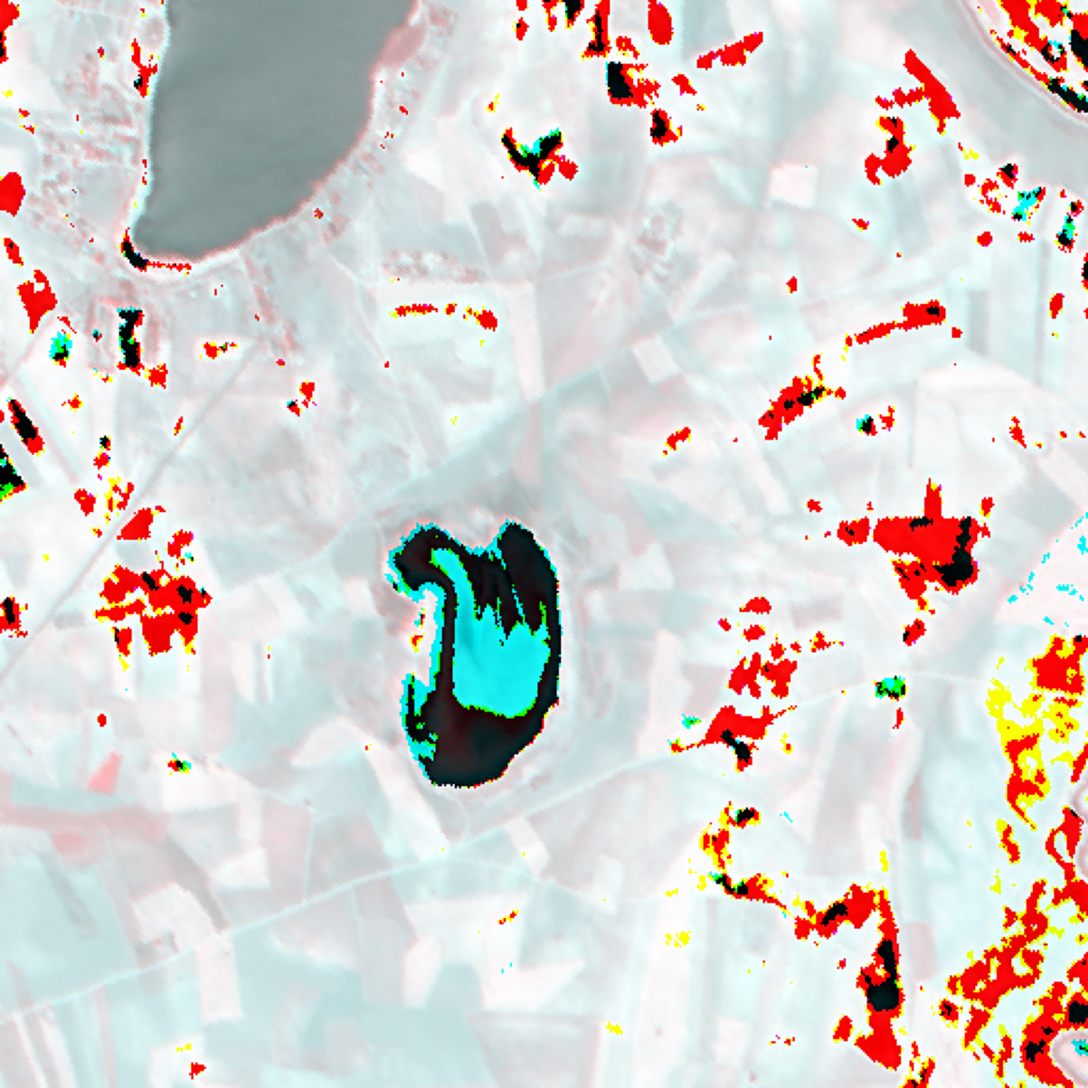  (a) Approximate RGB Composite | 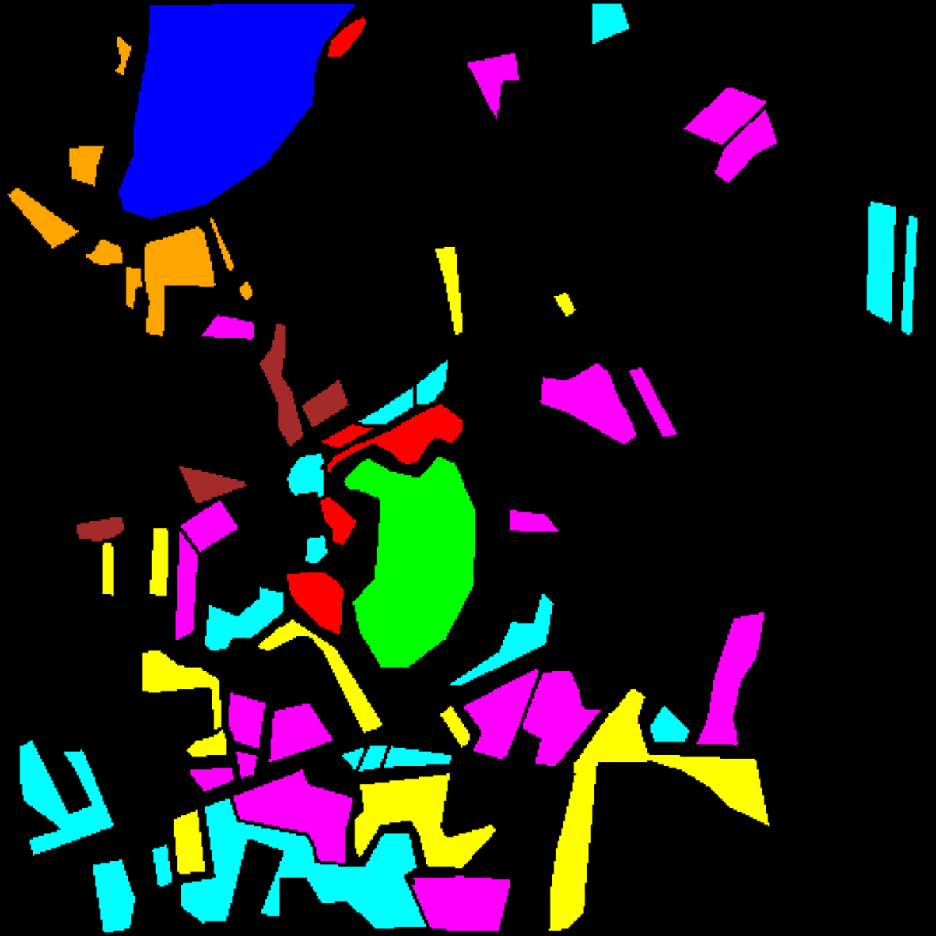  (b) Ground Truth Label Map
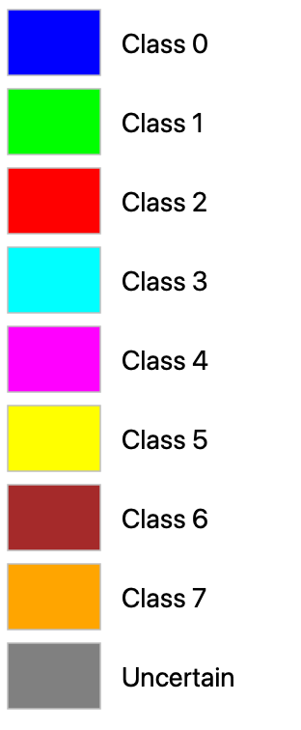
(c) Legend
Fig. 1. Scene overview for the full 512 × 512, 65-band DIAS Scene K01 hyperspectral dataset: (a) approximate RGB composite, (b) ground truth label map, and (c) shared class legend.
C. Credal Deep Ensemble (CreDE) Classification Maps
Fig. 2 shows the CreDE predicted class map ĉ = argmax p* for each architecture across all 262,144 pixels of the 512 × 512 scene.
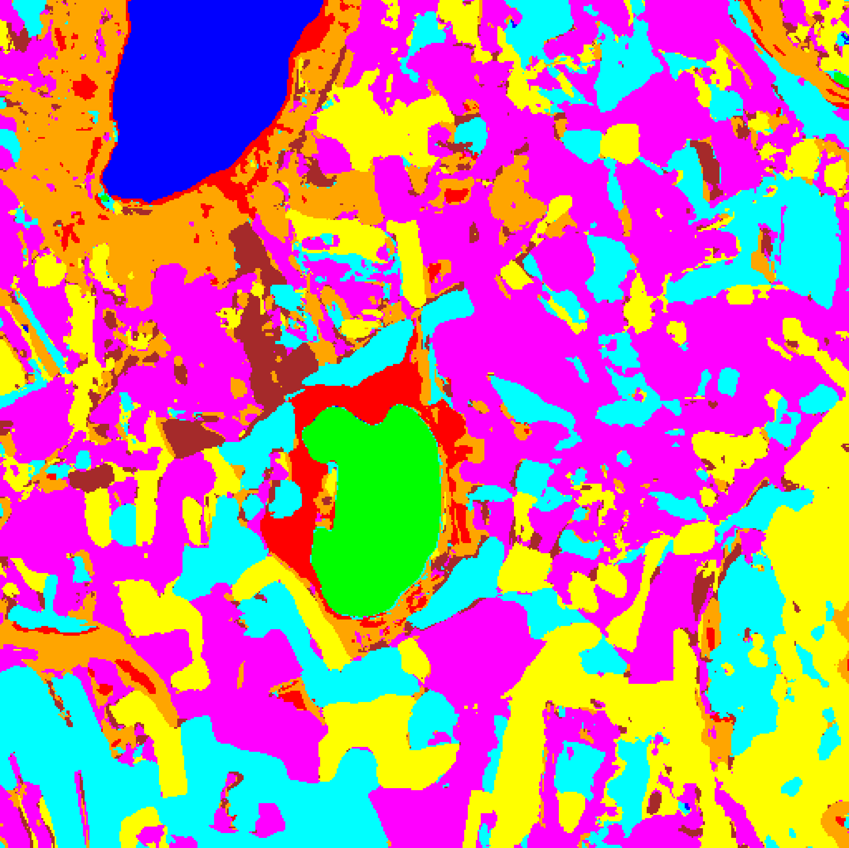  (a) AlexNet-CNN | 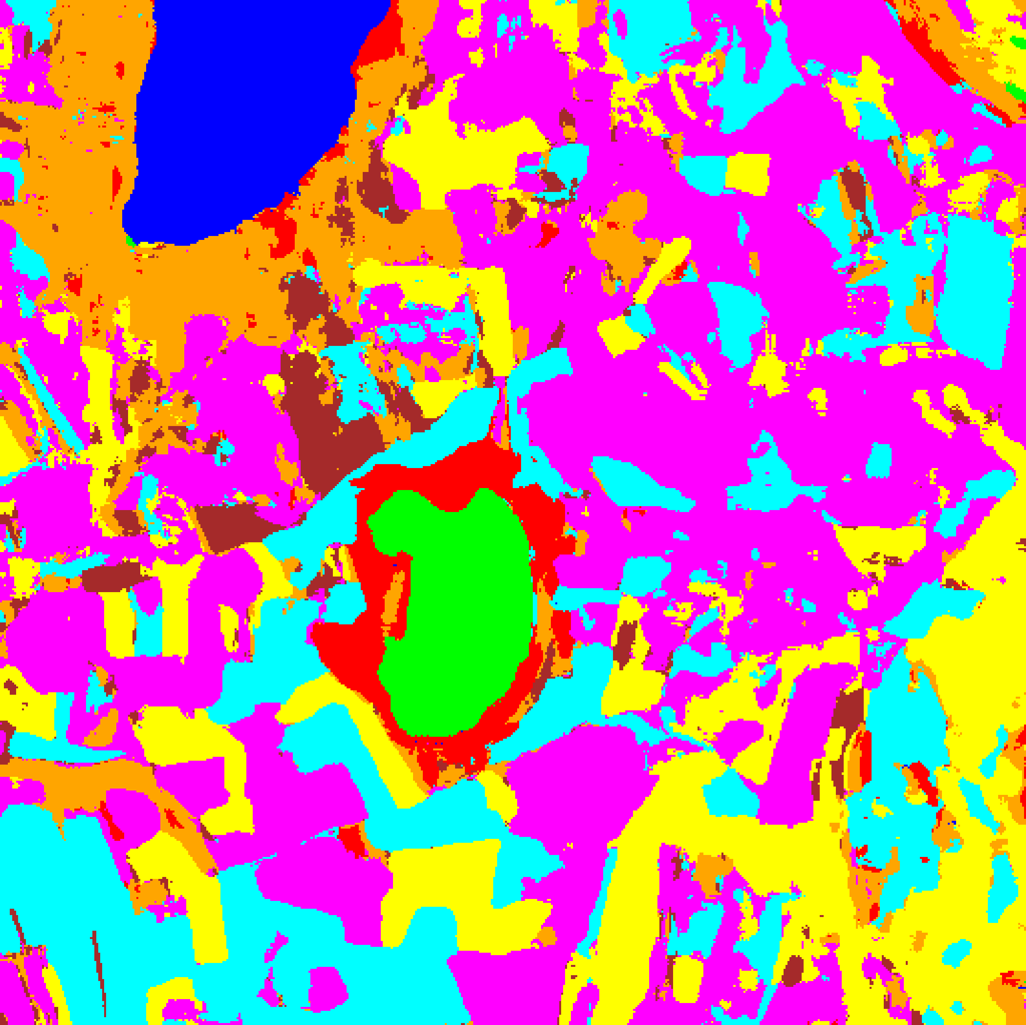  (b) GFNet
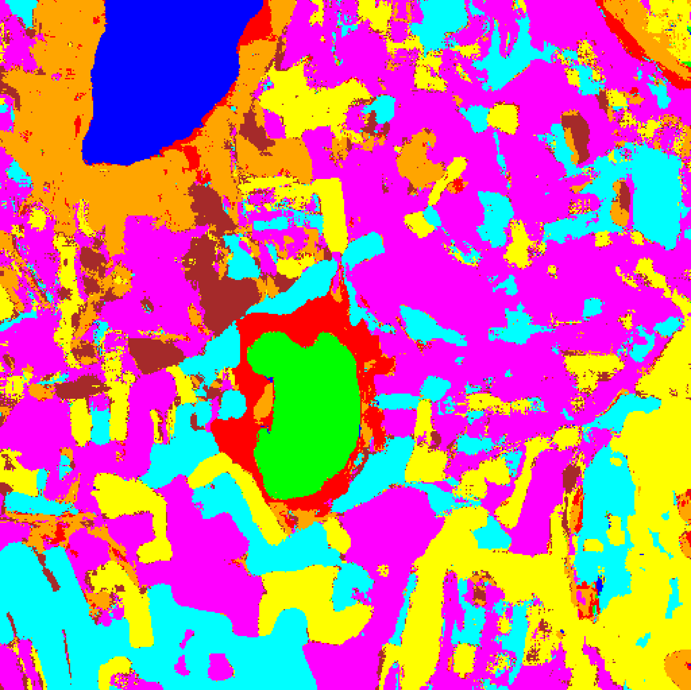  (c) ViT-UNet | (d) Legend
Fig. 2. CreDE predicted class maps ĉ = argmax p* across the full 512 × 512 scene: (a) AlexNet-CNN, (b) GFNet, and (c) ViT-UNet, with (d) shared class legend.
D. Scene-Wide Mean Uncertainty Summary
TABLE IV reports the scene-wide mean aleatoric (AU), epistemic (EU), and total (TU) CreDE uncertainty across all 262,144 pixels for each architecture.
TABLE IV
CREDE: SCENE-WIDE MEAN UNCERTAINTY SUMMARY (PER ARCHITECTURE)
Model | Mean AU | Mean EU | Mean TU
AlexNet-CNN | 0.0664 | 0.1036 | 0.1700
GFNet | 0.2556 | 0.0502 | 0.3058
ViT-UNet | 0.6706 | 0.0811 | 0.7517

ViT-UNet exhibits the highest scene-wide mean total uncertainty (TU = 0.7517), driven by its aleatoric entropy (AU = 0.6706 vs. GFNet’s 0.2556 and AlexNet-CNN’s 0.0664). Conversely, GFNet achieves the lowest mean epistemic uncertainty (EU = 0.0502), while AlexNet-CNN exhibits the highest mean epistemic disagreement (EU = 0.1036) alongside the lowest mean AU (0.0664) and lowest mean TU (0.1700).
E. Spatialised Aleatoric Uncertainty Maps
Fig. 3 maps the binary aleatoric uncertainty mask (AU > 0.5) across the full scene, Fig. 4 overlays the uncertain pixels in grey on the CreDE classification maps, and TABLE V reports the full-scene pixel counts.
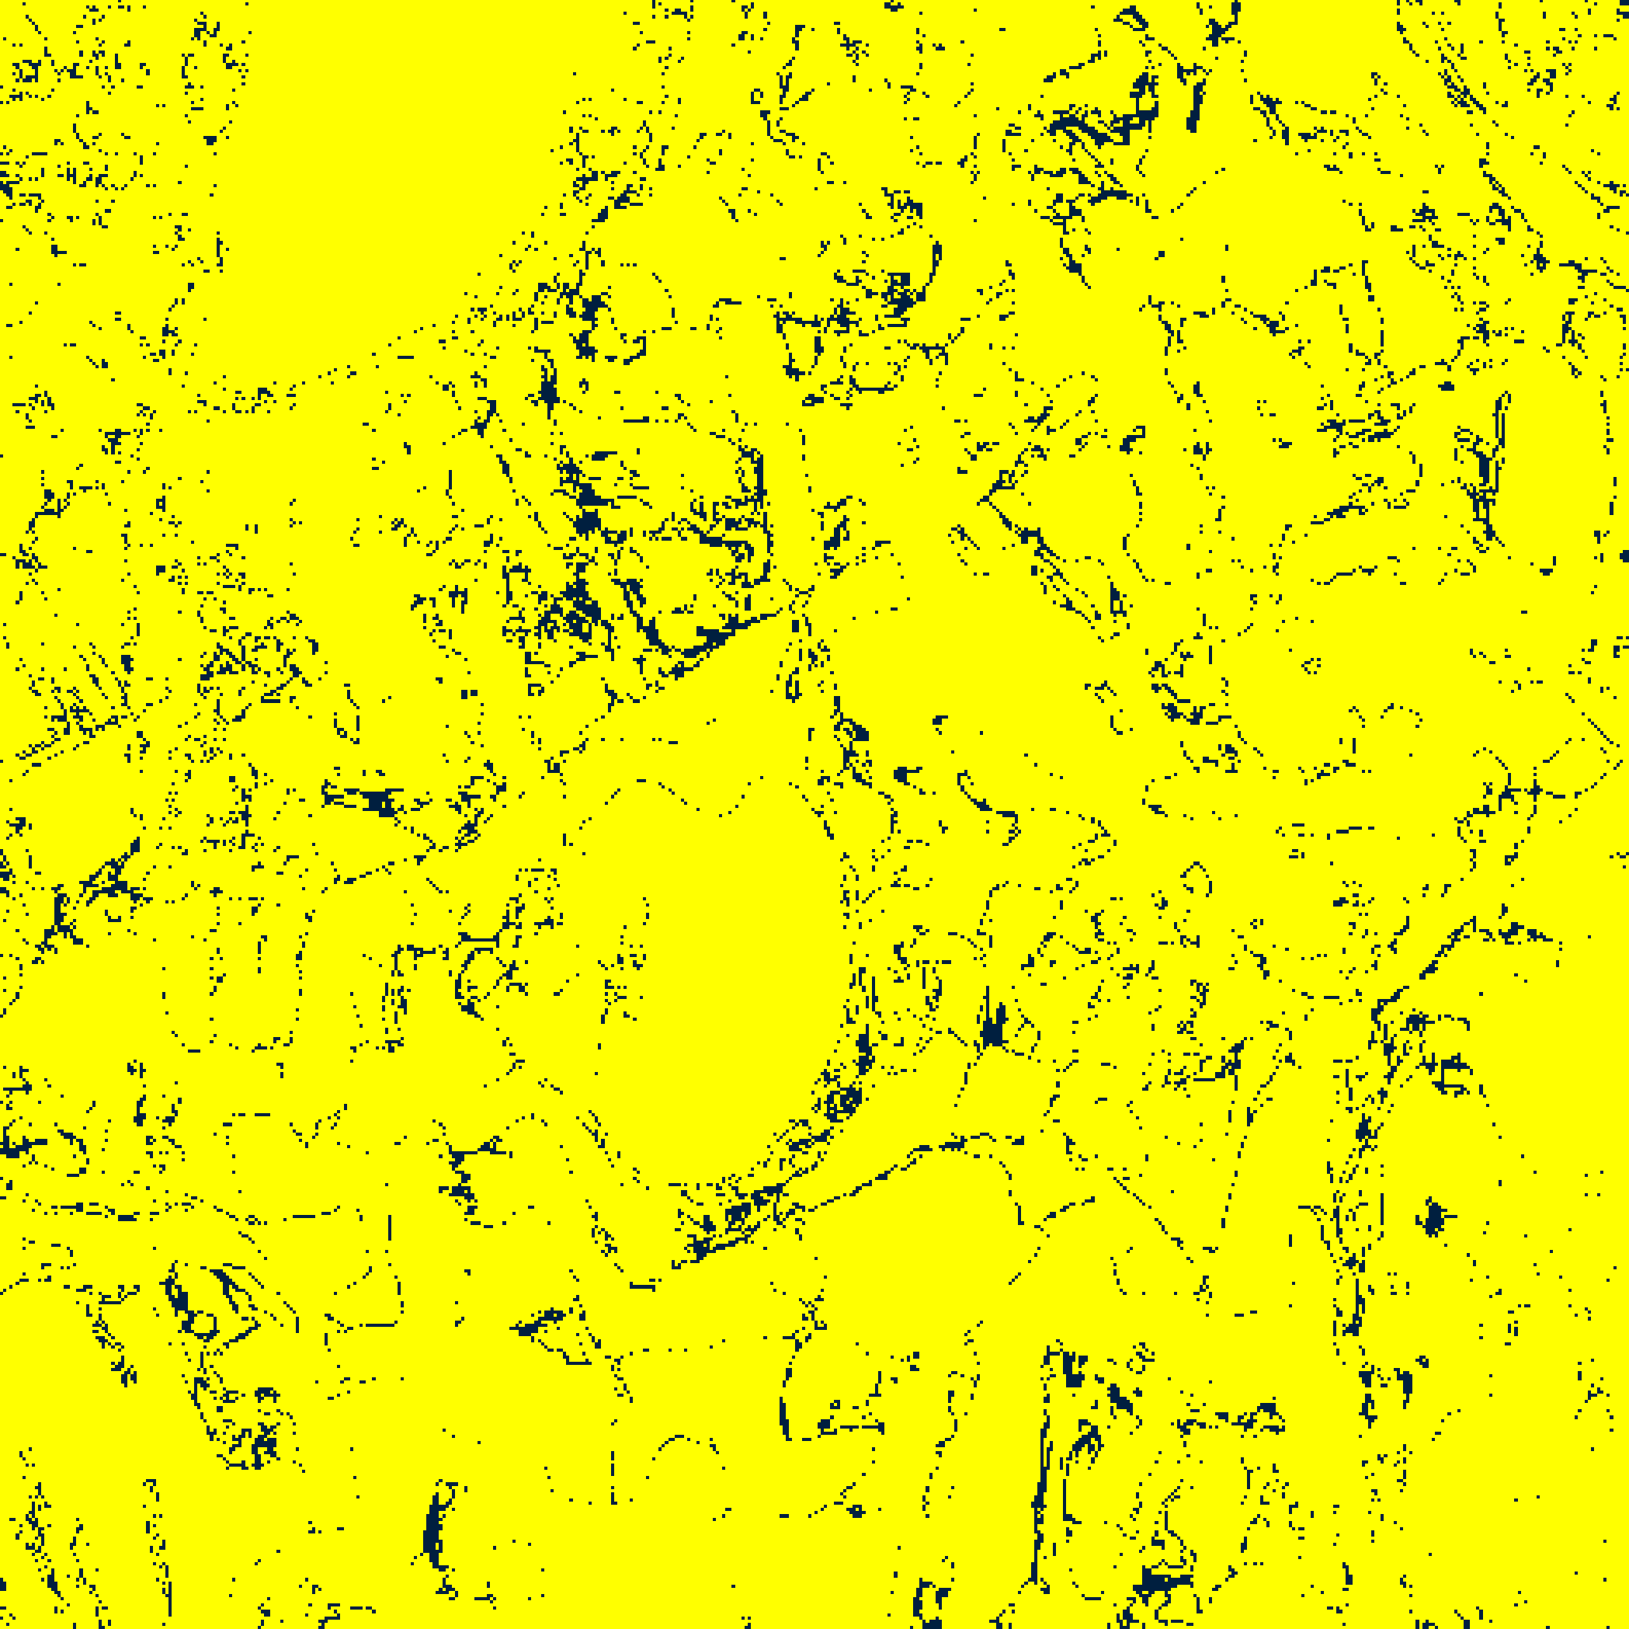  (a) AlexNet-CNN | 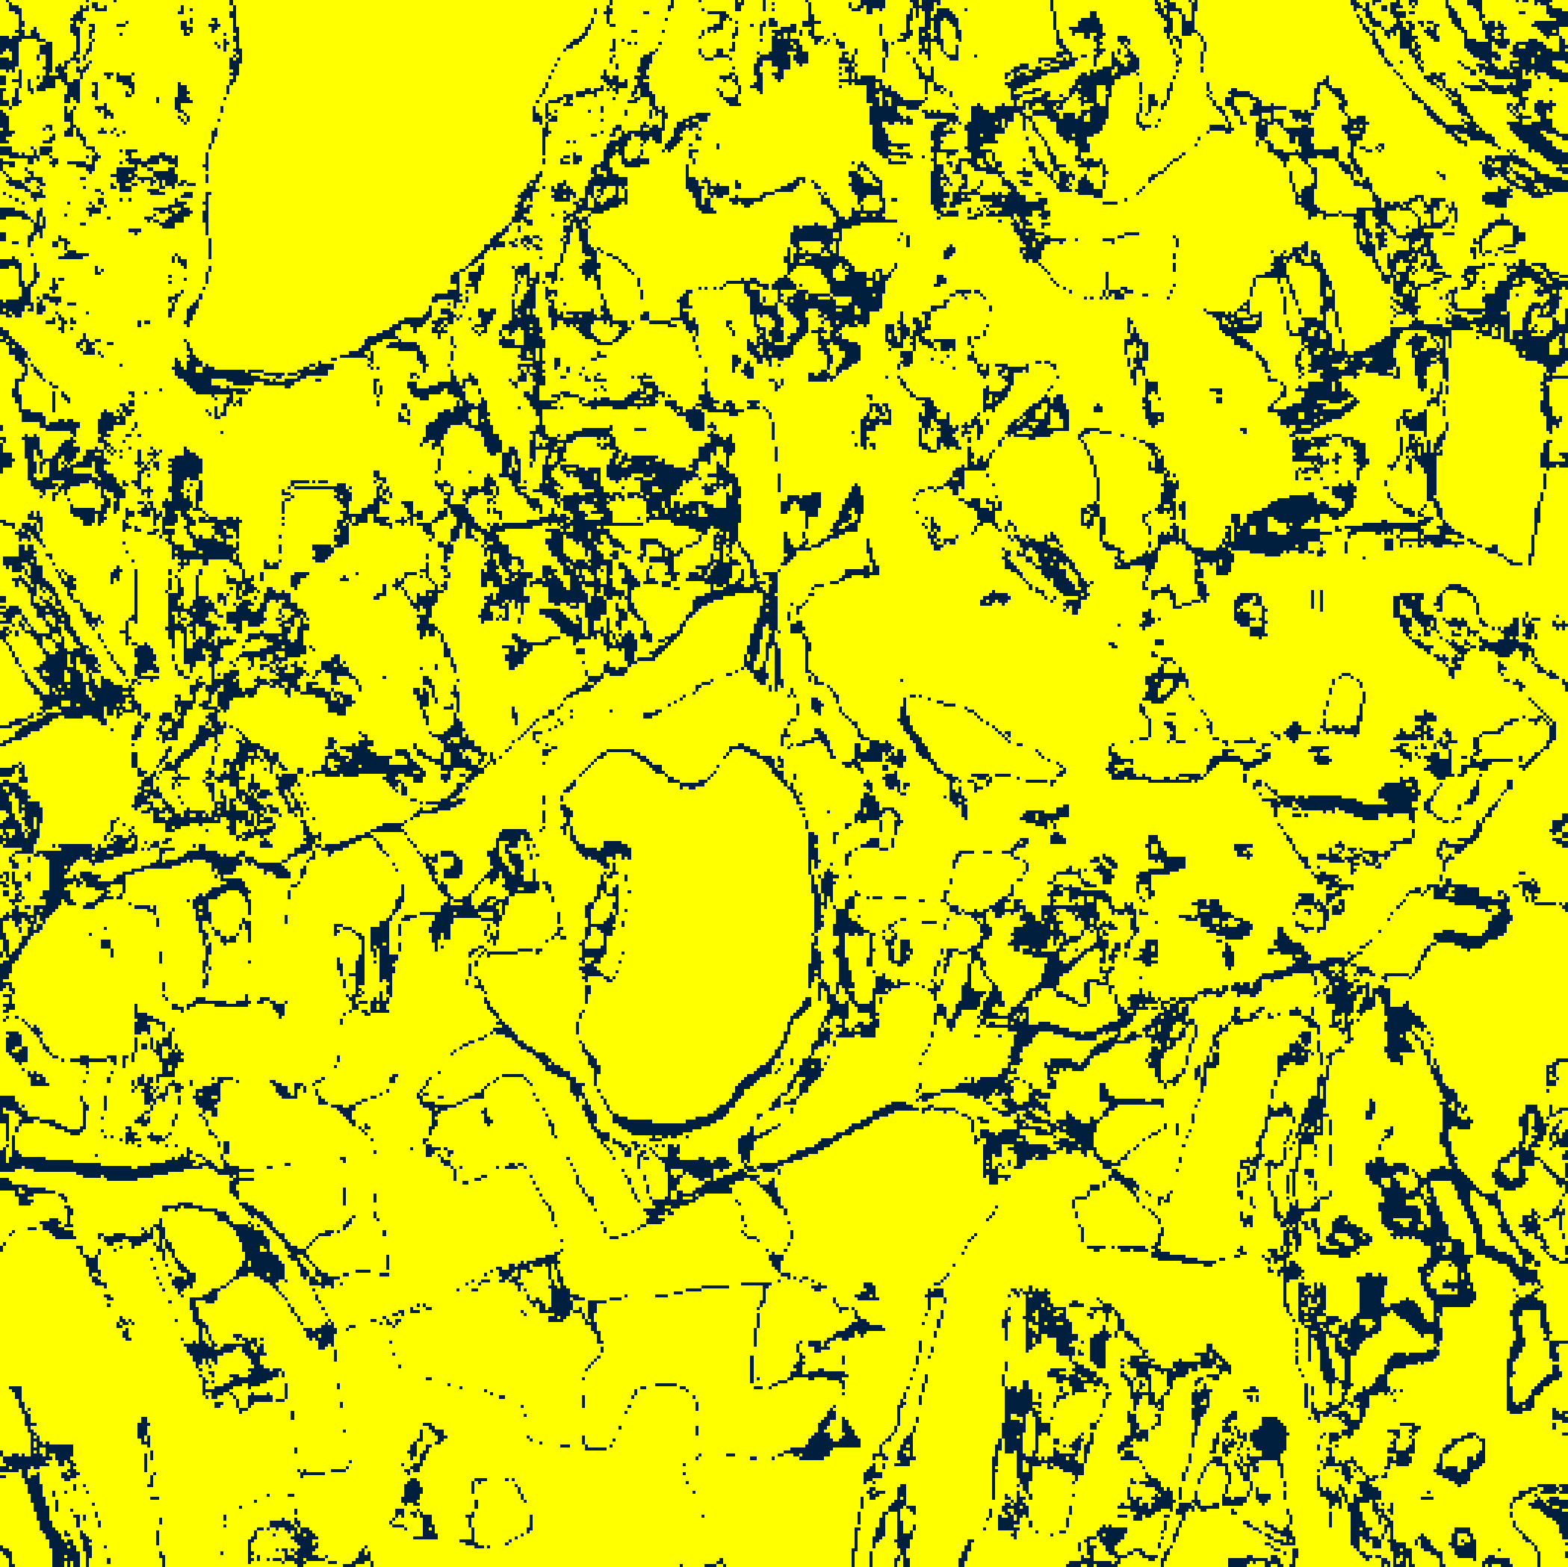  (b) GFNet
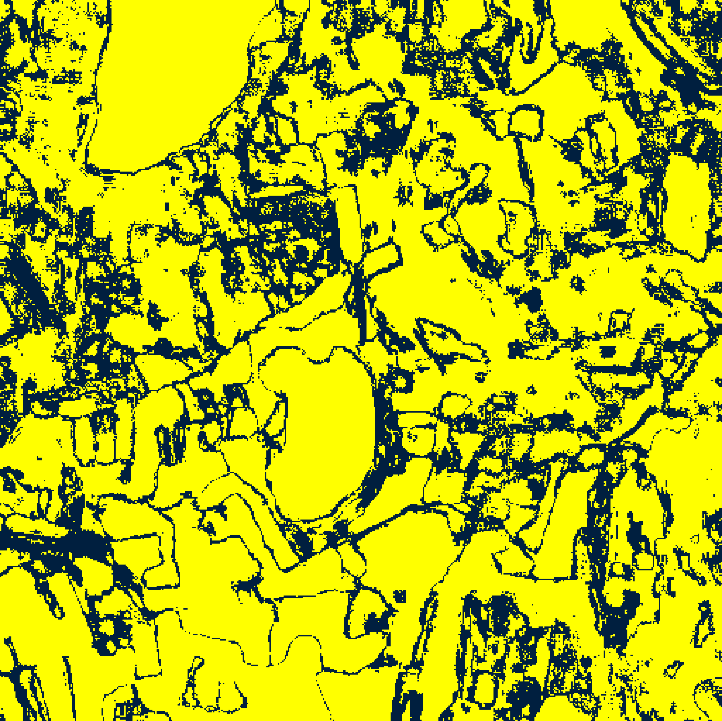  (c) ViT-UNet | 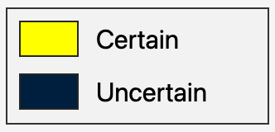  (d) Legend
Fig. 3. CreDE binary aleatoric uncertainty masks (AU > 0.5) for the full 512 × 512 scene: (a) AlexNet-CNN, (b) GFNet, (c) ViT-UNet. Yellow = certain; dark navy = uncertain.
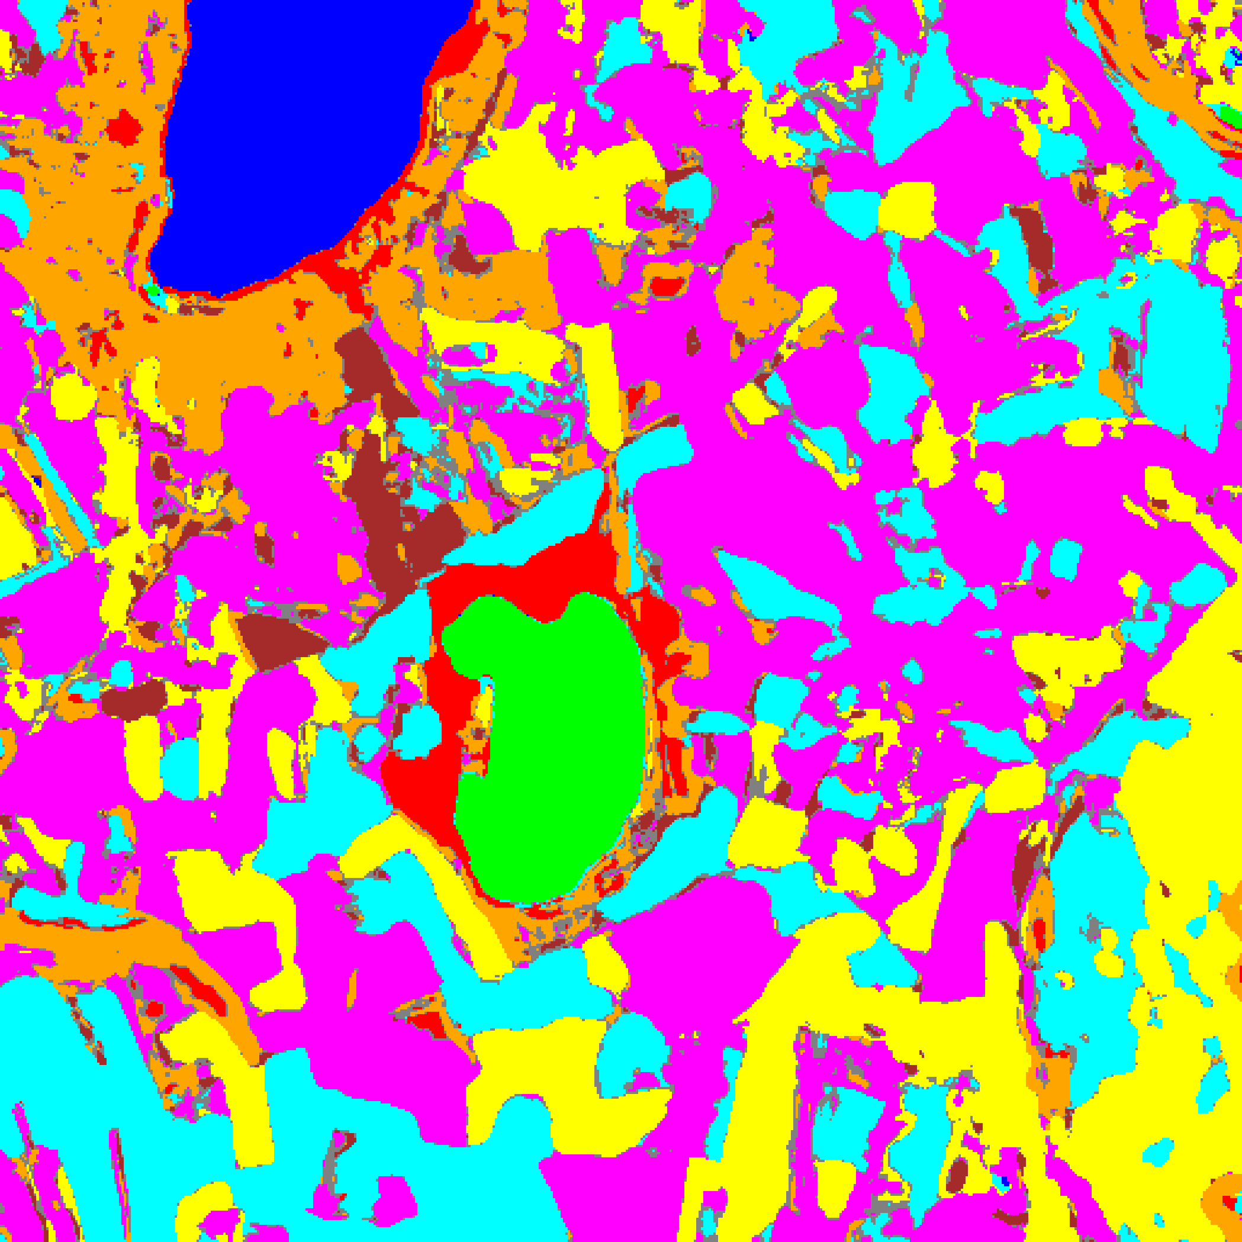  (a) AlexNet-CNN | 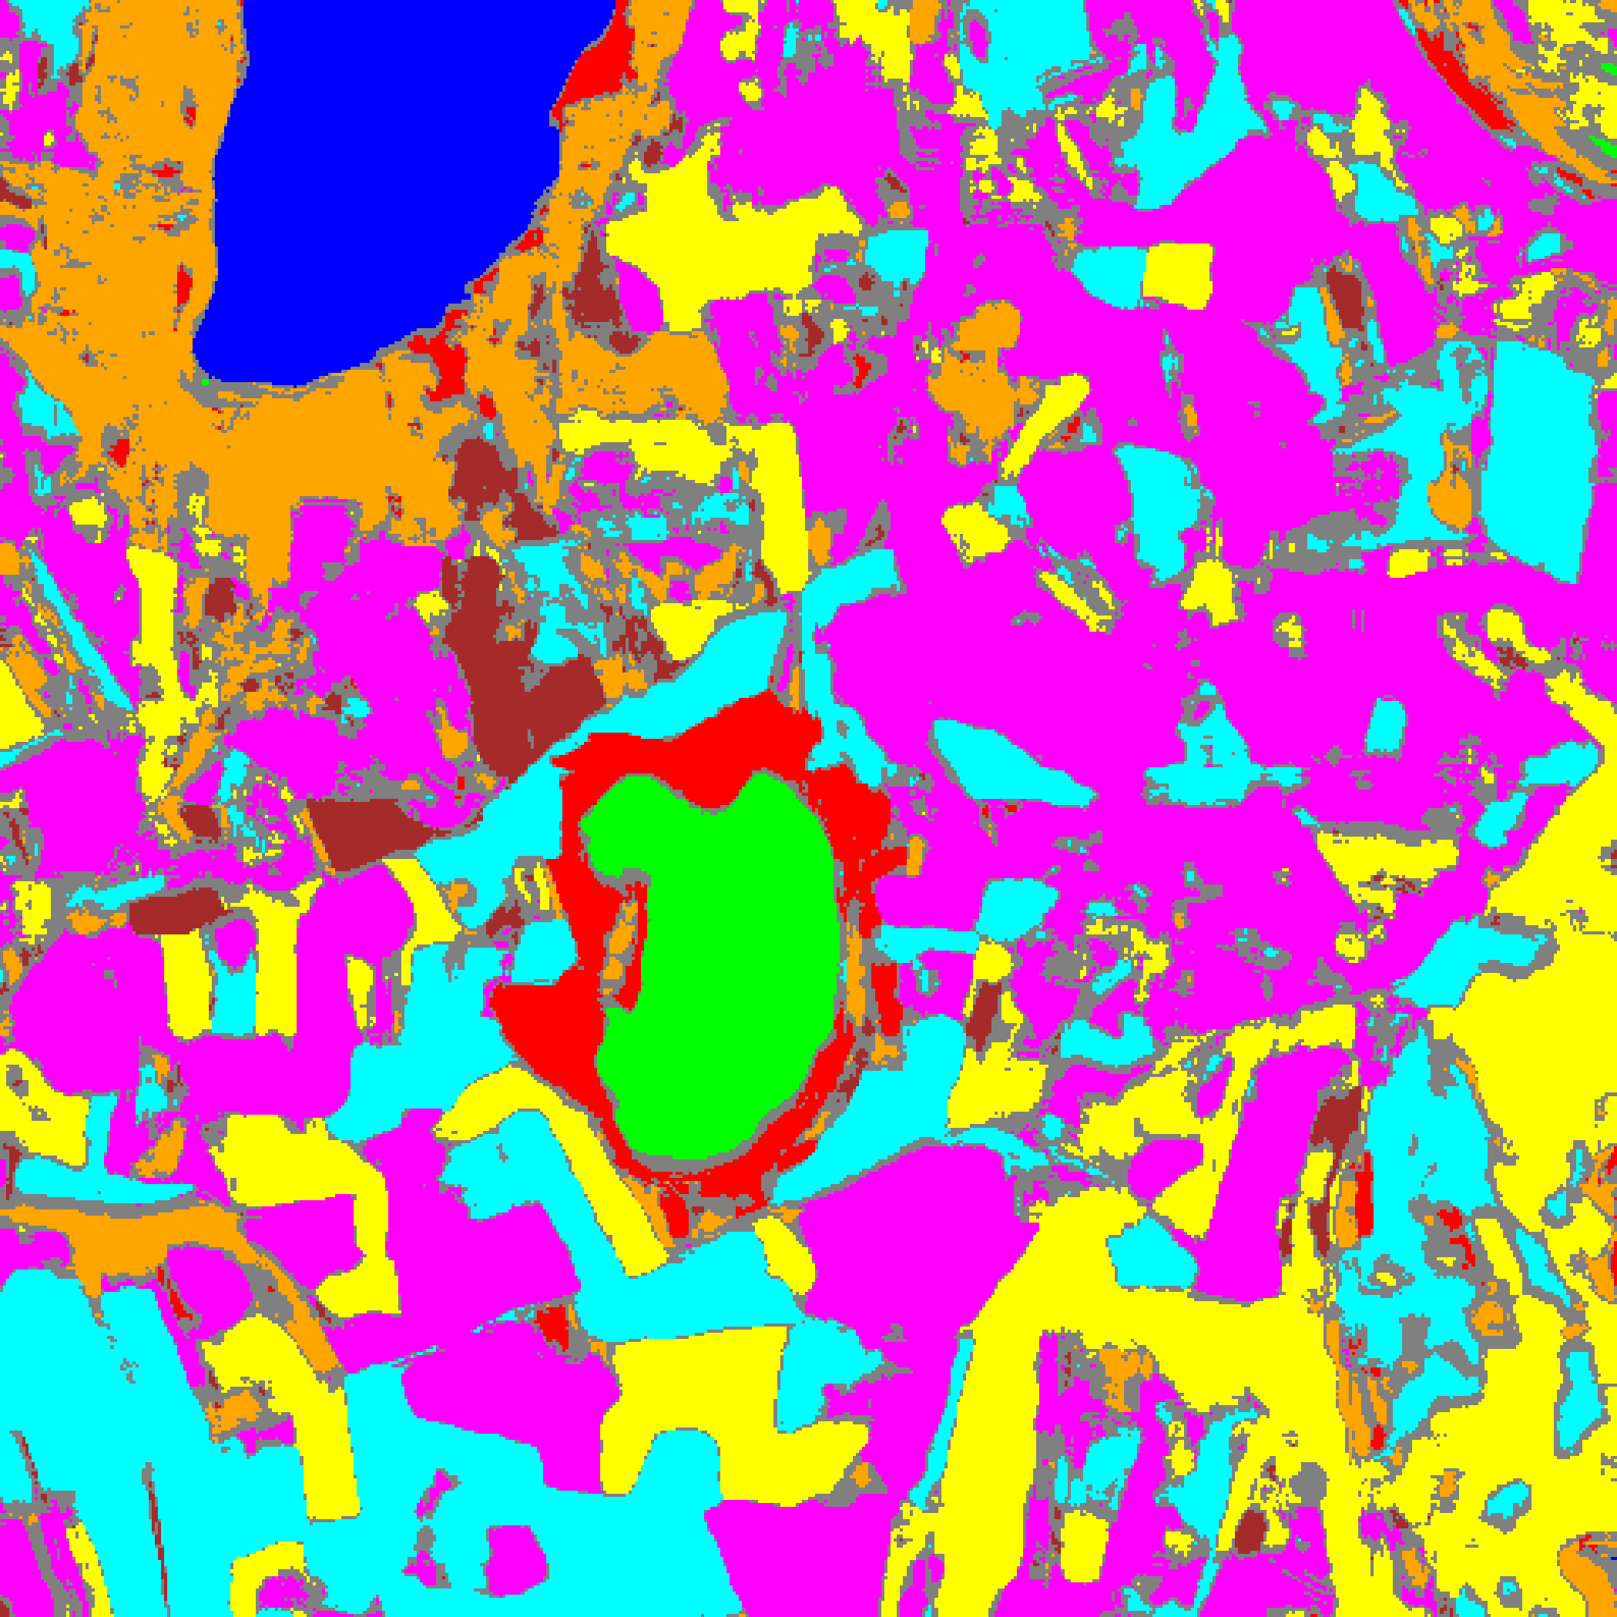  (b) GFNet
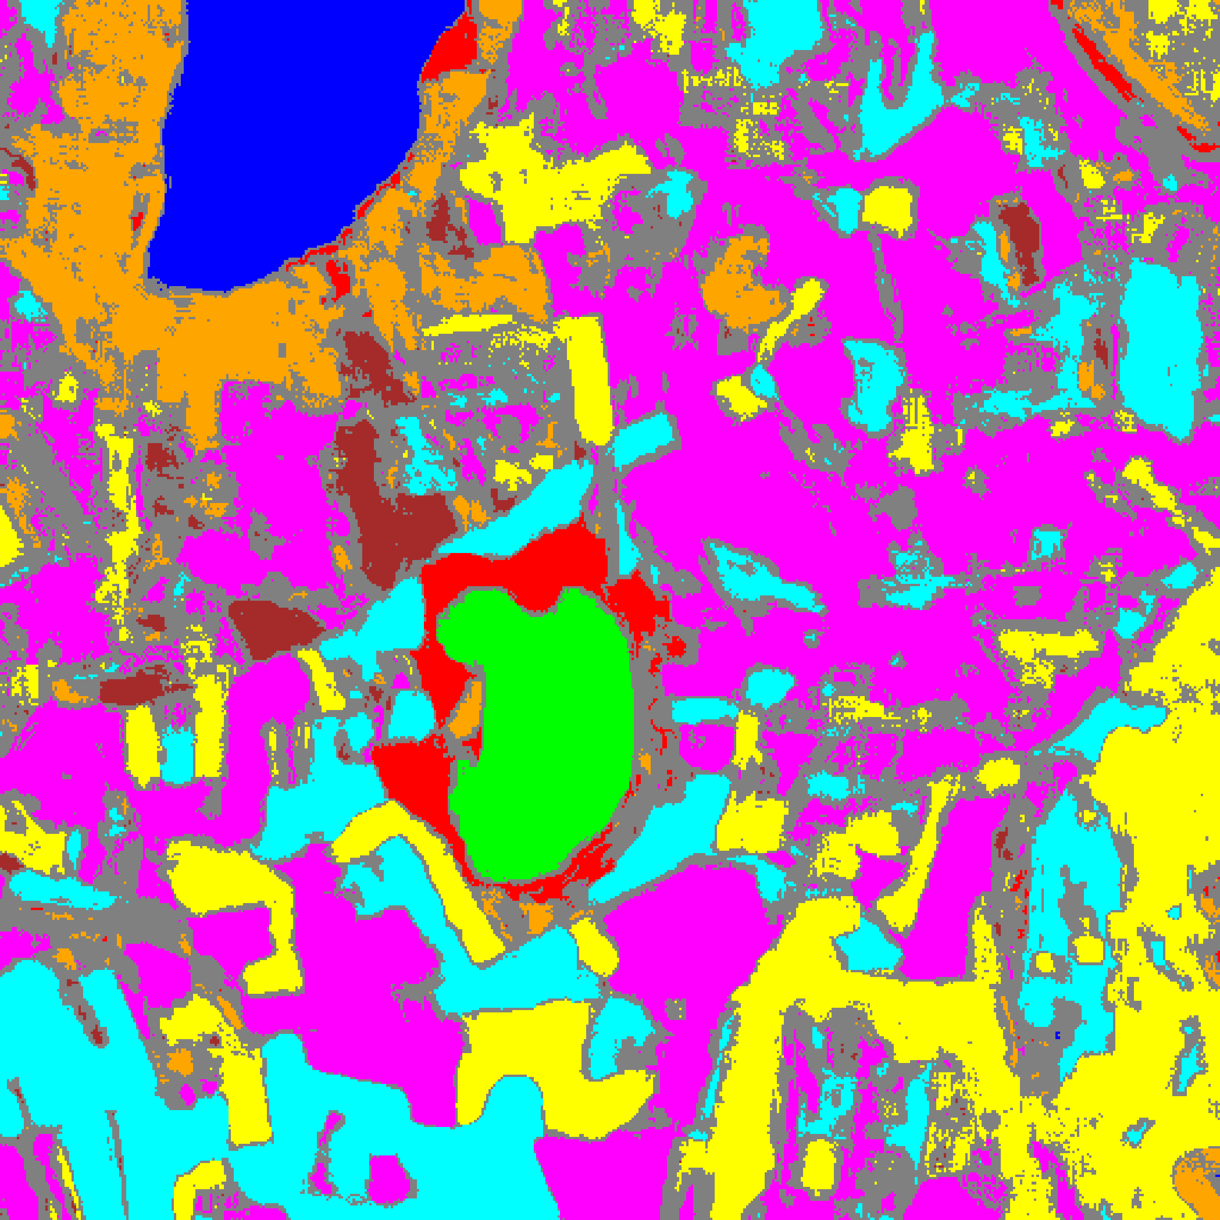  (c) ViT-UNet | (d) Legend
Fig. 4. Grey overlay of aleatoric-uncertain pixels (AU > 0.5) on the CreDE classification map: (a) AlexNet-CNN, (b) GFNet, (c) ViT-UNet, with (d) class legend.
TABLE V
CREDE ALEATORIC (AU > 0.5) PIXEL-COUNT DISTRIBUTION ACROSS ARCHITECTURES
Class / Region | AlexNet-CNN | GFNet | ViT-UNet
Class 0 | 11,035 | 11,282 | 11,102
Class 1 | 7,875 | 7,221 | 7,330
Class 2 | 7,344 | 7,147 | 5,194
Class 3 | 49,112 | 43,001 | 34,669
Class 4 | 88,564 | 80,957 | 72,216
Class 5 | 47,517 | 40,304 | 35,999
Class 6 | 7,874 | 5,770 | 4,444
Class 7 | 27,252 | 21,999 | 16,197
Uncertain | 15,571 | 44,463 | 74,993
Total (Scene) | 262,144 | 262,144 | 262,144

Under AU > 0.5, AlexNet-CNN flags only 15,571 uncertain pixels (5.94% of the 262,144 scene pixels), GFNet flags 44,463 (16.96%), and ViT-UNet flags 74,993 (28.61%).
F. Spatialised Epistemic Uncertainty Maps
Fig. 5 and Fig. 6 display the binary and grey-overlay epistemic uncertainty maps (EU > 0.2), and TABLE VI gives the pixel-count distribution.
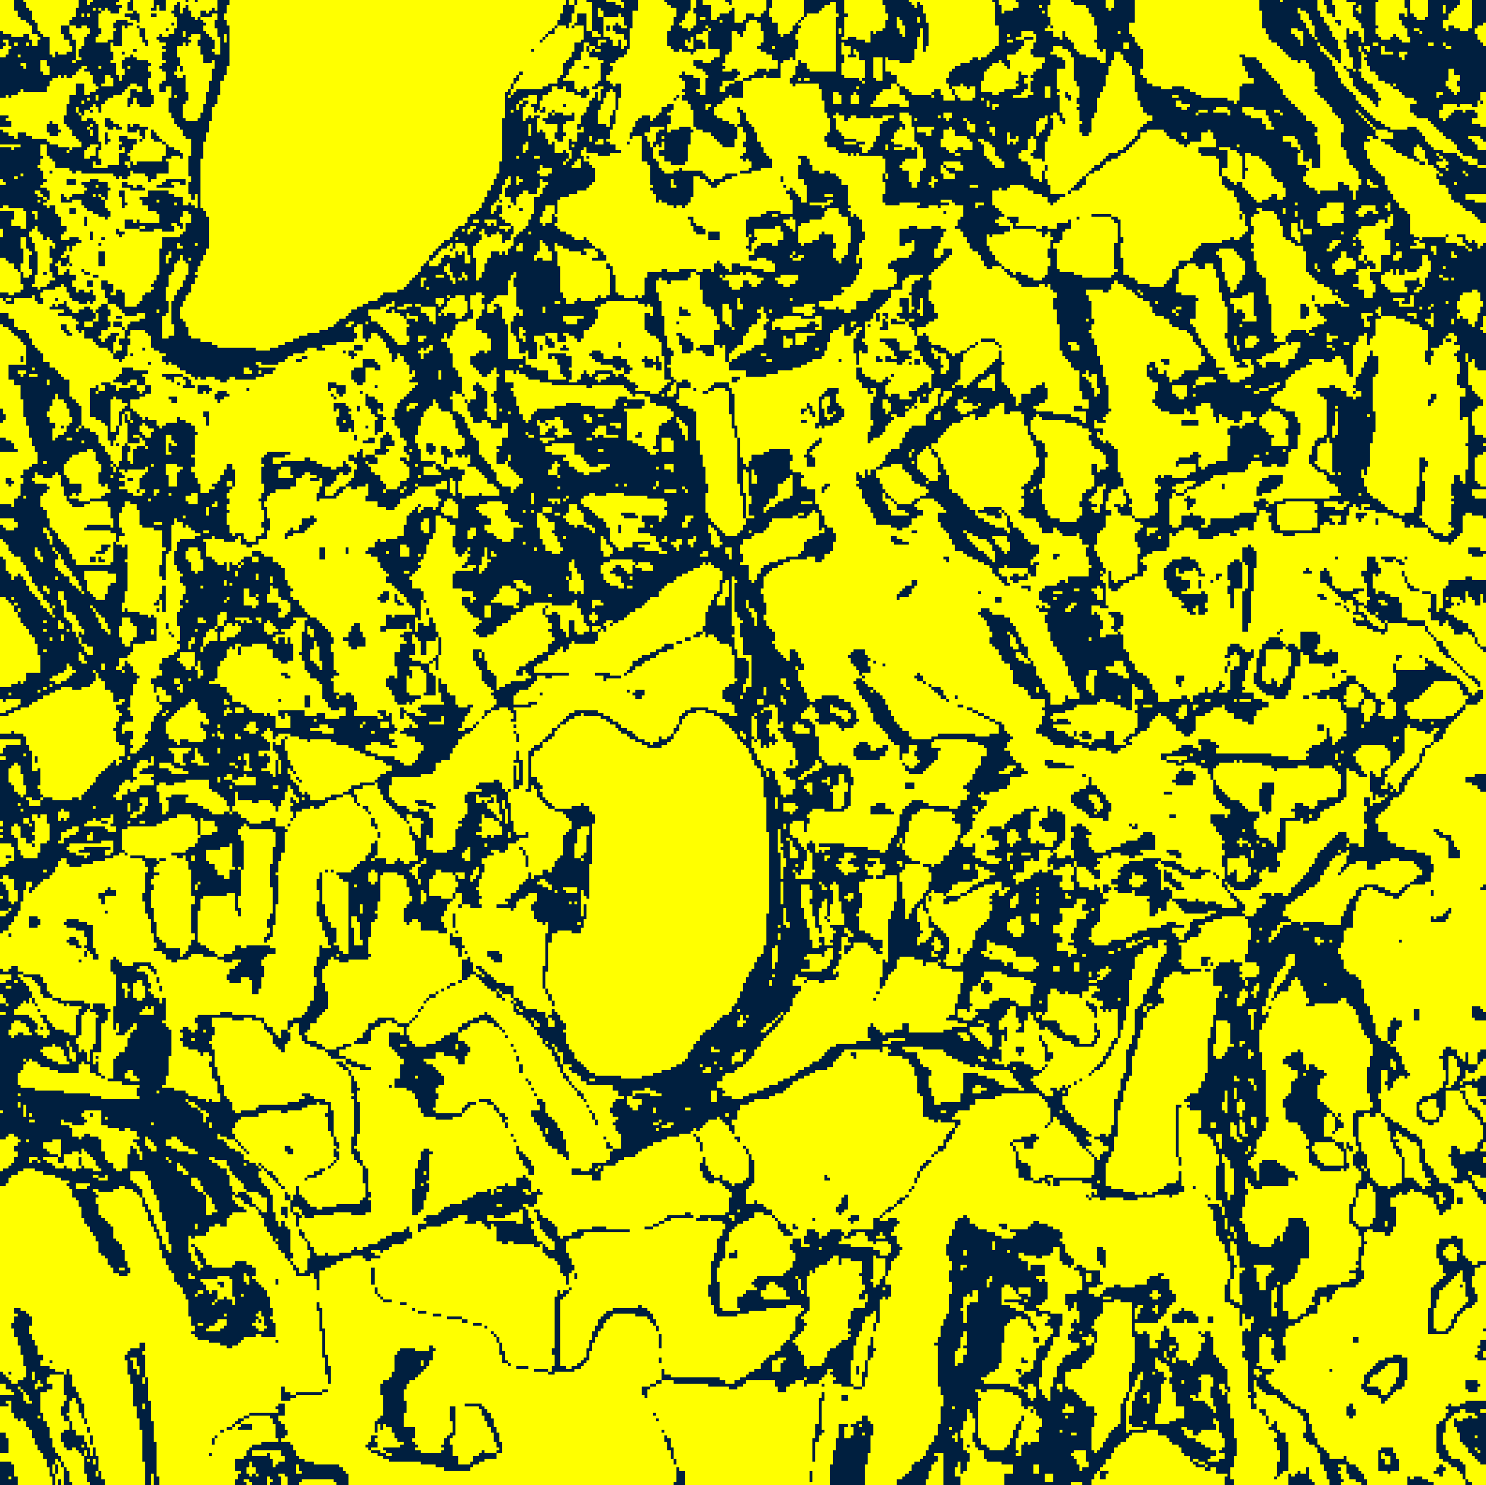  (a) AlexNet-CNN | 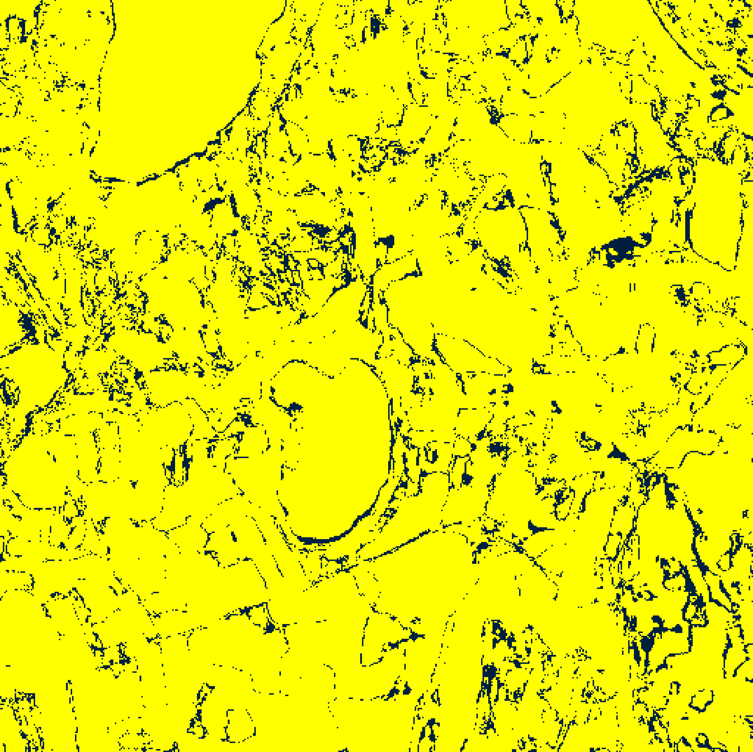  (b) GFNet
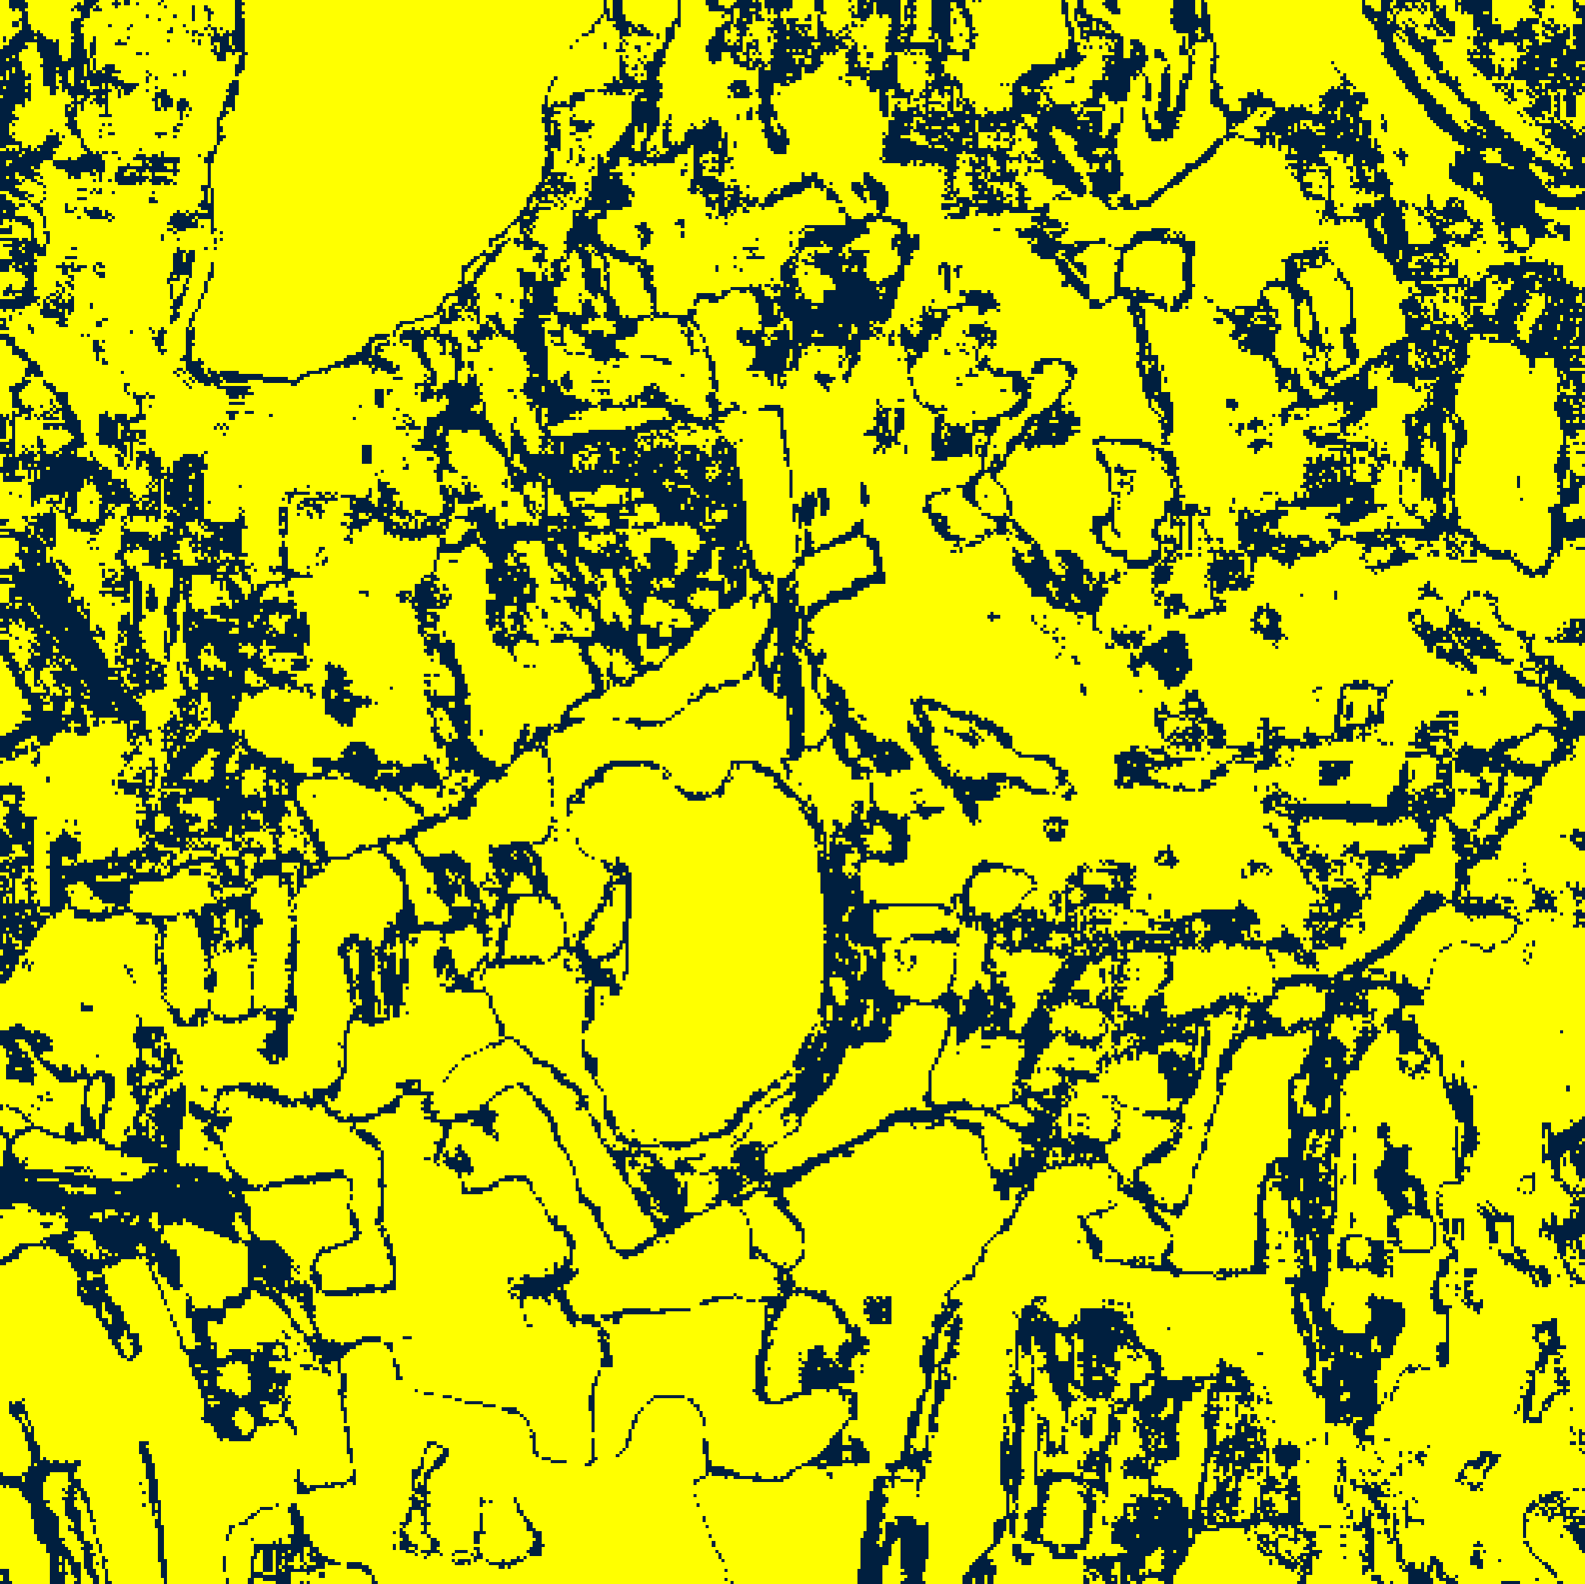  (c) ViT-UNet | (d) Legend
Fig. 5. CreDE binary epistemic uncertainty masks (EU > 0.2) for the full 512 × 512 scene: (a) AlexNet-CNN, (b) GFNet, (c) ViT-UNet. Yellow = certain; dark navy = uncertain.
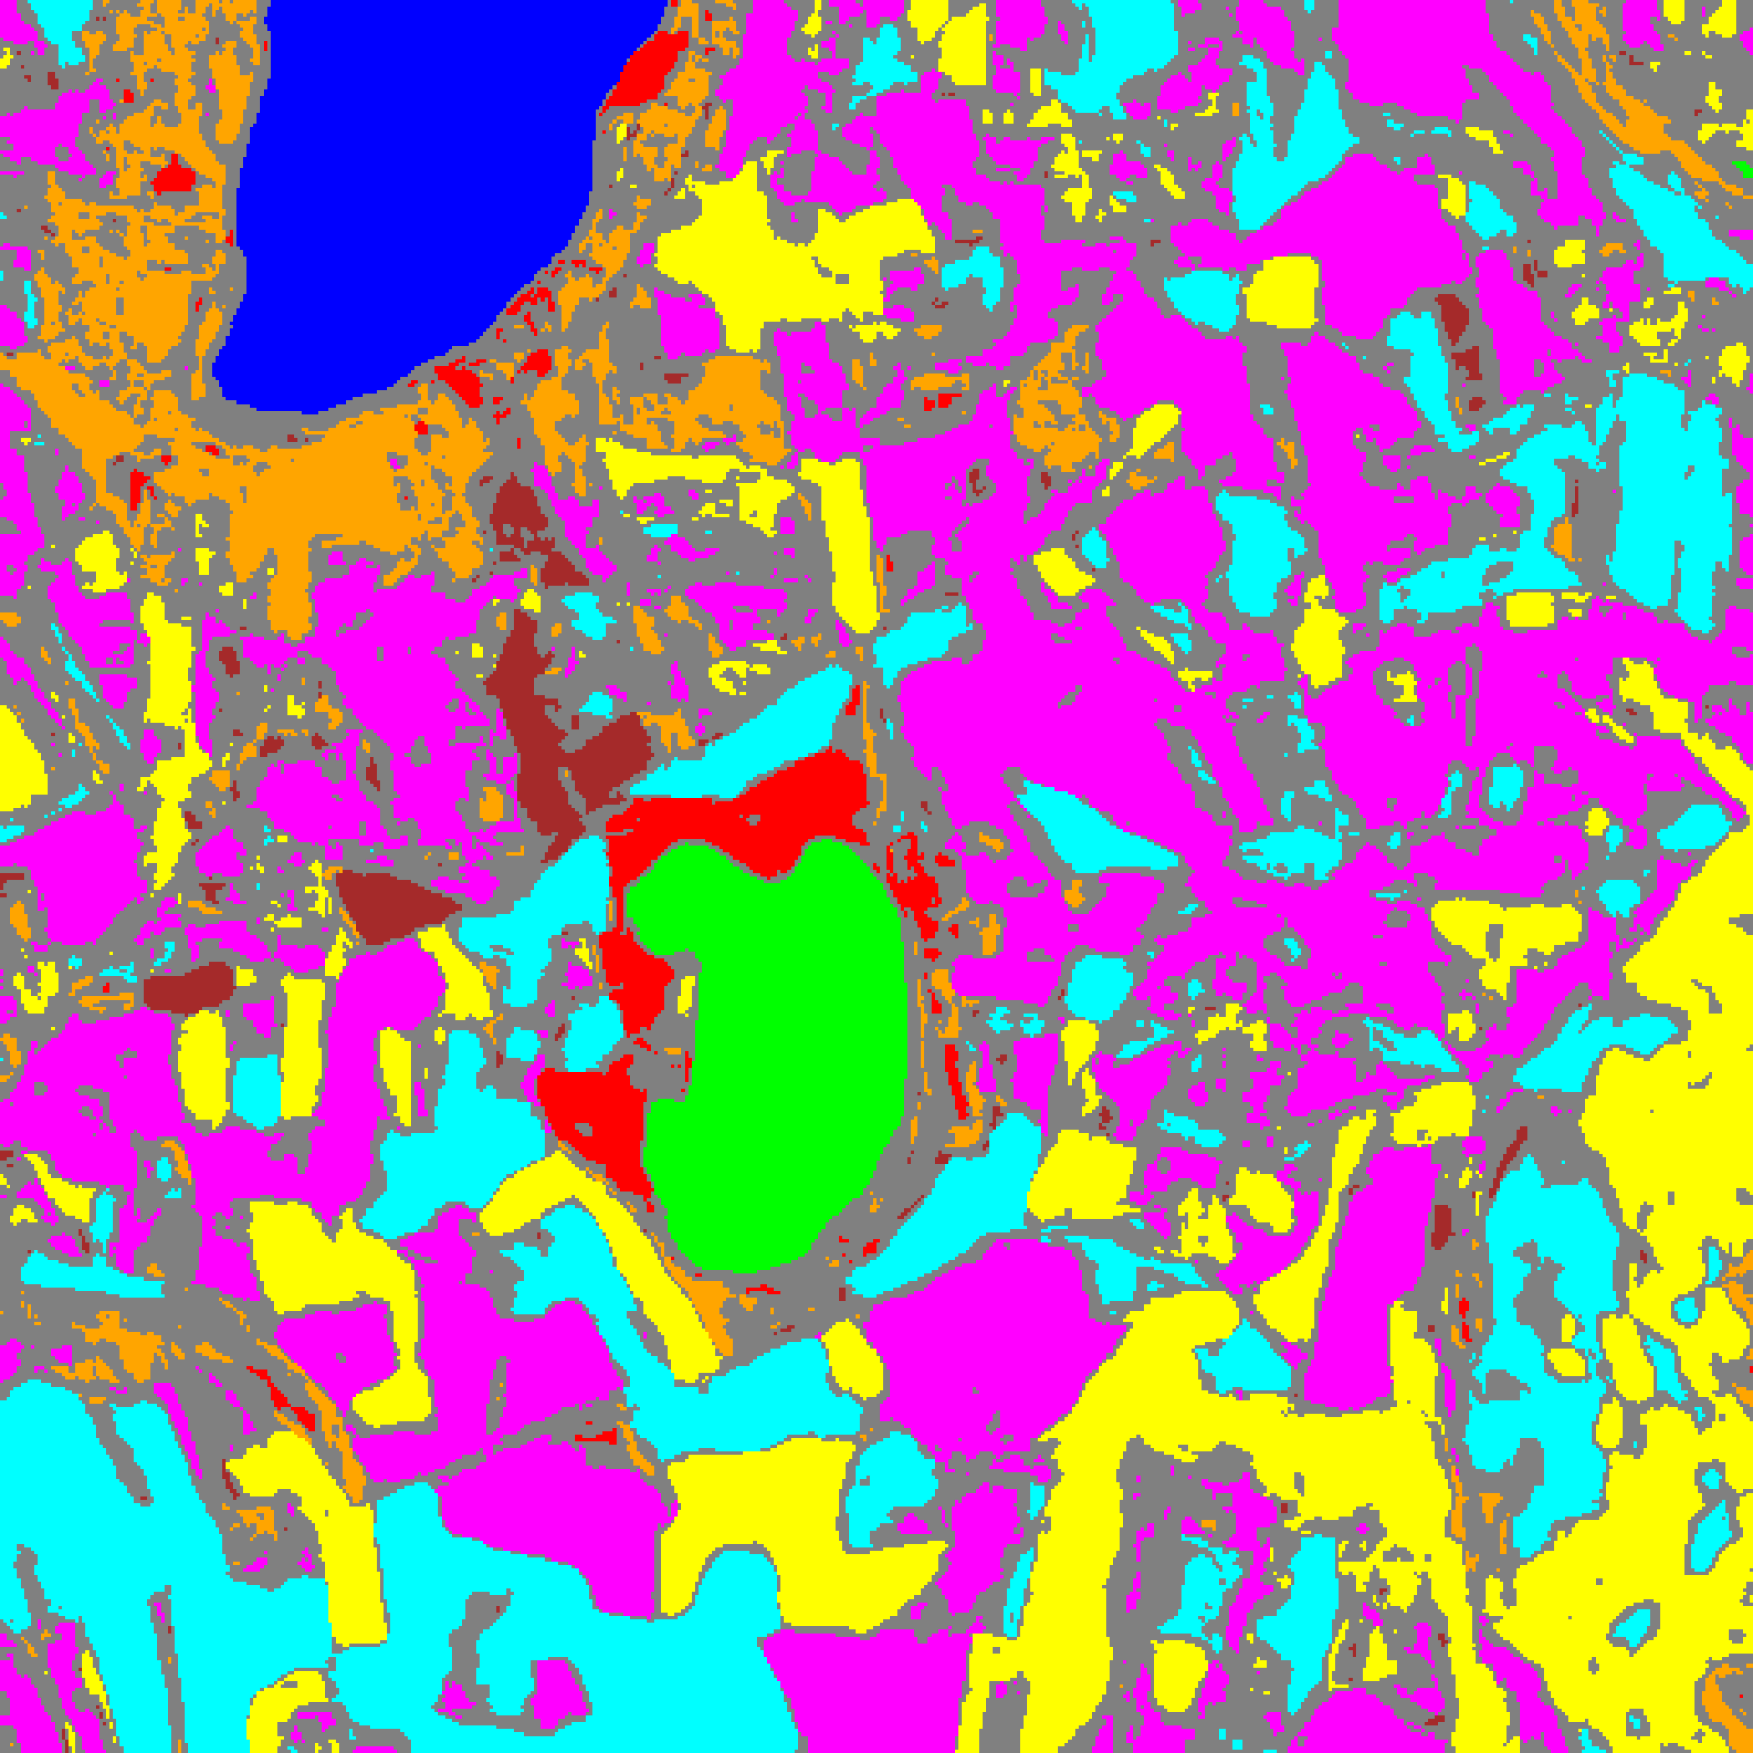  (a) AlexNet-CNN | 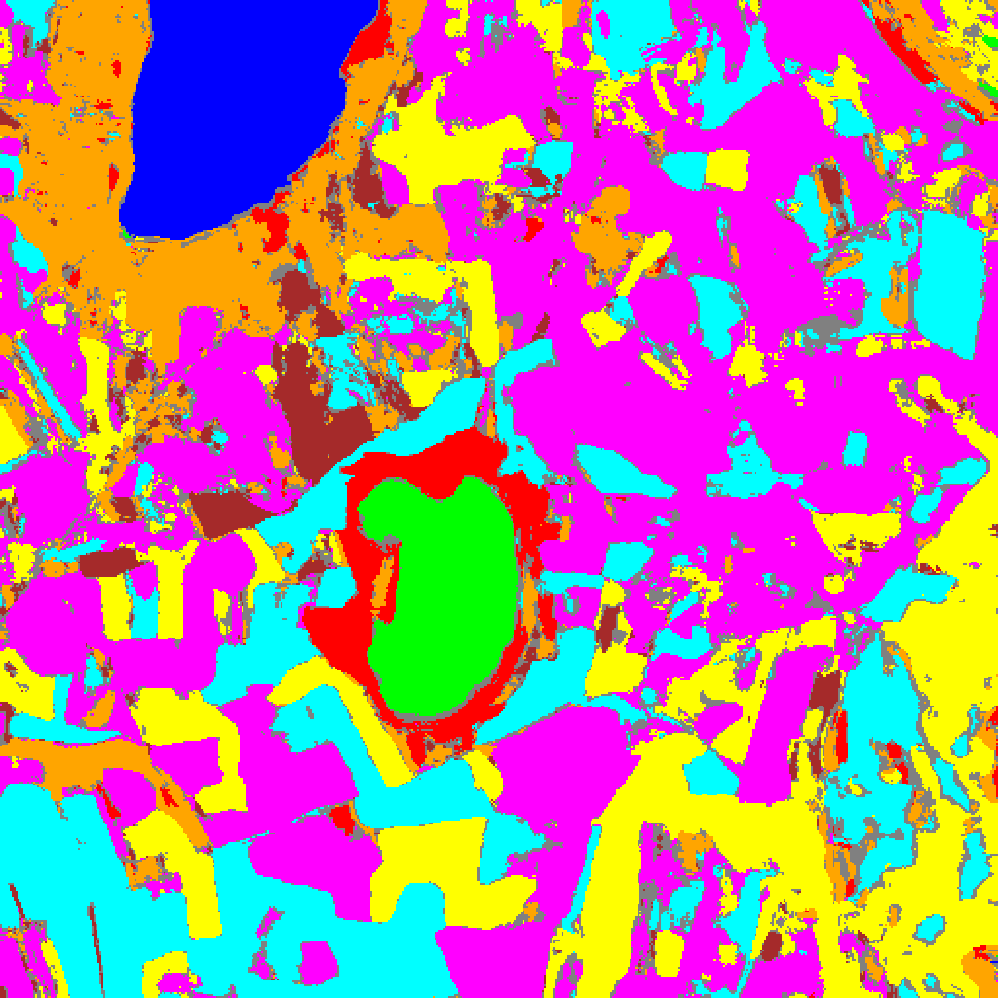  (b) GFNet
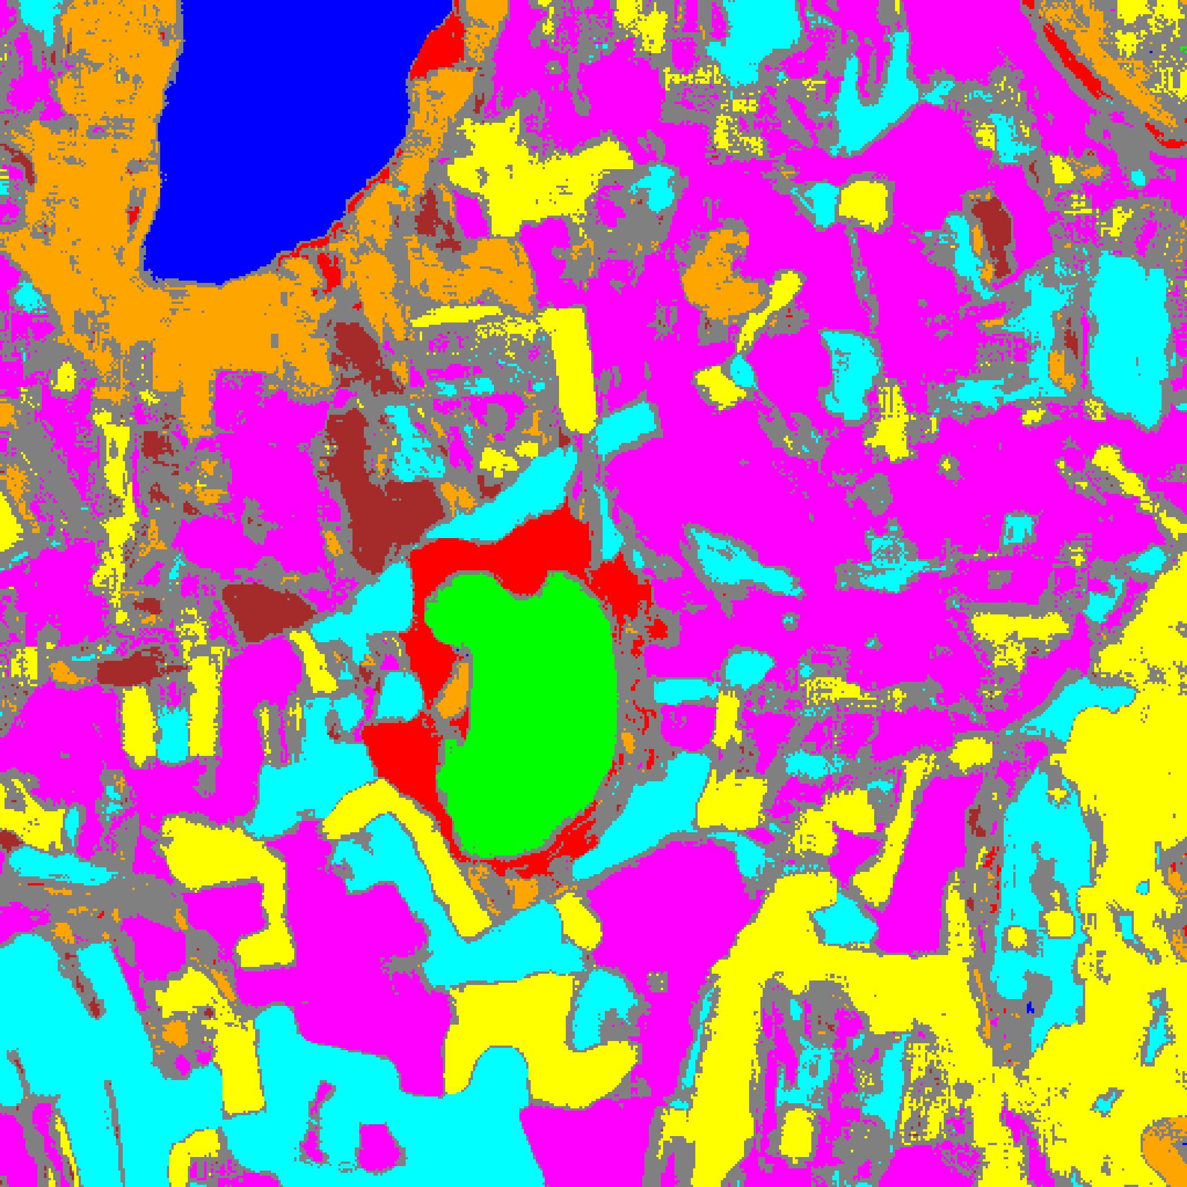  (c) ViT-UNet | (d) Legend
Fig. 6. Grey overlay of epistemic-uncertain pixels (EU > 0.2) on the CreDE classification map: (a) AlexNet-CNN, (b) GFNet, (c) ViT-UNet, with (d) class legend.
TABLE VI
CREDE EPISTEMIC (EU > 0.2) PIXEL-COUNT DISTRIBUTION ACROSS ARCHITECTURES
Class / Region | AlexNet-CNN | GFNet | ViT-UNet
Class 0 | 10,790 | 11,313 | 11,148
Class 1 | 7,569 | 7,279 | 7,357
Class 2 | 4,112 | 8,052 | 5,360
Class 3 | 36,432 | 45,490 | 35,643
Class 4 | 63,990 | 87,429 | 74,153
Class 5 | 36,638 | 44,818 | 36,925
Class 6 | 3,371 | 7,852 | 4,620
Class 7 | 13,320 | 26,399 | 16,795
Uncertain | 85,922 | 23,512 | 70,143
Total (Scene) | 262,144 | 262,144 | 262,144

Under EU > 0.2, GFNet achieves by far the smallest epistemic uncertainty footprint with 23,512 uncertain pixels (8.97%), whereas ViT-UNet flags 70,143 (26.76%) and AlexNet-CNN flags 85,922 (32.78%) due to greater seed-to-seed disagreement across unlabelled background regions.
G. Spatialised Total Uncertainty Maps
Fig. 7 and Fig. 8 present the binary and grey-overlay total uncertainty maps (TU > 0.7), and TABLE VII reports the pixel counts.
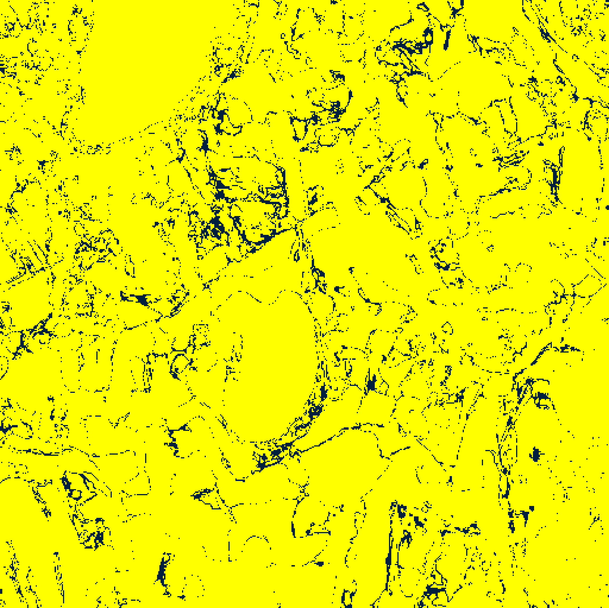  (a) AlexNet-CNN | 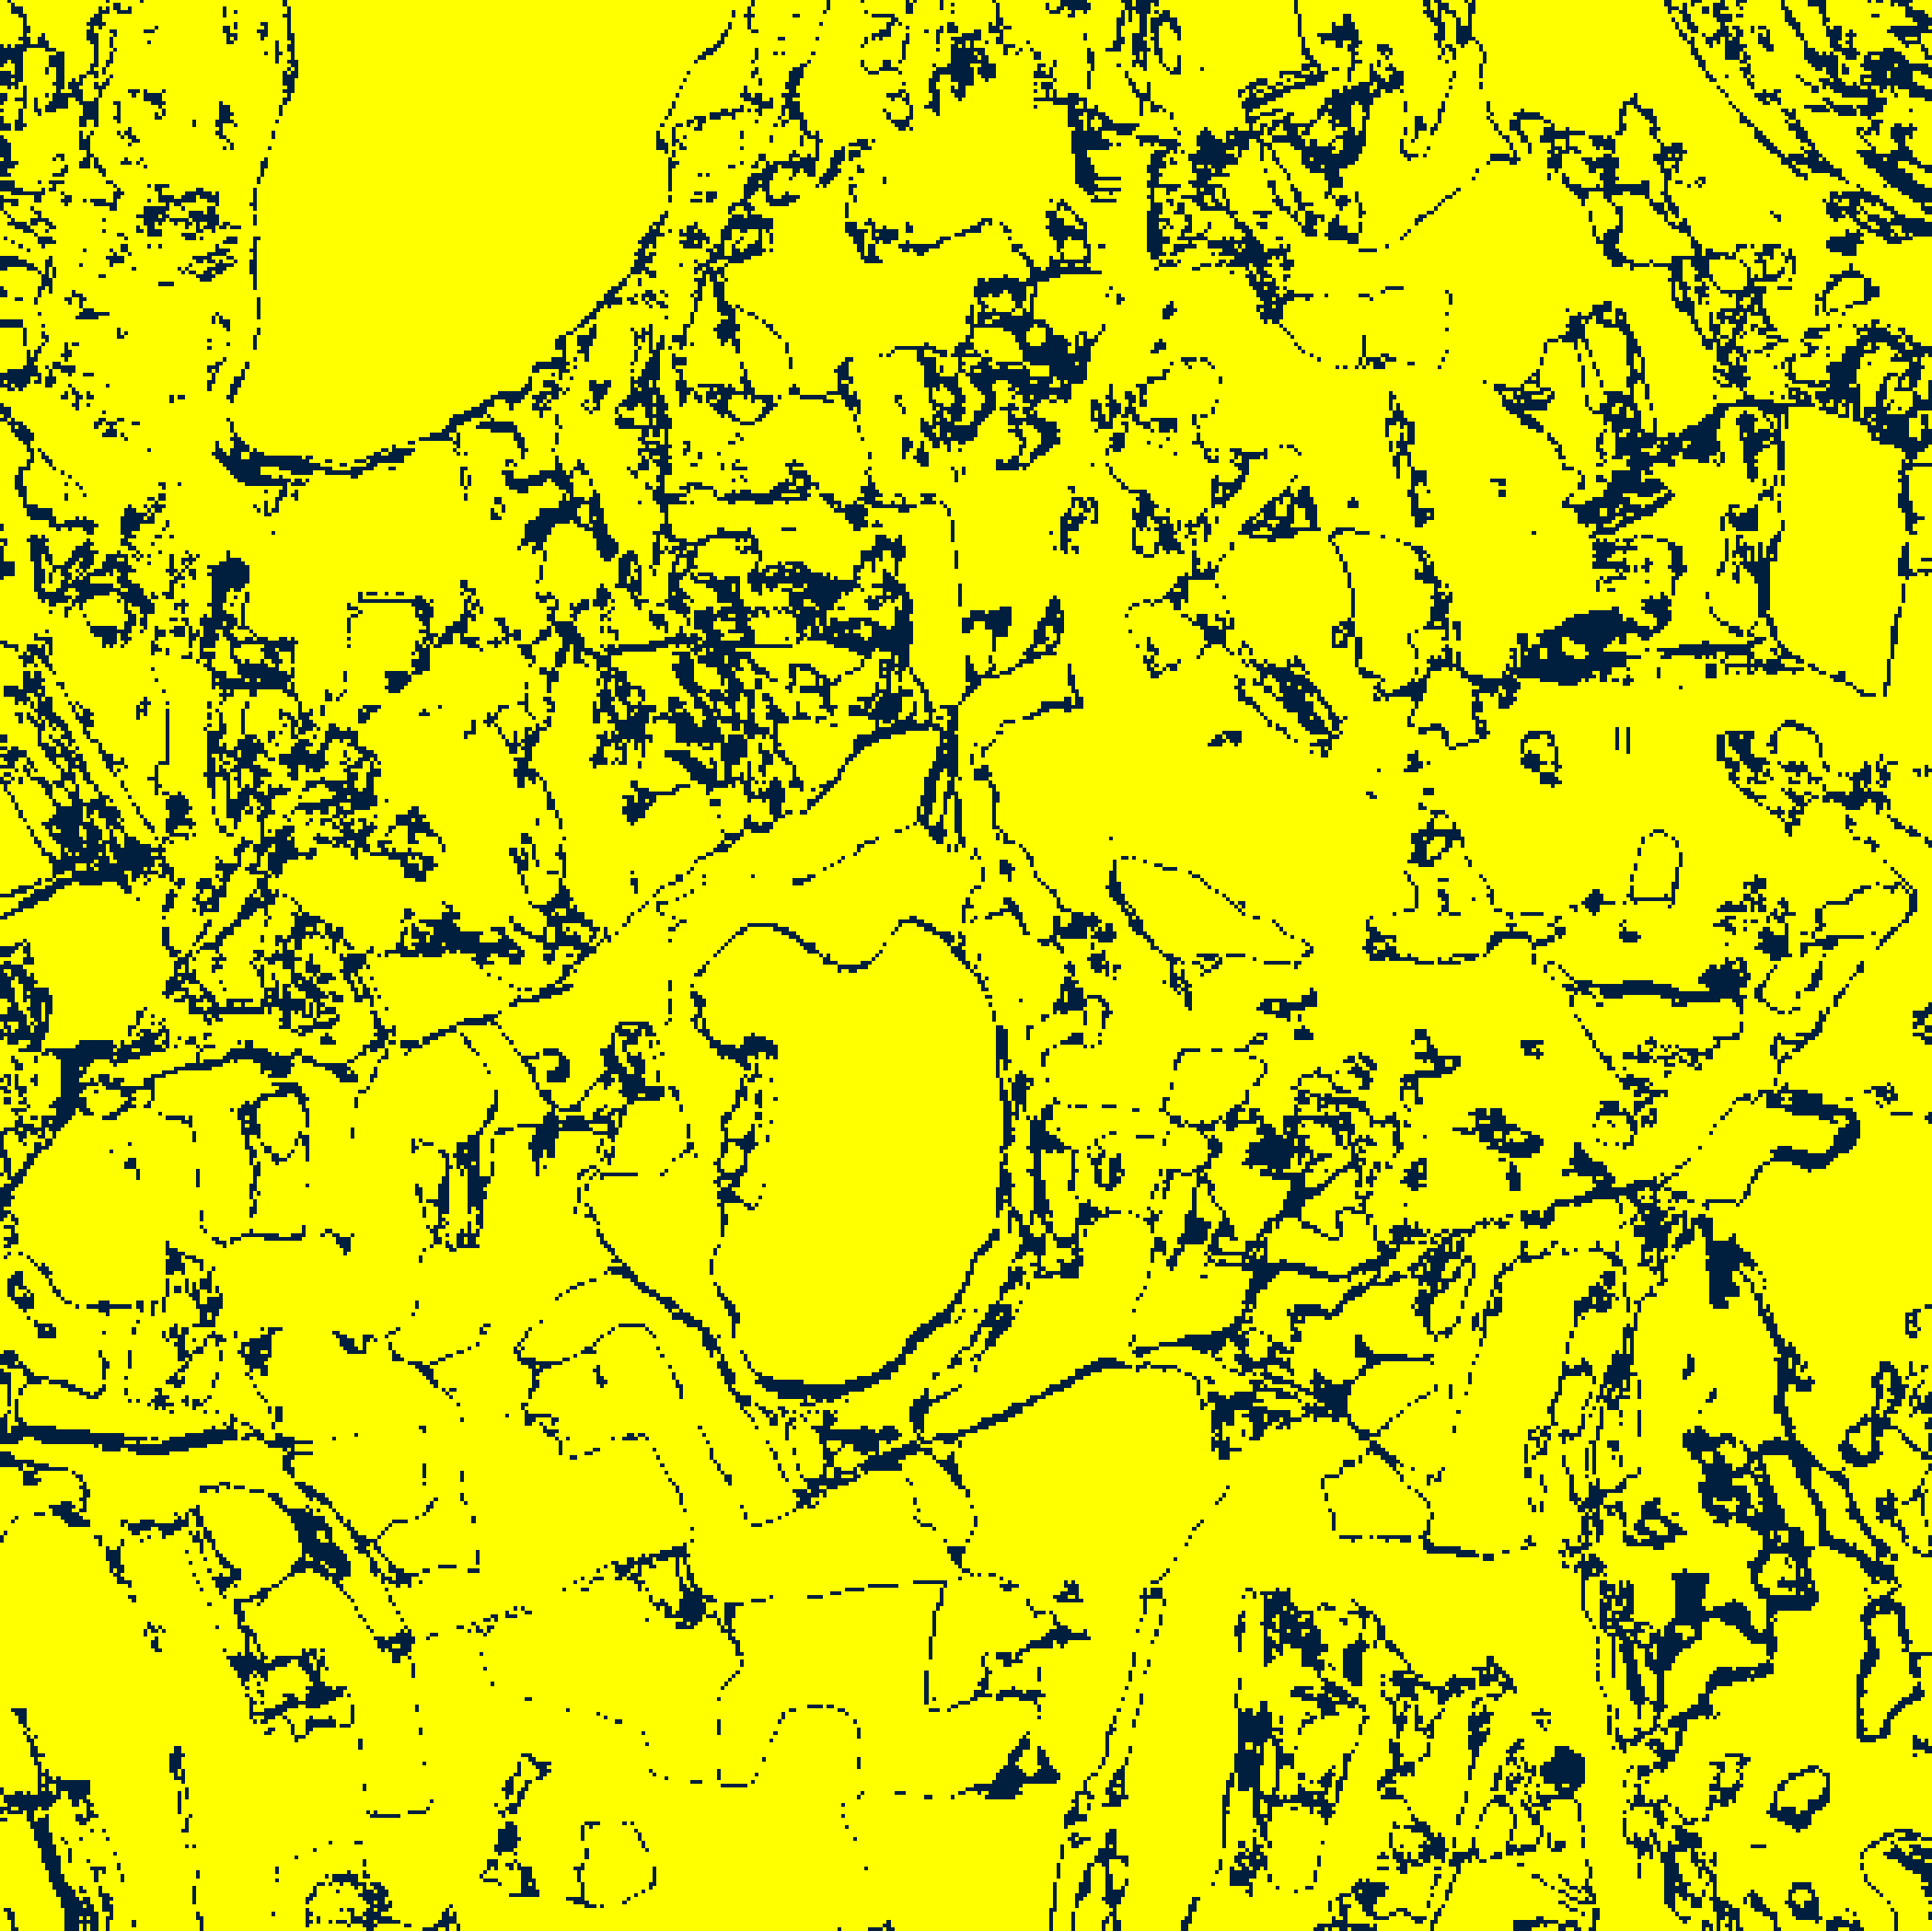  (b) GFNet
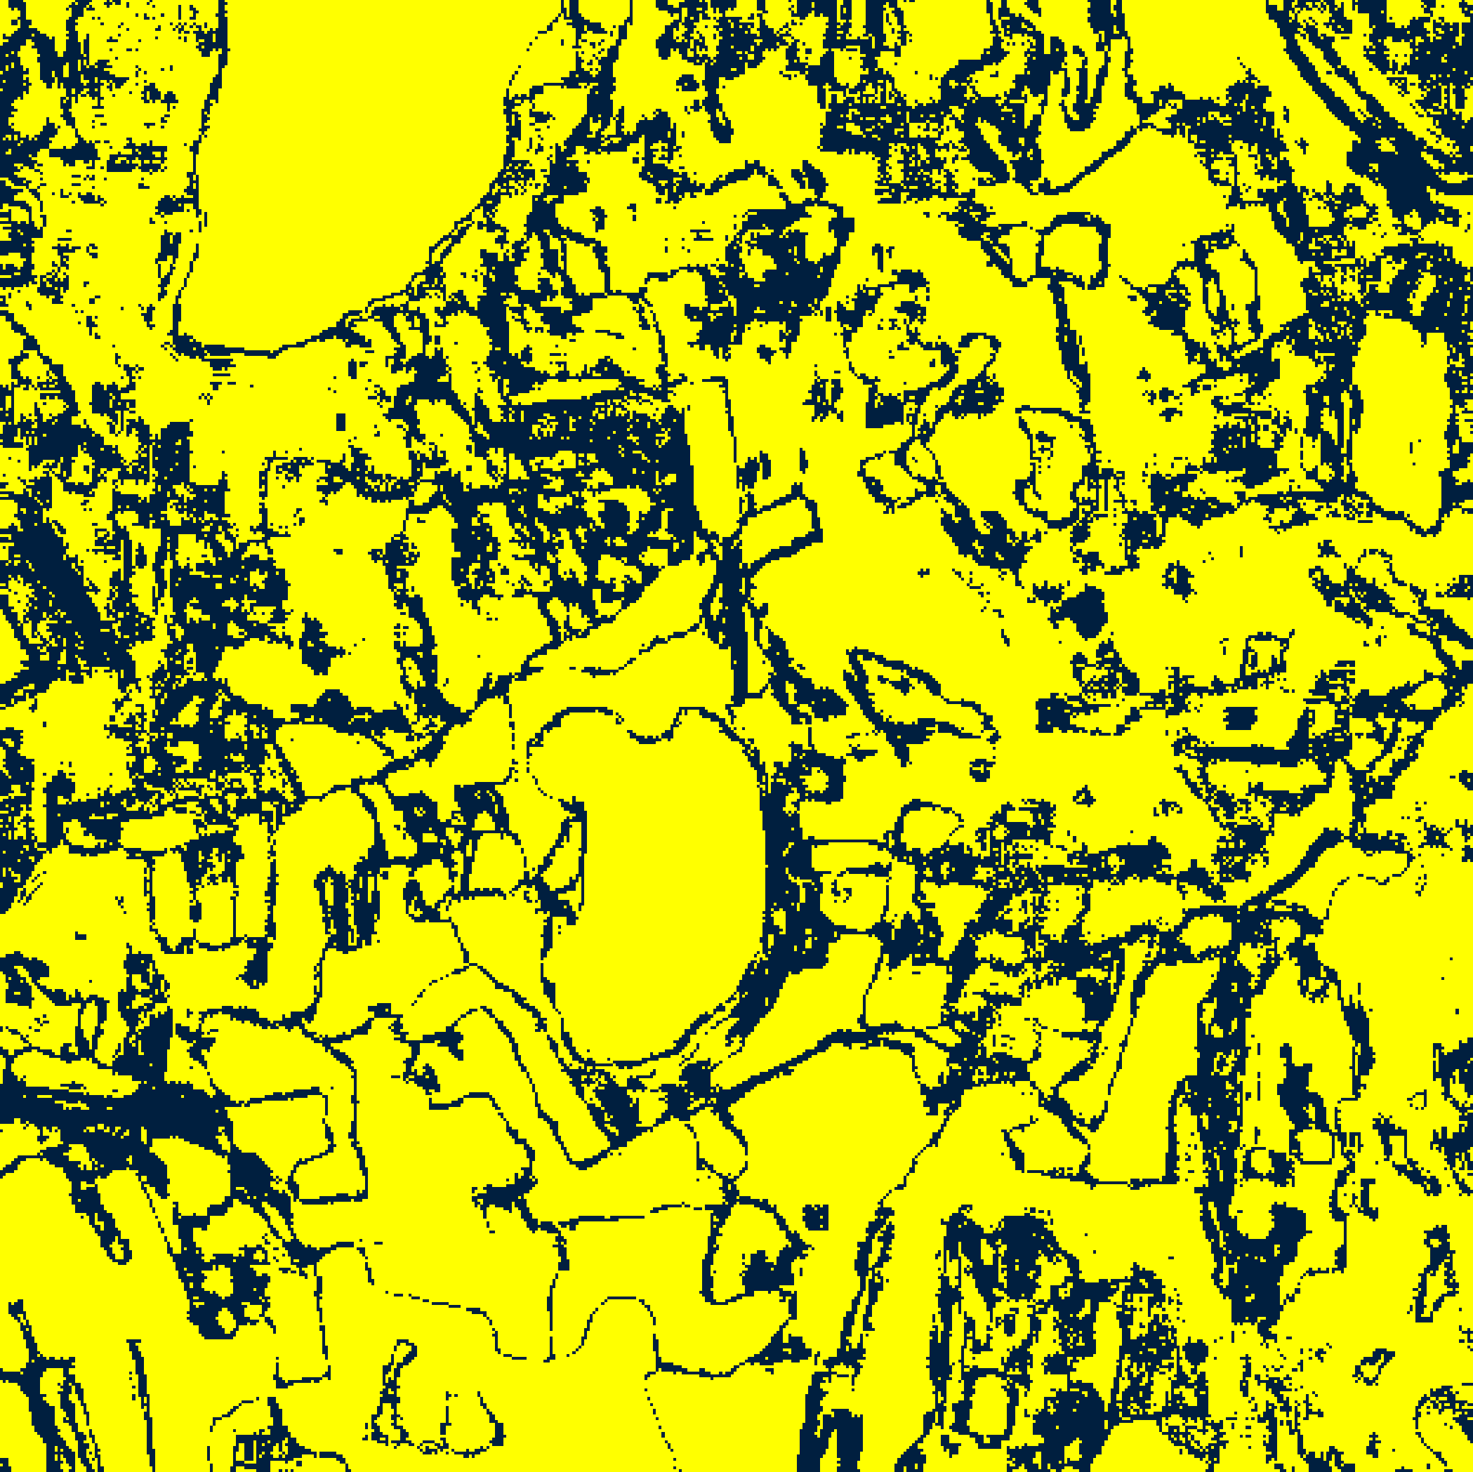  (c) ViT-UNet | (d) Legend
Fig. 7. CreDE binary total uncertainty masks (TU > 0.7) for the full 512 × 512 scene: (a) AlexNet-CNN, (b) GFNet, (c) ViT-UNet. Yellow = certain; dark navy = uncertain.
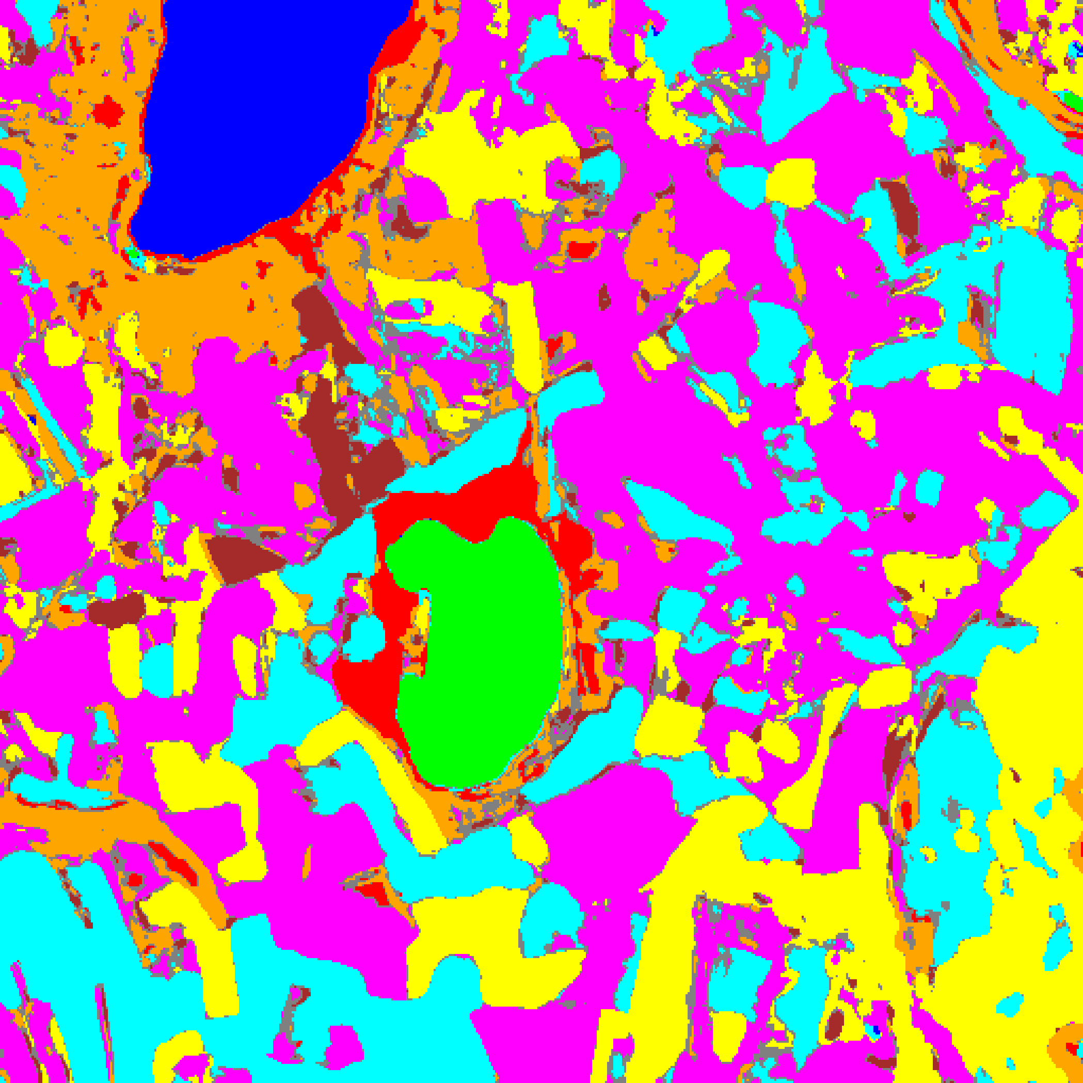  (a) AlexNet-CNN | 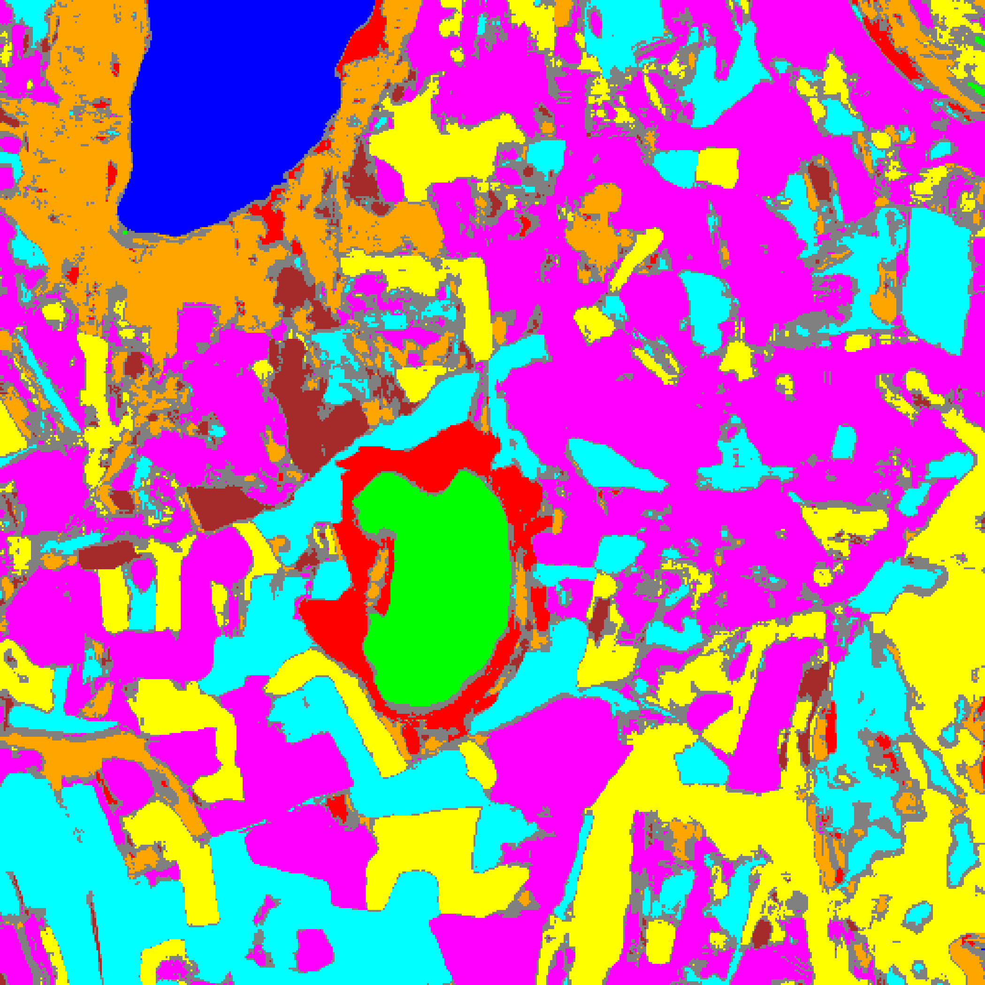  (b) GFNet
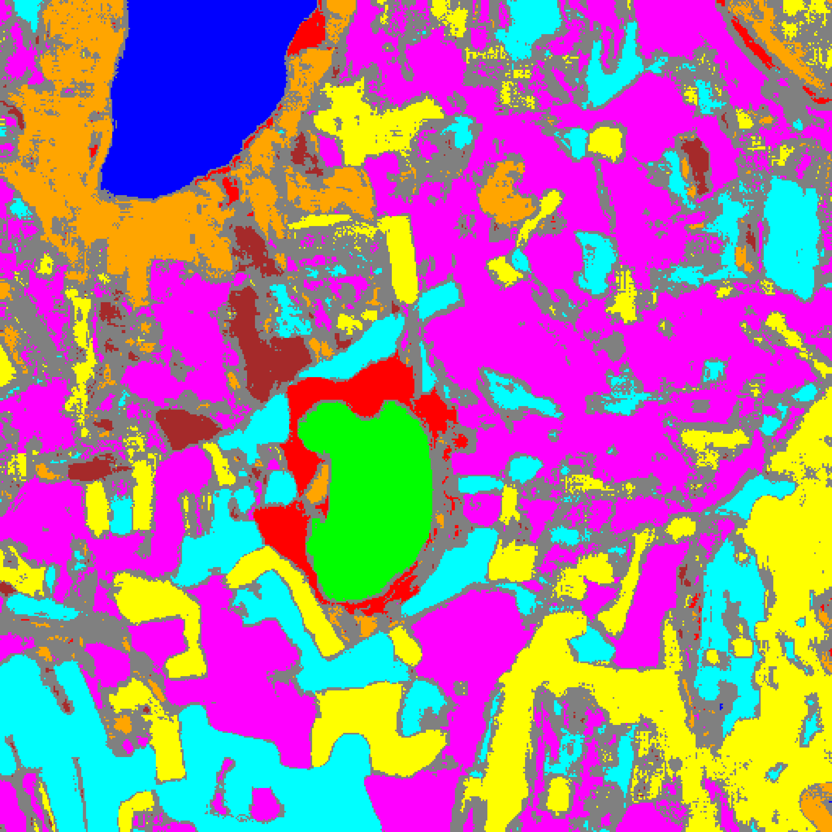  (c) ViT-UNet | (d) Legend
Fig. 8. Grey overlay of total-uncertain pixels (TU > 0.7) on the CreDE classification map: (a) AlexNet-CNN, (b) GFNet, (c) ViT-UNet, with (d) class legend.
TABLE VII
CREDE TOTAL (TU > 0.7) PIXEL-COUNT DISTRIBUTION ACROSS ARCHITECTURES
Class / Region | AlexNet-CNN | GFNet | ViT-UNet
Class 0 | 11,028 | 11,292 | 11,106
Class 1 | 7,864 | 7,224 | 7,336
Class 2 | 7,193 | 7,226 | 5,216
Class 3 | 48,480 | 43,285 | 34,826
Class 4 | 87,543 | 81,843 | 72,502
Class 5 | 47,087 | 40,925 | 36,143
Class 6 | 7,437 | 5,951 | 4,464
Class 7 | 26,623 | 22,445 | 16,272
Uncertain | 18,889 | 41,953 | 74,279
Total (Scene) | 262,144 | 262,144 | 262,144

Under TU > 0.7, AlexNet-CNN flags 18,889 pixels (7.21%), GFNet flags 41,953 (16.00%), and ViT-UNet flags 74,279 (28.34%).
IV. CONCLUSION
This paper presented a Credal Deep Ensemble (CreDE) [7] analysis on the 65-band DIAS Scene K01 hyperspectral dataset (512 × 512 pixels, K = 8 classes: Class 0–Class 7). Using M = 5 independently seeded checkpoints per architecture, GFNet achieved 100.00% test accuracy and the lowest scene-wide epistemic uncertainty (Mean EU = 0.0502; 23,512 EU-uncertain pixels), AlexNet-CNN achieved 99.93% accuracy and the lowest scene-wide aleatoric and total uncertainty (Mean AU = 0.0664, Mean TU = 0.1700; 18,889 TU-uncertain pixels), and ViT-UNet achieved 99.96% accuracy with the widest credal entropy (Mean AU = 0.6706, Mean TU = 0.7517).
REFERENCES
[1] B. Lakshminarayanan, A. Pritzel, and C. Blundell, “Simple and scalable predictive uncertainty estimation using deep ensembles,” in Adv. Neural Inf. Process. Syst. (NeurIPS), vol. 30, 2017.
[2] Y. Rao, W. Zhao, Z. Zhu, J. Lu, and J. Zhou, “Global filter networks for image classification,” in Adv. Neural Inf. Process. Syst. (NeurIPS), vol. 34, 2021.
[3] A. Dosovitskiy et al., “An image is worth 16x16 words: Transformers for image recognition at scale,” in Proc. ICLR, 2021.
[4] O. Ronneberger, P. Fischer, and T. Brox, “U-Net: Convolutional networks for biomedical image segmentation,” in Proc. MICCAI, Springer, 2015.
[5] A. Krizhevsky, I. Sutskever, and G. E. Hinton, “ImageNet classification with deep convolutional neural networks,” in Adv. Neural Inf. Process. Syst. (NeurIPS), vol. 25, 2012.
[6] M. Ahmad et al., “Hyperspectral image classification—Traditional to deep models: A survey for future prospects,” IEEE J. Sel. Topics Appl. Earth Observ. Remote Sens., 2022.
[7] Z. Wang et al., “Credal deep ensembles for uncertainty quantification,” in Adv. Neural Inf. Process. Syst. (NeurIPS), 2024.
[8] A. N. Angelopoulos and S. Bates, “A gentle introduction to conformal prediction and distribution-free uncertainty quantification,” arXiv:2107.07511, 2021.

