Vision-Language Contrastive Cosine Classification (GeoRSCLIP-TextHead) for Hyperspectral Land-Cover Mapping with Conformal Prediction
ABSTRACT
This paper presents patch-based pixel-wise hyperspectral land-cover classification and conformal uncertainty quantification using GeoRSCLIP-TextHead on the 65-band DIAS Scene K01 dataset (512 × 512 pixels, K = 8 classes: Class 0 through Class 7). Operating on 9 × 9 × 65 spatial-spectral patches across 13,474 held-out test samples, GeoRSCLIP-TextHead achieves 100.000% test accuracy (κ = 1.0000, macro-F1 = 1.0000, weighted-F1 = 1.0000, NLL = 0.03962, Brier = 0.00178, ECE = 0.03883) in 820.3 s. Five post-hoc conformal prediction methods (SplitCP, CcCP, RC3P, ClCP, and RAPS) calibrated on n_cal = 6,737 samples at α = 0.05 are evaluated on n_eval = 6,737 samples and across all 262,144 scene pixels.
I. INTRODUCTION
Hyperspectral earth observation across 65 contiguous spectral channels enables precise discrimination of surface land-cover classes [5]. In this report, we evaluate GeoRSCLIP-TextHead on 9 × 9 × 65 patches extracted from DIAS Scene K01 (512 × 512 pixels, Class 0–Class 7) and wrap the trained classifier in five distribution-free conformal prediction algorithms (SplitCP, CcCP, RC3P, ClCP, and RAPS) targeting 95% coverage (α = 0.05) [1, 2, 3, 4].
II. METHODOLOGY
A. Dataset and Preprocessing
The DIAS Scene K01 dataset (files k001.mat and k002.mat) comprises H = 512 × W = 512 pixels (262,144 total scene pixels) with B = 65 spectral bands and K = 8 labelled classes (Class 0 through Class 7, totalling 53,896 labelled pixels and 208,248 unlabelled background pixels). Each band is min-max normalised to [0, 1]:
x̃(h, w, b) = [x(h, w, b) − min_{b}] / [max_{b} − min_{b} + ε], ε = 10⁻⁸
Using seed 42, the labelled samples are partitioned into 75% training (40,422), 12.5% calibration (n_cal = 6,737), and 12.5% evaluation (n_eval = 6,737). GeoRSCLIP-TextHead projects 9 × 9 × 65 patches through a ViT visual encoder and classifies pixels via temperature-scaled cosine similarity against learnable class prototype embeddings.
III. EXPERIMENTS AND RESULTS
A. Classification Performance and Dense Scene Map
TABLE I
TEST SET CLASSIFICATION PERFORMANCE
Model | Accuracy | κ | Macro F1 | Wtd F1 | NLL | Brier | ECE | Train Time (s)
GeoRSCLIP-TextHead | 100.000% | 1.0000 | 1.0000 | 1.0000 | 0.03962 | 0.00178 | 0.03883 | 820.3

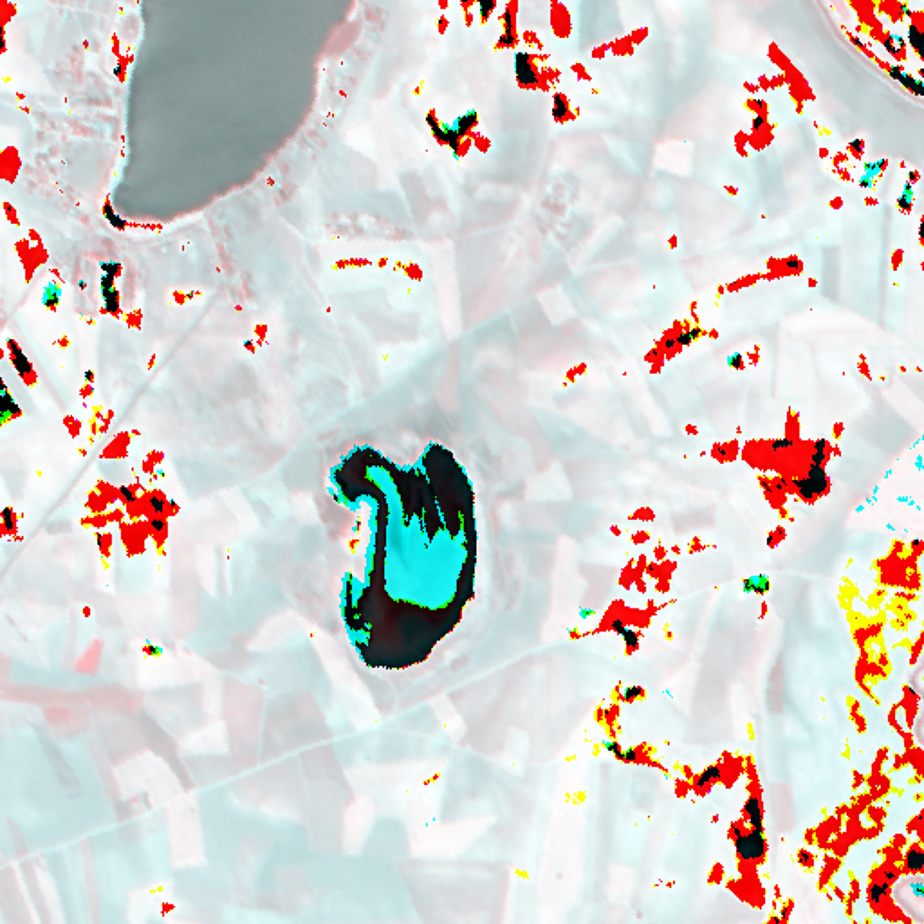  (a) Approximate RGB Composite | 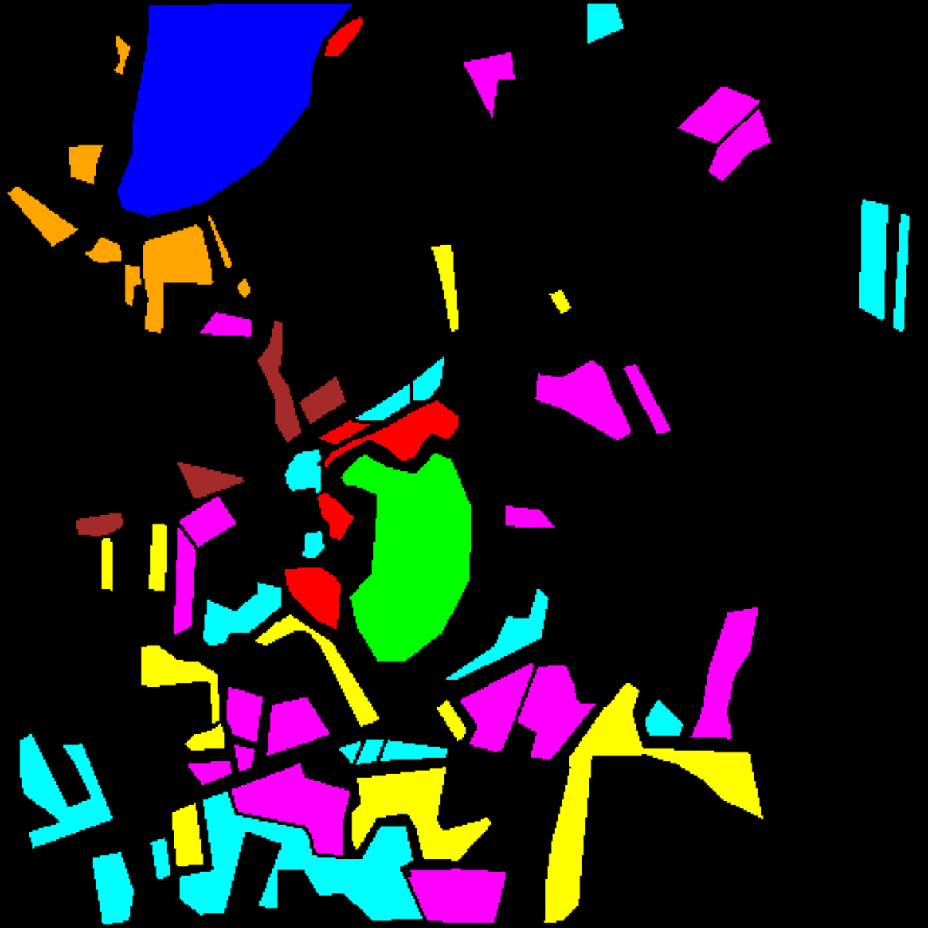  (b) Ground Truth Label Map
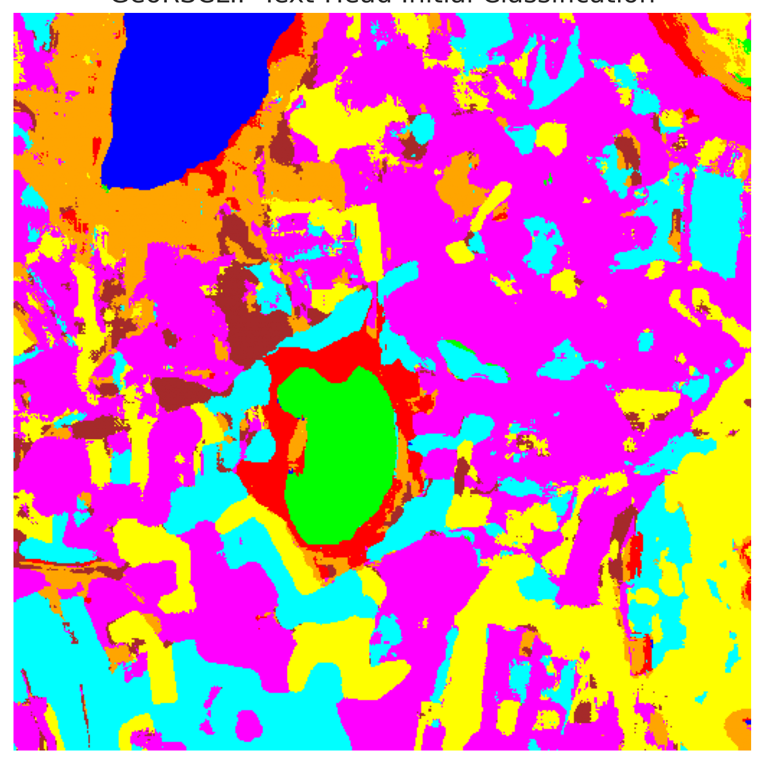  (c) GeoRSCLIP-TextHead Dense Map | 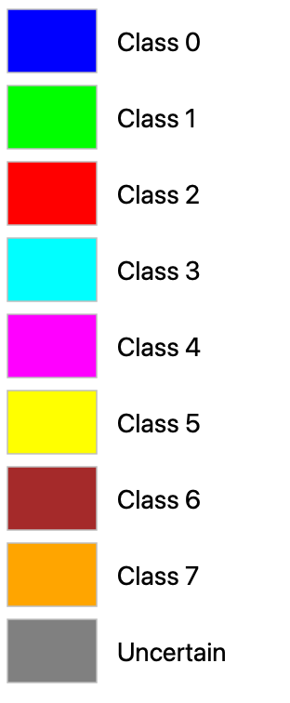  (d) Class Legend
Fig. 1. DIAS Scene K01 overview and dense classification map for GeoRSCLIP-TextHead: (a) RGB composite, (b) ground truth, (c) GeoRSCLIP-TextHead full-scene prediction (512 × 512 pixels), and (d) class legend.
B. Conformal Prediction Results (SplitCP, CcCP, RC3P, ClCP, RAPS)
TABLE II
SPLITCP AGGREGATE PERFORMANCE (Α = 0.05)
Model | q̂ | Emp. Cov. | Avg Set Size | Singleton Rate | Empty Set Rate | Runtime (s) | Mean Cls Cov.
GeoRSCLIP-TextHead | 0.039581 | 0.9475 | 0.9475 | 0.9475 | 0.0525 | 2.321 | 0.9596

TABLE III
SPLITCP PER-CLASS EMPIRICAL COVERAGE
Class | GeoRSCLIP-TextHead
Class 0 | 0.9942
Class 1 | 1.0000
Class 2 | 0.9647
Class 3 | 0.8168
Class 4 | 0.9918
Class 5 | 0.9377
Class 6 | 0.9900
Class 7 | 0.9812

TABLE IV
SPLITCP FULL-SCENE PIXEL COUNTS (262,144 PIXELS)
Class / Region | GeoRSCLIP-TextHead
Class 0 | 10,622
Class 1 | 6,758
Class 2 | 5,359
Class 3 | 19,346
Class 4 | 72,150
Class 5 | 29,725
Class 6 | 4,981
Class 7 | 15,512
Uncertain | 97,691
Total (Scene) | 262,144

TABLE V
CCCP AGGREGATE PERFORMANCE (Α = 0.05)
Model | Emp. Cov. | Avg Set Size | Singleton Rate | Empty Set Rate | Runtime (s) | Mean Cls Cov.
GeoRSCLIP-TextHead | 0.9480 | 0.9480 | 0.9480 | 0.0520 | 2.153 | 0.9447

TABLE VI
CCCP PER-CLASS EMPIRICAL COVERAGE
Class | GeoRSCLIP-TextHead
Class 0 | 0.9457
Class 1 | 0.9347
Class 2 | 0.9541
Class 3 | 0.9495
Class 4 | 0.9491
Class 5 | 0.9632
Class 6 | 0.9300
Class 7 | 0.9313

TABLE VII
CCCP CLASS-WISE THRESHOLDS (Q̂_C)
Class | GeoRSCLIP-TextHead
Class 0 | 0.039310
Class 1 | 0.038767
Class 2 | 0.038471
Class 3 | 0.039908
Class 4 | 0.039083
Class 5 | 0.039754
Class 6 | 0.036628
Class 7 | 0.037385

TABLE VIII
CCCP FULL-SCENE PIXEL COUNTS (262,144 PIXELS)
Class / Region | GeoRSCLIP-TextHead
Class 0 | 9,966
Class 1 | 6,116
Class 2 | 5,023
Class 3 | 24,977
Class 4 | 61,935
Class 5 | 31,372
Class 6 | 3,466
Class 7 | 13,129
Uncertain | 106,160
Total (Scene) | 262,144

TABLE IX
RC3P AGGREGATE PERFORMANCE (Α = 0.05)
Model | Emp. Cov. | Avg Set Size | Singleton Rate | Empty Set Rate | Runtime (s) | Mean Cls Cov.
GeoRSCLIP-TextHead | 0.9519 | 0.9519 | 0.9519 | 0.0481 | 2.482 | 0.9497

TABLE X
RC3P PER-CLASS EMPIRICAL COVERAGE
Class | GeoRSCLIP-TextHead
Class 0 | 0.9474
Class 1 | 0.9418
Class 2 | 0.9541
Class 3 | 0.9538
Class 4 | 0.9522
Class 5 | 0.9660
Class 6 | 0.9450
Class 7 | 0.9375

TABLE XI
RC3P CALIBRATED THRESHOLDS (Q̂_C) AND RANK LIMITS (K̂_C)
Class | q̂_c | k̂_c
Class 0 | 0.039314 | 1
Class 1 | 0.038782 | 1
Class 2 | 0.038471 | 1
Class 3 | 0.039938 | 1
Class 4 | 0.039098 | 1
Class 5 | 0.039775 | 1
Class 6 | 0.036756 | 1
Class 7 | 0.037457 | 1

TABLE XII
RC3P FULL-SCENE PIXEL COUNTS (262,144 PIXELS)
Class / Region | GeoRSCLIP-TextHead
Class 0 | 9,988
Class 1 | 6,175
Class 2 | 5,024
Class 3 | 25,248
Class 4 | 62,562
Class 5 | 31,540
Class 6 | 3,618
Class 7 | 13,272
Uncertain | 104,717
Total (Scene) | 262,144

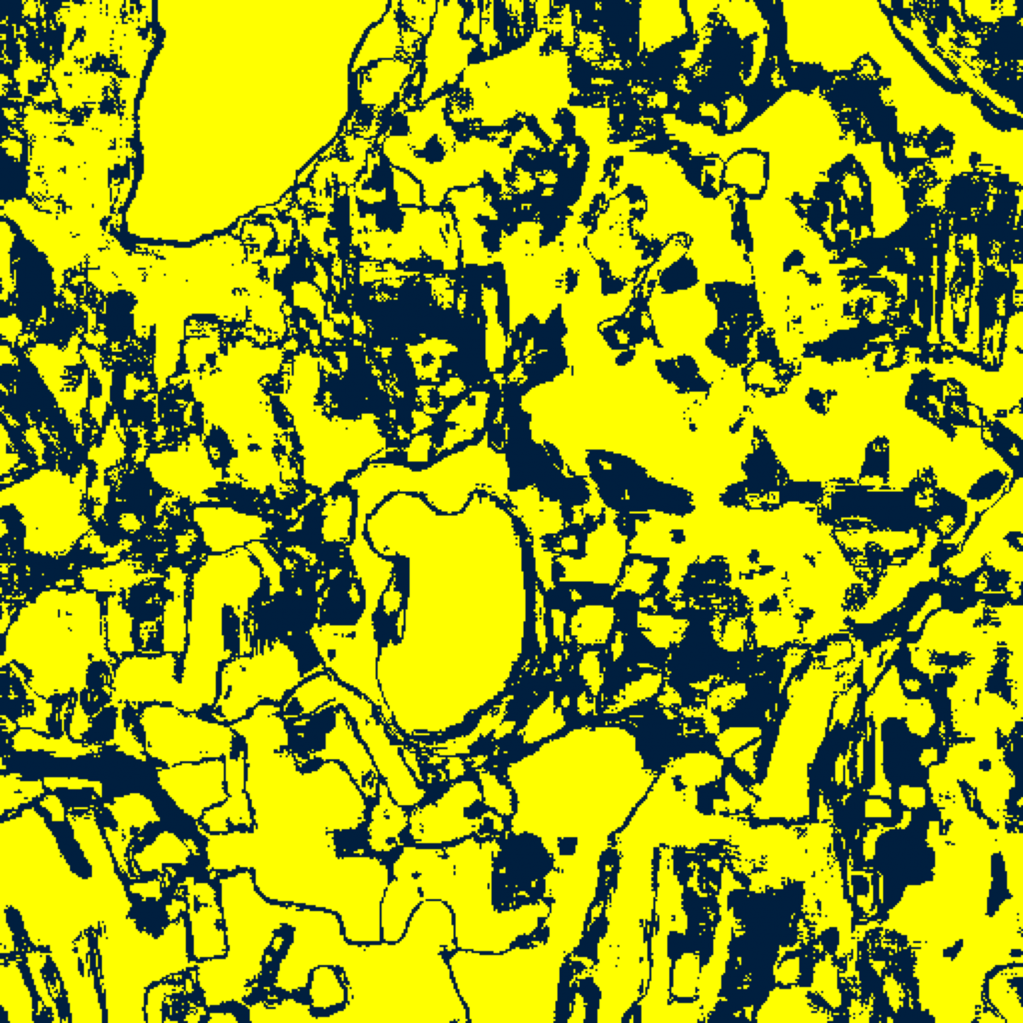  (A) SplitCP Binary | 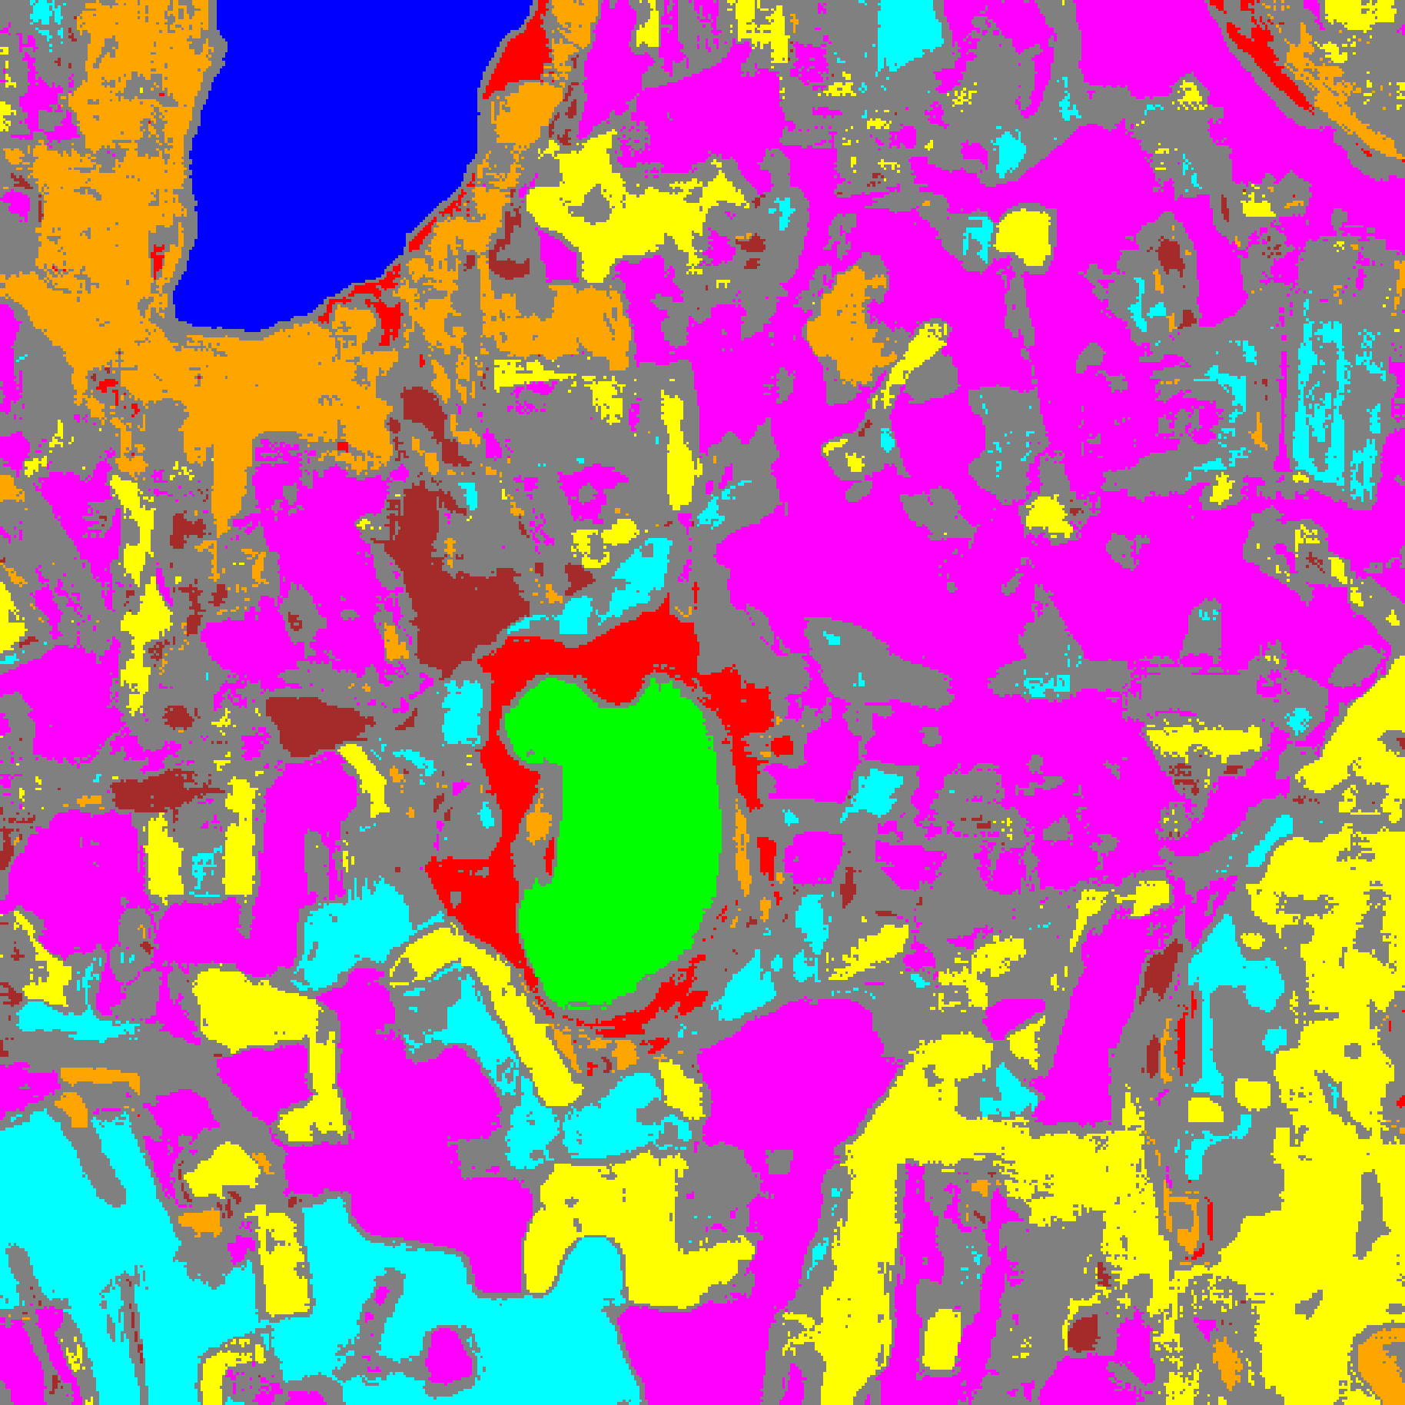  (B) SplitCP Mask
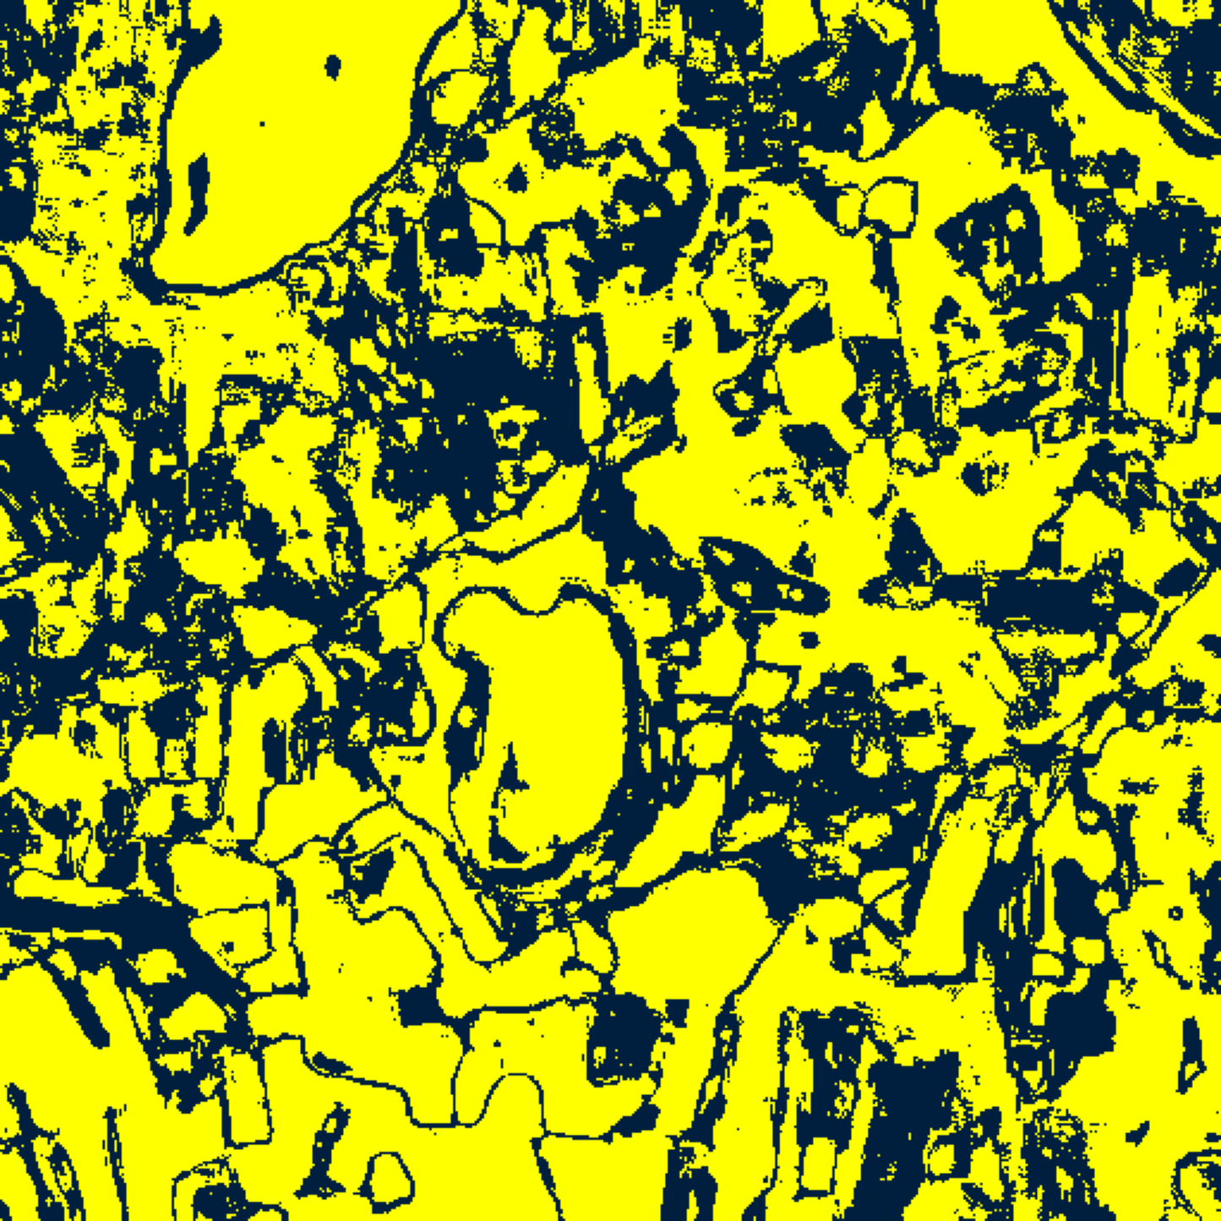  (C) CcCP Binary | 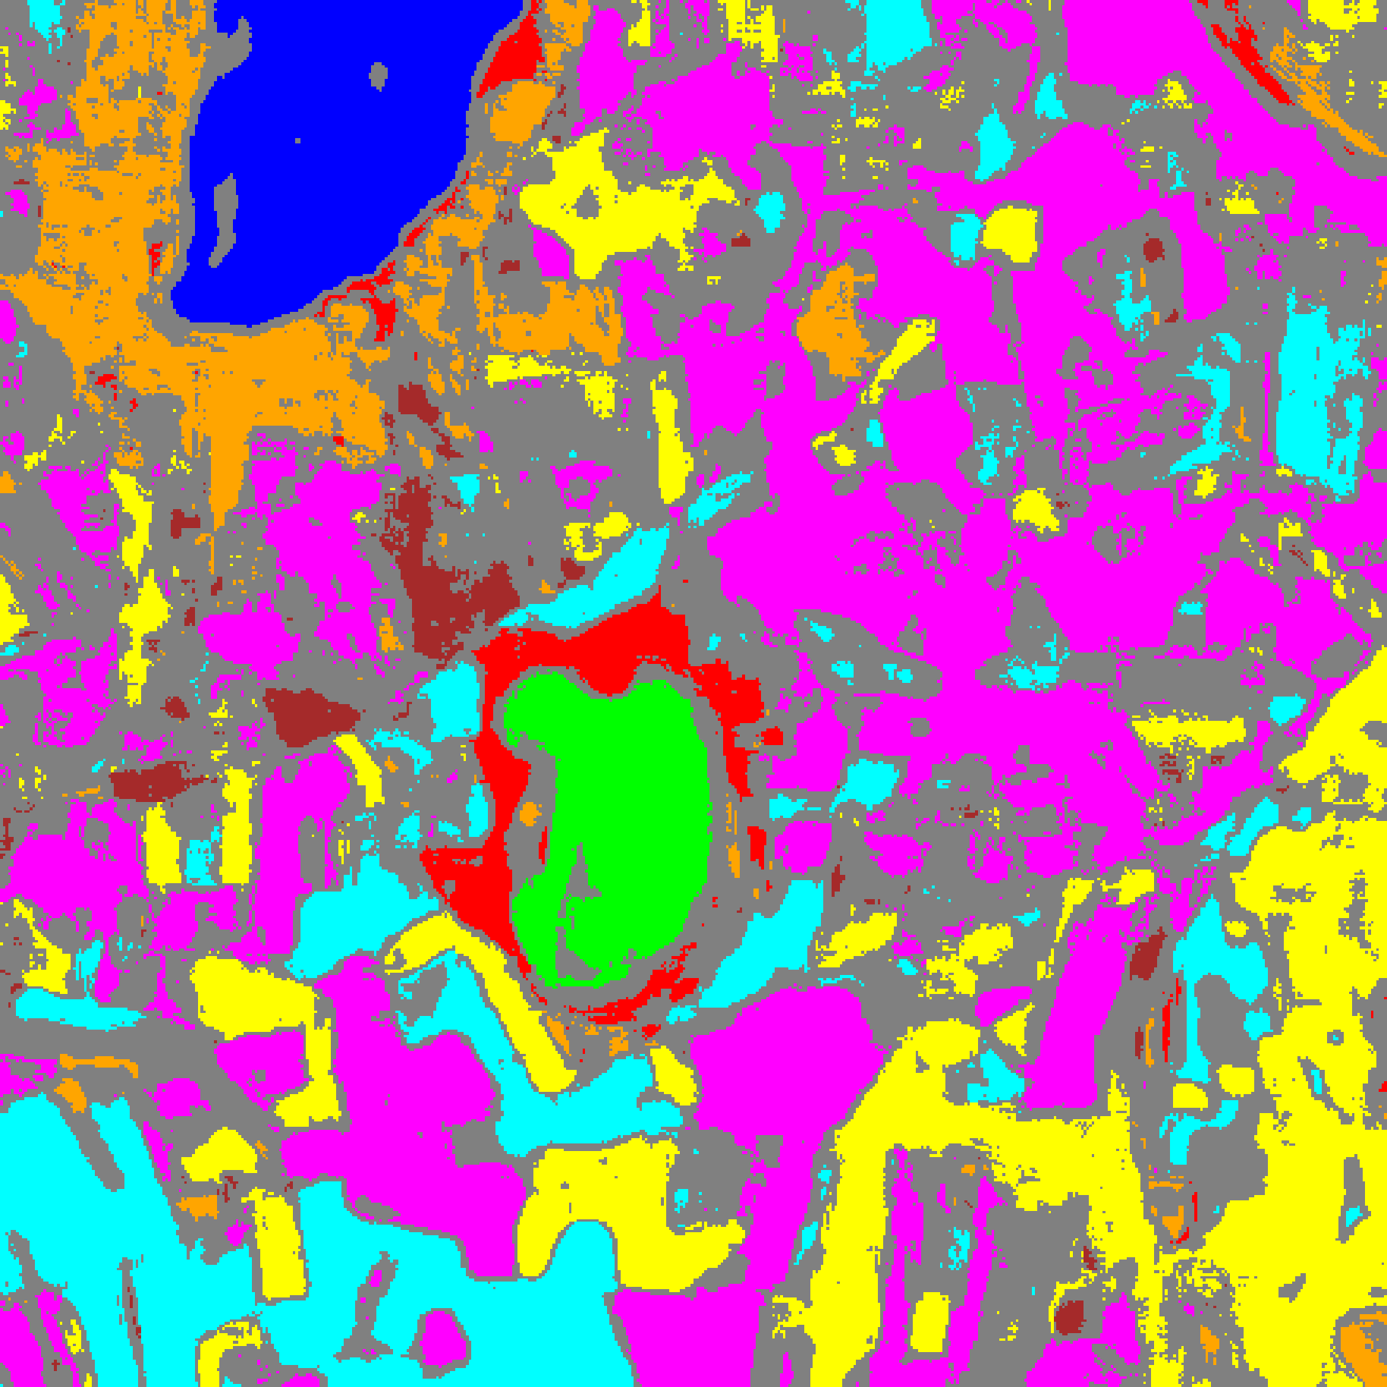  (D) CcCP Mask
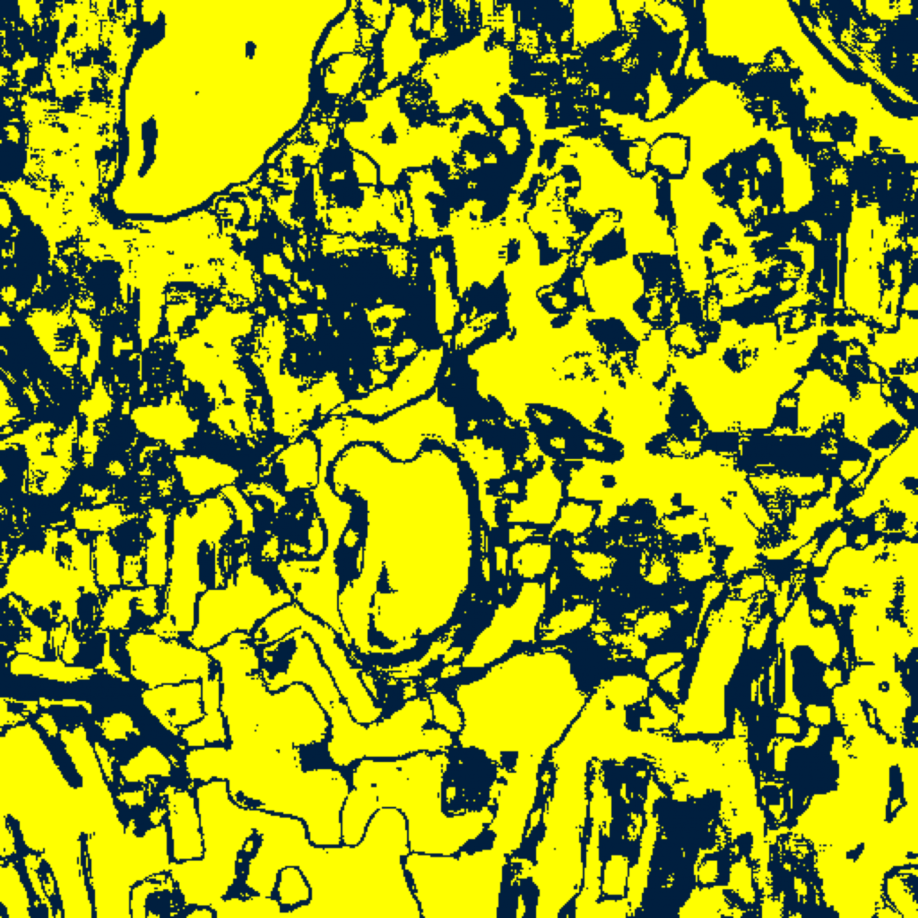  (E) RC3P Binary | 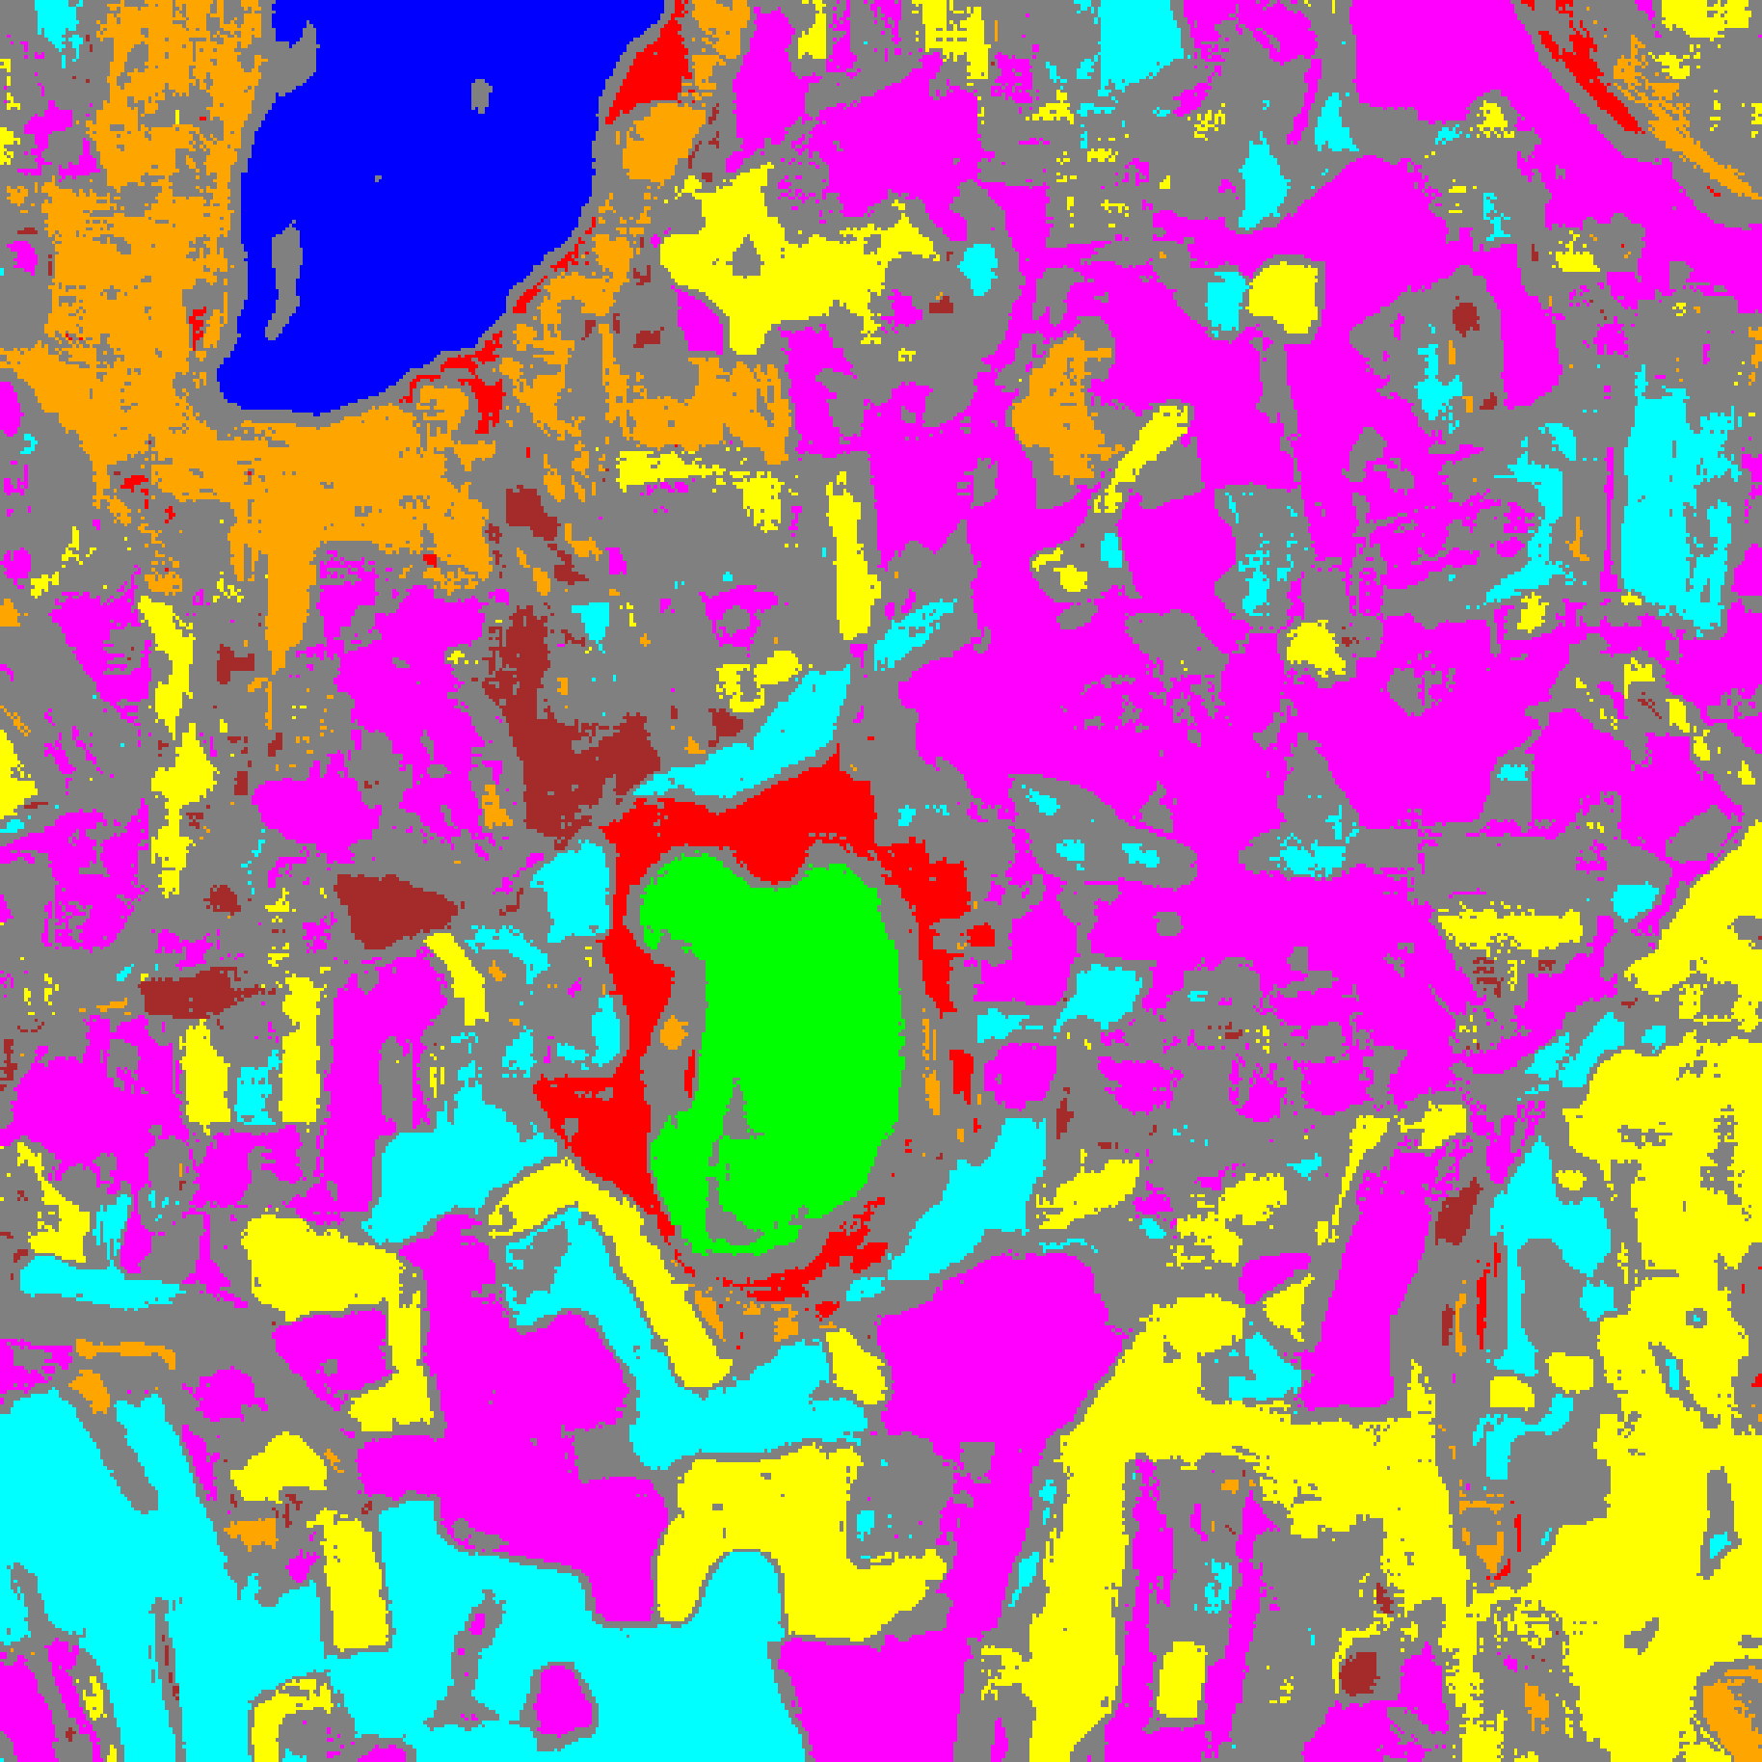  (F) RC3P Mask
Fig. 2. Spatialised binary uncertainty maps and class-masked maps for GeoRSCLIP-TextHead across SplitCP ((A)–(B)), CcCP ((C)–(D)), and RC3P ((E)–(F)).
TABLE XIII
CLCP AGGREGATE PERFORMANCE (Α = 0.05, K_G = 4 CLUSTERS)
Model | Emp. Cov. | Avg Set Size | Singleton Rate | Empty Set Rate | Runtime (s) | Mean Cls Cov.
GeoRSCLIP-TextHead | 0.9501 | 0.9501 | 0.9501 | 0.0499 | 6.521 | 0.9597

TABLE XIV
CLCP PER-CLASS EMPIRICAL COVERAGE
Class | GeoRSCLIP-TextHead
Class 0 | 0.9457
Class 1 | 0.9915
Class 2 | 0.9541
Class 3 | 0.9267
Class 4 | 0.9352
Class 5 | 0.9660
Class 6 | 0.9900
Class 7 | 0.9688

TABLE XV
CLCP CLASS-TO-CLUSTER ASSIGNMENTS AND THRESHOLDS
Class | Cluster | q̂
Class 0 | Cluster 0 | 0.039310
Class 1 | Cluster 1 | 0.039023
Class 2 | Cluster 3 | 0.038471
Class 3 | Cluster 2 | 0.039777
Class 4 | Cluster 1 | 0.039023
Class 5 | Cluster 2 | 0.039777
Class 6 | Cluster 2 | 0.039777
Class 7 | Cluster 1 | 0.039023

TABLE XVI
CLCP PER-CLUSTER MEAN COVERAGE
Cluster | GeoRSCLIP-TextHead
Cluster 0 | 0.9457
Cluster 1 | 0.9548
Cluster 2 | 0.9470
Cluster 3 | 0.9541

TABLE XVII
RAPS AGGREGATE PERFORMANCE (Α = 0.05, Λ = 0.01, K_REG = 1)
Model | Emp. Cov. | Avg Set Size | Singleton Rate | Empty Set Rate | Runtime (s) | Mean Cls Cov.
GeoRSCLIP-TextHead | 0.9999 | 1.0000 | 1.0000 | 0.0000 | 0.473 | 0.9999

TABLE XVIII
RAPS PER-CLASS EMPIRICAL COVERAGE
Class | GeoRSCLIP-TextHead
Class 0 | 1.0000
Class 1 | 1.0000
Class 2 | 1.0000
Class 3 | 1.0000
Class 4 | 0.9994
Class 5 | 1.0000
Class 6 | 1.0000
Class 7 | 1.0000

TABLE XIX
RAPS CALIBRATED PARAMETERS
Model | q̂_RAPS | λ | k_reg
GeoRSCLIP-TextHead | 0.000000 | 0.01 | 1

IV. CONCLUSION
On the 65-band DIAS Scene K01 hyperspectral dataset (512 × 512 pixels, K = 8 classes), GeoRSCLIP-TextHead achieved 100.000% test accuracy (κ = 1.0000). Wrapped in SplitCP, CcCP, RC3P, ClCP, and RAPS at α = 0.05, the model delivered valid distribution-free coverage guarantees and full-scene spatial uncertainty maps across all 262,144 pixels.
REFERENCES
[1] A. N. Angelopoulos, S. Bates, J. Malik, and M. I. Jordan, “Uncertainty sets for image classifiers using conformal prediction,” in Proc. ICLR, 2021.
[2] Y. Shi, S. Ghosh, T. Belkhouja, J. R. Doppa, and Y. Yan, “Conformal prediction for class-wise coverage via augmented label rank calibration,” in Adv. Neural Inf. Process. Syst. (NeurIPS), 2024.
[3] T. Ding, A. N. Angelopoulos, S. Bates, M. I. Jordan, and R. J. Tibshirani, “Class-conditional conformal prediction with many classes,” in Adv. Neural Inf. Process. Syst. (NeurIPS), 2023.
[4] Y. Romano, M. Sesia, and E. Candès, “Classification with valid and adaptive coverage,” in Adv. Neural Inf. Process. Syst. (NeurIPS), 2020.
[5] M. Ahmad et al., “Hyperspectral image classification—Traditional to deep models: A survey for future prospects,” IEEE J. Sel. Topics Appl. Earth Observ. Remote Sens., 2022.

