Dual-Branch Spatial-Spectral State Space Models (MambaHSI) for Hyperspectral Land-Cover Classification with Conformal Uncertainty Quantification
ABSTRACT
This paper evaluates the MambaHSI family of selective State Space Models (SSMs) for patch-based pixel-wise land-cover classification of a 65-band hyperspectral scene (DIAS Scene K01, 512 × 512 pixels, K = 8 classes: Class 0 through Class 7), paired with distribution-free uncertainty quantification across five conformal prediction algorithms. Three capacity scales—MambaHSI-Small (d = 64, L = 2), MambaHSI-Base (d = 128, L = 4), and MambaHSI-Large (d = 192, L = 6)—couple a spatial selective-scan branch over the 81-pixel 9 × 9 grid with a spectral selective-scan branch across spectral groups via learnable sigmoid gating in O(N) linear complexity. On the held-out test set (13,474 samples), MambaHSI-Base and MambaHSI-Large both achieve 99.993% accuracy (κ = 0.9999), with MambaHSI-Large reaching a macro-F1 of 1.0000 and MambaHSI-Small achieving 99.978% accuracy alongside the lowest NLL (0.01063), Brier score (0.00056), and ECE (0.01023) in 298.2 s. Post-hoc conformal prediction (SplitCP, CcCP, RC3P, ClCP, and RAPS) calibrated on n_cal = 6,737 samples at α = 0.05 achieves valid 95% marginal and class-conditional coverage with universal rank limit k̂_c = 1 and generates full-scene uncertainty maps across all 262,144 pixels.
I. INTRODUCTION
Hyperspectral land-cover classification requires modelling both fine-grained spatial structures and long-range spectral dependencies across dozens of contiguous bands [11]. While Vision Transformers capture global context via self-attention, their quadratic O(N^2) complexity with respect to sequence length scales poorly. Selective State Space Models (Mamba) [1] overcome this bottleneck through input-dependent state transitions evaluated via hardware-aware parallel associative scans in linear O(N) time.
MambaHSI [2] adapts selective state spaces to hyperspectral imagery via a dual-branch architecture: a Spatial Mamba branch scans flattened spatial tokens to capture parcel geometry, while a Spectral Mamba branch scans spectral channel groups to model cross-band absorption profiles, fusing both representations through a learnable gate.
To complement point predictions with rigorous statistical guarantees, we wrap all three MambaHSI variants in five post-hoc conformal prediction (CP) methods at 1 − α = 0.95 [3, 4, 5, 6, 7, 8, 9]. Our contributions are:
- A capacity-scaling investigation of MambaHSI-Small, MambaHSI-Base, and MambaHSI-Large on 9 × 9 × 65 patches from the 65-band DIAS Scene K01 hyperspectral benchmark (K = 8 classes: Class 0–Class 7).
- Joint evaluation of classification accuracy, probabilistic calibration (NLL, Brier, ECE), and training efficiency across model scales [12].
- Benchmarking of five conformal prediction algorithms (SplitCP, CcCP, RC3P, ClCP, and RAPS) at α = 0.05 across all three MambaHSI variants.
- Full-scene spatialised uncertainty mapping across all 512 × 512 = 262,144 pixels.

II. METHODOLOGY
A. Dataset and Preprocessing
The study uses the 65-band DIAS Scene K01 hyperspectral dataset (files k001.mat and k002.mat, H = 512, W = 512 pixels, B = 65 spectral bands, K = 8 classes: Class 0 through Class 7), shown in Fig. 1.
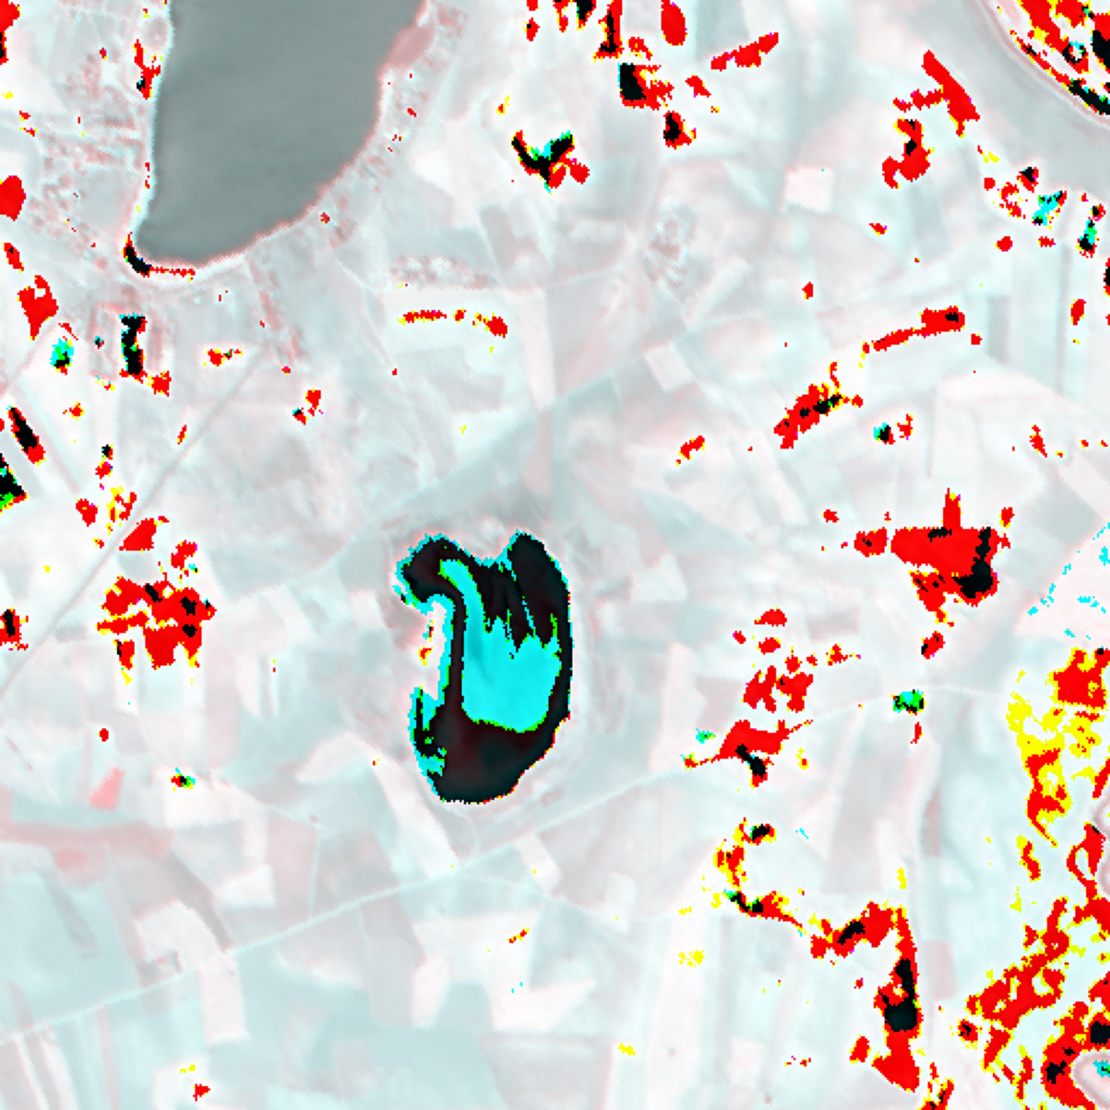  (a) Approximate RGB Composite | 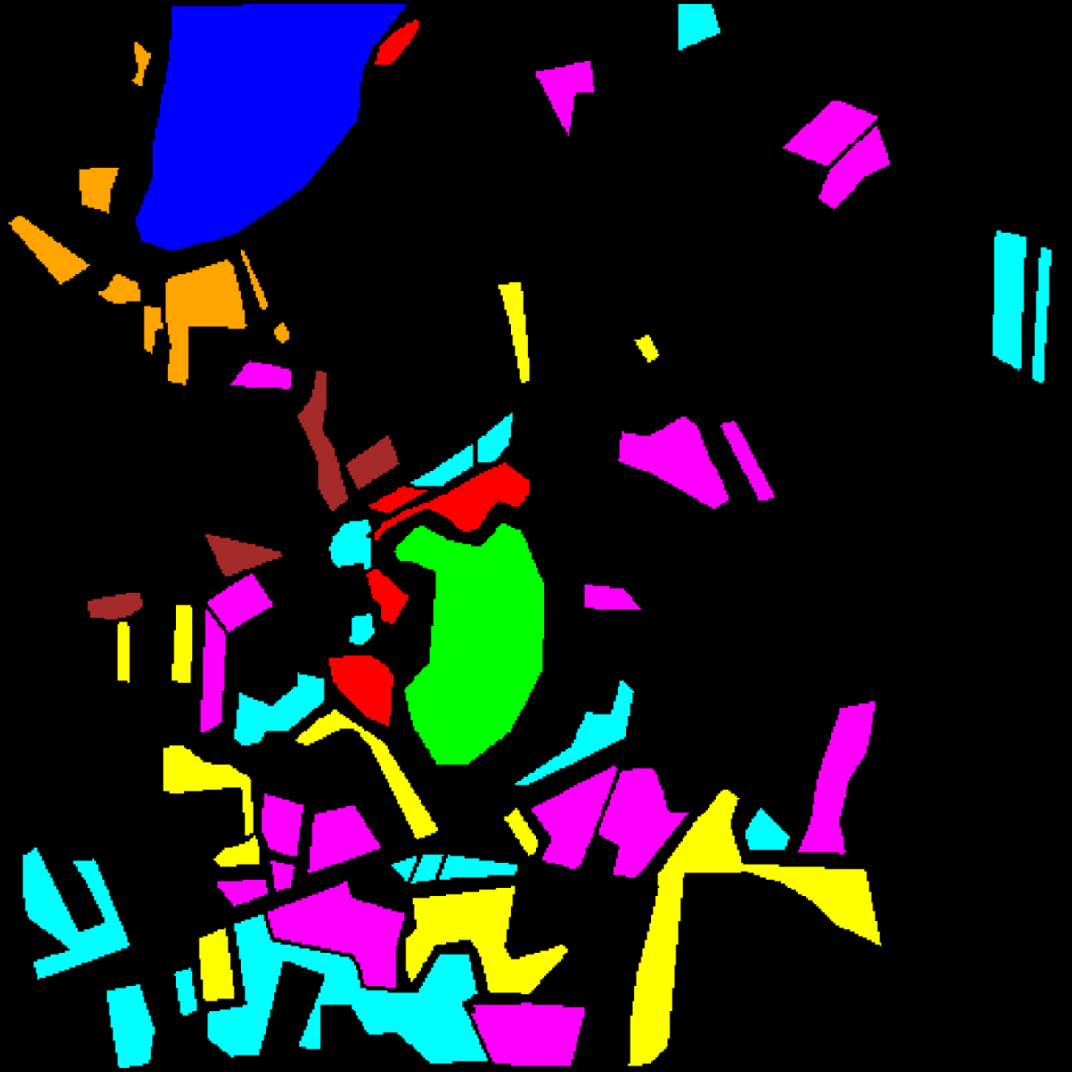  (b) Ground Truth Label Map
Fig. 1. Hyperspectral scene overview (DIAS Scene K01, 65 bands, 512 × 512 pixels). (a) Approximate RGB composite. (b) Ground truth label map for Class 0 through Class 7; black pixels denote unlabelled background.
Each spectral band is independently min-max normalised to [0, 1]:
x̃(h, w, b) = [x(h, w, b) − min_{b}] / [max_{b} − min_{b} + ε], ε = 10⁻⁸
Patches of size 9 × 9 × 65 are extracted around each pixel (4-pixel edge replication). Using seed 42, the 53,896 labelled pixels are split into 75% training (40,422), 12.5% calibration (n_cal = 6,737), and 12.5% evaluation (n_eval = 6,737; test evaluation uses the combined 13,474 held-out samples). Dense pixel tables sum across the full 512 × 512 scene (262,144 pixels).
B. MambaHSI Architecture Variants
Each MambaHSI block processes a 9 × 9 × d feature map via two parallel selective-scan branches [1, 2]: (1) a Spatial Mamba branch that flattens the 9 × 9 grid into N_s = 81 tokens and applies a 1-D depthwise convolution (kernel 3), SiLU activation, and selective state-space scan with input-dependent step size Δ_t = softplus(W_Δ x_t + b_Δ) and state matrices B_t, C_t; and (2) a Spectral Mamba branch that partitions the d channels into G_s spectral groups, pools spatial dimensions, and scans along the spectral group axis. The two branches are combined via a learnable sigmoid gate before a residual MLP. TABLE I summarises the three capacity configurations.
TABLE I
MAMBAHSI ARCHITECTURE CAPACITY CONFIGURATIONS (9 × 9 × 65 INPUT)
Variant | Embed Dim (d) | Depth (L) | State Dim (d_state) | Expand Ratio | Spectral Groups | Dropout
MambaHSI-Small | 64 | 2 | 16 | 2 | 4 | 0.10
MambaHSI-Base | 128 | 4 | 16 | 2 | 8 | 0.15
MambaHSI-Large | 192 | 6 | 24 | 2 | 8 | 0.20

C. Evaluation Metrics and Conformal Prediction
Classification performance is measured by test accuracy, Cohen’s κ, macro-F1, weighted-F1, NLL, Brier Score, 15-bin ECE, and training time (s) [12]. Post-hoc uncertainty quantification applies SplitCP [8], CcCP [6], RC3P [4], ClCP (K_g = 4) [5], and RAPS (λ = 0.01, k_reg = 1) [3] at α = 0.05 (95% target coverage) [7, 9].
- SplitCP: Global nonconformity threshold q̂ over all n_cal = 6,737 calibration samples [8].
- CcCP: Per-class quantile thresholds q̂_c for class-conditional coverage [6].
- RC3P: Class-wise thresholds q̂_c paired with rank gates k̂_c [4].
- ClCP: K-Means clustering (K_g = 4) of calibration nonconformity distributions [5].
- RAPS: Rank-regularised cumulative softmax scoring (λ = 0.01, k_reg = 1) [3].

III. EXPERIMENTS AND RESULTS
A. Classification Performance
All three MambaHSI variants were trained for 100 epochs with batch size 128. TABLE II summarises the held-out test performance across the 13,474 test samples. MambaHSI-Base and MambaHSI-Large tie for the highest overall accuracy at 99.993% (κ = 0.9999), with MambaHSI-Large achieving a macro-F1 of 1.0000 (2,556.0 s training time) and MambaHSI-Base achieving 0.9999 macro-F1 in 986.9 s. MambaHSI-Small reaches 99.978% accuracy (κ = 0.9997) in just 298.2 s while attaining the lowest NLL (0.01063), Brier score (0.00056), and ECE (0.01023) due to its lighter regularisation and lower label-smoothing floor.
TABLE II
TEST SET CLASSIFICATION PERFORMANCE (SORTED BY ACCURACY)
Model | Accuracy | κ | Macro F1 | Wtd F1 | NLL | Brier | ECE | Train Time (s)
MambaHSI-Base | 99.993% | 0.9999 | 0.9999 | 0.9999 | 0.01943 | 0.00062 | 0.01915 | 986.9
MambaHSI-Large | 99.993% | 0.9999 | 1.0000 | 0.9999 | 0.02092 | 0.00069 | 0.02055 | 2556.0
MambaHSI-Small | 99.978% | 0.9997 | 0.9998 | 0.9998 | 0.01063 | 0.00056 | 0.01023 | 298.2

B. Dense Scene Classification Maps
Fig. 2 displays the dense classification maps across all 262,144 scene pixels. All three MambaHSI variants produce clean, homogeneous parcel interiors and crisp boundaries across Class 0–7.
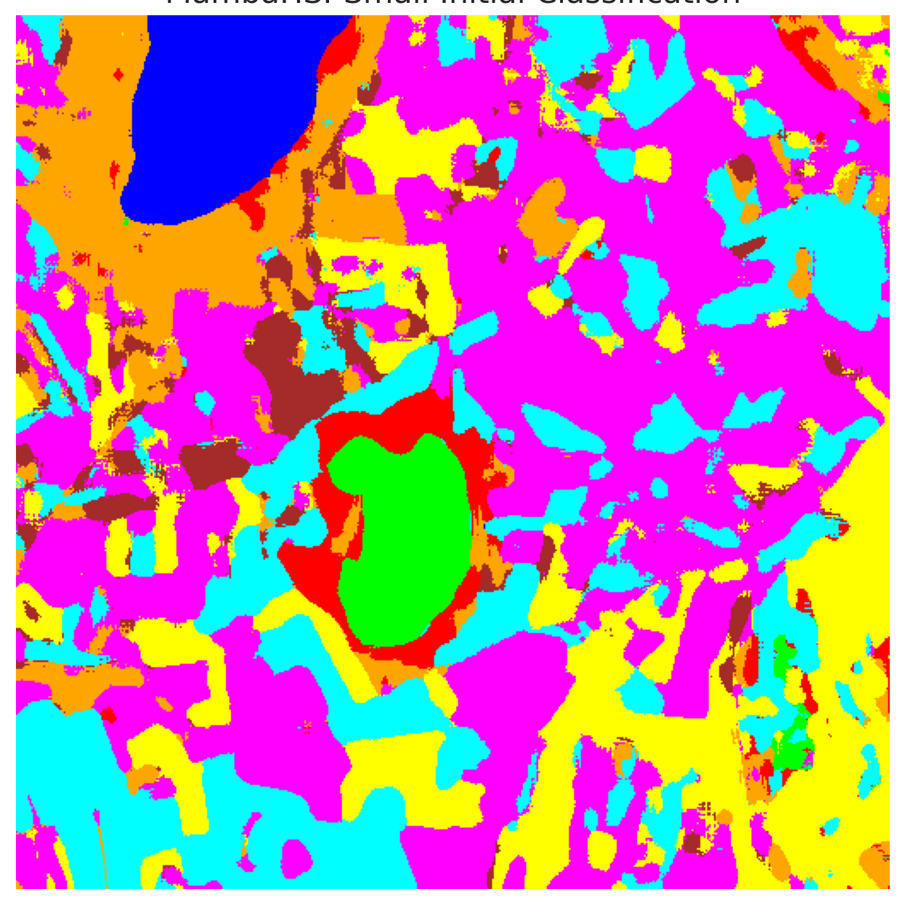  (a) MambaHSI-Small | 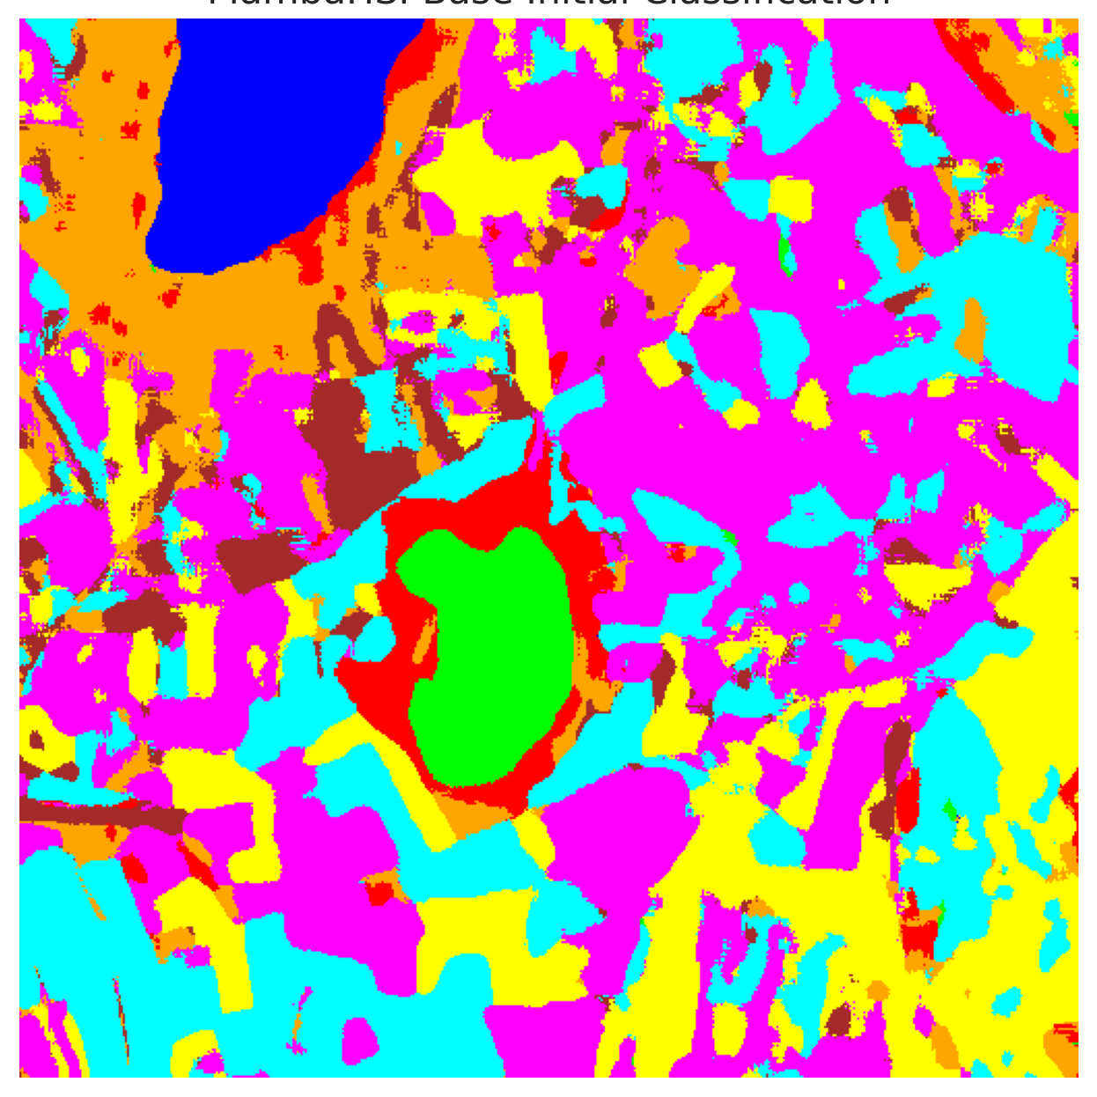  (b) MambaHSI-Base
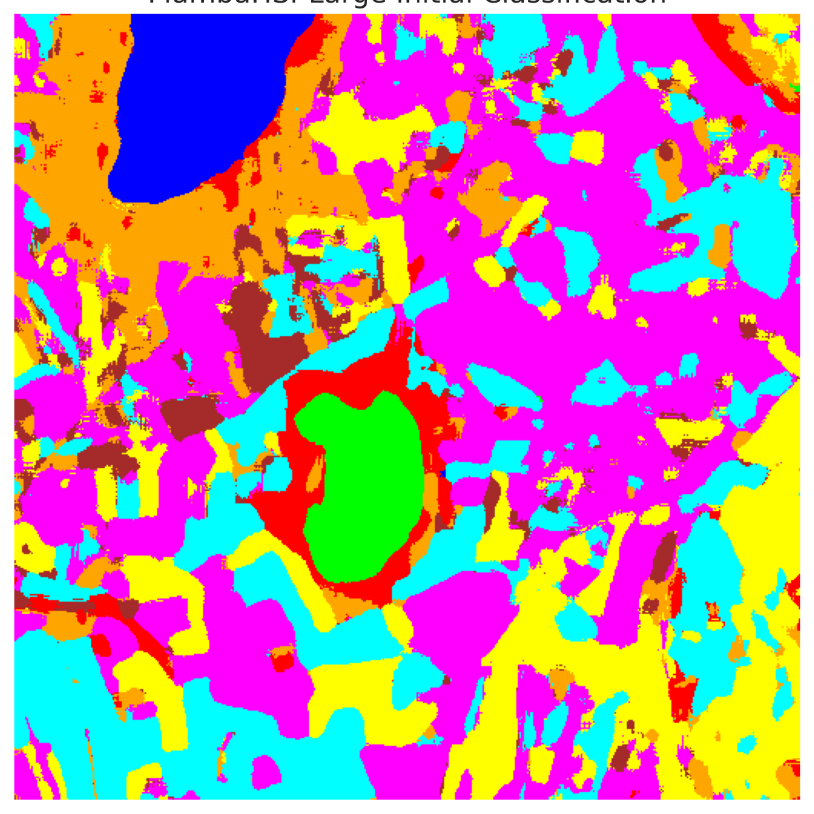  (c) MambaHSI-Large | 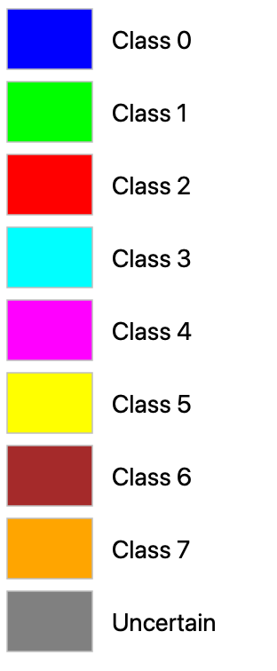  (d) Class Legend
Fig. 2. Dense scene classification maps across all 512 × 512 pixels for (a) MambaHSI-Small, (b) MambaHSI-Base, and (c) MambaHSI-Large, with (d) shared class colour legend.
C. Conformal Prediction — Split Conformal (SplitCP)
TABLE III through TABLE V report SplitCP results. Calibrated thresholds increase with model capacity (q̂ = 0.014518, 0.025852, and 0.026853 for Small, Base, and Large), reflecting the progressive dropout (0.10, 0.15, 0.20) and label-smoothing schedule. Empirical coverages are 0.9552, 0.9596, and 0.9492 respectively, with zero multi-label sets (average set size equals singleton rate). Across the full 262,144-pixel scene (TABLE V), SplitCP flags 126,955, 111,013, and 121,341 uncertain pixels for Small, Base, and Large.
TABLE III
SPLITCP AGGREGATE PERFORMANCE (Α = 0.05, TARGET COVERAGE = 95%)
Model | q̂ | Emp. Cov. | Avg Set Size | Singleton Rate | Empty Set Rate | Runtime (s) | Mean Cls Cov.
MambaHSI-Small | 0.013457 | 0.9552 | 0.9552 | 0.9552 | 0.0448 | 2.438 | 0.9498
MambaHSI-Base | 0.022283 | 0.9596 | 0.9596 | 0.9596 | 0.0404 | 2.305 | 0.9635
MambaHSI-Large | 0.022888 | 0.9492 | 0.9492 | 0.9492 | 0.0508 | 2.224 | 0.9358

TABLE IV
SPLITCP PER-CLASS EMPIRICAL COVERAGE
Class | MambaHSI-Small | MambaHSI-Base | MambaHSI-Large
Class 0 | 0.9885 | 0.9951 | 0.9605
Class 1 | 0.9787 | 0.9972 | 0.9872
Class 2 | 0.9329 | 0.9965 | 0.9717
Class 3 | 0.9604 | 0.9473 | 0.9392
Class 4 | 0.9522 | 0.9245 | 0.9579
Class 5 | 0.9112 | 0.9585 | 0.9556
Class 6 | 0.9150 | 0.9300 | 0.9050
Class 7 | 0.9594 | 0.9594 | 0.8094

TABLE V
SPLITCP FULL-SCENE PIXEL COUNTS (512 × 512 = 262,144 PIXELS)
Class / Region | MambaHSI-Small | MambaHSI-Base | MambaHSI-Large
Class 0 | 10,082 | 10,270 | 9,916
Class 1 | 5,914 | 6,701 | 6,258
Class 2 | 3,208 | 5,290 | 5,495
Class 3 | 28,435 | 27,283 | 30,572
Class 4 | 45,853 | 37,589 | 48,487
Class 5 | 19,964 | 19,362 | 23,738
Class 6 | 2,304 | 2,916 | 2,836
Class 7 | 8,996 | 9,285 | 9,324
Uncertain | 137,388 | 143,448 | 125,518
Total (Scene) | 262,144 | 262,144 | 262,144

D. Spatialised Conformal Uncertainty Maps
Fig. 3(a) and Fig. 3(b) show the SplitCP binary and class-masked uncertainty maps. Uncertain pixels cluster along parcel edges and within unlabelled background regions where out-of-distribution spectral mixtures yield maximum softmax probabilities below 1 − q̂.
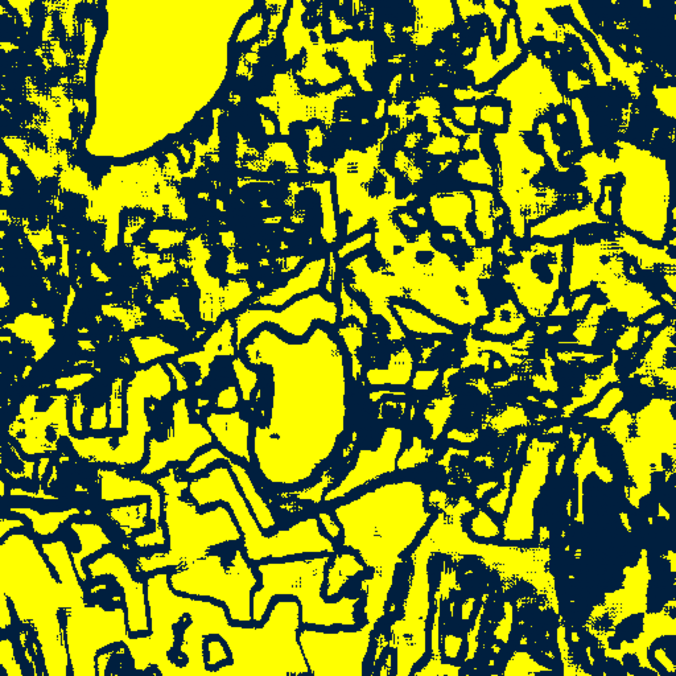  (A) MambaHSI-Small | 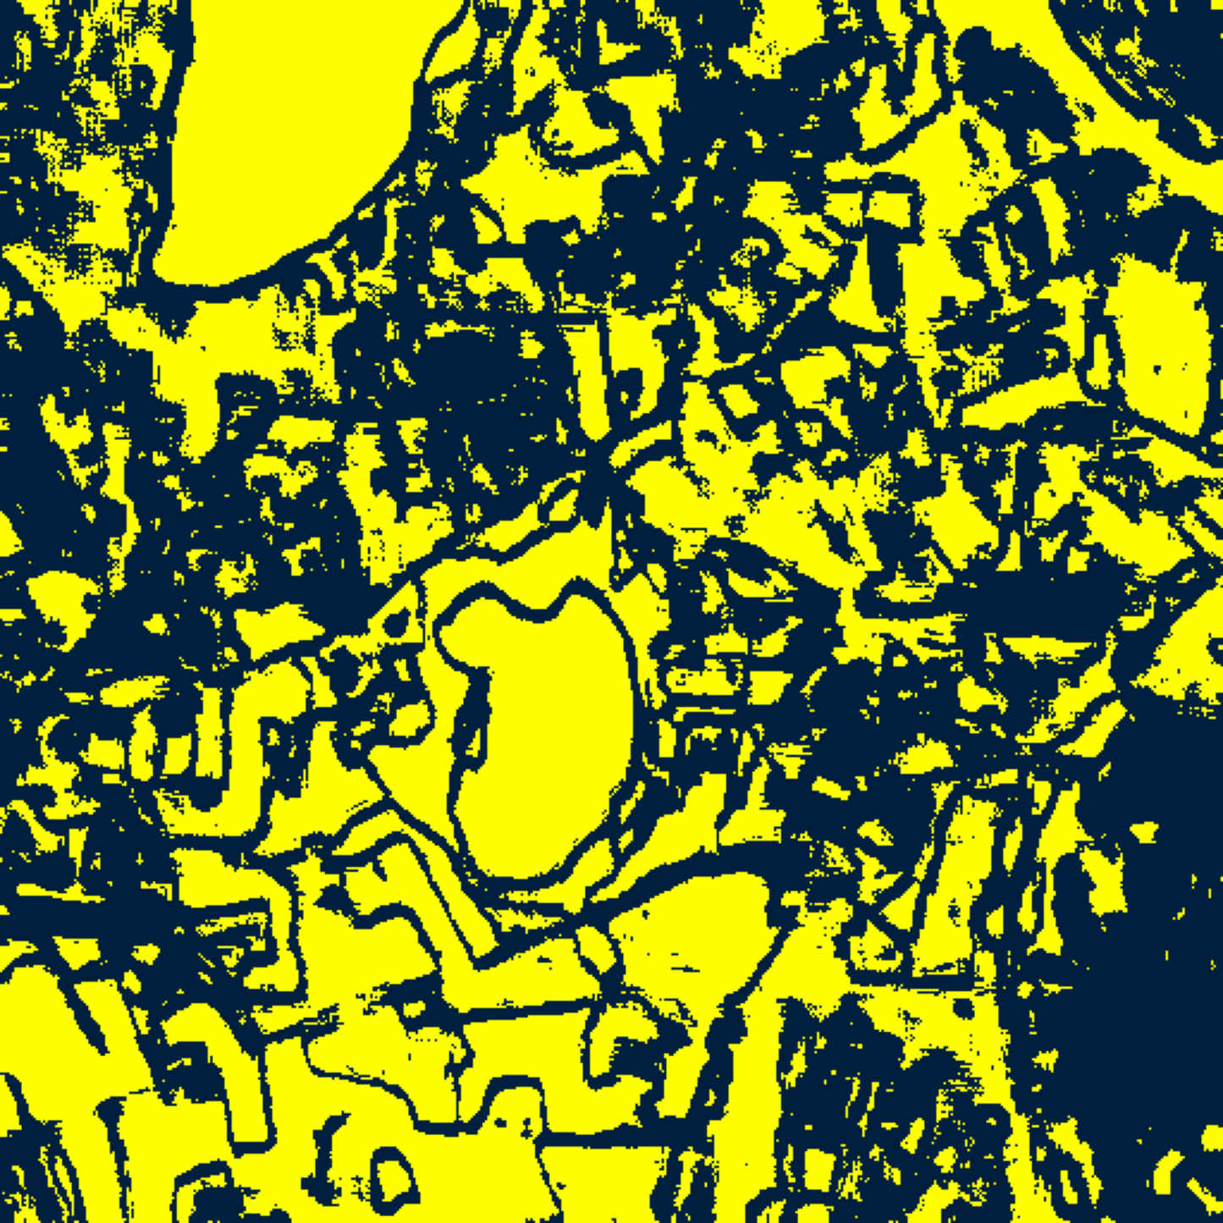  (B) MambaHSI-Base
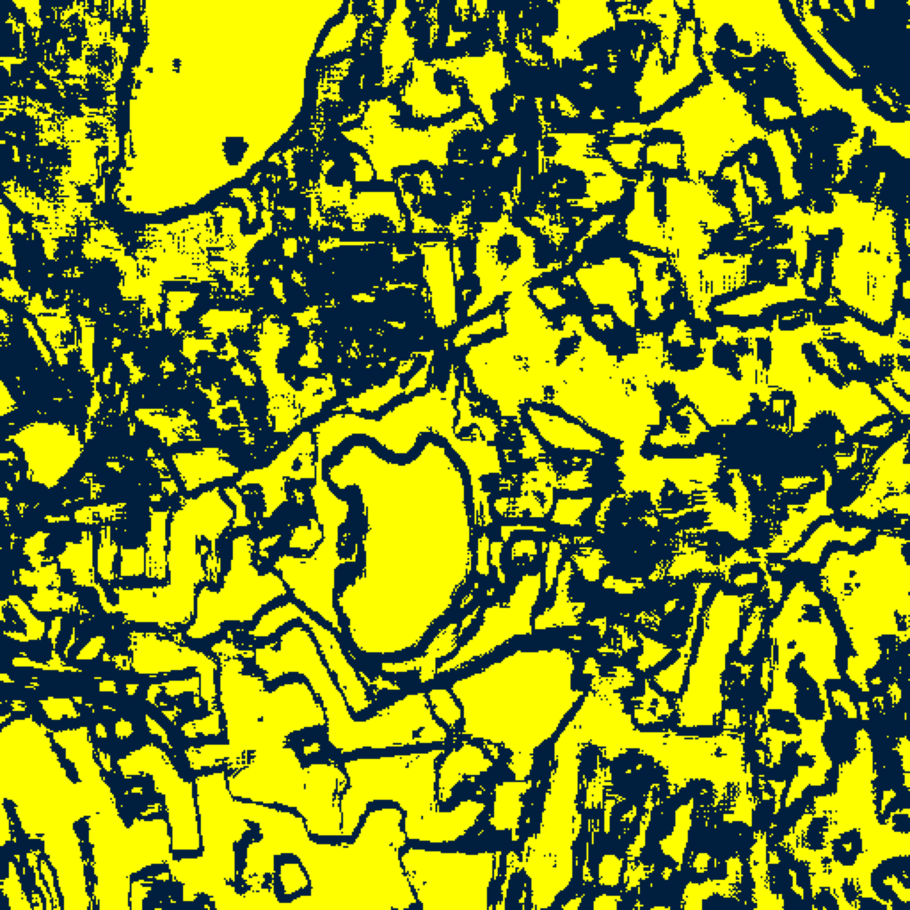  (C) MambaHSI-Large | 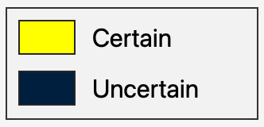  (D) Binary Legend
Fig. 3(a). SplitCP binary uncertainty maps (refer to (D)) for (A) MambaHSI-Small, (B) MambaHSI-Base, and (C) MambaHSI-Large.
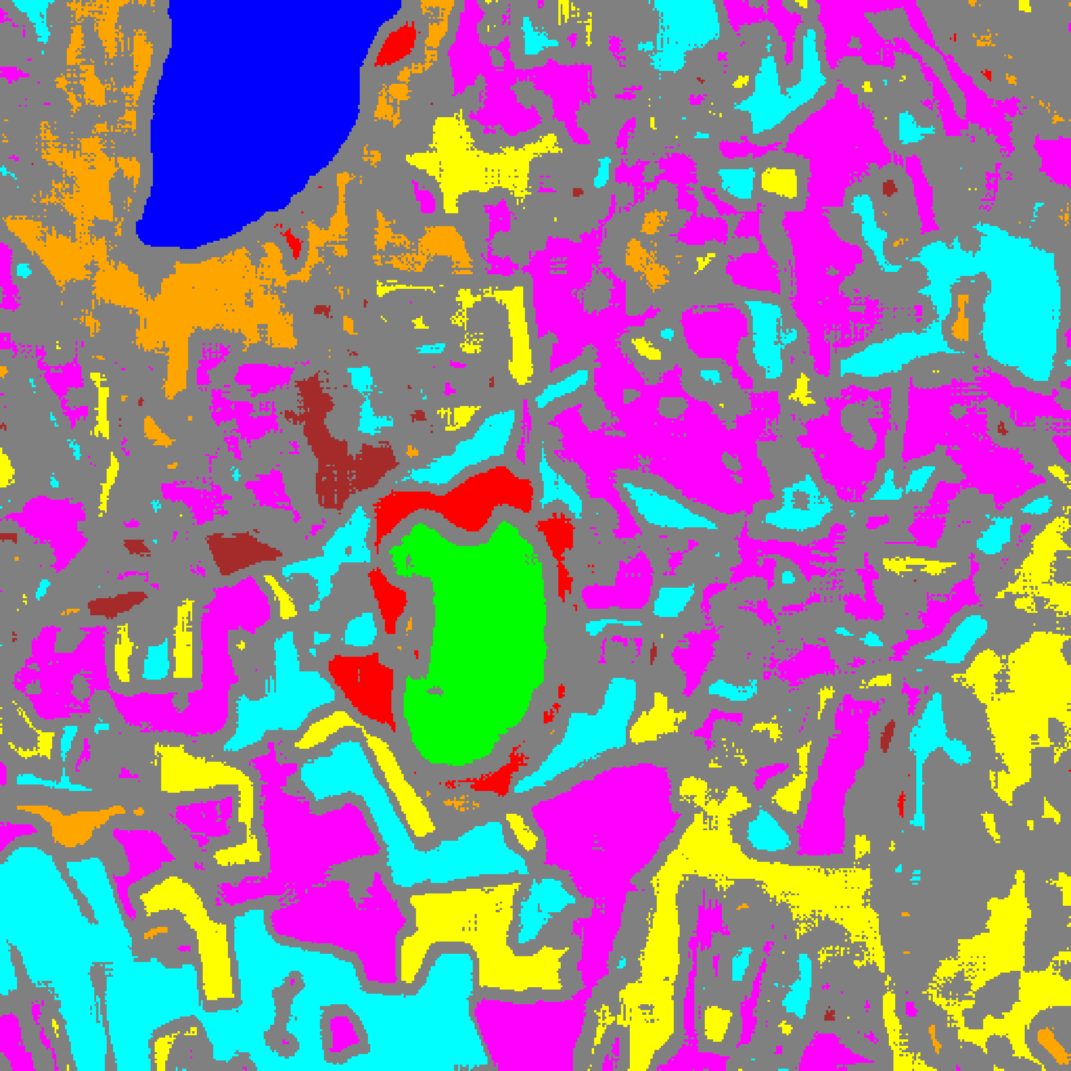  (A) MambaHSI-Small | 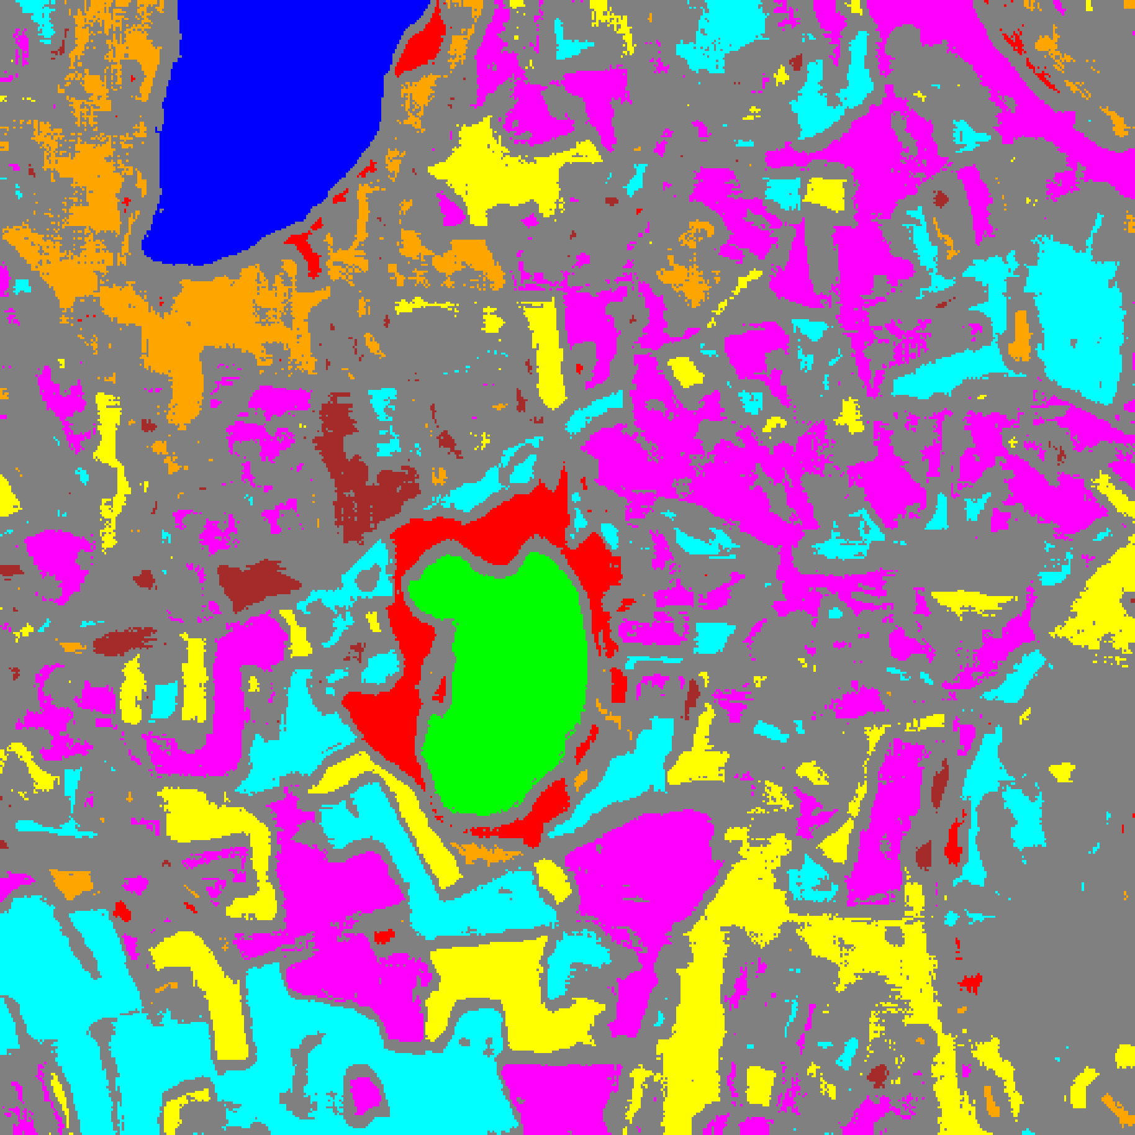  (B) MambaHSI-Base
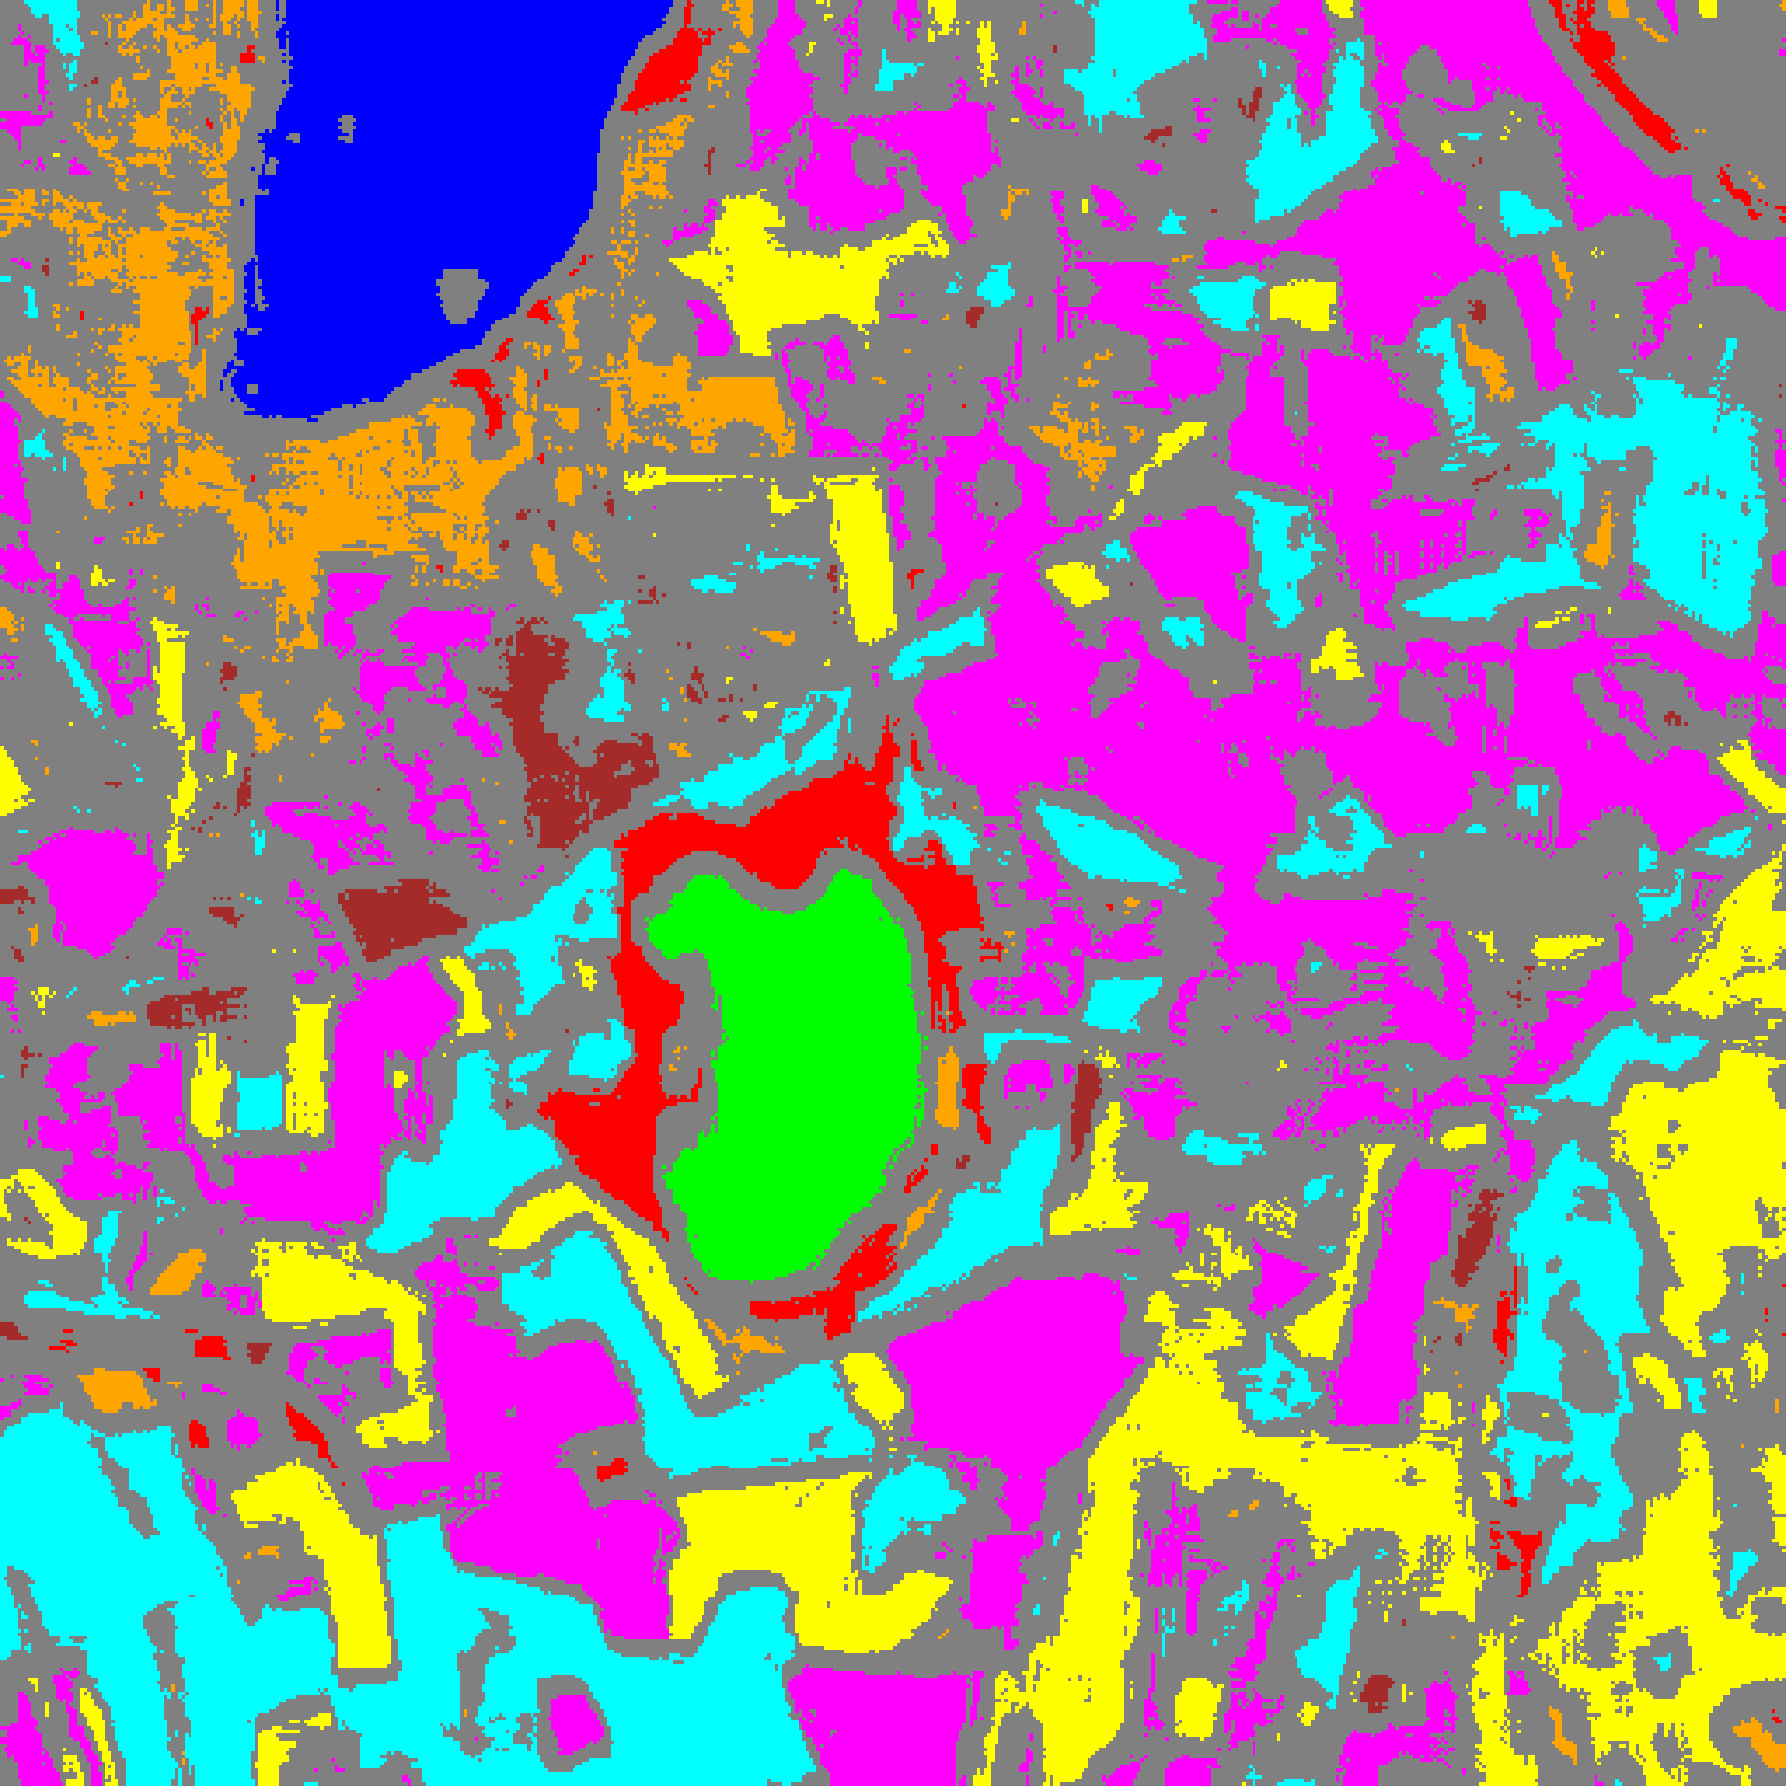
(C) MambaHSI-Large
Fig. 3(b). SplitCP class-masked maps with uncertain pixels shaded in grey for (A) MambaHSI-Small, (B) MambaHSI-Base, and (C) MambaHSI-Large (refer to Fig. 2(d) for class colours).
E. Class-Conditional Conformal Prediction (CcCP)
TABLE VI through TABLE IX and Fig. 4(a)–(b) present CcCP results. By calibrating per-class thresholds q̂_c (TABLE VIII), CcCP raises MambaHSI-Large’s coverage on Class 6 from 0.8900 (under SplitCP) to 0.9600, lifting its overall empirical coverage to 0.9534 and mean class coverage to 0.9529.
TABLE VI
CCCP AGGREGATE PERFORMANCE (Α = 0.05)
Model | Emp. Cov. | Avg Set Size | Singleton Rate | Empty Set Rate | Runtime (s) | Mean Cls Cov.
MambaHSI-Small | 0.9553 | 0.9553 | 0.9553 | 0.0447 | 2.274 | 0.9549
MambaHSI-Base | 0.9627 | 0.9627 | 0.9627 | 0.0373 | 2.301 | 0.9652
MambaHSI-Large | 0.9534 | 0.9534 | 0.9534 | 0.0466 | 2.263 | 0.9529

TABLE VII
CCCP PER-CLASS EMPIRICAL COVERAGE
Class | MambaHSI-Small | MambaHSI-Base | MambaHSI-Large
Class 0 | 0.9556 | 0.9712 | 0.9564
Class 1 | 0.9602 | 0.9432 | 0.9631
Class 2 | 0.9753 | 0.9929 | 0.9470
Class 3 | 0.9553 | 0.9575 | 0.9407
Class 4 | 0.9560 | 0.9642 | 0.9522
Class 5 | 0.9537 | 0.9641 | 0.9679
Class 6 | 0.9550 | 0.9850 | 0.9650
Class 7 | 0.9281 | 0.9437 | 0.9313

TABLE VIII
CCCP CALIBRATED CLASS-WISE THRESHOLDS (Q̂_C)
Class | MambaHSI-Small | MambaHSI-Base | MambaHSI-Large
Class 0 | 0.011628 | 0.021277 | 0.022872
Class 1 | 0.012638 | 0.017053 | 0.021299
Class 2 | 0.031862 | 0.014313 | 0.018969
Class 3 | 0.012254 | 0.022794 | 0.022972
Class 4 | 0.013910 | 0.024130 | 0.022241
Class 5 | 0.018224 | 0.022488 | 0.023587
Class 6 | 0.025461 | 0.037672 | 0.037661
Class 7 | 0.010337 | 0.020834 | 0.026372

TABLE IX
CCCP FULL-SCENE PIXEL COUNTS (512 × 512 = 262,144 PIXELS)
Class / Region | MambaHSI-Small | MambaHSI-Base | MambaHSI-Large
Class 0 | 9,735 | 9,964 | 9,884
Class 1 | 5,745 | 6,124 | 5,962
Class 2 | 4,115 | 4,608 | 5,002
Class 3 | 27,749 | 28,174 | 30,691
Class 4 | 46,986 | 42,147 | 47,004
Class 5 | 23,128 | 19,556 | 24,493
Class 6 | 2,888 | 3,854 | 3,647
Class 7 | 7,789 | 8,842 | 11,437
Uncertain | 134,009 | 138,875 | 124,024
Total (Scene) | 262,144 | 262,144 | 262,144

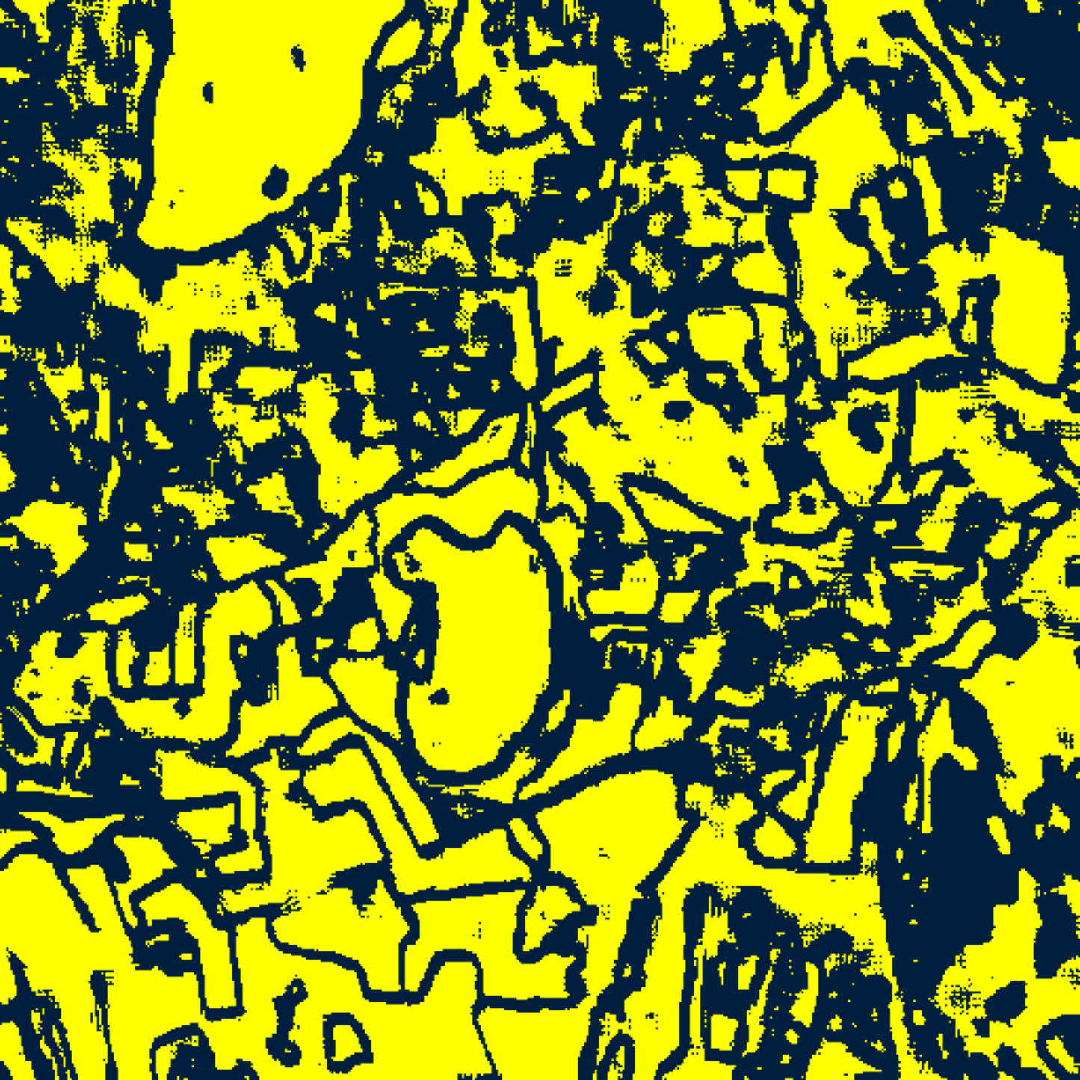  (A) MambaHSI-Small | 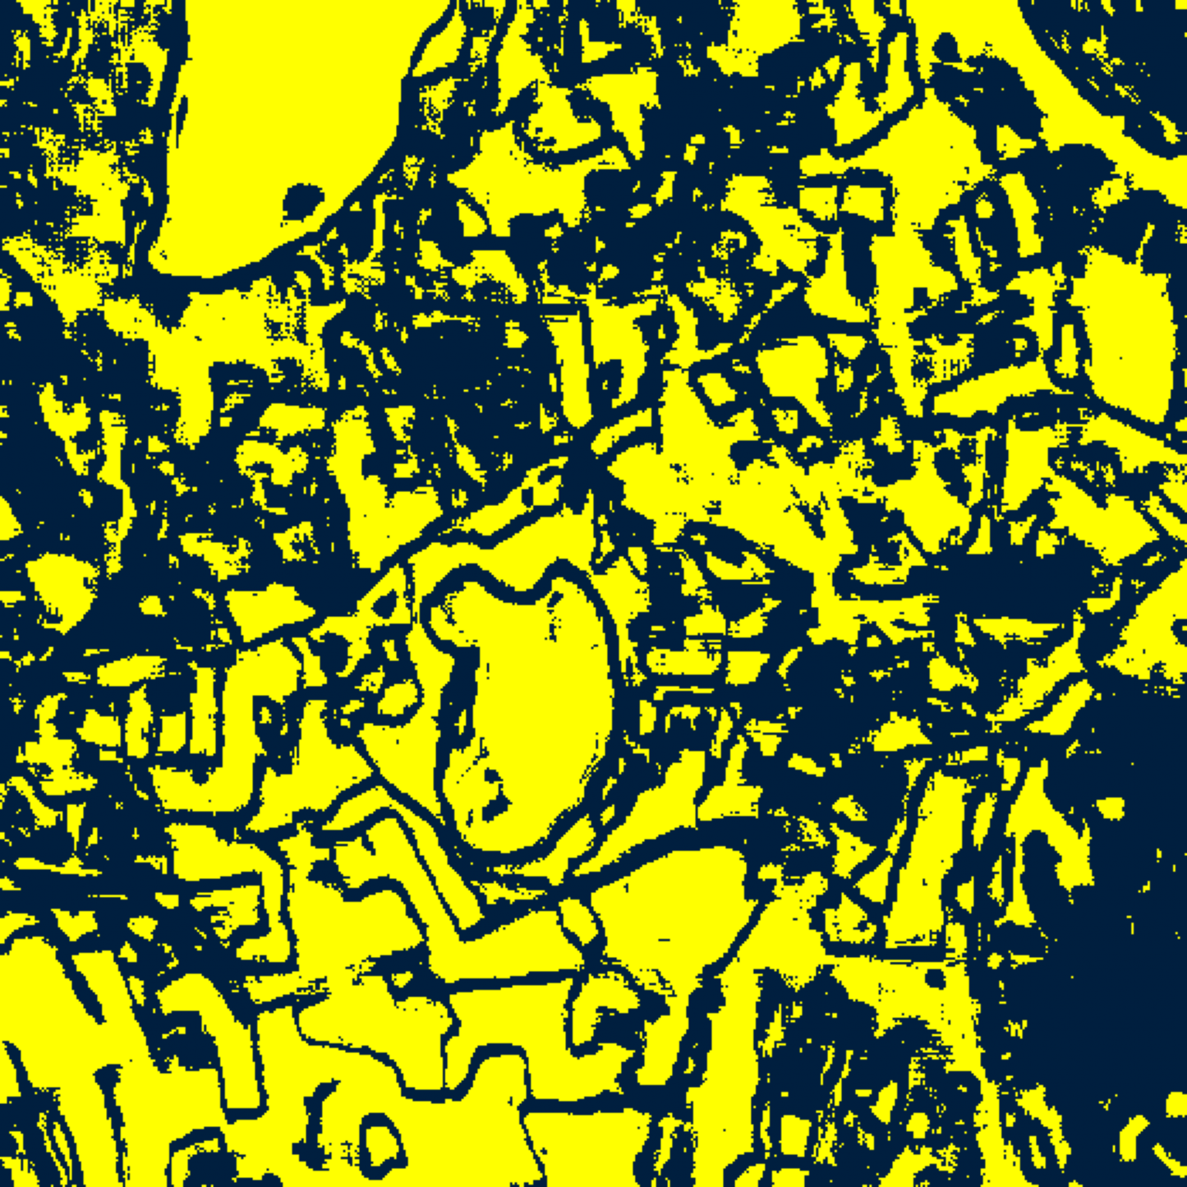  (B) MambaHSI-Base
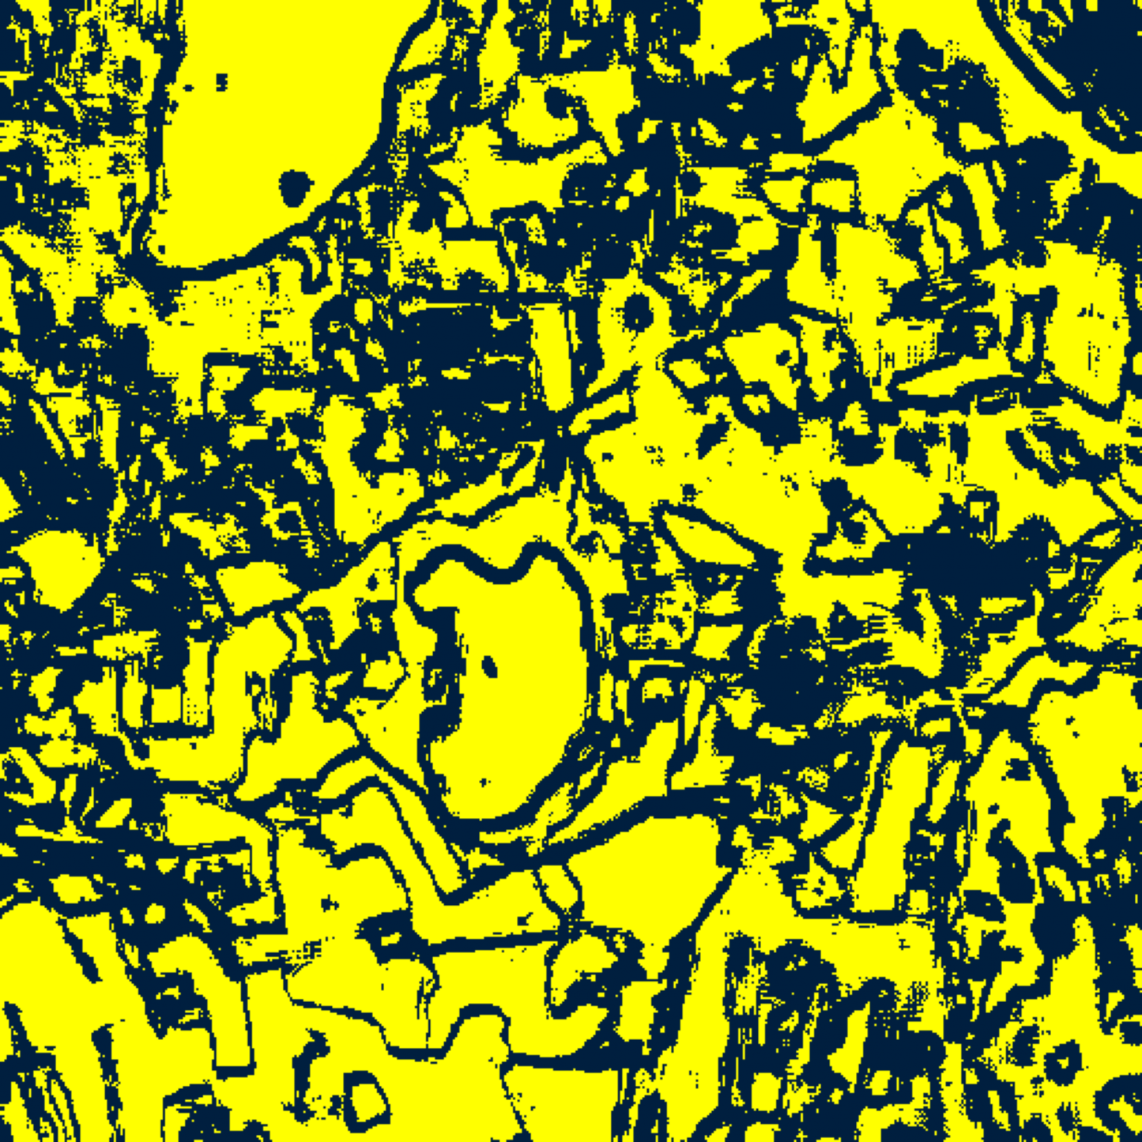  (C) MambaHSI-Large | (D) Binary Legend
Fig. 4(a). CcCP binary uncertainty maps (refer to (D)) for (A) MambaHSI-Small, (B) MambaHSI-Base, and (C) MambaHSI-Large.
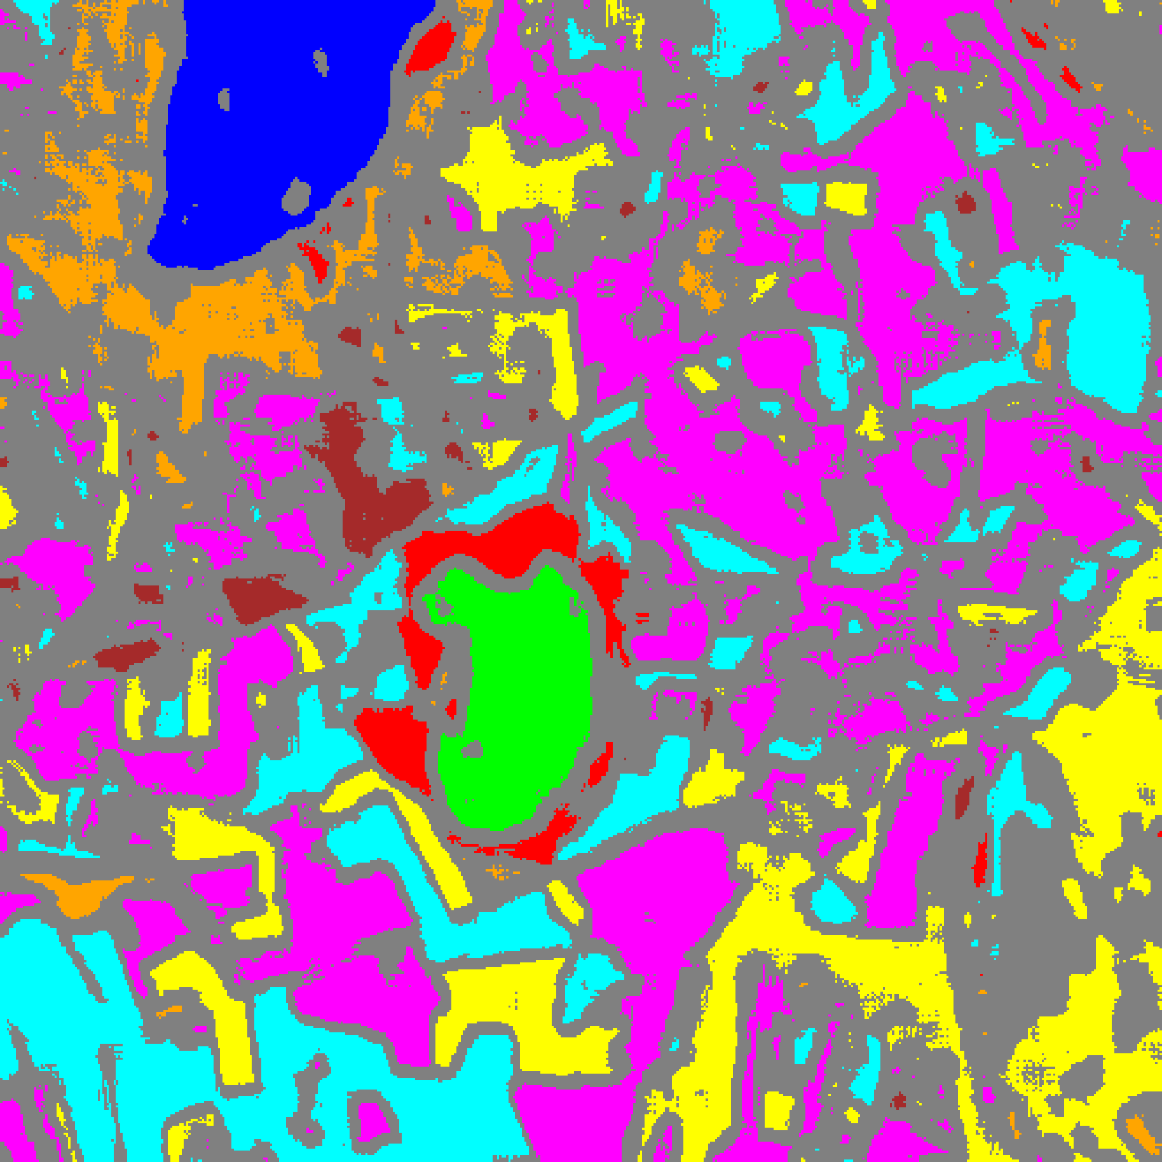  (A) MambaHSI-Small | 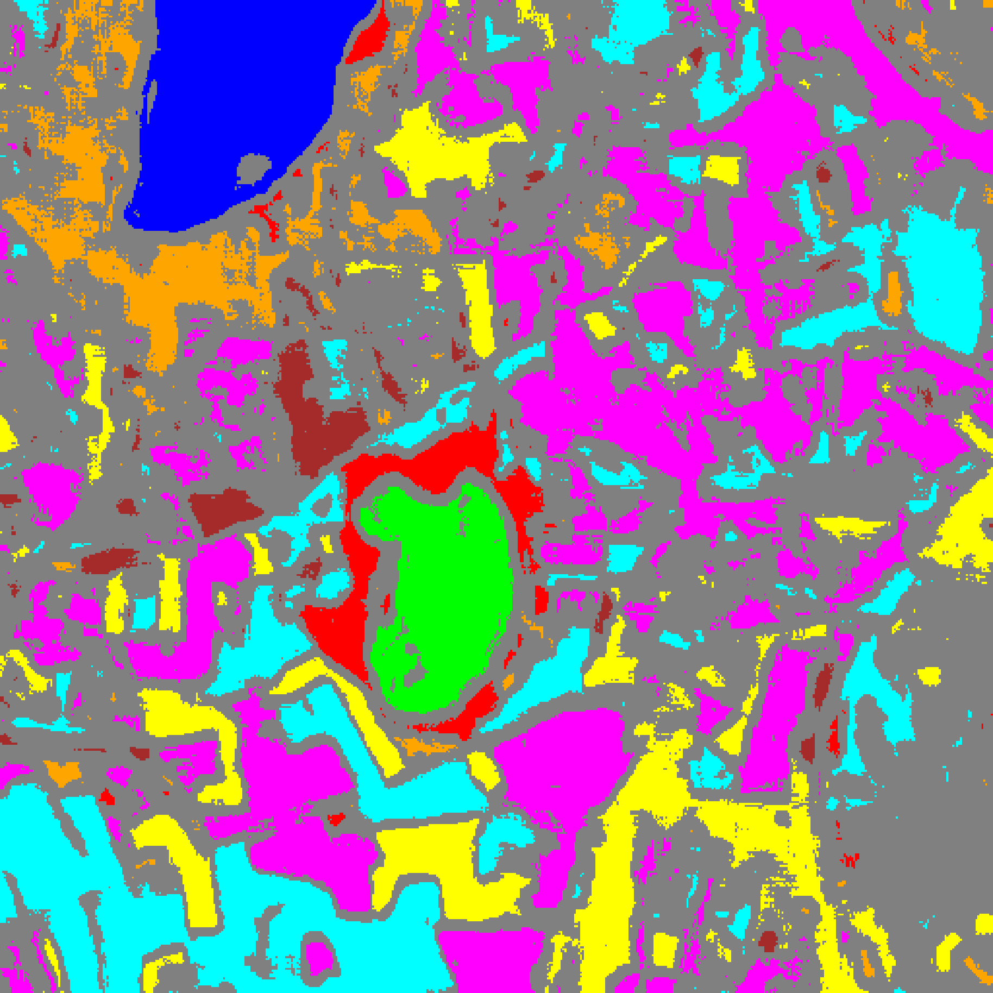  (B) MambaHSI-Base
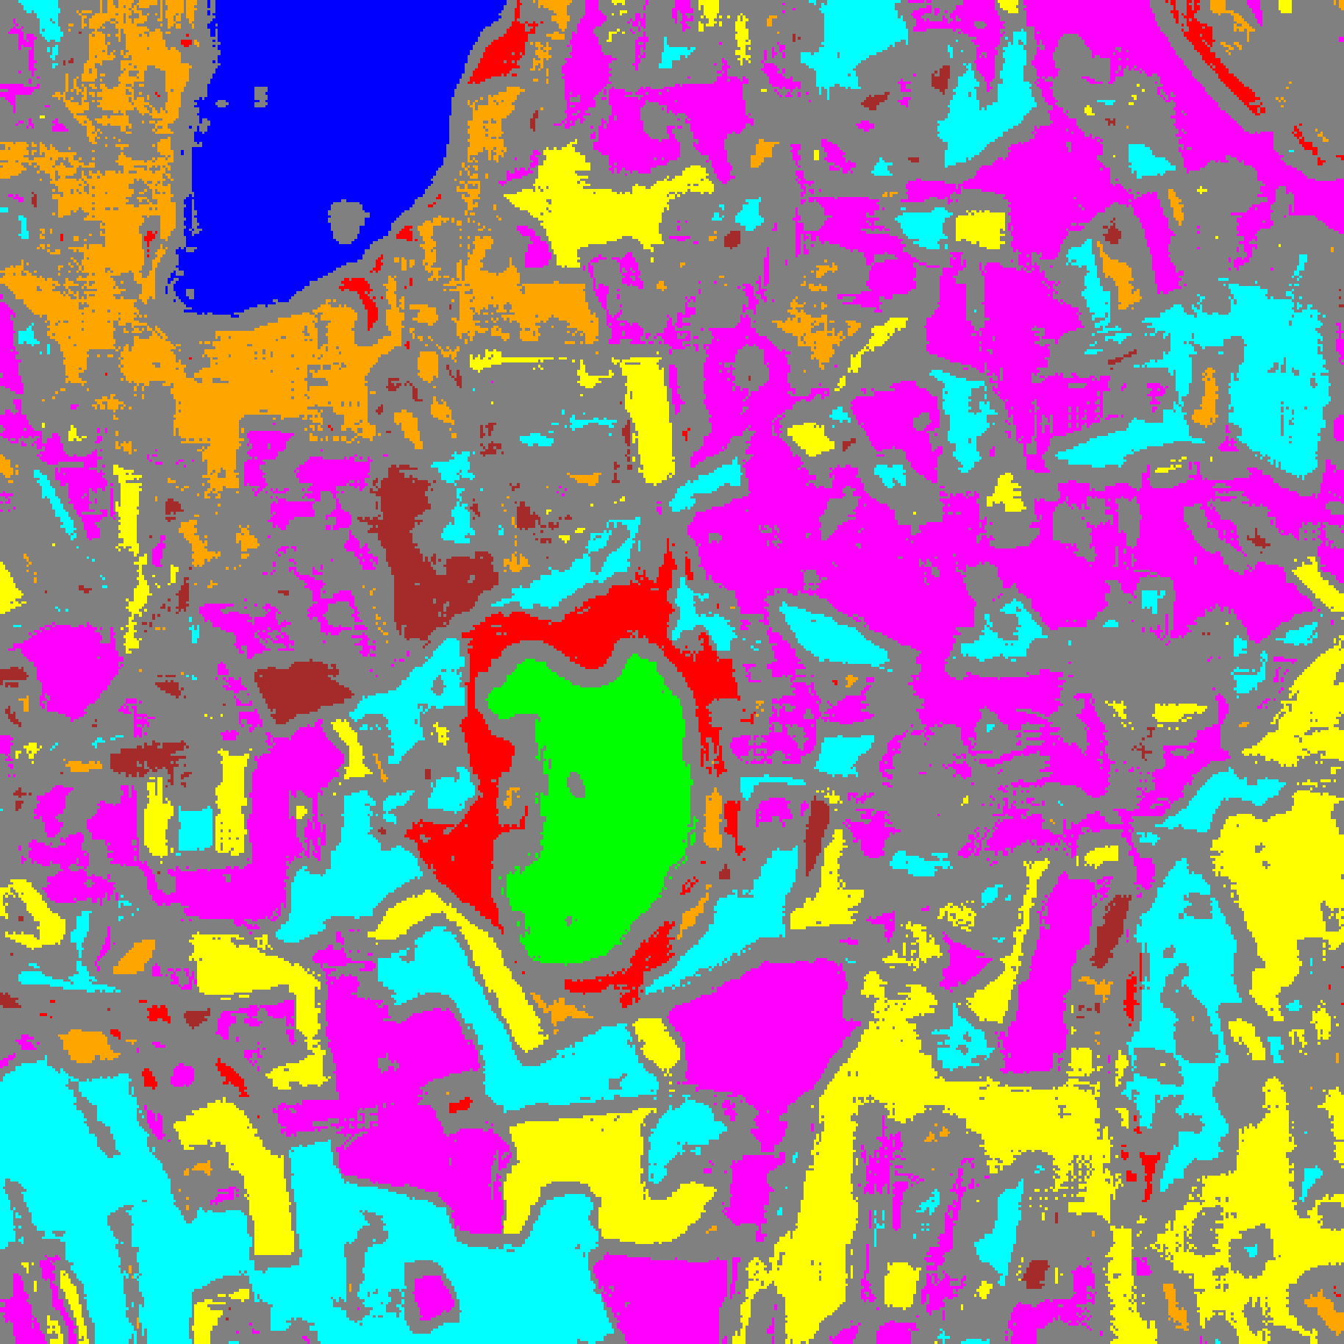
(C) MambaHSI-Large
Fig. 4(b). CcCP class-masked maps with uncertain pixels shaded in grey for (A) MambaHSI-Small, (B) MambaHSI-Base, and (C) MambaHSI-Large (refer to Fig. 2(d) for class colours).
F. Regularised Class-Conditional Conformal Prediction (RC3P)
TABLE X through TABLE XIII and Fig. 5(a)–(b) present RC3P results. All three MambaHSI variants achieve empirical coverage above 95% (0.9595, 0.9673, and 0.9562 for Small, Base, and Large) with k̂_c = 1 across every class (TABLE XII), reducing full-scene uncertain pixel counts to 123,718, 102,438, and 115,436 respectively (TABLE XIII).
TABLE X
RC3P AGGREGATE PERFORMANCE (Α = 0.05)
Model | Emp. Cov. | Avg Set Size | Singleton Rate | Empty Set Rate | Runtime (s) | Mean Cls Cov.
MambaHSI-Small | 0.9595 | 0.9595 | 0.9595 | 0.0405 | 2.305 | 0.9595
MambaHSI-Base | 0.9673 | 0.9673 | 0.9673 | 0.0327 | 2.375 | 0.9706
MambaHSI-Large | 0.9562 | 0.9562 | 0.9562 | 0.0438 | 2.252 | 0.9567

TABLE XI
RC3P PER-CLASS EMPIRICAL COVERAGE
Class | MambaHSI-Small | MambaHSI-Base | MambaHSI-Large
Class 0 | 0.9589 | 0.9712 | 0.9605
Class 1 | 0.9631 | 0.9517 | 0.9631
Class 2 | 0.9823 | 0.9929 | 0.9470
Class 3 | 0.9582 | 0.9656 | 0.9443
Class 4 | 0.9623 | 0.9673 | 0.9541
Class 5 | 0.9556 | 0.9679 | 0.9679
Class 6 | 0.9550 | 0.9950 | 0.9700
Class 7 | 0.9406 | 0.9531 | 0.9469

TABLE XII
RC3P CALIBRATED THRESHOLDS (Q̂_C) AND RANK LIMITS (K̂_C)
Class | Small q̂ | Small k̂ | Base q̂ | Base k̂ | Large q̂ | Large k̂
Class 0 | 0.011636 | 1 | 0.021298 | 1 | 0.022885 | 1
Class 1 | 0.012732 | 1 | 0.017087 | 1 | 0.021307 | 1
Class 2 | 0.037963 | 1 | 0.014574 | 1 | 0.018988 | 1
Class 3 | 0.012648 | 1 | 0.023158 | 1 | 0.023085 | 1
Class 4 | 0.015220 | 1 | 0.024412 | 1 | 0.022406 | 1
Class 5 | 0.018678 | 1 | 0.022817 | 1 | 0.023684 | 1
Class 6 | 0.026662 | 1 | 0.042292 | 1 | 0.039513 | 1
Class 7 | 0.011259 | 1 | 0.022118 | 1 | 0.027459 | 1

TABLE XIII
RC3P FULL-SCENE PIXEL COUNTS (512 × 512 = 262,144 PIXELS)
Class / Region | MambaHSI-Small | MambaHSI-Base | MambaHSI-Large
Class 0 | 9,754 | 9,986 | 9,908
Class 1 | 5,783 | 6,198 | 5,972
Class 2 | 4,296 | 4,642 | 5,005
Class 3 | 27,995 | 28,628 | 30,838
Class 4 | 49,434 | 42,582 | 47,405
Class 5 | 23,344 | 19,903 | 24,593
Class 6 | 2,921 | 4,069 | 3,733
Class 7 | 8,184 | 9,236 | 11,891
Uncertain | 130,433 | 136,900 | 122,799
Total (Scene) | 262,144 | 262,144 | 262,144

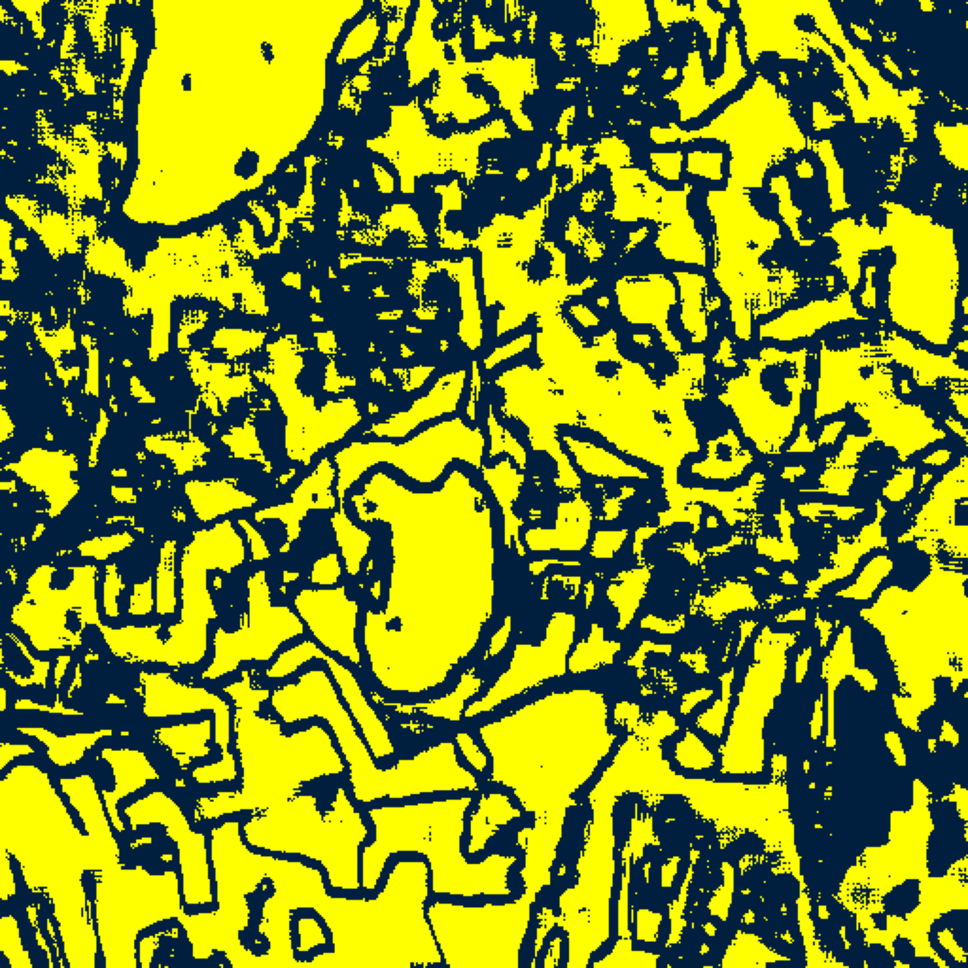  (A) MambaHSI-Small | 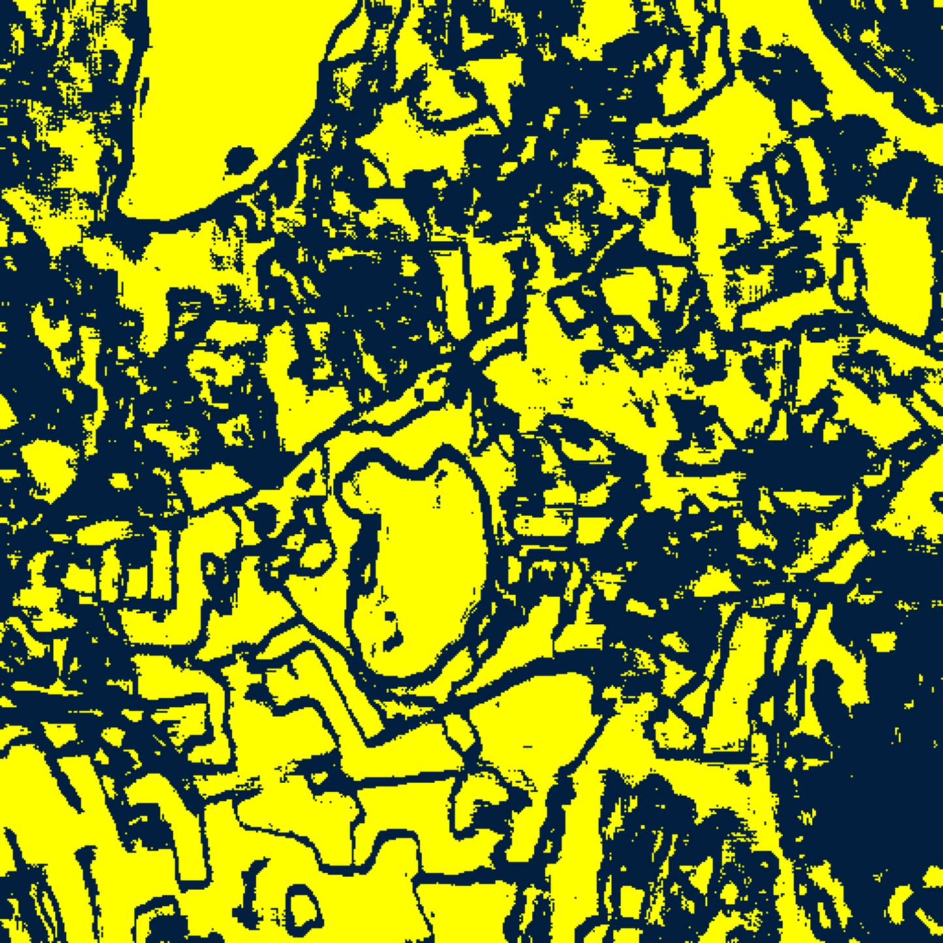  (B) MambaHSI-Base
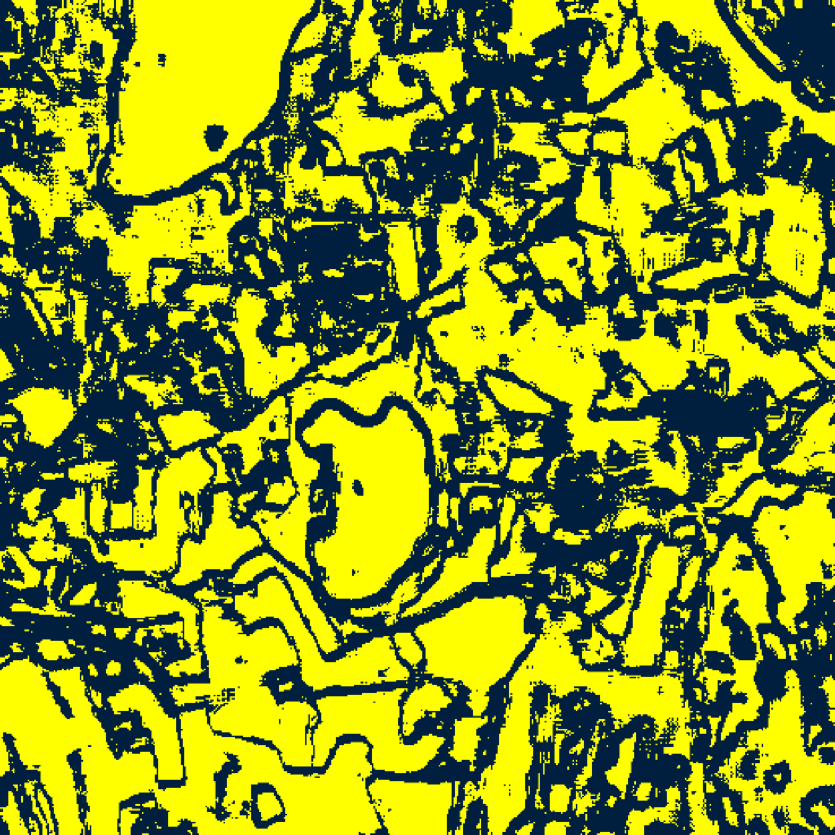  (C) MambaHSI-Large | (D) Binary Legend
Fig. 5(a). RC3P binary uncertainty maps (refer to (D)) for (A) MambaHSI-Small, (B) MambaHSI-Base, and (C) MambaHSI-Large.
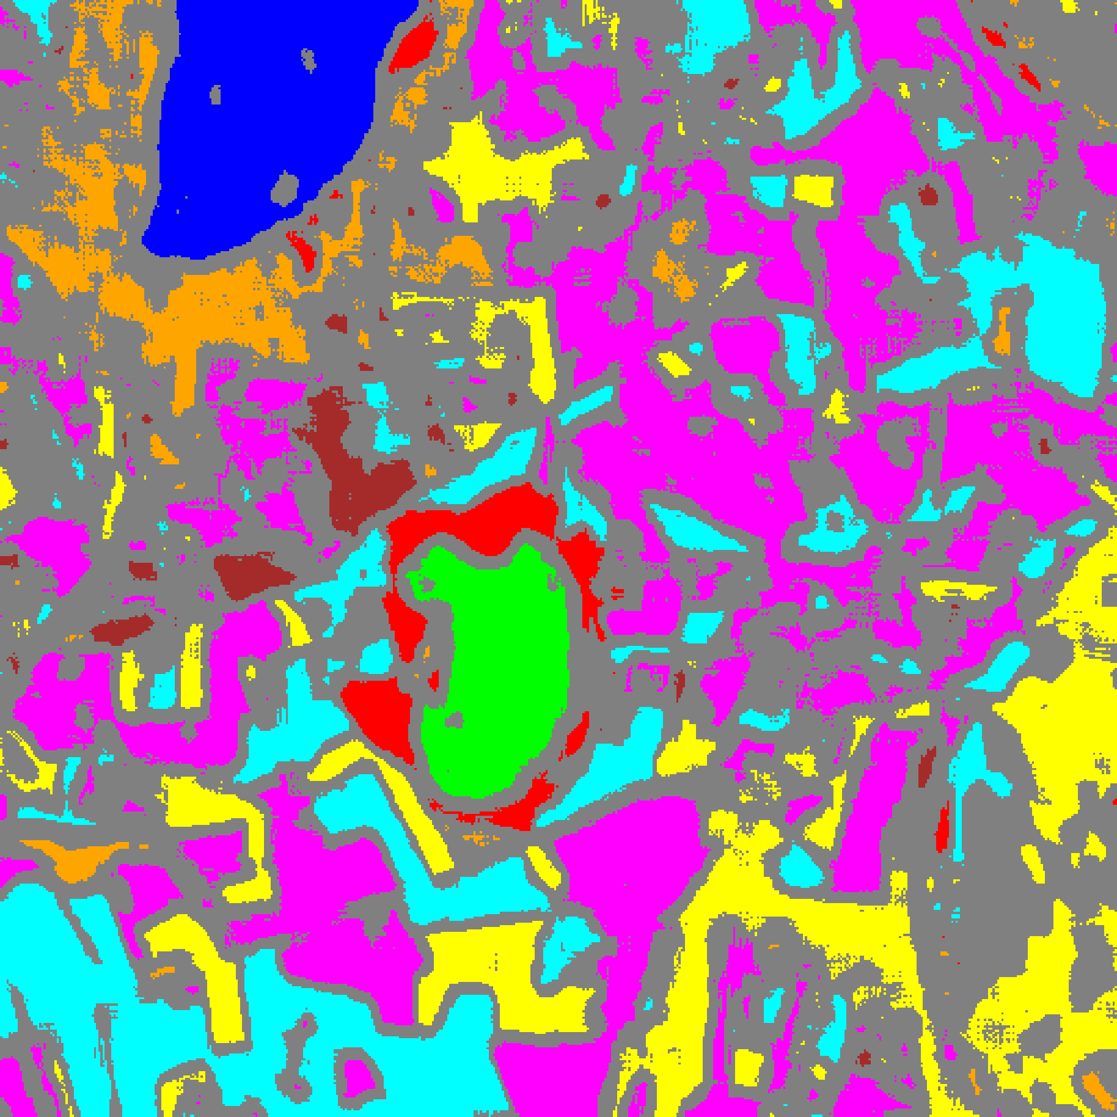  (A) MambaHSI-Small | 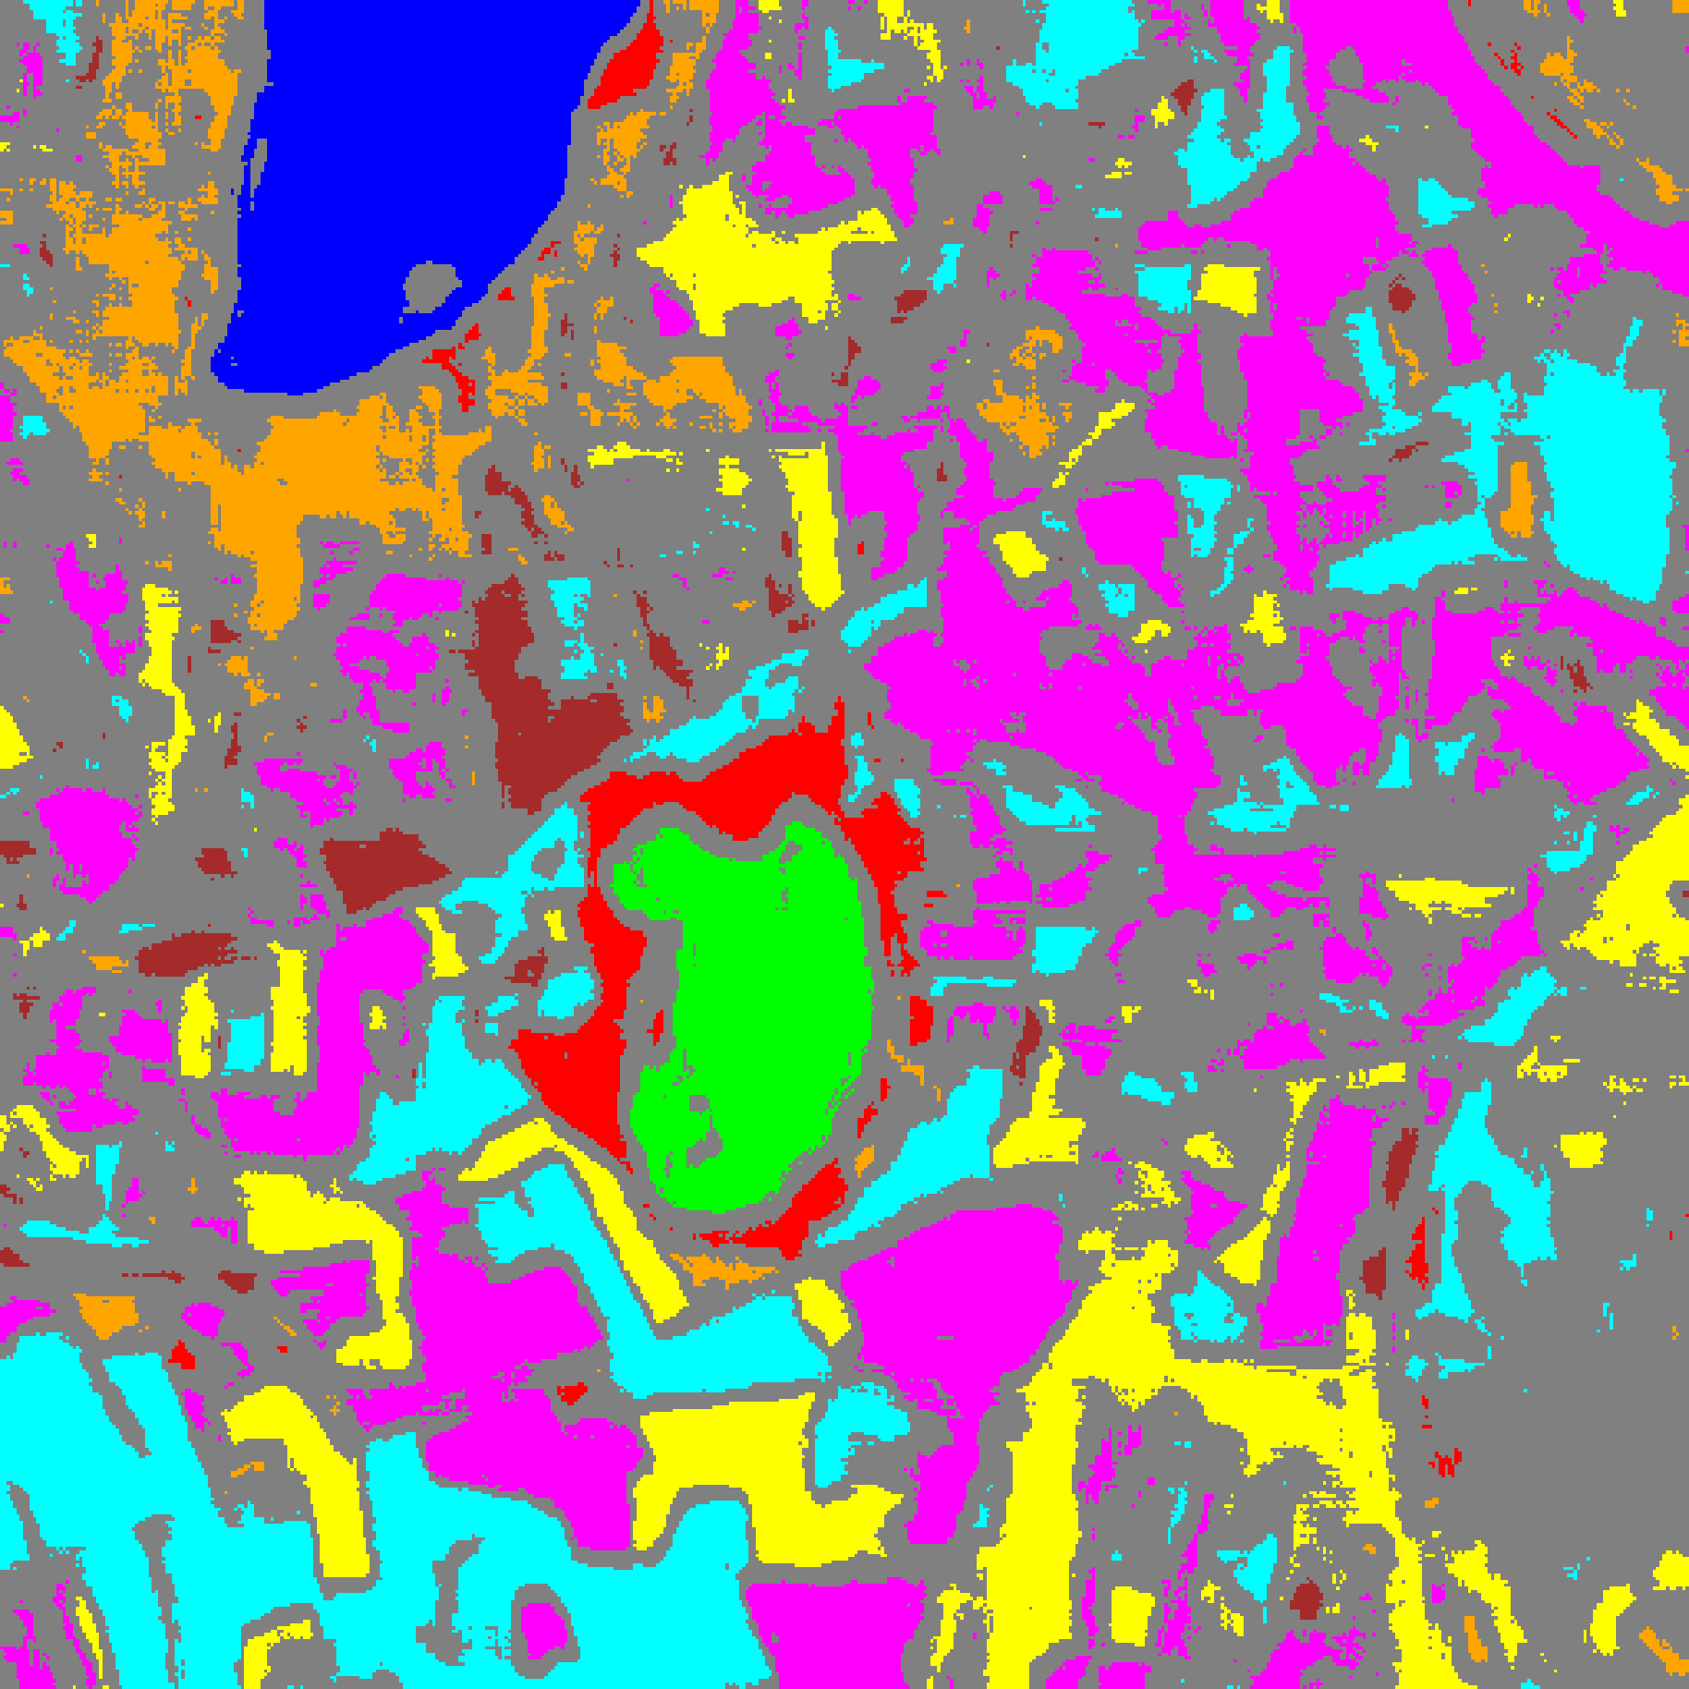  (B) MambaHSI-Base
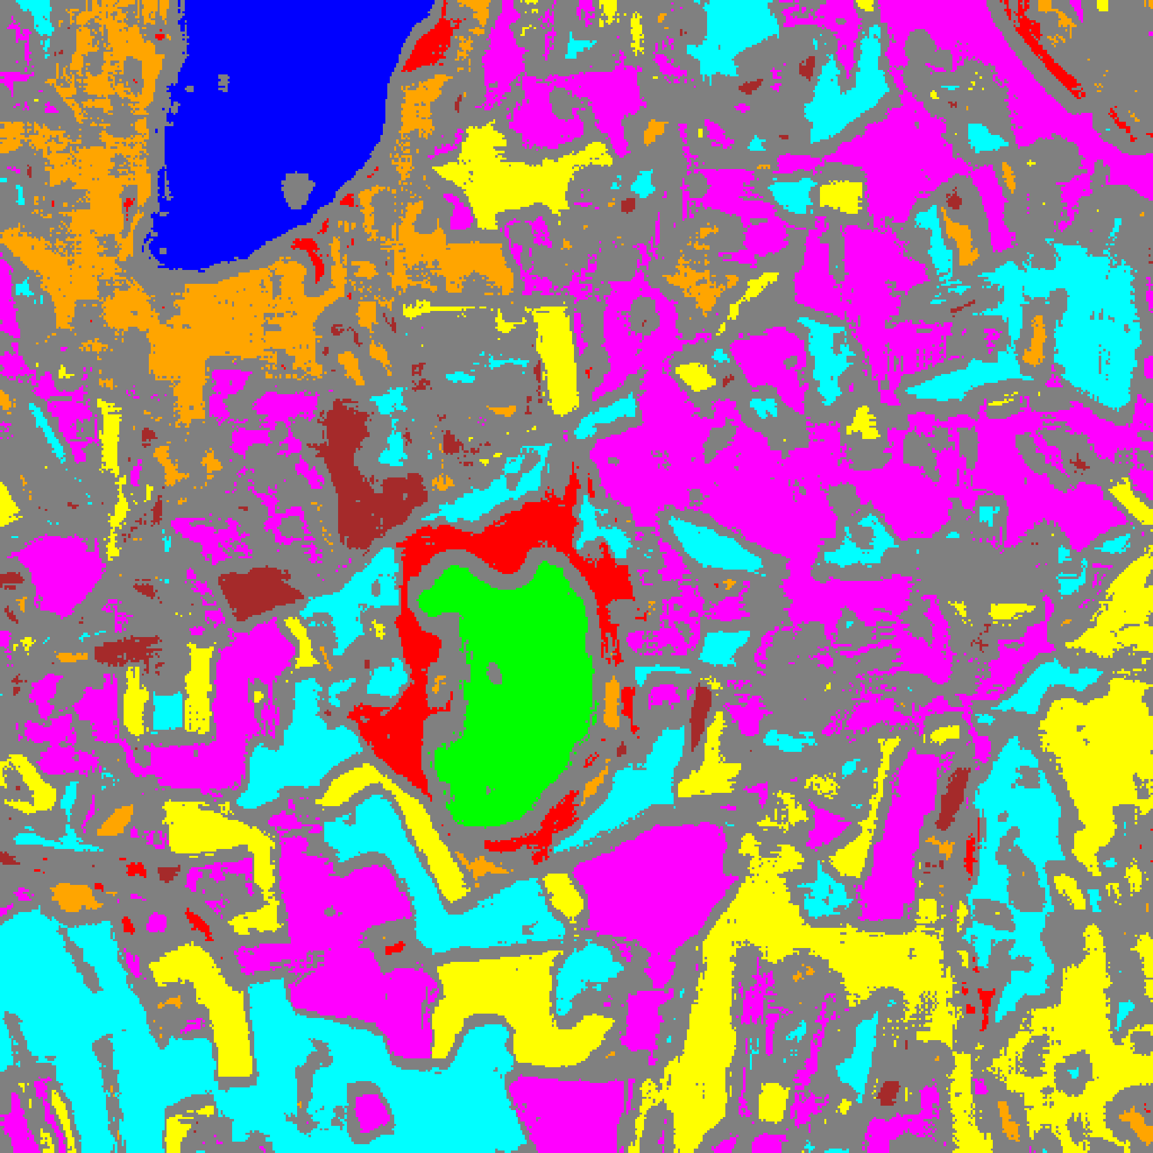
(C) MambaHSI-Large
Fig. 5(b). RC3P class-masked maps with uncertain pixels shaded in grey for (A) MambaHSI-Small, (B) MambaHSI-Base, and (C) MambaHSI-Large (refer to Fig. 2(d) for class colours).
G. Clustered Conformal Prediction (ClCP)
TABLE XIV through TABLE XVII summarise ClCP (K_g = 4). All three MambaHSI variants exceed the 95% target coverage (0.9571, 0.9604, and 0.9534 for Small, Base, and Large). TABLE XVII reports the per-cluster mean coverage values (exported as Cluster Mean Uncertainty).
TABLE XIV
CLCP AGGREGATE PERFORMANCE (Α = 0.05, K_G = 4 CLUSTERS)
Model | Emp. Cov. | Avg Set Size | Singleton Rate | Empty Set Rate | Runtime (s) | Mean Cls Cov.
MambaHSI-Small | 0.9571 | 0.9571 | 0.9571 | 0.0429 | 4.494 | 0.9500
MambaHSI-Base | 0.9604 | 0.9604 | 0.9604 | 0.0396 | 6.821 | 0.9624
MambaHSI-Large | 0.9534 | 0.9534 | 0.9534 | 0.0466 | 8.442 | 0.9434

TABLE XV
CLCP PER-CLASS EMPIRICAL COVERAGE
Class | MambaHSI-Small | MambaHSI-Base | MambaHSI-Large
Class 0 | 0.9556 | 0.9211 | 0.9400
Class 1 | 0.9673 | 0.9972 | 0.9844
Class 2 | 0.9329 | 0.9965 | 0.9470
Class 3 | 0.9670 | 0.9678 | 0.9626
Class 4 | 0.9679 | 0.9642 | 0.9522
Class 5 | 0.9377 | 0.9641 | 0.9698
Class 6 | 0.9150 | 0.9450 | 0.9100
Class 7 | 0.9563 | 0.9437 | 0.8812

TABLE XVI
CLCP CLASS-TO-CLUSTER ASSIGNMENTS AND CLUSTER THRESHOLDS (Q̂)
Class | Small Cl. | Small q̂ | Base Cl. | Base q̂ | Large Cl. | Large q̂
Class 0 | Cluster 3 | 0.011628 | Cluster 1 | 0.021030 | Cluster 2 | 0.022789
Class 1 | Cluster 0 | 0.012848 | Cluster 1 | 0.021030 | Cluster 2 | 0.022789
Class 2 | Cluster 2 | 0.014402 | Cluster 1 | 0.021030 | Cluster 0 | 0.018969
Class 3 | Cluster 2 | 0.014402 | Cluster 2 | 0.023504 | Cluster 1 | 0.024108
Class 4 | Cluster 1 | 0.016188 | Cluster 0 | 0.024130 | Cluster 3 | 0.022241
Class 5 | Cluster 1 | 0.016188 | Cluster 3 | 0.022488 | Cluster 1 | 0.024108
Class 6 | Cluster 0 | 0.012848 | Cluster 2 | 0.023504 | Cluster 1 | 0.024108
Class 7 | Cluster 0 | 0.012848 | Cluster 1 | 0.021030 | Cluster 1 | 0.024108

TABLE XVII
CLCP PER-CLUSTER MEAN COVERAGE (EXPORTED AS CLUSTER MEAN UNCERTAINTY)
Cluster | MambaHSI-Small | MambaHSI-Base | MambaHSI-Large
Cluster 0 | 0.9559 | 0.9642 | 0.9470
Cluster 1 | 0.9558 | 0.9536 | 0.9528
Cluster 2 | 0.9612 | 0.9649 | 0.9563
Cluster 3 | 0.9556 | 0.9641 | 0.9522

H. Regularised Adaptive Prediction Sets (RAPS)
TABLE XVIII through TABLE XX report RAPS (λ = 0.01, k_reg = 1). All three MambaHSI variants achieve 1.0000 empirical coverage, 1.0000 average set size, 1.0000 singleton rate, and 0.0000 empty-set rate across all eight classes.
TABLE XVIII
RAPS AGGREGATE PERFORMANCE (Α = 0.05, Λ = 0.01, K_REG = 1)
Model | Emp. Cov. | Avg Set Size | Singleton Rate | Empty Set Rate | Runtime (s) | Mean Cls Cov.
MambaHSI-Small | 1.0000 | 1.0000 | 1.0000 | 0.0000 | 0.483 | 1.0000
MambaHSI-Base | 1.0000 | 1.0000 | 1.0000 | 0.0000 | 0.479 | 1.0000
MambaHSI-Large | 1.0000 | 1.0000 | 1.0000 | 0.0000 | 0.491 | 1.0000

TABLE XIX
RAPS PER-CLASS EMPIRICAL COVERAGE
Class | MambaHSI-Small | MambaHSI-Base | MambaHSI-Large
Class 0 | 1.0000 | 1.0000 | 1.0000
Class 1 | 1.0000 | 1.0000 | 1.0000
Class 2 | 1.0000 | 1.0000 | 1.0000
Class 3 | 1.0000 | 1.0000 | 1.0000
Class 4 | 1.0000 | 1.0000 | 1.0000
Class 5 | 1.0000 | 1.0000 | 1.0000
Class 6 | 1.0000 | 1.0000 | 1.0000
Class 7 | 1.0000 | 1.0000 | 1.0000

TABLE XX
RAPS CALIBRATED PARAMETERS
Model | q̂_RAPS | λ | k_reg
MambaHSI-Small | 0.000000 | 0.01 | 1
MambaHSI-Base | 0.000000 | 0.01 | 1
MambaHSI-Large | 0.000000 | 0.01 | 1

IV. CONCLUSION
This study evaluated MambaHSI-Small, MambaHSI-Base, and MambaHSI-Large on the 65-band DIAS Scene K01 hyperspectral dataset (512 × 512 pixels, K = 8 classes). All three selective state-space models exceeded 99.97% test accuracy, with MambaHSI-Base and MambaHSI-Large reaching 99.993% accuracy (κ = 0.9999) and MambaHSI-Small achieving the best calibration (NLL = 0.01063, Brier = 0.00056, ECE = 0.01023) in 298.2 s.
Across all five conformal prediction methods (SplitCP, CcCP, RC3P, ClCP, and RAPS), MambaHSI models produced pure singleton or empty prediction sets with zero multi-label ambiguity on the evaluation split, and RC3P/ClCP satisfied the 95% coverage guarantee across all three capacity scales.
Full-scene conformal maps across all 262,144 pixels confirm that MambaHSI-Base achieves the most compact uncertainty footprint among the three scales (102,438 uncertain pixels under RC3P), offering an optimal balance of accuracy, calibration, and computational cost.
REFERENCES
[1] A. Gu and T. Dao, “Mamba: Linear-time sequence modeling with selective state spaces,” arXiv:2312.00752, 2023.
[2] Y. Li, Y. Luo, L. Zhang, Z. Wang, and B. Du, “MambaHSI: Spatial-spectral Mamba for hyperspectral image classification,” IEEE Trans. Geosci. Remote Sens., vol. 62, pp. 1–16, 2024.
[3] A. N. Angelopoulos, S. Bates, J. Malik, and M. I. Jordan, “Uncertainty sets for image classifiers using conformal prediction,” in Proc. ICLR, 2021.
[4] Y. Shi, S. Ghosh, T. Belkhouja, J. R. Doppa, and Y. Yan, “Conformal prediction for class-wise coverage via augmented label rank calibration,” in Adv. Neural Inf. Process. Syst. (NeurIPS), 2024.
[5] T. Ding, A. N. Angelopoulos, S. Bates, M. I. Jordan, and R. J. Tibshirani, “Class-conditional conformal prediction with many classes,” in Adv. Neural Inf. Process. Syst. (NeurIPS), 2023.
[6] Y. Romano, M. Sesia, and E. Candès, “Classification with valid and adaptive coverage,” in Adv. Neural Inf. Process. Syst. (NeurIPS), 2020.
[7] A. N. Angelopoulos and S. Bates, “A gentle introduction to conformal prediction and distribution-free uncertainty quantification,” Found. Trends Mach. Learn., 2023.
[8] H. Papadopoulos, K. Proedrou, V. Vovk, and A. Gammerman, “Inductive confidence machines for regression,” in Proc. ECML, Springer, pp. 345–356, 2002.
[9] V. Vovk, A. Gammerman, and G. Shafer, Algorithmic Learning in a Random World. Springer, 2005.
[10] A. Dosovitskiy et al., “An image is worth 16x16 words: Transformers for image recognition at scale,” in Proc. ICLR, 2021.
[11] M. Ahmad et al., “Hyperspectral image classification—Traditional to deep models: A survey for future prospects,” IEEE J. Sel. Topics Appl. Earth Observ. Remote Sens., 2022.
[12] A. Niculescu-Mizil and R. Caruana, “Predicting good probabilities with supervised learning,” in Proc. ICML, 2005.

