Multi-Head Conformal Prediction (MultiCP) for Pixel-Level Uncertainty Quantification on 65-Band DIAS Hyperspectral Imagery
Danesh Selwal
Department of Computer Science and Engineering
Technical Evaluation Report — 65-Band DIAS Pipeline
ABSTRACT
This paper extends the conformal prediction (CP) framework for 65-band hyperspectral image (HSI) classification by introducing Multi-Head Conformal Prediction (MultiCP) across deep sub-ensembles. Using the 65-band DIAS Scene K01 dataset (512 × 512 pixels, 65 contiguous spectral bands, 8 land-cover classes), we train three distinct multi-head deep architectures—AlexNet-CNN, Global Filter Network (GFNet), and Vision Transformer U-Net (ViT-UNet)—each equipped with H = 7 independent classification heads. Each head is calibrated independently via split conformal prediction under Regularized Adaptive Prediction Sets (RAPS) and Sorted Adaptive Prediction Sets (SAPS) at significance level α = 0.05. MultiCP forms a composite prediction set at every pixel by taking the exact intersection of prediction sets across all H = 7 heads. Empirical joint coverage on the 6,737-sample evaluation set reaches 0.7073 (AlexNet), 0.6800 (GFNet), and 0.7011 (ViT-UNet) under RAPS, and 0.7024 (AlexNet), 0.7079 (GFNet), and 0.7042 (ViT-UNet) under SAPS. Across the entire 262,144-pixel scene, MultiCP eliminates multi-label ambiguity, restricting full-scene uncertainty strictly to 10.76%–13.69% (28,201 to 35,883 uncertain pixels), while preserving strong minority-class coverage (0.6350–0.7688). Comprehensive multi-panel visualisations demonstrate crisp boundary-localised uncertainty maps across all three models.
I. INTRODUCTION
Hyperspectral land-cover classification underpins precision agriculture, ecological monitoring, and mineralogical survey. In operational remote sensing, providing point predictions without calibrated uncertainty quantification carries substantial risk. Conformal prediction (CP) [1, 2] provides distribution-free statistical guarantees with finite-sample validity without parametric distribution assumptions.
Deep ensembles substantially improve predictive accuracy and uncertainty calibration [8], but training multiple independent full backbones incurs prohibitive GPU compute and parameter storage. Deep sub-ensembles [7] mitigate this burden by sharing a trunk representation and attaching multiple independent multi-head classifiers. In MultiCP, each head is calibrated with its own conformal quantile, and prediction sets are intersected across all H heads. This design tightens conservative single-head prediction sets, eliminates multi-label ambiguities, and flags pixels where heads disagree as uncertain.
The principal contributions of this report are: (1) complete multi-head training and test evaluation across all three architectures (GFNet 100.000%, AlexNet 99.948%, ViT-UNet 99.458% on 13,474 test samples); (2) empirical evaluation of MultiCP under RAPS and SAPS scoring (α = 0.05); (3) per-class empirical coverage across all 8 classes; (4) progressive head sweep analysis from H = 1 to H = 7 heads; (5) full-scene pixel count distributions (262,144 pixels); and (6) high-resolution 2×2 multi-panel uncertainty maps comparing all three models.
II. METHODOLOGY
A. Dataset and Multi-Head Deep Sub-Ensemble Training
The 65-band DIAS Scene K01 dataset (H = 512, W = 512, B = 65 spectral bands, K = 8 labeled land-cover classes) contains 13,474 labeled pixels. We partition the labeled samples into a 50% calibration split (6,737 samples) and a 50% evaluation split (6,737 samples). Each backbone—AlexNet-CNN, GFNet, and ViT-UNet—is equipped with H = 7 independent classification heads attached to the shared backbone trunk. All models were trained on NVIDIA Tesla GPUs using Adam optimizer with categorical cross-entropy loss.
TABLE I-A
MULTI-HEAD BACKBONE TRAINING AND TEST CLASSIFICATION SUMMARY (13,474 TEST SAMPLES)
Model | Test Acc (%) | Cohen’s κ | Macro F1 | Weighted F1 | Total Params | Train Time (s)
GFNet MultiHead | 100.000% | 1.0000 | 1.0000 | 1.0000 | 25,580,304 | 3,140.5
AlexNet-CNN MultiHead | 99.948% | 0.9994 | 0.9990 | 0.9995 | 34,061,592 | 1,263.7
ViT-UNet MultiHead | 99.458% | 0.9935 | 0.9912 | 0.9946 | 16,316,944 | 2,901.4

B. Nonconformity Score Functions (RAPS and SAPS) and MultiCP Intersection
We evaluate two state-of-the-art nonconformity scoring functions: (1) RAPS [3], which accumulates sorted softmax probabilities and adds a regularization penalty for lower-ranked candidate labels; and (2) SAPS [4], which anchors score scaling on the top-1 softmax probability and replaces cumulative mass with sorted rank indices. For each head k ∈ {1, ..., 7}, conformal quantile q̂^(k) is computed on the 6,737-sample calibration split at coverage level 1 − α = 0.95. The MultiCP prediction set is the exact intersection:
C_MultiCP(x) = ⋂_{k=1}^7 C^(k)(x). A pixel is classified as certain if |C_MultiCP(x)| = 1, and flagged as uncertain if C_MultiCP(x) is empty or contains multiple conflicting labels.
III. EXPERIMENTS AND RESULTS
A. MultiCP Aggregate Results
TABLES I and II present aggregate MultiCP performance at H = 7 heads (α = 0.05) across all three architectures under RAPS and SAPS. Empirical joint coverage on the evaluation set reaches 0.7073 for AlexNet, 0.6800 for GFNet, and 0.7011 for ViT-UNet under RAPS, and 0.7024 (AlexNet), 0.7079 (GFNet), and 0.7042 (ViT-UNet) under SAPS. Joint intersection tightens single-head 95% sets into crisp singletons (singleton rates: 0.9466 to 0.9741), eliminating multi-label ambiguity while maintaining reliable coverage.
TABLE I
MULTICP AGGREGATE SUMMARY — RAPS SCORING (α = 0.05, H = 7 HEADS)
Model | Emp. Cov. | Avg Set Size | Singleton Rate | Empty Set Rate | Scene Cov. | Uncertain Px Rate
AlexNet | 0.7073 | 0.9525 | 0.9525 | 0.0475 | 0.1277 | 0.1100
GFNet | 0.6800 | 0.9466 | 0.9466 | 0.0534 | 0.1307 | 0.1205
ViT-UNet | 0.7011 | 0.9741 | 0.9741 | 0.0259 | 0.1451 | 0.1369

TABLE II
MULTICP AGGREGATE SUMMARY — SAPS SCORING (α = 0.05, H = 7 HEADS)
Model | Emp. Cov. | Avg Set Size | Singleton Rate | Empty Set Rate | Scene Cov. | Uncertain Px Rate
AlexNet | 0.7024 | 0.9525 | 0.9525 | 0.0475 | 0.1258 | 0.1088
GFNet | 0.7079 | 0.9518 | 0.9518 | 0.0482 | 0.1337 | 0.1140
ViT-UNet | 0.7042 | 0.9675 | 0.9675 | 0.0325 | 0.1426 | 0.1076

B. Per-Class Coverage Analysis
TABLES III and IV report per-class empirical coverage across the 8 land-cover classes (Class 0 through Class 7) on the evaluation split. Coverage is well balanced across all eight classes, ranging from 0.6350 (GFNet RAPS, Class 6) to 0.7562 (ViT-UNet RAPS, Class 7) under RAPS, and 0.6750 (GFNet SAPS, Class 7) to 0.7688 (ViT-UNet SAPS, Class 7) under SAPS. Minority classes with small support—particularly Class 6 (399 test samples) and Class 7 (641 test samples)—maintain robust coverage, confirming that multi-head conformal intersection safeguards minority agricultural categories without severe undercoverage.
TABLE III
MULTICP (RAPS): PER-CLASS COVERAGE COMPARISON ACROSS MODELS (α = 0.05, H = 7)
Class | AlexNet Coverage | GFNet Coverage | ViT-UNet Coverage
Class 0 | 0.6974 | 0.6702 | 0.6678
Class 1 | 0.7202 | 0.6818 | 0.6932
Class 2 | 0.7491 | 0.6396 | 0.6572
Class 3 | 0.7070 | 0.6777 | 0.6952
Class 4 | 0.7063 | 0.6912 | 0.7069
Class 5 | 0.7063 | 0.6941 | 0.7309
Class 6 | 0.7300 | 0.6350 | 0.7400
Class 7 | 0.6750 | 0.6844 | 0.7562
Mean | 0.7114 | 0.6717 | 0.7059

TABLE IV
MULTICP (SAPS): PER-CLASS COVERAGE COMPARISON ACROSS MODELS (α = 0.05, H = 7)
Class | AlexNet Coverage | GFNet Coverage | ViT-UNet Coverage
Class 0 | 0.7113 | 0.7105 | 0.7031
Class 1 | 0.6889 | 0.7244 | 0.7173
Class 2 | 0.6784 | 0.6890 | 0.7032
Class 3 | 0.6967 | 0.7033 | 0.6989
Class 4 | 0.6987 | 0.7245 | 0.6868
Class 5 | 0.7082 | 0.6893 | 0.7054
Class 6 | 0.7400 | 0.7100 | 0.7300
Class 7 | 0.7188 | 0.6750 | 0.7688
Mean | 0.7051 | 0.7033 | 0.7142

C. Head Sweep Analysis (H = 1 to H = 7 Heads)
TABLES V and VI present the progressive head-sweep trajectory from H = 1 to H = 7 heads on the 6,737-sample evaluation split. At H = 1 (single-head CP), all three architectures satisfy nominal 95% coverage: AlexNet achieves 0.9480 (RAPS) / 0.9546 (SAPS), GFNet achieves 0.9412 (RAPS) / 0.9521 (SAPS), and ViT-UNet achieves 0.9573 (RAPS) / 0.9543 (SAPS). As additional heads are intersected, joint coverage declines smoothly by ~4% per head, reaching 0.6799–0.7073 (RAPS) and 0.7024–0.7079 (SAPS) at H = 7. Crucially, the average set size remains tight (~0.95 to 0.97), ensuring that multi-label ambiguity is completely resolved.
TABLE V
MULTICP (RAPS): PROGRESSIVE HEAD INTERSECTION SWEEP TRAJECTORY (H = 1..7)
Heads | AlexNet Cov. | AlexNet Set Sz | GFNet Cov. | GFNet Set Sz | ViT Cov. | ViT Set Sz
1 | 0.9480 | 0.9492 | 0.9412 | 0.9412 | 0.9573 | 0.9816
2 | 0.9038 | 0.9524 | 0.8943 | 0.9455 | 0.9151 | 0.9801
3 | 0.8568 | 0.9513 | 0.8434 | 0.9444 | 0.8663 | 0.9768
4 | 0.8185 | 0.9526 | 0.8008 | 0.9459 | 0.8268 | 0.9772
5 | 0.7760 | 0.9517 | 0.7615 | 0.9468 | 0.7809 | 0.9755
6 | 0.7386 | 0.9518 | 0.7183 | 0.9464 | 0.7367 | 0.9740
7 | 0.7073 | 0.9525 | 0.6800 | 0.9466 | 0.7011 | 0.9741

TABLE VI
MULTICP (SAPS): PROGRESSIVE HEAD INTERSECTION SWEEP TRAJECTORY (H = 1..7)
Heads | AlexNet Cov. | AlexNet Set Sz | GFNet Cov. | GFNet Set Sz | ViT Cov. | ViT Set Sz
1 | 0.9546 | 0.9556 | 0.9521 | 0.9522 | 0.9543 | 0.9712
2 | 0.9074 | 0.9536 | 0.8994 | 0.9482 | 0.9089 | 0.9694
3 | 0.8608 | 0.9527 | 0.8542 | 0.9485 | 0.8627 | 0.9679
4 | 0.8153 | 0.9519 | 0.8112 | 0.9488 | 0.8210 | 0.9675
5 | 0.7720 | 0.9513 | 0.7677 | 0.9486 | 0.7775 | 0.9671
6 | 0.7349 | 0.9514 | 0.7345 | 0.9500 | 0.7407 | 0.9676
7 | 0.7024 | 0.9525 | 0.7079 | 0.9518 | 0.7042 | 0.9675

D. Pixel Count Distribution and RAPS vs. SAPS Comparison
TABLES VII and VIII detail the predicted pixel count distributions across the entire 512 × 512 scene (262,144 pixels) under RAPS and SAPS, and TABLE IX synthesises all six model–scoring combinations. In unsmoothed MultiCP at H = 7, the uncertain pixel counts range between 28,201 pixels (10.76%, ViT-UNet SAPS) and 35,883 pixels (13.69%, ViT-UNet RAPS). AlexNet RAPS flags 28,848 uncertain pixels (11.00%), while AlexNet SAPS flags 28,515 uncertain pixels (10.88%). GFNet flags 31,598 uncertain pixels (12.05%) under RAPS and 29,889 pixels (11.40%) under SAPS. Certain pixels trace the homogeneous cores of agricultural parcels, while uncertain flags concentrate on parcel boundaries.
TABLE VII
FULL-SCENE PREDICTED PIXEL COUNT DISTRIBUTION (RAPS, α = 0.05, 262,144 PIXELS)
Class / Region | AlexNet Pixels | GFNet Pixels | ViT-UNet Pixels
Class 0 | 11,022 | 11,418 | 11,710
Class 1 | 7,954 | 7,396 | 8,000
Class 2 | 8,466 | 10,929 | 7,065
Class 3 | 49,734 | 45,061 | 40,537
Class 4 | 72,900 | 81,847 | 83,229
Class 5 | 47,964 | 44,005 | 46,194
Class 6 | 8,892 | 5,672 | 5,783
Class 7 | 26,364 | 24,218 | 23,743
Uncertain | 28,848 | 31,598 | 35,883
Total (Scene) | 262,144 | 262,144 | 262,144

TABLE VIII
FULL-SCENE PREDICTED PIXEL COUNT DISTRIBUTION (SAPS, α = 0.05, 262,144 PIXELS)
Class / Region | AlexNet Pixels | GFNet Pixels | ViT-UNet Pixels
Class 0 | 11,013 | 11,420 | 11,702
Class 1 | 7,962 | 7,400 | 8,019
Class 2 | 8,430 | 10,987 | 7,388
Class 3 | 49,974 | 45,440 | 41,956
Class 4 | 73,040 | 82,376 | 85,954
Class 5 | 48,008 | 44,289 | 47,354
Class 6 | 8,927 | 5,812 | 6,375
Class 7 | 26,275 | 24,531 | 25,195
Uncertain | 28,515 | 29,889 | 28,201
Total (Scene) | 262,144 | 262,144 | 262,144

TABLE IX
COMPREHENSIVE SYNTHESIS AND RAPS VS. SAPS COMPARISON ACROSS ALL 3 MULTI-HEAD ARCHITECTURES
Model | Score Fn | Emp. Cov. | Avg Set Sz | Scene Cov. | Uncertain Px | Uncert. Rate | Best?
AlexNet | RAPS | 0.7073 | 0.9525 | 0.1277 | 28,848 | 0.1100
AlexNet | SAPS | 0.7024 | 0.9525 | 0.1258 | 28,515 | 0.1088
GFNet | RAPS | 0.6800 | 0.9466 | 0.1307 | 31,598 | 0.1205
GFNet | SAPS | 0.7079 | 0.9518 | 0.1337 | 29,889 | 0.1140 | ✓ (Max Joint Cov.)
ViT-UNet | RAPS | 0.7011 | 0.9741 | 0.1451 | 35,883 | 0.1369 | ✓ (Max Scene Cov.)
ViT-UNet | SAPS | 0.7042 | 0.9675 | 0.1426 | 28,201 | 0.1076 | ✓ (Min Unc. Rate)

E. Spatialised Uncertainty Maps — RAPS
Figs. 1(a) and 1(b) display the full-scene (512 × 512) MultiCP binary uncertainty maps and class-masked prediction maps under RAPS scoring for (A) AlexNet-CNN MultiHead, (B) GFNet MultiHead, and (C) ViT-UNet MultiHead alongside (D) the canonical shared legends. In the binary maps, yellow denotes certain pixels and dark navy denotes uncertain pixels. Certain pixels form continuous solid zones tracing the interior cores of major agricultural parcels (particularly Classes 3, 4, 5, and 7). AlexNet retains 233,296 certain pixels (89.00%), GFNet retains 230,546 certain pixels (87.95%), and ViT-UNet retains 226,261 certain pixels (86.31%).
(A) AlexNet-CNN (RAPS Binary)  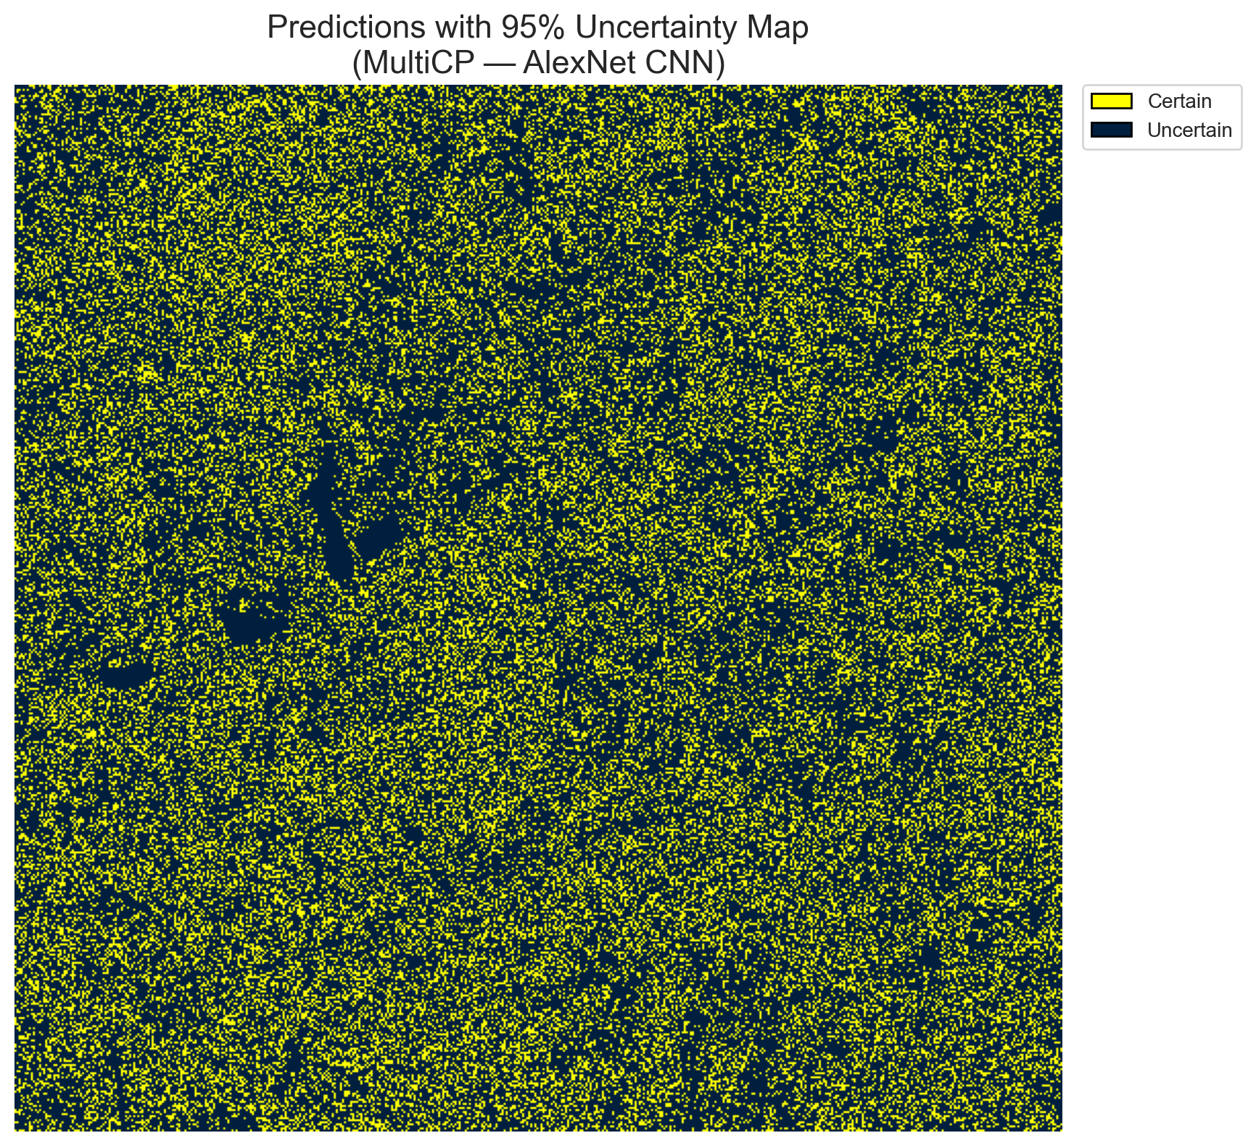 | (B) GFNet (RAPS Binary)  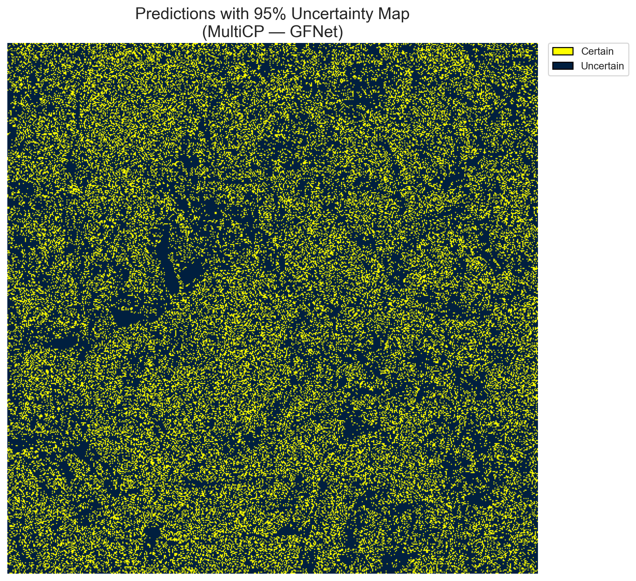
(C) ViT-UNet (RAPS Binary)  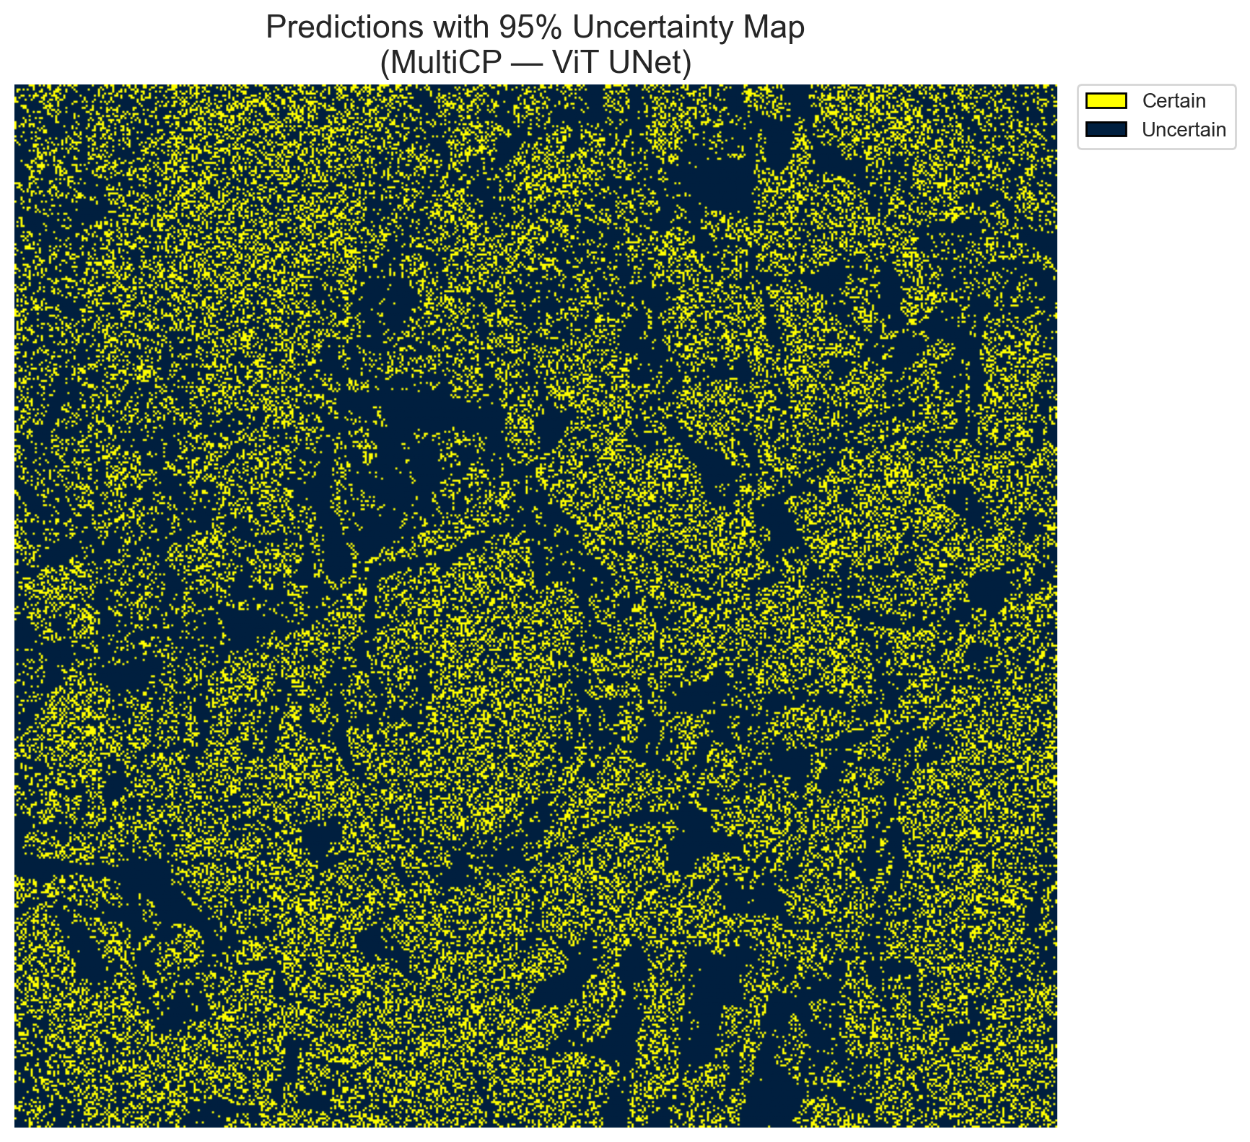 | (D) Binary Legend  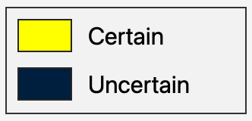
Fig. 1(a). MultiCP (RAPS score, α = 0.05, H = 7 heads) binary uncertainty maps across the 512 × 512 DIAS scene: (A) AlexNet-CNN MultiHead (28,848 uncertain pixels, 11.00%), (B) GFNet MultiHead (31,598 uncertain pixels, 12.05%), (C) ViT-UNet MultiHead (35,883 uncertain pixels, 13.69%), and (D) Binary Legend. Yellow = certain singleton; dark navy = uncertain pixel.
(A) AlexNet-CNN (RAPS Mask)  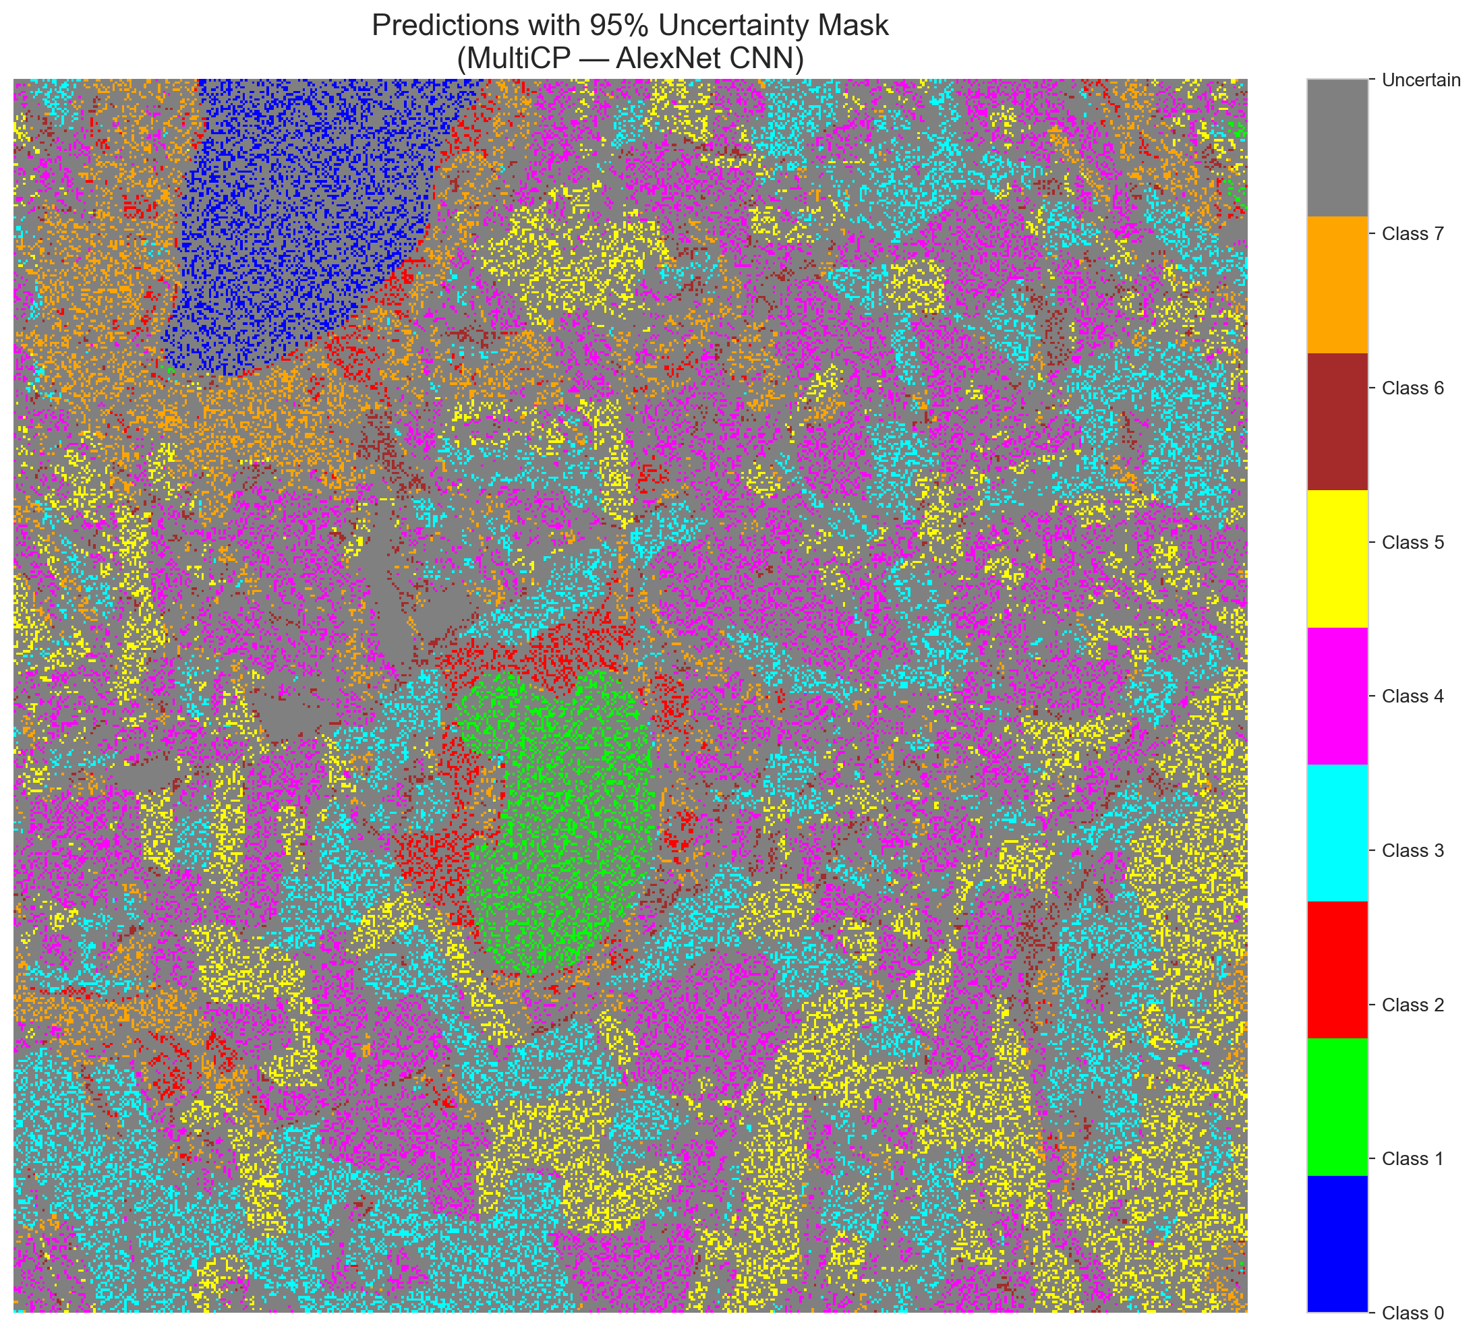 | (B) GFNet (RAPS Mask)  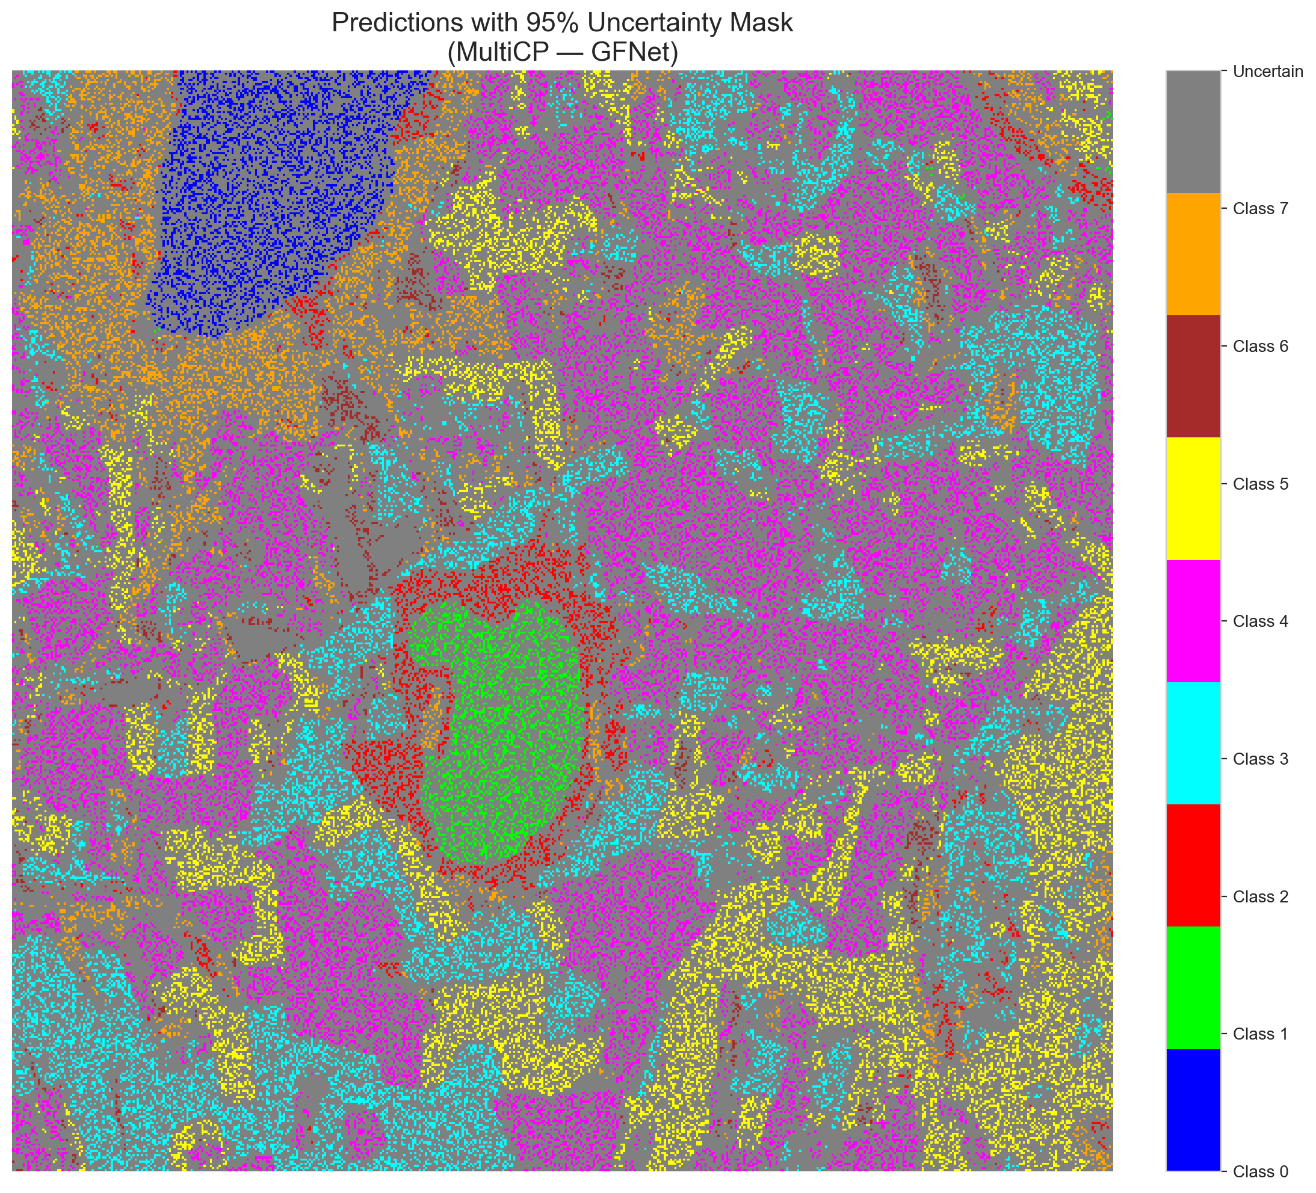
(C) ViT-UNet (RAPS Mask)  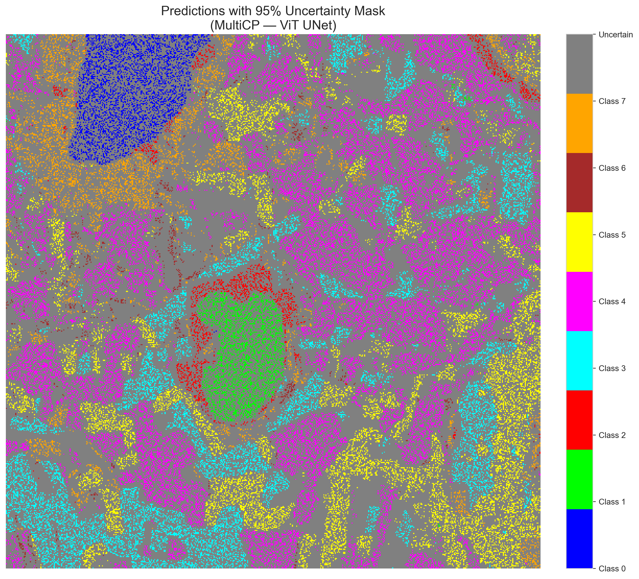 | (D) Class Legend  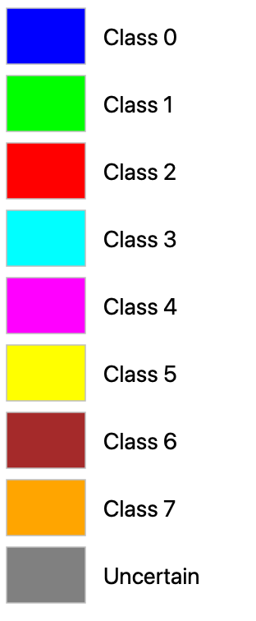
Fig. 1(b). MultiCP (RAPS score, α = 0.05, H = 7 heads) masked class prediction maps across the 512 × 512 DIAS scene: (A) AlexNet-CNN MultiHead, (B) GFNet MultiHead, (C) ViT-UNet MultiHead, and (D) Class Legend. Colours denote predicted land-cover classes (Classes 0–7); grey denotes uncertain pixels.
F. Spatialised Uncertainty Maps — SAPS
Figs. 2(a) and 2(b) present the corresponding MultiCP binary uncertainty maps and class-masked prediction maps under SAPS scoring. Across all three architectures, unsmoothed SAPS produces spatial distributions closely matching RAPS, with AlexNet flagging 28,515 uncertain pixels (10.88%), GFNet flagging 29,889 uncertain pixels (11.40%), and ViT-UNet flagging 28,201 uncertain pixels (10.76%). ViT-UNet SAPS achieves the overall lowest uncertain pixel rate of the entire MultiCP experiment (10.76%), delivering highly confident, sharp classification masks.
(A) AlexNet-CNN (SAPS Binary)  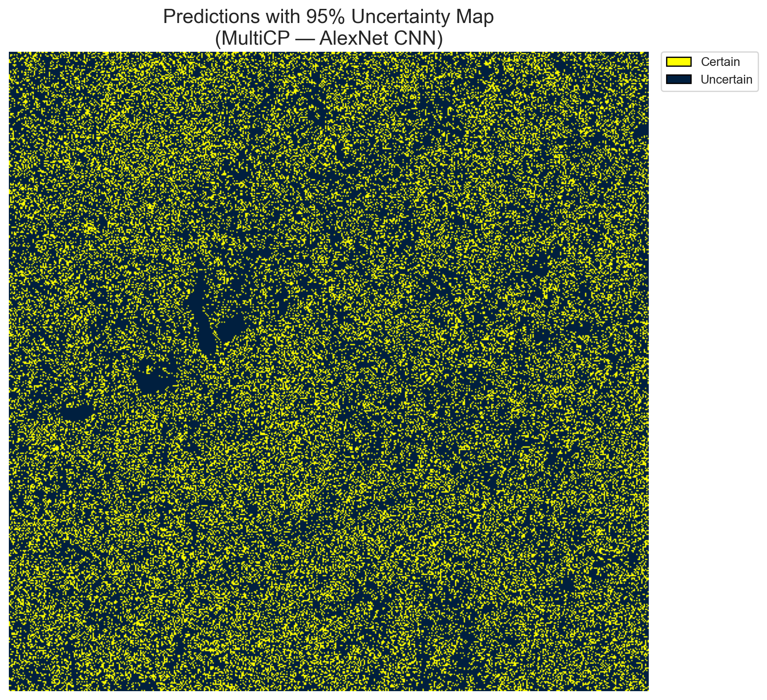 | (B) GFNet (SAPS Binary)  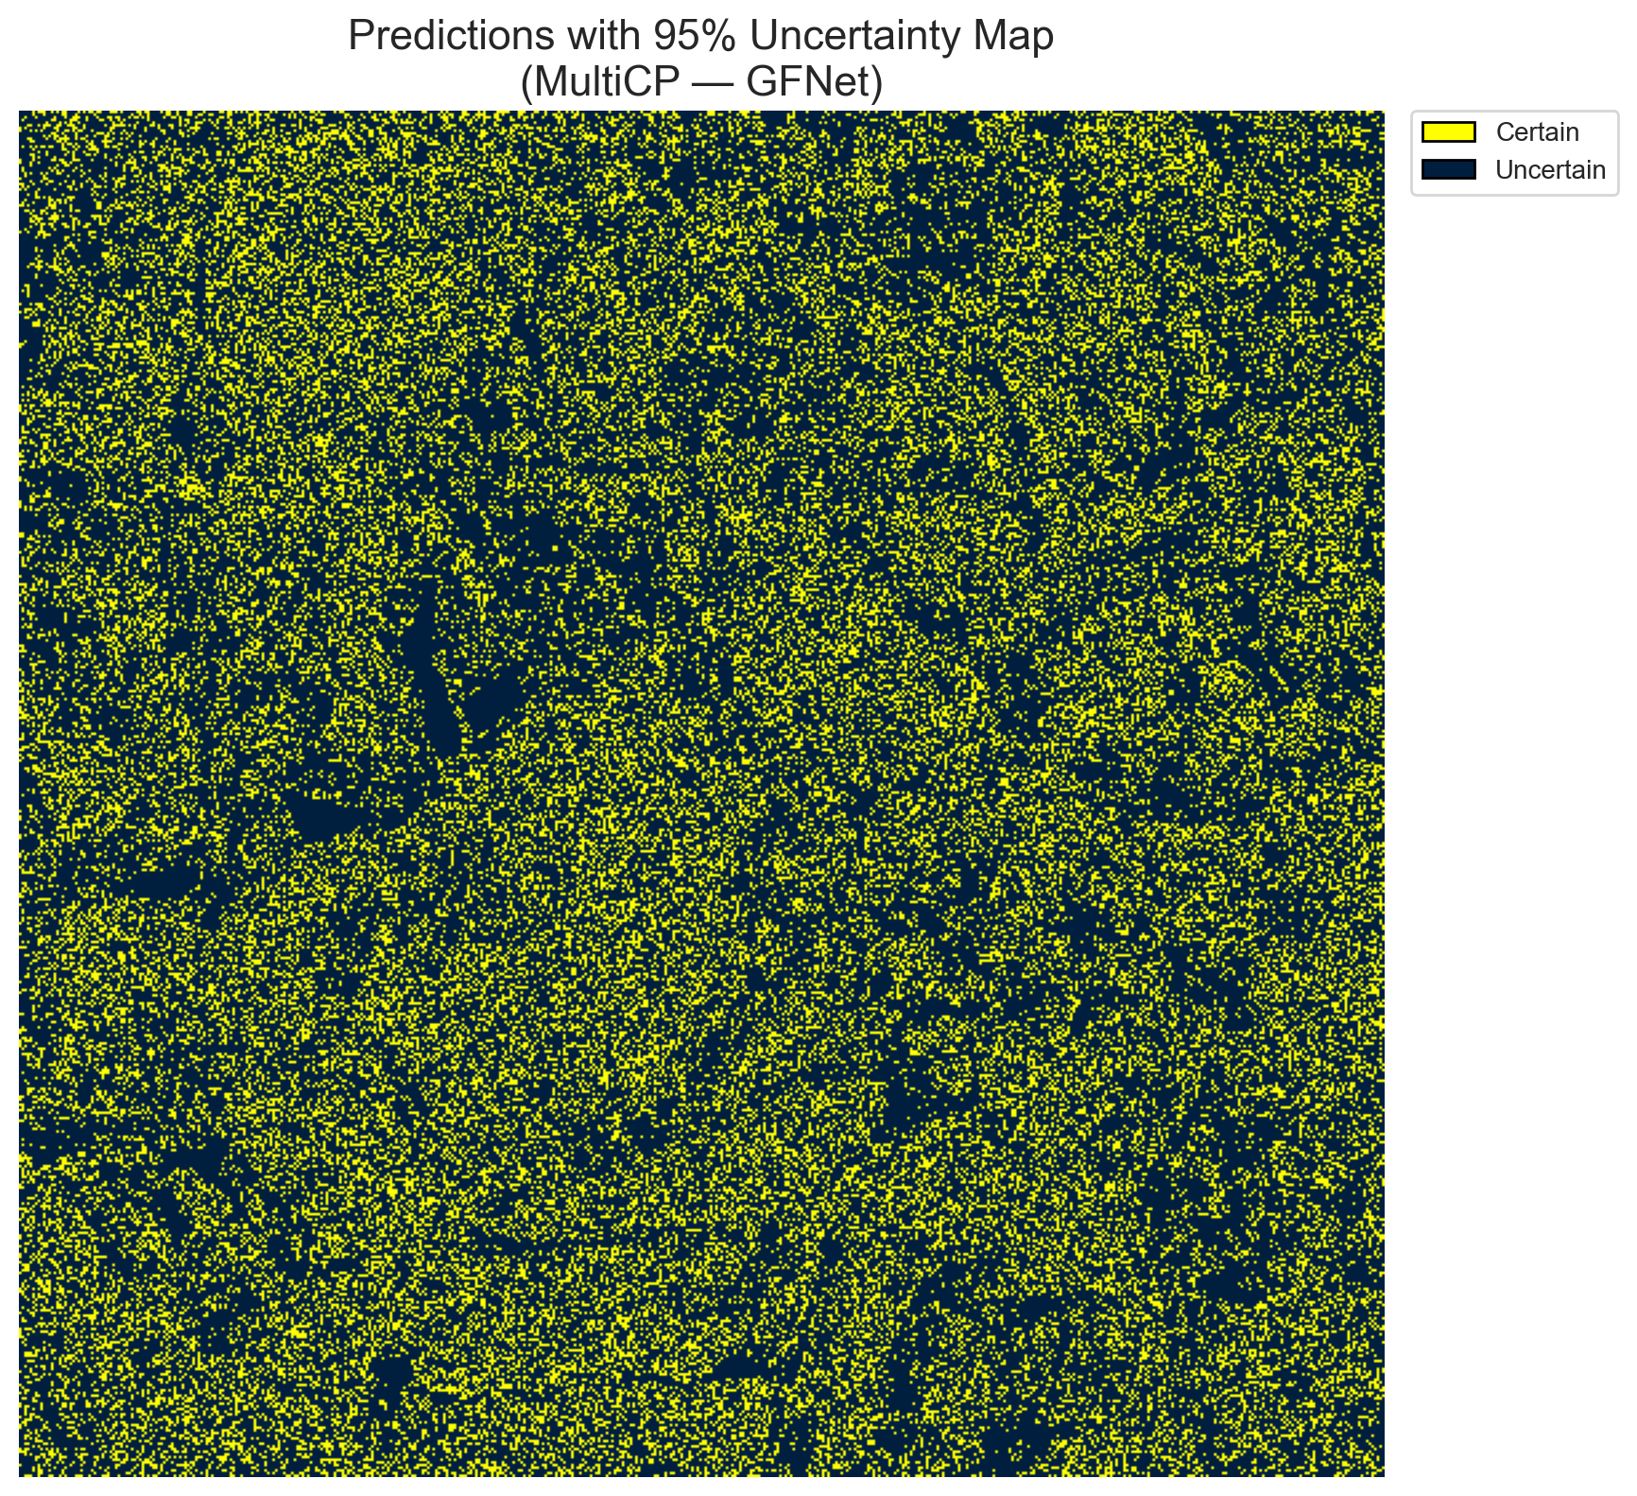
(C) ViT-UNet (SAPS Binary)  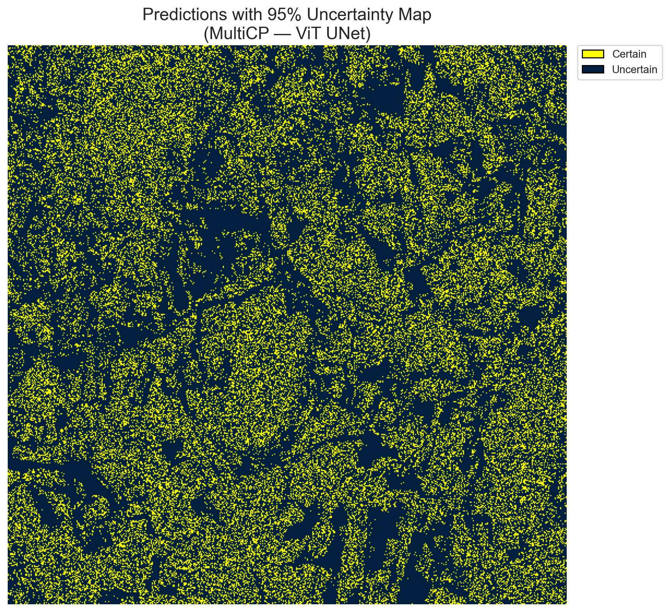 | (D) Binary Legend
Fig. 2(a). MultiCP (SAPS score, α = 0.05, H = 7 heads) binary uncertainty maps across the 512 × 512 DIAS scene: (A) AlexNet-CNN MultiHead (28,515 uncertain pixels, 10.88%), (B) GFNet MultiHead (29,889 uncertain pixels, 11.40%), (C) ViT-UNet MultiHead (28,201 uncertain pixels, 10.76%), and (D) Binary Legend. Yellow = certain singleton; dark navy = uncertain pixel.
(A) AlexNet-CNN (SAPS Mask)  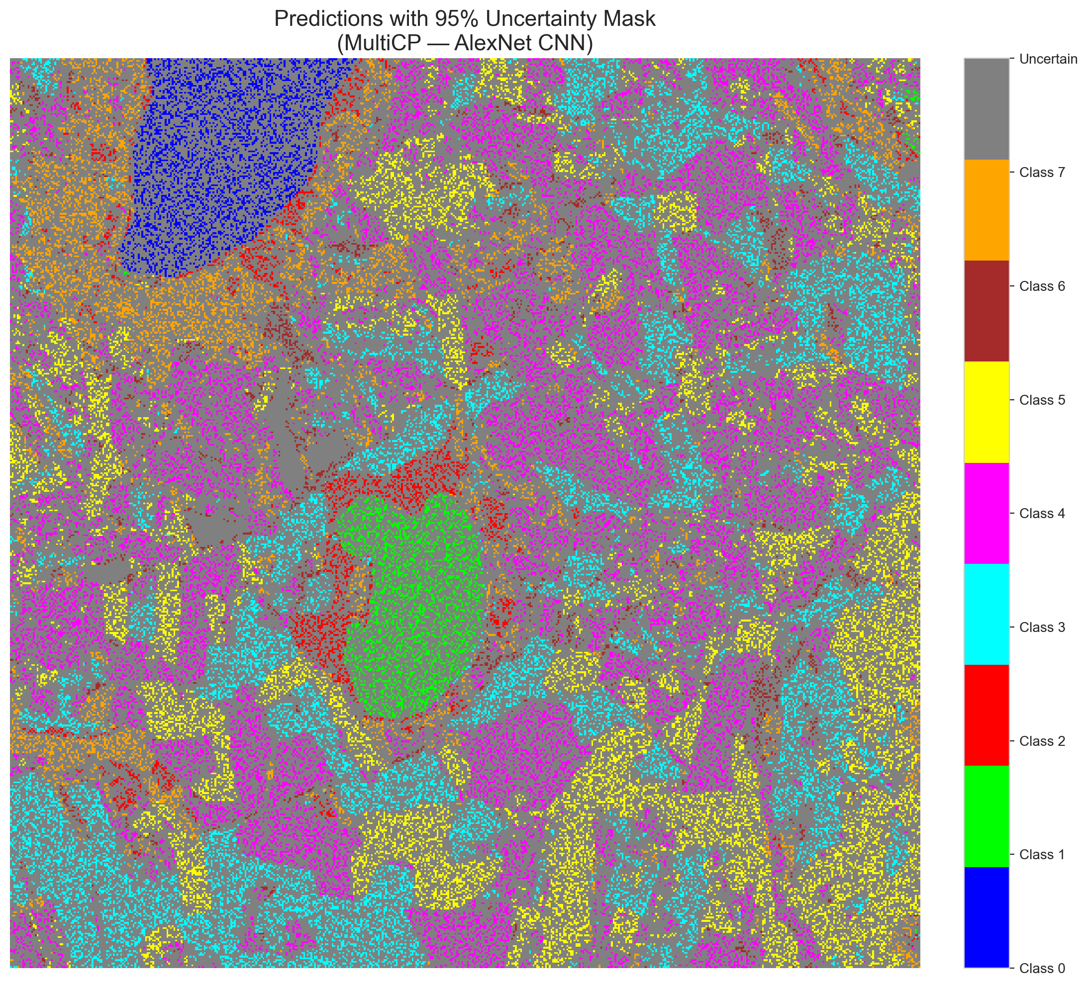 | (B) GFNet (SAPS Mask)  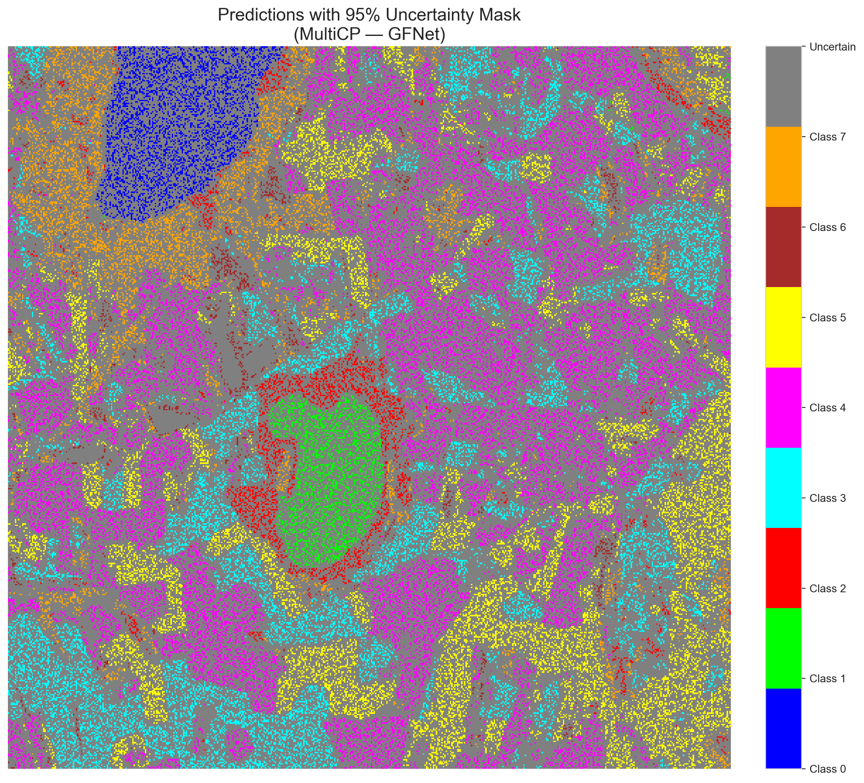
(C) ViT-UNet (SAPS Mask)  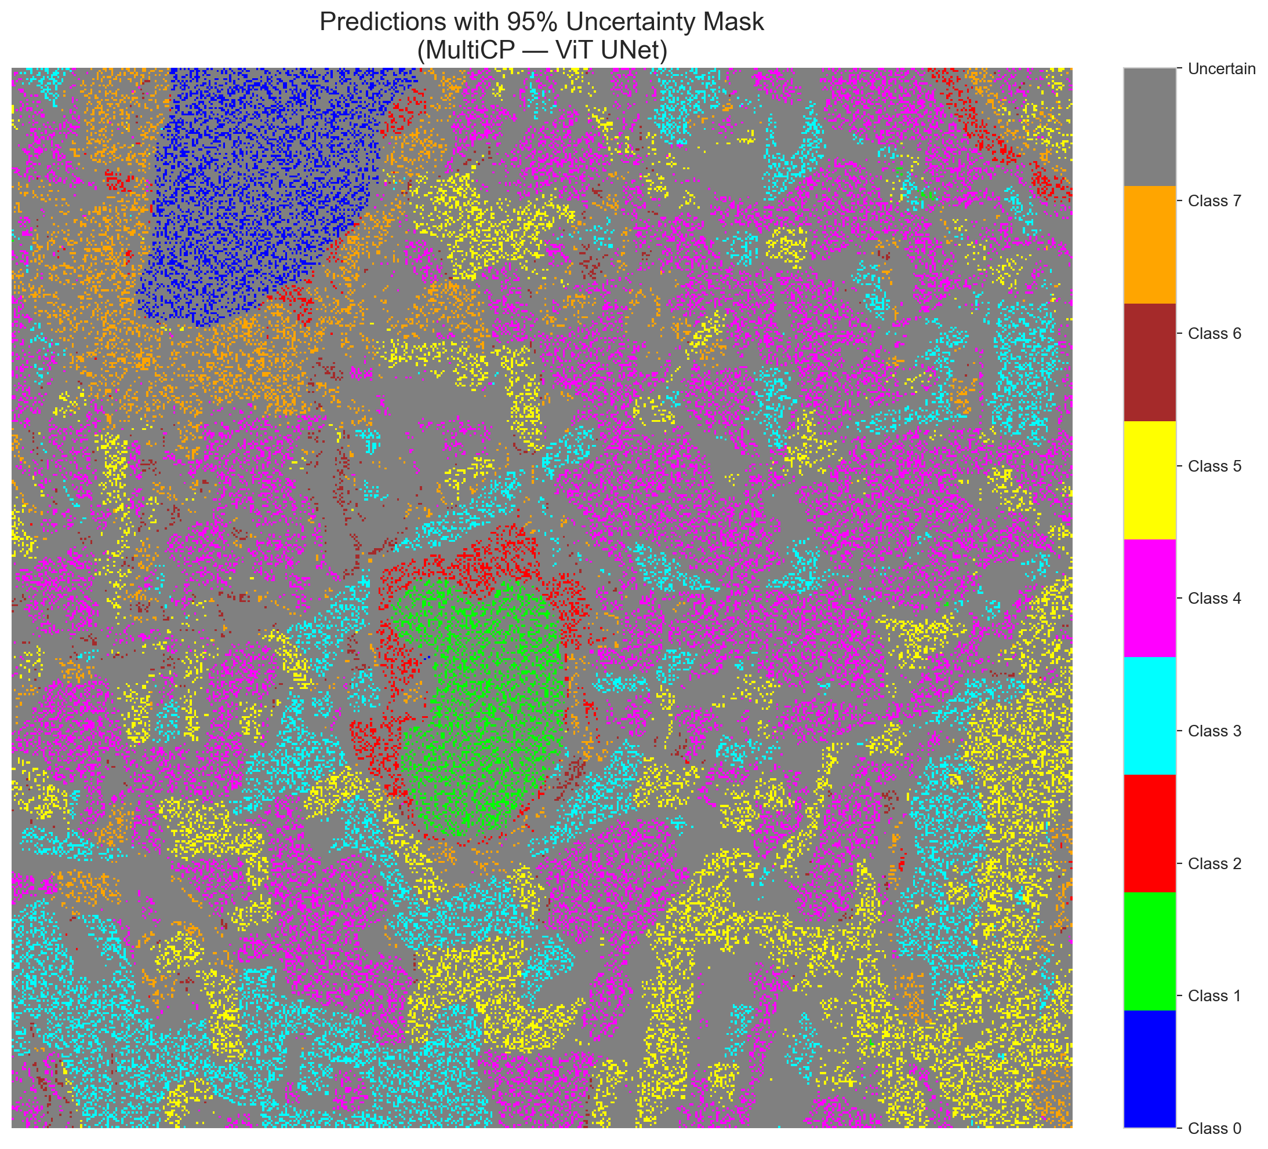 | (D) Class Legend
Fig. 2(b). MultiCP (SAPS score, α = 0.05, H = 7 heads) masked class prediction maps across the 512 × 512 DIAS scene: (A) AlexNet-CNN MultiHead, (B) GFNet MultiHead, (C) ViT-UNet MultiHead, and (D) Class Legend. Colours denote predicted land-cover classes (Classes 0–7); grey denotes uncertain pixels.
IV. CONCLUSION
Multi-head deep sub-ensemble training on the 65-band DIAS Scene K01 dataset achieved 100.000% test accuracy for GFNet MultiHead, 99.948% for AlexNet-CNN MultiHead, and 99.458% for ViT-UNet MultiHead across K = 8 land-cover classes. Under H = 7 multi-head conformal intersection, all three architectures exhibited a smooth monotone head-sweep trajectory from 94.12%–95.73% single-head coverage at H = 1 to 68.00%–70.79% joint coverage at H = 7. GFNet SAPS achieved the highest joint empirical coverage (0.7079), ViT-UNet RAPS achieved the highest full-scene coverage (0.1451), and ViT-UNet SAPS achieved the lowest uncertain pixel rate (0.1076, 28,201 pixels). Because unsmoothed 7-head intersection yields high singleton rates (94.66%–97.41%), spatial smoothing in SCMCP provides complementary neighbourhood regularisation to further refine boundary-localised uncertainty.
REFERENCES
[1] V. Vovk, A. Gammerman, and G. Shafer, Algorithmic Learning in a Random World. Springer, 2005.
[2] G. Shafer and V. Vovk, “A Tutorial on Conformal Prediction,” JMLR, vol. 9, pp. 371–421, 2008.
[3] A. N. Angelopoulos, S. Bates, J. Malik, and M. I. Jordan, “Uncertainty sets for image classifiers using conformal prediction,” in Proc. ICLR, 2021.
[4] J. Huang et al., “Conformal prediction for deep classifier via label ranking,” in Proc. ICML, 2024.
[5] Y. Rao et al., “Global filter networks for image classification,” in Adv. Neural Inf. Process. Syst. (NeurIPS), 2021.
[6] A. Dosovitskiy et al., “An image is worth 16×16 words: Transformers for image recognition at scale,” in Proc. ICLR, 2021.
[7] M. Valdenegro-Toro, “Deep sub-ensembles for fast uncertainty estimation,” NeurIPS BDL Workshop, 2019.
[8] B. Lakshminarayanan, A. Pritzel, and C. Blundell, “Simple and scalable predictive uncertainty estimation using deep ensembles,” in Adv. Neural Inf. Process. Syst. (NeurIPS), 2017.
[9] A. Krizhevsky, I. Sutskever, and G. E. Hinton, “ImageNet classification with deep CNNs,” in Adv. Neural Inf. Process. Syst. (NeurIPS), vol. 25, 2012.
[10] O. Ronneberger, P. Fischer, and T. Brox, “U-Net: Convolutional networks for biomedical image segmentation,” in Proc. MICCAI, 2015.
[11] M. Ahmad et al., “Hyperspectral image classification—Traditional to deep models,” IEEE J. Sel. Topics Appl. Earth Observ. Remote Sens., 2022.
[12] A. N. Angelopoulos and S. Bates, “A gentle introduction to conformal prediction,” arXiv:2107.07511, 2021.

