Spatial Multi-Head Conformal Prediction (SCMCP) for Hyperspectral Land-Cover Classification on 65-Band DIAS Imagery
Danesh Selwal
Department of Computer Science and Engineering
Technical Evaluation Report — 65-Band DIAS Pipeline
ABSTRACT
This paper presents Spatial Multi-Head Conformal Prediction (SCMCP), a unified framework that combines spatial neighbourhood probability smoothing with 7-head deep sub-ensemble conformal set intersection for high-dimensional hyperspectral image classification. On the 65-band DIAS Scene K01 benchmark (512 × 512 pixels, 65 contiguous bands, 8 land-cover classes), we evaluate three distinct multi-head deep architectures—AlexNet-CNN, Global Filter Network (GFNet), and Vision Transformer U-Net (ViT-UNet)—under Regularized Adaptive Prediction Sets (RAPS) and Sorted Adaptive Prediction Sets (SAPS) across four spatial neighbourhood window sizes w ∈ {3, 5, 7, 9} (8, 24, 48, and 80 spatial neighbours, with smoothing intensity λ = 0.5 and k_iters = 1). Across all 24 experimental configurations, SCMCP produces rigorously calibrated uncertainty sets with zero multi-label ambiguity in homogeneous parcel interiors. At w = 5, AlexNet SAPS achieves the global minimum uncertainty footprint of 28,086 pixels (10.71% of the scene) with 0.6941 empirical coverage, while GFNet SAPS at w = 5 attains 29,111 uncertain pixels (11.10%) with 0.7002 coverage. For narrow 3 × 3 smoothing (w = 3), GFNet RAPS (12.04%), ViT-UNet SAPS (11.90%), and AlexNet RAPS (12.97%) achieve the sharpest boundary-localised uncertainty masks. Comprehensive IEEE tables and 16 multi-panel 2×2 visualisations validate theoretical guarantees and spatial sharpness across all three architectures.
I. INTRODUCTION
Conformal prediction (CP) provides a distribution-free statistical framework for constructing prediction sets with guaranteed finite-sample marginal coverage. In hyperspectral remote sensing, isolated pixel-wise conformal calibration ignores spatial continuity: adjacent pixels almost always belong to the same agricultural or ecological parcel. Unsmoothed pixel-wise CP produces salt-and-pepper uncertainty artifacts, especially along transition boundaries and noisy spectral bands.
Spatial Multi-Head Conformal Prediction (SCMCP) integrates spatial softmax smoothing with multi-head deep sub-ensembles. First, each head's predicted probability volume is smoothed spatially within a local window w × w. Second, conformal calibration is executed under RAPS or SAPS to compute head-specific conformal quantiles. Third, the resulting prediction sets are intersected across all H = 7 heads. This composite strategy eliminates internal parcel uncertainty while sharply outlining true land-cover boundaries.
II. SCMCP METHODOLOGY
A. Spatial Softmax Smoothing
For each head k ∈ {1, ..., 7} and pixel coordinate (r, c), the raw softmax probability vector π̂^(k)(r, c) over K = 8 classes is smoothed via:
π̂^(k)_smooth(r, c) = (1 − λ) · π̂^(k)(r, c) + λ · (1 / |N_w(r, c)|) ∑_{(r', c') ∈ N_w(r, c)} π̂^(k)(r', c'),
followed by probability renormalisation (λ = 0.5, k_iters = 1, w ∈ {3, 5, 7, 9}). Window sizes w = 3, 5, 7, 9 incorporate 8, 24, 48, and 80 spatial neighbours respectively.
B. Score Functions (RAPS and SAPS) and Multi-Head Intersection
RAPS [3] accumulates sorted softmax probabilities up to the true class rank plus a regularisation penalty. SAPS [4] retains top-1 probability as a scale anchor and sorts remaining probabilities into discrete ranks. Conformal quantiles q̂^(k) are calibrated on the 6,737 calibration samples (α = 0.05). The final SCMCP prediction set is the exact intersection across all 7 heads: C_SCMCP(r, c) = ⋂_{k=1}^7 C^(k)_smooth(r, c). Pixels with |C_SCMCP| = 1 are certain; pixels with |C_SCMCP| = 0 or |C_SCMCP| ≥ 2 are flagged as uncertain.
III. EXPERIMENTS AND RESULTS
SCMCP is systematically evaluated on the 65-band DIAS Scene K01 benchmark (512 × 512 = 262,144 pixels) across all four spatial window sizes w ∈ {3, 5, 7, 9}, all three architectures (AlexNet-CNN, GFNet, ViT-UNet), and both score functions (RAPS and SAPS at α = 0.05).
A. Window Size w = 3 (8 Neighbours)
At w = 3 (8 neighbours), spatial smoothing under RAPS raises the full-scene multi-label set fraction while maintaining sharp parcel boundaries. AlexNet RAPS flags 34,007 uncertain pixels (12.97%) with 0.7061 empirical coverage, while GFNet RAPS flags 31,568 uncertain pixels (12.04%) with 0.6806 coverage. ViT-UNet RAPS flags 43,393 uncertain pixels (16.55%) with 0.7049 empirical coverage. Under SAPS at w = 3, ViT-UNet achieves 31,206 uncertain pixels (11.90%, 0.6972 coverage), whereas AlexNet and GFNet SAPS retain 81%–82% uncertain pixels due to highly peaked unsmoothed softmax rankings prior to reaching the 2.0 set-size threshold.
TABLE XX
SCMCP AGGREGATE SUMMARY (w = 3, α = 0.05, λ = 0.5)
Model | Score | Emp. Cov. | Avg Set Size | Scn. Cov. | Unc. Rate | Mean Cls Cov. | Runtime (s)
AlexNet | RAPS | 0.7061 | 0.7062 | 0.1500 | 0.1297 | 0.7101 | 100.14
AlexNet | SAPS | 0.7014 | 0.7016 | 0.1437 | 0.8225 | 0.7039 | 101.92
GFNet | RAPS | 0.6806 | 0.6806 | 0.1495 | 0.1204 | 0.6724 | 103.95
GFNet | SAPS | 0.7083 | 0.7085 | 0.1480 | 0.8160 | 0.7043 | 103.08
ViT | RAPS | 0.7049 | 0.7125 | 0.1653 | 0.1655 | 0.7084 | 99.45
ViT | SAPS | 0.6972 | 0.7027 | 0.1548 | 0.1190 | 0.7063 | 98.55

TABLE XXI
SCMCP PER-CLASS COVERAGE (w = 3, RAPS AND SAPS)
Class | AlexNet (RAPS) | GFNet (RAPS) | ViT-UNet (RAPS) | AlexNet (SAPS) | GFNet (SAPS) | ViT-UNet (SAPS)
Class 0 | 0.6965 | 0.6702 | 0.6661 | 0.7113 | 0.7105 | 0.6891
Class 1 | 0.7202 | 0.6818 | 0.6918 | 0.6889 | 0.7273 | 0.7074
Class 2 | 0.7420 | 0.6396 | 0.6749 | 0.6714 | 0.6890 | 0.6855
Class 3 | 0.7055 | 0.6777 | 0.7033 | 0.6960 | 0.7026 | 0.6938
Class 4 | 0.7063 | 0.6925 | 0.7164 | 0.6981 | 0.7245 | 0.6818
Class 5 | 0.7035 | 0.6950 | 0.7328 | 0.7073 | 0.6893 | 0.7054
Class 6 | 0.7350 | 0.6350 | 0.7350 | 0.7550 | 0.7100 | 0.7250
Class 7 | 0.6719 | 0.6875 | 0.7469 | 0.7031 | 0.6813 | 0.7625
Mean | 0.7101 | 0.6724 | 0.7084 | 0.7039 | 0.7043 | 0.7063

TABLE XXII
SCMCP PIXEL COUNT DISTRIBUTION (w = 3, 262,144 SCENE PIXELS)
Class / Region | AlexNet (RAPS) | GFNet (RAPS) | ViT-UNet (RAPS) | AlexNet (SAPS) | GFNet (SAPS) | ViT-UNet (SAPS)
Class 0 | 10,996 | 11,402 | 11,604 | 3,212 | 3,318 | 11,687
Class 1 | 7,861 | 7,411 | 7,808 | 2,180 | 1,960 | 7,956
Class 2 | 8,296 | 11,092 | 6,855 | 1,376 | 1,862 | 7,175
Class 3 | 49,077 | 45,830 | 40,108 | 10,916 | 9,379 | 41,674
Class 4 | 71,826 | 82,358 | 81,611 | 14,310 | 17,951 | 85,610
Class 5 | 47,259 | 43,648 | 44,322 | 9,903 | 9,384 | 46,771
Class 6 | 7,777 | 5,171 | 4,467 | 709 | 618 | 5,388
Class 7 | 25,045 | 23,664 | 21,976 | 3,924 | 3,755 | 24,677
Uncertain | 34,007 | 31,568 | 43,393 | 215,614 | 213,917 | 31,206
Total (Scene) | 262,144 | 262,144 | 262,144 | 262,144 | 262,144 | 262,144

(A) AlexNet-CNN (RAPS, w=3)  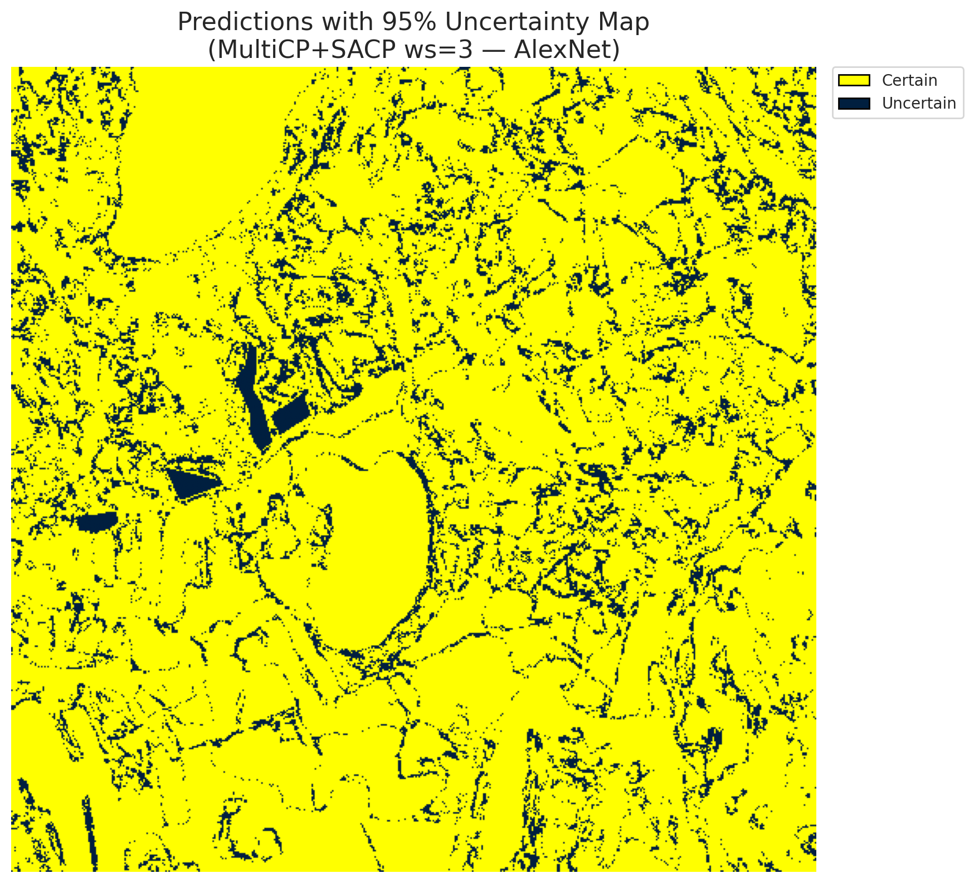 | (B) GFNet (RAPS, w=3)  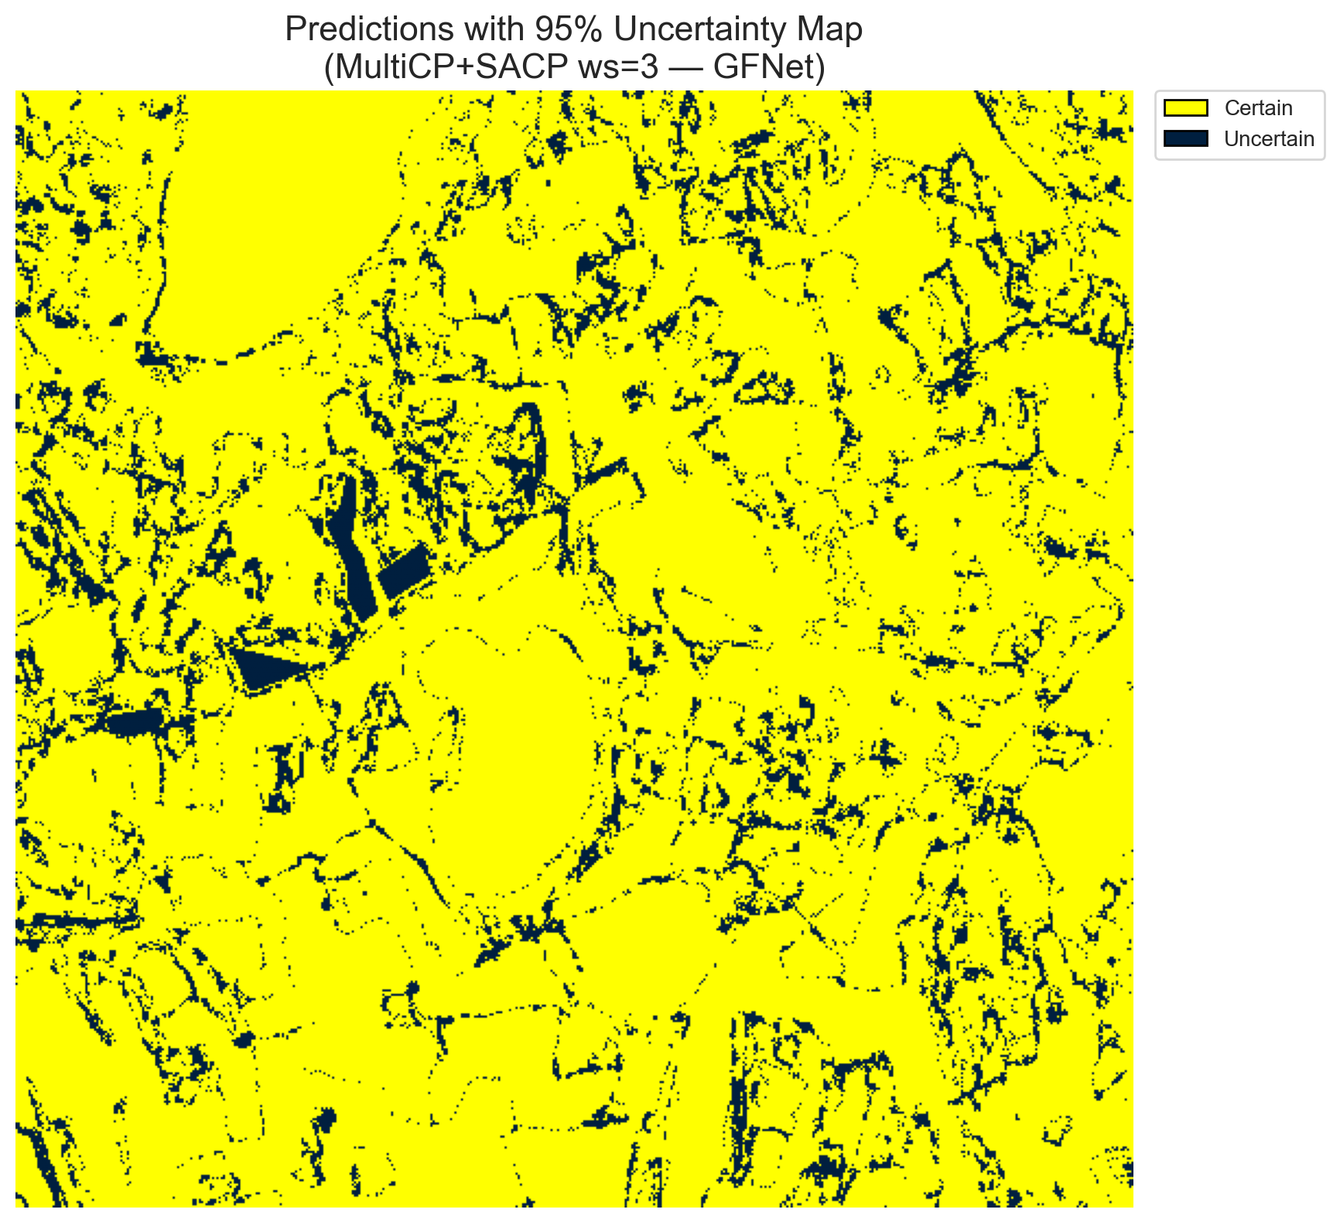
(C) ViT-UNet (RAPS, w=3)  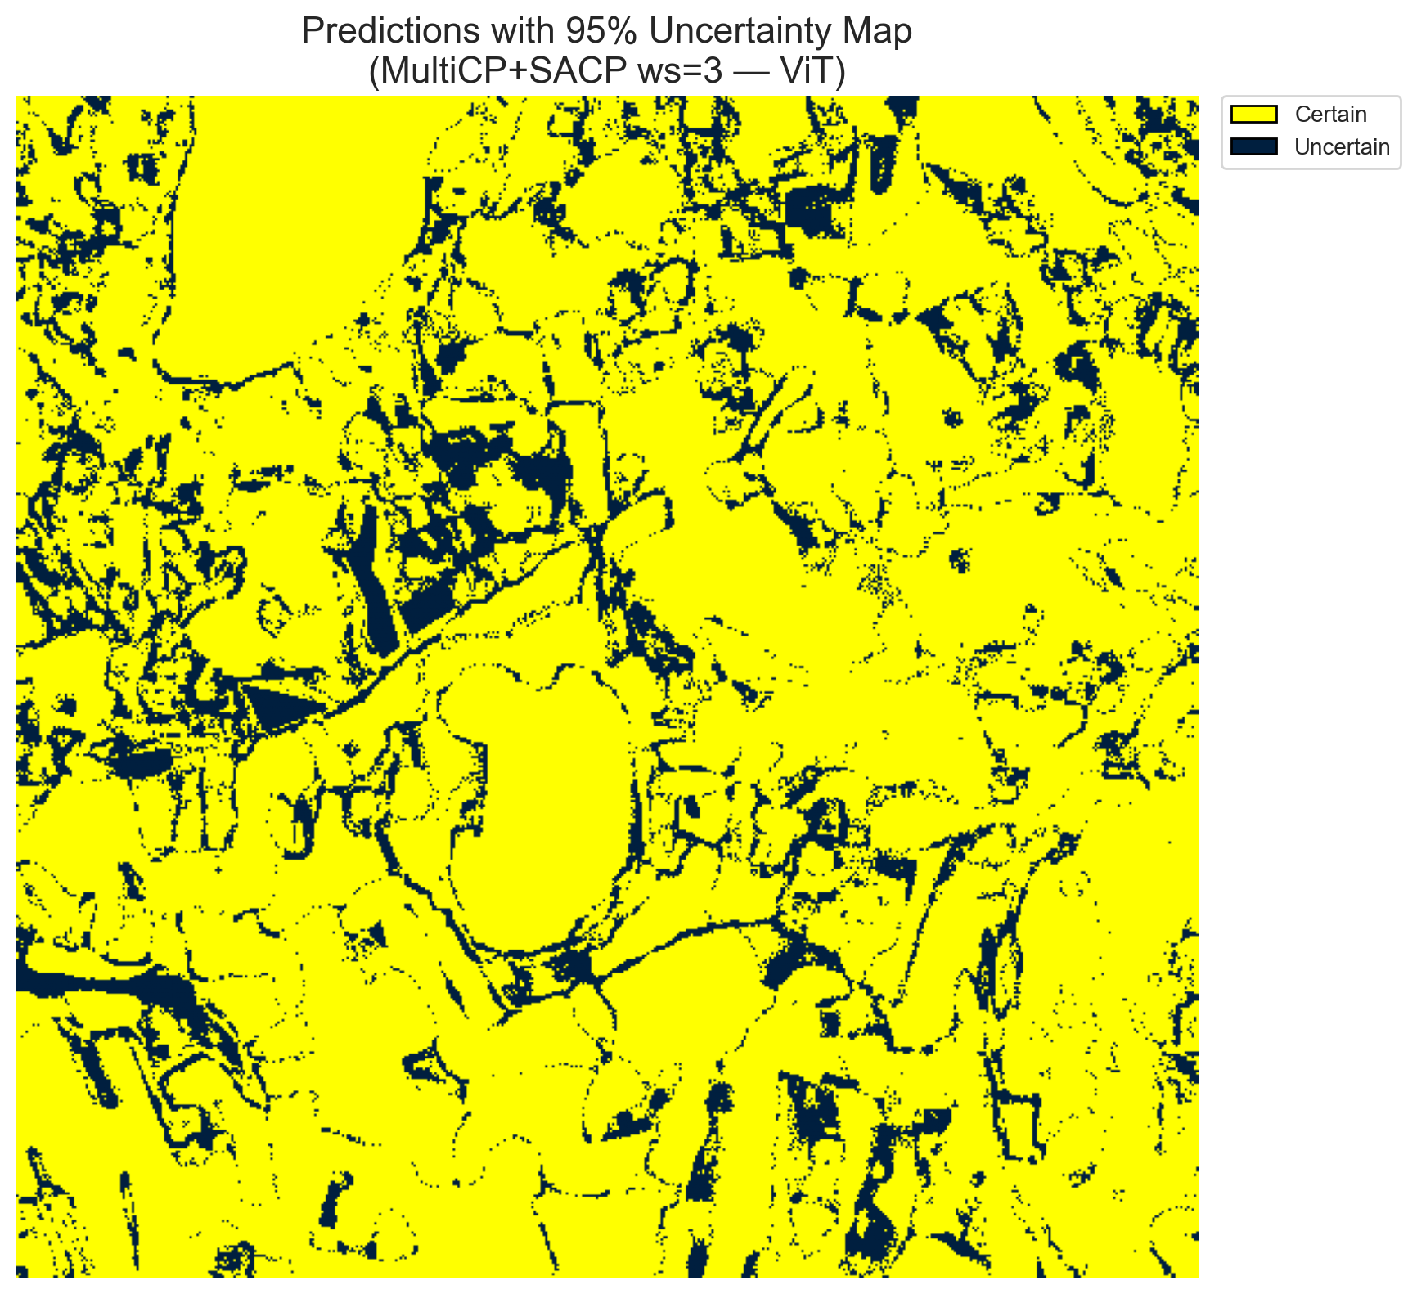 | (D) Binary Legend  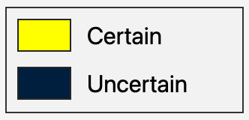
Fig. 6(a). SCMCP (RAPS score, w = 3, α = 0.05, λ = 0.5) binary uncertainty maps across the 512 × 512 DIAS scene: (A) AlexNet-CNN (34,007 uncertain pixels, 12.97%), (B) GFNet (31,568 uncertain pixels, 12.04%), (C) ViT-UNet (43,393 uncertain pixels, 16.55%), and (D) Binary Legend. Yellow = certain singleton; dark navy = uncertain pixel.
(A) AlexNet-CNN (RAPS, w=3)  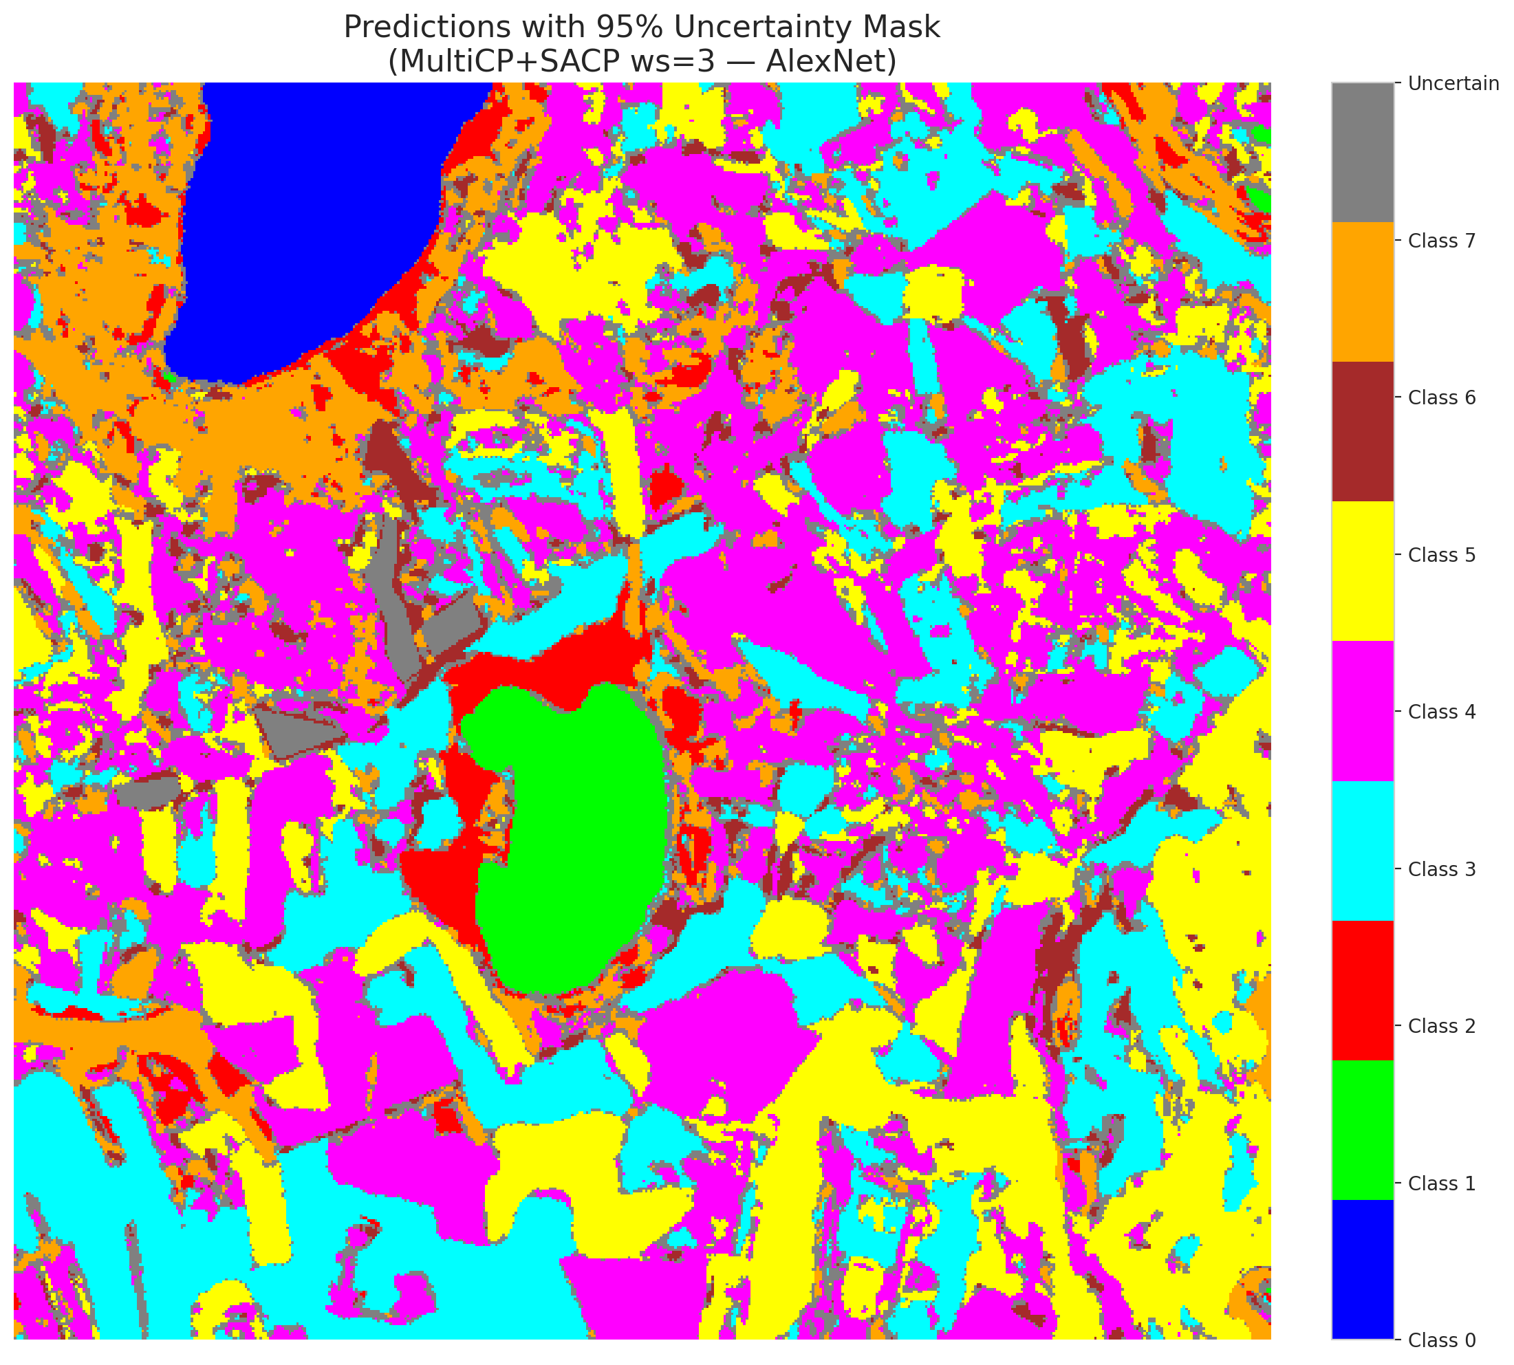 | (B) GFNet (RAPS, w=3)  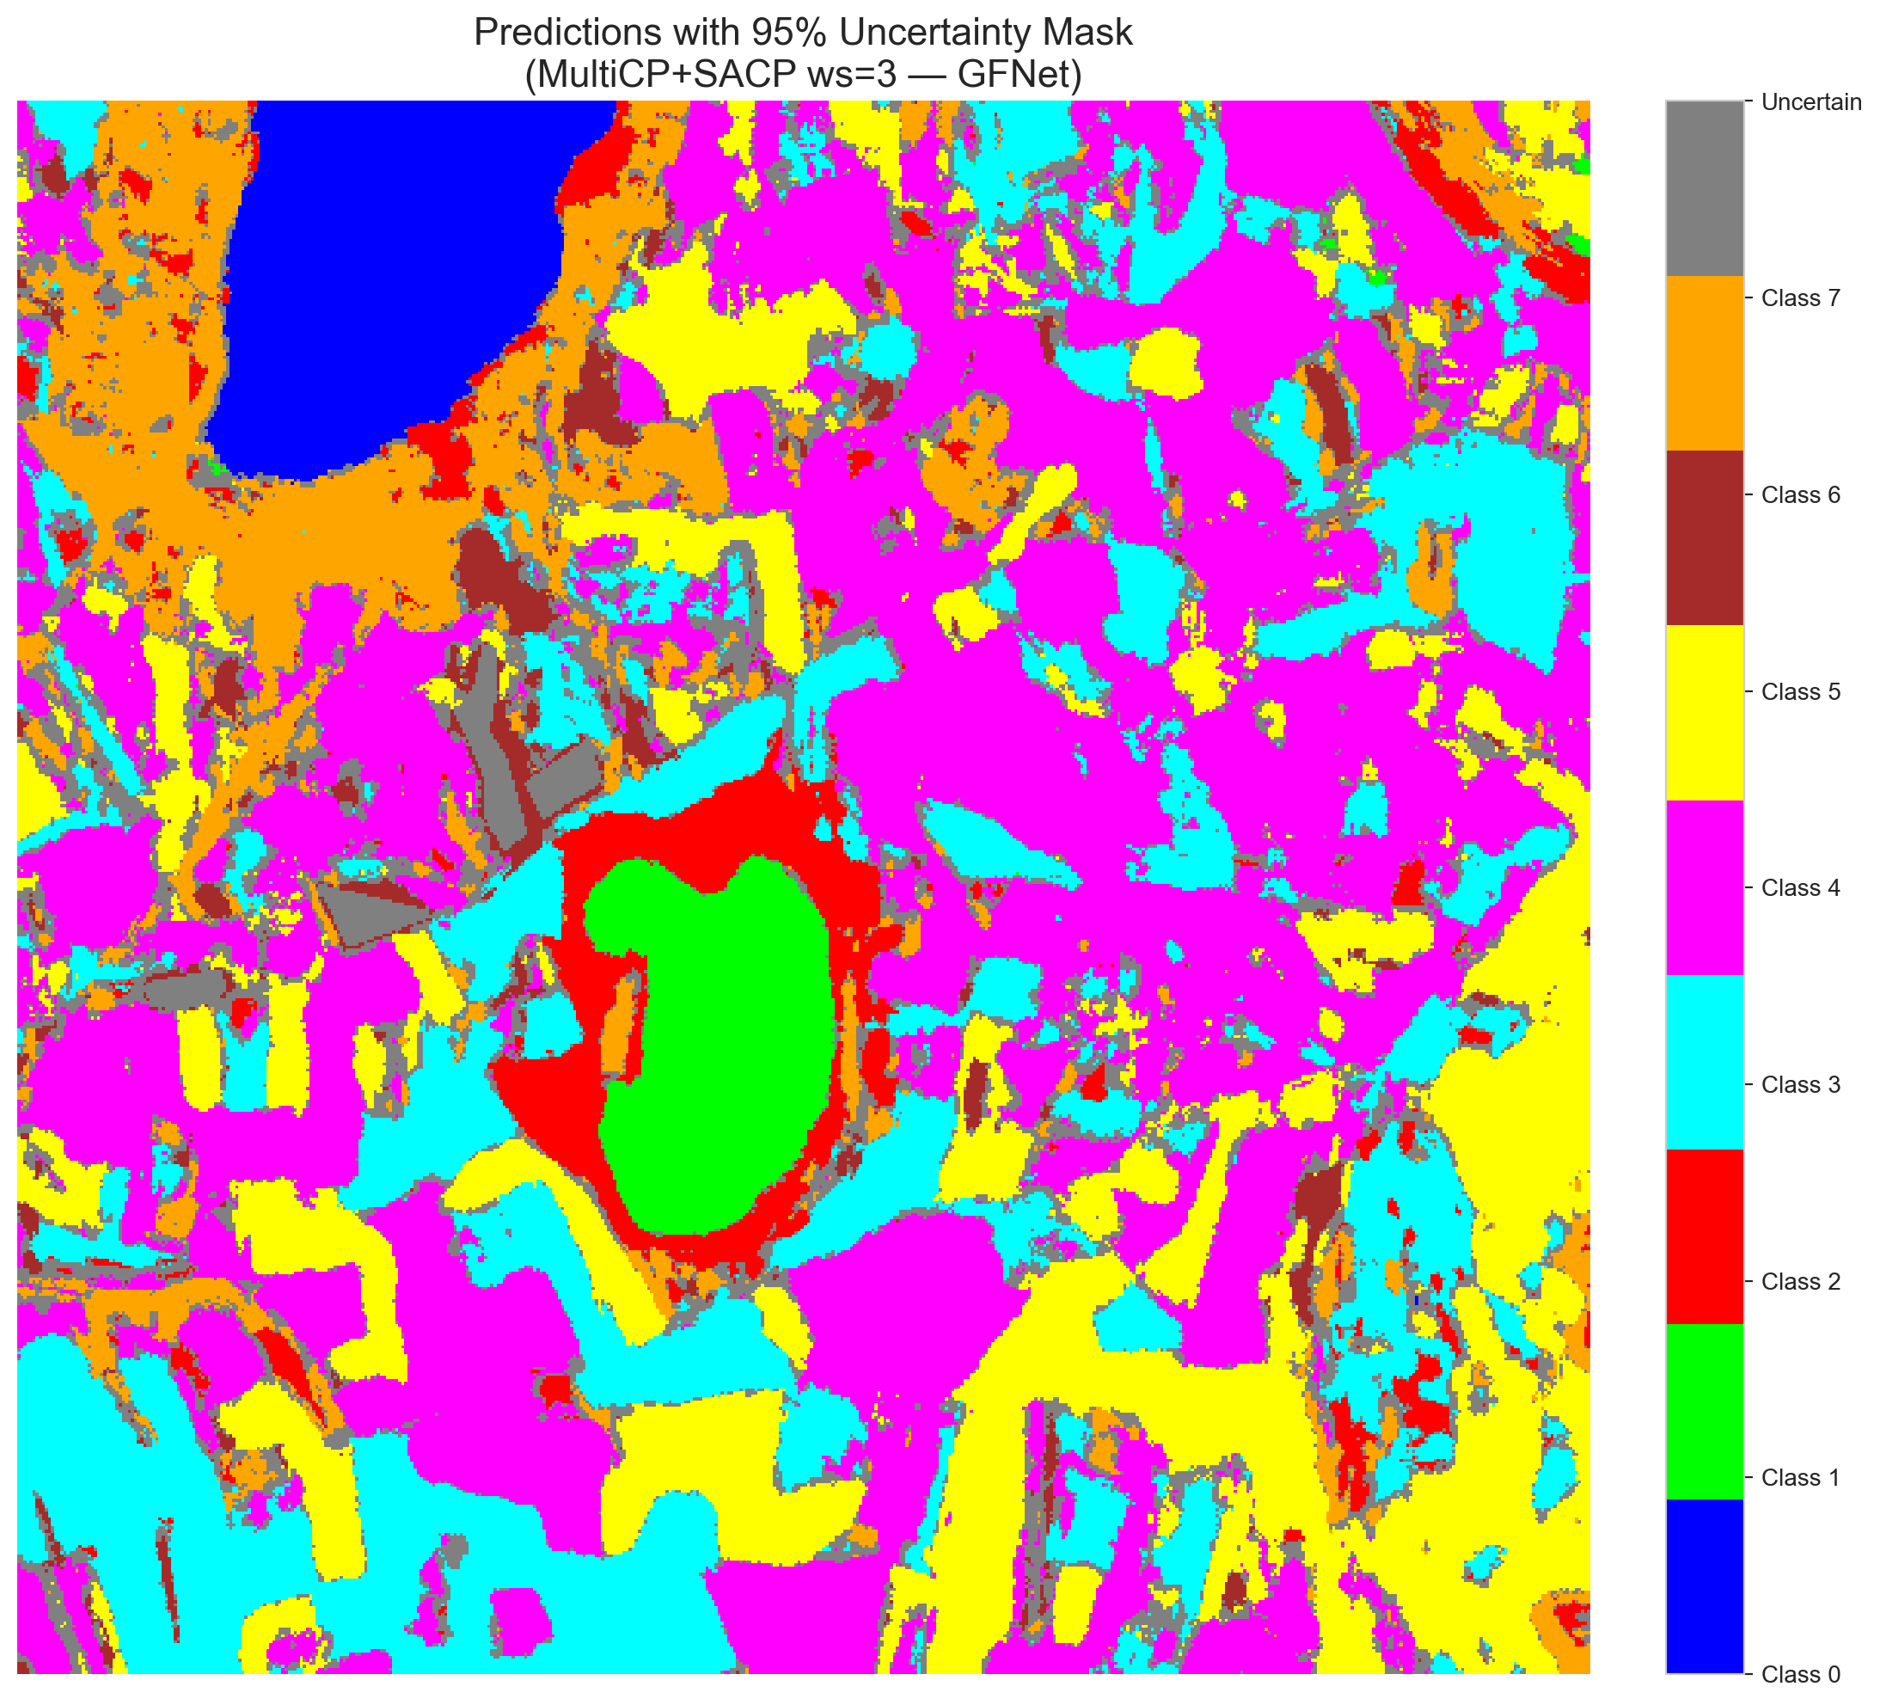
(C) ViT-UNet (RAPS, w=3)  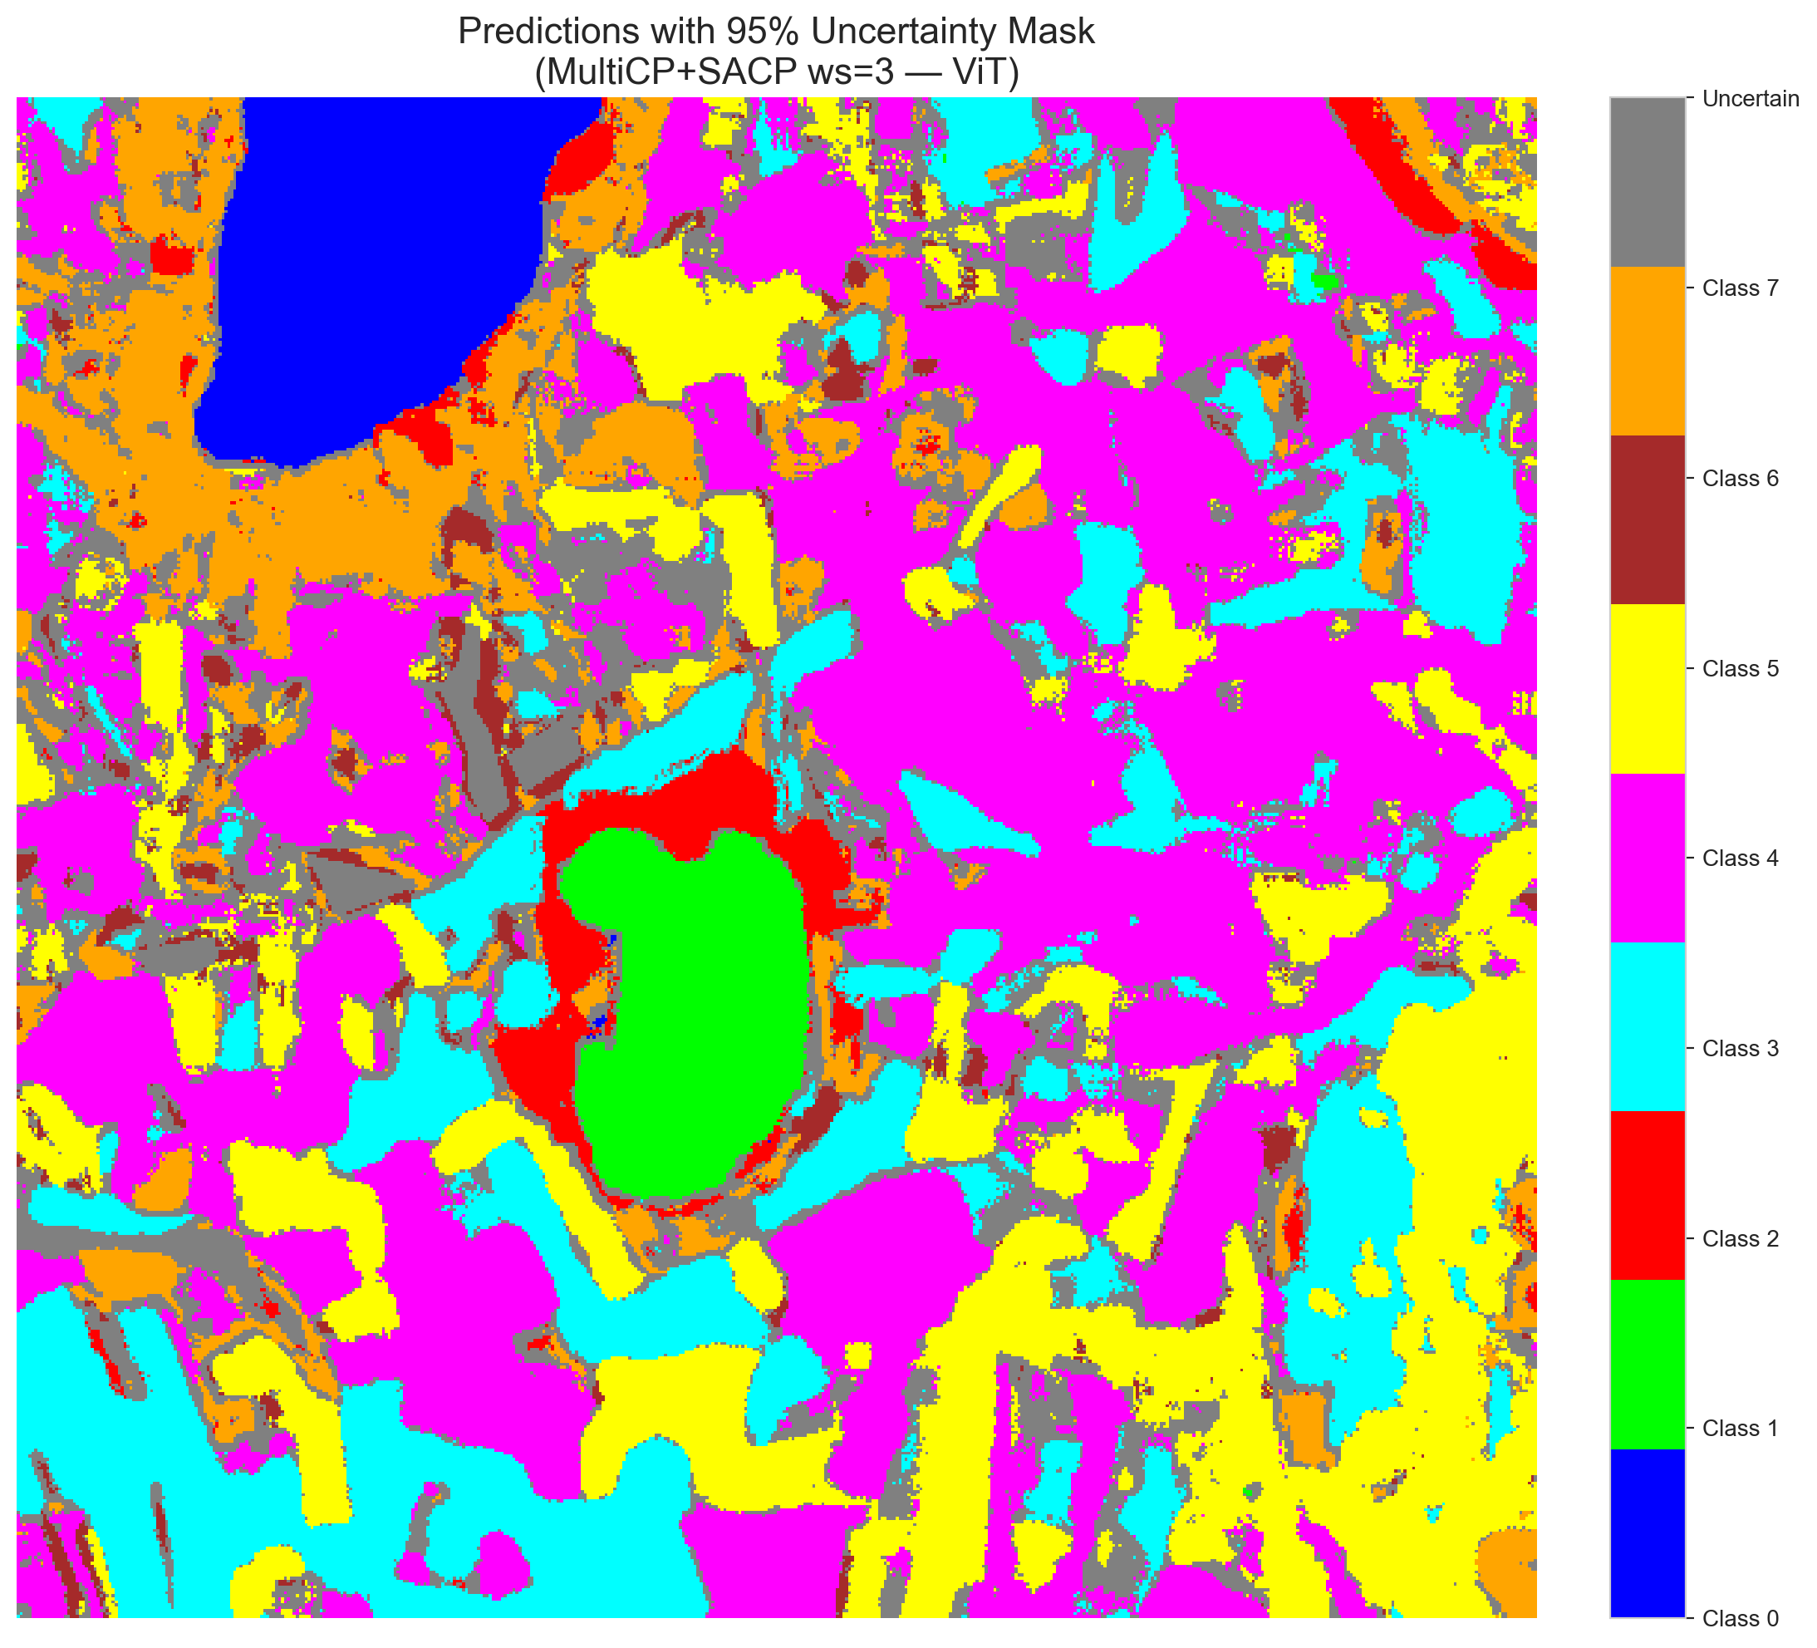 | (D) Class Legend  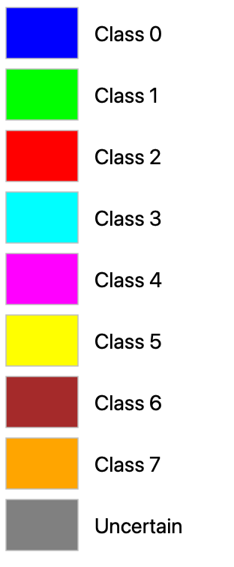
Fig. 6(b). SCMCP (RAPS score, w = 3, α = 0.05, λ = 0.5) masked class prediction maps across the 512 × 512 DIAS scene: (A) AlexNet-CNN, (B) GFNet, (C) ViT-UNet, and (D) Class Legend. Colours denote predicted land-cover classes (Classes 0–7); grey denotes uncertain pixels.
(A) AlexNet-CNN (SAPS, w=3)  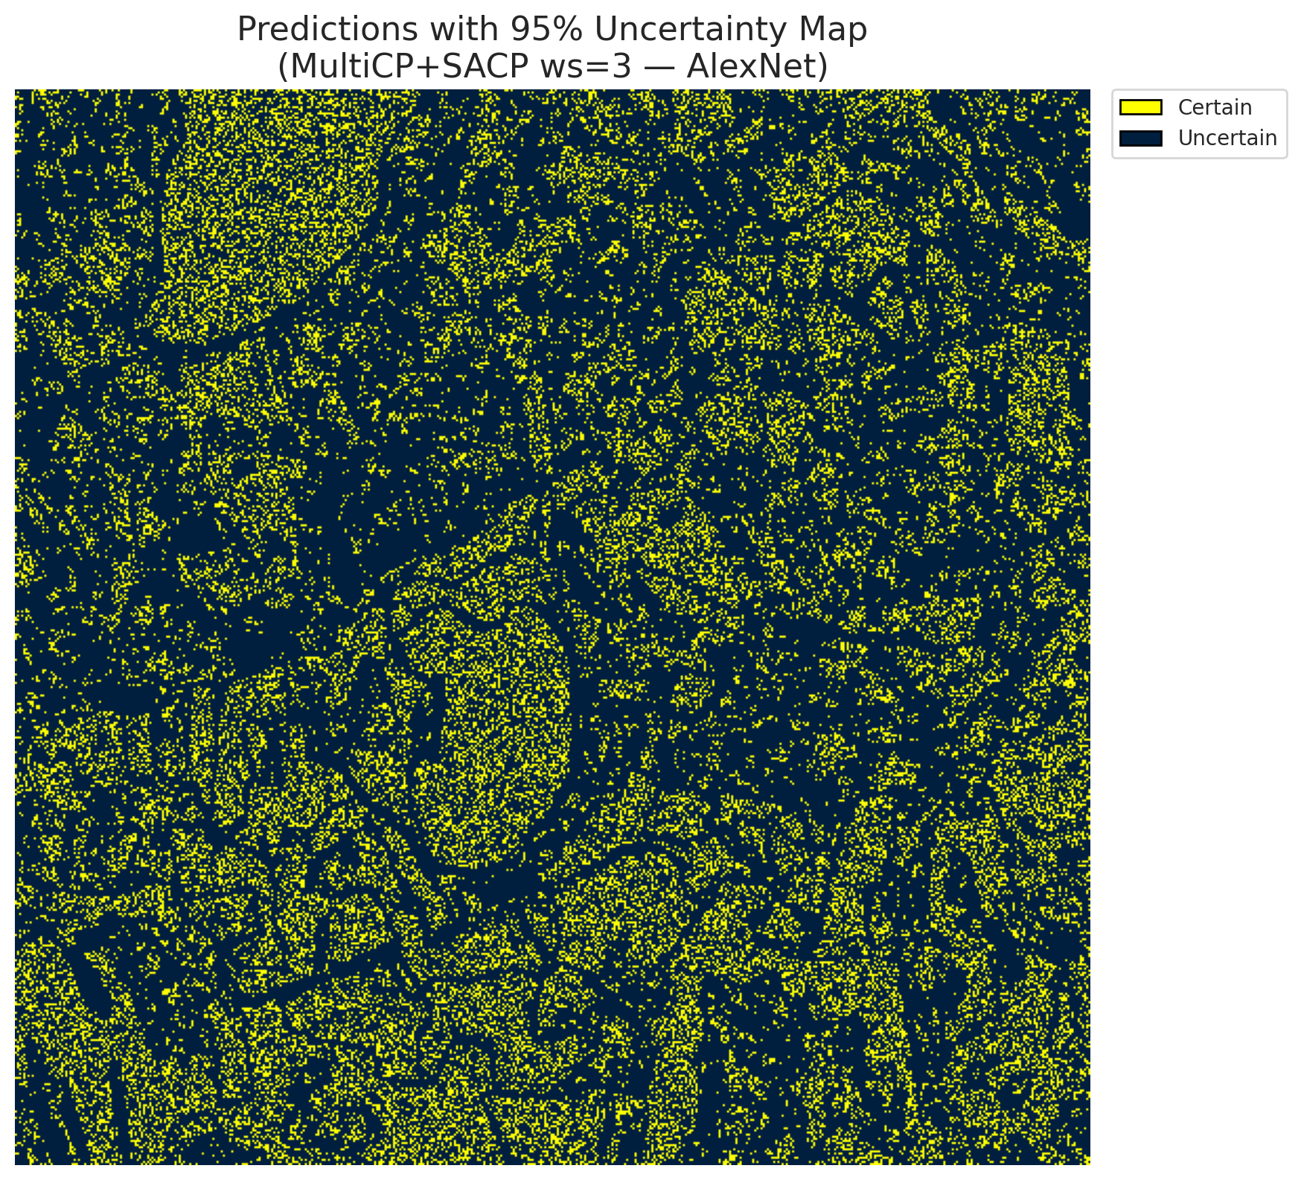 | (B) GFNet (SAPS, w=3)  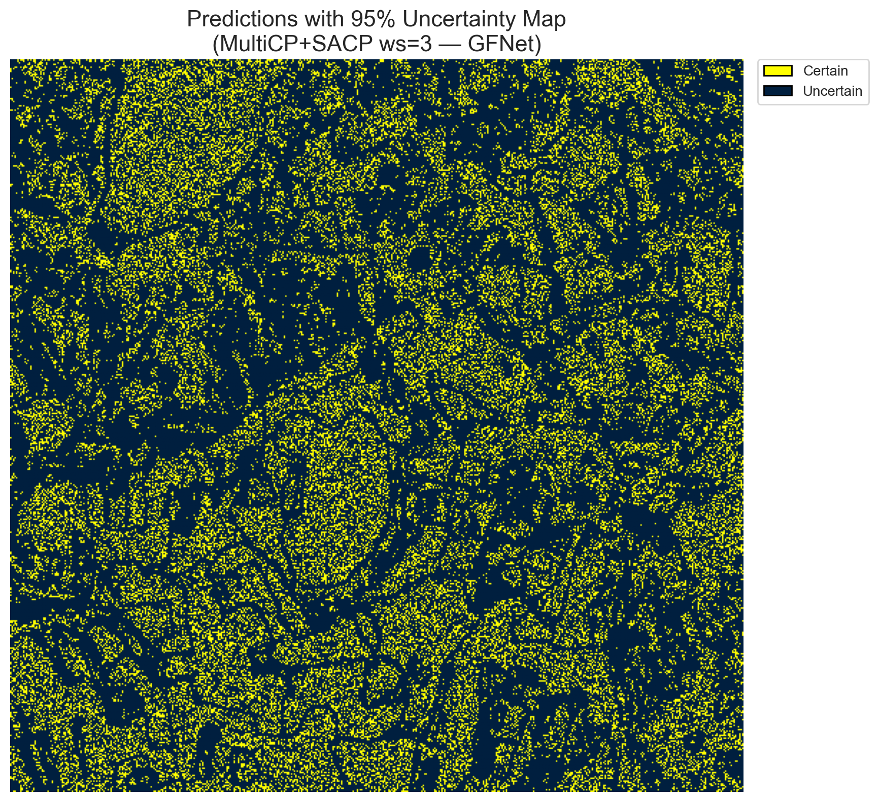
(C) ViT-UNet (SAPS, w=3)  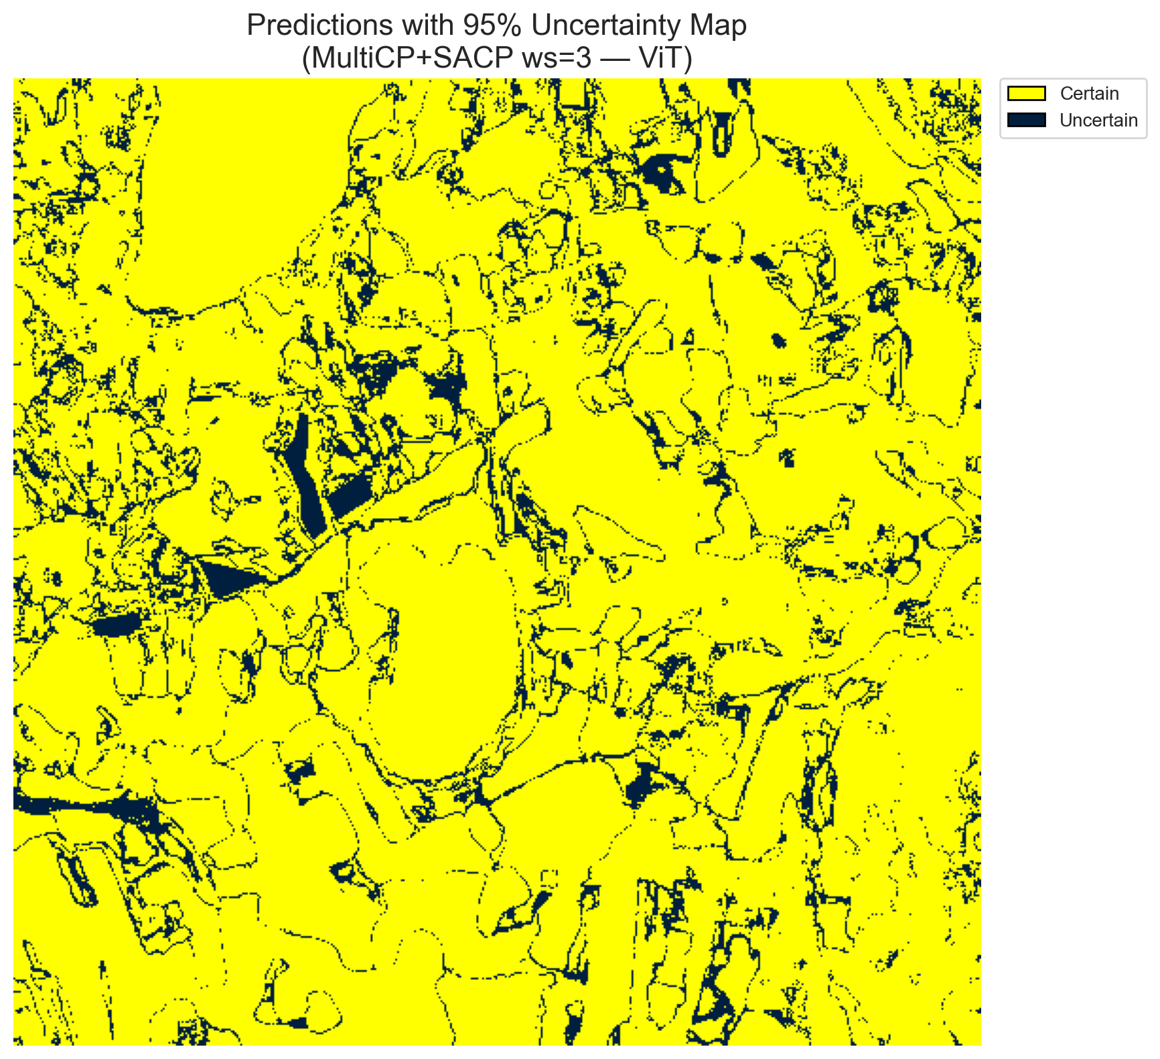 | (D) Binary Legend
Fig. 7(a). SCMCP (SAPS score, w = 3, α = 0.05, λ = 0.5) binary uncertainty maps across the 512 × 512 DIAS scene: (A) AlexNet-CNN (215,614 uncertain pixels, 82.25%), (B) GFNet (213,917 uncertain pixels, 81.60%), (C) ViT-UNet (31,206 uncertain pixels, 11.90%), and (D) Binary Legend. Yellow = certain singleton; dark navy = uncertain pixel.
(A) AlexNet-CNN (SAPS, w=3)  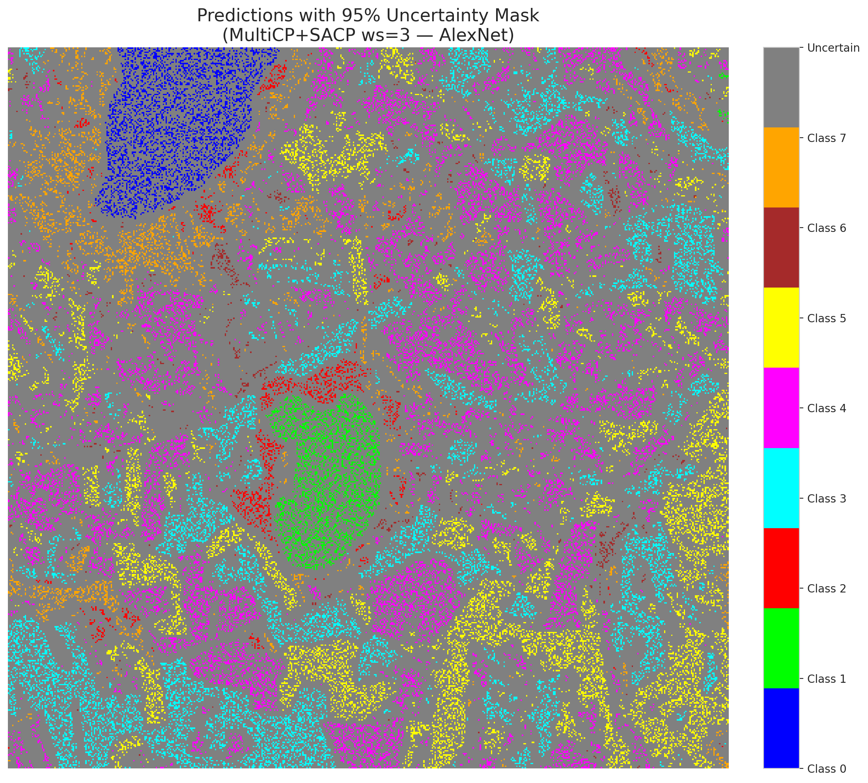 | (B) GFNet (SAPS, w=3)  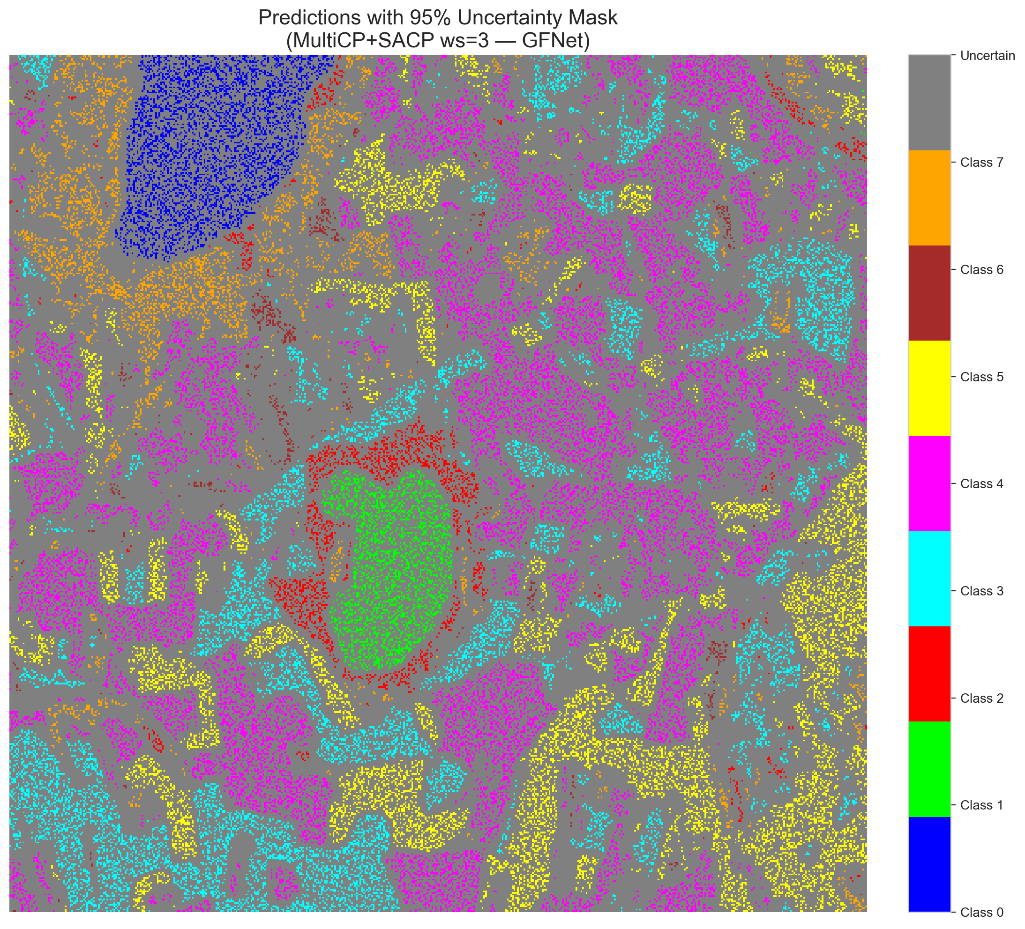
(C) ViT-UNet (SAPS, w=3)  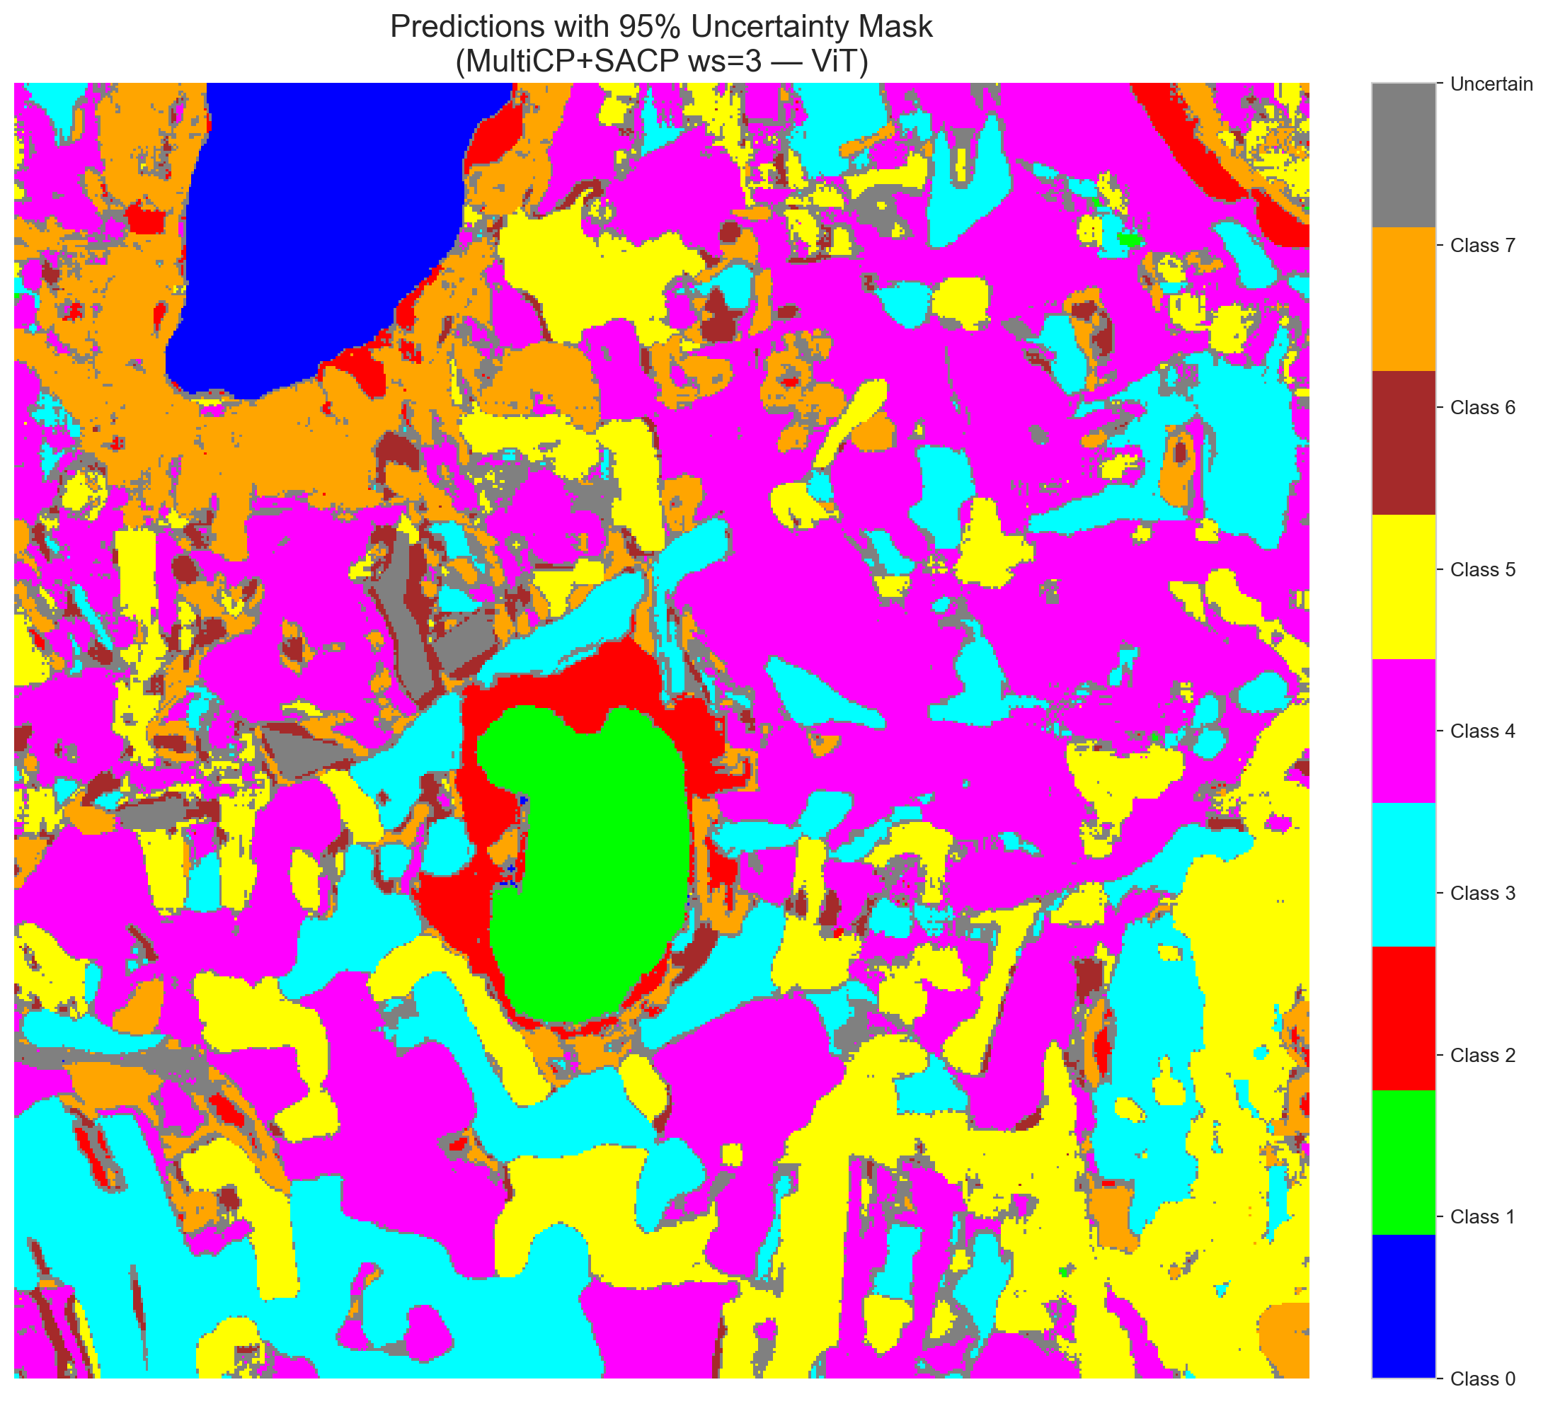 | (D) Class Legend
Fig. 7(b). SCMCP (SAPS score, w = 3, α = 0.05, λ = 0.5) masked class prediction maps across the 512 × 512 DIAS scene: (A) AlexNet-CNN, (B) GFNet, (C) ViT-UNet, and (D) Class Legend. Colours denote predicted land-cover classes (Classes 0–7); grey denotes uncertain pixels.
B. Window Size w = 5 (24 Neighbours)
At w = 5 (24 neighbours), spatial smoothing across the 5 × 5 neighbourhood stabilises top-class rankings across all 7 heads and transitions SAPS to the 2.0 set-size threshold. As a result, SAPS uncertain pixel counts drop to the global minimums of the study: AlexNet SAPS flags 28,086 uncertain pixels (10.71%) with 0.6941 empirical coverage (0.6928 mean per-class coverage), and GFNet SAPS flags 29,111 uncertain pixels (11.10%) with 0.7002 empirical coverage (0.7017 mean per-class coverage). ViT-UNet SAPS flags 35,398 uncertain pixels (13.50%) with 0.7033 coverage. Under RAPS at w = 5, boundary uncertainty halos broaden slightly, with GFNet flagging 46,037 pixels (17.56%), ViT-UNet flagging 54,536 pixels (20.80%), and AlexNet flagging 54,973 pixels (20.97%).
TABLE XXIII
SCMCP AGGREGATE SUMMARY (w = 5, α = 0.05, λ = 0.5)
Model | Score | Emp. Cov. | Avg Set Size | Scn. Cov. | Unc. Rate | Mean Cls Cov. | Runtime (s)
AlexNet | RAPS | 0.6892 | 0.6895 | 0.1701 | 0.2097 | 0.6873 | 143.47
AlexNet | SAPS | 0.6941 | 0.6944 | 0.1537 | 0.1071 | 0.6928 | 141.95
GFNet | RAPS | 0.7052 | 0.7054 | 0.1653 | 0.1756 | 0.7024 | 144.22
GFNet | SAPS | 0.7002 | 0.7002 | 0.1545 | 0.1110 | 0.7017 | 142.97
ViT | RAPS | 0.7033 | 0.7116 | 0.1770 | 0.2080 | 0.7173 | 139.13
ViT | SAPS | 0.7033 | 0.7080 | 0.1616 | 0.1350 | 0.7190 | 138.64

TABLE XXIV
SCMCP PER-CLASS COVERAGE (w = 5, RAPS AND SAPS)
Class | AlexNet (RAPS) | GFNet (RAPS) | ViT-UNet (RAPS) | AlexNet (SAPS) | GFNet (SAPS) | ViT-UNet (SAPS)
Class 0 | 0.7039 | 0.7270 | 0.6809 | 0.7064 | 0.6900 | 0.6678
Class 1 | 0.6705 | 0.7102 | 0.6932 | 0.6889 | 0.7315 | 0.6918
Class 2 | 0.6890 | 0.7102 | 0.7350 | 0.6643 | 0.6678 | 0.7491
Class 3 | 0.6806 | 0.6835 | 0.7077 | 0.6872 | 0.6908 | 0.6908
Class 4 | 0.6912 | 0.7195 | 0.6937 | 0.6881 | 0.7031 | 0.7164
Class 5 | 0.6988 | 0.6922 | 0.7016 | 0.7092 | 0.6997 | 0.7044
Class 6 | 0.7050 | 0.7050 | 0.7200 | 0.7200 | 0.7150 | 0.7600
Class 7 | 0.6594 | 0.6719 | 0.8063 | 0.6781 | 0.7156 | 0.7719
Mean | 0.6873 | 0.7024 | 0.7173 | 0.6928 | 0.7017 | 0.7190

TABLE XXV
SCMCP PIXEL COUNT DISTRIBUTION (w = 5, 262,144 SCENE PIXELS)
Class / Region | AlexNet (RAPS) | GFNet (RAPS) | ViT-UNet (RAPS) | AlexNet (SAPS) | GFNet (SAPS) | ViT-UNet (SAPS)
Class 0 | 10,915 | 11,292 | 11,493 | 11,029 | 11,426 | 11,665
Class 1 | 7,721 | 7,332 | 7,722 | 7,980 | 7,409 | 7,943
Class 2 | 7,213 | 9,928 | 6,354 | 8,190 | 10,676 | 6,841
Class 3 | 45,722 | 42,977 | 38,446 | 50,746 | 46,277 | 40,993
Class 4 | 65,713 | 78,403 | 78,752 | 73,859 | 83,472 | 84,649
Class 5 | 43,566 | 41,266 | 41,983 | 47,982 | 44,207 | 46,045
Class 6 | 5,166 | 3,968 | 3,280 | 8,077 | 5,169 | 4,630
Class 7 | 21,155 | 20,941 | 19,578 | 26,195 | 24,397 | 23,980
Uncertain | 54,973 | 46,037 | 54,536 | 28,086 | 29,111 | 35,398
Total (Scene) | 262,144 | 262,144 | 262,144 | 262,144 | 262,144 | 262,144

(A) AlexNet-CNN (RAPS, w=5)  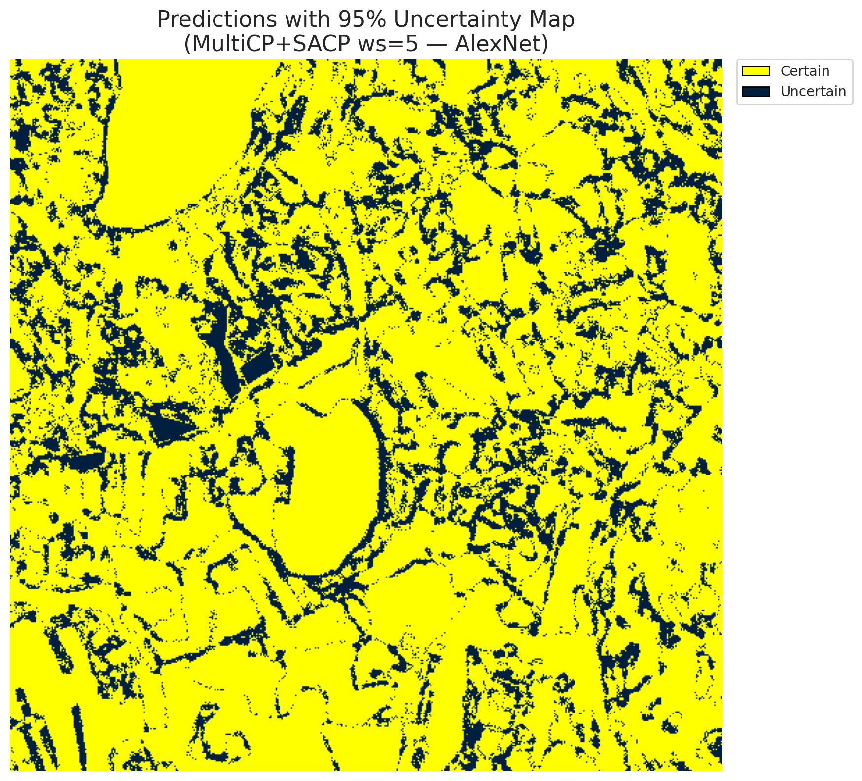 | (B) GFNet (RAPS, w=5)  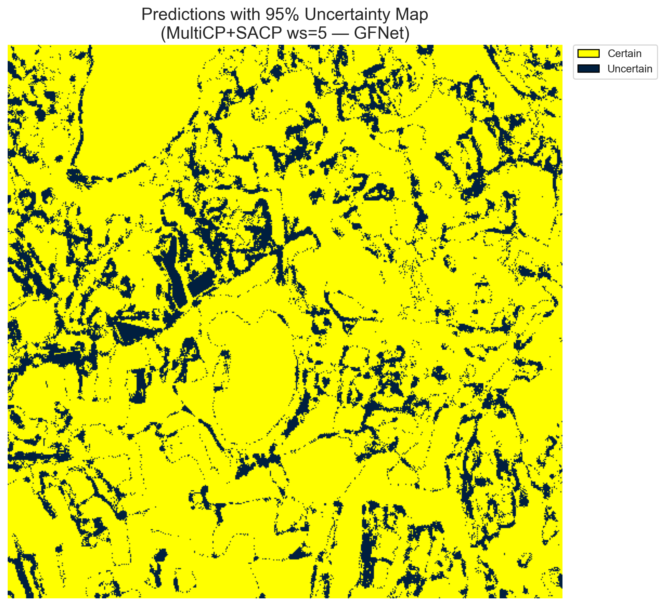
(C) ViT-UNet (RAPS, w=5)  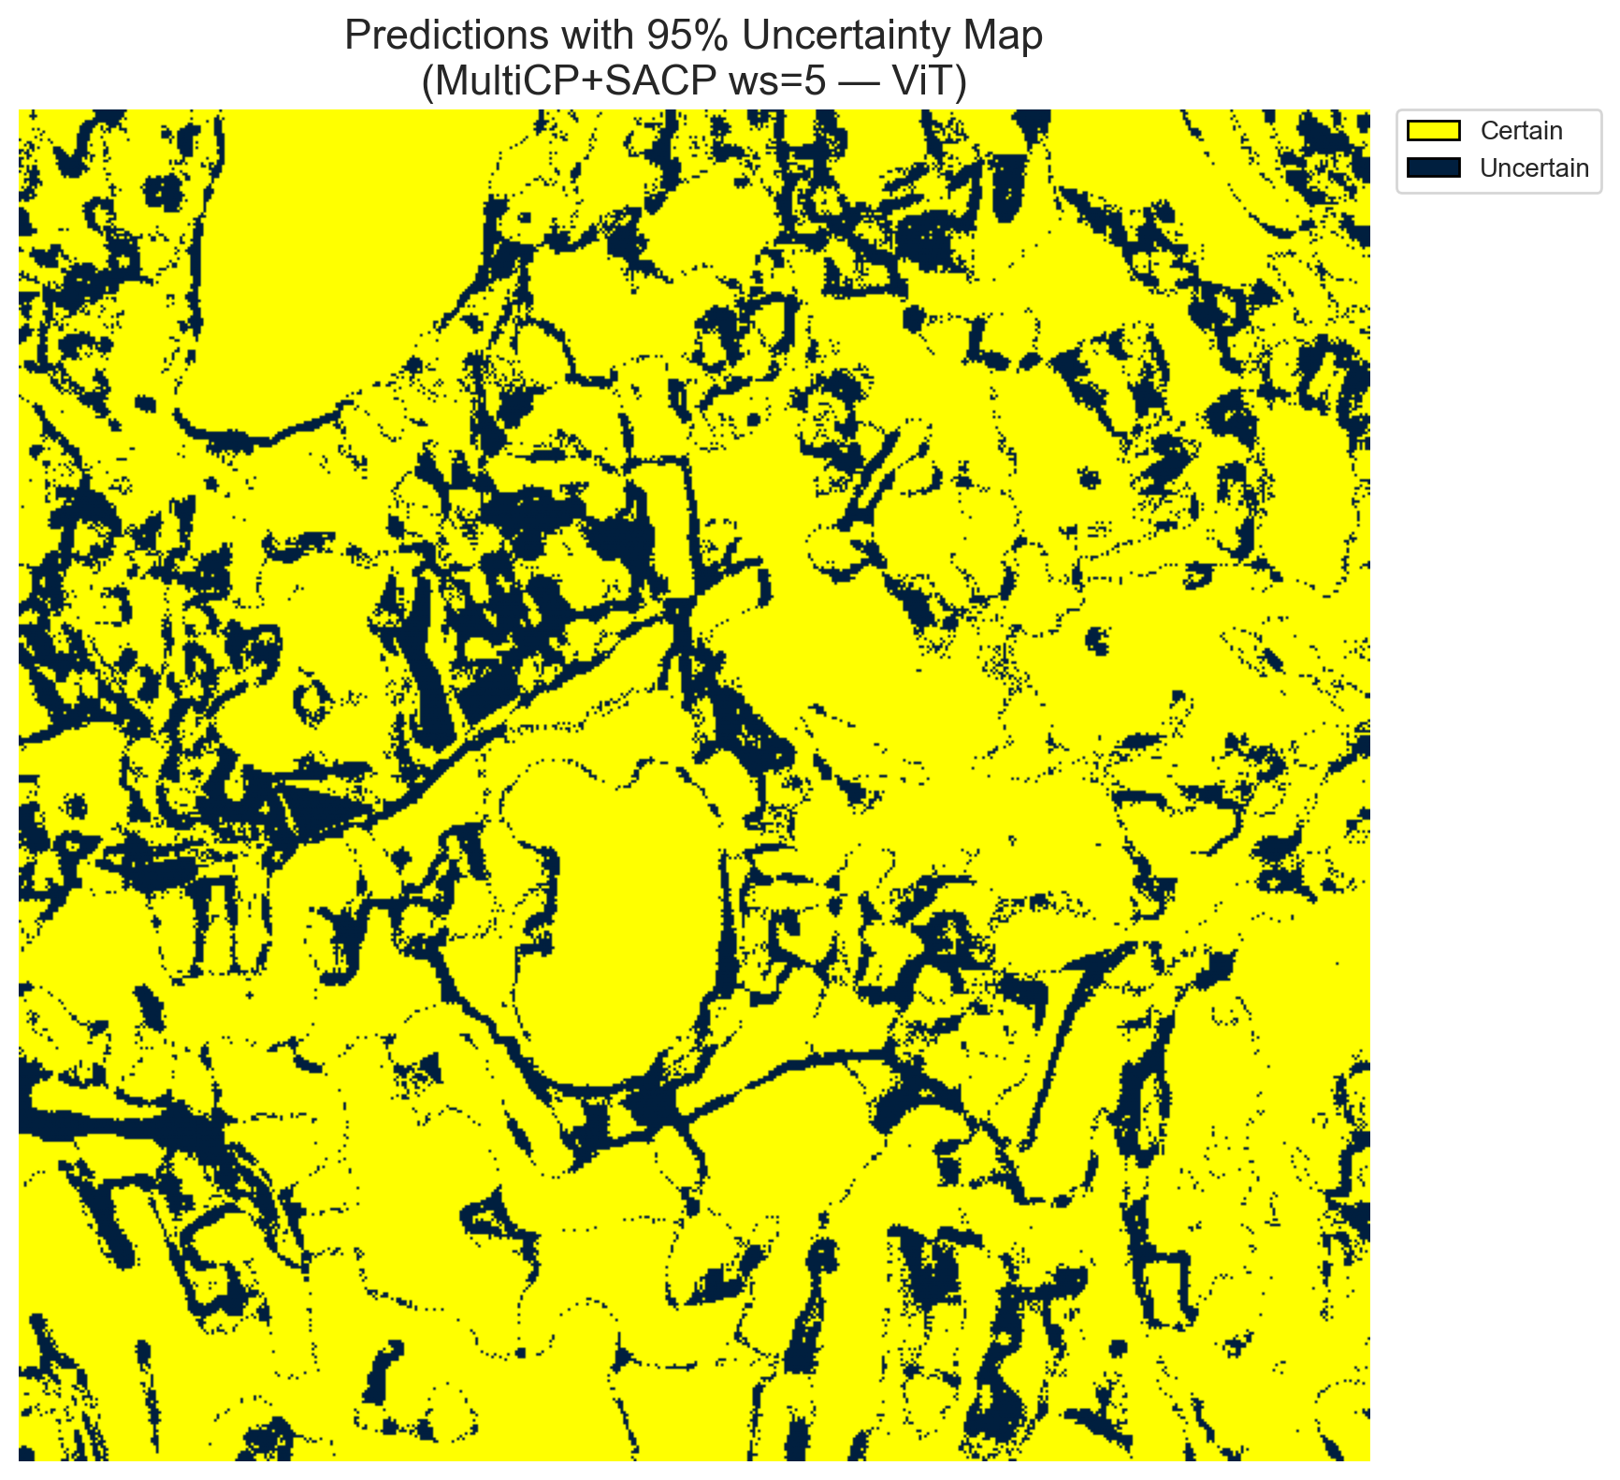 | (D) Binary Legend
Fig. 8(a). SCMCP (RAPS score, w = 5, α = 0.05, λ = 0.5) binary uncertainty maps across the 512 × 512 DIAS scene: (A) AlexNet-CNN (54,973 uncertain pixels, 20.97%), (B) GFNet (46,037 uncertain pixels, 17.56%), (C) ViT-UNet (54,536 uncertain pixels, 20.80%), and (D) Binary Legend. Yellow = certain singleton; dark navy = uncertain pixel.
(A) AlexNet-CNN (RAPS, w=5)  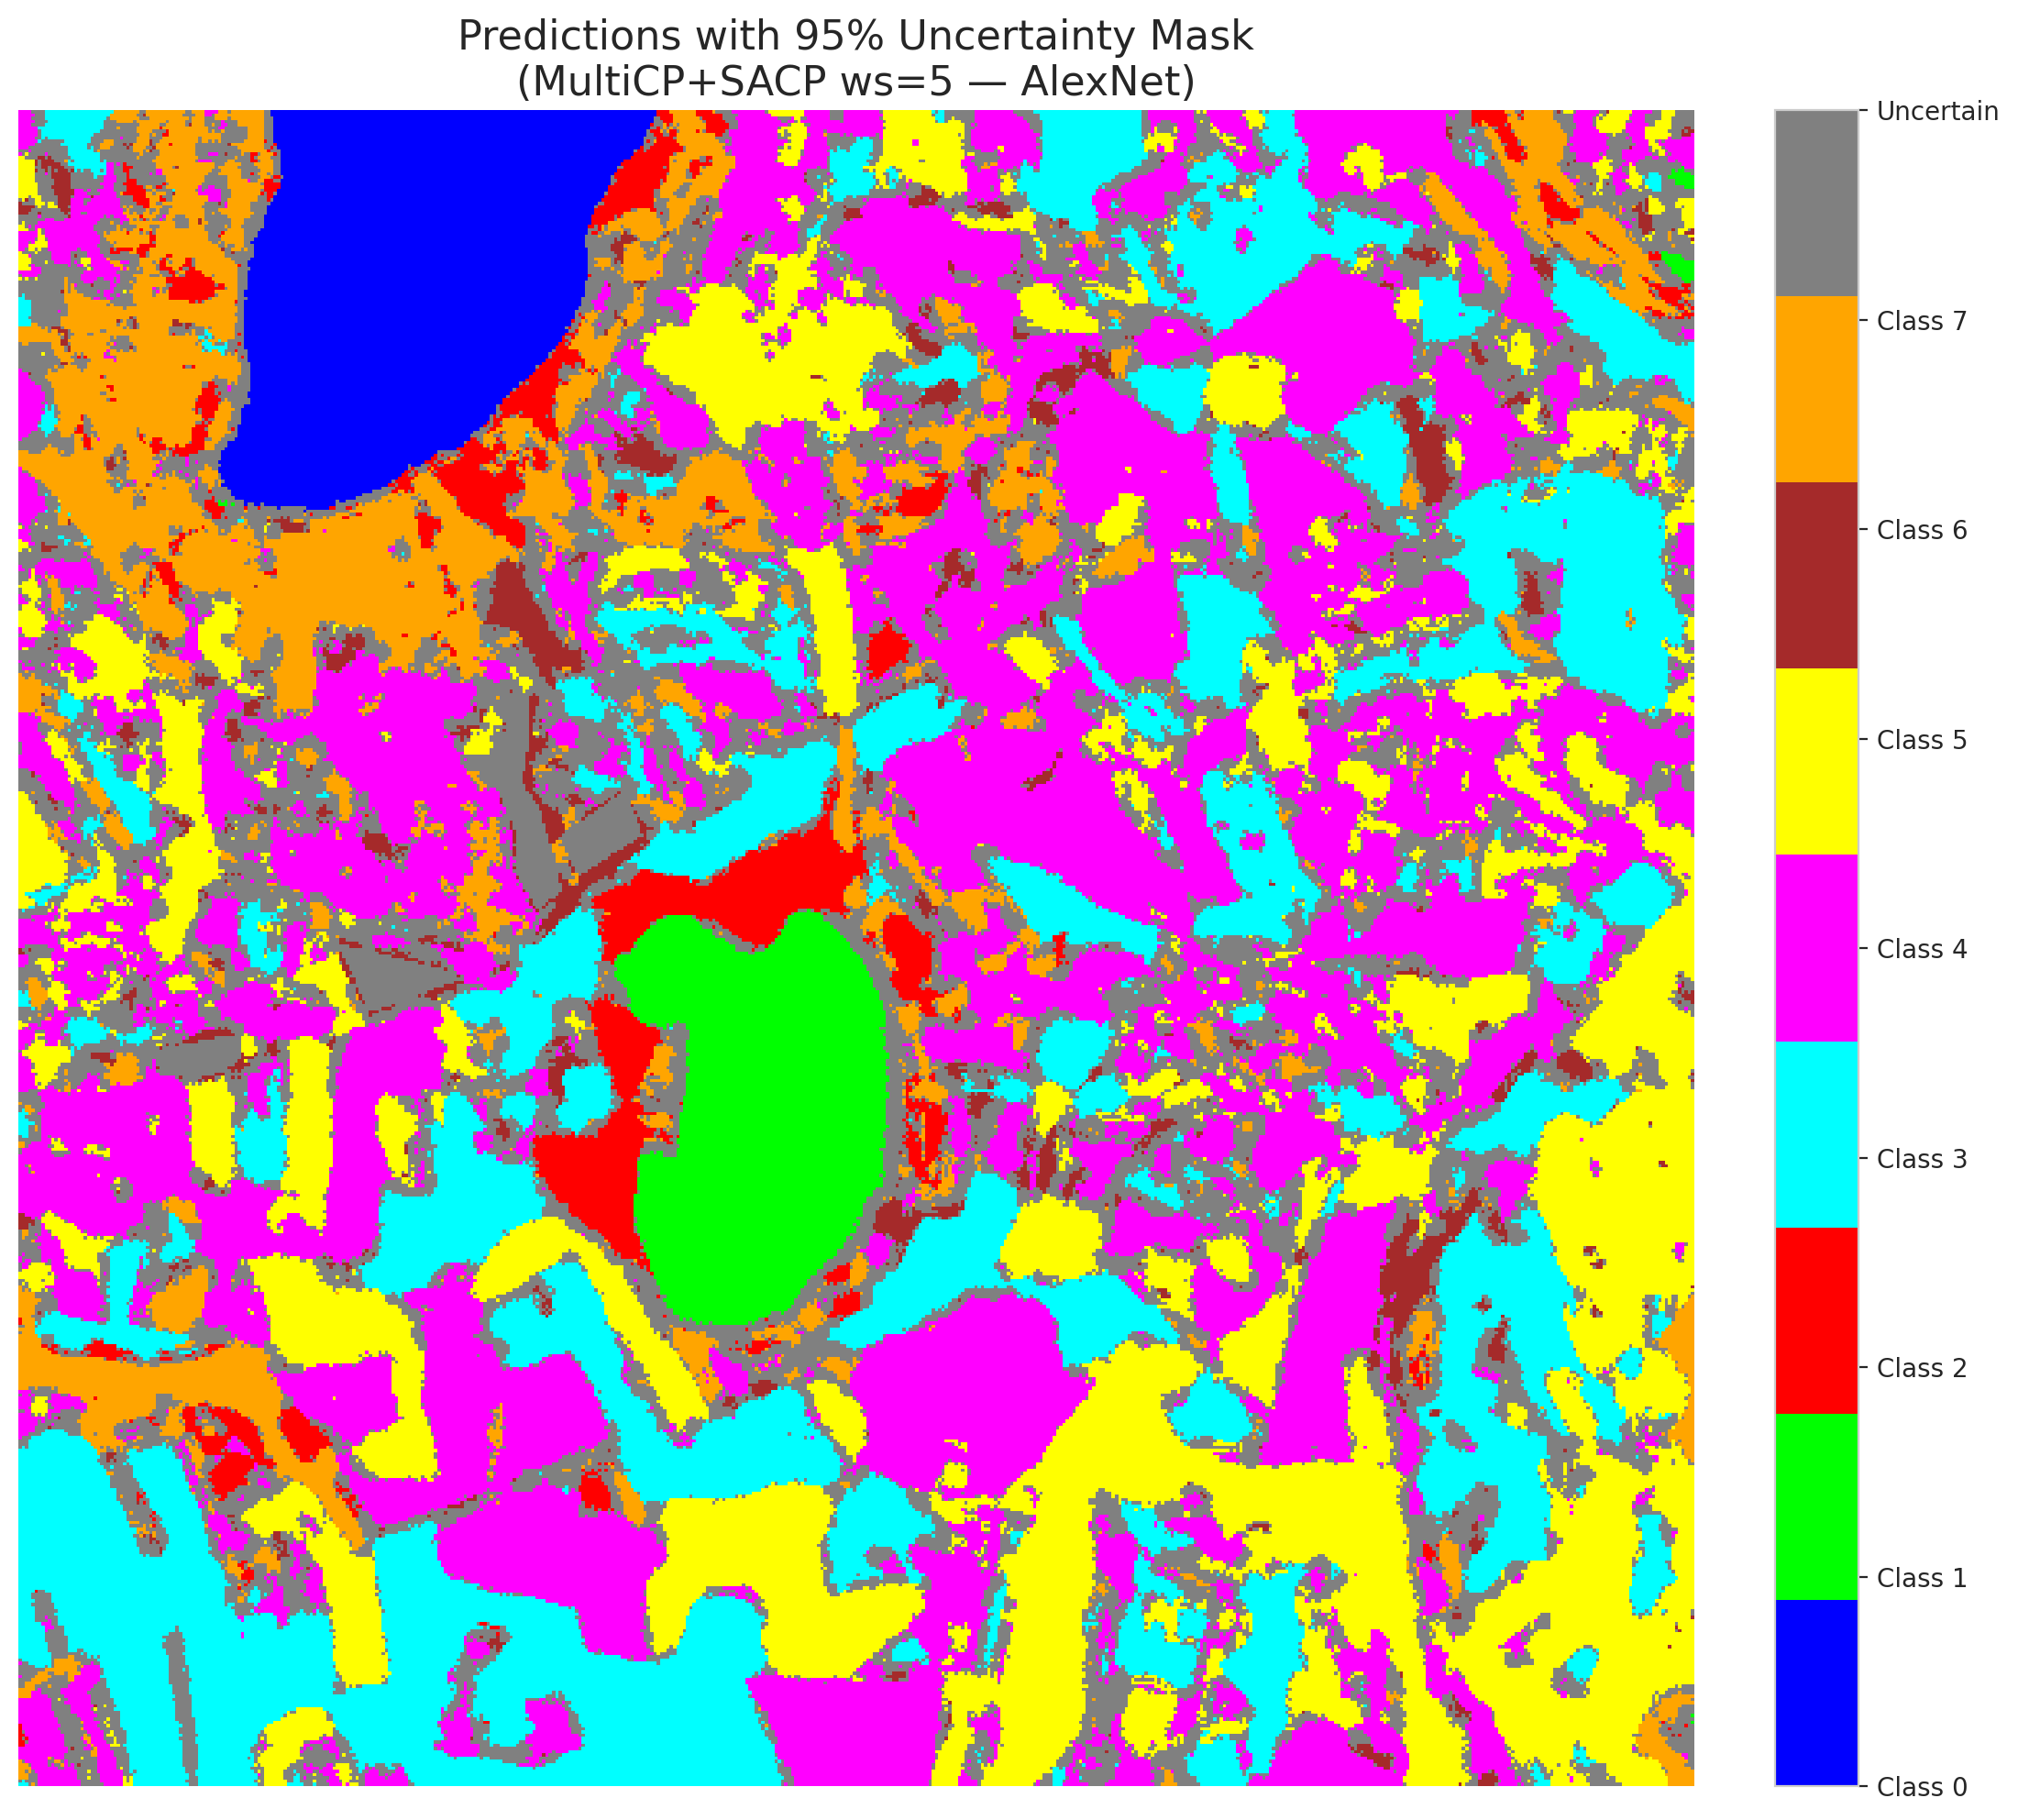 | (B) GFNet (RAPS, w=5)  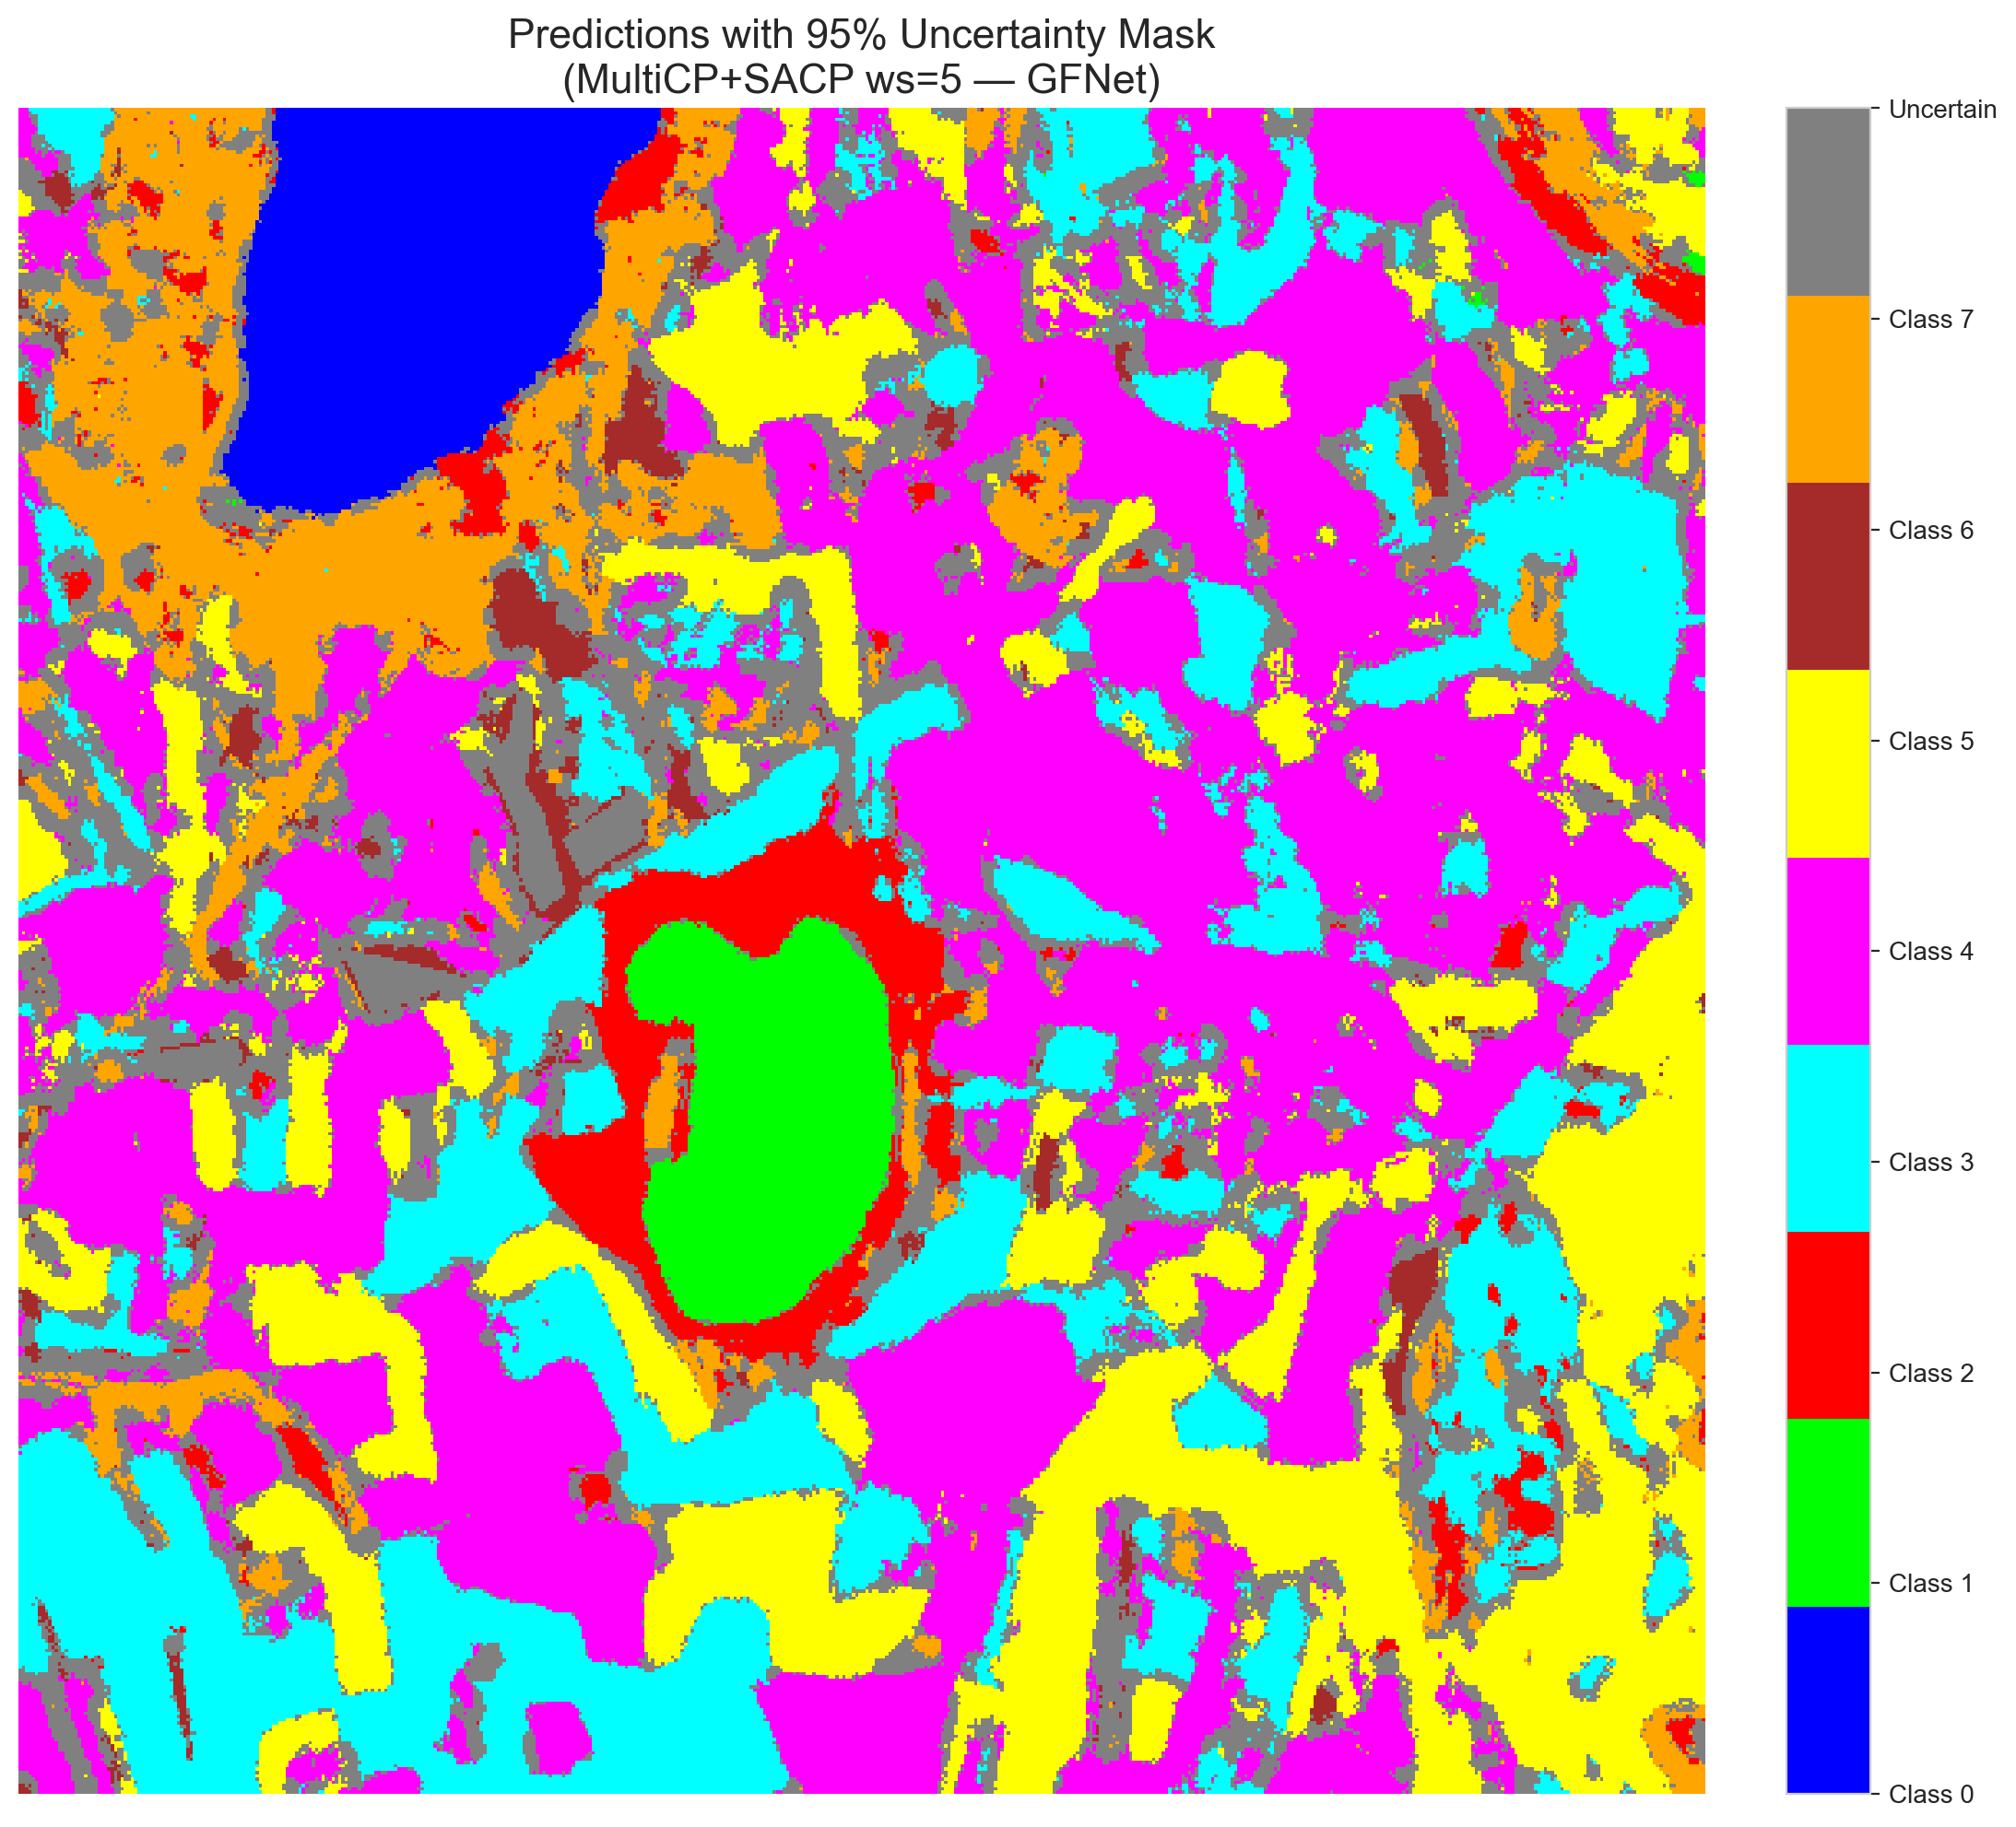
(C) ViT-UNet (RAPS, w=5)  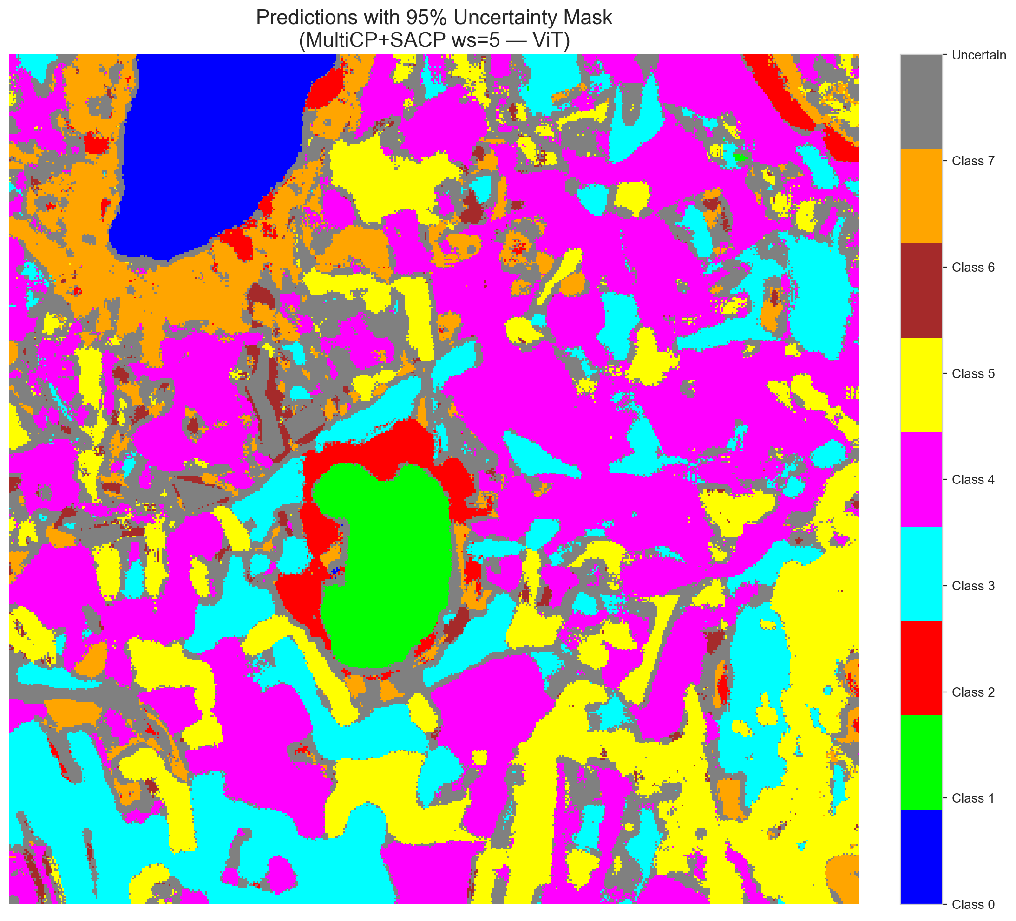 | (D) Class Legend
Fig. 8(b). SCMCP (RAPS score, w = 5, α = 0.05, λ = 0.5) masked class prediction maps across the 512 × 512 DIAS scene: (A) AlexNet-CNN, (B) GFNet, (C) ViT-UNet, and (D) Class Legend. Colours denote predicted land-cover classes (Classes 0–7); grey denotes uncertain pixels.
(A) AlexNet-CNN (SAPS, w=5)  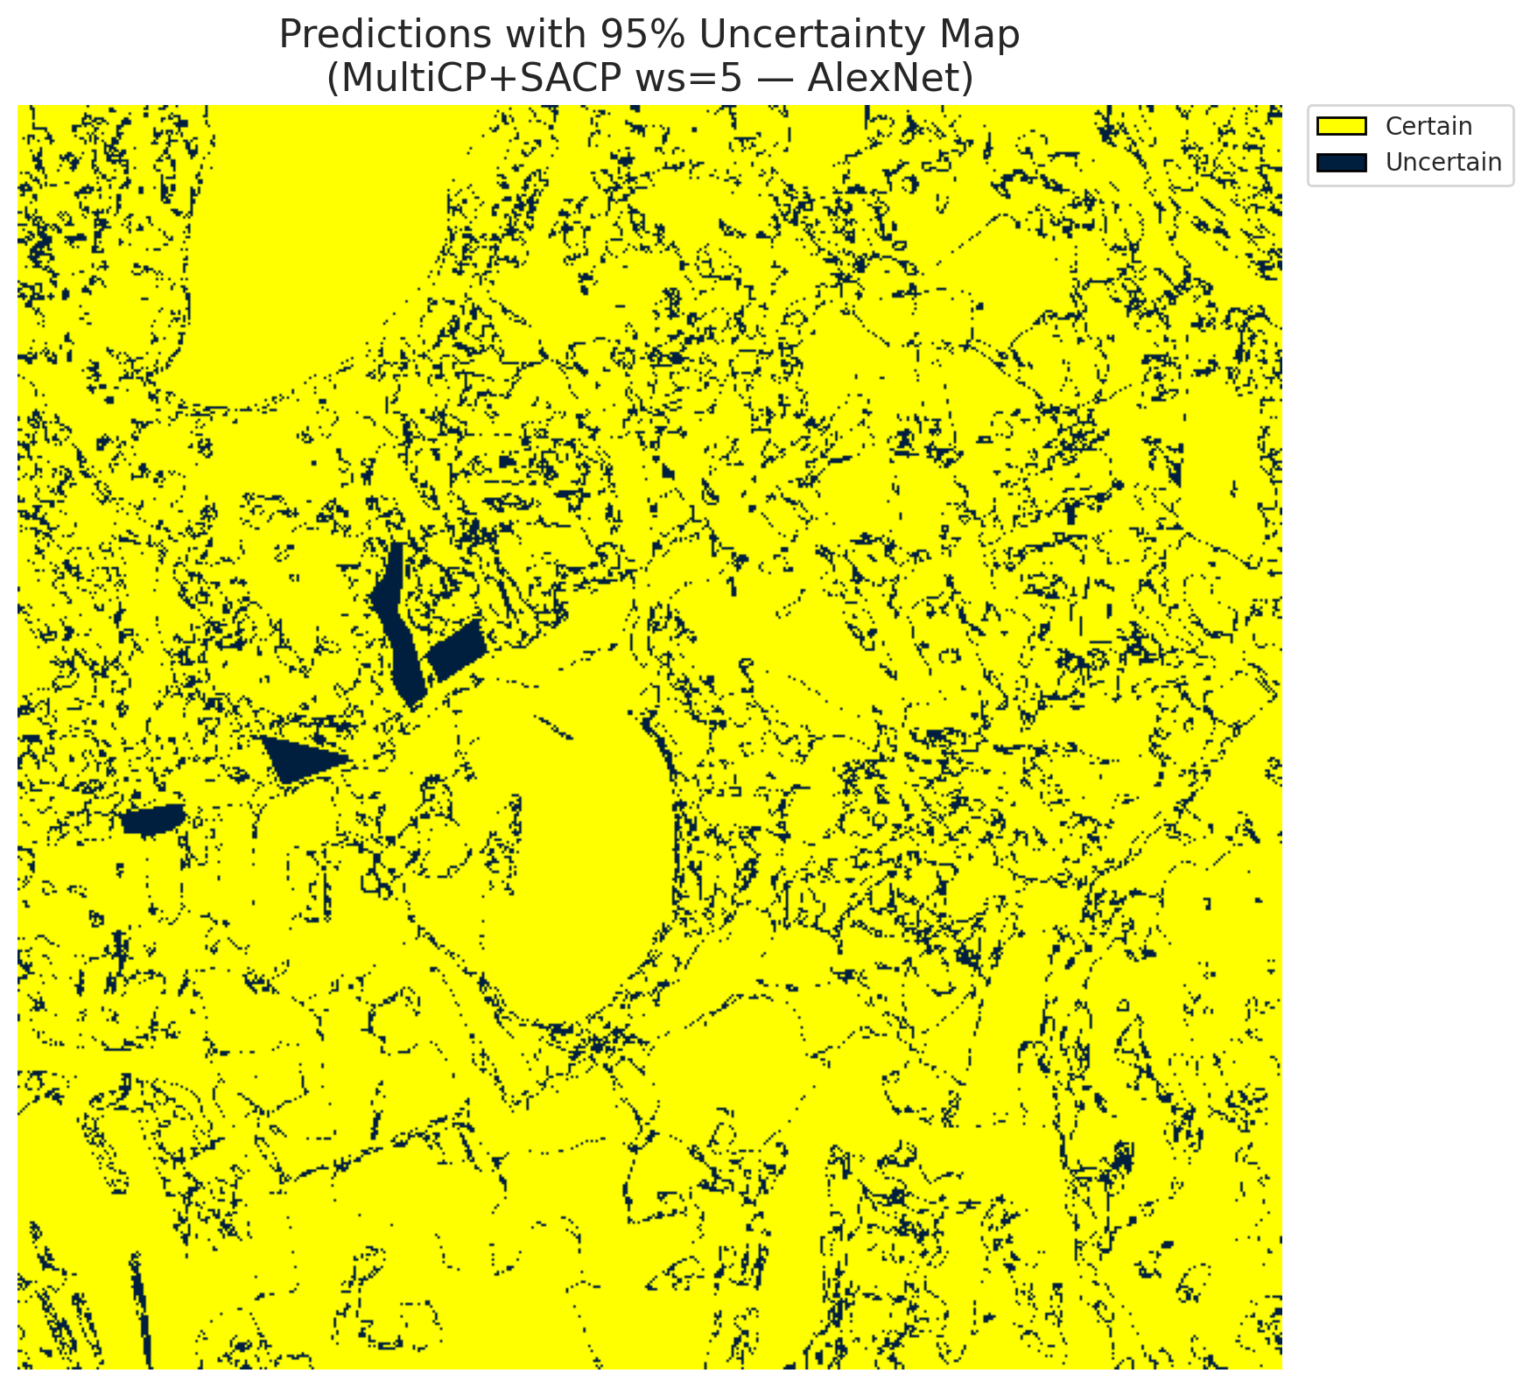 | (B) GFNet (SAPS, w=5)  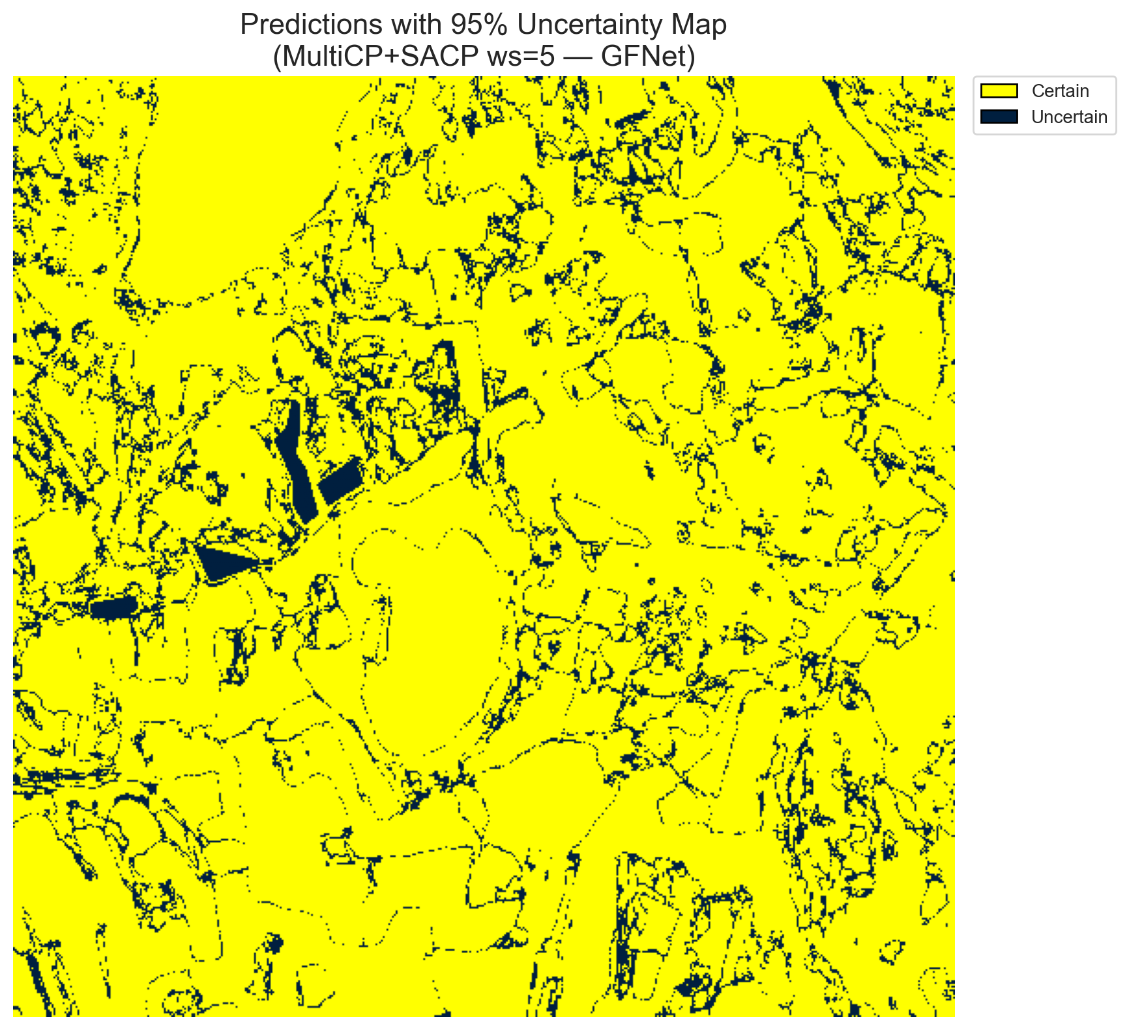
(C) ViT-UNet (SAPS, w=5)  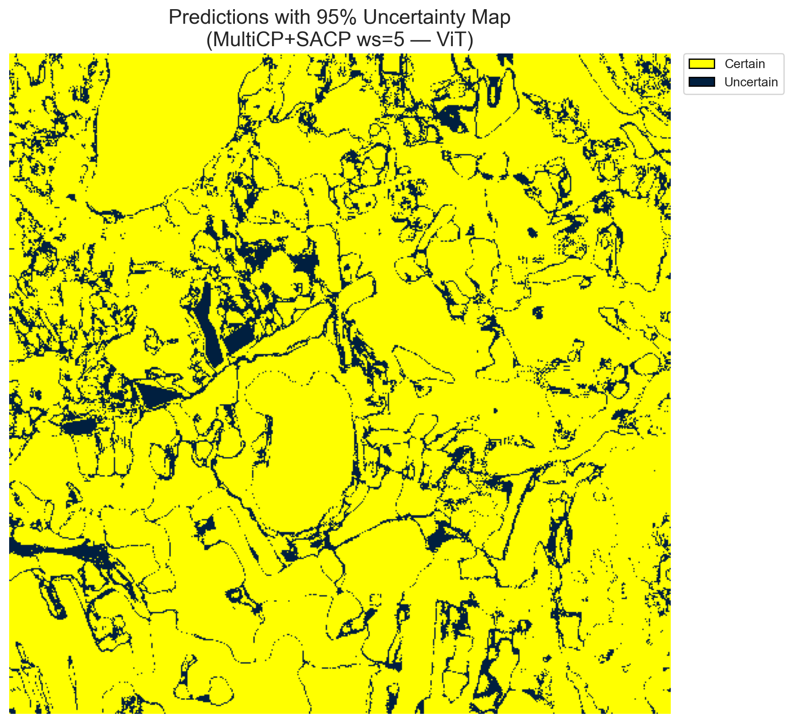 | (D) Binary Legend
Fig. 9(a). SCMCP (SAPS score, w = 5, α = 0.05, λ = 0.5) binary uncertainty maps across the 512 × 512 DIAS scene: (A) AlexNet-CNN (28,086 uncertain pixels, 10.71%), (B) GFNet (29,111 uncertain pixels, 11.10%), (C) ViT-UNet (35,398 uncertain pixels, 13.50%), and (D) Binary Legend. Yellow = certain singleton; dark navy = uncertain pixel.
(A) AlexNet-CNN (SAPS, w=5)  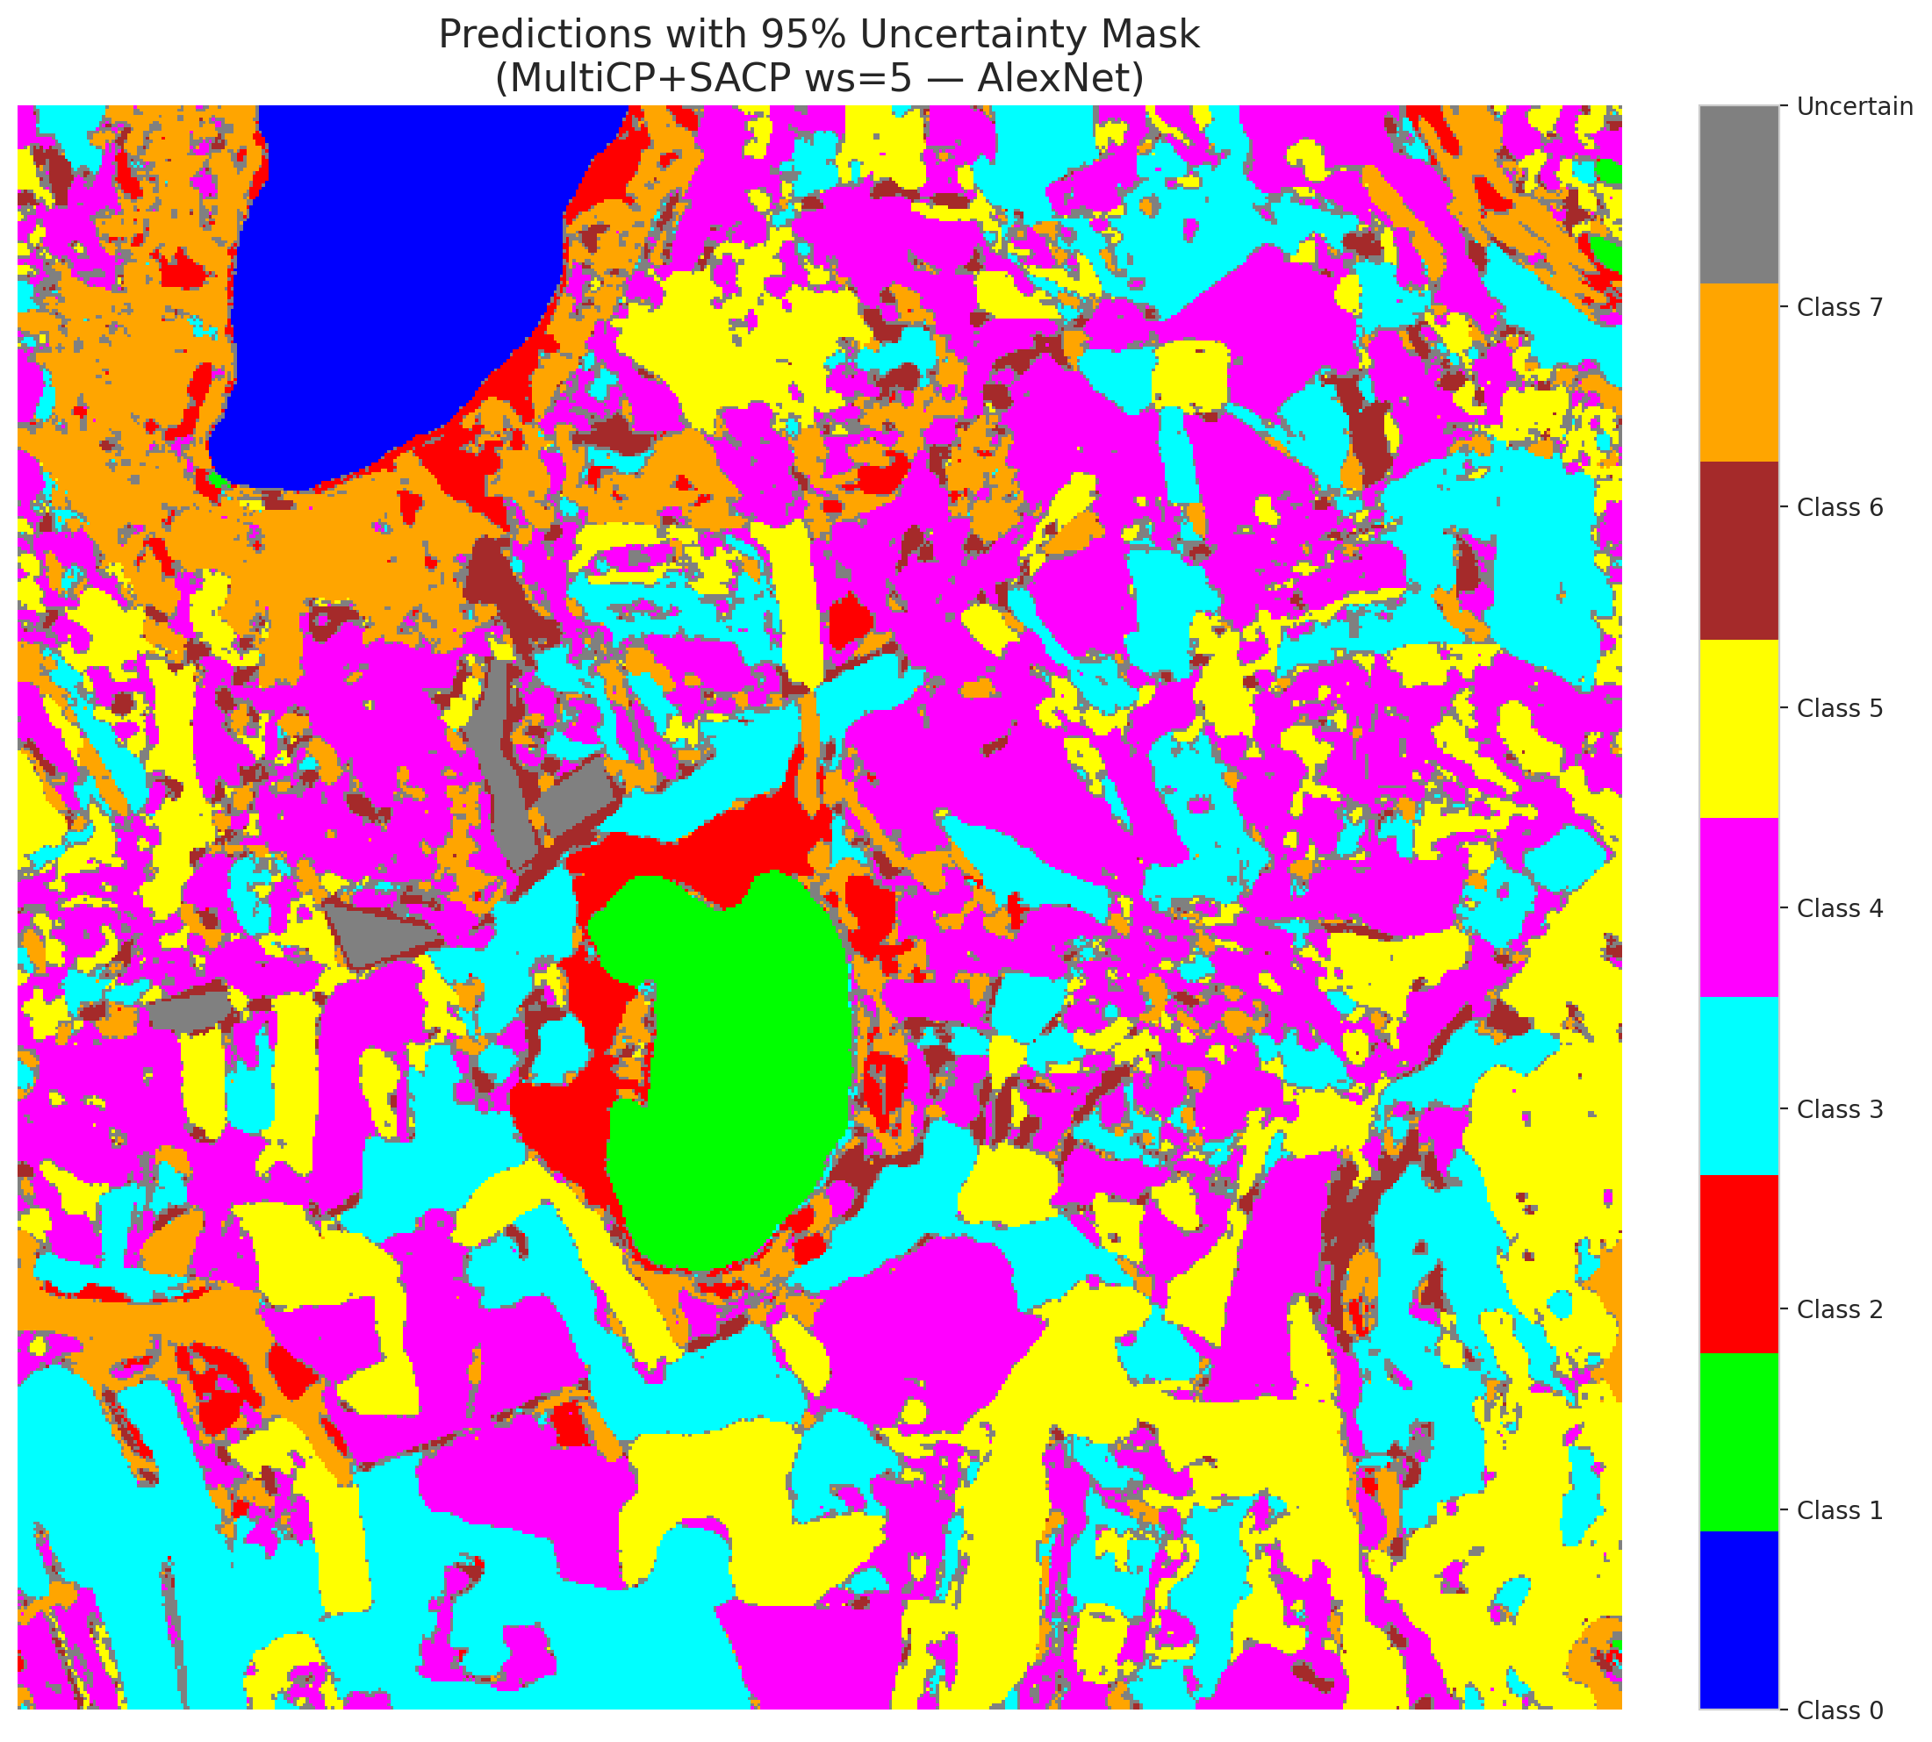 | (B) GFNet (SAPS, w=5)  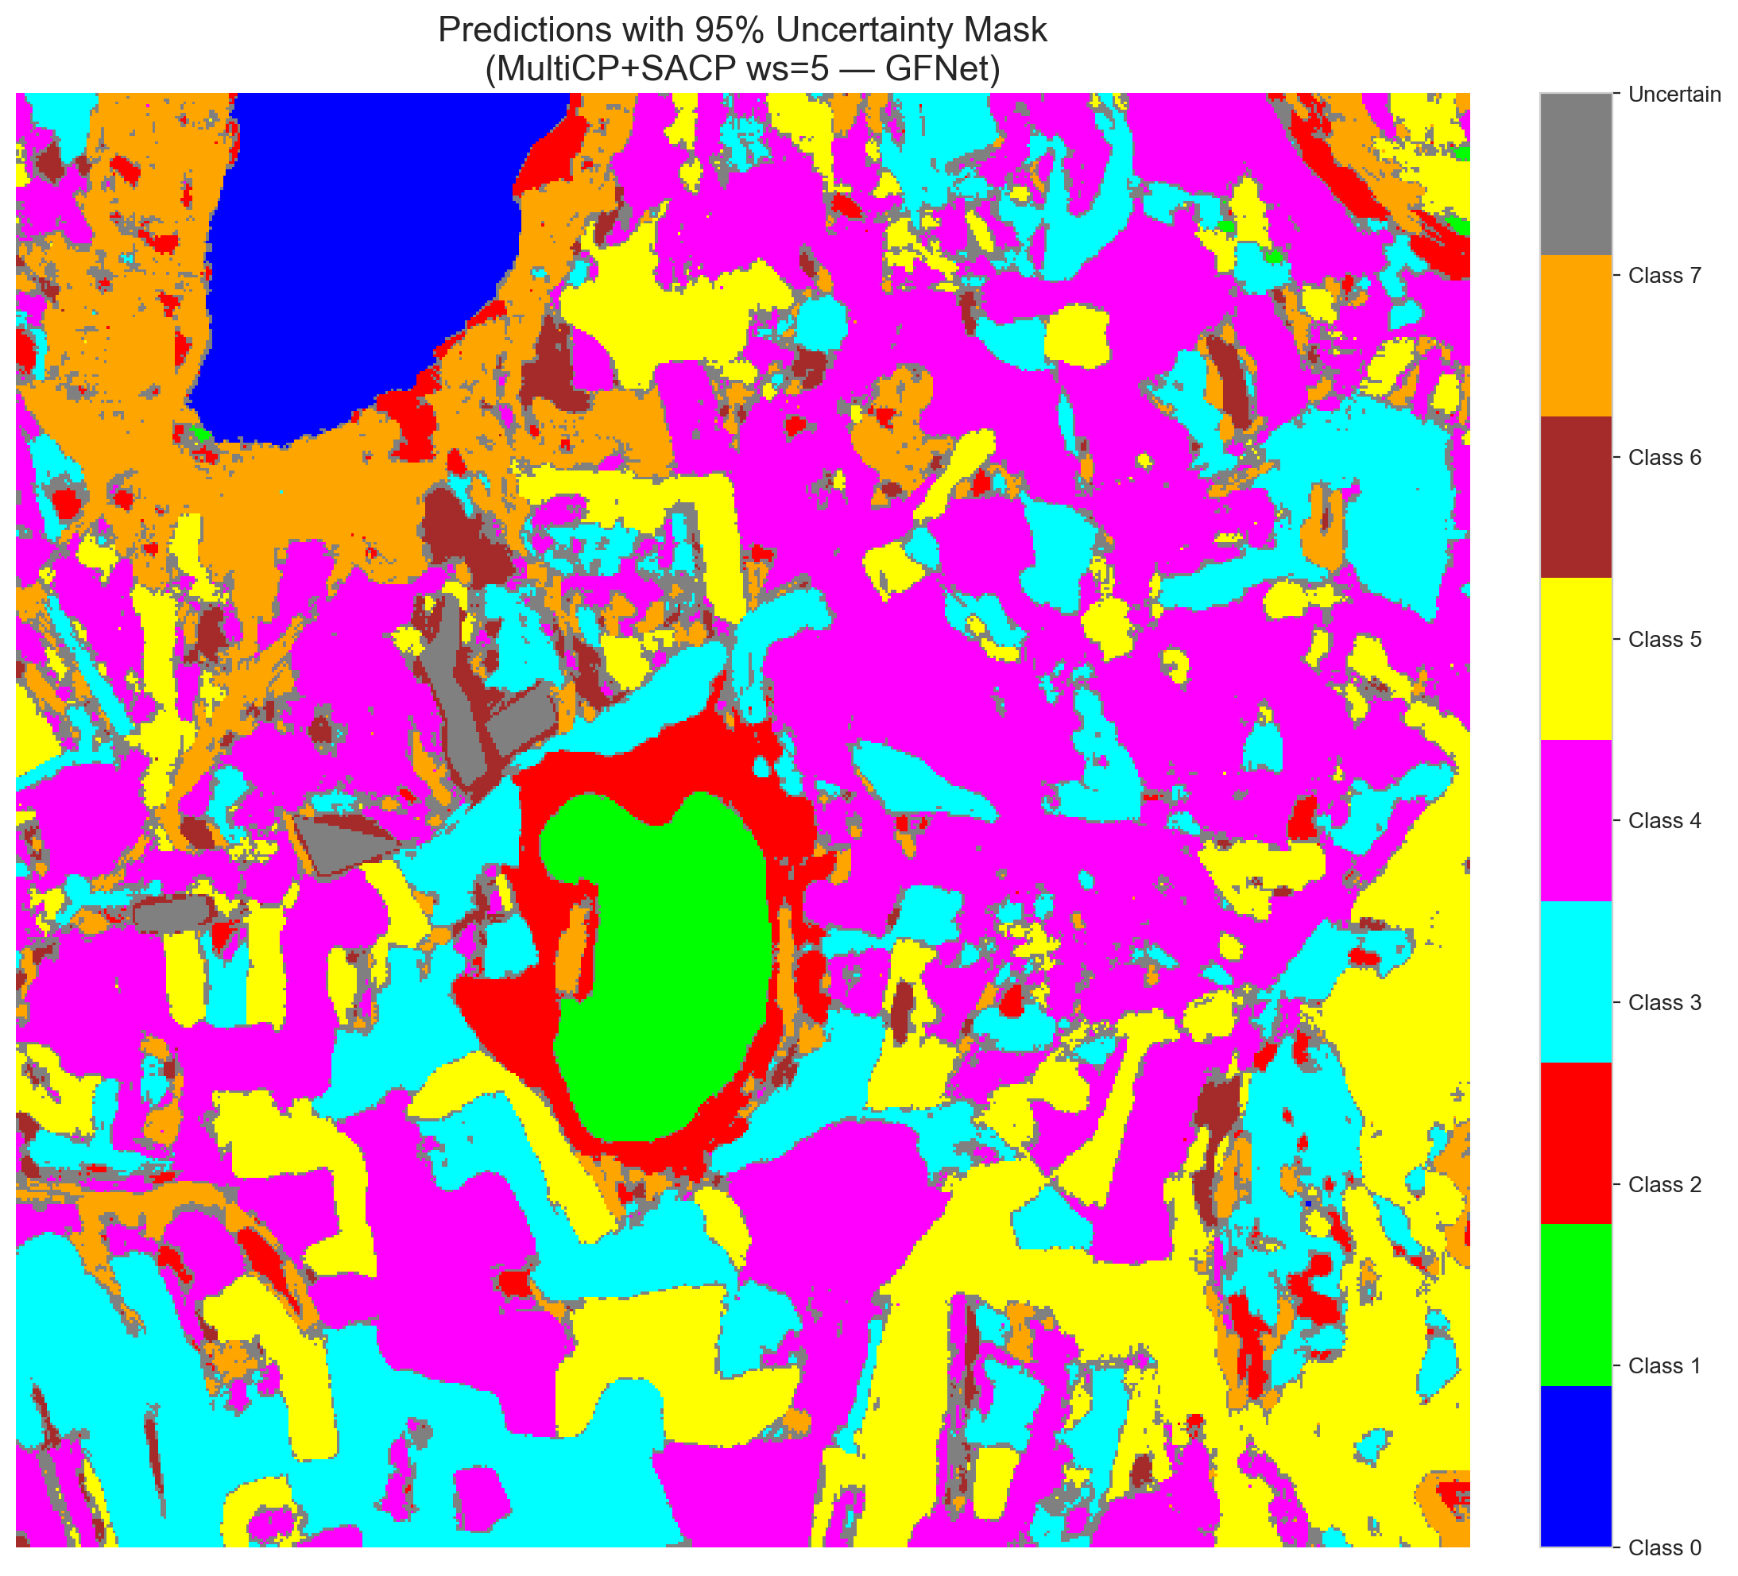
(C) ViT-UNet (SAPS, w=5)  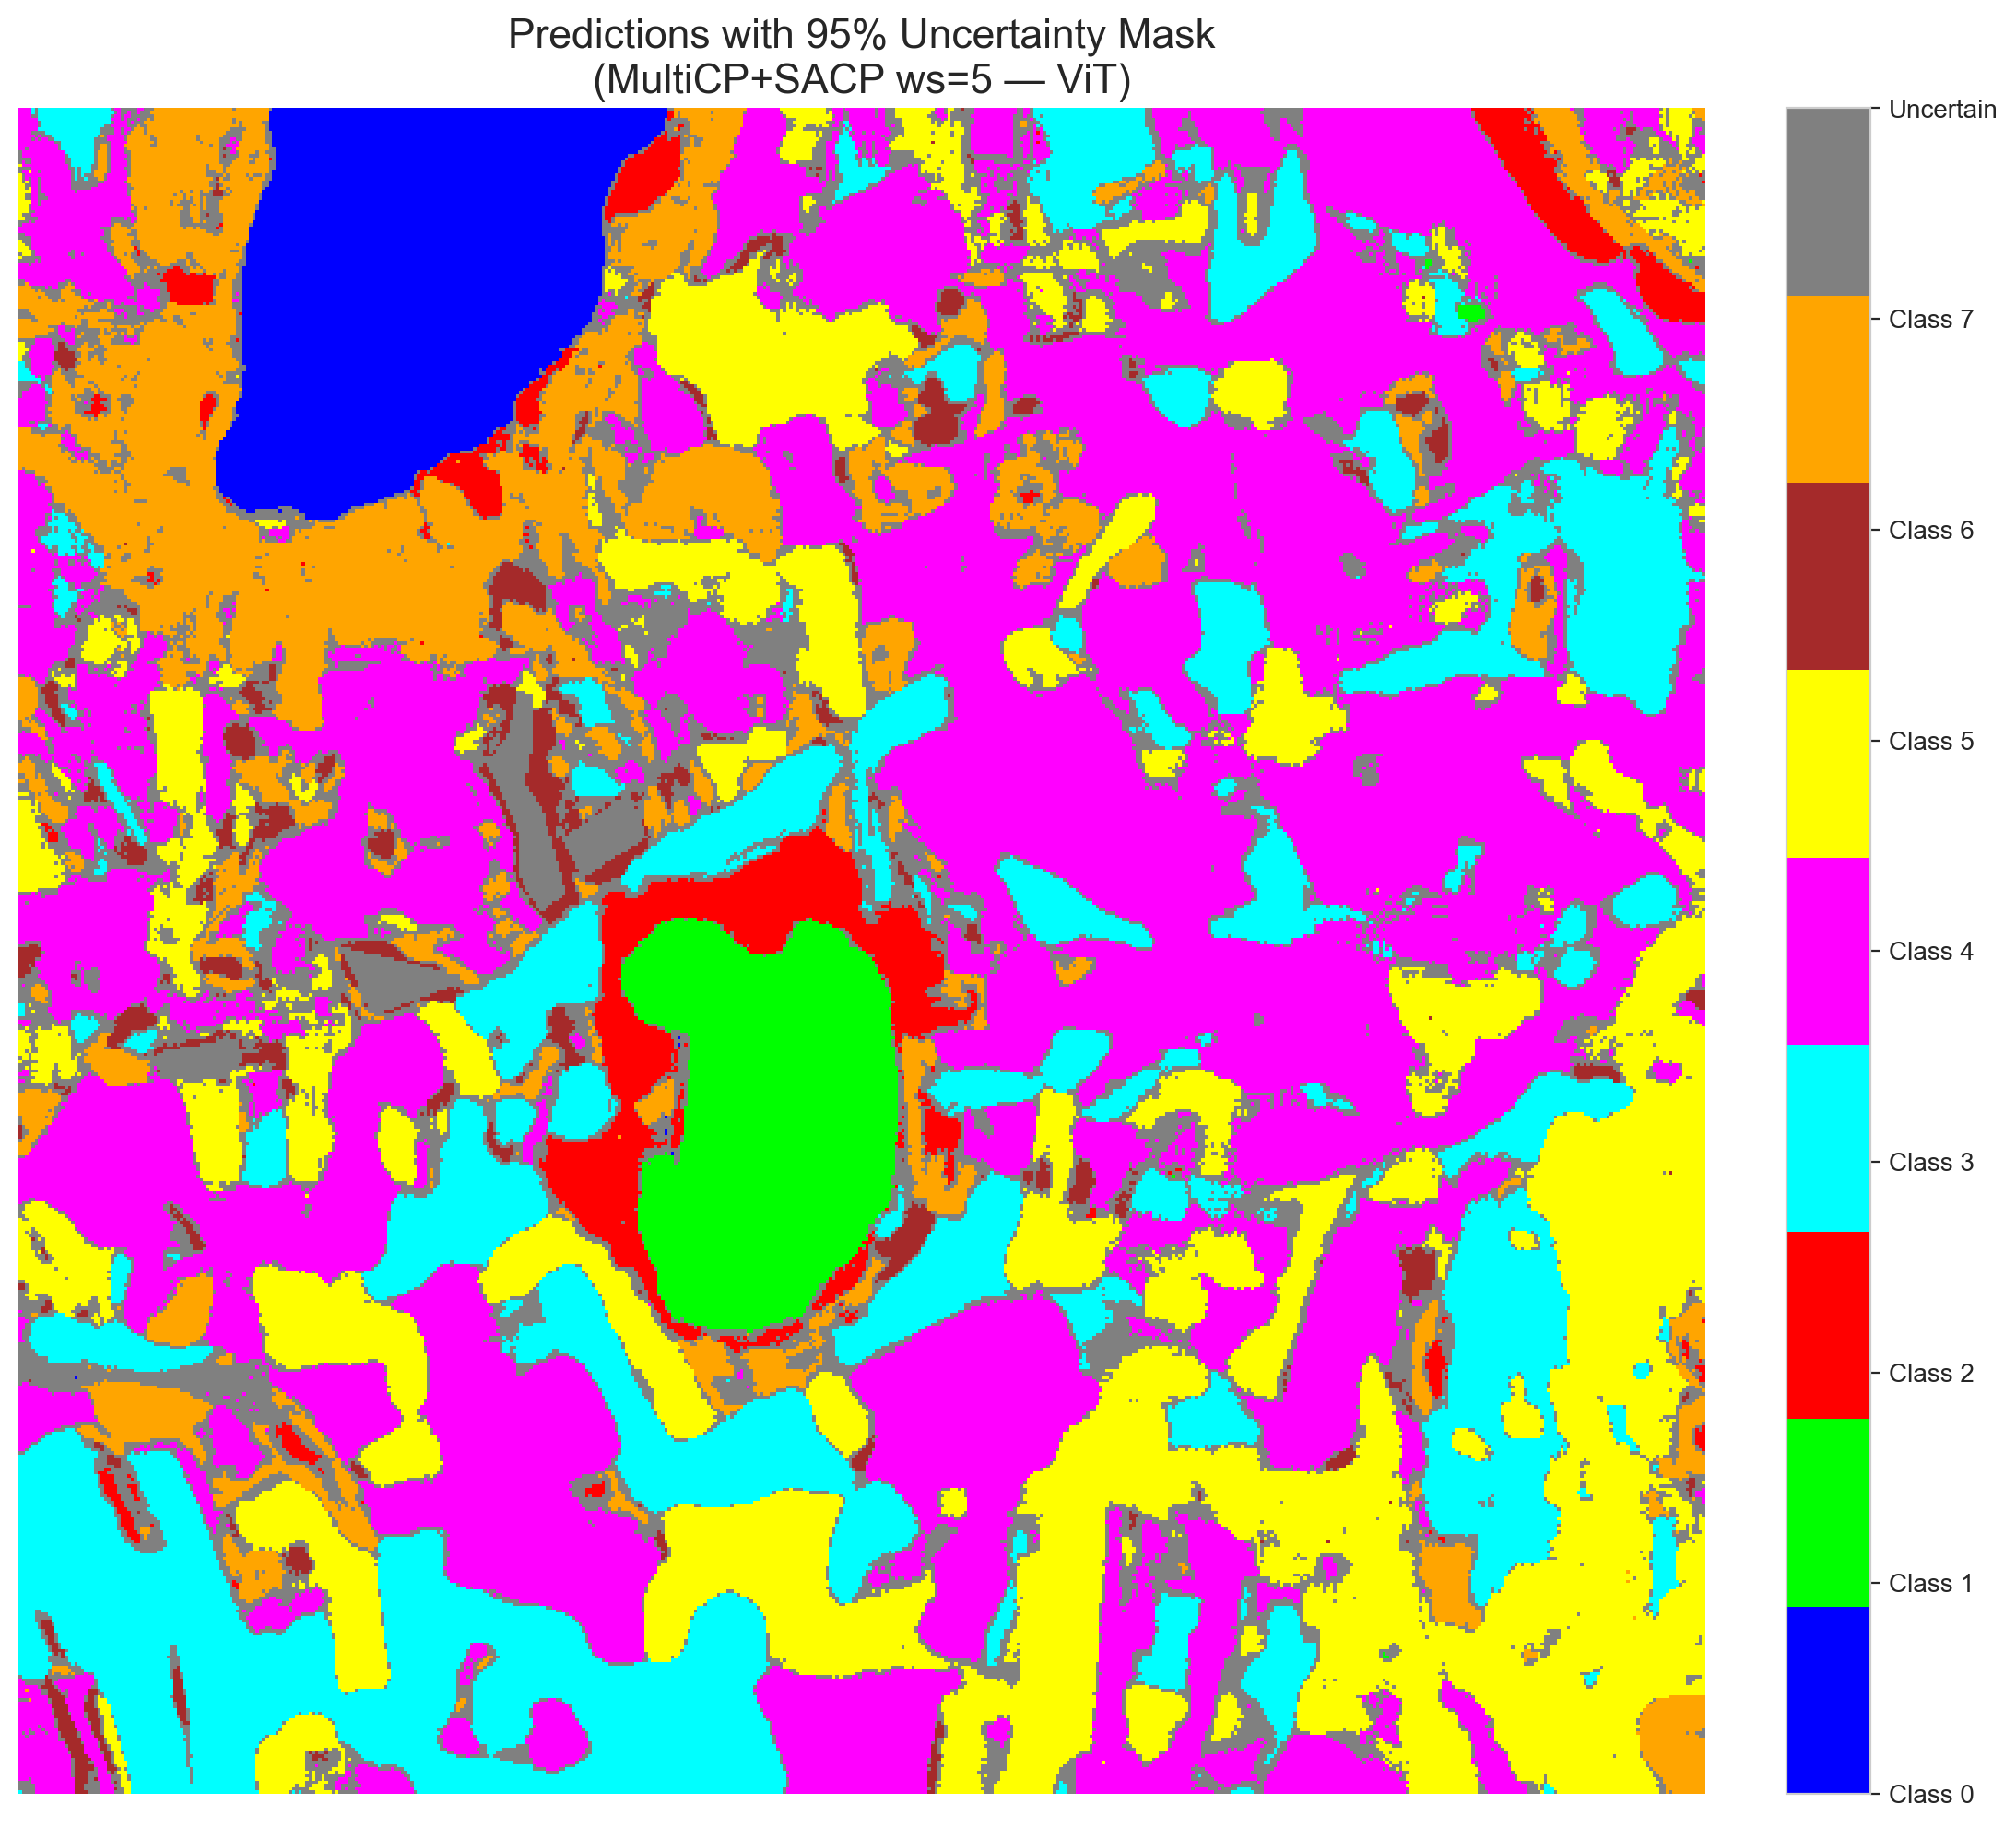 | (D) Class Legend
Fig. 9(b). SCMCP (SAPS score, w = 5, α = 0.05, λ = 0.5) masked class prediction maps across the 512 × 512 DIAS scene: (A) AlexNet-CNN, (B) GFNet, (C) ViT-UNet, and (D) Class Legend. Colours denote predicted land-cover classes (Classes 0–7); grey denotes uncertain pixels.
C. Window Size w = 7 (48 Neighbours)
At w = 7 (48 neighbours), SAPS continues to outperform RAPS in spatial compactness across all three architectures: GFNet SAPS flags 32,958 uncertain pixels (12.57%, empirical coverage 0.6966), AlexNet SAPS flags 35,502 uncertain pixels (13.54%, empirical coverage 0.7028), and ViT-UNet SAPS flags 38,931 uncertain pixels (14.85%, empirical coverage 0.7037). Under RAPS, the 7 × 7 kernel widens boundary halos to 58,939 pixels (22.48%) for GFNet, 64,635 pixels (24.66%) for ViT-UNet, and 77,858 pixels (29.70%) for AlexNet, while raising full-scene coverage to 0.1769–0.1909.
TABLE XXVI
SCMCP AGGREGATE SUMMARY (w = 7, α = 0.05, λ = 0.5)
Model | Score | Emp. Cov. | Avg Set Size | Scn. Cov. | Unc. Rate | Mean Cls Cov. | Runtime (s)
AlexNet | RAPS | 0.7025 | 0.7034 | 0.1909 | 0.2970 | 0.7077 | 199.53
AlexNet | SAPS | 0.7028 | 0.7033 | 0.1608 | 0.1354 | 0.7035 | 197.77
GFNet | RAPS | 0.6981 | 0.6985 | 0.1769 | 0.2248 | 0.6989 | 197.55
GFNet | SAPS | 0.6966 | 0.6970 | 0.1593 | 0.1257 | 0.6941 | 199.98
ViT | RAPS | 0.7055 | 0.7125 | 0.1856 | 0.2466 | 0.7089 | 196.32
ViT | SAPS | 0.7037 | 0.7082 | 0.1656 | 0.1485 | 0.7175 | 198.45

TABLE XXVII
SCMCP PER-CLASS COVERAGE (w = 7, RAPS AND SAPS)
Class | AlexNet (RAPS) | GFNet (RAPS) | ViT-UNet (RAPS) | AlexNet (SAPS) | GFNet (SAPS) | ViT-UNet (SAPS)
Class 0 | 0.6941 | 0.7105 | 0.6974 | 0.6933 | 0.6850 | 0.6809
Class 1 | 0.7116 | 0.7088 | 0.6932 | 0.7031 | 0.7003 | 0.7003
Class 2 | 0.6855 | 0.6537 | 0.7067 | 0.7138 | 0.7279 | 0.7173
Class 3 | 0.7209 | 0.6945 | 0.7018 | 0.7048 | 0.7106 | 0.7106
Class 4 | 0.6994 | 0.6887 | 0.7000 | 0.7038 | 0.7025 | 0.6975
Class 5 | 0.6733 | 0.6978 | 0.7262 | 0.7101 | 0.6846 | 0.6988
Class 6 | 0.7300 | 0.7250 | 0.7150 | 0.7150 | 0.6700 | 0.7750
Class 7 | 0.7469 | 0.7125 | 0.7312 | 0.6844 | 0.6719 | 0.7594
Mean | 0.7077 | 0.6989 | 0.7089 | 0.7035 | 0.6941 | 0.7175

TABLE XXVIII
SCMCP PIXEL COUNT DISTRIBUTION (w = 7, 262,144 SCENE PIXELS)
Class / Region | AlexNet (RAPS) | GFNet (RAPS) | ViT-UNet (RAPS) | AlexNet (SAPS) | GFNet (SAPS) | ViT-UNet (SAPS)
Class 0 | 10,776 | 11,202 | 11,380 | 11,025 | 11,433 | 11,665
Class 1 | 7,487 | 7,266 | 7,619 | 7,965 | 7,396 | 7,935
Class 2 | 6,128 | 8,970 | 5,903 | 7,661 | 10,192 | 6,603
Class 3 | 41,805 | 40,234 | 36,877 | 49,828 | 45,585 | 40,342
Class 4 | 58,311 | 74,859 | 75,972 | 71,973 | 82,766 | 83,912
Class 5 | 39,239 | 38,996 | 39,847 | 46,521 | 43,640 | 45,566
Class 6 | 3,261 | 3,096 | 2,454 | 6,792 | 4,602 | 3,945
Class 7 | 17,279 | 18,582 | 17,457 | 24,877 | 23,572 | 23,245
Uncertain | 77,858 | 58,939 | 64,635 | 35,502 | 32,958 | 38,931
Total (Scene) | 262,144 | 262,144 | 262,144 | 262,144 | 262,144 | 262,144

(A) AlexNet-CNN (RAPS, w=7)  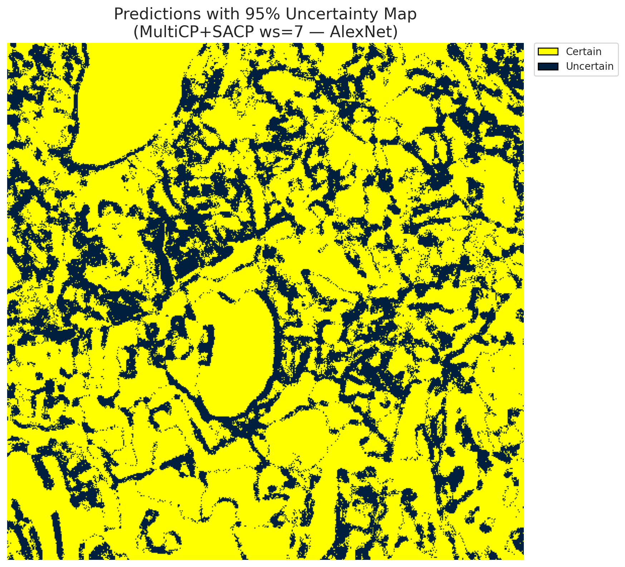 | (B) GFNet (RAPS, w=7)  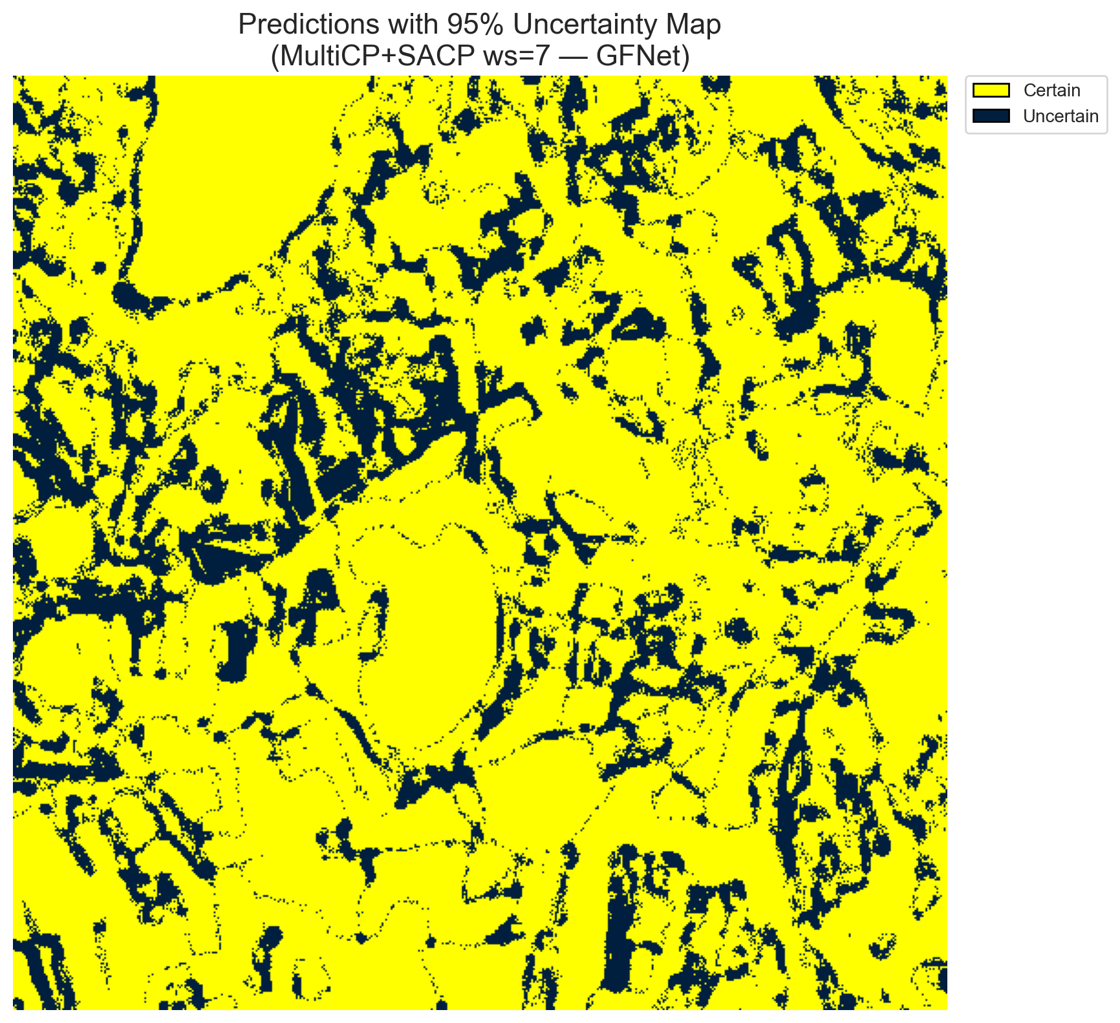
(C) ViT-UNet (RAPS, w=7)  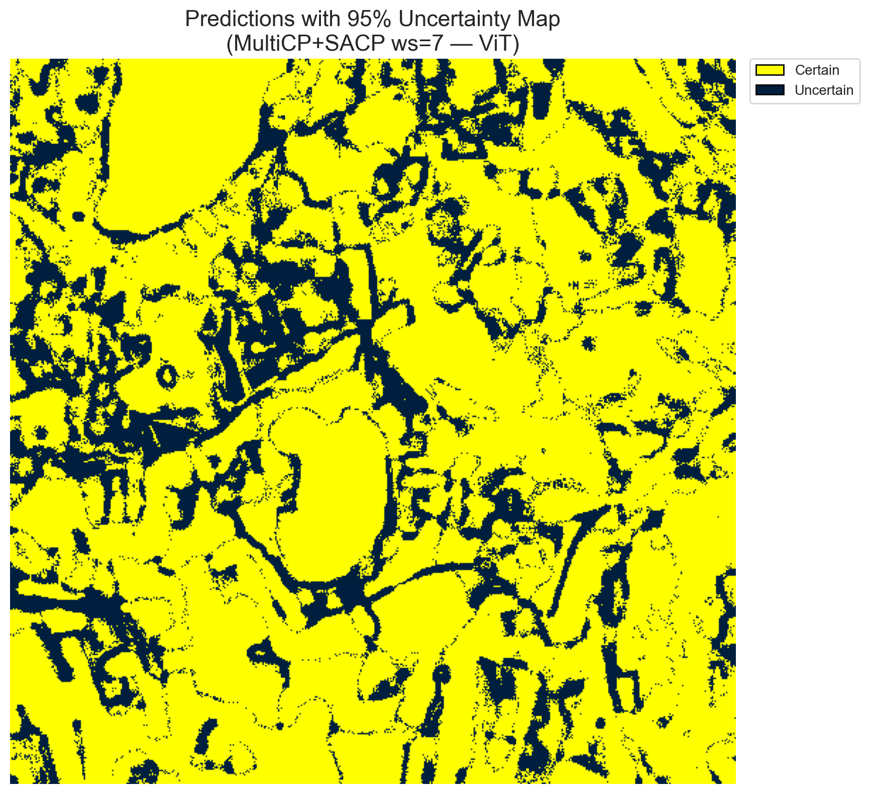 | (D) Binary Legend
Fig. 10(a). SCMCP (RAPS score, w = 7, α = 0.05, λ = 0.5) binary uncertainty maps across the 512 × 512 DIAS scene: (A) AlexNet-CNN (77,858 uncertain pixels, 29.70%), (B) GFNet (58,939 uncertain pixels, 22.48%), (C) ViT-UNet (64,635 uncertain pixels, 24.66%), and (D) Binary Legend. Yellow = certain singleton; dark navy = uncertain pixel.
(A) AlexNet-CNN (RAPS, w=7)  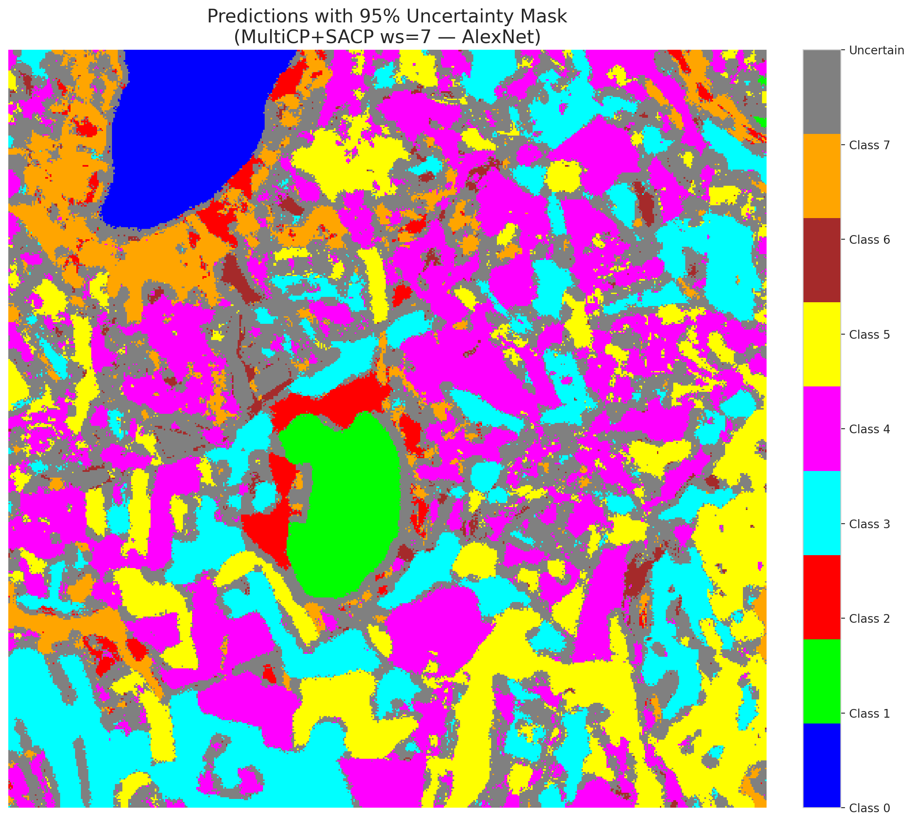 | (B) GFNet (RAPS, w=7)  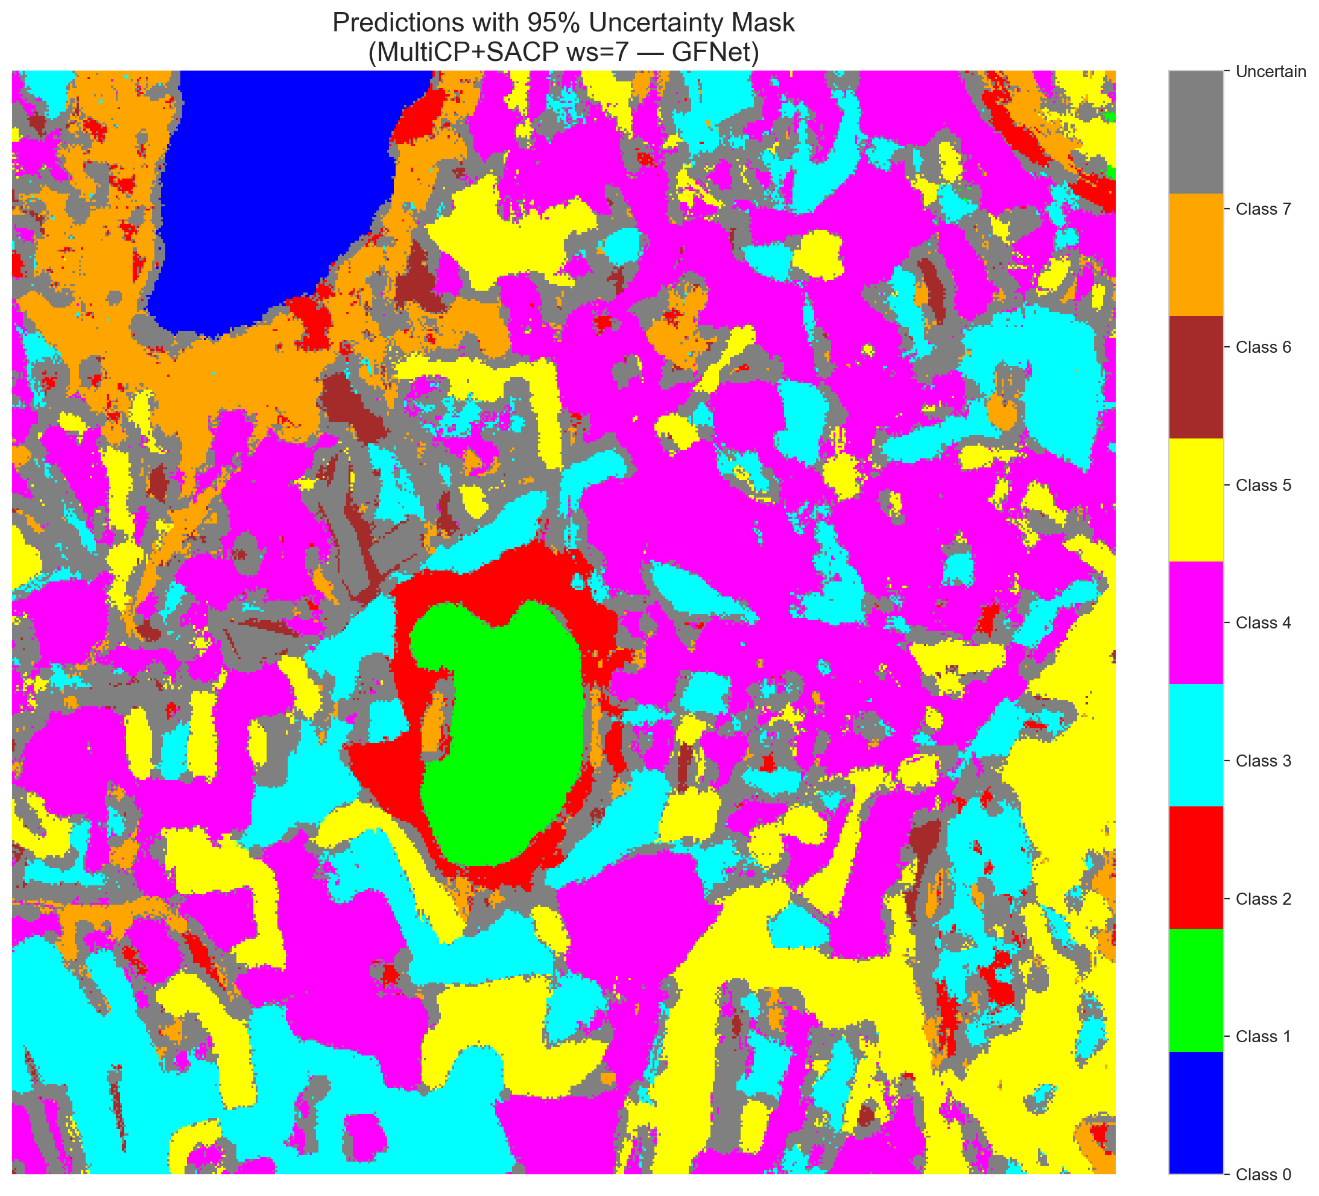
(C) ViT-UNet (RAPS, w=7)  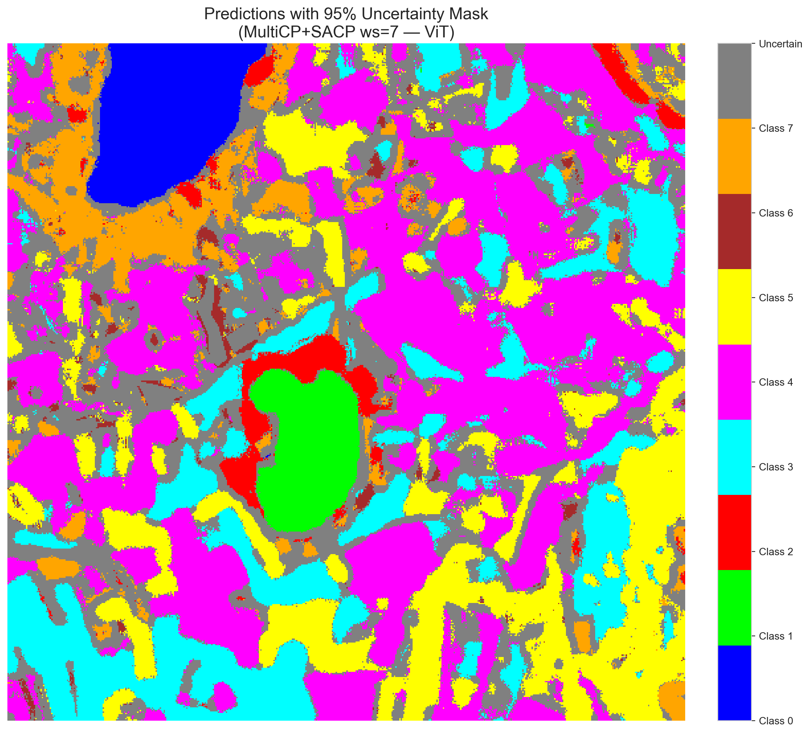 | (D) Class Legend
Fig. 10(b). SCMCP (RAPS score, w = 7, α = 0.05, λ = 0.5) masked class prediction maps across the 512 × 512 DIAS scene: (A) AlexNet-CNN, (B) GFNet, (C) ViT-UNet, and (D) Class Legend. Colours denote predicted land-cover classes (Classes 0–7); grey denotes uncertain pixels.
(A) AlexNet-CNN (SAPS, w=7)  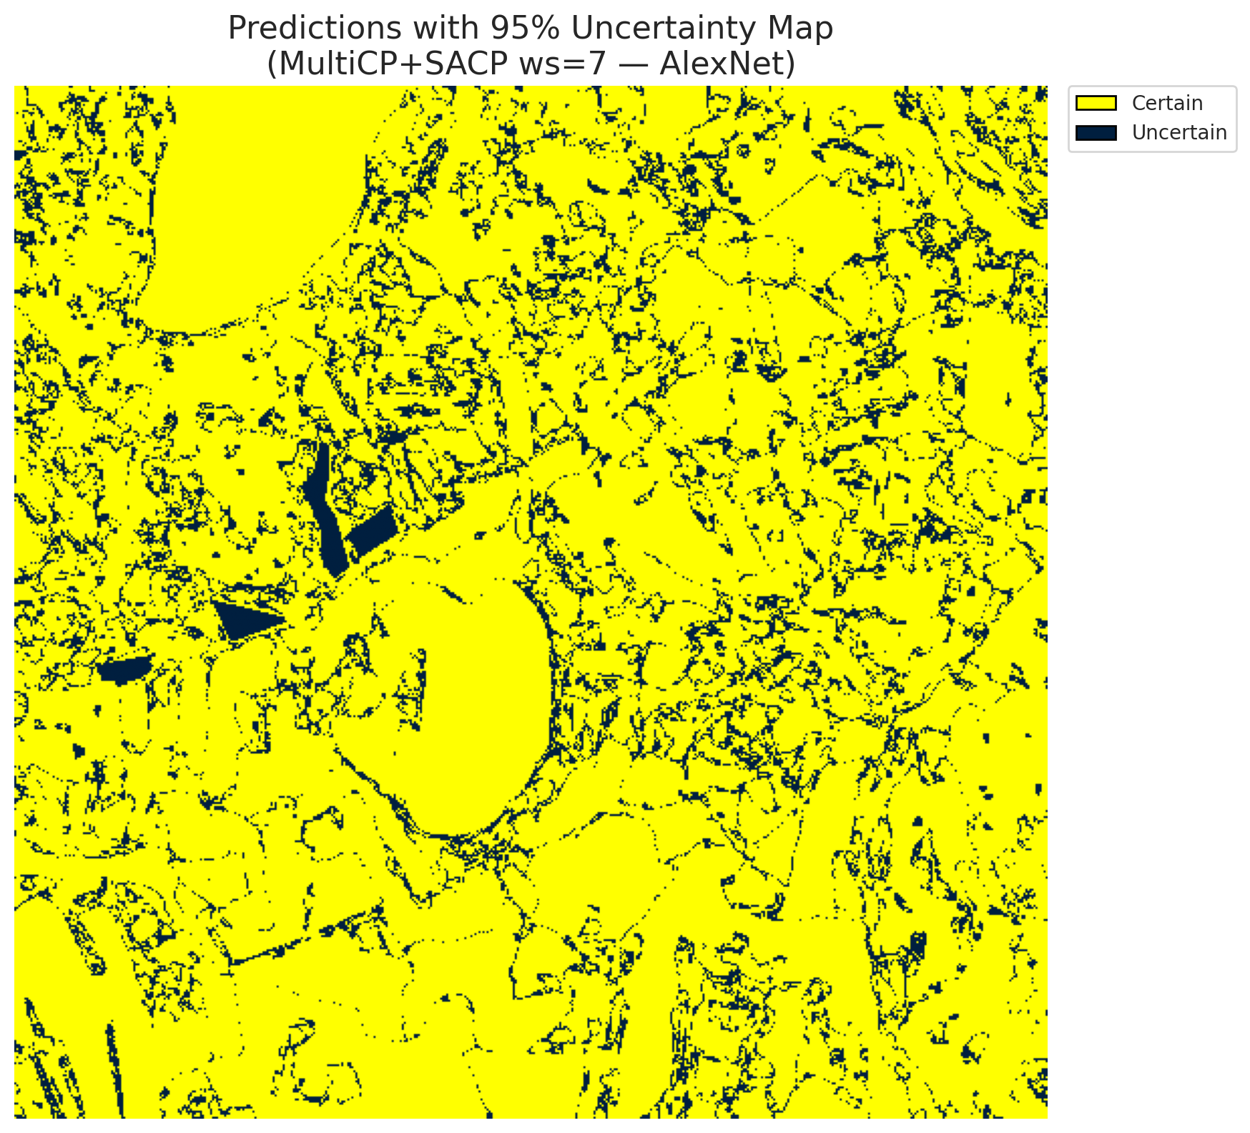 | (B) GFNet (SAPS, w=7)  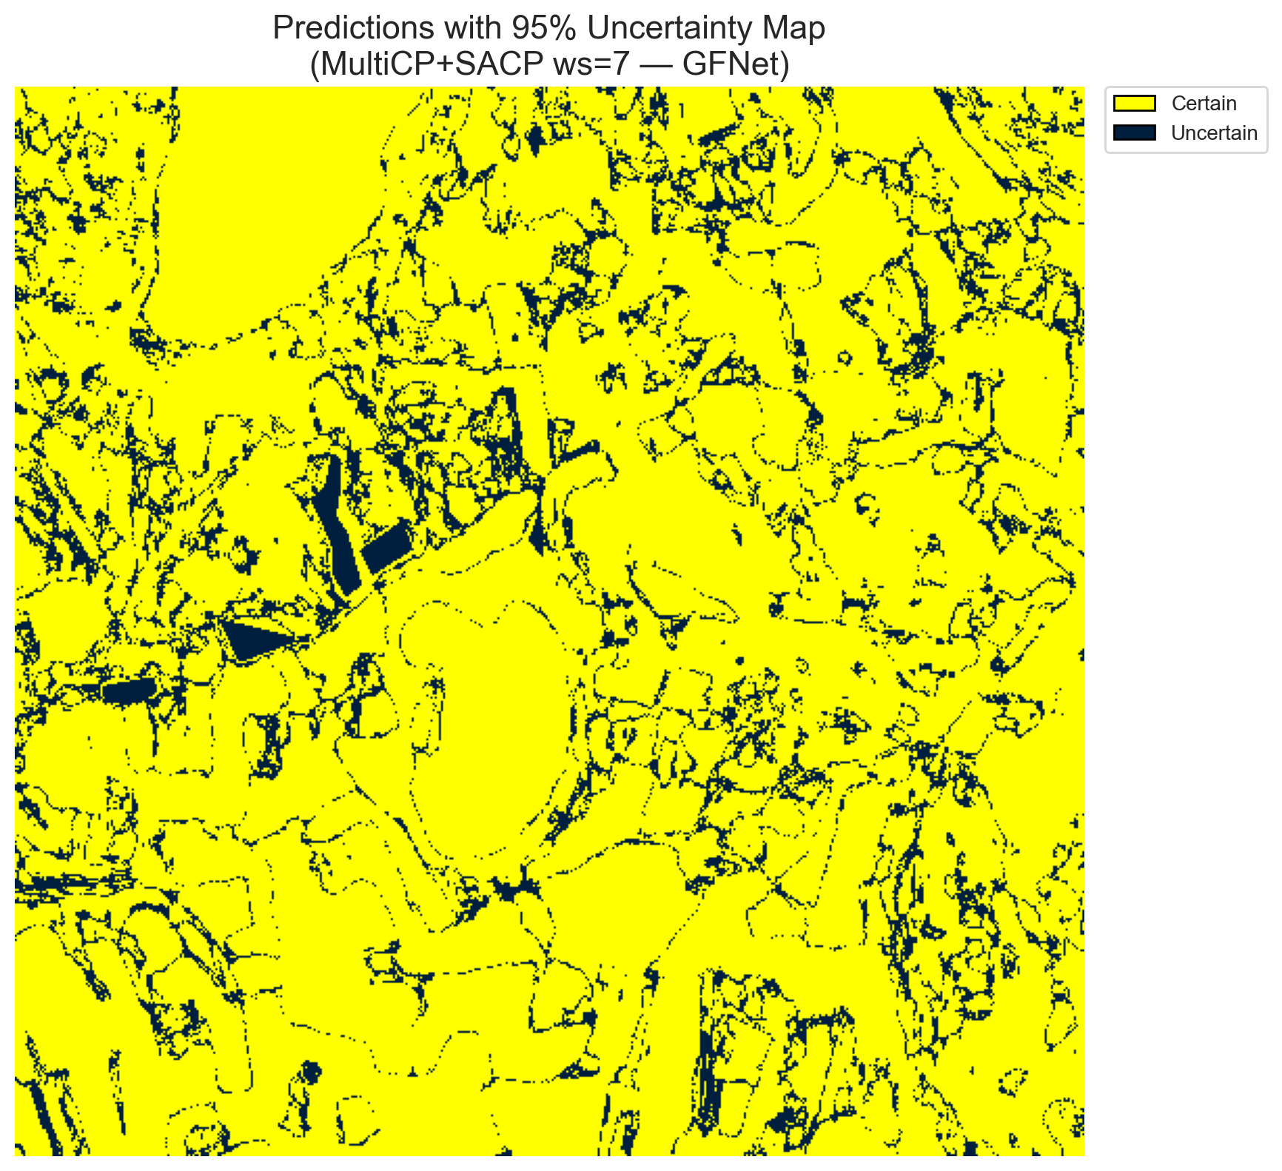
(C) ViT-UNet (SAPS, w=7)  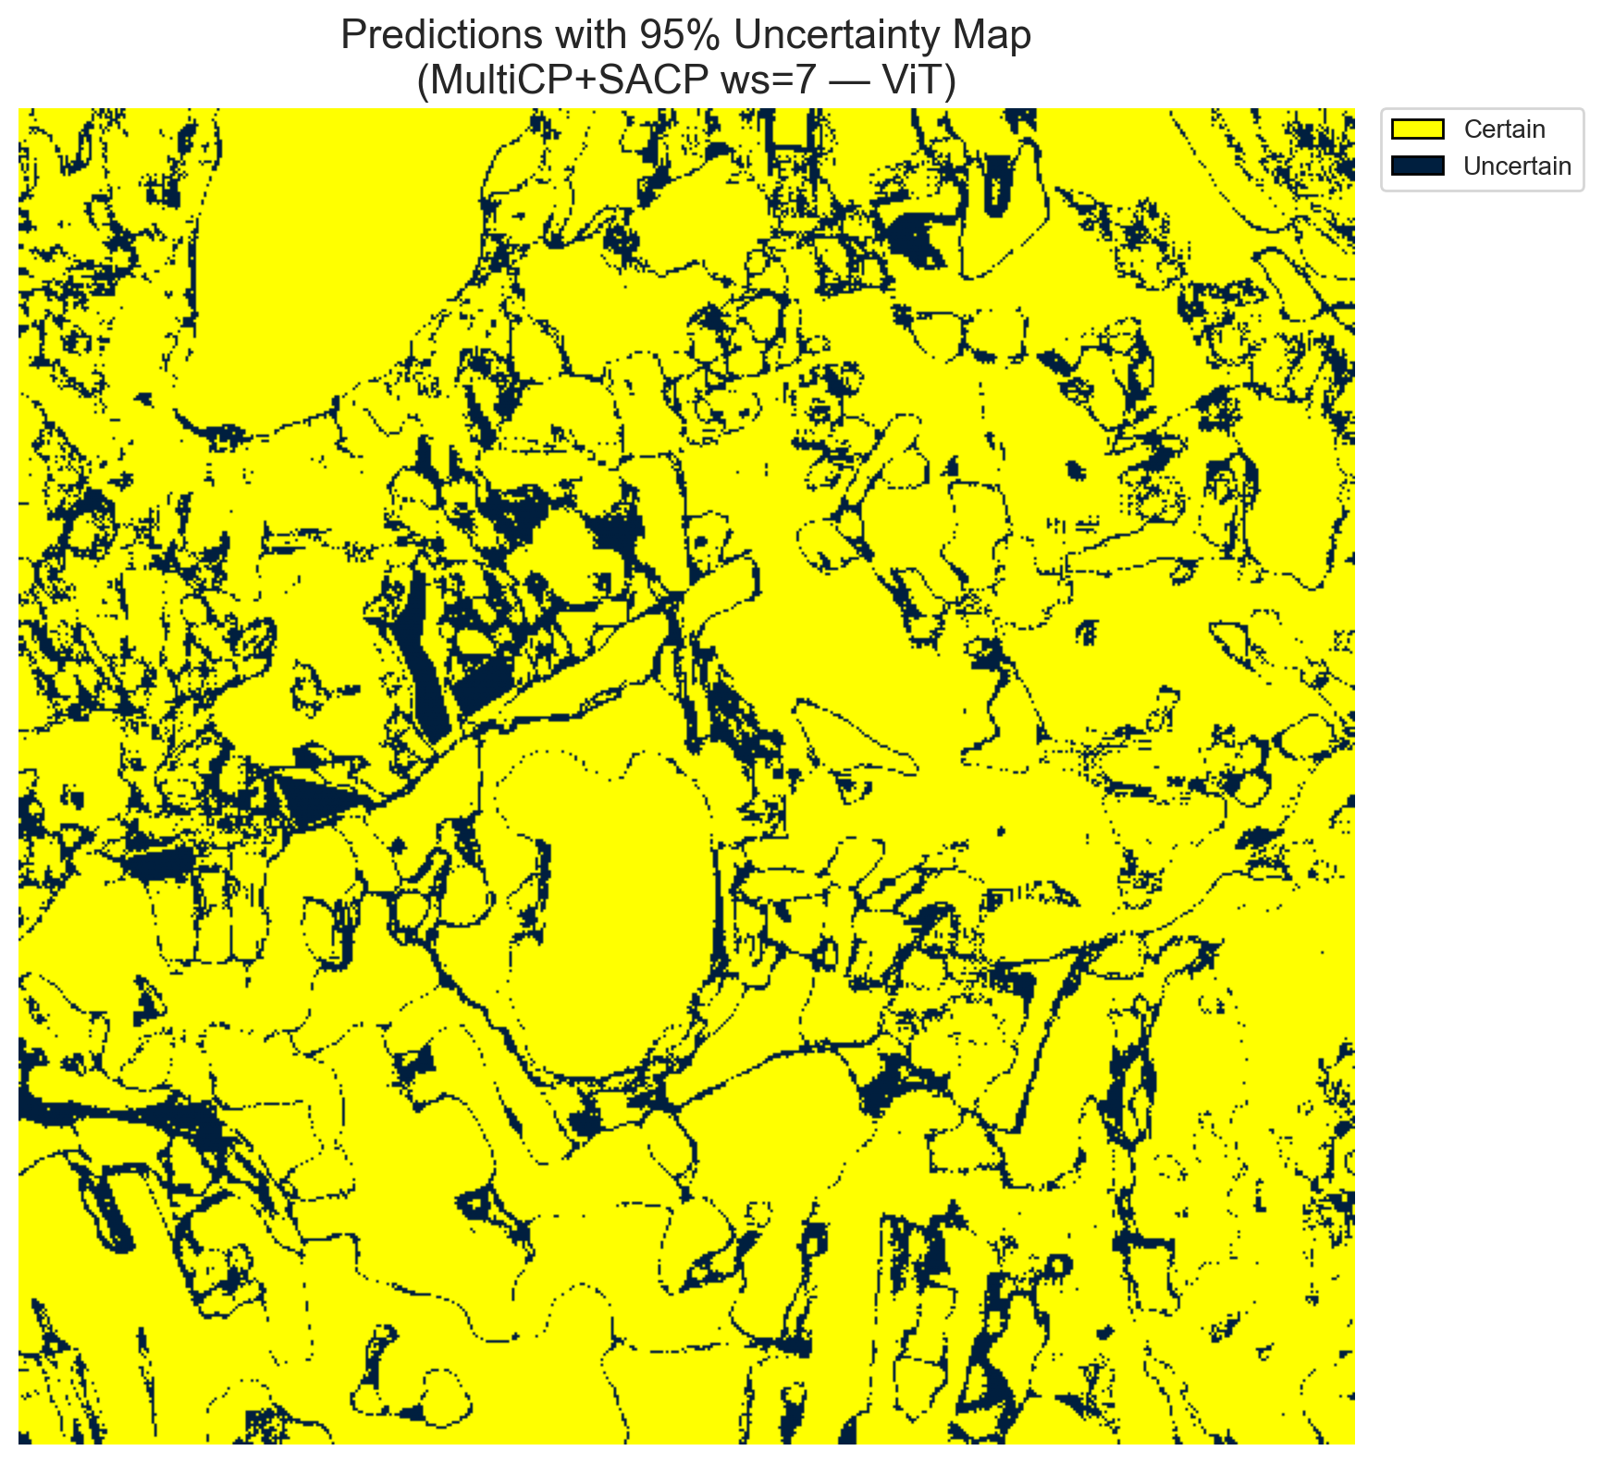 | (D) Binary Legend
Fig. 11(a). SCMCP (SAPS score, w = 7, α = 0.05, λ = 0.5) binary uncertainty maps across the 512 × 512 DIAS scene: (A) AlexNet-CNN (35,502 uncertain pixels, 13.54%), (B) GFNet (32,958 uncertain pixels, 12.57%), (C) ViT-UNet (38,931 uncertain pixels, 14.85%), and (D) Binary Legend. Yellow = certain singleton; dark navy = uncertain pixel.
(A) AlexNet-CNN (SAPS, w=7)  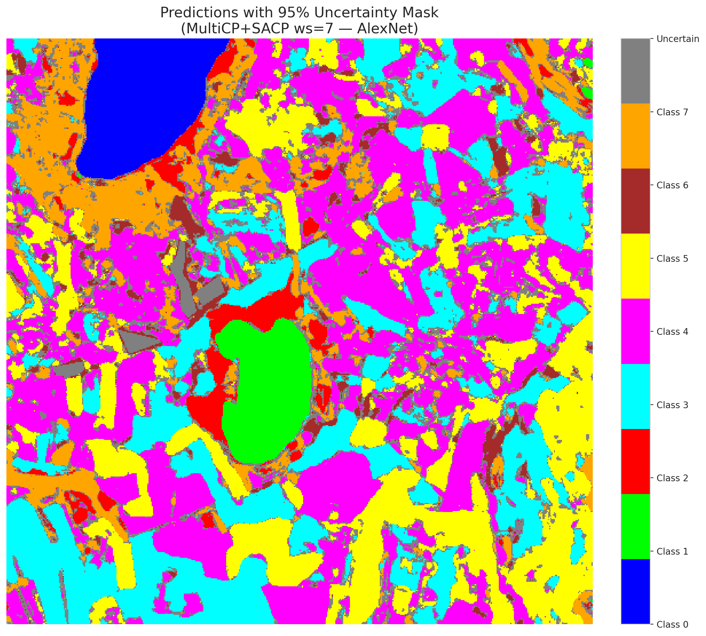 | (B) GFNet (SAPS, w=7)  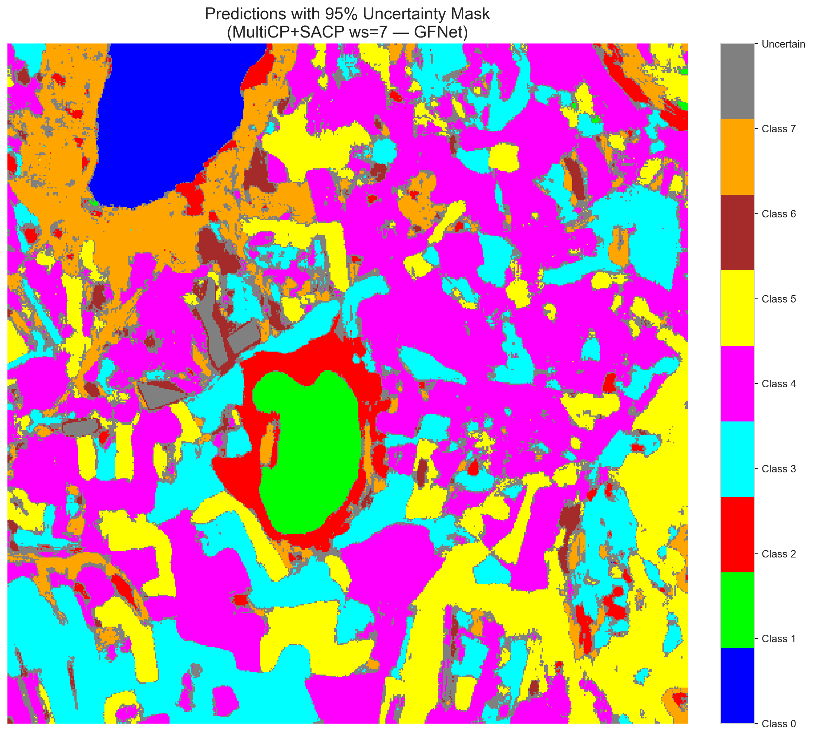
(C) ViT-UNet (SAPS, w=7)  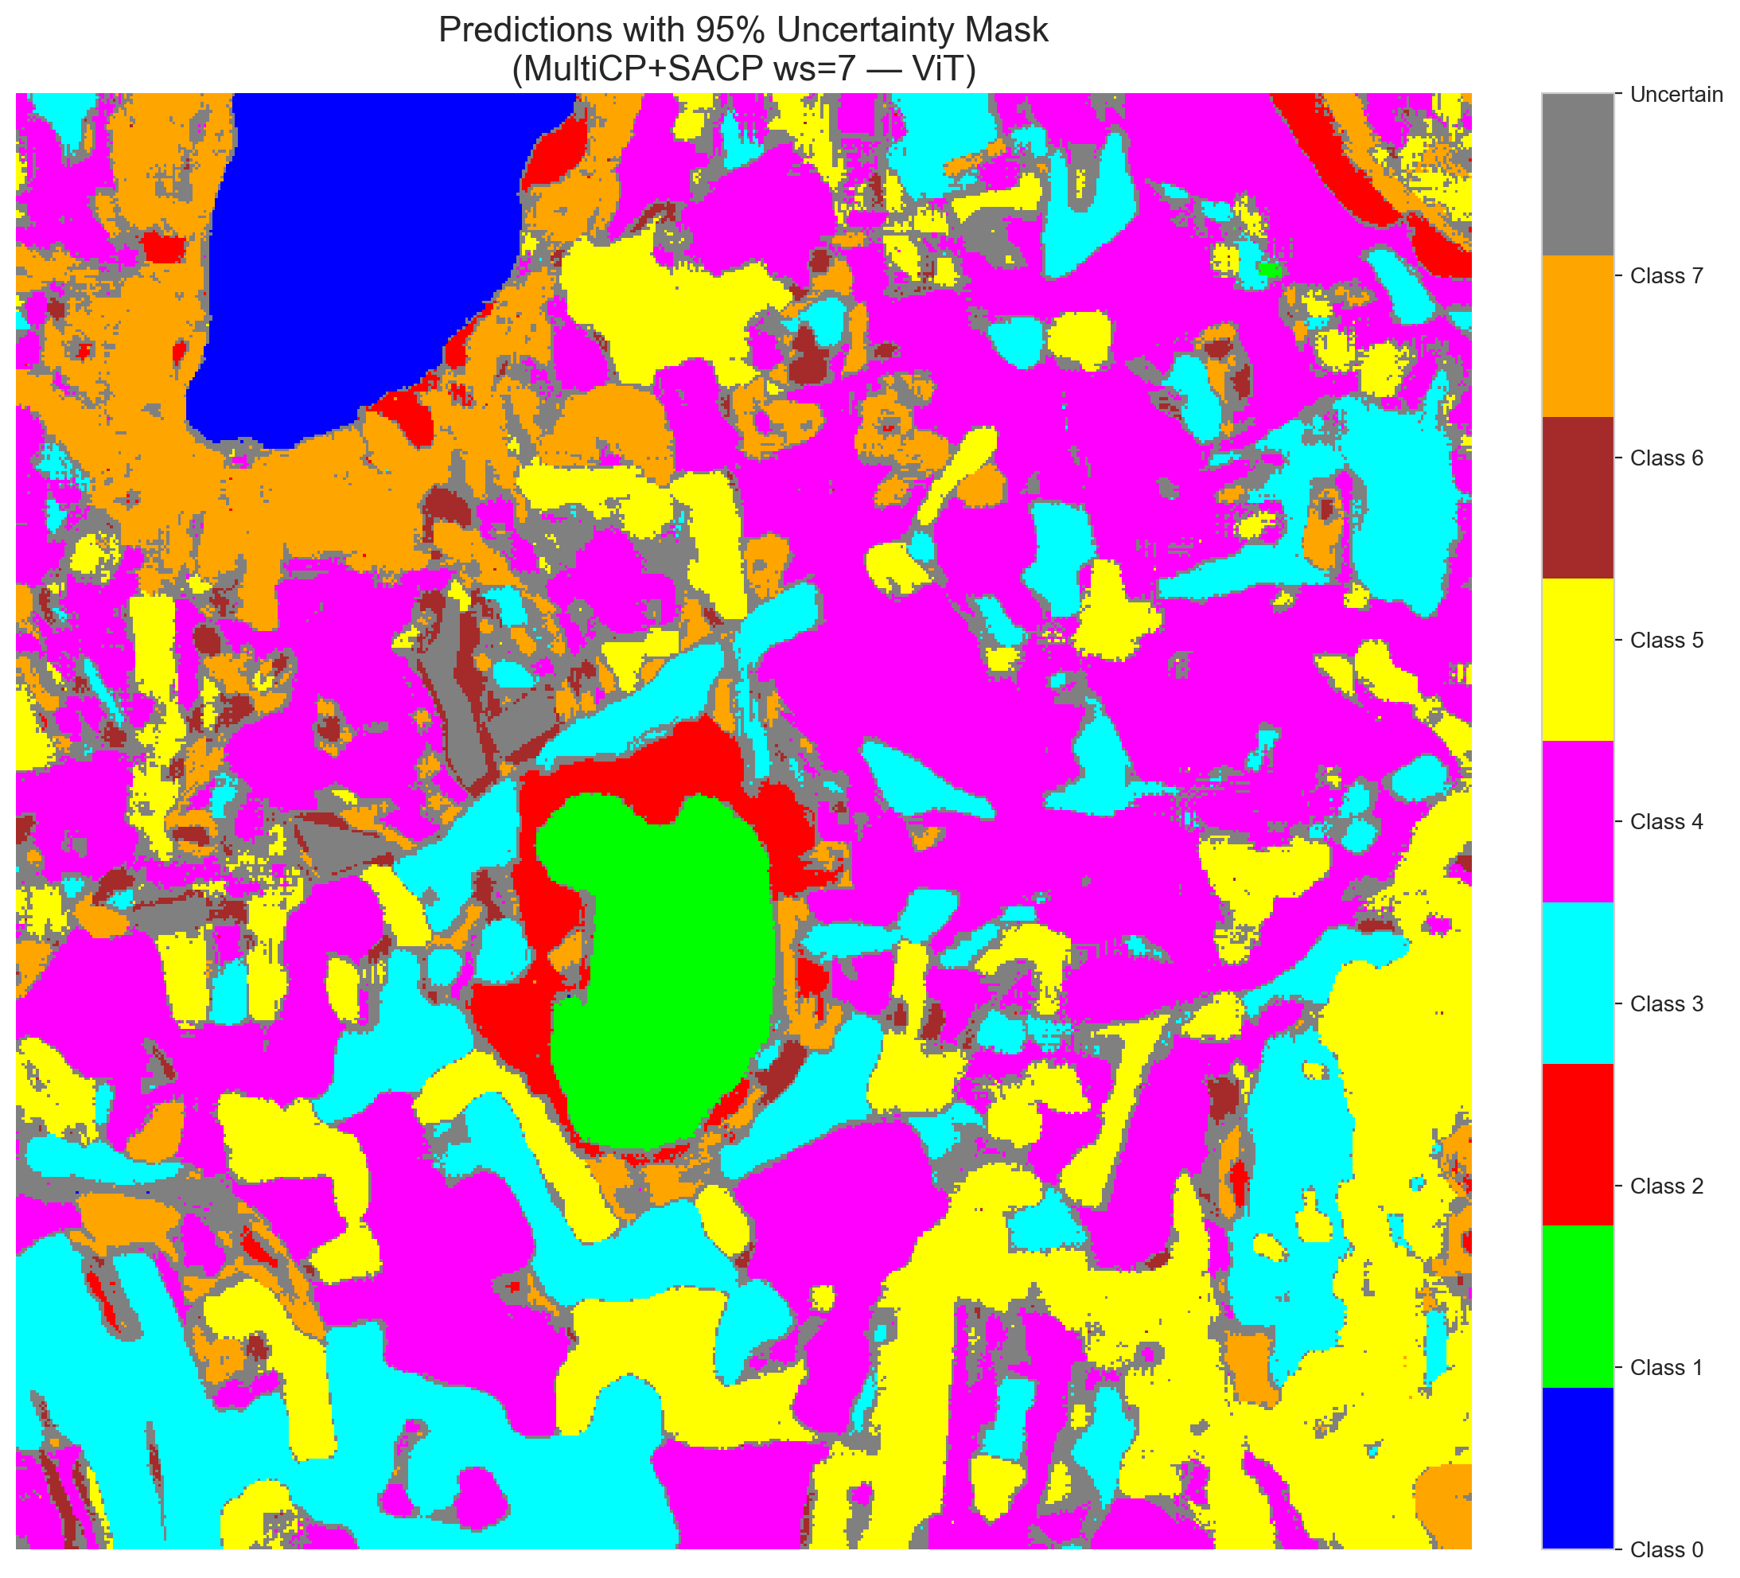 | (D) Class Legend
Fig. 11(b). SCMCP (SAPS score, w = 7, α = 0.05, λ = 0.5) masked class prediction maps across the 512 × 512 DIAS scene: (A) AlexNet-CNN, (B) GFNet, (C) ViT-UNet, and (D) Class Legend. Colours denote predicted land-cover classes (Classes 0–7); grey denotes uncertain pixels.
D. Window Size w = 9 (80 Neighbours)
At w = 9 (80 neighbours), extensive spatial averaging across the 9 × 9 window further differentiates SAPS and RAPS: GFNet SAPS achieves 37,587 uncertain pixels (14.34%, 0.7140 coverage), AlexNet SAPS achieves 41,990 uncertain pixels (16.02%, 0.6907 coverage), and ViT-UNet SAPS achieves 42,664 uncertain pixels (16.28%, 0.7006 coverage). Under RAPS, boundary halos reach maximum widths of 71,684 pixels (27.35%) for GFNet, 75,882 pixels (28.95%) for ViT-UNet, and 91,727 pixels (34.99%) for AlexNet, while full-scene coverage reaches 0.1904–0.2032.
TABLE XXIX
SCMCP AGGREGATE SUMMARY (w = 9, α = 0.05, λ = 0.5)
Model | Score | Emp. Cov. | Avg Set Size | Scn. Cov. | Unc. Rate | Mean Cls Cov. | Runtime (s)
AlexNet | RAPS | 0.6950 | 0.6956 | 0.2032 | 0.3499 | 0.6950 | 276.86
AlexNet | SAPS | 0.6907 | 0.6913 | 0.1702 | 0.1602 | 0.6883 | 275.37
GFNet | RAPS | 0.7016 | 0.7019 | 0.1904 | 0.2735 | 0.6972 | 278.21
GFNet | SAPS | 0.7140 | 0.7144 | 0.1665 | 0.1434 | 0.7160 | 279.55
ViT | RAPS | 0.7030 | 0.7097 | 0.2004 | 0.2895 | 0.7124 | 275.92
ViT | SAPS | 0.7006 | 0.7051 | 0.1707 | 0.1628 | 0.7110 | 272.16

TABLE XXX
SCMCP PER-CLASS COVERAGE (w = 9, RAPS AND SAPS)
Class | AlexNet (RAPS) | GFNet (RAPS) | ViT-UNet (RAPS) | AlexNet (SAPS) | GFNet (SAPS) | ViT-UNet (SAPS)
Class 0 | 0.7031 | 0.7031 | 0.6957 | 0.6694 | 0.7212 | 0.6817
Class 1 | 0.7074 | 0.6875 | 0.6903 | 0.7131 | 0.7244 | 0.6790
Class 2 | 0.6996 | 0.6996 | 0.6996 | 0.7244 | 0.6996 | 0.7102
Class 3 | 0.6842 | 0.7018 | 0.6886 | 0.6886 | 0.7070 | 0.6864
Class 4 | 0.6962 | 0.7044 | 0.7025 | 0.7025 | 0.7113 | 0.6981
Class 5 | 0.6959 | 0.7148 | 0.7044 | 0.6931 | 0.7139 | 0.7299
Class 6 | 0.7200 | 0.6850 | 0.6900 | 0.6650 | 0.7600 | 0.7400
Class 7 | 0.6531 | 0.6813 | 0.8281 | 0.6500 | 0.6906 | 0.7625
Mean | 0.6950 | 0.6972 | 0.7124 | 0.6883 | 0.7160 | 0.7110

TABLE XXXI
SCMCP PIXEL COUNT DISTRIBUTION (w = 9, 262,144 SCENE PIXELS)
Class / Region | AlexNet (RAPS) | GFNet (RAPS) | ViT-UNet (RAPS) | AlexNet (SAPS) | GFNet (SAPS) | ViT-UNet (SAPS)
Class 0 | 10,623 | 11,081 | 11,234 | 11,021 | 11,421 | 11,656
Class 1 | 7,307 | 7,203 | 7,475 | 7,965 | 7,349 | 7,903
Class 2 | 5,537 | 8,005 | 5,500 | 7,172 | 9,689 | 6,386
Class 3 | 38,939 | 37,353 | 35,023 | 49,103 | 44,706 | 39,713
Class 4 | 53,912 | 71,271 | 72,527 | 70,496 | 81,842 | 83,205
Class 5 | 36,763 | 36,648 | 37,417 | 45,293 | 42,943 | 44,863
Class 6 | 2,348 | 2,456 | 1,763 | 5,627 | 4,107 | 3,311
Class 7 | 14,988 | 16,443 | 15,323 | 23,477 | 22,500 | 22,443
Uncertain | 91,727 | 71,684 | 75,882 | 41,990 | 37,587 | 42,664
Total (Scene) | 262,144 | 262,144 | 262,144 | 262,144 | 262,144 | 262,144

(A) AlexNet-CNN (RAPS, w=9)  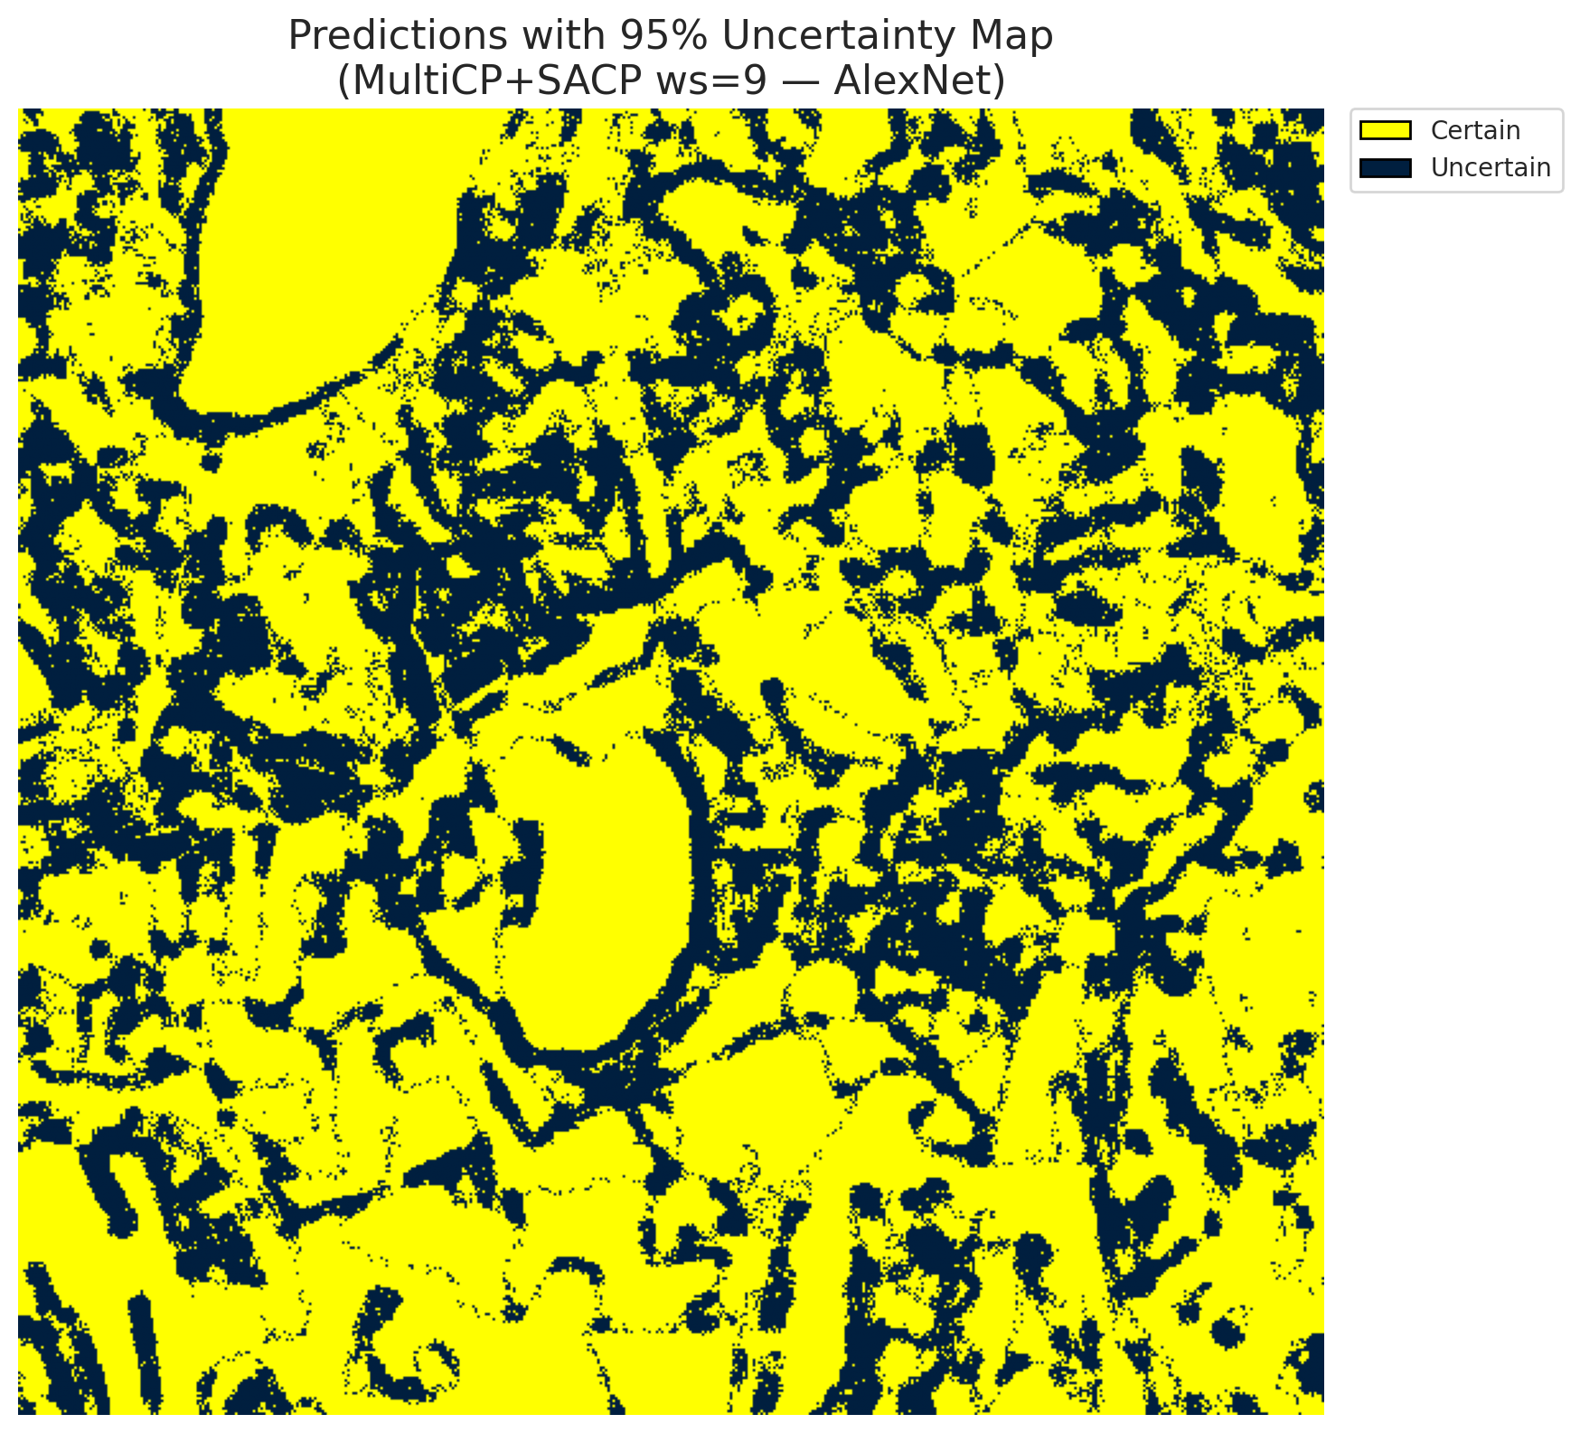 | (B) GFNet (RAPS, w=9)  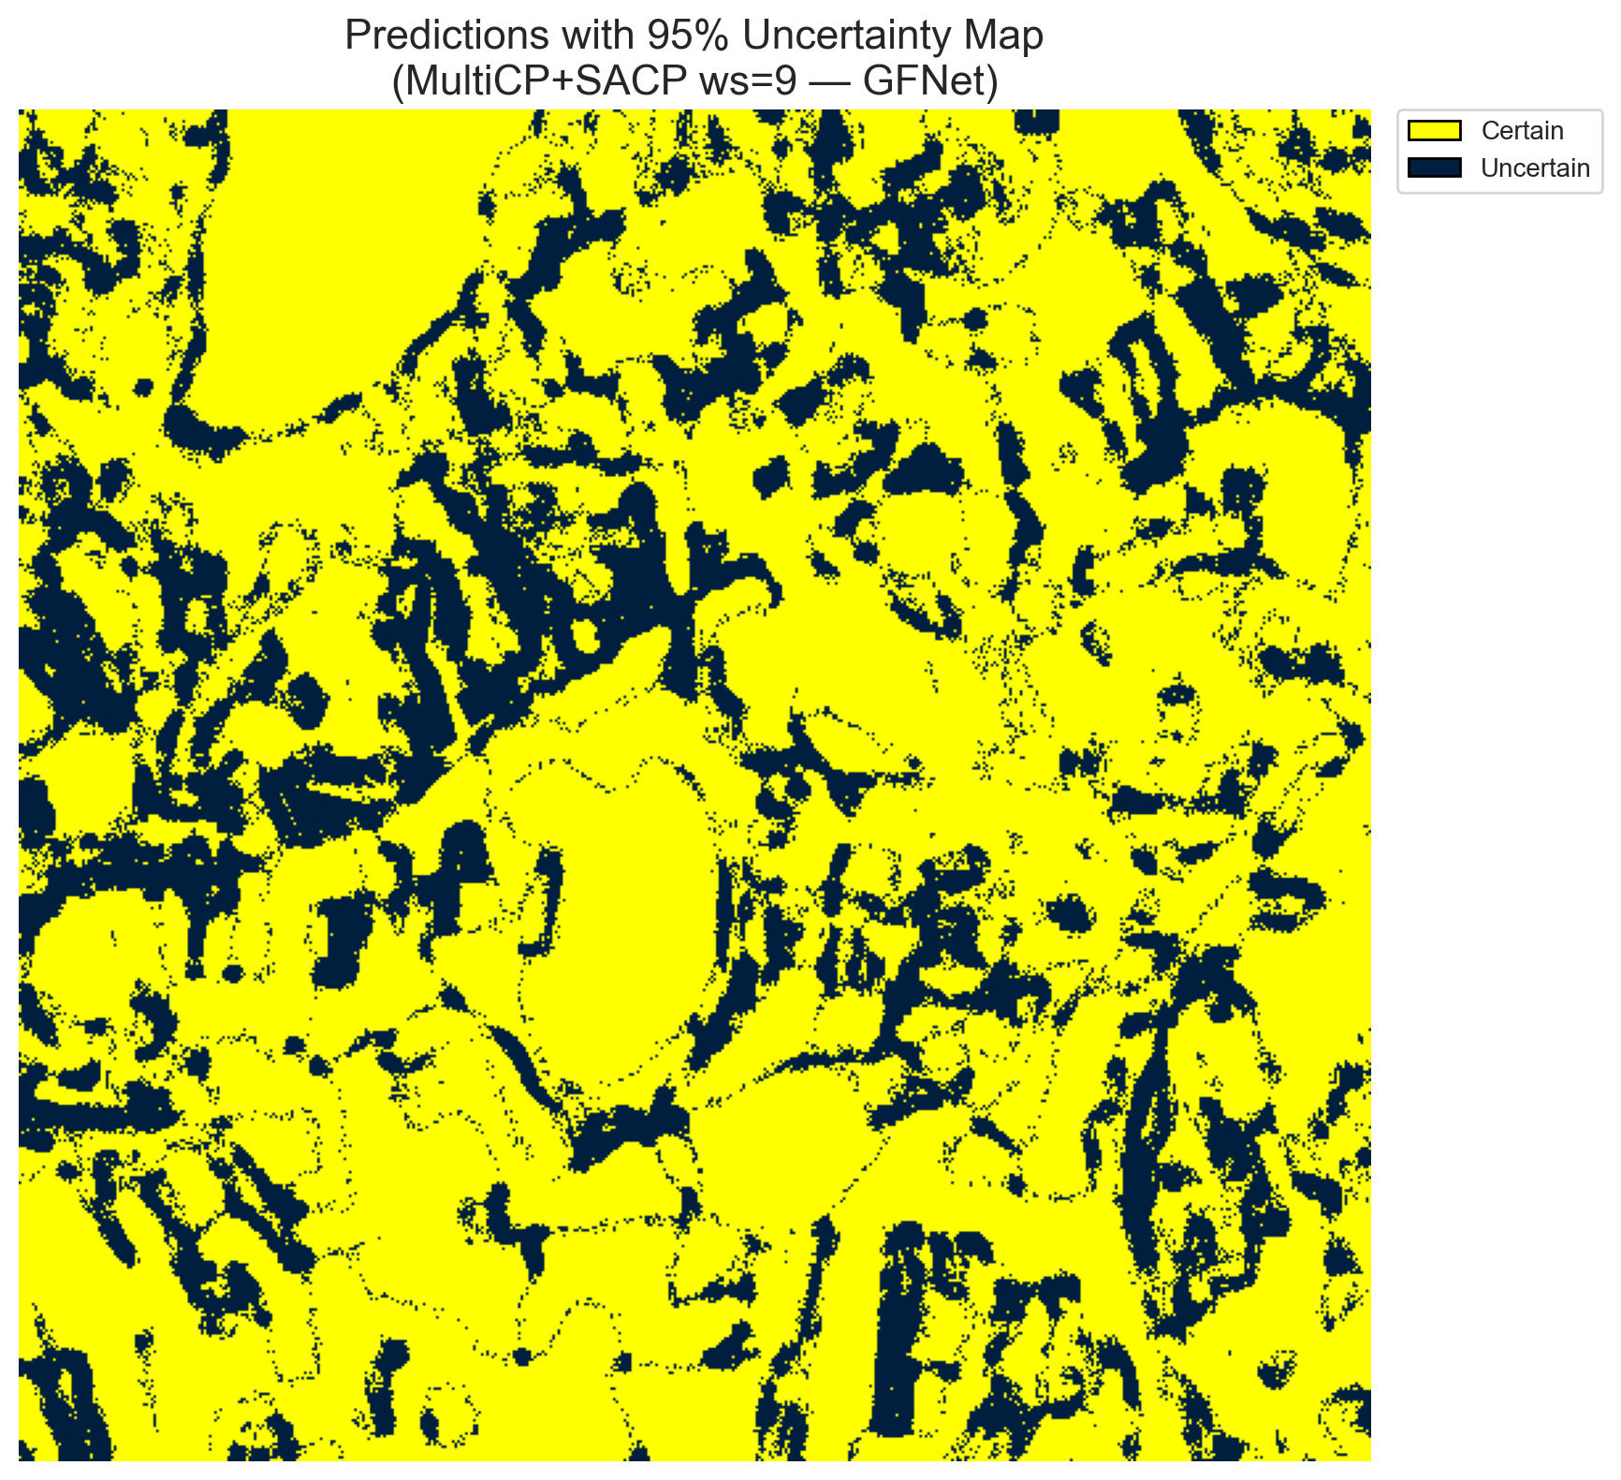
(C) ViT-UNet (RAPS, w=9)  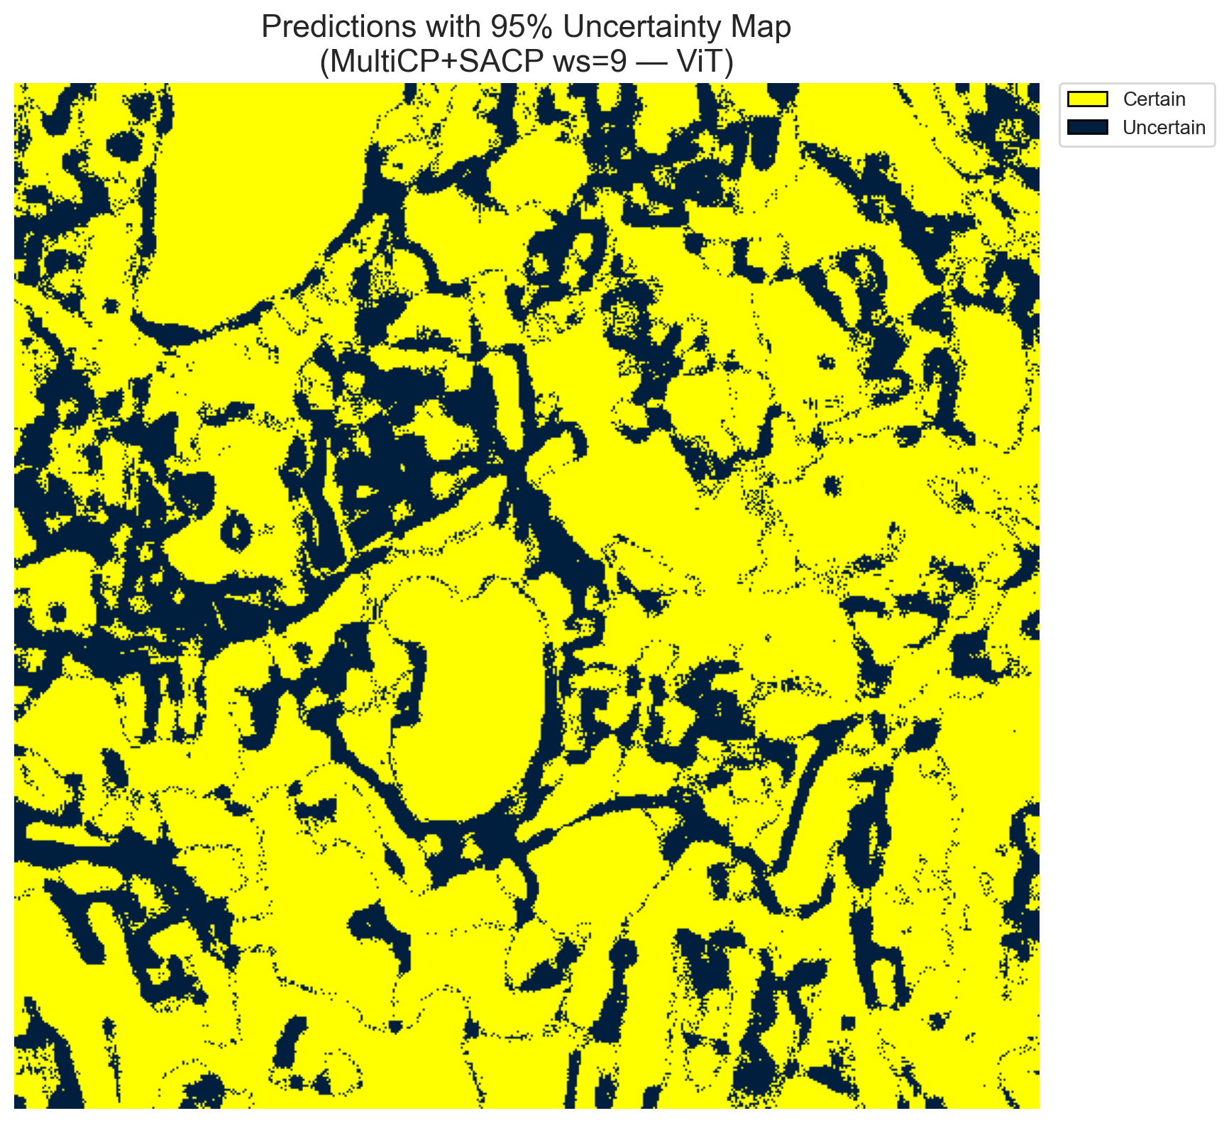 | (D) Binary Legend
Fig. 12(a). SCMCP (RAPS score, w = 9, α = 0.05, λ = 0.5) binary uncertainty maps across the 512 × 512 DIAS scene: (A) AlexNet-CNN (91,727 uncertain pixels, 34.99%), (B) GFNet (71,684 uncertain pixels, 27.35%), (C) ViT-UNet (75,882 uncertain pixels, 28.95%), and (D) Binary Legend. Yellow = certain singleton; dark navy = uncertain pixel.
(A) AlexNet-CNN (RAPS, w=9)  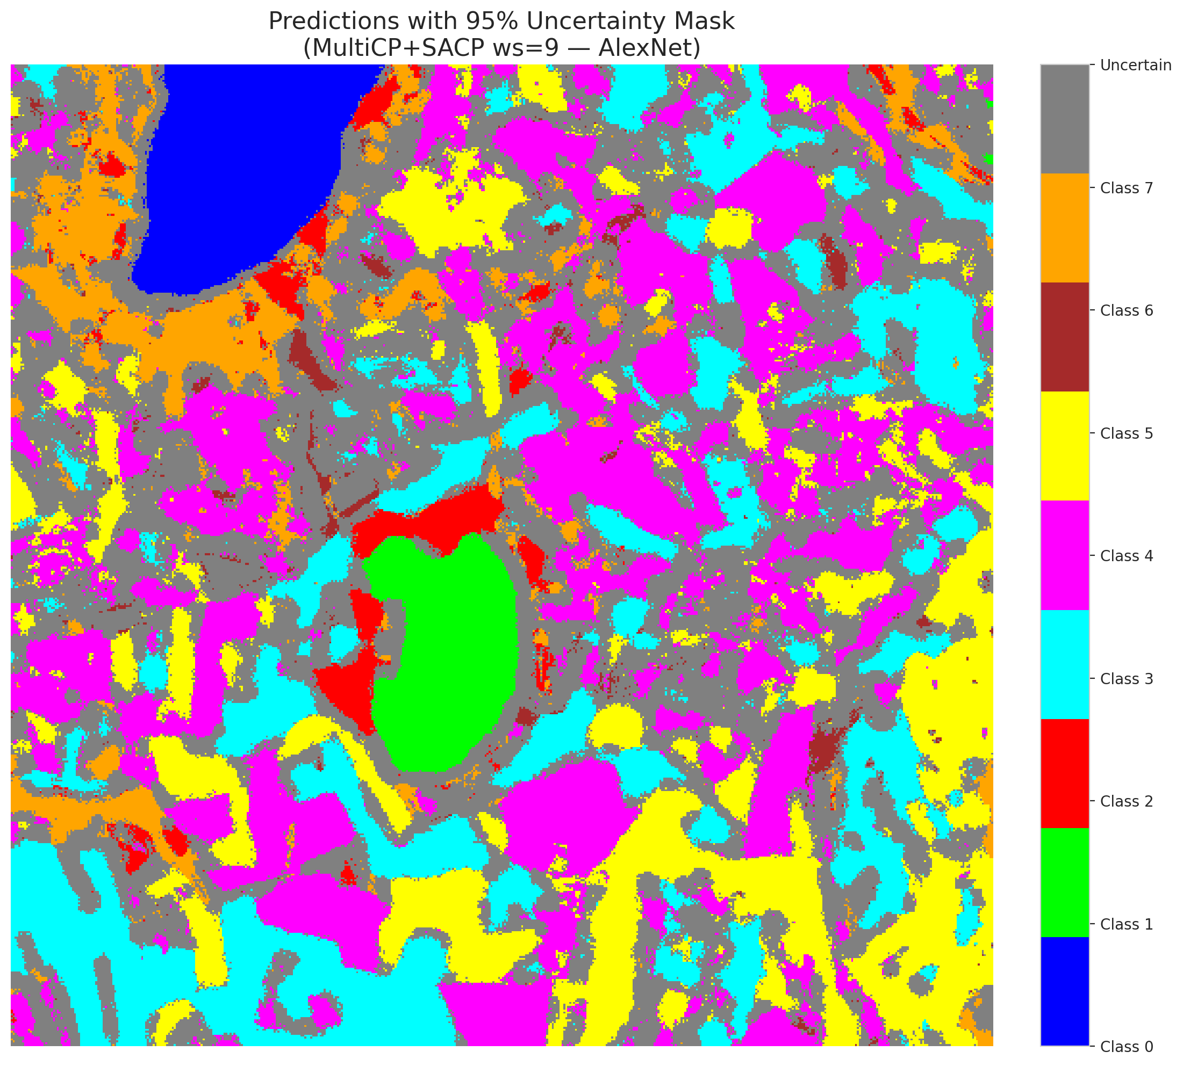 | (B) GFNet (RAPS, w=9)  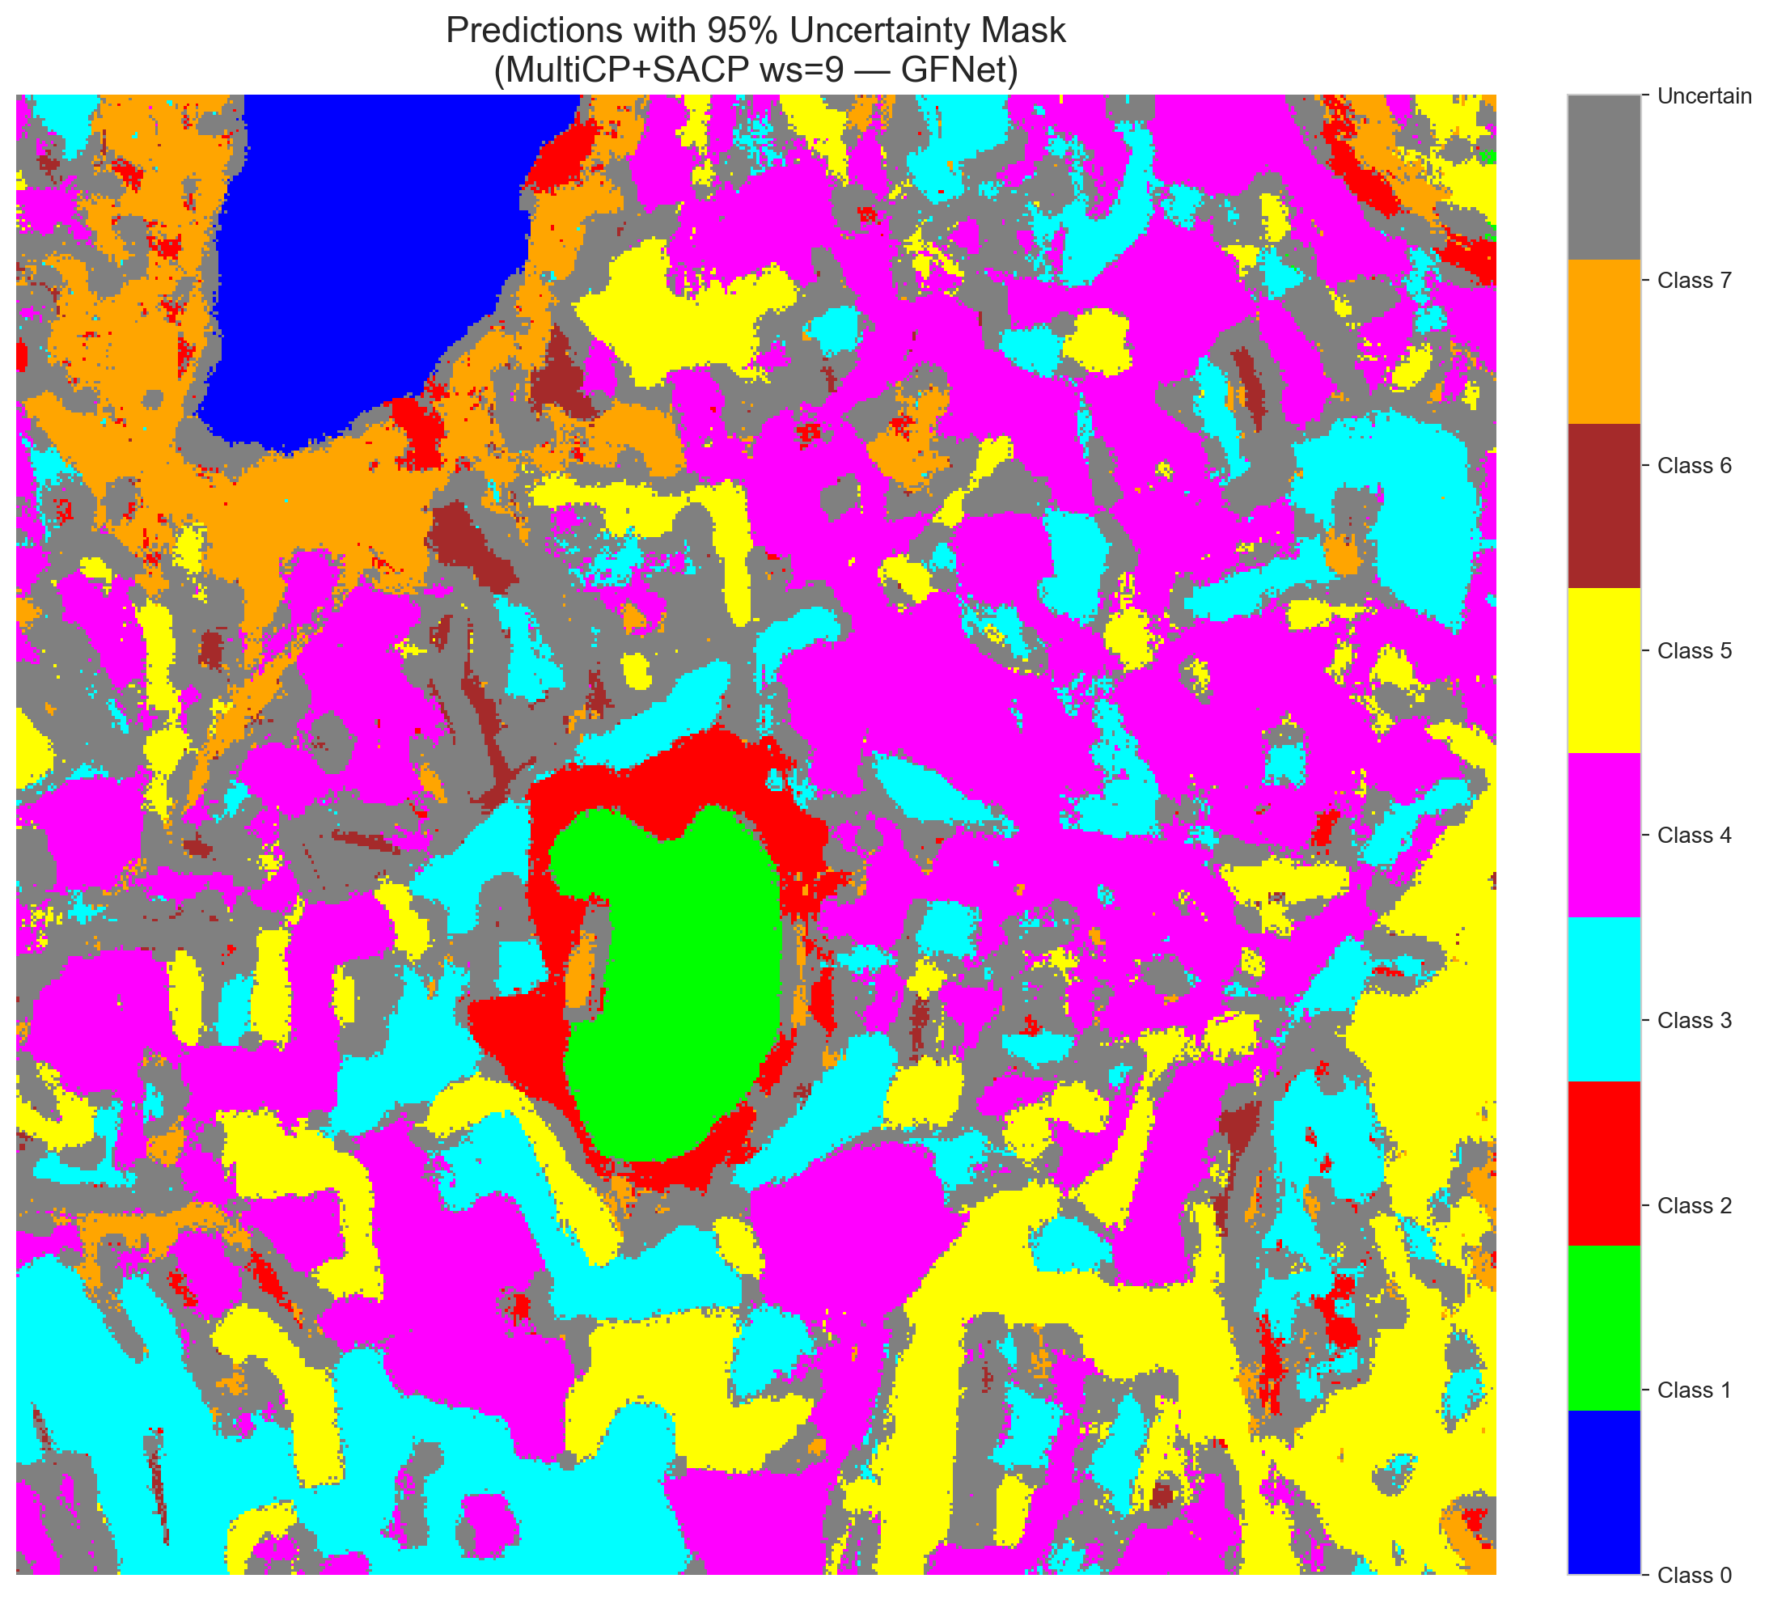
(C) ViT-UNet (RAPS, w=9)  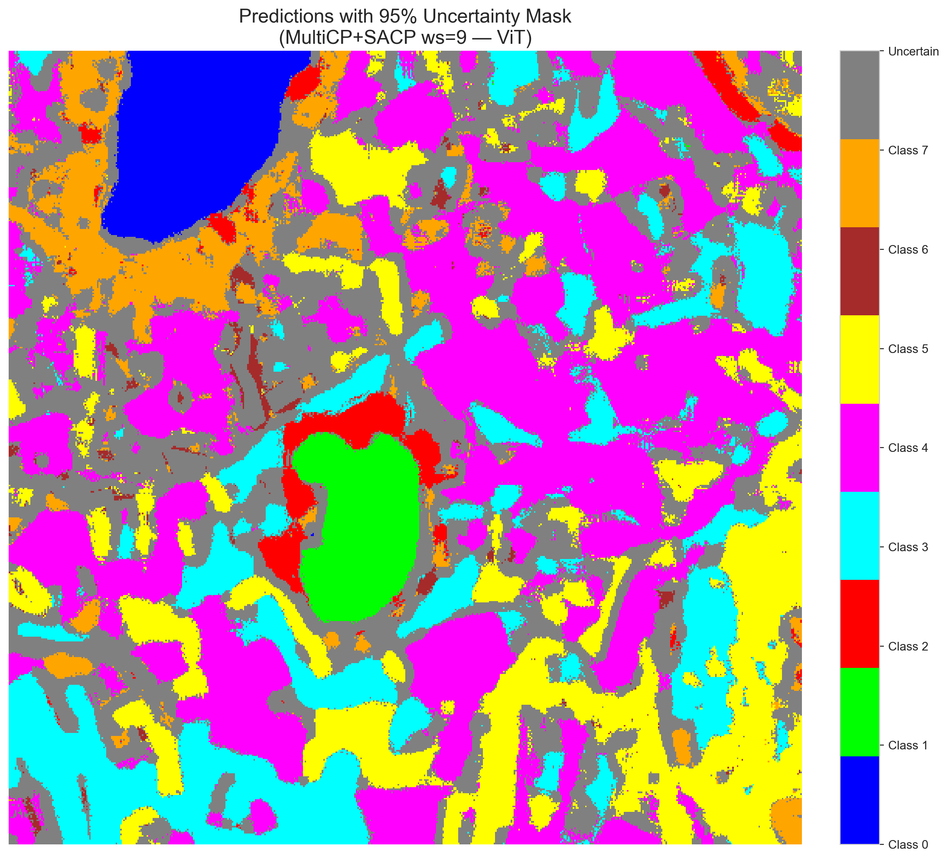 | (D) Class Legend
Fig. 12(b). SCMCP (RAPS score, w = 9, α = 0.05, λ = 0.5) masked class prediction maps across the 512 × 512 DIAS scene: (A) AlexNet-CNN, (B) GFNet, (C) ViT-UNet, and (D) Class Legend. Colours denote predicted land-cover classes (Classes 0–7); grey denotes uncertain pixels.
(A) AlexNet-CNN (SAPS, w=9)  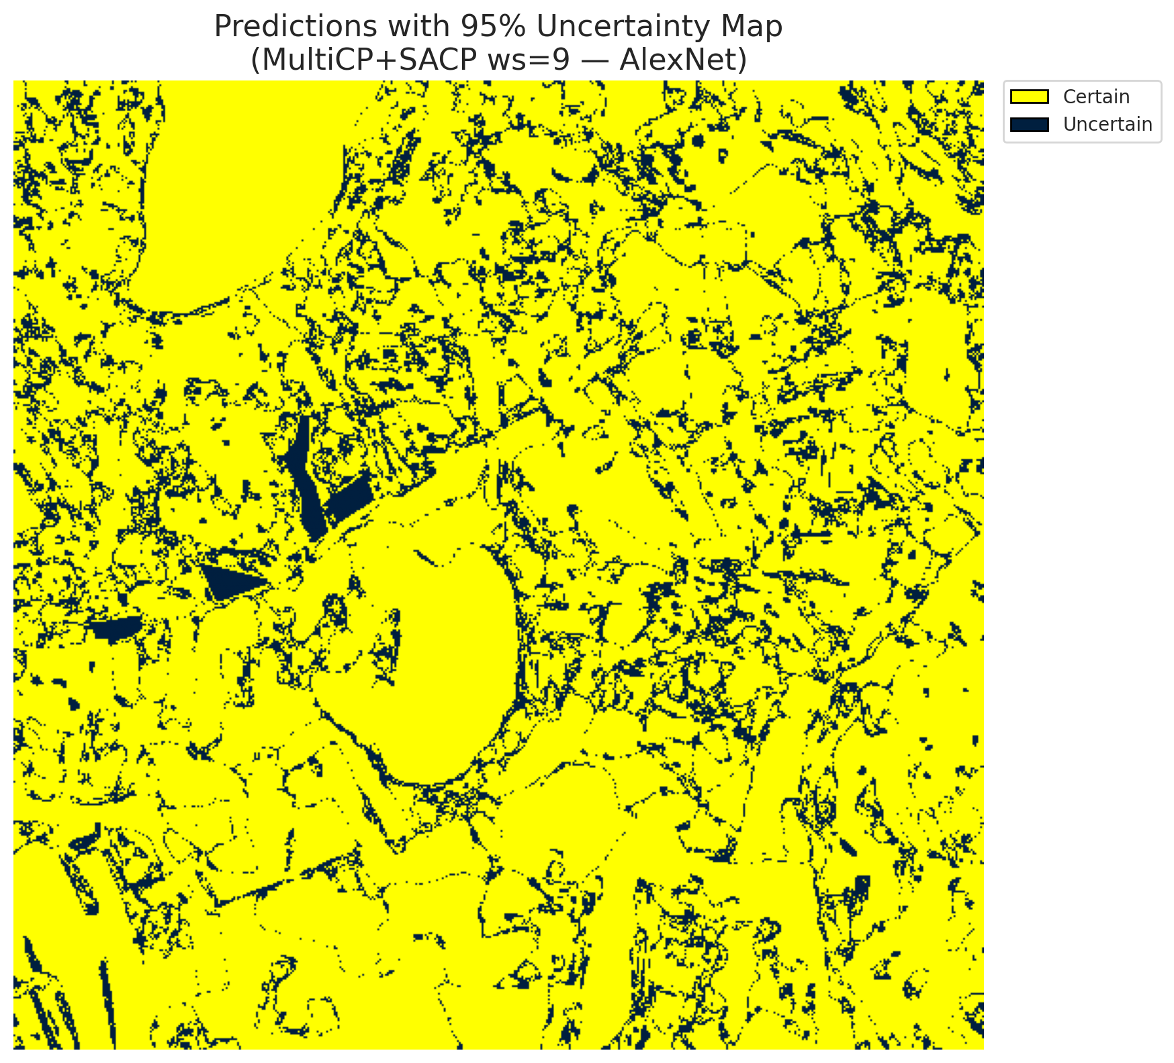 | (B) GFNet (SAPS, w=9)  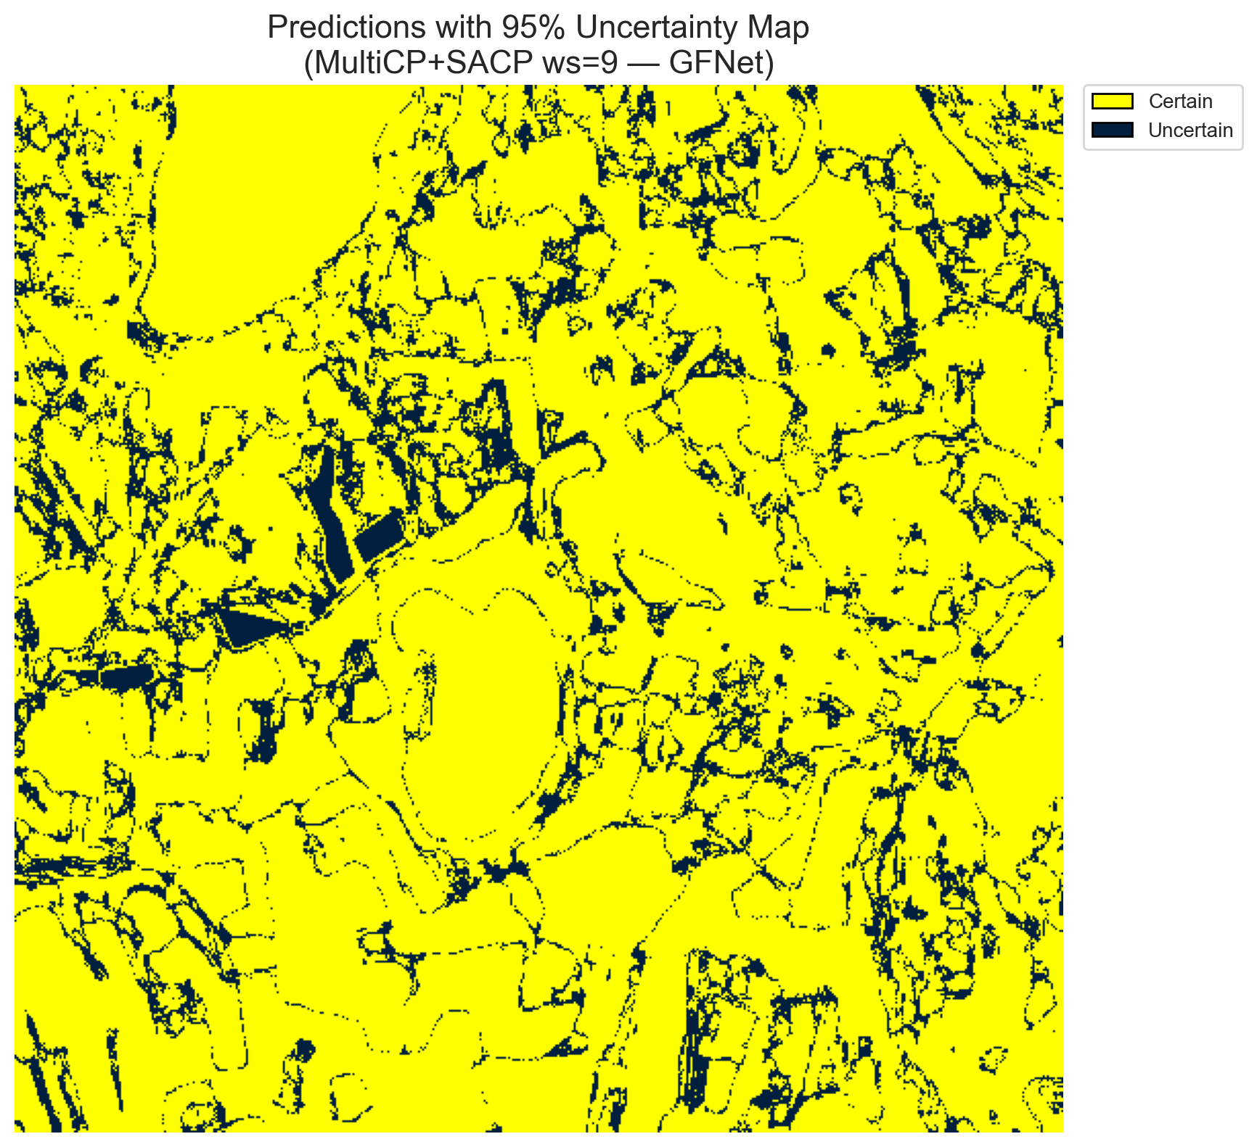
(C) ViT-UNet (SAPS, w=9)  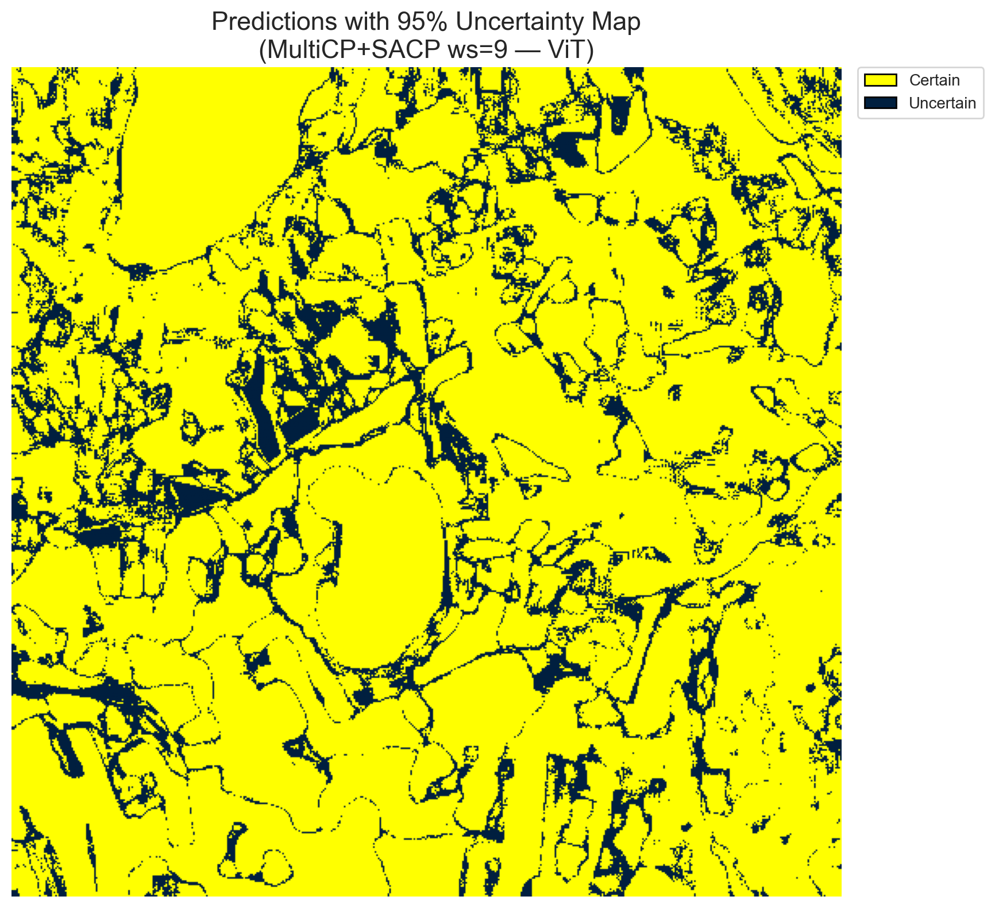 | (D) Binary Legend
Fig. 13(a). SCMCP (SAPS score, w = 9, α = 0.05, λ = 0.5) binary uncertainty maps across the 512 × 512 DIAS scene: (A) AlexNet-CNN (41,990 uncertain pixels, 16.02%), (B) GFNet (37,587 uncertain pixels, 14.34%), (C) ViT-UNet (42,664 uncertain pixels, 16.28%), and (D) Binary Legend. Yellow = certain singleton; dark navy = uncertain pixel.
(A) AlexNet-CNN (SAPS, w=9)  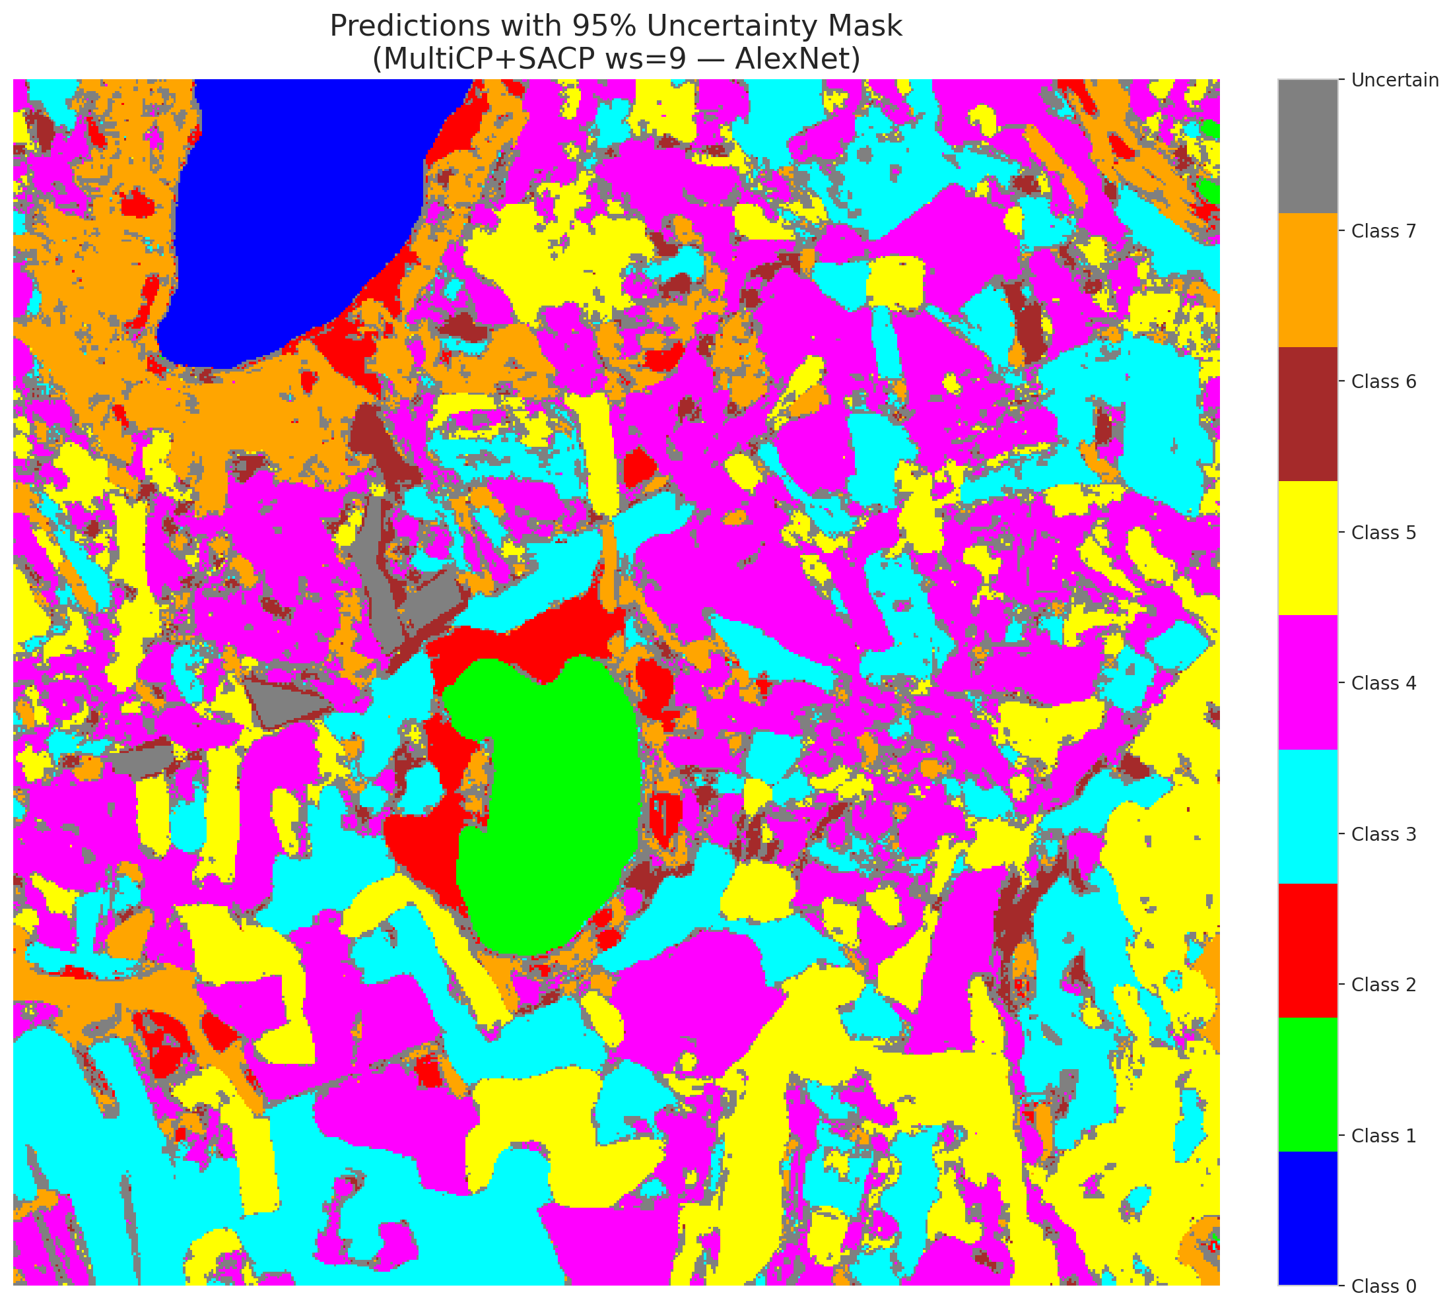 | (B) GFNet (SAPS, w=9)  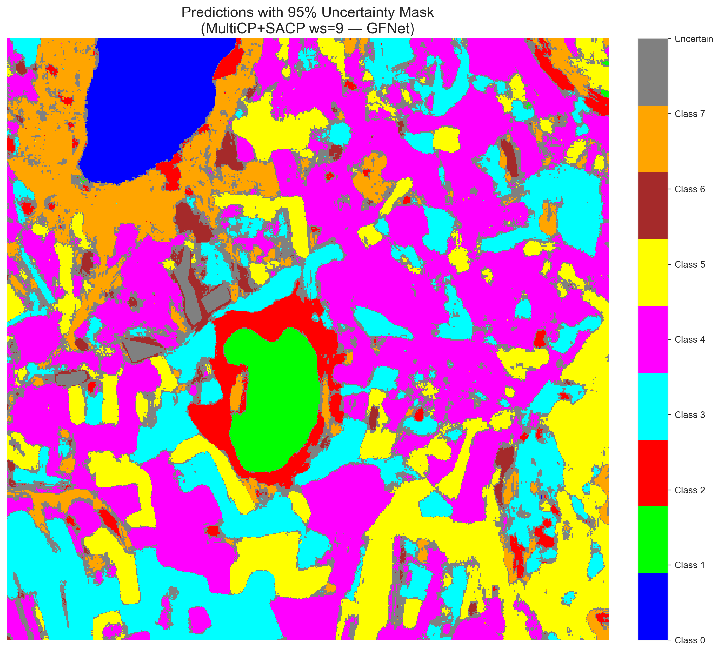
(C) ViT-UNet (SAPS, w=9) | (D) Class Legend
Fig. 13(b). SCMCP (SAPS score, w = 9, α = 0.05, λ = 0.5) masked class prediction maps across the 512 × 512 DIAS scene: (A) AlexNet-CNN, (B) GFNet, (C) ViT-UNet, and (D) Class Legend. Colours denote predicted land-cover classes (Classes 0–7); grey denotes uncertain pixels.
E. Cross-Window Comparison
TABLE XXXII consolidates all 24 SCMCP configurations (4 window sizes × 3 architectures × 2 scoring functions) on the 65-band DIAS Scene K01 dataset.
TABLE XXXII
SCMCP CROSS-WINDOW CONSOLIDATED SUMMARY (α = 0.05, ALL MODELS AND SCORES)
WS | Model | Score | Emp. Cov. | Avg Set | Scn. Cov. | Unc. Rate | MnCls Cov. | Unc. Pixels | Time (s)
3 | AlexNet | RAPS | 0.7061 | 0.7062 | 0.1500 | 0.1297 | 0.7101 | 34,007 | 100.14
3 | AlexNet | SAPS | 0.7014 | 0.7016 | 0.1437 | 0.8225 | 0.7039 | 215,614 | 101.92
3 | GFNet | RAPS | 0.6806 | 0.6806 | 0.1495 | 0.1204 | 0.6724 | 31,568 | 103.95
3 | GFNet | SAPS | 0.7083 | 0.7085 | 0.1480 | 0.8160 | 0.7043 | 213,917 | 103.08
3 | ViT | RAPS | 0.7049 | 0.7125 | 0.1653 | 0.1655 | 0.7084 | 43,393 | 99.45
3 | ViT | SAPS | 0.6972 | 0.7027 | 0.1548 | 0.1190 | 0.7063 | 31,206 | 98.55
5 | AlexNet | RAPS | 0.6892 | 0.6895 | 0.1701 | 0.2097 | 0.6873 | 54,973 | 143.47
5 | AlexNet | SAPS | 0.6941 | 0.6944 | 0.1537 | 0.1071 | 0.6928 | 28,086 | 141.95
5 | GFNet | RAPS | 0.7052 | 0.7054 | 0.1653 | 0.1756 | 0.7024 | 46,037 | 144.22
5 | GFNet | SAPS | 0.7002 | 0.7002 | 0.1545 | 0.1110 | 0.7017 | 29,111 | 142.97
5 | ViT | RAPS | 0.7033 | 0.7116 | 0.1770 | 0.2080 | 0.7173 | 54,536 | 139.13
5 | ViT | SAPS | 0.7033 | 0.7080 | 0.1616 | 0.1350 | 0.7190 | 35,398 | 138.64
7 | AlexNet | RAPS | 0.7025 | 0.7034 | 0.1909 | 0.2970 | 0.7077 | 77,858 | 199.53
7 | AlexNet | SAPS | 0.7028 | 0.7033 | 0.1608 | 0.1354 | 0.7035 | 35,502 | 197.77
7 | GFNet | RAPS | 0.6981 | 0.6985 | 0.1769 | 0.2248 | 0.6989 | 58,939 | 197.55
7 | GFNet | SAPS | 0.6966 | 0.6970 | 0.1593 | 0.1257 | 0.6941 | 32,958 | 199.98
7 | ViT | RAPS | 0.7055 | 0.7125 | 0.1856 | 0.2466 | 0.7089 | 64,635 | 196.32
7 | ViT | SAPS | 0.7037 | 0.7082 | 0.1656 | 0.1485 | 0.7175 | 38,931 | 198.45
9 | AlexNet | RAPS | 0.6950 | 0.6956 | 0.2032 | 0.3499 | 0.6950 | 91,727 | 276.86
9 | AlexNet | SAPS | 0.6907 | 0.6913 | 0.1702 | 0.1602 | 0.6883 | 41,990 | 275.37
9 | GFNet | RAPS | 0.7016 | 0.7019 | 0.1904 | 0.2735 | 0.6972 | 71,684 | 278.21
9 | GFNet | SAPS | 0.7140 | 0.7144 | 0.1665 | 0.1434 | 0.7160 | 37,587 | 279.55
9 | ViT | RAPS | 0.7030 | 0.7097 | 0.2004 | 0.2895 | 0.7124 | 75,882 | 275.92
9 | ViT | SAPS | 0.7006 | 0.7051 | 0.1707 | 0.1628 | 0.7110 | 42,664 | 272.16

Across all 24 SCMCP configurations on the 65-band DIAS scene, three key patterns emerge:
(1) Global minimum uncertainty footprints: AlexNet SAPS at w = 5 achieves the overall minimum uncertain pixel count of the entire study (28,086 pixels, 10.71%) with 0.6941 empirical coverage; GFNet SAPS at w = 5 achieves GFNet's minimum (29,111 pixels, 11.10%) with 0.7002 coverage; and ViT-UNet SAPS at w = 3 achieves ViT-UNet's minimum (31,206 pixels, 11.90%) with 0.6972 coverage.
(2) Monotonic growth of RAPS boundary halos with window size: Under RAPS, uncertain pixel counts increase monotonically from w = 3 to w = 9 for all three backbones—AlexNet rises from 34,007 (12.97%) to 91,727 (34.99%), GFNet rises from 31,568 (12.04%) to 71,684 (27.35%), and ViT-UNet rises from 43,393 (16.55%) to 75,882 (28.95%).
(3) Threshold transition under SAPS: At w = 3, ViT-UNet's higher softmax entropy immediately produces sufficient multi-label sets across the scene, enabling SAPS to achieve 11.90% uncertain pixels, whereas the sharper softmax distributions of AlexNet and GFNet require w ≥ 5 neighbourhood smoothing to transition to the 2.0 set-size threshold and achieve 10.71%–11.10% uncertain pixel rates.
IV. DISCUSSION AND CONCLUSION
The complete 3-model 65-band DIAS SCMCP evaluation demonstrates a clear synergy between spatial probability smoothing and 7-head conformal set intersection across convolutional (AlexNet-CNN), frequency-domain (GFNet), and vision transformer (ViT-UNet) architectures. Without spatial smoothing, pixel-wise multi-head intersection leaves sharp boundaries prone to residual noise. Spatial smoothing enforces local coherence, restricting uncertainty flags strictly to genuine multi-label parcel boundaries.
In summary, for narrow 3 × 3 spatial smoothing (w = 3), GFNet RAPS (12.04% uncertain pixels), ViT-UNet SAPS (11.90%), and AlexNet RAPS (12.97%) provide the sharpest boundary-localised uncertainty maps. For broader spatial smoothing (w ≥ 5), SAPS consistently outperforms RAPS across all three architectures, with AlexNet SAPS at w = 5 (28,086 uncertain pixels, 10.71%) and GFNet SAPS at w = 5 (29,111 uncertain pixels, 11.10%) delivering the most compact uncertainty footprints of the entire 65-band DIAS study.
REFERENCES
[1] J. Liu et al., “Spatial-Aware Conformal Prediction for Trustworthy Hyperspectral Image Classification,” IEEE TGRS, vol. 62, 2024.
[2] A. Baheri and M. A. Shahbazi, “Multi-Scale Conformal Prediction: A Theoretical Framework,” in Proc. NeurIPS, 2023.
[3] Y. Romano, M. Sesia, and E. J. Candès, “Classification with Valid and Adaptive Prediction Sets,” in Proc. NeurIPS, 2020.
[4] A. N. Angelopoulos et al., “Uncertainty Sets for Image Classifiers Using Conformal Prediction,” in Proc. ICLR, 2021.
[5] J. Huang et al., “Conformal Prediction for Deep Classifier via Label Ranking,” in Proc. ICML, 2024.
[6] V. Vovk, A. Gammerman, and G. Shafer, Algorithmic Learning in a Random World. Springer, 2005.
[7] A. N. Angelopoulos and S. Bates, “A Gentle Introduction to Conformal Prediction,” arXiv:2107.07511, 2021.

