Spatial-Aware Conformal Prediction (SACP) for Hyperspectral Land-Cover Classification: Complete Results Across Window Sizes 3, 5, 7, and 9
ABSTRACT
This report presents the complete results of Spatial-Aware Conformal Prediction (SACP) applied post-hoc to three deep learning architectures—AlexNet-style CNN (AlexNet), Global Filter Network (GFNet), and Vision Transformer with U-Net skip connections (ViT-UNet)—for pixel-wise land-cover classification of a 65-band hyperspectral scene from the DIAS dataset (Scene K01, 512 × 512 pixels, 262,144 total scene pixels, K = 8 classes: Class 0 through Class 7). SACP extends standard split conformal prediction by smoothing each pixel’s Adaptive Prediction Sets (APS) nonconformity score across a local spatial neighbourhood prior to threshold calibration, targeting 95% marginal coverage (α = 0.05, λ = 0.5, k = 1 smoothing round) on n_cal = 6,737 calibration samples and n_eval = 6,737 evaluation samples. Four spatial window sizes are evaluated: w ∈ {3, 5, 7, 9}. All twelve model–window configurations achieve empirical coverage between 99.97% and 100.00%, exceeding the 95% target with singleton rates of 99.91%–100.00% and zero empty sets. Across all three models, the calibrated threshold q̂ decreases monotonically as the spatial window widens from w = 3 to w = 9 (AlexNet: 0.8192 → 0.7301; GFNet: 0.8121 → 0.7241; ViT-UNet: 0.7874 → 0.7020), while full-scene uncertain pixel counts reach their minimum at w = 3 for AlexNet (18,135, 6.92%) and at w = 5 for GFNet (27,277, 10.41%) and ViT-UNet (21,780, 8.31%).
I. SPATIAL-AWARE CONFORMAL PREDICTION: METHODOLOGY
A. Overview and Intuition
Standard conformal prediction for image classification treats every pixel as an independent, exchangeable sample. In spatial remote sensing imagery, neighbouring pixels within a homogeneous parcel share the same land-cover class, and a borderline pixel’s uncertainty can be resolved by incorporating its local spatial context [1]. SACP exploits this structure by smoothing the nonconformity score itself across a local window before calibration, rather than post-processing predicted labels. Because the score function—not the underlying classifier—is modified, the formal finite-sample coverage guarantee is preserved [1, 2, 3].
Formally, let π̂_θ : X → Δ^{K−1} be a trained classifier producing a softmax probability vector over K = 8 land-cover classes (Class 0 through Class 7) from a 9 × 9 × 65 patch. SACP builds on the Randomised Adaptive Prediction Sets (APS) score of Romano et al. [2], fuses each pixel’s score with its spatial neighbourhood average via a Score Aggregation Operator V^k, and calibrates a global threshold q̂ from the fused calibration scores.
B. Base Nonconformity Score: Randomised APS
For a probability vector π̂(x), classes are ranked in decreasing probability order. The APS score for class y is:
S(x, y) = Σ_{j < o(y,x)} π̂_{(j)}(x) + U · π̂_{(o(y,x))}(x), U ∼ Uniform(0, 1)
where o(y, x) is the rank of class y in the sorted probability list and U is an independent uniform random draw.
C. Score Aggregation Operator: Spatial Smoothing
SACP replaces each pixel’s raw score vector with a convex blend of its own score and its spatial neighbours’ average:
V^t(B_i, y) = λ · V^{t−1}(B_i, y) + λ · (1 / |N_valid(r,c)|) Σ_{(r',c') ∈ N_valid(r,c)} V^{t−1}(B_{(r',c')}, y)
where λ = 0.5 is the mixing weight, N_valid(r, c) is the set of valid in-bounds neighbours within a w × w window, and k = 1 smoothing round is applied across window sizes w ∈ {3, 5, 7, 9}.
D. Experimental Configuration
SACP is applied with fixed parameters α = 0.05, λ = 0.5, k = 1 across w ∈ {3, 5, 7, 9} on the 65-band DIAS Scene K01 dataset (H = 512, W = 512, B = 65, K = 8 classes: Class 0–Class 7). The calibration split (n_cal = 6,737 samples) and evaluation split (n_eval = 6,737 samples; class supports 1,216, 704, 283, 1,365, 1,590, 1,059, 200, and 320) match the companion baseline study. Dense pixel-count tables sum across all 512 × 512 = 262,144 scene pixels.
II. SACP RESULTS: WINDOW SIZE W = 3
With a 3 × 3 smoothing window (up to 8 neighbours), TABLES I–IV present the aggregate metrics, per-class coverages, calibration parameters, and full-scene pixel counts; Figs. 1(a)–(b) show the binary uncertainty maps and class-masked maps.
TABLE I
SACP: AGGREGATE SUMMARY (WINDOW = 3, Α = 0.05, Λ = 0.5, K = 1)
Model | q̂ | Emp. Cov. | Avg Set Size | Singleton Rate | Empty Set Rate | Runtime (s) | Mean Cls Cov.
AlexNet | 0.8192 | 1.0000 | 1.0000 | 1.0000 | 0.0000 | 86.83 | 1.0000
GFNet | 0.8121 | 0.9999 | 1.0000 | 1.0000 | 0.0000 | 78.33 | 0.9994
ViT-UNet | 0.7874 | 0.9997 | 1.0009 | 0.9991 | 0.0000 | 101.57 | 0.9995

TABLE II
SACP: PER-CLASS COVERAGE COMPARISON (WINDOW = 3)
Class | AlexNet Coverage | GFNet Coverage | ViT-UNet Coverage
Class 0 | 1.0000 | 1.0000 | 0.9992
Class 1 | 1.0000 | 1.0000 | 1.0000
Class 2 | 1.0000 | 1.0000 | 1.0000
Class 3 | 1.0000 | 1.0000 | 1.0000
Class 4 | 1.0000 | 1.0000 | 1.0000
Class 5 | 1.0000 | 1.0000 | 1.0000
Class 6 | 1.0000 | 0.9950 | 1.0000
Class 7 | 1.0000 | 1.0000 | 0.9969

TABLE III
SACP: CALIBRATION PARAMETERS (WINDOW = 3)
Model | q̂ | α (alpha) | λ (lambda) | k | Win.
AlexNet | 0.8192 | 0.05 | 0.5 | 1 | 3
GFNet | 0.8121 | 0.05 | 0.5 | 1 | 3
ViT-UNet | 0.7874 | 0.05 | 0.5 | 1 | 3

TABLE IV
SACP: PREDICTED PIXEL COUNT DISTRIBUTION (WINDOW = 3)
Class / Region | AlexNet Pixels | GFNet Pixels | ViT-UNet Pixels
Class 0 | 10,847 | 11,470 | 11,457
Class 1 | 8,206 | 7,465 | 7,487
Class 2 | 8,295 | 7,739 | 8,596
Class 3 | 46,204 | 44,321 | 39,262
Class 4 | 82,407 | 85,469 | 93,592
Class 5 | 49,065 | 40,706 | 48,266
Class 6 | 11,512 | 5,572 | 6,852
Class 7 | 27,473 | 22,566 | 23,919
Uncertain | 18,135 | 36,836 | 22,713
Total (Scene) | 262,144 | 262,144 | 262,144

At w = 3, all three architectures exceed the 95% target with near-100% empirical coverage: AlexNet achieves 1.0000 (q̂ = 0.8192), GFNet achieves 0.9999 (q̂ = 0.8121, with Class 6 at 0.9950 and all other classes at 1.0000), and ViT-UNet reaches 0.9997 (q̂ = 0.7874, average set size 1.0009). Across the full 262,144-pixel scene, uncertain pixel counts are 18,135 (6.92%) for AlexNet, 36,836 (14.05%) for GFNet, and 22,713 (8.66%) for ViT-UNet.
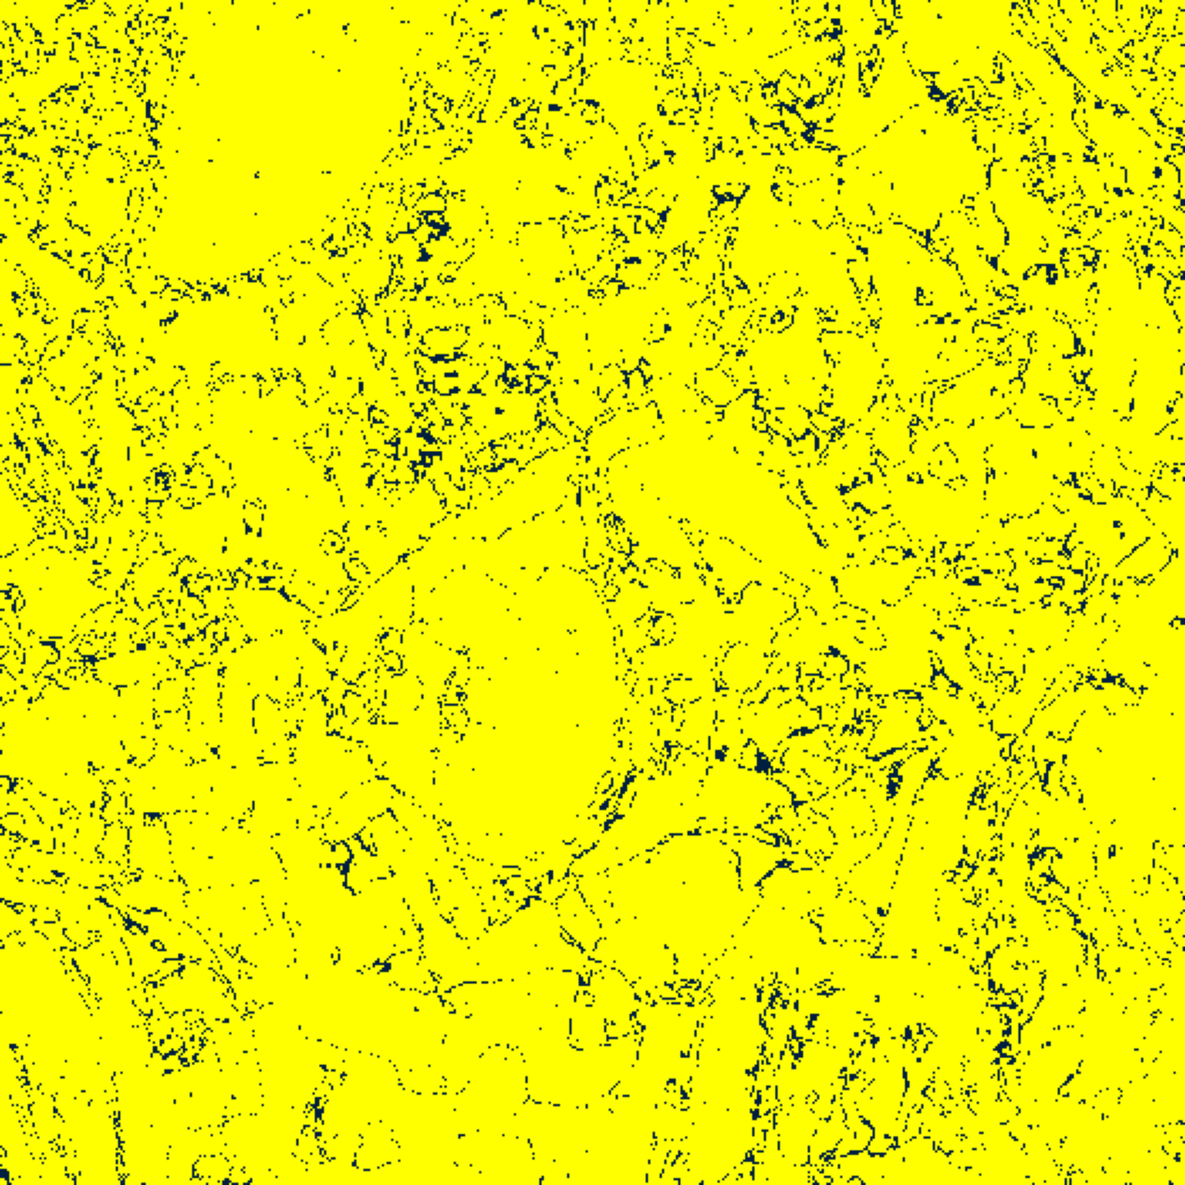  (A) AlexNet | 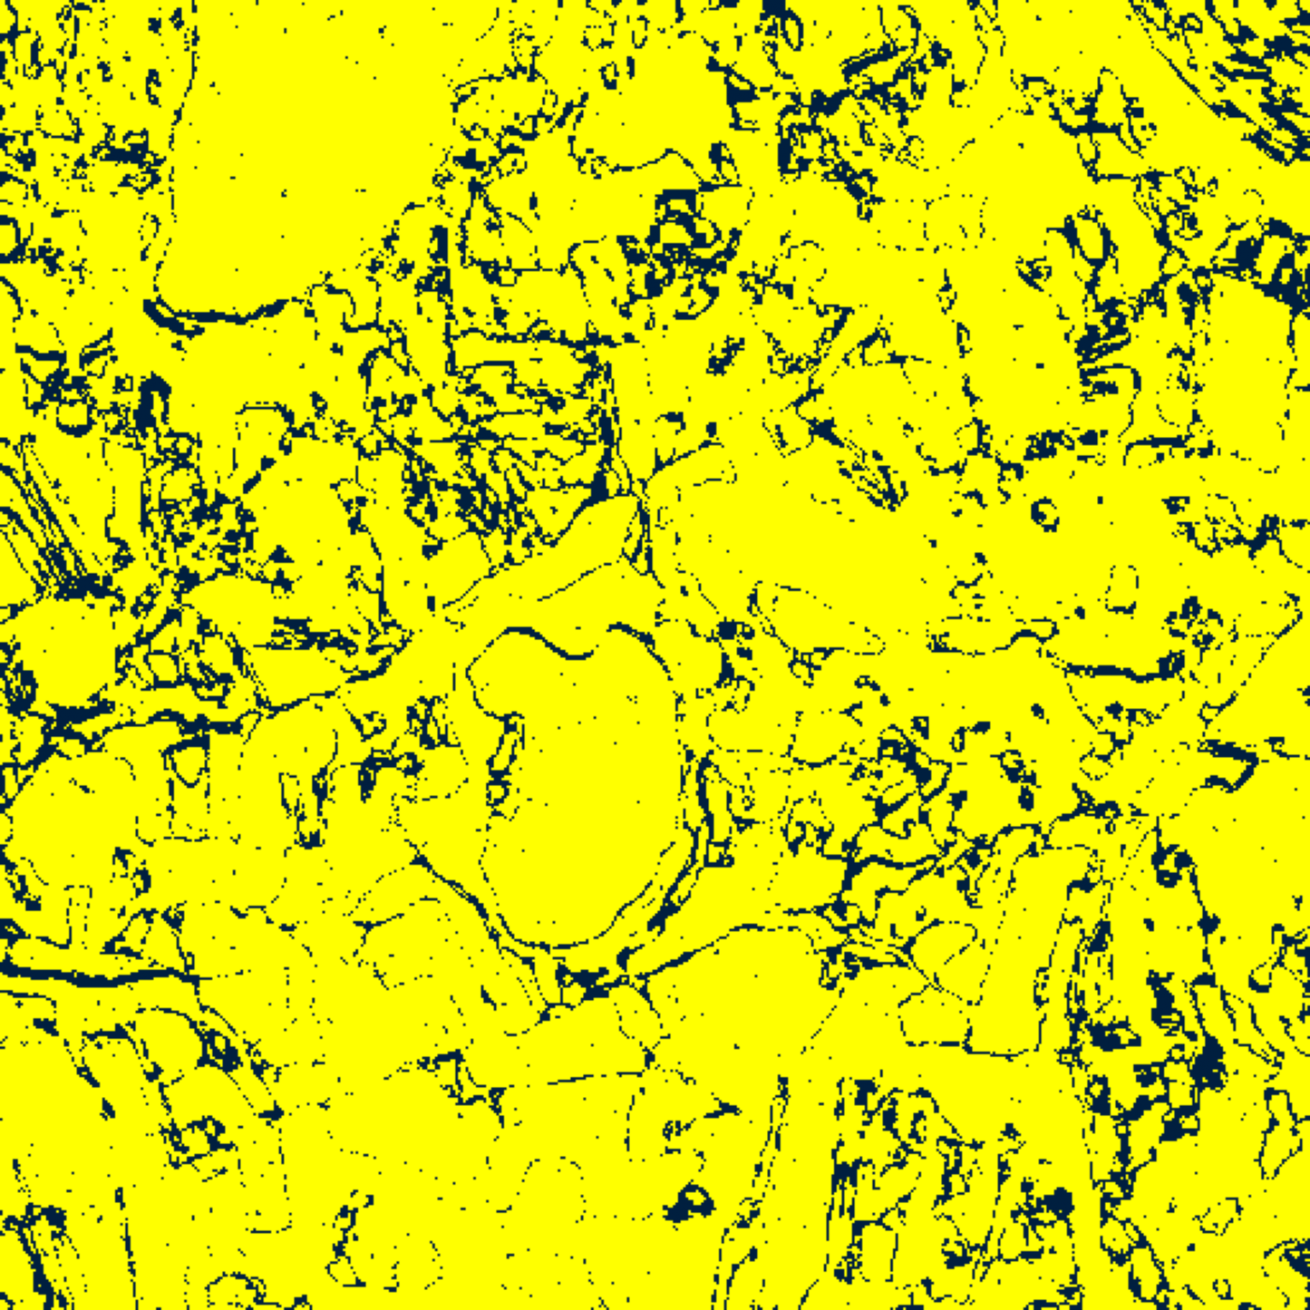  (B) GFNet
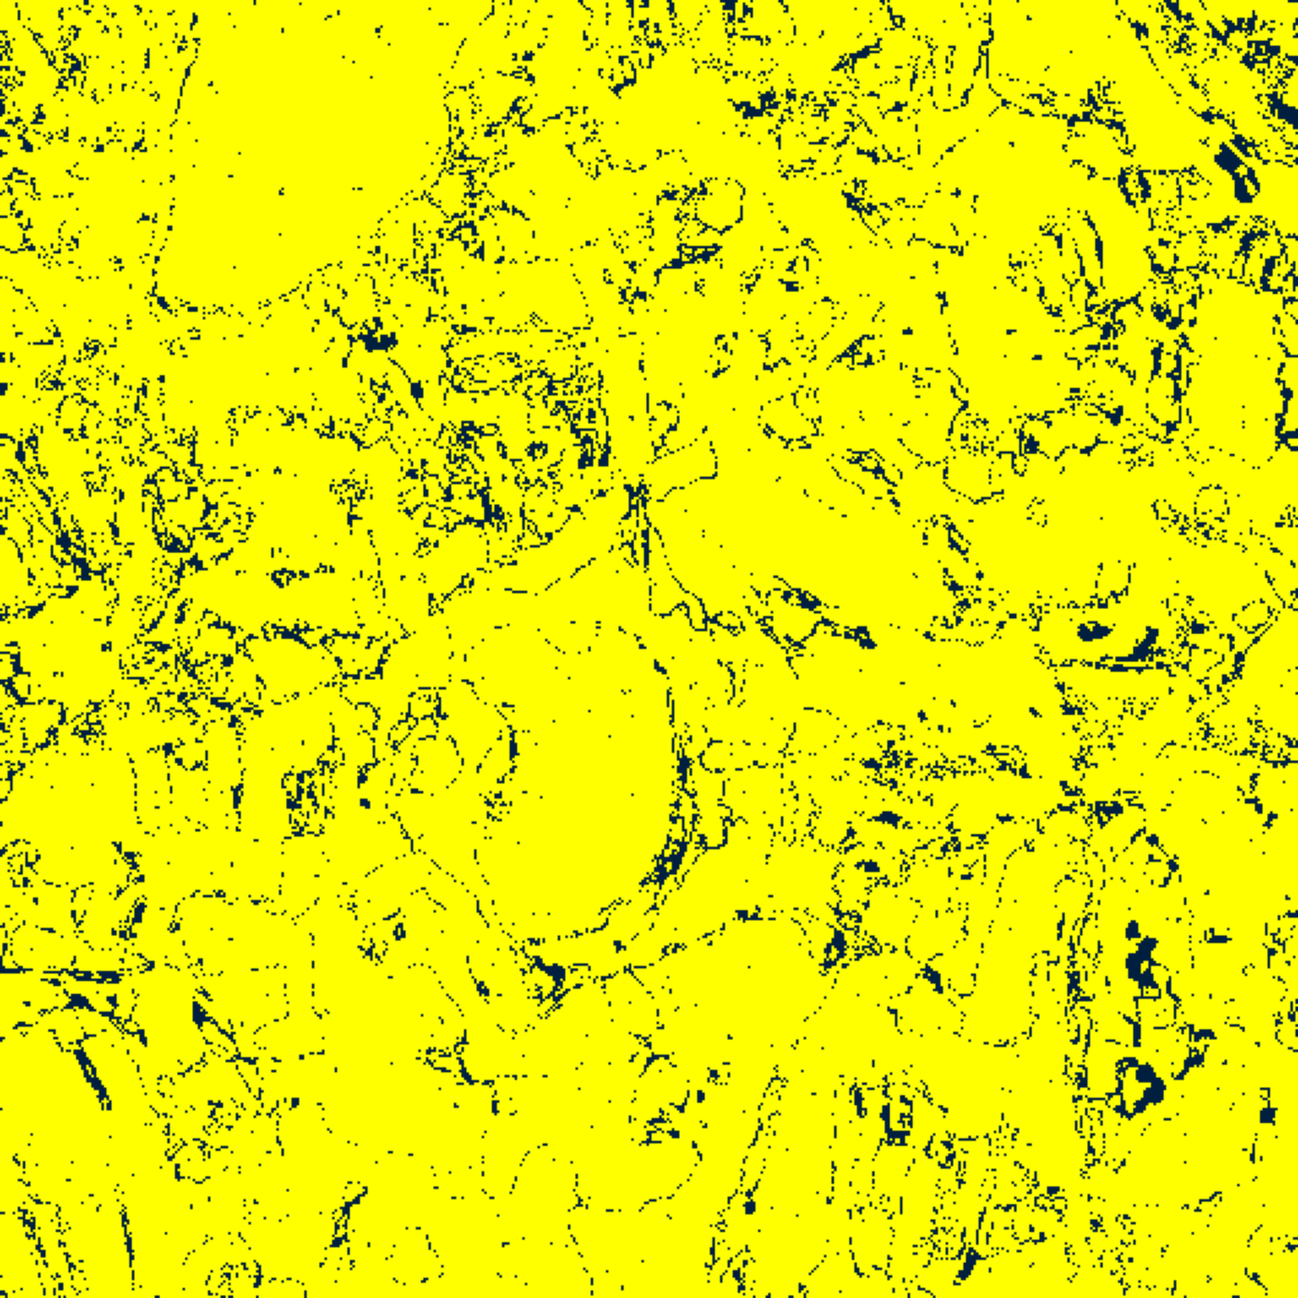  (C) ViT-UNet | 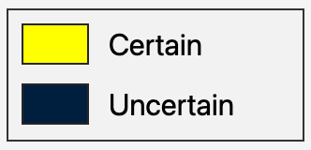  (D) Legend
Fig. 1(a). SACP (w=3) 95% binary uncertainty maps: (A) AlexNet, (B) GFNet, (C) ViT-UNet. Yellow = certain singleton (set size = 1); dark navy = uncertain (set size ≠ 1). Shared legend in (D).
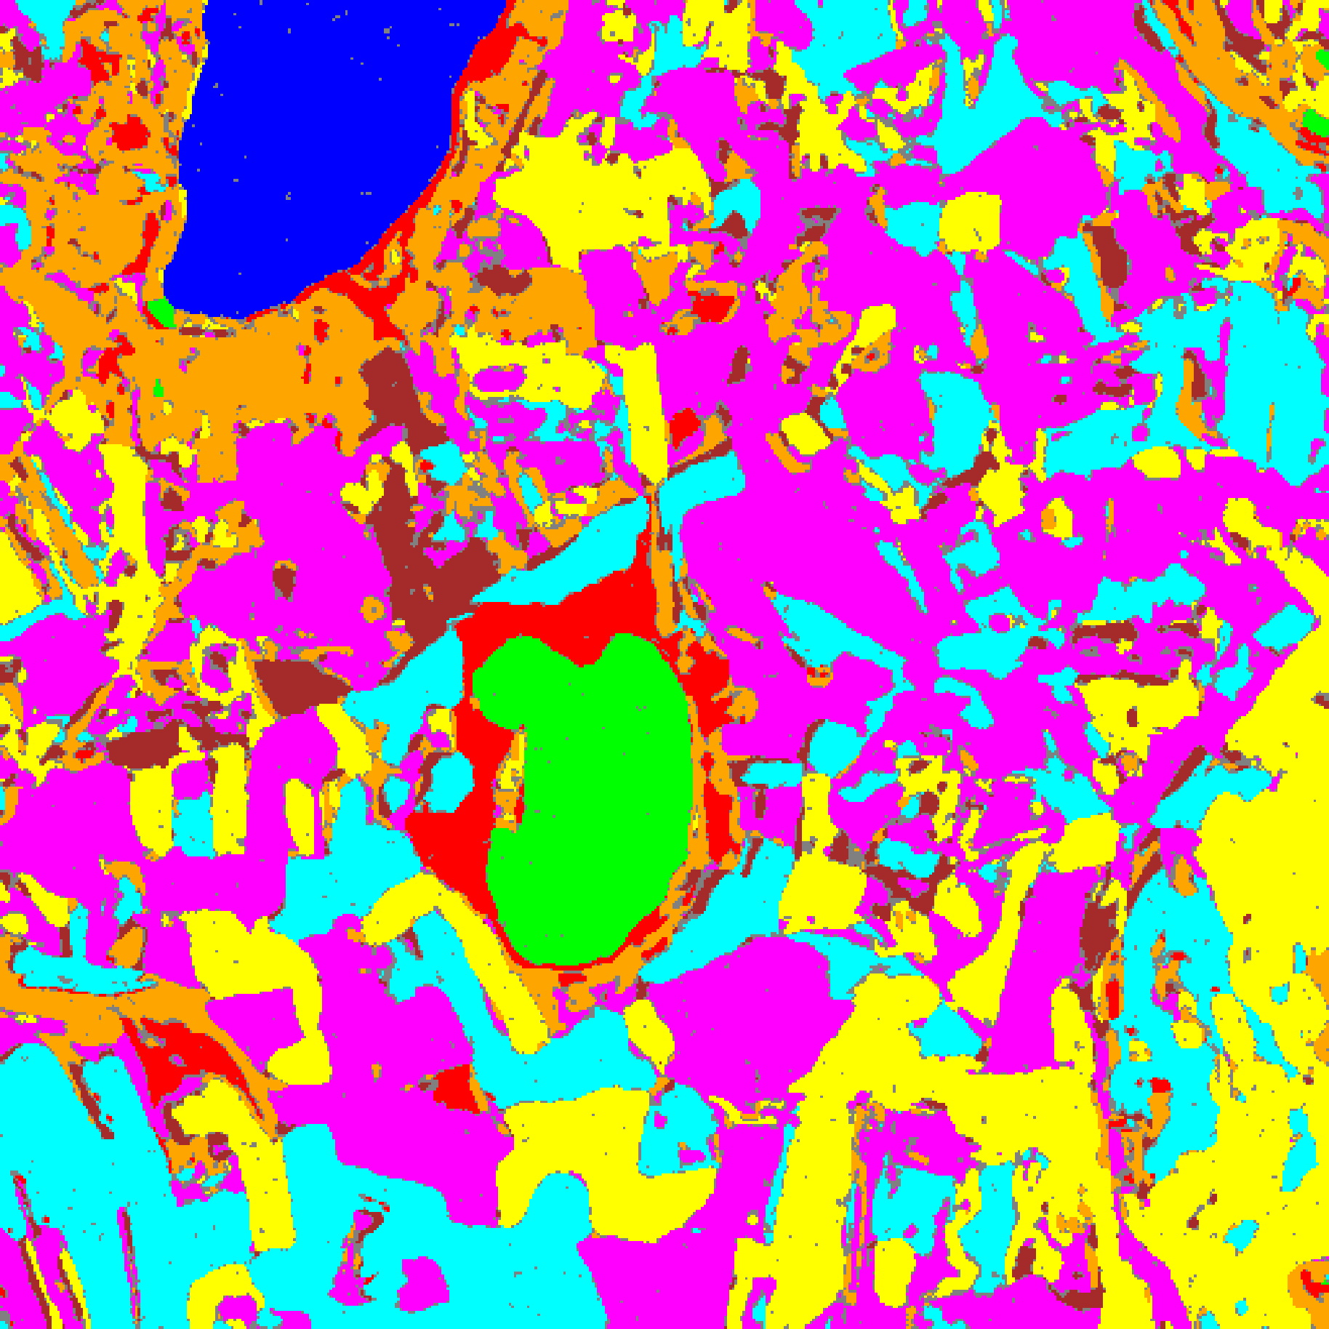  (A) AlexNet | 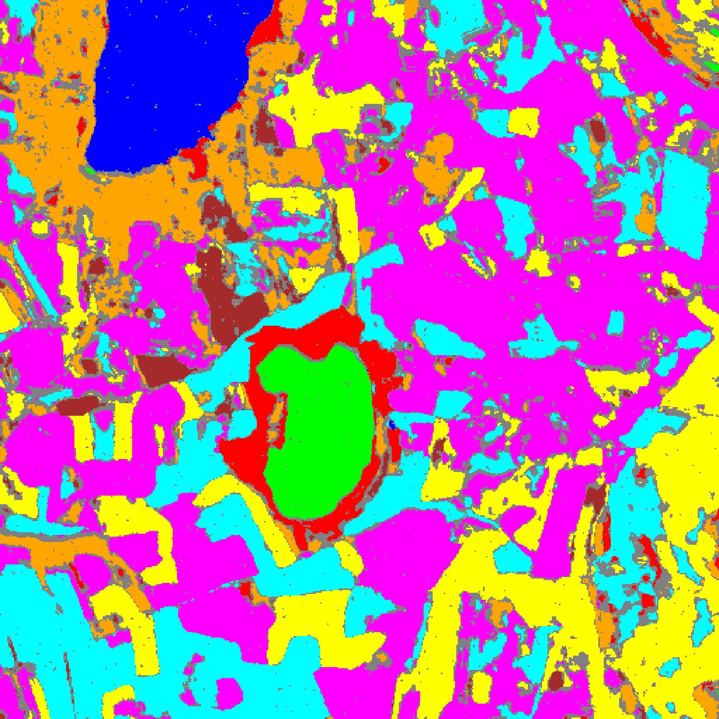  (B) GFNet
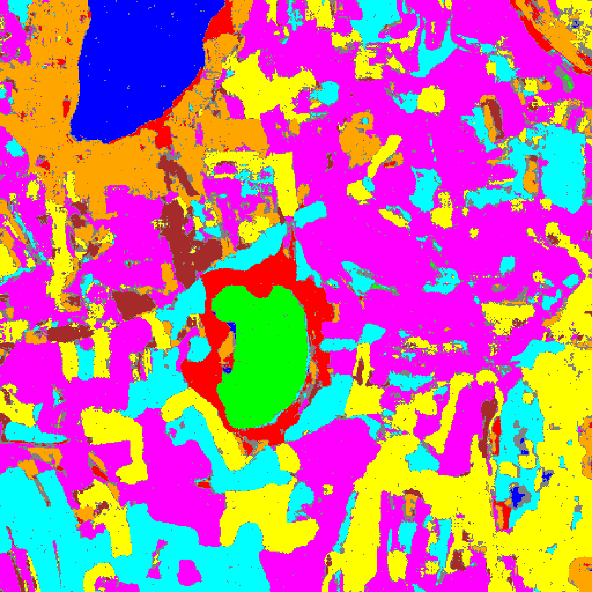  (C) ViT-UNet | 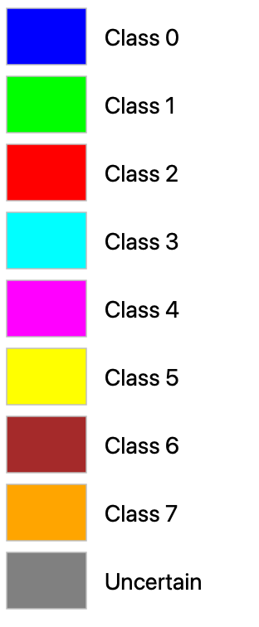  (D) Legend
Fig. 1(b). SACP (w=3) 95% uncertainty masks: (A) AlexNet, (B) GFNet, (C) ViT-UNet. Class colours per shared legend (D): Class 0 through Class 7; grey = uncertain.
III. SACP RESULTS: WINDOW SIZE W = 5
With a 5 × 5 smoothing window (up to 24 neighbours), TABLES V–VIII present the aggregate metrics, per-class coverages, calibration parameters, and full-scene pixel counts; Figs. 2(a)–(b) show the binary uncertainty maps and class-masked maps.
TABLE V
SACP: AGGREGATE SUMMARY (WINDOW = 5, Α = 0.05, Λ = 0.5, K = 1)
Model | q̂ | Emp. Cov. | Avg Set Size | Singleton Rate | Empty Set Rate | Runtime (s) | Mean Cls Cov.
AlexNet | 0.7525 | 1.0000 | 1.0000 | 1.0000 | 0.0000 | 91.49 | 1.0000
GFNet | 0.7467 | 1.0000 | 1.0001 | 0.9999 | 0.0000 | 83.24 | 1.0000
ViT-UNet | 0.7237 | 0.9999 | 1.0006 | 0.9994 | 0.0000 | 98.66 | 0.9999

TABLE VI
SACP: PER-CLASS COVERAGE COMPARISON (WINDOW = 5)
Class | AlexNet Coverage | GFNet Coverage | ViT-UNet Coverage
Class 0 | 1.0000 | 1.0000 | 0.9992
Class 1 | 1.0000 | 1.0000 | 1.0000
Class 2 | 1.0000 | 1.0000 | 1.0000
Class 3 | 1.0000 | 1.0000 | 1.0000
Class 4 | 1.0000 | 1.0000 | 1.0000
Class 5 | 1.0000 | 1.0000 | 1.0000
Class 6 | 1.0000 | 1.0000 | 1.0000
Class 7 | 1.0000 | 1.0000 | 1.0000

TABLE VII
SACP: CALIBRATION PARAMETERS (WINDOW = 5)
Model | q̂ | α (alpha) | λ (lambda) | k | Win.
AlexNet | 0.7525 | 0.05 | 0.5 | 1 | 5
GFNet | 0.7467 | 0.05 | 0.5 | 1 | 5
ViT-UNet | 0.7237 | 0.05 | 0.5 | 1 | 5

TABLE VIII
SACP: PREDICTED PIXEL COUNT DISTRIBUTION (WINDOW = 5)
Class / Region | AlexNet Pixels | GFNet Pixels | ViT-UNet Pixels
Class 0 | 10,663 | 11,376 | 11,386
Class 1 | 8,022 | 7,431 | 7,358
Class 2 | 8,133 | 8,285 | 8,662
Class 3 | 45,682 | 45,446 | 39,345
Class 4 | 81,487 | 88,179 | 93,803
Class 5 | 48,238 | 42,502 | 48,173
Class 6 | 11,603 | 6,441 | 7,249
Class 7 | 27,097 | 25,207 | 24,388
Uncertain | 21,219 | 27,277 | 21,780
Total (Scene) | 262,144 | 262,144 | 262,144

At w = 5, q̂ drops sharply across all three models: AlexNet to 0.7525 (−8.1% from w = 3), GFNet to 0.7467 (−8.1%), and ViT-UNet to 0.7237 (−8.1%). Both AlexNet and GFNet achieve 1.0000 empirical coverage across all eight classes, while ViT-UNet achieves 0.9999. Full-scene uncertain pixels decrease for GFNet (36,836 → 27,277, −26.0%) and ViT-UNet (22,713 → 21,780, −4.1%), reaching their global minimum at w = 5, whereas AlexNet increases slightly to 21,219 (8.09%).
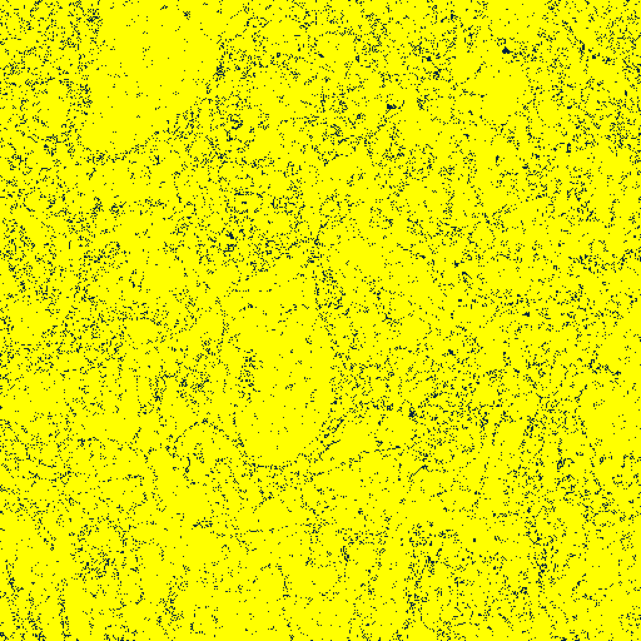  (A) AlexNet | 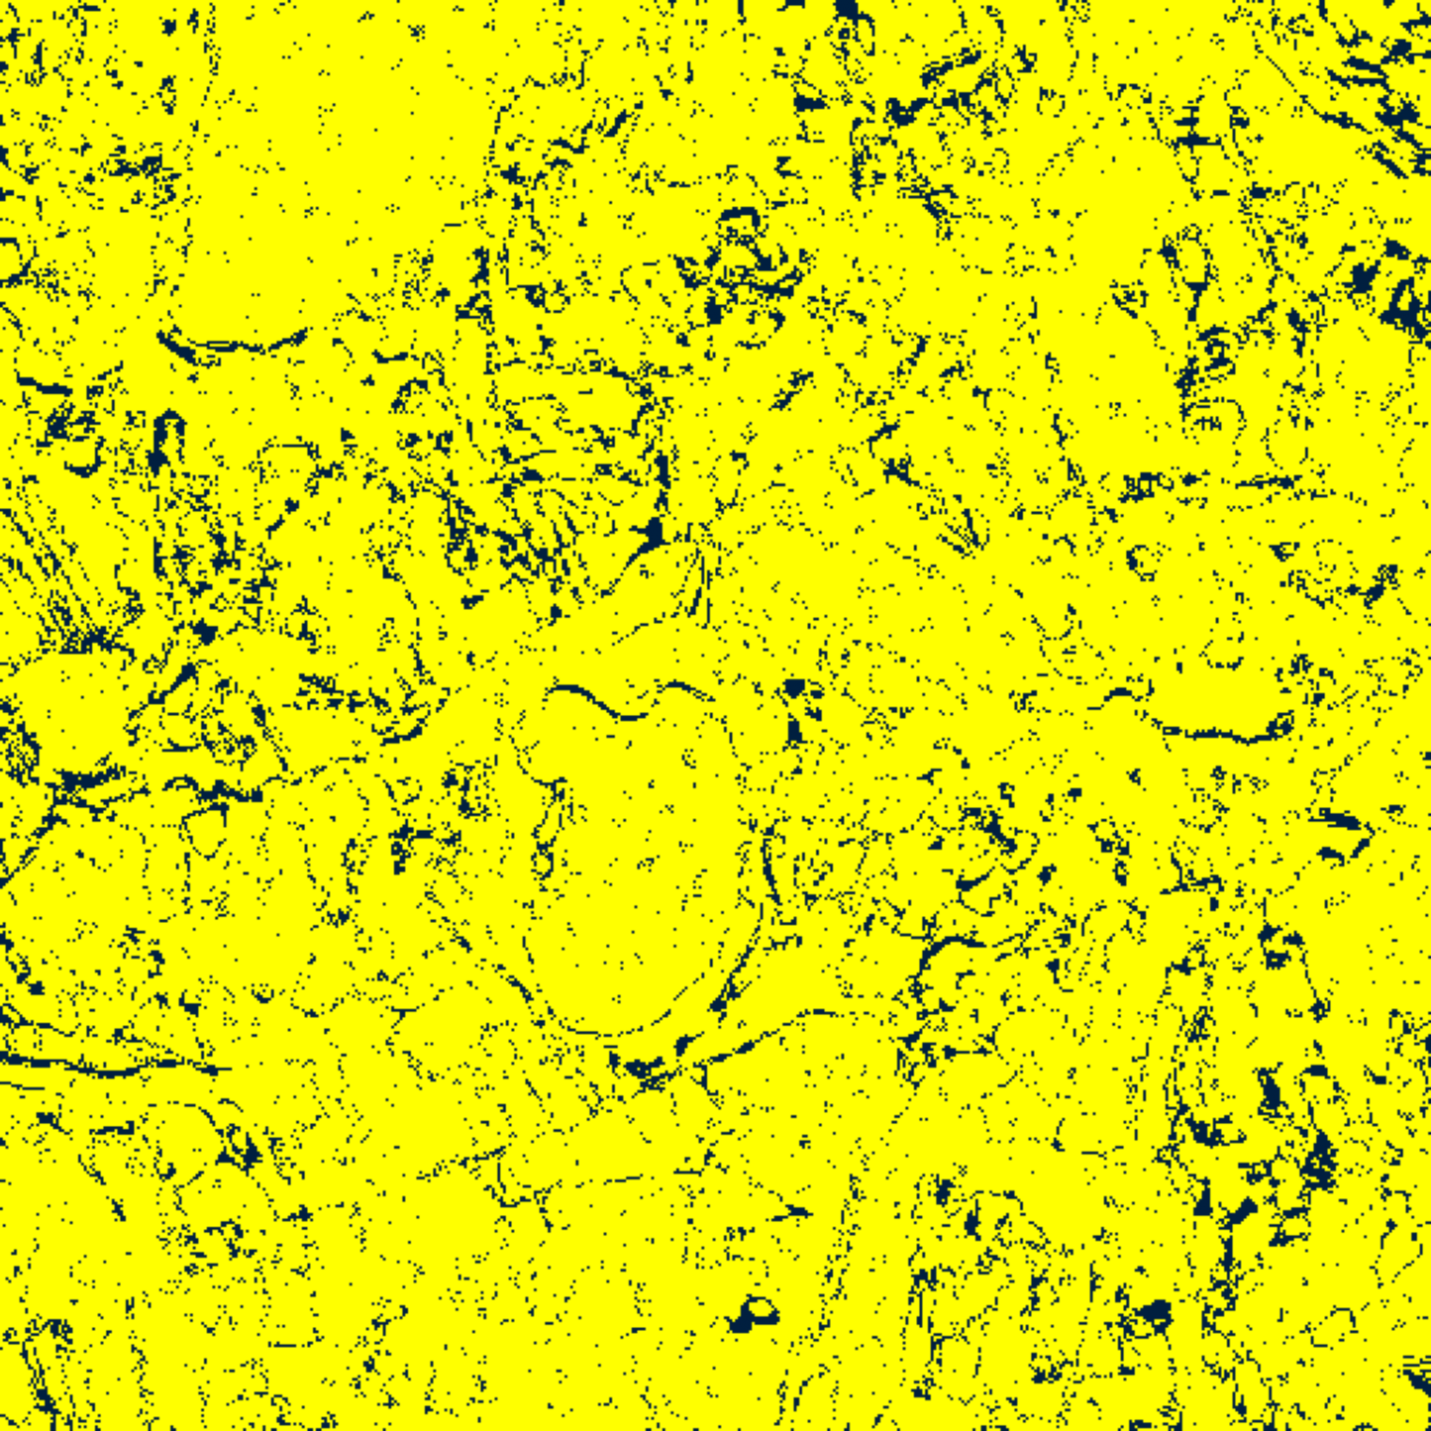  (B) GFNet
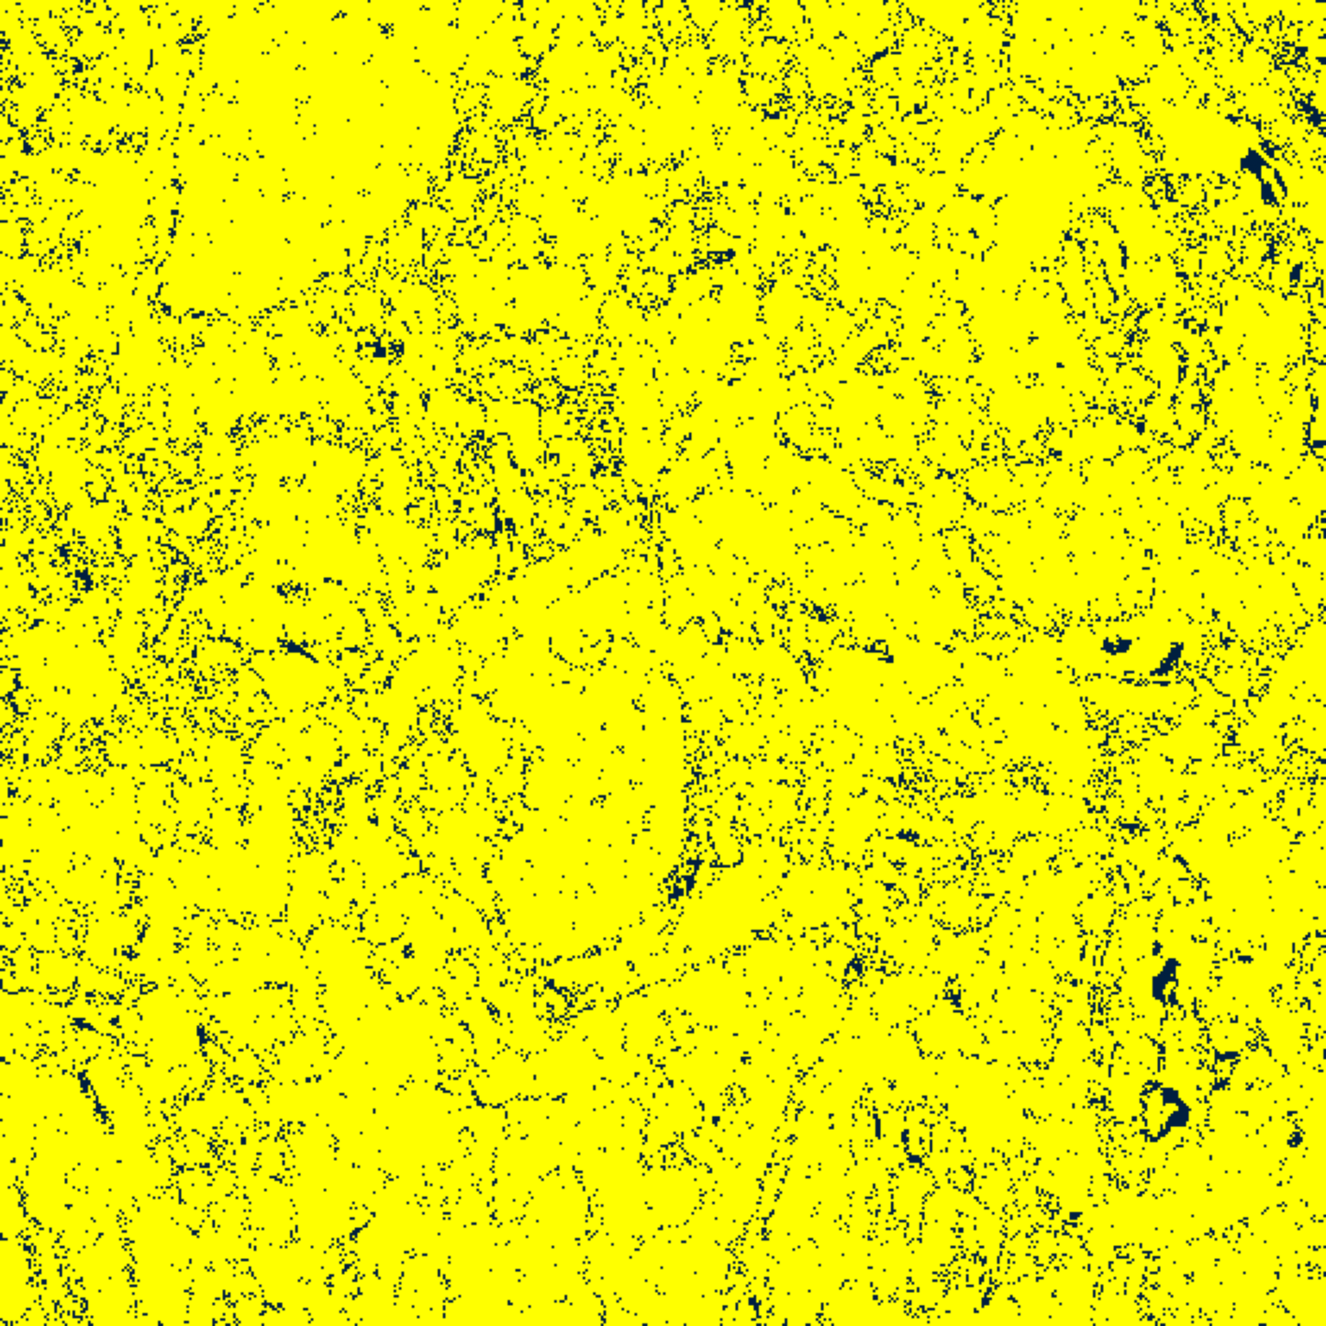  (C) ViT-UNet | (D) Legend
Fig. 2(a). SACP (w=5) 95% binary uncertainty maps: (A) AlexNet, (B) GFNet, (C) ViT-UNet. Yellow = certain singleton (set size = 1); dark navy = uncertain (set size ≠ 1). Shared legend in (D).
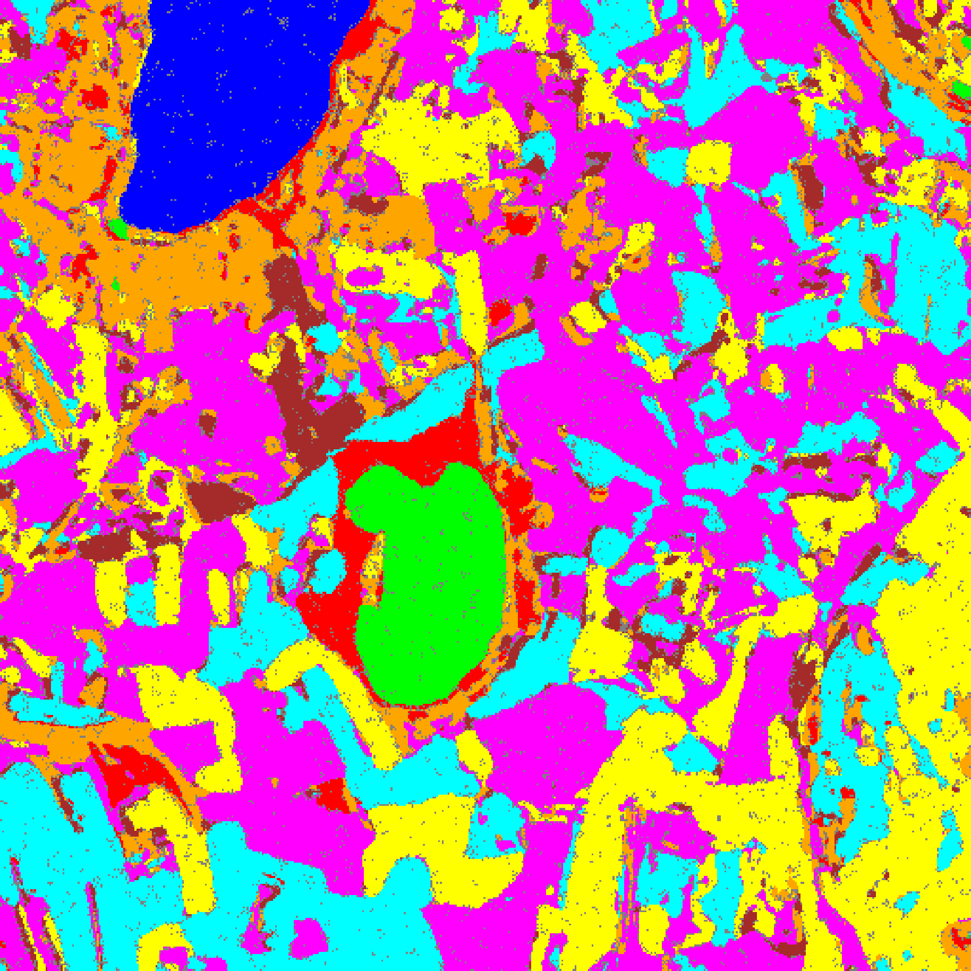  (A) AlexNet | 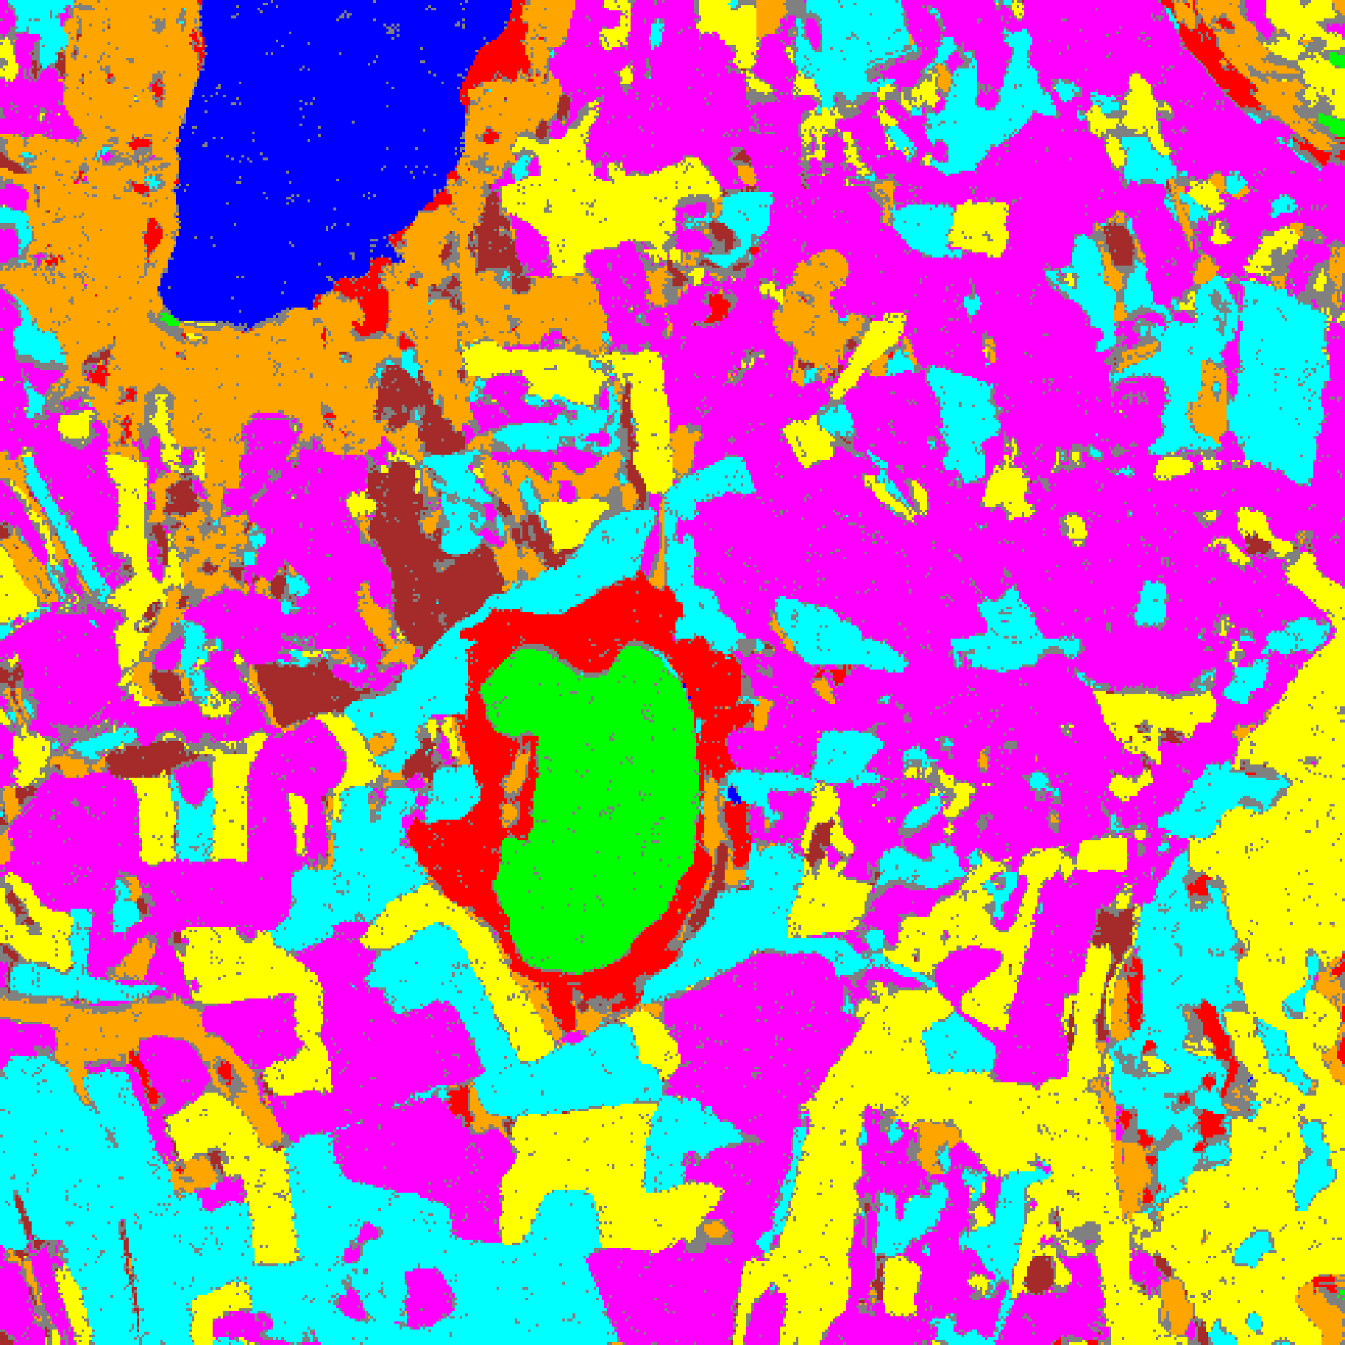  (B) GFNet
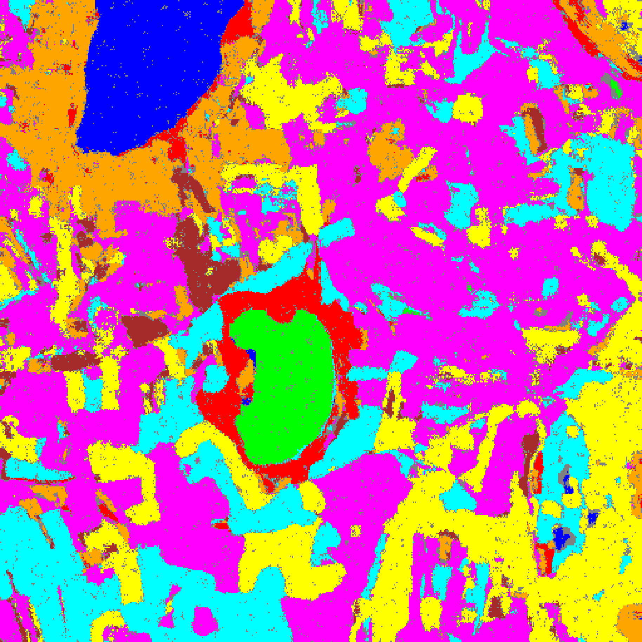  (C) ViT-UNet | (D) Legend
Fig. 2(b). SACP (w=5) 95% uncertainty masks: (A) AlexNet, (B) GFNet, (C) ViT-UNet. Class colours per shared legend (D): Class 0 through Class 7; grey = uncertain.
IV. SACP RESULTS: WINDOW SIZE W = 7
With a 7 × 7 smoothing window (up to 48 neighbours), TABLES IX–XII present the aggregate metrics, per-class coverages, calibration parameters, and full-scene pixel counts; Figs. 3(a)–(b) show the binary uncertainty maps and class-masked maps.
TABLE IX
SACP: AGGREGATE SUMMARY (WINDOW = 7, Α = 0.05, Λ = 0.5, K = 1)
Model | q̂ | Emp. Cov. | Avg Set Size | Singleton Rate | Empty Set Rate | Runtime (s) | Mean Cls Cov.
AlexNet | 0.7369 | 0.9999 | 1.0000 | 1.0000 | 0.0000 | 102.29 | 0.9999
GFNet | 0.7315 | 1.0000 | 1.0001 | 0.9999 | 0.0000 | 95.35 | 1.0000
ViT-UNet | 0.7091 | 0.9997 | 1.0004 | 0.9996 | 0.0000 | 111.00 | 0.9998

TABLE X
SACP: PER-CLASS COVERAGE COMPARISON (WINDOW = 7)
Class | AlexNet Coverage | GFNet Coverage | ViT-UNet Coverage
Class 0 | 1.0000 | 1.0000 | 0.9992
Class 1 | 1.0000 | 1.0000 | 1.0000
Class 2 | 1.0000 | 1.0000 | 1.0000
Class 3 | 0.9993 | 1.0000 | 0.9993
Class 4 | 1.0000 | 1.0000 | 1.0000
Class 5 | 1.0000 | 1.0000 | 1.0000
Class 6 | 1.0000 | 1.0000 | 1.0000
Class 7 | 1.0000 | 1.0000 | 1.0000

TABLE XI
SACP: CALIBRATION PARAMETERS (WINDOW = 7)
Model | q̂ | α (alpha) | λ (lambda) | k | Win.
AlexNet | 0.7369 | 0.05 | 0.5 | 1 | 7
GFNet | 0.7315 | 0.05 | 0.5 | 1 | 7
ViT-UNet | 0.7091 | 0.05 | 0.5 | 1 | 7

TABLE XII
SACP: PREDICTED PIXEL COUNT DISTRIBUTION (WINDOW = 7)
Class / Region | AlexNet Pixels | GFNet Pixels | ViT-UNet Pixels
Class 0 | 10,504 | 11,241 | 11,243
Class 1 | 7,850 | 7,342 | 7,236
Class 2 | 7,710 | 8,219 | 8,376
Class 3 | 44,076 | 44,627 | 38,311
Class 4 | 78,781 | 87,499 | 91,968
Class 5 | 46,553 | 42,158 | 46,960
Class 6 | 10,898 | 6,598 | 7,028
Class 7 | 25,684 | 25,628 | 23,794
Uncertain | 30,088 | 28,832 | 27,228
Total (Scene) | 262,144 | 262,144 | 262,144

At w = 7, q̂ continues its monotone decline to 0.7369 (AlexNet), 0.7315 (GFNet), and 0.7091 (ViT-UNet). Empirical coverages remain at 0.9999 (AlexNet), 1.0000 (GFNet), and 0.9997 (ViT-UNet). Full-scene uncertain pixel counts rise to 30,088 (11.48%) for AlexNet, 28,832 (11.00%) for GFNet, and 27,228 (10.39%) for ViT-UNet as the 7 × 7 neighbourhood begins spanning across parcel boundaries into adjacent background regions.
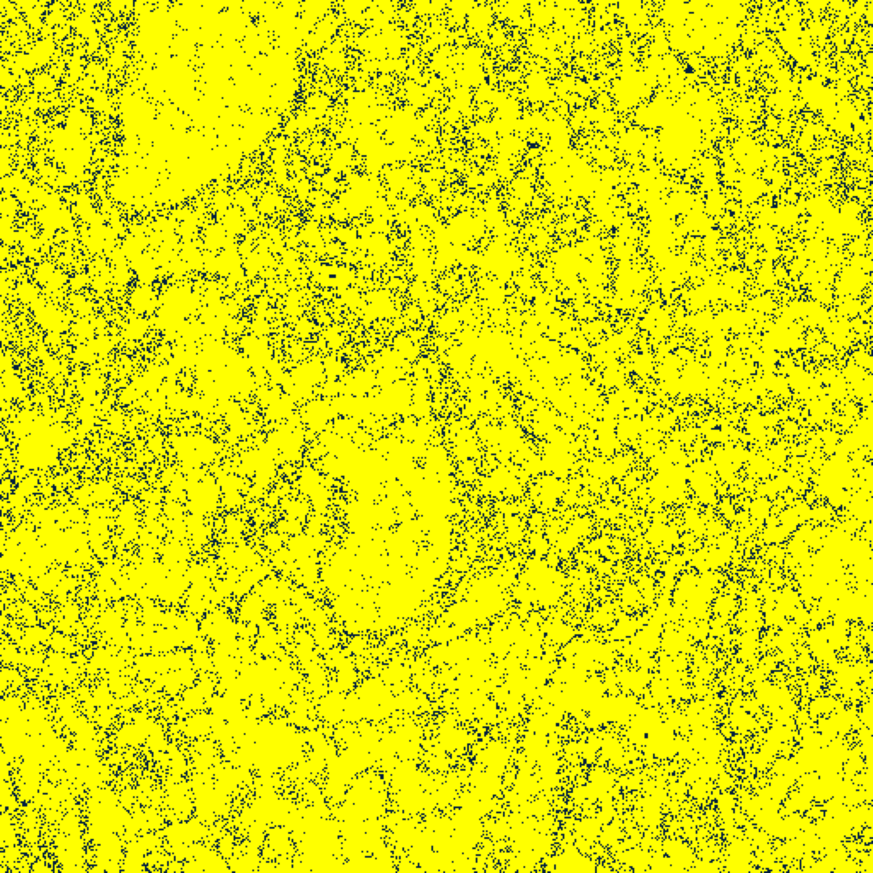  (A) AlexNet | 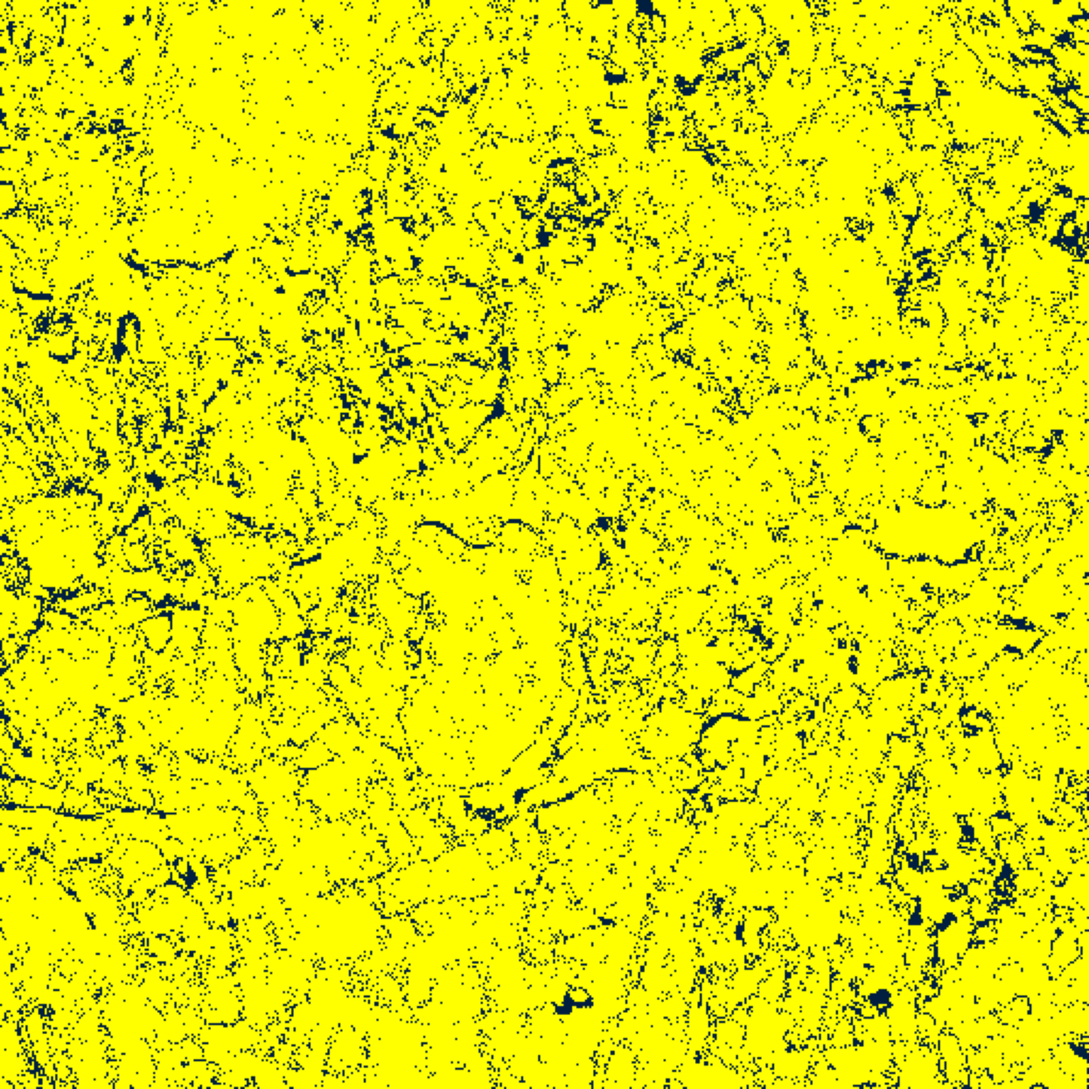  (B) GFNet
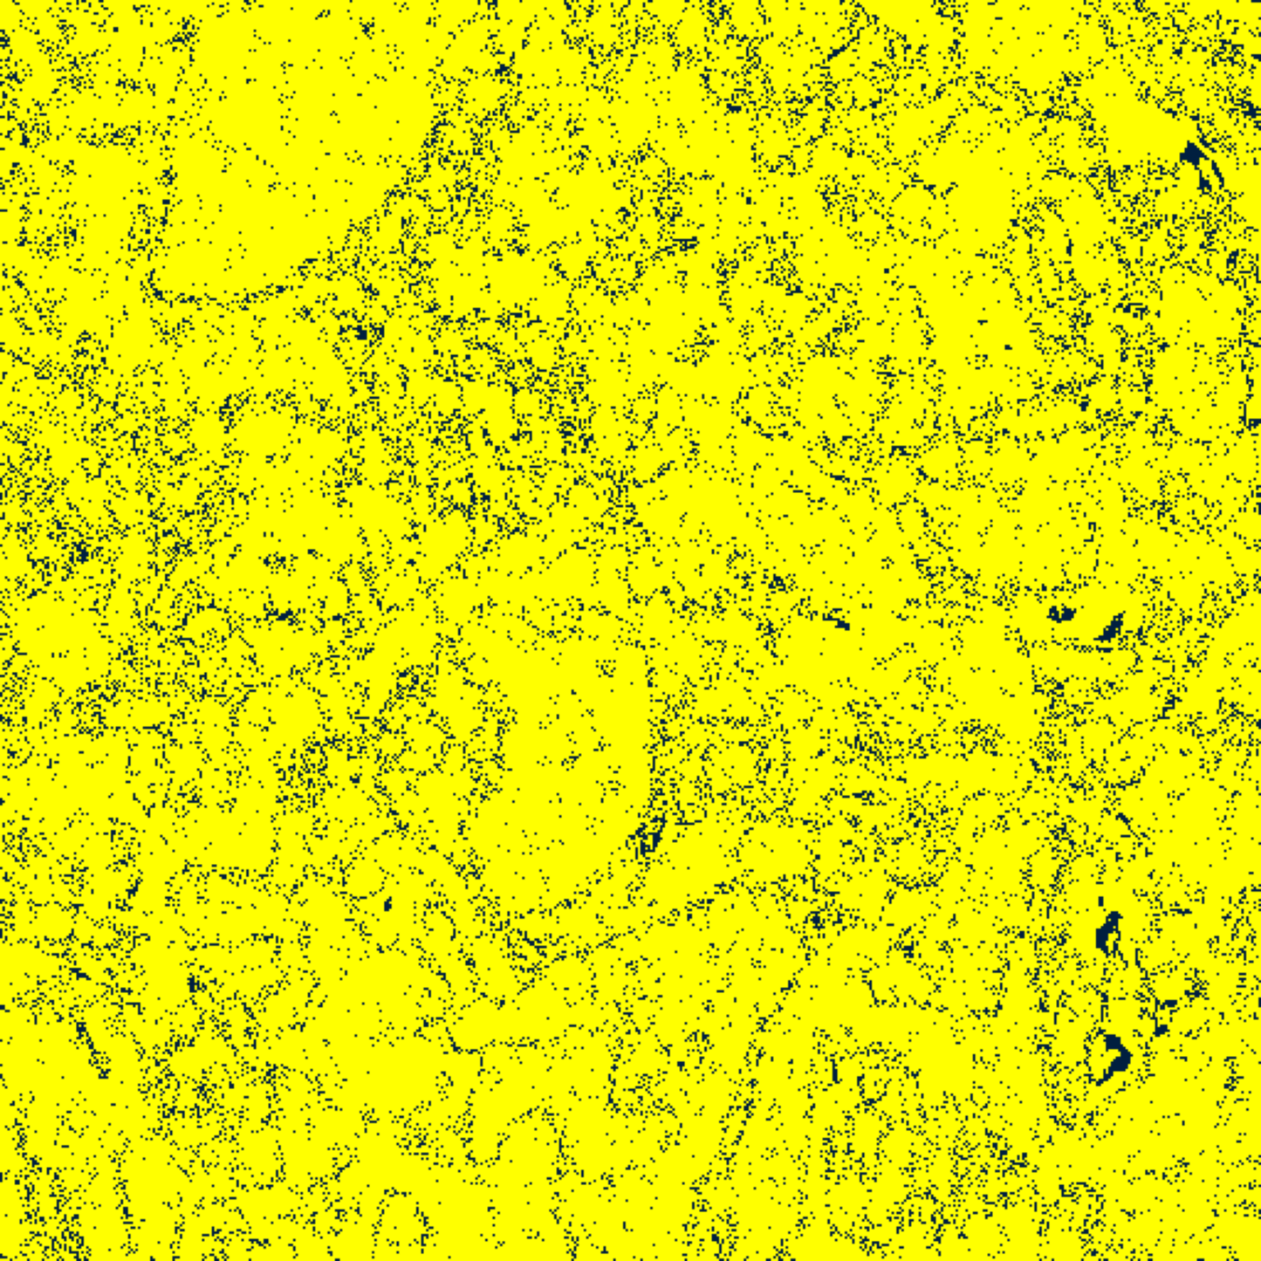  (C) ViT-UNet | (D) Legend
Fig. 3(a). SACP (w=7) 95% binary uncertainty maps: (A) AlexNet, (B) GFNet, (C) ViT-UNet. Yellow = certain singleton (set size = 1); dark navy = uncertain (set size ≠ 1). Shared legend in (D).
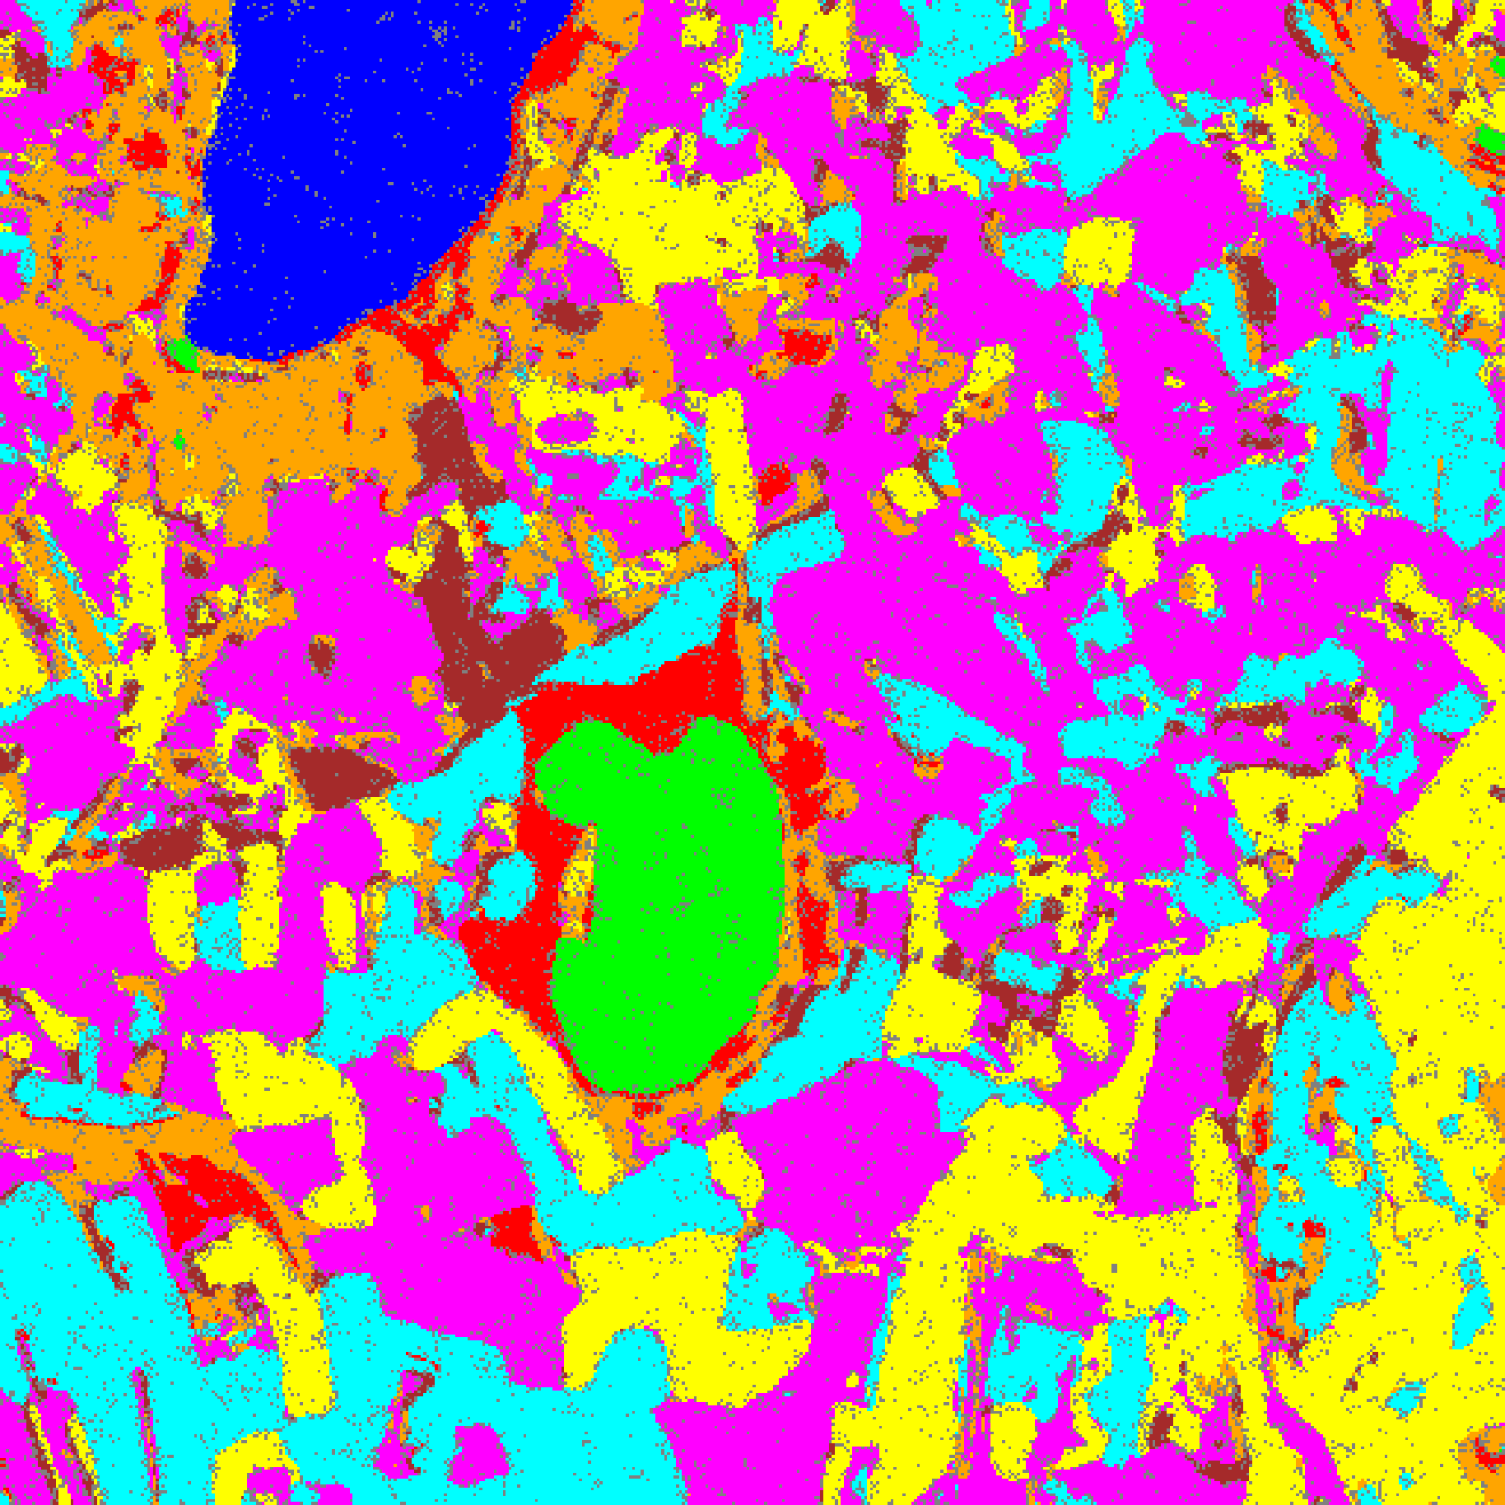  (A) AlexNet | 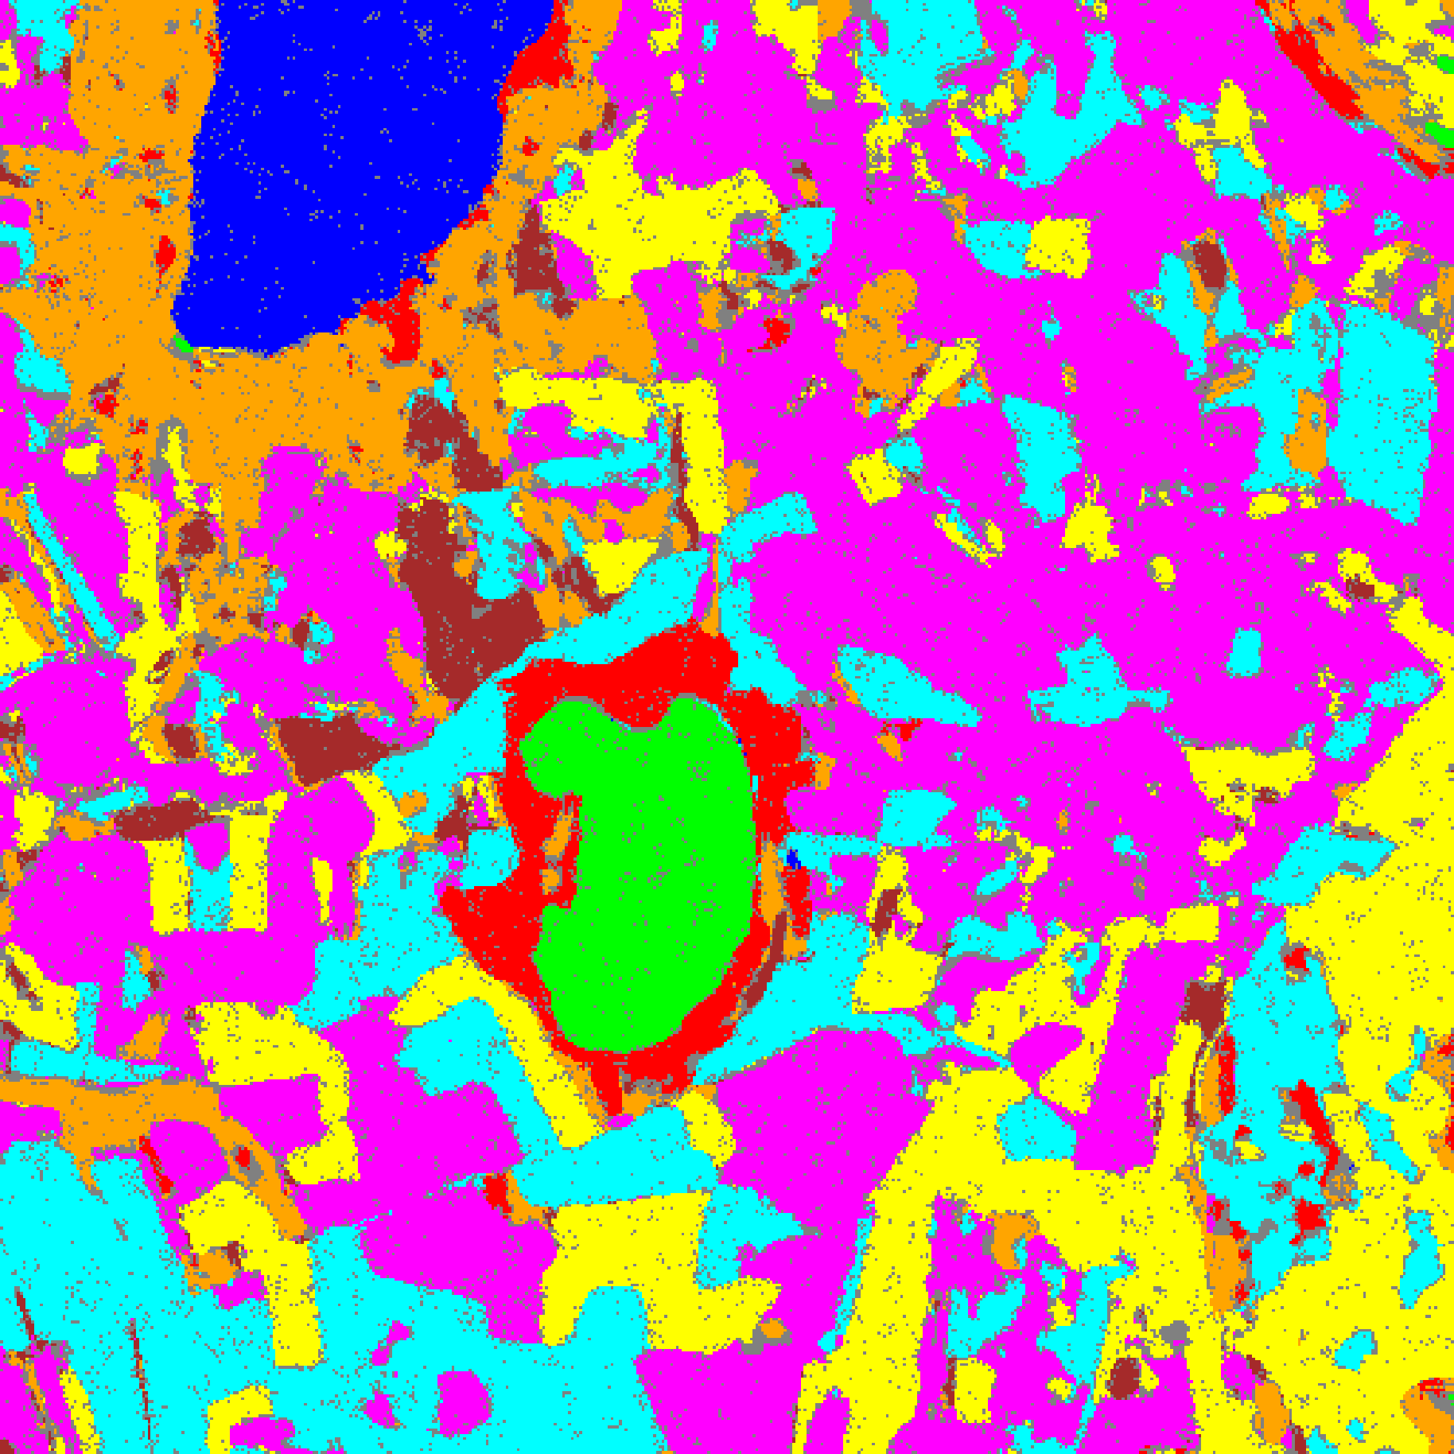  (B) GFNet
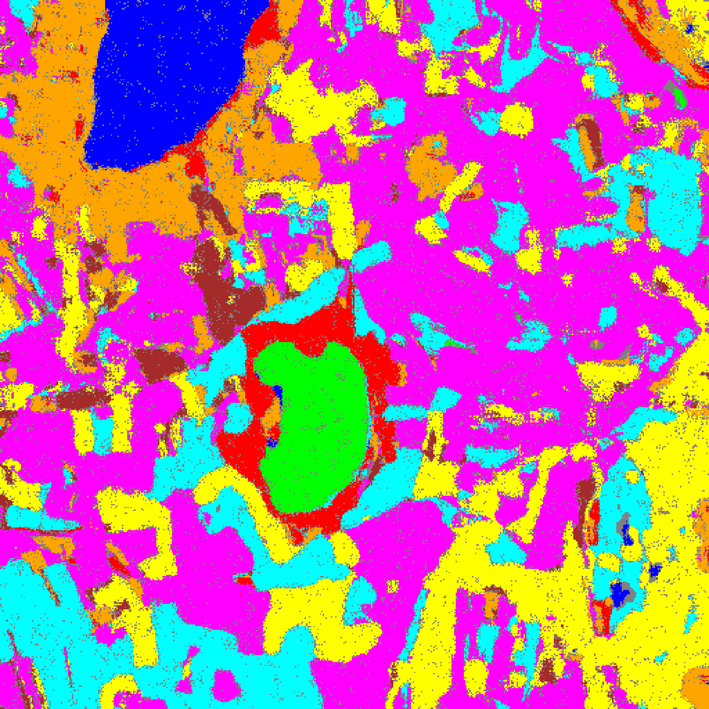  (C) ViT-UNet | (D) Legend
Fig. 3(b). SACP (w=7) 95% uncertainty masks: (A) AlexNet, (B) GFNet, (C) ViT-UNet. Class colours per shared legend (D): Class 0 through Class 7; grey = uncertain.
V. SACP RESULTS: WINDOW SIZE W = 9
With a 9 × 9 smoothing window (up to 80 neighbours), TABLES XIII–XVI present the aggregate metrics, per-class coverages, calibration parameters, and full-scene pixel counts; Figs. 4(a)–(b) show the binary uncertainty maps and class-masked maps.
TABLE XIII
SACP: AGGREGATE SUMMARY (WINDOW = 9, Α = 0.05, Λ = 0.5, K = 1)
Model | q̂ | Emp. Cov. | Avg Set Size | Singleton Rate | Empty Set Rate | Runtime (s) | Mean Cls Cov.
AlexNet | 0.7301 | 1.0000 | 1.0000 | 1.0000 | 0.0000 | 121.46 | 1.0000
GFNet | 0.7241 | 1.0000 | 1.0001 | 0.9999 | 0.0000 | 109.67 | 1.0000
ViT-UNet | 0.7020 | 0.9997 | 1.0004 | 0.9996 | 0.0000 | 123.30 | 0.9998

TABLE XIV
SACP: PER-CLASS COVERAGE COMPARISON (WINDOW = 9)
Class | AlexNet Coverage | GFNet Coverage | ViT-UNet Coverage
Class 0 | 1.0000 | 1.0000 | 0.9992
Class 1 | 1.0000 | 1.0000 | 1.0000
Class 2 | 1.0000 | 1.0000 | 1.0000
Class 3 | 1.0000 | 1.0000 | 0.9993
Class 4 | 1.0000 | 1.0000 | 1.0000
Class 5 | 1.0000 | 1.0000 | 1.0000
Class 6 | 1.0000 | 1.0000 | 1.0000
Class 7 | 1.0000 | 1.0000 | 1.0000

TABLE XV
SACP: CALIBRATION PARAMETERS (WINDOW = 9)
Model | q̂ | α (alpha) | λ (lambda) | k | Win.
AlexNet | 0.7301 | 0.05 | 0.5 | 1 | 9
GFNet | 0.7241 | 0.05 | 0.5 | 1 | 9
ViT-UNet | 0.7020 | 0.05 | 0.5 | 1 | 9

TABLE XVI
SACP: PREDICTED PIXEL COUNT DISTRIBUTION (WINDOW = 9)
Class / Region | AlexNet Pixels | GFNet Pixels | ViT-UNet Pixels
Class 0 | 10,394 | 11,142 | 11,129
Class 1 | 7,724 | 7,229 | 7,121
Class 2 | 7,390 | 8,038 | 8,128
Class 3 | 42,830 | 43,728 | 37,294
Class 4 | 76,712 | 86,420 | 90,133
Class 5 | 45,187 | 41,423 | 45,737
Class 6 | 10,303 | 6,527 | 6,776
Class 7 | 24,727 | 25,547 | 23,273
Uncertain | 36,877 | 32,090 | 32,553
Total (Scene) | 262,144 | 262,144 | 262,144

At w = 9, q̂ reaches its lowest values across all window sizes: 0.7301 for AlexNet, 0.7241 for GFNet, and 0.7020 for ViT-UNet. Unlike the 6-band dataset where q̂ rebounded slightly at w = 9, on the larger 512 × 512 65-band DIAS scene q̂ decreases monotonically through w = 9. However, broader cross-boundary score mixing increases full-scene uncertain pixels to 36,877 (14.07%) for AlexNet, 32,090 (12.24%) for GFNet, and 32,553 (12.42%) for ViT-UNet.
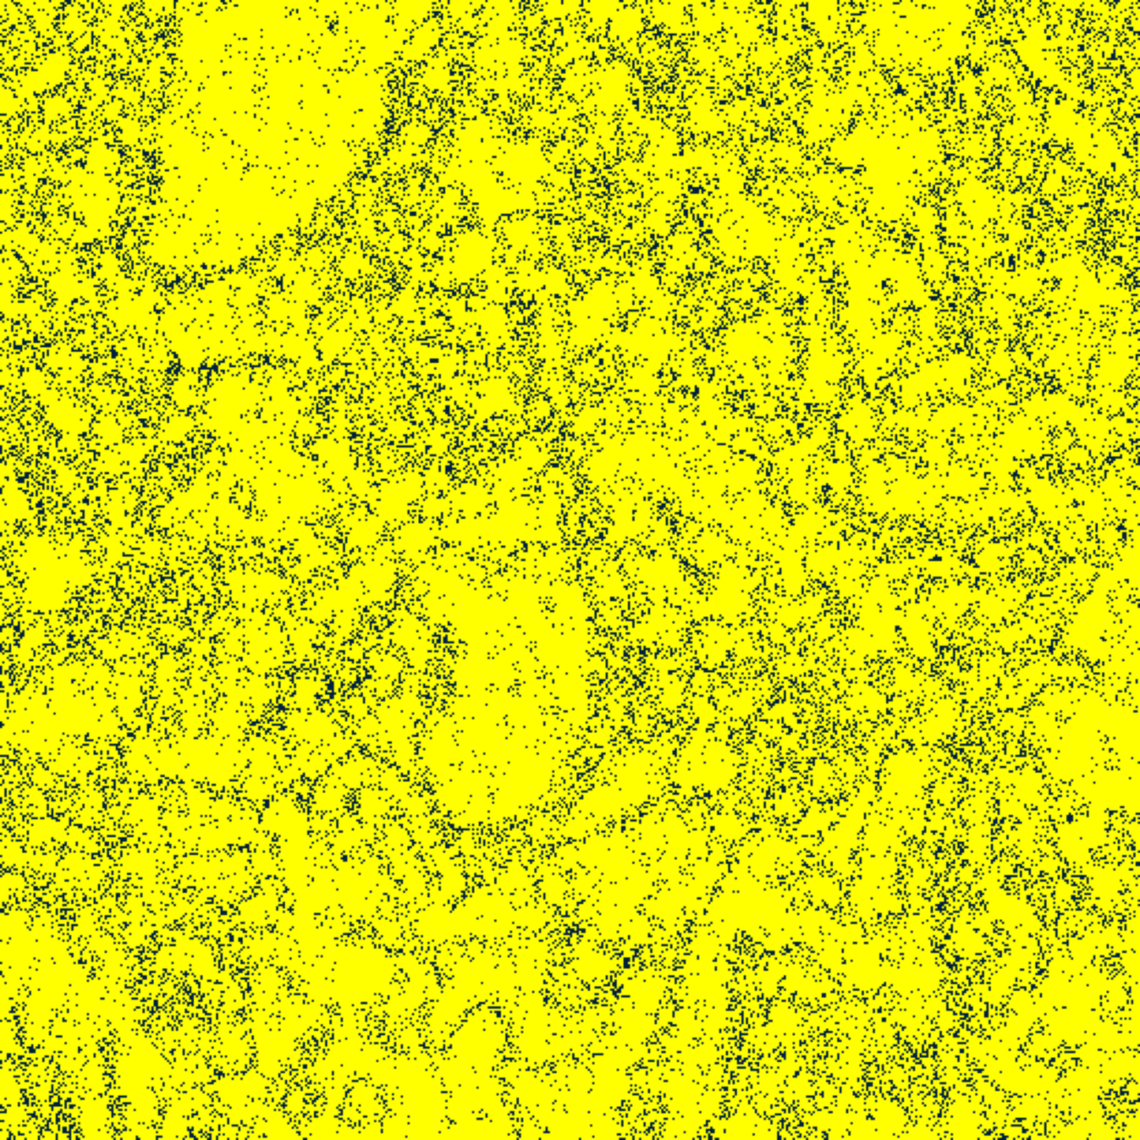  (A) AlexNet | 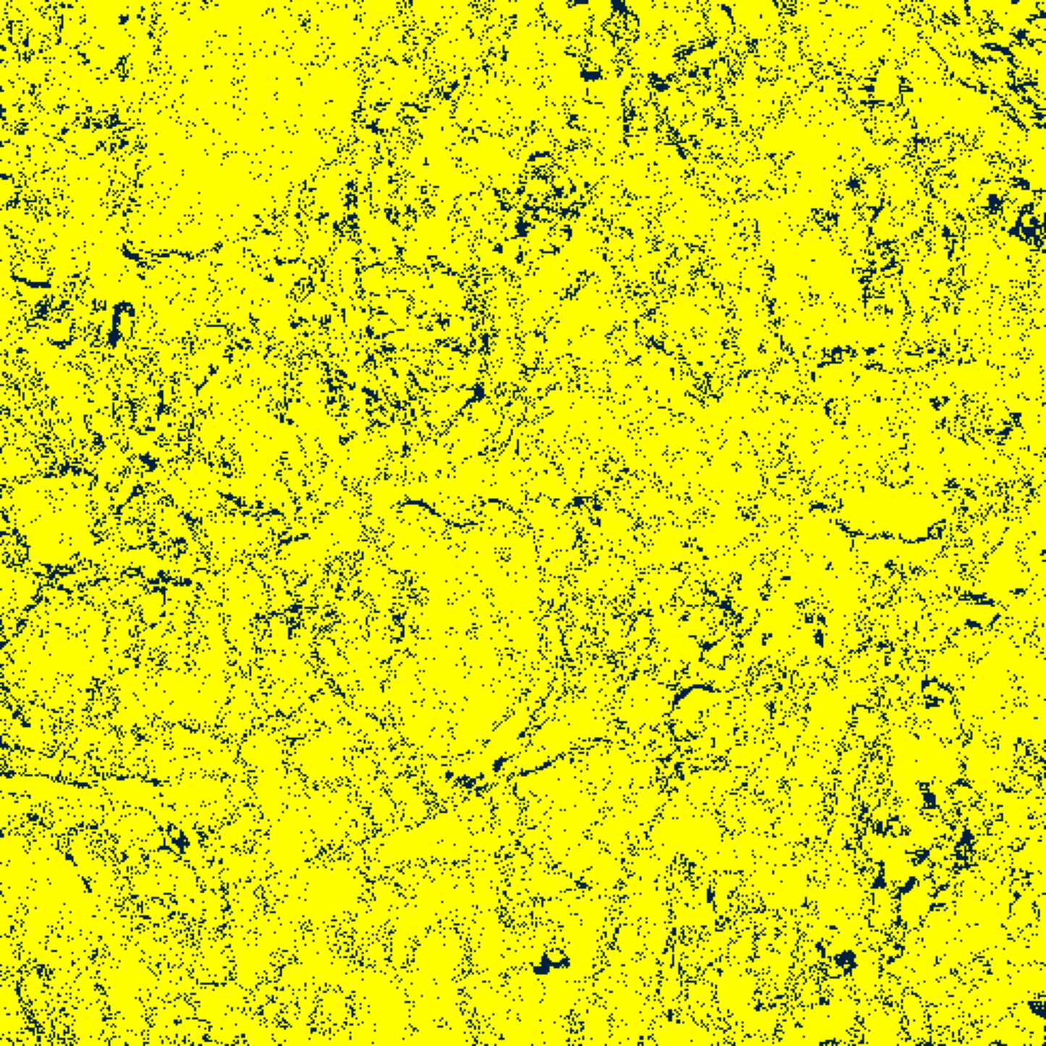  (B) GFNet
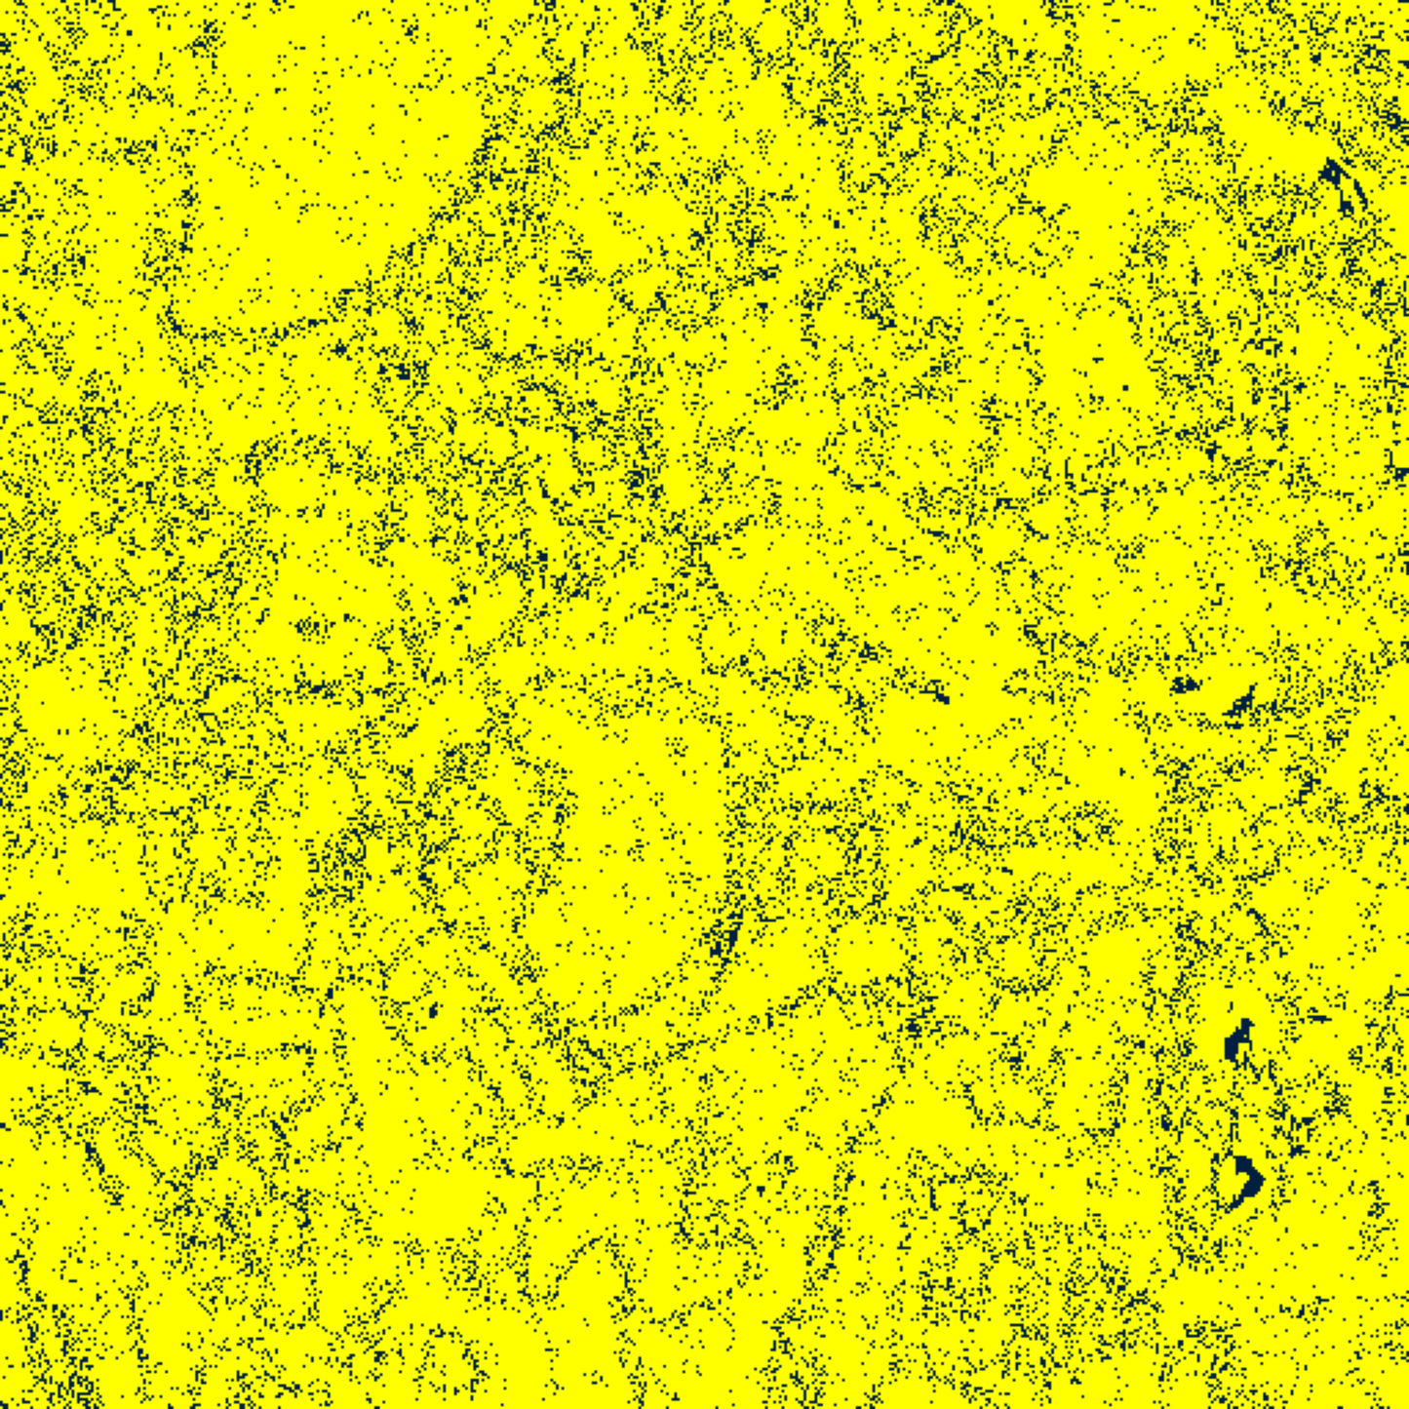  (C) ViT-UNet | (D) Legend
Fig. 4(a). SACP (w=9) 95% binary uncertainty maps: (A) AlexNet, (B) GFNet, (C) ViT-UNet. Yellow = certain singleton (set size = 1); dark navy = uncertain (set size ≠ 1). Shared legend in (D).
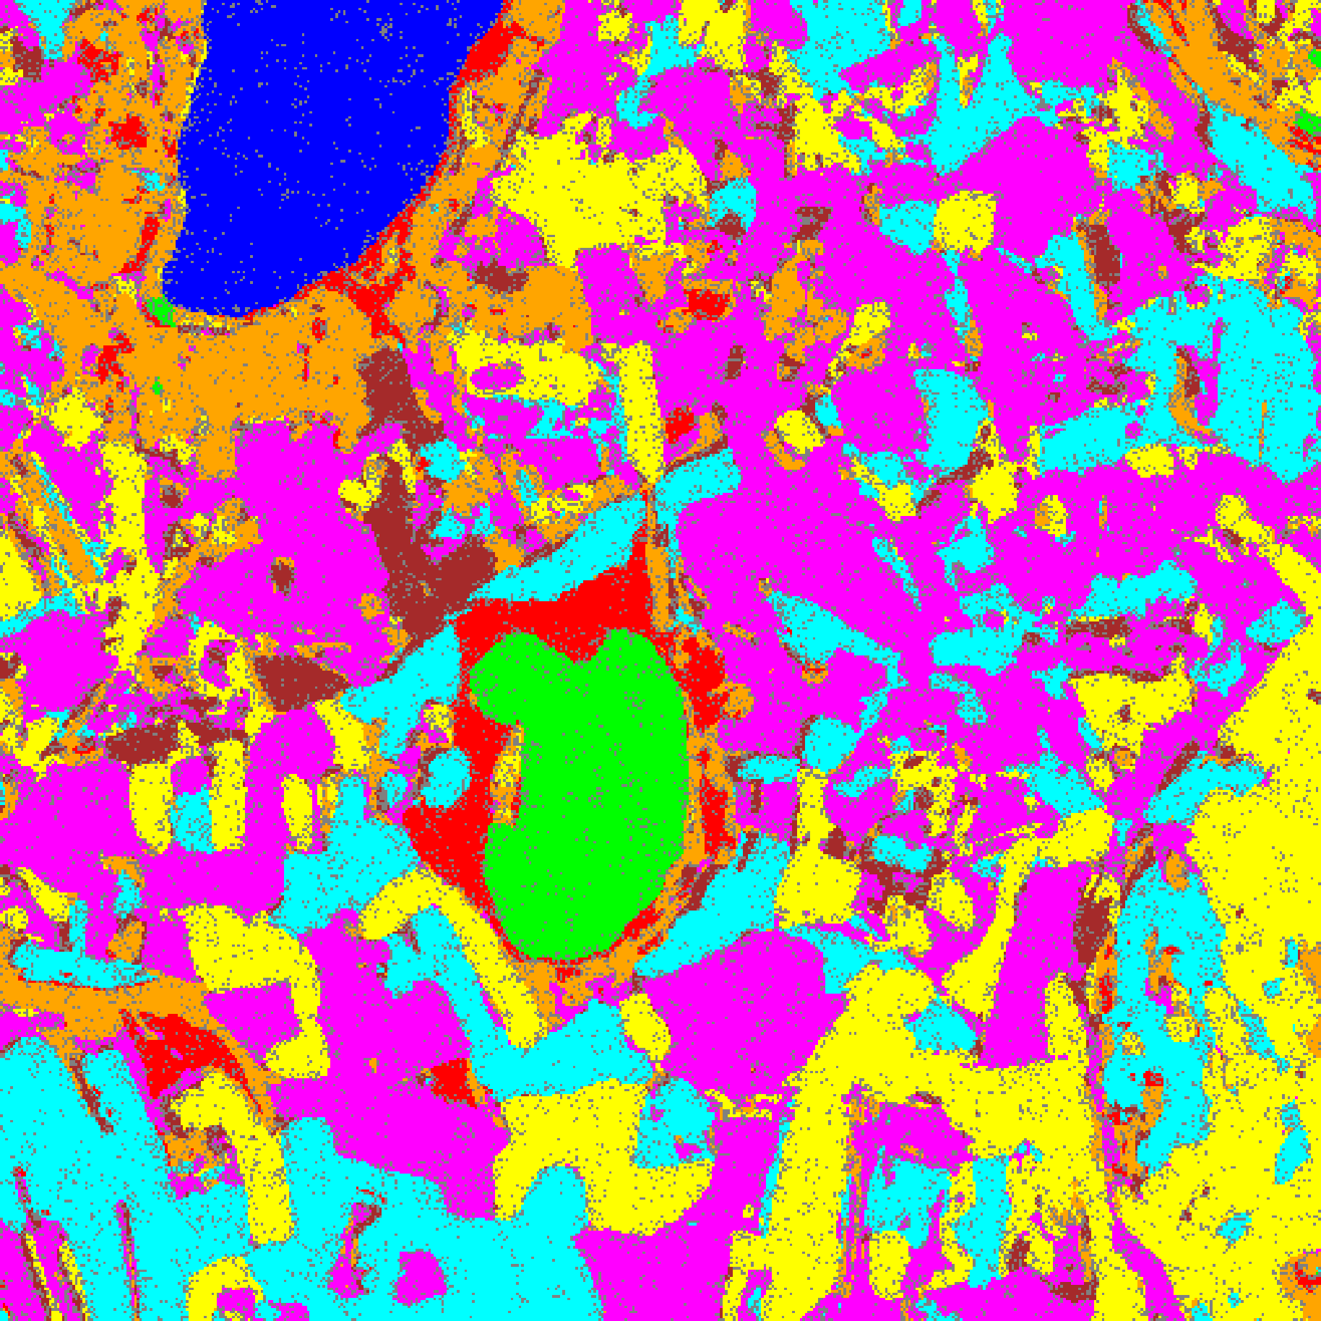  (A) AlexNet | 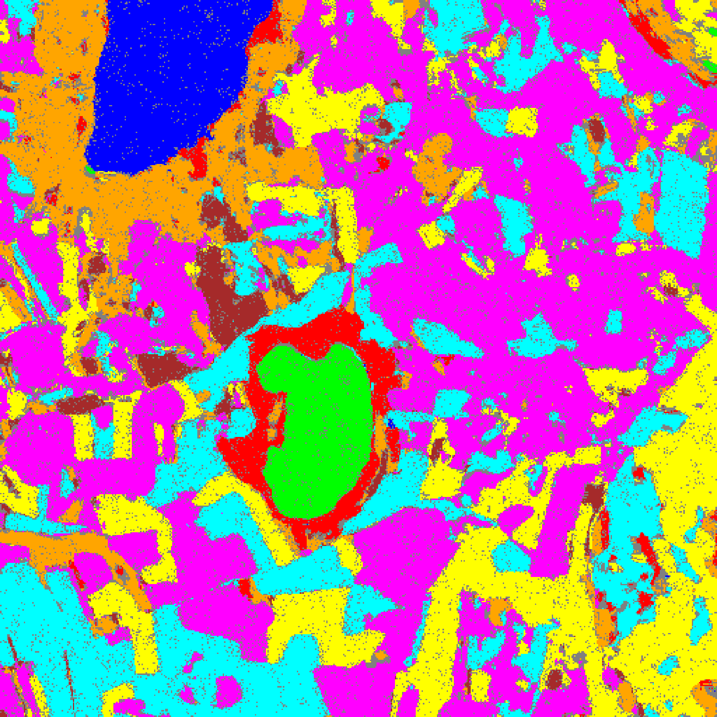  (B) GFNet
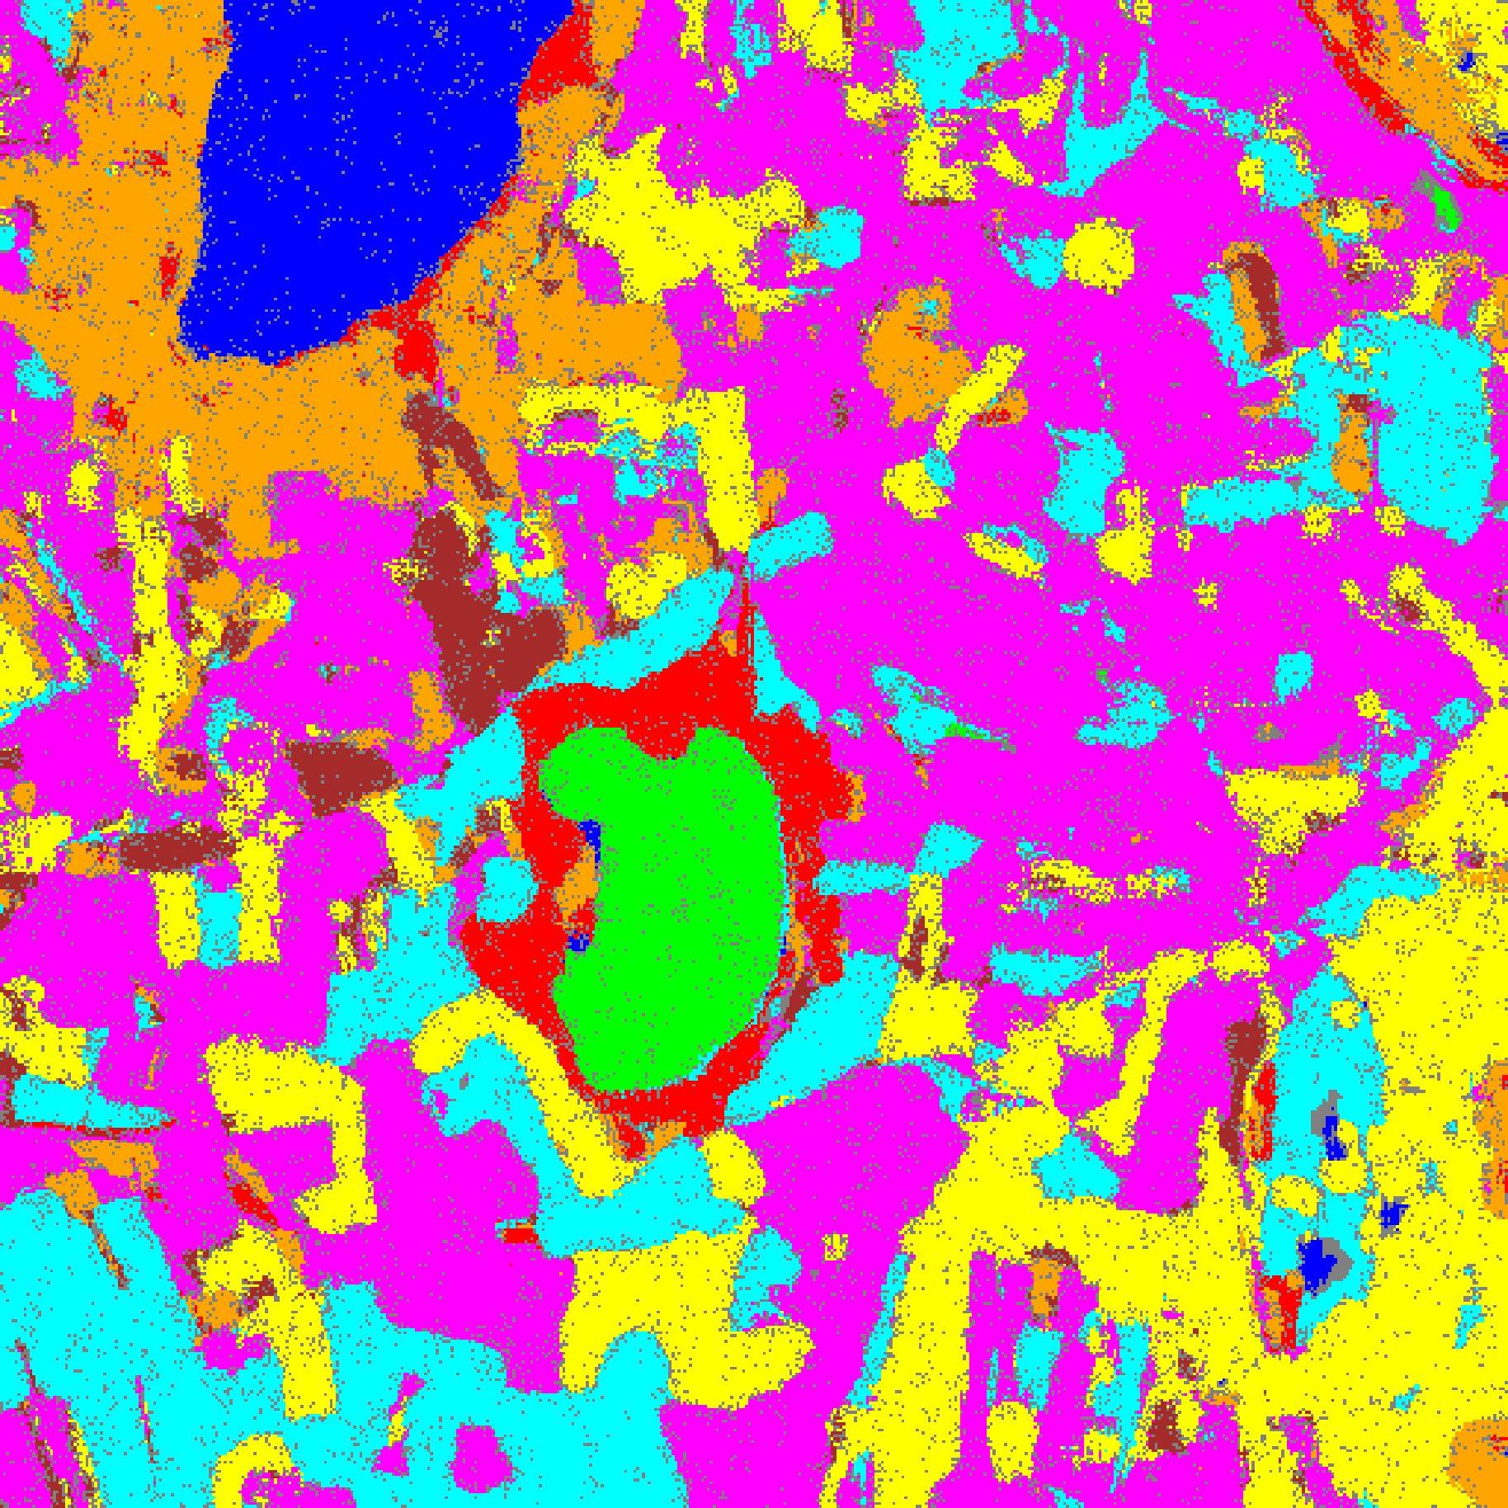  (C) ViT-UNet | (D) Legend
Fig. 4(b). SACP (w=9) 95% uncertainty masks: (A) AlexNet, (B) GFNet, (C) ViT-UNet. Class colours per shared legend (D): Class 0 through Class 7; grey = uncertain.
VI. CROSS-WINDOW SUMMARY (W = 3, 5, 7, 9)
TABLE XVII
SACP: CROSS-WINDOW Q̂ AND UNCERTAIN PIXEL RATE SUMMARY (OUT OF 262,144 SCENE PIXELS)
Model | q̂ w=3 | q̂ w=5 | q̂ w=7 | q̂ w=9 | Unc% w=3 | Unc% w=5 | Unc% w=7 | Unc% w=9
AlexNet | 0.8192 | 0.7525 | 0.7369 | 0.7301 | 6.92% | 8.09% | 11.48% | 14.07%
GFNet | 0.8121 | 0.7467 | 0.7315 | 0.7241 | 14.05% | 10.41% | 11.00% | 12.24%
ViT-UNet | 0.7874 | 0.7237 | 0.7091 | 0.7020 | 8.66% | 8.31% | 10.39% | 12.42%

Coverage behaviour. All twelve model–window combinations achieve empirical coverage between 0.9997 and 1.0000 on the 6,737-sample evaluation split, with singleton rates ≥ 0.9991 and zero empty sets throughout. Because SACP uses the Randomised APS score blended across spatial neighbours, the calibrated quantile q̂ ∈ [0.7020, 0.8192] accommodates the uniform randomisation draw U·π̂_1(x) on confident interior pixels, eliminating empty prediction sets across the entire scene.
q̂ trajectory. Unlike the smaller 6-band scene where q̂ rebounded at w = 9, on the 512 × 512 65-band DIAS scene q̂ decreases monotonically across all four window sizes for every model: AlexNet drops from 0.8192 (w=3) to 0.7301 (w=9), GFNet from 0.8121 to 0.7241, and ViT-UNet from 0.7874 to 0.7020.
Uncertain pixel trajectory. Across the full 262,144-pixel scene, GFNet and ViT-UNet follow a V-shaped uncertain-pixel trajectory with their global minimum at w = 5 (GFNet: 27,277 pixels, 10.41%; ViT-UNet: 21,780 pixels, 8.31%), whereas AlexNet achieves its minimum at w = 3 (18,135 pixels, 6.92%) and increases monotonically with window width as larger smoothing windows propagate multi-label sets across parcel boundaries.
VII. CONCLUSION
SACP delivers distribution-free uncertainty quantification across all four spatial smoothing windows w ∈ {3, 5, 7, 9} on the 65-band DIAS Scene K01 hyperspectral dataset (512 × 512 pixels, K = 8 classes). All twelve model–window combinations achieve 99.97%–100.00% empirical coverage with zero empty sets and dramatically lower full-scene uncertain pixel rates (6.92%–14.07%) than unsmoothed threshold-based conformal methods (∼37%–51%). Window size w = 3 is optimal for AlexNet (18,135 uncertain pixels, 6.92%), while w = 5 is optimal for ViT-UNet (21,780, 8.31%) and GFNet (27,277, 10.41%).
REFERENCES
[1] J. Liu, Y. Xu, et al., “Spatial-Aware Conformal Prediction for Trustworthy Hyperspectral Image Classification,” arXiv:2409.01236, 2024.
[2] Y. Romano, M. Sesia, and E. Candès, “Classification with Valid and Adaptive Coverage,” in Adv. Neural Inf. Process. Syst. (NeurIPS), 2020.
[3] A. N. Angelopoulos and S. Bates, “A Gentle Introduction to Conformal Prediction and Distribution-Free Uncertainty Quantification,” arXiv:2107.07511, 2021.
[4] Y. Rao, W. Zhao, Z. Zhu, J. Lu, and J. Zhou, “Global Filter Networks for Image Classification,” in Adv. Neural Inf. Process. Syst. (NeurIPS), 2021.
[5] A. Dosovitskiy et al., “An Image is Worth 16×16 Words: Transformers for Image Recognition at Scale,” in Proc. ICLR, 2021.

