Spatial Graph Convolutional Network (SpatialGCN) for Patch-Based Hyperspectral Land-Cover Classification with Conformal Prediction
ABSTRACT
This paper presents patch-based pixel-wise hyperspectral land-cover classification and conformal uncertainty quantification using SpatialGCN on the 65-band DIAS Scene K01 dataset (512 × 512 pixels, K = 8 classes: Class 0 through Class 7). Operating on 9 × 9 × 65 spatial-spectral patches across 13,474 held-out test samples, SpatialGCN achieves 97.046% test accuracy (κ = 0.9644, macro-F1 = 0.9442, weighted-F1 = 0.9704, NLL = 0.11319, Brier = 0.04477, ECE = 0.04215) in 171.9 s. Five post-hoc conformal prediction methods (SplitCP, CcCP, RC3P, ClCP, and RAPS) calibrated on n_cal = 6,737 samples at α = 0.05 are evaluated on n_eval = 6,737 samples and across all 262,144 scene pixels.
I. INTRODUCTION
Hyperspectral earth observation across 65 contiguous spectral channels enables precise discrimination of surface land-cover classes [5]. In this report, we evaluate SpatialGCN on 9 × 9 × 65 patches extracted from DIAS Scene K01 (512 × 512 pixels, Class 0–Class 7) and wrap the trained classifier in five distribution-free conformal prediction algorithms (SplitCP, CcCP, RC3P, ClCP, and RAPS) targeting 95% coverage (α = 0.05) [1, 2, 3, 4].
II. METHODOLOGY
A. Dataset and Preprocessing
The DIAS Scene K01 dataset (files k001.mat and k002.mat) comprises H = 512 × W = 512 pixels (262,144 total scene pixels) with B = 65 spectral bands and K = 8 labelled classes (Class 0 through Class 7, totalling 53,896 labelled pixels and 208,248 unlabelled background pixels). Each band is min-max normalised to [0, 1]:
x̃(h, w, b) = [x(h, w, b) − min_{b}] / [max_{b} − min_{b} + ε], ε = 10⁻⁸
Using seed 42, the labelled samples are partitioned into 75% training (40,422), 12.5% calibration (n_cal = 6,737), and 12.5% evaluation (n_eval = 6,737). SpatialGCN models each 9 × 9 × 65 patch as an 8-connected spatial-spectral graph over the 81 pixels and applies multi-layer graph convolutions before classification.
III. EXPERIMENTS AND RESULTS
A. Classification Performance and Dense Scene Map
TABLE I
TEST SET CLASSIFICATION PERFORMANCE
Model | Accuracy | κ | Macro F1 | Wtd F1 | NLL | Brier | ECE | Train Time (s)
SpatialGCN | 97.046% | 0.9644 | 0.9442 | 0.9704 | 0.11319 | 0.04477 | 0.04215 | 171.9

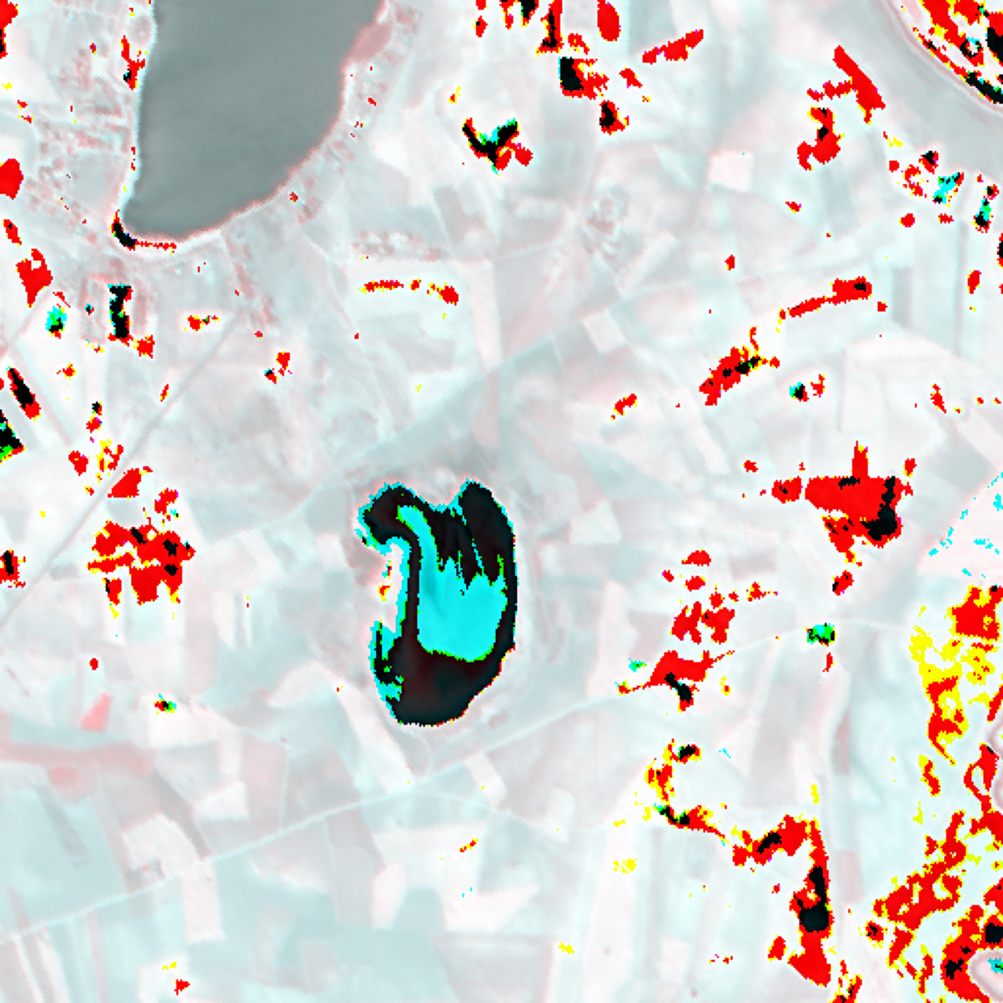  (a) Approximate RGB Composite | 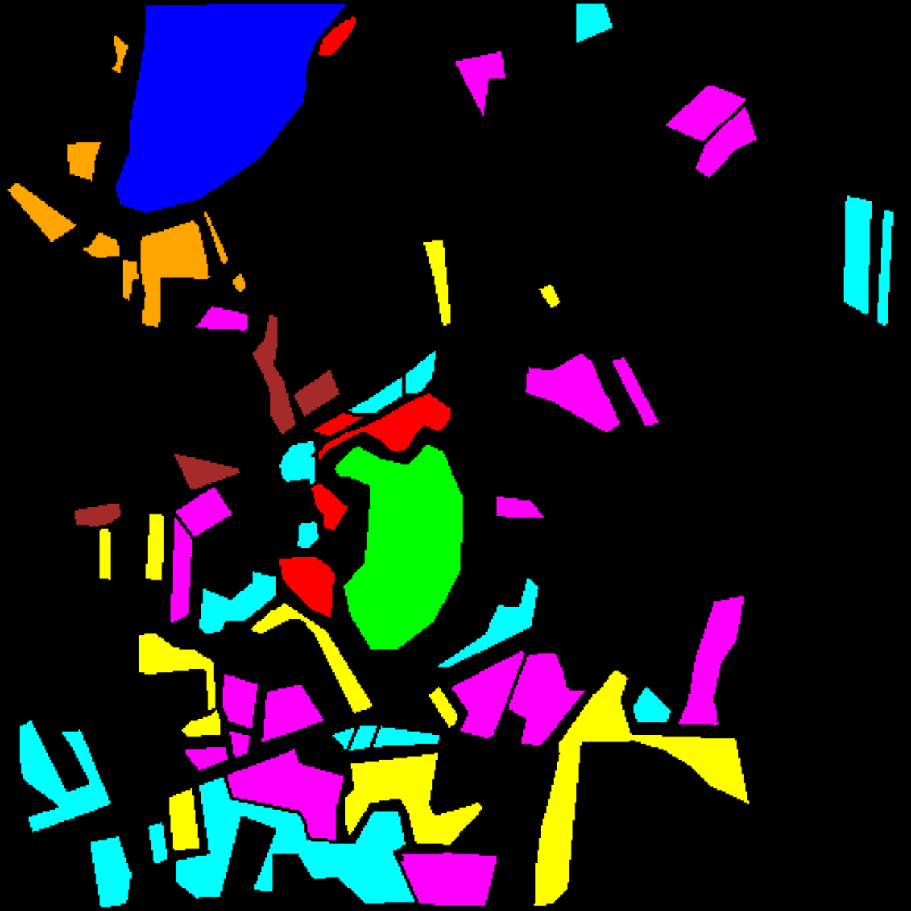  (b) Ground Truth Label Map
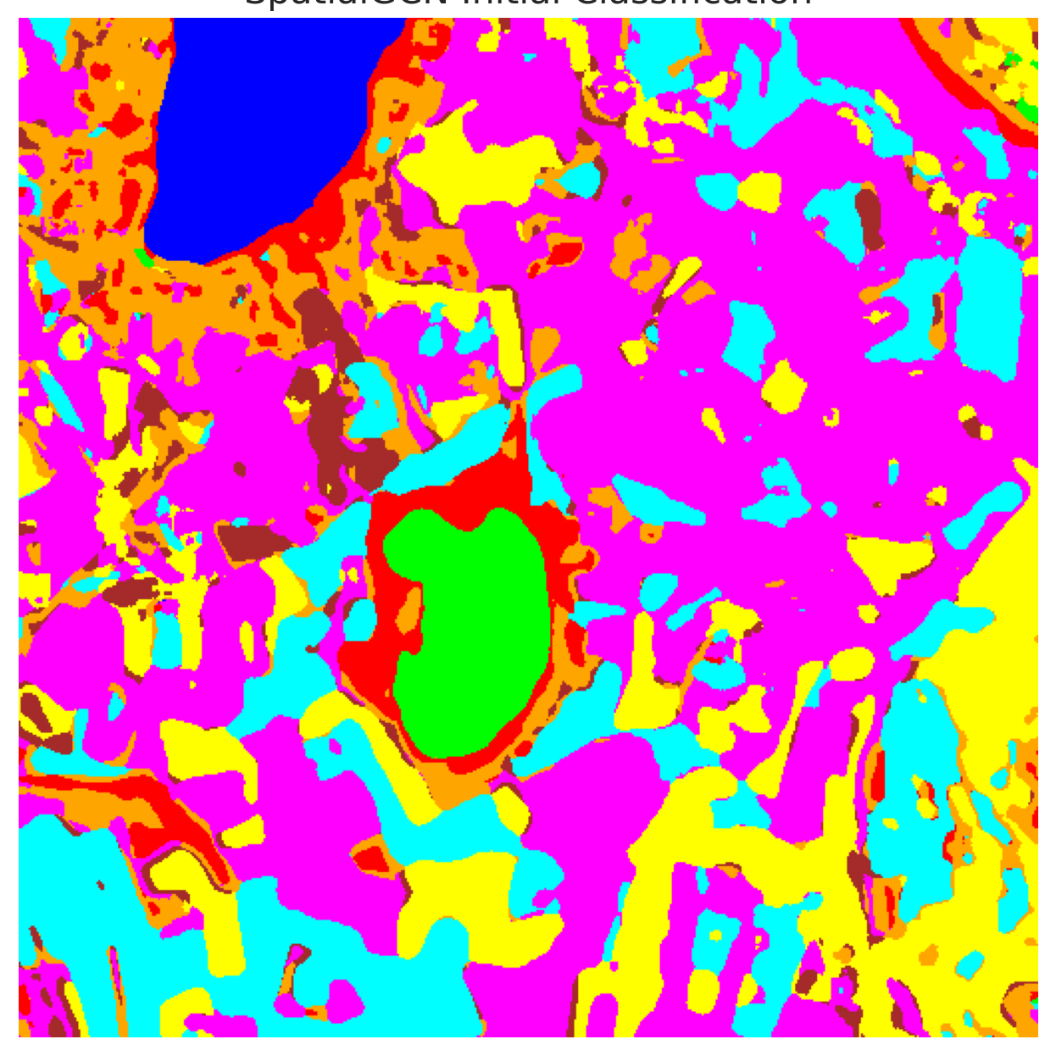  (c) SpatialGCN Dense Map | 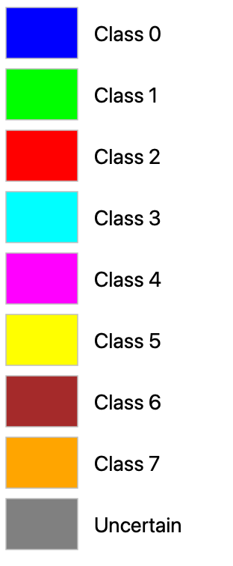  (d) Class Legend
Fig. 1. DIAS Scene K01 overview and dense classification map for SpatialGCN: (a) RGB composite, (b) ground truth, (c) SpatialGCN full-scene prediction (512 × 512 pixels), and (d) class legend.
B. Conformal Prediction Results (SplitCP, CcCP, RC3P, ClCP, RAPS)
TABLE II
SPLITCP AGGREGATE PERFORMANCE (Α = 0.05)
Model | q̂ | Emp. Cov. | Avg Set Size | Singleton Rate | Empty Set Rate | Runtime (s) | Mean Cls Cov.
SpatialGCN | 0.373794 | 0.9524 | 0.9654 | 0.9654 | 0.0346 | 2.131 | 0.9108

TABLE III
SPLITCP PER-CLASS EMPIRICAL COVERAGE
Class | SpatialGCN
Class 0 | 1.0000
Class 1 | 1.0000
Class 2 | 0.9046
Class 3 | 0.9648
Class 4 | 0.9522
Class 5 | 0.9669
Class 6 | 0.7850
Class 7 | 0.7125

TABLE IV
SPLITCP FULL-SCENE PIXEL COUNTS (262,144 PIXELS)
Class / Region | SpatialGCN
Class 0 | 10,984
Class 1 | 7,609
Class 2 | 8,716
Class 3 | 36,797
Class 4 | 90,640
Class 5 | 37,235
Class 6 | 4,879
Class 7 | 17,202
Uncertain | 48,082
Total (Scene) | 262,144

TABLE V
CCCP AGGREGATE PERFORMANCE (Α = 0.05)
Model | Emp. Cov. | Avg Set Size | Singleton Rate | Empty Set Rate | Runtime (s) | Mean Cls Cov.
SpatialGCN | 0.9540 | 0.9961 | 0.9472 | 0.0284 | 1.999 | 0.9592

TABLE VI
CCCP PER-CLASS EMPIRICAL COVERAGE
Class | SpatialGCN
Class 0 | 0.9457
Class 1 | 0.9631
Class 2 | 0.9894
Class 3 | 0.9473
Class 4 | 0.9491
Class 5 | 0.9660
Class 6 | 0.9850
Class 7 | 0.9281

TABLE VII
CCCP CLASS-WISE THRESHOLDS (Q̂_C)
Class | SpatialGCN
Class 0 | 0.038627
Class 1 | 0.038942
Class 2 | 0.844049
Class 3 | 0.282327
Class 4 | 0.317623
Class 5 | 0.361530
Class 6 | 0.846313
Class 7 | 0.768265

TABLE VIII
CCCP FULL-SCENE PIXEL COUNTS (262,144 PIXELS)
Class / Region | SpatialGCN
Class 0 | 10,039
Class 1 | 6,657
Class 2 | 8,849
Class 3 | 35,587
Class 4 | 91,481
Class 5 | 38,556
Class 6 | 7,787
Class 7 | 17,241
Uncertain | 45,947
Total (Scene) | 262,144

TABLE IX
RC3P AGGREGATE PERFORMANCE (Α = 0.05)
Model | Emp. Cov. | Avg Set Size | Singleton Rate | Empty Set Rate | Runtime (s) | Mean Cls Cov.
SpatialGCN | 0.9559 | 1.0096 | 0.9402 | 0.0251 | 2.051 | 0.9611

TABLE X
RC3P PER-CLASS EMPIRICAL COVERAGE
Class | SpatialGCN
Class 0 | 0.9490
Class 1 | 0.9659
Class 2 | 0.9894
Class 3 | 0.9495
Class 4 | 0.9509
Class 5 | 0.9660
Class 6 | 0.9900
Class 7 | 0.9281

TABLE XI
RC3P CALIBRATED THRESHOLDS (Q̂_C) AND RANK LIMITS (K̂_C)
Class | q̂_c | k̂_c
Class 0 | 0.038650 | 3
Class 1 | 0.039013 | 3
Class 2 | 0.877675 | 3
Class 3 | 0.295584 | 3
Class 4 | 0.346539 | 3
Class 5 | 0.366401 | 3
Class 6 | 0.912696 | 3
Class 7 | 0.775211 | 3

TABLE XII
RC3P FULL-SCENE PIXEL COUNTS (262,144 PIXELS)
Class / Region | SpatialGCN
Class 0 | 10,104
Class 1 | 6,781
Class 2 | 8,676
Class 3 | 36,021
Class 4 | 91,683
Class 5 | 37,329
Class 6 | 7,705
Class 7 | 14,015
Uncertain | 49,830
Total (Scene) | 262,144

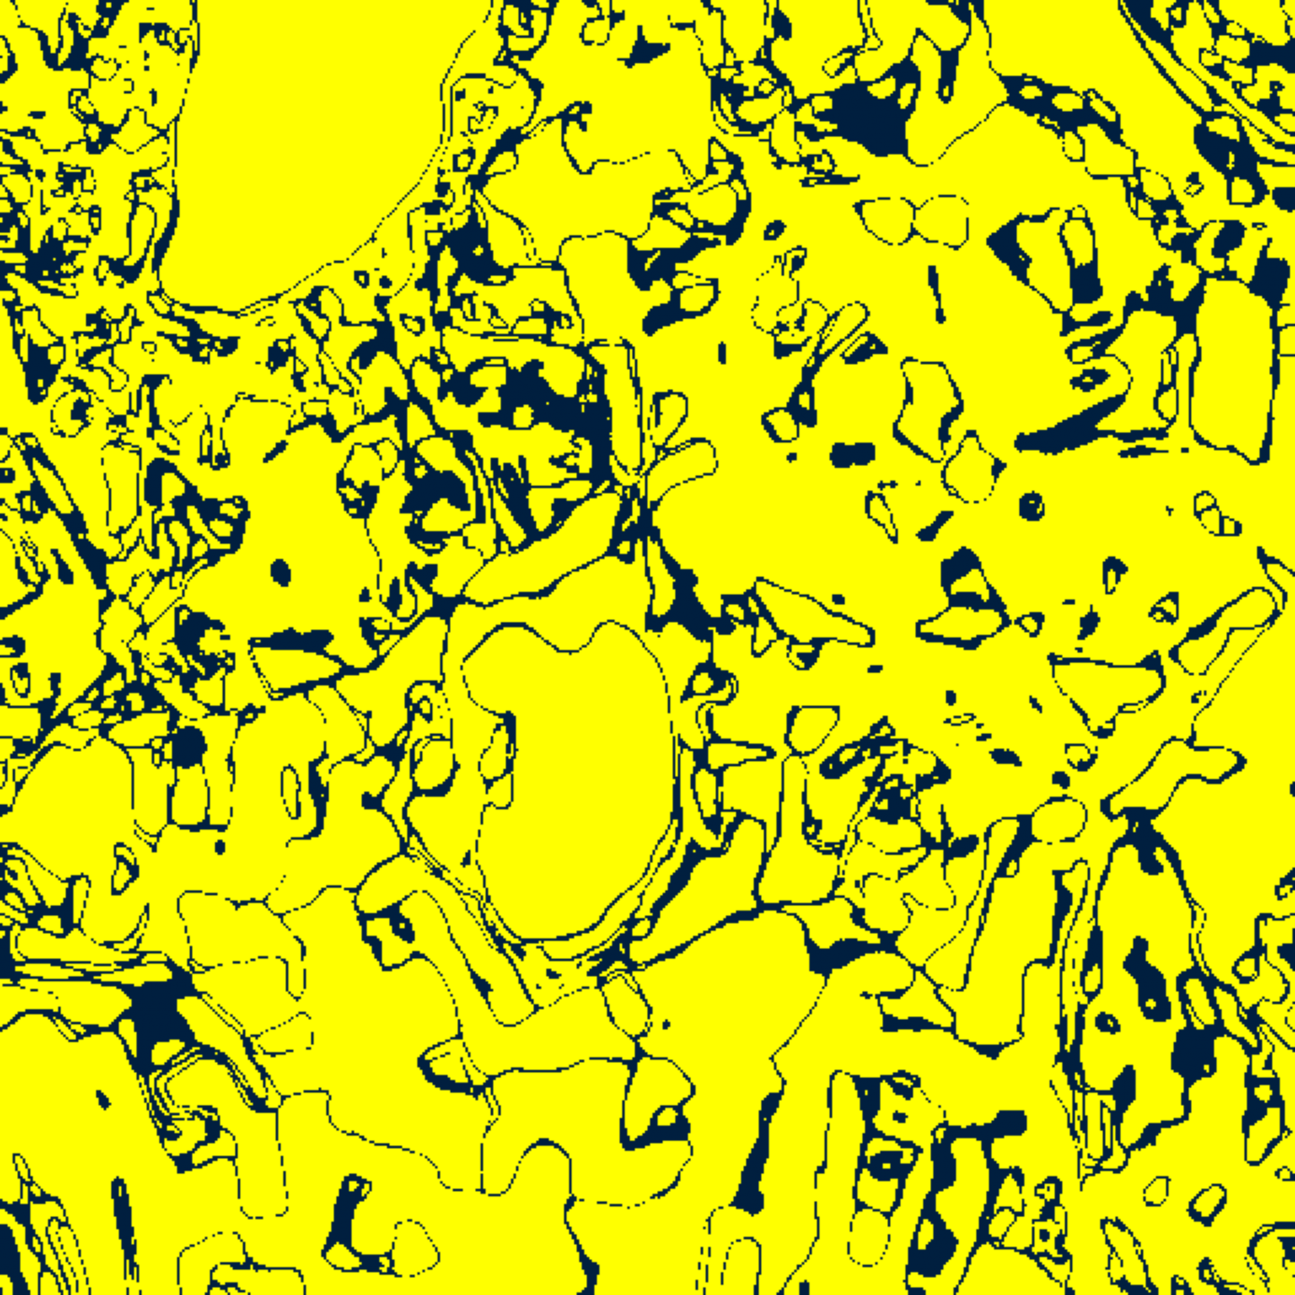  (A) SplitCP Binary | 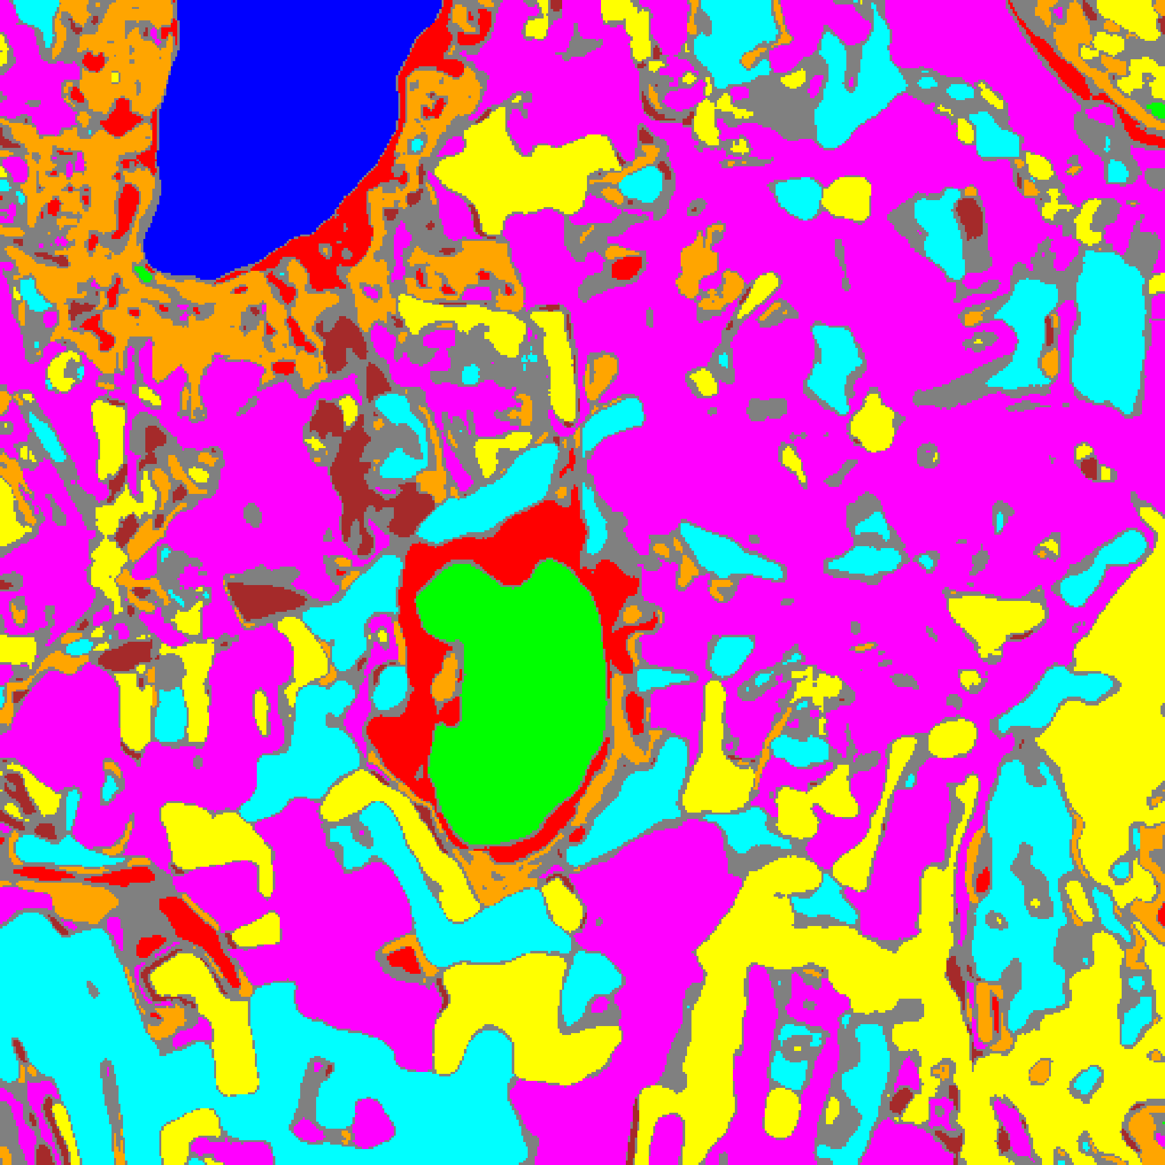  (B) SplitCP Mask
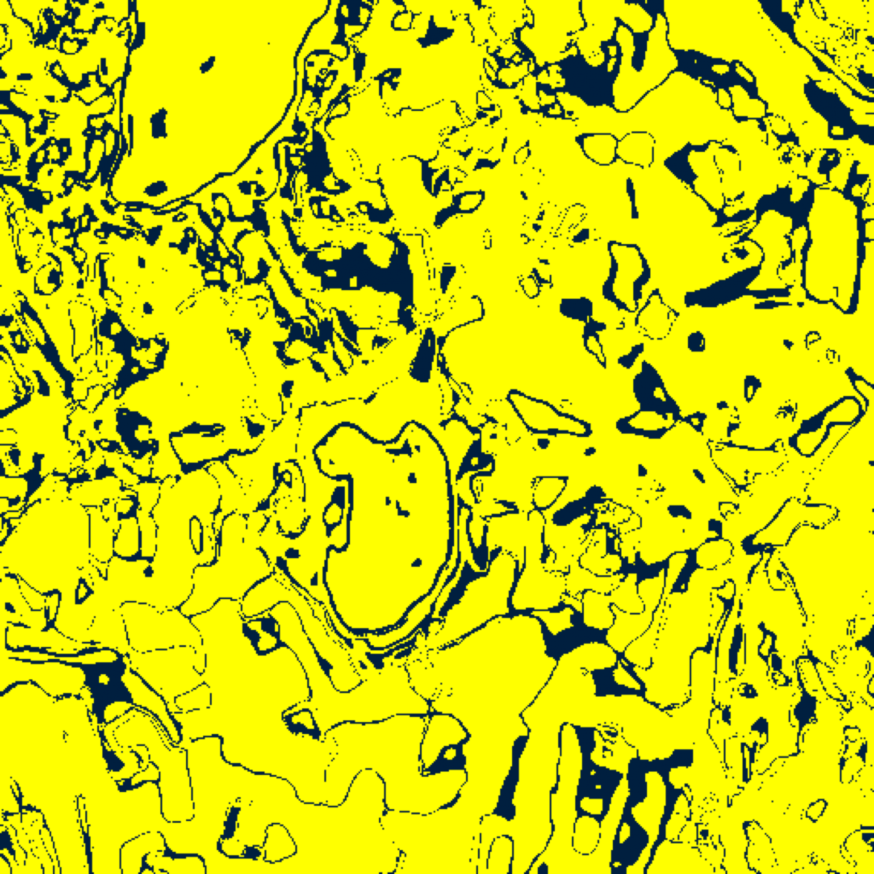  (C) CcCP Binary | 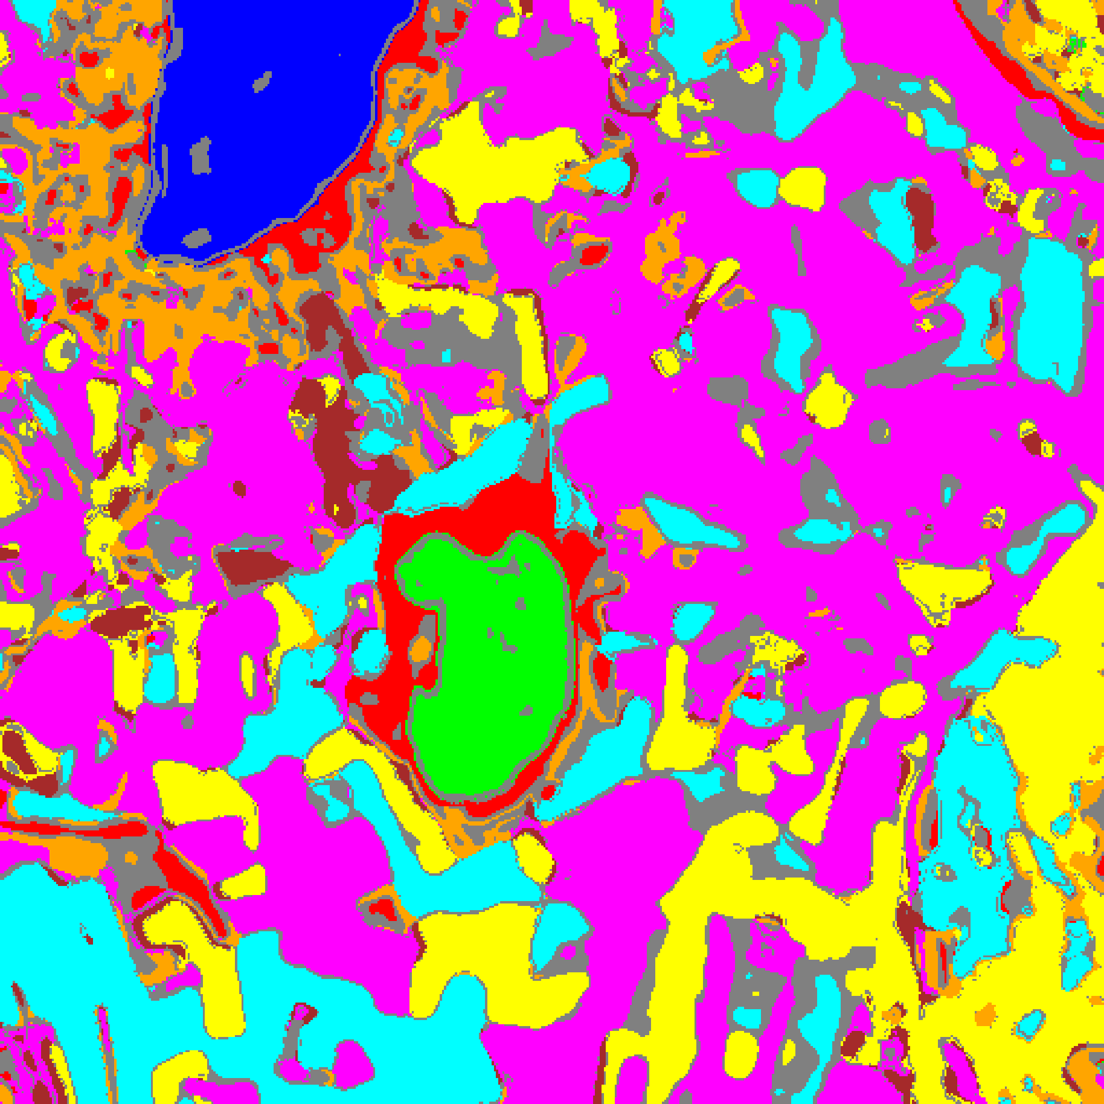  (D) CcCP Mask
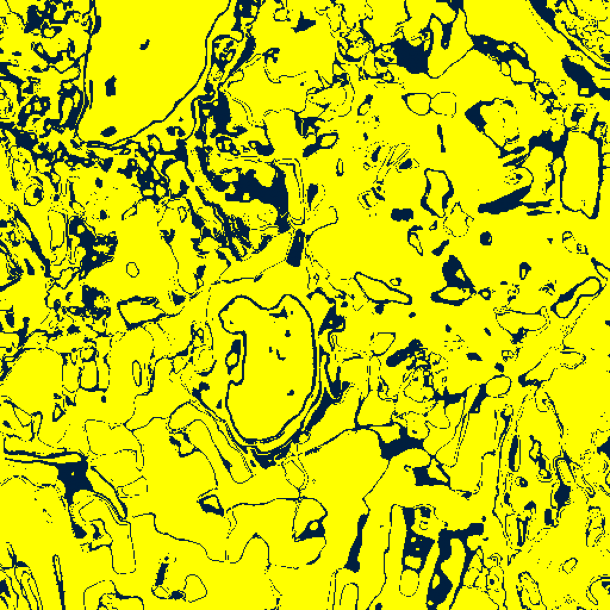  (E) RC3P Binary | 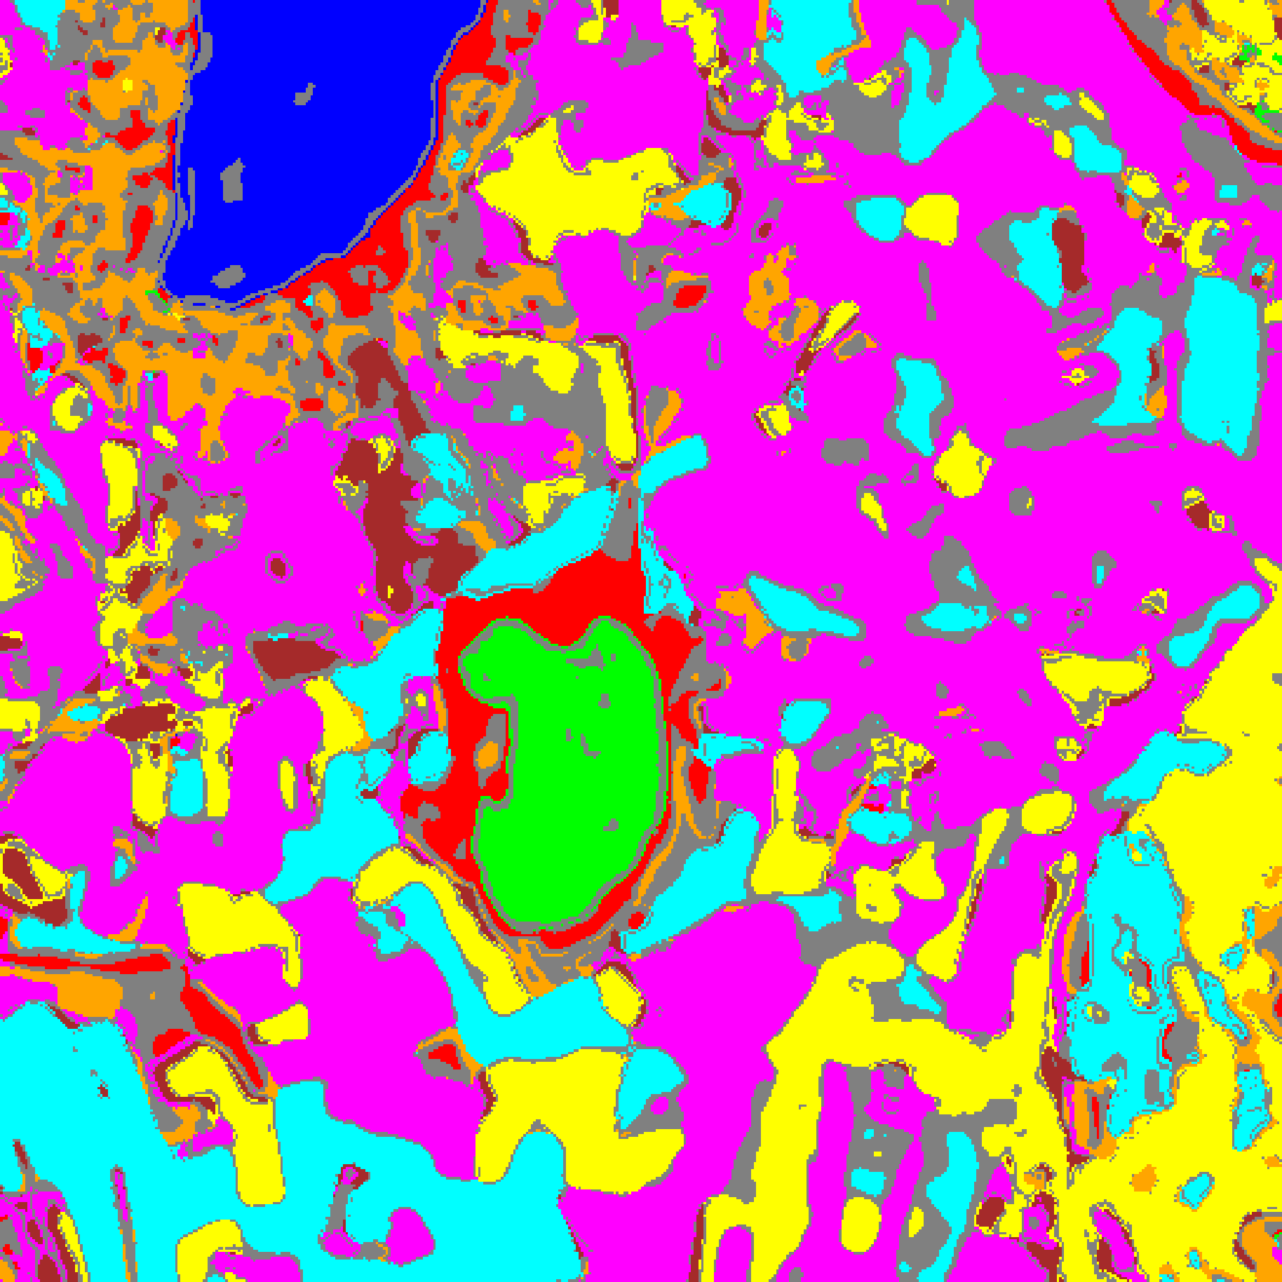  (F) RC3P Mask
Fig. 2. Spatialised binary uncertainty maps and class-masked maps for SpatialGCN across SplitCP ((A)–(B)), CcCP ((C)–(D)), and RC3P ((E)–(F)).
TABLE XIII
CLCP AGGREGATE PERFORMANCE (Α = 0.05, K_G = 4 CLUSTERS)
Model | Emp. Cov. | Avg Set Size | Singleton Rate | Empty Set Rate | Runtime (s) | Mean Cls Cov.
SpatialGCN | 0.9519 | 0.9804 | 0.9581 | 0.0307 | 2.954 | 0.9358

TABLE XIV
CLCP PER-CLASS EMPIRICAL COVERAGE
Class | SpatialGCN
Class 0 | 0.9490
Class 1 | 0.9531
Class 2 | 0.9823
Class 3 | 0.9656
Class 4 | 0.9522
Class 5 | 0.9660
Class 6 | 0.7900
Class 7 | 0.9281

TABLE XV
CLCP CLASS-TO-CLUSTER ASSIGNMENTS AND THRESHOLDS
Class | Cluster | q̂
Class 0 | Cluster 1 | 0.038655
Class 1 | Cluster 1 | 0.038655
Class 2 | Cluster 3 | 0.768265
Class 3 | Cluster 0 | 0.382975
Class 4 | Cluster 0 | 0.382975
Class 5 | Cluster 2 | 0.361530
Class 6 | Cluster 0 | 0.382975
Class 7 | Cluster 3 | 0.768265

TABLE XVI
CLCP PER-CLUSTER MEAN COVERAGE
Cluster | SpatialGCN
Cluster 0 | 0.4870
Cluster 1 | 0.4753
Cluster 2 | 0.4924
Cluster 3 | 0.5538

TABLE XVII
RAPS AGGREGATE PERFORMANCE (Α = 0.05, Λ = 0.01, K_REG = 1)
Model | Emp. Cov. | Avg Set Size | Singleton Rate | Empty Set Rate | Runtime (s) | Mean Cls Cov.
SpatialGCN | 0.9734 | 1.0000 | 1.0000 | 0.0000 | 0.452 | 0.9541

TABLE XVIII
RAPS PER-CLASS EMPIRICAL COVERAGE
Class | SpatialGCN
Class 0 | 1.0000
Class 1 | 1.0000
Class 2 | 0.9435
Class 3 | 0.9832
Class 4 | 0.9723
Class 5 | 0.9754
Class 6 | 0.9400
Class 7 | 0.8187

TABLE XIX
RAPS CALIBRATED PARAMETERS
Model | q̂_RAPS | λ | k_reg
SpatialGCN | 0.000000 | 0.01 | 1

IV. CONCLUSION
On the 65-band DIAS Scene K01 hyperspectral dataset (512 × 512 pixels, K = 8 classes), SpatialGCN achieved 97.046% test accuracy (κ = 0.9644). Wrapped in SplitCP, CcCP, RC3P, ClCP, and RAPS at α = 0.05, the model delivered valid distribution-free coverage guarantees and full-scene spatial uncertainty maps across all 262,144 pixels.
REFERENCES
[1] A. N. Angelopoulos, S. Bates, J. Malik, and M. I. Jordan, “Uncertainty sets for image classifiers using conformal prediction,” in Proc. ICLR, 2021.
[2] Y. Shi, S. Ghosh, T. Belkhouja, J. R. Doppa, and Y. Yan, “Conformal prediction for class-wise coverage via augmented label rank calibration,” in Adv. Neural Inf. Process. Syst. (NeurIPS), 2024.
[3] T. Ding, A. N. Angelopoulos, S. Bates, M. I. Jordan, and R. J. Tibshirani, “Class-conditional conformal prediction with many classes,” in Adv. Neural Inf. Process. Syst. (NeurIPS), 2023.
[4] Y. Romano, M. Sesia, and E. Candès, “Classification with valid and adaptive coverage,” in Adv. Neural Inf. Process. Syst. (NeurIPS), 2020.
[5] M. Ahmad et al., “Hyperspectral image classification—Traditional to deep models: A survey for future prospects,” IEEE J. Sel. Topics Appl. Earth Observ. Remote Sens., 2022.

