Ref: https://www.w3schools.com/html/default.asp
Ex:
<!DOCTYPE html>
<html> <!—mobai>
<head>
<title>Page Title</title>
</head>
<body>
<h1>This is a Heading</h1>
<p>This is a paragraph.</p>
</body>
</html> <!—ketbai>
<!-- >
- The <!DOCTYPE html> declaration defines that this document is an HTML5 document
- The <html> element is the root element of an HTML page
- The <head> element contains meta information about the HTML page
- The <title> element specifies a title for the HTML page (which is shown in the browser's title bar or in the page's tab)
- The <body> element defines the document's body, and is a container for all the visible contents, such as headings, paragraphs, images, hyperlinks, tables, lists, etc.
- The <h1> element defines a large heading
- The <p> element defines a paragraph

HTML Page Structure

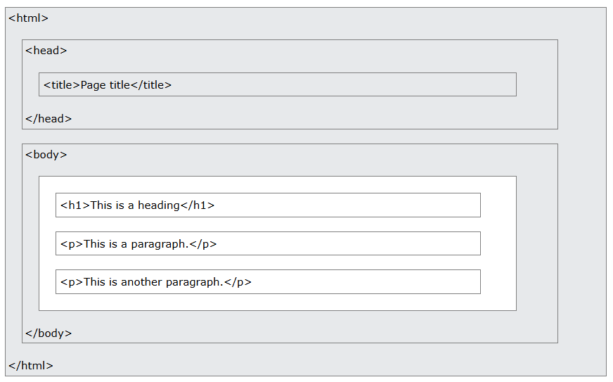

HTML Links
Ex:
<a href="https://www.w3schools.com">This is a link</a>

