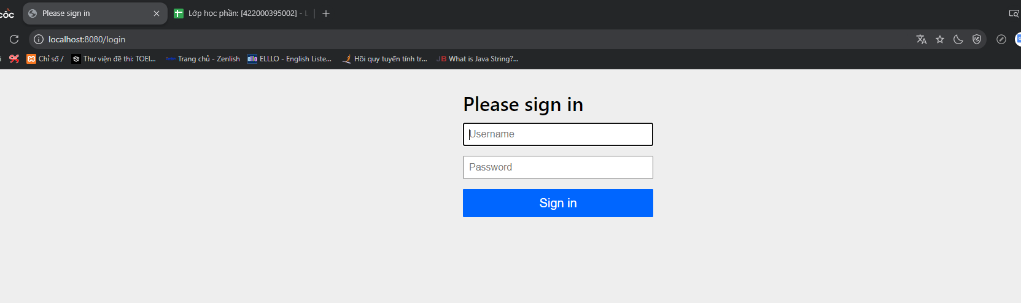

Trước update



Sau update



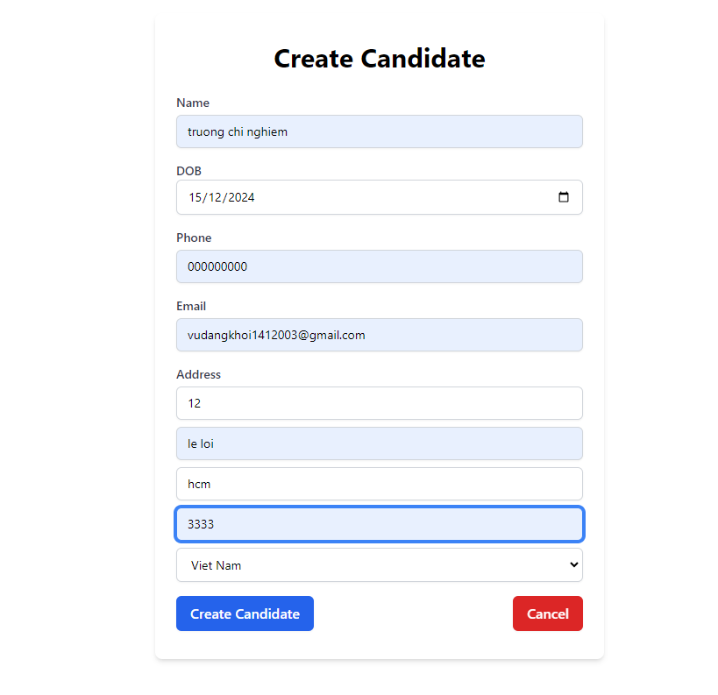

Nhấn delete



Company

