Một số lệnh Docker Compose cơ bản
1 docker compose version
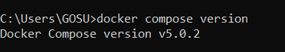
2 docker compose up
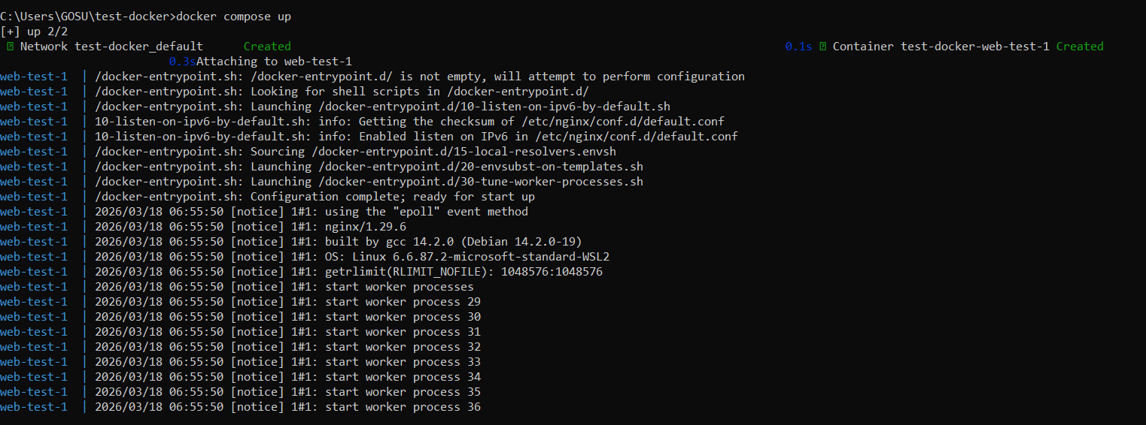
3 docker compose up -d
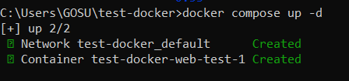
4 docker compose ps
5 docker compose down
6 docker compose restart
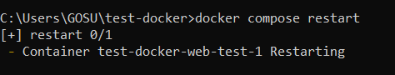
7 docker compose logs -f
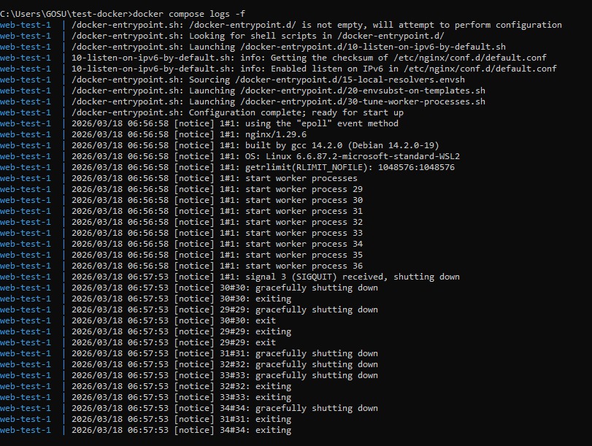
8 docker compose build
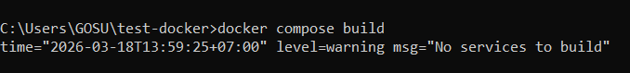
9 docker compose exec <service_name> <command>

10 docker compose down -v
11 docker compose run <service_name> <command>
12 docker compose stop <service_name>
13 docker compose rm <service_name>
14 docker compose config
15 docker compose up -d --build

