David Dang
djd122
10/1/18
EECS 473 – PS2

I modified my sin_commander.cpp from PS1 into sin_commander_service.cpp. This node was written to include a service that receives amplitude and frequency. I then wrote a sin_commander_client.cpp node that prompts the user for those values.

Figure 1 illustrates 4 nodes in action: minimal_simulator, minimal_controller, sin_commander_service, and sin_commander_client.

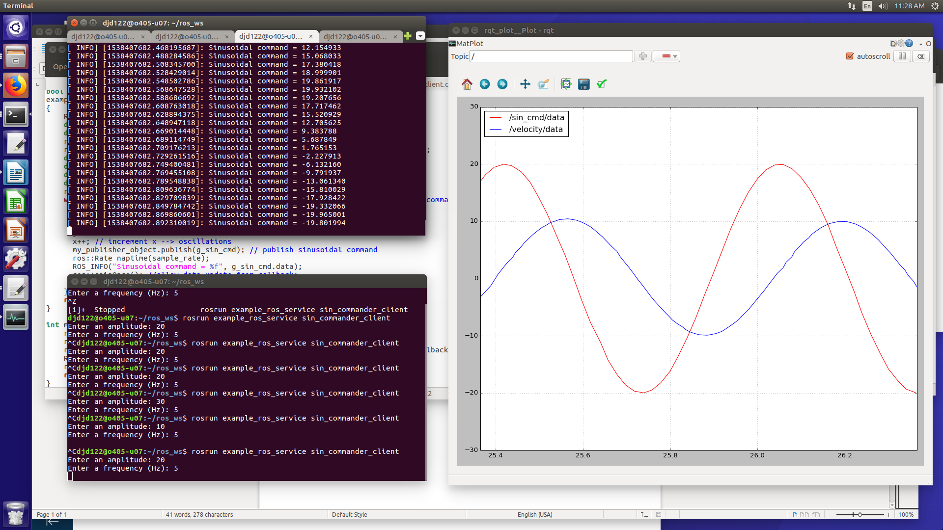
Figure 1: Client/Service node sinusoidal output

After making more edits to my code, I found that my nodes could not reproduce the above output anymore. I kept getting an error message reading:

[ERROR] [1538414700.182644935]: client wants service /sinusoidal_command to have md5sum ab1d9a46fea204f6b916f6e7e20658d9, but it has b70d2061492ef5edc77a68a3504a33ca. Dropping connection.

I could not fix this error for some reason. Hopefully this issue does not appear on your end.

