David Dang
djd122
10/15/18
EECS473 – PS4

Limitations
I attempted to launch the irb120.launch file using the Jennings computers but Gazebo would either open up with errors or catkin_make would freeze up. After struggling with this for several hours, I had to resort to using my virtual machine.

When I attempted to launch the irb120.launch on my virtual machine, I encountered the same issue: Gazebo would open up with an error (Figure 1).

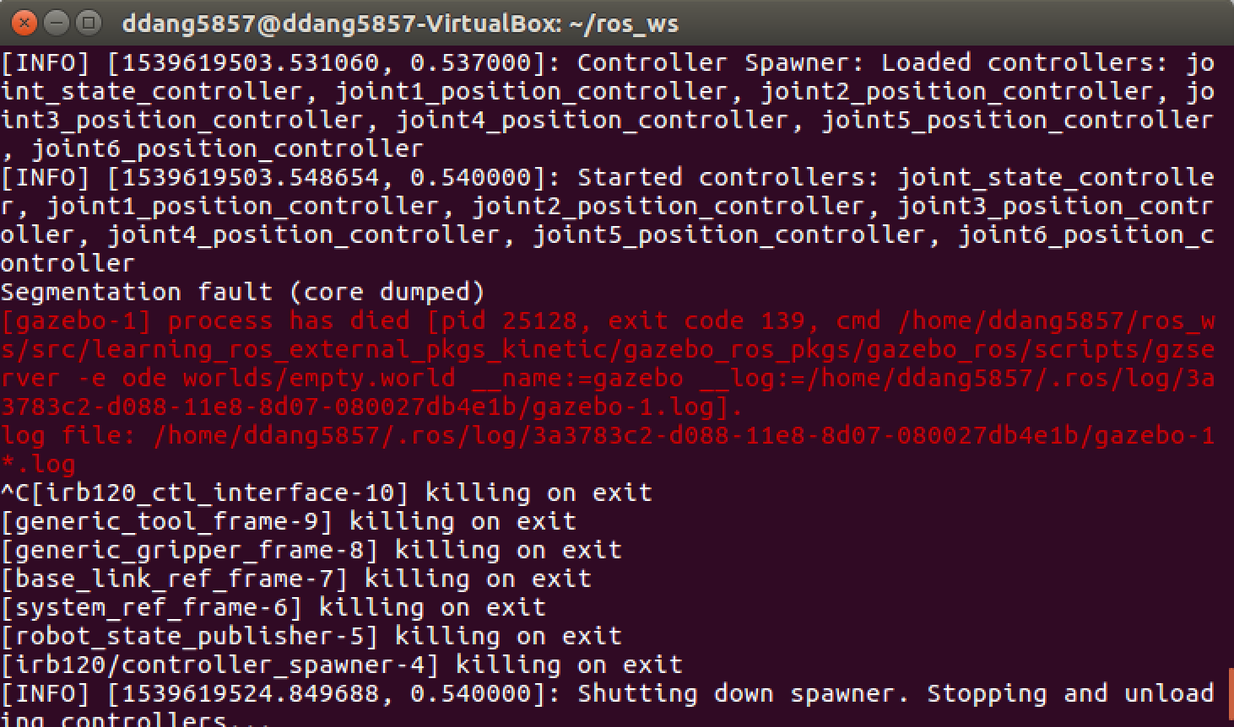
Figure 1: Gazebo error that pops up on my virtual machine

However, the strange thing was when I restarted roscore and tried to launch it again, Gazebo and the robot model appeared with no issues (Figure 2).

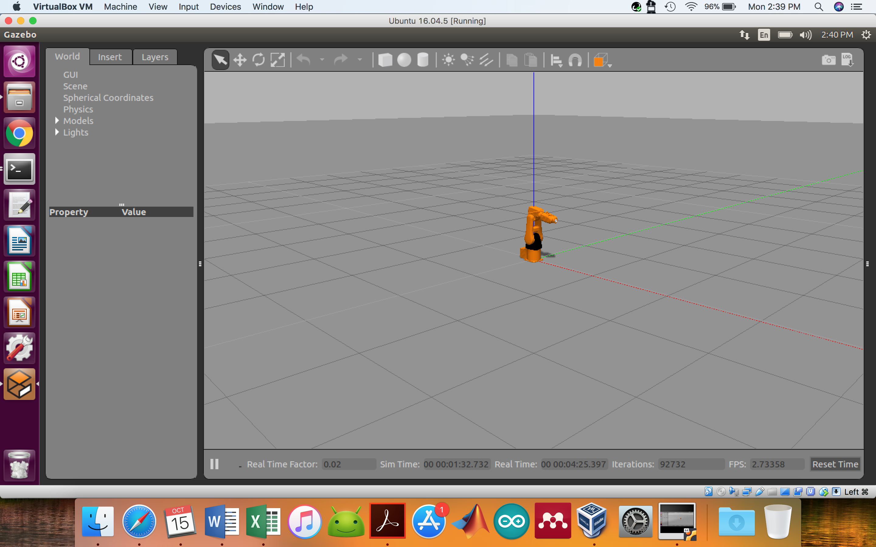
Figure 2: Gazebo and robot model opening with no issues

I attempted to repeat this, but it is extremely inconsistent. I basically have to keep re-launching irb120.launch until Gazebo does not open with an error.

The Code
I modified test_traj_sender_irb120.cpp and renamed it traj_sender_irb120.cpp → it is to be used with the irb120_ctl_interface package in Part_5 of learning_ros_kinetic.

I changed the joint positions so that the robot rises up and touches the ground in three different places.

Please see djd122_ps4.mp4 for the animation.

