David Dang
djd122
12/14/18
EECS 473 – PS9

Link to Github code: https://github.com/DangD96/eecs473_djd/tree/master/ps9
Video: djd122_ps9.mp4

My Approach
The aims of this assignment are to have all parts present, having all parts pass both quality inspection stations, all parts being placed where desired, and finally having a drone pick up the correct shipment.

Note that the parts are pre-loaded within the correct positioning tolerances, so I will need to halt the program, deliberately perturb one of the parts, and then demonstrate that the robot is able to readjust the part position. I plan to do this at quality inspection station 1 (Q1). In addition, it seems that replacement of the defective piston rod part at Q1 results in a passing inspection at Q2. Therefore, I will not check for defective parts until the box arrives at Q2 in order to demonstrate that Q2 operations are functional.

When I start my demo_order_filler.cpp node, I first call the /ariac/start_competition server. The box is then moved to Q1 where I manually perturb one of the parts. Once the program resumes, the robot readjusts the part and sends the box over to quality inspection station 2 (Q2).

At Q2, the program identifies that the piston rod part is defective and promptly removes it. After that, it prepares to populate the box with missing parts. The robot goes to the bin, picks up a new piston rod part, and drops it into the box. Once that was done, the box moves to the drone depot where it is then picked up and the program ends.

Results
Below is a screenshot of my score: 0 points

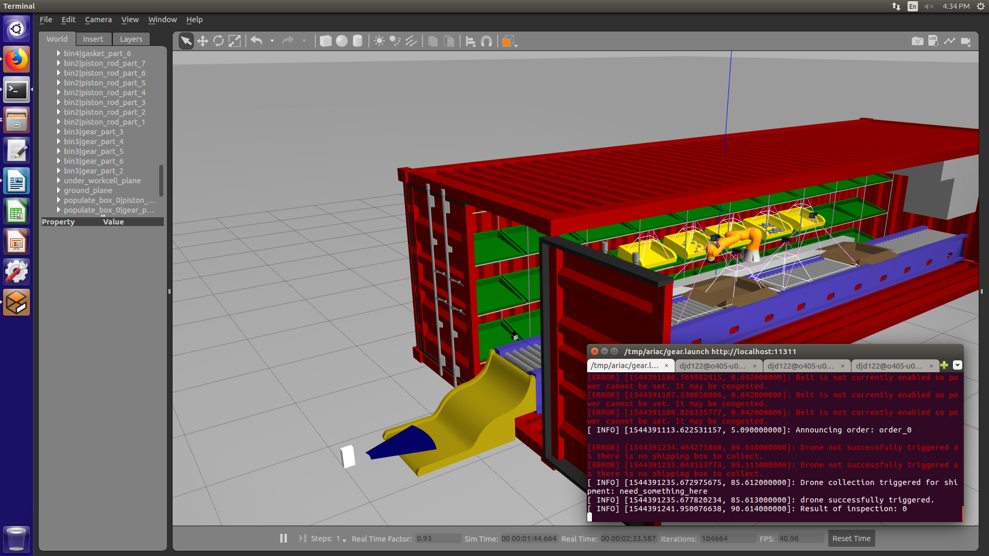

Limitations
- I had to use the robotBehaviorInterface.release_and_retract() function here instead of robotBehaviorInterface.place_part_in_box_no_release(place_part) because the latter would place the part at its Q1 location. I was mystified as to why this was happening and had a hard time figuring out how to address this issue. In the end. I had to settle with dropping the part into the box instead.
- I am a little confused as to why I got 0 points at the end of the competition. Maybe the competition required parts to be removed in a certain order? The fact that I removed the piston rod part at Q2 instead of at Q1 could have violated this rule. But again, I reiterate that I perturbed parts at Q1 and removed the defective piston rod part at Q2 in that order so I could demonstrate that operations at Q2 were functional.

