David Dang
djd122
9/25/18
EECS 473 – PS1 Revised (Jennings Computer)

Changing values of dt (simulator) and Kt and dt_controller (minimal controller)
dt (integration time step in sec) | Kt (v feedback gain) | dt_controller (sample rate in sec) | Effect
0.01 | 1.0 | 0.1 | Baseline values
0.01 | 3.0 | 0.1 | Waveform rises very quickly and smoothly to its target velocity
0.01 | 3.0 | 0.01 | Output rate of minimal_controller is now matched with that of minimal_simulator. The speed at which the waveform rises to its target velocity seems slower now
0.01 | 5.0 | 0.01 | Waveform now rises and drops very quickly and smoothly

Computers in the Jennings lab perform much better than my Mac. This allowed me to change those three parameters without experiencing weird issues.

My preferred parameters are dt = 0.01, Kt = 5.0 and dt_controller = 0.01

sin_commander.cpp – Limitations to performance

When I changed the update frequency of sin_commander.cpp to match that of minimal_simulator and minimal_controller (100 Hz), I found that while the waveform was indeed a sine wave, the simulated velocity had trouble keeping up with the commanded velocity (Figure 1).

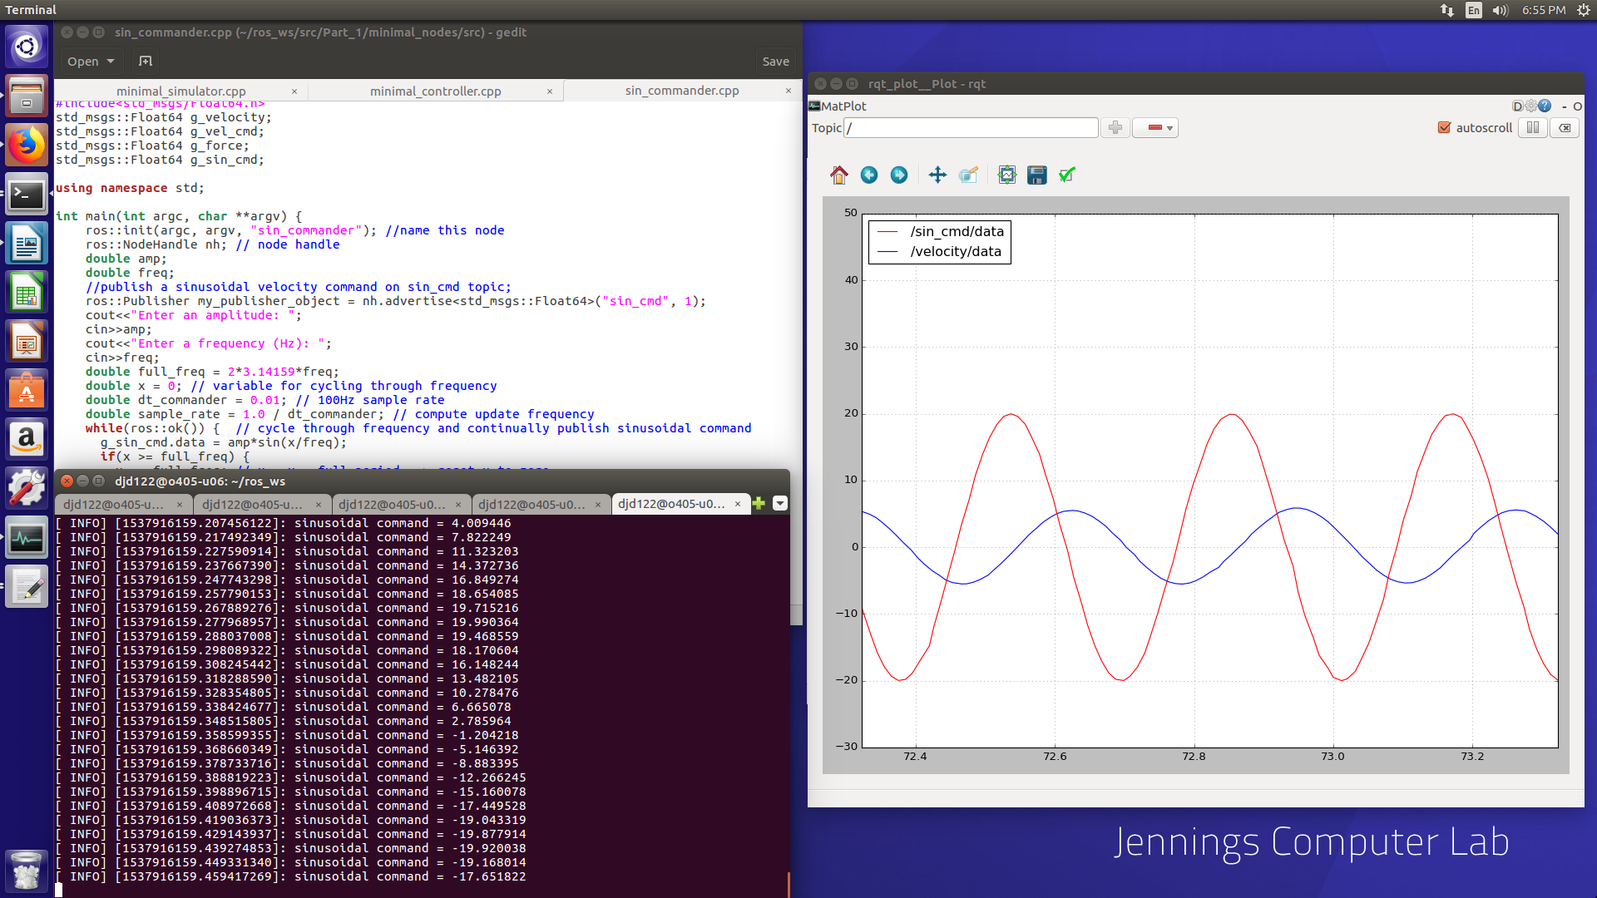
Figure 1: sin_commander with 100 Hz update frequency

When I decreased the rate down to 25 Hz, the simulated velocity had an easier time keeping up, but the graph did not look as aesthetically pleasing (Figure 2).

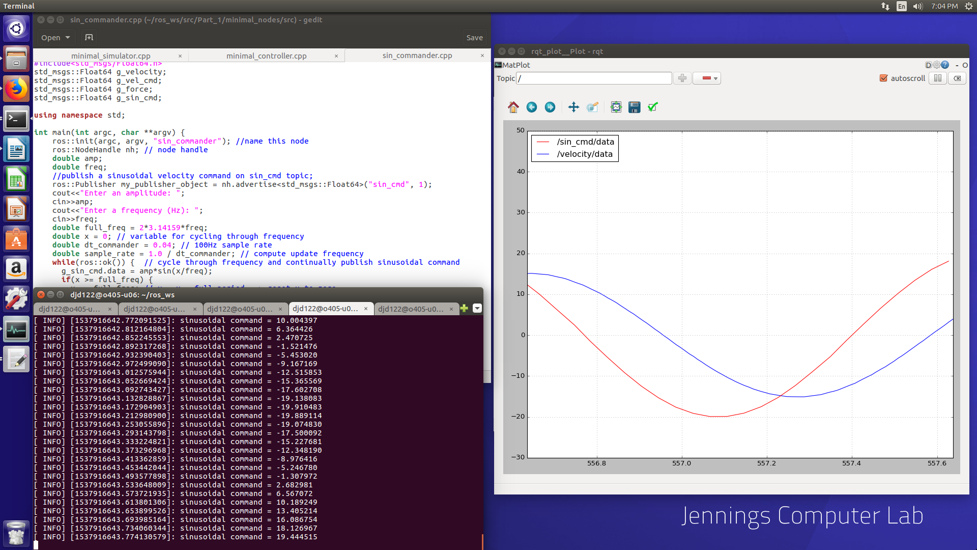
Figure 2: sin_commander with 25 Hz update frequency

In the end, I settled on a 50 Hz update frequency (Figure 3) since the gap between the simulated and commanded velocities was smaller than the gap for the 100 Hz scenario. It was also more obvious that the 50 Hz scenario was outputting sine waves compared to the 25 Hz scenario.

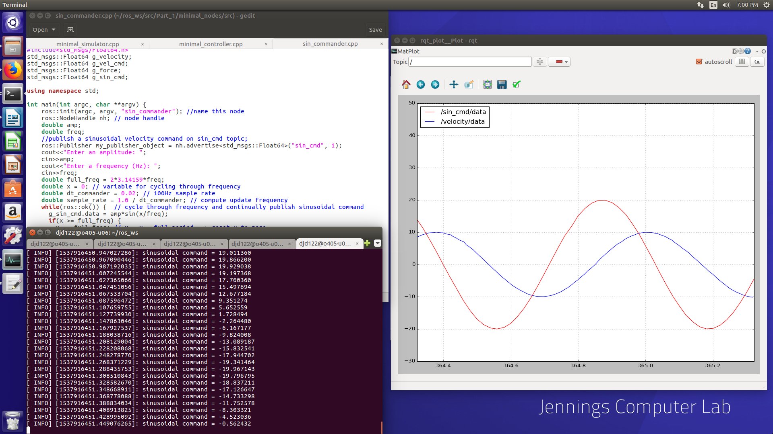
Figure 3: sin_commander with 50 Hz update frequency

