David Dang
djd122
10/1/18
EECS 473 – PS2

I modified my sin_commander.cpp from PS1 into sin_commander_service.cpp. This node was written to include a service that receives amplitude and frequency. I then wrote a sin_commander_client.cpp node that prompts the user for those values.

Figure 1 illustrates 4 nodes in action: minimal_simulator, minimal_controller, sin_commander_service, and sin_commander_client.

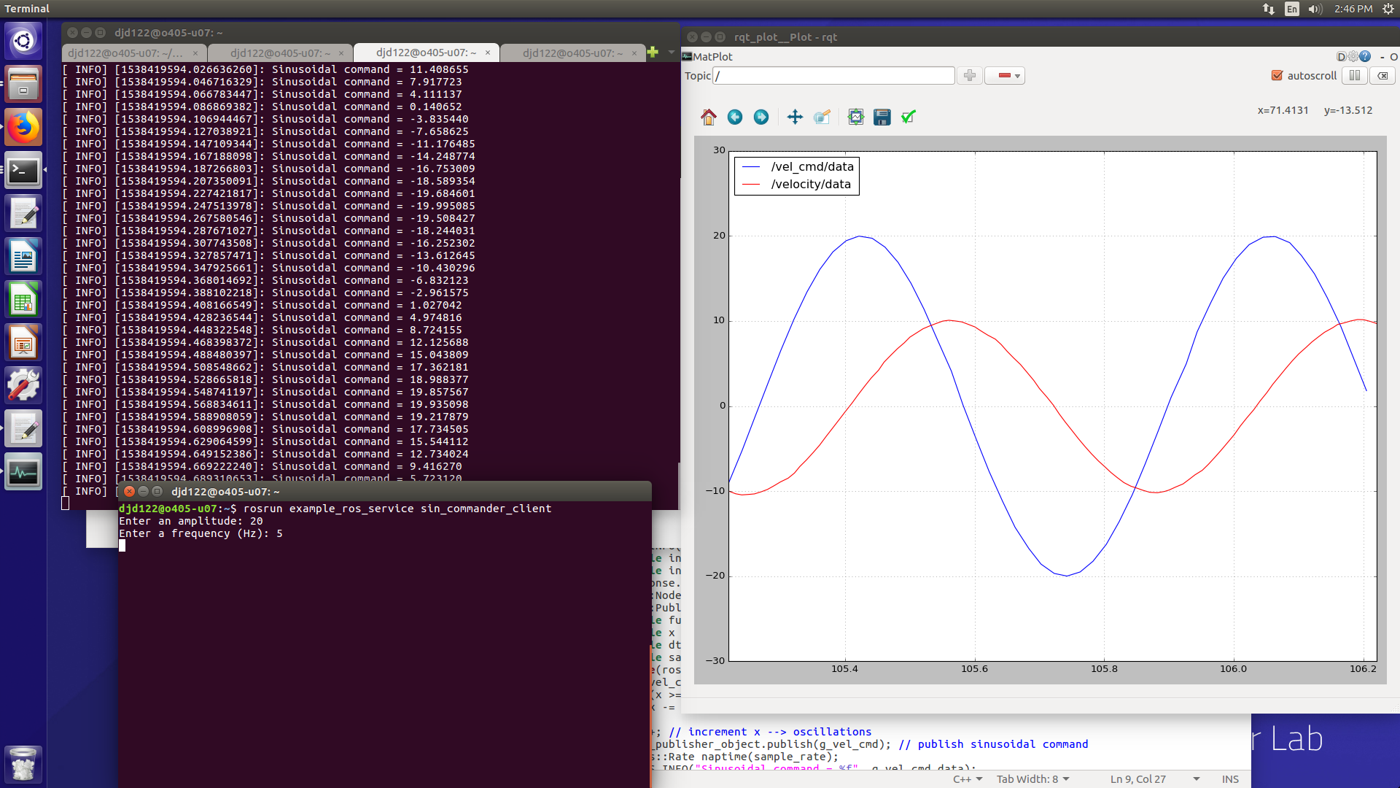
Figure 1: Client/Service node sinusoidal output

Note: minimal_simulator and minimal_controller were both run from the minimal_nodes package while sin_commander_service and sin_commander_client were both run from the example_ros_service package.

