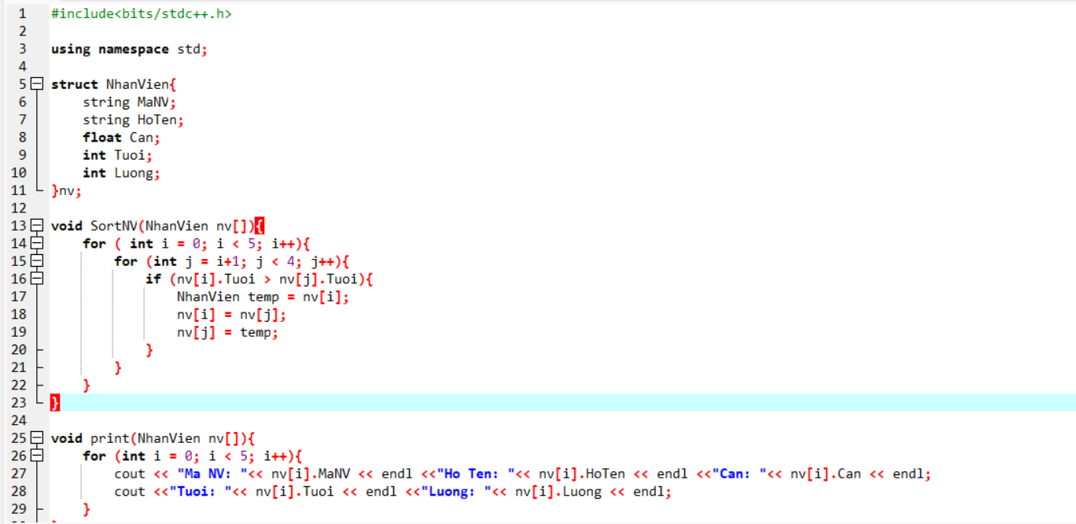

Kết quả:

