MÀN HÌNH CONSOLE:

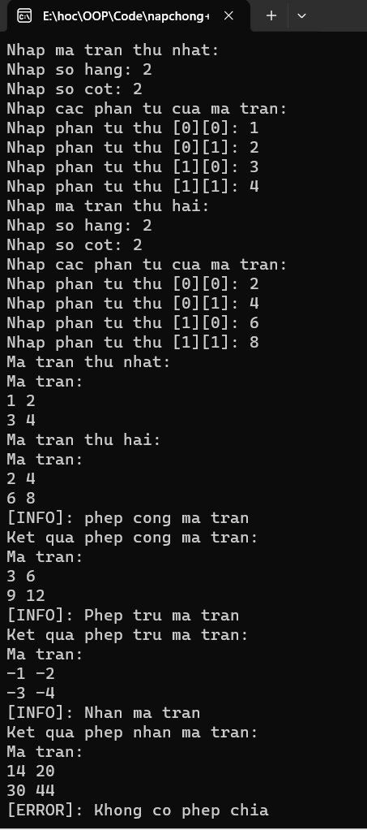

CODE:

