
Business Analytics
Assignment 1: Data Analytics



Student Name | Dang Khoa Nguyen
Student ID | S3891931
Course Name | Business Analytics
Course ID | ISYS3374
Lecturer’s Name | Dr Hadi Naghavipour
Class time | Thursday 17:30 pm
Word counts | 1321

Question 1:

Figure 1: Distribution of price for houses with two car parks and more than two car parks
The distribution chart illustrates how the number of car park influences house prices. Houses with two car parks dominate the lower price ranges, particularly between $1 million and $1.99 million, and continue to be more frequent in the $2 million to $2.99 million range. In contrast, houses with more than two car parks are significantly fewer in number across all brackets. As prices rise above $3 million, the number of houses decreases sharply for both categories, with houses offering more than two car parks remaining scarce. This suggests that while additional car spaces might be associated with higher-priced homes, they remain relatively rare features in the housing market.

Figure 2: Outlier in the price variable pertaining to each suburb
The box plot shows key price outliers across various suburbs. Kew stands out with several high-priced outliers, including properties above $5 million, indicating a concentration of luxury homes. Fitzroy also shows a few outliers, though at lower price points, with prices occasionally exceeding $2 million. In contrast, suburbs like Melton and Reservoir display more consistent price distributions with fewer or no significant outliers. This suggests that suburbs like Kew experience greater price variability due to the presence of high-end properties, while other suburbs have more stable price ranges.
Question 2:
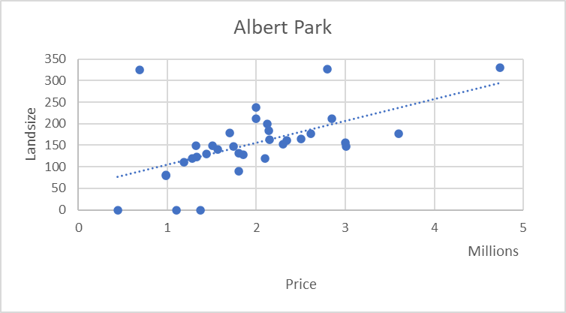
Figure 3: Relationship between price and landsize in Albert Park
The scatter plot for Albert Park shows a positive relationship between land size and price. As land size increases, the price of properties generally tends to rise, indicating that larger plots of land in this suburb command higher values. However, the data points show some variability around the trendline, with certain properties having larger land sizes but not corresponding to significantly higher prices, suggesting other factors may also affect property values.

Figure 4: Relationship between price and land size in Brunswick East
The scatter plot for Brunswick East shows a positive relationship between land size and price. However, there are notable exceptions in which the prices are not significantly higher due to the larger land size (over 600 sqm). The majority of homes are concentrated between 0.5 and 1.5 million, with land sizes ranging from 100 to 400 square metres, indicating some variation in how land sizes influences price in suburbs.

Figure 5: Relationship between price and land size in Kew
The scatter plot for Kew shows positive relationship between land size and price, with wider spread of both variables compared to other suburbs. There are notable outliers, including a property with a land size over 2500 sqm, though most properties fall within 500 to 1000 sqm and 1 to 4 million in price. The trendline suggests that larger land sizes generally correspond to higher prices, but the spread indicates variability in this relationship, especially for higher-priced properties.

Figure 6: Relationship between price and land size in Fitzroy
The scatter plot for Fitzroy indicates that larger land sizes do not always match rising prices. Some houses with significant land areas (up to 7000 sqm) are priced under $1 million, implying that factors such as location or development potential could impact on property values more than land size.
b
Figure 7: Relationship between price and lands size in Melton
The scatter plot for Melton demonstrates a positive link between land size and price, with the trendline indicating that larger land sizes generally correspond to higher property values. Most of properties fall around 400 to 700 sqm and are priced between $300,000 to $600,000, suggesting a relatively predictable correlation between land size and price in this suburb. Minimal outliers help to highlight Melton’s consistent link.

Figure 8: Relationship between price and land size in Reservoir
The scatter plot for Reservoir shows a weak positive relationship between land size and price, with most properties clustered between $300,000 to $800,000 and 0 to 800 sqm. A popular outlier with a land size exceeding 4000 sqm has little effect on this trend, which remains relatively flat, indicating a limited impact of land size on property prices in this suburb.
Question 3:
Average of Price | Column Labels
Row Labels | h | t | u | Grand Total
Albert Park | 2.07 |  | 0.74 | 1.95
Brunswick East | 1.25 | 0.91 | 0.52 | 1.06
Fitzroy | 1.73 | 0.92 | 0.64 | 1.24
Kew | 2.43 | 0.92 | 0.69 | 1.96
Melton | 0.44 |  |  | 0.44
Reservoir | 0.78 | 0.56 | 0.40 | 0.66
Grand Total | 1.41 | 0.76 | 0.52 | 1.16
Figure 9: Average Property Prices by Type and Suburb
The heat map illustrates the fluctuations in average property prices across different property prices types and suburbs. With average prices of $2.43 million and $2.07 million respectively. Kew and Albert Park turn out as the most costly suburbs for houses. Town house prices are consistent, around $0.91 million to $0.92 million in Brunswick East, Fitzroy, and Kew. Units are the least expensive, with Reservoir and Melton showing the lowest averages at $0.40 million and $0.44 million. Overall, location and property type significantly affect price, with premium suburbs like Kew and Albert Park commanding higher prices.
Question 4:

Figure 10: Average Land size by Property Type and Suburb
The chart reveals significant variation in average land size across property types and suburbs. Fitzroy stands out with the largest land sizes for townhouses (1425 sqm) and units (1379 sqm), far exceeding other areas. Kew and Melton have bigger house land areas, with 610 sqm and 730 sqm, respectively. In contrast, Albert Park, Brunswick East, and Reservoir have smaller land sizes across all property types, particularly for townhouses and units. This suggests Fitzroy favors larger developments, while Kew and Melton focus on spacious houses, with other suburbs tending toward more compact properties.
Question 5:

Figure 11: Property Development Trends Near and Beyond 4 Kilometers from the CBD (1870-2020)
The line chart highlights property development trends near and far from the CBD. Suburban expansion beyond 4 kilometers surged in the late 1800s, peaking around 1890. After a period of slower growth, a significant post-war boom occurred in the 1950s to 1970s, particularly beyond 4 kilometers. Development within 4 kilometers remained more stable with modest growth. Following 2000, both areas had increased building, with a sharper surge beyond the 4-kilometer radius, indicating sustained suburban growth and outward expansion. This trend reflects ongoing demand for development outside the central city area.
Question 6:
The relationship between price and variables such as number of parking spaces, land size, and suburb location shows the complex dynamics of Melbourne’s housing market. The price distribution for homes with two or more than two car parks (Figure 1) reveal that price with two car parks are concentrated in the $1-2 million range, while those with more than two car parks are more frequently found in the $2-$2.99 million bracket. This suggests that properties with more parking spots are larger and more expensive, owing to the additional room and luxury facilities. The scarcity of homes with more than two car spaces indicates a supply restriction, which drives up prices for these high-end properties.
Figure 2 emphasizes the role of location in determining prices. Kew has high price diversity, with numerous outliers above $5 million, indicating the presence of luxury houses. In contrast, Albert Park and Fitzroy have high average costs but more constant pricing, indicating a steady premium market. On the other hand, Melton and Reservoir have lower price ranges and fewer outliers, indicating more affordable areas with less price fluctuation. This means suburb status and demand have a substantial influence on property values.
Land size is also important, especially in premium regions like Fitzroy, where townhouses and units with bigger land amounts (e.g., 1425 sqm for townhouses) drive up costs. However, in more cheap areas such as Melton, larger land holdings do not always translate into higher costs, with the average remaining at $0.44 million. This suggests that, while land size influences value, location, market demand, and local reputation are frequently more important.
In conclusion, price of Melbourne’s houses determined by a combination of car parks, land size, and suburb location, with premium amenities driving higher values, especially in desirable regions.

