
visualising and communicating insights in business
Assignment 2: Developing data visualisations


Contents
Executive Summary 2
1. Business Problem and Dashboard Overview 2
Key Patterns Surfaced by the Dashboard 3
2. Visualisation Selection and Techniques 4
Visualisation Technique Mapping 4
3. Insights from the Dashboard 6
Insight 1: Attrition risk is material and role-specific 6
Insight 2: Gender imbalance changes how equity indicators should be interpreted 7
Insight 3: Career mobility should be monitored as a retention driver 8
Insight 4: Salary distribution requires controlled pay equity analysis 8
Insight 5: Training is strong, but its outcome impact is unclear 9
Insight 6: People experience is moderate-to-positive, not uniformly high 10
4. Recommendations 10
5. Conclusion 11
References 11
Appendix: Key Calculated Fields 11

HR People Analytics Dashboard Report
Visualising and Communicating Insights for Business

Executive Summary
Key point: The dashboard is designed as a decision-support tool, not a static HR report. It integrates attrition, workforce composition, career progression, pay equity, working conditions and people experience into one executive view.
This report presents an interactive HR People Analytics Dashboard for HR managers, workforce planners, diversity and inclusion teams and senior leaders. The core business problem is that people-related risks are often monitored through separate reports, making it difficult to understand whether attrition, representation, salary distribution, training, absence and satisfaction are connected. The dashboard addresses this issue by consolidating employee-level data into a clear, filtered overview that helps leaders identify where workforce risk is concentrated and where action should be prioritised.
The dataset contains employee status, department, job role, job level, hire year, age band, gender, ATSI identification, education, salary bands, training sessions, absence days, career tenure measures and people experience scores. The dashboard reports four headline indicators: 405 total attritions, 23% attrition rate, 1,380 active employees and average satisfaction of 3.16/4.0. It then explains these outcomes through role risk, demographic composition, career mobility, salary distribution, training exposure, absence patterns and satisfaction distribution.
The key findings are that attrition is material and role-specific, gender representation is uneven, career mobility requires ongoing monitoring, training participation is strong, and employee experience is moderate-to-positive but not uniformly high. The report recommends targeted retention analysis, controlled pay equity review, linking training to career progression, and quarterly people experience monitoring. These actions directly align with the dashboard evidence and the assessment criteria requiring an explicit connection between business problem, data analysis, visualisation task, insights and recommendations.

1. Business Problem and Dashboard Overview
The dashboard uses a top-down executive layout. It begins with KPI tiles and then moves into diagnostic visualisations covering hiring trend, department and role risk, demographics, career background, salary by gender, job level, training, absence and satisfaction distribution. This structure supports the business user journey: first understand the overall workforce position, then diagnose which people groups, roles or work conditions may explain the pattern.
The visual design uses a consistent mauve, plum and light-grey palette. Mauve represents actual contribution, grey represents background contribution, and darker plum highlights heatmap concentration. Interactive filters for Department, Job Role, Gender and Age Band allow managers to test whether patterns remain consistent across workforce segments.
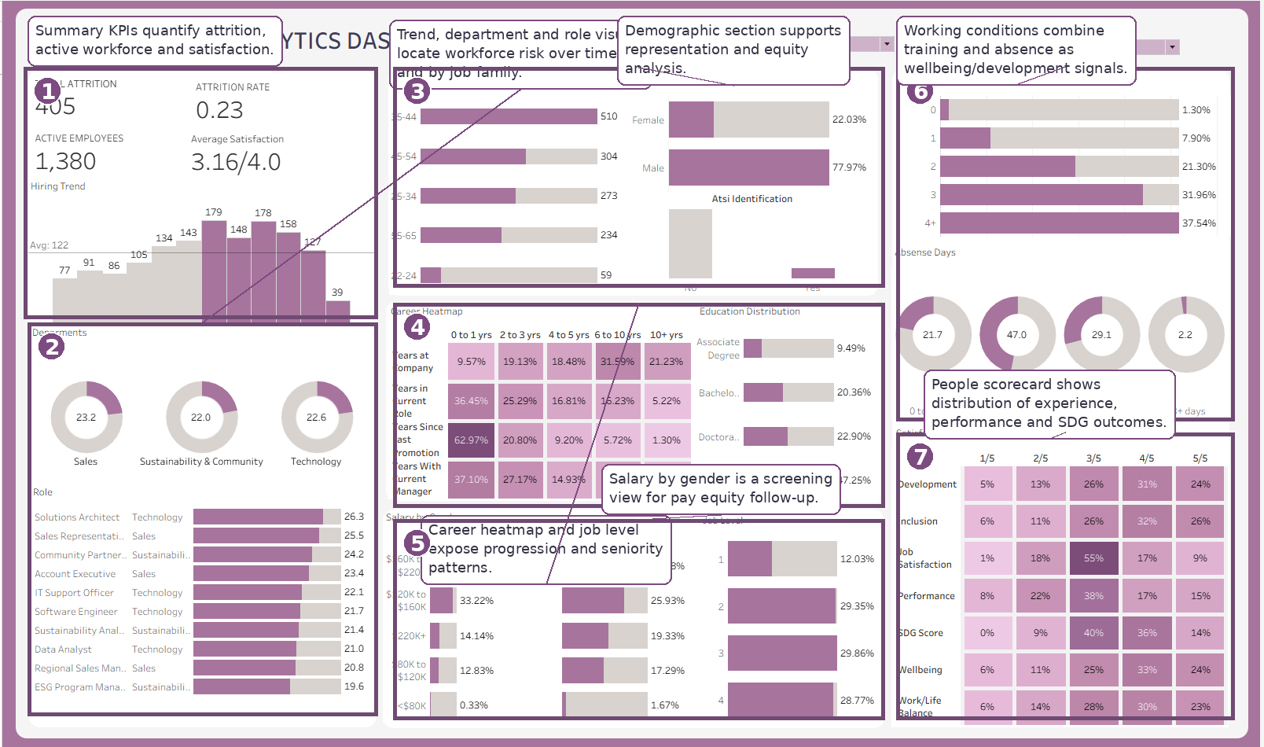
Figure 1. Annotated full dashboard overview showing KPI, demographic, career, salary, working condition and satisfaction sections.

Key Patterns Surfaced by the Dashboard
Dashboard evidence | Business meaning | Decision supported
405 attritions and 23% attrition rate | Turnover is a material workforce risk. | Prioritise role and department retention analysis.
Male employees represent 77.97% of the workforce | Representation imbalance affects interpretation of pay and progression. | Review hiring pipeline, promotion outcomes and salary distribution.
Career heatmap shows tenure, role and promotion bands | Career risk is multidimensional, not visible from one variable. | Monitor internal mobility and promotion delay.
Training is concentrated at 3 and 4+ sessions | Development activity appears strong but needs outcome testing. | Link training to promotion readiness and satisfaction.
People scores cluster around 3/5 and 4/5 | Experience is moderate-to-positive but not excellent. | Use scorecard as an early-warning system.

2. Visualisation Selection and Techniques
The dashboard was built to satisfy three analytical tasks: identify the workforce problem, diagnose its likely drivers and support evidence-based action. The visualisations therefore combine summary metrics, distribution charts, ranked bars, heatmaps and mini-donuts. This avoids relying on one chart type and enables the user to see both high-level trends and detailed group patterns.
Key design decision: All count-based measures use distinct employee counting where necessary. This prevents inflated results after long-format helper tables were used for career and satisfaction heatmaps.

Visualisation Technique Mapping
Visualisation | Technique | Why it was selected | Analytical question
KPI tiles | Large numeric indicators | Provides immediate executive summary of workforce health. | How serious is the workforce situation?
Hiring trend | Bar chart with average reference line | Shows recruitment movement over time and highlights recent change. | When did hiring accelerate or decline?
Role risk chart | Ranked horizontal bars with grey max bars | Ranks roles and provides visual contribution context. | Which roles show higher attrition risk?
Career heatmap | Matrix with percentage colour intensity | Compresses four career variables into one readable view. | Are employees concentrated in stable or stagnant career stages?
Salary by gender | Small multiple bars by gender | Screens pay distribution while keeping gender comparison visible. | Does salary concentration differ by gender?
Satisfaction scorecard | Heatmap across 1/5 to 5/5 bands | Shows distribution rather than hiding variation in averages. | Which people outcomes are strong or weak?
The dashboard also applies usability techniques including tooltips, section cards, consistent spacing and manually controlled filters. Importantly, the Gender filter should not be applied to Gender Distribution or Salary by Gender, because doing so would remove the comparison those charts are designed to show. Similarly, the Age Band filter should not apply to the Age Distribution chart if the purpose is to retain a baseline demographic view.

3. Insights from the Dashboard

Insight 1: Attrition risk is material and role-specific
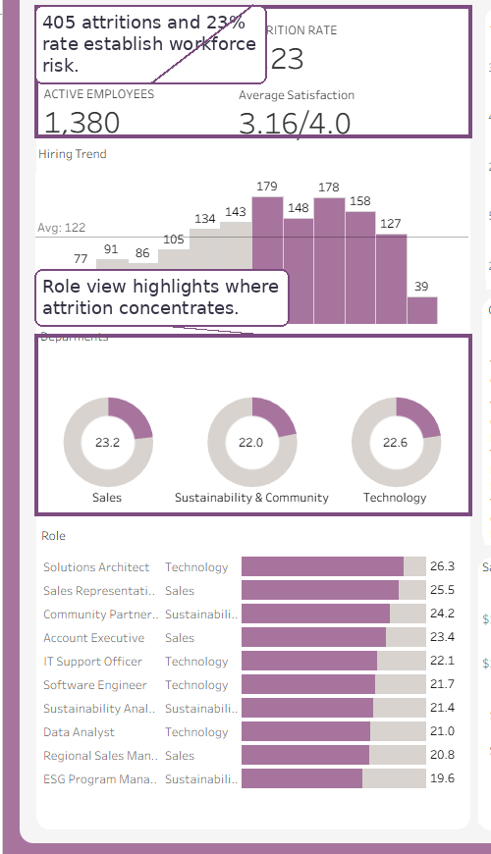
Figure 2. Annotated attrition and role-risk evidence.
The dashboard reports 405 total attritions and an attrition rate of 23%, making attrition a significant management issue rather than a minor HR statistic. The role chart strengthens this finding by showing that risk is uneven across job families. Roles such as Solutions Architect and Sales Representative sit around the mid-20% range, suggesting that turnover risk may be concentrated in specific skill or operational areas. The business implication is that retention action should be role-specific, not generic.

Insight 2: Gender imbalance changes how equity indicators should be interpreted
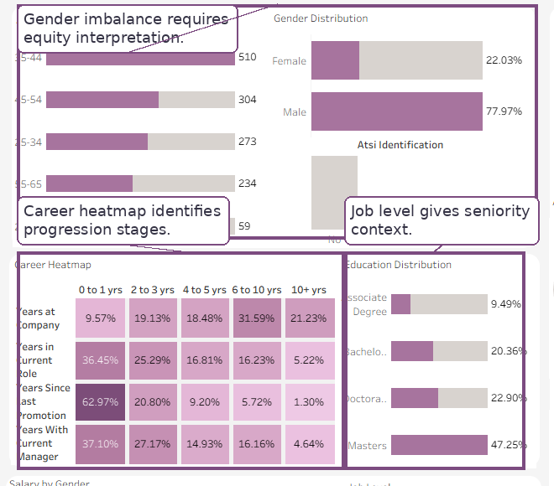
Figure 3. Annotated demographic and career-progression evidence.
The Gender Distribution chart shows that males account for 77.97% of active employees and females account for 22.03%. This does not prove inequity by itself; however, it materially affects the interpretation of salary, job level and satisfaction outcomes. If men are overrepresented in higher salary bands or senior roles, the organisation needs a controlled pay and progression analysis by department, role, tenure and performance. This is a stronger analytical position than claiming bias directly from descriptive charts.

Insight 3: Career mobility should be monitored as a retention driver
The career heatmap shows how employees are distributed across years at company, years in current role, years since last promotion and years with current manager. This design is useful because career stagnation is rarely visible from one metric alone. Employees with long company tenure, long current-role tenure and slow promotion movement may remain active but become disengaged. The dashboard therefore identifies career mobility as a possible retention driver that should be monitored alongside attrition and satisfaction.

Insight 4: Salary distribution requires controlled pay equity analysis
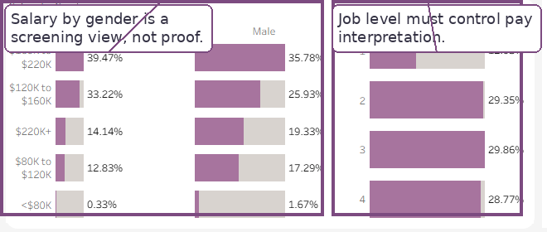
Figure 4. Annotated salary and job-level evidence.
The Salary by Gender chart shows how male and female employees are distributed across salary bands, while the Job Level chart provides seniority context. This combination is important because salary differences may reflect job level, role mix, tenure or performance. The dashboard should therefore be read as a pay equity screening tool, not a final legal or ethical conclusion. The key insight is that descriptive visuals identify where deeper statistical or controlled analysis is required.

Insight 5: Training is strong, but its outcome impact is unclear
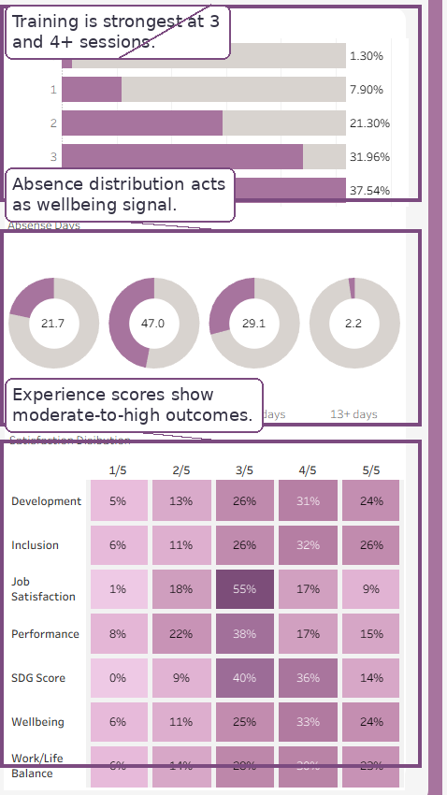
Figure 5. Annotated working conditions and people scorecard evidence.
Training participation appears positive, with the largest share of employees receiving 4+ training sessions. However, training volume does not automatically mean capability improvement. The dashboard becomes more insightful when training is interpreted with career heatmap and satisfaction scorecard outcomes. If employees receive training but remain concentrated in low mobility or moderate satisfaction groups, HR should test whether training is aligned with career pathways and promotion readiness.

Insight 6: People experience is moderate-to-positive, not uniformly high
The satisfaction scorecard shows several indicators clustered around 3/5 and 4/5. This distributional view is more rigorous than a single average satisfaction value because it reveals whether employee experience is concentrated in weak, moderate or strong bands. The result suggests that people experience is not poor overall, but it is also not consistently excellent. Job satisfaction and work-life balance should therefore be monitored with absence and attrition patterns as early-warning indicators.

4. Recommendations
Recommendation | Evidence base | Action required | Expected value
1. Target role-based retention | High attrition and role variation | Run exit interviews, workload review and manager check-ins for high-risk roles. | Reduces avoidable turnover and protects critical skills.
2. Conduct controlled pay equity review | Uneven gender representation and salary-band variation | Analyse pay by gender while controlling for job level, role, tenure and performance. | Improves fairness, governance and workforce trust.
3. Link training to career mobility | High training participation but uncertain progression impact | Compare training sessions with promotion delay, satisfaction and job level movement. | Ensures training investment creates capability and career outcomes.
4. Monitor people experience quarterly | Scorecard clusters around 3/5 and 4/5 | Review satisfaction, wellbeing, absence and attrition together every quarter. | Creates an early-warning system for workforce risk.
These recommendations are actionable because they follow directly from dashboard evidence. They also recognise the limits of visual analysis: charts can identify patterns and priorities, but deeper HR action requires follow-up investigation, qualitative context and controlled analysis where equity issues are involved.

5. Conclusion
Overall conclusion: The dashboard meets the business objective by converting fragmented HR data into a clear workforce monitoring and decision-support system.
The HR People Analytics Dashboard identifies attrition, representation, salary distribution, career mobility, training, absence and employee experience patterns in one coherent view. Its strongest value is connecting KPIs to drivers and actions. With careful filter use and consistent visual design, the dashboard supports targeted HR decision-making and ongoing people analytics reporting.

References
Deloitte 2026, 2026 Global Human Capital Trends, Deloitte Insights, viewed 27 May 2026, https://www.deloitte.com/us/en/insights/topics/talent/human-capital-trends.html.
McKinsey & Company 2015, Power to the new people analytics, McKinsey Quarterly, viewed 27 May 2026, https://www.mckinsey.com/capabilities/people-and-organizational-performance/our-insights/power-to-the-new-people-analytics.
Tableau 2026, Best practices for effective dashboards, Tableau Help, viewed 27 May 2026, https://help.tableau.com/current/pro/desktop/en-us/dashboards_best_practices.htm.
Tableau 2026, Visual best practices, Tableau Blueprint, viewed 27 May 2026, https://help.tableau.com/current/blueprint/en-us/bp_visual_best_practices.htm.

Appendix: Key Calculated Fields
Calculated field | Plain-language purpose | Formula logic
Active Employees CountD | Counts active employees without double counting after joins. | COUNTD(IF active_employee = 1 THEN employee_id END)
Attrition Rate | Measures terminated employees as a share of all employees. | COUNTD(terminated employees) / COUNTD(all employees)
Career Year Band | Groups tenure and promotion variables into readable periods. | 0-1, 2-3, 4-5, 6-10, 10+ years
Salary Band | Groups salary values for pay equity screening. | <$80K, $80K-$120K, $120K-$160K, $160K-$220K, $220K+

