1. **Image Error**

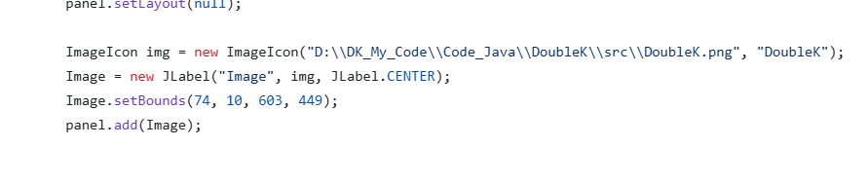

1. Download Project.
2. Copy link of **DoubleK.png** in the folder **src.**
3. Change the line: “*D:\\DK_My_Code\\Code_Java\\DoubleK\\src\\DoubleK.png*” by the link you have been copied..
4. **Sql Server**
5. Right click on the name of project in Eclipse
6. Click on “Properties”
7. Click tab “Libraries”
8. Choose “Module Path”
9. “Add External JARs”
10. Choose this file: “mysql-connector-j-9.1.0.jar”

