**MappingTarget**

**Class UserMapper**

**//**



**Class UserService**

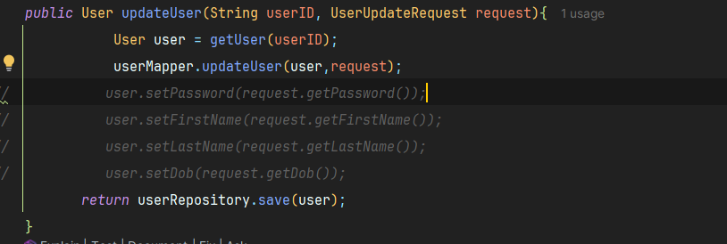



**Ignore**

