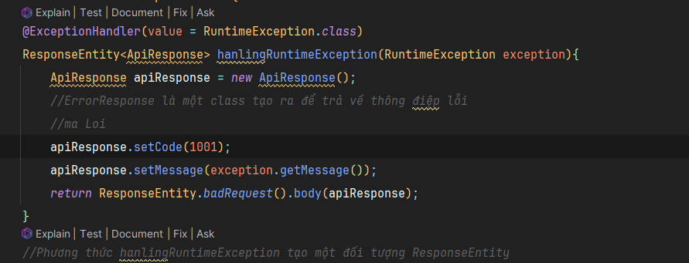

**Trung ten Username**

**Dung if appexception de lay ra loi, class appexception**

**//Error - Advance Exception Handling**

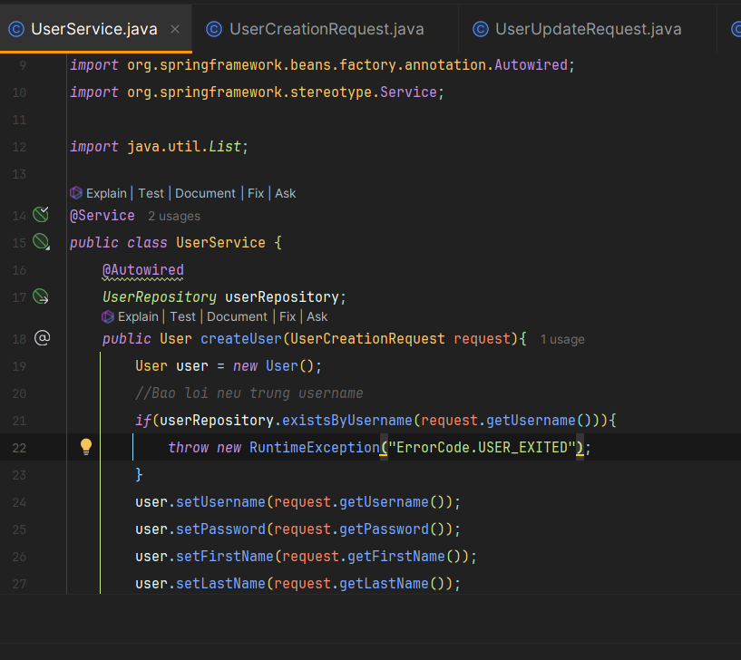

**Nhảy sang :  
**

**Toi uu**

