# Statistics for Files in D:/Documents/Unob_7/STC/STC_code/DB_Performance/_Test/Performance/Result/cockroach

## File: gql_forms.txt

Number of queries: 1000

Mean: 25.59

Median: 21.4

Max: 171.23

Min: 15.0

Variance: 145.66

Standard Deviation: 12.07

90th Percentile: 37.34

Is normal: No

Shapiro-Wilk test p-value: 5.5186496641425676e-40

Is exponential: No

Kolmogorov-Smirnov test p-value: 0.0

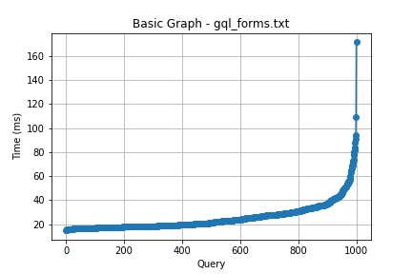

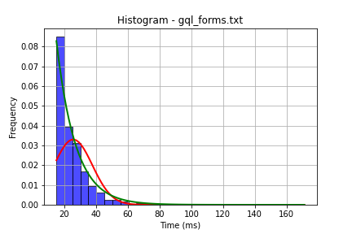

## File: gql_ug.txt

Number of queries: 1000

Mean: 16.18

Median: 14.12

Max: 125.85

Min: 7.98

Variance: 61.41

Standard Deviation: 7.84

90th Percentile: 23.62

Is normal: No

Shapiro-Wilk test p-value: 1.0024749083933309e-40

Is exponential: No

Kolmogorov-Smirnov test p-value: 0.0

