# Statistics for Files in D:/Documents/Unob_7/STC/STC_code/DB_Performance/_Test/Performance/Result

## File: gql_forms.txt

Number of queries: 1000

Mean: 36.88

Median: 35.02

Max: 100.49

Min: 19.71

Variance: 103.34

Standard Deviation: 10.17

90th Percentile: 48.92

Is normal: No

Shapiro-Wilk test p-value: 3.816252371516267e-26

Is exponential: No

Kolmogorov-Smirnov test p-value: 0.0

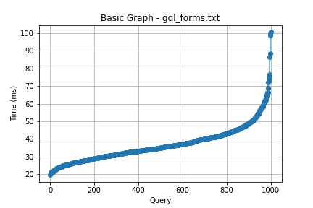

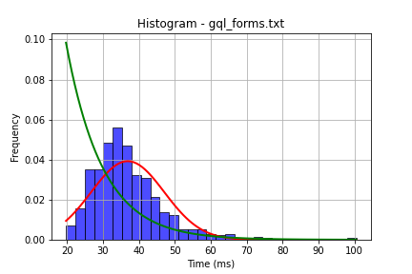

## File: gql_ug.txt

Number of queries: 1000

Mean: 39.31

Median: 36.7

Max: 114.91

Min: 18.38

Variance: 182.78

Standard Deviation: 13.52

90th Percentile: 56.09

Is normal: No

Shapiro-Wilk test p-value: 5.894779138001148e-26

Is exponential: No

Kolmogorov-Smirnov test p-value: 0.0

