# Statistics for Files in D:/Documents/Unob_7/STC/STC_code/DB_Performance/_Test/Performance/Test_v1/cockroach

## File: gql_event.txt

Number of queries: 100

Mean: 235.53

Median: 221.68

Max: 1084.03

Min: 97.77

Variance: 13622.0

Standard Deviation: 116.71

90th Percentile: 339.56

Is normal: No

Shapiro-Wilk test p-value: 5.967754502372857e-13

Is exponential: No

Kolmogorov-Smirnov test p-value: 2.0000000000001775e-200

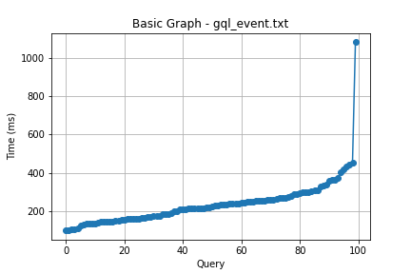

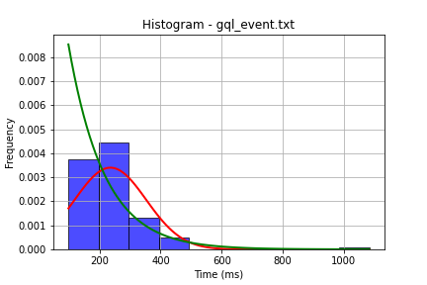

## File: gql_facilities.txt

Number of queries: 100

Mean: 234.19

Median: 219.5

Max: 945.28

Min: 77.57

Variance: 11982.0

Standard Deviation: 109.46

90th Percentile: 351.25

Is normal: No

Shapiro-Wilk test p-value: 1.279878286686298e-10

Is exponential: No

Kolmogorov-Smirnov test p-value: 2.0000000000001775e-200

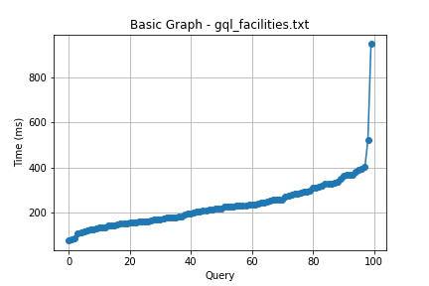

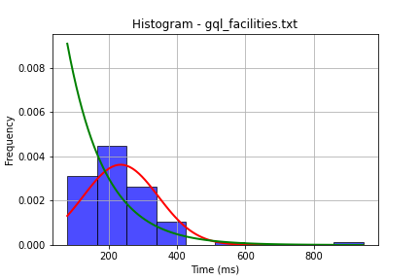

## File: gql_forms.txt

Number of queries: 100

Mean: 229.86

Median: 211.73

Max: 872.98

Min: 89.53

Variance: 9837.54

Standard Deviation: 99.18

90th Percentile: 331.07

Is normal: No

Shapiro-Wilk test p-value: 2.514440600176471e-10

Is exponential: No

Kolmogorov-Smirnov test p-value: 2.0000000000001775e-200

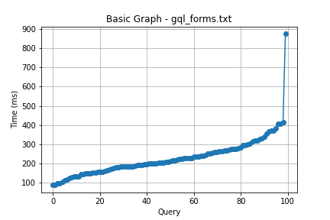

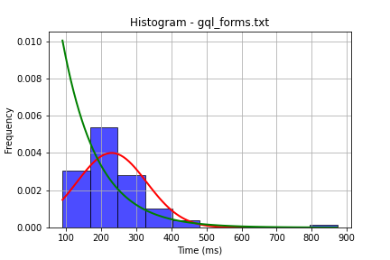

## File: gql_granting.txt

Number of queries: 100

Mean: 250.03

Median: 202.98

Max: 4055.67

Min: 41.27

Variance: 164814.0

Standard Deviation: 405.97

90th Percentile: 352.25

Is normal: No

Shapiro-Wilk test p-value: 7.592665639464952e-20

Is exponential: No

Kolmogorov-Smirnov test p-value: 2.0000000000001775e-200

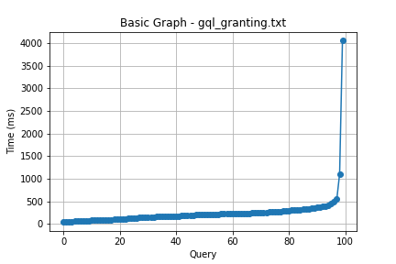

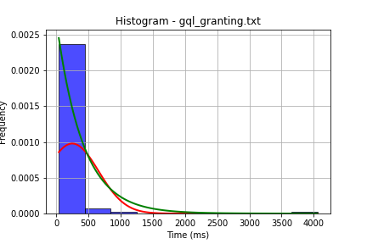

## File: gql_lessons.txt

Number of queries: 100

Mean: 226.04

Median: 204.32

Max: 1083.02

Min: 61.35

Variance: 14143.0

Standard Deviation: 118.92

90th Percentile: 335.91

Is normal: No

Shapiro-Wilk test p-value: 1.5297026069883285e-13

Is exponential: No

Kolmogorov-Smirnov test p-value: 2.0000000000001775e-200

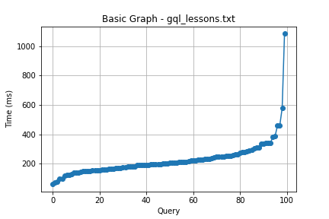

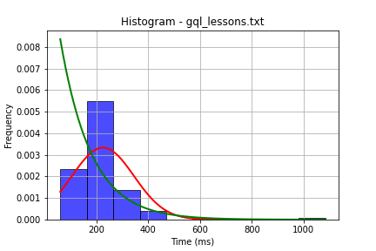

## File: gql_presences.txt

Number of queries: 100

Mean: 248.1

Median: 222.42

Max: 1338.67

Min: 43.57

Variance: 23525.65

Standard Deviation: 153.38

90th Percentile: 386.0

Is normal: No

Shapiro-Wilk test p-value: 4.119935729379742e-12

Is exponential: No

Kolmogorov-Smirnov test p-value: 2.0000000000001775e-200

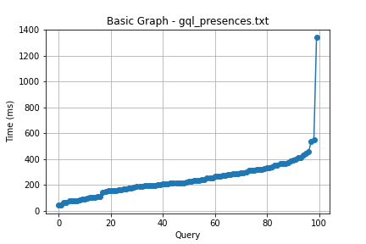

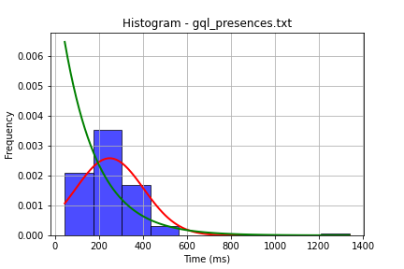

## File: gql_projects.txt

Number of queries: 100

Mean: 242.99

Median: 219.27

Max: 1320.89

Min: 49.53

Variance: 22336.36

Standard Deviation: 149.45

90th Percentile: 362.56

Is normal: No

Shapiro-Wilk test p-value: 1.0742927814694214e-12

Is exponential: No

Kolmogorov-Smirnov test p-value: 2.0000000000001775e-200

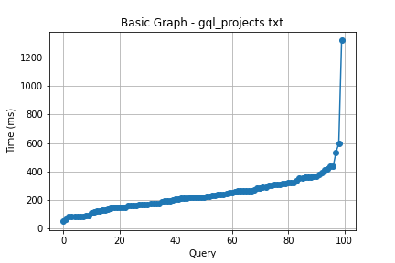

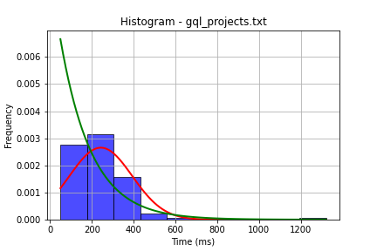

## File: gql_ug.txt

Number of queries: 100

Mean: 255.95

Median: 256.58

Max: 676.12

Min: 35.51

Variance: 20930.27

Standard Deviation: 144.67

90th Percentile: 433.78

Is normal: No

Shapiro-Wilk test p-value: 0.0013569509610533714

Is exponential: No

Kolmogorov-Smirnov test p-value: 2.0000000000001775e-200

