# Statistics for Files in D:/Documents/Unob_7/STC/STC_code/DB_Performance/_Test/Performance/Test_v1/postgres

## File: gql_event.txt

Number of queries: 100

Mean: 227.24

Median: 218.31

Max: 439.91

Min: 58.78

Variance: 5182.02

Standard Deviation: 71.99

90th Percentile: 316.92

Is normal: No

Shapiro-Wilk test p-value: 0.00024845494772307575

Is exponential: No

Kolmogorov-Smirnov test p-value: 2.0000000000001775e-200

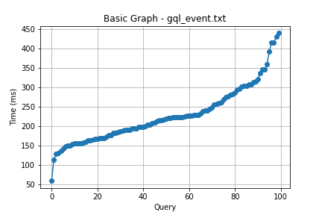

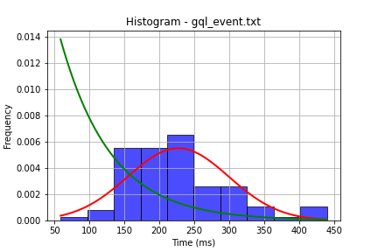

## File: gql_facilities.txt

Number of queries: 100

Mean: 213.52

Median: 207.07

Max: 564.45

Min: 69.25

Variance: 5852.89

Standard Deviation: 76.5

90th Percentile: 308.07

Is normal: No

Shapiro-Wilk test p-value: 1.6006416672098567e-06

Is exponential: No

Kolmogorov-Smirnov test p-value: 2.0000000000001775e-200

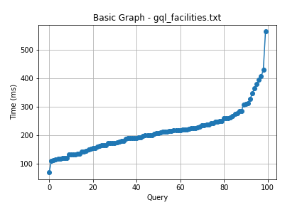

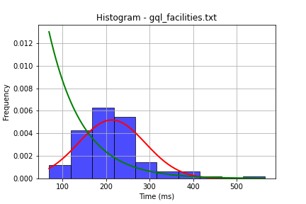

## File: gql_forms.txt

Number of queries: 100

Mean: 225.31

Median: 215.3

Max: 719.15

Min: 79.49

Variance: 7615.14

Standard Deviation: 87.26

90th Percentile: 303.4

Is normal: No

Shapiro-Wilk test p-value: 2.801006537822559e-09

Is exponential: No

Kolmogorov-Smirnov test p-value: 2.0000000000001775e-200

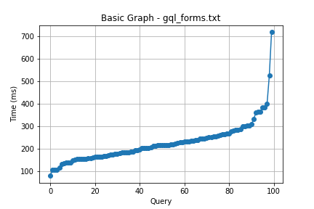

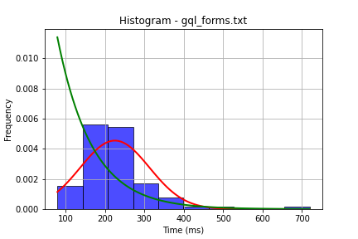

## File: gql_granting.txt

Number of queries: 100

Mean: 229.12

Median: 215.66

Max: 509.62

Min: 61.77

Variance: 7774.47

Standard Deviation: 88.17

90th Percentile: 352.28

Is normal: No

Shapiro-Wilk test p-value: 8.968172915047035e-05

Is exponential: No

Kolmogorov-Smirnov test p-value: 2.0000000000001775e-200

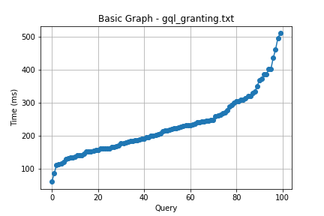

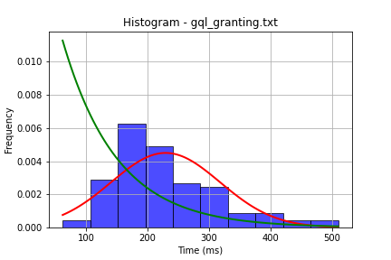

## File: gql_lessons.txt

Number of queries: 100

Mean: 222.02

Median: 207.51

Max: 650.97

Min: 64.29

Variance: 7251.48

Standard Deviation: 85.16

90th Percentile: 314.25

Is normal: No

Shapiro-Wilk test p-value: 2.070273239951348e-06

Is exponential: No

Kolmogorov-Smirnov test p-value: 2.0000000000001775e-200

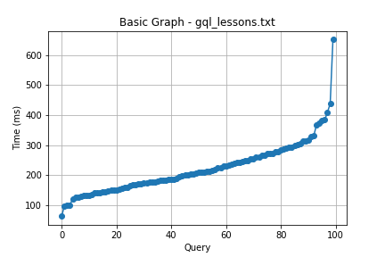

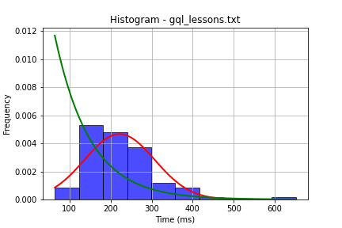

## File: gql_presences.txt

Number of queries: 100

Mean: 230.1

Median: 221.11

Max: 504.81

Min: 24.8

Variance: 9717.91

Standard Deviation: 98.58

90th Percentile: 350.35

Is normal: Yes

Shapiro-Wilk test p-value: 0.05958971753716469

Is exponential: No

Kolmogorov-Smirnov test p-value: 2.0000000000001775e-200

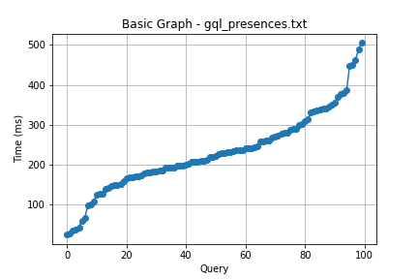

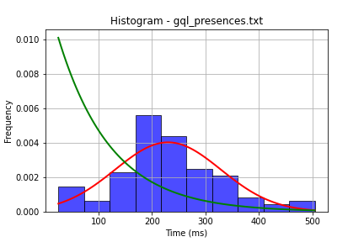

## File: gql_projects.txt

Number of queries: 100

Mean: 226.47

Median: 214.58

Max: 534.3

Min: 108.11

Variance: 4997.69

Standard Deviation: 70.69

90th Percentile: 306.65

Is normal: No

Shapiro-Wilk test p-value: 6.478730210801587e-05

Is exponential: No

Kolmogorov-Smirnov test p-value: 2.0000000000001775e-200

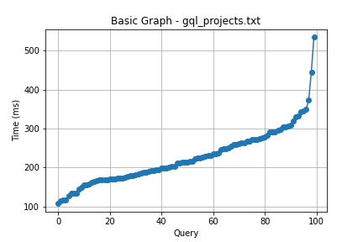

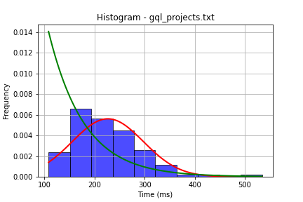

## File: gql_ug.txt

Number of queries: 100

Mean: 233.81

Median: 228.89

Max: 632.94

Min: 28.0

Variance: 11687.84

Standard Deviation: 108.11

90th Percentile: 366.74

Is normal: No

Shapiro-Wilk test p-value: 0.0027013069484382868

Is exponential: No

Kolmogorov-Smirnov test p-value: 2.0000000000001775e-200

