# Statistics for Files in D:/Documents/Unob_7/STC/STC_code/DB_Performance/_Test/Performance/Test_v1/yugabyte

## File: gql_event.txt

Number of queries: 5

Mean: 774.34

Median: 202.35

Max: 2527.8

Min: 159.43

Variance: 831160.77

Standard Deviation: 911.68

90th Percentile: 1844.38

Is normal: No

Shapiro-Wilk test p-value: 0.016147518530488014

Is exponential: No

Kolmogorov-Smirnov test p-value: 0.0006399999999999993

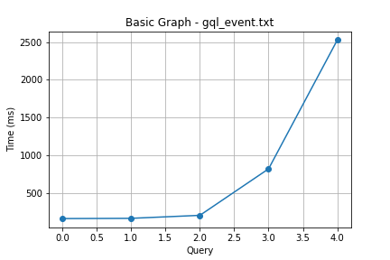

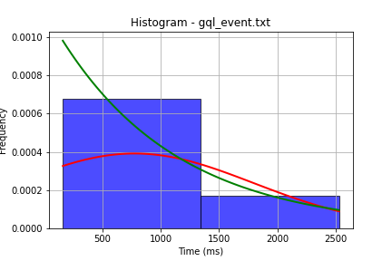

## File: gql_facilities.txt

Number of queries: 5

Mean: 139.3

Median: 41.96

Max: 492.44

Min: 23.43

Variance: 32039.99

Standard Deviation: 179.0

90th Percentile: 338.16

Is normal: No

Shapiro-Wilk test p-value: 0.00568419648334384

Is exponential: No

Kolmogorov-Smirnov test p-value: 0.0006399999999999993

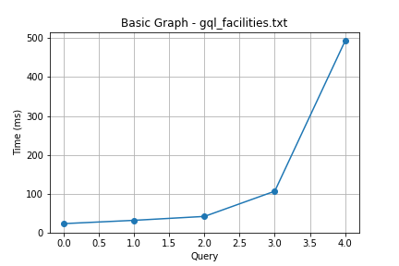

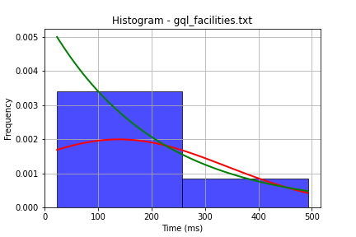

## File: gql_forms.txt

Number of queries: 5

Mean: 756.77

Median: 330.88

Max: 1964.19

Min: 156.45

Variance: 462933.24

Standard Deviation: 680.39

90th Percentile: 1599.54

Is normal: Yes

Shapiro-Wilk test p-value: 0.14484335482120514

Is exponential: No

Kolmogorov-Smirnov test p-value: 0.0006399999999999993

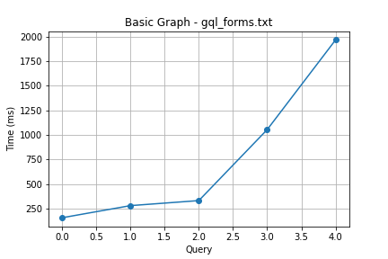

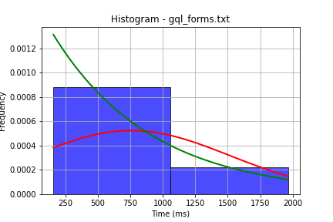

## File: gql_granting.txt

Number of queries: 5

Mean: 800.37

Median: 285.09

Max: 1960.87

Min: 41.84

Variance: 597155.62

Standard Deviation: 772.76

90th Percentile: 1771.0

Is normal: Yes

Shapiro-Wilk test p-value: 0.15215249359607697

Is exponential: No

Kolmogorov-Smirnov test p-value: 0.0006399999999999993

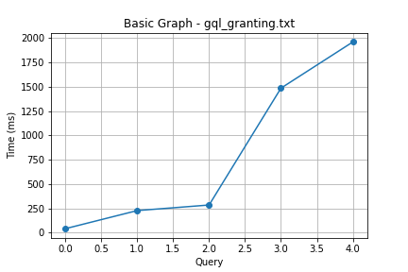

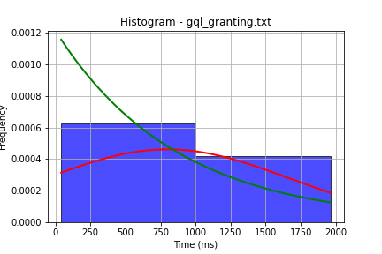

## File: gql_lessons.txt

Number of queries: 5

Mean: 790.48

Median: 253.6

Max: 1977.85

Min: 147.86

Variance: 575459.46

Standard Deviation: 758.59

90th Percentile: 1748.92

Is normal: Yes

Shapiro-Wilk test p-value: 0.07770867645740509

Is exponential: No

Kolmogorov-Smirnov test p-value: 0.0006399999999999993

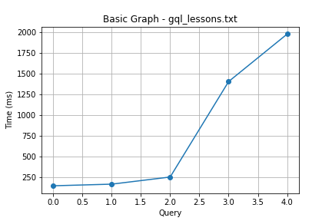

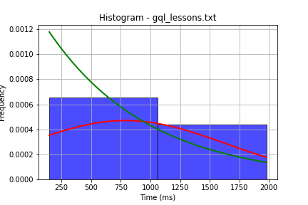

## File: gql_presences.txt

Number of queries: 5

Mean: 797.93

Median: 315.1

Max: 1709.98

Min: 86.31

Variance: 535059.41

Standard Deviation: 731.48

90th Percentile: 1693.4

Is normal: No

Shapiro-Wilk test p-value: 0.0413295179605484

Is exponential: No

Kolmogorov-Smirnov test p-value: 0.0006399999999999993

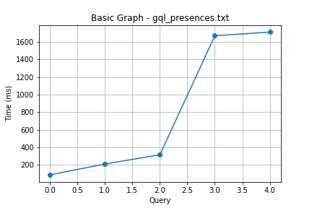

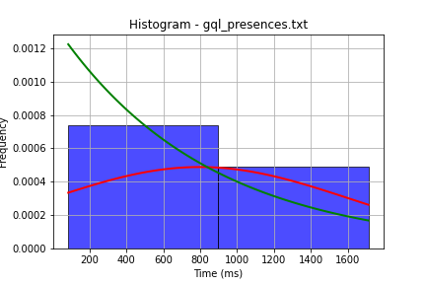

## File: gql_projects.txt

Number of queries: 5

Mean: 784.85

Median: 221.62

Max: 2027.67

Min: 110.93

Variance: 595616.38

Standard Deviation: 771.76

90th Percentile: 1759.55

Is normal: Yes

Shapiro-Wilk test p-value: 0.09482885897159576

Is exponential: No

Kolmogorov-Smirnov test p-value: 0.0006399999999999993

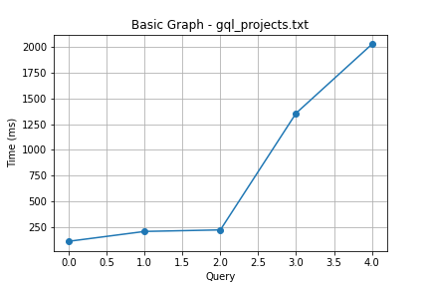

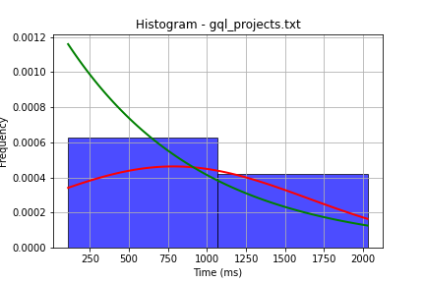

## File: gql_ug.txt

Number of queries: 5

Mean: 781.47

Median: 419.64

Max: 1806.15

Min: 187.09

Variance: 421809.76

Standard Deviation: 649.47

90th Percentile: 1596.6

Is normal: Yes

Shapiro-Wilk test p-value: 0.17695872485637665

Is exponential: No

Kolmogorov-Smirnov test p-value: 0.0006399999999999993

