# Statistics for Files in D:/Documents/Unob_7/STC/STC_code/DB_Performance/_Test/Performance/Test_v2/cockroach

## File: gql_event.txt

Number of queries: 100

Mean: 37.43

Median: 31.31

Max: 281.82

Min: 22.73

Variance: 798.95

Standard Deviation: 28.27

90th Percentile: 46.25

Is normal: No

Shapiro-Wilk test p-value: 8.447078976487786e-19

Is exponential: No

Kolmogorov-Smirnov test p-value: 5.073619863360421e-197

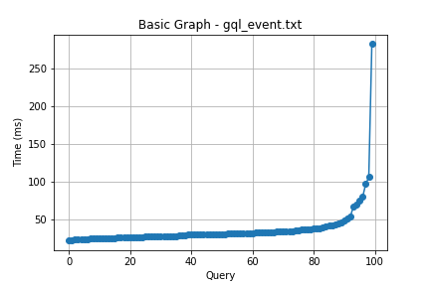

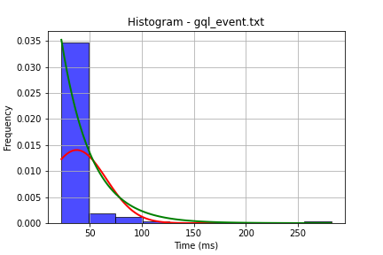

## File: gql_facilities.txt

Number of queries: 100

Mean: 36.64

Median: 29.62

Max: 375.25

Min: 22.42

Variance: 1274.92

Standard Deviation: 35.71

90th Percentile: 45.16

Is normal: No

Shapiro-Wilk test p-value: 3.881975739934978e-20

Is exponential: No

Kolmogorov-Smirnov test p-value: 2.0000016328213807e-200

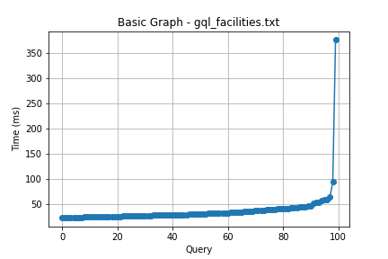

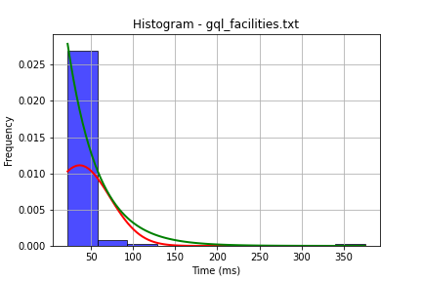

## File: gql_forms.txt

Number of queries: 100

Mean: 36.55

Median: 28.95

Max: 296.58

Min: 20.0

Variance: 995.93

Standard Deviation: 31.56

90th Percentile: 45.51

Is normal: No

Shapiro-Wilk test p-value: 7.640250625918743e-19

Is exponential: No

Kolmogorov-Smirnov test p-value: 2.0000000000001775e-200

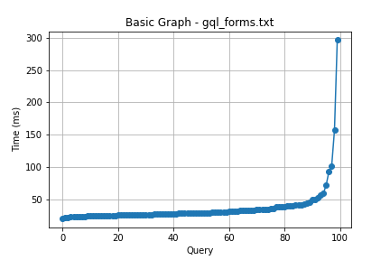

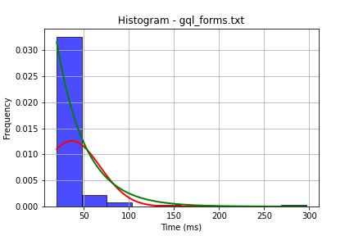

## File: gql_granting.txt

Number of queries: 100

Mean: 45.71

Median: 27.71

Max: 1179.47

Min: 21.0

Variance: 14804.95

Standard Deviation: 121.68

90th Percentile: 44.45

Is normal: No

Shapiro-Wilk test p-value: 2.0219452643642756e-21

Is exponential: No

Kolmogorov-Smirnov test p-value: 2.535301240759685e-170

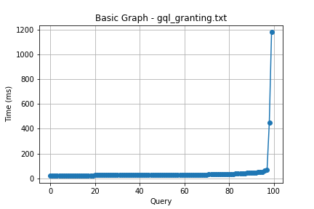

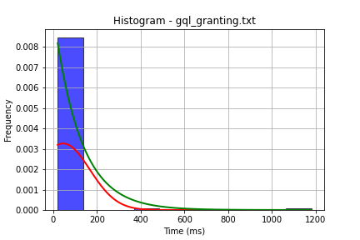

## File: gql_lessons.txt

Number of queries: 100

Mean: 36.49

Median: 27.26

Max: 494.74

Min: 20.01

Variance: 2339.68

Standard Deviation: 48.37

90th Percentile: 41.06

Is normal: No

Shapiro-Wilk test p-value: 1.4889099160763912e-20

Is exponential: No

Kolmogorov-Smirnov test p-value: 2.0001790672365393e-200

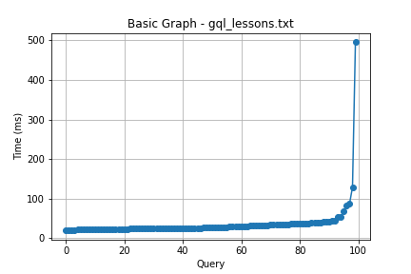

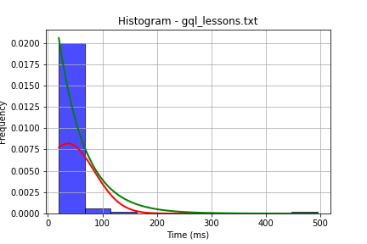

## File: gql_presences.txt

Number of queries: 100

Mean: 40.28

Median: 31.35

Max: 572.29

Min: 21.37

Variance: 3047.42

Standard Deviation: 55.2

90th Percentile: 54.67

Is normal: No

Shapiro-Wilk test p-value: 1.15269338959562e-20

Is exponential: No

Kolmogorov-Smirnov test p-value: 2.0000000000024e-200

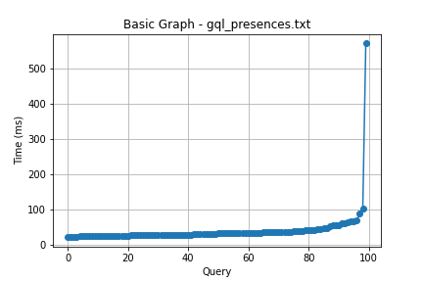

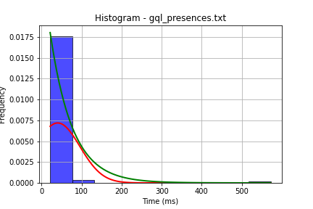

## File: gql_projects.txt

Number of queries: 100

Mean: 34.6

Median: 26.1

Max: 523.44

Min: 19.09

Variance: 2554.83

Standard Deviation: 50.55

90th Percentile: 43.11

Is normal: No

Shapiro-Wilk test p-value: 6.818898114704262e-21

Is exponential: No

Kolmogorov-Smirnov test p-value: 2.0000000000001775e-200

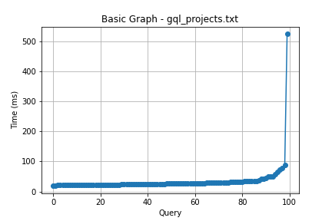

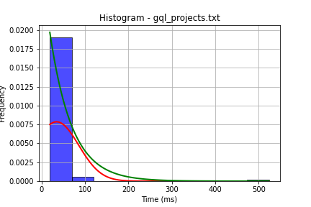

## File: gql_ug.txt

Number of queries: 100

Mean: 102.33

Median: 52.55

Max: 2009.99

Min: 32.89

Variance: 68300.62

Standard Deviation: 261.34

90th Percentile: 116.53

Is normal: No

Shapiro-Wilk test p-value: 8.158829732844299e-21

Is exponential: No

Kolmogorov-Smirnov test p-value: 3.662780076980261e-200

