# Statistics for Files in D:/Documents/Unob_7/STC/STC_code/DB_Performance/_Test/Performance/Test_v2/yugabyte

## File: gql_event.txt

Number of queries: 100

Mean: 40.09

Median: 36.46

Max: 99.28

Min: 25.46

Variance: 162.15

Standard Deviation: 12.73

90th Percentile: 56.01

Is normal: No

Shapiro-Wilk test p-value: 1.3691282829686457e-10

Is exponential: No

Kolmogorov-Smirnov test p-value: 2.000000000697405e-200

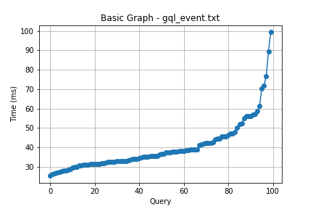

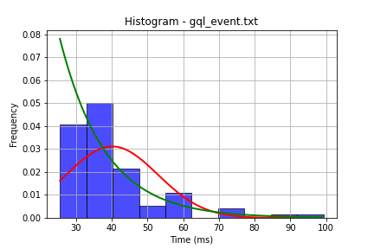

## File: gql_facilities.txt

Number of queries: 100

Mean: 21.49

Median: 19.32

Max: 169.49

Min: 9.48

Variance: 250.45

Standard Deviation: 15.83

90th Percentile: 26.85

Is normal: No

Shapiro-Wilk test p-value: 2.0743073804142735e-19

Is exponential: No

Kolmogorov-Smirnov test p-value: 2.3308089914126523e-200

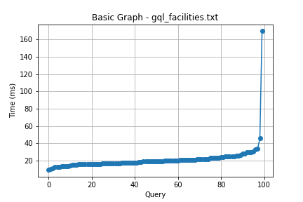

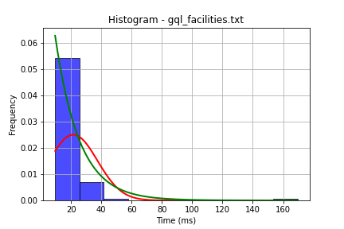

## File: gql_forms.txt

Number of queries: 100

Mean: 50.16

Median: 44.93

Max: 148.96

Min: 25.45

Variance: 415.27

Standard Deviation: 20.38

90th Percentile: 71.2

Is normal: No

Shapiro-Wilk test p-value: 4.942203313262894e-10

Is exponential: No

Kolmogorov-Smirnov test p-value: 2.0000000000001775e-200

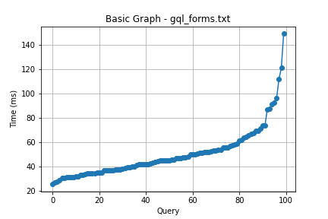

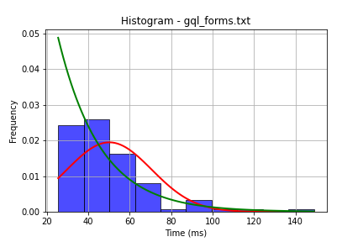

## File: gql_granting.txt

Number of queries: 100

Mean: 44.21

Median: 37.82

Max: 174.29

Min: 24.19

Variance: 470.37

Standard Deviation: 21.69

90th Percentile: 72.95

Is normal: No

Shapiro-Wilk test p-value: 5.545477271828858e-13

Is exponential: No

Kolmogorov-Smirnov test p-value: 2.0004481239233402e-200

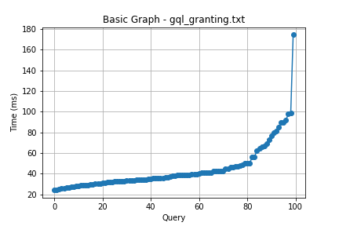

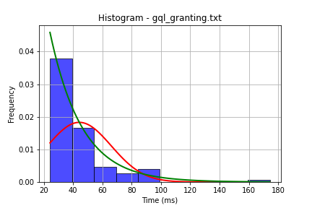

## File: gql_lessons.txt

Number of queries: 100

Mean: 41.39

Median: 37.19

Max: 111.38

Min: 24.19

Variance: 254.32

Standard Deviation: 15.95

90th Percentile: 57.53

Is normal: No

Shapiro-Wilk test p-value: 6.198214164143678e-11

Is exponential: No

Kolmogorov-Smirnov test p-value: 2.0000000000268275e-200

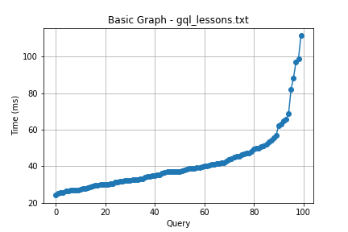

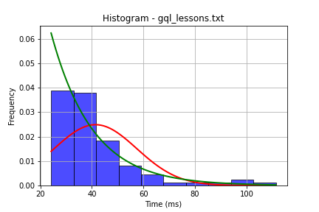

## File: gql_presences.txt

Number of queries: 100

Mean: 38.35

Median: 35.95

Max: 113.93

Min: 23.44

Variance: 180.15

Standard Deviation: 13.42

90th Percentile: 49.25

Is normal: No

Shapiro-Wilk test p-value: 2.88967222546177e-12

Is exponential: No

Kolmogorov-Smirnov test p-value: 2.3014719561034878e-200

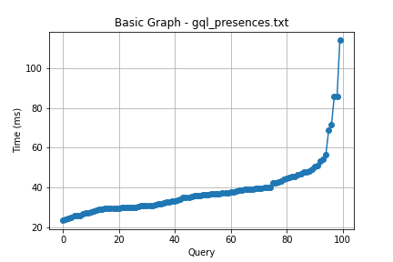

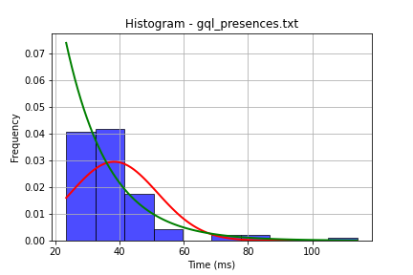

## File: gql_projects.txt

Number of queries: 100

Mean: 35.55

Median: 31.16

Max: 98.56

Min: 20.01

Variance: 186.31

Standard Deviation: 13.65

90th Percentile: 49.99

Is normal: No

Shapiro-Wilk test p-value: 4.6063086678316267e-10

Is exponential: No

Kolmogorov-Smirnov test p-value: 2.535301200456691e-170

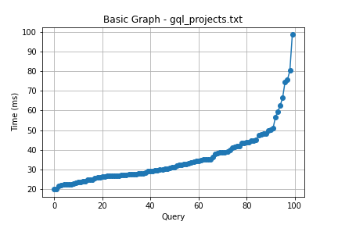

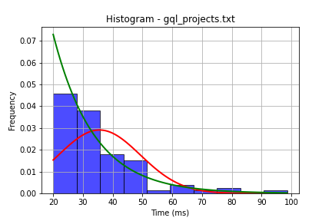

## File: gql_ug.txt

Number of queries: 100

Mean: 114.33

Median: 107.37

Max: 253.1

Min: 33.28

Variance: 1807.52

Standard Deviation: 42.51

90th Percentile: 169.76

Is normal: No

Shapiro-Wilk test p-value: 0.007193550933152437

Is exponential: No

Kolmogorov-Smirnov test p-value: 2.0000000000001775e-200

