# Statistics for Files in D:/Documents/Unob_7/STC/STC_code/DB_Performance/_Test/Performance/Test_v3/cockroach

## File: groupById_1.txt

Number of queries: 100

Mean: 192.43

Median: 193.46

Max: 387.83

Min: 82.39

Variance: 4134.66

Standard Deviation: 64.3

90th Percentile: 282.29

Is normal: No

Shapiro-Wilk test p-value: 0.005285901948809624

Is exponential: No

Kolmogorov-Smirnov test p-value: 2.0000000000001775e-200

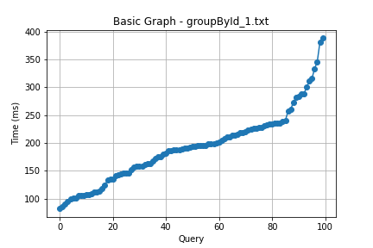

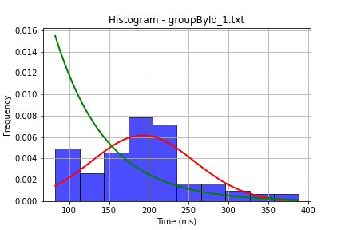

## File: groupById_2.txt

Number of queries: 100

Mean: 197.14

Median: 197.4

Max: 405.63

Min: 55.0

Variance: 5636.12

Standard Deviation: 75.07

90th Percentile: 299.94

Is normal: Yes

Shapiro-Wilk test p-value: 0.1287468671798706

Is exponential: No

Kolmogorov-Smirnov test p-value: 2.0000000000001775e-200

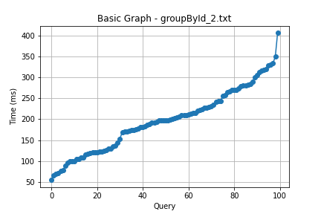

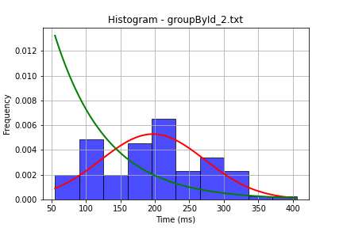

## File: userById_1.txt

Number of queries: 100

Mean: 187.6

Median: 176.59

Max: 388.98

Min: 80.21

Variance: 3372.44

Standard Deviation: 58.07

90th Percentile: 264.39

Is normal: No

Shapiro-Wilk test p-value: 0.0010849597165361047

Is exponential: No

Kolmogorov-Smirnov test p-value: 2.0000000000001775e-200

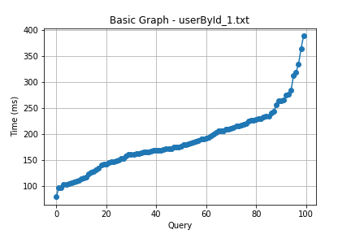

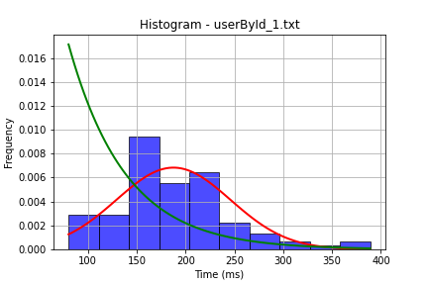

## File: userById_2.txt

Number of queries: 100

Mean: 152.26

Median: 141.84

Max: 304.1

Min: 72.0

Variance: 1845.32

Standard Deviation: 42.96

90th Percentile: 211.74

Is normal: No

Shapiro-Wilk test p-value: 6.104625936131924e-05

Is exponential: No

Kolmogorov-Smirnov test p-value: 2.0000000000001775e-200

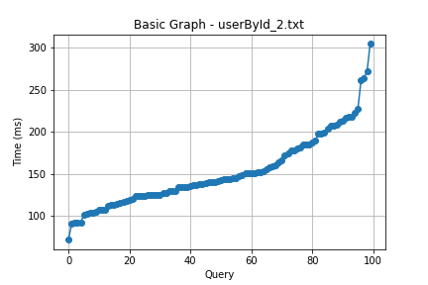

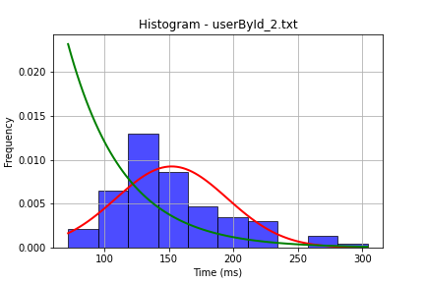

## File: user_insert.txt

Number of queries: 100

Mean: 154.26

Median: 142.64

Max: 329.86

Min: 100.8

Variance: 1777.89

Standard Deviation: 42.17

90th Percentile: 205.67

Is normal: No

Shapiro-Wilk test p-value: 1.8928913902982458e-07

Is exponential: No

Kolmogorov-Smirnov test p-value: 2.0000000000001775e-200

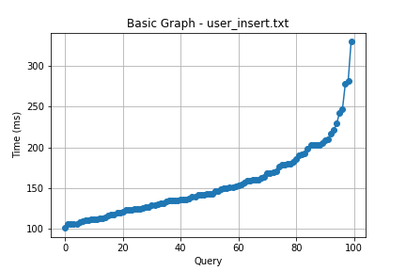

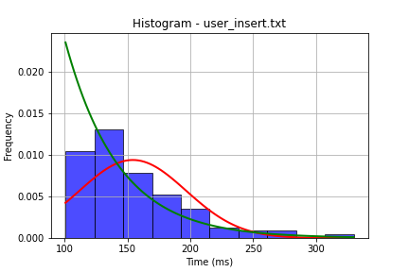

## File: user_update.txt

Number of queries: 100

Mean: 198.55

Median: 200.51

Max: 394.77

Min: 38.0

Variance: 6103.86

Standard Deviation: 78.13

90th Percentile: 294.29

Is normal: Yes

Shapiro-Wilk test p-value: 0.40755873918533325

Is exponential: No

Kolmogorov-Smirnov test p-value: 2.0000000000001775e-200

