# Statistics for Files in D:/Documents/Unob_7/STC/STC_code/DB_Performance/_Test/Performance/Test_v3/postgres

## File: groupById_1.txt

Number of queries: 100

Mean: 215.56

Median: 211.07

Max: 390.46

Min: 67.19

Variance: 7292.84

Standard Deviation: 85.4

90th Percentile: 328.76

Is normal: No

Shapiro-Wilk test p-value: 0.0017252671532332897

Is exponential: No

Kolmogorov-Smirnov test p-value: 2.0000000000001775e-200

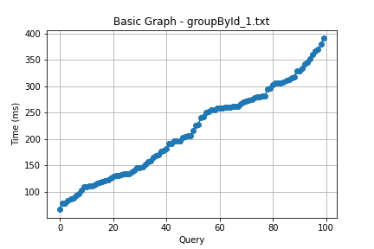

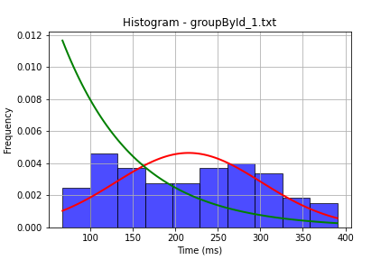

## File: groupById_2.txt

Number of queries: 100

Mean: 221.61

Median: 234.38

Max: 502.6

Min: 35.22

Variance: 11526.2

Standard Deviation: 107.36

90th Percentile: 347.97

Is normal: No

Shapiro-Wilk test p-value: 0.009611605666577816

Is exponential: No

Kolmogorov-Smirnov test p-value: 2.0000000000001775e-200

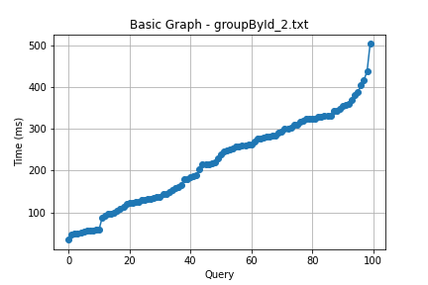

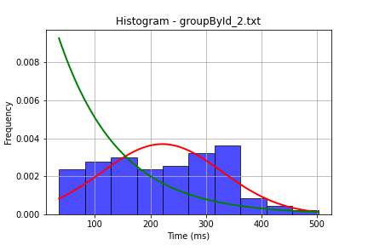

## File: userById_1.txt

Number of queries: 100

Mean: 216.13

Median: 208.0

Max: 514.32

Min: 51.88

Variance: 8897.29

Standard Deviation: 94.33

90th Percentile: 323.17

Is normal: No

Shapiro-Wilk test p-value: 0.003023313358426094

Is exponential: No

Kolmogorov-Smirnov test p-value: 2.0000000000001775e-200

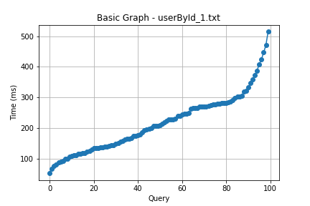

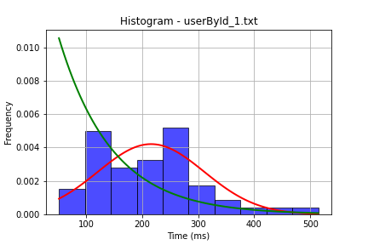

## File: userById_2.txt

Number of queries: 100

Mean: 184.61

Median: 181.46

Max: 372.56

Min: 78.39

Variance: 5023.38

Standard Deviation: 70.88

90th Percentile: 268.07

Is normal: No

Shapiro-Wilk test p-value: 0.0014550522901117802

Is exponential: No

Kolmogorov-Smirnov test p-value: 2.0000000000001775e-200

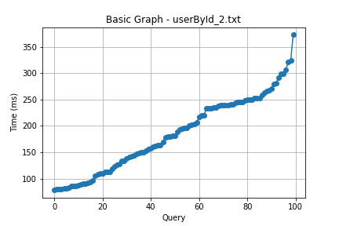

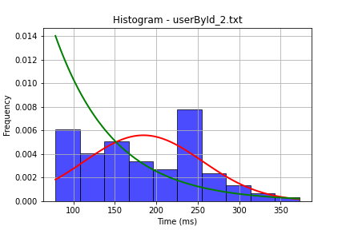

## File: user_insert.txt

Number of queries: 100

Mean: 172.53

Median: 179.24

Max: 328.26

Min: 55.96

Variance: 5140.68

Standard Deviation: 71.7

90th Percentile: 257.86

Is normal: No

Shapiro-Wilk test p-value: 0.0009811510099098086

Is exponential: No

Kolmogorov-Smirnov test p-value: 2.0000000000001775e-200

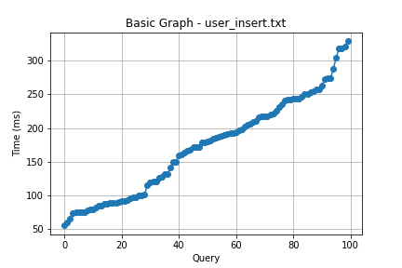

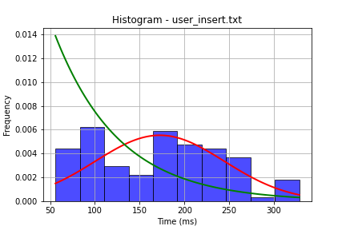

## File: user_update.txt

Number of queries: 100

Mean: 221.2

Median: 230.55

Max: 454.88

Min: 48.47

Variance: 10979.11

Standard Deviation: 104.78

90th Percentile: 356.32

Is normal: No

Shapiro-Wilk test p-value: 0.002960105426609516

Is exponential: No

Kolmogorov-Smirnov test p-value: 2.0000000000001775e-200

