# Statistics for Files in D:/Documents/Unob_7/STC/STC_code/DB_Performance_0/_Test/Performance/Test_v3/postgres_duplica

## File: groupById_1.txt

Number of queries: 100

Mean: 300.17

Median: 298.22

Max: 741.51

Min: 70.21

Variance: 22295.76

Standard Deviation: 149.32

90th Percentile: 509.88

Is normal: No

Shapiro-Wilk test p-value: 0.0011683477787300944

Is exponential: No

Kolmogorov-Smirnov test p-value: 2.0000000000001775e-200

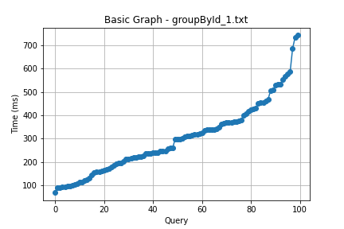

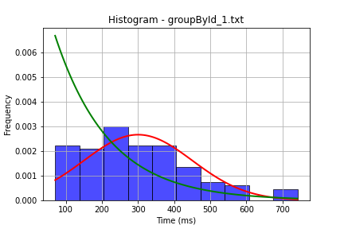

## File: groupById_2.txt

Number of queries: 100

Mean: 305.98

Median: 272.14

Max: 951.05

Min: 48.42

Variance: 30207.79

Standard Deviation: 173.8

90th Percentile: 553.03

Is normal: No

Shapiro-Wilk test p-value: 0.0004688117769546807

Is exponential: No

Kolmogorov-Smirnov test p-value: 2.0000000000001775e-200

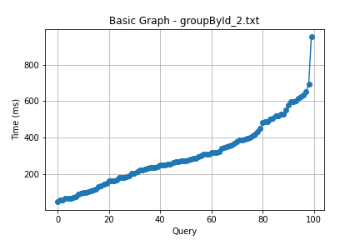

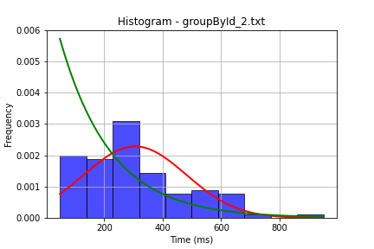

## File: userById_1.txt

Number of queries: 100

Mean: 298.72

Median: 268.07

Max: 741.41

Min: 88.71

Variance: 21717.44

Standard Deviation: 147.37

90th Percentile: 513.5

Is normal: No

Shapiro-Wilk test p-value: 0.000274637684924528

Is exponential: No

Kolmogorov-Smirnov test p-value: 2.0000000000001775e-200

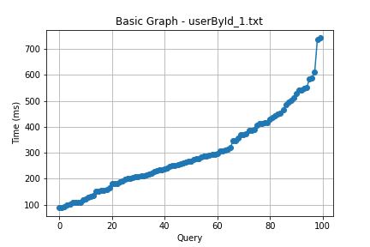

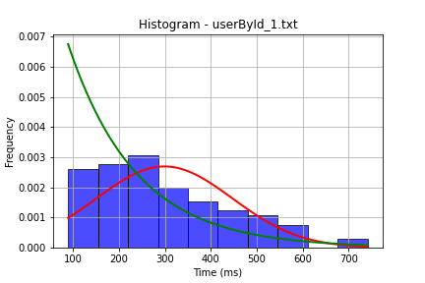

## File: userById_2.txt

Number of queries: 100

Mean: 263.88

Median: 245.31

Max: 659.95

Min: 70.14

Variance: 15380.08

Standard Deviation: 124.02

90th Percentile: 427.85

Is normal: No

Shapiro-Wilk test p-value: 2.5168099455186166e-05

Is exponential: No

Kolmogorov-Smirnov test p-value: 2.0000000000001775e-200

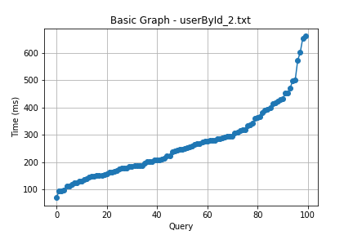

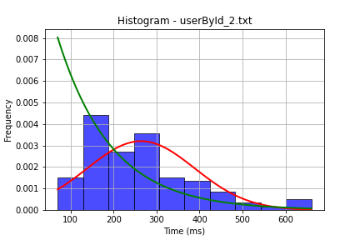

## File: user_insert.txt

Number of queries: 100

Mean: 242.05

Median: 217.21

Max: 674.49

Min: 64.31

Variance: 13904.56

Standard Deviation: 117.92

90th Percentile: 388.76

Is normal: No

Shapiro-Wilk test p-value: 2.2898788643033186e-07

Is exponential: No

Kolmogorov-Smirnov test p-value: 2.0000000000001775e-200

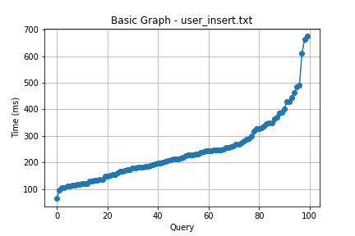

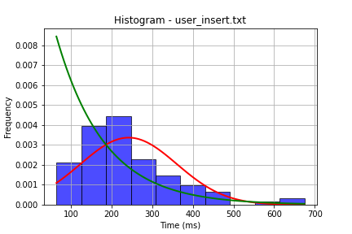

## File: user_update.txt

Number of queries: 100

Mean: 306.41

Median: 287.91

Max: 757.67

Min: 24.02

Variance: 29179.12

Standard Deviation: 170.82

90th Percentile: 537.77

Is normal: No

Shapiro-Wilk test p-value: 0.0066750794649124146

Is exponential: No

Kolmogorov-Smirnov test p-value: 2.0000000000001775e-200

