# Statistics for Files in D:/Documents/Unob_7/STC/STC_code/DB_Performance/_Test/Performance/Test_v3/postgres_ha

## File: groupById_1.txt

Number of queries: 100

Mean: 119.23

Median: 114.65

Max: 230.62

Min: 52.96

Variance: 1768.07

Standard Deviation: 42.05

90th Percentile: 182.95

Is normal: No

Shapiro-Wilk test p-value: 0.0025880769826471806

Is exponential: No

Kolmogorov-Smirnov test p-value: 2.0000000000001775e-200

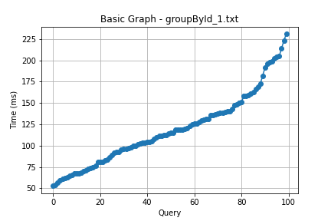

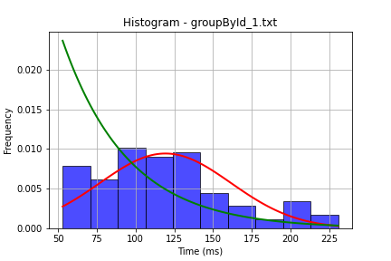

## File: groupById_2.txt

Number of queries: 100

Mean: 126.48

Median: 123.95

Max: 241.86

Min: 51.69

Variance: 2086.55

Standard Deviation: 45.68

90th Percentile: 177.08

Is normal: No

Shapiro-Wilk test p-value: 0.016409875825047493

Is exponential: No

Kolmogorov-Smirnov test p-value: 2.0000000000001775e-200

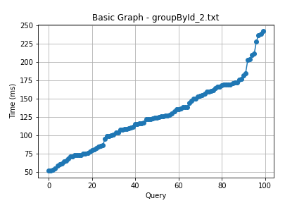

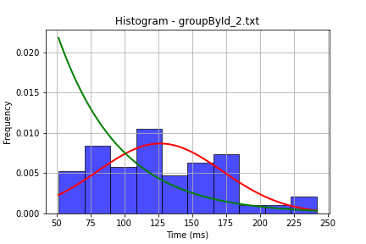

## File: userById_1.txt

Number of queries: 100

Mean: 116.11

Median: 110.88

Max: 235.98

Min: 49.52

Variance: 1453.02

Standard Deviation: 38.12

90th Percentile: 170.75

Is normal: No

Shapiro-Wilk test p-value: 0.0017206576885655522

Is exponential: No

Kolmogorov-Smirnov test p-value: 2.0000000000001775e-200

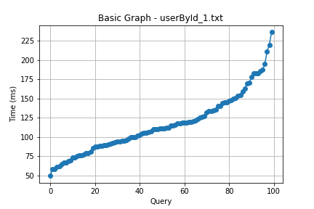

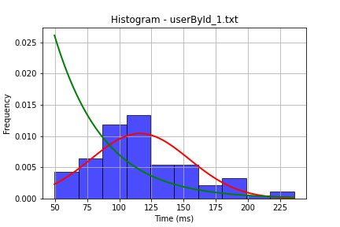

## File: userById_2.txt

Number of queries: 100

Mean: 99.21

Median: 92.26

Max: 198.0

Min: 49.05

Variance: 768.56

Standard Deviation: 27.72

90th Percentile: 139.91

Is normal: No

Shapiro-Wilk test p-value: 2.5852236831269693e-06

Is exponential: No

Kolmogorov-Smirnov test p-value: 2.0000000000001775e-200

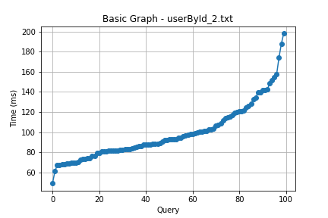

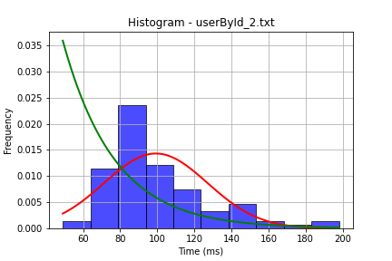

## File: user_insert.txt

Number of queries: 100

Mean: 99.94

Median: 92.16

Max: 197.99

Min: 56.59

Variance: 780.47

Standard Deviation: 27.94

90th Percentile: 133.74

Is normal: No

Shapiro-Wilk test p-value: 1.0367793038312811e-05

Is exponential: No

Kolmogorov-Smirnov test p-value: 2.0000000000001775e-200

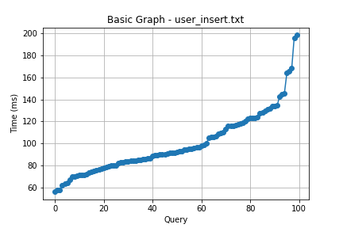

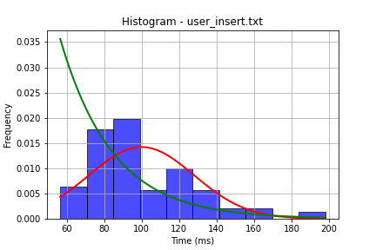

## File: user_update.txt

Number of queries: 100

Mean: 126.89

Median: 123.74

Max: 248.9

Min: 35.02

Variance: 2092.37

Standard Deviation: 45.74

90th Percentile: 199.92

Is normal: No

Shapiro-Wilk test p-value: 0.028572741895914078

Is exponential: No

Kolmogorov-Smirnov test p-value: 2.0000000000001775e-200

