# Statistics for Files in D:/Documents/Unob_7/STC/STC_code/DB_Performance/_Test/Performance/Test_v3/postgres_replica

## File: groupById_1.txt

Number of queries: 100

Mean: 185.52

Median: 177.15

Max: 367.82

Min: 42.4

Variance: 7344.41

Standard Deviation: 85.7

90th Percentile: 310.17

Is normal: No

Shapiro-Wilk test p-value: 0.022201454266905785

Is exponential: No

Kolmogorov-Smirnov test p-value: 2.0000000000001775e-200

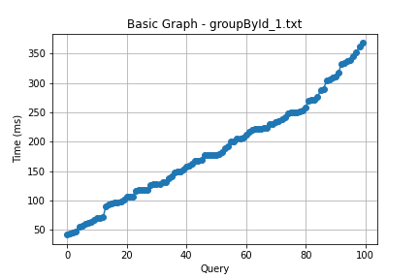

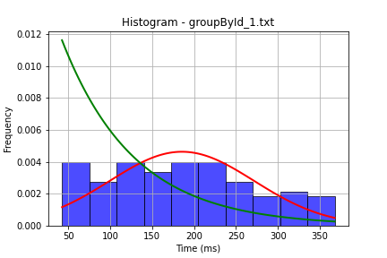

## File: groupById_2.txt

Number of queries: 100

Mean: 190.74

Median: 196.56

Max: 366.38

Min: 39.97

Variance: 7511.23

Standard Deviation: 86.67

90th Percentile: 303.03

Is normal: No

Shapiro-Wilk test p-value: 0.023969125002622604

Is exponential: No

Kolmogorov-Smirnov test p-value: 4.670326896634834e-170

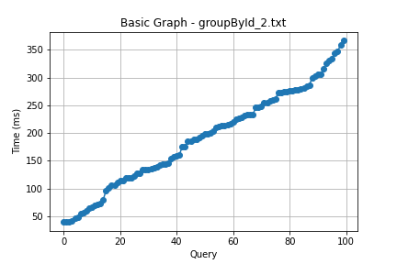

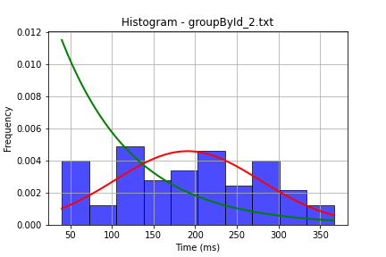

## File: userById_1.txt

Number of queries: 100

Mean: 184.05

Median: 173.94

Max: 388.12

Min: 51.0

Variance: 6633.63

Standard Deviation: 81.45

90th Percentile: 298.99

Is normal: No

Shapiro-Wilk test p-value: 0.007535471580922604

Is exponential: No

Kolmogorov-Smirnov test p-value: 2.0000000000001775e-200

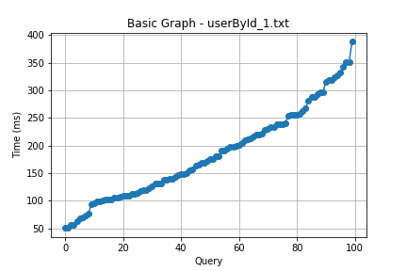

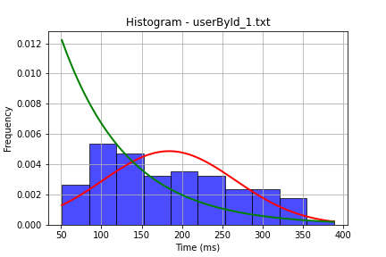

## File: userById_2.txt

Number of queries: 100

Mean: 159.73

Median: 154.48

Max: 335.58

Min: 60.0

Variance: 4128.0

Standard Deviation: 64.25

90th Percentile: 237.77

Is normal: No

Shapiro-Wilk test p-value: 0.006363541819155216

Is exponential: No

Kolmogorov-Smirnov test p-value: 2.535301200456691e-170

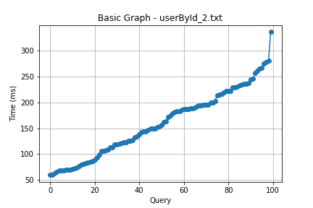

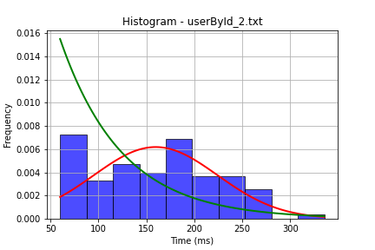

## File: user_insert.txt

Number of queries: 100

Mean: 151.88

Median: 143.47

Max: 337.0

Min: 48.03

Variance: 4011.96

Standard Deviation: 63.34

90th Percentile: 232.21

Is normal: No

Shapiro-Wilk test p-value: 0.01344379223883152

Is exponential: No

Kolmogorov-Smirnov test p-value: 2.0000000000001775e-200

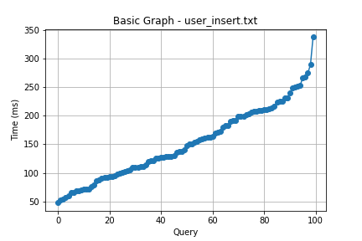

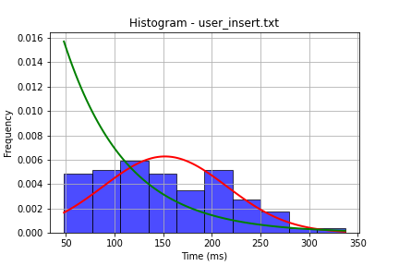

## File: user_update.txt

Number of queries: 100

Mean: 191.42

Median: 191.92

Max: 499.4

Min: 21.7

Variance: 9998.91

Standard Deviation: 99.99

90th Percentile: 310.14

Is normal: No

Shapiro-Wilk test p-value: 0.02343244105577469

Is exponential: No

Kolmogorov-Smirnov test p-value: 2.0000000000001775e-200

