# Statistics for Files in D:/Documents/Unob_7/STC/STC_code/DB_Performance/_Test/Performance/Test_v3/yugabyte

## File: groupById_1.txt

Number of queries: 100

Mean: 564.69

Median: 444.22

Max: 7679.02

Min: 99.46

Variance: 640183.48

Standard Deviation: 800.11

90th Percentile: 823.29

Is normal: No

Shapiro-Wilk test p-value: 7.872481065905123e-19

Is exponential: No

Kolmogorov-Smirnov test p-value: 2.0000000000001775e-200

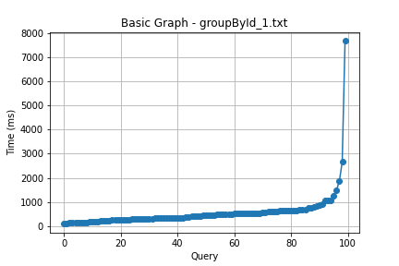

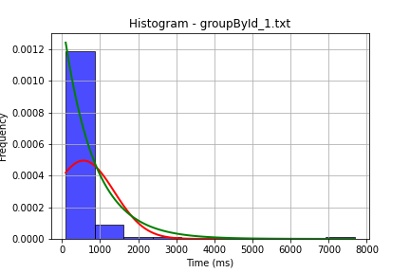

## File: groupById_2.txt

Number of queries: 100

Mean: 820.5

Median: 277.31

Max: 10911.63

Min: 94.56

Variance: 2310219.37

Standard Deviation: 1519.94

90th Percentile: 1986.54

Is normal: No

Shapiro-Wilk test p-value: 2.503146140897743e-17

Is exponential: No

Kolmogorov-Smirnov test p-value: 2.0000000000001775e-200

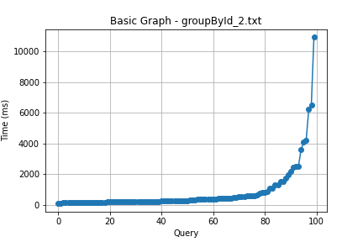

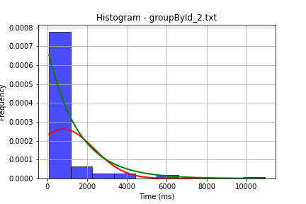

## File: userById_1.txt

Number of queries: 100

Mean: 551.53

Median: 366.78

Max: 3064.07

Min: 183.95

Variance: 272886.75

Standard Deviation: 522.39

90th Percentile: 1002.31

Is normal: No

Shapiro-Wilk test p-value: 3.4560780191888628e-15

Is exponential: No

Kolmogorov-Smirnov test p-value: 2.0000000000001775e-200

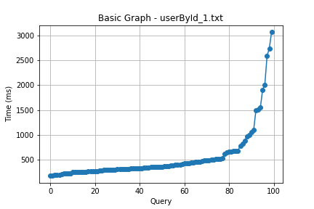

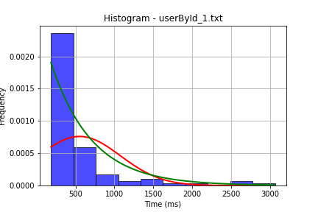

## File: userById_2.txt

Number of queries: 100

Mean: 693.64

Median: 172.98

Max: 11473.72

Min: 52.66

Variance: 2818127.16

Standard Deviation: 1678.73

90th Percentile: 1468.1

Is normal: No

Shapiro-Wilk test p-value: 1.739784787349866e-18

Is exponential: No

Kolmogorov-Smirnov test p-value: 2.0000000000001775e-200

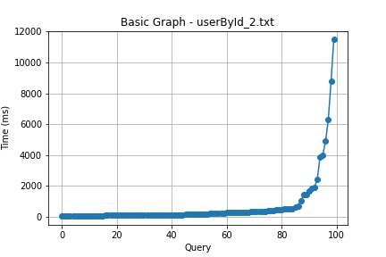

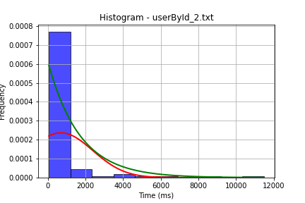

## File: user_insert.txt

Number of queries: 100

Mean: 433.28

Median: 353.88

Max: 1469.61

Min: 164.58

Variance: 74601.68

Standard Deviation: 273.13

90th Percentile: 829.01

Is normal: No

Shapiro-Wilk test p-value: 1.7027454446427726e-10

Is exponential: No

Kolmogorov-Smirnov test p-value: 2.0000000000001775e-200

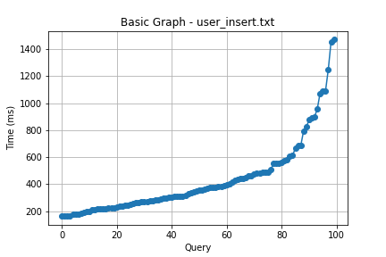

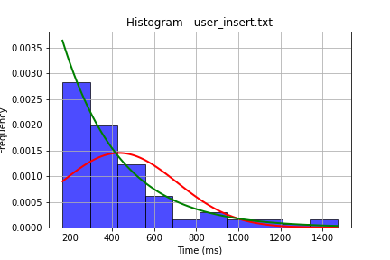

## File: user_update.txt

Number of queries: 100

Mean: 669.18

Median: 451.04

Max: 8313.51

Min: 77.82

Variance: 1215807.33

Standard Deviation: 1102.64

90th Percentile: 967.76

Is normal: No

Shapiro-Wilk test p-value: 2.5036498938907878e-18

Is exponential: No

Kolmogorov-Smirnov test p-value: 2.0000000000001775e-200

