# Statistics for Files in D:/Documents/Unob_7/STC/STC_code/DB_Performance/_Test/Performance/Test_v4

## File: gql_forms.txt

Number of queries: 5

Mean: 37.03

Median: 33.63

Max: 48.12

Min: 32.58

Variance: 35.05

Standard Deviation: 5.92

90th Percentile: 44.16

Is normal: Yes

Shapiro-Wilk test p-value: 0.053168512880802155

Is exponential: No

Kolmogorov-Smirnov test p-value: 0.03008000000000002

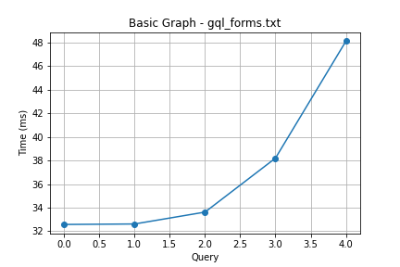

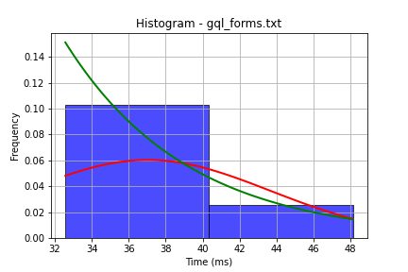

## File: gql_ug.txt

Number of queries: 5

Mean: 19.16

Median: 18.35

Max: 23.15

Min: 17.59

Variance: 4.08

Standard Deviation: 2.02

90th Percentile: 21.33

Is normal: No

Shapiro-Wilk test p-value: 0.012459203600883484

Is exponential: No

Kolmogorov-Smirnov test p-value: 0.0006404677348408938

