# Statistics for Files in D:/Documents/Unob_7/STC/STC_code/DB_Performance/_Test/Performance/Test_v5/cockroach

## File: gql_event.txt

Number of queries: 100

Mean: 41.0

Median: 34.24

Max: 94.15

Min: 21.14

Variance: 306.29

Standard Deviation: 17.5

90th Percentile: 67.74

Is normal: No

Shapiro-Wilk test p-value: 1.2933195847608658e-08

Is exponential: No

Kolmogorov-Smirnov test p-value: 2.0000000000001775e-200

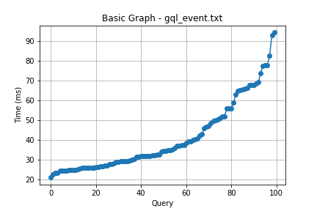

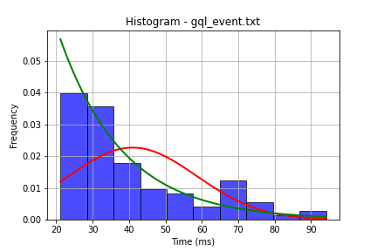

## File: gql_facilities.txt

Number of queries: 100

Mean: 50.25

Median: 43.14

Max: 142.56

Min: 20.0

Variance: 467.61

Standard Deviation: 21.62

90th Percentile: 75.97

Is normal: No

Shapiro-Wilk test p-value: 5.637427307192411e-07

Is exponential: No

Kolmogorov-Smirnov test p-value: 2.0000000000001775e-200

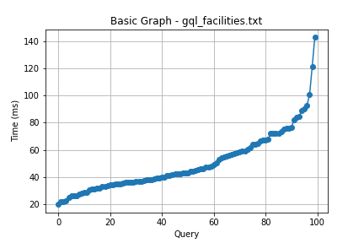

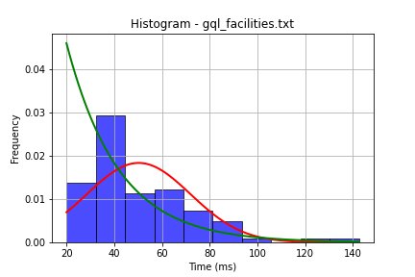

## File: gql_forms.txt

Number of queries: 100

Mean: 59.96

Median: 55.55

Max: 135.09

Min: 27.69

Variance: 491.58

Standard Deviation: 22.17

90th Percentile: 89.52

Is normal: No

Shapiro-Wilk test p-value: 3.398383796593407e-07

Is exponential: No

Kolmogorov-Smirnov test p-value: 2.0000000000001775e-200

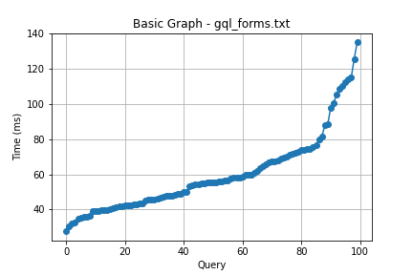

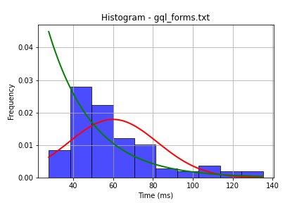

## File: gql_granting.txt

Number of queries: 100

Mean: 51.7

Median: 45.01

Max: 249.32

Min: 20.99

Variance: 794.43

Standard Deviation: 28.19

90th Percentile: 73.87

Is normal: No

Shapiro-Wilk test p-value: 5.829129632326305e-14

Is exponential: No

Kolmogorov-Smirnov test p-value: 2.000115588115198e-200

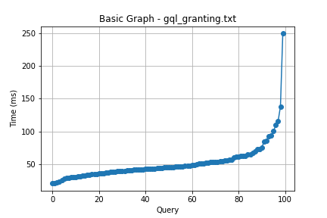

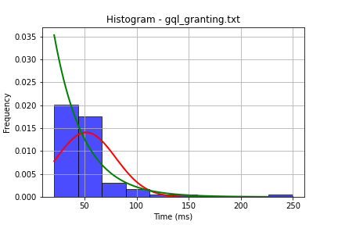

## File: gql_lessons.txt

Number of queries: 100

Mean: 56.53

Median: 49.86

Max: 238.28

Min: 29.7

Variance: 825.5

Standard Deviation: 28.73

90th Percentile: 83.03

Is normal: No

Shapiro-Wilk test p-value: 1.4696701971725346e-13

Is exponential: No

Kolmogorov-Smirnov test p-value: 2.0000000000001775e-200

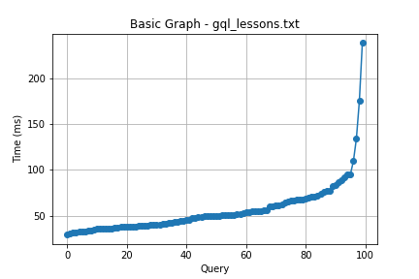

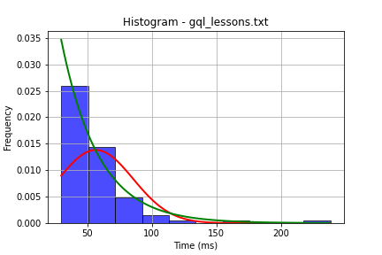

## File: gql_presences.txt

Number of queries: 100

Mean: 40.59

Median: 34.56

Max: 140.67

Min: 21.91

Variance: 344.54

Standard Deviation: 18.56

90th Percentile: 69.39

Is normal: No

Shapiro-Wilk test p-value: 2.2850511760541536e-10

Is exponential: No

Kolmogorov-Smirnov test p-value: 3.871009858124822e-169

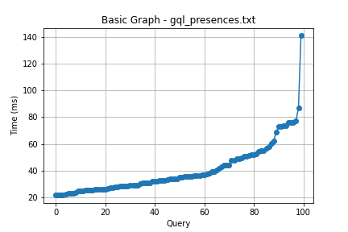

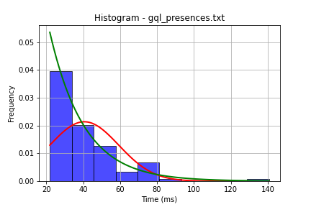

## File: gql_projects.txt

Number of queries: 100

Mean: 38.44

Median: 31.62

Max: 126.47

Min: 18.0

Variance: 403.92

Standard Deviation: 20.1

90th Percentile: 67.14

Is normal: No

Shapiro-Wilk test p-value: 1.2564496665312674e-10

Is exponential: No

Kolmogorov-Smirnov test p-value: 2.0000000000001775e-200

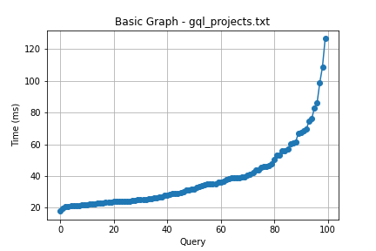

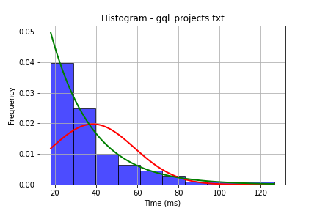

## File: gql_ug.txt

Number of queries: 100

Mean: 103.06

Median: 94.67

Max: 302.43

Min: 39.59

Variance: 1854.97

Standard Deviation: 43.07

90th Percentile: 160.32

Is normal: No

Shapiro-Wilk test p-value: 6.095857543186867e-07

Is exponential: No

Kolmogorov-Smirnov test p-value: 2.0000000000001775e-200

