# Statistics for Files in D:/Documents/Unob_7/STC/STC_code/DB_Performance/_Test/Performance/Test_v5/postgres

## File: gql_event.txt

Number of queries: 100

Mean: 47.15

Median: 29.86

Max: 1403.18

Min: 16.0

Variance: 18847.51

Standard Deviation: 137.29

90th Percentile: 46.68

Is normal: No

Shapiro-Wilk test p-value: 1.2852763054004488e-21

Is exponential: No

Kolmogorov-Smirnov test p-value: 2.0000000000001775e-200

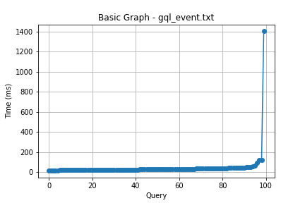

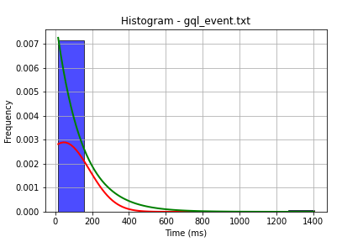

## File: gql_facilities.txt

Number of queries: 100

Mean: 44.8

Median: 28.83

Max: 1448.87

Min: 16.0

Variance: 20080.62

Standard Deviation: 141.71

90th Percentile: 41.49

Is normal: No

Shapiro-Wilk test p-value: 9.193328948766965e-22

Is exponential: No

Kolmogorov-Smirnov test p-value: 2.0000000000001775e-200

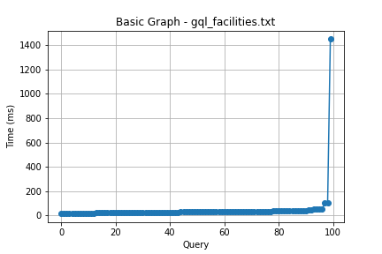

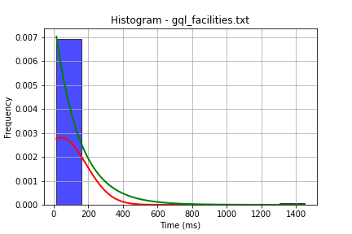

## File: gql_forms.txt

Number of queries: 100

Mean: 46.81

Median: 33.17

Max: 267.13

Min: 21.0

Variance: 1604.68

Standard Deviation: 40.06

90th Percentile: 77.29

Is normal: No

Shapiro-Wilk test p-value: 5.743779119725878e-16

Is exponential: No

Kolmogorov-Smirnov test p-value: 1.030795030817713e-152

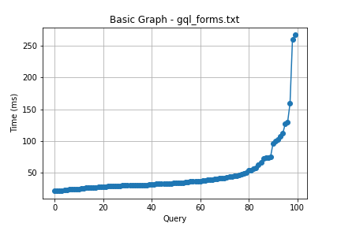

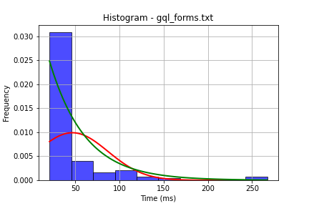

## File: gql_granting.txt

Number of queries: 100

Mean: 33.66

Median: 27.4

Max: 170.24

Min: 17.67

Variance: 479.03

Standard Deviation: 21.89

90th Percentile: 49.59

Is normal: No

Shapiro-Wilk test p-value: 1.1693914523644216e-15

Is exponential: No

Kolmogorov-Smirnov test p-value: 2.3624826847792066e-200

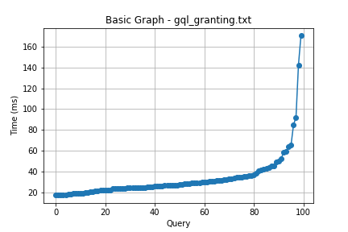

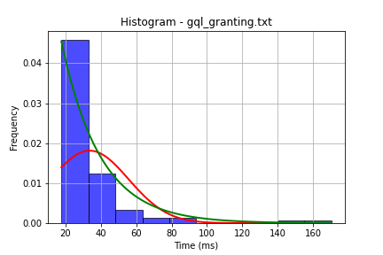

## File: gql_lessons.txt

Number of queries: 100

Mean: 42.58

Median: 37.02

Max: 121.24

Min: 15.8

Variance: 387.95

Standard Deviation: 19.7

90th Percentile: 67.55

Is normal: No

Shapiro-Wilk test p-value: 3.239019719103453e-08

Is exponential: No

Kolmogorov-Smirnov test p-value: 2.0000000000001775e-200

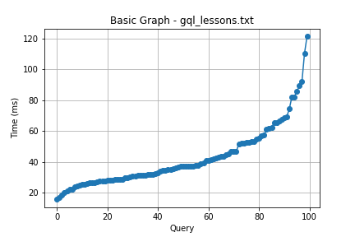

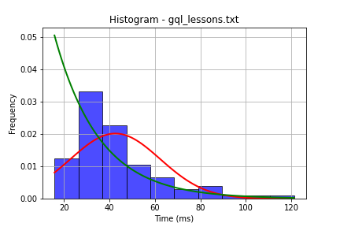

## File: gql_presences.txt

Number of queries: 100

Mean: 34.5

Median: 29.18

Max: 125.81

Min: 14.99

Variance: 322.74

Standard Deviation: 17.96

90th Percentile: 51.3

Is normal: No

Shapiro-Wilk test p-value: 1.7265774313740545e-12

Is exponential: No

Kolmogorov-Smirnov test p-value: 2.0000000000001775e-200

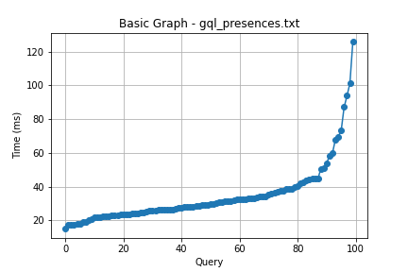

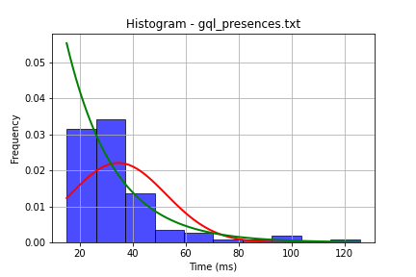

## File: gql_projects.txt

Number of queries: 100

Mean: 41.93

Median: 25.3

Max: 651.21

Min: 13.24

Variance: 5269.81

Standard Deviation: 72.59

90th Percentile: 56.13

Is normal: No

Shapiro-Wilk test p-value: 2.0877839620503523e-19

Is exponential: No

Kolmogorov-Smirnov test p-value: 2.5353012004595013e-170

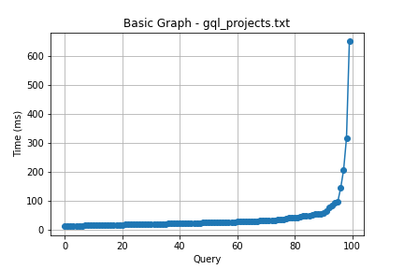

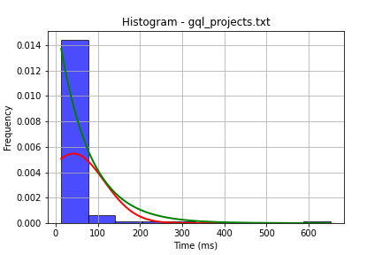

## File: gql_ug.txt

Number of queries: 100

Mean: 70.71

Median: 50.33

Max: 1194.49

Min: 28.83

Variance: 13726.51

Standard Deviation: 117.16

90th Percentile: 90.91

Is normal: No

Shapiro-Wilk test p-value: 1.4111533229092727e-20

Is exponential: No

Kolmogorov-Smirnov test p-value: 2.0000000000090596e-200

